**Relationship between the Census of Agriculture and Fruit, Nut and Specialty Commodity Surveys**

The Census of Agriculture (CoA) is conducted once every five years (with reference years ending in 2 or 7). It is used as an acreage and production benchmark for commodities like fruit, nuts and berries. The CoA is also used to identify farms that produce these commodities, to be used to sample for annual surveys. The following table is an example of the type of questions that will be asked in the 2022 Census of Agriculture. This image is from the Census of Agriculture 2020 Content Test (OMB # 0535-0243). The acreage data will be used to create stratified samples for annual fruit, nut and specialty crop surveys.

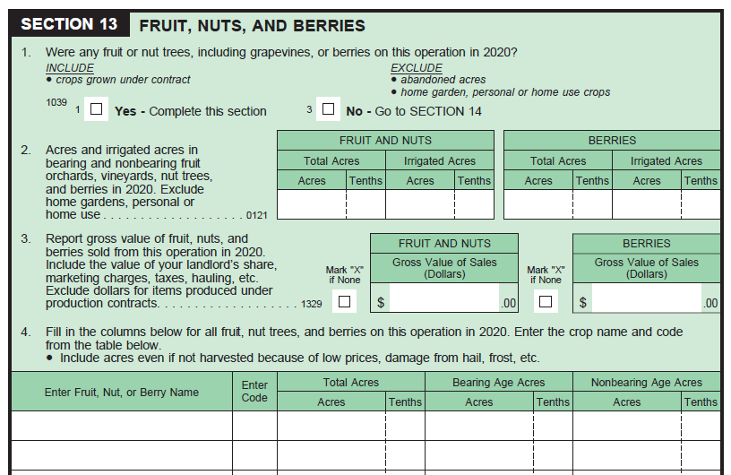

The fruit, nut and specialty crop surveys will ask for greater detail for each of the commodities.  For example, in August of each year, NASS collects projected production data from growers of most major crops. (See following table.)

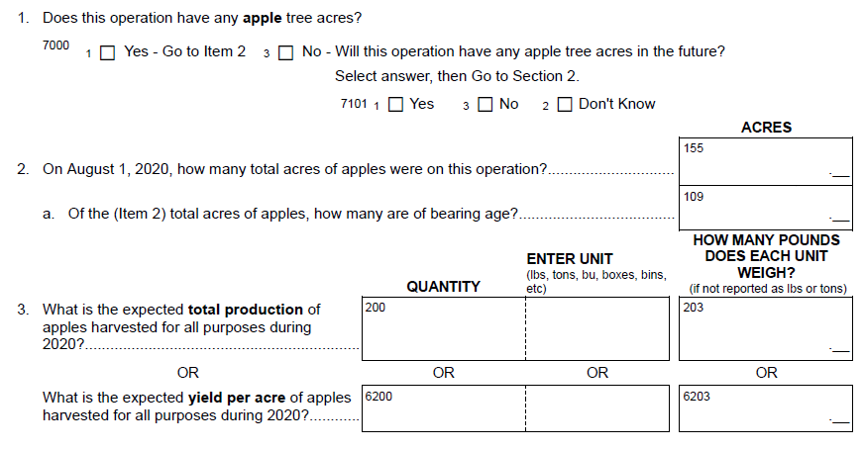

For some commodities, NASS will also collect varietal data like the questions below from the Grape Variety Survey.

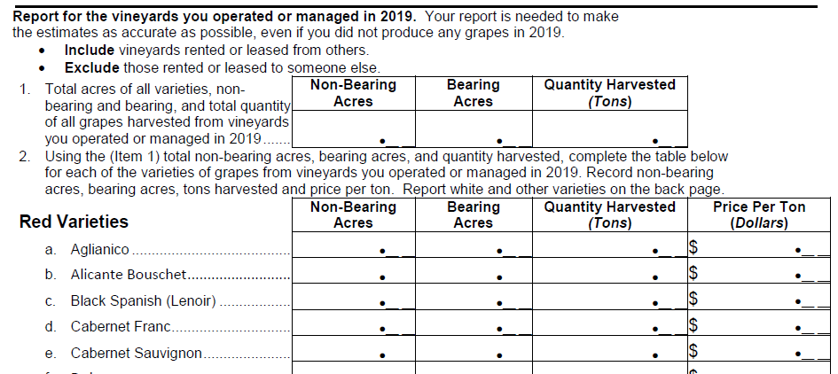

Also, the fruit and nut surveys collect data for specific time periods during the growing season to provide data users with production, price, variety, and acreage data that they need for making operating decisions. This all correlates with the NASS data publication calendar so that data users who track production data over time can have the data at the same time each year.

Due to the complexity and scope of the Census of Agriculture, the data will not be available during the growing season. The data collection period for the 2022 Census of Agriculture extends from December 2022 through May 2023, so data for crop year 2022 will not be available until the latter part of 2023 (and published in early 2024).