**Non-substantive Change Request**

**0535-0039 – Fruit, Nuts, and Specialty Crops**

**Fruit and Nut Production and Disposition Inquiry - February 2022**

**Grape Production and Disposition Inquiry - February 2022**

As part of continually reviewing comments about previous surveys and data needs from data collectors and analysts, NASS added the following questions to the Fruit and Nut Production and Disposition Inquiry and Grape Production and Disposition Inquiry. Both surveys will be conducted in February 2022. Changes will be documented for each questionnaire separately.

Fruit and Nut Production and Disposition Inquiry - February 2022

Question four for the apple and pear sections will add two disposition questions to account for growers storing apple and pear crops in climate-controlled conditions (not frozen) for fresh sale up to twelve months after harvest. The “Not Sold” category will add the following two items to account for climate-controlled storage.

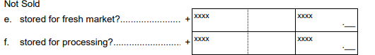

The previously approved question four for apples and pears is

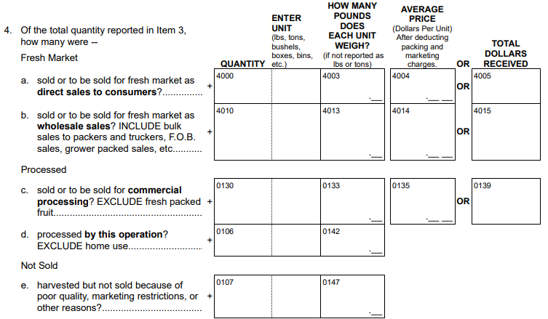

The new question four for apples and pears will be

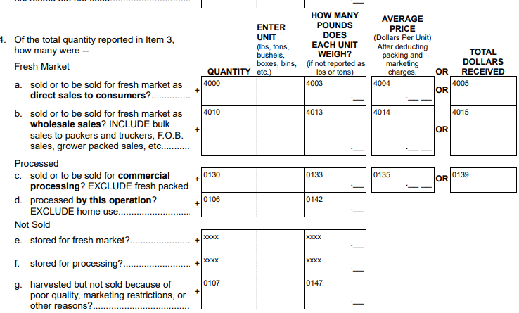

Grape Production and Disposition Inquiry - February 2022

The following question, currently asked on the August Grape Inquiry, will be asked after the primary screening question on the February Grape Production and Disposition Inquiry.

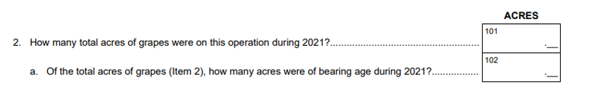

This is being requested to get a better indication of bearing acreage for end of the year estimates due to:

1. The sample for the February Grape Production and Disposition differs from the August Grape Inquiry, and
2. The shorter data collection for the August Grape Inquiry results in more non-response so the operator may have been a non-respondent in August.

The front page of the currently approved Grape Production and Disposition Inquiry is:

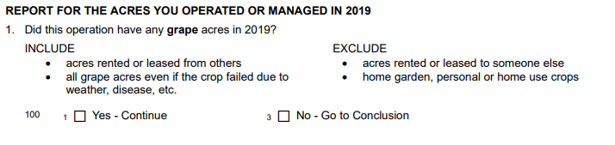

The new front page of the currently approved Grape Production and Disposition Inquiry will be:

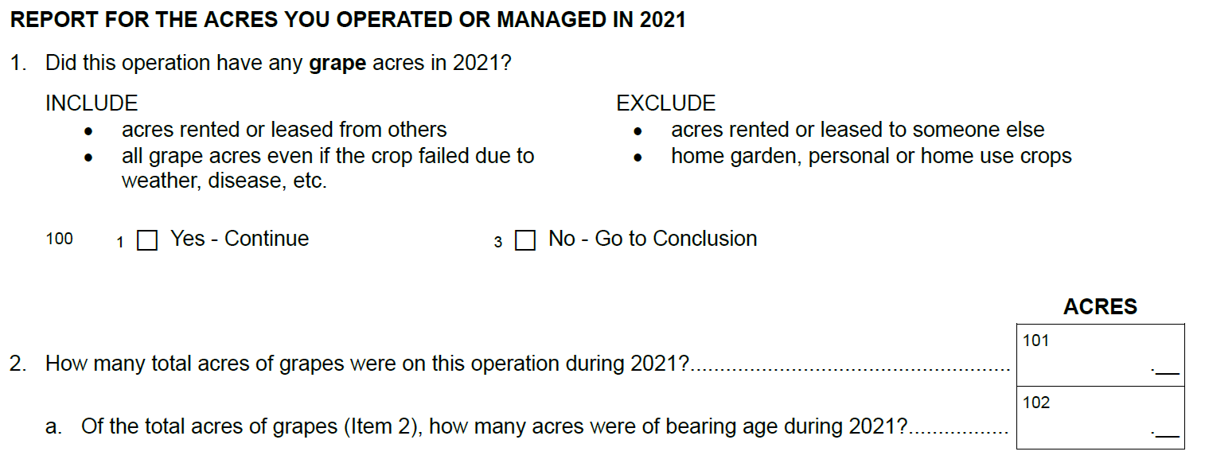

These changes will not impact the current sample size or respondent burden.