Non-substantive Change Request
0535-0213 – Agricultural Surveys Program
June Area Survey US Master Version - June 2022
Agricultural Coverage Evaluation Survey - 2022

As part of continually reviewing comments about previous surveys and data needs from data collectors and analysts, NASS made the following changes to the June Area and Agricultural Surveys. Both surveys will be conducted in June 2022. Changes will be documented for each questionnaire separately.
June Area Survey US Master Version – June 2022
Section A, new questions four and five:
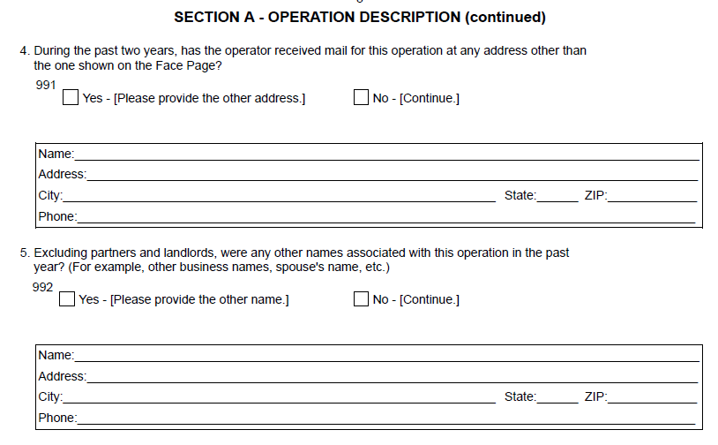
Section D
Question 40 now reads: How many acres inside the red boundary were or will be planted to two different crops (including any soybeans reported in item code 602 box) or will have two uses of the same crop in the current crop year?
Section E, question 12 now reads: How many acres of new alfalfa or alfalfa mixtures have been or will be seeded during 2022? (INCLUDE mixed with a nurse crop, other forage, or direct seedings.)

Section K, new question four that will appear only on the Kentucky version. The additional question will be used as a Not On List component for an equine survey funded by the University of Kentucky that will be submitted under OMB Control Number 0535-0264 “Quick Response for Cooperator-funded Surveys Generic Clearance”:
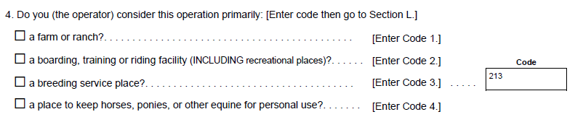

Section N, A new bank of questions to calculate points for the Census of Agriculture Not on Mail List operations.
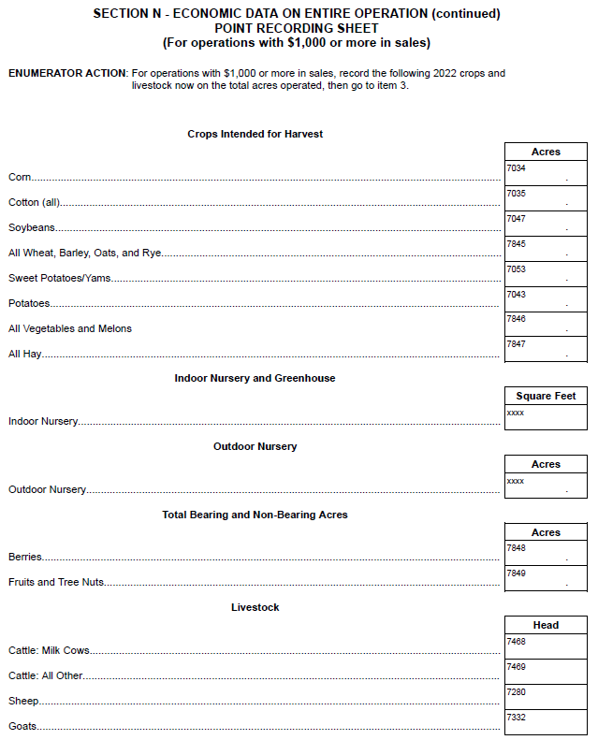

Section O - Technology Use has been dropped.
Section P – Operator Characteristics has been replaced with a new Personal Characteristics section that coincides with the 2022 Census of Agriculture.
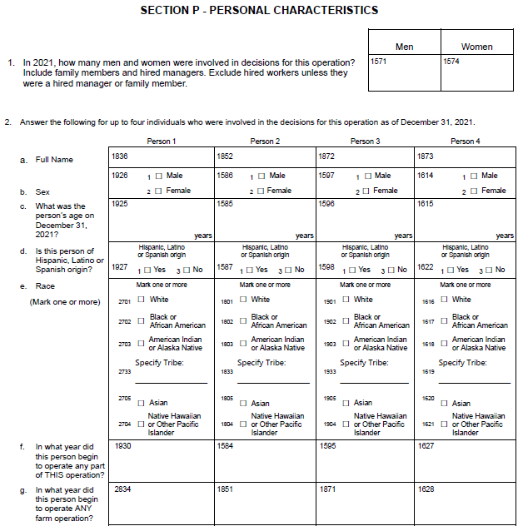

Agricultural Coverage Evaluation Survey - 2022
Section E, Item 1b(i) was removed.
Section K was added in the Kentucky version to include inventory and the new question four that will appear only on the Kentucky version. The additional question will be used as a Not On List component for an equine survey funded by the University of Kentucky that will be submitted under OMB Control Number 0535-0264 “Quick Response for Cooperator-funded Surveys Generic Clearance”:
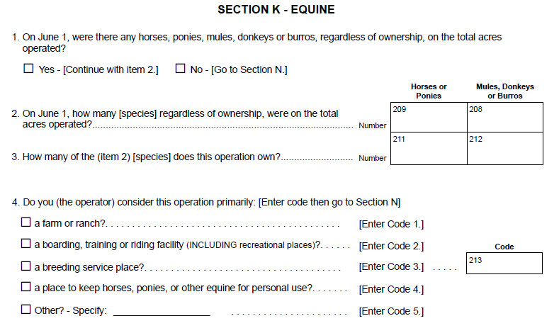
Section N, Item 2 was removed.
Section P, Item 3 was removed.

Agricultural Coverage Evaluation Survey – Hawaii Version 2022
The commodity table of Section N in the national version has reformatted in the Hawaii version to include some Hawaii-specific crops. It now appears in Section E as shown below:
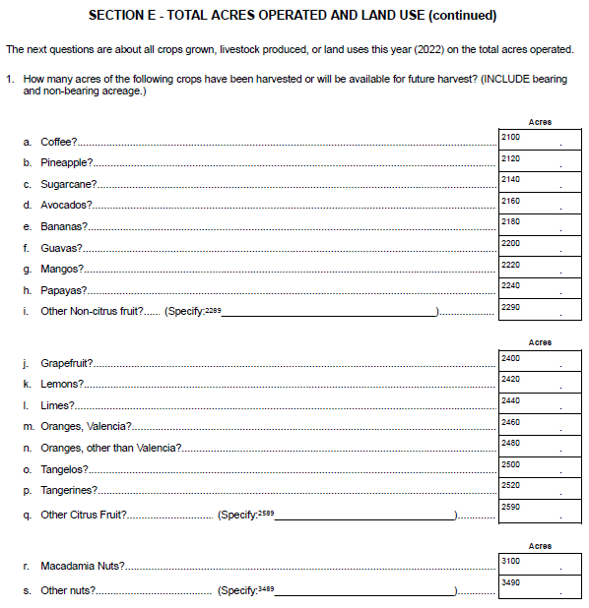

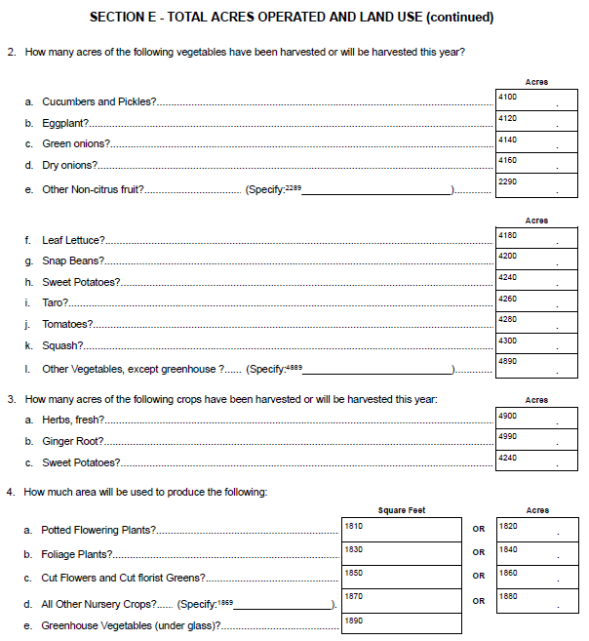

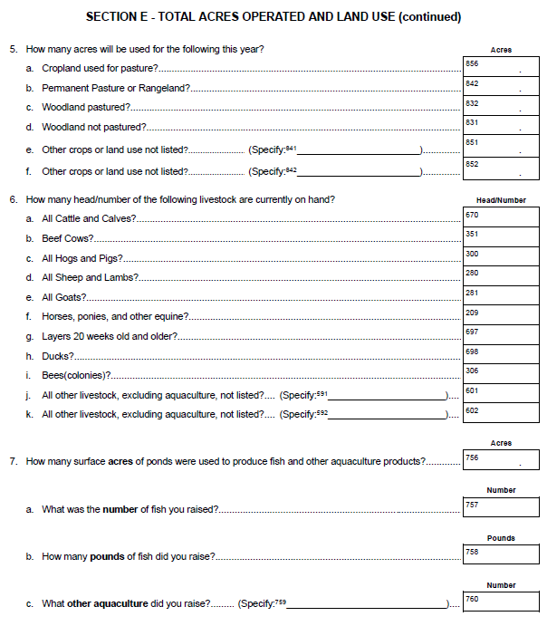

Section N, Item 1 – New questions were added as follows:
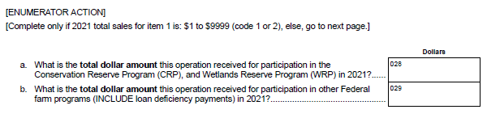

These changes will not impact the current sample size or respondent burden.

