Attachment B1. Screenshots of Mail Household Screener

(Web Version)
The National Food Study (https://www.ers.usda.gov/foodaps) collects information that ensures USDA programs are delivered efficiently, effectively, and with integrity. This study will also ensure that USDA programs focus on helping Americans make healthy food choices.
Your identity and the information you provide will be protected and shall remain strictly confidential. It will be used for statistical purposes only. If you have any question about filling out this form, please contact us at <toll-free number>.
According to the Paperwork Reduction Act of 1995, an agency may not conduct or sponsor, and a person is not required to respond to, a collection of information unless it displays a valid OMB control number. The valid OMB control number for this information collection is 0536-XXXX. The time required to complete this information collection is estimated to average six minutes per response, including the time for reviewing instructions, searching existing data sources, gathering and maintaining the data needed, and completing and reviewing the collection of information.
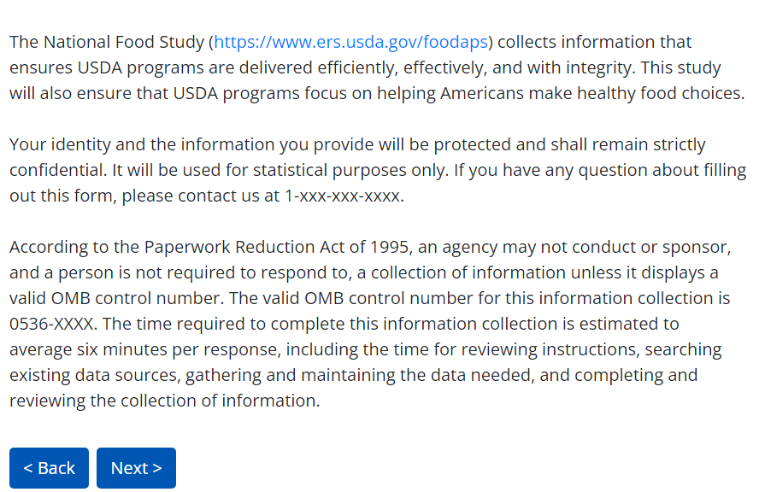

Commonly Asked Questions
How was I selected?
The National Food Study is a study by the federal government on how people in the United States get their food. We cannot interview every person in the US. Your community was chosen scientifically to represent other similar parts of the country, and your address was randomly selected from a list of all addresses in your community.
How do I know this is a legitimate survey?
The National Food Study (https://www.ers.usda.gov/foodaps) is a national study about where households get their food and how much they pay for food. It is funded by the US Department of Agriculture (USDA). Westat, an independent research firm, was hired by USDA to conduct this study. You can contact Dr. Mark Denbaly, Deputy Director for Food Economics Data, at 202-694-5390 or mark.denbaly@usda.gov if you have questions about the legitimacy of the survey.
Is my information confidential?
All your information will remain strictly confidential. The USDA will use the collected data for research and statistical purposes only. Your identity and the answers you provide will be protected and shall remain confidential. Your information will be combined with data collected from hundreds of other people in this study to provide national-level statistics and information to improve Americans’ food choices and health. Your responses will not have any effect on services you currently receive or may apply for in the future.
To maintain your privacy and confidentiality, any information you provide is stored in encrypted files, transferred through encrypted transmission, and stored on devices that are not accessible from the Internet or by outside parties. All personnel working on this study sign a confidentiality pledge and take annual security training to safeguard your information. Violators can face heavy fines and/or prison time.
The USDA, its employees, agents, and partner statistical agencies, will use the information you provide for statistical purposes only and will hold the information in confidence to the full extent permitted by law. In accordance with the Confidential Information Protection and Statistical Efficiency Act of 2002 (Title 5 of Public Law 107-347) and other applicable Federal laws, your responses will not be disclosed in identifiable form without your informed consent. Per the Federal Cybersecurity Enhancement Act of 2015, Federal information systems are protected from malicious activities through cybersecurity screening of transmitted data.

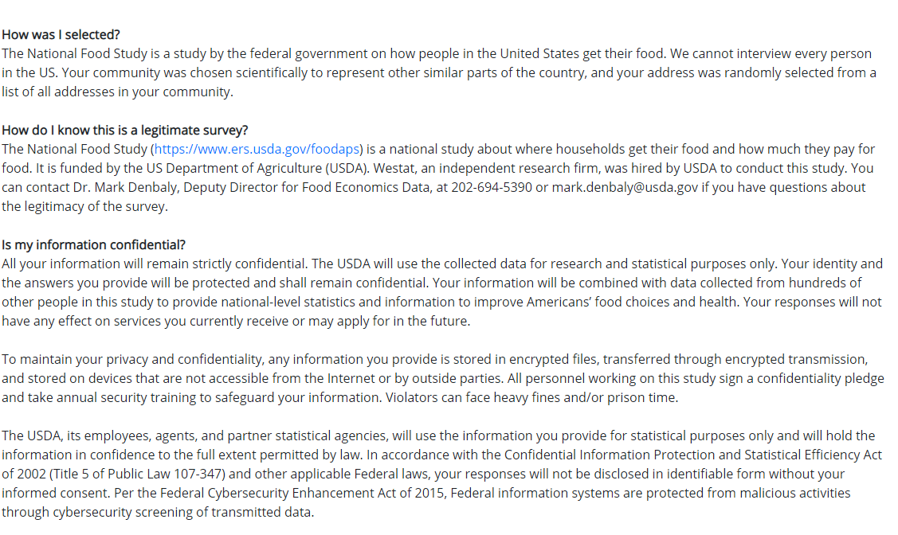

Who can I contact if I have general questions about this form?
You can call the National Food Study support toll-free at 1-xxx-xxx-xxxx.
Why are you asking about who lives in my household?
We need to understand the needs of households of different sizes and income. There are ten questions about your household to answer and they will only take a few minutes to complete.

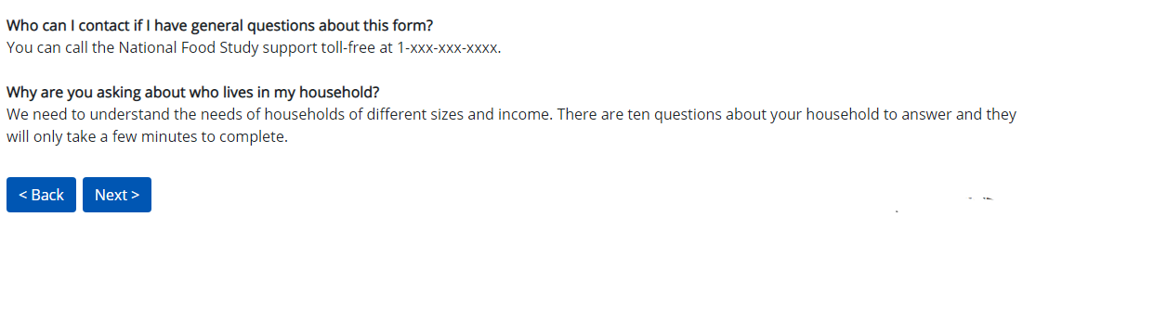

Section 1. Food and Your Household
1. In a typical week, how many times does your household eat out as a group at a restaurant or at a friend’s or a relative’s home? Write ‘0’ if your household does not eat out together as a group.

Number of times eating out as a household

2. In a typical week, how many times does your household shop for groceries? Write ‘0’ if your household does not shop for groceries.

Number of times shopping for groceries
3. Which of these statements best describes the food eaten in your household in the last 30 days?
Enough of the kinds of food (I/we) want to eat

Enough, but not always the kinds of food (I/we) want to eat
Sometimes not enough to eat
Often not enough to eat

4. To what extent was the following statement often true, sometimes true, or never true for you/your household in the last 30 days?
I/We worried whether our food would run out before I/we got money to buy more.
Often true

Sometimes true
Never true

Section 2. More about Your Household
- Thinking about the people who consider this address as their main home, how many people, including yourself, live at this address and have no other place they usually live? This includes people who usually stay at this address, but temporarily away on business, on vacation, in the hospital or in the military. Do not include people living away at school or incarcerated.

Number of people who live at this address and have no other place they usually live

- Is there anyone in your household under the age of 18?
YES NO
- Is there anyone in your household 65 years or older?
YES NO

- What was your household total income in the past 12 months, before taxes?

Less than $10,000
$10,000 to $19,999
$20,000 to $29,999
$30,000 to $39,999
$40,000 to $49,999
$50,000 to $59,999
$60,000 to $69,999
$70,000 to $79,999
$80,000 or more
- Do you or any member of your household currently receive [FILL STATE SNAP NAME] benefits? This program puts money on an EBT card that you can use to buy food.
YES NO

- The WIC program - the Women, Infants, and Children program-- provides healthy foods and other services to low-income pregnant and breastfeeding women, infants, and children up to age 5. Is anyone in your household now receiving benefits from WIC?
YES NO

11. Please provide us with your name {and address} [DISPLAY AND REQUEST ADDRESS ONLY WHEN ADDRESS ON SAMPLE FRAME IS A P.O. BOX] in case we have any questions about this form.
Name

Street address

City, State, Zip

