Attachment J2. Web Screenshots for Profile Questionnaire

(To be completed by all household members. PR proxy reports for kids under 11.)
[PROGRAMMER NOTE: IF AGE (FROM INITIAL INTERVIEW) IS LESS THAN 11, FILL [NAME] FROM THE DROPDOWN BOX PR SELECTED]
P0. Thank you for your participation in this important food study. This questionnaire will ask you a few questions for classification purposes. You will earn a $2 incentive upon completion of this questionnaire.

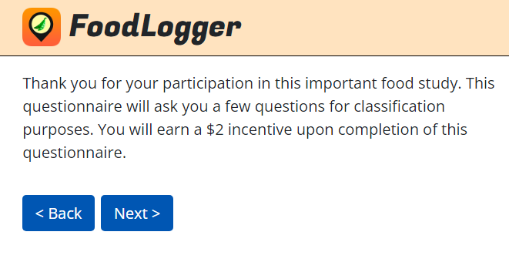

P1. {Are you/Is NAME} male or female? Select a choice below.
- Male
- Female

P3. {Are you/Is NAME} of Hispanic, Latino, or Spanish origin?
- Not of Hispanic, Latino, or Spanish origin
- Mexican, Mexican American, Chicano
- Puerto Rican
- Cuban
- Another Hispanic, Latino or Spanish origin (for example, Salvadoran, Dominican, Colombian, Guatemalan, Spaniard, Ecuadorian, etc.)

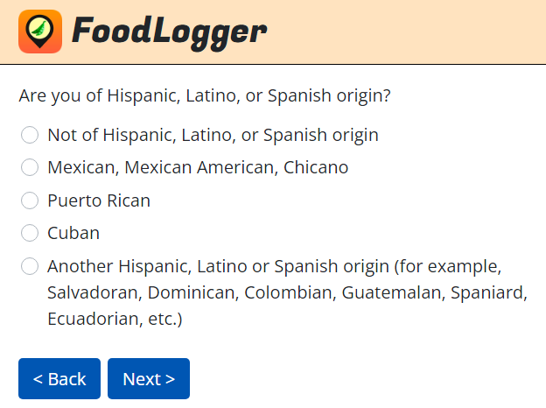

P4. What is {your/NAME’s} race? Please select all that apply.
- White
- Black or African American
- American Indian or Alaska Native
- Asian
- Native Hawaiian or Other Pacific Islander

[IF AGE>=16, ASK P5. ELSE GO TO P7A]
P5. What is the highest level of school {you/NAME} completed or the highest degree you received?
- Less than 1st grade
- 1st to 8th grade
- 9th to 12th grade, no diploma
- High school graduate with diploma or GED
- One or more years of college, no degree
- Associate (2-year) college degree
- Bachelor’s degree (e.g., BA, AB, BS)
- Master’s or higher degree

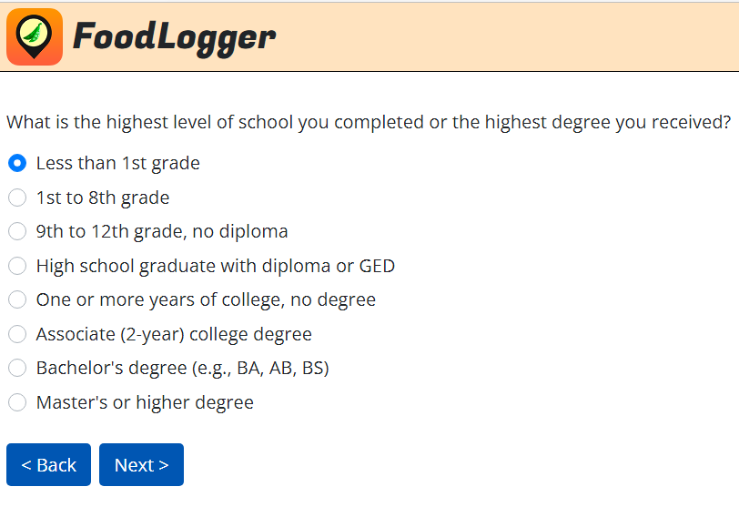

P7a. In general, would you say {your health/NAME’s health} is …
- Excellent
- Very good
- Good
- Fair
- Poor

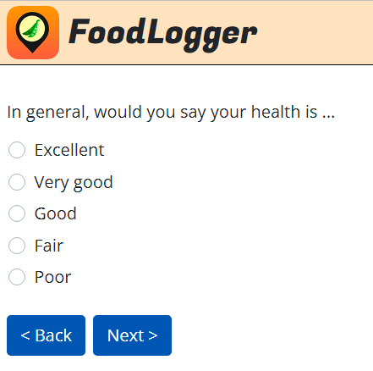

[IF AGE>=16, ASK P7B. ELSE GO TO P7C]
P7b. {Do you/Does NAME} smoke cigarettes, cigars, E-cigarettes, or pipes, or chew tobacco?
- Yes
- No

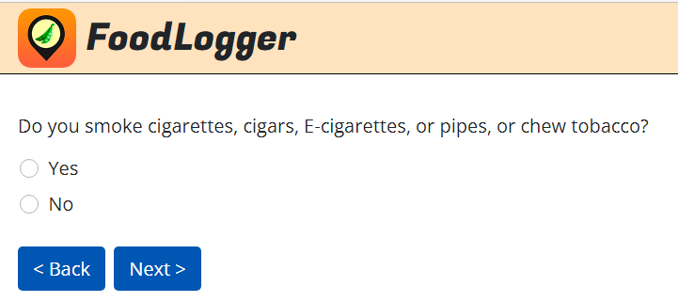

P7c. [IF P1=2 AND AGE>=20, SHOW:] Other than during pregnancy, {have you/has NAME} ever been told by a doctor or other health professional that {you have/NAME has} diabetes or sugar diabetes?
[OTHERWISE, SHOW:] {Have you/Has NAME} ever been told by a doctor or other health professional that {you have/NAME has} diabetes or sugar diabetes?
- Yes
- No
- Don’t know

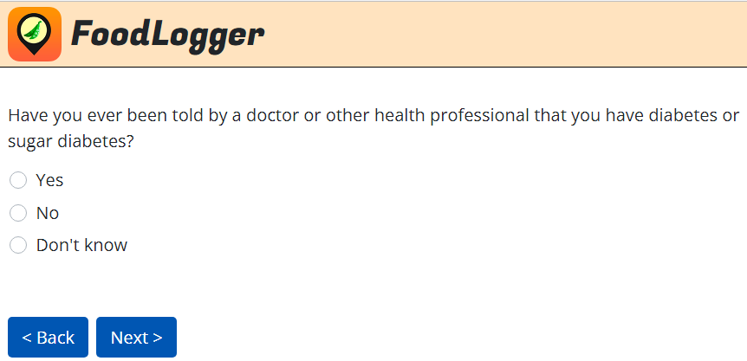

[IF AGE>=16, ASK P7D. ELSE GO TO SKIP INSTRUCTION BEFORE P7E]
P7d. {Have you/Has NAME} ever been told by a doctor or other health professional that {you/NAME} had hypertension, also called high blood pressure?
- Yes
- No
- Don’t know

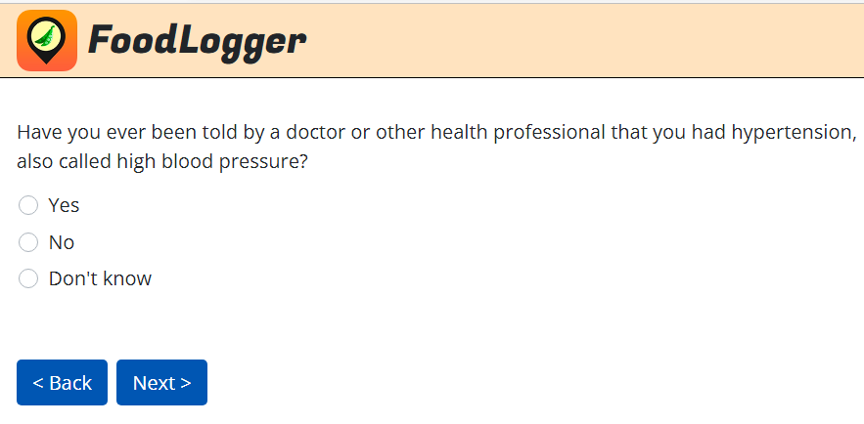

[IF AGE>=20, ASK P7D. ELSE GO TO SKIP INSTRUCTION BEFORE P8]
P7e. {Have you/Has NAME} ever been told by a doctor or other health professional that {your/NAME’s} blood cholesterol level was high?
- Yes
- No
- Don’t know

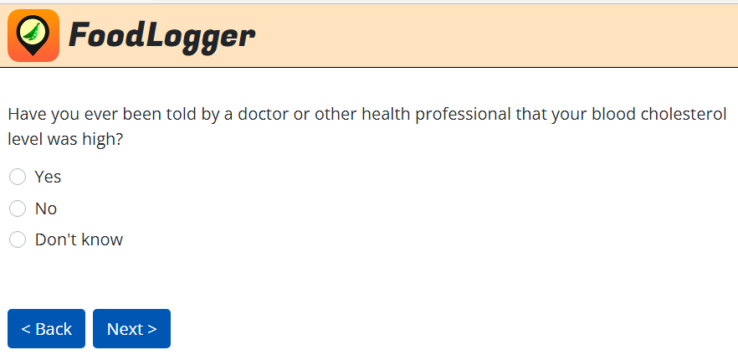

[IF AGE>=16 THEN ASK P8. ELSE GO TO P16.]
P8. {Have you/Has NAME} ever served on active duty in the U.S. Armed Forces, Reserves, or National Guard?
- Never served in the military
- Only on active duty for training in the Reserves or National Guard
- Now on active duty
- On active duty in the past, but not now

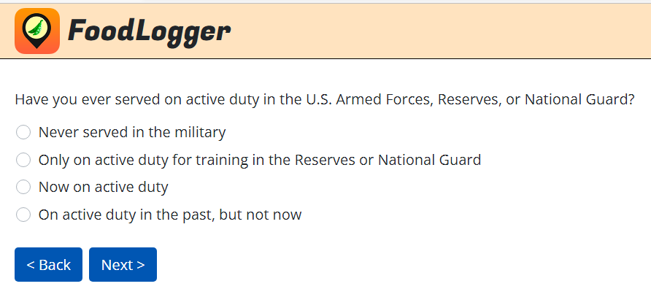

P9a. The following questions ask about work-related activities last week. By last week, we mean the week beginning on Sunday, [FILL IN: DATE], and ending on Saturday, [FILL IN: DATE].
Did you retire before last week?
- Yes GO TO P9A1
- No GO TO P9B
- Don’t know GO TO P9B
- Rather not answer GO TO P9B
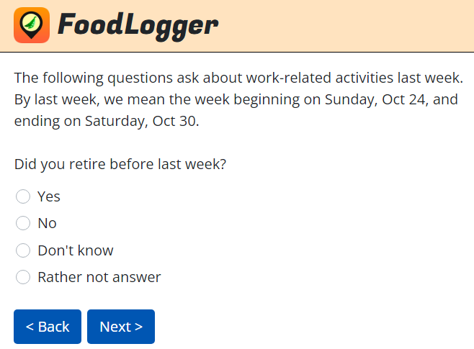

P9A1. Did you retire early because of a disability?
- Yes
- No
- Don’t know
- Rather not answer
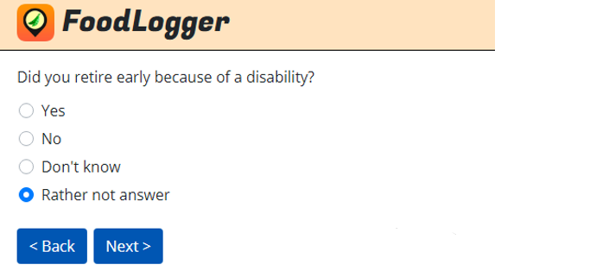

P9B. Do you own a business or a farm?
- Yes
- No
- Don’t know
- Rather not answer
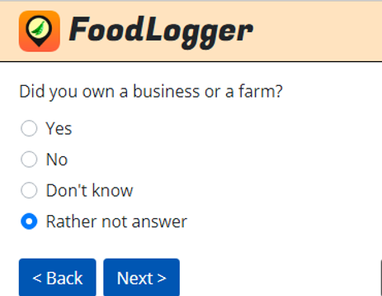

P9C. Last week, were you enrolled in school as a full-time or part-time student?

- Full-time
- Part-time
- No
- Don’t know
- Rather not answer
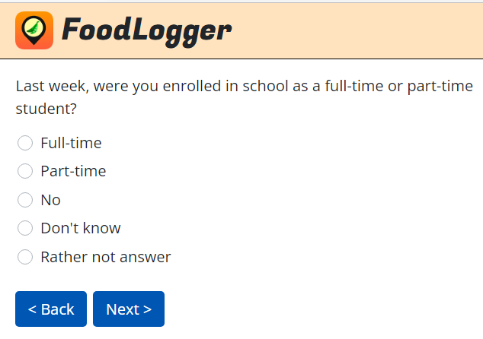

P9D. Last week, did you do any work for either pay or profit?
- Yes
- No
- Don’t know
- Rather not answer
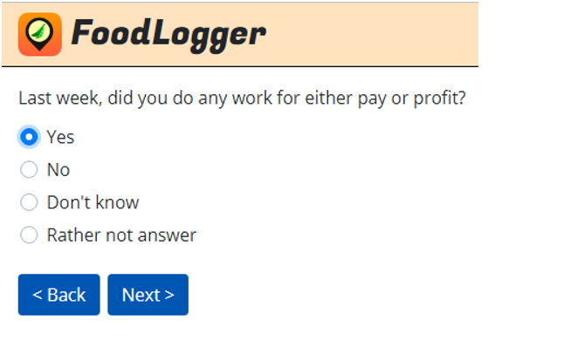

[IF P9D=1 (YES), GO TO P9E.
ELSE IF P9D =2 (NO), 3 (DON’T KNOW), 4 (RATHER NOT ANSWER) AND P9A=1 (RETIRED), GO TO P9E.
ELSE ASK P9D1]
P9D1. What is the main reason you did not work last week?
- Taking care of house/family
- Disabled
- On layoff (temporary or indefinite)
- Slack work/business conditions
- Waiting for new job to begin
- Vacation/personal days
- Own illness/injury/medical problems
- Child care problems
- Maternity/paternity leave
- Other family/personal obligation
- Labor dispute
- Weather affected job
- School/training
- Civic/military duty
- Other (specify)
- Don’t know
- Rather not answer
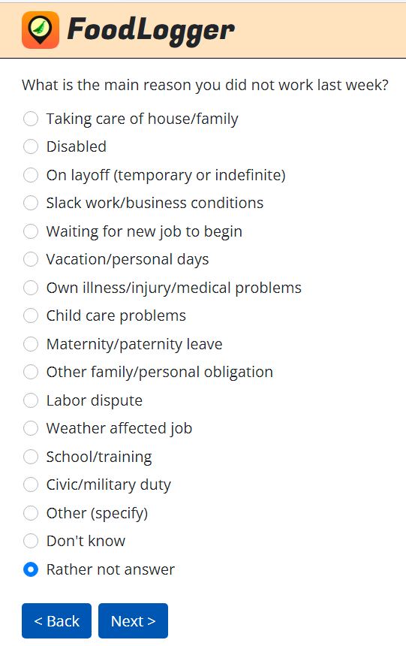

P9E. Are you currently looking for a job, either full or part time?
- Yes
- No
- Don’t know
- Rather not answer

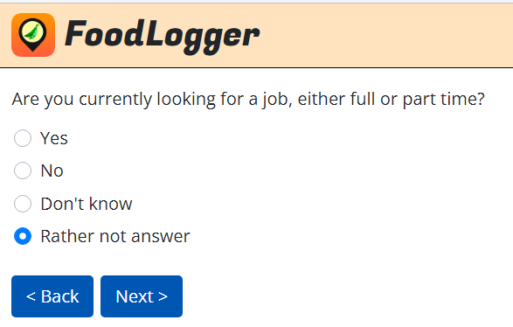

[IF P9A = 1 (YES) AND P9D = 2 (NO) GO TO P16.
ELSE ASK P10]
P10. Did you receive earnings or wages from more than one employer last week?
- Yes, more than one employer GO TO P11
- No, only one employer GO TO P11
- Did not receive any earnings or wages last week SKIP TO P16
- Don’t know GO TO P11
- Rather not answer GO TO P11

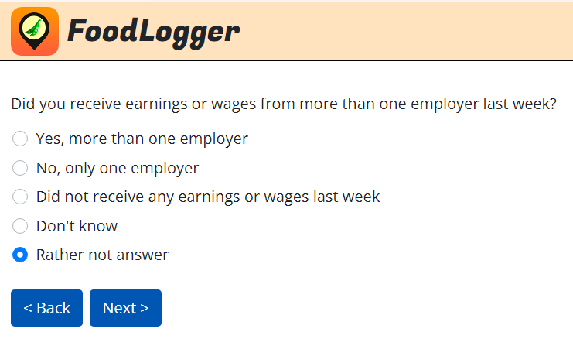

P11. In total, about how many hours do you normally work and get paid for per week, including paid sick time and paid leave time?
__________ Number of hours

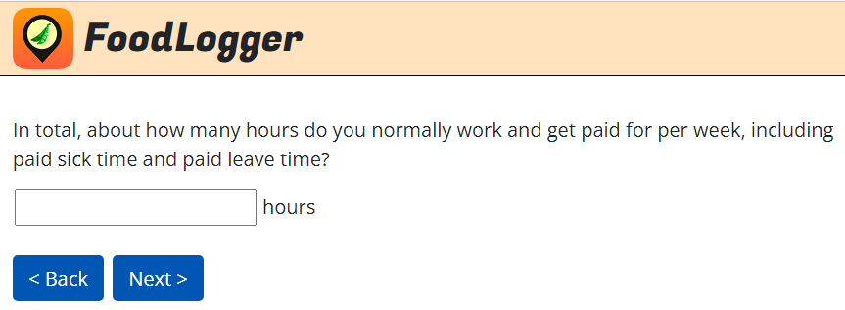

[IF P11 = 0, GO TO P16]
P12.
[IF P10=2 (NO), 4 (DON’T KNOW), 5 (RATHER NOT ANSWER), SHOW:] What shift or shifts do you work? Please check all that apply.
[IF P10=1 (YES), SHOW:] What shift or shifts do you work across all your jobs? Please check all that apply.
- Day shift (e.g. morning to early evening)
- Swing shift (e.g. early evening to midnight)
- Night shift (e.g. midnight to morning)
- Varying schedule (not a fixed schedule)
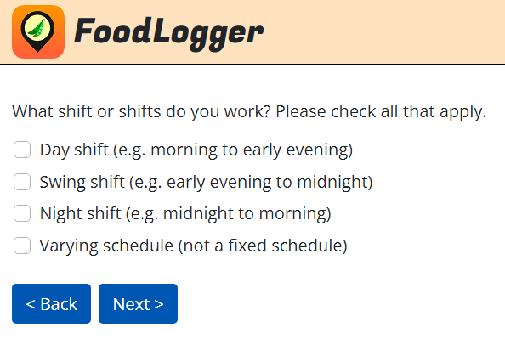

P13.
[IF P10=2 (NO), 4 (DON’T KNOW), 5 (RATHER NOT ANSWER), SHOW:] On what date did you receive your last paycheck?
[IF P10=1 (YES), SHOW:] On what date did you receive your last paycheck from your primary job?
__/__/__ mm/dd/yyyy
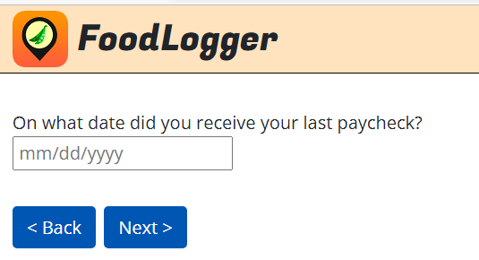

P14a. [IF P10=1 (YES): “Across all jobs,”] do you commute to work at least once a week?
- Yes, commute to work at least once a week GO TO P14
- No, work from home or telework every dayGO TO P16
- Don’t know GO TO P15
- Rather not answer GO TO P15

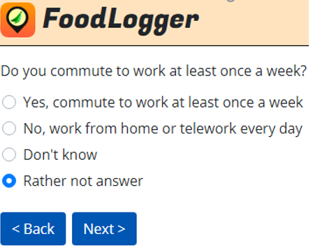

P14. [IF P10=2 (NO), 4 (DON’T KNOW), 5 (RATHER NOT ANSWER), SHOW:] How long does it usually take you to get from home to work?
[IF P10=1 (YES), SHOW:] For your main job, how long does it usually take you to get from home to work?
Hours: ________
Minutes: ________

P15. When at work, where do you usually get food (for example, for lunch or dinner)?
- Workplace - purchase
- Workplace - free
- Purchase from store/restaurant/food truck
- Bring food from home
- Do not eat food at work
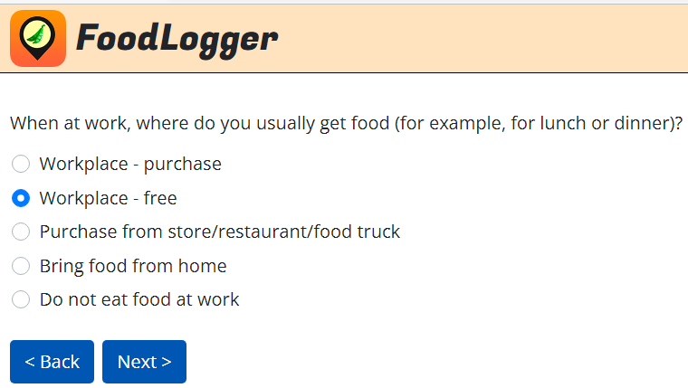

P16. How many times {do you/does NAME} eat breakfast out during an average week? This includes restaurants, school and workplace cafeterias, fast-food, take-out, and delivery. (Please provide your best estimate.)

Number: ________

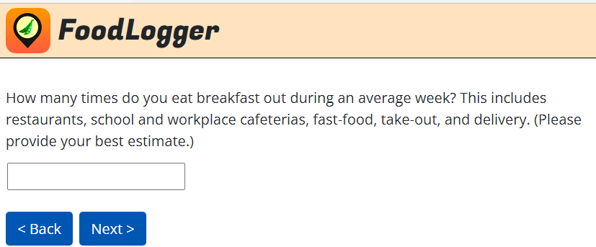

P17. How many times {do you/does NAME} eat lunch out during an average week? This includes restaurants, school and workplace cafeterias, fast-food, take-out, and delivery. (Please provide your best estimate.)

Number: ________

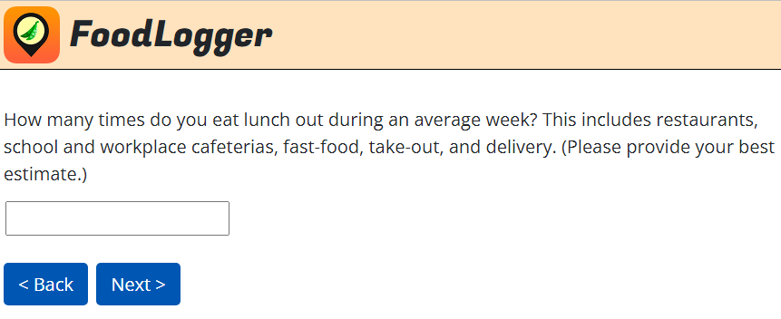

P18. How many times {do you/does NAME} eat dinner out during an average week? This includes restaurants, school and workplace cafeterias, fast-food, take-out, and delivery. (Please provide your best estimate.)

Number: ________

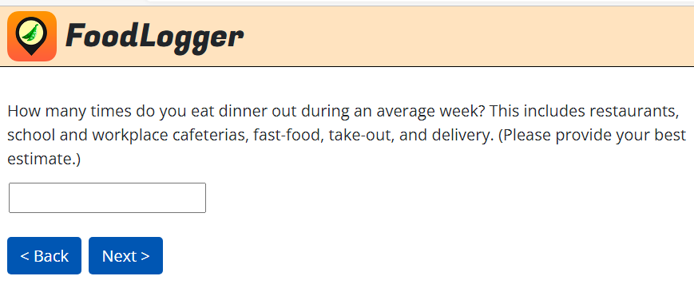

P6_UNITS: The next questions are about {your/NAME’s} height and weight.
In what units will you report {your/NAME’s} height?
- Feet and Inches GO TO P6
- Meters and Centimeters GO TO P6
- Don’t know {my/NAME’s} height SKIP TO P7_UNITS

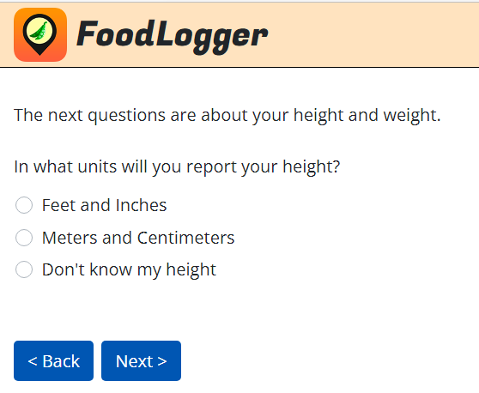

P6. [IF AGE>=2, SHOW:] How tall {are you/is NAME}?
[IF AGE < 2, SHOW:] How tall is NAME when lying down and measured from head to toe?
___Feet ___Inches
___Meters__Centimeters

P7_UNITS: In what units will you report {your/NAME’s} weight?
- Pounds (LBS) GO TO P7
- Kilograms (KG) GO TO P7
- Don’t know {my/NAME’s} weight SKIP TO P7_CAT1

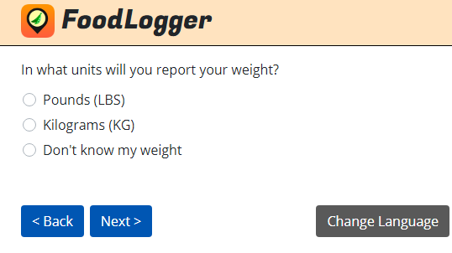

P7. How much {do you/does NAME} weigh?
___Pounds
___Kilograms

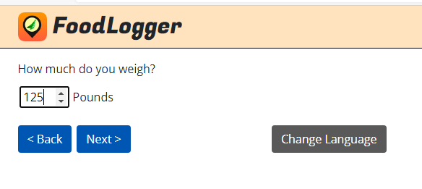

[IF P6_UNITS=3 (DON’T KNOW) AND P7_UNITS=1 OR 2, THEN CALCULATE BMI AS P7 DIVIDED BY SQUARE OF P6 IF REPORTED IN STANDARD METRICS OR P7 DIVIDED BY SQUARE OF P6 AND TIMES 703 IF REPORTED IN POUNDS AND INCHES.

IF AGE>17 AND (BMI<18 OR BMI>54), SHOW MESSAGE: “Please go back to verify your height and weight. Thanks!” AND BRING PEOPLE BACK TO P6 AND P7]

[IF AGE>18 AND P7_UNITS=3 (DON’T KNOW) AND P6_UNITS=1 OR 2, ASK P7_CAT1 AND P7_CAT2. ELSE GO TO P19.]

[PROGRAMMER NOTE: FILL IN XX BASED ON HEIGHT REPORTED IN P6. XX IS THE BMI CUTOFF BETWEEN OVERWEIGHT AND OBESITY]
P7_CAT1. {Do you/Does NAME} weigh more or less than [XX]?
- More SKIP TO P19
- Less GO TO P7_CAT2
- Same SKIP TO P19
- Don’t know GO TO P7_CAT2

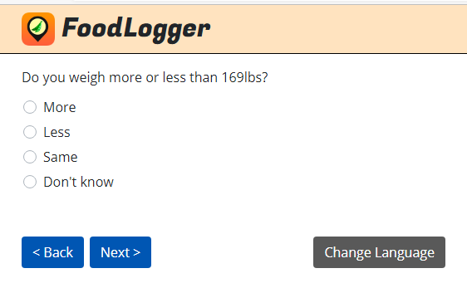

[PROGRAMMER NOTE: FILL IN YY BASED ON HEIGHT REPORTED IN P6. YY IS THE BMI CUTOFF BETWEEN NORMAL WEIGHT AND OVERWEIGHT.]
P7_CAT2. {Do you/Does NAME} weigh more or less than [YY]?
- More
- Less
- Same
- Don’t know
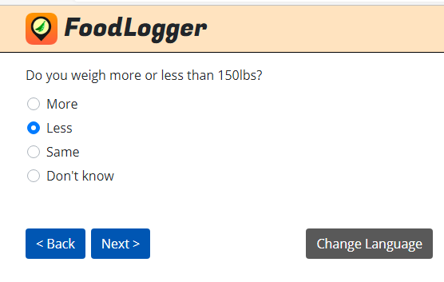

P19. In which state {were you/was NAME} born?
______________
- Not in United States

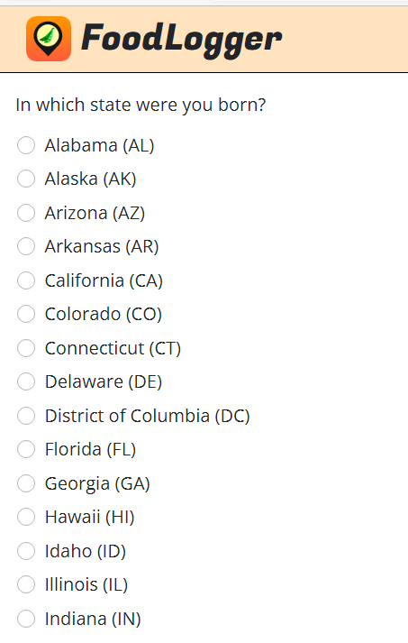
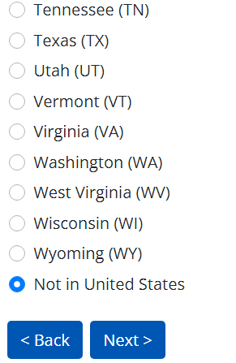

[IF PR, GO TO G1. ELSE GO TO END.]
G1. Does your household rent or own your home?
- Rent
- Own
- Other, do not pay for housing

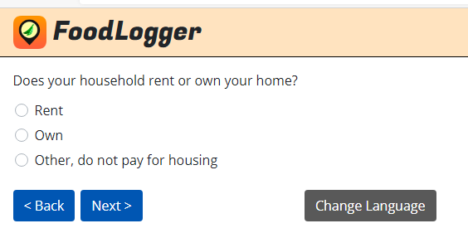

[IF G1=3 (OTHER, DO NOT PAY) OR G1=1 (RENT), ASK G3. OTHERWISE GO TO G4]
G3. Is this public housing – that is, is it owned by a local public housing authority or other public agency? Do not include military housing.
- Yes
- No

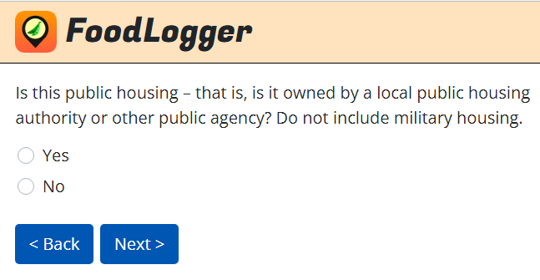

[IF G1=1 (RENT) AND G3=2 (NO), ASK G4. OTHERWISE GO TO G2]
G4. Is your rent subsidized by the Federal, State, or Local government? That is, is the government paying part of the cost? Do not include military housing.
- Yes
- No
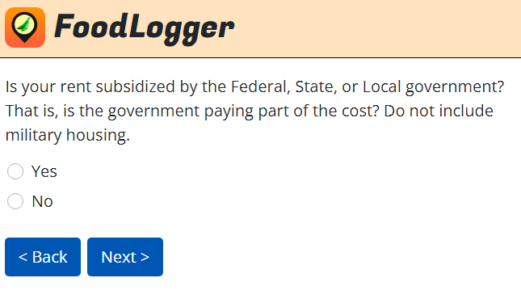

G2. Does anyone in your household own or lease a vehicle, like a car or truck?
- Yes
- No

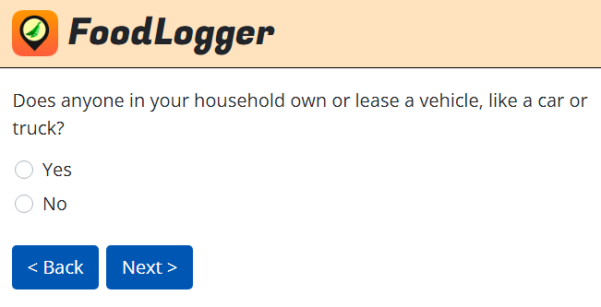

[IF G2=1 (YES), ASK G5]
G5. How many vehicles does your household own or lease?
NUMBER: ____________

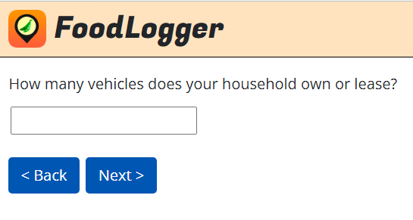

[IF G1=1 (RENT) OR 2 (OWN), ASK G6B. ELSE GO TO G9]
G6B. How frequently does your household pay for {G1=2: mortgage/G1=1: rent]?
Options for Rent | Options for Mortgage
 | Every other week
Weekly | Monthly
Every other week | Quarterly
Twice per month | Semiannually
Monthly | Annually
Other | Do not pay mortgage SKIP TO G7A0

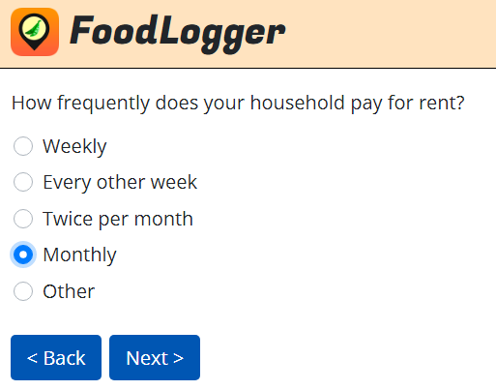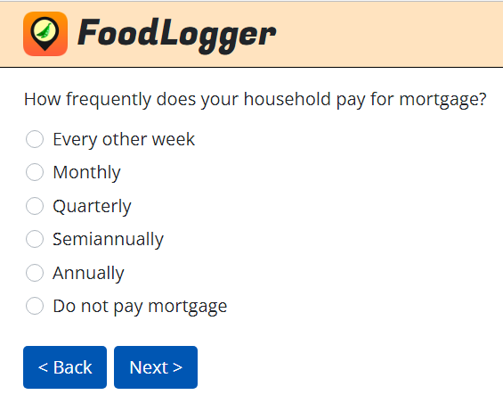

G6A. How much does your household usually pay for {G1=2: mortgage/G1=1: rent] per payment? If you don’t usually pay anything, enter 0 below.
$______.__

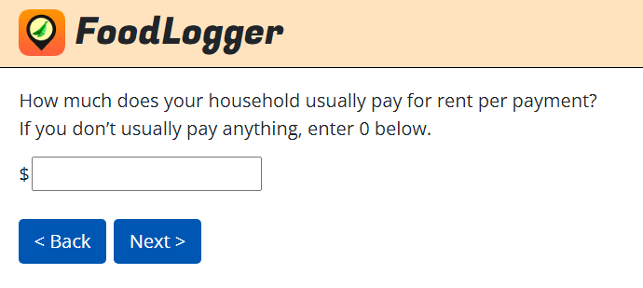

[IF G6A=0, GO TO SKIP INSTRUCTION BEFORE G7A0.
IF G6A>0 AND G1=2 (OWN), ASK G6A1.
ELSE GO TO GO TO SKIP INSTRUCTION BEFORE G7A0]
G6A1. Which of the following are included in this payment? Select all that apply.
- Principal
- Interest
- Property tax
- Homeowner’s insurance
- Other expenses

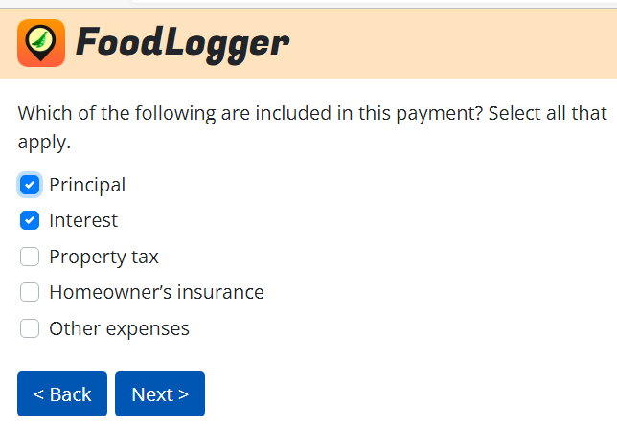

[IF “HOMEOWNERS INSURANCE” IS CHECKED IN G6A1, GO TO SKIP INSTRUCTIONS BEFORE G8A0. ELSE ASK G7A0]
G7A0. Does your household pay {G1=2: homeowners/G1=1: renters] insurance?
- Yes, paid separately GO TO G7B
- Yes, paid as part of other expenses GO TO SKIP INSTRUCTIONS BEFORE G8A0
- No, does not pay insurance GO TO SKIP INSTRUCTIONS BEFORE G8A0

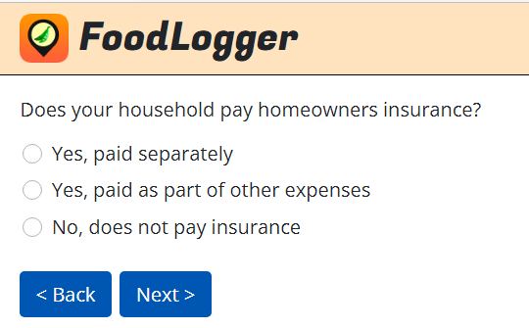

G7B. How frequently does your household pay for {G1=2: homeowners/G1=1: renters] insurance?
- Monthly
- Quarterly
- Semiannually
- Annually

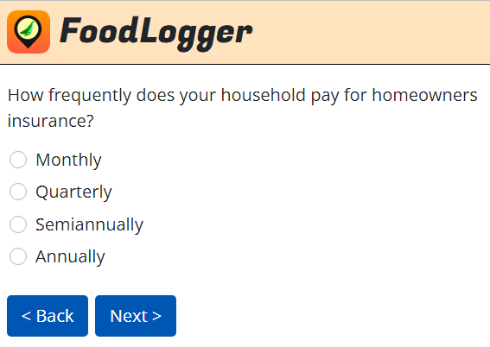

G7A. How much does your household usually pay for {G1=2: homeowners/G1=1: renters] insurance per payment?
$______.__

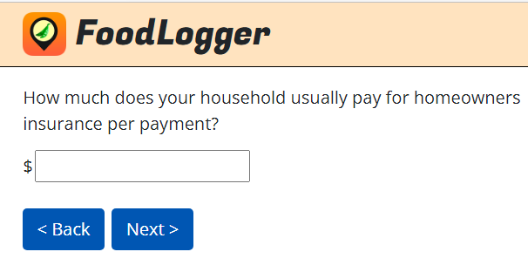

[IF “PROPERTY TAX” IS CHECKED IN G6A1 OR G1=1 (RENT) OR 3 (NO HOUSING PAY), GO TO G9. ELSE ASK G8A0]
G8A0. Does your household pay real estate or property tax on your home?
- Yes, paid separately GO TO G8B
- Yes, paid as part of other expenses GO TO G9
- No, no tax payment GO TO G9

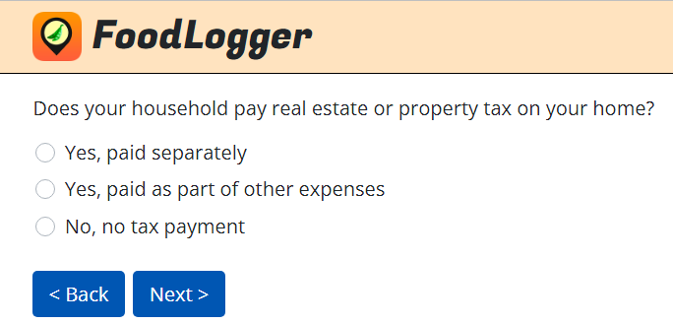

G8B. How frequently does your household pay for real estate or property tax on your home?
- Monthly
- Quarterly
- Semiannually
- Annually

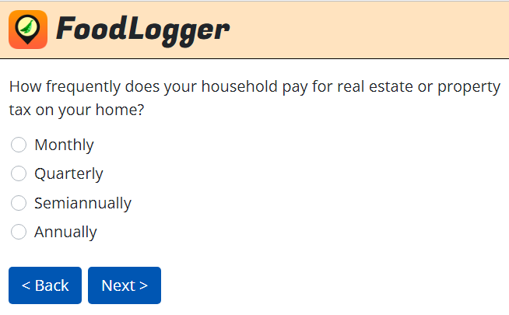

G8A. How much does your household usually pay for real estate or property tax on your home per payment?
$______.__

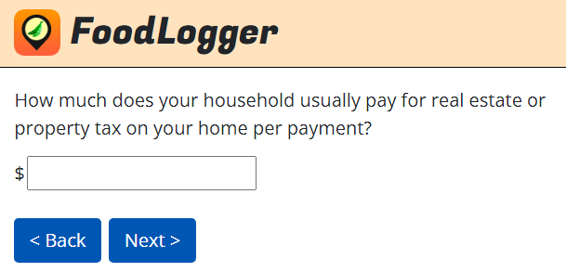

G9. Over the past month, has your household had any unusually large and unexpected expenses that affected your spending on food this week?
- Yes
- No

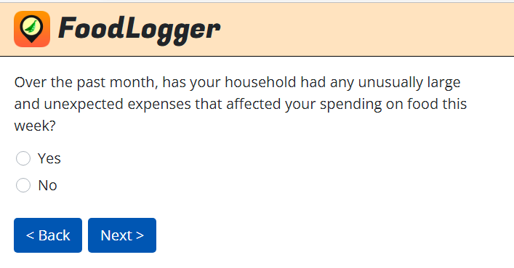

END. Thank you very much for completing this Profile Questionnaire. You’ve earned a $2 incentive for your household.

