Attachment L2. Web Screenshots of Income Questionnaire

(To be completed by household members aged 16 or older)
This questionnaire asks about income that {you have/NAME has} received in the last month to help USDA understand how much money Americans like you have available to spend on food.

You will earn a $2 incentive upon completion of this questionnaire.

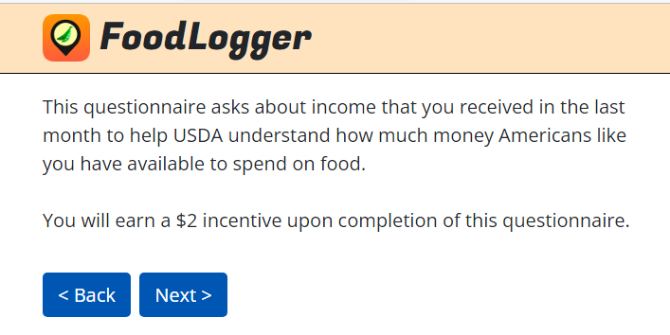

I1. Which type of income did {you/NAME} receive in the last month? Please select all that apply.
- Earnings from work
- Unemployment compensation
- Workers compensation
- Temporary Assistance for Needy Families (TANF)
- General assistance other than TANF
- Child support
- Alimony
- Disability income or Supplemental Security Income (SSI)
- Social security
- Retirement and pensions
- Investment income
- Other sources (e.g., income from roomers or boarders in your house; lump-sum or one-time payment)
- None of the above

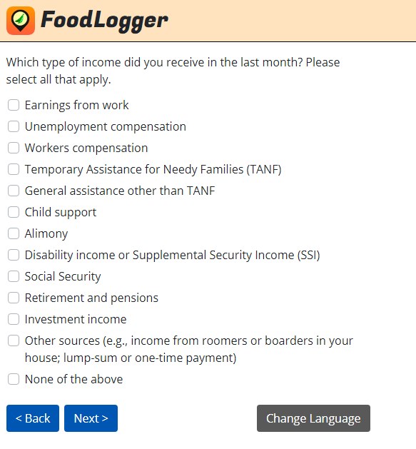

[IF I1=8, ASK I1A. ELSE GO TO SKIP INSTRUCTIONS BEFORE I2]
I1a. What was the source of disability income or SSI that {you/NAME} received in the last month? Please select all that apply.

- Social Security Disability Insurance (SSDI)
- Black Lung Benefits
- Supplemental Security Income (SSI)
- Other
- Don’t know

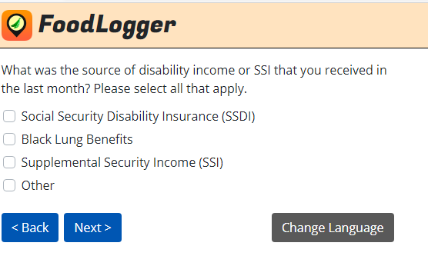

[IF I1=13, ASK I7. ELSE GO TO I2]
[PROGRAMMER NOTE: REPEAT I2 TO I6 FOR EACH INCOME SOURCE SELECTED AT I1]
I2. What is the easiest way for you to tell us about {your/NAME's} income from [RESPONSE FROM I1]? Tap a choice below.

- Weekly
- Every other week
- Twice a month
- Monthly
- Yearly
- Lump-sum or one-time payment

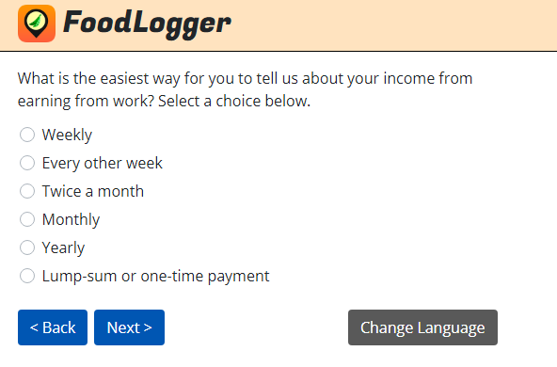

[PROGRAMMER NOTE: DISPLAY I3 AND I4 ON ONE SCREEN]
I3. How much did {you/NAME} receive [RESPONSE FROM I2] in income from [RESPONSE FROM I1], before taxes? Your best estimate is fine.
$___________

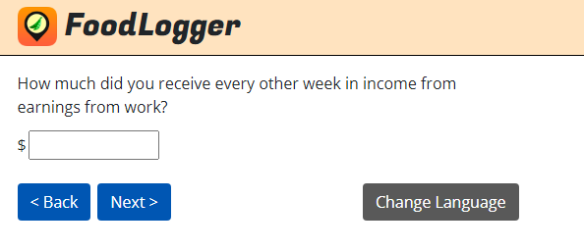

[IF I2=1 (WEEKLY), 2 (EVERY OTHER WEEK), 3 (TWICE A MONTH), THEN ASK I4 TO I6. OTHERWISE, GO TO NEXT INCOME SOURCE OR SKIP INSTRUCTION BEFORE I8a.]
I4. How many payments did {you/NAME} receive last month?
_______

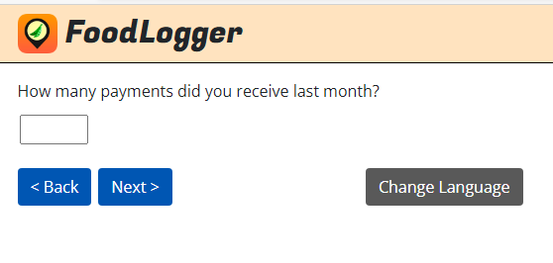

[PROGRAMMER NOTE: DISPLAY I5 ON ONE SCREEN]
I5. According to our calculations, {you/NAME} received [CALCULATED TOTAL FROM I3*I4] altogether from [RESPONSE FROM I1] during the last month. Is that correct?
- Yes
- No

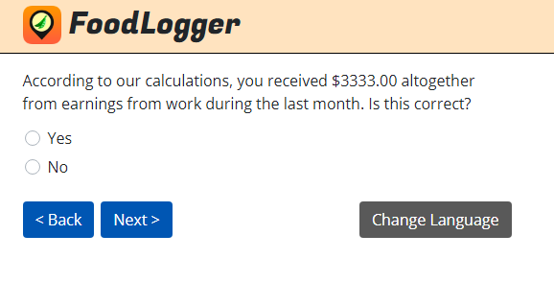

[IF I5=0 (NO), ASK I6. ELSE GO TO NEXT INCOME SOURCE OR SKIP INSTRUCTION BEFORE I8a].
I6. What is your best estimate of the correct total amount that {you/NAME} received in income from [RESPONSE FROM I1] in the last month?
$ [__________]

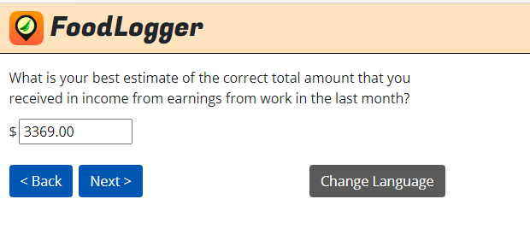

[IF I1=1, ASK I6A. ELSE GO TO SKIP INSTRUCTIONS BEFORE I7]
I6a. To your best knowledge, is that before taxes or after taxes?
  - Before
  - After
  - Don’t know

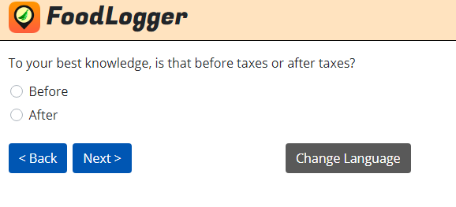

[IF I1=13, ASK I7. ELSE GO TO I8A.]
I7. USDA would like you to report all sources of income including earnings from work, unemployment compensation, welfare, child support, alimony, retirement, disability, investment and any other sources of income. Are you sure that you did not receive any income in the last month?
- Yes, I received income last month GO TO I1
- No, I did not receive any income last month GO TO SKIP INSTRUCTIONS BEFORE I8A.

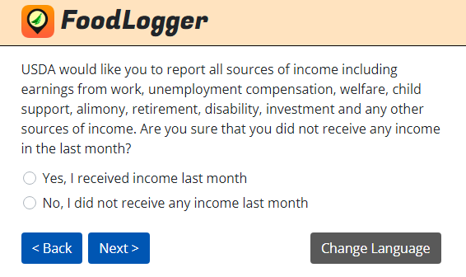

[IF RESPONDENT IS AGED 18 OR OLDER, NOT PR, SELF-REORTING, FLAGGED TO RECEIVING SNAP (B1B FROM INITIAL INTERVIEW IS CHECKED), IS NOT IN PR’S SNAP UNIT (FROM INITIAL INTERVIEW), ASK I8A. ELSE GO TO SKIP INSTRUCTION BEFORE I9.]

[PROGRAMMER: DISPLAY I8A, I8B, I8C, AND I8D ON ONE SCREEN]
I8a. On what date did you last receive benefits from SNAP? This program used to be called food stamps and, in your state, it is called [FILL IN STATE SNAP NAME]. It puts money on a SNAP EBT card that you can use to buy food.
MONTH: ________
DAY: ___________
YEAR: __________

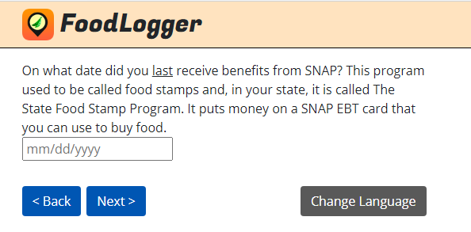

I8b. How many dollars were put on your SNAP EBT card the last time you received SNAP benefits?
$_____________

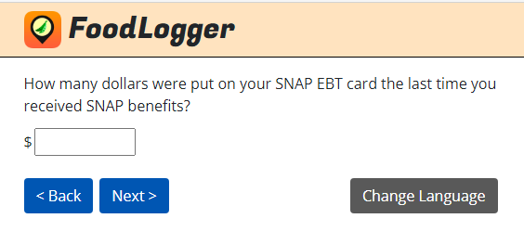

I8c. Is that the amount usually added each month, more than the usual amount, or less than the usual amount?
1. The usual amount
2. More than the usual amount
3. Less than the usual amount
4. Don’t know

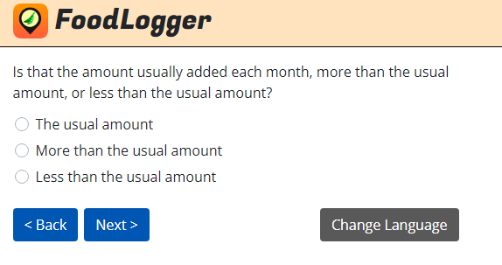

I8D. What is the number on your SNAP EBT card?
This number will only be used for purposes of matching to program administrative records. Your data will be used for statistical purposes only and will be kept strictly confidential.
SNAP EBT CARD NUMBER: ____________________________

- RATHER NOT ANSWER

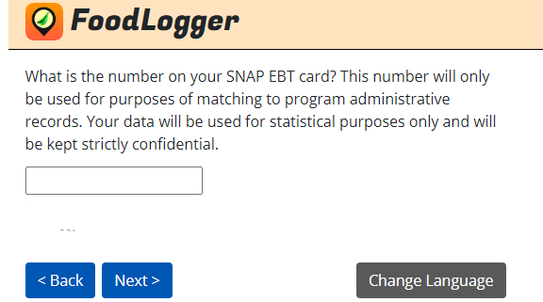

[IF PR, ASK I9. ELSE GO TO I10]
[PROGRAMMER: DISPLAY I9 ON ONE SCREEN]
I9. How much does your household have in cash, checking accounts, saving accounts, money markets, or other assets that are easily converted to cash? We want to know how much your total liquid assets are worth.
1. Zero
2. $1 to $2,250
3. $2,251 to $3,500
4. $3,501 to $5,000
5. $5,001 to $9,000
6. $9,001 to $25,000
7. $25,001 or more
8. RATHER NOT ANSWER

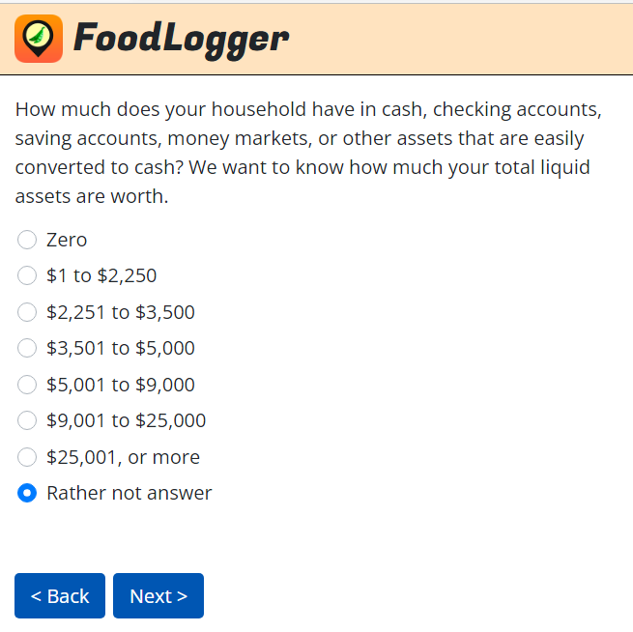

[PROGRAMMER: DISPLAY I10 ON ONE SCREEN]
I10. Thank you very much for completing the Income questionnaire. You’ve earned a $2 incentive for your household.
