Attachment D1a. In-person Screening Advance Letter for Recruitment Screener Nonrespondents

(Advance letter sent prior to interviewer’s first visit for sample households that did not complete the recruitment screener)
OMB Control Number: xxxx-xxxx
Expiration Date: xx/xx/xxxx
April 2022
NAME
ADDRESS 1
ADDRESS 2
CITY, STATE ZIP

Dear [NAME],

On behalf of the U.S. Department of Agriculture (USDA), we are inviting you to take part in the National Food Study (NFS) Pilot. The NFS Pilot will help USDA learn about the kinds of food US households have access to and get. This study will also help USDA make improvements to food programs in your community that improve everybody’s health.

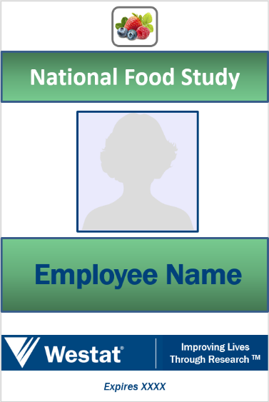
We would like to invite your household to tell us more about the foods and drinks you get. Your participation will give us a complete picture of the foods you get and will help the USDA improve food programs in your community. A single person household, selected to participate, can receive up to $105 upon study completion. Larger households may receive more.

Westat, a research firm located in Rockville, Maryland, is conducting this important study for the USDA. A Westat interviewer, wearing an ID badge similar to the one displayed here, will come to your home to tell you more about the study and explain how to keep track of and record all of the food your household gets. Westat requires that all interviewers be fully vaccinated against COVID-19 and that they wear a mask for the duration of the visit to your home.

Participation in this study is completely voluntary, but we hope you will participate. Your information will be kept confidential and combined with responses from other households. You have the right to refuse or stop participating in this study at any time without affecting any current (or future) benefits you may be receiving from USDA or any other governmental agency.

According to the Paperwork Reduction Act of 1995, an agency may not conduct or sponsor, and a person is not required to respond to, a collection of information unless it displays a valid OMB control number. The valid OMB control number for this information collection is 0536-XXXX. The time required the initial screening is estimated to average 9 minutes per response, including the time for reviewing instructions, searching existing data sources, gathering and maintaining the data needed, and completing and reviewing the collection of information.

For more information on the National Food Study Pilot, please visit the study website (https://www.nationalfoodstudy.org). You may also call us toll free at XXX-XXX-XXXX to ask questions or schedule an appointment for an interviewer to visit your home.

This important study can only succeed with the help of households like yours. I do hope you will agree to be a part of it.

Thank you for taking the time to read this letter.

Sincerely,

Jeffrey Gonzalez
Food Assistance Branch, Food Economics Division
Economic Research Service, USDA

The USDA, its employees, agents, and partner statistical agencies, will use the information you provide for statistical purposes only and will hold the information in confidence to the full extent permitted by law. In accordance with the Confidential Information Protection and Statistical Efficiency Act of 2002 (Title 5 of Public Law 107-347) and other applicable Federal laws, your responses will not be disclosed in identifiable form without your informed consent. Per the Federal Cybersecurity Enhancement Act of 2015, Federal information systems are protected from malicious activities through cybersecurity screening of transmitted data

