Attachment C3. Postcard Nonresponse

(Postcard for mail screener sent to second mailing nonrespondents)
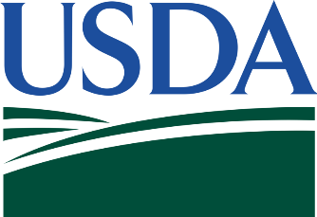
Make your voice heard.

The National Food Study is the main source of information on how and where Americans get food and it informs USDA food-assistance programs in your community about the availability of healthy foods for all.
About a week ago, we sent you a letter asking for your help with this important study. If you have already completed the short survey, thank you! If not, there’s still time. Sharing your food buying experiences will help improve food programs in the future—and it will be fun too!

To get started, please complete and mail back the brief survey from the package that we sent you last week. If you have misplaced your survey form, you can also complete the brief survey by visiting our website at www.NationalFoodStudy.org and entering your PIN number. Your PIN number is located above your address on the other side of this card.
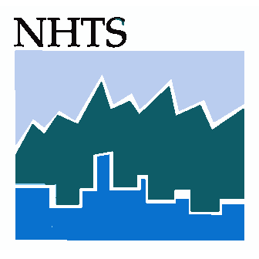
A single person household selected to participate, can receive up to $105 upon study completion. Households with additional persons may receive more. Thank you for helping to improve our nation’s food programs!
For more information about the study, please visit our website at https://www.nationalfoodstudy.org or call us at [INSERT TOLL-FREE NUMBER].
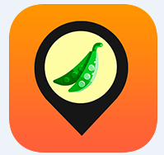
National Food Study

<PIN>

<CITY> Resident
<PRIMARYADDRESS>
<CITY>, <STATE> <ZIP>

