- APHIS Form 2020 https://ncahappspub.aphis.usda.gov/NCAHPortal/auth/aphis2020/create
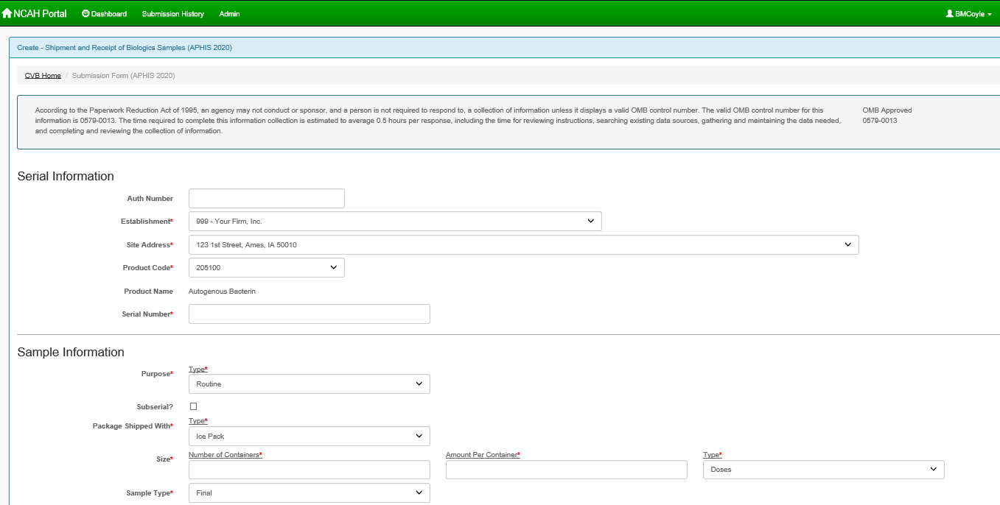
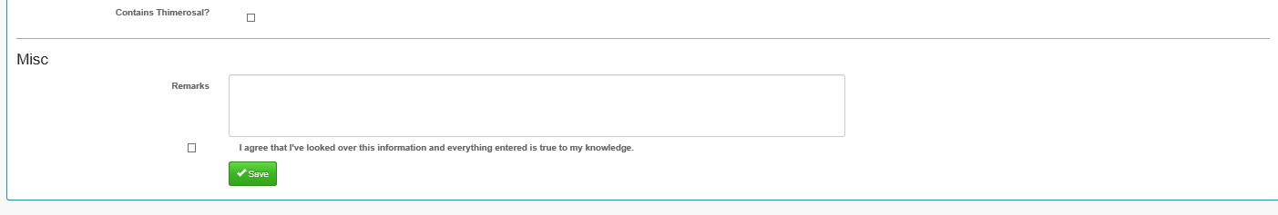

- APHIS Form 2008 https://ncahappspub.aphis.usda.gov/NCAHPortal/auth/aphis2008/create
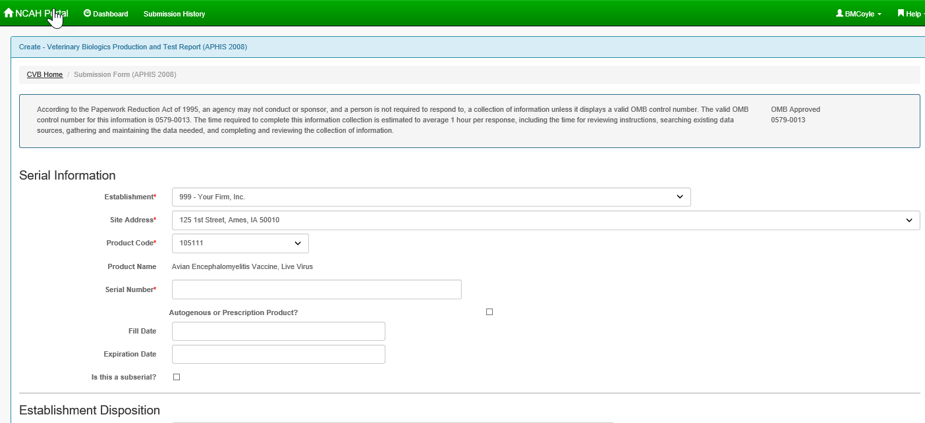
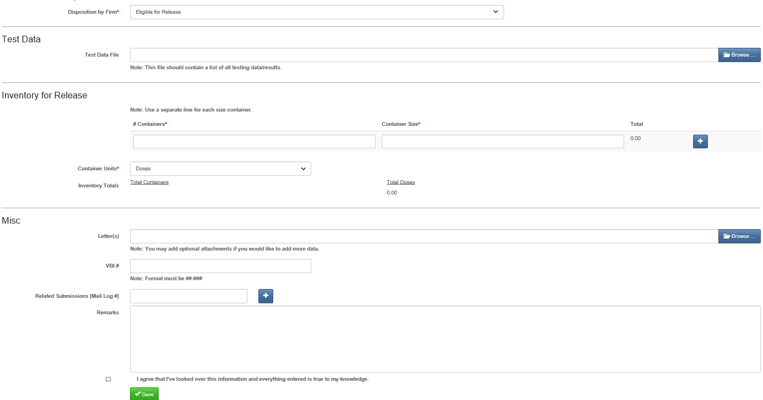

- APHIS Form 2007 https://ncahappspub.aphis.usda.gov/NCAHPortal/auth/aphis2007/create
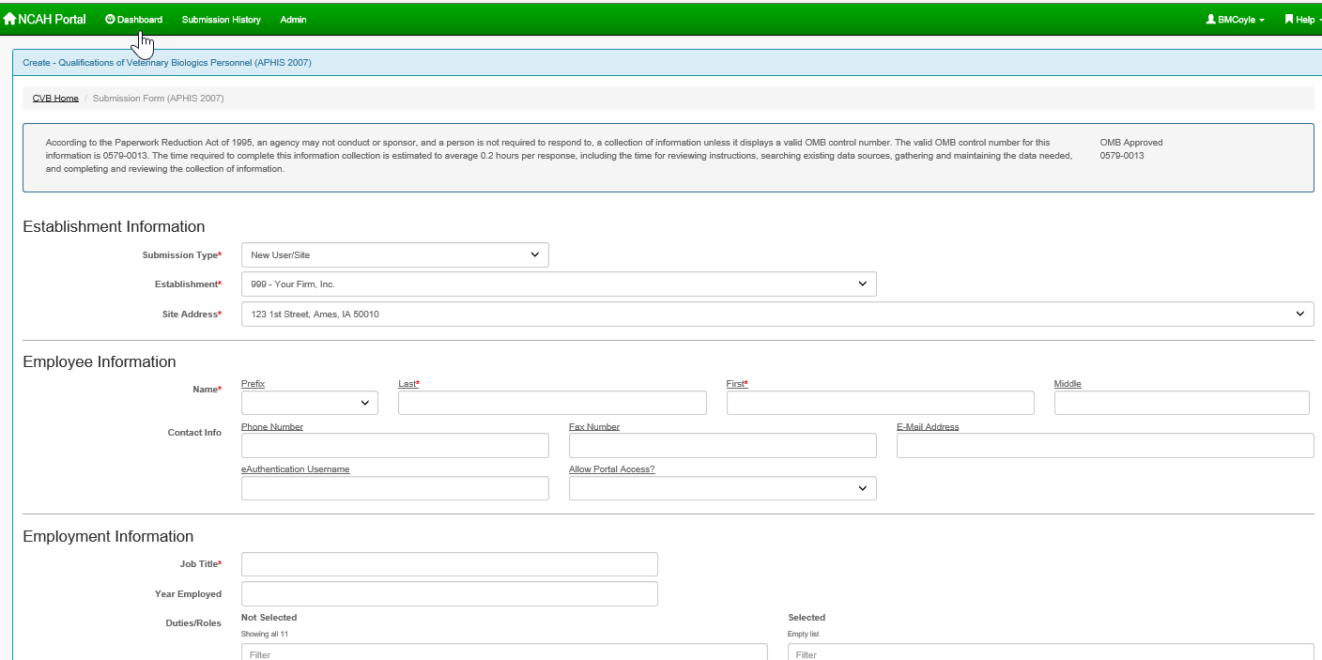
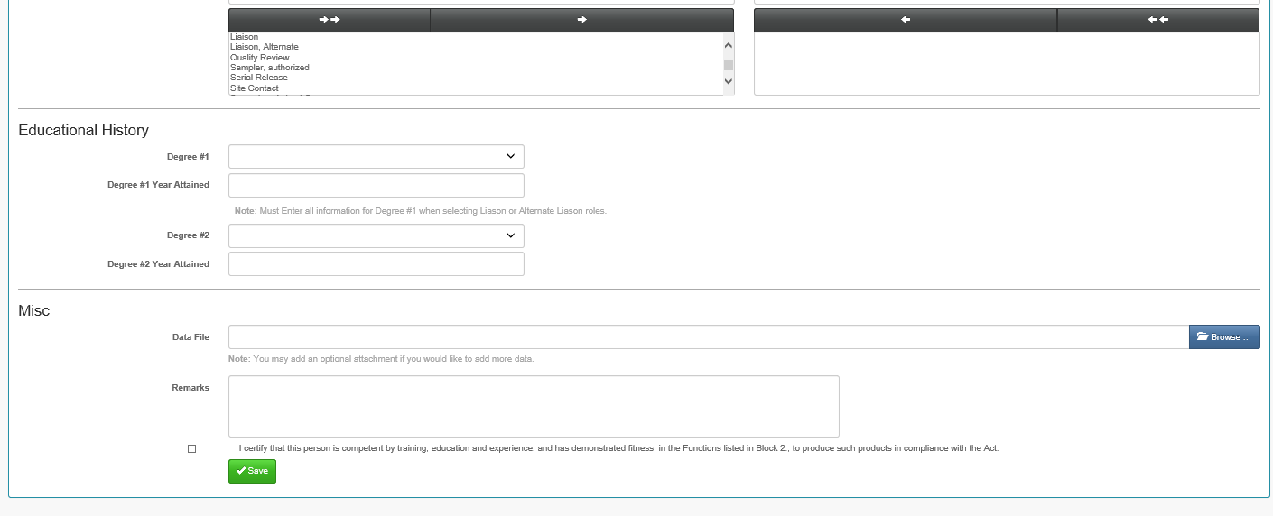

- APHIS Form 2048 https://ncahappspub.aphis.usda.gov/NCAHPortal/auth/aphis2048/create
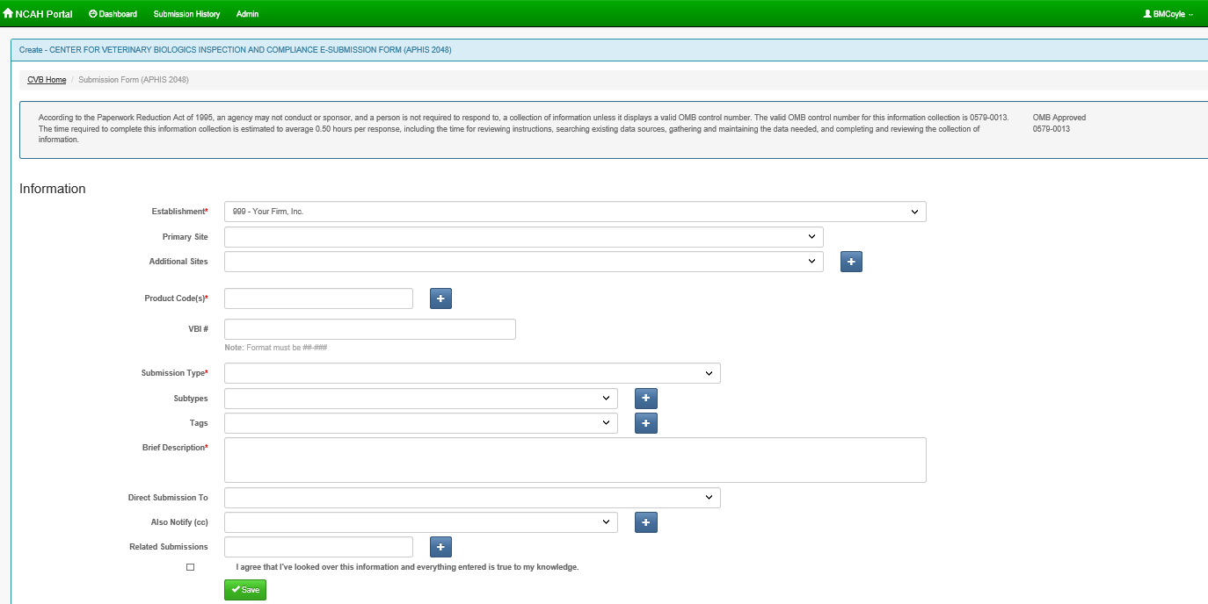

- APHIS Form 2049 https://ncahappspub.aphis.usda.gov/NCAHPortal/auth/aphis2049/create
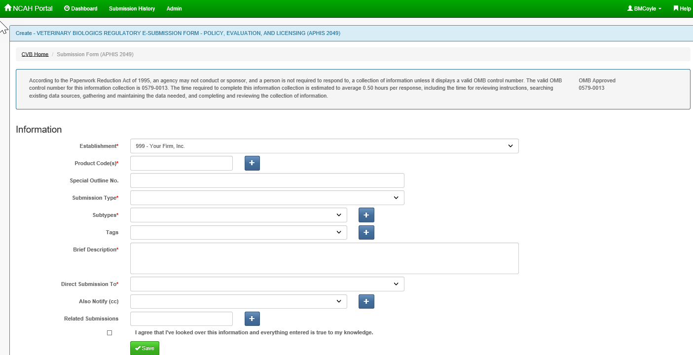

- APHIS Forms 2017, 2046, 2046-S, 2047 & 2047-S https://ncahappspub.aphis.usda.gov/NCAHPortal/auth/biologicsExportCertification/create
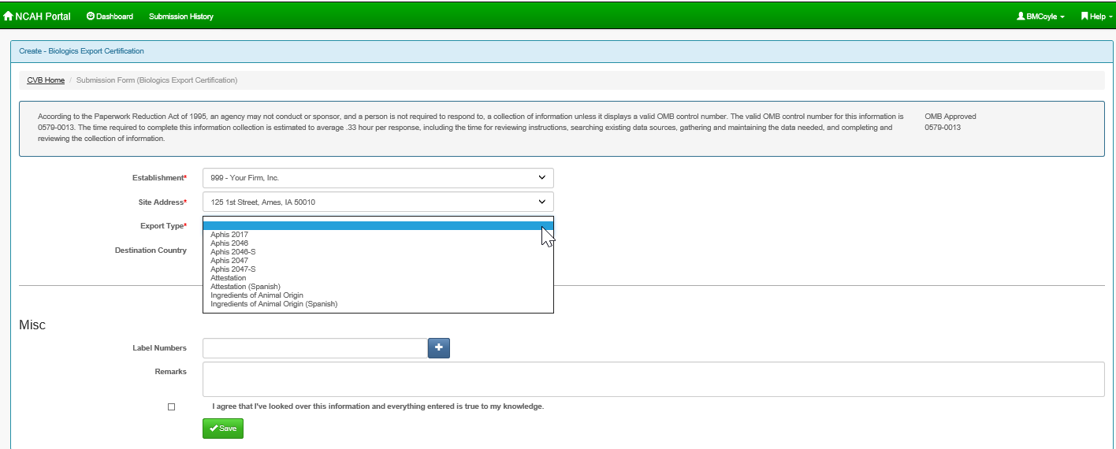

- APHIS Form 2005 https://ncahappspub.aphis.usda.gov/NCAHPortal/auth/biologicsPermits/create
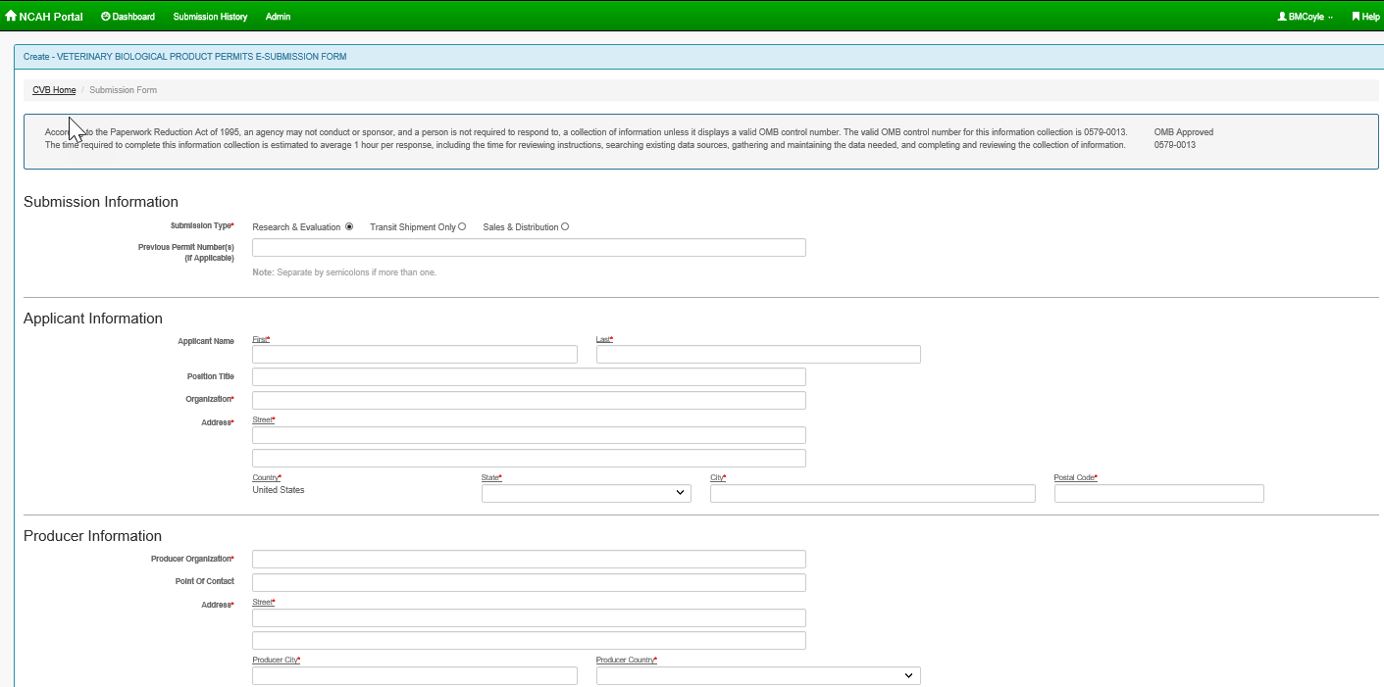
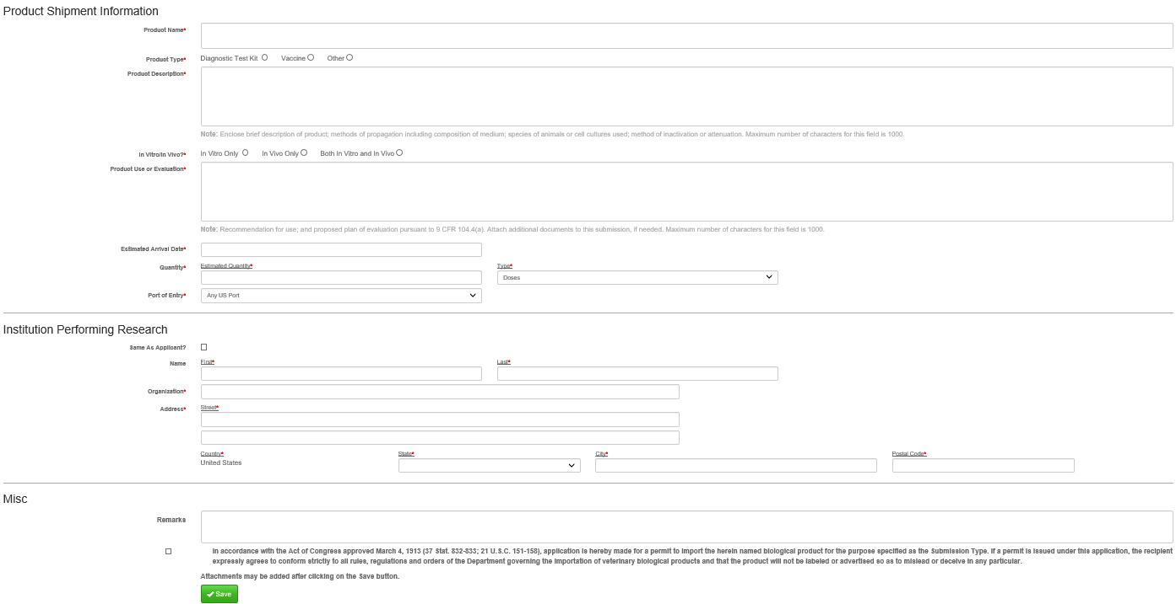

CVB has general guidance on how the NCAH Portal for CVB Submitters on the CVB website at https://www.aphis.usda.gov/aphis/ourfocus/animalhealth/veterinary-biologics/sa_ncah_portal_guidance/ct_cvb_portal_guidance
CVB has NCAH Portal User Guides available on the CVB website that include screen shots for how to complete different tasks related to CVB submissions at https://www.aphis.usda.gov/aphis/ourfocus/animalhealth/veterinary-biologics/sa_ncah_portal_guidance/ct_vb_ncah_portal_user_guides
CVB has NCAH Portal Training Videos available on the CVB website that demonstrate how to prepare CVB submissions at https://www.aphis.usda.gov/aphis/ourfocus/animalhealth/veterinary-biologics/sa_ncah_portal_guidance/ct_vb_ncah_portal_videos

