PRUNE MARKETING COMMITTEE AND CALIFORNIA DRIED PLUM BOARD

OFFICIAL NOMINATION BALLOT
FOR VOTING ON NOMINEES FOR INDEPENDENT PRODUCER MEMBERS AND ALTERNATES
TO SERVE ON THE PRUNE MARKETING COMMITTEE
FOR THE TWO-YEAR TERM BEGINNING JUNE 1, 20___

WHO MAY VOTE

General: For purposes of this vote, a producer is any individual person who, or business unit which, was engaged in a proprietary capacity on March 1, 20___, in the State of California in growing prune plums, commonly known as fresh prunes, for drying or dehydrating into dried plums which were not committed to be marketed through a cooperative marketing association.
Only one vote may be cast by a producer regardless of the number of orchards operated by him/her.
Landlord-Tenant (Share Rental): A landlord and tenant, operating on a share-crop basis, are each entitled to one vote.
Landlord-Tenant (Cash Rental): Only the tenant (cash renter) has a vote.
Partnership (including family partnership): A partnership has only one vote regardless of the number and location of orchards operated by the partnership. This also applies to husband and wife who are operating community property, or who have a joint interest in the production.
Producer Corporation: A producer corporation has only one vote, regardless of the number and location of its orchards.
Green Prune Buyer: Only the orchard owner or operator has a vote.

INSTRUCTIONS

- Consult the enclosed maps to find the district(s) in which your prune orchard(s) is/are located. (Location of orchard, not your mailing address, determines the district in which you vote.)
- Vote only for candidates in a district in which your prune orchard was located on March 1, 20___, except for the candidates for Board Member At-Large and Board Floating Alternate who can be from any district. (If you are engaged in prune production in more than one district, the district you choose for voting on Committee membership may be different from the district you choose to vote on Board membership.) Specify on the Ballot the district in which you wish to vote by marking an “X” in the box provided at the right of the district number.
- Do not vote for candidates in more than one district except for the Board Member At-Large and Board Floating Alternate who can be from any district. Regardless of the number of districts in which he or she may be a producer, an independent prune producer may participate with respect to only one and the same district in nominating, being nominated, or voting. Therefore, a producer may not elect to cast a mail Ballot on behalf of a nominee in a district different from the district in which such producer participated in the nomination or was nominated.
- Do not vote for the same person for both member and alternate positions.
- Place a mark (X) in the box immediately following the name of the candidate of your choice. If you wish to vote for a prune producer other than those listed in your district, write in the name of that candidate in the space provided, but be sure that he or she is an independent prune producer in the district in which you vote (except for the Board Floating Alternate position) and is not named as a candidate in any other district.
- Be sure to complete the certification form printed on the inside of the flap of the return envelope. Also be sure to sign it. Insert it AND the Ballot in the SECRET BALLOT ENVELOPE in the return envelope, seal it, and mail it. The information on the certification form is essential to verify your eligibility to vote without disclosing your identity on the Ballot, the secrecy of which is further protected by the SECRET BALLOT ENVELOPE. The SECRET BALLOT ENVELOPE containing your Ballot will be placed in the Ballot box and will not be opened until all Ballots are tabulated by the Elections Committee right after the voting period closes on March 31, 20___. It is important, therefore, that your Ballot be marked correctly.
- Be sure the return envelope containing your Ballot is postmarked no later than March 31, 20___.

INSERT BALLOT IN SECRET BALLOT ENVELOPE

According to the Paperwork Reduction Act of 1995, an agency may not conduct or sponsor, and a person is not required to respond to a collection of information unless it displays a valid OMB control number. The valid OMB control number for this information collection is 0581-0178. The time required to complete this information collection is estimated to average 12 minutes per response, including the time for reviewing instructions, searching existing data sources, gathering and maintaining the data needed, and completing and reviewing the collection of information.

BALLOT FOR INDEPENDENT PRODUCER NOMINEES
NOTE: PLEASE VOTE FOR BOTH COMMITTEE AND BOARD MEMBERSHIP
PRUNE MARKETING COMMITTEE  VOTE IN ONE DISTRICT ONLY FOR BOTH MEMBER AND ALTERNATE |  | CALIFORNIA DRIED PLUM BOARD
 |  | VOTE IN ONE DISTRICT ONLY FOR MEMBER | VOTE FOR ONE FLOATING ALTERNATE CANDIDATE FROM ANY DISTRICT
DISTRICT NO. 1 □ |  | DISTRICT NO. 1 □⁮
(The counties of Colusa, Glenn, Solano and Yolo)
FOR COMM. MEMBER  (Vote for one)  ___________________ □  ___________________ □  (Write in Space) | FOR COMM. ALTERNATE  (Vote for one)  ___________________ □  ___________________ □  (Write in Space) | FOR BOARD MEMBER  (Vote for one)  ___________________ □  ___________________ □  (Write in Space) | FOR BOARD FLOATING ALTERNATE  (Vote for one)  ___________________ □  ___________________ □  ___________________ □  ___________________ □  ___________________ □  ___________________ □  (Write in Space)
DISTRICT NO. 2 □ |  | DISTRICT NO. 2 □
(That portion of Sutter County north of a line extending along Franklin Road easterly to the Yuba County line and westerly to the Colusa County line)
FOR COMM. MEMBER  (Vote for one)  ___________________ □  ___________________ □  (Write in Space) | FOR COMM. ALTERNATE  (Vote for one)  ___________________ □  ___________________ □  (Write in Space) | FOR BOARD MEMBER  (Vote for one)  ___________________ □  ___________________ □  (Write in Space)
DISTRICT NO. 3 □ |  | DISTRICT NO. 3 □
(That portion of Sutter County south of a line extending along Franklin Road easterly to the Yuba County line and westerly to the Colusa County line)
FOR COMM. MEMBER  (Vote for one)  ___________________ □  ___________________ □  (Write in Space) | FOR COMM. ALTERNATE  (Vote for one)  ___________________ □  ___________________ □  (Write in Space) | FOR BOARD MEMBER  (Vote for one)  ___________________ □  ___________________ □  (Write in Space)
DISTRICT NO. 4 □ |  | DISTRICT NO. 4 □
(The counties of Alpine, Amador, Del Norte, El Dorado, Humboldt, Lake, Lassen, Mendocino, Modoc, Napa, Nevada, Placer, Plumas Sacramento, Shasta, Sierra, Siskiyou, Sonoma, Tehama and Trinity)
FOR COMM. MEMBER  (Vote for one)  ___________________ □  ___________________ □  (Write in Space) | FOR COMM. ALTERNATE  (Vote for one)  ___________________ □  ___________________ □  (Write in Space) | FOR BOARD MEMBER  (Vote for one)  ___________________ □  ___________________ □  (Write in Space)
DISTRICT NO. 5 □ |  | DISTRICT NO. 5 □
(Butte County)
FOR COMM. MEMBER  (Vote for one)  ___________________ □  ___________________ □  (Write in Space) | FOR COMM. ALTERNATE  (Vote for one)  ___________________ □  ___________________ □  (Write in Space) | FOR BOARD MEMBER  (Vote for one)  ___________________ □  ___________________ □  (Write in Space)
DISTRICT NO. 6 □ |  | DISTRICT NO. 6 □
(Yuba County)
FOR COMM. MEMBER  (Vote for one)  ___________________ □  ___________________ □  (Write in Space) | FOR COMM. ALTERNATE  (Vote for one)  ___________________ □  ___________________ □  (Write in Space) | FOR BOARD MEMBER  (Vote for one)  ___________________ □  ___________________ □  (Write in Space)
DISTRICT NO. 7 □ |  | DISTRICT NO. 7 □
(The counties of Fresno, Kings, Merced, San Benito, San Joaquin, Santa Clara, Solano, Tulare and all other counties not included in Districts 1, 2, 3, 4, 5 and 6)
FOR COMM. MEMBER  (Vote for one)  ___________________ □  ___________________ □  (Write in Space) | FOR COMM. ALTERNATE  (Vote for one)  ___________________ □  ___________________ □  (Write in Space) | FOR BOARD MEMBER  (Vote for one)  ___________________ □  ___________________ □  (Write in Space)
AT-LARGE (From any independent producer district)
FOR BOARD MEMBER
(Vote for one)
___________________ □

MAP OF INDEPENDENT CALIFORNIA PRUNE PRODUCERS VOTING DISTRICTS

Key:
District 1 Counties: Colusa, Glenn, Solano, and Yolo

District 2 Counties: That portion of Sutter County north of a line extending along Franklin Road easterly to the Yuba County line and westerly to the Colusa County line
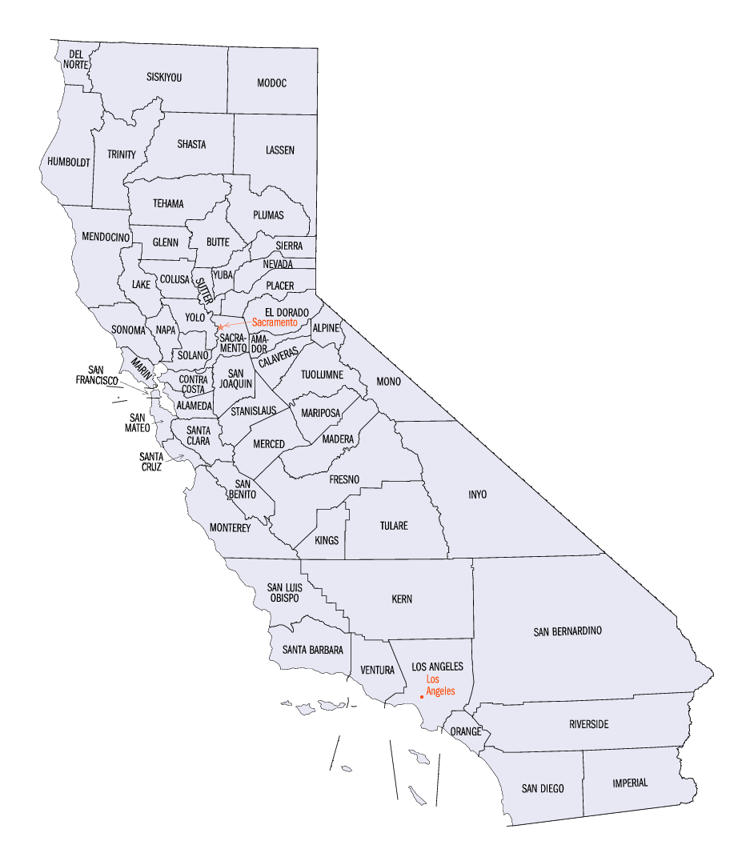
District 3 Counties: That portion of Sutter County south of the line extending along Franklin Road easterly to the Yuba County Line and westerly to the Colusa County line

District 4 Counties: Alpine, Del Norte, El Dorado, Humbolt, Lake, Lassen, Mendocino, Modoc, Napa, Nevada, Placer, Plumas, Sacramento, Shasta, Sierra, Siskiyou, Sonoma, Tehama and Trinity

District 5 County: Butte County

District 6 County: Yuba County

District 7 Counties: Fresno, Kern, King, Madera, Merced, San Benito, San Joaquin, Santa Clara, Tulare, and all other counties not included in District 1,2,3,4,5, or 6

In accordance with Federal civil rights law and U.S. Department of Agriculture (USDA) civil rights regulations and policies, the USDA, its Agencies, offices, and employees, and institutions participating in or administering USDA programs are prohibited from discriminating based on race, color, national origin, religion, sex, gender identity (including gender expression), sexual orientation, disability, age, marital status, family/parental status, income derived from a public assistance program, political beliefs, or reprisal or retaliation for prior civil rights activity, in any program or activity conducted or funded by USDA (not all bases apply to all programs). Remedies and complaint filing deadlines vary by program or incident.

Persons with disabilities who require alternative means of communication for program information (e.g., Braille, large print, audiotape, American Sign Language, etc.) should contact the responsible Agency or USDA’s TARGET Center at (202) 720-2600 (voice and TTY) or contact USDA through the Federal Relay Service at (800) 877-8339. Additionally, program information may be made available in languages other than English.
To file a program discrimination complaint, complete the USDA Program Discrimination Complaint Form, AD-3027, found online at http://www.ascr.usda.gov/complaint_filing_cust.html and at any USDA office or write a letter addressed to USDA and provide in the letter all of the information requested in the form. To request a copy of the complaint form, call (866) 632-9992. Submit your completed form or letter to USDA by: (1) mail: U.S. Department of Agriculture Office of the Assistant Secretary for Civil Rights 1400 Independence Avenue, SW Washington, D.C. 20250-9410; (2) fax: (202) 690-7442; or (3) email: program.intake@usda.gov. USDA is an equal opportunity provider, employer, and lender.

