Appendix A1
Authorizing Statutes

Code of Federal Regulations. Title 7. Agriculture. Part 246. Special Supplemental Nutrition Program for Women, Infants, and Children. Section 246.7(e). Nutritional Risk. August 2019.
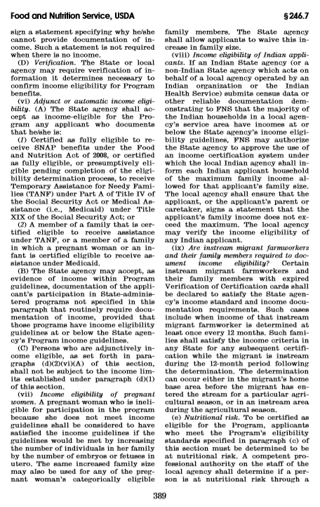

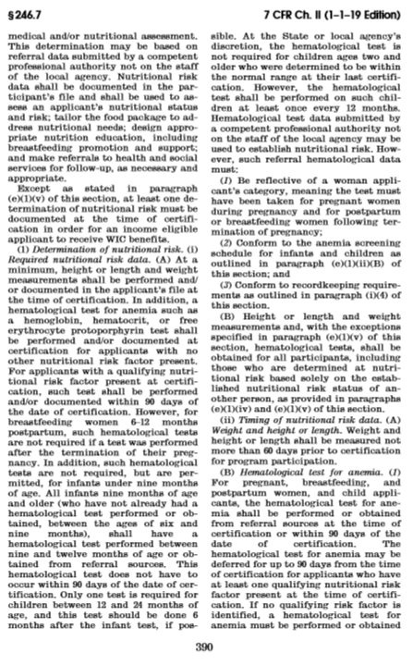
Section 28 of the Richard B Russel National School Lunch Act as Amended by HHFKA of 2010

