APPENDIX B.2
2023 Farm to school Census Frequently Asked Questions (FAQs)

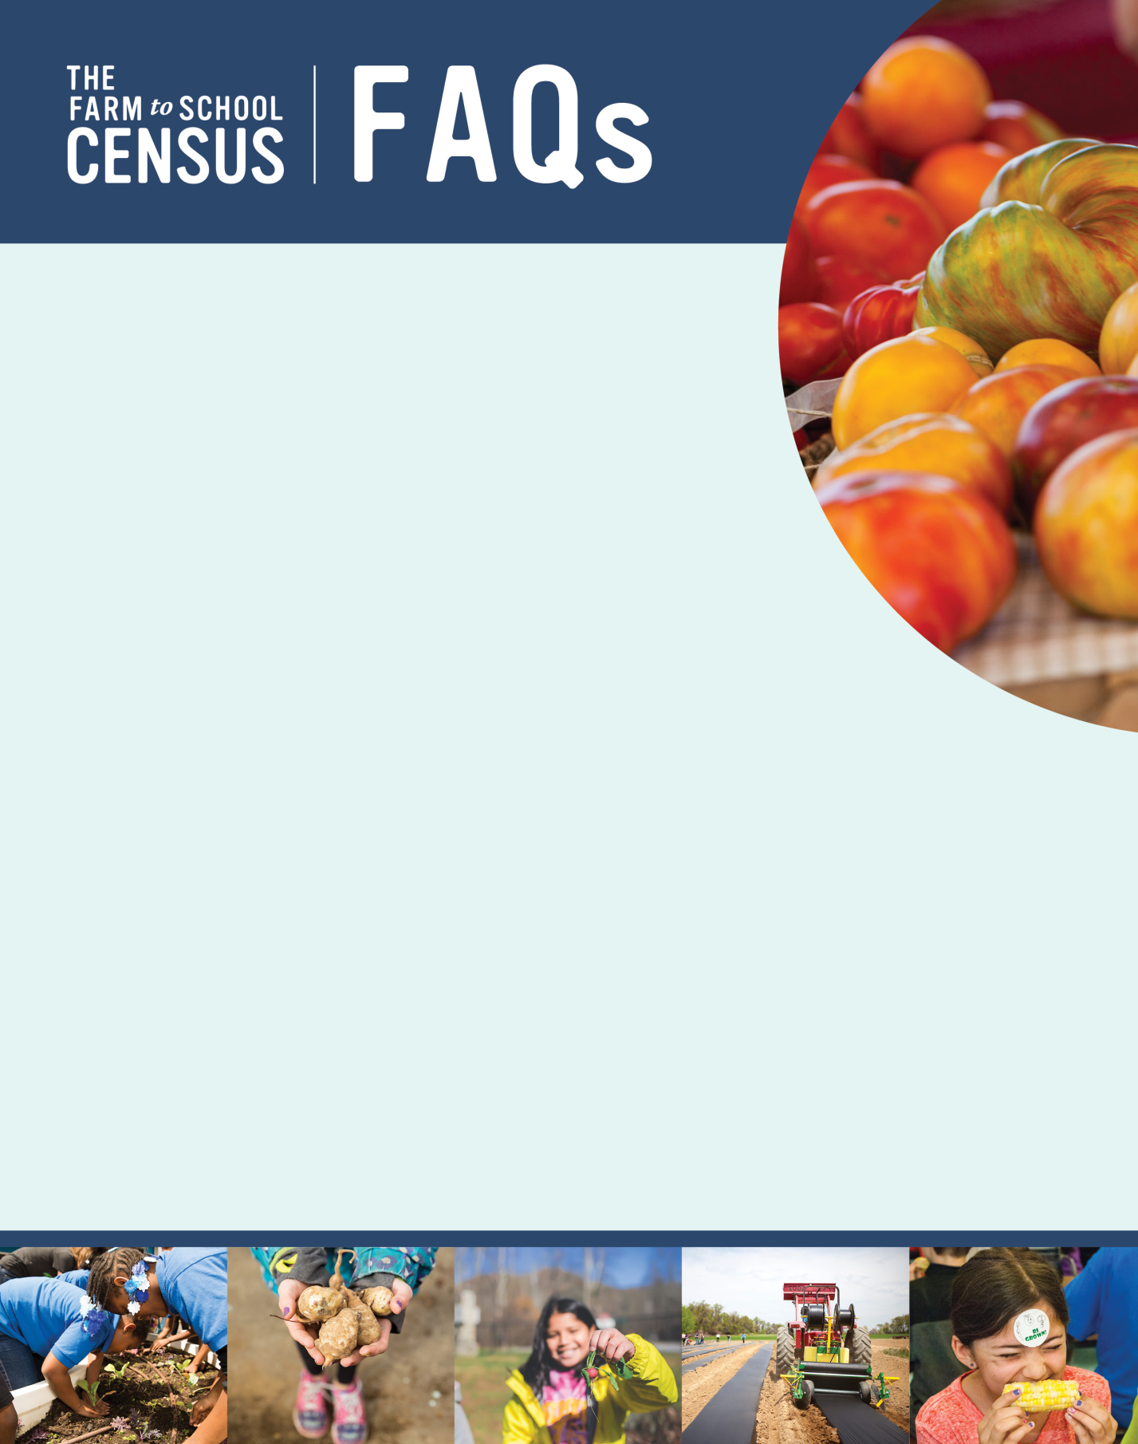

What is the purpose of the Farm to School Census?
The 2023 Farm to School Census (2023 Census) will collect data on local food purchasing
for school meals, school food gardens, other farm to school activities and policies
among approximately 20,000 SFAs across the country. Results for SFAs, States and the
nation will be made available on a public website. A report using the findings will examine
farm to school efforts in SY 2022-23 and over time.
Who was selected to participate?
All public (including charter schools) and private SFAs that participate in the National School
Lunch Program (NSLP) are being asked to complete the Census. SFA names, the names of SFA
directors, and contact information were provided by State Child Nutrition offices.
I am an SFA Director. What do you need me to do for this study?
We need you to complete the Census. SFA directors will be emailed a unique link for your SFA’s
Census survey. Please follow the link, where you will find instructions, an optional worksheet to help
you prepare [insert link], and the Census survey questions.
The schools in my district don’t do any farm to school activities – do I still need to fill out the Census?
Yes! All public and private SFAs that participate in the NSLP in all 50 States as well as Guam, Puerto Rico, the Virgin
Islands, American Samoa, and Washington, D.C. should complete the 2019 Census. This effort will help us understand
which SFAs do farm to school activities and will help the USDA provide support for farm to school activities in the future.
I don’t think I am the correct person to complete the Census.
If you don’t know about farm to school in your SFA and don’t know who else in your SFA should complete the survey, or if you are no longer associated with the SFA, please let the study team know by phone at [study phone number] or by email at [study email address].
What if I don’t know the answers to the Census questions?
To help you gather the necessary information for the Census, we prepared an optional worksheet that is available on the Census webpage. It will walk you through the information that will be helpful to collect ahead of completing the Census.
You may need to consult with your farm to school partners, such as vendors, school garden coordinators, foodservice staff, or teachers. You can directly share the Census survey with others using the unique survey link emailed to the SFA director. Anyone can access the survey using this link, and when they exit the survey, their responses will automatically be saved.
The Census asks for detailed information about your food purchases – this information is crucial to helping us understand the details about how much local food schools are purchasing. Please answer these questions to the best of your ability. We understand that often vendors don’t provide information about local purchases, and you may not have all the answers. Please tell what you can – your best estimate is fine!
You may not be able to answer some questions initially or at all. You can always continue and return to those questions. We ask that you please try to answer as many questions as possible, but it’s OK if you aren’t able to answer them all or need to provide estimates for some.

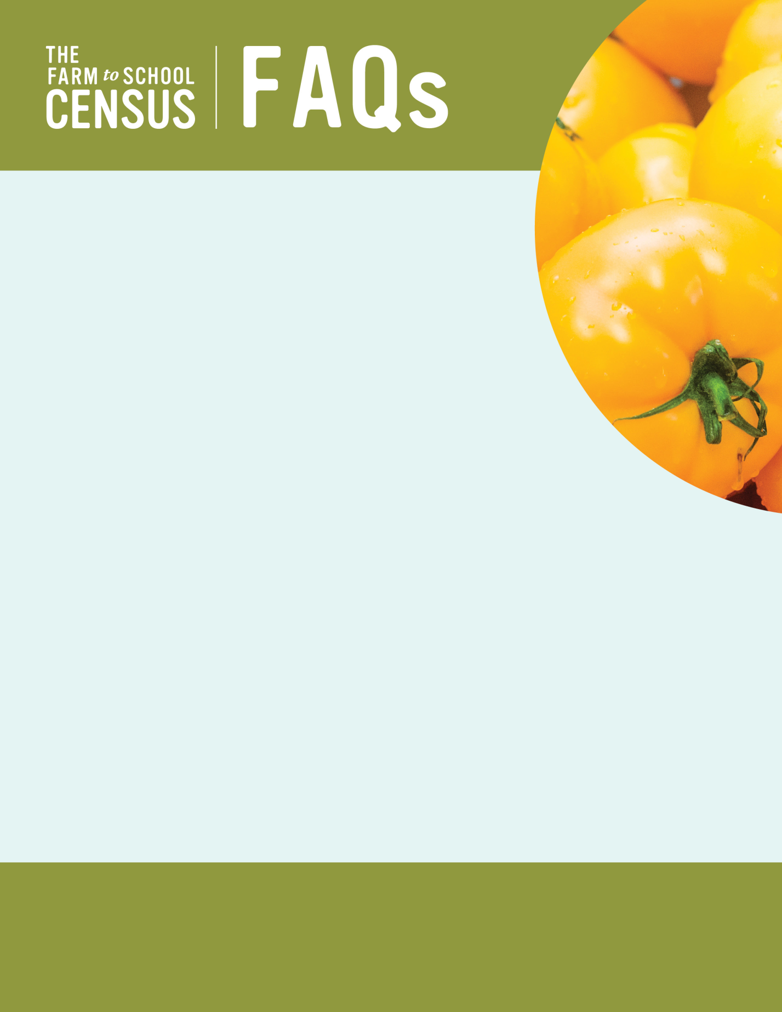

Do I need to complete all the Census questions at one time?
No, you do not need to complete the Census all at once. You will be able to answer
questions, save your responses, close out of the Census, and return to complete it at a
later time.
How long will the Census take me to complete?
The Census could take up to 30 minutes to complete for some SFAs. Most SFAs will take
between 5 and 30 minutes to finish it.
Why should I complete the Census?
Participation by all SFAs will ensure accurate representation of farm to school activities, including
which farm to school activities SFAs do, what has changed since the 2019 Census, how SFAs and
the community benefit from farm to School. The Census also helps indicate the challenges of
participating in farm to school and what USDA FNS and other stakeholders can do to support SFAs
who want to source local foods, provide food and agriculture education and engage in other farm to
school activities.
When will the Census be conducted?
The 2019 Farm to School Census will be distributed in October 2023 and available through December.
Can I complete the Census over the phone or on my mobile device?
Yes, you can complete the Census on a computer, a mobile device, or over the phone. Use the link sent to you by email to complete
the survey on a laptop, desktop, cell phone, or tablet. Get in touch with a member of the study team by phone at [study phone number] or by email at [study email address] to schedule a time to complete the survey over the phone.
Where can I find the final Census Report and data?
When posted, the report and data will be available at: https://farmtoschoolcensus.fns.usda.gov. Your contact information (e.g., name and email address) will not be linked to your Census responses, but the response for your SFA will be made publicly available, as they were in the past. Findings and the final report for 2019 are currently available at https://farmtoschoolcensus.fns.usda.gov.
Who can I contact for more information?

[Insert contractor project director/ Amy Rosenthal,
study team contact info] Project Officer, Farm to School Census
FNS/USDA
703-305-2245
Amy.Rosenthal@usda.gov

This information is being collected to assist the Food and Nutrition Service in understanding and tracking farm to school engagement. This is a mandatory collection and FNS will use the information to set priorities for USDA outreach and technical support. This collection does not request any personally identifiable information under the Privacy Act of 1974. According to the Paperwork Reduction Act of 1995, an agency may not conduct or sponsor, and a person is not required to respond to, a collection of information unless it displays a valid OMB control number. The valid OMB control number for this information collection is 0584-0646. The time required to complete this information collection is estimated to average 0.25 hours per response, including the time for reviewing instructions, searching existing data sources, gathering and maintaining the data needed, and completing and reviewing the collection of information. Send comments regarding this burden estimate or any other aspect of this collection of information, including suggestions for reducing this burden, to: U.S. Department of Agriculture, Food and Nutrition Service, Office of Policy Support, 1320 Braddock Place, 5th Floor, Alexandria, VA 22306 ATTN: PRA (0584-0646). Do not return the completed form to this address.

