APPENDIX C.4
INITIAL Census Recruitment EMAIL from study team to sfas

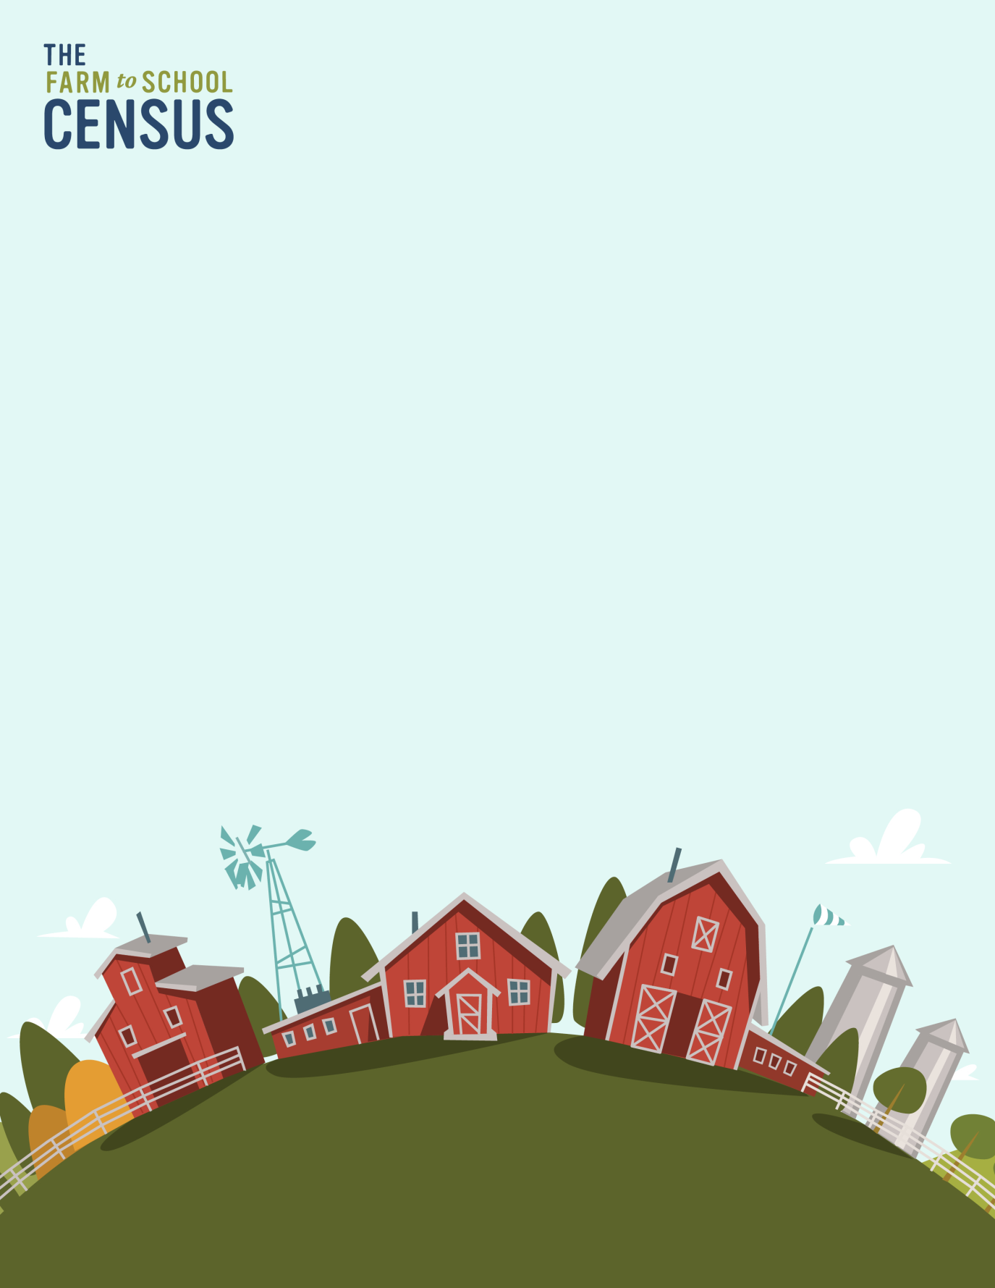
OMB Number: 0584-0646
Date: xx/xx/xxxx

Dear (SFA Director’s Name):
It’s time for the 2023 Farm to School Census, and we want to hear from [insert name of SFA]! The United States Department of Agriculture (USDA) Food and Nutrition Service (FNS) conducts this survey every four years to collect information about local purchasing, school gardens, and food and agriculture education & activities across the country.
The Census is for all SFAs, not just those that receive Farm to School grant funds or participate in farm to school activities. Participation in FNS research is required by the National School Lunch Act.
To complete the survey, please follow this link:
[Insert Web survey link here]
The survey should take between 5 and 30 minutes. Click here [insert link] to review an optional worksheet that will help you prepare the information you’ll need to complete the Census. You are encouraged to collaborate with other staff or vendors to obtain the information. You can also share the survey using the link in this email.
If you are no longer at [insert name of SFA], please let us know as soon as possible, so [insert name of SFA] isn’t left out!
If you have questions or need additional information about the Census, please review the Frequently Asked Questions document [insert link]. We’ll also be hosting a webinar for SFAs with a detailed walk through of the survey instrument on [insert date] – register here [insert link]!
You can also contact the project team toll-free at [insert study phone number] from 9 AM to 9 PM ET, or e-mail [insert study email]. USDA FNS has contracted with [insert contractor name], an independent research company, to conduct this important study.
Your participation is crucial to making sure we get the best information possible about school meals in the U.S. Thank you for your time and support to make the 2023 Farm to School Census a success!

This information is being collected to assist the Food and Nutrition Service in understanding and tracking farm to school engagement. This is a mandatory collection and FNS will use the information to set priorities for USDA outreach and technical support. This collection does not request any personally identifiable information under the Privacy Act of 1974. According to the Paperwork Reduction Act of 1995, an agency may not conduct or sponsor, and a person is not required to respond to, a collection of information unless it displays a valid OMB control number. The valid OMB control number for this information collection is 0584-0646. The time required to complete this information collection is estimated to average 0.0668 hours per response, including the time for reviewing instructions, searching existing data sources, gathering and maintaining the data needed, and completing and reviewing the collection of information. Send comments regarding this burden estimate or any other aspect of this collection of information, including suggestions for reducing this burden, to: U.S. Department of Agriculture, Food and Nutrition Service, Office of Policy Support, 1320 Braddock Place, 5th Floor, Alexandria, VA 22306 ATTN: PRA (0584-0646). Do not return the completed form to this address.

