APPENDIX C.5
Census Reminder Emails from study team to SFAs

Table of Contents
Census Reminder Email #1 1
Census Reminder Email #2 2
Census Reminder Email #3 3
Census Reminder Email #4 4
Census Reminder Email #5 5
Census Reminder Email #6 6
Census Reminder Email #7 7
Census Reminder Email #8 8

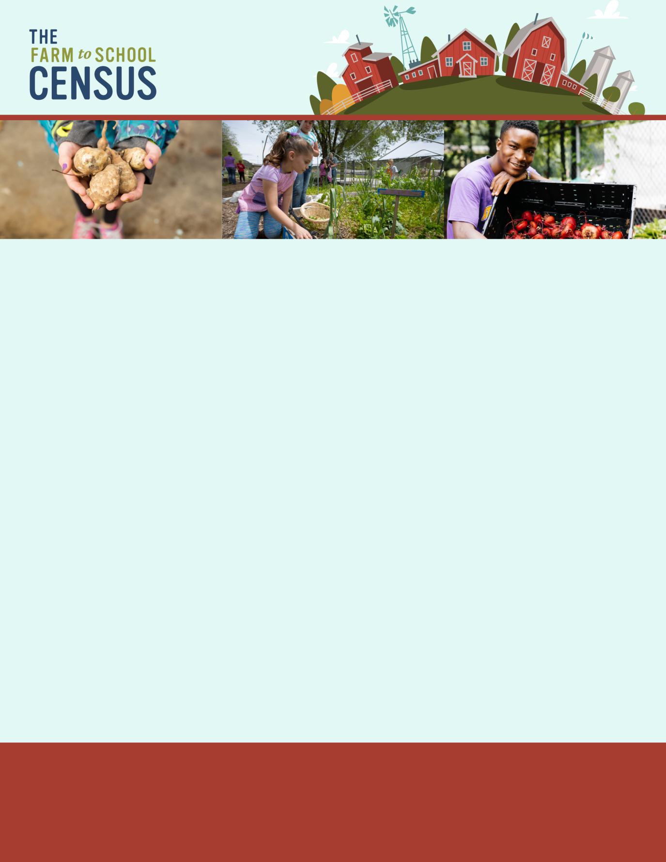
Census Reminder Email #1

Dear [Name of SFA director],
OMB Number: 0584-0646
Date: xx/xx/xxxx

Please complete your 2023 Farm to School Census so that your state and SFA are represented!
Remember, whether you participate in farm to school activities or not, we want to hear from you! The Census is for all SFAs, public, charter, and private; rural, suburban, and urban; large, medium, and small.
Use this link to access the Census:
[Insert link here]
The Census will:
- Measure progress of farm to school activities at the SFA, State, and national levels;
- Identify the number of students impacted by farm to school programs and the dollars spent on local food by schools, and
- Help decision makers understand the benefits and challenges farm to school programs to inform policy and funding decisions for farm to school.
Click here [insert link] to review an optional worksheet to help you collect information needed to complete the Census. You may need to contact other district or school staff to obtain the information included on the worksheet, such as local purchasing data or the number of edible gardens in your district. You can also share the survey directly by forwarding this email.
If you are no longer associated with [name of SFA], please let us know as soon as possible by responding to this email —we want to make sure the right person has access.
For additional information about the Census, please review the “Frequently Asked Questions” document [insert link] or contact the study project team toll-free at [study phone number] from 9 AM to 9 PM ET, or e-mail [study email].
We look forward to receiving your responses. Thank you for your participation in the 2023 Farm to School Census!
Sincerely,
[Study Director name]
Project Director, 2023 Farm to School Census
[Contractor name]
This information is being collected to assist the Food and Nutrition Service in understanding and tracking farm to school engagement. This is a mandatory collection and FNS will use the information to set priorities for USDA outreach and technical support. This collection does not request any personally identifiable information under the Privacy Act of 1974. According to the Paperwork Reduction Act of 1995, an agency may not conduct or sponsor, and a person is not required to respond to, a collection of information unless it displays a valid OMB control number. The valid OMB control number for this information collection is 0584-0646. The time required to complete this information collection is estimated to average 0.0167 hours per response, including the time for reviewing instructions, searching existing data sources, gathering and maintaining the data needed, and completing and reviewing the collection of information. Send comments regarding this burden estimate or any other aspect of this collection of information, including suggestions for reducing this burden, to: U.S. Department of Agriculture, Food and Nutrition Service, Office of Policy Support, 1320 Braddock Place, 5th Floor, Alexandria, VA 22306 ATTN: PRA (0584-0646). Do not return the completed form to this address.

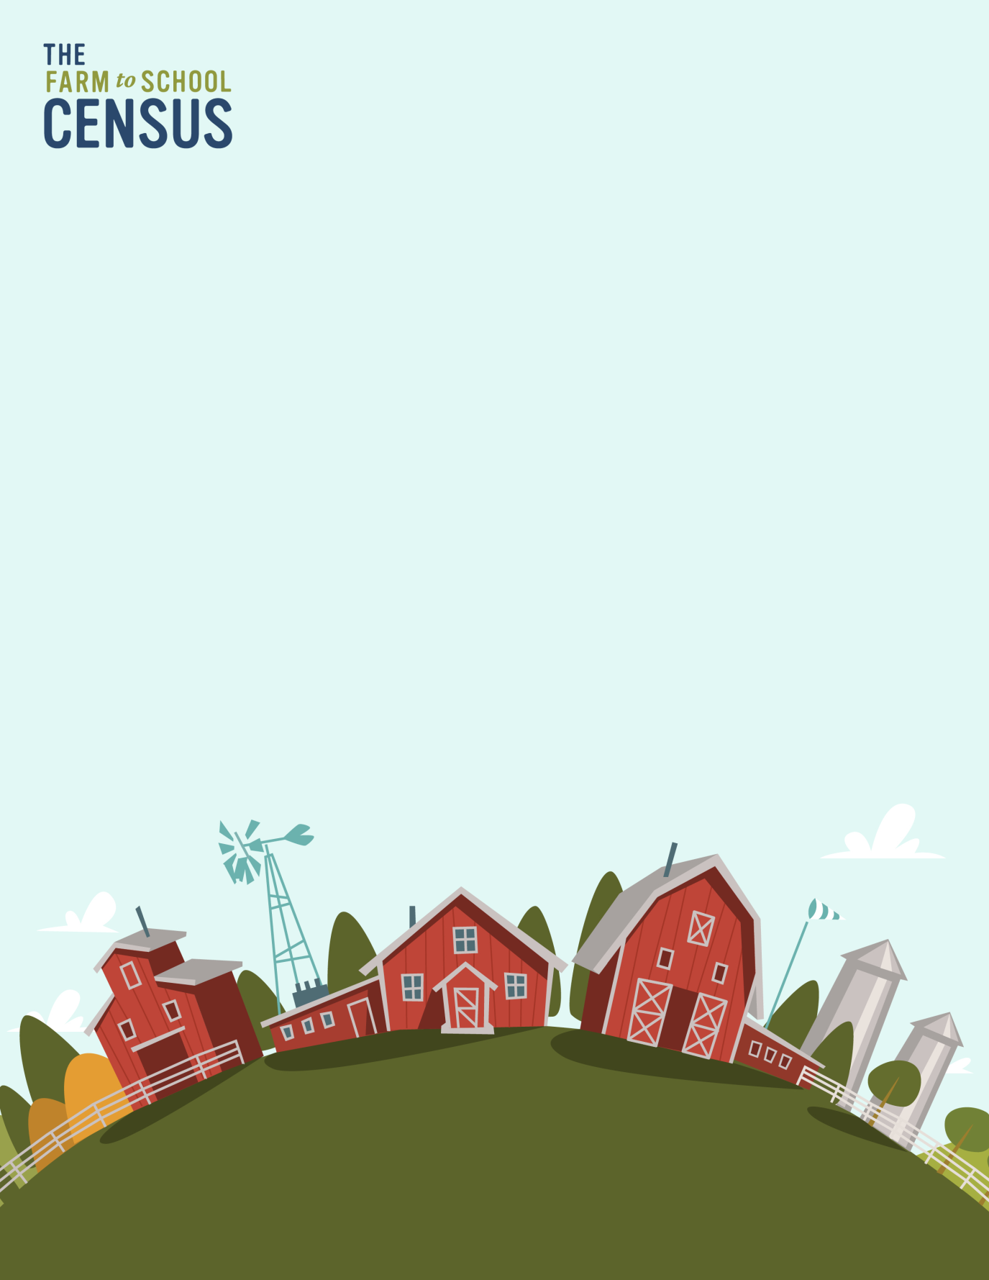
Census Reminder Email #2
OMB Number: 0584-0646
Date: xx/xx/xxxx

Dear [Name of SFA Director]:
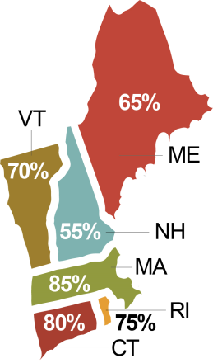
How does your State compare to your neighbors in the national effort to complete the 2023 Farm to School Census? Check out the map to see which State in your region has the highest Census participation rate!
Northeast States Participation Rates
Complete your Census -- and encourage your neighboring SFAs to do the same to help us reach 100% participation!
You can access your Farm to School Census by following the link below:
[Insert Census Link]
Click here [insert link] to review an optional worksheet to help you prepare to complete the Census. You may have all the information you need already, but if you are unsure of items included on the worksheet, please contact other district or school staff to obtain the necessary information. You can forward them this email to access the survey using the link above.
And remember, it’s OK if you don’t have all the information we ask for – please answer to the best of your ability,
If you , please let us know as soon as possible.
For additional information about the Census, please review the “Frequently Asked Questions” document [insert link] or contact the study project team toll-free at [study phone number] from 9 AM to 9 PM ET, or e-mail [study email].
Thank you in advance for your support and assistance in maximizing participation in the 2023 Farm to School Census!
Sincerely,
[Study Director name]
Project Director, 2023 Farm to School Census
[Contractor name].

This information is being collected to assist the Food and Nutrition Service in understanding and tracking farm to school engagement. This is a mandatory collection and FNS will use the information to set priorities for USDA outreach and technical support. This collection does not request any personally identifiable information under the Privacy Act of 1974. According to the Paperwork Reduction Act of 1995, an agency may not conduct or sponsor, and a person is not required to respond to, a collection of information unless it displays a valid OMB control number. The valid OMB control number for this information collection is 0584-0646. The time required to complete this information collection is estimated to average 0.0167 hours per response, including the time for reviewing instructions, searching existing data sources, gathering and maintaining the data needed, and completing and reviewing the collection of information. Send comments regarding this burden estimate or any other aspect of this collection of information, including suggestions for reducing this burden, to: U.S. Department of Agriculture, Food and Nutrition Service, Office of Policy Support, 1320 Braddock Place, 5th Floor, Alexandria, VA 22306 ATTN: PRA (0584-0646). Do not return the completed form to this address.

Census Reminder Email #3
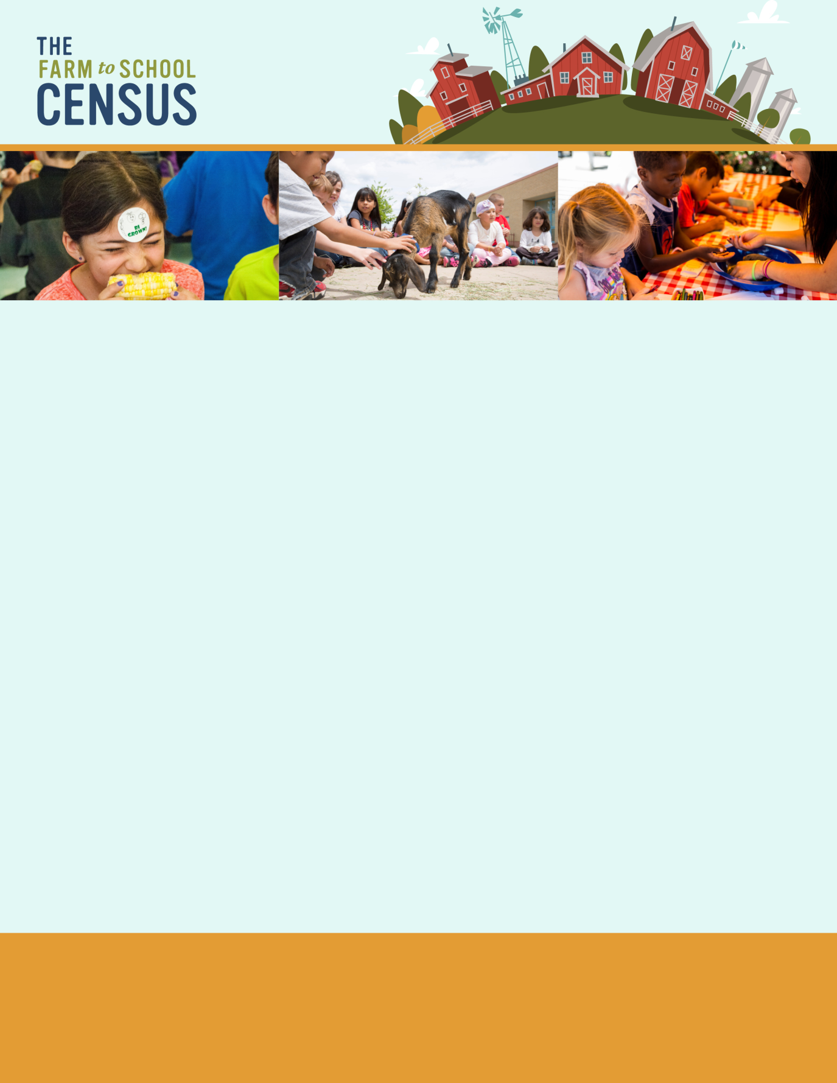

OMB Number: 0584-0646
Date: xx/xx/xxxx

Dear (SFA Director Name):
We noticed you haven’t completed your 2023 Farm to School Census yet. Even if you do not participate in farm to school, we want to hear from you!
The 2019 Farm to School Census reported that 64% of SFAs participate in farm to school activities. Please complete your survey and help us find out if farm to school has grown nationwide. Some examples of farm to school activities are:
- serving local foods in school meals;
- growing food in school gardens;
- taking field trips to local farms or orchards;
- taste testing local foods, and;
any other food, agriculture, or nutrition education that incorporates locally-produced foods.
You can access your 2023 Farm to School Census here:
[Insert web link]
Click here [insert link] to review an optional worksheet to help you collect information needed to complete the Census. You may need to contact other district or school staff to obtain the information included on the worksheet, such as local purchasing data or the number of edible gardens in your district. You can also share the survey directly by forwarding this email.
If you are no longer with [name of SFA], please let us know as soon as possible by responding to this email.
For additional information about the Census, please review the “Frequently Asked Questions” document [insert link] or contact the study project team toll-free at [study phone number] from 9 AM to 9 PM ET, or e-mail [study email].
We look forward to your responses and thank you for your participation in the 2023 Farm to School Census! For more information on USDA’s Farm to School Program, please visit our website: https://www.fns.usda.gov/farmtoschool/farm-school
Sincerely,
[Study Director name]
Project Director, 2023 Farm to School Census
[Contractor name]
This information is being collected to assist the Food and Nutrition Service in understanding and tracking farm to school engagement. This is a mandatory collection and FNS will use the information to set priorities for USDA outreach and technical support. This collection does not request any personally identifiable information under the Privacy Act of 1974. According to the Paperwork Reduction Act of 1995, an agency may not conduct or sponsor, and a person is not required to respond to, a collection of information unless it displays a valid OMB control number. The valid OMB control number for this information collection is 0584-0646. The time required to complete this information collection is estimated to average 0.0167 hours per response, including the time for reviewing instructions, searching existing data sources, gathering and maintaining the data needed, and completing and reviewing the collection of information. Send comments regarding this burden estimate or any other aspect of this collection of information, including suggestions for reducing this burden, to: U.S. Department of Agriculture, Food and Nutrition Service, Office of Policy Support, 1320 Braddock Place, 5th Floor, Alexandria, VA 22306 ATTN: PRA (0584-0646). Do not return the completed form to this address.

Census Reminder Email #4
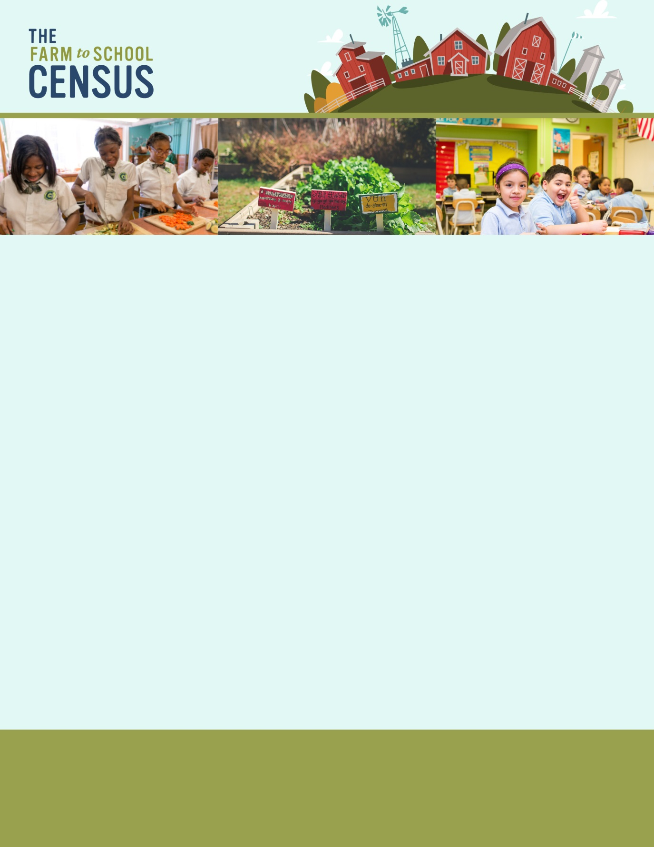

OMB Number: 0584-0646
Date: xx/xx/xxxx

Dear [Name of SFA Director],
Please complete your 2023 Farm to School Census to make sure your State and SFA are represented! Use this link to access your Census: [Insert census link here]
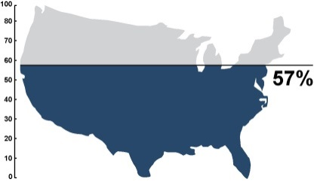
Help us reach 100% Census participation! See the map to check our progress!
National Participation Rate
Click here [insert link] to review an optional worksheet to help you collect information needed to complete the Census. You may need to contact other district or school staff to obtain the information included on the worksheet, such as local purchasing data or the number of edible gardens in your district. You can also share the survey directly by forwarding this email.
Remember, it’s OK not to have all the answers! Please complete the survey as best you can.
If you are no longer with this SFA, please let us know as soon as possible—we want to make sure this Census is in the right hands!
For additional information about the Census, please review the “Frequently Asked Questions” document [insert link] or contact the study project team toll-free at [study phone number] from 9 AM to 9 PM ET, or e-mail [study email].
Thank you in advance for your support and assistance in maximizing participation in the 2023 Farm to School Census!
Sincerely,
[Study Director name]
Project Director, 2023 Farm to School Census
[Contractor name]

This information is being collected to assist the Food and Nutrition Service in understanding and tracking farm to school engagement. This is a mandatory collection and FNS will use the information to set priorities for USDA outreach and technical support. This collection does not request any personally identifiable information under the Privacy Act of 1974. According to the Paperwork Reduction Act of 1995, an agency may not conduct or sponsor, and a person is not required to respond to, a collection of information unless it displays a valid OMB control number. The valid OMB control number for this information collection is 0584-0646. The time required to complete this information collection is estimated to average 0.0167 hours per response, including the time for reviewing instructions, searching existing data sources, gathering and maintaining the data needed, and completing and reviewing the collection of information. Send comments regarding this burden estimate or any other aspect of this collection of information, including suggestions for reducing this burden, to: U.S. Department of Agriculture, Food and Nutrition Service, Office of Policy Support, 1320 Braddock Place, 5th Floor, Alexandria, VA 22306 ATTN: PRA (0584-0646). Do not return the completed form to this address.

Census Reminder Email #5
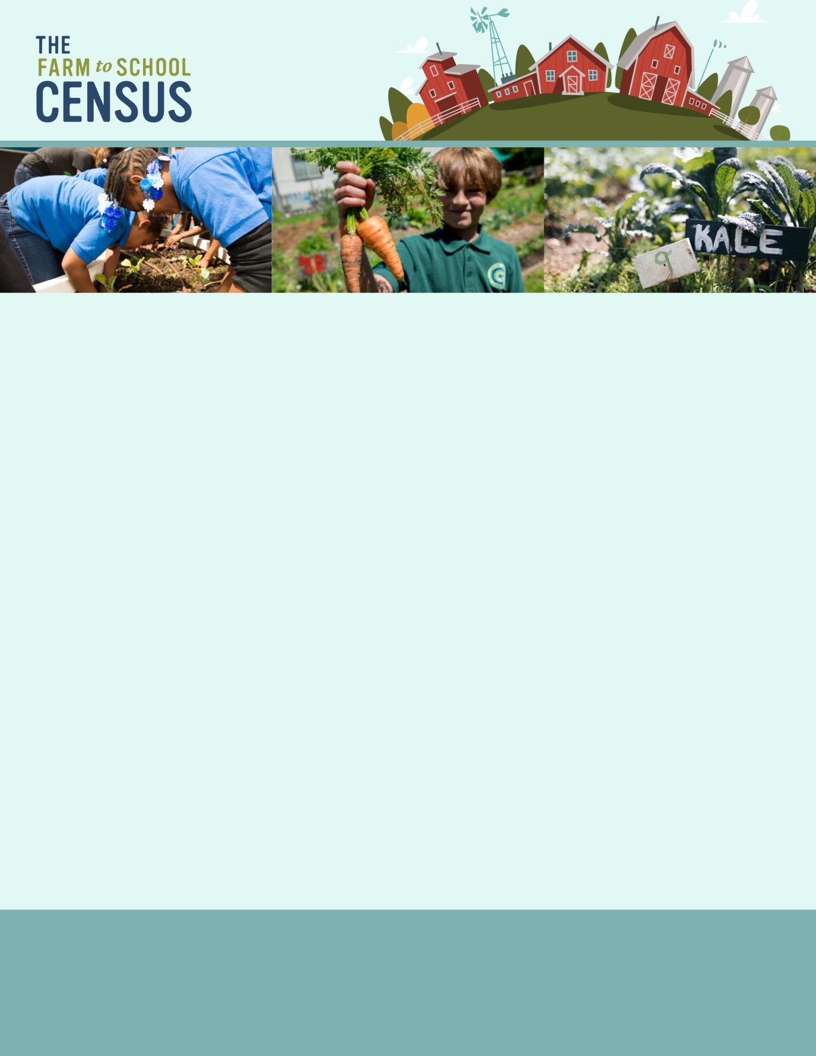

OMB Number: 0584-0646
Date: xx/xx/xxxx

Dear [Name of SFA Director]:
How did your SFA bring the farm to your schools in the 2022-2023 school year? Let us know by completing the 2023 Farm to School Census.
No farm to school program in your district? That’s ok! Let us know why not. Your responses will help inform USDA policy and practices so FNS is better able to meet your needs.
Use this link to access your brief Census:
[Census link]
The 2015 Farm to School Census found that SFAs experienced the following benefits from participating in farm to school activities:
- increased support from parents and community members for the healthier school meals;
- improved acceptance of healthier school meals;
- lower school meal program costs; and,
- increased participation in school meal programs.

Click here [insert link] to review an optional worksheet to help you collect information needed to complete the Census. You may need to contact other district or school staff to obtain the information included on the worksheet. You can also share the survey directly by forwarding this email. If you are no longer associated with [name of SFA], please let us know as soon as possible by responding to this email —we want to make sure the right person has access.
For additional information about the Census, please review the “Frequently Asked Questions” document [insert link] or contact the study project team toll-free at [study phone number] from 9 AM to 9 PM ET, or e-mail [study email].
We look forward to receiving your responses and thank you for your participation in the 2023 Farm to School Census!
Sincerely,
[Study Director name]
Project Director, 2023 Farm to School Census
[Contractor name]
This information is being collected to assist the Food and Nutrition Service in understanding and tracking farm to school engagement. This is a mandatory collection and FNS will use the information to set priorities for USDA outreach and technical support. This collection does not request any personally identifiable information under the Privacy Act of 1974. According to the Paperwork Reduction Act of 1995, an agency may not conduct or sponsor, and a person is not required to respond to, a collection of information unless it displays a valid OMB control number. The valid OMB control number for this information collection is 0584-0646. The time required to complete this information collection is estimated to average 0.0167 hours per response, including the time for reviewing instructions, searching existing data sources, gathering and maintaining the data needed, and completing and reviewing the collection of information. Send comments regarding this burden estimate or any other aspect of this collection of information, including suggestions for reducing this burden, to: U.S. Department of Agriculture, Food and Nutrition Service, Office of Policy Support, 1320 Braddock Place, 5th Floor, Alexandria, VA 22306 ATTN: PRA (0584-0646). Do not return the completed form to this address.

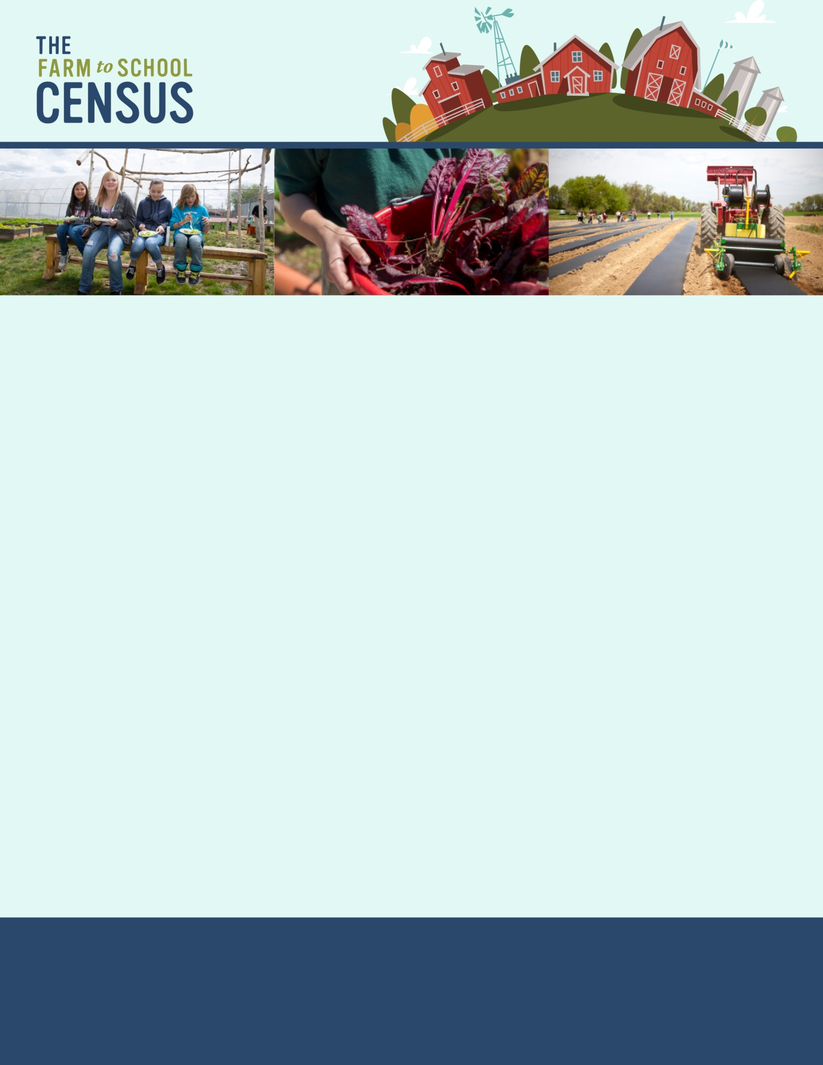
Census Reminder Email #6

OMB Number: 0584-0646
Date: xx/xx/xxxx

Dear [Name of SFA Director],
We’re nearing the close of the 2023 Farm to School Census and we want to reach 100% participation! Please complete your 2023 Farm to School Census – it shouldn’t take more than 30 minutes and may take as few as 5.
Use this link to access your survey: [Insert census link here]
How’s your State doing?
Northeast States Participation Rates
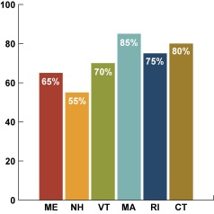 | 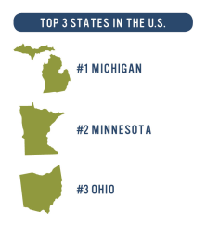
Improve your State’s participation rate by completing your survey and then encourage your neighboring SFAs to complete theirs as well! Remember, it’s OK if you don’t have all the answers – please complete the survey to the best of your ability.
Click here [insert link] to review an optional worksheet to help you collect information needed to complete the Census. You can also share the survey with others who might have answers by forwarding this email. If you are no longer associated with [name of SFA], please let us know as soon as possible by responding to this email.
For additional information about the Census, please review the “Frequently Asked Questions” document [insert link] or contact the study project team toll-free at [study phone number] from 9 AM to 9 PM ET, or e-mail [study email].
Thank you in advance for your support and assistance in maximizing participation in the 2023 Farm to School Census!
Sincerely,
[Study Director name]
Project Director, 2023 Farm to School Census
[Contractor name]

This information is being collected to assist the Food and Nutrition Service in understanding and tracking farm to school engagement. This is a mandatory collection and FNS will use the information to set priorities for USDA outreach and technical support. This collection does not request any personally identifiable information under the Privacy Act of 1974. According to the Paperwork Reduction Act of 1995, an agency may not conduct or sponsor, and a person is not required to respond to, a collection of information unless it displays a valid OMB control number. The valid OMB control number for this information collection is 0584-0646. The time required to complete this information collection is estimated to average 0.0167 hours per response, including the time for reviewing instructions, searching existing data sources, gathering and maintaining the data needed, and completing and reviewing the collection of information. Send comments regarding this burden estimate or any other aspect of this collection of information, including suggestions for reducing this burden, to: U.S. Department of Agriculture, Food and Nutrition Service, Office of Policy Support, 1320 Braddock Place, 5th Floor, Alexandria, VA 22306 ATTN: PRA (0584-0646). Do not return the completed form to this address.

Census Reminder Email #7
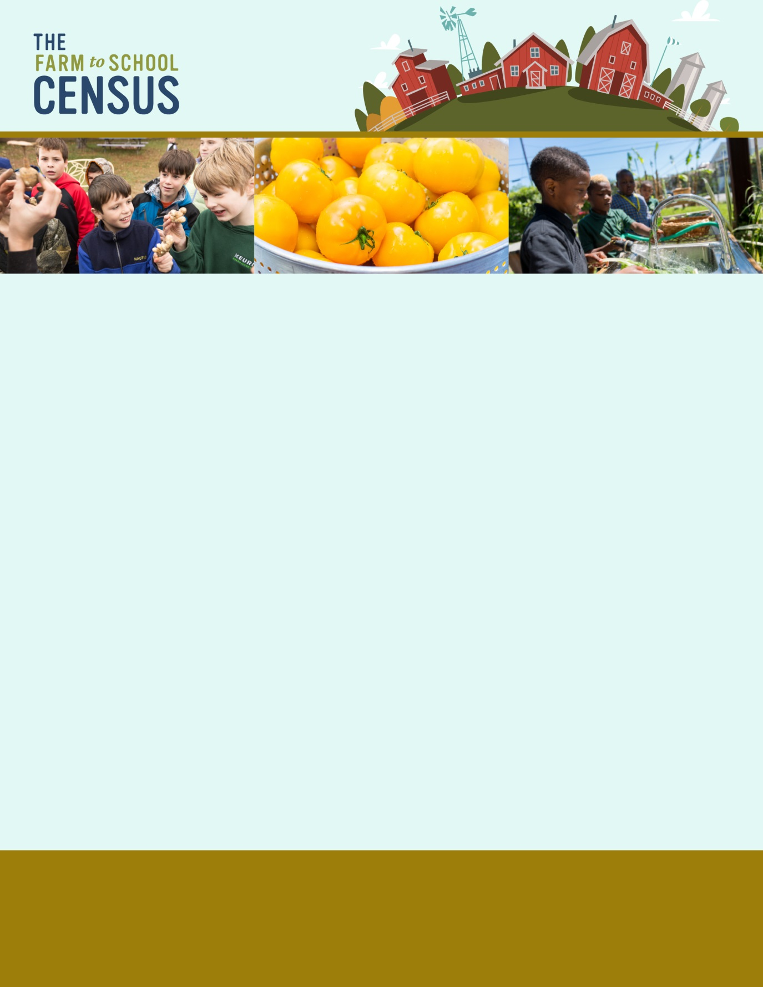

OMB Number: 0584-0646
Date: xx/xx/xxxx

Dear [Name of SFA Director]:
We want you to complete the Farm to School Census. All SFAs should complete the Census, whether or not they have farm to school efforts in their SFA.
Why should you fill out the Census?
- To track your progress and learn what has changed since the last Census.
- To provide an accurate view of who participates in farm to school.
- To discover which farm to school activities SFAs engage in.
- To learn how your SFAs and community benefit from farm to school efforts.
To share and learn about the challenges of participating in farm to school.
Follow the link below to complete your Census and make your voice heard!
[Census link here]
Click here [insert link] to review an optional worksheet to help you collect information needed to complete the Census. You may need to contact other district or school staff to obtain the information included on the worksheet, such as local purchasing data or the number of edible gardens in your district. You can also share the survey directly by forwarding this email.
For additional information about the Census, please review the “Frequently Asked Questions” document [insert link] or contact the study project team toll-free at [study phone number] from 9 AM to 9 PM ET, or e-mail [study email].
We look forward to receiving your responses, and thank you for your participation in the 2023 Farm to School Census!
Sincerely,
[Study Director name]
Project Director, 2023 Farm to School Census
[Contractor name]

This information is being collected to assist the Food and Nutrition Service in understanding and tracking farm to school engagement. This is a mandatory collection and FNS will use the information to set priorities for USDA outreach and technical support. This collection does not request any personally identifiable information under the Privacy Act of 1974. According to the Paperwork Reduction Act of 1995, an agency may not conduct or sponsor, and a person is not required to respond to, a collection of information unless it displays a valid OMB control number. The valid OMB control number for this information collection is 0584-0646. The time required to complete this information collection is estimated to average 0.0167 hours per response, including the time for reviewing instructions, searching existing data sources, gathering and maintaining the data needed, and completing and reviewing the collection of information. Send comments regarding this burden estimate or any other aspect of this collection of information, including suggestions for reducing this burden, to: U.S. Department of Agriculture, Food and Nutrition Service, Office of Policy Support, 1320 Braddock Place, 5th Floor, Alexandria, VA 22306 ATTN: PRA (0584-0646). Do not return the completed form to this address.

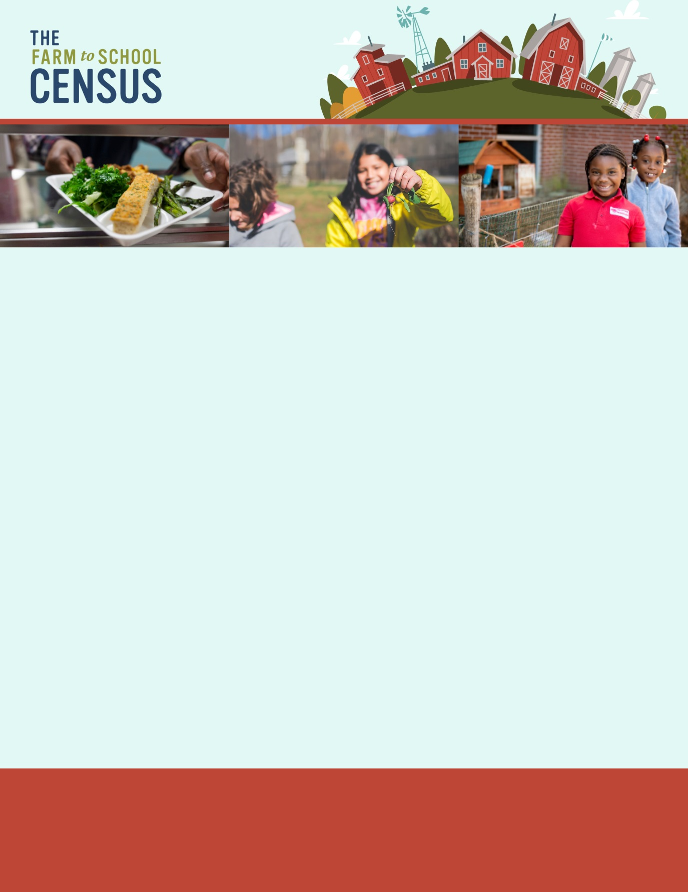
Census Reminder Email #8

OMB Number: 0584-0646
Date: xx/xx/xxxx

Dear [Name of SFA Director],
We’re nearing the close of the 2023 Farm to School Census, and we are still aiming for 100% participation! Help us cross the finish line and reach our goal before we close the survey on [CLOSING DATE]! Please complete your 2023 Farm to School Census to represent your state and make your voice heard!
How’s your State doing?
Northeast States Participation Rates | National Participation Rate
 | 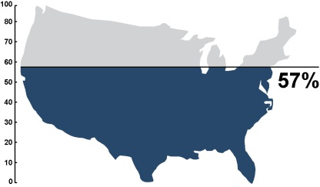

Please use this link to access your Census:
[Insert census link here]
Click here [insert link] to review an optional worksheet to help you collect information needed to complete the Census. Remember, it’s OK to provide us with your best estimate if you don’t know the exact answers.
For additional information about the Census, please review the “Frequently Asked Questions” document [insert link] or contact the study project team toll-free at [study phone number] from 9 AM to 9 PM ET, or e-mail [study email].
Thank you in advance for your support for and participation in the 2023 Farm to School Census!
Sincerely,
[Study Director name]
Project Director, 2023 Farm to School Census
[Contractor name]

This information is being collected to assist the Food and Nutrition Service in understanding and tracking farm to school engagement. This is a mandatory collection and FNS will use the information to set priorities for USDA outreach and technical support. This collection does not request any personally identifiable information under the Privacy Act of 1974. According to the Paperwork Reduction Act of 1995, an agency may not conduct or sponsor, and a person is not required to respond to, a collection of information unless it displays a valid OMB control number. The valid OMB control number for this information collection is 0584-0646. The time required to complete this information collection is estimated to average 0.0167 hours per response, including the time for reviewing instructions, searching existing data sources, gathering and maintaining the data needed, and completing and reviewing the collection of information. Send comments regarding this burden estimate or any other aspect of this collection of information, including suggestions for reducing this burden, to: U.S. Department of Agriculture, Food and Nutrition Service, Office of Policy Support, 1320 Braddock Place, 5th Floor, Alexandria, VA 22306 ATTN: PRA (0584-0646). Do not return the completed form to this address.

