APPENDIX C.8
CENSUS REMINDER LETTER FROM STUDY TEAM TO TO SFAS

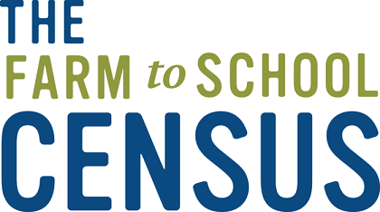

NAME
Address Line 1
Address Line 2
Address Line 3

OMB Number: 0584-0646
Date: xx/xx/xxxx

Dear [SFA Director’s Name]:
You have likely received several emails from us about the 2023 Farm to School Census, but in case you have not, we would like to bring your attention to the need to complete the Census as soon as possible to make sure your SFA is represented. The United States Department of Agriculture (USDA) Food and Nutrition Service (FNS) has contracted with [contractor name] to administer the Census.
The Census is set to close on [closing date]. If you have already completed the Census, thank you, and please ignore this letter. If you are not sure whether the Census has been completed for your SFA, please reach out to us for assistance at [study phone number] or [study name].


The Census is a brief web survey that asks for information related to your SFA’s participation in farm to school activities. The Census is for all SFAs, not just those that receive Farm to School grant funds or participate in Farm to School activities. SFA participation in FNS research is required under the National School Lunch Act.
To complete the 2023 Census for your SFA, please visit this link: [Insert Web survey link here].

Anyone in the SFA can access this survey so please share this link with anyone who can respond to some or all of the questions.

Please find a list of “Frequently asked Questions” on the back side of this letter. Visit https://www.fns.usda.gov/cfs/farm-school-census-preparation-worksheet for an optional worksheet that may help you prepare the information you’ll need to complete the Census. You are encouraged to collaborate with other district staff or vendors to obtain the information.
If you have questions or need additional information about the Census, please contact the project team toll-free at [study phone number] from 9 AM to 9 PM ET, or e-mail [study email address].
Thank you for your participation in the 2023 Farm to School Census!
Sincerely,
[Project Director name], Project Director
Farm to School Census and Comprehensive Review
[Contractor name]

This information is being collected to assist the Food and Nutrition Service in understanding and tracking farm to school engagement. This is a mandatory collection and FNS will use the information to set priorities for USDA outreach and technical support. This collection does not request any personally identifiable information under the Privacy Act of 1974. According to the Paperwork Reduction Act of 1995, an agency may not conduct or sponsor, and a person is not required to respond to, a collection of information unless it displays a valid OMB control number. The valid OMB control number for this information collection is 0584-0646. The time required to complete this information collection is estimated to average 0.0334 hours per response, including the time for reviewing instructions, searching existing data sources, gathering and maintaining the data needed, and completing and reviewing the collection of information. Send comments regarding this burden estimate or any other aspect of this collection of information, including suggestions for reducing this burden, to: U.S. Department of Agriculture, Food and Nutrition Service, Office of Policy Support, 1320 Braddock Place, 5th Floor, Alexandria, VA 22306 ATTN: PRA (0584-0646). Do not return the completed form to this address.

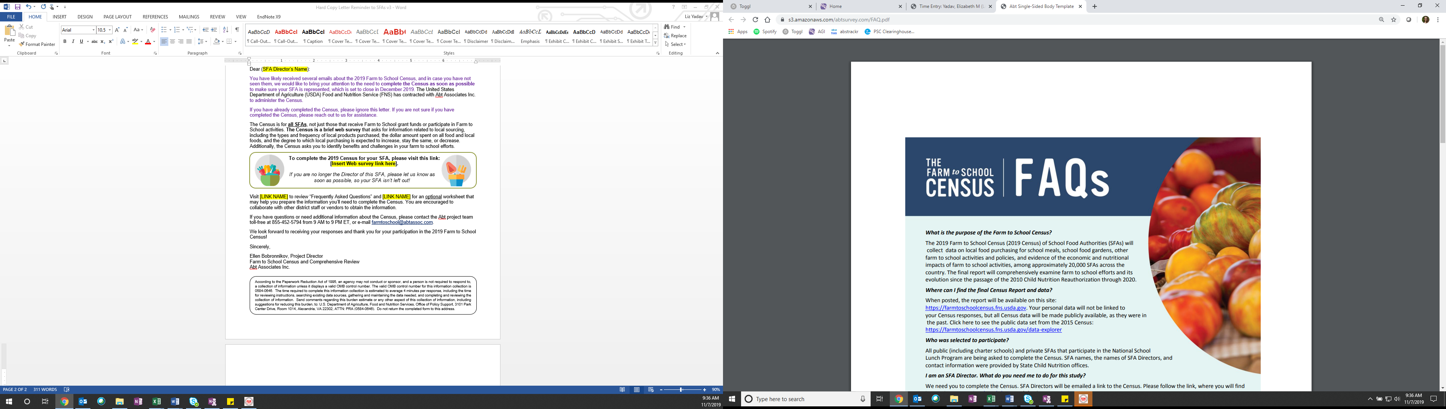
The schools in my district don’t do any farm to school activities – do I still need to fill out the Census?
Yes! All public and private school food authorities (SFAs) that participate in the National School Lunch Program (NSLP) in all 50 States, as well as Guam, the Northern Mariana Islands, Puerto Rico, the Virgin Islands, American Samoa, and Washington, D.C. should complete the 2019 Census. This effort will help us understand which SFAs and schools do farm to school activities and will help the USDA provide support for farm to school activities in the future.
What if I don’t know the answers to the Census questions?
You may need to consult with your farm to school partners, such as vendors, school garden coordinators, foodservice staff, or teachers. To help you gather the necessary information for the Census, we prepared an optional worksheet that is available on the Census webpage. It will walk you through the information that will be helpful to collect ahead of completing the Census.
You can directly share the Census survey with others using the unique survey link emailed to the SFA director. Anyone can access the survey using this link, and when they exit the survey, their responses will automatically be saved.
We ask that you please try to answer as many questions as possible, but it’s OK if you aren’t able to answer them all or need to provide estimates for some.
I don’t think I am the correct person to complete the Census. I don’t know anything about Farm to school in my SFA.
If you don’t know about farm to school in your SFA and don’t know who else in your SFA should complete the survey, or if you are no longer associated with the SFA, please let the study team know by phone at [study phone number] or by email at [study email address].
Do I need to complete all the Census questions at one time?
No, you do not need to complete the Census all at once. You will be able to answer questions, save your responses, close out of the Census, and return to complete it at a later time.
How long will the Census take me to complete?
The Census could take up to 30 minutes to complete for some SFAs. Most will take between 5 and 30 minutes to complete.
Where can I find the final Census Report and data?
When posted, the report and findings will be available on this site: https://farmtoschoolcensus.fns.usda.gov. Your personal data (e.g., name and contact information) will not be linked to your Census responses, but all the responses for your SFA will be made publicly available, as they were in the past.

