**Using your Samsung Tablet for the Ask U.S. Panel pilot**

# Getting to Know Your Device

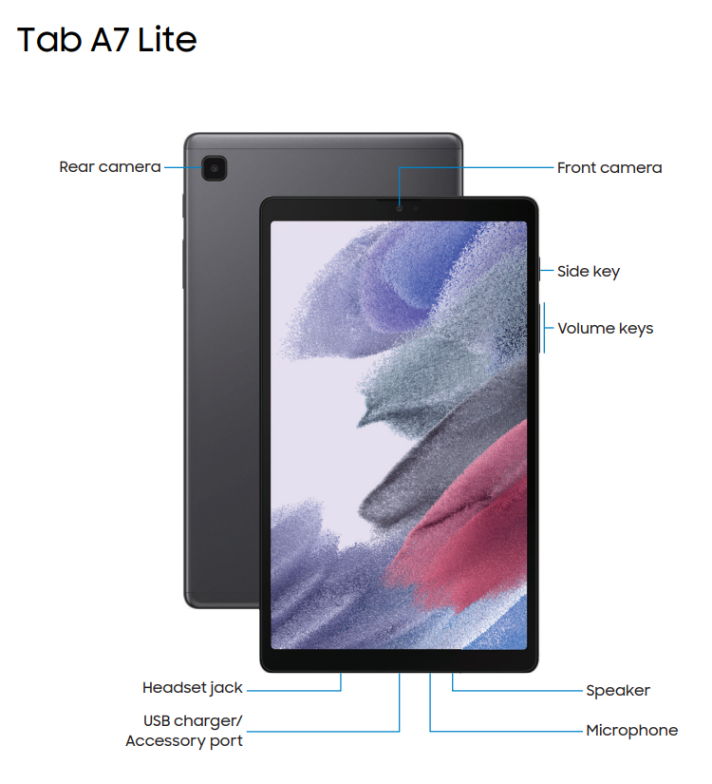

# Getting Started

* Before powering on your Samsung Tablet, ensure that it is fully charged. To charge the tablet, plug in the charging cord and insert the adapter into the port located at the bottom of the tablet.

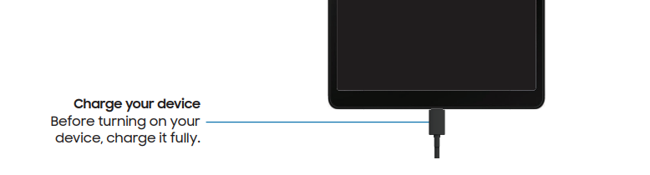

* Once you plug in your device, your battery’s percentage will display in the center of the device, even if it is not turned on.

* To power on the device, press and hold the side key located on the right side of the tablet just above the volume strip, pictured below.
* To lock your tablet screen, press the side key located on the right side of the tablet. This is the same key that when pressed and held will power the device on. To unlock the device, simply press the side key again and swipe from left to right along the screen.

* If facial recognition, pattern, PIN or password protection has been set you will need to enter this information to unlock the device.
* To power off the tablet, simply press and hold the power key. A screen will then display with the option to *Power Off*.
* To adjust the tablet volume, press up or down on the side bar located on the right side of the device just below the power key.

# Connecting to the Internet

## Checking Mobile Connection

Your tablet comes enabled with an unlimited mobile data connection plan and should automatically connect to the internet. However, to check if you are connected to mobile internet navigate to the settings and look for the 4G symbol.

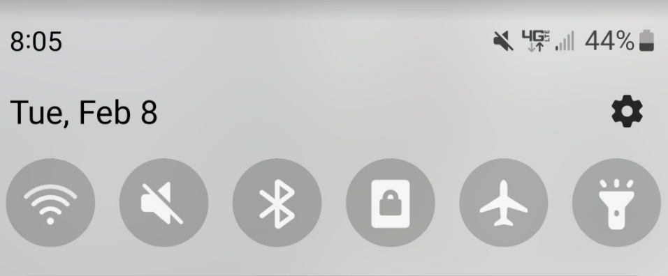

## Connecting to Wi-Fi

*The Samsung tablet will be mobile data enabled and should connect to the internet automatically. However, accessing Wi-Fi may be useful if cellular data service is weak.*

* To connect to a Wi-Fi network, access the device settings by swiping down from the top of the device screen. Select the settings icon shown below, and then select Connections 🡪 Wi-Fi. This will then display a list of available Wi-Fi networks.

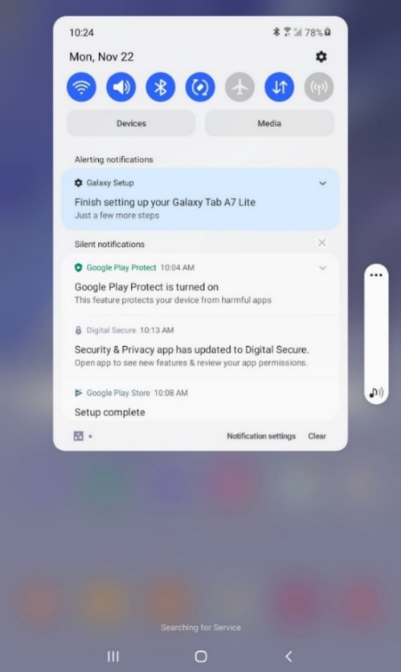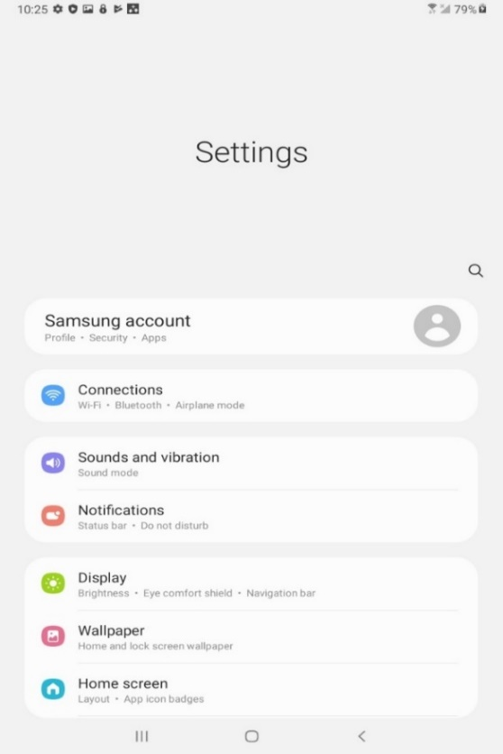

# Accessing Ask U.S. Panel pilot Surveys on your tablet

* All surveys can be completed via the internet, using the Chrome browser that is pre-loaded on your tablet and accessed through the icon located on the home screen shown below, or with any other device you have access to that is connected to the internet.

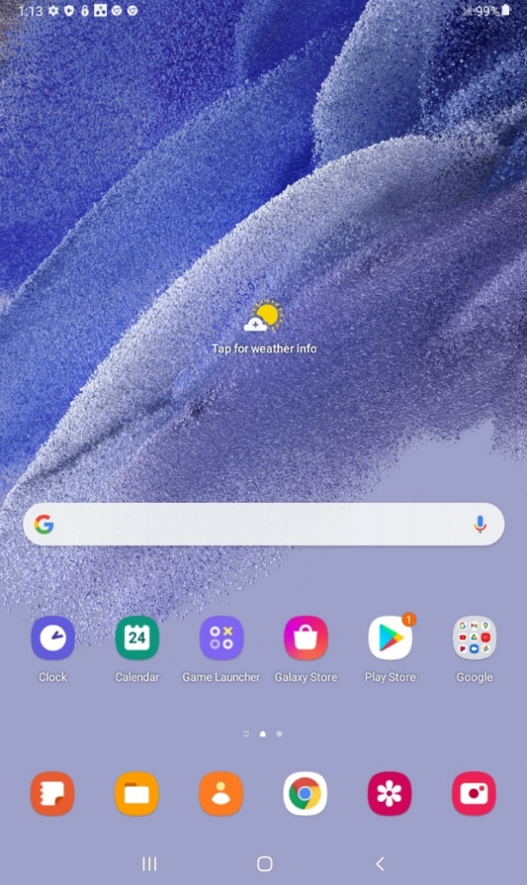

* To access Ask U.S. Panel pilot surveys using your tablet:
  1. Click on the link you received in your email, or enter the link provided in your invitation letter into your web browser.
  2. After navigating to the link, enter the PIN provided in your invitation to start the survey.

# Getting Help with Your Tablet

* If you encounter problems with your tablet or while trying to access panel surveys, you can contact project staff by:
  + E-mail: askuspanel@rti.org
    - Please include your name and survey PIN, if available.
    - Please note that while you can send an e-mail anytime, it will likely be answered between 8:00 a.m. and 5:00 p.m. on weekdays.
  + Project Hotline: 1-866-558-0774
    - You can also call the project hotline. If you are unable to reach a project staff member, leave a message that includes your name, survey PIN if available, and phone number, and we will return your call as soon as possible.
    - The hotline is available between 9:00 am-12:00 am Monday through Thursday, 9:00 am-11:00 pm on Fridays, 10:00 am-9:00 pm on Saturdays, and 1:30 pm-11:00 pm on Sundays (EST).
* You can also access your tablet’s quick start guide included in the box your tablet came in, or at the link below. For more advanced tablet settings, you can access the full manual by below:
  + Samsung Galaxy Tab A7 Quick Start Guide: <https://downloadcenter.samsung.com/content/UM/202106/20210624005839913/WIFI_Galaxy_Tab_A7_Lite_IBG_050621.pdf>
  + Samsung Galaxy Tab A7 Full User Manual: <https://ss7.vzw.com/is/content/VerizonWireless/samsung-galaxy-tab-a7-lite-user-manual>

# Maintaining Your Tablet

* Keep your tablet charged when you’re not using it. When charging your tablet:
  + Use the charging cable RTI provided you. Do not use another charger, even if it appears to fit your tablet.
  + Ensure the charging cable is secured in the charging port on the bottom of your tablet.
  + Avoid moving the charging cable post while it’s connected to the tablet. Doing so can damage the port on your tablet.
* Clean your tablet display regularly.
  + Wipe the screen surface gently using a soft cotton cloth or cleaning wipes specifically designed for cleaning screens.
  + Do not use abrasive cleaners.
  + Do not pour or spray liquids directly on your tablet or wash your tablet with a heavily soaked cloth.
* Keep your tablet away from extreme temperatures, including out of direct sunlight.
* Avoid exposing your tablet to water, dirt, dust, sand, etc.
* Keep your tablet in its protective case.
* When carrying it in a bag, make sure it’s in a separate compartment and the screen is protected.
* If your tablet breaks or stops working and you cannot get it to restart, please contact the Ask U.S. Panel pilot support at [askuspanel@rti.org](mailto:askuspanel@rti.org) or 1-8##-###-####.