BEACH RECREATION VISITORS SURVEY
The public reporting burden for this collection of information, 0710-CBRS is estimated to average 15 minutes per response, including the time for reviewing instructions, searching existing data sources, gathering and maintaining the data needed, and completing and reviewing the collection of information. Send comments regarding the burden estimate or burden reduction suggestions to the Department of Defense, Washington Headquarters Services, at whs.mc-alex.esd.mbx.dd-dod-information-collections@mail.mil. Respondents should be aware that notwithstanding any other provision of law, no person shall be subject to any penalty for failing to comply with a collection of information if it does not display a currently valid OMB control number.

We ask you to fill out a survey on coastal environmental change, beach visitation, and coastal erosion management. We do not anticipate risks or discomforts from participating in this research. No personally identifiable information will be collected. The research project is designed to provide information on the economic value of coastal resources and beach visitation. Completion of the survey implies consent to participate in our research project. We sincerely thank you for your participation!
Craig Landry is the primary researcher and a professor at the University of Georgia. If you have questions, you may contact him at clandry@uga.edu or at 706.542.3705. If you have any questions or concerns regarding your rights as a research participant in this study, you may contact the Institutional Review Board (IRB) Chairperson at 706.542.3199 or irb@uga.edu

BEACH RECREATION VISITORS SURVEY: DOMESTIC
Hello, I’m ___________________. We’re conducting a survey on behalf of the US Army Corps of Engineers and the University of Georgia about your use of beaches in Puerto Rico. Are you a resident of Puerto Rico? YES
This is part of a research study to determine economic value of public beaches. Your participation is entirely voluntary, and all of your responses will be confidential. The survey will only take about 10 to 15 minutes. Will you be willing to answer a few questions?
Date of Interview: ________________________ Starting Time: _____________________________
Interview Location (Section): _________________________________________________________
The Office of Management and Budget Control (OMB) number for the study is OMB-710-___________

Section A: Beach Quality

Please circle one response for each question.

A1. How would you rate the overall quality of your beach experience today?
Category | Very Poor | Poor | Fair | Good | Excellent
Rating | 1 | 2 | 3 | 4 | 5

A2. How likely are you to return to this beach in the future?
Category | Very unlikely | Unlikely | Not sure | Likely | Very Likely
Rating | 1 | 2 | 3 | 4 | 5

A3. How likely are you to recommend others to visit this beach?
Category | Very unlikely | Unlikely | Not sure | Likely | Very Likely
Rating | 1 | 2 | 3 | 4 | 5

A4. How likely are you to post about your experience at this beach on social media sites?
Category | Very unlikely | Unlikely | Not sure | Likely | Very Likely
Rating | 1 | 2 | 3 | 4 | 5

A5. How important are the following beach attributes to you?
Category | Not  Important |  |  |  | Very  Important
Water Quality/Cleanliness | 1 | 2 | 3 | 4 | 5
Litter (Beach Cleanliness) | 1 | 2 | 3 | 4 | 5
Parking Availability | 1 | 2 | 3 | 4 | 5
Cost of Parking | 1 | 2 | 3 | 4 | 5
Availability of showers and restrooms | 1 | 2 | 3 | 4 | 5
Quality of showers, restrooms, and other beach facilities | 1 | 2 | 3 | 4 | 5
Congestion on the beach | 1 | 2 | 3 | 4 | 5
Beach Quality and Erosion | 1 | 2 | 3 | 4 | 5
Weather | 1 | 2 | 3 | 4 | 5
Availability of Lifeguards | 1 | 2 | 3 | 4 | 5
Social scene | 1 | 2 | 3 | 4 | 5
Surrounding amenities (i.e. restaurants) | 1 | 2 | 3 | 4 | 5
Scenic beauty | 1 | 2 | 3 | 4 | 5

A6. How would you rate the performance of this beach on the following characteristics?
Category | Very Poor |  |  |  | Very Good
Water Quality/Cleanliness | 1 | 2 | 3 | 4 | 5
Litter (Beach Cleanliness) | 1 | 2 | 3 | 4 | 5
Parking Availability | 1 | 2 | 3 | 4 | 5
Cost of Parking | 1 | 2 | 3 | 4 | 5
Availability of showers and restrooms | 1 | 2 | 3 | 4 | 5
Quality of showers, restrooms, and other beach facilities | 1 | 2 | 3 | 4 | 5
Congestion on the beach | 1 | 2 | 3 | 4 | 5
Beach Quality and Erosion | 1 | 2 | 3 | 4 | 5
Weather | 1 | 2 | 3 | 4 | 5
Availability of Lifeguards | 1 | 2 | 3 | 4 | 5
Social scene | 1 | 2 | 3 | 4 | 5
Surrounding amenities (i.e. restaurants) | 1 | 2 | 3 | 4 | 5
Scenic beauty | 1 | 2 | 3 | 4 | 5

Section B: Recreation Trips

B1. How many trips you have taken to San Juan beaches over the past 3 months for the primary purpose of recreation and leisure (e.g., swimming, sunbathing, walking, relaxing, fishing, playing sports).
______________ trips over past 3 months
  - Of these trips, how many, if any, involved an overnight stay? ______
  - On average, how many nights did you stay? ____
  - What kind of accommodations: hotel/ rental house/ camp/ friend/ other

B2. Now, think about your trip TODAY. Please indicate the types of beach activities in which you plan to participate in. Pick all that apply
- Sunbathing
- Swimming
- Running/Jogging/Walking
- Beach Sports such as Volleyball
- Fishing
- Wildlife Viewing
- Water-related activity (kayaking, paddle boarding, etc.)
- OTHER (Please describe __________________________________________________________)
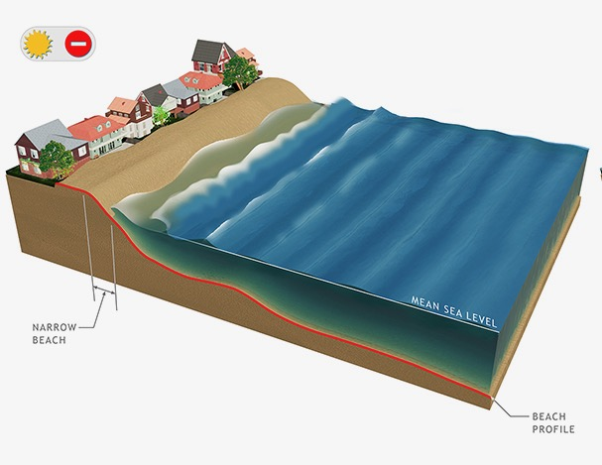
Beaches provide for storm protection, coastal recreation, and ecological habitat. Natural and man-made forces have contributed to the chronic erosion of Puerto Rico’s coastal beaches, reducing space for beach activities, increasing the potential for coastal storm damages, and reducing habitat.
Current Beach Quality in San Juan: The width of the dry sand beach from the dune to the ocean in San Juan is between 3 and 30 meters at high tide, with an average of 18 meters.

B3. How would you rate the current beach width in San Juan?
Category | Very Poor | Poor | Neutral | Good | Very Good
Rating | 1 | 2 | 3 | 4 | 5

B4. How many recreation trips do you expect to take San Juan beaches over the next 3 months?

_____________ trips over next 3 months

Continued erosion in San Juan could further reduce beach width in the years to come. Suppose beach width decreased from an average of 18 to 10 meters.
B5. How would this affect your beach recreation experience?

Category | Much Worse | Worse | Neutral | Better | Much Better
Rating | 1 | 2 | 3 | 4 | 5

B6. Think about the number of recreation beach trips that you plan to take to this San Juan over the next 3 months. Would such a change in beach conditions affect your planned beach trips?
- Yes
- No (skip to Section C)
- Don’t know

B7. How would you change your planned trip?
- Cancel trip(s)
- Change number of trips: How many more? ____ How many less? _______
- Change length of trip: How much longer? ____ How much shorter? _______
- Relocate to another part of coast
- Do something else [write in: __________________________________]
Section C: Coastal Erosion Management

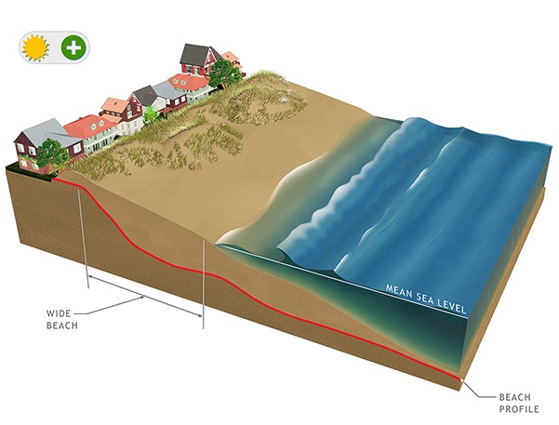 | Adding beach sand - providing additional space for storm protection and recreation (through beach replenishment and improved sediment management)
Environmental managers are considering a coordinated program for the protection of Puerto Rico shorelines. The project aims to protect coastal properties and infrastructure, maintain recreation and tourism, and maintain beach habitat for species such as turtles and birds.The shoreline protection projects can have a number of components, including:
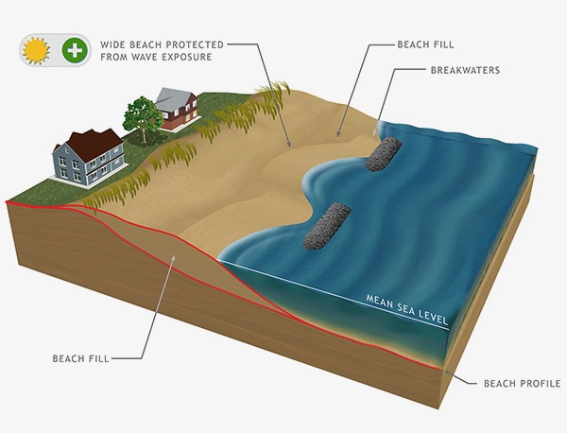 | Installing breakwaters (shore-parallel rock structures offshore) - trapping sand to improve the beach, reducing wave energy, improving fish habitat, and enhancing diving and snorkelling
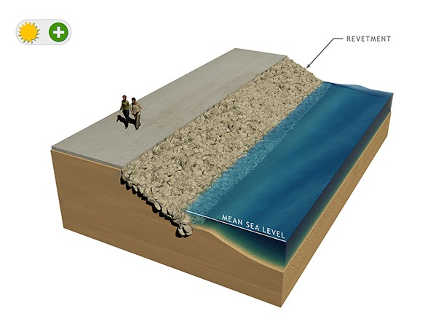 | Installing stone revetment (sloping rock wall) - protecting coastal property

C1. In general, how do you view the following coastal erosion and storm management options?
 | Strongly  Oppose | Oppose | Somewhat  Oppose | Not Sure | Somewhat  Support | Support | Strongly  Support
Beach replenishment (adding sand to the beach) | 1 | 2 | 3 | 4 | 5 | 6 | 7
Breakwaters (shore-parallel offshore structures) | 1 | 2 | 3 | 4 | 5 | 6 | 7
Revetments/seawalls (to protect property) | 1 | 2 | 3 | 4 | 5 | 6 | 7

We are interested to learn about Puerto Rico residents’ views on management programs to control beach erosion and reduce storm risk.
• The management program would be conducted jointly by the US Army Corps of Engineers and the Puerto Rico Department of Natural and Environmental Resources.
• The program can improve beach conditions, enhance fish habitat, improve diving quality in nearshore waters, and protect coastal property along the public beaches in Puerto Rico
• The coastal erosion management program must be paid for with matching funds from the Commonwealth of Puerto Rico in the form of a one-time surcharge on income taxes.
• Currently:
- Beach width varies in San Juan, ranging between 3 and 30 meters
- About 10% of beaches have been fortified with revetment and seawalls (to protect property)
- There are no large-scale breakwaters currently in place

Paying the one-time tax increase to support improvements in Puerto Rico’s beaches means your household would have less money to spend on other things such as food, clothes, trips, and other programs that address environmental problems that you may care about. It is very important that you answer these questions as if you were making a real choice. You need to imagine that people like you actually have to dig into their household budgets and pay the additional costs.

C2. Do you understand the above scenario and are you willing and able to provide feedback on funding of coastal erosion management plans in Puerto Rico?
- Yes
- No (please reread the above information and continue to the next section)
- Not sure (please reread the above information and continue to the next section)

Voting on a Coastal Erosion Management Plan
A coastal erosion management plan would provide Federal participation for 50 years and can:
• Increase average beach width from 18 meters to 25 meters (modest increase) or 35 meters (large increase)
• Install large-scale breakwaters to reduce wave energy, improve fish habitat, and enhance diving
• Increase the amount of shoreline revetment to protect additional properties (15% of the shoreline) or maintain and repair the existing revetment (on 10% of the shoreline)
• The additional tax payment would cost your household between $5 and $75 (one-time)

The results of this study will be made available to policy makers and could serve as a guide for future shoreline management and local financing decisions.
Suppose that a coastal erosion program was on the ballot as a referendum.
• If a majority of Puerto Rican households vote to support and fund the program, the program would be implemented, and all households would have to pay the additional tax.
• If a majority voted not to support and fund the program, the program would not be implemented, and no households would have to pay additional taxes.
• Please vote as if this referendum were actually on the ballot.
C3. If the following erosion management program was on the ballot, would you vote for or against it? Please note the features of the program and the cost to your household.
 |  | Beach Conditions
Program Attributes |  | Erosion Control Program | .2 | .2 | No program
Beach Width |  | 35 meters |  |  | 18 meters
Breakwaters |  | YES |  |  | NO
Stone Revetment |  | 15% of shoreline |  |  | 10% of the shoreline
One-time surcharge on Income Tax |  | $30 |  |  | $0
I would vote for
Please mark one of the boxes to the right

C4. How certain are you of the selection you made on this question?
Category | Very Uncertain | Uncertain | Not sure | Certain | Very Certain
Rating | 1 | 2 | 3 | 4 | 5

C5. Next, consider the following erosion management program that could be on the ballot. Independently of you answered the first question, would you vote for or against this program? Please note the features of the program and the cost to your household.
 |  | Beach Conditions
Program Attributes |  | Erosion Control Program | .2 | .2 | No program
Beach Width |  | 25 meters |  |  | 18 meters
Breakwaters |  | NO |  |  | NO
Stone Revetment |  | 15% of shoreline |  |  | 10% of the shoreline
One-time surcharge on Income Tax |  | $15 |  |  | $0
I would vote for
Please mark one of the boxes to the right

C6. How certain are you of the selection you made on this question?
Category | Very Uncertain | Uncertain | Not sure | Certain | Very Certain
Rating | 1 | 2 | 3 | 4 | 5

C7. Next, consider the following erosion management program that could be on the ballot. Independently of you answered the first question, would you vote for or against this program? Please note the features of the program and the cost to your household.
 |  | Beach Conditions
Program Attributes |  | Erosion Control Program | .2 | .2 | No program
Beach Width |  | 25 meters |  |  | 18 meters
Breakwaters |  | YES |  |  | NO
Stone Revetment |  | 10% of shoreline |  |  | 10% of the shoreline
One-time surcharge on Income Tax |  | $15 |  |  | $0
I would vote for
Please mark one of the boxes to the right

C8. How certain are you of the selection you made on this question?
Category | Very Uncertain | Uncertain | Not sure | Certain | Very Certain
Rating | 1 | 2 | 3 | 4 | 5

C9. Next, consider the following erosion management program that could be on the ballot. Independently of you answered the first question, would you vote for or against this program? Please note the features of the program and the cost to your household.
 |  | Beach Conditions
Program Attributes |  | Erosion Control Program | .2 | .2 | No program
Beach Width |  | 20-50 meters |  |  | 3 - 30 meters
Breakwaters |  | NO |  |  | NO
Stone Revetment |  | 15% of shoreline |  |  | 10% of the shoreline
One-time surcharge on Income Tax |  | $5 |  |  | $0
I would vote for
Please mark one of the boxes to the right

C10. How certain are you of the selection you made on this question?
Category | Very Uncertain | Uncertain | Not sure | Certain | Very Certain
Rating | 1 | 2 | 3 | 4 | 5

C11. Do you think the results of this survey will be used by policy makers to make decisions about what shoreline protection features to use in the erosion management program?

Very Unlikely | Unlikely | Somewhat  Unlikely | Not Sure | Somewhat Likely | Likely | Very Likely
1 | 2 | 3 | 4 | 5 | 6 | 7

C12. Do you think the results of this survey will be used by policy makers to make decisions about local taxation policies for financing beach erosion management?
Very Unlikely | Unlikely | Somewhat  Unlikely | Not Sure | Somewhat Likely | Likely | Very Likely
1 | 2 | 3 | 4 | 5 | 6 | 7

C13. How important are the following motivations to how you answered the above beach management scenarios?

 | Not at all  Important | Unimportant | Somewhat  Unimportant | Neutral | Somewhat Important | Important | Very Important
a) Maximizing recreational opportunities | 1 | 2 | 3 | 4 | 5 | 6 | 7
b) Improving habitat for species | 1 | 2 | 3 | 4 | 5 | 6 | 7
c) Protecting communities from natural hazards such as hurricanes | 1 | 2 | 3 | 4 | 5 | 6 | 7
d) Maximizing Puerto Rico’s tourism potential | 1 | 2 | 3 | 4 | 5 | 6 | 7
e) Improving coastal aesthetics | 1 | 2 | 3 | 4 | 5 | 6 | 7
f) Protecting land from erosion | 1 | 2 | 3 | 4 | 5 | 6 | 7

C14. Previously, you stated that your planned visits/trips to the beach over the next 3 months.
Beach Width | Bulkheads | Revetment
3 – 30 meters | Yes | No
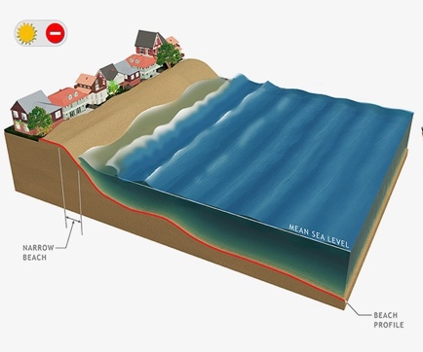 | 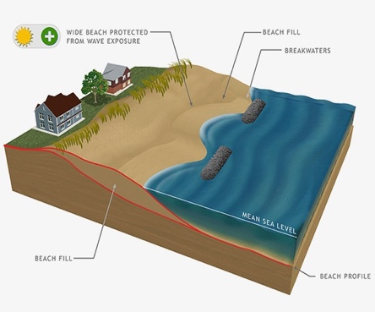 | 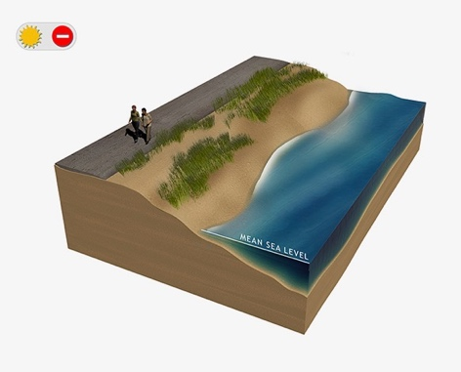
How would the planned visits/trips change if you anticipated the following conditions at Puerto Rico’s public beaches:

How many visits/trips would you make under the conditions noted above?
- The same number of visits/trips over the next 3 months
- More visits/trips over the next 3 months: How many more? _______
- Less visits/trips over the next 3 months: How many less? ________

C15. How much do you agree or disagree with the following statements?
 | Strongly  Disagree | Disagree | Neutral | Agree | Strongly  Agree
a) Tourism helps me pay my bills | 1 | 2 | 3 | 4 | 5
b) A portion of my income is tied to tourism in Puerto Rico | 1 | 2 | 3 | 4 | 5
c) I would economically benefit from more tourism development in Puerto Rico | 1 | 2 | 3 | 4 | 5
d) My family’s economic future depends on tourism in Puerto Rico | 1 | 2 | 3 | 4 | 5

C16. How much do you agree or disagree with the following statements about Puerto Rico’s tourism industry?
 | Strongly  Disagree | Disagree | Neutral | Agree | Strongly  Agree
a) I believe tourism should be actively encouraged in Puerto Rico | 1 | 2 | 3 | 4 | 5
b) I support tourism and want to see it remain important to Puerto Rico | 1 | 2 | 3 | 4 | 5
c) Puerto Rico should remain a tourist destination | 1 | 2 | 3 | 4 | 5
d) Puerto Rico should support the promotion of tourism | 1 | 2 | 3 | 4 | 5
Section D: About You and Your Household

Answers to the following questions will help us to better understand the visitors we serve. Your responses are completely anonymous. But if you prefer not to answer any question, just leave it blank

D1. Do you own a home or other property that is on or very close to the sea?
- Yes
- No

D2. What is your ethnic background?
- Hispanic or Latino
- Not Hispanic or Latino

D3) What is your race? Select all that apply.
- American Indian or Alaskan Native
- Asian
- Black or African American
- Native Hawaiian or Other Pacific Islander
- Hispanic
- White
- Other (Please be specific) ______________________________

D4) What is your employment status?

Full-time 1
Part-time 2
Homeworker 3
Student 4
Unemployed 5
Retired 6

D5) What is the highest level of education you have completed?

Less than high school 1
High school or GED 2
Technical, vocational or trade school 3
Some college (includes jr. college) 4
Bachelor’s degree 5
Master’s degree 6
Ph.D./Professional degree 7

D6) Including yourself, how many people are in your household? _______________

D7) How many children (under age 18) are in your household? __________________

D8) What is your approximate annual household income before taxes?

Less than $5,000 1
$5,000-$9,999 2
$10,000-$19,999 3
$20,000-$29,999 4
$30,000-$39,999 5
$40,000-$49,999 6
$50,000-$74,999 7
$75,000-$99,999 8
$100,000-$199,999 9
$200,000 or greater 10
Prefer not to answer 11

D9) What year were you born? ___________ (year)
D10) Please note below any additional comments about Puerto Rico beaches you would like to share.

__________________________________________________________________________________________________________________
__________________________________________________________________________________________________________________

__________________________________________________________________________________________________________________

__________________________________________________________________________________________________________________
Thank You for Participating!

