Contents
Acknowledgements v
Abbreviations v
Introduction to Red Carpet Entry 1
Background 1
The History of RCE 1
Effectiveness of RCE 2
Using This Implementation Manual 2
Overview of Red Carpet Entry 3
RCE Core Components 3
RCE Key Players 3
RCE Theoretical Foundation and Logic Model 4
Associated Costs and Required Resources for Implementing RCE 4
Is RCE Right for Your Clinic? 5
Planning and Preparation for Red Carpet Entry 6
Assess Clinic and System Readiness 6
Assess RCE Readiness 6
Organizational Motivation 6
Leadership Support 6
Staff Buy-in 6
Clinic Capacity 7
Funding and Sustainability 7
Staff Resources 8
Staff Training 10
Client Referrals 10
Clinic Workflows and Processes 11
Monitoring and Evaluation 11
Client Population 12
Understanding Your Client Population 12
External Environment 12
Connection to External Partners and Resources 12
Promoting RCE 12
Red Carpet Entry Implementation 13
Client Journey Through RCE 13
RCE Patient-Centered Approach 13
Active Client Engagement 13
Warm Handoffs 13
RCE Referral Process 14
RCE Visit 15
Purpose of the RCE Visit 15
RCE Visit Snapshot 15
Delivery of the RCE Visit 15
RCE Outreach and Reengagement 18
Purpose of RCE Outreach 18
Delivery of RCE Outreach 18
Troubleshooting 20
Scenario 1 – A Client Has No Insurance 20
Scenario 2 – No Appointment Availability with the HIV Specialist 20
Scenario 3 – Loss of Contact with an RCE Client 21
Scenario 4 – Patient Calls the Clinic with the RCE Discreet Phrase “Red Carpet Entry” 21
Scenario 5 – RCE Client Misses Their Initial RCE visit 21
Implementation Study 22
Eligibility Criteria 22
Screening for Eligibility 22
Enrollment 22
Monitoring and Evaluation 23
Steps for Monitoring Progress 23
Access Database Reports 23
Report Cards 23
Data Collection 24
Key Benchmarks 24
Making Changes and Informing the Toolkit 24
RCE Client Input 24
Sharing Progress with Partners, Stakeholders, and Other Audiences 24
References 25
Appendix A. RCE Logic Model 26
Appendix B. Sample Memorandum of Agreement 27
Appendix C. Intake Form 30
Appendix D. Participant Screener 33

List of Figures
Figure 1. System-Level RCE Players 9
Figure 2. Red Carpet Entry Theory 9
Figure 3. Client Journey Through Red Carpet Entry 19
Figure 4. Client Journey Through their RCE Visit 22
Figure 5. RCE Outreach Process 25

List of Tables
Table 1. Roles and Responsibilities 8
Table 2. Red Carpet Entry Sample Marketing Materials 11

Acknowledgements
Implementation of Red Carpet Entry (RCE) was originally conducted by Whitman-Walker Health (WWH) and DC Health’s HIV/AIDS, Hepatitis, STI, and TB Administration (HAHSTA).

Abbreviations
- ACE: Active Client Engagement
- CBO: Community-based organization
- CDC: Centers for Disease Control and Prevention
- CTR: Counseling, Testing, Referral
- EHE: Ending the HIV Epidemic: A Plan for America
- HAHSTA: DC Health’s HIV Aids, Hepatitis, STI, and TB Administration
- HIPAA: Health Insurance Portability and Accountability Act of 1996
- HIV: Human Immunodeficiency Virus
- IS: Implementation Study
- MOA: Memorandum of Agreement
- RCE: Red Carpet Entry
- SOP: Standard Operating Procedure
- WWH: Whitman-Walker Health

1 | Introduction to Red Carpet Entry

Background
Ending the HIV Epidemic: A Plan for America (EHE) aims to reduce new human immunodeficiency virus (HIV) infections by 90% by 2030 by diagnosing, treating, and preventing new HIV infections.¹ In 2018, Centers for Disease Control and Prevention (CDC) data indicated approximately 76% of people living with HIV (aged 13 or older, diagnosed and undiagnosed) received HIV medical care. Furthermore, only 58% were retained in continuous care.² Structural barriers, such as unemployment, transportation issues, unstable housing, or lack of health insurance are factors that hinder patients’ ability to remain in care.³ Linkage to and retention in HIV care can result in lower viral loads, improved CD4 cell counts, and an overall reduction in morbidity and mortality.³ There is a critical need for interventions and programs that overcome the structural barriers that people living with HIV often face and increase their linkage to and retention in care.
Defining RCE
Red-Carpet Entry (RCE) is a patient-centered structural intervention for healthcare systems that aims to link people with HIV who are newly diagnosed or returning to care within 72 hours of referral. RCE strives to make seeking and staying in treatment the easy choice by helping address structural and individual barriers to care. This is accomplished through the following:
- Establishing referral networks;
- Designating an RCE Concierge who receives referrals from HIV counseling, testing, and referral (CTR) partners or self-referrals from clients and then coordinates engagement in care;
- Adopting a redesigned first appointment that emphasizes warm handoffs and referrals to wraparound services, which will support the client’s engagement in care; and
- Using positive and supportive messaging around making the transition into care as smooth and easy as possible and commending that the patient is seeking treatment.

The History of RCE
RCE was born out of the need to better serve the District of Columbia community by facilitating fast-track access and entry into HIV medical care by people living with HIV who are newly diagnosed or who are not currently receiving care.

RCE at Whitman-Walker Health
In 2008, Whitman-Walker Health (WWH)—a community health center in Washington, DC—designed RCE to facilitate immediate entry into HIV care among people newly diagnosed with HIV or new to HIV care. “Red Carpet” was the brainchild of Dr. Kunthavi Sathasivam and was so called because WWH leadership and staff wanted patients facing a new HIV diagnosis to feel the health center was “rolling out the red carpet” to promote patient engagement and remove barriers to care. This meant immediately connecting newly diagnosed patients with their entire care team. Since then, RCE continues to expand at WWH. In November 2017, RCE incorporated a same-day start of HIV medication initiative titled “Fast Forward.”

RCE at DC Health
Following this, DC Health’s HIV/AIDS, Hepatitis, STI, and TB Administration (HAHSTA) initiated a series of community meetings with program executives and medical providers from clinics, hospitals, and community-based organizations (CBOs) across the city to adapt and disseminate RCE throughout DC. Eighteen medical facilities and community organizations signed on to the RCE strategy of care—including providing HIV assessments to patients the same day or within 72 hours of their positive test, appointing a Red Carpet Concierge accessible by mobile phone, and creating a discreet phrase used to identify priority patients in need of services—with the goal of shortening the waiting period and removing barriers to HIV treatment and care. Because of this community partnership, outcomes around HIV testing, linkage to medical care, engagement in medical care, prescription of antiretroviral therapy, and viral suppression improved markedly after RCE implementation.

Effectiveness of RCE
An evaluation of DC Health’s RCE found that 70% of newly diagnosed people with HIV were linked to care within 72 hours.⁴ RCE also has been adapted to improve outcomes among youth in Kenya; a healthcare facility– and school-based program increased rates of linkage to care from 57% to 97% and 3-month retention in care from 66% to 90%.⁵ Based on this evidence, the CDC designated RCE as an evidence-informed structural intervention in their Compendium of Evidence-based Interventions and Best Practices for HIV Prevention.⁶
[TBD] – Update outcome data from the RCE IS when available to demonstrate the benefits/impact.
Watch the RCE Orientation Video to learn more about RCE’s background and impact.

Using This Implementation Manual
This manual is designed to provide step-by-step guidance for RCE planning, implementation, monitoring, and evaluation, with the overarching goal of increasing implementation consistency and linkage outcomes for clients with HIV.
This manual includes strategies to help clinic staff:
- Plan and prepare for RCE implementation by onboarding and training clinic staff,
- Implement RCE following step-by-step instructions,
- Find solutions to potential implementation challenges, and
- Understand the strategies used to monitor and evaluate RCE.
[TBD] – After the IS, the last bullet point will be updated to “Know how to monitor and evaluate RCE to make improvements over time”.
Key Points of Contact
[Will remove contact information from manual after IS]
Alexa Ortiz, Clinic Liaison  Phone: 919-316-3344  Email: amortiz@rti.org | Brittany Zulkiewicz, Clinic Liaison  Phone: 781-370-4055  Email: bzulkiewicz@rti.org

Overview of Red Carpet Entry

RCE Core Components
RCE is defined by six core components:
- The RCE agency establishes a referral network with partner organizations and conducts marketing to reach and promote awareness among eligible clients.
- The RCE agency establishes a discreet phrase (such as “Red Carpet Entry”) for self-referrals and CTR referrals to request RCE service.
- The RCE Concierge receives client referrals.
- The client receives the following services during a visit to the RCE agency within 72 hours of referral:
  - Speaks with the RCE Concierge;
  - Completes a brief intake process (30 minutes or less);
  - Receives laboratory tests, including a confirmatory viral load test and other tests to assess medical status;
  - Discusses insurance and financial assistance programs;
  - Meets with an HIV care provider; and
  - Receives referrals to wraparound services, if necessary.
- Reengagement is attempted through RCE Outreach and Reengagement if the RCE Concierge is unable to establish contact with the client or if the client does not attend their RCE visit.
- The client is engaged through Active Client Engagement (ACE) and warm handoffs at all steps in RCE.
These core components of RCE serve to engage individuals living with HIV who have been newly diagnosed or who have been out of care with affirming and supportive HIV care and to make their transition into care as smooth and easy as possible.

RCE Key Players
Two separate but intertwined components are required for successful implementation of RCE (Figure 1).

- Implementation System: This includes the HIV care clinics, health departments, community health clinics, and CBOs that refer clients into RCE and/or provide wraparound services to RCE clients. The implementation system supports successful implementation of RCE at the organizational level.
- RCE Implementation Team: This includes the key staff responsible for implementing and monitoring the core components of RCE, including warm handoffs, appointment scheduling, the RCE Visit, and ACE. The implementation team supports successful implementation of RCE at the individual level.
The specific components of these two systems are detailed in Figure 1. Additional details about staff roles and responsibilities also are covered in Chapter 2.
[TBD] – Other key players and their credentials/skills across both the implementation system and the RCE implementation team will be updated based on those identified during the IS.

Figure 1. System-Level RCE Players
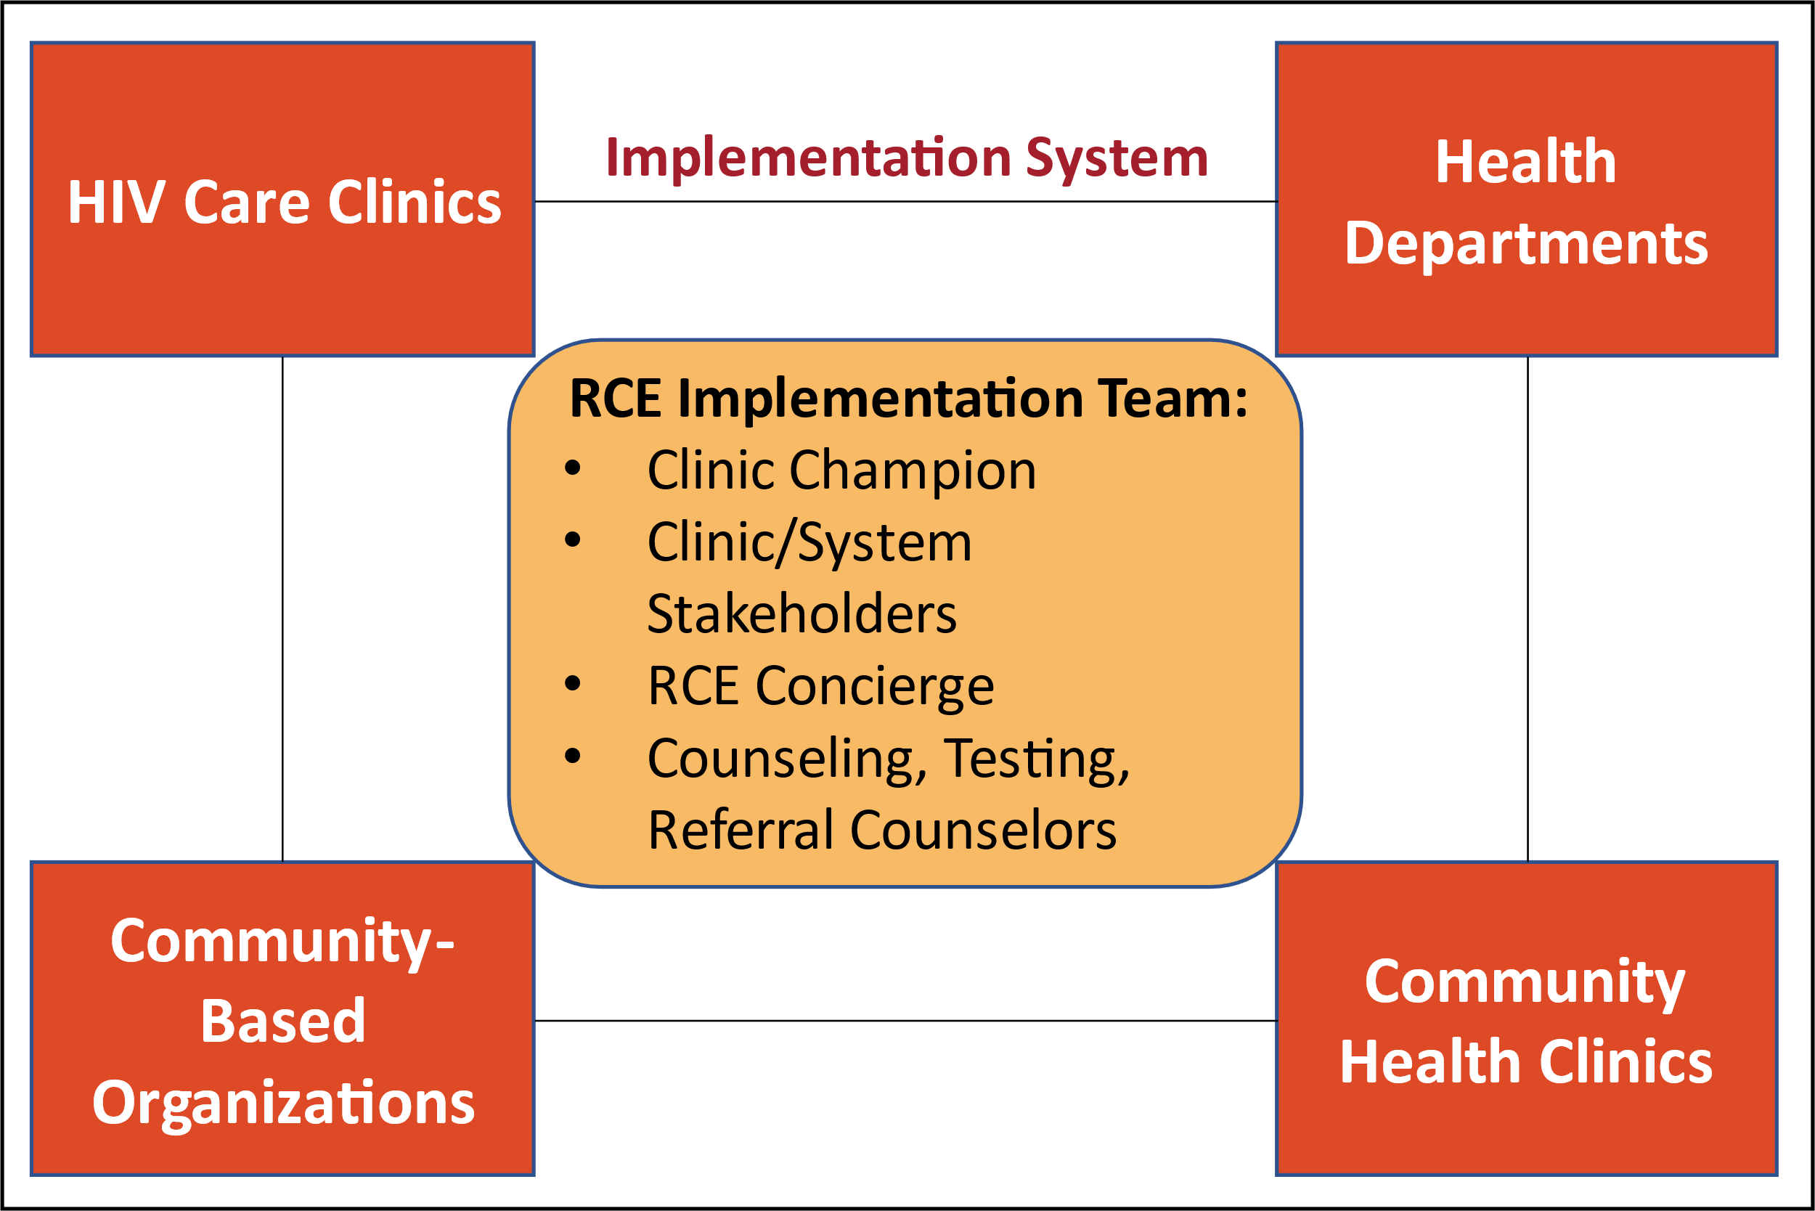

View the RCE Quick Guide to learn how these key players interact and the responsibilities of each.

RCE Theoretical Foundation and Logic Model
RCE is theorized to improve individual health outcomes, decrease community-level viral load, and decrease population-level HIV incidence by quickly engaging newly diagnosed patients in HIV care through rapid referral, as shown in Figure 2. The RCE logic model that outlines strategies, outputs, outcomes, and impacts is provided in Appendix A.

Figure 2. Red Carpet Entry Theory
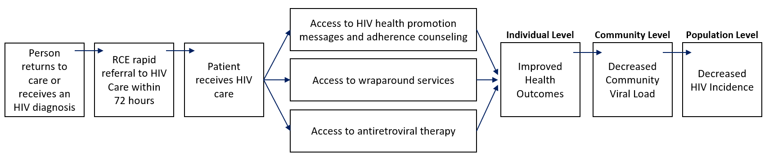

Associated Costs and Required Resources for Implementing RCE
[TBD] – A rough estimate of the monthly and annual costs will be included after the IS.

Is RCE Right for Your Clinic?
The list below will help you assess whether your clinic is facing the needs or challenges that RCE aims to address:
- Your clinic serves a community with a high incidence of newly diagnosed HIV cases.
- Your clinic schedulers frequently cannot accommodate the appointment needs of newly diagnosed HIV clients for several weeks or months.
- Your clinic relies on linkages to additional supportive wraparound services—such as mental health services, substance abuse services, housing support, or nutritional assistance—to serve your patient population.

2 | Planning and Preparation for Red Carpet Entry

Assess Clinic and System Readiness

Assess RCE Readiness
Use the questions in the readiness worksheet (linked below) to assess what your clinic and larger implementation system need to do to prepare to implement RCE and to identify specific changes you need to make before implementing RCE. The domains covered in the readiness worksheet include the following:
- Organizational Motivation: leadership support, staff buy-in, and organizational culture.
- Clinic Capacity: funding and sustainability, staff resources, staff training, client referral, clinic workflows and processes, and monitoring and evaluation.
- Client Population: defining and understanding your target client population, such as demographics, needs, health insurance status of target RCE clients, and clinic processes to ensure confidentiality and reduce stigma.
- External Environment: connection to external partners and resources available to RCE clients.

[TBD] – After the IS, will add additional information about how clinics can address areas requiring change in order to be considered “ready”.
View the RCE Readiness Worksheet to assess if your clinic is ready to implement RCE.

Organizational Motivation

Leadership Support
Before implementing RCE, it is critical to obtain buy-in from the leadership within your organization, such as health system leaders or clinic management. Leadership buy-in is especially helpful if RCE is expected to disrupt or require significant changes to your clinic’s workflow or staffing structure. Staff in leadership positions will need to understand the purpose of RCE and how it would benefit your clinic’s patient population. Work with your leadership to identify goals that RCE will accomplish and set a trial period to assess progress toward those goals.
[TBD] - Will confirm with IS sites what methods and materials are most helpful to obtain leadership buy-in and update the IM accordingly.

Staff Buy-in
Staff buy-in is also vital to the success of RCE. Clinic staff need to be on the same page about why RCE is being implemented, the problem RCE is addressing, and the overall goal of patient engagement that RCE is trying to achieve. Staff input is a necessary component to achieving staff buy-in. Discussions with staff—both informal and/or in a structured setting such as clinic huddles or team meetings—can help confirm if clinic staff are open to workflow changes. These conversations can also help uncover potential implementation barriers to RCE—such as feeling overworked and understaffed—and possible facilitators or approaches to overcoming these barriers. Each clinic site should determine the optimal method and time to gather staff input. Additionally, consider what motivates your staff and how you might be able to leverage existing or newly created incentives to bolster staff buy-in to RCE.
[TBD] - Will confirm with IS sites what methods and materials are most helpful to obtain staff buy-in and update the IM accordingly.
Organizational Culture
Organizational culture is often driven by preexisting policies and procedures such as:
- Cultural competence,
- Insurance accepted and funding/programs to support uninsured clients,
- Operating hours and staff availability,
- Scheduling protocols, and
- Space usage, such as keeping rooms open for impromptu discussions and nonmedical visits.
Some of your clinic’s policies and procedures may need to be amended to support the patient-centered and immediate care delivery processes required by RCE. Also, RCE may require the development of new policies and procedures with guidance specific to RCE. These may include the following:
- Establishing RCE after-hours operations if appropriate to your implementation system and patient population,
- Determining how to handle nonmedical visits,
- Making referrals to external wraparound services.
- Deciding whether to provide staff’s direct contact information—such as cell phone number or direct lines—to RCE clients and permitting text messaging,
- Establishing partnerships/communication channels with testing sites, and
- Adjusting intake paperwork and procedures to make them easier, more patient-centered, and less overwhelming for clients.

Clinic Capacity

Funding and Sustainability
Healthier patients will require less complex care and fewer clinic resources. Your clinic can use data from the RCE trial period to show staff time requirements, budget impacts, potential return on investment, and sustainability of RCE. Your local or state health department might also offer additional funding opportunities.
[TBD] - Will update with additional funding/sustainability guidance after the IS.

Staff Resources
RCE Quick Tip
Consider the following questions during participatory goal setting:
- WHAT outcomes would contribute to RCE success?
- WHY are these outcomes important to you?
- HOW will you achieve these outcomes?

Team Roles and Responsibilities
RCE requires that staff both within and across organizations work cohesively to provide the most stress-free experience possible for clients seeking treatment for their HIV. Having positive personal relationships is among the most important factors in employee engagement. Activities such as participatory goal setting and regular team check-ins can provide a shared understanding of purpose, increase interpersonal connection, and stimulate communication and cooperation. Similarly, clear and open communication encourages feelings of trust and cohesion. Table 1 provides an overview of the RCE roles and responsibilities.
Table 1. Roles and Responsibilities
Role | Responsibilities
Champion  Staff member who holds a management-level position—such as a physician or clinic manager. | Preparation | - Oversee preparation for implementation, secure leadership buy-in, and review the proposed RCE workflow.
 | Delivery | - Support RCE staff, troubleshoot problems with the RCE team, and monitor RCE adherence and fidelity.  - Motivate the team, recognize staff for their effort, and publicly celebrate RCE successes.
RCE Concierge  Staff member who has strong interpersonal and communication skills, is embedded within the clinic workflow, and routinely interacts with patients.  [Will update with recommendations of existing staff who could play this role after IS.] | Preparation | - Oversee preparation for RCE and assist your Clinic Champion with securing leadership buy-in.
 | Delivery | - Facilitate the RCE client’s warm handoffs to medical care and/or internal or external resources following the initial contact.  - If the RCE Visit is missed, make two attempts to directly engage the client, reschedule the client’s appointment, and address barriers that led to the missed appointment.  - If these outreach attempts are unsuccessful, contact the CTR referral source to inform the CTR Counselor of the patient’s absence​ at their RCE Visit.  - Identify RCE program implementation issues and work with the Clinic Champion to troubleshoot, as needed.  - [will remove from manual after IS] During the Implementation Study (IS), the RCE Concierge will also be responsible for data collection.
CTR Counselor  Staff who routinely connect clients to or provide clients with HIV-related services. Internal CTR Counselors are housed within your clinic system such as in an STD clinic or emergency room. External CTR Counselors are housed in CBOs such as mental and behavioral health services, shelters, or LGBTQ+ centers. | Preparation | - Assist the RCE Concierge with preparation for RCE, as needed.
 | Delivery | - Identify and refer clients to RCE.  - If the initial RCE appointment is missed and the RCE Concierge is unable to engage the client, make at least two attempts to connect the client to the RCE Concierge.  - If contact is established, coordinate with the RCE Concierge as needed to reschedule the client’s appointment and address any barriers that led to the missed appointment.
(continued)

Table 1. Roles and Responsibilities (continued)
Role | Responsibilities
HIV Specialist  An HIV Specialist is a medical provider—such as a physician, nurse practitioner, or physician assistant—who provides HIV primary care services. | Preparation | - Help the Clinic Champion and RCE Concierge promote the program prior to implementation to obtain staff buy-in.
 | Delivery | - Briefly introduce yourself to the client during the initial RCE visit.
HIV Navigator  An HIV Navigator is a staff member who links the client to additional wraparound services. This role could be filled by the RCE Concierge, a care/case manager, or a social worker. | Preparation | - Establish familiarity with the wraparound services that your clinic offers and the services that require a referral.
 | Delivery | - Facilitate the client’s referral to wraparound services, as needed.

[TBD] - Additional roles will be defined and added after the IS.
[TBD] - If we are able to gather the information before or after the IS, we also will include the expected amount of time/hours each of these people will spend on RCE.

Key Staff Availability
RCE Commitment Pledge
Together as the RCE team, we will strive to link those diagnosed with HIV to care and wraparound services quickly and smoothly regardless of when or where they learned of their diagnosis. We will treat all clients with respect and dignity and will give them the attention and care they deserve.
It will be important to clearly define and confirm the availability of staff who will assume the various RCE roles and which staff will serve in backup roles. In addition to primary staff, your clinic should identify and train alternate staff members to cover any absence of the designated RCE Concierge or other key staff. Identifying, confirming, and coordinating across RCE roles promotes teamwork, helps ensure a smooth implementation, reduces confusion or duplication of efforts, and prevents potential gaps in service for RCE clients. A sample staff RCE pledge is shown in the callout box “RCE Commitment Pledge.” This pledge is a quick way to remind staff of the purpose of RCE. Consider printing this out and posting it in a common room or encouraging staff to post it on a wall by their desk.

Hire to Fill Potential Gaps
Evaluate the staff currently available and those assigned to key roles. RCE implementation may create additional staff responsibilities and potentially increase your clinic’s patient population. Your clinic may need to hire one or more staff members to fill gaps and address increases in staff workload given the level of effort anticipated for each role.

Notify Non-Implementation Staff
Ensure that clinic staff who are not directly involved in RCE implementation understand the goal and core components of RCE. This can be achieved by providing a brief handout or slide deck outlining basic information about RCE and how its implementation will impact your clinic, such as the different use of space or exam rooms and warm handoffs at the front desk. Non-implementation staff are very important to the overall success of RCE and can also be provided with the RCE Client Palm Card (discussed in Table 2), which they can share with potentially eligible RCE clients. Non-implementation staff may include the following:
- Laboratory technicians  - Medical assistants  - Physical therapists | Social workers  Other specialty providers
[TBD] - Will confirm with IS sites what materials and strategies are most helpful to non-implementation staff and update the IM accordingly.

Staff Training
Several resources are available to assist with preparing and training the core implementation staff.
The RCE Video Training Modules present guidance on how to implement the core components of RCE. | The RCE Quick Guide provides an at-a-glance resource of need-to-know information that staff can keep at their desk.

After reviewing the training resources linked above, assess the team’s understanding of RCE. Conducting dry runs and/or role-playing scenarios allows the team to obtain firsthand experience with RCE, help identify potential barriers prior to implementation, and ensure the client has a positive experience in which they feel affirmed and supported.

Client Referrals
Before patients can be enrolled into RCE, it is important to identify where potential clients are coming from within the implementation system, such as HIV care clinics, health departments, community health clinics, and CBOs (Figure 1). Marketing materials can be used to increase awareness of RCE and its benefits among people eligible for RCE (primary audience) and for partners and referrers (secondary audience). The aim of these materials is to encourage self-referrals into RCE and provide more information for clients referred from an offsite testing and/or referral site.

Table 2 outlines all sample marketing materials provided as part of this toolkit. These materials can be customized to include the phone number/email address for the RCE Concierge or your clinic’s website.

Table 2. Red Carpet Entry Sample Marketing Materials
Item | Audience | Purpose | Link
Palm Cards | RCE Client | - Hard-copy materials to be made available in clinics and partner organizations as a resource to current and potential RCE clients.  - Introduces RCE to potential clients, outlines RCE eligibility, and provides contact information for the RCE Concierge, who they can contact directly to self-refer into RCE.  - Can serve as a reminder to enrolled RCE clients about RCE’s benefits and their RCE point of contact. | Client  Palm Card
Palm Cards | Clinic Staff | - Hard-copy materials to be made available in clinics and partner organizations as a resource to clinic staff.  - Serves as a quick guide, reminding clinic staff of RCE eligibility and who can be contacted for referrals and RCE-related questions. | Clinic Staff  Palm Card
Social Media Ads | Potential RCE Clients | - Electronic materials available for clinics and their partners to share through their social media accounts to expand RCE visibility and encourage self-referrals.  - Includes branded graphics for Twitter, Facebook, and Snapchat and sample text to include in the posts.  - [will remove from manual after IS] For the IS, RTI will pay for and implement dissemination of the social media ads. RTI also will make the social media graphics and posts available to the IS sites, should they want to share them on their social media accounts. | Social Media  Ads

Clinic Workflows and Processes
RCE Quick Tip
Creating new workflows is not always necessary. Pre-existing clinic workflows and processes can be adapted to fit RCE.
Before RCE is implemented at your clinic, it is important to confirm a sample RCE workflow by physically walking through your clinic following that workflow. Reviewing the RCE workflow early helps to identify potential barriers and leads to discussions about solutions. This ensures RCE implementation and placement of RCE marketing materials align with clinic resources, layout, and processes.
[TBD] – Will add an example review of clinic workflow from the IS.

Monitoring and Evaluation
Monitoring and evaluation of RCE is discussed in Section 4.

Client Population

Understanding Your Client Population
RCE is designed for anyone who is
- Newly diagnosed with HIV, or
- Living with HIV and not receiving care.
To maximize RCE’s impact, it is vital to understand the characteristics of your client population, including what motivates them to seek care and what barriers to care they are experiencing, then map out how RCE can help. For example, the prompt, easy access process used by RCE—including warm handoffs, a dedicated care team, and linkage to wraparound services—is especially beneficial for clients who may not have entered HIV treatment previously because of logistical, financial, and/or emotional barriers.

External Environment

Connection to External Partners and Resources
Engaging partners establishes a referral network for RCE clients and provides them with access to additional services beyond those offered at the HIV care clinic. This network of referral partners includes testing sites, wraparound service providers, pharmacies, CBOs, and external/standalone healthcare clinics. Examples of potential partners include the following:
RCE Quick Tip
If your clinic is part of a larger healthcare system, do not forget to engage internal partners. Other units within your organization also can refer potential RCE clients.
- Health departments,
- Shelters and food banks,
- Healthcare transportation services,
- Employment services/job programs,
- Immigration counseling services,
- LGBTQ+ advocacy or peer support groups,
- Substance use and addiction treatment providers, and
- Mental and behavioral health services.
Establishing a Memorandum of Agreement (MOA) between your clinic and external organizations is a great way to formalize relationships and establish a shared commitment to improving linkage to care and care delivery for people living with HIV. A sample MOA is provided in Appendix B. This is a de-identified example of an informal contract (i.e., not legally binding) between two partner organizations collaborating to coordinate services for clients who enter care through RCE.

Promoting RCE
Before implementation, coordinate with the appropriate clinic staff and partner organizations to distribute the tailored marketing materials (see Table 1). It also is important to refine promotion approaches throughout implementation, updating when and where each promotional material is distributed and customizing the content to reach the largest audience.
[TBD] – Will update with additional details describing how clinics can target RCE promotion after the IS.
3 | Red Carpet Entry Implementation

Client Journey Through RCE
Receiving an HIV diagnosis can be stressful and overwhelming. Patients may have a lot of questions and feel as though they are unsure of next steps. RCE introduces your clinic’s overall HIV care processes and HIV care team in a manageable way so as not to overload the client with new information. Figure 3 provides a step-by-step overview of RCE as a flowchart with different paths the client might take. The client’s journey through RCE includes the initial referral, the RCE Visit (including an initial introduction to their HIV Specialist, lab work, and referrals to wraparound services), and outreach and reengagement if they miss their RCE visit.
Figure 3. Client Journey Through Red Carpet Entry

RCE Patient-Centered Approach

Active Client Engagement

Defining ACE
ACE is a patient-centered framework in which each member of the healthcare team engages the client in a collaborative relationship and affirms the client’s experience by giving them ample opportunities to ask questions related to their HIV diagnosis and/or any information provided at the RCE Visit, actively listening to the client, and being highly responsive to the client’s needs. ACE lets the patient know that they matter and empowers patients to take control of their health by remaining engaged in care.

When to use ACE
The ACE framework should also be used throughout RCE to promote the patient's engagement in their care.

Warm Handoffs

Defining Warm Handoffs
Warm handoffs are purposeful exchanges between members of your clinic’s staff and the client, characterized by empathy, caring, and sensitivity, in which one staff person introduces (hands off) the client to the next staff person they will be interacting with.
RCE Quick Tip
If a warm handoff is occurring immediately after receiving an HIV diagnosis, keep in mind that clients may be stressed and might not absorb all the information provided. It will be important for RCE clinic staff to reinforce key points, as needed.

When and How Warm Handoffs Happen
Warm handoffs can occur at any stage of RCE implementation, including referrals to wraparound services, and between any members of the healthcare team, including clinicians, front office staff, or social workers. They occur any time the RCE client is introduced to one staff member by another staff member through a caring greeting—such as a smile and a handshake— exchanging names, and briefly describing the new staff member’s clinic role. The RCE client should also be provided with a description of how the new staff member will assist and interact with them in the future.

Importance of Warm Handoffs
Warm handoffs work to ensure patient safety by preventing possible breakdowns in communication, which can lead to medical errors.⁷ Furthermore, this step supports engagement with the RCE client as an active participant in their care, establishes a connection between the client and clinic staff, lays a foundation for trust, and allows space for the client to ask questions. Warm handoffs should also involve active listening by clinic staff to ensure that the client’s questions are answered and their needs are met.

Key Points to Cover During Warm Handoffs
During a warm handoff, items/topics to cover should include the following:
- The role of the clinic staff member the client is meeting,
- The current status of the client’s care,
- What will happen next in the client’s care, and
- Who the client can expect to contact them next.

[TBD] – Will be updated with additional details as needed after the IS.

Learn more and see this process in action in the RCE Visit Training Module

RCE Referral Process
As seen in Figure 3, referrals to RCE are made through two avenues:
- Self-referrals: All clients seeking to participate in RCE may walk in or call your clinic and use the RCE phrase “Red Carpet Entry.” The RCE Concierge will confirm the potential client’s eligibility for RCE.
- CTR referrals: Both internal (on site) and external (off site) CTR Counselors can provide referrals to the RCE Concierge.

Learn more and see this process in action in the RCE Referrals and Outreach Training Module

RCE Visit

Purpose of the RCE Visit
The RCE Visit occurs within 72 hours of the client’s referral. The purpose of the RCE Visit is rapid engagement or reengagement of the client in care and establishment of a connection between the client, the RCE Concierge, and other members of their care team.

RCE Visit Snapshot
 | Who is involved in the RCE Visit?  The client’s RCE Visit involves the RCE Concierge and the client’s HIV Specialist. If needed, the client might also meet the HIV Navigator and your clinic’s Financial Counselor as part of the RCE Visit.
 | When does the RCE Visit happen?  The client’s RCE Visit occurs within 72 hours after their initial contact with your clinic. Initial contact with your clinic can occur through self-referral by the client using the RCE discreet phrase or a referral being provided by a CTR Counselor.
 | Where should the RCE Visit happen?  The RCE Visit should take place in a private, dedicated space, consultation area, or exam room in your clinic that preserves the client’s confidentiality.
 | Why is the RCE Visit important?  The RCE Visit is the first step to engage or reengage the RCE client in care and establishes a connection between the client, the RCE Concierge, and other members of their care team. It is the starting place for a long-term healthcare relationship.

Delivery of the RCE Visit
Figure 4 presents an overview of the client journey through their RCE visit. The RCE Visit should always start with a meeting with the RCE Concierge and end with the visit wrap-up; however, the other components can happen in whichever order is both best for each client’s individual experience and works within your clinic’s daily schedule. If your clinic offers Rapid Start or Same-Day Access programs for anti-retroviral therapy (ART) initiation, that should also be integrated into the RCE Visit.

[TBD] – Will be updated with additional SDA/Rapid Start RCE visit integration details after the IS.
Figure 4. Client Journey Through their RCE Visit
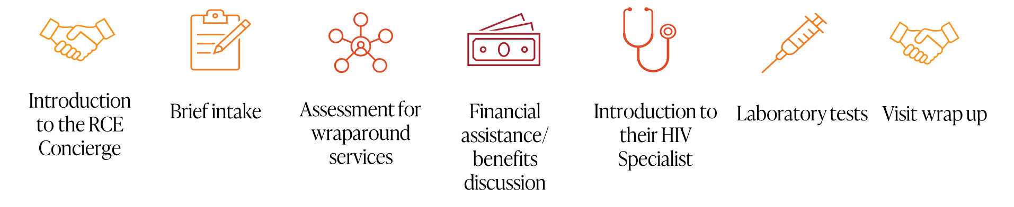
RCE Quick Tip
Conversations with the client should always use a positive framing approach around making the transition into care as smooth and easy as possible. The RCE Concierge and other clinic staff should commend the client for seeking care.

Introduction to the RCE Concierge
- The client should meet the RCE Concierge, confirming their preferred name and pronouns.
- The client should receive a brief orientation to RCE and the client’s HIV care team.
- This is a great opportunity to reassure the client and commend them for seeking treatment.

Brief Intake
- The client should complete a brief intake form with the RCE Concierge or HIV Navigator, such as a case manager or social worker.
- This intake form should ask for insurance information and other key information (e.g., income) to determine if uninsured clients are eligible for medical assistance programs.
- An example intake form is provided in Appendix C. This form is designed to be quick and easy to complete so as not to overwhelm or overburden the client. Tailor this form to meet your clinic’s needs. You can either redesign your clinic’s existing intake form or adopt an RCE-specific intake form and have RCE clients complete any additional paperwork during subsequent visits.

Assessment for Wraparound Services

Screening for Wraparound Services
- The intake form provides an opportunity for an initial assessment of client needs related to wraparound services.
- Following this brief intake period, clinic staff should continue to actively listen for and respond to client needs. Warm handoffs offer a great opportunity for clinic staff to engage in active listening by asking the clients how they are feeling and assessing the client’s needs based on their response. All clinic staff should be prepared to discuss wraparound services and to connect the client with an HIV navigator, if needed.
RCE Quick Tip
Wraparound services might include the following:
- Patient navigator services  - AIDS drug assistance program  - Medical and social insurance assistance  - Adherence counseling  - Medical case management services | - Mental health services  - Substance use services  - Nutritional assistance  - Medical transportation services  - Housing support  - Childcare  - Employment assistance

Linking to Wraparound Services
- The client should be provided with information on wraparound services offered by your clinic and those offered off-site by community partners.
- So as not to overwhelm the client, focus on linking them to wraparound services that may prevent them from attending their next clinic visit, such as transportation or childcare. Then, acknowledge their need for any additional services and let them know that resources to address these needs will be discussed during their next visit.
[TBD] –Will update with additional details about the referral process to wraparound services after the IS.
RCE Quick Tip
Many clients worry about the financial burden of their diagnosis, so much so that they may avoid seeking treatment. When discussing the cost of care, make sure to be reassuring, understanding, and compassionate.
Explain things in plain language and keep the conversation brief. Help clients begin to navigate the financial aspects of their care while not overwhelming them with information.

Financial Assistance/Benefits Discussion
- The client should briefly meet with a financial counselor, insurance navigator, or HIV Navigator to confirm their insurance information and discuss financial assistance programs and/or payment plan options they may qualify for that can help them pay for their HIV care.
- Clients who do not have insurance should be reminded that their initial RCE visit and lab work are free and that insurance is not required to participate in RCE.
- If your clinic does not have a financial counselor or HIV navigator, the RCE Concierge may perform this role.

HIV Specialist Introduction
- At a minimum, the client should briefly meet their HIV Specialist so they know who will be providing their care and so they can start building the foundation of a positive patient–provider relationship.
- If your clinic has a Same-Day Access or Rapid Start program, this may be initiated at this time.
- If there is availability in your clinic’s schedule, the patient may have their first primary care visit at this time.

Laboratory Tests
- The client should receive laboratory tests, including a confirmatory viral load test and other tests to assess medical status.

Visit Wrap-up
- The client should be allowed time to ask any remaining questions about their HIV diagnosis, next steps, and clinic services.
- The RCE Concierge should confirm with the client the time and date and who the client will be interacting with at their next appointment.

[TBD] – Will updated with additional details as needed after the IS.
Learn more about the RCE Visit and see this process in action in the RCE Visit Training Module

RCE Outreach and Reengagement

Purpose of RCE Outreach
RCE Outreach and Reengagement, hereafter referred to as RCE Outreach, is a formal structure for outreach and engagement that is initiated following a client’s loss of contact or missed RCE Visit.
Who is involved in RCE Outreach?
Both the RCE Concierge and the CTR Counselor can make multiple attempts to engage the RCE client directly throughout the RCE Outreach process.
- [TBD] – Will updated with additional staff after the IS depending on how this component is implemented by the two sites.
When does RCE Outreach happen?
RCE Outreach is initiated if the RCE Concierge is unable to contact a referred client to schedule their RCE Visit or if the client misses their initial RCE Visit.
- [TBD] – Will updated how wraparound services are monitored after the IS.
How should RCE Outreach happen?
RCE Outreach can be conducted via phone calls, emails/patient portal messages, and/or text messages.
Why is RCE Outreach important?
RCE Outreach maintains engagement with the client and ensures linkage to care and that the client does not fall out of care. Additionally, RCE Outreach can help the RCE team identify any barriers to care that the client is experiencing.

Delivery of RCE Outreach
Figure 5 outlines each step that comprises the RCE Outreach process with further details below.
Figure 5. RCE Outreach Process
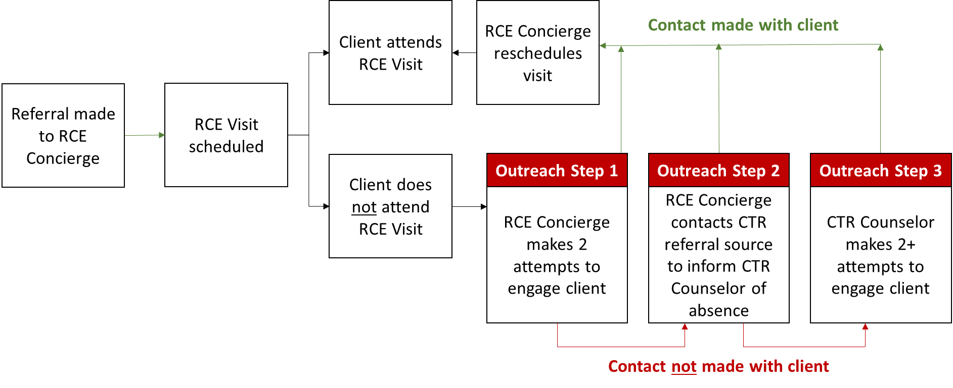

Step 1
It is the RCE Concierge’s duty to first make two attempts to engage the client directly. If contact is established, the RCE Concierge should attempt to understand the barriers that led to the missed RCE visit and how to best address these barriers, then attempt to reschedule the appointment.

Step 2
If the RCE Concierge is not able to engage the client after two attempts, they should inform the CTR Counselor of the client’s absence.
RCE Quick Tip
RCE Outreach is used to reengage clients who miss their initial RCE Visit. If a client misses their follow-up visit with the HIV Specialist, your clinic should follow your standard of care practices for missed appointments.

Step 3
The CTR Counselor should then make two or more attempts to engage the client. If the CTR Counselor is able to establish contact with the client, they should attempt to understand the barriers that led to the missed appointment and how to best address these barriers, then attempt to reschedule the appointment.
If attempts to reach the client by the RCE Concierge and the CTR Counselor fail, the client should be referred to your clinic’s standard of care outreach.

Key Points
Key points to consider when contacting the RCE client include the following:
- RCE Outreach methods are individually tailored to each client; not all clients can be contacted through all methods (i.e., phone, email, patient portal, or text message).
- Consider the time of day—for example, were earlier phone calls usually happening around the same time of day?
- Other touch points (such as pharmacies) might have more up-to-date contact information for the client or may have had more recent interactions with the client.
- Check with your institution’s policies and procedures to confirm how clients can be contacted (e.g., telephone, patient portal, email, or text messages).
- If available, check the client’s chart to ensure they have authorized outreach and their preferred method of outreach.
- If contact is established, ask questions to identify the client’s gaps or needs.
- Address barriers (or identify and refer other clinic staff to address barriers) that might hinder the client’s ability to attend their next appointment.
  - This might include linkage to community-based services such as transportation or insurance navigation services.

[TBD] – Will be updated with additional details as needed after the IS.
Learn more and see this process in action in the RCE Referrals and Outreach Training Module

Troubleshooting
This section provides three potential RCE scenarios and reviews both the correct and incorrect response by clinic staff for each.
[TBD] – For all example scenarios, these processes will be confirmed with the clinics during the IS and update as needed.

Scenario 1 – A Client Has No Insurance
A potential client recently diagnosed with HIV is referred into RCE by a partner organization. When they come into the clinic for their warm handoff, the RCE Concierge is notified by the front desk staff that the client does not have insurance.
Correct Response | Incorrect Response
The RCE Concierge reassures the client they are still eligible for RCE without insurance, schedules their RCE Visit, and notifies the clinic’s financial counselor, insurance navigator, or HIV Navigator to assist the client in identifying and signing up for insurance coverage and/or financial assistance programs for which the client may quality. | The RCE Concierge schedule the RCE Visit for the client but allows the client to leave without information about insurance options or financial assistance programs.

Scenario 2 – No Appointment Availability with the HIV Specialist
A potential client walks into the clinic and uses the RCE phrase “Red Carpet Entry.” Upon reviewing the clinic’s schedule, the RCE Concierge confirms there is no medical care appointment availability with the HIV Specialist in the next 72 hours.
Correct Response | Incorrect Response
The RCE Concierge initiates the RCE Visit despite the HIV Specialist’s unavailability for a full medical appointment, and the RCE Visit includes a brief introduction with the HIV specialist. During the visit wrap-up, the RCE Concierge schedules the client for the next available appointment with their HIV Specialist.  NOTE: If the RCE Concierge deems that the client has an urgent medical situation, they should work with the HIV specialist or on call physician to find an available medical appointment for the client that day. If needed, the client can be referred to a partner site. | The RCE Concierge tells the client there is no availability, turning away an eligible RCE client during normal business hours.

Scenario 3 – Loss of Contact with an RCE Client
A potential client walks into the clinic and uses the RCE phrase “Red Carpet Entry” at 4:30 pm, when the clinic is scheduled to close at 5:00 pm.
Correct Response | Incorrect Response
The RCE Concierge schedules the RCE Visit for the client within the next 72 hours while the potential client is in the clinic, which ensures the client’s information is in the clinic’s system and reduces the chances of the client not coming back. | The RCE Concierge writes down the client’s name and contact information and confirms someone from the clinic will be in touch in the near future.

Scenario 4 – Patient Calls the Clinic with the RCE Discreet Phrase “Red Carpet Entry”
A potential client calls the clinic and uses the RCE phrase “Red Carpet Entry” during normal business hours. The call center notes the potential client should be connected with the RCE Concierge; however, the call center staff is unable to reach the RCE Concierge.
Correct Response | Incorrect Response
The call center staff connects the potential client with the clinic’s backup contact for the RCE Concierge, who schedules the RCE Visit within the next 72 hours. The backup RCE Concierge then communicates the client’s information and their upcoming appointment to the primary RCE Concierge. | The call center tells the potential client that the RCE Concierge is not available and asks them to call back tomorrow.

Scenario 5 – RCE Client Misses Their Initial RCE visit
A potential client is referred to RCE by the CTR Counselor but misses their RCE visit with the RCE Concierge.
Correct Response | Incorrect Response
The RCE Concierge notes that the client missed their appointment and begins the RCE Outreach process by making two attempts to reach the client. If the RCE Concierge is unable to reach the client, they notify the CTR Counselor who makes at least two additional attempts to reach the client.  NOTE: If either the RCE Concierge or the CTR Counselor reach the client, they should work with the client to identify and address barriers that hinder the RCE client’s ability to attend their appointments. | The RCE Concierge calls the client the day of the missed appointment and leaves a voicemail but does not make additional attempts and does not notify the CTR Counselor of the missed appointment.

Implementation Study [will remove from manual after IS]:

Eligibility Criteria
Eligible RCE clients include both English- and Spanish-speaking clients over the age of 18 (or emancipated minors) who are within each clinic’s jurisdiction, not enrolled in any confounding studies, and meet one of the following criteria:
- Newly diagnosed (i.e., diagnosed with HIV in the past 12 months);
- New to care (i.e., diagnosed with an HIV infection more than 12 months ago but never received HIV primary care); or
- Out of care (i.e., last seen for an HIV primary care appointment more than 12 months ago).

Screening for Eligibility
Following the initial warm handoff (CTR referrals) or introductions (self-referrals), the RCE Concierge should use the screener in Appendix D to determine if a client is eligible for the RCE implementation study and record answers to the screener questions in the Access Database.
Even if the client’s eligibility for the study is not able to be confirmed, they should still be provided with medical care through RCE.

Enrollment
Consenting clients into the RCE Implementation Study should be done in a way that is cognizant of the heightened emotions and information overload clients are likely experiencing during their RCE visit. Be sure to allow time for clients to review the forms and ask questions. We recommend briefly mentioning the RCE Implementation Study at the beginning of the RCE Visit—framing this as a voluntary research opportunity that they can learn more about at the end of their RCE visit if they are interested—and enrolling patients during visit wrap-up to give them the time they need to make an informed decision. A sample recruitment script is provided in Appendix D along with the screener questions.
When enrolling an RCE client into the implementation study, items/topics to cover should include the following:
- Review the purpose of the RCE evaluation.
- Provide an overview of what the client’s involvement in the RCE evaluation would entail.
- Ensure the client understands that their clinical care and receipt of RCE services is not contingent upon their involvement in the study and that they are able to refuse.
- Review the consent form and the Health Insurance Portability and Accountability Act of 1996 (HIPAA) authorization form with the client.
  - Use the Spanish consent and HIPAA authorization form, if needed.
- Obtain the client’s signature on the consent form and the HIPAA authorization form to participate in the RCE evaluation.
  - An unsigned copy of the consent form and the HIPAA authorization form can be provided to the client for their records, if requested.
- Provide the client with a $25 gift card upon enrolling in the evaluation.
- Record the date and time the client consented in your clinic’s Access database.

4 | Monitoring and Evaluation

[TBD] - The content in Section 4 is tailored to monitoring and evaluation of the IS. When the IS has concluded, this entire section will be modified to reflect wider dissemination and use of RCE.

Steps for Monitoring Progress

Access Database Reports
Every 2 weeks, the RCE Concierge at each site will generate a report from the Access database. This report will be sent to RTI, who will use these data to monitor progress on recruitment and data collection efforts across sites.
[TBD] – Will add screenshots of the Access database with additional instruction when available.

Report Cards
Every 2 months, RTI will provide written performance feedback in the form of report cards to RCE sites. RTI will develop the report cards based on discussions during the biweekly check-ins, quality assurance checks, and ad hoc technical assistance requests.
Components of the RCE Report Cards include the following:
- Process Metrics
  - Number of clients referred and the source of the referral
  - Eligibility criteria/client characteristics
  - Number of clients who received their RCE Visit
  - RCE Visit component received

- Evaluation Metrics
  - Number of clients who attend their second appointment

- Narrative Report
  - What went well during the reporting period
  - What did not go well and improvements to be made
  - Actionable steps to take in the next two months to improve RCE implementation

The RCE Video Training Modules present guidance on how the report card will be used to monitor RCE. | Review the RCE Report Card to see all process and evaluation metrics.

Data Collection

Key Benchmarks
RCE’s effectiveness is measured with two primary indicators:
- Linkage to Care: The RCE client receives care, which can be attending the RCE Visit, within 72 hours of referral to RCE.
- Retention in Care: The RCE client has a second appointment within 2 to 4 months of the initial RCE visit.

Making Changes and Informing the Toolkit
RCE metrics will have a dual purpose:
- Your Clinic Champion and RCE Concierge will use the Access database reports and the RTI-developed report cards to make real-time adjustments to optimize RCE, as needed.
- RTI will use feedback from your clinic site alongside clinic-specific metrics to refine the RCE toolkit, highlighting important components and confirming processes.

RCE Client Input
RCE Quick Tip
If your clinic or healthcare system has a patient advisory panel, input from the panel can be used to help understand the social and/or structural needs or barriers that potential clients might experience. This information can be used to help inform RCE implementation processes.
Once RCE is launched, it can be helpful for clinic staff to get feedback from participating clients. This can occur during informal discussions with clients to understand their experience with HIV, including their challenges, concerns, fears, and needs. Similarly, it is valuable to learn more about their experiences going through RCE, such as how they felt at various points during their RCE journey, what they really liked about their experience, and what they wish were different.
Information gathered from RCE clients can inform improvements to the RCE Visit, including warm handoffs and active client engagement, and can help you identify additional partners to engage for wraparound services and referrals. This type of ongoing quality improvement will allow your clinic to make regular adjustments to RCE implementation protocols to best serve your client population.
[TBD] - Will update with additional detail about who was involved, where these conversations took place, what topics were most useful to learn about, and what information was covered after the IS.

Sharing Progress with Partners, Stakeholders, and Other Audiences
If feasible, clinics implementing RCE are encouraged to share their successes and challenges when staff and partners convene. This can be done by any clinic staff member during regularly scheduled staff meetings, daily staff huddles, or partner meetings held specifically to discuss RCE.
[TBD] - Will update with additional detail about effective strategies to do this after the IS.
5 | References

1. Harris NS, Johnson AS, Huang YA, et al. Vital signs: status of human immunodeficiency virus testing, viral suppression, and HIV preexposure prophylaxis - United States, 2013-2018. MMWR Morb Mortal Wkly Rep. 2019;68(48):1117-1123. doi:10.15585/mmwr.mm6848e1
2. Centers for Disease Control and Prevention. Monitoring selected national HIV prevention and care objectives by using HIV surveillance data-United States and 6 dependent areas, 2018. HIV Surveillance Supplemental Report. 2020;25(2)
3. Centers for Disease and Control and Prevention. Retention in care. Prevention is care. Care is prevention. Centers for Disease and Control and Prevention. Accessed February 15, 2021. https://www.cdc.gov/actagainstaids/campaigns/pic/talks/retention-care.html
4. Olejemeh C, Denson A, Frison L, Freehill G, Pappas G. Treatment is prevention: enhanced entry into HIV care: the RED Carpet strategy in the District of Columbia, USA. presented at: International AIDS Society Conference; 2012; Washington, DC.
5. Ruria EC, Masaba R, Kose J, et al. Optimizing linkage to care and initiation and retention on treatment of adolescents with newly diagnosed HIV infection. AIDS. 2017;31 Suppl 3(Suppl 3):S253-S260. doi:10.1097/QAD.0000000000001538
6. Centers for Disease Control and Prevention. Red Carpet Program (RCP). Centers for Disease Control and Prevention. Updated November 19. Accessed February 15, 2021. https://www.cdc.gov/hiv/pdf/research/interventionresearch/compendium/si/cdc-hic-Red_Carpet_Program_RCP_SI_EI.pdf
7. Agency for Healthcare Research and Quality. Implementation quick start guide. Warm handoff. Agency for Healthcare Research and Quality. Accessed February 15, 2021. https://www.ahrq.gov/sites/default/files/wysiwyg/professionals/quality-patient-safety/patient-family-engagement/pfeprimarycare/warm-handoff-qsg-brochure.pdf

Appendix A. RCE Logic Model
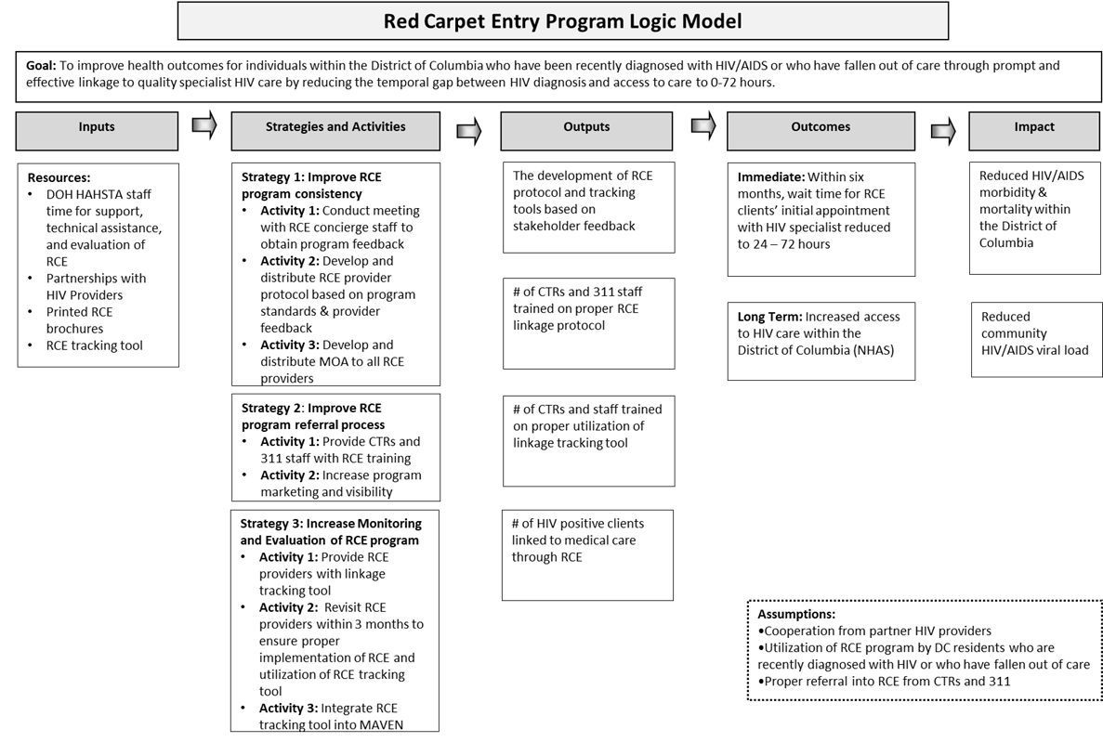

Appendix B. Sample Memorandum of Agreement
MEMORANDUM OF AGREEMENT
BETWEEN
[RCE Implementation Site] and [Partner Organization]
I. INTRODUCTION
This Memorandum of Agreement (hereinafter referred to as the “MOA” or the “Agreement”) is entered into between the [RCE Implementation Site] and [Partner Organization].
Red Carpet Entry (RCE) is a structural intervention for HIV primary care clinics that aims to link people with HIV who are newly diagnosed or returning to care within 72 hours of referral. This is accomplished through the establishment of referral networks, the designation of an RCE Concierge who receives referrals from HIV counseling, testing, and referral (CTR) partners or self-referrals from clients and coordinates appointments, and a redesigned first appointment that emphasizes warm handoffs and provides clients with initial HIV care and referrals to services that will support their engagement in care.
[Description of RCE Implementation Site]
[Description of Partner Organization]
II. PROGRAM GOALS AND OBJECTIVES
The purpose of this MOA is to establish the terms and conditions of a working agreement between [RCE Implementation Site] and [Partner Organization] to coordinate services for clients who enter HIV primary care at [RCE Implementation Site] through Red Carpet Entry, which will ultimately expand access to supportive services for people living with HIV/AIDS through increased access to care.
Specifically, [Partner Organization] agrees to [Insert Supportive Services Provided].
Pursuant to this Agreement, [RCE Implementation Site] and [Partner Organization] agree to carry out the following responsibilities in furtherance of our shared goals.
III. SCOPE OF SERVICES

A. [RCE Implementation Site] Agrees to:
- [Insert Services]

B. [Partner Organization] agrees to:
- [Insert Services]

IV. DURATION OF MOA
- The period of this MOA shall be from execution through _____________unless terminated in writing by the Parties prior to the expiration.

V. AUTHORITY FOR MOA

A. [City Name] Official Code [Insert Code Number]

VI. FUNDING PROVISIONS

A. Cost of Services

B. ANTI-DEFICIENCY CONSIDERATIONS
The Parties acknowledge and agree that their respective obligations to fulfill financial obligations of any kind pursuant to any and all provisions of this MOA, or any subsequent agreement entered into by the parties pursuant to this MOA, are and shall remain subject to the provisions of (i) the federal Anti-Deficiency Act, 31 U.S.C. §§1341, 1342, 1349, 1351, [insert local Anti-Deficiency Act information], as the foregoing statutes may be amended from time to time, regardless of whether a particular obligation has been expressly so conditioned.
VII. COMPLIANCE AND MONITORING
As the services detailed in this MOA are funded by the [Insert Funding Agency], [RCE Implementation Site] will provide monitoring and oversight to [Partner Organization]. This will include scheduled and unscheduled monitoring reviews to ensure compliance with all applicable requirements with federal regulations.
VIII. RECORDS AND REPORTS
[RCE Implementation Site] shall maintain records and receipts for the expenditure of all funds provided for a period of no less than three years from the date of expiration or termination of the MOA and, upon the request, make these documents available for inspection by duly authorized representatives from [Insert].
IX. CONFIDENTIAL INFORMATION
The Parties to this MOA will use, restrict, safeguard and dispose of all information related to services provided by this MOA, in accordance with all relevant federal and local statutes, regulations, policies.
X. TERMINATION
Either Party may terminate this MOA in whole or in part by giving 30 calendar days advance written notice to the other Party.
XI. NOTICE
The following individuals are the contact points for each Party under this MOA:
[RCE Implementation Site] Contact for Red Carpet Entry:

[Insert Contact Information]

[Partner Organization] Contact for Red Carpet Entry:

[Insert Contact Information]

XII. MODIFICATIONS
The terms and conditions of this MOA may be modified only upon prior written agreement by the Parties.
XIII. MISCELLANEOUS
The Parties shall comply with all applicable laws, rules and regulations whether now in force or hereafter enacted or promulgated.

IN WITNESS WHEREOF, the Parties hereto have executed this MOA as follows:

______________________________ Date: _______________
[Name of Witness #1]

______________________________ Date: ________________
[Name of Witness #2]

Appendix C. Intake Form

Patient Registration Form
Welcome! We are happy you have chosen us for your care. To register, please complete this form. Several of the items below help us ensure that we are meeting the needs of the population we serve, so please be as thorough as you can. Let us know if you have any questions or if you need help in completing this form.

Today’s Date: | Month: |  | Day: |  | Year: |  | Referred By:
Name/location of previous medical care (if appropriate):
First Name: |  |  |  |  | Middle Initial: |  |  |  | Last Name:
I go by (Name):
Date of Birth: | Month: |  | Day: |  | Year: |  | Social Security Number: _______-_____-________
Street Address:
City: |  |  |  |  | State: |  |  |  |  | Zip:
Is your housing: □ Stable □ Unstable □ Temporary
Home Phone: |  |  |  | Cell Phone: |  |  |  |  |  | Work Phone:
Email Address: |  |  |  |  |  | Marital Status: □ Single □ Married □ Partnership  □ Divorced □ Separated □ Widowed
Gender Identity:  □ Man  □ Woman  □ Trans Man  □ Trans Woman  □ Genderqueer/Non-binary  □____________ |  | Sex Assigned at Birth:  □ Male  □ Female  □ lntersex  □_____________ |  |  |  | Do you identify as transgender?  □ Yes □ No  Gender Pronouns:  □ He/Him/His  □ She/Her/Hers  □ They/Them/Theirs  □_____________ |  |  |  |  | Sexual Orientation:  □ Lesbian, Gay, Homosexual  □ Straight, Heterosexual  □ Bisexual  □_____________
Annual Family Income:  $ ____________  Family Size:  ____________  (includes spouse, dependent children, or other people dependent on you) |  | Ethnicity (select one or more)  □ Non-Hispanic/Non-Latino  Hispanic/Latino (please specify)  □ Mexican/Mexican American/Chicano/a  □ Puerto Rican  □ Cuban  □ Another Hispanic Latino/a Spanish Origin |  |  |  |  |  | Race (select one or more)  □ African American/Black (including Africa, Caribbean)  □ Caucasian/White (including Middle Eastern)  □ American Indian or Alaska Native  (including all Original Peoples of the Americas)
 |  |  |  |  |  |  |  | Asian (please specify)  □ Asian Indian  □ Chinese  □ Filipino  □ Japanese  □ Korean  □ Vietnamese  □ Other Asian |  |  |  | Native Hawaiian/Pacific Islander (please specify)  □ Native Hawaiian  □ Samoan  □ Guamanian or Chamorro  □ Other Pacific Islander
Are you a Veteran?
□ Yes □ No

Patient Registration Form (continued)
Language  □ English □ Spanish  □ _______________  □ I request language translation services. |  |  |  | Please list any accommodations you need due to an illness, injury, or disability.
Emergency Contact Information
First Name: | Last Name: |  |  |  |  |  |  |  |  | Relationship:
Street Address:
City: |  | State: |  |  |  |  |  |  | Zip:
Home Phone: |  |  | Cell Phone: |  |  |  |  | Work Phone:
Insurance Information (Please provide your insurance card at the time of registration)
Are you insured?  □ Yes □ No | If you do not have insurance, you will meet with a financial counselor or insurance navigator to see if you are eligible for financial assistance programs and/or to go over payment plan options.
Insurance Information | Company: |  |  |  |  | Identification Number:
Insurance Information | Group Number: |  |  |  |  | Contact Number (on back of card):
Insurance Information | In whose name is your insurance?  □ Self  □ Other |  |  |  |  | If private/commercial insurance:  □ Employer-Paid  □ Individual-Paid  □ Other
Secondary Insurance Information | Company: |  |  |  |  | Identification Number:
Secondary Insurance Information | Contact Number (on back of card):
Sex/Gender Marker  with Insurance Company: |  | We recognize your gender identity. For insurance billing purposes, what sex/gender marker is on file with your insurance company?  □ Male  □ Female |  |  |  |  | Is your legal name on your insurance card?  □ Yes  □ No, it’s listed as: __________________________
How can we help you? (Please check all that apply)
□ Medication assistance  □ Insurance assistance  □ Mental health services  □ Substance use services  □ Nutritional assistance  □ Medical transportation services |  |  |  |  | □ Housing support  □ Childcare  □ Employment assistance  □ Dental  □ Legal Services  □ Support Groups  □ Other: _______________

Appendix D. Participant Screener
Red Carpet Entry
Participant Screener

Instructions to the RCE Concierge: All patients who are newly diagnosed, or who are not currently receiving care for their HIV can enter into care via RCE. However, only certain patients are eligible for the RCE study. Use the screener below to identify (1) patients who are eligible to enter care through RCE and (2) those who are eligible for the study.

Part 1: Introduction & Screening – When Participant is Introduced to the RCE Concierge
Hi, I’m [NAME], and I’m the Red Carpet Entry Concierge at [CLINIC NAME]. We’re so happy to welcome you to our clinic today! As the Concierge, it’s my job to escort you throughout your first RCE Visit, make sure you feel comfortable, introduce you to the members of your care team, and answer any questions you might have. Before we get started, I’d like to ask you a few questions to make sure that Red Carpet Entry is right for you.

May I proceed?

No è [Thank respondent and end conversation.]

Yes è CONTINUE

- What language are you most comfortable speaking and writing?
_____ | English è CONTINUE  Spanish è CONTINUE  All Other Languages è TERMINATE FOR STUDY  CONTINUE FOR RCE CLINICAL CARE

- How old are you?
_____ | <18 è CONTINUE  18+ è SKIP to Q4

- Are you an emancipated minor?
Yes |  | è CONTINUE
No |  | è TERMINATE FOR STUDY  CONTINUE FOR RCE CLINICAL CARE
- Have you ever tested positive for HIV?
Yes |  | è CONTINUE
No |  | è TERMINATE FOR STUDY & RCE CLINICAL CARE

- When did you test positive?
_DD/MM/YY__ |  | ≤ 12 months è CONTINUE  [Patient Qualifies as Newly Diagnosed]  > 12 months ago è CONTINUE

- Have you ever received care by a doctor for your HIV?
Yes |  | è CONTINUE
No |  | è SKIP TO END  [Patient Qualifies as New to Care]

- When was the last time you saw your HIV doctor?
_MM/YY__ |  | < 12 months è TERMINATE FOR STUDY  CONTINUE FOR RCE CLINICAL CARE  > 12 months ago è CONTINUE  [Patient Qualifies as Out of Care]

[If Eligible] Great! It looks like you’re eligible for Red Carpet Entry. If you would like to continue, we can schedule your first visit with us. [Allow time for the client to ask questions about what the first visit entails, then schedule visit].
[If Not Eligible for RCE] Unfortunately, it doesn’t seem like Red Carpet Entry is a good option for you at this time. Let’s talk about other ways our clinic might be able to support you in your medical care.
Part 2: Consenting for Eligible Patients

2a. Towards the end of the RCE Concierge Introduction
Before I introduce you to [name of next person patient will interact with] I wanted to let you know that we are doing a study about how [CLINIC NAME] is running Red Carpet Entry. Through this study, we hope to learn more about the best ways to get people connected to medical care as quickly and stress-free as possible. You do not have to agree to be a part of this evaluation to receive medical care through Red Carpet Entry at our clinic. Also, I know this can be an overwhelming time, so you do not need to decide anything right now. We will talk about it again at the end of your visit today.

2b. When Participant is wrapping up their RCE Visit
Before you leave today, I wanted to talk to you again about the evaluation of Red Carpet Entry at [CLINIC NAME], as I mentioned earlier today. The purpose of this evaluation is to learn more about how RCE is being implemented in [CLINIC NAME]. What we learn will help the Centers for Disease Control and Prevention (CDC) make Red Carpet Entry a better experience for patients just like you all across the country and help us connect them to their care teams more quickly and as stress-free as possible. If you choose to participate, we will collect the following information from your electronic health record: medical care appointment dates and attendance, confirmation of your HIV diagnosis, and information such as your age, sex, and race/ethnicity. You do not have to complete any surveys or get any additional bloodwork done. These data will not have your name, or any other identifying information attached to it and will stay confidential. As a thank you, you will receive a $25 gift card before you leave today. You may choose to stop participation at any time for any reason. As a reminder, you do NOT have to participate in this evaluation to receive medical care through Red Carpet Entry at our clinic.

Are you interested in participating?

Yes è [Review consent and HIPPA forms with client; answer questions and obtain client signatures. Provide the client with a $25 gift card and finish the RCE visit wrap-up.] Record date and time of client consent in the access database. Provide the client with an unsigned copy of the consent form and HIPAA authorization form for their records if requested.

No è [Thank respondent and finish RCE Visit wrap-up.]

