Attachment B – Screen Shots for Modifications to FMS Application Module
OMB control number 0920-0765
Fellowship management system
In support of a Nov 2021 non-substantive change request

PHAP eFMS Applicant Module Personal Statement Revisions
11.1-a. Personal Statement Fields
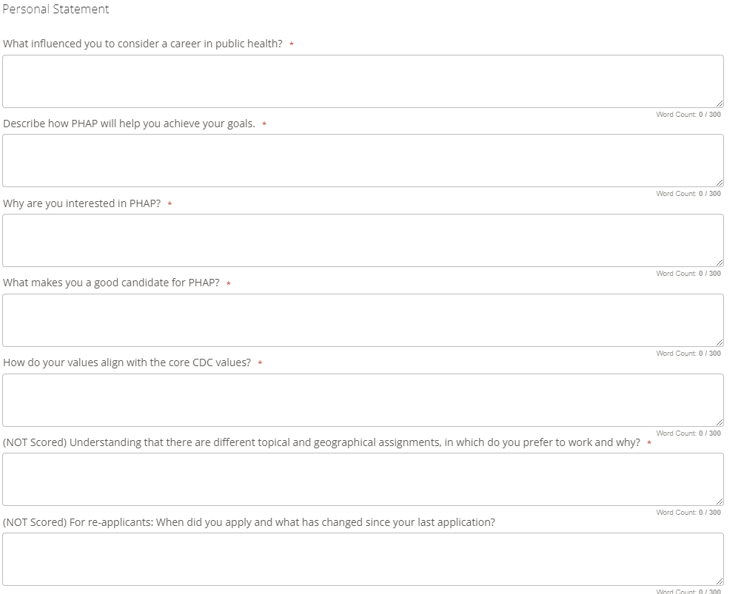
Remove
Remove

