OMB Control Number 0920-0765 Fellowship Management System Change Request
Attachment 1 – Application Module Screenshots
Program | Section | Current Question/Item | Requested Change | Screenshot
PMR/F | 6.4.1 Eligibility | None | New instructional text | 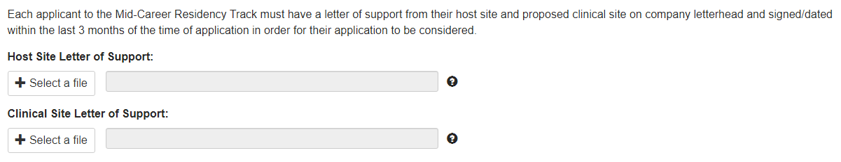
PMR/F | 6.4.1  Eligibility | You are likely eligible to apply for the 12-month External Residency Track. Do you wish to continue and apply for this Track? | You are likely eligible to apply for the 12- Month Mid-Career Residency Track. Do you wish to continue and apply for this Track?
PH-TIPP | 6.10.1  Eligibility | None | New instructional text
PH-TIPP | 6.10.1  Eligibility | Will you be able to attend Orientation in either August or September in Atlanta, Georgia | Will you be able to attend the Summer Orientation Session in Atlanta, Georgia? | 
LLS, EIS | 7.7 | “Title and Abstract” | Remove “Title and Abstract” and change to “Description of Dissertation” | 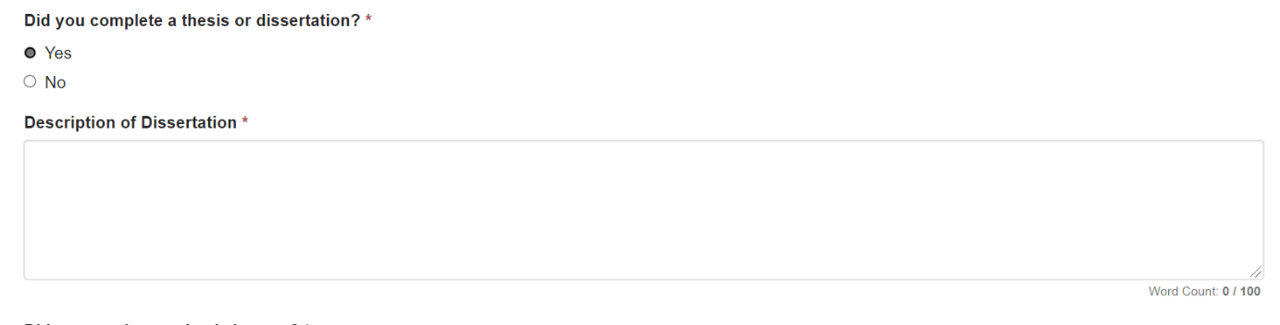
LLS | 8.2-a | Work & Volunteer Experience. What do you want to add? | New instructional text for “What do you want to add?”  For Volunteer Experience, please list activities outside your normal working hours/responsibilities. | 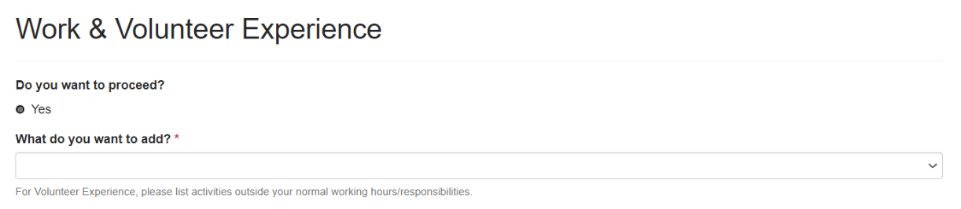
LLS | 10.2-a | Honors and Awards  What do you want to add? | New instructional text for “What do you want to add?”  For Honors and Awards, please do not list academic scholarships. | 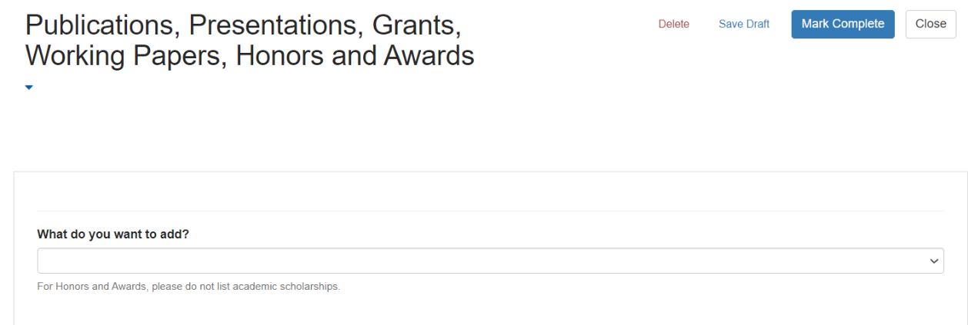
LLS, EIS | 10.3-a | In the Details text box below, please list all research grants and include the following for each: | Revise question to:  In the Details text box below, please list all competitive research grants and include the following for each: | 
LLS | 11.1-a | Describe how this fellowship/program will help you achieve your goals. * | Revise question to:  What are your goals and how will this program help you achieve your goals? * | 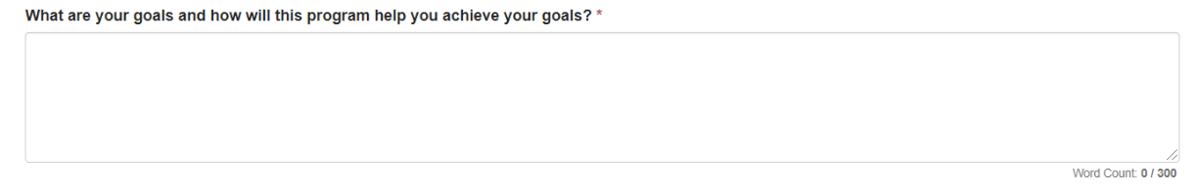
EIS | 13.2-a | n/a | New Question  Q. Will the US Military or other federal agency provide complete financial support for your 2-year fellowship period? Yes/No  Q: If YES, Please provide the name of the service and the contact information of the person who can confirm you have received approval to participate in EIS. | 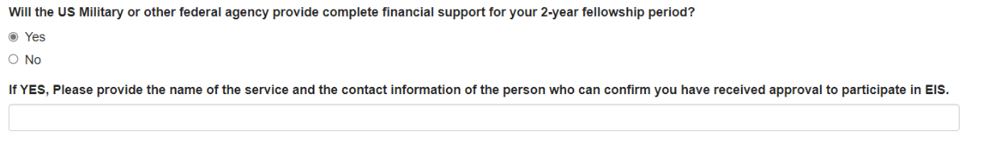
EIS | 7.2-a | What do you want to add?  - Undergraduate Education  - Graduate Education  - Additional Coursework  - Active U.S. License | Revise response option  Change “Active U.S. License” to “Active U.S. Clinical License  Add instructional text (“Active U.S. Clinical License for clinical applicants only” | 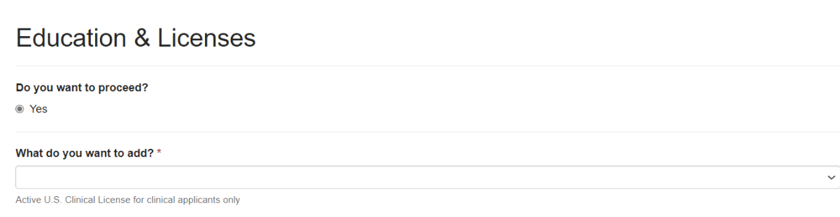  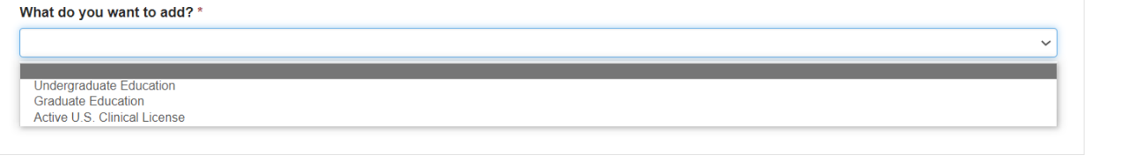
EIS, LLS | 10.3-a | What do you want to add?  - Publications  - Presentations  - Grants  - Honors and Awards  - Monographs or Reports  - Research Grants  - Working Papers (Job Market Papers) | For each relevant section add instructional text that says,  Please enter all publications in the same entry; do not create a separate entry for each publication.  Please enter all presentations in the same entry; do not create a separate entry for each presentation.  Please enter all grants in the same entry; do not create a separate entry for each grant.  Please enter all honors and awards in the same entry; do not create a separate entry for each honor/award.  Please enter all monographs or reports in the same entry; do not create a separate entry for each monograph or report.  Please enter all research grants in the same entry; do not create a separate entry for each research grant.  Please enter all working papers (job market papers) in the same entry; do not create a separate entry for each working paper. |   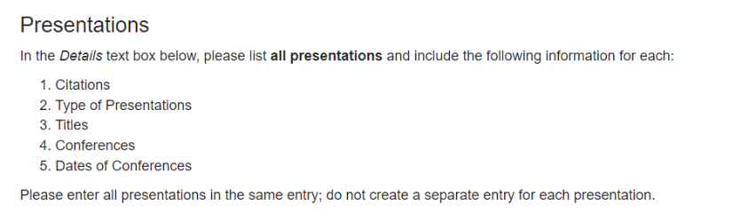  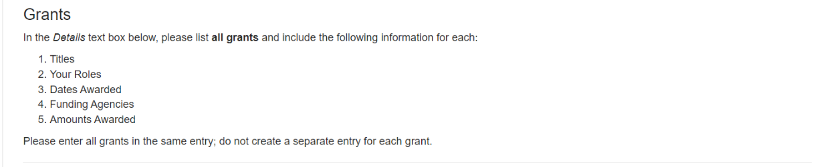  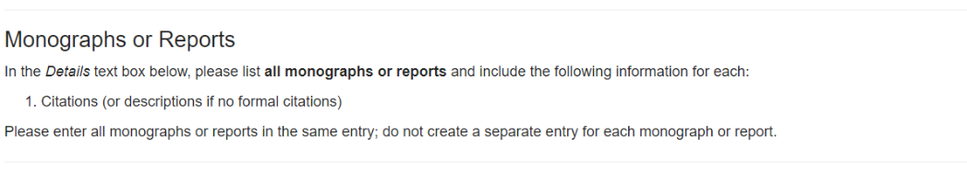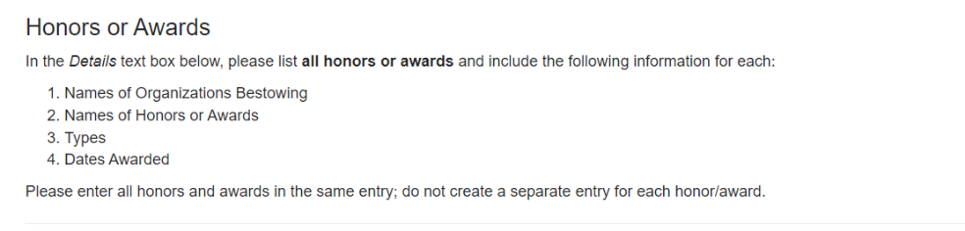  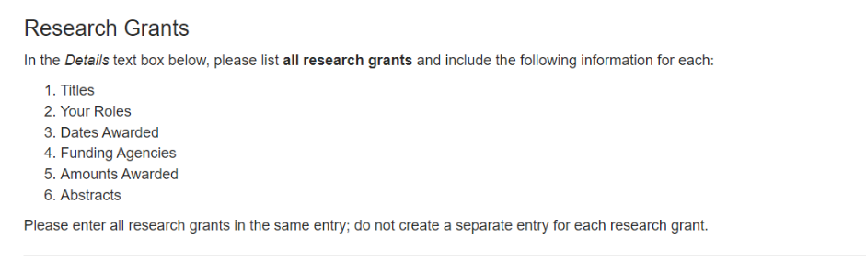  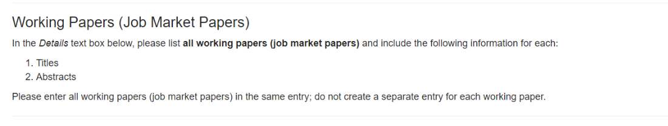
EIS | 9.5-a | Additional Training, Certifications, or Professional Development  List all professional development sessions not included in the Education section. Include trainings, workshops, or other experiences providing 8+ hours of training or resulting in a certification. | Additional Training, Certifications, or Professional Development  Change instructional text:  Include significant trainings or other experiences providing at least 8 hours of training or resulting in a certification.
EIS | 13.6.1-a | Old writing sample prompt on display. | Instructional text (writing sample) will change each year. eFMS OMB Writing Sample Module includes writing sample options. | 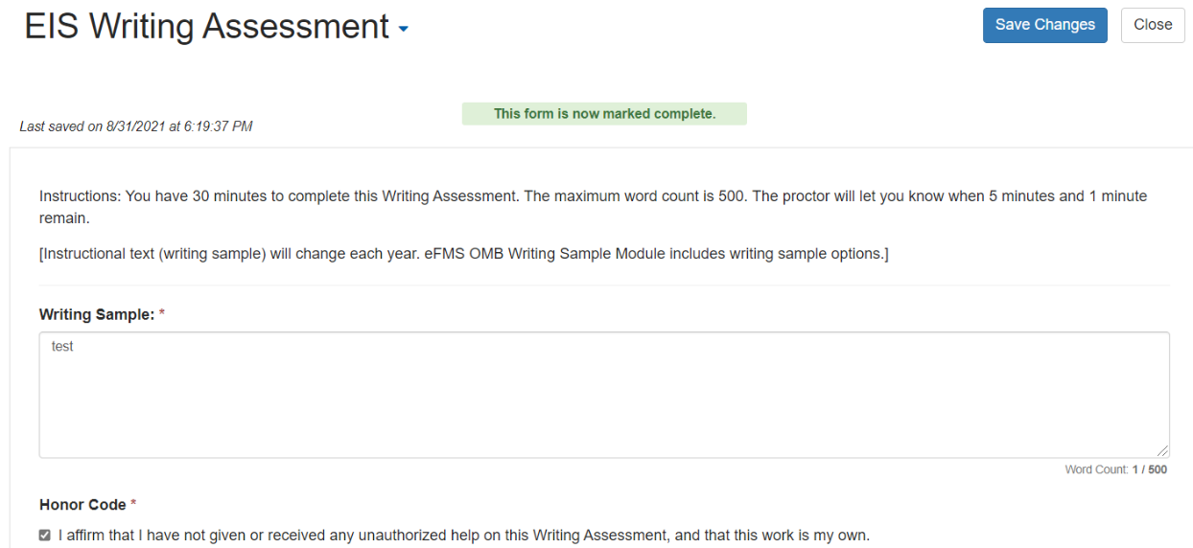
EIS | NEW SECTION 14.1a | n/a | You may be contacted for an EIS interview day. You may be contacted for an EIS interview day. {Interview day information}. Please indicate your top 5 preferred interview dates.  Please indicate your top 5 preferred interview dates.  Are you planning to attend EIS interviews? You will receive your scheduled interview date by XXX. Yes/No  If no, reason for decline:  Please indicate if you are available for the following interview dates by checking the box. Please select all that apply (at least 5)  Interview Date A  Interview Date B  Interview Date C  Interview Date E  Interview Date F  etc.  Please provide a phone number where you can be reached on your interview day. | 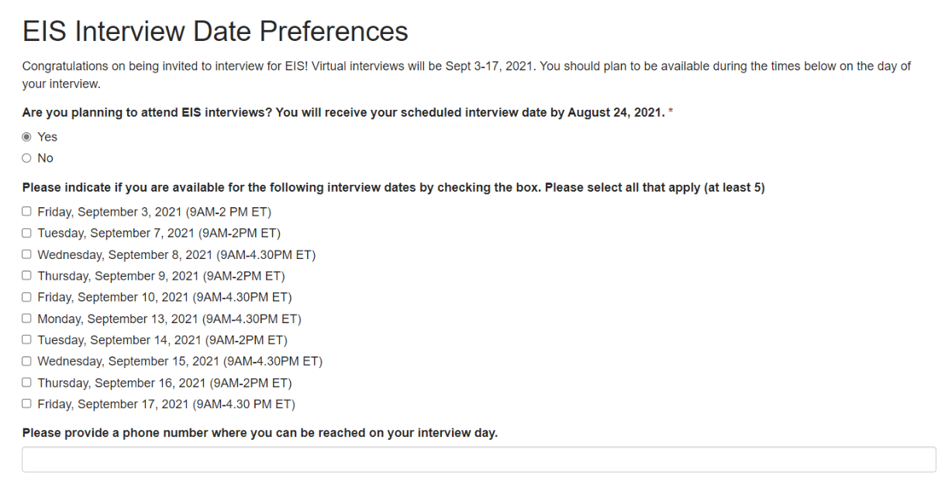
EIS | 13.5 EIS CIO Assignment Interests | Entire Section 13.5 | Remove entire section | n/a
EIS, LLS | 12.3.1 | Current response options/values for relevant sLOR questions:  1. Average (75% or below)  2. Above Average (Top 25%)  3. Excellent (Top 10%)  4. Superior (Top 2%)  5. Not able to judge | Current response options/values for all relevant sLOR questions to:  1. Below average (Below 75%)  2. Average (Top 75%)  3. Above Average (Top 25%)  4. Excellent (Top 10%)  5. Superior (Top 2%)  6. Not able to judge | 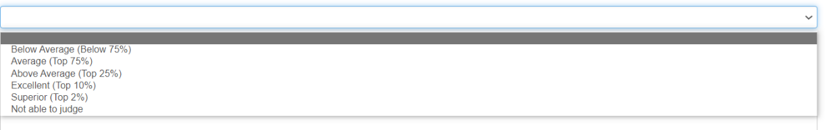
EIS | 6.2-a | n/a | If Country of Citizenship is not the United States, then display text:  “Please be aware that non-U.S. Citizens will not be able to travel internationally and will be limited to positions focused on domestic work." | 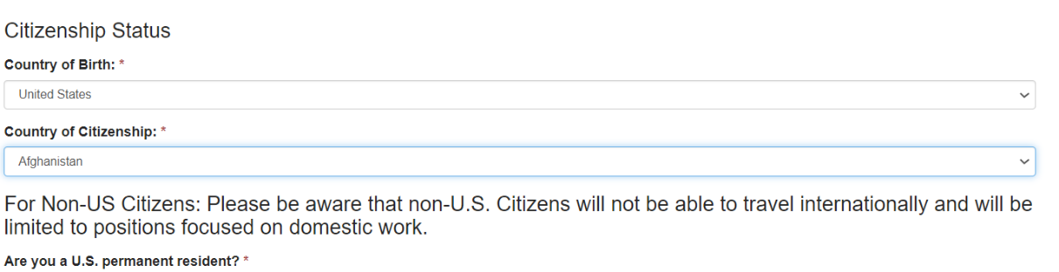
EIS | 11.3-a | State/Territory Preference(s) | Change to: To which states or territories would you be willing to relocate for the duration of the 2-year EIS fellowship?” | 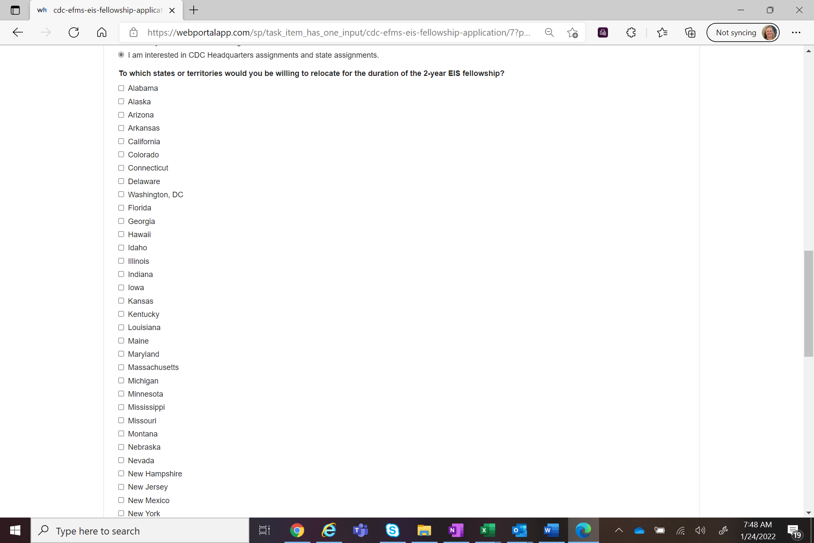

Program | Section | Current Question/Item | Requested Change | Screenshot
All | 3-a. eFMS System Help Desk Ticket Fields | 1. System Error Message  2. Sign-In or Password  3. Smart Card Sign-In  4. Data Not Saving  5. Unable to Submit  6. Reset application back to "Draft"  7. Withdraw Fellowship Application  8. Other | Add Response Option  1. System Error Message  2. Sign-In or Password  3. Smart Card Sign-In  4. Data Not Saving  5. Unable to Submit  6. Reset application back to "Draft"  7. Reset activity back to “Draft”  8. Withdraw Fellowship Application  9. Other | 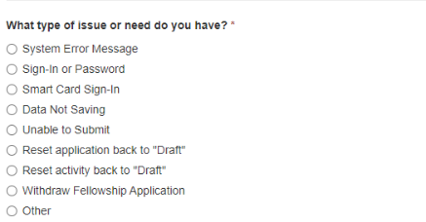
SAF | 6.6.1a | Specify Grade Level Taught: | Revise Question  “Specify Current Grade Level(s) taught” (select all that apply)  1. Elementary School (grades K-5)  2. Middle School (grades 6-8)  3. High School (grades 9-12)  2. Community College  3. College (Undergraduate)  4. College (Graduate)  5. Other: Curriculum Development  6. Other: Professional Development  7. Other (Specify) | 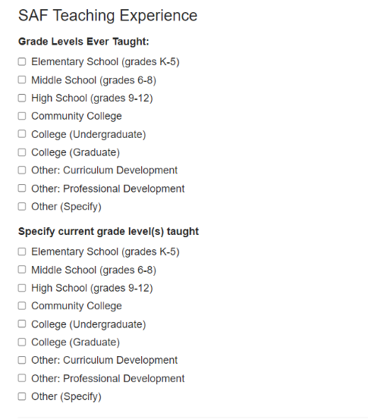
LLS | 12.1.2a | None | Add Instructional Text for SLOR request  Identify two people who can provide recommendations on your behalf using our standardized online form.  Select 2 individuals who have served in a supervisory or mentoring role and are familiar with your academic achievements, aspirations, personal qualities, and professional attributes. These individuals should provide recommendations specific to your LLS fellowship application.  Avoid requesting letters from colleagues or friends. Recommendations must be written in English.  Request/confirm their email address.  Tell recommendation writers to expect a system-generated email from LLS@cdc.gov with instructions for electronically submitting their responses to questions in a standardized recommendation form.  One of the two standardized letters of recommendation must be from persons who are not currently employed at the CDC. | 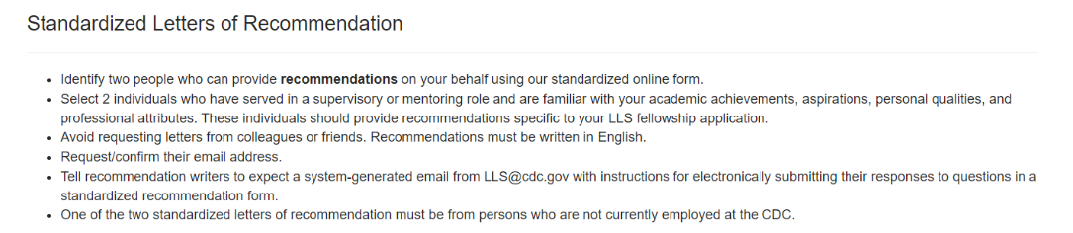
EEP | 13.3.3a | What type of work settings are you open to? (select all that apply, please note that the EEP program cannot guarantee a specific work setting): | Revise Question  What type of work settings are you open to? (select all that apply, please note that the EEP program cannot guarantee a specific work setting):  - In person (100%)  - Telework/remote (100%)  - Hybrid, mostly in person (>50%)  - Hybrid, mostly telework/remote (<50%) | 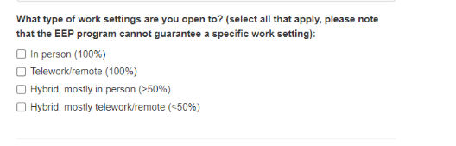
EIS | 13.2-a | N/A | Add Question  Are you applying to the EIS-IDSA Fellowship [name subject to change]  - Yes  - No  If yes, which infectious disease fellowships are you applying to? [open response] | 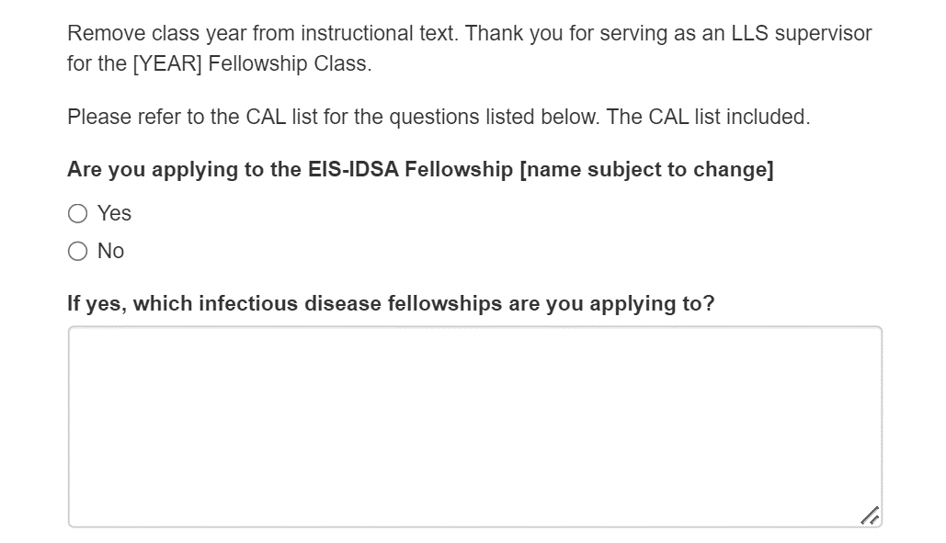
All | 9.2-a | What do you need to add?  - Clinical Training  - U.S. Board Certification  - Additional Training, Certification or Professional Development  - Language Skill  - None of the Above | Revise Response Option  Change response option “U.S. Board Certification” to “U.S. Clinical Board Certification” | 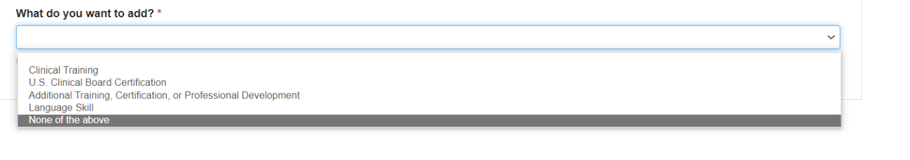
All | 7.7 Degree | Magna Cum Laude  Summa Cum Laude  Cum Laude  Valedictorian  Benedictorian  Salutatorian  Phi Beta Kappa | Add Response Option | 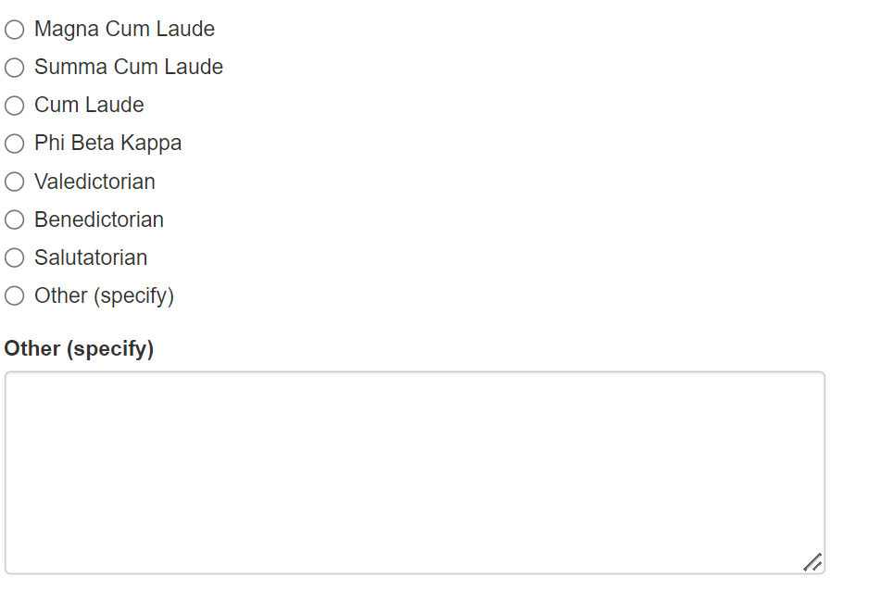
LLS | 10.2-a | 1. Publications  2. Presentations  3. Grants  4. Honor or Awards  5. Monographs or Reports  6. Research Grants  7. Working Papers (Job Market Papers) | Revise Response Options  LLS: Separate into poster presentations and oral presentations as two separate response options.  Otherwise, add instructional text regarding separating poster and oral presentations in this section. | n/a
LLS | 12.3.3-a | As a candidate for this fellows/program, I consider the applicant:  1. Not suitable  2. Minimally suitable  3. Suitable  4. Very suitable  5. Most suitable | Replace Question  As a candidate for this fellows/program, I consider the applicant:  1. Not suitable  2. Minimally suitable  3. Suitable  4. Very suitable | 