OMB Control Number 0920-0765 Fellowship Management System Change Request
Attachment 2 – Writing Sample
Program | Section | Current Question/Item | Requested Change | Screenshot
EIS | 13.6.1-a | 13.6 | n/a | 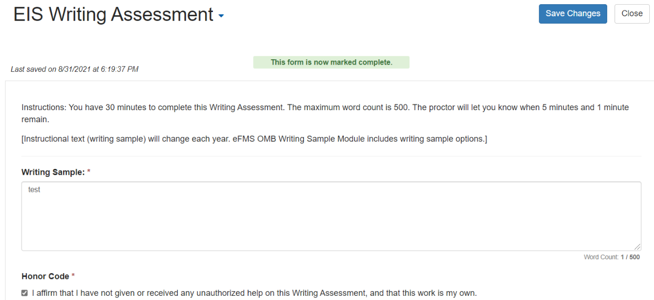  Add new Writing Sample prompt options (only one will be selected each year):  