OMB Control Number 0920-0765 Fellowship Management System Change Request
Attachment 3 – Host Site Module Screenshots
Program | Section | Current Question/Item | Requested Change | Screenshot
All | 3-a. eFMS System Help Desk Ticket Fields | 1. System Error Message  2. Sign-In or Password  3. Smart Card Sign-In  4. Data Not Saving  5. Unable to Submit  6. Reset application back to "Draft"  7. Withdraw Fellowship Application  8. Other | Add Response Option  1. System Error Message  2. Sign-In or Password  3. Smart Card Sign-In  4. Data Not Saving  5. Unable to Submit  6. Reset application back to "Draft"  7. Reset activity back to “Draft”  8. Withdraw Fellowship Application  9. Other | 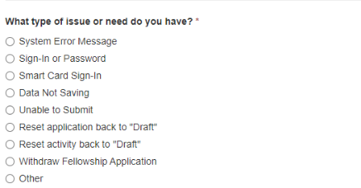
LLS | 6-2.a | Describe the breadth of work that the candidate will experience: | Revise Question  Describe the breadth of work that the candidate will experience with a focus on professional enrichment opportunities: | 
EIS | 6-2.a | Describe the breadth of work that the candidate will experience: | Change Option for EIS to  No | n/a
EIS | 6-2.a | None | Add Question  “Describe the types of activities the candidate would work on in this position.” | 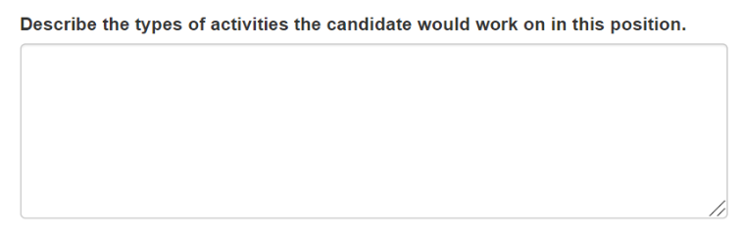
EIS | 6-2.a | Position Assignment Strengths: | Change Option for EIS to  No | n/a
EIS | 6-2.a | None | Add Question  “Position Strengths” | 
EEP | 6.2a | None | Add optional question for EEP  Add an optional question: Together with our public health partners, CDC is working to reduce, and ultimately, eliminate racial and ethnic inequities in health by addressing the structural and social conditions that give rise to them.  In consideration of this, describe how project(s) in this position may help address health equity, racism, or social determinants of health. | 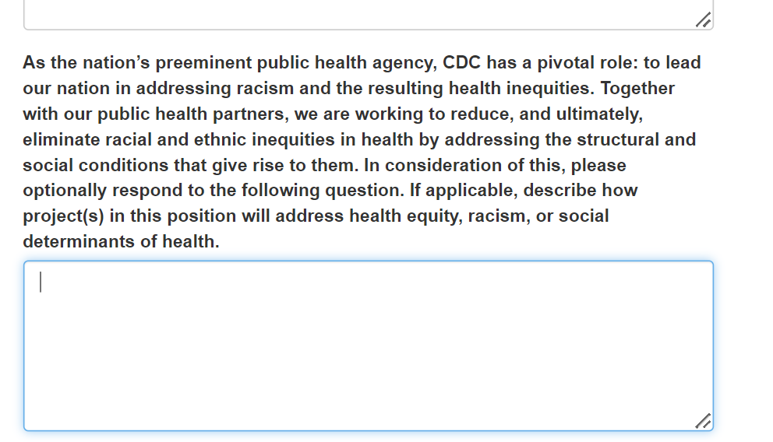
EEP | 6.3a | None | Add Question  What type of work setting are you open to?  - In person (100%)  - Telework/remote (100%)  - Hybrid, mostly in person (>50%)  - Hybrid, mostly telework/remote (<50%) | 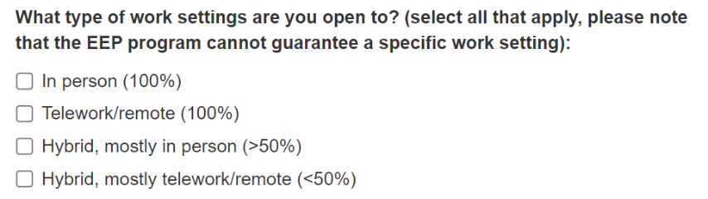
EIS, LLS, EEP | 7.2a | In what year did the supervisor start the fellowship program(s): | Change Option for EEP to  No | n/a
SAF | 11.2 | REASON FOR DEFERMENT | Change Option for SAF to  No  SAF does not have host sites | n/a
EIS, LLS | 5.3-a | n/a | Add Question  What is the anticipated work status for this position?  - In person (100%)  - Telework/remote (100%)  - Hybrid, mostly in person (>50%)  - Hybrid, mostly telework/remote (<50%) | 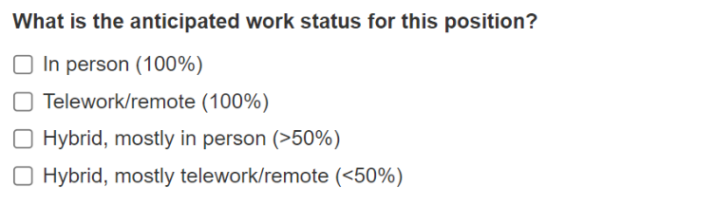
EIS | 6.2-a | Describe the breadth of work that the candidate will experience with a focus on professional enrichment opportunities. | Change Option for EIS to  No | n/a
LLS | 6.2-a | Describe the breadth of work that the candidate will experience. | Revise Question  Change question to “Describe the breadth of work that the candidate will experience with a focus on professional enrichment opportunities:” | 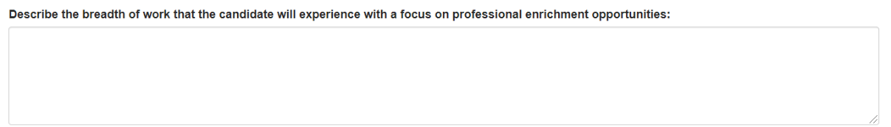
EIS | 6.2-a | None | Add Question  Describe the types of activities the candidate would work on in this position. | 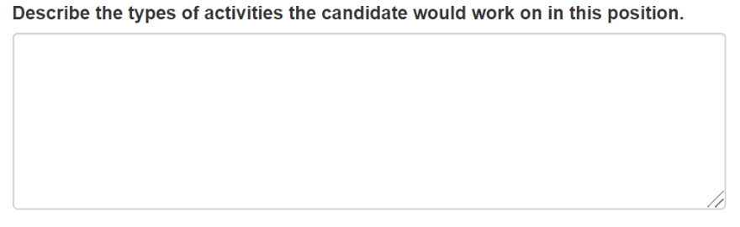
EIS | 6.2-a | Position Assignment Strengths | Change Option for EIS to  No | n/a
EIS | 6.2-a | None | Add Question  Add question for EIS” “Position Strengths” | 
EIS, LLS | 6.6-a | Please include the following information for consultants and officers/fellows in the text boxes below:  - Full Name  - Emails  - Current Titles  - Degrees  - Fellowship year  Alumni Status | Revise Question  EIS/ LLS: Revise and create two sets of instructions:  Consultants: Please include the following information for consultants in the text boxes below: Name- Current Titles- Degrees  Officers/Fellows: Please include the following information for officers/fellows in the text boxes below: Full Name- Degrees- Fellowship Year  EIS Only: Previous EIS Officers (in past 4-6 years) | 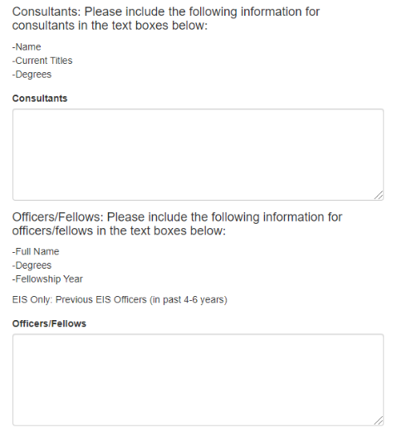
EIS | 6.6-a | None | Add Question  Briefly describe the current/recent EIS officer projects. | 
EIS | 6.7.1-a | None | Add Instructional Text:  “Describe how health equity, racism, or social determinants of health will be incorporated into the project(s).”  - In the last sentence of the Proposed Analytic Projects instructions  - After the first sentence in the Field Investigation CAL instructions  - In the last sentence of the Proposed Surveillance Project instructions
EIS | 6.7.1-a | Briefly describe the host site proposed projects. | Change Option for EIS to  No | n/a
EIS, LLS | 6.7.2-a | Is this a pre-match position?  1. Yes  2. No | Revise Question  “Are you applying to recruit in the pre-match?” | 
EIS, LLS | 6.7.2-a | Describe why this position should be considered for a pre-match. | Revise Question  [If Yes to #1] Describe why this position should be considered for pre-match. | 
EIS, LLS | 6.7.2-a | Will this position be funded by the host site or the EIS/LLS Program?  1. Host Site  2. EIS/LLS Program | Revise Question  [If yes to #1] Will the fellow’s salary and benefits by funded by the Host Site or the EIS Program? All non-federal host sites (e.g., state and local health departments) should select “EIS/LLS Program”.  1. Host Site  2. EIS/LLS Program | 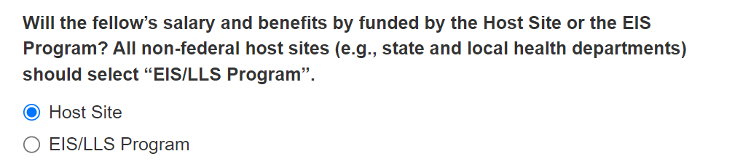
EIS, LLS | 6.7.2-a | If this position is not selected to be funded by the EIS/LLS program, will the host site be willing to fund the position?  1. Yes  2. No | Revise Question  [if yes to #1 and “EIS/LLS Program” to #3]: If this position is not selected to be funded by the EIS/LLS program, would the host site be willing to pay for the fellow’s salary and benefits? All non-federal host sites (e.g., state and local health departments) should select “No”.  1. Yes  2. No | 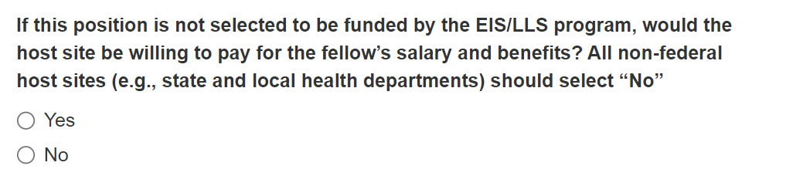
EIS, LLS | 6.7.2-a | Is this a pre match [OR OTHER CDC PRIORITY PROCESS] position?  1. Yes  2. No  Describe why this position should be considered for a pre match/[OR OTHER CDC PRIORITY PROCESS]. | Revise Question  Are you applying to recruit as a [CDC PRIORITY PROCESS] position?  1. Yes  2. No  Describe why this position should be considered for a [CDC PRIORITY PROCESS] position. | 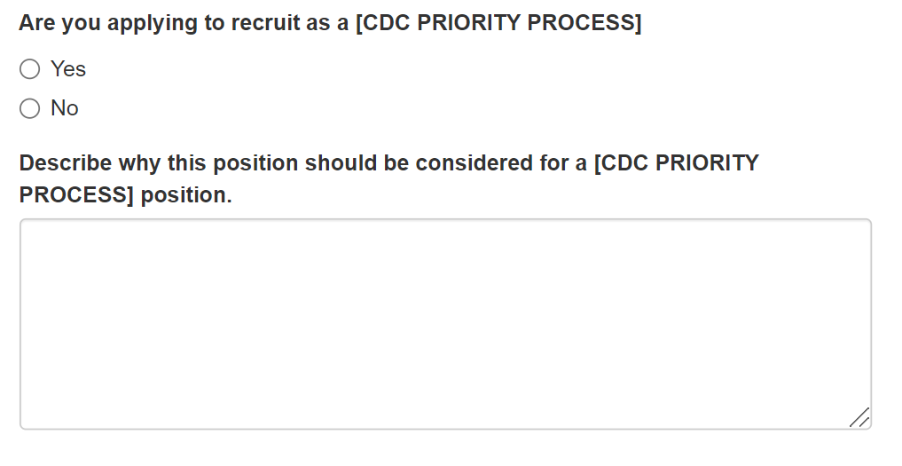
EIS, LLS, EEP | 7.2-a | In what year did the supervisor start the fellowship program(s)? | Change Option for EIS/LLS/EEP to  No | n/a
EIS | 7.3-a | Supervisory Experience [Select all that apply]:  1. I have supervised staff within my organization  2. I have supervised fellows/associates in this fellowship/program.  3. I have supervised fellows/associates in other fellowships/programs. | Change Option for EIS to  No | n/a
EIS | 7.3-a | None | Add Question  Supervisory Experience (Select all that apply):  1. I have supervised staff within my organization.  2. I have supervised fellows/associates in this fellowship/program.  3. I have supervised fellows/associates in other fellowships/programs.  4. Other (specify)  5. None of the Above | 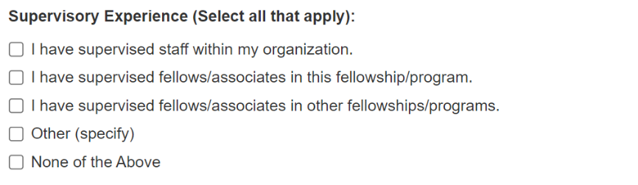
EIS | 7.3-a | None | Add Question  Other (specify) (if selecting 4. Other in previous question) | 
EIS | 7.3-c | Please outline a brief supervision plan that will ensure appropriate on-the-job training, management of the officer’s workload and performance, and support for the officer’s professional and personal growth. This plan should include 1) each supervisor’s role on the team; 2) communication methods and meeting frequency with the officer and 3) how the team will facilitate engagement of the officer with others in the host site. | Change Option for EIS to  No | n/a
EIS | 7.3-c | None | Add question  Please outline a brief supervision plan that will ensure appropriate on-the-job training, management of the officer’s workload and performance, and support for the officer’s professional and personal growth. This plan should include 1) each supervisor’s role on the team; 2) communication methods and meeting frequency with the officer; 3) anticipated percentage of time each supervisor works in the office (vs. remote or telework); 4) anticipated supervisor expectations for the percentage of time the EIS officer will work in the office; and 5) how the team will facilitate engagement of the officer with others in the host site. | 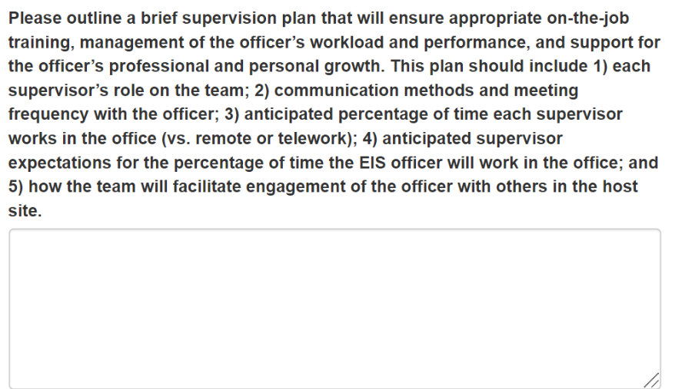
EEP | 7.4-a | Mentorship Experience (Select all that apply):  1. I have mentored staff within my organization.  2. I have mentored fellows/associates in this fellowship/program.  3. I have mentored fellows/associates in other fellowships/programs. | Change Option for EEP to  No | n/a
EEP | 7.4-a | None | Add question  Mentorship Experience (Select all that apply)  1. I have mentored staff within my organization.  2. I have mentored fellows/associates in this fellowship/program.  3. I have mentored fellows/associates in other fellowships/programs.  4. Other (specify)  5. None of the Above | 