OMB Control Number 0920-0765 Fellowship Management System Change Request
Attachment 4 – Activity Tracking Screenshots
Program | Section | Current Question/Item | Requested Change | Screenshot
All | 3-a. eFMS System Help Desk Ticket Fields | 1. System Error Message  2. Sign-In or Password  3. Smart Card Sign-In  4. Data Not Saving  5. Unable to Submit  6. Reset application back to "Draft"  7. Withdraw Fellowship Application  8. Other | Add Response Option  1. System Error Message  2. Sign-In or Password  3. Smart Card Sign-In  4. Data Not Saving  5. Unable to Submit  6. Reset application back to "Draft"  7. Reset activity back to “Draft”  8. Withdraw Fellowship Application  9. Other | 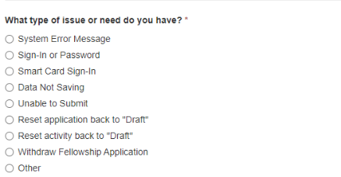
SAF | 6.2.1-1 | n/a | Add Question  Was this conference held in-person, virtually, or hybrid?  1. In person  2. Virtually (if so, Skip to Title of Conference Presentation)  3. Hybrid | 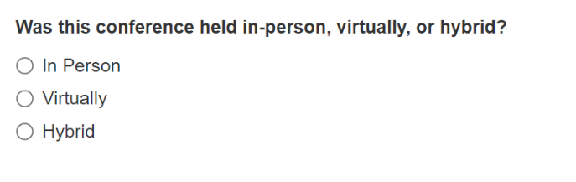
SAF | 7.2.1.1.b. Introduction Fields | 6. Which of the following are barriers to you teaching public health | Add Question  Changes to the school environment due to the COVID-19 pandemic (e.g., virtual or remote learning, masking policies, social distancing)  Response options:  1. Not a barrier  2. Somewhat of a barrier  3. Major barrier | 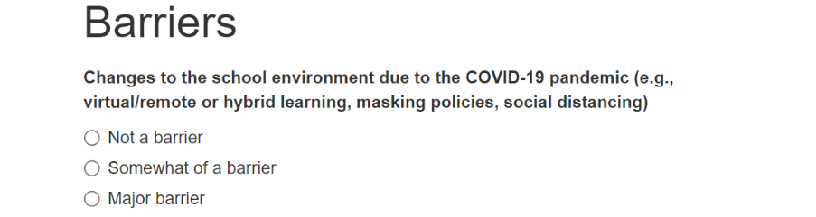
SAF | 7.2.1.1.b. Introduction Fields | 6. Which of the following are barriers to you teaching public health | Add Question  Changes to course curriculum due to restrictions on what can be taught as a result of the COVID-19 pandemic  Response options:  1. Not a barrier  2. Somewhat of a barrier  3. Major barrier | 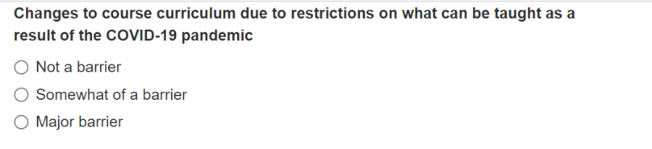
SAF | 7.2.1.1e | Please indicate your level of agreement with each of the following: “I found the ____helpful in increasing my knowledge, skills, or confidence in teaching public health.” Introduction Sessions (CDC Welcome, CDC Mission, CDC Curriculum: Teaching tomorrow’s disease detectives) | Revise Response Options  - Strongly Disagree  - Disagree  - Neutral  - Agree  - Strongly Agree  - N/A | 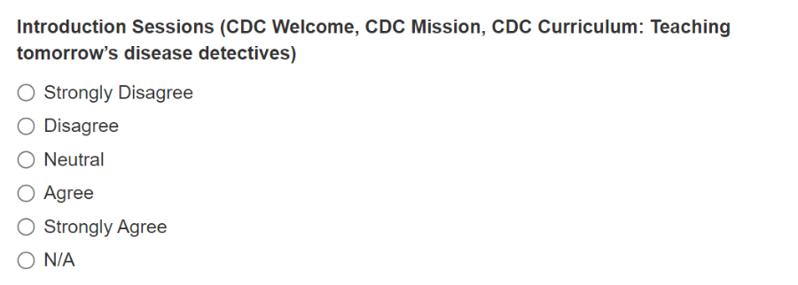
SAF | 7.2.1.1e | Please indicate your level of agreement with each of the following: “I found the ____helpful in increasing my knowledge, skills, or confidence in teaching public health.” Topic Sessions by CDC Subject Matter Experts (SME) | Revise Response Options  - Strongly Disagree  - Disagree  - Neutral  - Agree  - Strongly Agree  - N/A | 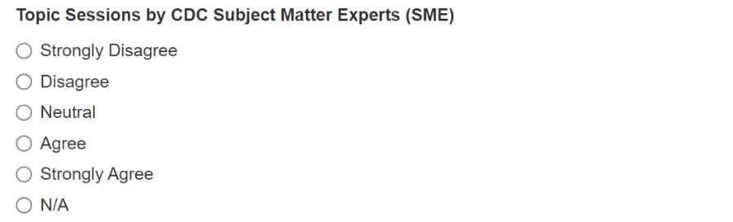
SAF | 7.2.1.1e | Please indicate your level of agreement with each of the following: “I found the ____helpful in increasing my knowledge, skills, or confidence in teaching public health.” Activity Planning Sessions | Revise Response Options  - Strongly Disagree  - Disagree  - Neutral  - Agree  - Strongly Agree  - N/A | 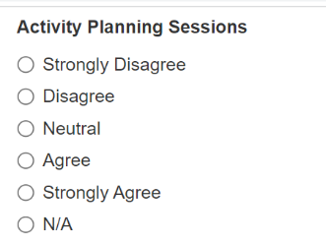
SAF | 7.2.1.1e | Please indicate your level of agreement with each of the following: “I found the ____helpful in increasing my knowledge, skills, or confidence in teaching public health.” Teacher Talks | Revise Response Options  - Strongly Disagree  - Disagree  - Neutral  - Agree  - Strongly Agree  - N/A | 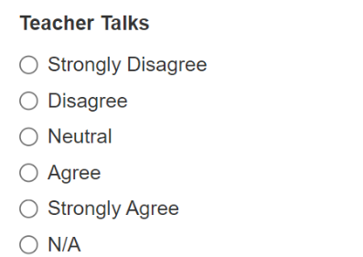
SAF | 7.2.1.1f | Please indicate your level of agreement with each of the following: “I found the ____helpful in increasing my knowledge, skills, or confidence in teaching public health.” Tours & Special Sessions | Revise Response Options  - Strongly Disagree  - Disagree  - Neutral  - Agree  - Strongly Agree  - N/A | 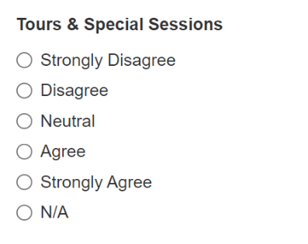
SAF | 7.2.1.2b | After participation in the CDC Science Ambassador Fellowship summer course, I feel confident that I can teach public health content. | Revise Question  Move this question to immediately follow “Prior to participation in the CDC Science Ambassador Fellowship summer course, I felt confident teaching public health content.” in section 7.2.1.2a. | n/a
SAF | 7.2.2.1b | 2. In the past school year, which subject area(s) did you teach? (Select all that apply) | Revise Response Options  - Epidemiology or Public Health  - Life Sciences (e.g., Biology)  - Physical Sciences (e.g., Chemistry, Physics)  - Health and Medical Sciences  - Mathematics or Statistics  - Not applicable  - Other (please specify): ________ | 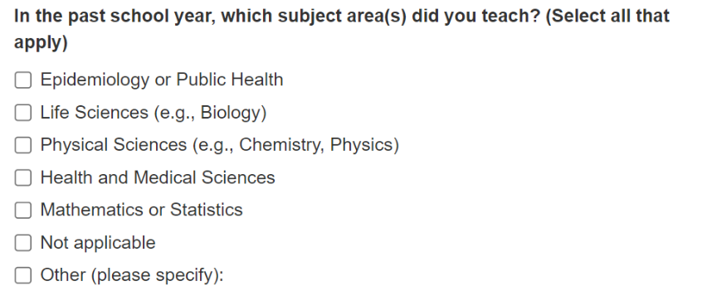
SAF | 7.2.2.1.b | 3. In the past school year, which resource(s) did you use to teach public health content? (Select all that apply) | Revise Response Options  1. CDC NERD Academy  2. CDC Science Ambassador Fellowship Lesson Plans/Activities  3. CDC Website  4. Other Lesson Plans/Activities (e.g., Young Epidemiology Scholars Lesson Plans) or Websites (e.g., Medical Detectives). Please provide at least 1-2 examples:  5. In the past school year, I did not teach public health content. | 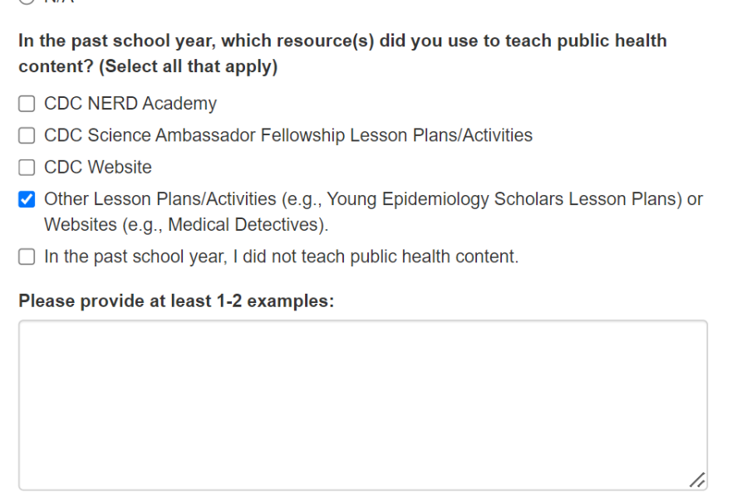
SAF | 7.2.2.1h | What types of activities would you like to participate in? | Revise Response Options  1. Networking with CDC staff  2. Networking with other SAF alumni  3. Sharing ideas and resources with other SAF alumni  4. In-person trainings focused on teaching epidemiology  5. Virtual trainings focused on teaching epidemiology  6. Co-teaching with CDC at conferences and trainings  7. Other | 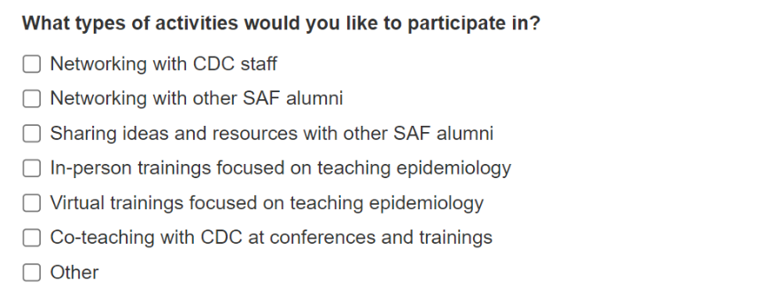
SAF | 8.1.2.a | Missing requirements:  Additional information needed  General comments of feedback | Change Option for SAF to  No | N/A
LLS | 8.2.2.1.a CAL 1 Fields | What is the status of this CAL? | Revise Question  What is the status of this CAL? Please refer to the CAL Status Guide to determine percent complete.
LLS | Table 8.2.2.1.g. CAL 7 Fields | Clearance Submission: When was the manuscript submitted to clearance? | Revise Question  Please select the interim deliverable completed:  1. Project Summary  2. Introduction  3. Outline of Findings and Conclusions  4. Manuscript Draft (or published manuscript) | 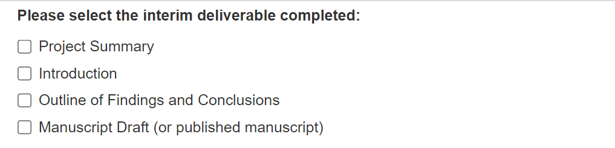
LLS | Figure 8.2.2.1.g. CAL 7 Fields | CAL 7: Write, and submit as first author, a scientific manuscript for a peer-reviewed journal. | Revise Instructional Text  CAL 7: Write, as first author, a scientific manuscript for a peer-reviewed journal.
LLS | Figure 8.2.2.1.g. CAL 7 Fields | Citation | Remove Citation | n/a
LLS | Figure 7.3.1.1.a. Introduction Fields; Supervisor 1-Year Survey | Thank you for serving as an LLS supervisor for the 2018 Fellowship Class. | Revise Instructional Text  Remove class year from instructional text.  Thank you for serving as an LLS supervisor for the [YEAR] Fellowship Class. | 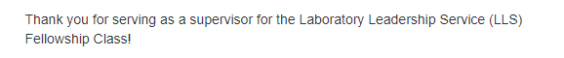
LLS | Figure 7.3.1.2.a. Communication Fields; Supervisor 1-Year Survey | Your interactions with your CIO ADLS about an LLS-related question or problem. | Change Option for LLS to  No: This question should be removed from the survey entirely | N/A
LLS | Figure 7.3.2.1.a. Introduction Fields; Supervisor Exit Survey | Thank you for serving as an LLS supervisor for the 2018 Fellowship Class. | Revise Instructional Text  Please update "2018" in the introduction to the respective year. In this case, it's for the 2020 Fellowship Class.
LLS | Figure 7.3.2.1.c. Introduction Fields; Supervisor Exit Survey | Please refer to the 2019 CAL list for the questions listed below. The CAL list for 2019 included: | Revise Question  Please remove the year from the CAL list in the introduction so the date doesn’t have to be updated each year. Instead, state, "Please refer to the CAL list for the questions listed below. The CAL list included:" | 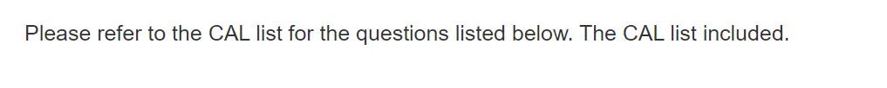
LLS | Figure 7.3.1.2.a. Communication Fields; Supervisor Exit Survey | Your interactions with your CIO ADLS about an LLS-related question or problem. | Change Option for LLS to  No: This question should be removed from the survey entirely | N/A
SAF/EEP | 8.2.3.a. Activity Review Fields | Missing requirements:  Additional information needed  General comments of feedback | Change Option for SAF/EEP to  No | N/A
SAF | 8.3.2.a. Accomplishment Review Fields | Missing requirements:  Additional information needed  General comments of feedback | Change Option for SAF to  No | N/A
SAF | 8.4.2.b. Project Review Fields | Missing requirements:  Additional information needed  General comments of feedback | Change Option for SAF to  No | N/A
SAF/EEP | 8.6.2.a. Activity Review Fields | Missing requirements:  Additional information needed  General comments of feedback | Change Option for SAF/EEP to  No | N/A

