OMB Control Number 0920-0765 Fellowship Management System Change Request
Attachment 5 – Alumni Tracking Screenshots
Program | Section | Current Question/Item | Requested Change | Screenshot
All | 3-a. eFMS System Help Desk Ticket Fields | 1. System Error Message  2. Sign-In or Password  3. Smart Card Sign-In  4. Data Not Saving  5. Unable to Submit  6. Reset application back to "Draft"  7. Withdraw Fellowship Application  8. Other | Add Response Option  1. System Error Message  2. Sign-In or Password  3. Smart Card Sign-In  4. Data Not Saving  5. Unable to Submit  6. Reset application back to "Draft"  7. Reset activity back to “Draft”  8. Withdraw Fellowship Application  9. Other | 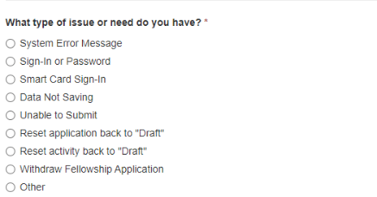
SAF | 5.1-a. General Information Fields | Employment Status | Change Option for SAF to  No | n/a
SAF | 5.1-a. General Information Fields | Employment Status | Add question  1. Employed as a K-12 or post-secondary teacher  2. Employed in an education leadership role  3. Employed in other educational type role (museum educator, librarian, literacy instructor, etc..)  4. Retired  5. Employed in field other than education  6. Other (Specify) | 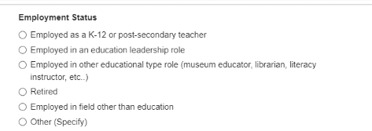
SAF | 5.3-a. Fellowship Information Fields | CDC ID | Change Option for SAF to  No | n/a
LLS | Table 6.-a. Fellowship Information Fields | Completed Undergraduate Degrees:  Completed Graduate Degrees:  Please indicate the institution’s accreditation status for the graduate degrees listed above. (Check all that apply)  Practicum:  Completed Residencies:  Active Board Certifications:  Active Medical Licenses: | Add Response Option  Post-doctoral training: | 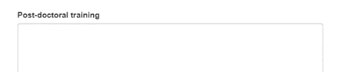
SAF | 6.-a. Fellowship Information Fields | Completed Residencies  Active Board Certifications:  Physician eligible to practice within the U.S.? | Change Option for SAF to  No
EIS, LLS, EEP | 6a | Please indicate the institution’s accreditation status for the graduate degrees listed above. (Check all that apply) | Add new question:  "Please indicate which of the following types of programs you completed for the graduate degrees listed above":  1. Accredited U.S. Medical School  2. Non-U.S. Medical School  3. Accredited Nursing School  4. Accredited Veterinary School  5. Other doctoral program (e.g. PhD, EdD, PharmD, SD, etc.)  6. Other allied health program  7. Other types of degrees (e.g. MBA, EdS, etc.) | 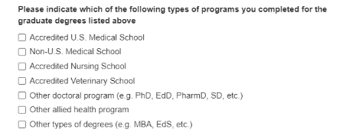
SAF | 8.1.1-a. Career Progression Fields | Thinking about your current position, how much of your work is related to any type of public health (including scientific, programmatic, or administrative activities)? This includes traditional and non-traditional public health settings. | Change Option for SAF to  No | n/a
SAF | 8.1.1-a. Career Progression Fields | Have you received any of the following within the past [insert timeframe since last survey, i.e., year, two years, five years]? (Check all that apply) | Change Option for SAF to  No | n/a
SAF | 8.1.4.-b. Preparing Alumni for Post-Fellowship Job Fields | Year 1 survey only] Overall, to what extent did your fellowship experience prepare you to perform your first job after your fellowship? | Change Option for SAF to  No | n/a
All | Table 8.1.5.-a. Alumni Engagement Fields | Based on your experience, where should we be marketing our fellowship opportunities? (Select up to three) | Revise Response Options  1. Job sites (Indeed, LinkedIn, Glassdoor, etc.)  2. Social media platforms (Facebook, Instagram, Twitter, etc.)  3. Social media pages (partners, conferences, schools, workplaces, etc.)  4. School events  5. Conferences  6. Professional organizations  7. Newsletter email subscriptions  8. Other (specify) | 