OMB Control Number 0920-0765 Fellowship Management System Change Request
Attachment 1 – Application Module Screenshots
Program | Section | Requested Change | Screenshot
All | 13.2-a | Change Type: Question revision | Which of the following most influenced you to apply to this fellowship?  - Handshake (e.g., job posting, fellow/alumni ambassador)  - Other job search platform (e.g., Indeed, ZipRecruiter, Job Openings for Economists)  - In-person event (e.g., conference booth)  - News advertising (e.g., online ad, news media)  - Newsletter or email listserv (e.g., from CDC, your university, professional organization)  - Social Media (e.g., Facebook, LinkedIn, Instagram, Twitter, YouTube)  - Webinar or other virtual event (e.g., information session, alumni panel)  - Word of mouth (e.g., from current or former fellow, professor, supervisor)  - Other (please specify)
 | 13.2-a | Change type: Question deletion | 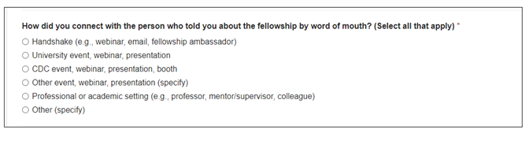  Delete Question
 | 13.2-a | Change type: Question deletion | 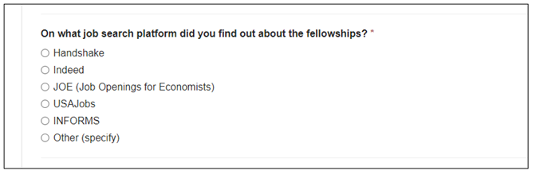  Delete Question
SAF | 6.6 | Change type: Question addition  In the past 5 years, in which ways have you interacted with the Science Ambassador program?  Options [SELECT ALL THAT APPLY]:  - Attended a CDC Science Ambassador regional training workshop  - Previously applied to the CDC Science Ambassador Fellowship  - Used CDC NERD Academy curriculum in my classroom  - Used CDC Science Ambassador lesson plans in my classroom  - None of the above  - Other | 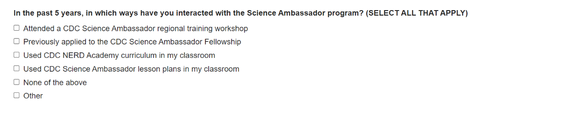
SAF | 6.6 | Change type: Question deletion  Do you have a current teaching license in your state? | N/A - This field will be hidden for the SAF Fellow Application.
SAF | 7.2-a | Change type: Question deletion  4. Active U.S. License (due to limitation of eFMS, a new question must be added for SAF):  {Instructions: Include completed degrees and any degrees in progress}  Do you want to add?  - Undergraduate Education  - Graduate Education (includes degrees in progress)  - Additional Coursework | 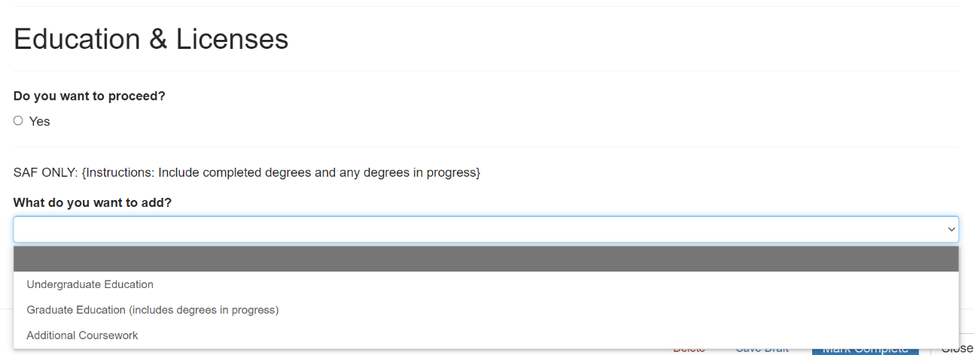
All | 7.2-a | Change Type: Response option revision  2. Graduate Education to 2. Graduate Education (including degrees in progress)
SAF | 7.9-a | Change type: Question deletion  Remove for SAF | N/A - These fields will be hidden for the SAF Fellow Application.
All | 7.11-a | Change Type: Question revision  Incomplete Reason (Note: List expected graduation date if degree is still in progress): | 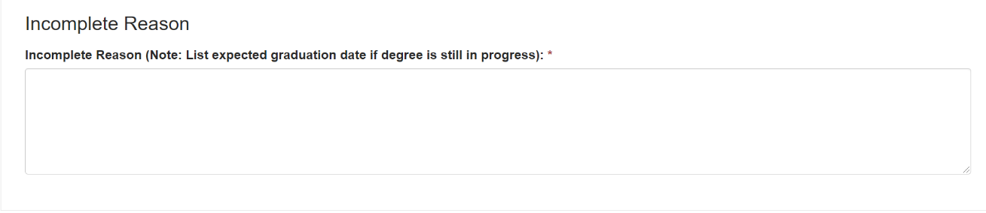
1q11SAF | 8.3-a | Change Type: Question revision  Does this organization, school, or school district receive Title 1 financial assistance? | 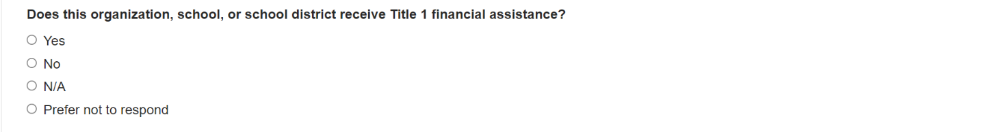
SAF | 8.3-a | Change Type: Response option revision  Add additional answer option: 4. Prefer not to respond
SAF | 9.2-a | Change Type: Response option revision/question addition  Remove:  1. Clinical Training  2. U.S. Board Certification  4. Language Skill  Due to limitations of eFMS, a new question must be created for SAF:  What do you need to add?  - Additional Training, Certification or Professional Development  - None of the Above | 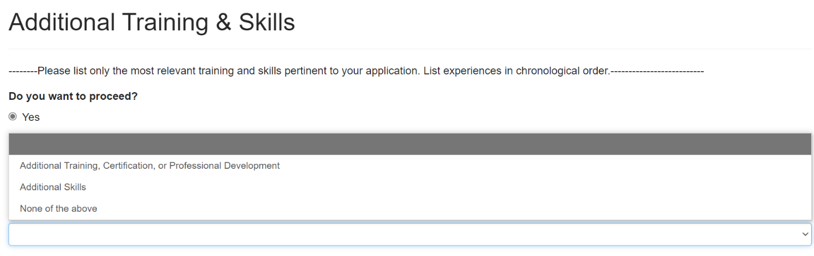
EEP | 9.2-a | Change Type: Response option revision/question addition  Add response:  - Additional Skills  Due to limitations of eFMS, a new question must be created for SAF:  What do you need to add?  - Additional Training, Certification or Professional Development  - Additional Skills  - None of the Above
EEP | New section if possible: 9.9 | Change type: Question addition  Please select the statistical software package(s) for which you have Proficient/Skilled or Mastery/Expert competency [SELECT ALL THAT APPLY]:  Entry/Novice  - Limited capabilities  - Little or no experience  Proficient/Skilled  - Basic capabilities  - Moderate amount of experience  Mastery/Expert  - Advanced capabilities  - Extensive experience  - SAS  - STATA  - Epi-Info  - R  - Excel  - Other: [Open-ended] | 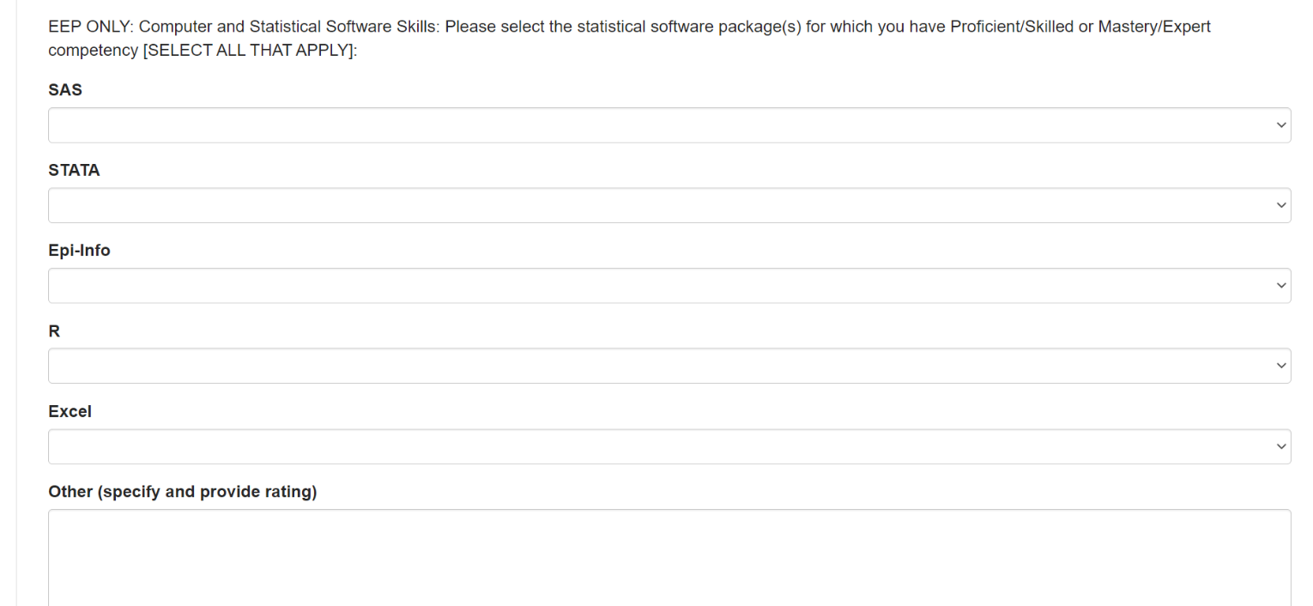
All applicable programs | 10.2-a | Change Type: Question revision  4. Honor or Awards to 4. Honors or Awards | 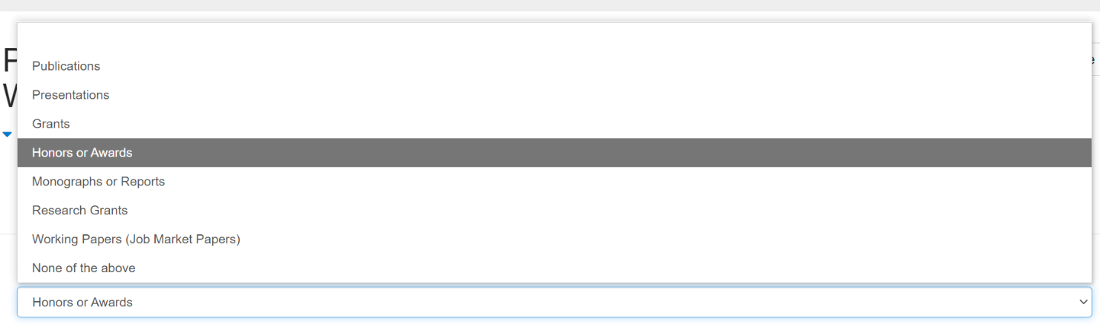
EEP | 11.1-a | Change type: Question deletion | N/A – This field will be hidden for the EEP Fellow Application.
EEP | 13.3.2-a | Change Type: Response option revision  Topic area(s): [SELECT ALL THAT APPLY]  Note: added options are 13, 18, 27, 28, 29, 33, 34  1. Obesity, nutrition, and physical activity  2. Cancer prevention and control  3. Diabetes  4. Heart disease and stroke prevention  5. Tobacco prevention and cessation  6. Other chronic disease  7. Emergency preparedness and response  8. Asthma and air pollution  9. Environmental health  10. Immunizations/vaccine preventable disease  11. Influenza  12. HIV/AIDS, or Tuberculosis  13. STD prevention  14. Viral hepatitis  15. Foodborne diseases  16. Waterborne diseases  17. Vectorborne diseases  18. Fungal Diseases  19. One Health and zoonotic disease  20. Arctic Investigations (Alaska)  21. Healthcare-associated infections  22. Quarantine and border health services  23. Unintentional injury  24. Opioid/prescription drug overdose prevention  25. Occupational health and safety  26. Violence Prevention  27. Reproductive Health  28. Maternal and infant health  29. Blood Disorders  30. Health statistics  31. State, local, and territorial health  32. Global health  33. COVID-19  34. Other (specify) | 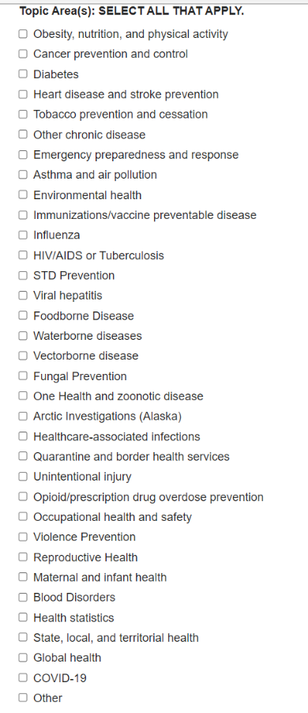
EEP | 13.3.3-a | Change Type: Response option revision  What is your preference for the location of your project assignment? (Select all that apply)  1. CDC headquarters or Atlanta regional campuses (Atlanta, Georgia)  2. Other CDC Regional Campuses  3. Other Federal Agencies  4. State, local, or territorial health departments  5. CDC Country Office (Remote) | 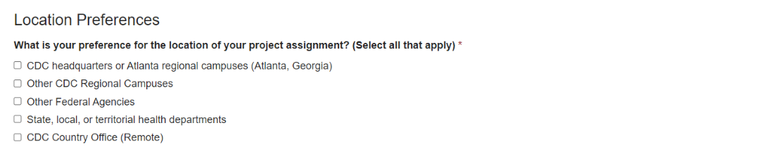
EEP | 13.3.3-a | Change type: Question addition  Add new question for EEP after What is your preference for the location of your project assignment:  What type of work settings are you open to? (select all that apply, please note that the EEP program cannot guarantee a specific work setting):  - Remote/Full Telework  - Hybrid/Partial Telework  - In-person | 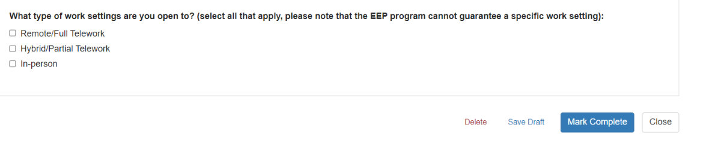
EEP | 13.3.3-a | Change Type: Response option revision  Other CDC Regional Campuses (Select all that apply):  1. Anchorage, Alaska  2. Ft. Collins, Colorado  3. San Juan, Puerto Rico  4. Hyattsville, Maryland  5. Morgantown, West Virginia  6. Cincinnati, Ohio  7. Pittsburgh, Pennsylvania  8. Spokane, Washington  9. Denver, Colorado  10. Durham, North Carolina  11. Washington, DC  12. I am open to locations not listed above | 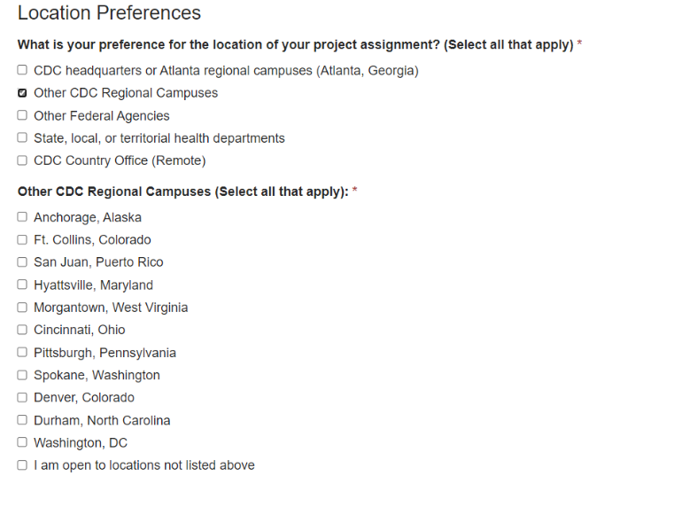
EEP | 13.3.3-a | Change Type: Response option revision  Other Federal Agencies (Select all that apply):  - National Park Service (Fort Collins, Colorado)  - National Park Service (Albuquerque, New Mexico)  - National Park Service (Washington, DC)  - Indian Health Service (varies)  - I am open to additional federal agencies not already listed above | 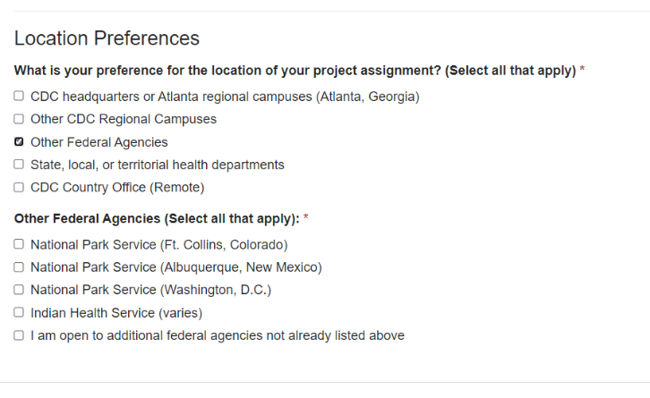
SAF | 13.5-a | Change Type: Response option revision  First [Second | Third] Choice Area:  1. Obesity, nutrition, and physical activity  2. Cancer prevention and control  3. Diabetes  4. Heart disease and stroke prevention  5. Tobacco prevention and cessation  6. Other chronic disease  7. Emergency preparedness and response  8. Asthma and air pollution  9. Environmental health  10. Immunizations/vaccine preventable disease  11. Influenza  12. HIV/AIDS, or Tuberculosis  13. STD prevention  14. Viral hepatitis  15. Foodborne diseases  16. Waterborne diseases  17. Vectorborne diseases  18. Fungal Diseases  19. One Health and zoonotic disease  20. Arctic Investigations (Alaska)  21. Healthcare-associated infections  22. Quarantine and border health services  23. Unintentional injury  24. Opioid/prescription drug overdose prevention  25. Occupational health and safety  26. Violence Prevention  27. Reproductive Health  28. Maternal and infant health  29. Blood Disorders  30. Health statistics  31. State, local, and territorial health  32. Global health  33. COVID-19  34. Other (specify) | 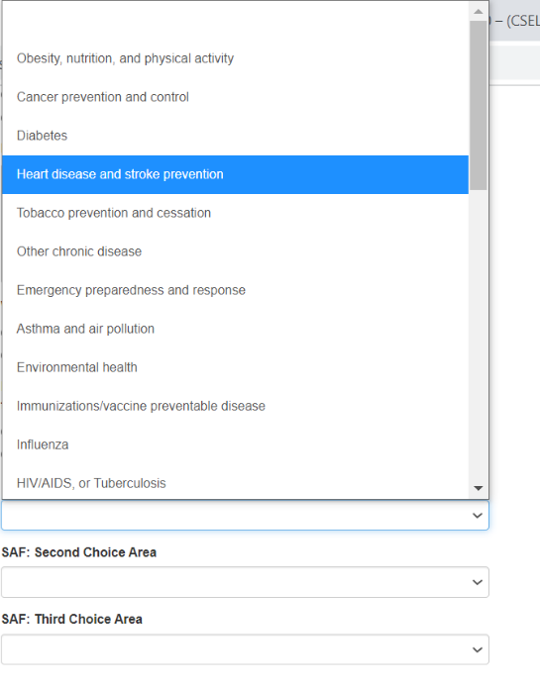  Note: not possible to show all response options in one screenshot.
EEP | 15 | Change type: Question deletion, instructional text revision  Change item to read (remove questions 3 and 4):  Contact Information Confirmation  You can view and update your contact information in the EEP Fellowship Application Portal under Applicant Profile. We will be using this information to contact you regarding application status and match.  1. The email listed on my profile form is accurate and accessible for the next 6 months. (Yes)  2. The phone number(s) listed on my profile form are accurate and accessible for the next 6 months. (Yes) | 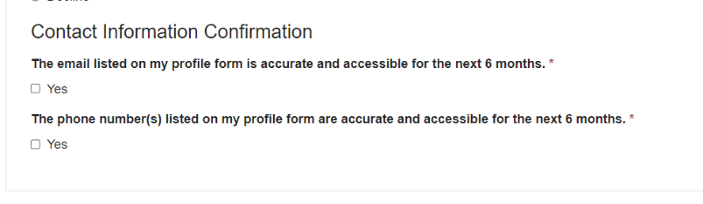
EEP | Degree List | Change Type: Response option revision  Create separate Undergraduate and Graduate Degree lists, with undergraduate list changed to:  AB  BA  BS  BS/BA  BSc  SB  ScB  Other | 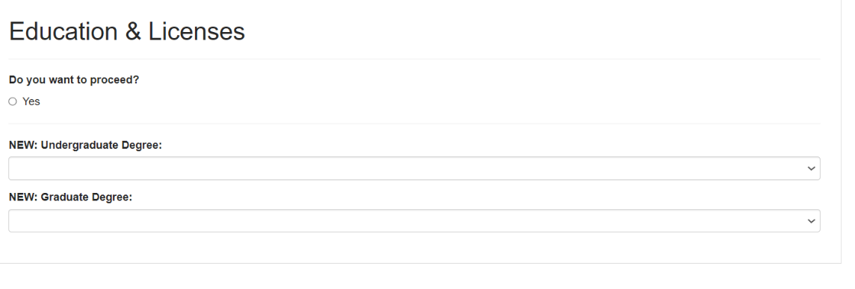  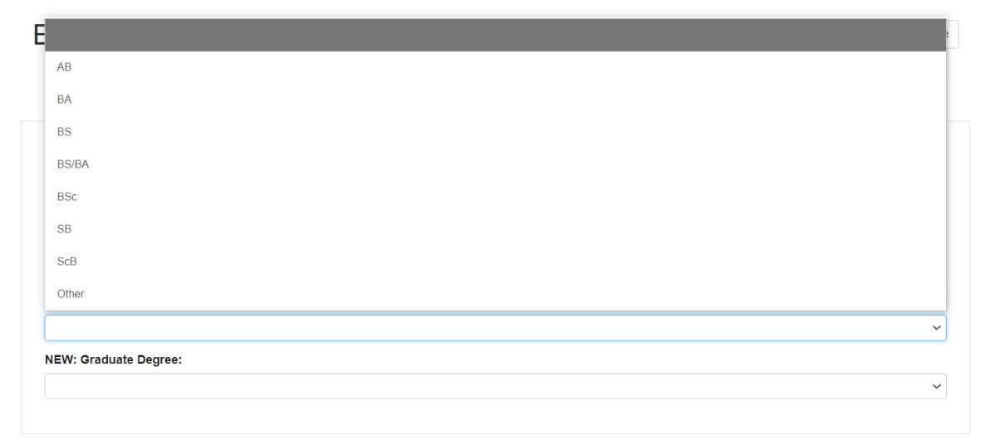
EEP | Degree List | Change Type: Response option revision  Create separate Undergraduate and Graduate Degree lists, with graduate list changed to:  AM  BA  DHS  DHSc  DNSc  DPH  DPhil  DrPH  DrS  DrSc  EdD  MA  MEd  MHS  MHSc  MHSE  MN  MPH  MPhil  MPHTM  MPVM  MS  MSVPH  MSc  MScPH  MSPH  MTM&H  PhD  SB  ScB  ScD  ScM  SM  Other | 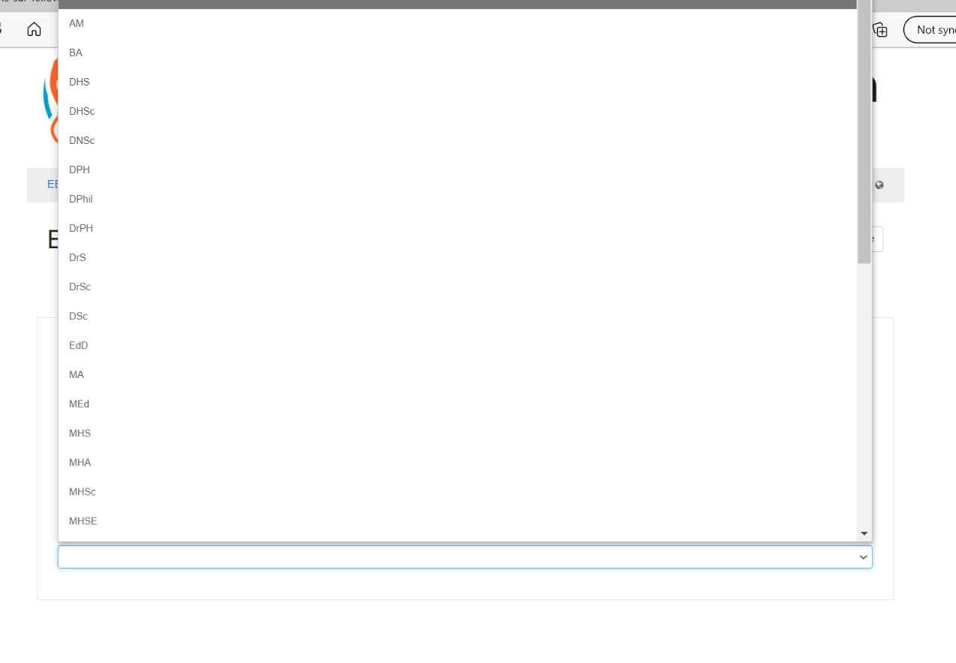  Note: not possible to show all response options in one screenshot.
LLS, EIS | 8.1-a Adding Work or Volunteer Experience | Change Type: Instructional Text Revision  {Instructions: Add relevant examples to explain what should be included in each section} | 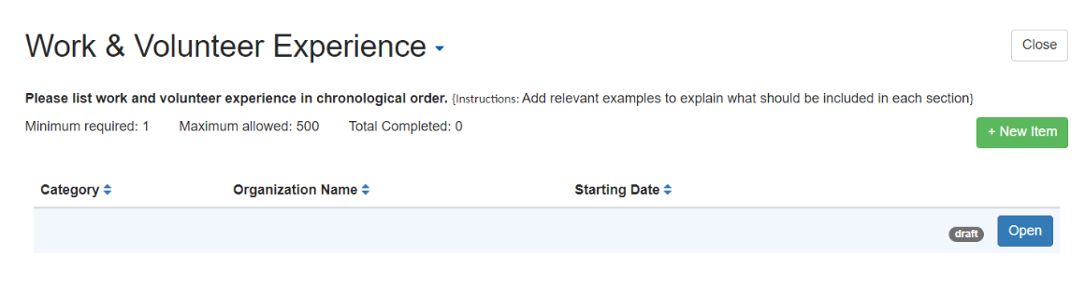
LLS, EIS | 9.5-1. Additional Training, Certifications, or Professional Development Fields | Change Type: Instructional Text Revision  {Instructions: Add relevant examples to explain what should be included in each section} | 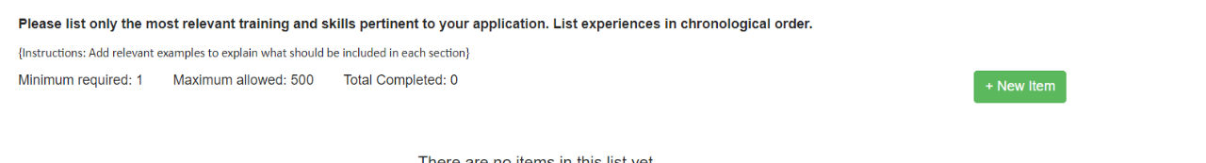
All | - Field Value Tables | Change Type: Response option revision  Add American Samoa | 