Addendum to Supporting Statement for Form SSA-10

Application for Widow’s or Widower’s Insurance Benefits
20 CFR 404.335-404.338, and 404.603
OMB No. 0960-0004

Revisions to the Collection Instruments

SSA is making the following revisions to Form SSA-10:

- Change #1: We are updating the title of the application to “Application for Social Security Benefits” on page 1 and page 7 (the receipt).

Justification #1: We are beginning our effort to streamline our Title II benefit applications into one application so that we can avoid unnecessarily re-collecting information from claimants who file for more than one benefit. This change is consistent with our scope of Title II applications, which makes any application an application for all Title II benefits to which the claimant may be eligible.

- Change #2: We are rewording the scope of the application from “this may also be considered an application” to “this may serve as an application.”

Justification #2: We are removing passive voice which is consistent with plain language standards.

- Change #3: We are removing question #1(b): Check (X) one for the Deceased. Male Female. We do not believe that removing this question will cause a decrease in the average burden per response since the questions take less than a minute to complete.

Justification #3: We no longer need this information for eligibility or entitlement for benefits. The MCS claims system will continue to pull this information from our records until the new complete the new platform i.e., Consolidate Claim Experience (CCE) System. CCE will not include that information.

- Change #4: We are removing question #6(a), “Did the Deceased ever file an application for Social Security benefits, a period of disability under Social Security, Supplemental Security Income, or hospital or medical insurance under Medicare?” as well as question #6(b), “Enter name of person on whose Social Security record other application was file,” and question #6(c), “Enter Social Security number of the person named in (b).”

Justification #4: We are removing these questions because we are not required to ask individuals these questions since the information is already in SSA records. The data fields for these questions will remain in the Modernized Claim System (MCS). Technicians will complete the data fields with information they obtained from SSA records. We do not believe that removing these questions will cause a decrease in the average burden per response since the questions take less than a minute to complete.

- Change #5: We are removing question #8(a), (b) and (c) and #19.

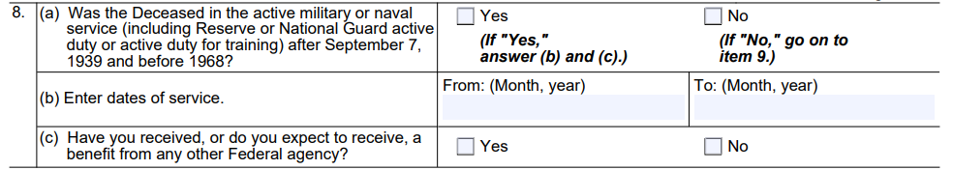

Justification #5: These questions are no longer relevant since they apply to claimants who are currently age 71 and older.

- Change #6: We are removing the word “about” from question #9(a) and (b).

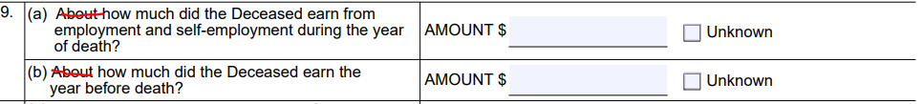

Justification #6: We removed the term because it is not meaningful in this context.

- Change #7: We are removing question #14(b) and (c).

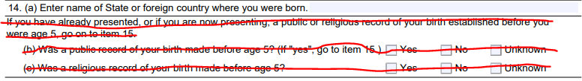

Justification #7: We do not need to see records of birth for documentation in all cases. When we do need to see records, we ask for specific items. We do not need to ask about the existence of records for all claimants.

- Change #8: We are inserting questions about citizenship and legal presence to become question #13.

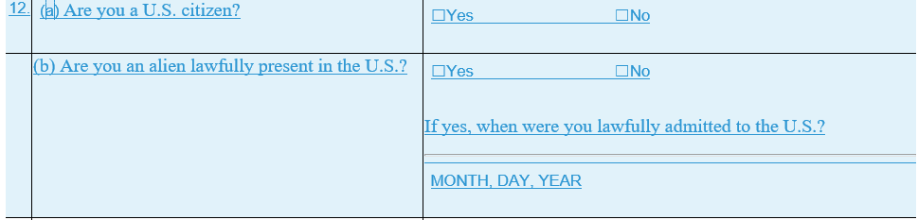

Justification #8: We need to collect the citizenship or legal presence status of the claimant. The question is already present on the screens included in previously approved packages. We do not believe that inserting these questions will cause an increase in the average burden per response since the questions take less than a minute to complete.

- Change #9: We are removing question #17(a), “Have you (or has someone on your behalf) ever filed an application for Social Security benefits, a period of disability under Social Security, Supplemental Security Income, or hospital or medical insurance under Medicare?” as well as question #17(b), “Enter name of person on whose Social Security record you filed other application,” and question #17(c), “Enter Social Security number of person named in (b).”

Justification #9: We are removing these questions because we are not required to ask individuals these questions since the information is already in SSA records. The data fields for these questions will remain in the Modernized Claim System (MCS). Technicians will complete the data fields with information they obtained from SSA records. We do not believe that removing these questions will cause a decrease in the average burden per response since the questions take less than a minute to complete.

- Change #10: We are inserting question #21 (c), “Are you filing for foreign Social Security benefits?”

Justification #10: We are inserting this question because the Title II application can protect the filing date for the foreign benefit. The updated format is consistent with other Title II applications. The question is already present on the screens included in previously approved packages. We do not believe that adding this question will cause an increase in the average burden per response since the questions take less than a minute to complete.

- Change #11: We are updating the penalty of perjury statement:

From:
I declare under penalty of perjury that I have examined all the information on this form, and on any accompanying statements or forms, and it is true and correct to the best of my knowledge. I understand that anyone who knowingly gives a false or misleading statement about a material fact in this information, or causes someone else to do so, commits a crime and may be sent to prison, or may face other penalties, or both.

To:
I declare under penalty of perjury that I have examined all the information on this form, and on any accompanying statements or forms, and it is true and correct to the best of my knowledge. I understand that anyone who knowingly gives a false or misleading statement about a material fact in this information, or causes someone else to do so, commits a crime and may be subject to fine or imprisonment, or both.

Justification #11: We are updating the statement to be consistent with our other benefit applications.

- Change #12: We are replacing the “Social Security Claim Number” with the beneficiary notice control number (BNC).

Justification #12: We are removing Social Security numbers per the Social Security Number Fraud Prevention Act.

- Change #13: We are reformatting the internet link to SSA’s website from “www.socialsecurity.gov” to “www.ssa.gov” located on page 4, “Medicare Information” section and page 8 “Changes To Be Reported and How to Report” section.

Justification #13: We are displaying the internet link using our current naming convention.

- Change #14: We adjusted the question numbers and references to question numbers throughout the form.

Justification #14: The removal and addition of questions required changes to subsequent questions and referrals to those questions.

- Change #15: We are revising the PRA statement on this form.

Justification #15: We are revising the PRA statement to reflect our current boilerplate language. The current language, which dates back to the last reprint of the form, is now outdated.

Preliminary Claims System (PCS)

- Change #16: We are removing reference about PCS as a collection tool that we added with the March 2019 Change Request.

Justification #16: Due to reassessing IT Modernization initiatives, we stopped development for the PCS. The focus shifted to creating the Consolidated Claims Experience (CCE), which will replace our current legacy claim system with web-based claims.

