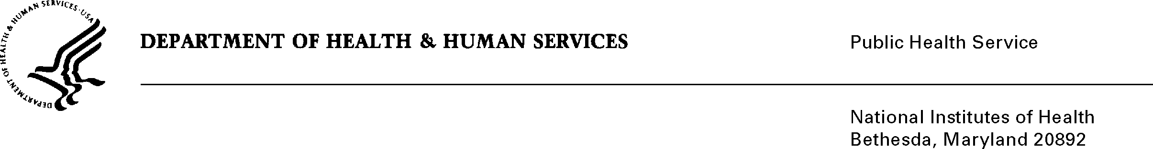

(Date) February 17, 2022

TO: Office of Management and Budget (OMB)
Through: Reports Clearance Officer, Terry Clark, DHHS
Project Clearance Chief, Mikia Currie, NIH
Project Clearance Liaison, Jane Lambert, (NIEHS)

FROM: Joan P. Packenham, Ph.D.,
NIH/NIEHS Office of Human Research and Community Engagement

SUBJECT: Non-Substantial Change Request to Generic: Challenge and Competitions solicitation, OMB # 0990-0390, expiration date 04/30/2023

NIH/NIEHS requests OMB approval of an additional of 10 Burden Hours and 60 responses in order for the Generic package to have adequate burden hours to complete the following: “Women’s Health Awareness (WHA) Climate Change in Your Community Challenge for North Carolina Middle Schools (Climate Change and Your Community: Making an Impact on Environmental Health)” GenIC that will be submitted following the approval of the Non-Substantive Change Request.

Thank you for your consideration

Signature of Submitter

