OMB Control number 1024 -XXXX
Current expiration Date: XX/XX/20XX

National Park Service Recreation Fee Pricing Study
No Past or Future Visitation
Survey Pre-Test

PAPERWORK REDUCTION ACT STATEMENT: The National Park Service is authorized by the NPS Research Mandate (54 USC 100702) to collect this information. This information will be used by the NPS in future initiatives related to the visitor use and resource management within the site. Response to this request is voluntary. No action may be taken against you for refusing to supply the information requested. The permanent data will be anonymous. An agency may not conduct or sponsor, and a person is not required to respond to, a collection of information unless it displays a currently valid OMB control number.

BURDEN ESTIMATE: Public reporting burden for this form is estimated to average 25 minutes per response. Please direct comments regarding the burden estimate or any other aspect of this form to: Tristan Cherry, RSG, Tristan.cherry@rsginc.com (email); or Phadrea Ponds, NPS Information Collection Clearance Officer at phadrea_ponds@nps.gov (email).

ScreenING SCRIPT (S)
NOTE TO REVIEWER: When reviewing this questionnaire, keep in mind the following notations that provide detail on how the survey will flow and look programmed online.
- Dynamic Inserts: Words that are dynamically inserted based on responses to previous questions are shown in carrots, such as “<insert last NPS Unit visited>” or <Error: Please enter a valid 5-digit zip code>.
- Survey Logic and Programming Notes: Text that specifies logic, programming notes, instructions to programmers and will not be shown on the screen are surrounded by square brackets “[]” such as “[skip to Question PVS2]” or question names such as “[age]”.
Welcome to the National Park Service Visitor Planning Survey. Your answers will help the National Park Service, the federal agency responsible for managing all 400+ national parks, monuments and other historical sites in the United States, better understand how people think about and plan visits to these areas. The information you provide will be kept strictly confidential by the National Park Service and RSG (the company that is collecting the survey data).
Please use the “Next” button in the lower left-hand corner of the screen to go forward. To review a previous question, use the “Previous” button. It is important that you do not use your web browser’s “forward” or “back” buttons because your answers may not be recorded properly.
The survey should take approximately 25 minutes. If you can’t finish the survey in one sitting, you can stop at any time and return to where you left off by re-entering your password.
Please enter the password from the letter (or postcard) then click “Next” to begin.
Password: _________
NOTE TO REVIEWER: If the respondent enters a non-valid password: <‘Sorry, the password you entered is not valid, please check the postcard or letter you received in the mail and try again.’>

If respondent indicates they are not 18 years or older in S1 then terminate from the survey.
- Are you 18 years old or older? [age]
- Yes
- No

Past Park Unit Visitation Screener (PVS)
NOTE TO REVIEWER: The questions in this section will determine the number of times the respondent has visited one or more units of the National Park System in the past two years, and which specific park units were visited. This information is necessary to determine whether the respondent meets the criteria to respond to the Stated Preference Exercises.
The National Park Service (NPS) manages a wide variety of public areas including National Parks, National Seashores, National Historic Sites, National Battlefields, and National Monuments. For simplicity, we will refer to all of these areas as “national parks.”
The NPS is one of several agencies that manage federal recreation sites. Others include the U.S. Forest Service, Bureau of Reclamation, and Bureau of Land Management. In this survey, we will only ask you about your use of parks managed by the NPS.

- Which national parks have you visited in the past two years? [past_park_module]
NOTE TO REVIEWER: The autofill textboxes and US map combination will be similar to the maps found at: https://irma.nps.gov/Stats/. The text box will only allow pre-loaded options. Respondents will be able to select a state and re-center the map where parks/park boundaries will display. The selected parks will auto populate. The survey will automatically populate <current month> and <current year - 2> based on the date the respondent accesses the survey.
The map below shows all national parks in the United States. Please tell us which national parks you’ve visited within the last two years. You can search for a specific park by typing the name below or by searching for parks by state.
Please only include the national parks you have visited in the past two years (since <current month>, <current year – 2>.
- I haven’t visited any national parks in the last two years. [skip to Question PVS2 ]
If you have visited more than 10 national parks in the past two years, please only enter the 10 parks that you visited most recently.

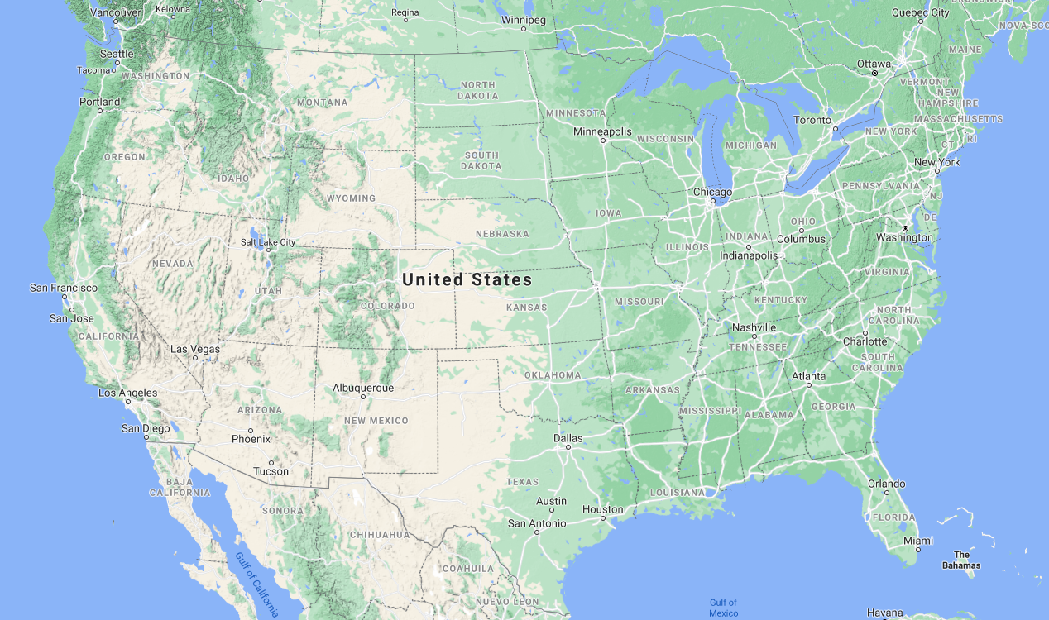
Parks You’ve Visited in the Last 2 Years
1. Yellowstone National Park
2. Badlands National Park
3. Devil’s Tower National Monument
4. <Next Park>
Once you’ve entered all the national parks you’ve visited in the last two years, click “Next.” [Send to PVS2. Respondents who selected 10 parks, Skip to PVS4]
NOTE TO REVIEWER: Question PVS2 will present a map that shows parks that: (1) are within a 100 mile of the respondent’s zip code, (2) the respondent hasn’t already selected in Question PVS1. A respondent’s zip code will be linked to survey passwords; the survey will automatically populate with the respondent’s correct zip and list of parks.

A check box list and map with national parks within 100-mile radius of the respondent’s home zip code will be displayed. The survey will distinguish which units are already loaded into the check box list once selected or already selected in PVS1.
- We want to make sure we haven’t missed any other national parks that you may have visited. People sometimes forget about national parks that are in their local area. The list below is of national parks within 100 miles of your zip code.
Have you visited any of these nearby national parks within the last two years? [past_park_local]
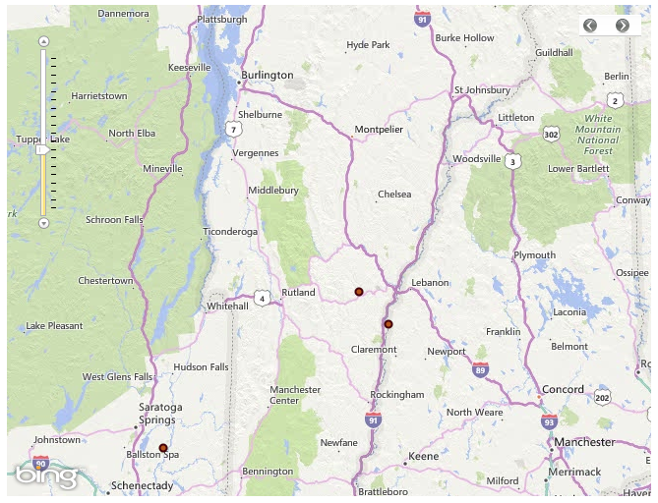
Select All That Apply
q | Marsh-Billings-Rockefeller National Historical Park
q | Saint-Gaudens National Historic Site
q | Saratoga National Historical Park

Once you’ve entered any additional national parks that you’ve visited within the last two years, click “Next.” [Skip to Question PVS4]
- I don’t think I’ve visited any of these national parks within the last two years [If checked then send to PVS3]

NOTE TO REVIEWER: Question PVS3 is only shown to respondents who selected no parks in PVS1 and PVS2.
- Have you ever, in your lifetime, visited a national park? [past_num_visit]
- Yes [Skip to Question FV1]
- No [Skip to Question FV1]
- Not sure [Skip to Question FV1]

NOTE TO REVIEWER: If respondent hasn’t visited any parks in last 2 years or only visited parks that are prohibited from charging entrance fees, send to Question FVS1.
- Please tell us how many times you visited each of these national parks in the last two years. [num_visits]
A visit means that you entered the national park on one day or on multiple days during a single trip from your home.

NOTE TO REVIEWER: A matrix containing a row for each NPS Unit visited will be displayed. Drop down allows 1,2,3…. 10 or more. Once completed for all units, continue to Question PV1.

Park | Number of Visits
<NPS Unit 1> | <DROP DOWN>
<NPS Unit 2> | <DROP DOWN>

NOTE TO REVIEWER: If respondent hasn’t visited any parks in last 2 years or only visited parks that are prohibited from charging entrance fees, send to Question FVS1.

- hank you for your responses so far. Based on what you’ve told us, you have not visited any national parks within the last two years.
Do you have any specific plans to visit national parks over the next 12 months? [future_park_visit]
- Yes, I currently have one or more trips planned [Skip to Question FVS3]
- No, I don’t have any trips planned at the moment
- Not sure
- Do you expect to ever visit a national park in the future? [no_future_parks]
- Yes [Skip to Question NV1]
- No [Skip to Question NV1]
- Not sure [Skip to Question NV1]
- The map below shows all national parks in the United States. Please tell us which national parks you have specific plans to visit over the next 12 months. You can search for a park by typing the name below or by searching for parks by state.

NOTE TO REVIEWER: The autofill textboxes and US map combination will be similar to the maps found at: https://irma.nps.gov/Stats/. The text box will only allow pre-loaded options. Respondents will be able to select a state and re-center the map where parks/park boundaries will display. The selected parks will auto populate. The survey will automatically populate <current month> and <current year - 2> based on the date the respondent accesses the survey.

If respondent doesn’t plan to visit any parks or only plans to visit parks that are prohibited from charging entrance fees, send to Question NV1
Parks you plan to visit in the next 12 months
1. Yellowstone National Park
2. Badlands National Park
3. Devil’s Tower National Monument
4. <Next Park>
Once you’ve entered all of the national parks you have specific plans to visit in the next 12 months, click “Next.”
- I’m actually not quite sure which parks I plan to visit [Skip to Question NV1]

No Past or Future Visitation(NV)
NOTE TO REVIEWER: Respondents that have not visited a park unit in the last two years and do not plan to visit a park unit in the next 12 months will be presented with a list of possible reasons why and asked to select all that apply. Respondents will be sent to Question AT1 once they have answered NV1.
- Please select any reasons why you haven’t visited any national parks in the last 2 years. [y_no_visit]
Select all that apply.
- Entrance fees are too expensive or high at national parks.
- The travel distance is too far from my home to get to any national parks I’m interested in visiting.
- National parks are too crowded.
- National parks are not accessible to people with disabilities.
- I don’t know much about what there is to do in national parks.
- It costs too much money to travel to a national park.
- I don’t share the same interests as people who visit national parks.
- There aren’t good transportation options for me to get to a national park.
- I’m concerned about my personal safety if I visit a park.
- I’m just not that interested in national parks.
- Personal health issues keep me from visiting the national parks.
- I don’t like being out of touch with family and friends due to lack of connectivity in parks.
- I’m just not that interested in travel/tourism.
- I don’t know enough about national parks to plan a visit.
- People who work in the national parks are of a very a different racial/ethnic background than mine.
- People who visit national parks are of a very different racial/ethnic background than mine.
- National parks are not of service to my community or heritage.
- I don’t feel welcome in a national park.
- Other, please specify _______
[Send to AT1]

Fee and Payment Attitudes (AT)
NOTE TO REVIEWER: In the section following the Stated Preference Exercises, respondents will be asked a series of questions about fees and payments, such as which park passes they were aware of, which passes apply to them, and opinions about different entrance fee structures. Responses to these questions will be evaluated to test whether this information can be used to better understand respondents’ attitudes towards different fee structures, and their opinions regarding increasing revenues at national parks.
- You’re doing great! Before finishing up we’d like to ask for your opinions about visiting and paying to use national parks. [pass_holder]
NPS offers discounted (or free) passes to several groups of people:
- Military Pass: Active members of the US military, their dependents, veterans, and Gold Star families enjoy free entry to all national parks
- Every Kid in a Park Pass: This initiative allows free entry for 4th graders and their families to all national parks
- Senior Pass: US citizens age 62 or older can purchase a lifetime pass for $80 (or an annual pass for $20) that provides free entry into all national parks
- Access Pass: US citizens with lifelong physical disabilities can obtain a free lifetime pass to all national parks

- Before taking this survey, which of these passes were you aware of? [pass_aware]
Select all that apply.
- Military Pass
- Every Kid in a Park Pass
- Senior Pass
- Access Pass
- None of the above

- Which of these passes apply to one or more members of your household? [pass_qualify]
Select all that apply.
- Military Pass
- Every Kid in a Park Pass
- Senior Pass
- Access Pass
- None of the above

- Many national parks are free for the public to access. [free_importance]
How important is it to you that national parks that are currently free remain free?
- Very important
- Somewhat important
- No opinion
- Not very important
- Not Important at all
NOTE TO REVIEWER: Questions AT5 through AT7 will be shown as matrices with attitude statements in the first column and answer options (Strongly Oppose through Strongly Support) in the subsequent columns.
- NPS is considering a variety of options for changing the way that visitor entrance fees are structured at national parks. Depending on how these changes are carried out, they could potentially increase or decrease total entrance fee revenues for national parks. [fee_structures1]

How strongly do you support or oppose the following approaches to structuring visitor entrance fees at national parks?
- Allowing entry fees to vary by size of vehicle (e.g., discounts for smaller vehicles)
- Allowing entry fees to vary by place of residence (e.g., discounts for locals)
- Allowing entry fees to vary by type of visitor (e.g., discounts for students, seniors, veterans, and/or the disabled)
- Allowing entry fees to vary by season of the year (e.g., discounts for off-season visitors)
- Allowing entry fees to vary by day of the week (e.g., discounts for weekday trips)
- Allowing entry fees to vary by time of day (e.g., discounts for visits during less busy times of day)
- Allowing entry fees to vary by method of purchase (e.g., discounts for online, advance purchases)

- Most major national parks currently charge per vehicle entrance fees that are valid for a one-week visit. How strongly do you support or oppose the following changes to that approach to charging entrance fees? [fee_structures2]
- Charging for every adult rather than for every vehicle
- Charging by day rather than by week (with discounts for longer trips)

- NPS currently has a substantial maintenance shortfall. This shortfall could be addressed by increasing revenues, reducing costs, or both. [revenue_opinion_1]

How strongly do you support or oppose the following approaches to increasing revenues at national parks?
- Increase park entrance fees
- Begin charging entrance fees at parks that are currently free
- Eliminate special discounts for certain types of visitors (e.g., students, seniors, and/or veterans)
- Increase entrance fees for visitors who come from other countries
- Charge new or higher fees for tours, parking, camping, or other amenities within parks

- How do you think the national parks in this country should primarily be funded? [funding]
- Federal tax dollars
- Fees paid by park visitors
- Donations
- Other, please specify ___________

- Overall, how important do you think national parks are to the American public? [park_importance]
- Extremely important
- Very Important
- Moderately important
- Slightly important
- Not important at all

Demographics (D)
NOTE TO REVIEWER: This section of questions will be used to obtain basic demographic characteristics, including household size, gender, age, education level, ethnicity, race, employment status, and income. Demographics will be used to identify segments of the population that are more or less responsive to changes in entrance fees and/or fee structures and compare respondent characteristics to those from other NPS and general population surveys as well as the non-response survey.
- In this final section we would like to learn more about your background. This information will help us compare your answers to those of other people. We stress that all of your answers are confidential.
Do you have internet access in your home? [internet]
Yes
No
- Do you own a smartphone (e.g., iPhone, Samsung Galaxy or similar device)? [devices]
- Yes
- No [Skip to D4]
- Which of the following mobile apps do you use on your smartphone? [device_use]
Select all that apply.
- Shopping Apps (Apple Store, Amazon, Google Play, etc.)
- Banking Apps (Citi, Bank of America, etc.)
- Mobile Payment Apps (Apple Pay, Venmo, Cash App, etc.)
- Social Networking Apps (Facebook, Twitter, Instagram, etc.)
- Navigation Apps (Google Maps, Apple Maps, Waze, etc.)
- Rideshare Hailing Apps (Uber, Lyft, etc.)
- None of the above

- Which of the following websites and apps have you used to plan or pay for visits to national parks and other recreation areas in the United States? [tech_use]
Select all that apply.
- YourPassNow.com
- Recreation.gov
- Pay.gov
- Chimani App
- National Park Service Apps
- None of the above

NOTE TO REVIEWER: Question D5 is a drop down. Options are:
- Adults – ‘1’ through ‘10 or more’,
- Children – ‘0’ through ‘10 or more’
- How many people, including yourself, live in your household? [hhsize]
- Adults (18 years or older, including yourself) <DROP DOWN>
- Children (under 18 years old) <DROP DOWN>

- What is your gender? [gender]
- Male
- Female
- Transgender, non-binary, or another gender
- Prefer not to respond

NOTE TO REVIEWER: Question D7 is a drop down – show years 1920 through (n-18), where n is the current year
- What year were you born? [age]
- What is the highest level of education you have completed? [edu]
- No schooling
- Any schooling through grade 12, no diploma
- High school graduate, including GED or alternative credit
- Some college
- Associate’s degree
- Bachelor’s degree
- Master’s degree
- Professional degree beyond a bachelor’s
- Doctoral degree
D9. Are you of Hispanic, Latino or Spanish origin? [hispanic]
- Yes
- No

D10. Which category best describes your race? [race]
One or more categories may be selected.
- American Indian or Alaskan Native
- Asian
- Black or African American
- Native Hawaiian or Other Pacific Islander
- White
- Prefer to self describe: ______

D11. Which one of the following best describes you? [employ]
- Employed full time
- Employed part time
- Full time student
- Retired
- Not at all employed

D12. Which of the following income categories best describes your household income last year, before taxes? [income]
- Less than $10,000  - $10,000 - $24,999  - $25,000 - $49,999  - $50,000 - $74,999  - $75,000 - $99,999  - $100,000 - $149,999 | - $150,000 - $199,999  - $200,000 - $249,999  - $250,000 - $299,999  - $300,000 or more  - Rather not say

NOTE TO REVIEWER: Questions D9 and D10 will be shown to pre-test respondents only. All other respondents will be skipped to D11

- Would you be willing to take part in a follow-up telephone call to discuss your survey experience? [debrief]
The interview will take about 30 minutes to complete.
- Yes
- No
- Thank you! Please leave your first name, phone number, and/or an email where we can reach you. [name] [phone] [email] [dates]
Please note: Not all respondents who wish to participate in the follow-ups will receive a call. We will reach out to respondents based on the order that we receive completed surveys. Your understanding and willingness to participate is appreciated.
First name: ____________________
Phone Number: _________________
Email: _______________________
Please provide days and times below when you can be reached. Don’t forget to include your time zone!
Day: ____________________
Time: _________________

Thank you for taking the time to participate in this survey. Your responses have been saved. [end]
Please provide any additional comments regarding this survey or national parks in the box below.

End of survey.

