OMB Control number 1024 -XXXX
Current expiration Date: XX/XX/20XX

National Park Service Recreation Fee Pricing Study
Past Visitation
Pilot Survey

PAPERWORK REDUCTION ACT STATEMENT: The National Park Service is authorized by the NPS Research Mandate (54 USC 100702) to collect this information. This information will be used by the NPS in future initiatives related to the visitor use and resource management within the site. Response to this request is voluntary. No action may be taken against you for refusing to supply the information requested. The permanent data will be anonymous. An agency may not conduct or sponsor, and a person is not required to respond to, a collection of information unless it displays a currently valid OMB control number.
BURDEN ESTIMATE: Public reporting burden for this form is estimated to average 25 minutes per response. Please direct comments regarding the burden estimate or any other aspect of this form to: Tristan Cherry, RSG, Tristan.cherry@rsginc.com (email); or Phadrea Ponds, NPS Information Collection Clearance Officer at phadrea_ponds@nps.gov (email).

ScreenING SCRIPT (S)
NOTE TO REVIEWER: When reviewing this questionnaire, keep in mind the following notations that provide detail on how the survey will flow and look programmed online.
- Dynamic Inserts: Words that are dynamically inserted based on responses to previous questions are shown in carrots, such as “<insert last NPS Unit visited>” or <Error: Please enter a valid 5-digit zip code>.
- Survey Logic and Programming Notes: Text that specifies logic, programming notes, instructions to programmers and will not be shown on the screen are surrounded by square brackets “[]” such as “[skip to Question PVS2]” or question names such as “[age]”.
Welcome to the National Park Service Visitor Planning Survey. Your answers will help the National Park Service, the federal agency responsible for managing all 400+ national parks, monuments and other historical sites in the United States, better understand how people think about and plan visits to these areas. The information you provide will be kept strictly confidential by the National Park Service and RSG (the company that is collecting the survey data).
Please use the “Next” button in the lower left-hand corner of the screen to go forward. To review a previous question, use the “Previous” button. It is important that you do not use your web browser’s “forward” or “back” buttons because your answers may not be recorded properly.
The survey should take approximately 25 minutes. If you can’t finish the survey in one sitting, you can stop at any time and return to where you left off by re-entering your password.
Please enter the password from the letter (or postcard) then click “Next” to begin.
Password: _________

NOTE TO REVIEWER: If the respondent enters a non-valid password: <‘Sorry, the password you entered is not valid, please check the postcard or letter you received in the mail and try again.’>

If respondent indicates they are not 18 years or older in S1 then terminate from the survey.
- Are you 18 years old or older? [age]
- Yes
- No

Past Park Unit Visitation Screener (PVS)
NOTE TO REVIEWER: The questions in this section will determine the number of times the respondent has visited one or more units of the National Park System in the past two years, and which specific park units were visited. This information is necessary to determine whether the respondent meets the criteria to respond to the Stated Preference Exercises.
The National Park Service (NPS) manages a wide variety of public areas including National Parks, National Seashores, National Historic Sites, National Battlefields, and National Monuments. For simplicity, we will refer to all of these areas as “national parks.”
The NPS is one of several agencies that manage federal recreation sites. Others include the U.S. Forest Service, Bureau of Reclamation, and Bureau of Land Management. In this survey, we will only ask you about your use of parks managed by the NPS.
NOTE TO REVIEWER: The autofill textboxes and US map combination will be similar to the maps found at: https://irma.nps.gov/Stats/. The text box will only allow pre-loaded options. Respondents will be able to select a state and re-center the map where parks/park boundaries will display. The selected parks will auto populate. The survey will automatically populate <current month> and <current year - 2> based on the date the respondent accesses the survey.
- Which national parks have you visited in the past two years? [past_park_module]
The map below shows all national parks in the United States. Please tell us which national parks you’ve visited within the last two years. You can search for a specific park by typing the name below or by searching for parks by state.
Please only include the national parks you have visited in the past two years (since <current month>, <current year – 2>.
- I haven’t visited any national parks in the last two years. [skip to Question PVS2 ]

If you have visited more than 10 national parks in the past two years, please only enter the 10 parks that you visited most recently.
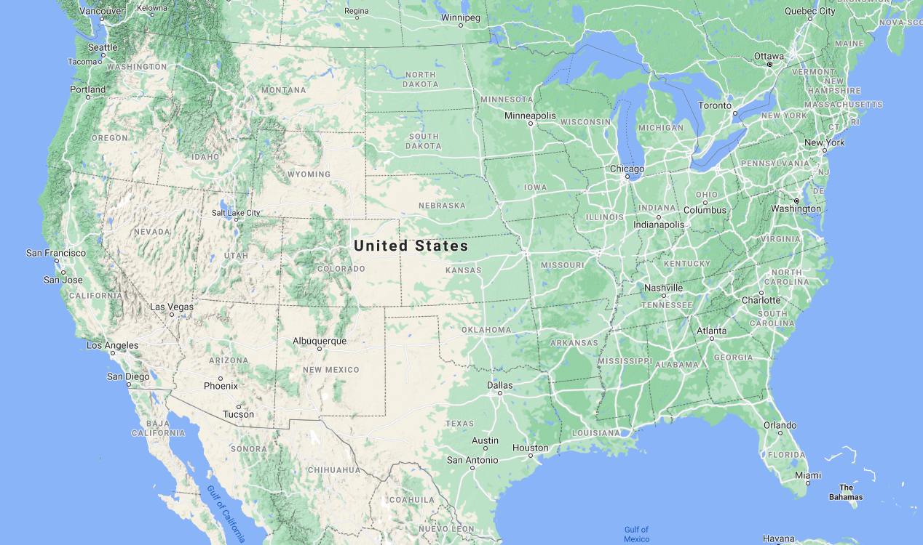
Parks You’ve Visited in the Last 2 Years
1. Yellowstone National Park
2. Badlands National Park
3. Devil’s Tower National Monument
4. <Next Park>
Once you’ve entered all the national parks you’ve visited in the last two years, click “Next.” [Send to PVS2. Respondents who selected 10 parks, Skip to PVS4]

NOTE TO REVIEWER: Question PVS2 will present a map that shows parks that: (1) are within a 100 mile of the respondent’s zip code, (2) the respondent hasn’t already selected in Question PVS1. A respondent’s zip code will be linked to survey passwords; the survey will automatically populate with the respondent’s correct zip and list of parks.

A check box list and map with national parks within 100-mile radius of the respondent’s home zip code will be displayed. The survey will distinguish which units are already loaded into the check box list once selected or already selected in PVS1.
- We want to make sure we haven’t missed any other national parks that you may have visited. People sometimes forget about national parks that are in their local area. The list below is of national parks within 100 miles of your zip code.
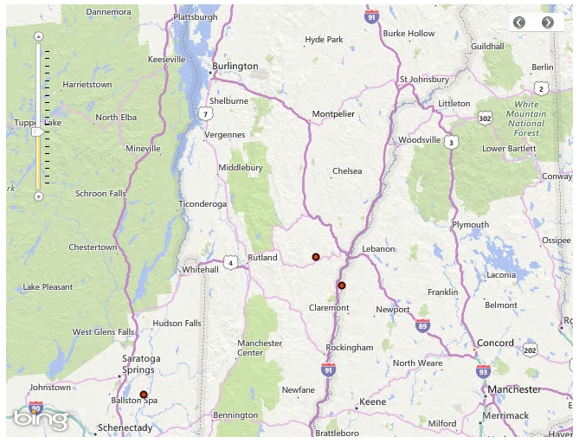
Have you visited any of these nearby national parks within the last two years? [past_park_local]
Select All That Apply
q | Marsh-Billings-Rockefeller National Historical Park
q | Saint-Gaudens National Historic Site
q | Saratoga National Historical Park

Once you’ve entered any additional national parks that you’ve visited within the last two years, click “Next.” [Skip to Question PVS4]
- I don’t think I’ve visited any of these national parks within the last two years [If checked then send to PVS3]

NOTE TO REVIEWER: Question PVS3 is only shown to respondents who selected no parks in PVS1 and PVS2.
- Have you ever, in your lifetime, visited a national park? [past_num_visit]
- Yes [Skip to Question FV1]
- No [Skip to Question FV1]
- Not sure [Skip to Question FV1]

NOTE TO REVIEWER: If respondent hasn’t visited any parks in last 2 years or only visited parks that are prohibited from charging entrance fees, send to Question FVS1.

- Please tell us how many times you visited each of these national parks in the last two years. [num_visits]
A visit means that you entered the national park on one day or on multiple days during a single trip from your home.
NOTE TO REVIEWER: A matrix containing a row for each NPS Unit visited will be displayed. Drop down allows 1,2,3…. 10 or more. Once completed for all units, continue to Question PV1.

Park | Number of Visits
<NPS Unit 1> | <DROP DOWN>
<NPS Unit 2> | <DROP DOWN>

Past Park Visitation Info (PV)
NOTE TO REVIEWER: Questions PV1 through PV24 will be used to render an accurate account of visitation behavior for respondents who have visited one or more qualifying park units in the past two years. If a respondent visited more than one qualifying park in the past two years – one park unit (<NPS unit>) will be selected to meet park-level sampling objectives that ensure a broad range of units are included for testing. The park-level sampling objectives are designed to gather proportional representation from parks within 6 tier groups developed by the study team, where each park is assigned to a tier based on its annual visitation levels and entrance fee policies. An example park type tiering structure is presented below and is based on 2018 visitation statistics and pricing policies.
- Tier 1: Units with entrance fees, 75th visitation percentile (27 Units)
- Tier 2: Units with entrance fees, 25th-75th visitation percentile (53 Units)
- Tier 3: Units with entrance fees, below the 25th visitation percentile (27 units)
- Tier 4: Units without entrance fees, 75th visitation percentile (63 units)
- Tier 5: Units without entrance fees, 25th- 75th visitation percentile (124 units)
- Tier 6: Units without entrance fees, below the 25th visitation percentile (63 units)
The park selected by the survey is referred to in the reviewer notes as the respondent’s reference park unit. The information from the responses in this section will be used to construct respondent-specific questions in the Stated Preference Exercises below.
- Thank you for telling us about the national parks you’ve visited recently. Now we’d like to ask you a few questions about your most recent visit to <NPS Unit>.
How much time did you spend in <NPS Unit> on your most recent visit? [past_duration]
- 1 day or less  - 2 days  - 3 days | - 4 days  - 5 days  - 6 days | - 7 days  - 8 or more days
NOTE TO REVIEWER: Peak season will be defined for each park as the 5 consecutive months with the highest visitation. These data will be pre-loaded and then dynamically accessed by the survey platform and displayed in the <peak month range> and <off-peak month range> text insertions.
- During what season did you visit <NPS Unit>? [past_season]
- Peak (<peak month range>)
- Off-Peak (<off-peak month range>) [Skip to Question PV4]
- If there were limitations or increased costs associated with visiting during the peak season, could you have made this visit to <NPS Unit> during the off-peak season (<off-peak month range>)? [past_seasonal_flex]
- Yes
- No
- Not sure
- Did you visit <NPS Unit> alone or with other people on your most recent visit? [past_solo_group]
- I visited <NPS Unit> alone [Skip to Question PV6]
- I visited <NPS Unit> with one or more other people (we will refer to this as your group)
- Who was with you on your most recent visit to <NPS Unit>? [past_group_members]
NOTE TO REVIEWER: Total number of members is summed and shown in <x>.
Please provide the number of each type of visitors in your group below.
_____ Other members of my household age 16 or older
_____ Other members of my household under the age of 16
_____ Friends, relatives, or others not living in my household age 16 or older
_____ Friends, relatives, or others not living in my household under the age of 16
______________________________________________________________________
<x> Total (not including yourself)
NOTE TO REVIEWER: <You/your group> text insertion for the remainder of the survey depends on the respondent’s answer selection in PV4.
- If visited alone in PV4 then ‘you’.
- If visited with one or more other people in PV4 then ‘your group’
- What mode of transportation did <you/your group> use to enter <NPS Unit> on your most recent visit? [past_entry_mode]
- Car, truck, or SUV, please enter the number of vehicles in your group: _____
- Motorcycle, please enter the number of motorcycles in your group: ____
- Recreational vehicle or motor home
- Tour bus or tour van [Skip to AT1]
- City bus or subway
- Bicycle
- Walk/hike
- Other, please specify __________
NOTE TO REVIEWER: Answer option availability depends on the respondent’s answer selection in PV6
- If entered in a vehicle then show ‘Vehicle pass’
- If entered using a motorcycle, then show ‘Motorcycle pass’
- There are many different types of passes you can use to enter <NPS Unit>.
Which of the following best describes the pass which <you/your group> used to enter <NPS Unit> on your most recent visit? [past_fee_type]
- Individual pass (per person 1-day, 3-day, or weekly pass) [Skip to Question PV9]
- Vehicle pass (per vehicle 1-day, 3-day, or weekly pass) [Skip to Question PV9]
- Motorcycle pass [Skip to Question PV9]
- Annual or lifetime pass
- The fee was part of a tour package [Skip to AT1]
- I visited on a fee-free day [Skip to Question PV15]

- What type of pass did <you/your group> use to enter <NPS Unit>? [past_pass_type]
- Annual Pass for <NPS Unit>
- Interagency Annual Pass – for all national parks and federal recreational lands
- Senior Pass
- Access Pass
- Military Pass
- Volunteer Pass
- Annual 4th Grade Pass

NOTE TO REVIEWER: Question PV9 is shown to respondents who selected that they visited as a group in Question PV5. The <pass type> text insertion for the remainder of the survey depends on the respondent’s answer selection in Question PV7 and PV8.
- Who purchased the <pass type> used on this visit to <NPS Unit>? [past_fee_who]
- I or someone in my household purchased the pass
- Someone else in my group purchased the pass

NOTE TO REVIEWER: Question PV10 is shown to respondents who selected a personal vehicle, motorcycle pass or an annual or lifetime pass in Question PV7 to enter their reference unit.
- Where <did you purchase your pass/was the pass purchased> for <NPS Unit>? [past_fee_purchase]
- At <NPS Unit> park entrance
- At another park entrance
- Online (e.g., YourPassNow.com, Pay.gov, Recreation.gov, etc.)
- United States Geological Survey (USGS) Store
- Other
- Not sure/don’t remember

NOTE TO REVIEWER: Question PV11 is shown to respondents who selected a personal vehicle or motorcycle pass in Question PV7 to enter their reference unit.
- How much <did you/did you and your group> spend to enter <NPS Unit>? [past_fee_amount]
Include the total amount that you and others traveling with you spent on fees to enter the park. If you are not sure, give your best guess.
$_____
NOTE TO REVIEWER: Questions PV12 and PV13 are shown to respondents who selected an annual or lifetime pass product in Question PV7 to enter their reference park unit.
- How much did the <pass type> that <you/you and your group used> to enter <NPS Unit> cost? [past_pass_amount]
Include the total amount that you or someone in your group spent on the pass at the time of purchase. If you are not sure, give your best guess.
$_____
- How many times do you expect to visit <NPS Unit> using this <pass type>? [past_expect_visit]
Please include the total number of past visits you have made and future visits you expect to make over the period for which your pass is valid.
_____ Visits

NOTE TO REVIEWER: If respondent selected a per person or per vehicle/motorcycle pass in Question PV7. If respondent selected an Annual or Lifetime pass in Question PV7, the question text will read: ‘In your opinion, was the cost of the pass…’
- In your opinion was the entrance fee <you paid/you and your group paid>… [past_fee_opinion]
- Too expensive
- About the right price
- Too cheap
- No opinion
- Did you visit any other national parks during the same trip where you visited <NPS Unit>? [past_other_parks]
- Yes
- No
- Select the option that best describes your visit to <NPS Unit> [past_trip_type]
- Visiting <NPS Unit> was the primary purpose of my trip.
- Visiting <NPS Unit> along with one or more other national parks was the primary purpose of my trip.
- Visiting <NPS Unit> was planned, but it was a secondary activity, or just a part of a trip with other activities.
- Visiting <NPS Unit> was not planned, it was a spur-of-the-moment decision.
NOTE TO REVIEWER: Question PV17 is shown to respondents who selected ‘Yes’ in Question PV15. The question will list all parks selected in the past visit screener section and listed in Question PVS4 as answer options.
- What other national parks did you visit during your recent trip to visit <NPS Unit>? [past_tour_parks_1] though [past_tour_parks_2]
Select each national park that you visited during the same trip where you visited <NPS Unit>.
- <NPS Unit 1>
- <NPS Unit 2>
- <NPS Unit 3>
- <NPS Unit 10>

NOTE TO REVIEWER: Question PV18 is shown to respondents who selected ‘Yes’ in Question PV15. Question will list as answer options each park that was selected in Question PV17 in a matrix. The first row will be auto filled and contain a respondent’s reference unit and number of visit days from Question PVS4. The drop-down list for each row will include ‘1 day’ through ‘8 days or more’
The ‘Total number of days..’ [past_total_tour_days] will equal the summation of ([past_duration], [past_park_tour_1], …).

If respondent indicated ‘No’ to Question PV15, then [past_total_tour_days] = [past_duration].
- How many days did you spend at these other national parks during that trip? [past_park_tour_1] through [past_park_tour_n]
National Park | How many days?
<NPS Unit > [past_park_tour_1] | <[past_duration]>
<NPS Unit 2> [past_park_tour_2] | <DROP DOWN>
<NPS Unit N..> [past_park_tour_n] | <DROP DOWN>

Total number of days you visited national parks during your trip: <[past_total_tour_days]>

- Trips to visit national parks can include many expenses beyond entrance fees. We’d like to learn more about the total cost of your recent trip to visit <NPS Unit>.
Please tell us how much you spent on your recent trip to visit <NPS Unit>. [past_visit_cost_1]
Please include dining, lodging, transportation, entry fees, and any other trip costs for your entire group.
- $0 to $49
- $50 to $99
- $100 to $249
- $250 to $499
- $500 to $999
- $1,000 to $1,499
- $1,500 to $1,999
- $2,000 or more
- I’m not sure/can’t remember

NOTE TO REVIEWER: Question PV20 is shown to respondents who selected a ‘Individual’, ‘Vehicle’ or ‘Motorcycle’ pass in PV7. The <past_duration> text insertion is based on the response to Question PV1.
- For your last visit to <NPS Unit> where you stayed for <past_duration> days, imagine you were given a pass that allowed you to enter the park for an unlimited number of days.
Using your pass, would you have extended your visit?
- Yes
- No [Skip to Question PV24]
- How many days would you have spent at <NPS Unit>? [past_hypo_visits]
Total number: ______
NOTE TO REVIEWER: Question PV22 is shown to respondents who selected a ‘Individual’, ‘Vehicle’ or ‘Motorcycle’ pass in PV7. The <past_total_tour_days> text insertion will be the summation of park visit days from Question PV18. <NPS Units> will list all units the respondent selected in PV17.
- For your last <past_total_tour_days> trip to <NPS Units>, imagine you were given a pass that allowed you to enter the parks for an unlimited number of days.
Using your pass, would you have extended your trip?
- Yes
- No [Skip to PV24]
- How many days would you have spent at national parks on your trip?
Total number: ______

- Imagine tomorrow you were given an annual pass that allowed you to enter all national parks for free.
Using your annual pass, would you visit any national parks in the next year?
- Yes
- No [Skip to SP1]
- Not sure [Skip to SP1]
- How many days in the next year would you spend at national parks? [past_hypo_visits_total]
Total number: ______

Future Park Unit Visitation Screener(FVS)
NOTE TO REVIEWER: This section is shown to respondents that have not visited an NPS unit within the past two years – i.e., no qualifying NPS units were selected in the Past Park Visitation Section (PV). The questions in this section will determine parks the respondent plans to visit in the next 12 months, and which specific park units are to be visited. This information is necessary to determine whether the respondent meets the criteria to respond to the Stated Preference Exercises.

- Thank you for your responses so far. Based on what you’ve told us, you have not visited any national parks within the last two years.
Do you have any specific plans to visit national parks over the next 12 months? [future_park_visit]
- Yes, I currently have one or more trips planned [Skip to Question FVS3]
- No, I don’t have any trips planned at the moment
- Not sure
- Do you expect to ever visit a national park in the future? [no_future_parks]
- Yes [Skip to Question NV1]
- No [Skip to Question NV1]
- Not sure [Skip to Question NV1]

NOTE TO REVIEWER: The autofill textboxes and US map combination will be similar to the maps found at: https://irma.nps.gov/Stats/. The text box will only allow pre-loaded options. Respondents will be able to select a state and re-center the map where parks/park boundaries will display. The selected parks will auto populate. The survey will automatically populate <current month> and <current year - 2> based on the date the respondent accesses the survey.
- The map below shows all national parks in the United States. Please tell us which national parks you have specific plans to visit over the next 12 months. You can search for a park by typing the name below or by searching for parks by state.
Parks you plan to visit in the next 12 months
1. Yellowstone National Park
2. Badlands National Park
3. Devil’s Tower National Monument
4. <Next Park>
Once you’ve entered all of the national parks you have specific plans to visit in the next 12 months, click “Next.”
- I’m actually not quite sure which parks I plan to visit [Skip to Question NV1]

NOTE TO REVIEWER: If respondent doesn’t plan to visit any parks or only plans to visit parks that are prohibited from charging entrance fees, send to Question NV1.

Future Park Unit Visitation Info
NOTE TO REVIEWER: Questions FV1 through FV20 will be used to render an accurate account of visitation behavior for respondents who have not visited one or more qualifying park units in the past two years, but do plan to visit one or more qualifying NPS Units in the next 12 months . If a respondent plans to visit more than one qualifying park in the next 12 months – one park unit <NPS unit> will be selected to meet park-level sampling objectives that ensure a broad range of units are included for testing. This park is referred to in reviewer notes as the respondent’s reference park unit. The information from the responses in this section will be used to construct respondent-specific questions in the Stated Preference Exercises below.
- Thank you for telling us about the national park<s> you are planning to visit in the next 12 months. Now, we’d like to ask you a few questions about your next planned visit to <NPS Unit>.
How much time do you expect to spend in <NPS Unit>? [future_duration]
- 1 day or less
- 2 days
- 3 days
- 4 days
- 5 days
- 6 days
- 7 days
- 8 or more days
- During what season do you plan to visit <NPS Unit>? [future_season]
NOTE TO REVIEWER: Peak season will be defined for each park as the 5 consecutive months with the highest visitation. These data will be pre-loaded and then dynamically accessed by the survey platform and displayed in the <peak month range> and <off-peak month range> text insertions.
- Peak (<peak month range>)
- Off-Peak (<off-peak month range>) [Skip to FV4]
- If there were limitations or increased costs associated with visiting during the peak season, could you make this visit to <NPS Unit> during the off-peak season (<off-peak month range>)? [future_seasonal_flex]
- Yes
- No
- Not sure
- Do you plan to visit <NPS Unit> alone or with other people? [future_solo_group]
- I plan to visit <NPS Unit> alone [Skip to Question FV6]
- I plan to visit <NPS Unit> with one or more other people (we will refer to this as your group)
- Who will travel with you when you visit <NPS Unit>? [future_group_members]
NOTE TO REVIEWER: Total number of members is summed and shown in <x>.
Please provide the number of each type of visitors in your group below.
_____ Other members of my household age 16 or older
_____ Other members of my household under the age of 16
_____ Friends, relatives, or others not living in my household age 16 or older
_____ Friends, relatives, or others not living in my household under the age of 16
_________________________________________________________________
<x> Total (not including yourself)

NOTE TO REVIEWER: <You/your group> text insertion for the remainder of the survey depends on the respondent’s answer selection in FV4.
- If visited alone in FV4 then ‘you’.
- If visited with one or more other people in FV4 then ‘your group’.
- What mode of transportation will <you/your group> use to enter <NPS Unit>? [future_entry_mode]
- Car, truck, or SUV, please enter the number of vehicles in your group: _____
- Motorcycle, please enter the number of motorcycles in your group: ____
- Recreational vehicle or motor home
- Tour bus or tour van [Skip to AT1]
- City bus or subway
- Bicycle
- Walk/hike
- Other, please specify __________
- There are many different types of passes you can use to enter <NPS Unit>.
Which of the following best describes the pass which <you/your group> will use to enter <NPS Unit>? [future_fee_type]
- Individual pass (per person 1-day, 3-day, or weekly pass) [Skip to Question FV9]
- Vehicle pass (per vehicle 1-day, 3-day, or weekly pass) [Skip to Question FV9]
- Motorcycle pass [Skip to Question FV9]
- Annual or lifetime pass
- The fee will be included as part of a tour package [Skip to AT1]
- I plan to visit on a fee-free day [Skip to Question FV12]
- Not sure
- What type of pass will <you/your group> use to enter <NPS Unit>? [future_park_pass]
- Annual Pass for <NPS Unit>
- Interagency Annual Pass – for all national parks and federal recreational lands
- Senior Pass
- Access Pass
- Military Pass
- Volunteer Pass
- Annual 4th Grade Pass
- Not sure
NOTE TO REVIEWER: Question FV9 is shown to respondents who selected they will travel as a group in Question FV4. The <pass type> text insertion for the remainder of the survey depends on the respondent’s answer selection in Question FV7 or FV8.
- Who will be responsible for purchasing the <pass type>? [future_fee_responsible]
- I or someone in my household will purchase the pass
- Someone else in my group will purchase the pass
- Not sure

NOTE TO REVIEWER: Question FV10 is shown to respondents who selected a personal vehicle, motorcycle pass or an annual or lifetime pass in Question FV7 to enter their reference unit.
- Where do you plan to purchase your pass/expect the pass to be purchased for <NPS Unit>? [future_fee_purchase]
- At <NPS Unit> park entrance
- At another park entrance
- Online (e.g., YourPassNow.com, Pay.gov, Recreation.gov, etc.)
- United States Geological Survey (USGS) Store
- Other
- Not sure
NOTE TO REVIEWER: Question FV11 is shown to respondents who selected a personal vehicle or motorcycle pass in Question FV7 to enter their reference unit.
- How much do you think <you/you and your group> will spend to enter <NPS Unit>? [future_fee_amount]
Include the total amount that you and any other members traveling with you will spend on fees to enter the park. If you are not sure, give your best guess.
$_____
- Do you plan to visit any other national parks during your trip to visit <NPS Unit>? [future_other_parks]
- Yes
- No
- Select the option that best describes your planned visit to <NPS Unit>. [future_trip_type]
- Visiting <NPS Unit> will be the primary purpose of my trip
- Visiting <NPS Unit> along with one or more other national parks will be the primary purpose of my trip
- Visiting <NPS Unit> will be a secondary activity, or just another part of a trip with other activities
- Not sure

NOTE TO REVIEWER: Respondents who selected ‘Yes’ in Question FV12 will have a of the parks selected in Question FVS3.
- During your next planned trip to visit <NPS Unit>, which other national parks do you also plan to visit? [future_tour_parks]
Select each park that you will also visit during the same trip where you will be visiting <NPS Unit>.
- <NPS Unit 1>
- <NPS Unit 2>
- <NPS Unit 3>
- ….<NPS Unit 10>

NOTE TO REVIEWER: The matrix in Question FV15 will be auto filled using the information from respondents who selected ‘Yes’ in Question FV12 and selected parks in Question FV14. The number of visit days will be auto filled from Question FV1.

The drop-down list for each row will include ‘1 day’ through ‘8 days or more’.

The ‘Total number of days..’ [future_total_tour_days] will equal the summation of ([future_duration], [future_park_tour_1], …).

If respondent indicated ‘No’ to Question FV12, then [future_total_tour_days] = [future_duration].
- How many days do you plan to spend at these other national parks during that trip? [future_park_tour_1] through [future_park_tour_n]
National Park | How many days?
<NPS Unit> [future_park_tour_1] | <[future_duration]>
<NPS Unit 2> [future_park_tour_2] | <DROP DOWN>
<NPS Unit N..> [future_park_tour_n] | <DROP DOWN>

Total number of days you will visit national parks during your trip: <[future_total_tour_days]>

- Trips to visit national parks can include many expenses beyond entrance fees. We’d like to learn more about the anticipated total cost of your planned trip to visit <NPS Unit>
Please tell us how much you anticipate spending on your next planned trip to <NPS Unit>. [future_visit_cost_1]
Please include dining, lodging, transportation, entry fees, and any other anticipated trip costs for your entire group.
- $0 to $49  - $50 to $99  - $100 to $249  - $250 to $499  - $500 to $999 | - $1,000 to $1,499  - $1,500 to $1,999  - $2,000 or more  - I’m not sure

NOTE TO REVIEWER: Only the respondents who selected: Individual, Vehicle or Motorcycle pass in FV7 will answer Question FV17.
- For your upcoming visit to <NPS Unit> where you are planning to stay for <future_total tour_days> days, imagine you were given a pass that allowed you enter the park for an unlimited number of days.
Using your pass, would you extend your planned visit?
- Yes
- No [Skip to Question FV19]
- How many days would you spend at <NPS Unit>? [future_hypo_visits]
Total number: ______

- Imagine tomorrow you were given an annual pass that allowed you to enter all national parks for free.
Using your annual pass, would you visit any other national parks in the next year?
- Yes
- No [Skip to Question SP1]
- How many days in the next year would you spend at national parks? [future_hypo_visits_total]
Total number: ______

No Past or Future Visitation(NV)
NOTE TO REVIEWER: Respondents that have not visited a park unit in the last two years and do not plan to visit a park unit in the next 12 months will be presented with a list of possible reasons why and asked to select all that apply. Respondents will be sent to Question AT1 once they have answered NV1.
- Please select any reasons why you haven’t visited any national parks in the last 2 years. [y_no_visit]
Select all that apply.
- Entrance fees are too expensive or high at national parks.
- The travel distance is too far from my home to get to any national parks I’m interested in visiting.
- National parks are too crowded.
- National parks are not accessible to people with disabilities.
- I don’t know much about what there is to do in national parks.
- It costs too much money to travel to a national park.
- I don’t share the same interests as people who visit national parks.
- There aren’t good transportation options for me to get to a national park.
- I’m concerned about my personal safety if I visit a park.
- I’m just not that interested in national parks.
- Personal health issues keep me from visiting the national parks.
- I don’t like being out of touch with family and friends due to lack of connectivity in parks.
- I’m just not that interested in travel/tourism.
- I don’t know enough about national parks to plan a visit.
- People who work in the national parks are of a very a different racial/ethnic background than mine.
- People who visit national parks are of a very different racial/ethnic background than mine.
- National parks are not of service to my community or heritage.
- I don’t feel welcome in a national park.
- Other, please specify _______
[Send to AT1]

Stated Preference Exercises For Single or Multi-Park TOur Trips (SP)
NOTE TO REVIEWER: The questions in this section constitute the Stated Preference (SP) questions. Respondents who have visited a park unit in the last two years by selecting one or more parks in Questions PVS1 and PVS2 or plan to visit a park unit in the next 12 months by selecting one or more parks in FVS1 will be presented with 8-10 SP questions about their most recent visit (or planned visit) to their reference park unit.

Two different stated preference designs have been developed and will be shown to the respondent based on their reference park unit and the visitation information collected in the past park or future park visitation sections of the questionnaire.
- Single or multi-park tour trips: This SP design will be shown to respondents who visited or plan to visit one or more national parks during a single trip from home. An example experiment from this design is shown in Question SP3. [These respondents are skipped to SP1]
- Single park with frequent visits: This SP design will be shown to respondents whose reference unit is a fee-free unit that was visited frequently in the past two years (10+ visits). This design will not include daily or weekly pass products, only annual types. An example experiment from this design is shown in Question SP6 [These respondents are skipped to SP4]
The separate designs are necessary to control for the unique considerations a respondent might have when selecting a pass product for parks that serve different types of activities and purposes. For example, visitors planning a once in a decade trip to Yellowstone will evaluate entrance costs and pass types differently than a resident of San Francisco who frequents Golden Gate National Recreation Area each weekend.

Regardless of the design shown, each SP question will be composed of 2 or more alternatives, each described by two or more attributes. An attribute is a characteristic of the pass product being tested (e.g., Type of Pass, Season of Visit, Pass Price), which is described by levels (e.g., $20, $30, $50). When the attributes and levels composing each alternative are systematically varied, statistical methods will isolate exactly what features of the pass product make the alternatives more or less desirable. Figure 1 shows an example SP question that demonstrates four pass product option alternatives characterized by 4 attributes (Type of pass, visit season, pass cost, etc.) that could be shown to a respondent whose reference park was a single or multi-park trip. In this example, the respondent is asked to evaluate 3 different weekly adult passes, and a single annual type of pass they could use to enter their reference park unit. The respondent must consider the entrance policies, purchase location, visitation season and overall price for each alternative before making a choice.
Figure 1: Example Stated Preference Question with Annotations

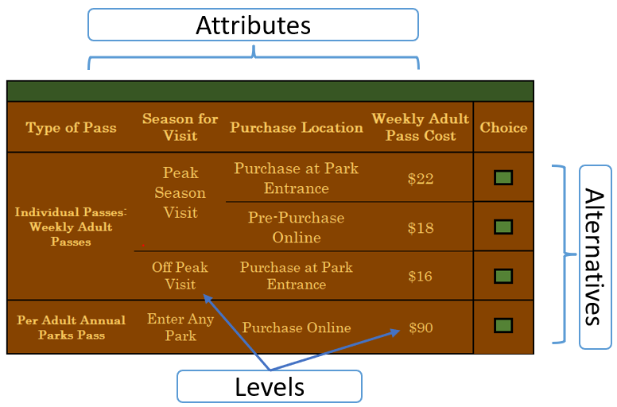

Most attributes will remain fixed for a single respondent’s set of SP questions and only vary between respondents. The availability of some attributes and levels will also depend on a respondent’s reported reference park unit visit they described earlier in the survey. The attributes tested in the experiments that describe the alternatives will include:
- Weekly or Daily Pass Type: Each respondent will be shown one of four weekly or daily pass type levels. These will remain constant across all SP questions and only vary between respondents.
- One-day Adult Pass
- Weekly Adult Pass
- One-day Vehicle or Motorcycle Pass
- Weekly Vehicle or Motorcycle Pass
- Annual Pass Type: Each respondent will be shown one of two annual pass type levels. These will remain constant across all SP questions and only vary between respondents.
- Annual Adult Pass
- Annual Vehicle Pass
- Season of visit: If respondent the selected ‘Yes’ in PV3 or FV3, weekly or daily pass products will also include an option for peak and off-peak period passes.
- Peak season
- Off-peak season
- Purchase Location: Purchase location indicates where a pass product can be purchased. Discounts will be applied to alternatives with the pre-purchase online level.
- At a park entrance
- Pre-purchase online
- Cost: Each alternative will have an associated cost. The cost will vary according to an experimental design and change from one experiment to the next. Price levels will be contingent on the values of other attributes. For example, daily pass products will always be cheaper than weekly pass products, and peak period passes will be charged a premium compared to off-peak pass products.
The respondent will be asked to select their choice of pass product (one of which would be not to visit), and also to report the number of days they would visit given their selected pricing and visitation details. The total cost for each alternative will include price expansion by the number of adults in their reference park unit visit group.

The responses to these questions will be evaluated to assess adequacy of wording and attribute levels, and whether the information can be used to measure the price elasticity of demand for park visits and ultimately the potential change in revenues resulting from the implementation of alternative entrance fee prices and structures.

Single or Multi-park Tour Stated Preference Exercises
NOTE TO REVIEWER: The instructions and questions in this section are shown to respondents whose reference park unit was a visit or planned visit to one or more national parks during a single trip from home.
- To help maintain and preserve national parks, the NPS has committed to review entrance fee and annual pass policies periodically. We are interested in understanding how these changes might affect decisions you make to visit national parks. [cbc_intro1]
NOTE TO REVIEWER: Question SP1 will include a brief introduction to the stated preference experiments. Text insertions depend on the respondent’s previous answer selections.
- If the respondent made a recent visit by selecting one or more parks in Questions PVS1 or PVS2 then <recent> and <spent>
- If the respondent is planning a visit by selecting one or more parks in Question FVS1 then <planned> and <will spend>
- If the respondent visited one park during their reference unit visit by selecting ‘No’ in Question PV15 or FV12 then <visit to NPS Unit>
- If the respondent visited more than one park during their reference unit visit by selecting ‘Yes’ in Question PV15 or FV12 then <trip that included NPS Unit>
In this section of the survey, we will ask you about your <recent/planned> <visit to NPS Unit/trip that included a visit to NPS Unit>
A visit is the total number of days you <spent/will spend> at <NPS Unit> during a single trip.
- In the next series of questions, we will ask how you would choose to visit <NPS Unit> if different pass options and entrance fees were in place. The options will differ in the following ways: [cbc_intro2]

NOTE TO REVIEWER: The respondent will be shown one of the following weekly or daily pass types for all stated preference questions. The pass type shown will be selected at random.
- One-day Adult Pass: NPS will no longer sell 3 or 7 day passes for a driver and all passengers in a personal vehicle/on a motorcycle. Per-person passes will be sold that cover one day of entry.
Weekly Adult Pass: NPS will no longer sell 3 or 7 day passes for a driver and all passengers in a personal vehicle. Per-person passes will be sold that cover one person for 7 days of entry.
- One-day Vehicle and Motorcycle Pass: NPS will no longer sell 3 or 7 day passes for a driver and all passengers in a personal vehicle or on a motorcycle. Passes will cover all occupants in a personal vehicle or on a motorcycle for one day of entry.
- Weekly Vehicle and Motorcycle Pass: Passes will continue to be sold that cover all occupants in a personal vehicle or on a motorcycle for one week of entry.

NOTE TO REVIEWER: The respondent will be shown one of the following annual pass types for all stated preference questions. The pass type shown will be selected at random.
- Annual Vehicle/Motorcycle Pass: Passes will be sold that cover all occupants in a personal vehicle/or on a motorcycle for entry at any national park.
- Annual Adult Pass: Passes will be sold that cover a single individual for entry at any national park.

Note that changes will not affect free or discounted passes for the permanently disabled (Access Pass), Senior Pass, US Military Pass or the Annual 4th Grader Pass.
NOTE TO REVIEWER: If the respondent selected ‘Yes’ in PV3 or FV3 weekly or daily pass products will also include an option for purchasing peak and off-peak period passes.
Season for Visit
- Peak versus Off Peak Season: Different entrance fees may apply <peak month range>.
Purchase Location
- Park Entrance versus Online: Depending on the type, passes may be purchased at park entrances at the time of your visit, or in advance on-line.
Cost
- The total cost for entry to <NPS Unit>
NOTE TO REVIEWER: For simplicity of this review, the example experiment shown in SP3 is for respondents who visited their reference unit in the past two years. The online survey will include versions where aspects of the experiments, including the tense of the instructions and questions, are modified for respondents who are planning a visit to a qualifying park.
- Thinking about your recent trip that included visiting <NPS Unit>
If your trip included visiting more than one park, we’d like you to focus only on your visit to <NPS Unit>.
Figure 2: Example Single Unit Visit Trip DetaIls
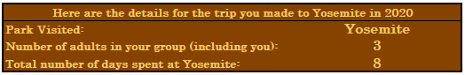
- First, please review the available options for park entry below.
- Second, indicate the number of days you would visit (if different from your recent trip).
- Third, review the options and their costs and select the one you most prefer.

Figure 3: Example SP Exercise for A Recent Visit to one or more units
If these were the options for your trip to Yosemite in 2020, which would you choose?
NOTE TO REVIEWER: Question SP3 will have between 8-10 additional experiments. We expect respondents to spend an average of 45 seconds responding to each experiment. Once the last experiment is complete the respondents will be skipped to SP7.

Single PArk with Frequent visits stated Preference exercises
NOTE TO REVIEWER: The instructions and questions in this section are shown to respondents whose reference park is a fee-free unit (the survey backend will be programmed to flag units that do not charge fees) that was visited frequently in the past two years (10+ visits).
- To help maintain and preserve national parks, the NPS has committed to review entrance fee and annual pass policies periodically. We are interested in understanding how these changes might affect decisions you make to visit national parks.
In this section of the survey, we will ask you about your recent visits to <NPS Unit>.
NOTE TO REVIEWER: The total number of visits in [num_visit] will equal the number of visits the respondent made to their reference park unit as indicated in Question PVS4.
In the previous section you indicated that you’ve visited <NPS Unit> <[num_visits]>

- Many national parks like <NPS Unit> are currently free to the public. In the future, the NPS could implement an entrance fee to visit these parks. In the next section of the survey, you’ll be shown a series of questions involving two hypothetical annual pass options for <NPS Unit> and other national parks:
- Annual Adult Pass for <NPS Unit> only: Passes may be sold for a single individual to enter the park an unlimited number of times.
- Annual Adult Pass: Passes may be sold that cover a single individual for entry at any national park.

NOTE TO REVIEWER: Question SP6 will have between 8-10 additional experiments. We expect respondents to spend an average of 30 seconds responding to each experiment. Once the last experiment is complete the respondents will go to SP7.
- Thinking about your recent trips to <NPS Unit>, what option would you choose if the following passes were available?
Figure 4: example SP Exercise for Single Unit High VIsitation
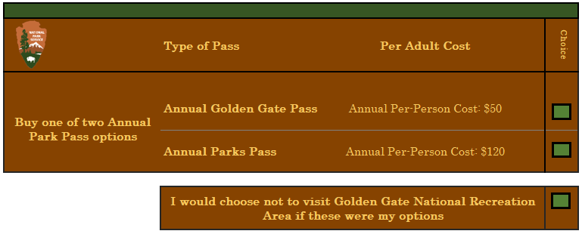

Stated PREFERENCE Follow-up questions
NOTE TO REVIEWER: This subsection will be shown to all respondents who completed either version of the stated preference exercises.

Question SP7 is shown only to respondents who reported visiting more than one park in PV15. The STEP 1 table will include randomly selected SP levels from one selected alternative in the respondent’s SP questions. If no pass option was selected, the lowest priced pass option from the respondent’s experiment set will be selected. If the respondent visited a single park, then skip to SP8.

Question text and the Step 2 parks displayed will be populated with parks selected from Question PV17.

The drop-down list for each row will include ‘1 day’ through ‘8 days or more’.

The ‘Total Visit Days’ output <Sum Input> will sum the number of days at each park selected.
- Imagine you were planning your trip to <past_tour_park_1, past_tour_park_n…> again. Assuming your group size stayed the same and the following pass option was available, how many days would you visit each park? [park_days_1] through [park_days_n]
Step 1: Review the pass type and price for your visit:
Pass Type | Season | Purchase Location | Daily Cost Per-Person to Visit Each Park
Daily Adult Pass | Peak Season | Purchase at park entrance | $22
Step 2: Indicate the number of days you would spend at each park given the pass type and price above. Note the total cost may change with the number of days you choose to visit.
National Park | How many days? |  | Total Visit Days
< past_tour_park_1> | <DROP DOWN> |  | <Sum Input>
< past_tour_park_2> | <DROP DOWN>
< past_tour_park_n> | <DROP DOWN>
- In the previous section, we asked you about how changes to entrance fees might affect decisions you make to visit national parks.
Did you find it difficult to understand these questions? [comprehend]
- They were NOT difficult to understand
- They were somewhat difficult understand
- They were difficult to understand
- They were very difficult to understand
- I did not understand what was being asked
NOTE TO REVIEWER: Question SP9 will only be shown to respondents who never selected a pass option in SP3 or SP6.
- In this previous section why did you never select to purchase any passes to visit national parks? [why_no_pass]
Select all that apply.
- The Annual Pass option shown was too expensive
- The per-day entrance passes were too expensive
- I don’t support charging fees to access national parks
- Other reason, please specify ___________

Fee and Payment Attitudes (AT)
NOTE TO REVIEWER: In the section the respondents will be asked a series of questions about fees and payments (e.g., which park passes they were aware of, which passes apply to them, and opinions about different entrance fee structures). Responses to these questions will be evaluated to test whether this information can be used to better understand respondents’ attitudes towards different fee structures, and their opinions regarding increasing revenues at national parks.
- You’re doing great! Before finishing up we’d like to ask for your opinions about visiting and paying to use national parks. [pass_holder]
NPS offers discounted (or free) passes to several groups of people:
- Military Pass: Active members of the US military, their dependents, veterans, and Gold Star families enjoy free entry to all national parks
- Every Kid in a Park Pass: This initiative allows free entry for 4th graders and their families to all national parks
- Senior Pass: US citizens age 62 or older can purchase a lifetime pass for $80 (or an annual pass for $20) that provides free entry into all national parks
- Access Pass: US citizens with lifelong physical disabilities can obtain a free lifetime pass to all national parks
- Before taking this survey, which of these passes were you aware of? [pass_aware]
Select all that apply.
- Military Pass
- Every Kid in a Park Pass
- Senior Pass
- Access Pass
- None of the above
- Which of these passes apply to one or more members of your household? [pass_qualify]
Select all that apply.
- Military Pass
- Every Kid in a Park Pass
- Senior Pass
- Access Pass
- None of the above

- Many national parks are free for the public to access. [free_importance]
How important is it to you that national parks that are currently free remain free?
- Very important
- Somewhat important
- No opinion
- Not very important
- Not Important at all

NOTE TO REVIEWER: Questions AT5 through AT7 will be shown as matrices with attitude statements in the first column and answer options (Five- point scale, Strongly Oppose through Strongly Support) in the subsequent columns.
- NPS is considering a variety of options for changing the way that visitor entrance fees are structured at national parks. Depending on how these changes are carried out, they could potentially increase or decrease total entrance fee revenues for national parks. [fee_structures1]
How strongly do you support or oppose the following approaches to structuring visitor entrance fees at national parks?
- Allowing entry fees to vary by size of vehicle (e.g., discounts for smaller vehicles)
- Allowing entry fees to vary by place of residence (e.g., discounts for locals)
- Allowing entry fees to vary by type of visitor (e.g., discounts for students, seniors, veterans, and/or the disabled)
- Allowing entry fees to vary by season of the year (e.g., discounts for off-season visitors)
- Allowing entry fees to vary by day of the week (e.g., discounts for weekday trips)
- Allowing entry fees to vary by time of day (e.g., discounts for visits during less busy times of day)
- Allowing entry fees to vary by method of purchase (e.g., discounts for online, advance purchases)

- Most major national parks currently charge per vehicle entrance fees that are valid for a one-week visit. How strongly do you support or oppose the following changes to that approach to charging entrance fees? [fee_structures2]
- Charging for every adult rather than for every vehicle
- Charging by day rather than by week (with discounts for longer trips)

- NPS currently has a substantial maintenance shortfall. This shortfall could be addressed by increasing revenues, reducing costs, or both. [revenue_opinion_1]
How strongly do you support or oppose the following approaches to increasing revenues at national parks?
- Increase park entrance fees
- Begin charging entrance fees at parks that are currently free
- Eliminate special discounts for certain types of visitors (e.g., students, seniors, and/or veterans)
- Increase entrance fees for visitors who come from other countries
- Charge new or higher fees for tours, parking, camping, or other amenities within parks
- How do you think the national parks in this country should primarily be funded? [funding]
- Federal tax dollars
- Fees paid by park visitors
- Donations
- Other, please specify ___________
- Overall, how important do you think national parks are to the American public? [park_importance]
- Extremely important
- Very Important
- Moderately important
- Slightly important
- Not important at all

Demographics (D)
NOTE TO REVIEWER: This section of questions will be used to obtain basic demographic characteristics, including household size, gender, age, education level, ethnicity, race, employment status, and income. Demographics will be used to identify segments of the population that are more or less responsive to changes in entrance fees and/or fee structures and compare respondent characteristics to those from other NPS and general population surveys as well as the non-response survey.
- In this final section we would like to learn more about your background. This information will help us compare your answers to those of other people. We stress that all of your answers are confidential.
Do you have internet access in your home? [internet]
- Yes
- No

- Do you own a smartphone (e.g., iPhone, Samsung Galaxy or similar device)? [devices]
- Yes
- No [Skip to D4]
- Which of the following mobile apps do you use on your smartphone? [device_use]
Select all that apply.
- Shopping Apps (Apple Store, Amazon, Google Play, etc.)
- Banking Apps (Citi, Bank of America, etc.)
- Mobile Payment Apps (Apple Pay, Venmo, Cash App, etc.)
- Social Networking Apps (Facebook, Twitter, Instagram, etc.)
- Navigation Apps (Google Maps, Apple Maps, Waze, etc.)
- Rideshare Hailing Apps (Uber, Lyft, etc.)
- None of the above

- Which of the following websites and apps have you used to plan or pay for visits to national parks and other recreation areas in the United States? [tech_use]
Select all that apply.
- YourPassNow.com
- Recreation.gov
- Pay.gov
- Chimani App
- National Park Service Apps
- None of the above

NOTE TO REVIEWER: Question D5 is a drop down. Options are:
- Adults – ‘1’ through ‘10 or more’
- Children – ‘0’ through ‘10 or more’
- How many people, including yourself, live in your household? [hhsize]
- Adults (18 years or older, including yourself) <DROP DOWN>
- Children (under 18 years old) <DROP DOWN>
- What is your gender? [gender]
- Male
- Female
- Prefer not to respond.

NOTE TO REVIEWER: Question D7 is a drop down – show years 1920 through (n-18), where n is the current year
- What year were you born? [age]
- What is the highest level of education you have completed? [edu]
- No schooling
- Any schooling through grade 12, no diploma
- High school graduate, including GED or alternative credit
- Some college
- Associate’s degree
- Bachelor’s degree
- Master’s degree
- Professional degree beyond a bachelor’s
- Doctoral degree
D9. Are you of Hispanic, Latino or Spanish origin? [hispanic]
- Yes
- No

D10 Which category best describes your race? [race]
One or more categories may be selected.
- American Indian or Alaskan Native
- Asian
- Black or African American
- Native Hawaiian or Other Pacific Islander
- White
- Prefer to self describe: ______

D11. Which one of the following best describes you? [employ]
- Employed full time
- Employed part time
- Full time student
- Retired
- Not at all employed

D12. Which of the following income categories best describes your household income last year, before taxes? [income]
- Less than $10,000 | - $150,000 - $199,999
- $10,000 - $24,999 | - $200,000 - $249,999
- $25,000 - $49,999 | - $250,000 - $299,999
- $50,000 - $74,999 | - $300,000 or more
- $75,000 - $99,999 | - Rather not say
- $100,000 - $149,999

NOTE TO REVIEWER: Questions D9 and D10 will be shown to pre-test respondents only. All other respondents will be skipped to D11

D13. Would you be willing to take part in a follow-up telephone call to discuss your survey experience? [debrief]
The interview will take about 30 minutes to complete.
- Yes
- No
D14. Thank you! Please leave your first name, phone number, and/or an email where we can reach you. [name] [phone] [email] [dates]
Please note: We cannot guarantee all respondents who wish to participate in the follow-ups will receive a call. We will reach out to respondents based on the order that we receive completed surveys. Your understanding and willingness to participate is appreciated.
First name: ____________________
Phone Number: _________________
Email: _______________________
Please provide days and times below when you can be reached. Don’t forget to include your time zone!
Thank you for taking the time to participate in this survey. Your responses have been saved. [end] [comment]

Please provide any additional comments regarding this survey or national parks in the box below.
End of survey.

