National Household Education Survey 2023 (NHES:2023)
Full-scale Data Collection

OMB# 1850-0768 v.19

Appendix 3 – Screener and Topical Web Specifications

February 2022

The National Household Education Survey 2023 (NHES:2023) Web Instrument
This appendix provides the web instrument for the NHES:2023 full-scale study, including the screener, Early Childhood Program Participation (ECPP), and Parent and Family Involvement (PFI) web survey instruments. All sampled households will receive an invitation to participate in the study on the web. The web survey instrument provided in this document includes all items a sampled household would receive if they were completing the screener on the web. Immediately upon completing the screener, each household will automatically see the items associated with the survey their child is sampled for--either the ECPP or the PFI. (Ineligible households will be thanked and logged out.) Because the text for the NHES:2023 web instrument is not yet programmed into the Census Bureau’s web administration software system this appendix includes screenshots from the NHES:2019 web survey instrument as examples. The question and response text may not align between the screenshot and item wording provided below the screenshot due to changes between 2019 and 2023.

For web content other than the survey items provided in this appendix and for example screen shots for web content other than survey items, please see the “NHES:2023 Web Survey Instrument Text” section of Appendix 1 in this submission.

Contents
The National Household Education Survey 2023 (NHES:2023) Web Instrument 2
NHES:2023 Screener Web Instrument Specification 15
Item: Any children in household (s1_anychldrn) 15
Item: Number of children (s1_childmany) 16
Item: Child name roster (s1_rosteraname) 17
Item: Birth month and year (s1_p1dobmm) 20
Item: Age (s1_p1age) 22
Item: Sex (s1_p1sex) 23
Item: Enrollment Type (s1_p1enrol) 24
Item: Grade level (s1_p1grade_web) 26
Item: Next child birth month and year (s1_p2dobmm) 28
Item: Next child age (s1_p2age) 29
Item: Next child sex (s1_p2sex) 31
Item: Next child enrollment (s1_p2enrol) 32
Item: Next child grade (s1_p2grade_web) 34
Item: Next child birth month and year (s1_p3dobmm) 36
Item: Next child age (s1_p3age) 37
Item: Next child sex (s1_p3sex) 38
Item: Next child enrollment (s1_p3enrol) 39
Item: Next child grade (s1_p3grade_web) 41
Item: Next child birth month and year (s1_p4dobmm) 44
Item: Next child age (s1_p4age) 45
Item: Next child sex (s1_p4sex) 46
Item: Next child enrollment (s1_p4enrol) 47
Item: Next child grade (s1_p4grade_web) 49
Item: Next child birth month and year (s1_p5dobmm) 51
Item: Next child age (s1_p5age) 52
Item: Next child sex (s1_p5sex) 54
Item: Next person enrollment (s1_p5enrol) 55
Item: Next child grade (s1_p5grade_web) 57
Item: sampling (not an actual page but behind the scenes) 59
Item: PFI Introduction (ps_pfirelate) 59
Item: ECPP Introduction (ps_ecpprelate) 61
Item: Thank You (s1_thank_you) 63
Item: Confirm information Screener (s1_Incent_Name) 64
Item: Confirm address Screener (s1_inc_address) 66
Item: Address information Screener (S1_PRIM_ADD_new) 67
Item: Survey End (s1_survey_end_inc) 69
Item: After Exit Survey 69
NHES:2023_ECPP Web Instrument Specification 71
WHERE TO START THE ECPP: 71
Item: Sampled Child Check (ECPP_ECPPCHK) 71
Item: Regular Basis Check (ECPP_RCNOW) 72
Item: Regular Care Arrangements (ECPP_CARENOW) 74
Item: Regular Care Arrangements (ECPP_PCPCARE) 74
Item: Weekly Care Arrangements (ECPP_RCWEEK) 76
Item: Relative Care (ECPP_RCTYPE ) 77
Item: Age of Relative (ECPP_RCAGE) 79
Item: Place of Care (ECPP_RCPLACE) 80
Item: Time to Relative’s home (ECPP_RCTIME) 81
Item: Days of Care (ECPP_RCDAYS) 83
Item: Hours of Care (ECPP_RCHRUNIT) 84
Item: Hours of Care (ECPP_RCHRS) 85
Item: Relative Care Coverage For Work (ECPP_RCCVRWK) 87
Item: Child’s Age at Start of Care (ECPP_RCSTRTY) 88
Item: Child’s Language (ECPP_RCSPEAK) 90
Item: Sick without Fever (ECPP_RCSKNFV) 91
Item: Other Children (ECPP_RCOTCH) 93
Item: Relative Care Fee (ECPP_RCFEE) 94
Item: Paid by Organization (ECPP_RCREL) 96
Item: Paid by Household (ECPP_RCUNIT) 98
Item: Fee for No. of Children (ECPP_RCCSTHNX) 100
Item: Amount Paid by Household (ECPP_RCCOST) 102
Item: Other Care Arrangements with relative (ECPP_RCOTHC) 104
Item: Hours at Other Care Arrangements (ECPP_RCTLHR) 105
Item: Non-Relative Care (ECPP_NCNOW) 106
Item: Non-Relative Care per Week (ECPP_NCWEEK) 107
Item: Non-Relative Care Home (ECPP_NCHOME) 109
Item: Non-Relative Care Location (ECPP_NCPLACE) 110
Item: Time to Non Relative’s home (ECPP_NCTIME) 111
Item: Days of Non-Relative Care (ECPP_NCDAYS) 112
Item: Hours of Non-Relative Care (ECPP_NCHRUNIT) 113
Item: Hours of Non-Relative Care (ECPP_NCHRS) 113
Item: Non-Relative Care Coverage For Work (ECPP_NCCVRWK) 115
Item: Child’s Age in Years at Start of Non-Relative Care (ECPP_NCSTRTY) 116
Item: Knew of Non-Relative Care (ECPP_NCALKNE) 117
Item: Age of Non-Relative Care (ECPP_NCAGE) 118
Item: Language of Non-Relative Care Provider (ECPP_NCSPEAK) 119
Item: Non-Relative Care with Sick Child but No Fever (ECPP_NCSKNFV) 120
Item: Non-Relative Care Other Children (ECPP_NCOTCH) 121
Item: Non-Relative Care Recommendation (ECPP_NCRCMDPT) 122
Item: Fee by Non-Relative Care Provider (ECPP_NCFEE) 123
tem: Non-Relative Care Paid by an Organization (ECPP_NCREL) 124
Item: Non-Relative Care Paid by Household (ECPP_NCUNIT) 126
Item: Non-Relative Care Fee for No. of Children (ECPP_NCCSTHNX) 127
Item: Non-Relative Care Amount Paid by Household (ECPP_NCCOST) 129
Item: Other Non-Relative Care (ECPP_NCOTHC) 131
Item: Other Non-Relative Care Hours (ECPP_NCTLHR) 132
Item: Childcare Centers and Programs (ECPP_CPNNOWX) 133
Item: Attends Childcare Centers and Programs (ECPP_CPWEEKX) 134
Item: Type of Childcare Centers and Programs (ECPP_CPTYPE) 135
Item: Program Location (ECPP_CPPLACEX) 137
Item: Program Teach Religion (ECPP_CPRELIGC) 138
Item: Program at Workplace (ECPP_CPWORK) 139
Item: Head Start Programs (ECPP_CPHEADST) 140
Item: Days at Program (ECPP_CPDAYS) 142
Item: Hours at Program (ECPP_CPHRUNIT) 143
Item: Hours at Program (ECPP_CPHRS) 143
Item: Program Coverage For Work (ECPP_CPCVRWK) 145
Item: Child’s Age at Start of Program (ECPP_CPSTRTY) 147
Item: Language of Main Care Provider (ECPP_CPSPEAK) 148
Item: Time to Program (ECPP_CPTIME) 150
Item: Recommend Program (ECPP_CPRCMDPT) 151
Item: Remove From Program (ECPP_CPREMOVE) 152
Item: Program Services (ECPP_CPTEST) 153
Item: Program Care for Child Sick Without Fever (ECPP_CPSKNFV) 154
Item: Fee Paid by Other Party (ECPP_CPFEE) 155
Item: Program Paid by Groups (ECPP_CPREL) 156
Item: Way of Paying for Program (ECPP_CPUNIT) 158
Item: No. of Children Fee Covers (ECPP_CPCSTHNX) 160
Item: Amount Household Pays (ECPP_CPCOST) 161
Item: Other Care Arrangements (ECPP_CPOTHC) 163
Item: Hours per week at Day Care (ECPP_CPTLHR) 164
Item: Attend Head Start Programs (ECPP_PCEVRHDX) 165
Item: Reason for Childcare (ECPP_MAINRESN) 166
Item: Choices for Childcare (ECPP_ PPCHOIC) 168
Item: Search for child care (ECPP_CRSRCH) 169
Item: Difficulty Finding Childcare (ECPP_PPDIFCLT) 170
Item: Difficulty Reason in Finding Childcare (ECPP_WHYDIFCLT) 171
Item: Receiving Care in the Past Year (ECPP_CCPY) 173
Item: Main reason for Child Care (ECPP_CCREASN) 174
Item: Reason Importance in Finding Childcare (ECPP_DCLOA) 175
Item: Reason Importance in Finding Childcare continued (ECPP_DCLOA2) 178
Item: Number of Child’s Books (ECPP_HABOOKS) 181
Item: Number of Times Read to Child (ECPP_FOREADTOXA) 182
Item: Number of Minutes Read to Child (ECPP_FORDDAYX) 183
Item: Weekly Activities with Child (ECPP_FOSTORYX) 184
Item: Number of Days Family Eaten Together (ECPP_FODINNERX) 185
Item: Visited the Library (ECPP_FOLIBRAY) 186
Item: Visited the Bookstore (ECPP_FOBOOKST) 187
Item: 2 Years of Age (ECPP_DPIAGE) 188
Item: Name Letters (ECPP_DPLETTER) 189
Item: Writing Name (ECPP_DPNAME) 190
Item: Letter Sounds (ECPP_DPLTRSND) 191
Item: Explain things (ECPP_DPEXPLN) 193
Item: Counting (ECPP_DPCOUNT) 194
Item: Name Shapes (ECPP_DPSHAPE) 195
Item: Child’s Health (ECPP_HDHEALTH) 196
Item: Express Health Concern (ECPP_HDEXCNRN) 197
Item: Satisfaction with Health Providers Response (ECPP_HDSTCNRN) 198
Item: Child’s Health Conditions (ECPP_HDINTDIS) 199
Item: Confirm any listed conditions (ECPP_HDCOND) 206
Item: Write-in conditions (ECPP_HDCONDWI) 207
Item: Developmental Delay (ECPP_HDDLYRSK) 208
Item: Receiving Service for Condition (ECPP_HDRECSERV) 209
Item: Service for Condition (ECPP_HDIFSPIEP) 210
Item: Satisfaction with IFSP or IEP Services (ECPP_HDCOMMUXX) 211
Item: Child’s Ability (ECPP_HDLEARN) 213
Item: Child’s Birth Date (ECPP_CDOBMM_WEB) 216
Item: Child’s Age (ECPP_CAGE) 217
Item: Child’s Birth Place (ECPP_CPLCBRTH) 218
Item: Age when moving to U.S. (ECPP_CMOVEAGE) 219
Item: Hispanic Origin (ECPP_CHISPANX) 220
Item: Child’s Race (ECPP_CAMIND) 221
Item: Child’s Sex (ECPP_CSEX) 223
Item: Child’s Address (ECPP_CLIVYN) 224
Item: Where Child Spends Most Time (ECPP_CLIVELSWX) 225
Item: Child’s Language (ECPP_CSPEAKX) 226
Item: Enrolled in 2nd Language (ECPP_CENGLPRG) 227
Item: Total Number in Household (ECPP_HHTOTALXX) 228
Item: Relation to Child (ECPP_HHREL1) 229
Item: Parent or Guardian (ECPP_P1REL) 230
Item: Parent/Guardian (ECPP_P1GUARD) 232
Item: Relation to this Child (ECPP_P1HHREL2) 232
Item: Other Parent/Guardian Relationship (ECPP_P1REL2) 235
Item: Parent/Guardian Sex (ECPP_P1SEX) 237
Item: Parent/Guardian Marital status (ECPP_P1MRSTAR) 239
Item: Living with Partner (ECPP_P1BFGF) 241
Item: First Language of Parent/Guardian (ECPP_P1FRLNG) 242
Item: Current Language of Parent/Guardian (ECPP_P1SPEAK) 244
Item: Parent/Guardian Place of Birth (ECPP_P1PLCBRTH) 246
Item: Parent/Guardian Age when moved to U.S. (ECPP_P1AGEMV) 248
Item: Hispanic Origin (ECPP_P1HISPANX) 250
Item: Parent/Guardian Race (ECPP_P1AMIND) 252
Item: Parent/ Guardian Highest Level of Education (ECPP_P1EDUC) 254
Item: Parent/Guardian Currently Enrolled in Postsecondary Education (ECPP_P1ENRL) 256
Item: Parent/Guardian Employment Status (ECPP_P1EMPL) 258
Item: Parent/Guardian Hours Worked Weekly (ECPP_P1HRSWK) 260
Item: Hours Worked past 4 Weeks (ECPP_P1LKWRK) 262
Item: Worked past 12 Months (ECPP_P1MTHSWRK) 264
Item: Parent/Guardian Cell Phone Internet Access (ECPP_P1INTSPHO) 266
Item: Parent/Guardian Age (ECPP_P1AGE) 267
Item: 2nd Parent/Guardian (ECPP_P2GUARD) 269
Item: Relation to this Child (ECPP_P2HHREL) 271
Item: 2nd Parent/Guardian Relation to Child (ECPP_P2REL) 273
Item: 2nd Parent/Guardian Sex (ECPP_P2SEX) 275
Item: 2nd Parent/Guardian Marital Status (ECPP_P2MRSTAR) 277
Item: 2nd Parent/Guardian Partner (ECPP_P2BFGF) 279
Item: 2nd Parent/Guardian First Language (ECPP_P2FRLNG) 281
Item: 2nd Parent/Guardian Birth Place (ECPP_P2PLCBRTH) 285
Item: 2nd Parent/Guardian Age Once moved to U.S. (ECPP_P2AGEMV) 287
Item: 2nd Parent/Guardian Hispanic Origin (ECPP_P2HISPANX) 289
Item: 2nd Parent/Guardian Race (ECPP_P2AMIND) 291
Item: 2nd Parent/Guardian Highest Level of Education (ECPP_P2EDUC) 294
Item: 2nd Parent/Guardian Postsecondary Enrollment (ECPP_P2ENRL) 296
Item: 2nd Parent/Guardian Employment (ECPP_P2EMPL) 298
Item: 2nd Parent/Guardian Hours Worked (ECPP_P2HRSWK) 301
Item: 2nd Parent/Guardian Worked past 4 Weeks (ECPP_P2LKWRK) 303
Item: 2nd Parent/Guardian Worked past 12 Months (ECPP_P2MTHSWRK) 305
Item: 2nd Parent/Guardian Cell Phone Internet Access (ECPP_P2INTSPHO) 307
Item: Age of 2nd Parent/Guardian (ECPP_P2AGE) 309
Item: Family Benefits (ECPP_HWELFTAN) 311
Item: Household Income (ECPP_TTLHHINC) 313
Item: House Status (ECPP_OWNRNTHB) 316
Item: Household Internet Access (ECPP _HVINTCOM) 317
Item: Child’s Internet Use (ECPP_CHLDNT) 318
Item: Child’s Device for Learning Activities (ECPP_LRNCOMP) 319
Item: Confirm Information ECPP (ECPP_Incent_Name) 320
Item: Confirm address ECPP (ECPP_Inc_address ) 322
Item: Address Information ECPP (ECPP_PRIM_ADD_new) 323
Item: Survey End (ECPP_survey_end_inc) 325
Item: Thank You Page (ECPP_thank_you) 326
Item: After Exit Survey 327
NHES:2023 Parent and Family Involvement Web Instrument Specification 328
WHERE TO START: 328
Item: Full or Partial Kindergarten (PFIC_FDPDKIND) 328
Item: Child’s Current Grade (PFIC_ALLGRADEX_web) 329
Item: Education Setting (PFIC_EDCPUB) 331
Item: School Other than College (PFIC_OTHSCHL) 335
Item: Education Setting Type of School (PFIC_EDCPUB2) 336
Item: Home School Alternative (PFIC_HOMESCHLX) 339
Item: Home School Arrangement (PFIC_HMSCHARR) 340
Item: Homeschooling in Co-op (PFIC_HSCOOP) 342
Item: Main Person Providing Instruction (PFIC_HSWHOX) 343
Item: Home Instruction by Tutor (PFIC_HSTUTOR) 344
Item: Online courses homeschool (PFIC_HSINTNET) 345
Item: Reasons for Online Schooling (PFIC_ONLNAP) 346
Item: Important Reason for Online (PFIC_HSIMPONLI) 349
Item: Online Instruction Provider (PFIC_HSINTPUB) 351
Item: Number of Online Course homeschool (PFIC_HSINTNUM) 353
Item: Fee for Instruction (PFIC_HSINTFEE) 354
Item: Online Instructions Hours Homeschool (PFIC_HSINTHRS) 355
Item: Teaching Style Used to Homeschool (PFIC_HSSTYL) 356
Item: Homeschool Activities (PFIC_HSKACTIV) 358
Item: Online Instruction at Home (PFIC_HSCOURS) 359
Item: Homeschooled grades (PFIC_HOMEKX ) 360
Item: Reason for Choosing to Homeschool (PFIC_HSSAFETYX) 362
Item: Most Important Reason for Choosing to Homeschool (PFIC_HSMOSTX) 365
Item: Current Subjects Taught in Homeschool (PFIC_HSSUBJ1) 367
Item: Activities with Local Homeschooling Association (PFIC_HSASSNX) 368
Item: Frequency of Activities with Local Homeschooling Association (PFIC_HSFREQX) 369
Item: Household a Member of the National Homeschooling Association (PFIC_HSNATL) 370
Item: Military family (PFIC_HSMLTY) 371
Item: Enrolled in school (PFIC_HSENRL) 372
Item: School Hours per Week (PFIC_SCHLHRSWK) 373
Item: Attends Assigned School District (PFIC_DISTASSI) 375
Item: Attends a Charter School (PFIC_SCHRTSCHL) 377
Item: Attends a Magnet School (PFIC_SCHLMAGNET) 379
Item: Moved to Neighborhood for School (PFIC_SNEIGHBRX) 380
Item: School Choice (PFIC_SCCHOICE) 382
Item: Public School Choice (PFIC_SPUBCHOIX) 383
Item: Other Schools (PFIC_SCONSIDR) 384
Item: Reasons School Chosen (PFIC_LOCALE ) 385
Item: Find School (PFIC_FINDSCHL) 388
Item: First Choice School (PFIC_S1STCHOI) 390
Item: Same School since the Beginning of School Year (PFIC_SSAMSC) 391
Item: Online courses (PFIC_EINTNET) 392
Item: Reason for choosing online schooling (PFIC_ADVCCRSE) 393
Item: Most Important Reason for Choosing Online Schooling (PFIC_MOSTIMPT) 396
Item: Instruction Provider (PFIC_SPBSCH) 398
Item: Number of Online Course (PFIC_INTNUM) 400
Item: Charge Fee for Instruction (PFIC_SINSTFEE) 401
Item: Online Instructions Hours (PFIC_INTHRS) 402
Item: Child Enjoys School (PFIC_SEENJOY) 403
Item: Child Grades (PFIC_SEGRADES) 404
Item: AP Classes (PFIC_SEADPLCXX) 406
Item: Child’s Teacher Contacted Staff (PFIC_SEBEHAVX) 406
Item: Days Absent (PFIC_SEABSNT) 409
Item: Repeat Grades (PFIC_SEREPEAT) 410
Item: Repeated Grades (PFIC_SEREPTK) 411
Item: Child Experiences (PFIC_SESUSOUT) 412
Item: Child’s Work at School (PFIC_SEGRADEQ) 414
Item: Activities at School (PFIC_FSSPORTX) 415
Item: Adult Participation in School Activities (PFIC_FSFREQ) 417
Item: School Communication (PFIC_FSNOTESX) 418
Item: Child’s Performance (PFIC_FSSPPERF) 419
Item: Satisfaction with School Components (PFIC_FCSCHOOL) 423
Item: Homework Outside of School (PFIC_FHHOME) 425
Item: Hours of Homework per Week (PFIC_FHWKHRS) 426
Item: Parent’s Feelings about Amount of Homework (PFIC_FHAMOUNT) 427
Item: Child’s Feelings about Amount of Homework (PFIC_FHCAMT) 428
Item: Child’s Place for Homework (PFIC_FHPLACE) 429
Item: Homework Checks (PFIC_FHCHECKX) 430
Item: Days Homework Help (PFIC_FHHELP) 431
Item: Weekly Family Activities (PFIC_FOSTORY2X) 432
Item: Number of Days Family Eaten Together (PFIC_FODINNERX) 434
Item: Monthly Family Activities (PFIC_FOLIBRAYX) 435
Item: Description of Child’s Health (PFIC_HDHEALTH) 436
Item: Child’s Health Conditions (PFIC_HDINTDIS) 437
Item: Confirm any listed conditions (PFIC_HDCOND) 442
Item: Write-in conditions (PFIC_HDCONDWI) 443
Item: IEP Services (PFIC_HDIEPX) 443
Item: Satisfaction of IEP Services (PFIC_HDCOMMUXX) 444
Item: Child’s Condition and Ability (PFIC_HDLEARN) 445
Item: Child’s Birth Month and Year (PFIC_CDOBMM_WEB) 447
Item: Child’s Age in Years (PFIC_CAGE) 448
Item: Child’s Place of Birth (PFIC_CPLCBRTH) 450
Item: Child’s Age once moved to U.S. (PFIC_CMOVEAGE) 451
Item: Child’s Hispanic Origin(PFIC_CHISPANX) 452
Item: Race of Child (PFIC_CAMIND) 453
Item: Sex of Child (PFIC_CSEX) 455
Item: Address of Child (PFIC_CLIVYN) 455
Item: Where This Child Spends Most Time (PFIC_CLIVELSWX) 456
Item: Language Most Spoken at Home by this child (PFIC_CSPEAKX) 458
Item: English as Second Language (PFIC_CENGLPRG) 459
Item: Total in Household Number (PFIC_HHTOTALXX) 460
Item: Relation to this Child (PFIC_HHREL1) 461
Item: Parent/Guardian (PFIC_P1REL) 462
Item: Parent/Guardian (PFIC_P1GUARD) 464
Item: Relation to this Child (PFIC_P1HHREL2) 465
Item: Parent/Guardian (PFIC_P1REL2) 467
Item: Parent or Guardian Sex (PFIC_P1SEX) 469
Item: Parent or Guardian Marital status (PFIC_P1MRSTAR) 472
Item: Parent or Guardian Living with Partner (PFIC_P1BFGF) 474
Item: First Language of Parent or Guardian (PFIC_P1FRLNG) 475
Item: Current Language of Parent or Guardian (PFIC_P1SPEAK) 477
Item: Difficulty Participating in School Activities (PFIC_P1DIFFI) 479
Item: School Interpreters (PFIC_P1SCINT) 481
Item: School Written Materials (PFIC_P1WRMTL) 483
Item: Parent or Guardian Place of Birth (PFIC_P1PLCBRTH) 485
Item: Parent or Guardian Age when moved to U.S. (PFIC_P1AGEMV) 487
Item: Parent or Guardian Hispanic Origin (PFIC_P1HISPANX) 489
Item: Parent or Guardian Race (PFIC_P1AMIND) 491
Item: Parent or Guardian Highest Level of Education (PFIC_P1EDUC) 493
Item: Parent or Guardian Currently Enrolled in Postsecondary Education (PFIC_P1ENRL) 495
Item: Parent or Guardian Employment Status (PFIC_P1EMPL) 497
Item: Parent or Guardian Hours Worked Weekly (PFIC_P1HRSWK) 499
Item: Hours Parent or Guardian Worked past 4 Weeks (PFIC_P1LKWRK) 501
Item: Months Parent or Guardian Worked (PFIC_P1MTHSWRK) 503
Item: Parent/Guardian Cell Phone Internet Access (PFIC_P1INTSPHO) 505
Item: Parent or Guardian Age (PFIC_P1AGE) 506
Item: 2nd Parent or Guardian (PFIC_P2GUARD) 508
Item: Relation to this Child (PFIC_P2HHREL) 510
Item: 2nd Parent or Guardian Relation to Child (PFIC_P2REL) 512
Item: 2nd Parent or Guardian Sex (PFIC_P2SEX) 514
Item: 2nd Parent or Guardian Marital Status (PFIC_P2MRSTAR) 516
Item: 2nd Parent or Guardian Partner (PFIC_P2BFGF) 518
Item: 2nd Parent or Guardian First Language (PFIC_P2FRLNG) 520
Item: 2nd Parent or Guardian Current Language (PFIC_P2SPEAK) 522
Item: 2nd Parent or Guardian Difficulty with School Activities (PFIC_P2DIFFI) 524
Item: 2nd Parent or Guardian School Interpreters (PFIC_P2SCINT) 527
Item: School Communication for 2nd Parent or Guardian (PFIC_P2WRMTL) 529
Item: 2nd Parent or Guardian Birth Place (PFIC_P2PLCBRTH) 531
Item: 2nd Parent or Guardian Age Once moved to U.S. (PFIC_P2AGEMV) 533
Item: 2nd Parent or Guardian Hispanic Origin (PFIC_P2HISPANX) 535
Item: 2nd Parent or Guardian Race (PFIC_P2AMIND) 537
Item: 2nd Parent or Guardian Highest Level of Education (PFIC_P2EDUC) 540
Item: 2nd Parent or Guardian Postsecondary Enrollment (PFIC_P2ENRL) 542
Item: 2nd Parent or Guardian Employment (PFIC_P2EMPL) 544
Item: 2nd Parent or Guardian Hours Worked (PFIC_P2HRSWK) 547
Item: 2nd Parent or Guardian Worked past 4 Weeks (PFIC_P2LKWRK) 549
Item: 2nd Parent or Guardian Worked past 12 Months (PFIC_P2MTHSWRK) 551
Item: 2nd Parent/Guardian Cell Phone have Internet Access (PFIC_P2INTSPHO) 553
Item: Age of 2nd Parent or Guardian (PFIC_P2AGE) 555
Item: This Family’s Benefits (PFIC_HWELFTAN) 557
Item: This Household’s Income (PFIC_TTLHHINC) 559
Item: House or Apartment Status (PFIC_OWNRNTHB) 561
Item: Household Internet Access (PFIC _HVINTCOM) 562
Item: Internet Use of This Child (PFIC_CHLDNT) 563
Item: This Child’s Device for Learning Activities (PFIC_LRNCOMP) 564
Item: Education Expectation (PFIC_ SEFUTUREX) 565
Item: Child’s School (PFIC_RSCHOOL) 567
Item: Child’s School Write-In (PFIC_SCHNAME) 570
Item: PFI Debrief Request (PFIC_DEBRIEF) 571
Item: PFI Debrief Request (PFIC_DEBRIEFmd) 572
Item: PFI Debrief Request (PFIC_DEBRIEFcntct) 573
Item: Confirm information PFI (PFIC_Incent_Name) 574
Item: Confirm address PFIC (PFIC_inc_address) 576
Item: Address Information (PFIC_PRIM_ADD_new) 577
Item: Survey End (PFIC_survey_end_inc) 579
Item: Thank You Page (PFIC_thank_you) 580
Item: After Exit Survey 581

NHES:2023 Screener Web Instrument Specification

Item: Any children in household (s1_anychldrn)
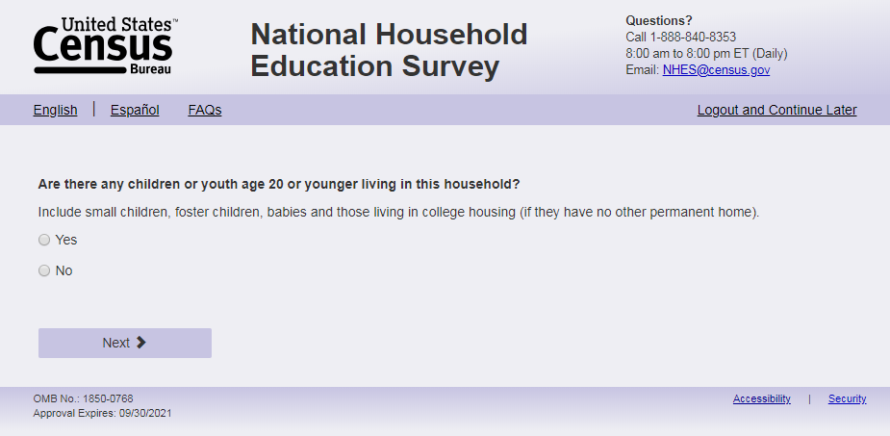
English Text Reads:
Are there any children or youth age 20 or younger living in this household?
Include small children, foster children, babies and youth who are away at college (if they have no other permanent home).
Spanish Text Reads:
¿Hay algún niño o joven de 20 años o menos viviendo en este hogar?
Incluya niños pequeños, niños de crianza temporal (Foster), bebés y jóvenes que están en la universidad (si no tienen otro hogar permanente).
English Answer:
1= Yes
2= No

Spanish Answer:
1= Sí
2= No

s1_anychldrn, (1,2), numeric, radio
Skip patterns:
If s1_anychldrn= 2 and (USE_CHOICE_PLUS = missing or 0) or (EBWP_FLAG = 1 and survey complete date is after 3/13/23) then go to thank_you; else if s1_anychldrn= 2 and (USE_CHOICE_PLUS= 1) or (EBWP_FLAG = 1 and survey complete date on or before 3/13/23) then go to Incent_Name. Else go to s1_childmany.

Item: Number of children (s1_childmany)

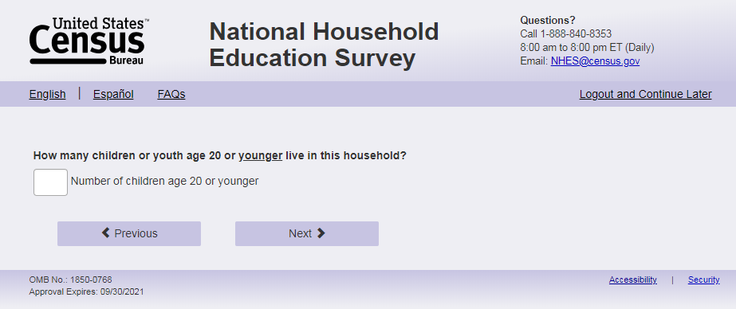
English Text Reads:
How many children or youth age 20 or YOUNGER live in this household?
Include small children, foster children, babies, and youth who are away at college (if they have no other permanent home).
Spanish Text Reads:
¿Cuántos niños o jóvenes de 20 años o MENOS viven es este hogar?
Incluya niños pequeños, niños de crianza temporal (Foster), bebés y jóvenes que están en la universidad (si no tienen otro hogar permanente).

English and Spanish Answer:
s1_childmany, (1,99) numeric, write-in
Skip patterns:
Go to s1_rosteraname
Logic Checks/Programming specifications:
English:
Display ‘child(ren) ’ next to the right of the write-in box
Spanish:
Display “niño(s)” next to the right of the write-in box
Do not allow the respondent to enter “0” only allow values between 1 and 99.
Text Displayed for logic/range check violation:
English
[if s1_childmany = 0] "Please check and make sure your answer is correct before continuing since you reported there are children or youth age 20 or younger living in this household. "
Spanish
[if s1_childmany = 0] “Por favor, compruebe y asegúrese de que su respuesta es correcta antes de continuar, ya que previamente dijo que hay niños o jóvenes de 20 años o menos que viven en este hogar”

Item: Child name roster (s1_rosteraname)
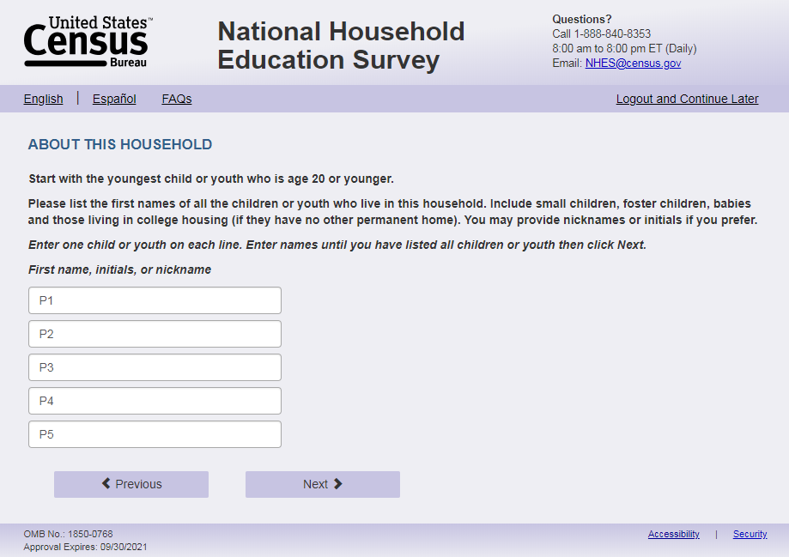
English Respondent Text Reads:
Please list the first name of each household child age 20 or younger. If you prefer, you may use initials or nicknames instead of names.
[Start with the youngest child.]
______________ (s1_p1name)
______________ (s1_p2name)
______________ (s1_p3name)
______________ (s1_p4name)
______________ (s1_p5name)
______________ (s1_p6name)
______________ (s1_p7name)
______________ (s1_p8name)
______________ (s1_p9name)
______________ (s1_p10name)

Spanish Respondent Text Reads:
Por favor, enumere los nombres de todos los niños o jóvenes que viven en este hogar de 20 años o menos. Si lo prefiere, puede usar iniciales o apodos en vez de nombres.
[Empiece con el más pequeño.]
______________ (s1_p1name)
______________ (s1_p2name)
______________ (s1_p3name)
______________ (s1_p4name)
______________ (s1_p5name)
______________ (s1_p6name)
______________ (s1_p7name)
______________ (s1_p8name)
______________ (s1_p9name)
______________ (s1_p10name)

English Admin/TQA Text Reads
Please tell me the first name of each household child age 20 or younger, starting with the youngest child. If you prefer, you may use initials or nicknames instead of names.
______________ (s1_p1name)
______________ (s1_p2name)
______________ (s1_p3name)
______________ (s1_p4name)
______________ (s1_p5name)
______________ (s1_p6name)
______________ (s1_p7name)
______________ (s1_p8name)
______________ (s1_p9name)
______________ (s1_p10name)

Spanish Admin/TQA Text Reads:
Por favor, digame los nombres de todos los niños o jóvenes que viven en este hogar de 20 años o menos, comenzando con el más pequeño. Si lo prefiere, puede usar iniciales o apodos en vez de nombres.
______________ (s1_p1name)
______________ (s1_p2name)
______________ (s1_p3name)
______________ (s1_p4name)
______________ (s1_p5name)
______________ (s1_p6name)
______________ (s1_p7name)
______________ (s1_p8name)
______________ (s1_p9name)
______________ (s1_p10name)

English and Spanish Answer:
s1_p1name- s1_p10name, (0,30) character, write-in
Skip patterns:
If s1_childmany and s1_rosteraname are all blank, and (USE_CHOICE_PLUS= 0 or missing)or (EBWP_FLAG = 1 and survey complete date is after 3/13/23) then go to thank_you; else if s1_childmany and s1_rosteraname are all blank and (USE_CHOICE_PLUS= 1) or (EBWP_FLAG = 1 and survey complete date is on or before 3/13/23) then go to Incent_Name. Else go to s1_p1dobmm.
Logic Checks/Programming specifications
Display the number of boxes based on s1_childmany. If s1_childmany is blank display all 10 boxes.
If s1_childmany > 1, display the text in brackets “Start with the youngest child.” Spanish: “Empiece con el más pequeño”
Number of children in the household as referenced in the rest of the web specs is as follows:
- If s1_childmany and the number of names in s1_rosteraname are equal then number of children =s1_childmany
- If s1_childmany and the number of names in s1_rosteraname are not equal (s1_childmany>s1_rosteraname is the only possible scenario since s1_rosteraname only shows the number of boxes reported in s1_childmany) then number of children = number of names in s1_rosteraname
- If s1_childmany is missing, and number of names in s1_rosteraname >0, number of children = number of names in s1_rosteraname.
- If s1_childmany is missing, and number of names in s1_rosteraname are all blank or 0, number of children = 0.
If the number of children entered on s1_rosteraname is less than the number of children entered on s1_childmany, then ask the follow-up screener questions (s1_pXdobmm through s1_pXgrade_web, where X is the number of children reported in s1_rosteraname). If s1_childmany equals the number entered in s1_rosteraname (and s1_childmany and s1_rosteraname is not 0 or blank), then ask about that number in the follow-up screener questions (s1_pXdobmm through s1_pXgrade_web, where X is the number of children reported in s1_childmany and s1_rosteraname), unless that number is 0 or blank, in which follow: If s1_childmany and s1_rosteraname are all blank or 0 then assume no children in household and end survey (follow skip pattern programming for the end survey screen).
If the respondent reports 6 children in s1_childmany but only puts 2 children in s1_p1name and s1_p2name and then reports a child in s1_p6name make sure that the corresponding data for that person in the sex, age, enrollment, and grade questions (s1_pXdobmm through s1_pXgrade_web) aligns with the p3name variable. In 2017 the data output had the name in p1_s6name but the remaining data for that person in s1_p3<variable name>. For sampling purposes the NHES:2023 will only sample from first five children reported (s1_p1-s1_p5).

Item: Birth month and year (s1_p1dobmm)
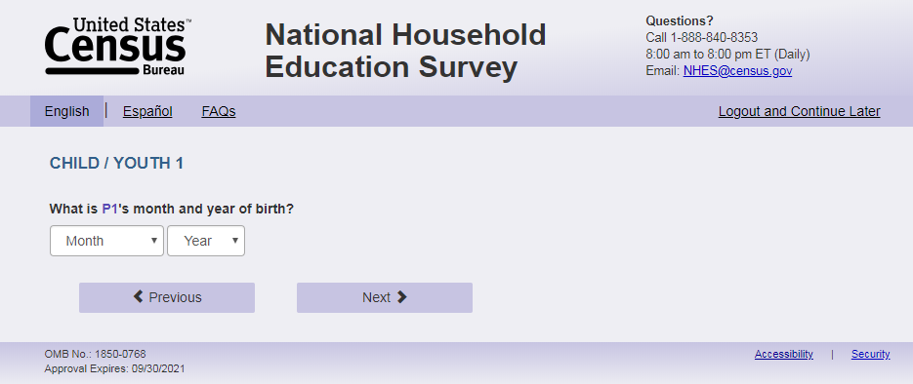
English Text reads:
[We are now going to ask a few questions about 5 of your children.]
What is [s1_p1name]'s month and year of birth?
Spanish text reads:
[Ahora vamos a hacerle algunas preguntas sobre 5 de sus hijos.]
¿En qué mes y año nació [s1_p1name]?
English and Spanish Answer:
S1_p1dobmm, (1,12) numeric, drop-down
S1_p1dobyy, (2002, 2023), numeric, drop-down
Skips:
Go to s1_p1age if s1_p1dobyy is blank; else go to s1_p1sex.
Logic checks/Programming Specifications:
Show s1_p1dobmm and s1_p1dobyy on the same screen. In the drop down, the names of the months will be written out. See table below.
Allow respondents to scroll the options within drop-down

English:
Only display text in brackets “[We are now going to ask a few questions about 5 of your children.]” if number of children > 5 (calculated based off the logic programming from s1_rosteraname).

Display ‘month’ as label above the dropdown box and leave the dropdown box blank..
Display ‘year of birth’ as label above the dropdown box and leave the dropdown box blank..
Use s1_p1name from s1_rosteraname to autofill [s1_p1name] regardless of length and characters used.
Spanish:
Only display text in brackets “[Ahora vamos a hacerle algunas preguntas sobre 5 de sus hijos.]”
If number of children > 5 (calculated based off the logic programming from s1_rosteraname).
Display ‘mes’ as label above the dropdown box and leave the dropdown box blank.
Display ‘año de nacimiento’ as label above the dropdown box and leave the dropdown box blank..
Use s1_p1name from s1_rosteraname to autofill [s1_p1name] regardless of length and characters used.
Text versions of numerical months – text version should be displayed
Month # | Month, English | Month, Spanish
01 | January | enero
02 | February | febrero
03 | March | marzo
04 | April | abril
05 | May | mayo
06 | June | junio
07 | July | julio
08 | August | agosto
09 | September | septiembre
10 | October | octubre
11 | November | noviembre
12 | December | diciembre

Item: Age (s1_p1age)
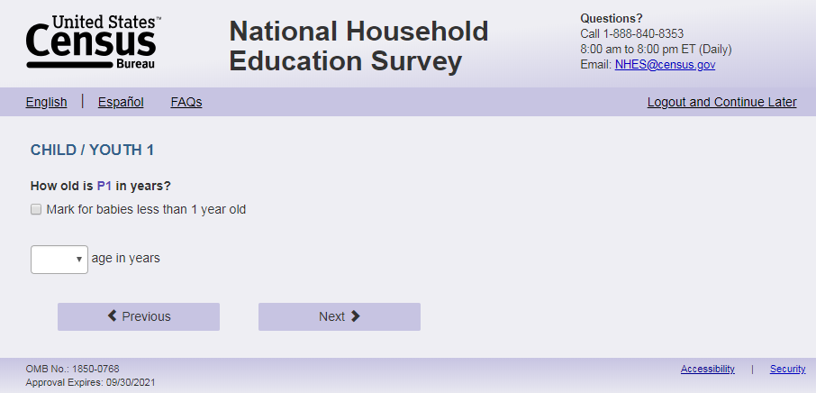
English Text reads:
How old is [s1_p1name] in years?
Spanish text reads:
¿Qué edad, en años, tiene [s1_p1name]?
English and Spanish Answer:
S1_p1baby, (1 = item marked) numeric, checkbox
S1_p1age, (1,20) numeric, text box
Skips:
Go to s1_p1sex.
Logic checks/Programming Specifications:
Logic/range check triggers a warning message, with the following text displayed.
English
[If not within 1-20] Display "You entered the age of this child as older than 20 years old. Please check and make sure your answer is correct before continuing.”
Spanish
[If not within 1-20] Display "Usted ingresó la edad de este niño como mayor de 20 años. Por favor, compruebe y asegúrese de que su respuesta es correcta antes de continuar."
If S1_p1baby is selected, the text box should be deactivated.
English:
Display ‘Mark for babies less than 1 year old’ to right of checkbox.
Display ‘ years old’ to the right of the text box.
Use s1_p1name from s1_rosteraname to autofill [s1_p1name] regardless of length and characters used.

Spanish:
Display ‘Marque aquí si es un bebé menor de 1 año’ to the right of checkbox.
Display ‘edad’ to the right of the text box.
Use s1_p1name from s1_rosteraname to autofill [s1_p1name] regardless of length and characters used.

Item: Sex (s1_p1sex)
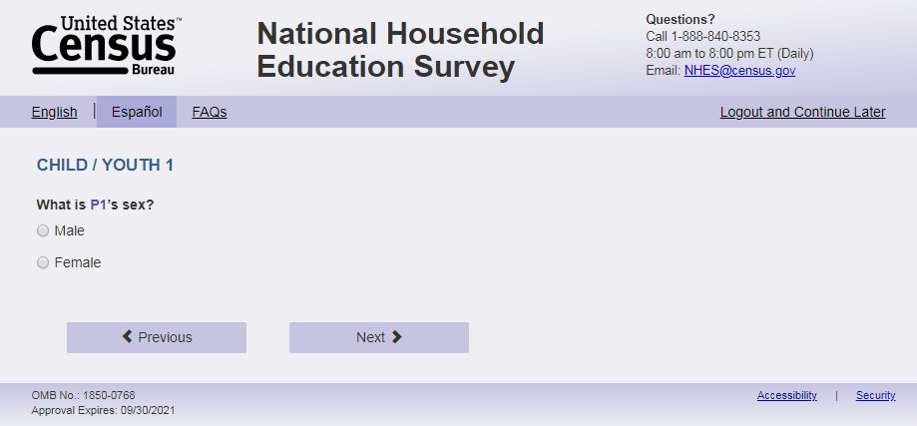
English Text reads:
What is [s1_p1name]’s sex?
Spanish Text reads:
¿De qué sexo es [s1_p1name]?
English Answer:
1 = Male
2 = Female
Spanish Answer:
1 = Masculino
2 =Femenino
S1_p1sex, (1,2), numeric, radio
Skips:
Go to s1_p1enrol.
Logic checks/Programming Specifications:
English:
Use s1_p1name from s1_rosteraname to autofill [s1_p1name] regardless of length and characters used.
Spanish:
Use s1_p1name from s1_rosteraname to autofill [s1_p1name] regardless of length and characters used.

Item: Enrollment Type (s1_p1enrol)

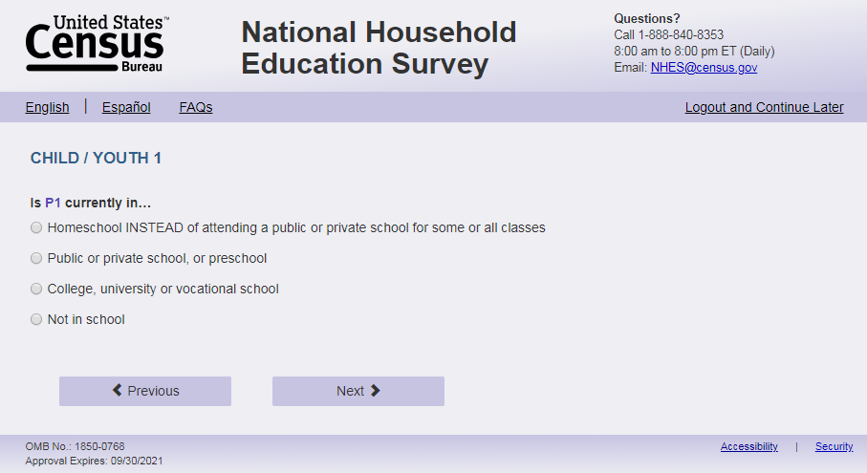
English Text Reads:
Is [s1_p1name] currently in…
Spanish Text reads:
Actualmente, ¿[s1_p1name]…

English Admin/TQA Text Reads:
Is [s1_p1name] currently in…
[Interviewer please read response options.]
Spanish Admin/TQA Text reads:
Actualmente, ¿[s1_p1name]
[Entrevistador por favor lea las opciones de respuesta.]

English Answer:
1 = Homeschool INSTEAD of attending a public or private school for some or all classes
2 = Public or private school, or preschool
3 = College, university or vocational school
4 = Not in school

Spanish Answer:
1= Recibe la enseñanza escolar en el hogar (homeschool) EN VEZ DE asistir a una escuela pública o privada para algunas o todas sus clases?
2= Asiste a una escuela pública o privada, o preescolar?
3= Asiste a un colegio universitario, universidad o escuela vocacional?
4= No está en la escuela?
S1_p1enrol, (1,4), numeric, radio
Skip patterns:
If S1_p1enrol = 3 or 4, and the number of children in the household is greater than 1, that is, s1_childmany>1 or (s1_childmany is blank and names in s1_rosteraname >1), go to s1_p2dobmm. Else if S1_p1enrol = 3 or 4 and the number of children is =1, go to sampling. Else go to s1_p1grade_web.
Logic checks/Programming Specifications:
Logic/range check triggers a warning message, with the following text displayed.
English
Use s1_p1name from s1_rosteraname to autofill [s1_p1name] regardless of length and characters used.
Error message with enrollment not in school (or missing enrollment) and age do not align:
[If s1_p1enrol = 4 or blank and in the CatchAll Spec table “Age/Grade Error Message for Screener” on page 74 (No Markup view) has an “X”] Display “You entered [s1_p1name]'s age as [s1_p1age] and not in school. Please check and make sure your answer is correct before continuing. If you need to correct your answer you can go back to the item.”
Error message with enrollment not in school (or missing enrollment) and date of birth do not align:
[If s1_p1enrol = 4 or blank and CatchAll Spec table “Age/Grade Error Message for Screener” on page 74 (No Markup view) has an “X”] Display “You entered [s1_p1name]'s month and year of birth as [s1_p1dobmm s1_p1dobyy] and not in school. Please check and make sure your answer is correct before continuing. If you need to correct your answer you can go back to the item.”
Spanish
Use s1_p1name from s1_rosteraname to autofill [s1_p1name] regardless of length and characters used.
Error message with enrollment not in school (or missing enrollment) and age do not align:
[If s1_p1enrol = 4 or blank and CatchAll Spec table “Age/Grade Error Message for Screener” on page 74 (No Markup view) has an “X”] Display "Usted ingresó [s1_p1age] como la edad de [s1_p1name]y seleccionó que no va a la escuela. Por favor, compruebe y asegúrese de que su respuesta es correcta antes de continuar. Si necesita corregir su respuesta, puede volver a la pregunta. "
Error message with enrollment not in school (or missing enrollment) and date of birth do not align:
[If s1_p1enrol = 4 or blank and CatchAll Spec table “Age/Grade Error Message for Screener” on page 74 (No Markup view) has an “X”] Display "Usted ingresó [s1_p1dobmm s1_p1dobyy] como el mes y año de naciemiento de [s1_p1name] y seleccionó que va a la la escuela. Por favor, compruebe y asegúrese de que su respuesta es correcta antes de continuar. Si necesita corregir su respuesta, puede volver a la pregunta."

Item: Grade level (s1_p1grade_web)

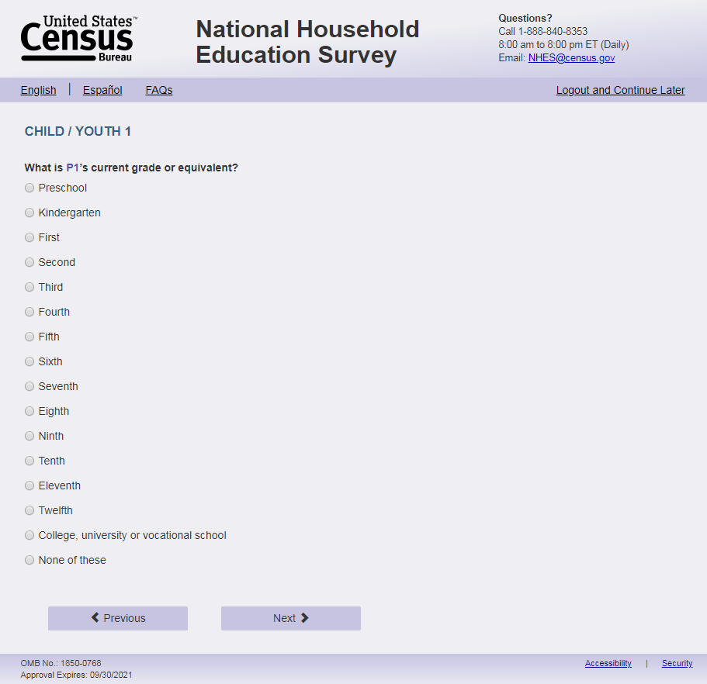
English Text reads:
What is [s1_p1name]’s current grade or grade equivalent?
Spanish Text reads:
Actualmente, ¿en qué grado o equivalencia de grado está [s1_p1name]?

English Answer:
1 = Preschool
2 = Kindergarten
3 = First
4 = Second
5 = Third
6 = Fourth
7 = Fifth
8 = Sixth
9 = Seventh
10 = Eighth
11 = Ninth
12 = Tenth
13 = Eleventh
14 = Twelfth
15 = College, university or vocational school
16 = None of these

Spanish Answer:
1 = Preescolar
2 = Kindergarten
3 = Grado 1
4 = Grado 2
5 = Grado 3
6 = Grado 4
7 = Grado 5
8 = Grado 6
9 = Grado 7
10 = Grado 8
11 = Grado 9
12 = Grado 10
13 = Grado 11
14 = Grado 12
15 = Colegio universitario, universidad o escuela vocacional
16 = Ninguno de estos

S1_p1grade_web, (1,16), numeric, radio

Skip patterns:
if the number of children in the household is greater than 1, that is, s1_childmany>1 or (s1_childmany is blank and names in s1_rosteraname >1) , go to s1_p2dobmm; else if the number of children in the household = 1 ) go to sampling.
Logic checks/Programming Specifications:
Logic/range check triggers a warning message, with the following text displayed.
English
Use s1_p1name from s1_rosteraname to autofill [s1_p1name] regardless of length and characters used.
Error message with grade and age:
[If combination of s1_p1age and s1_p1grade_web in the CatchAll Spec table “Age/Grade Error Message for Screener” on page 74 (No Markup view) has an “X”] Display “You entered [s1_p1name]'s age as [s1_p1age] and grade as [s1_p1grade_web]. Please check and make sure your answer is correct before continuing. If you need to correct your answer you can go back to the item.”
Error message with grade and date of birth:
[If combination of s1_p1dobmm and s1_p1grade_web in the CatchAll Spec table “Age/Grade Error Message for Screener” on page 74 (No Markup view) has an “X”] Display “You entered [s1_p1name]'s month and year of birth as [s1_p1dobmm s1_p1dobyy] and grade as [s1_p1grade_web]. Please check and make sure your answer is correct before continuing. If you need to correct your answer you can go back to the item.
Spanish
Use s1_p1name from s1_rosteraname to autofill [s1_p1name] regardless of length and characters used.
Error message with grade and age:
[If combination of s1_p1age and s1_p1grade_web in the CatchAll Spec table “Age/Grade Error Message for Screener” on page 74 (No Markup view) has an “X”] Display "Usted ingresó la edad de [s1_p1name] como [s1_p1age] y el grado como [s1_p1grade_web]. Por favor, compruebe y asegúrese de que su respuesta es correcta antes de continuar. Si necesita corregir su respuesta, puede volver a la pregunta."
Error message with grade and date of birth:
[If combination of s1_p1dobmm and s1_p1grade_web in the CatchAll Spec table “Age/Grade Error Message for Screener” on page 74 (No Markup view) has an “X”] Display "Usted ingresó [s1_p1dobmm s1_p1dobyy] como el mes y año de nacimiento de [s1_p1name] y el grado como [s1_p1grade_web]. Por favor, compruebe y asegúrese de que su respuesta es correcta antes de continuar. Si necesita corregir su respuesta, puede volver a la pregunta.”

Item: Next child birth month and year (s1_p2dobmm)
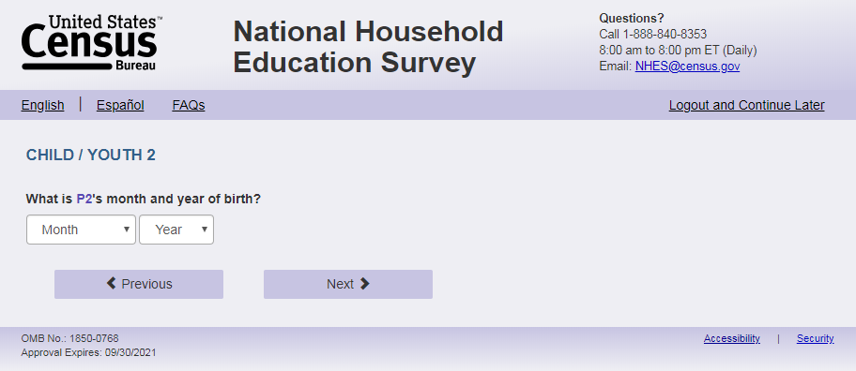
Note: Page names incremented based on person number, e.g. s1_p2age, s1_p3age)
English Text reads:
What is [s1_p2name]'s month and year of birth?
Spanish text reads:
¿En qué mes y año nació [s1_p2name]?
English and Spanish Answer:
S1_p2dobmm, (1,12) numeric, drop-down
S1_p2dobyy, (2002,2023), numeric, drop-down
Skips:
Go to s1_ p2age if s1_p2dobyy is blank; else go to s1_p2sex.
Logic checks/Programming Specifications:
Allow respondents to scroll the options within drop-down
Show s1_p2dobmm and s1_p2dobyy on the same screen. In the drop down, the names of the months will be written out. See table on s1_p1dombb, s1_p1dobyy page.
English:
Display ‘month’ as label above the dropdown box and leave the dropdown box blank.
Display ‘year of birth’ as label above the dropdown box and leave the dropdown box blank.
Use s1_p2name from s1_rosteraname to autofill [s1_p2name] regardless of length and characters used. Spanish:
Display ‘mes’ as label above the dropdown box and leave the dropdown box blank.
Display ‘año de nacimiento’ as label above the dropdown box and leave the dropdown box blank.
Use s1_p2name from s1_rosteraname to autofill [s1_p2name] regardless of length and characters used.

Item: Next child age (s1_p2age)
Note: Page names incremented based on person number, e.g. s1_p2age, s1_p3age)
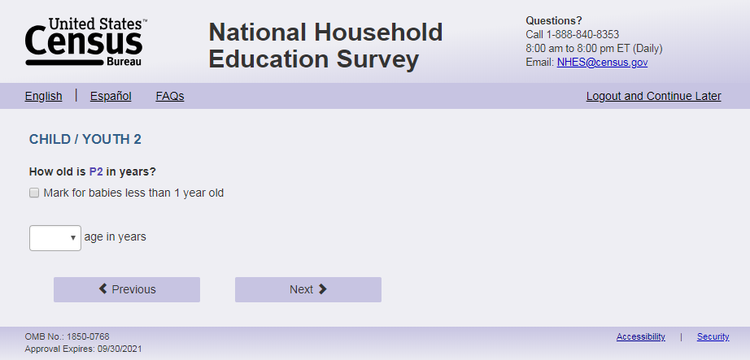
English Text reads:
How old is [s1_p2name] in years?
Spanish text reads:
¿Qué edad, en años, tiene [s1_p2name]?
English and Spanish Answer:
S1_p2baby, (1 = item marked) numeric, checkbox
S1_p2age, (1,20) numeric, text box
Skips:
Go to s1_p2sex.
Logic checks/Programming Specifications:
Logic/range check triggers a warning message, with the following text displayed.
English
[If not within 1-20] Display "You entered the age of this child as older than 20 years old. Please check and make sure your answer is correct before continuing.”
Spanish
[If not within 1-20] Display "Usted ingresó la edad de este niño como mayor de 20 años. Por favor, compruebe y asegúrese de que su respuesta es correcta antes de continuar."
If S1_p2baby is selected, the text box should be deactivated.
English:
Use s1_p2name from s1_rosteraname to autofill [s1_p2name] regardless of length and characters used.
Display ‘Mark for babies less than 1 year old’ to right of checkbox.
Display ‘years old’ to the right of the text box.
Spanish:
Display ‘Marque aquí si es un bebé menor de 1 año’ to the right of checkbox.
Display ‘edad’ to the right of the text box.
Use s1_p2name from s1_rosteraname to autofill [s1_p2name] regardless of length and characters used.

Item: Next child sex (s1_p2sex)
Note: Page names incremented based on person number, e.g. s1_p2sex, s1_p3sex)
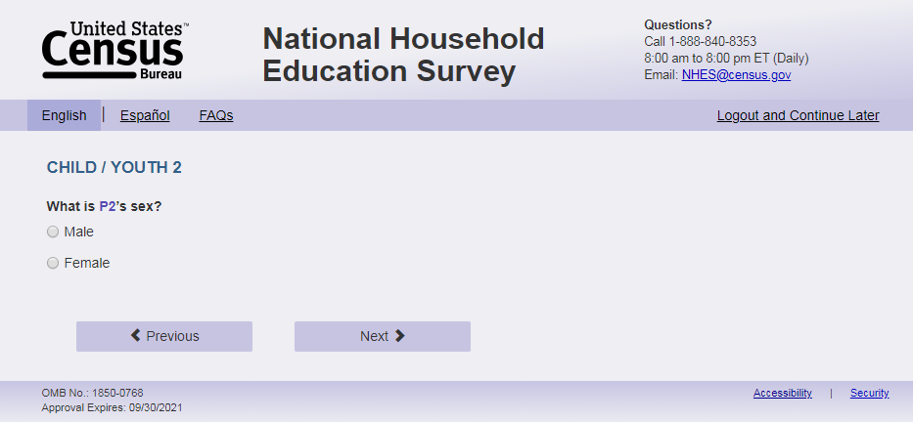
English Text reads:
What is [s1_p2name]’s sex?
Spanish Text reads:
¿De qué sexo es [s1_p2name]?
English Answer:
1 = Male
2 = Female
Spanish Answer:
1 = Masculino
2 =Femenino
S1_p2sex, (1,2), numeric, radio
Skips:
Go to s1_p2enrol.
Logic checks/Programming Specifications:
English:
Use s1_p2name from s1_rosteraname to autofill [s1_p2name] regardless of length and characters used.
Spanish:
Use s1_p2name from s1_rosteraname to autofill [s1_p2name] regardless of length and characters used.

Item: Next child enrollment (s1_p2enrol)
Note: Page names incremented based on person number, e.g. s1_p2enrol, s1_p3enrol)
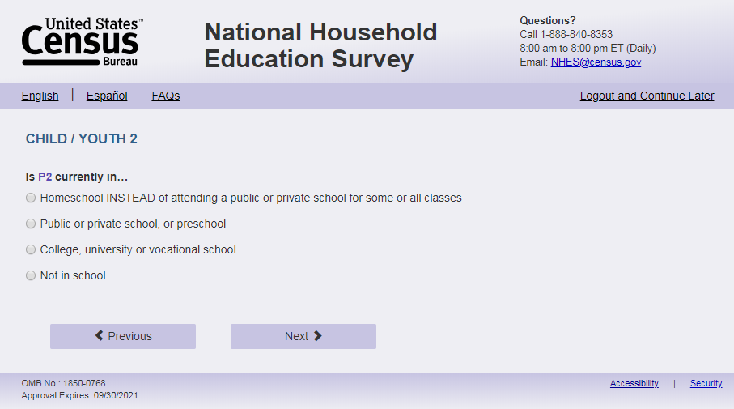
English Text Reads:
Is [s1_p2name] currently in…
Spanish Text reads:
Actualmente, ¿[s1_p2name]…

English Admin/TQA Text Reads:
Is [s1_p2name] currently in…
[Interviewer please read response options.]
Spanish Admin/TQA Text reads:
Actualmente, ¿[s1_p2name]
[Entrevistador por favor lea las opciones de respuesta.]

English Answer:
1 = Homeschool INSTEAD of attending a public or private school for some or all classes
2 = Public or private school, or preschool
3 = College, university or vocational school
4 = Not in school

Spanish Answer:
1= Recibe la enseñanza escolar en el hogar (homeschool) EN VEZ DE asistir a una escuela pública o privada para algunas o todas sus clases?
2= Asiste a una escuela pública o privada, o preescolar?
3= Asiste a un colegio universitario, universidad o escuela vocacional?
4= No está en la escuela?
S1_p2enrol, (1,4), numeric, radio
Skip patterns:
If s1_p2enrol = 3 or 4, and the number of children in the household is gt 2 (s1_childmany>2 or (s1_childmany is blank and names in s1_rostername >2)), go to s1_p3dobmm. Else if s1_p2enrol = 3 or 4 and the number of children in the household =2, go to sampling. Else Go to s1_p2grade_web.
Logic checks/Programming Specifications:
Logic/range check triggers a warning message, with the following text displayed.
English
Use s1_p2name from s1_rosteraname to autofill [s1_p2name] regardless of length and characters used. Error message with enrollment not in school (or missing enrollment) and age do not align:
[If s1_p2enrol = 4 or blank and CatchAll Spec table “Age/Grade Error Message for Screener” on page 74 (No Markup view) has an “X”] Display “You entered [s1_p2name]'s age as [s1_p2age] and not in school. Please check and make sure your answer is correct before continuing. If you need to correct your answer you can go back to the item.”
Error message with enrollment not in school (or missing enrollment) and date of birth do not align:
[If s1_p2enrol = 4 or blank and CatchAll Spec table “Age/Grade Error Message for Screener” on page 74 (No Markup view) has an “X”] Display “You entered [s1_p2name]'s month and year of birth as [s1_p2dobmm s1_p2dobyy] and not in school. Please check and make sure your answer is correct before continuing. If you need to correct your answer you can go back to the item.”
Spanish
Use s1_p2name from s1_rosteraname to autofill [s1_p2name] regardless of length and characters used.
Error message with enrollment not in school (or missing enrollment) and age do not align:
[If s1_p2enrol = 4 or blank and CatchAll Spec table “Age/Grade Error Message for Screener” on page 74 (No Markup view) has an “X”] Display "Usted ingresó [s1_p2age] como la edad de [s1_p2name] y que no va a la escuela. Por favor, compruebe y asegúrese de que su respuesta es correcta antes de continuar. Si necesita corregir su respuesta, puede volver a la opción. "
Error message with enrollment not in school (or missing enrollment) and date of birth do not align:
[If s1_p2enrol = 4 or blank and CatchAll Spec table “Age/Grade Error Message for Screener” on page 74 (No Markup view) has an “X”] Display "Usted ingresó [s1_p2dobmm s1_p2dobyy] como el mes y año de nacimiento commode [s1_p2name] y que no va a la escuela. Por favor, compruebe y asegúrese de que su respuesta es correcta antes de continuar. Si necesita corregir su respuesta, puede volver a la pregunta."

Item: Next child grade (s1_p2grade_web)
Note: Page names incremented based on person number, e.g. s1_p2grade_web, s1_p3grade_web)
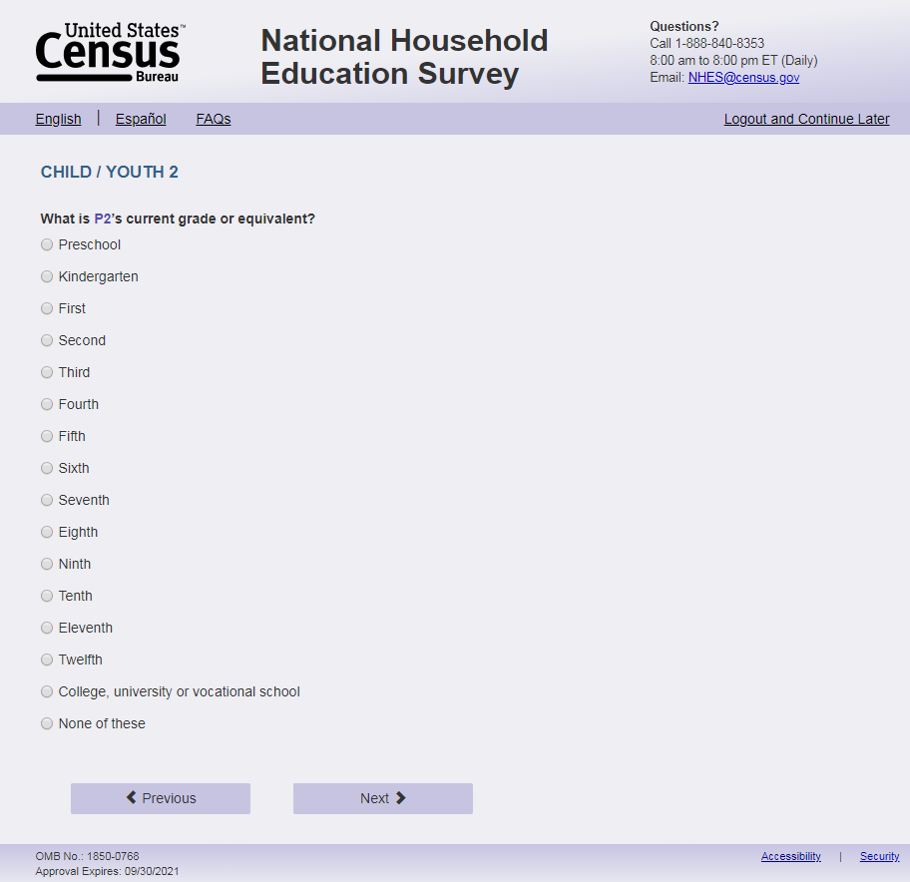
English Text reads:
What is [s1_p2name]’s current grade or grade equivalent?
Spanish Text reads:
Actualmente, ¿en qué grado o equivalencia de grado está [s1_p2name]?

English Answer:
1 = Preschool
2 = Kindergarten
3 = First
4 = Second
5 = Third
6 = Fourth
7 = Fifth
8 = Sixth
9 = Seventh
10 = Eighth
11 = Ninth
12 = Tenth
13 = Eleventh
14 = Twelfth
15 = College, university or vocational school
16 = None of these

Spanish Answer:
1 = Preescolar
2 = Kindergarten
3 = Grado 1
4 = Grado 2
5 = Grado 3
6 = Grado 4
7 = Grado 5
8 = Grado 6
9 = Grado 7
10 = Grado 8
11 = Grado 9
12 = Grado 10
13 = Grado 11
14 = Grado 12
15 = Colegio universitario, universidad o escuela vocacional
16 = Ninguno de estos

S1_p2grade_web, (1,16), numeric, radio
Skip patterns:
if the number of children in the household is greater than 2 (s1_childmany>2 or (s1_childmany is blank and names in s1_rostername >2)), go to s1_p3dobmm; else if the number of children in the household = 2 go to sampling.Logic checks/Programming Specifications:
Logic/range check triggers a warning message, with the following text displayed.
English
Use s1_p2name from s1_rosteraname to autofill [s1_p2name] regardless of length and characters used.
Error message with grade and age:
[If combination of s1_p2age and s1_p2grade_web in the CatchAll Spec table “Age/Grade Error Message for Screener” on page 74 (No Markup view) has an “X”] Display “You entered [s1_p2name]'s age as [s1_p2age] and grade as [s1_p2grade_web]. Please check and make sure your answer is correct before continuing. If you need to correct your answer you can go back to the item.”
Error message with grade and date of birth:
[If combination of s1_p2dobmm and s1_p2grade_web in the CatchAll Spec table “Age/Grade Error Message for Screener” on page 74 (No Markup view) has an “X”] Display “You entered [s1_p2name]'s month and year of birth as [s1_p2dobmm s1_p2dobyy] and grade as [s1_p2grade_web]. Please check and make sure your answer is correct before continuing. If you need to correct your answer you can go back to the item.
Spanish
Use s1_p2name from s1_rosteraname to autofill [s1_p2name] regardless of length and characters used. Error message with grade and age:
[If combination of s1_p2age and s1_p2grade_web in the CatchAll Spec table “Age Grade Error” has an “X”] Display "Usted ingresó la edad de [s1_p2name] como [s1_p2age] y y el grado como [s1_p2grade_web]. Por favor, compruebe y asegúrese de que su respuesta es correcta antes de continuar. Si necesita corregir su respuesta, puede volver a la pregunta."
Error message with grade and date of birth:
[If combination of s1_p2dobmm and s1_p2grade_web in the CatchAll Spec table “Age Grade Error” has an “X”] Display "Usted ingresó [s1_p2dobmm s1_p2dobyy] como el mes y año de nacimiento de [s1_p2name] y el grado como [s1_p2grade_web]. Por favor, compruebe y asegúrese de que su respuesta es correcta antes de continuar. Si necesita corregir su respuesta, puede volver a la pregunta.”

Item: Next child birth month and year (s1_p3dobmm)
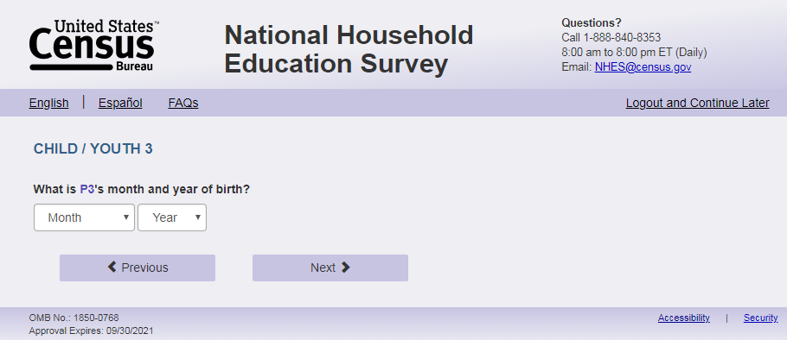
Note: Page names incremented based on person number, e.g. s1_p2age, s1_p3age)
English Text reads:
What is [s1_p3name]'s month and year of birth?
Spanish text reads:
¿En qué mes y año nació [s1_p3name]?
English and Spanish Answer:
S1_p3dobmm, (1,12) numeric, drop-down
S1_p3dobyy, (2002, 2023), numeric, drop-down
Skips:
Go to s1_ p3age if s1_p3dobyy is blank; else go to s1_p3sex.
Logic checks/Programming Specifications:
Allow respondents to scroll the options within drop-down
Show s1_p3dobmm and s1_p3dobyy on the same screen. In the drop down, the names of the months will be written out. See table on s1_p1dombb, s1_p1dobyy page.
English:
Display ‘month’ as label above the dropdown box and leave the dropdown box blank.
Display ‘year of birth’ as label above the dropdown box and leave the dropdown box blank.
Use s1_p3name from s1_rosteraname to autofill [s1_p3name] regardless of length and characters used.
Spanish:
Display ‘mes’ as label above the dropdown box and leave the dropdown box blank.
Display ‘año de nacimiento’ as label above the dropdown box and leave the dropdown box blank.
Use s1_p3name from s1_rosteraname to autofill [s1_p3name] regardless of length and characters used.

Item: Next child age (s1_p3age)
Note: Page names incremented based on person number, e.g. s1_p2age, s1_p3age)
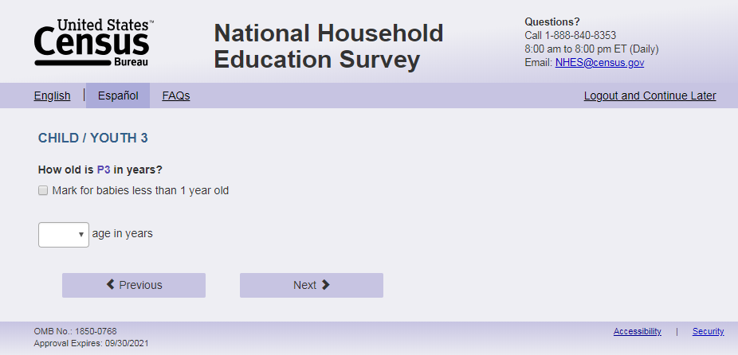
English Text reads:
How old is [s1_p3name] in years?
Spanish text reads:
¿Qué edad, en años, tiene [s1_p3name]?
English and Spanish Answer:
S1_p3baby, (1 = item marked) numeric, checkbox
S1_p3age, (1,20) numeric, text box
Skips:
Go to s1_p3sex.
Logic checks/Programming Specifications:
Logic/range check triggers a warning message, with the following text displayed.
English
[If not within 1-20] Display "You entered the age of this child as older than 20 years old. Please check and make sure your answer is correct before continuing.”
Spanish
[If not within 1-20] Display "Usted ingresó la edad de este niño como mayor de 20 años. Por favor, compruebe y asegúrese de que su respuesta es correcta antes de continuar."
If S1_p3baby is selected, the text box should be deactivated.
English:
Use s1_p3name from s1_rosteraname to autofill [s1_p3name] regardless of length and characters used.

Display ‘Mark for babies less than 1 year old’ to right of checkbox.
Display ‘years old’ to the right of the text box.
Spanish:
Use s1_p3name from s1_rosteraname to autofill [s1_p3name] regardless of length and characters used.
Display ‘Marque aquí si es un bebé menor de 1 año’ to the right of checkbox.
Display ‘edad’ to the right of the text box.

Item: Next child sex (s1_p3sex)
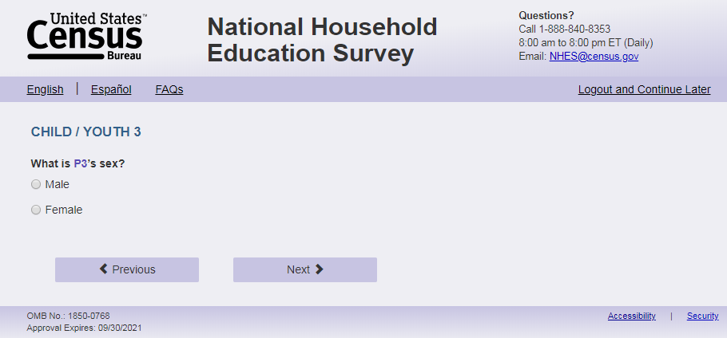
Note: Page names incremented based on person number, e.g. s1_p2sex, s1_p3sex)

English Text reads:
What is [s1_p3name]’s sex?
Spanish Text reads:
¿De qué sexo es [s1_p3name]?
English Answer:
1 = Male
2 = Female
Spanish Answer:
1 = Masculino
2 =Femenino
S1_p3sex, (1,2), numeric, radio
Skips:
Go to s1_p3enrol.
Logic checks/Programming Specifications:
English:
Use s1_p3name from s1_rosteraname to autofill [s1_p3name] regardless of length and characters used
Spanish:
Use s1_p3name from s1_rosteraname to autofill [s1_p3name] regardless of length and characters used.

Item: Next child enrollment (s1_p3enrol)
Note: Page names incremented based on person number, e.g. s1_p2enrol, s1_p3enrol)
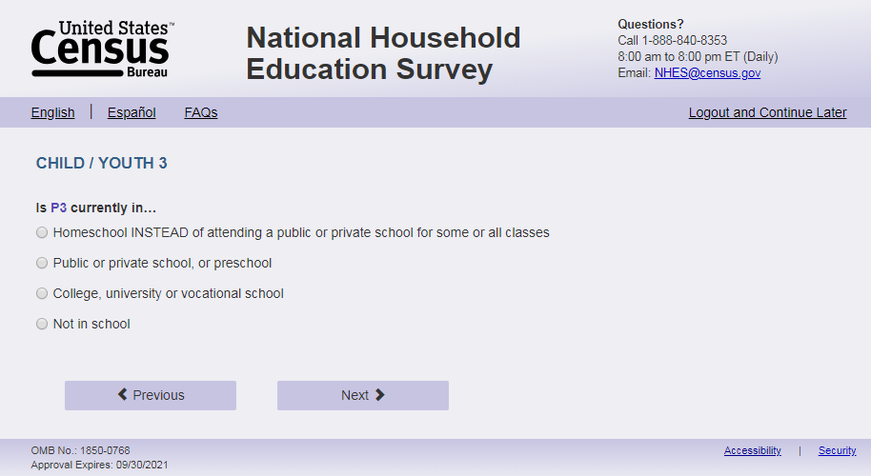
English Text Reads:
Is [s1_p3name] currently in…
Spanish Text reads:
Actualmente, ¿[s1_p3name]…

English Admin/TQA Text Reads:
Is [s1_p3name] currently in…
[Interviewer please read response options.]
Spanish Admin/TQA Text reads:
Actualmente, ¿[s1_p3name]
[Entrevistador por favor lea las opciones de respuesta.]

English Answer:
1 = Homeschool INSTEAD of attending a public or private school for some or all classes
2= Public or private school, or preschool
3 = College, university or vocational school
4=Not in school

Spanish Answer:
1= Recibe la enseñanza escolar en el hogar (homeschool) EN VEZ DE asistir a una escuela pública o privada para algunas o todas sus clases?
2= Asiste a una escuela pública o privada, o preescolar?
3= Asiste a un colegio universitario, universidad o escuela vocacional?
4= No está en la escuela?
S1_p3enrol, (1,4), numeric, radio
Skip patterns:
If Ss1_p3enrol = 3 or 4, and the number of children in the household is greater than 3 (s1_childmany>3 or (s1_childmany is blank and names in s1_rostername >3)), go to S1_p4dobmm. Else if S1_p3enrol = 3 or 4 and the number of children in the household = 3, go to sampling. Else Go to S1_p3grade_web

Logic checks/Programming Specifications:
Logic/range check triggers a warning message, with the following text displayed.
English
Use s1_p3name from s1_rosteraname to autofill [s1_p3name] regardless of length and characters used.
Error message with enrollment not in school (or missing enrollment) and age do not align:
[If s1_p3enrol = 4 or blank and CatchAll Spec table “Age/Grade Error Message for Screener” on page 74 (No Markup view) has an “X”] Display “You entered [s1_p3name]'s age as [s1_p3age] and not in school. Please check and make sure your answer is correct before continuing. If you need to correct your answer you can go back to the item.”
Error message with enrollment not in school (or missing enrollment) and date of birth do not align:
[If s1_p3enrol = 4 or blank and CatchAll Spec table “Age/Grade Error Message for Screener” on page 74 (No Markup view) has an “X”] Display “You entered [s1_p3name]'s month and year of birth as [s1_p3dobmm s1_p3dobyy] and not in school. Please check and make sure your answer is correct before continuing. If you need to correct your answer you can go back to the item.”
Spanish
Use s1_p3name from s1_rosteraname to autofill [s1_p3name] regardless of length and characters used.
Error message with enrollment not in school (or missing enrollment) and age do not align:
[If s1_p3enrol = 4 or blank and CatchAll Spec table “Age/Grade Error Message for Screener” on page 74 (No Markup view) has an “X”] Display "Usted ingresó [s1_p3age] como la edad de [s1_p3name] y que no va a la escuela. Por favor, compruebe y asegúrese de que su respuesta es correcta antes de continuar. Si necesita corregir su respuesta, puede volver a la opción. "
Error message with enrollment not in school (or missing enrollment) and date of birth do not align:
[If s1_p3enrol = 4 or blank and CatchAll Spec table “Age/Grade Error Message for Screener” on page 74 (No Markup view) has an “X”] Display "Usted ingresó [s1_p3dobmm s1_p3dobyy] como el mes y año de nacimiento commode [s1_p3name] y que no va a la escuela. Por favor, compruebe y asegúrese de que su respuesta es correcta antes de continuar. Si necesita corregir su respuesta, puede volver a la pregunta."

Item: Next child grade (s1_p3grade_web)
Note: Page names incremented based on person number, e.g. s1_p2grade_web, s1_p3grade_web)
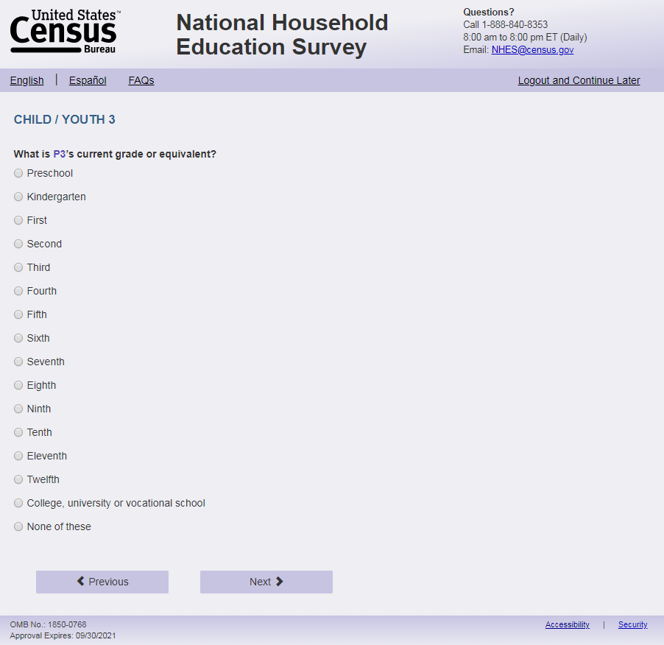
English Text reads:
What is [s1_p3name]’s current grade or grade equivalent?
Spanish Text reads:
Actualmente, ¿en qué grado o equivalencia de grado está [s1_p3name]?

English Answer:
1 = Preschool
2 = Kindergarten
3 = First
4 = Second
5 = Third
6 = Fourth
7 = Fifth
8 = Sixth
9 = Seventh
10 = Eighth
11 = Ninth
12 = Tenth
13 = Eleventh
14 = Twelfth
15 = College, university or vocational school
16 = None of these

Spanish Answer:
1 = Preescolar
2 = Kindergarten
3 = Grado 1
4 = Grado 2
5 = Grado 3
6 = Grado 4
7 = Grado 5
8 = Grado 6
9 = Grado 7
10 = Grado 8
11 = Grado 9
12 = Grado 10
13 = Grado 11
14 = Grado 12
15 = Colegio universitario, universidad o escuela vocacional
16 = Ninguno de estos

S1_p3grade_web, (1,16), numeric, radio
Skip patterns:
if the number of children in the household is greater than 3 (s1_childmany>3 or (s1_childmany is blank and names in s1_rostername >3)), go to s1_p4dobmm; else if the number of children in the household = 3 go to sampling.
Logic checks/Programming Specifications:
Logic/range check triggers a warning message, with the following text displayed.
English
Use s1_p3name from s1_rosteraname to autofill [s1_p3name] regardless of length and characters used.
Error message with grade and age:
[If combination of s1_p3age and s1_p3grade_web in the CatchAll Spec table “Age Grade Error” has an “X”] Display “You entered [s1_p3name]'s age as [s1_p3age] and grade as [s1_p3grade_web]. Please check and make sure your answer is correct before continuing. If you need to correct your answer you can go back to the item.”
Error message with grade and date of birth:
[If combination of s1_p3dobmm and s1_p3grade_web in the CatchAll Spec table “Age Grade Error” has an “X”] Display “You entered [s1_p3name]'s month and year of birth as [s1_p3dobmm s1_p3dobyy] and grade as [s1_p3grade_web]. Please check and make sure your answer is correct before continuing. If you need to correct your answer you can go back to the item.
Spanish
Use s1_p3name from s1_rosteraname to autofill [s1_p3name] regardless of length and characters used.
Error message with grade and age:
[If combination of s1_p3age and s1_p3grade_web in the CatchAll Spec table “Age Grade Error” has an “X”] Display "Usted ingresó la edad de [s1_p3name] como [s1_p3age] y y el grado como [s1_p3grade_web]. Por favor, compruebe y asegúrese de que su respuesta es correcta antes de continuar. Si necesita corregir su respuesta, puede volver a la pregunta."
Error message with grade and date of birth:
[If combination of s1_p3dobmm and s1_p3grade_web in the CatchAll Spec table “Age Grade Error” has an “X”] Display "Usted ingresó [s1_p3dobmm s1_p3dobyy] como el mes y año de nacimiento de [s1_p3name] y el grado como [s1_p3grade_web]. Por favor, compruebe y asegúrese de que su respuesta es correcta antes de continuar. Si necesita corregir su respuesta, puede volver a la pregunta.”

Item: Next child birth month and year (s1_p4dobmm)
Note: Page names incremented based on person number, e.g. s1_p2age, s1_p3age)
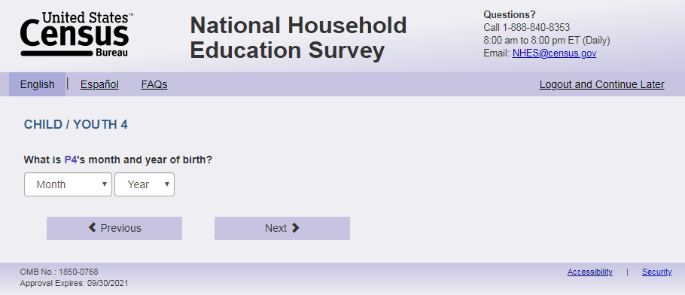
English Text reads:
What is [s1_p4name]'s month and year of birth?
Spanish text reads:
¿En qué mes y año nació [s1_p4name]?
English and Spanish Answer:
S1_p4dobmm, (1,12) numeric, drop-down
S1_p4dobyy, (2002,2023), numeric, drop-down
Skips:
Go to s1_p4age if s1_p4dobyy is blank; else go to s1_p4sex.
Logic checks/Programming Specifications:
Allow respondents to scroll the options within drop-down
Show s1_p4dobmm and s1_p4dobyy on the same screen. In the drop down, the names of the months will be written out. See table on s1_p1dombb, s1_p1dobyy page.
English:
Display ‘month’ as label above the dropdown box and leave the dropdown box blank.
Display ‘year of birth’ as label above the dropdown box and leave the dropdown box blank.
Use s1_p4name from s1_rosteraname to autofill [s1_p4name] regardless of length and characters used.
Spanish:
Display ‘mes’ as label above the dropdown box and leave the dropdown box blank.
Display ‘año de nacimiento’ as label above the dropdown box and leave the dropdown box blank.
Use s1_p4name from s1_rosteraname to autofill [s1_p4name] regardless of length and characters used.

Item: Next child age (s1_p4age)
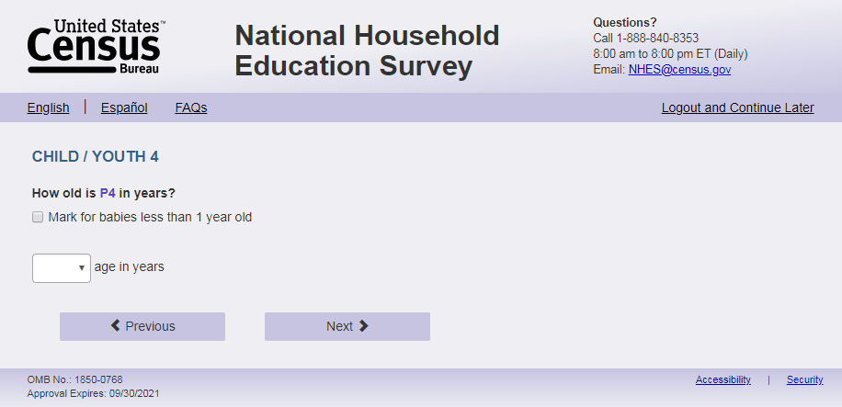
Note: Page names incremented based on person number, e.g. s1_p2age, s1_p3age)

English Text reads:
How old is [s1_p4name] in years?
Spanish text reads:
¿Qué edad, en años, tiene [s1_p4name]?
English and Spanish Answer:
S1_p4baby, (1 = item marked) numeric, checkbox
S1_p4age, (1,20) numeric, text box
Skips:
Go to s1_p4sex.
Logic checks/Programming Specifications:
Logic/range check triggers a warning message, with the following text displayed.
English
[If not within 1-20] Display "You entered the age of this child as older than 20 years old. Please check and make sure your answer is correct before continuing.”
Spanish
[If not within 1-20] Display "Usted ingresó la edad de este niño como mayor de 20 años. Por favor, compruebe y asegúrese de que su respuesta es correcta antes de continuar."
If S1_p4baby is selected, the text box should be deactivated.
English:
Use s1_p4name from s1_rosteraname to autofill [s1_p4name] regardless of length and characters used.
Display ‘Mark for babies less than 1 year old’ to right of checkbox.
Display ‘years old’ to the right of the text box.
Spanish:
Display ‘Marque aquí si es un bebé menor de 1 año’ to the right of checkbox.
Display ‘edad’ to the right of the text box.
Use s1_p4name from s1_rosteraname to autofill [s1_p4name] regardless of length and characters used.

Item: Next child sex (s1_p4sex)
Note: Page names incremented based on person number, e.g. s1_p2sex, s1_p3sex)
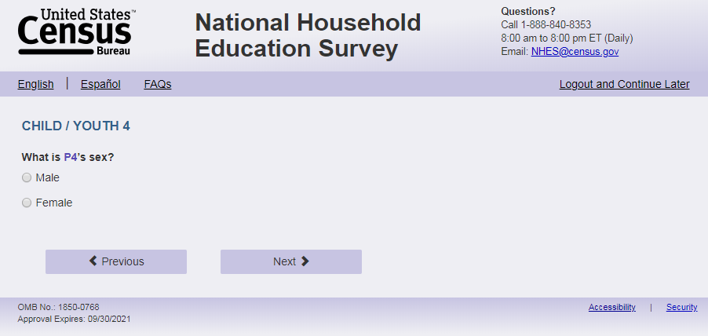
English Text reads:
What is [s1_p4name]’s sex?
Spanish Text reads:
¿De qué sexo es [s1_p4name]?
English Answer:
1 = Male
2 = Female
Spanish Answer:
1 = Masculino
2 =Femenino
S1_p4sex, (1,2), numeric, radio
Skips:
Go to s1_p4enrol.
Logic checks/Programming Specifications:
English:
Use s1_p4name from s1_rosteraname to autofill [s1_p4name] regardless of length and characters used.
Spanish:
Use s1_p4name from s1_rosteraname to autofill [s1_p4name] regardless of length and characters used.

Item: Next child enrollment (s1_p4enrol)
Note: Page names incremented based on person number, e.g. s1_p2enrol, s1_p3enrol)
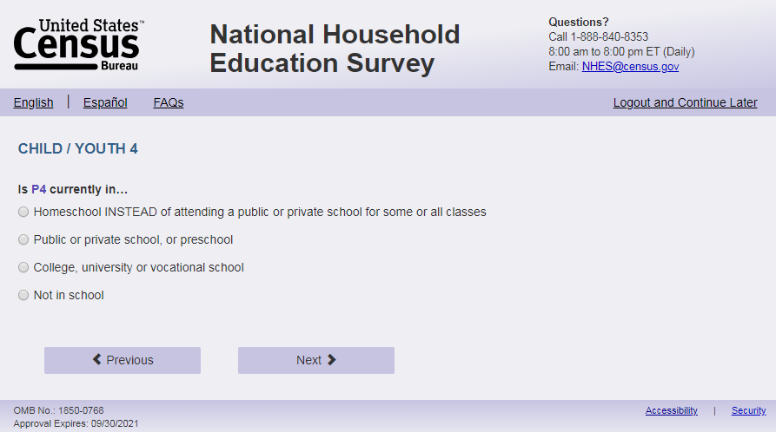
English Text Reads:
Is [s1_p4name] currently in…
Spanish Text reads:
Actualmente, ¿[s1_p4name]…

English Admin/TQA Text Reads:
Is [s1_p4name] currently in…
[Interviewer please read response options.]
Spanish Admin/TQA Text reads:
Actualmente, ¿[s1_p4name]
[Entrevistador por favor lea las opciones de respuesta.]

English Answer:
1 = Homeschool INSTEAD of attending a public or private school for some or all classes
2=Public or private school, or preschool
3 = College, university or vocational school
4=Not in school

Spanish Answer:
1= Recibe la enseñanza escolar en el hogar (homeschool) EN VEZ DE asistir a una escuela pública o privada para algunas o todas sus clases?
2= Asiste a una escuela pública o privada, o preescolar?
3= Asiste a un colegio universitario, universidad o escuela vocacional?
4= No está en la escuela?
S1_p4enrol, (1,4), numeric, radio
Skip patterns:
If S1_p4enrol = 3 or 4, and the number of children in the household is greater than 4 (s1_childmany>4 or (s1_childmany is blank and names in s1_rostername >4)), go to S1_p5dobmm. Else if S1_p4enrol = 3 or 4 and the number of children in the household is = 4, go to sampling. Else Go to S1_p4grade_web
Logic checks/Programming Specifications:
Logic/range check triggers a warning message, with the following text displayed.
English
Use s1_p4name from s1_rosteraname to autofill [s1_p4name] regardless of length and characters used. Error message with enrollment not in school (or missing enrollment) and age do not align:
[If s1_p4enrol = 4 or blank and CatchAll Spec table “Age/Grade Error Message for Screener” on page 74 (No Markup view) has an “X”] Display “You entered [s1_p4name]'s age as [s1_p4age] and not in school. Please check and make sure your answer is correct before continuing. If you need to correct your answer you can go back to the item.”
Error message with enrollment not in school (or missing enrollment) and date of birth do not align:
[If s1_p4enrol = 4 or blank and CatchAll Spec table “Age/Grade Error Message for Screener” on page 74 (No Markup view) has an “X”] Display “You entered [s1_p4name]'s month and year of birth as [s1_p4dobmm s1_p4dobyy] and not in school. Please check and make sure your answer is correct before continuing. If you need to correct your answer you can go back to the item.”
Spanish
Use s1_p4name from s1_rosteraname to autofill [s1_p4name] regardless of length and characters used.
Error message with enrollment not in school (or missing enrollment) and age do not align:
[If s1_p4enrol = 4 or blank and CatchAll Spec table “Age/Grade Error Message for Screener” on page 74 (No Markup view) has an “X”] Display "Usted ingresó [s1_p4age] como la edad de [s1_p4name] y que no va a la escuela. Por favor, compruebe y asegúrese de que su respuesta es correcta antes de continuar. Si necesita corregir su respuesta, puede volver a la opción. "
Error message with enrollment not in school (or missing enrollment) and date of birth do not align:
[If s1_p4enrol = 4 or blank and CatchAll Spec table “Age/Grade Error Message for Screener” on page 74 (No Markup view) has an “X”] Display "Usted ingresó [s1_p4dobmm s1_p4dobyy] como el mes y año de nacimiento commode [s1_p4name] y que no va a la escuela. Por favor, compruebe y asegúrese de que su respuesta es correcta antes de continuar. Si necesita corregir su respuesta, puede volver a la pregunta."

Item: Next child grade (s1_p4grade_web)
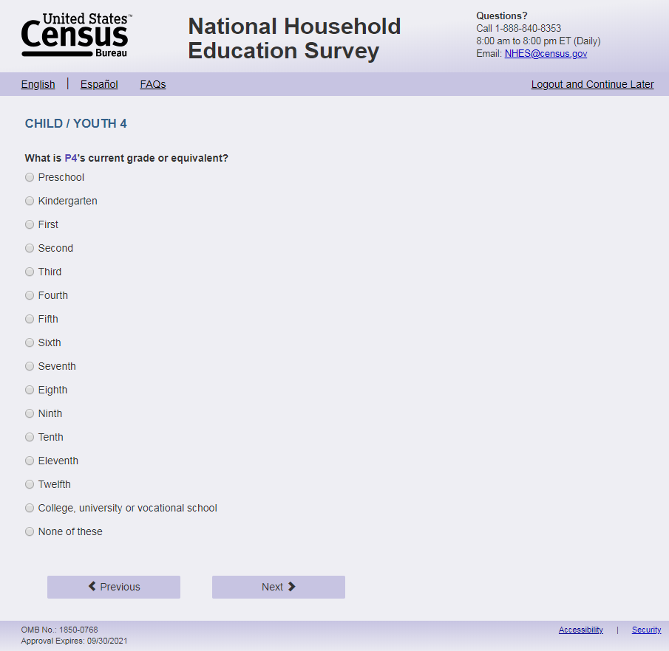
Note: Page names incremented based on person number, e.g. s1_p2grade_web, s1_p3grade_web)

English Text reads:
What is [s1_p4name]’s current grade or grade equivalent?
Spanish Text reads:
Actualmente, ¿en qué grado o equivalencia de grado está [s1_p4name]?

English Answer:
1 = Preschool
2 = Kindergarten
3 = First
4 = Second
5 = Third
6 = Fourth
7 = Fifth
8 = Sixth
9 = Seventh
10 = Eighth
11 = Ninth
12 = Tenth
13 = Eleventh
14 = Twelfth
15 = College, university or vocational school
16 = None of these

Spanish Answer:
1 = Preescolar
2 = Kindergarten
3 = Grado 1
4 = Grado 2
5 = Grado 3
6 = Grado 4
7 = Grado 5
8 = Grado 6
9 = Grado 7
10 = Grado 8
11 = Grado 9
12 = Grado 10
13 = Grado 11
14 = Grado 12
15 = Colegio universitario, universidad o escuela vocacional
16 = Ninguno de estos

S1_p4grade_web, (1,16), numeric, radio
Skip patterns:
if the number of children in the household is greater than 4 (s1_childmany>4 or (s1_childmany is blank and names in s1_rostername >4)), go to S1_p5dobmm; else if the number of children in the household = 4 go to sampling.
Logic checks/Programming Specifications:
Logic/range check triggers a warning message, with the following text displayed.
English
Use s1_p4name from s1_rosteraname to autofill [s1_p4name] regardless of length and characters used.
Error message with grade and age:
[If combination of s1_p4age and s1_p4grade_web in the CatchAll Spec table “Age Grade Error” has an “X”] Display “You entered [s1_p4name]'s age as [s1_p4age] and grade as [s1_p4grade_web]. Please check and make sure your answer is correct before continuing. If you need to correct your answer you can go back to the item.”
Error message with grade and date of birth:
[If combination of s1_p4dobmm and s1_p4grade_web in the CatchAll Spec table “Age Grade Error” has an “X”] Display “You entered [s1_p4name]'s month and year of birth as [s1_p4dobmm s1_p4dobyy] and grade as [s1_p4grade_web]. Please check and make sure your answer is correct before continuing. If you need to correct your answer you can go back to the item.
Spanish
Use s1_p4name from s1_rosteraname to autofill [s1_p4name] regardless of length and characters used.
Error message with grade and age:
[If combination of s1_p4age and s1_p4grade_web in the CatchAll Spec table “Age Grade Error” has an “X”] Display "Usted ingresó la edad de [s1_p4name] como [s1_p4age] y y el grado como [s1_p4grade_web]. Por favor, compruebe y asegúrese de que su respuesta es correcta antes de continuar. Si necesita corregir su respuesta, puede volver a la pregunta."
Error message with grade and date of birth:
[If combination of s1_p4dobmm and s1_p4grade_web in the CatchAll Spec table “Age Grade Error” has an “X”] Display "Usted ingresó [s1_p4dobmm s1_p4dobyy] como el mes y año de nacimiento de [s1_p4name] y el grado como [s1_p4grade_web]. Por favor, compruebe y asegúrese de que su respuesta es correcta antes de continuar. Si necesita corregir su respuesta, puede volver a la pregunta.”

Item: Next child birth month and year (s1_p5dobmm)
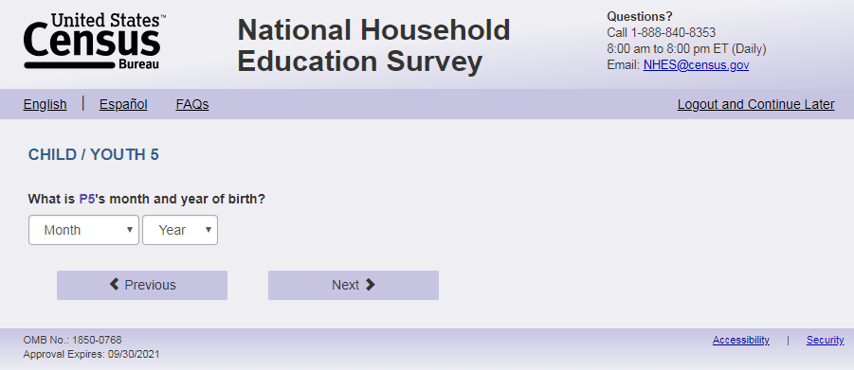
Note: Page names incremented based on person number, e.g. s1_p2age, s1_p3age)
English Text reads:
What is [s1_p5name]'s month and year of birth?
Spanish text reads:
¿En qué mes y año nació [s1_p5name]?
English and Spanish Answer:
S1_p5dobmm, (1,12) numeric, drop-down
S1_p5dobyy, (2002,2023), numeric, drop-down
Skips:
Go to s1_ p5age if s1_p5dobyy is blank; else go to s1_p5sex.
Logic checks/Programming Specifications:
Allow respondents to scroll the options within drop-down
Show s1_p5dobmm and s1_p5dobyy on the same screen. In the drop down, the names of the months will be written out. See table on s1_p1dombb, s1_p1dobyy page.
English:
Display ‘month’ as label above the dropdown box and leave the dropdown box blank.
Display ‘year of birth’ as label above the dropdown box and leave the dropdown box blank.
Use s1_p5name from s1_rosteraname to autofill [s1_p5name] regardless of length and characters used.
Spanish:
Display ‘mes’ as label above the dropdown box and leave the dropdown box blank..
Display ‘año de nacimiento’ as label above the dropdown box and leave the dropdown box blank..
Use s1_p5name from s1_rosteraname to autofill [s1_p5name] regardless of length and characters used.

Item: Next child age (s1_p5age)
Note: Page names incremented based on person number, e.g. s1_p2age, s1_p3age)
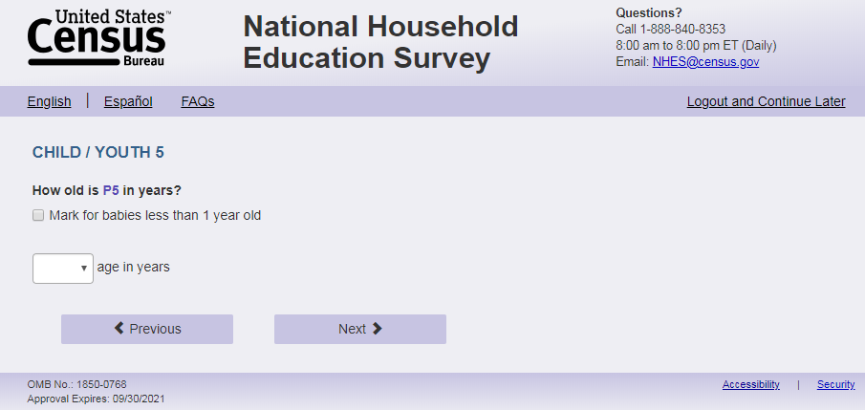
English Text reads:
How old is [s1_p5name] in years?
Spanish text reads:
¿Qué edad, en años, tiene [s1_p5name]?
English and Spanish Answer:
S1_p5baby, (1 = item marked) numeric, checkbox
S1_p5age, (1,20) numeric, text box
Skips:
Go to s1_p5sex.
Logic checks/Programming Specifications:
Logic/range check triggers a warning message, with the following text displayed.
English
[If not within 1-20] Display "You entered the age of this child as older than 20 years old. Please check and make sure your answer is correct before continuing.”
Spanish
[If not within 1-20] Display "Usted ingresó la edad de este niño como mayor de 20 años. Por favor, compruebe y asegúrese de que su respuesta es correcta antes de continuar."
If S1_p5baby is selected, the text box should be deactivated.
English:
Display ‘Mark for babies less than 1 year old’ to right of checkbox.
Display ‘years old’ to the right of the text box.
Use s1_p5name from s1_rosteraname to autofill [s1_p5name] regardless of length and characters used.
Spanish:
Display ‘Marque aquí si es un bebé menor de 1 año’ to the right of checkbox.
Display ‘edad’ to the right of the text box.
Use s1_p5name from s1_rosteraname to autofill [s1_p5name] regardless of length and characters used.

Item: Next child sex (s1_p5sex)
Note: Page names incremented based on person number, e.g. s1_p2sex, s1_p3sex)
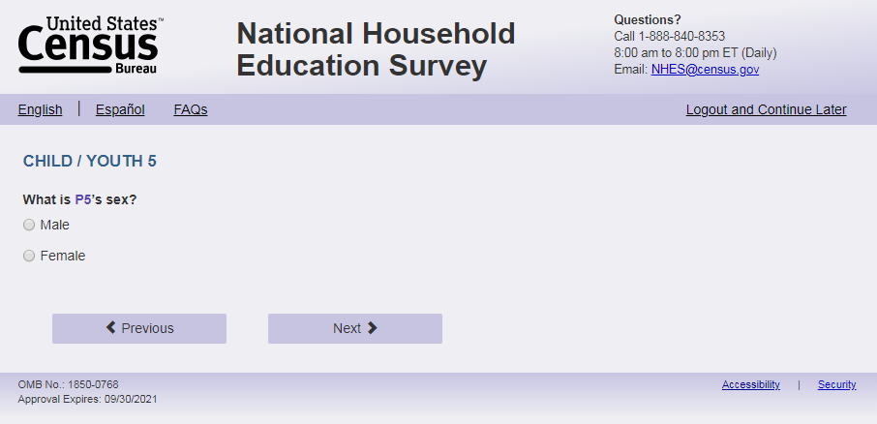
English Text reads:
What is [s1_p5name]’s sex?
Spanish Text reads:
¿De qué sexo es [s1_p5name]?
English Answer:
1 = Male
2 = Female
Spanish Answer:
1 = Masculino
2 =Femenino
S1_p5sex, (1,2), numeric, radio
Skips:
Go to s1_p5enrol.
Logic checks/Programming Specifications:
English:
Use s1_p5name from s1_rosteraname to autofill [s1_p5name] regardless of length and characters used.
Spanish:
Use s1_p5name from s1_rosteraname to autofill [s1_p5name] regardless of length and characters used.

Item: Next person enrollment (s1_p5enrol)
Note: Page names incremented based on person number, e.g. s1_p2enrol, s1_p3enrol)
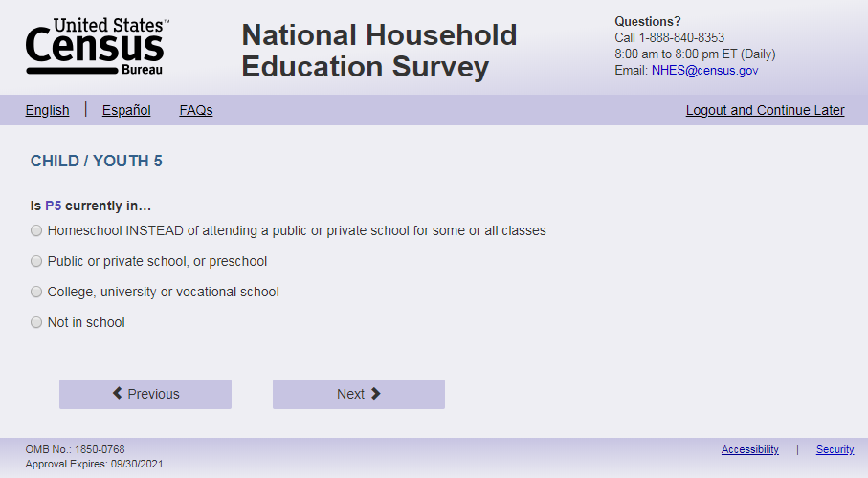
English Text Reads:
Is [s1_p5name] currently in…
Spanish Text reads:
Actualmente, ¿[s1_p5name]…

English Admin/TQA Text Reads:
Is [s1_p5name] currently in…
[Interviewer please read response options.]
Spanish Admin/TQA Text reads:
Actualmente, ¿[s1_p5name]
[Entrevistador por favor lea las opciones de respuesta.]

English Answer:
1 = Homeschool INSTEAD of attending a public or private school for some or all classes
2=Public or private school, or preschool
3 = College, university or vocational school
4=Not in school

Spanish Answer:
1= Recibe la enseñanza escolar en el hogar (homeschool) EN VEZ DE asistir a una escuela pública o privada para algunas o todas sus clases?
2= Asiste a una escuela pública o privada, o preescolar?
3= Asiste a un colegio universitario, universidad o escuela vocacional?
4= No está en la escuela?
S1_p5enrol, (1,4), numeric, radio
Skip patterns:
If S1_p5enrol = 3 or 4 go to sampling. Else Go to S1_p5grade_web.
Logic checks/Programming Specifications:
Logic/range check triggers a warning message, with the following text displayed.
English
Use s1_p5name from s1_rosteraname to autofill [s1_p5name] regardless of length and characters used. Error message with enrollment not in school (or missing enrollment) and age do not align:
[If s1_p5enrol = 4 or blank and CatchAll Spec table “Age/Grade Error Message for Screener” on page 74 (No Markup view) has an “X”] Display “You entered [s1_p5name]'s age as [s1_p5age] and not in school. Please check and make sure your answer is correct before continuing. If you need to correct your answer you can go back to the item.”
Error message with enrollment not in school (or missing enrollment) and date of birth do not align:
[If s1_p5enrol = 4 or blank and CatchAll Spec table “Age/Grade Error Message for Screener” on page 74 (No Markup view) has an “X”] Display “You entered [s1_p5name]'s month and year of birth as [s1_p5dobmm s1_p5dobyy] and not in school. Please check and make sure your answer is correct before continuing. If you need to correct your answer you can go back to the item.”
Spanish
Use s1_p5name from s1_rosteraname to autofill [s1_p5name] regardless of length and characters used. Error message with enrollment not in school (or missing enrollment) and age do not align:
[If s1_p5enrol = 4 or blank and CatchAll Spec table “Age/Grade Error Message for Screener” on page 74 (No Markup view) has an “X”] Display "Usted ingresó [s1_p5age] como la edad de [s1_p5name] y que no va a la escuela. Por favor, compruebe y asegúrese de que su respuesta es correcta antes de continuar. Si necesita corregir su respuesta, puede volver a la opción. "
Error message with enrollment not in school (or missing enrollment) and date of birth do not align:
[If s1_p5enrol = 4 or blank and CatchAll Spec table “Age/Grade Error Message for Screener” on page 74 (No Markup view) has an “X”] Display "Usted ingresó [s1_p5dobmm s1_p5dobyy] como el mes y año de nacimiento commode [s1_p5name] y que no va a la escuela. Por favor, compruebe y asegúrese de que su respuesta es correcta antes de continuar. Si necesita corregir su respuesta, puede volver a la pregunta."

Item: Next child grade (s1_p5grade_web)
Note: Page names incremented based on person number, e.g. s1_p2grade_web, s1_p3grade_web)
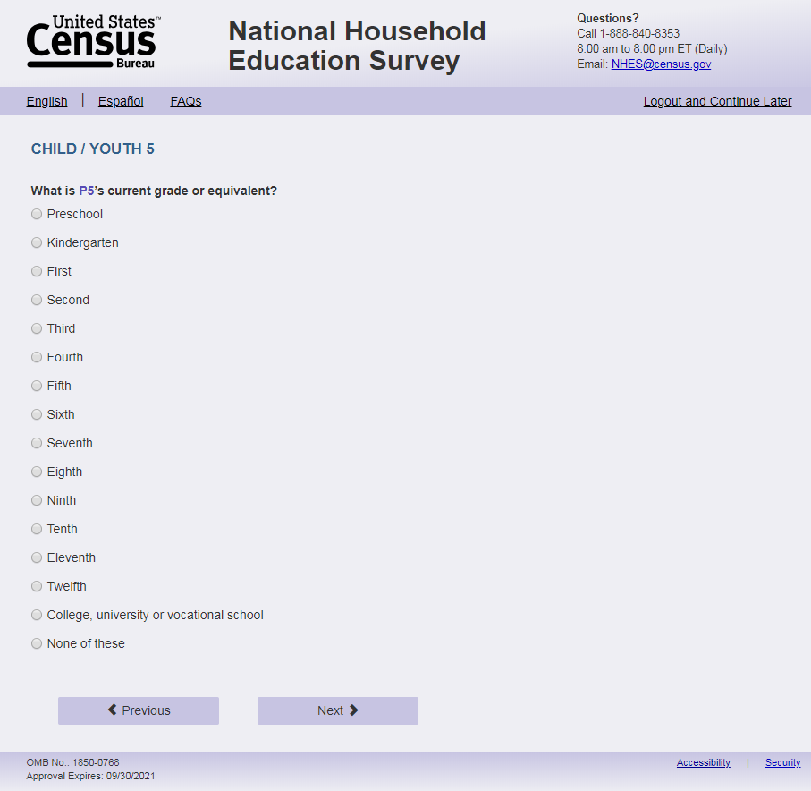
English Text reads:
What is [s1_p5name]’s current grade or grade equivalent?
Spanish Text reads:
Actualmente, ¿en qué grado o equivalencia de grado está [s1_p5name]?

English Answer:
1 = Preschool
2 = Kindergarten
3 = First
4 = Second
5 = Third
6 = Fourth
7 = Fifth
8 = Sixth
9 = Seventh
10 = Eighth
11 = Ninth
12 = Tenth
13 = Eleventh
14 = Twelfth
15 = College, university or vocational school
16 = None of these

Spanish Answer:
1 = Preescolar
2 = Kindergarten
3 = Grado 1
4 = Grado 2
5 = Grado 3
6 = Grado 4
7 = Grado 5
8 = Grado 6
9 = Grado 7
10 = Grado 8
11 = Grado 9
12 = Grado 10
13 = Grado 11
14 = Grado 12
15 = Colegio universitario, universidad o escuela vocacional
16 = Ninguno de estos

S1_p5grade_web, (1,16), numeric, radio
Skip patterns:
Go to sampling.
Logic checks/Programming Specifications:
Logic/range check triggers a warning message, with the following text displayed.
English
Use s1_p5name from s1_rosteraname to autofill [s1_p5name] regardless of length and characters used.
Error message with grade and age:
[If combination of s1_p5age and s1_p5grade_web in the CatchAll Spec table “Age Grade Error” has an “X”] Display “You entered [s1_p5name]'s age as [s1_p5age] and grade as [s1_p5grade_web]. Please check and make sure your answer is correct before continuing. If you need to correct your answer you can go back to the item.”
Error message with grade and date of birth:
[If combination of s1_p5dobmm and s1_p5grade_web in the CatchAll Spec table “Age Grade Error” has an “X”] Display “You entered [s1_p5name]'s month and year of birth as [s1_p5dobmm s1_p5dobyy] and grade as [s1_p5grade_web]. Please check and make sure your answer is correct before continuing. If you need to correct your answer you can go back to the item.
Spanish
Use s1_p5name from s1_rosteraname to autofill [s1_p5name] regardless of length and characters used.
Error message with grade and age:
[If combination of s1_p5age and s1_p5grade_web in the CatchAll Spec table “Age Grade Error” has an “X”] Display "Usted ingresó la edad de [s1_p5name] como [s1_p5age] y y el grado como [s1_p5grade_web]. Por favor, compruebe y asegúrese de que su respuesta es correcta antes de continuar. Si necesita corregir su respuesta, puede volver a la pregunta."
Error message with grade and date of birth:
[If combination of s1_p5dobmm and s1_p5grade_web in the and CatchAll Spec table “Age Grade Error” has an “X”] Display "Usted ingresó [s1_p5dobmm s1_p5dobyy] como el mes y año de nacimiento de [s1_p5name] y el grado como [s1_p5grade_web]. Por favor, compruebe y asegúrese de que su respuesta es correcta antes de continuar. Si necesita corregir su respuesta, puede volver a la pregunta.”

Item: sampling (not an actual page but behind the scenes)
As noted in the NHES 2023 CatchAll specifications only sample from those children reported in s1_p1 through s1_p5. Do not use data from s1_p6 through s1_p10.
If sampled for PFI, go to ps_pfirealte. If sampled for ECPP, go to ps_ecpprelate. If no sampled child for the PFI or ECPP and (EBWP_FLAG = 1 and survey complete date is after 3/13/23) or EBWP_FLAG = 0 or (USE_CHOICE_PLUS= missing or 0) then go to s1_thank_you; else if no sampled child for the PFI or ECPP and (USE_CHOICE_PLUS =1 ) or (EBWP_FLAG = 1 and survey complete date is on or before 3/13/23) then go to s1_Incent_Name.

Item: PFI Introduction (ps_pfirelate)
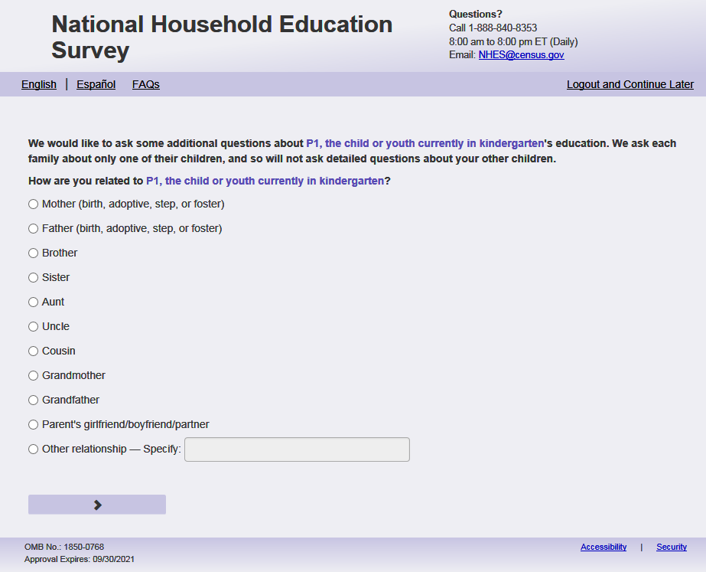
English Respondent Text reads:
We would like to ask some additional questions about [this child]'s education. [We ask each family about only one of their children, and so will not ask detailed questions about your other children.]
How are you related to [this child]?
Spanish Respondent text reads:
Nos gustaría hacerle preguntas adicionales sobre la educación de [este niño (esta niña)]. [A cada familia solo le preguntamos sobre uno de sus niños, así que no vamos a hacer preguntas detalladas sobre sus otros niños.]
¿Cuál es su relación o parentesco con [este niño (esta niña)]?”
English Admin/TQA Text reads:
We would like to ask some additional questions about [this child]'s education. [We ask each family about only one of their children, and so will not ask detailed questions about your other children.]
How are you related to [this child]?
Spanish Admin/TQA text reads:
Nos gustaría hacerle preguntas adicionales sobre la educación de [este niño (esta niña)]. [A cada familia solo le preguntamos sobre uno de sus niños, así que no vamos a hacer preguntas detalladas sobre sus otros niños.]
¿Cuál es su relación o parentesco con [este niño (esta niña)]?”
English Answer:
1= Mother (birth, adoptive, step, or foster)
2= Father (birth, adoptive, step, or foster)
3= Grandmother
4 = Grandfather
5 = Parent’s girlfriend/boyfriend/partner
6= Aunt
7= Uncle
8 = Sister
9 = Brother
10 = Other relationship–Specify:

Spanish answers:
1= Madre (biológica, adoptiva, madrastra o de crianza temporal (Foster))
2= Padre (biológico, adoptivo, padrastro o de crianza temporal (Foster))
3= Abuela
4= Abuelo
5= Novia/Novio o pareja de alguno de los padres
6= Tía
7= Tío
8= Hermana
9 = Hermano
10= Otro relación o parentesco–Especifique:

ps_pfirelate, (1,10), numeric, radio.
If 10 is selected, then activate write-in box (ps_pfireloth, (0,100), character, write-in
Skip patterns:
Go to PFI topical.

Logic checks/Programming Specifications:
For all child name fills, follow the rules in the catch all spec
If there is only one child in the household [s1_childmany=1], please remove the sentence English and English Admin/TQA: “We ask each family about only one of their children, and so will not ask detailed questions about your other children.”; Spanish and Spanish Admin/TQA: “A cada familia solo le preguntamos sobre uno de sus niños, así que no vamos a hacer preguntas detalladas sobre sus otros niños.”

Item: ECPP Introduction (ps_ecpprelate)
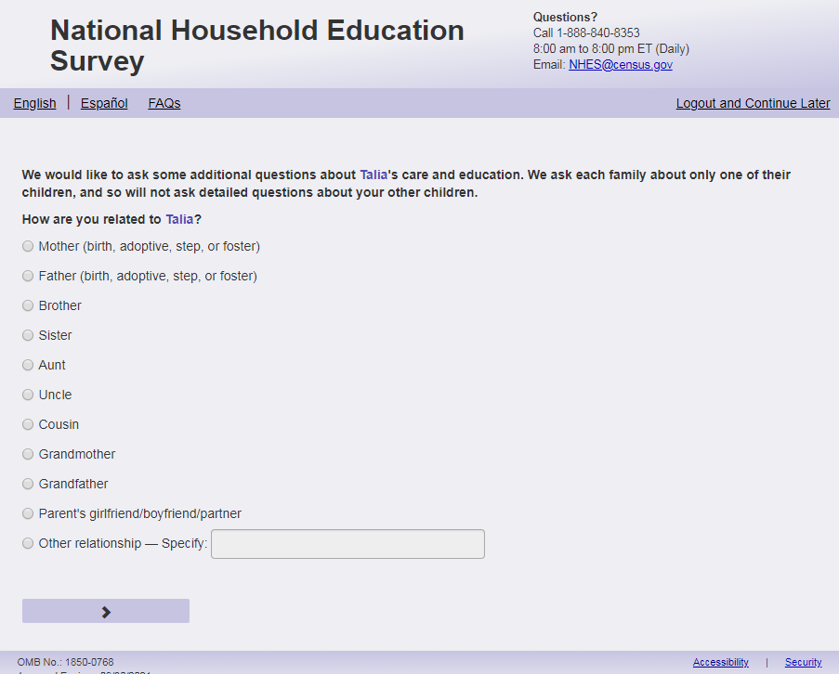

English Respondent Text reads:
We would like to ask some additional questions about [this child]'s care and education. [We ask each family about only one of their children, and so will not ask detailed questions about your other children.]
How are you related to [this child]?
Spanish Respondent text reads:
Queremos hacerle más preguntas sobre el cuidado y la educación de [este niño (esta niña)]. [A cada familia solo le preguntamos sobre uno de sus niños, así que no vamos a hacer preguntas detalladas sobre sus otros niños.]
¿Cuál es su relación o parentesco con [este niño (esta niña)]?
English Admin/TQA Text reads:
We would like to ask some additional questions about [this child]'s care and education. [We ask each family about only one of their children, and so we will not ask detailed questions about your other children.]
How are you related to [this child]?
Spanish Admin/TQA text reads:
Queremos hacerle más preguntas sobre el cuidado y la educación de [este niño (esta niña)]. [A cada familia solo le preguntamos sobre uno de sus niños, así que no vamos a hacer preguntas detalladas sobre sus otros niños.]
¿Cuál es su relación o parentesco con [este niño (esta niña)]?
English Answer:
1= Mother (birth, adoptive, step, or foster)
2= Father (birth, adoptive, step, or foster)
3= Grandmother
4= Grandfather
5= Parent’s girlfriend/boyfriend/partner
6 = Aunt
7 = Uncle
8 = Sister
9 = Brother
10 = Other relationship – Specify:

Spanish answers:
1= Madre (biológica, adoptiva, madrastra o de crianza temporal (Foster))
2= Padre (biológico, adoptivo, padrastro o de crianza temporal (Foster))
3= Abuela
4= Abuelo
5= Novia/Novio o pareja de alguno de los padres
6= Tía
7= Tío
8 = Hermana
9 = Hermano
10 = Otra relación o parentesco – Especifique:

ps_ecpprelate, (1,10), numeric, radio.
If 10 is selected, then activate write-in box (ps_ecppreloth, (0,100), character, write-in

Skip patterns:
Go to ECPP topical.
Logic checks/Programming Specifications:
For all child name fills follow the rules in the catch all spec.
If there is only one child in the household [s1_childmany=1], please remove the sentence English and English Admin/TQA: “We ask each family about only one of their children, and so will not ask detailed questions about your other children.” Spanish and Spanish Admin/TQA: “A cada familia solo le preguntamos sobre uno de sus niños, así que no vamos a hacer preguntas detalladas sobre sus otros niños.”

Item: Thank You (s1_thank_you)
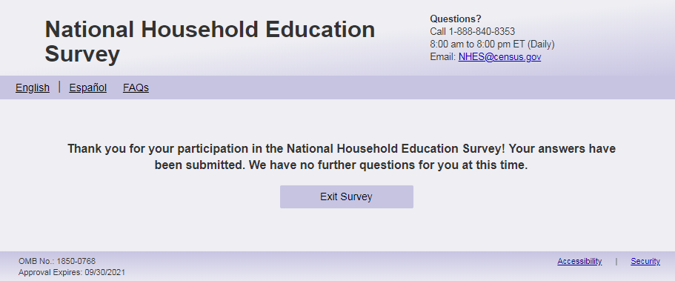
English Text reads:
Thank you for your participation in the National Household Education Survey! Your answers have been submitted. [The remainder of this survey focuses on children age 20 or younger. Because no children age 20 or younger live in your household, we have no further questions for you.] (We have no further questions for you at this time.)
Spanish text reads:
Gracias por su participación en la Encuesta Nacional en Hogares sobre Educación. Sus respuestas han sido enviadas. [El resto de esta encuesta se centra en niños de 20 años o menos. Debido a que ningún niño de 20 años o menos vive en su hogar, no tenemos más preguntas para usted.] (No tenemos más preguntas.)
English Answer:
‘Exit Survey’ button
Spanish Answer:
‘Salir de la Encuesta’ button

Logic checks/Programming Specifications:
If s1_anychildren = 2, or s1_anychildren = 1 and no child is sampled for the PFI or ECPP, display the text in bracket and do not display the text in parentheticals. English: “The remainder of this survey focuses on children age 20 or younger. Because no children age 20 or younger live in your household, we have no further questions for you.” (Spanish: “El resto de esta encuesta se centra en niños de 20 años o menos. Debido a que ningún niño de 20 años o menos vive en su hogar, no tenemos más preguntas para usted.” Exclude this text if s1_anychildren = 2, or (s1_childmany=’ ‘ and s1_rosteraname=’ ‘): English - “We have no further questions for you at this time.”; Spanish – “No tenemos más preguntas.”

Item: Confirm information Screener (s1_Incent_Name)
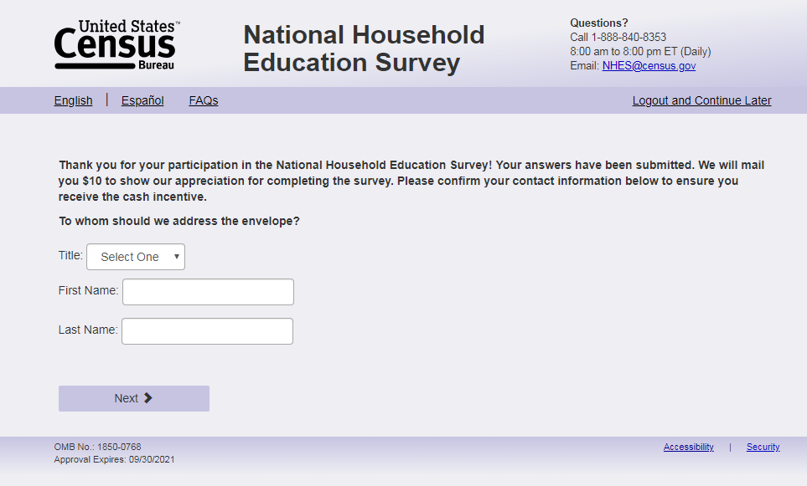
English Text Reads
Thank you for your participation in the National Household Education Survey! Your answers have been submitted. [This survey is about children’s care and educational experiences. Since you mentioned you do not have any children age 20 or younger living at this household, you are not eligible for the remainder of this survey. However, your response is still important as it helps us understand your household.] We will mail you $20 to show our appreciation for completing the survey. Please confirm your contact information below to ensure you receive the cash incentive.
To whom should we address the envelope?

Spanish Text Reads
Gracias por su participación en la Encuesta Nacional en Hogares sobre Educación. Sus respuestas han sido enviadas. [Esta encuesta es sobre las experiencias de cuidado y educación de los niños. Debido a que usted mencionó que no tiene hijos(as) de 20 años o menos viviendo en este hogar, usted no es elegible para el resto de la encuesta. Sin embargo, su respuesta es importante ya que nos ayuda a entender su hogar.] Le enviaremos por correo $20 para mostrarle nuestro agradecimiento por completar la encuesta. Por favor, confirme su información de contacto a continuación para asegurarse de recibir el incentivo en efectivo.
¿A quién deberíamos dirigirnos el sobre?

English Answer
Title: (inc_title)
First Name: _____________________ (inc_gvname)
Last Name: _____________________ (inc_lstname)

Spanish Answer
Título: (inc_title)
Nombre de pila: _____________________ (inc_gvname)
Apellido: _____________________ (inc_lstname)

inc_title: Dropdown, numeric
inc_gvname: write-in (0, 100) character, write-in
inc_lstname: write-in (0, 100) character, write-in

Skip patterns:
Go to s1_inc_address
Logic checks/Programming Specifications:
If s1_anychildren = 2, or s1_anychildren = 1 and no child is sampled for the PFI or ECPP, display the text in bracket “This survey is about children’s care and educational experiences. Since you mentioned you do not have any children age 20 or younger living at this household, you are not eligible for the remainder of this survey. However, your response is still important as it helps us understand your household.” (Spanish: Esta encuesta es sobre las experiencias de cuidado y educación de los niños. Debido a que usted mencionó que no tiene hijos(as) de 20 años o menos viviendo en este hogar, usted no es elegible para el resto de la encuesta. Sin embargo, su respuesta es importante ya que nos ayuda a entender su hogar.)

For inc_title use a standard dropdown for titles (for example: Mr., Ms., Mrs., Miss, Dr.)
English
Display “Title” to the left of the first dropdown box
Display “First Name” to the left of the first write-in box
Display “Last Name” to the left of the second write-in box

Item: Confirm address Screener (s1_inc_address)
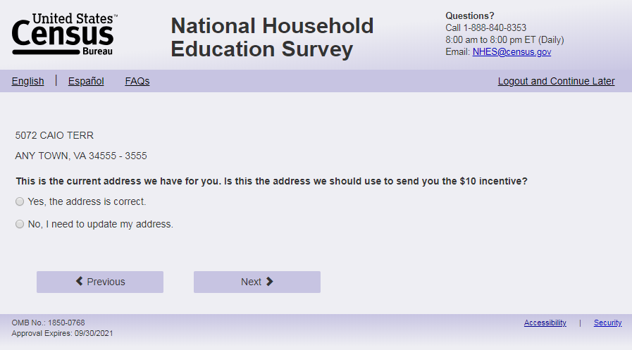
English Text Reads

PRIM_ADD
SEC_ADD
city, state zip-ZIP4

This is the current address we have for you. Is this the address we should use to send you the $20 incentive?
Spanish Text Reads
PRIM_ADD
SEC_ADD
city, state zip-ZIP4

Esta es la dirección actual que tenemos para usted. ¿Es esta la dirección que deberíamos usar para enviarle el incentivo de $20?
English Answer
1= Yes, the address is correct.
2= No, I need to update my address.
Spanish Answer
1= Sí, la dirección es correcta.
2= No, necesito actualizar mi dirección.
s1_inc_address, (1,2), numeric, radio
Skip patterns:
Go to “s1_survey_end_inc” if s1_inc_address=1, else go to s1_prim_add_new
Logic checks/Programming specifications:
The variables PRIM_ADD, SEC_ADD, city, state, zip and ZIP4 are available on the frame file and specify the address of the household. These variables should be used to fill this item so that respondents can confirm their addresses.

Item: Address information Screener (S1_PRIM_ADD_new)
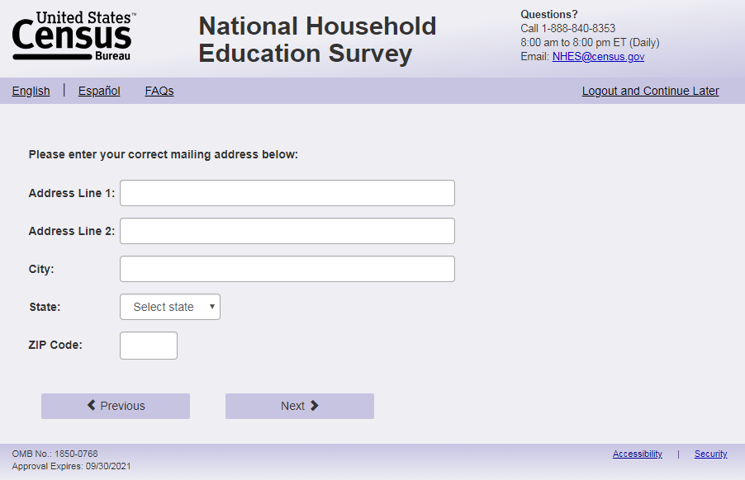
English Text reads:
Please enter your correct mailing address below:
Spanish Text reads:
Por favor ingrese su dirección postal correcta a continuación:
English Answer:
Address Line 1: _____________________________ (PRIM_ADD_new)
Address Line 2: _____________________________ (SEC_ADD_new)
City: _________________________ (city_new)
State: ________________________ (state_new)
ZIP:____________________ (zip_new)
Spanish Answer:
Dirección Postal Line 1: _____________________________ (PRIM_ADD_new)
Dirección Postal Line 2: _____________________________ (SEC_ADD_new)
Ciudad: _________________________ (city_new)
Estado: ________________________ (state_new)
Código Postal:____________________ (zip_new)

PRIM_ADD_new: write-in (0, 100) character, write-in
SEC_ADD_new: write-in (0, 100) character, write-in
city_new: write-in (0, 100) character, write-in
state_new: dropdown, numeric
zip_new: write-in (0, 10) character, write-in
Skip patterns:
Go to “s1_survey_end_inc”
Logic checks/Programming Specifications:
For state_new dropdown, use a dropdown with the 50 states in the United States and the District of Columbia.
English
Display “Address Line 1” to the left of the first write-in box
Display “Address Line 2” to the left of the second write-in box
Display “City” to the left of the third write-in box
Display “State” to the left of the first dropdown box
Display “ZIP” to the left of the fourth write-in box
Spanish
Display “Dirección Postal Line 1” to the left of the first write-in box
Display “Dirección Postal Line 2” to the left of the second write-in box
Display “Ciudad” to the left of the third write-in box
Display “Estado” to the left of the first dropdown box
Display “Código Postal” to the left of the fourth write-in box

Item: Survey End (s1_survey_end_inc)
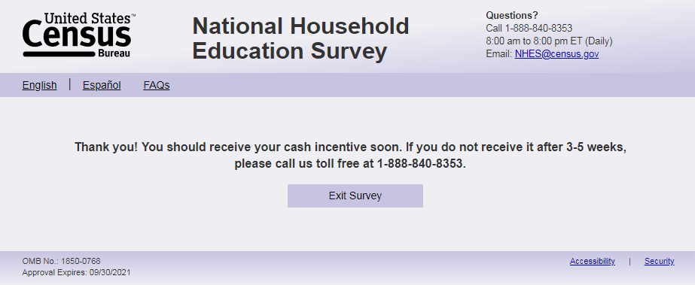
English Text reads:
Thank you! You should receive your cash incentive soon. If you do not receive it after 3-5 weeks, please call us toll free at 1-888-840-8353.
Spanish text reads:
¡Gracias! Debería recibir su incentivo en efectivo pronto. Si no lo recibe después de 3-5 semanas, llámenos grátis al 1-888-840-8353.

English Answer:
‘Exit Survey’ button
Spanish Answer:
‘Salir de la Encuesta’ button

Item: After Exit Survey

After “Exit Survey” button is clicked the respondent goes to the login page and says “You have been logged out” (Spanish “Usted ha sido desconnectado”). See screenshots below. respondent doesn't have to select exit survey, reaching this page does submit their answer and their case would be considered submitted/complete. But selecting that exit survey re-affirms they are done and 'logged out'. Lastly, if you log back in for a case that has reached the page with 'exit survey' it simply takes you back to this page; you can't hit back and edit answers.

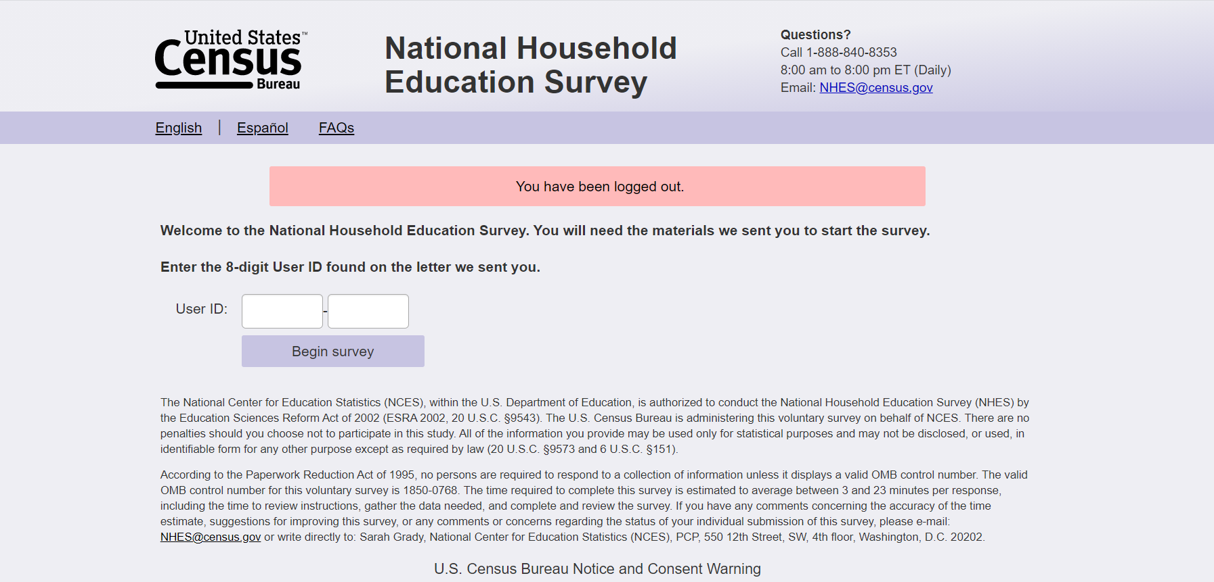
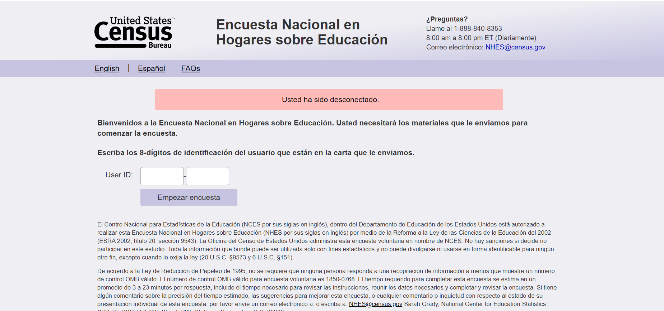

NHES:2023_ECPP Web Instrument Specification

WHERE TO START THE ECPP:
Prior to ECPP_ECPPCHK: Ask ECPP_ECPPCHK only when sampled child is ages 5 or 6 AND (S1_P(x)ENROL is missing or S1_P(x)GRADE_web is missing from Screener.) Else if ECPP_CARE_VER=2 (a case was NOT assigned to split panel), start with ECPP_RCNOW or ECPP_CARE_VER=1 (a case was assigned to split panel), start with ECPP_CARENOW. Note that the variable S1_P(x)ENROL and S1_P(x)GRADE_web are from the screener.

Item: Sampled Child Check (ECPP_ECPPCHK)
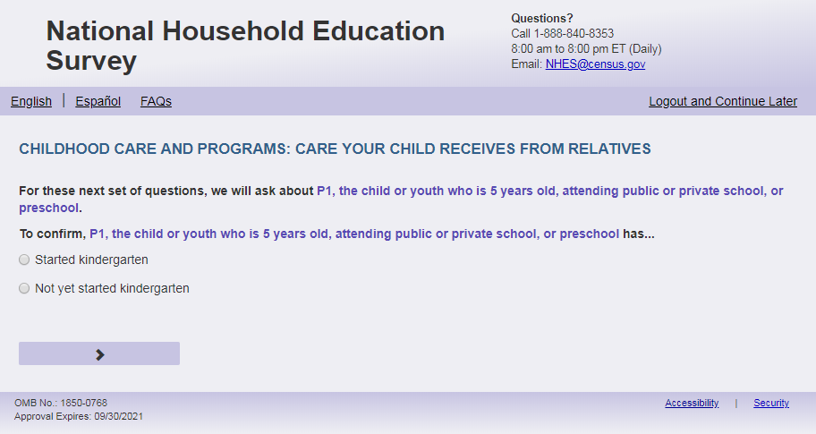
English Respondent Text Reads:

For these next set of questions, we will ask about [SAMPLED CHILD].

To confirm, [CHILD] has…

Spanish Respondent text reads:
Para este próximo grupo de preguntas, le preguntaremos acerca de [este niño].
Para confirmar, [CHILD] ha
English Admin/TQA Text Reads:
For these next set of questions, we will ask about [SAMPLED CHILD].

To confirm, has [CHILD] started kindergarten?
Spanish Admin/TQA text reads:
Para este próximo grupo de preguntas, le preguntaremos acerca de [este niño].
Para confirmar, ha empezado kindergarten [CHILD]?
English Answers
1 = Started kindergarten
2 = Not yet started kindergarten
Spanish Answers:
1= empezó kindergarten
2= todavía no ha empezado kindergarten
ECPP_ECPPCHK, (1,2) , numeric, radio

Skips:
If ECPP_ECPPCHK = 1 go to PFIC_ALLGRADEX_web on the PFI-C questionnaire.
If ECPP_ECPPCHK =2 or blank and ECPP_CARE_VER=2 go to ECPP_RCNOW. Else if ECPP_ECPPCHK=2 or blank and ECPP_CARE_VER=1, go to ECPP_CARENOW.
Logic Checks/Programming specifications
Ask ECPP_ECPPCHK only when sampled child is ages 5 or 6 AND (S1_P(x)ENROL is missing or S1_P(x)GRADE_web is missing from Screener.) Else, start with ECPP_RCNOW if ECPP_CARE_VER=2. Else, start with ECPP_CARENOW if ECPP_CARE_VER=1.

Item: Regular Basis Check (ECPP_RCNOW)

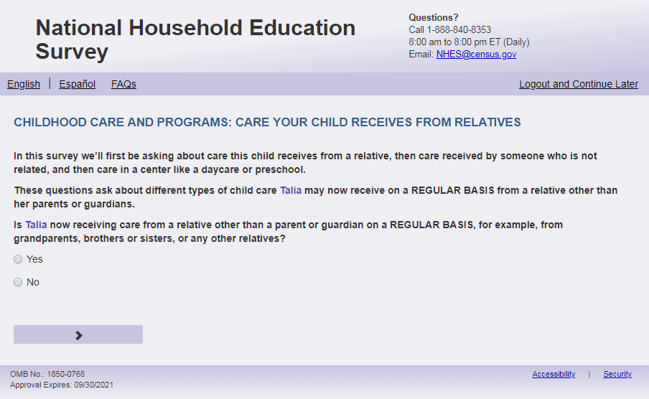
English Text Reads:
In this survey we’ll first be asking about care this child receives from a relative, then care received by someone who is not related, and then care in a center like a daycare or preschool.

These questions ask about different types of childcare [this child] may now receive on a REGULAR BASIS from a relative other than [his/her/his or her] parents or guardians.

Is [this child] now receiving care from a relative other than a parent or guardian on a REGULAR BASIS, for example, from grandparents, brothers or sisters, or any other relatives?

Spanish text reads:
En esta encuesta preguntaremos primero acerca del cuidado que recibe este niño (esta niña) de un pariente, y luego sobre el cuidado que recibe de alguien que no sea pariente, y luego sobre el cuidado en un centro como un daycare o programa preescolar.
Estas preguntas son acerca de los distintos tipos de cuidado infantil que [este niño (esta niña)] podría recibir actualmente CON REGULARIDAD, por parte de personas distintas a los padres o tutores legales.
Actualmente, ¿cuida a [este niño (esta niña)] CON REGULARIDAD un pariente, distinto a uno de los padres o tutores legales? Por ejemplo, los abuelos, hermanos, hermanas u otro pariente.
English Answer:
1=Yes
2=No

Spanish Answer
1= Sí
2=No

ECPP_RCNOW, (1,2), numeric, radio
Skips:
If ECPP_RCNOW = 2, then go to ECPP_NCNOW. Else, if ECPP_RCNOW =1 or blank, go to ECPP_RCWEEK.
Logic Checks/Programming specifications
Only display this screen if ECPP_CARE_VER =2

Item: Regular Care Arrangements (ECPP_CARENOW)
<New item for NHES:2023 – no screenshot available>
English Text Reads:
Does [this child] receive care or early education from anyone besides [his/her/his or her] parents or guardians on a REGULAR BASIS?

Spanish text reads:
¿Recibe [este niño (esta niña)] cuidado o educación temprana CON REGULARIDAD de alguien que no sea sus padres o tutores legales?
English Answer:
1=Yes
2=No

Spanish Answer
1= Sí
2=No

ECPP_CARENOW, (1,2), numeric, radio

Skips:
If ECPP_CARENOW=2, then go to ECPP_PCEVRHDX. Else if ECPP_CARENOW=1 or blank, go to ECPP_PCPCARE.
Logic Checks/Programming specifications
Only display this screen if ECPP_CARE_VER =1

Item: Regular Care Arrangements (ECPP_PCPCARE)
<New item for NHES:2023 – no screenshot available>
English Respondent Text Reads:
Who provides care or early education for [this child] on a REGULAR BASIS?

Spanish Respondent Text Reads:
¿Quién proporciona el cuidado o educación temprana para [este niño (esta niña)] CON REGULARIDAD?

English Admin/TQA Text Reads:
Who provides care or early education for [this child] on a REGULAR BASIS?
Please answer ‘yes’ or ‘no’ for EACH option as I read them.

Spanish Admin/TQA text reads:
¿Quién proporciona el cuidado o educación temprana para [este niño (esta niña)] CON REGULARIDAD?
Por favor, responda 'sí' o 'no' para cada opción como las leí.

English Answer:
- A parent or guardian, ECPP_PCPCARE, (1=Yes, 2=No), numeric
- A relative such as grandparent, brother, sister, or other relative, who is NOT [this child]’s guardian. ECPP_RCPCARE, (1=Yes, 2=No), numeric
- A person NOT related to [this child] such as neighbor, home child care provider, nanny, or au pair. ECPP_NCPCARE, (1=Yes, 2=No), numeric
- A teacher or staff person in a day care center, child care center, preschool, or prekindergarten (not in a private home). ECPP_CPPCARE, (1=Yes, 2=No), numeric

Spanish Answer:
- Un padre o tutor, ECPP_PCPCARE, (1= Sí , 2=No), numeric
- Un pariente como un abuelo(a), hermano(a) u otro pariente, quién NO es el tutor de [este niño (esta niña)]. ECPP_RCPCARE, (1=Sí, 2=No), numeric
- Una persona SIN parentesco con [este niño (esta niña)] como un vecino, proveedor de cuidado infantil en la casa, canguro o au pair. ECPP_NCPCARE, (1=Sí, 2=No), numeric
- Un maestro(a) o personal de una guardería, centro de cuidado infantil, programa preescolar o prekindergarten (que no sea en un hogar privado). ECPP_CPPCARE, (1=Sí, 2=No), numeric

Skips:
If ECPP_RCPCARE=1 or blank and ECPP_PCPCARE = 1, 2 or blank, go to ECPP_RCWEEK
Else if ECPP_RCPCARE=2 and ECPP_NCPCARE=1 or blank and ECPP_PCPCARE = 1, 2 or blank, go to ECPP_NCWEEK
Else if ECPP_RCPCARE=2 and ECPP_NCPCARE=2 and ECPP_CPPCARE=1 or blank and ECPP_PCPCARE = 1, 2 or blank, go to ECPP_CPTYPE
Else go to ECPP_PCEVRHDX if ECPP_RCPCARE = 2 and ECPP_NCPCARE = 2 and ECPP_CPPCARE = 2 and ECPP_PCPCARE = 1, 2 or blank
Only display this screen if ECPP_CARE_VER =1

Item: Weekly Care Arrangements (ECPP_RCWEEK)
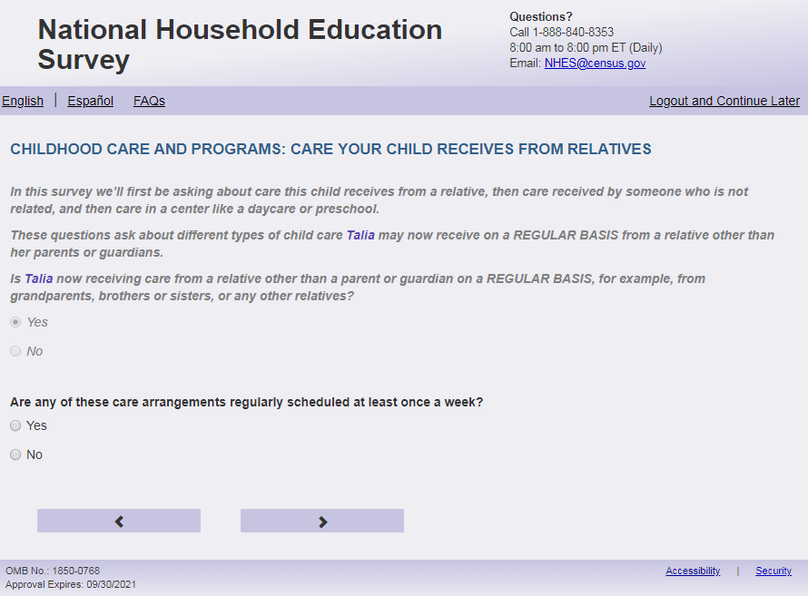
English Text Reads:
If not in the split panel (ECPP_CARE_VER = 2), then:
Are any of these care arrangements regularly scheduled at least once a week?

If in the split panel (ECPP_CARE_VER = 1), then:
These next questions are about the care that [this child] receives from the relative who provides the most care, OTHER THAN [his/her/his or her] parent(s) or guardian(s).

Does this other relative provide care regularly at least once a week?

Spanish Text Reads:
If not in the split panel (ECPP_CARE_VER = 2), then:
¿Se planifica con regularidad alguno de estos arreglos de cuidado infantil por lo menos una vez a la semana?
If in the split panel (ECPP_CARE_VER = 1), then:
Las siguientes preguntas se tratan del cuidado que [este niño (esta niña)] recibe por parte del pariente que lo cuida la mayor parte del tiempo, QUE NO SEAN padre(s) o tutor(es) de [él/ella/este niño (esta niña)].

¿Proporciona este otro pariente cuidado infantil con regularidad por lo menos una vez a la semana?

English Answer
1=Yes
2= No

Spanish Answer
1= Sí
2=No

ECPP_RCWEEK, (1,2), numeric, radio
Skips:
If ECPP_RCWEEK = 1 or blank, go to ECPP_RCTYPE.
Else if ECPP_CARE_VER=2 and ECPP_RCWEEK = 2 then go to ECPP_NCNOW.
Else if ECPP_CARE_VER= 1 and ECPP_RCWEEK=2 and ECPP_NCPCARE=1 or blank, go to ECPP_NCWEEK.
Else if ECPP_CARE_VER=1 and ECPP_RCWEEK=2 and ECPP_NCPCARE=2 and ECPP_CPPCARE=1 or blank, go to ECPP_CPTYPE.
Else, go to ECPP_ PCEVRHDX.

Logic Checks/Programming specifications
Do not display on same screen as ECPP_RCNOW.

Item: Relative Care (ECPP_RCTYPE )
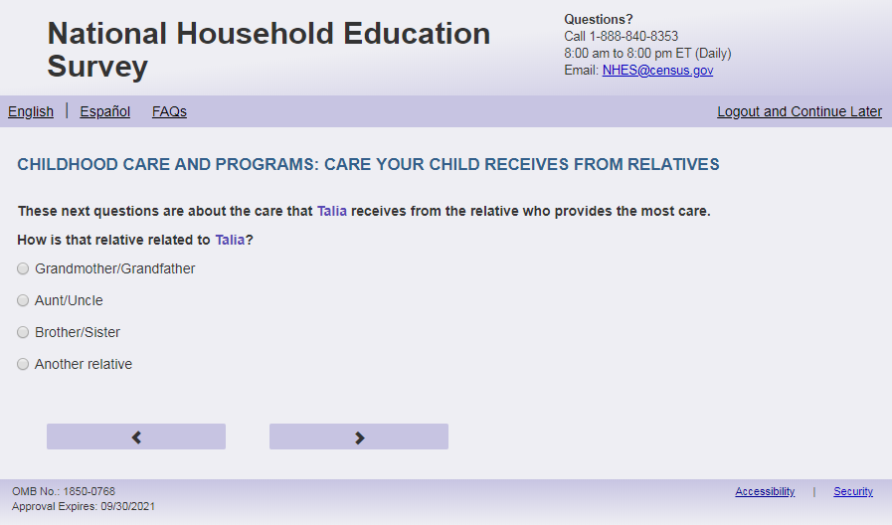
English Text Reads:
If not in split panel (ECPP_CARE_VER = 2), then:

These next questions are about the care that [this child] receives from the relative who provides the most care.

How is that relative related to [this child]?

If in split panel (ECPP_CARE_VER = 1), then:

How is that relative related to [this child]?

Spanish Text Reads:

If not in split panel (ECPP_CARE_VER = 2), then:

Las siguientes preguntas se tratan del cuidado que [este niño (esta niña)] recibe por parte del pariente que lo cuida la mayor parte del tiempo.

¿Cuál es la relación o el parentesco de ese pariente con este niño (esta niña)?

If in split panel (ECPP_CARE_VER = 1), then:
¿Cuál es la relación o el parentesco de ese pariente con este niño (esta niña)?

English Answer:
1= Grandmother/Grandfather
2= Aunt/Uncle
3= Brother/Sister
4= Another relative

Spanish Answer:
1=Abuela/Abuelo
2=Tía/Tío
3=Hermano/Hermana
4= Otro pariente

ECPP_RCTYPE, (1,4), numeric, radio
Skips:
Go to ECPP_RCAGE

Item: Age of Relative (ECPP_RCAGE)
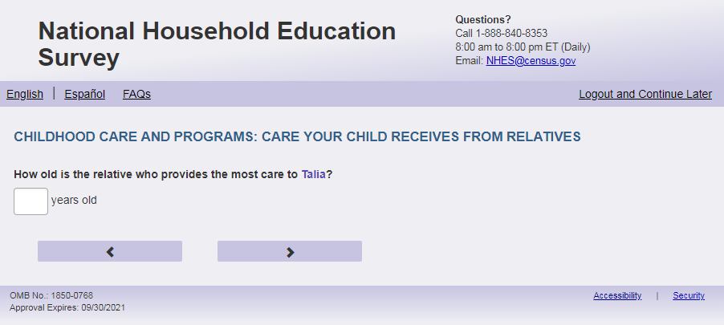

English Text Reads:
How old is the [ECPP_RCTYPE_ALT/relative] who provides the most care to [this child]?

Spanish Text Reads:

¿Qué edad tiene [ECPP_RCTYPE_ALT/pariente] que cuida a [este niño (esta niña)] la mayoría del tiempo?

English and Spanish Answer:
ECPP_RCAGE, (1, 99), numeric, write-in
Skips:
Go to ECPP_RCPLACE
Logic Checks/Programming specifications
English:
Fill for ECPP_RCTYPE _ALT

If ECPP_RCTYPE = 1 then: grandparent
If ECPP_RCTYPE = 2 then: aunt or uncle
If ECPP_RCTYPE = 3 then: sibling
If ECPP_RCTYPE = 4 then: other relative
Use relative if ECPP_RCTYPE is blank.
Display "years old" to right of box on English pages.

Spanish:
Fill for ECPP_RCTYPE _ALT

If ECPP_RCTYPE = 1 then: este abuelo/ esta abuela
If ECPP_RCTYPE = 2 then: este tío/ esta tía
If ECPP_RCTYPE = 3 then: este hermano/esta hermana
If ECPP_RCTYPE = 4 then: este otro pariente
Use este pariente if ECPP_RCTYPE is blank.
Display "años" to right of box on Spanish pages.
Text displayed for logic/range check violation
Mobile: Display numeric keypad

Logic/range check triggers a warning message, with the following text displayed.

English:
[If less than 10] Display " You entered the age of the relative that cares for this child as less than ten years old. Please check and make sure your answer is correct before continuing.
Spanish:
[If less than 10] Display: “Usted ingresó la edad del familiar que cuida a este niño como menor de diez años. Por favor, compruebe y asegúrese de que su respuesta es correcta antes de continuar.”

Item: Place of Care (ECPP_RCPLACE)
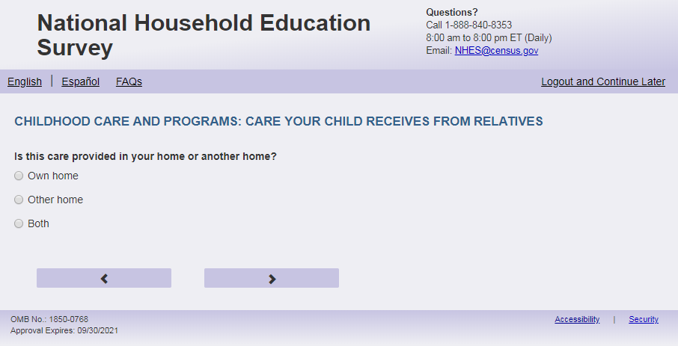
English Text Reads:
Is this care provided in your home or another home?

Spanish Text Reads:

¿Cuida al niño(a) en su casa o en otra casa?

English Answer
1=Own home
2=Other home
3=Both

Spanish Answer

1=Mi propia casa
2=Otra casa
3=Ambas

ECPP_RCPLACE, (1,3), numeric, radio
Skips:
If ECPP RCPLACE = 1, go to ECPP_RCDAYS. Else to go ECPP_RCTIME

Item: Time to Relative’s home (ECPP_RCTIME)
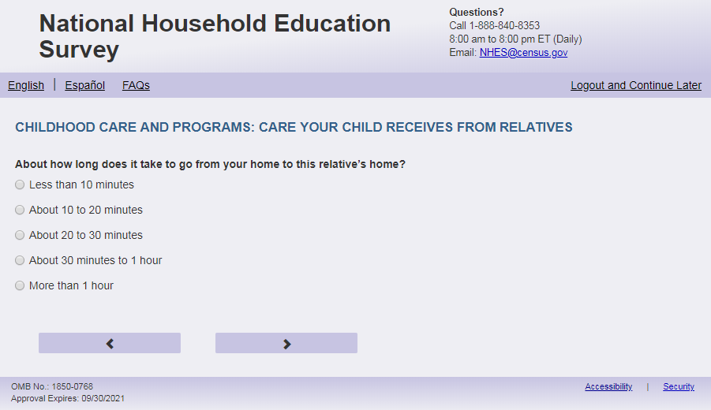
English Text Reads:
About how long does it take to go from your home to this [ECPP_RCTYPE_ALT/relative]’s home?
Spanish Text Reads:
Más o menos, ¿cuántotiempo le toma el viaje de su casa a la casa de [ECPP_RCTYPE_ALT/este pariente]?
English Admin/TQA Text Reads:
About how long does it take to go from your home to this [ECPP_RCTYPE_ALT/relative]’s home?
{Please read response options.}
Spanish Admin/TQA Text Reads:
¿Usualmente, cuanto tiempo le toma el viaje de su casa a la casa de [ECPP_RCTYPE_ALT/este pariente]?
{Por favor, lea las opciones de respuesta.}

English Answer:
1=Less than 10 minutes
2=About 10 to 20 minutes
3=About 20 to 30 minutes
4=About 30 minutes to 1 hour
5=More than 1 hour

Spanish Answer
1=Menos de 10 minutos
2=De 10 a 20 minutoes
3=De 20 a 30 minutos
4=De 30 minutos a 1 hora
5= Más de una hora

ECPP_RCTIME, (1,5), numeric, radio
Skips:
Go to ECPP_RCDAYS
Logic Checks/Programming specifications
English:
Fill for ECPP_RCTYPE _ALT

If ECPP_RCTYPE = 1 then: grandparent
If ECPP_RCTYPE = 2 then: aunt or uncle
If ECPP_RCTYPE = 3 then: sibling
If ECPP_RCTYPE = 4 then: other relative
Use relative if ECPP_RCTYPE is blank.

Spanish:
Fill for ECPP_RCTYPE_ALT

If ECPP_RCTYPE = 1 then: este abuelo/ esta abuela
If ECPP_RCTYPE = 2 then: este tío/ esta tía
If ECPP_RCTYPE = 3 then: este hermano/esta hermana
If ECPP_RCTYPE = 4 then: este otro pariente
Use este pariente if ECPP_RCTYPE is blank.

Item: Days of Care (ECPP_RCDAYS)
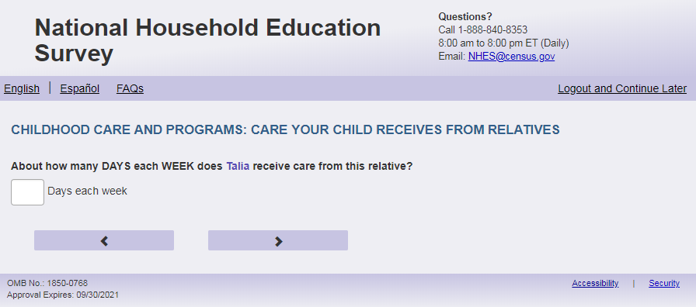

English Text Reads:
About how many DAYS each WEEK does [this child] receive care from this [ECPP_RCTYPE_ALT/relative]?

Spanish Text Reads:

Más o menos, ¿cuántos DÍAS a la SEMANA cuida [ECPP_RCTYPE_ALT/este pariente] a [este niño (esta niña)]?

English and Spanish Answer

ECPP_RCDAYS, (1, 7), numeric, write-in
Skips:
Go to ECPP_RCHRUNIT
Logic Checks/Programming specifications
English:
Fill for ECPP_RCTYPE _ALT

If ECPP_RCTYPE = 1 then: grandparent
If ECPP_RCTYPE = 2 then: aunt or uncle
If ECPP_RCTYPE = 3 then: sibling
If ECPP_RCTYPE = 4 then: other relative
Use relative if ECPP_RCTYPE is blank.
Display "days each week' to the right of the box.

Spanish:
Fill for ECPP_RCTYPE_ALT

If ECPP_RCTYPE = 1 then: este abuelo/ esta abuela
If ECPP_RCTYPE = 2 then: este tío/ esta tía
If ECPP_RCTYPE = 3 then: este hermano/esta hermana
If ECPP_RCTYPE = 4 then: este otro pariente
Use este pariente if ECPP_RCTYPE is blank.
Display "días a la semana" to the right of the box.
Mobile: Display numeric keypad

Text displayed for logic/range check violation
Logic/range check triggers a warning message, with the following text displayed.

English: [If 0 or more than 7] Display "Please check and make sure your answer is correct before continuing. Typically, care is between one and seven days."
Spanish [If 0 or more than 7] Display "Por favor, compruebe y asegúrese de que su respuesta es correcta antes de continuar. Por lo general, el cuidado infantil es de entre uno y siete días"

Item: Hours of Care (ECPP_RCHRUNIT)
<New item for NHES:2023 – no screenshot available>
English Text Reads:
How would you like to report the hours that [this child] receives child care from this [ECPP_RCTYPE_ALT/relative]?

Spanish Text Reads:
¿Cómo le gustaría responder sobre las horas que [este niño (esta niña)] recibe cuidado por parte de [ECPP_RCTYPE_ALT/este pariente]?
English Answer
1=hours per week
2=hours per day

Spanish Answer:
1=horas a la semana
2=horas al día
ECPP_RCHRUNIT, (1,2), numeric, radio
Skips:
Go to ECPP_RCHRS
Logic Checks/Programming specifications
English:
Fill for ECPP_RCTYPE _ALT

If ECPP_RCTYPE = 1 then: grandparent
If ECPP_RCTYPE = 2 then: aunt or uncle
If ECPP_RCTYPE = 3 then: sibling
If ECPP_RCTYPE = 4 then: other relative
Use relative if ECPP_RCTYPE is blank.
Spanish:
Fill for ECPP_RCTYPE_ALT

If ECPP_RCTYPE = 1 then: este abuelo/ esta abuela
If ECPP_RCTYPE = 2 then: este tío/ esta tía
If ECPP_RCTYPE = 3 then: este hermano/esta hermana
If ECPP_RCTYPE = 4 then: este otro pariente
Use este pariente if ECPP_RCTYPE is blank.

Item: Hours of Care (ECPP_RCHRS)

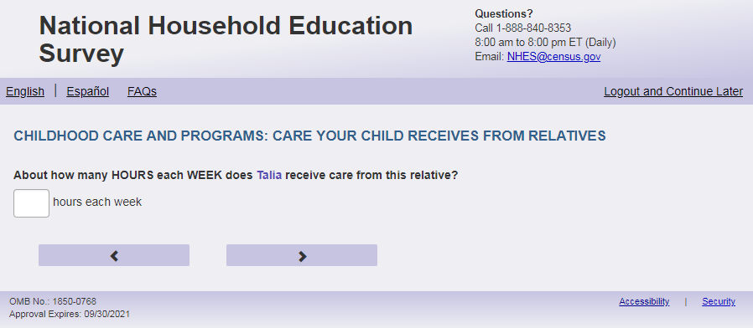
English Text Reads:
About how many HOURS each [unit] does [this child] receive care from [ECPP_RCTYPE_ALT/this relative]?

Spanish text reads:

Más o menos, ¿cuántas HORAS cada[unit] cuida [ECPP_RCTYPE_ALT/este pariente] a [este niño (esta niña)]?

English and Spanish Answers:ECPP_RCHRS, numeric (0,99), write-in
Skips:
Go to ECPP_RCCVRWK
Logic Checks/Programming specifications
English:
Fill for unit:
If ECPP_RCHRUNIT=1 or blank, then use “WEEK”
If ECPP_RCHRUNIT=2, then use “DAY”

Fill for ECPP_RCTYPE _ALT:
If ECPP_RCTYPE = 1 then: [this child]’s grandparent
If ECPP_RCTYPE = 2 then: [this child]’s aunt or uncle
If ECPP_RCTYPE = 3 then: [this child]’s sibling
If ECPP_RCTYPE = 4 then: [this child]’s other relative
Use relative if ECPP_RCTYPE is blank.
ECPP_RCHRUNIT=1 or blank, display “hours each week” to the right of box. Else display “hours each day” to the right of the box.

Spanish:
Fill for unit:
If ECPP_RCHRUNIT=1 or blank, then use “SEMANA”
If ECPP_RCHRUNIT=2, then use “DÍA”

Fill for ECPP_RCTYPE _ALT

If ECPP_RCTYPE = 1 then: el abuelo/ abuela de [este niño(a)]
If ECPP_RCTYPE = 2 then: el tío/ tía de [este niño(a)]
If ECPP_RCTYPE = 3 then: el hermano/ hermana de [este niño(a)]
If ECPP_RCTYPE = 4 then: otro pariente de [este niño(a)]
Use este pariente if ECPP_RCTYPE is blank.
If ECPP_RCHRUNIT=1 or blank, display "horas a la semana" to right of box on Spanish pages. Else display “horas al día” to the right of box.
Mobile: Display numeric keypad

Logic/range check triggers a warning message, with the following text displayed.
For hours per day:
English: [If 0 or more than 16] Display “Please check your answer before continuing. Typically, children are in care between one and 16 hours per day.”
Spanish: [If 0 or more than 16] Display "Por favor, compruebe su respuesta antes de continuar. Por lo general, los niños están en cuidado infantil entre una y 16 horas al día".
For hours per week:
English: [If 0 or more than 80] Display "Please check your answer before continuing. Typically, children are in care with relatives other than parents between one and 80 hours per week."
Spanish: [If 0 or more than 80] Display "Por favor, revise su respuesta antes de continuar. Por lo general, los niños están bajo cuidado con parientes que no son padres entre una y 80 horas a la semana".

Item: Relative Care Coverage For Work (ECPP_RCCVRWK)
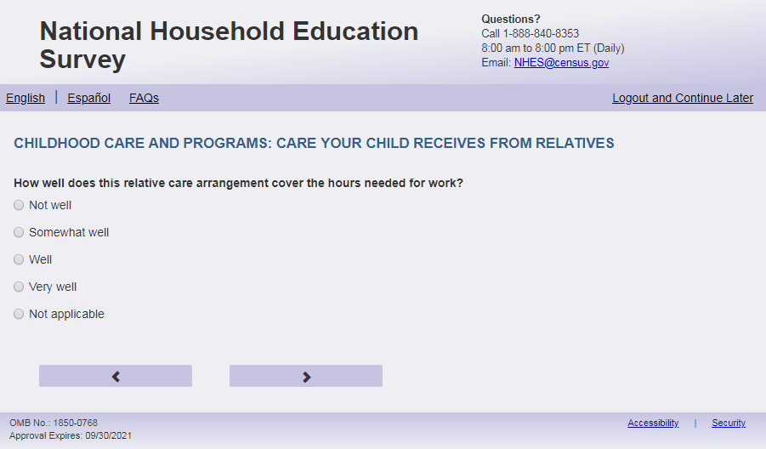
English text reads:
How well does this relative care arrangement cover the hours of care needed for work?
Spanish text reads:
¿Qué tan bien cubre este pariente las horas que usted necesita para el cuidado de este niño(a) durante sus horas de trabajo?

English Answers:
1=Not well
2=Somewhat well
3=Well
4=Very well
5=Not applicable
English Admin/TQA text reads:
How well does this relative care arrangement cover the hours of care needed for work?
You can say they cover the hours needed for work “not well,” “somewhat well,” “well,” or “very well.”
{Do not read “Not applicable.” If the Respondent says they don’t work, select this answer, or if they hesitate, say ‘You can also say “not applicable.”’}
Spanish Admin/TQA text reads:
¿Qué tan bien cubre este pariente las horas que usted necesita para el cuidado de este niño(a) durante sus horas de trabajo?Se puede decir que cubren las horas necesarias para el trabajo "nada bien", "más o menos bien", "bien" o "muy bien".
{No lea "No aplica". Si el participante dice que no trabajan, seleccione esta respuesta, o si duda, diga 'También puede decir 'No aplica''.}
Spanish Answers:
1=Nada bien
2=Más o menos bien
3= Bien
4=Muy Bien
5= No aplica

ECPP_ RCCVRWK, (1,5), numeric, radio
Skips:
Go to ECPP_ RCSTRTY
Logic Checks/Programming specifications
Increase spacing between response options “Very Well” (ECPP_RCCVRWK=4) and “Not Applicable” (ECPP_RCCVRWK=5) by about double the spacing between the other response options. Apply to Spanish response options.

Item: Child’s Age at Start of Care (ECPP_RCSTRTY)
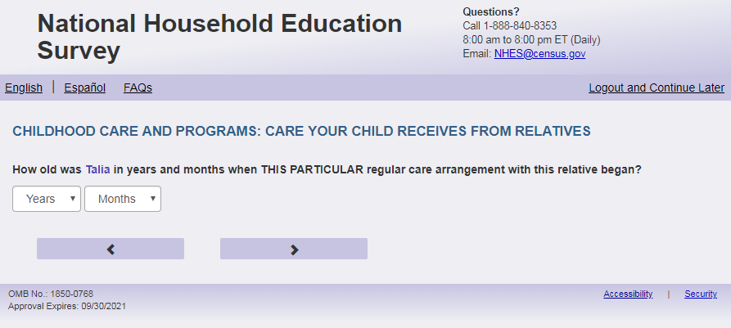

English Text Reads:
How old was [this child] in years and months when THIS PARTICULAR regular care arrangement with this [ECPP_RCTYPE_ALT/relative] began?

Spanish text reads:
¿Qué edad tenía [este niño (esta niña)], en años y meses, cuando comenzó este arreglo regular ESPECÍFICO con este [ECPP_RCTYPE_ALT/pariente]?

English and Spanish answer:

ECPP_RCSTRTY, (0,6) numeric, drop down
ECPP_RCSTRTM (0, 11), numeric, drop down
Skips:
Go to ECPP_RCSPEAK
Logic Checks/Programming specifications

Allow respondents to scroll the options within drop-down.
Only display options that are equal to or less than child's current age from Screener.
Display months (ECPP_RCSTRTM) and years (ECPP_RCSTRTY) on same page. English:
Fill for ECPP_RCTYPE _ALT

If ECPP_RCTYPE = 1 then: grandparent
If ECPP_RCTYPE = 2 then: aunt or uncle
If ECPP_RCTYPE = 3 then: sibling
If ECPP_RCTYPE = 4 then: other relative
Use relative if ECPP_RCTYPE is blank.
English:
Display ‘months’ as label above the ECPP_RCSTRTM dropdown box and leave the dropdown box blank.
Display ‘years’ as label above the ECPP_RCSTRTY dropdown box and leave the dropdown box blank.

Spanish:
Fill for ECPP_RCTYPE _ALT

If ECPP_RCTYPE = 1 then: este abuelo/ esta abuela
If ECPP_RCTYPE = 2 then: este tío/ esta tía
If ECPP_RCTYPE = 3 then: este hermano/esta hermana
If ECPP_RCTYPE = 4 then: este otro pariente
Use este pariente if ECPP_RCTYPE is blank.
Display ‘meses’ as label above the ECPP_RCSTRTM dropdown box and leave the dropdown box blank.
Display ‘años’ as label above the ECPP_RCSTRTY dropdown box and leave the dropdown box blank.

Item: Child’s Language (ECPP_RCSPEAK)
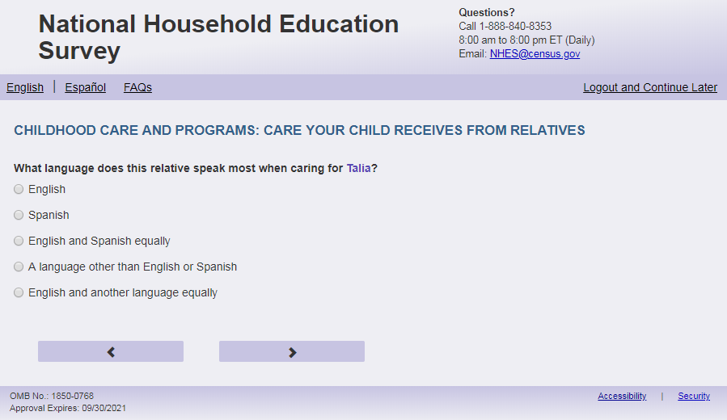

English Respondent Text Reads:
What language does this [ECPP_RCTYPE_ALT/relative] speak most when caring for [this child]?

Spanish Respondent Text Reads:

¿Qué idioma habla más [ECPP_RCTYPE_ALT/este pariente] cuando está cuidando a [este niño (esta niña)]?
English Admin/TQA Text Reads:
What language does this [ECPP_RCTYPE_ALT/relative] speak most when caring for [this child]?
{Please read response options}

Spanish Admin/TQA Text Reads:

¿Qué idioma habla más [ECPP_RCTYPE_ALT/este pariente] cuando está cuidando a [este niño (esta niña)]?

{Por favor, lea las opciones de respuesta.}

English Answer:
1= English
2= Spanish
3= English and Spanish equally
4= A language other than English or Spanish
5= English and another language equally

Spanish Answer:
1= Inglés
2= Español
3= Inglés y español por igual
4= Otro idioma aparte del inglés o español
5= Inglés y otro idioma por igual

ECPP_RCSPEAK, (1,5), numeric, radio
Skips:
Go to ECPP_RCSKNFV
Logic Checks/Programming specifications
English:
Fill for ECPP_RCTYPE _ALT

If ECPP_RCTYPE = 1 then: grandparent
If ECPP_RCTYPE = 2 then: aunt or uncle
If ECPP_RCTYPE = 3 then: sibling
If ECPP_RCTYPE = 4 then: other relative
Use relative if ECPP_RCTYPE is blank.
Spanish:
Fill for ECPP_RCTYPE_ALT

If ECPP_RCTYPE = 1 then: este abuelo/ esta abuela
If ECPP_RCTYPE = 2 then: este tío/ esta tía
If ECPP_RCTYPE = 3 then: este hermano/esta hermana
If ECPP_RCTYPE = 4 then: este otro pariente
Use este pariente if ECPP_RCTYPE is blank.

Item: Sick without Fever (ECPP_RCSKNFV)
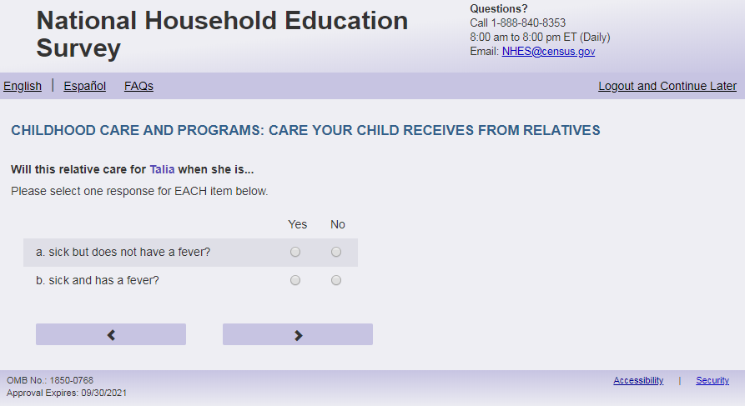
English Respondent Text Reads:
Will this [ECPP_RCTYPE_ALT/relative] care for [this child] when [he/she/he or she] is…

- sick but does not have a fever? (ECPP_RCSKNFV, (1=Yes, 2=No), numeric)
- sick and has a fever? (ECPP_RCSKFV, (1=Yes, 2= No), numeric)

Spanish Respondent Text Reads:

¿ [ECPP_RCTYPE_ALT/Este pariente] ¿lo(a) cuida si el niño(a) está…
- enfermo pero no tiene fiebre? (ECPP_RCSKNFV, (1= Sí, 2=No), numeric)
- enfermo y tiene fiebre? (ECPP_RCSKFV, (1=Sí, 2= No), numeric)

English Admin/TQA Text Reads:
Will this [ECPP_RCTYPE_ALT/relative] care for [this child] when [he/she/he or she] is sick but does not have a fever? (ECPP_RCSKNFV, (1=Yes, 2=No), numeric)

Will this [ECPP_RCTYPE_ALT/relative] care for [this child] when [he/she/he or she] is sick and has a fever? (ECPP_RCSKFV, (1=Yes, 2= No), numeric)

Spanish Admin/TQA Text Reads:

¿ [ECPP_RCTYPE_ALT/Este pariente] ¿lo(a) cuida si el niño(a) está enfermo pero no tiene fiebre? (ECPP_RCSKNFV, (1= Sí, 2=No), numeric)

¿ [ECPP_RCTYPE_ALT/Este pariente] ¿lo(a) cuida si el niño(a) está enfermo y tiene fiebre? (ECPP_RCSKFV, (1=Sí, 2= No), numeric)

Skips:
Go to ECPP_RCOTCH
Logic Checks/Programming specifications
For respondent text display as grid and remove swim lanes
For Admin/TQA display as two items on the screen (not as a grid)
English:
Fill for ECPP_RCTYPE _ALT

If ECPP_RCTYPE = 1 then: grandparent
If ECPP_RCTYPE = 2 then: aunt or uncle
If ECPP_RCTYPE = 3 then: sibling
If ECPP_RCTYPE = 4 then: other relative
Use relative if ECPP_RCTYPE is blank.
If S1_Pxsex = 1, use ‘he’, if s1_pxsex = 2, use ‘she’, else use ‘he or she’
Spanish:
Fill for ECPP_RCTYPE _ALT

If ECPP_RCTYPE = 1 then: este abuelo/esta abuela
If ECPP_RCTYPE = 2 then: este tío/esta tía
If ECPP_RCTYPE = 3 then: este hermano/esta hermana
If ECPP_RCTYPE = 4 then: este otro pariente
Use este pariente if ECPP_RCTYPE is blank.

Item: Other Children (ECPP_RCOTCH)
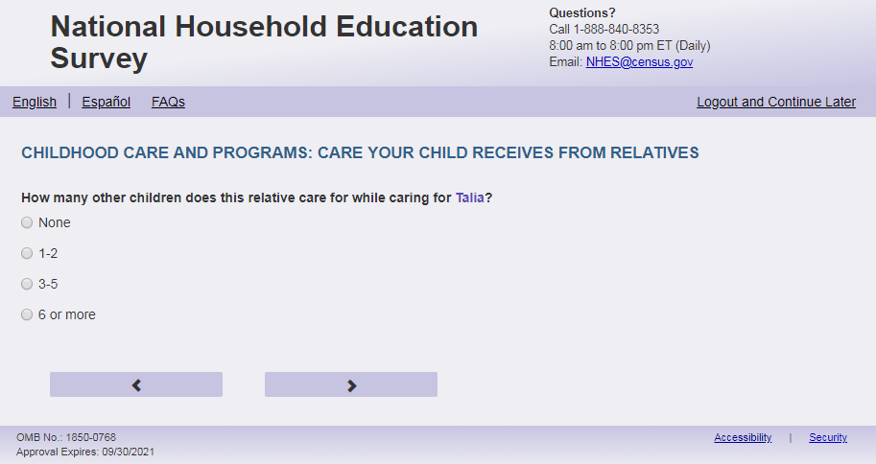
English text reads:
How many other children does this [ECPP_RCTYPE_ALT/relative] care for while caring for [this child?
Spanish text reads:
¿Mientras [ECPP_RCTYPE_ALT/este pariente] cuida a este niño(a), a cuántos otros niños cuida?
English answer:
1=None
2=1 to 2
3=3 to 5
4=6 or more

Spanish answer:
1 = Ninguno
2= 1 a 2
3= 3 a 5
4=6 o más

ECPP_RCOTCH, (1,4), numeric, radio

Skips:
Go to ECPP_RCFEE

Logic Checks/Programming specifications

English:
Fill for ECPP_RCTYPE _ALT

If ECPP_RCTYPE = 1 then: grandparent
If ECPP_RCTYPE = 2 then: aunt or uncle
If ECPP_RCTYPE = 3 then: sibling
If ECPP_RCTYPE = 4 then: other relative
Use relative if ECPP_RCTYPE is blank.

Spanish:
Fill for ECPP_RCTYPE _ALT

If ECPP_RCTYPE = 1 then: este abuelo/esta abuela
If ECPP_RCTYPE = 2 then: este tío/esta tía
If ECPP_RCTYPE = 3 then: este hermano/esta hermana
If ECPP_RCTYPE = 4 then: este otro pariente
Use este pariente if ECPP_RCTYPE is blank.

Item: Relative Care Fee (ECPP_RCFEE)
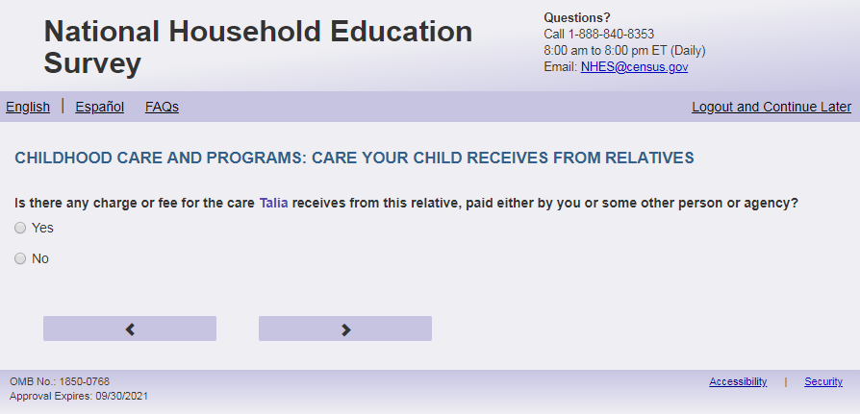
English Text Reads:
Is there any charge or fee for the care [this child] receives from this [ECPP_RCTYPE_ALT/relative], paid either by you or some other person or agency?

Spanish Text Reads:

¿Hay algún costo o pago por el cuidado que [este niño (esta niña)] recibe por parte de [ECPP_RCTYPE_ALT/este pariente], ya sea que lo pague usted u otra persona o agencia?

English Answer

1=Yes
2=No

Spanish Answer
1= Sí
2=No

ECPP_RCFEE, (1,2), numeric, radio

Skips:
If ECPP_RCFEE = 2 then go to ECPP_RCOTHC. Else go to ECPP_RCREL
Logic Checks/Programming specifications
English:
Fill for ECPP_RCTYPE _ALT

If ECPP_RCTYPE = 1 then: grandparent
If ECPP_RCTYPE = 2 then: aunt or uncle
If ECPP_RCTYPE = 3 then: sibling
If ECPP_RCTYPE = 4 then: other relative
Use relative if ECPP_RCTYPE is blank.
Spanish:
Fill for ECPP_RCTYPE _ALT

If ECPP_RCTYPE = 1 then: este abuelo/esta abuela
If ECPP_RCTYPE = 2 then: este tío/esta tía
If ECPP_RCTYPE = 3 then: este hermano/esta hermana
If ECPP_RCTYPE = 4 then: este otro pariente
Use este pariente if ECPP_RCTYPE is blank.

Item: Paid by Organization (ECPP_RCREL)
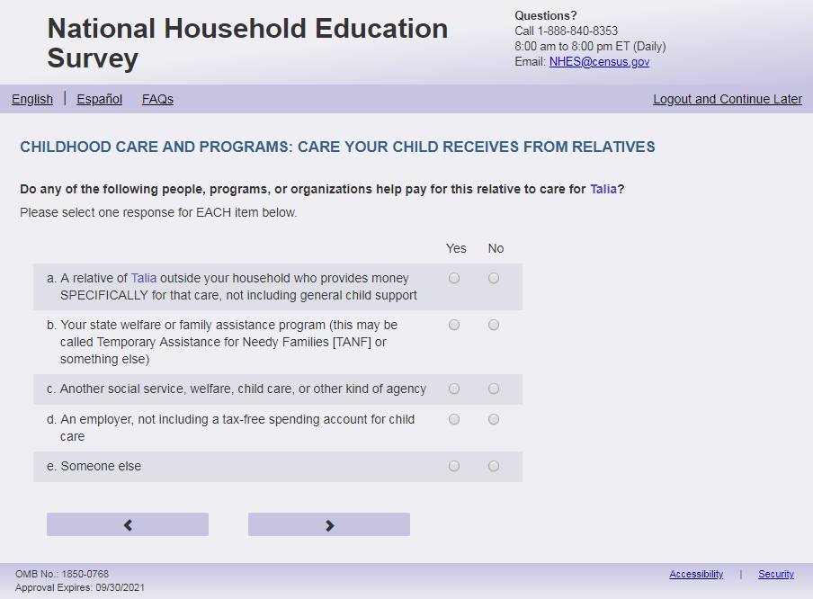

English Respondent Text Reads:
Do any of the following people, programs, or organizations help pay for this [ECPP_RCTYPE_ALT/relative] to care for [this child]?

Spanish Respondent Text Reads:

¿Alguna de las siguientes personas, programas u organizaciones le ayuda a pagarle a [ECPP_RCTYPE_ALT/este pariente] por el cuidado de [este niño (esta niña)]?

English Admin/TQA Text Reads:
Do any of the following people, programs, or organizations help pay for this [ECPP_RCTYPE_ALT/relative] to care for [this child]?
Please respond ‘yes’ or ‘no’ for EACH item as I read them.
{Please re-read the question if the respondent asks or seems to have forgotten the question.}

Spanish Admin/TQA Text Reads:

¿Algunas de las siguientes personas, programas u organizaciones le ayuda a pagarle a [ECPP_RCTYPE_ALT/este pariente] por el cuidado de [este niño (esta niña)]?
Por favor, responda 'sí' o 'no' para CADA opción a medida que las leo.
{Por favor, vuelva a leer la pregunta si el encuestado pregunta o parece haber olvidado la pregunta.}

English Answer:

- A relative of [this child] outside your household who provides money SPECIFICALLY for that care, not including general child support, ECPP_RCREL, (1=Yes, 2=No), numeric, radio
- Your state welfare or family assistance program (this may be called Temporary Assistance for Needy Families [TANF] or something else), ECPP_RCTANF, (1=Yes, 2=No), numeric, radio
- Another social service, welfare, child care, or other kind of agency, ECPP_RCSSAC, (1=Yes, 2=No), numeric, radio
- An employer, not including a tax-free spending account for child care, ECPP_RCEMPL, (1=Yes, 2=No), numeric, radio
- Someone else, ECPP_RCOTHER, (1=Yes, 2=No), numeric, radio
Spanish Answer:
- Un pariente de [este niño (esta niña)] que no vive en su hogar y da dinero para pagar ESPECÍFICAMENTE por ese cuidado, sin incluir manutención para niños(as), ECPP_RCREL, (1= Sí, 2=No), numeric, radio
- Programa de asistencia social o familiar de su estado (puede ser Asistencia Temporal a Familias Necesitadas [TANF por sus siglas en ingles], o algo similar), ECPP_RCTANF, (1= Sí, 2=No), numeric, radio
- Otro servicio social, asistencia social, cuidado infantil, u otro tipo de agencia, ECPP_RCSSAC, (1= Sí, 2=No), numeric, radio
- Un empleador, sin incluir cuentas especiales para pagos de cuidado infantil libres de impuestos, ECPP_RCEMPL, (1= Sí, 2=No), numeric, radio
- Alguien más, ECPP_RCOTHER, (1= Sí, 2=No), numeric, radio
Skips:
Go to ECPP_RCUNIT
Logic Checks/Programming specifications:
Display as grid
If child’s name is available on screener, use child’s name for fill in response option a “A relative of [name of child] outside your household who provides money SPECIFICALLY for that care, not including general child support”. If child’s name is not available, use “this child” as fill. (Spanish: este niño (esta niña))

English:
Fill for ECPP_RCTYPE _ALT

If ECPP_RCTYPE = 1 then: grandparent
If ECPP_RCTYPE = 2 then: aunt or uncle
If ECPP_RCTYPE = 3 then: sibling
If ECPP_RCTYPE = 4 then: other relative
Use relative if ECPP_RCTYPE is blank.Spanish:
Fill for ECPP_RCTYPE _ALT

If ECPP_RCTYPE = 1 then: este abuelo/ esta abuela
If ECPP_RCTYPE = 2 then: este tío/ esta tía
If ECPP_RCTYPE = 3 then: este hermano/esta hermana
If ECPP_RCTYPE = 4 then: este otro pariente
Use este pariente if ECPP_RCTYPE is blank.

Item: Paid by Household (ECPP_RCUNIT)

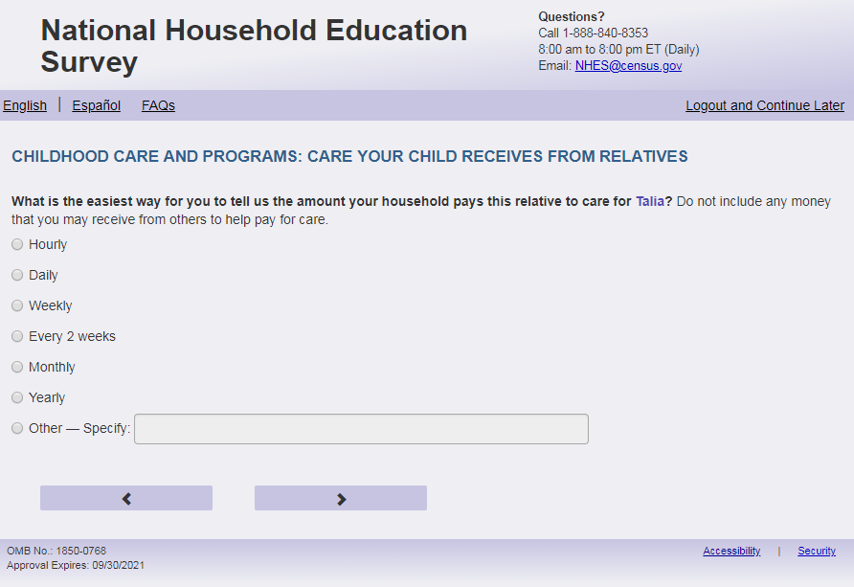
English Respondent Text Reads:
What is the easiest way for you to tell us the amount your household pays this [ECPP_RCTYPE_ALT/relative] to care for [this child]? Do not include any money that you may receive from others to help pay for care.

Spanish Respondent Text Reads:

¿Cuál es la forma más fácil para decirnos cuánto le paga este hogar a su [ECPP_RCTYPE_ALT/este pariente] por el cuidado de [este(a) niño(a)]? No incluya el dinero que reciba de otras personas para pagar los gastos del cuidado.

English Admin/TQA Text Reads:
What is the easiest way for you to tell us the amount your household pays this [ECPP_RCTYPE_ALT/relative] to care for [this child]? Do not include any money that you may receive from others to help pay for care.
{Read the answer options to the respondent. You do not need to read “Other.”}

Spanish Admin/TQA Text Reads:

¿Cuál es la forma más fácil para decirnos cuánto le paga este hogar a su [ECPP_RCTYPE_ALT/este pariente] por el cuidado de [este(a) niño(a)]? No incluya el dinero que reciba de otras personas para pagar los gastos del cuidado.
{Lea las opciones de respuesta al encuestado. Tampoco es necesario leer "Otro."}

English Answer:
1= Hourly
2= Daily
3= Weekly
4= Every 2 weeks
5= Monthly
6= Yearly
7 = Other – Specify:

Spanish Answer:

1= Por hora
2= Por día
3= Por semana
4= Quincena (cada 2 semanas)
5= Por mes
6= Por año
7= Otro – Especifíque:

ECPP_RCUNIT, (1,7), numeric, radio. If 7 selected, specify box should become active (ECPP_RCUNITOS): (0,200), character, write-in. Display specify response box 1 row by 50 characters.

Skips:
If only 1 person on Screener is under 18 years of age (s1_pxdobyy gt 2005 or age lt 18), don't display ECPP_RCCSTHNX and go to ECPP_RCCOST. Else if any age on screener is blank for any person, or there is more than 1 person under 18, then go to ECPP_RCCSTHNX.
English:
Fill for ECPP_RCTYPE _ALT

If ECPP_RCTYPE = 1 then: grandparent
If ECPP_RCTYPE = 2 then: aunt or uncle
If ECPP_RCTYPE = 3 then: sibling
If ECPP_RCTYPE = 4 then: other relative
Use relative if ECPP_RCTYPE is blank.

Spanish:
Fill for ECPP_RCTYPE _ALT

If ECPP_RCTYPE = 1 then: este abuelo/esta abuela
If ECPP_RCTYPE = 2 then: este tío/esta tía
If ECPP_RCTYPE = 3 then: este hermano/esta hermana
If ECPP_RCTYPE = 4 then: este otro pariente
Use este pariente if ECPP_RCTYPE is blank.

Item: Fee for No. of Children (ECPP_RCCSTHNX)
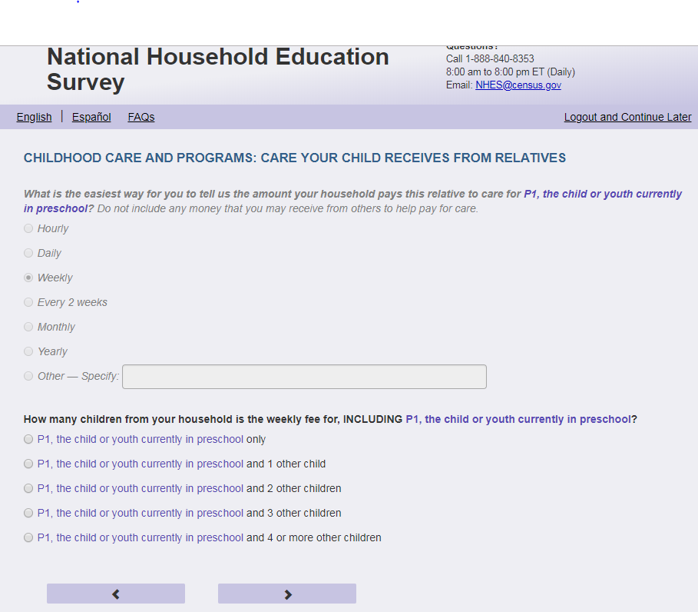
English Text Reads:
How many children from your household is this [ECPP_RCUNIT] amount for, INCLUDING [this child]?

Spanish Text Reads:

¿Para cuántos de los niños(as) de su hogar es la cantidad [ECPP_RCUNIT], INCLUYENDO a [este(a) niño(a)]?

English Answer:

1= [This child] only
2= [This child] and 1 other child
3= [This child] and 2 other children
4= [This child] and 3 other children
5= [This child] and 4 or more other children

Spanish Answer:

1= Sólo para [este niño (esta niña)]
2= [Este niño (esta niña)] y otro 1 niño(a)
3= [Este niño (esta niña)] y otros 2 niños(as)
4= [Este niño (esta niña)] y otros 3 niños(as)
5= [Este niño (esta niña)] y otros 4 o más niños(as)

ECPP_RCCSTHNX, (1,5), numeric, radio

Skips:
Go to ECPP_RCCOST
Logic Checks/Programming specifications:
Fill ECPP_RCUNIT with response category from ECPP_RCUNIT. If ECPP_RCUNIT = 7, and ECPP_RCUNITOS = ' ', do not include a fill and have it read: English: '...is the fee for,..' Spanish: ‘..es la tarifa,..’.
Don’t display on the same screen as ECPP_RCUNIT. Display on a new screen.
Don't display if only one child (18 and under) was entered on the screener. If any age is blank show item.
For answer options: display options corresponding to number of children (18 and under) in HH from screener. If any age is blank, show all options.
For English answers, if child’s name is available on screener, use child’s name for response options 1 through 5. If child’s name is not available, use “This child”:
1= [This child] only
2= [This child] and 1 other child
3= [This child] and 2 other children
4= [This child] and 3 other children
5= [This child] and 4 or more other children

For Spanish answers, if child’s name is available on screener, use child’s name for response options 1 through 5. If child’s name is not available, use “Este niño (esta niña)”:
1= Sólo para [este niño(a)]
2= [Este niño (esta niña)] y otro 1 niño(a)
3= [Este niño (esta niña)] y otros 2 niños(as)
4= [Este niño (esta niña)] y otros 3 niños(as)
5= [Este niño (esta niña)] y otros 4 o más niños(as)

Item: Amount Paid by Household (ECPP_RCCOST)
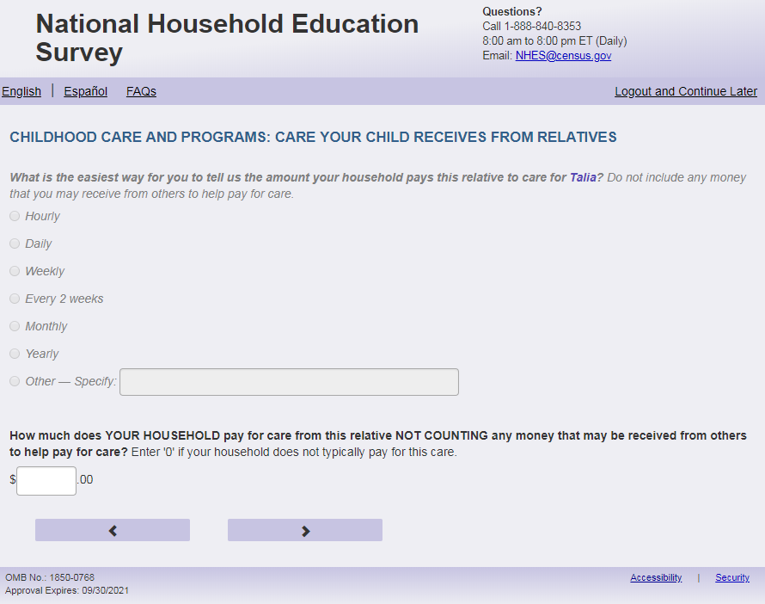
English Respondent Text Reads:
How much does YOUR HOUSEHOLD pay for this [ECPP_RCTYPE_ALT/relative] to care for [this child] [ECPP_RCUNIT], NOT COUNTING any money that may be received from others to help pay for care? Enter '0' if your household does not pay this relative for care.

Spanish Respondent Text Reads:

¿Cuánto paga SU HOGAR a [ECPP_RCTYPE_ALT/este pariente} [ECPP_RCUNIT] por el cuidado de este niño(a), SIN INCLUIR dinero que reciba de otras personas para ayudarle a pagar el cuidado de [este niño (esta niña)]? Ingrese ‘0’ si su hogar no le paga a este pariente por el cuidado de este niño(a).

English Admin/TQA Text Reads:
How much does YOUR HOUSEHOLD pay for this [ECPP_RCTYPE_ALT/relative] to care for [this child] [ECPP_RCUNIT], NOT COUNTING any money that may be received from others to help pay for care?
{Enter '0' if the household does not pay this relative for care.}

Spanish Admin/TQA Text Reads:

¿Cuánto paga SU HOGAR a [ECPP_RCTYPE_ALT/este pariente} [ECPP_RCUNIT] por el cuidado de este niño(a), SIN INCLUIR dinero que reciba de otras personas para ayudarle a pagar el cuidado de [este niño (esta niña)]?
{Ingrese ‘0’ si su hogar no le paga a este pariente por el cuidado de este niño(a).}

English and Spanish Answer:

ECPP_RCCOST, (0,99999), numeric, write-in

Skips:
Go to ECPP_RCOTHC.

Logic Checks/Programming specifications:
Fill ECPP_RCUNIT with response category from ECPP_RCUNIT.
If ECPP_RCUNIT = 7, and ECPP_RCUNITOS = ' ', do not include a fill and have it read: '…this [ECPP_RCTYPE/relative]to care for [this child], NOT COUNTING…'. For Spanish, do not include a fill and end it with: ‘[ECPP_RCTYPE/este pariente]?’
Display on a new screen. Don’t display on the same screen as ECPP_RCUNIT and ECPP_RCCSTHNX.
Display "$" to the left of the box. Display ".00" to the right of the box. Right-justified and will enter the response box from the right side. If a numerical response contains more than three digits, a comma will be auto-filled.
English:
Fill for ECPP_RCTYPE _ALT

If ECPP_RCTYPE = 1 then: grandparent
If ECPP_RCTYPE = 2 then: aunt or uncle
If ECPP_RCTYPE = 3 then: sibling
If ECPP_RCTYPE = 4 then: other relative
Use relative if ECPP_RCTYPE is blank.
Spanish:
Fill for ECPP_RCTYPE _ALT

If ECPP_RCTYPE = 1 then: este abuelo/esta abuela
If ECPP_RCTYPE = 2 then: este tío/esta tía
If ECPP_RCTYPE = 3 then: este hermano/esta hermana
If ECPP_RCTYPE = 4 then: este otro pariente
Use este pariente if ECPP_RCTYPE is blank.
Mobile: Display numeric keypad

Item: Other Care Arrangements with relative (ECPP_RCOTHC)
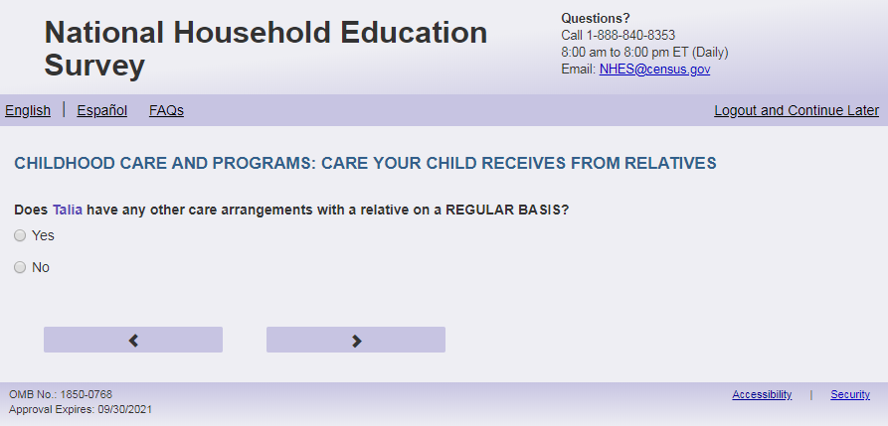
English Text Reads:
Does [this child] have any other care arrangements with a relative on a REGULAR BASIS?

Spanish Text Reads:

¿Tiene [este niño (esta niña)] algún otro arreglo de cuidado infantil con un pariente CON REGULARIDAD?

English Answer:

1=Yes
2= No

Spanish Answer:

1= Sí
2= No

ECPP_RCOTHC, (1,2), numeric, radio

Skips:
If ECPP_CARE_VER=2 and ECPP_RCOTHC = 2 then go to ECPP_NCNOW. Else if ECPP_CARE_VER=1 and ECPP_RCOTHC=2, and ECPP_NCPCARE =1 or blank, then go to ECPP_NCWEEK. Else if ECPP_CARE_VER=1 and ECPP_RCOTHC=2, and ECPP_NCPCARE=2 and ECPP_CPPCARE=1 or blank, then go to ECPP_CPTYPE. Else if ECPP_CARE_VER=1 and ECPP_RCOTHC=2, and ECPP_NCPCARE=2 and ECPP_CPPCARE=2, then go to ECPP_PCEVRHDX. Else go to ECPP_RCTLHR.

Item: Hours at Other Care Arrangements (ECPP_RCTLHR)
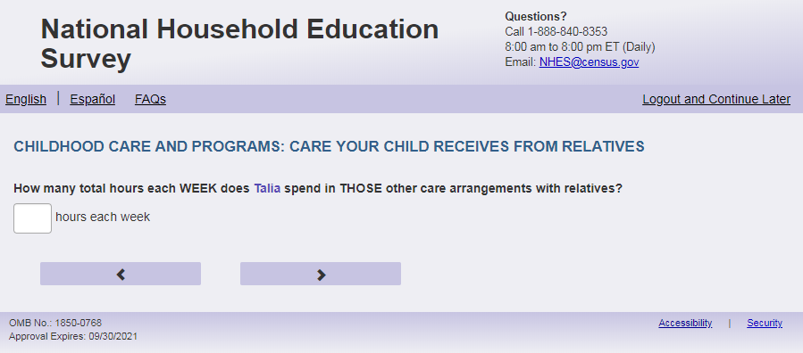
English Text Reads:
How many total hours each WEEK does [this child] spend in THOSE OTHER care arrangements with relatives?

Spanish Text Reads:

¿Cuántas horas a la SEMANA en total pasa [este niño (esta niña)] al cuidado de ESOS OTROS parientes?

English and Spanish Answer:

ECPP_RCTLHR, (0, 99), numeric, write-in

Skips:
If ECPP_CARE_VER = 1 and ECPP_NCPCARE =1 or blank, then go to ECPP_NCWEEK. Else if ECPP_CARE_VER=1 and ECPP_NCPCARE=2 and CPPCARE=1 or blank, go to ECPP_CPTYPE. Else if ECPP_CARE_VER=1 and ECPP_NCPCARE=2 and CPPCARE=2, go to ECPP_ PCEVRHDX.
Else go to ECPP_NCNOW.
Logic Checks/Programming specifications:
English: Display "hours each week" to right of box
Spanish: Display “horas a la semana” to right of box
Mobile: Display numeric keypad

Text displayed for logic/range check violation:
Logic/range check triggers a warning message, with the following text displayed.
[If 0 or more than 80] Display English: " Please check your answer before continuing. Typically, children who are in care arrangements with two different relatives are with the second relative between one and 80 hours per week."
[If 0 or more than 80] Display Spanish: "Por favor, compruebe su respuesta antes de continuar. Por lo general, los niños que están en arreglos de cuidado con dos parientes diferentes están con segundo pariente entre una y 80 horas a la semana."

Item: Non-Relative Care (ECPP_NCNOW)
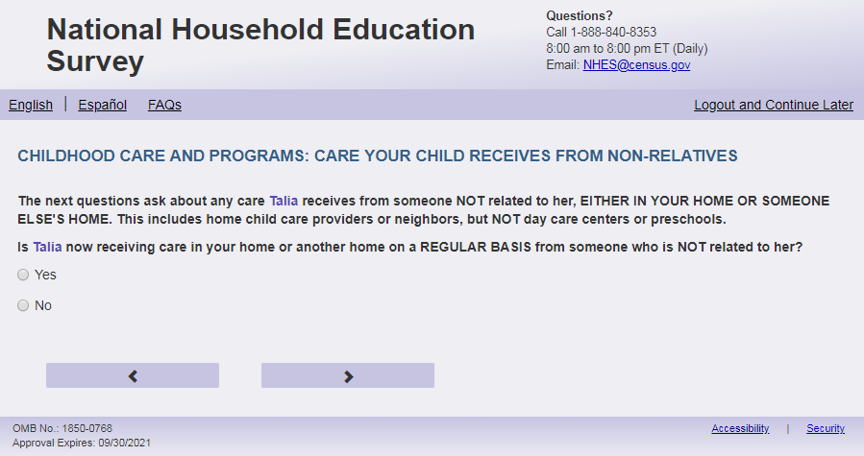
English Text Reads:
The next questions ask about any care [this child] receives from someone NOT related to [him/her/him or her], EITHER IN YOUR HOME OR SOMEONE ELSE'S HOME. This includes home childcare providers or neighbors, but NOT day care centers or preschools.

Is [this child] now receiving care in your home or another home on a REGULAR BASIS from someone who is NOT related to [him/her/him or her]?

Spanish Text Reads:

Las siguientes preguntas se tratan del cuidado que [este niño (esta niña)] recibe por parte de personas que NO sean sus parientes, YA SEA EN SU CASA O EN LA CASA DE OTRA PERSONA. Esto incluye a personas que cuidan niños(as) en sus casas o vecinos, pero NO incluye guarderías ni programas preescolares

Actualmente, ¿cuida a [este niño (esta niña)] CON REGULARIDAD una persona que NO es su pariente, ya sea en su casa o en otra casa?

English Answer:

1= Yes
2= No

Spanish Answer:

1= Sí
2= No

ECPP_NCNOW, (1,2), numeric, radio

Skips:
If ECPP_NCNOW = 2 then go to ECPP_CPNNOWX. Else go to ECPP_NCWEEK.

Logic Checks/Programming specifications:
Only display this screen if ECPP_CARE_VER =2
English:
If S1_Pxsex = 1, use ‘him’, if s1_pxsex = 2, use ‘her’, else use ‘him or her’

Item: Non-Relative Care per Week (ECPP_NCWEEK)
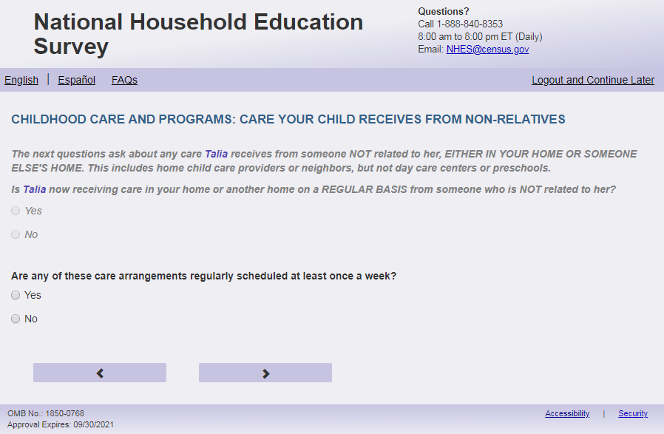
English Text Reads:
If not in the split panel (ECPP_CARE_VER = 2), then:

Are any of these care arrangements regularly scheduled at least once a week?

If in the split panel (ECPP_CARE_VER = 1), then:

The next questions ask about any care that [this child] receives from someone NOT related to [him/her/him or her]; the care can be provided EITHER IN YOUR HOME OR SOMEONE ELSE'S HOME. This includes home childcare providers or neighbors, but NOT day care centers or preschools.

Does this non-relative provide care regularly at least once a week?

Spanish Text Reads:

If not in the split panel (ECPP_CARE_VER = 2), then:

¿Se planifica con regularidad alguno de estos arreglos de cuidado infantil por lo menos una vez a la semana?

If in the split panel (ECPP_CARE_VER = 1), then:

Las siguientes preguntas se tratan del cuidado que [este niño (esta niña)] recibe por parte de personas que NO sean sus parientes; el cuidado puede ser proporcionado YA SEA EN SU CASA O EN LA CASA DE OTRA PERSONA. Esto incluye a personas que cuidan niños(as) en sus casas o vecinos, pero NO incluye guarderías ni programas preescolares

¿Cuida al niño(a) esta persona que no es su pariente con regularidad por lo menos una vez a la semana?

English Answer:

1=Yes
2=No

Spanish Answer:

1= Sí
2= No

ECPP_NCWEEK, (1,2), numeric, radio

Skips:
If ECPP_CARE_VER=2 and ECPP_NCWEEK = 2 then go to ECPP_CPNNOWX. Else if ECPP_CARE_VER=1 and ECPP_NCWEEK=2 and ECPP_CPPCARE =1 or blank, then go to CPTYPE. Else if ECPP_CARE_VER=1 and ECPP_NCWEEK=2 and ECPP_CPPCARE=2, then go to ECPP_ PCEVRHDX. Else go to ECPP_NCHOME.
Logic Checks/Programming specifications:
Display on a new screen. Do not display on same screen as ECPP_NCNOW.
English:
If S1_Pxsex = 1, use ‘him’, if s1_pxsex = 2, use ‘her’, else use ‘him or her’

Item: Non-Relative Care Home (ECPP_NCHOME)
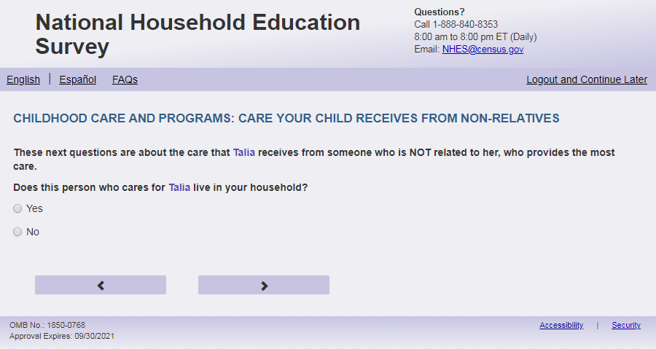
English Text Reads:
These next questions are about the care that [this child] receives from someone who is NOT related to [him/her/him or her], who provides the most care.

Does this non-relative who cares for [this child] live in your household?

Spanish Text Reads:

Las siguientes preguntas se tratan del cuidado que [este niño (esta niña)] recibe por parte de una persona que NO es su pariente y que lo cuida la mayor parte del tiempo.

¿Vive en el hogar de usted esta persona que no es su pariente y cuida a [este niño(a)]?

English Answer:
1 = Yes
2= No

Spanish Answer:

1= Sí
2= No

ECPP_NCHOME, (1,2), numeric, radio

Skips:
Go to ECPP_NCPLACE

Item: Non-Relative Care Location (ECPP_NCPLACE)
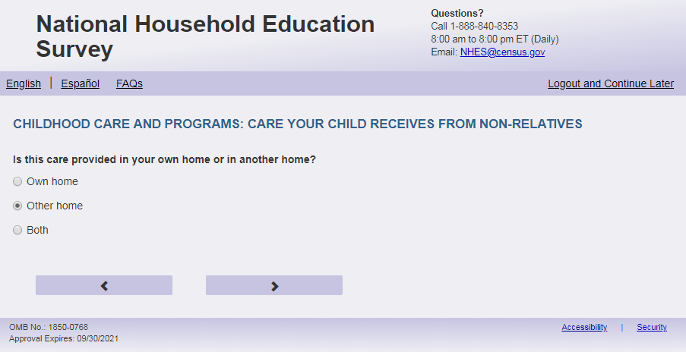
English Text Reads:
Is [this child] cared for by a non-relative in your own home or another home?

Spanish Text Reads:

¿Esta persona que no es su pariente, cuida al niño(a) en su casa o en otra casa?

English Answer:

1= Own home
2= Other home
3= Both

Spanish Answer:

1=Mi propia casa
2=Otra casa
3=Ambas

ECPP_NCPLACE, (1,3), numeric, radio

Skips:
If ECPP_ NCPLACE = 1, go to ECPP_NCDAYS. Else go to ECPP_NCTIME.

Item: Time to Non Relative’s home (ECPP_NCTIME)
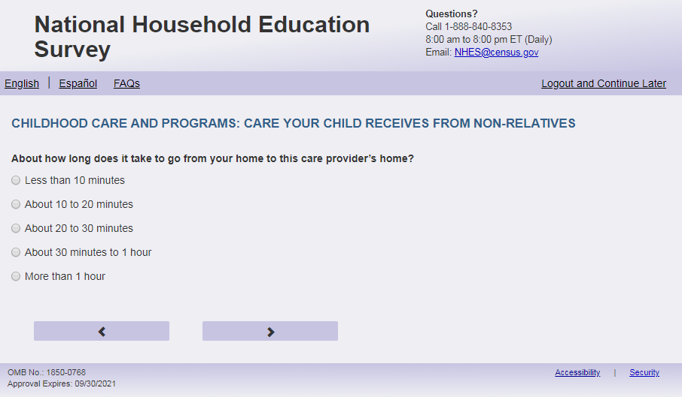
English Respondent Text Reads:
About how long does it take to go from your home to this care provider’s home?
Spanish Respondent Text Reads:
Más o menos, ¿cuánto tiempo le toma el viaje de su casa a la casa de esta persona?
English Admin/TQA Text Reads:
About how long does it take to go from your home to this care provider’s home?
{Please read response options}
Spanish Admin/TQA Text Reads:
Más o menos, ¿cuánto tiempo le toma el viaje de su casa a la casa de esta persona?
{Por favor, lea las opciones de respuesta.}
English Answer:
1=Less than 10 minutes
2=About 10 to 20 minutes
3=About 20 to 30 minutes
4=About 30 minutes to 1 hour
5=More than 1 hour

Spanish Answer
1=Menos de 10 minutos
2=De 10 a 20 minutos
3=De 20 a 30 minutos
4=De 30 minutos a 1 hora
5= Más de una hora

ECPP_NCTIME, (1,5), numeric, radio
Skip:
Go to ECPP_NCDAYS

Item: Days of Non-Relative Care (ECPP_NCDAYS)
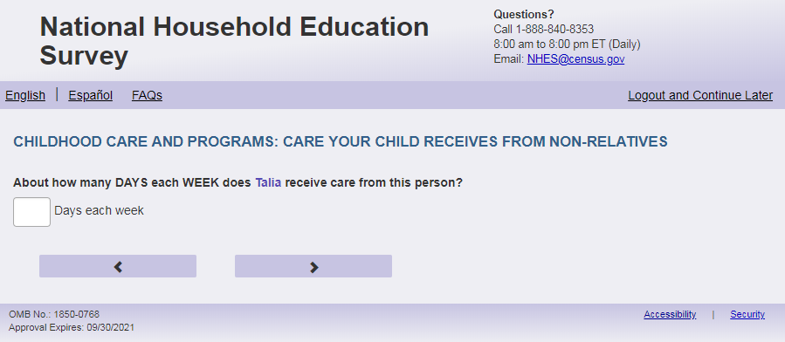

English Text Reads:
About how many DAYS each WEEK does [this child] receive care from this non-relative?

Spanish Text Reads:

Más o menos, ¿cuántos DÍAS a la SEMANA cuida esta persona que no es su pariente a [este niño (esta niña)]?

English and Spanish Answer:

ECPP_NCDAYS, (1,7), numeric, write-in,

Skips:
Go to ECPP_NCHRUNIT.
Logic Checks/Programming specifications:
English: Display "days each week" to right of box
Spanish: Display "días a la semana" to right of box
Mobile: Display numeric keypad
Text displayed for logic/range check violation
Logic/range check triggers a warning message, with the following text displayed.
English: [If 0 or more than 7] Display "Please check and make sure your answer is correct before continuing. Typically, care is between one and seven days."
Spanish [If 0 or more than 7] Display "Por favor, compruebe y asegúrese de que su respuesta es correcta antes de continuar. Por lo general, el cuidado es de entre uno y siete días"

Item: Hours of Non-Relative Care (ECPP_NCHRUNIT)
<New item for NHES:2023 – no screenshot available>
English Text Reads:
How would you like to report the hours that [this child] receives care from this non-relative?

Spanish Text Reads:

¿Cómo le gustaría responder sobre las horas que [este niño (esta niña)] recibe cuidado por parte de esta persona que no es su pariente?

English Answer
1=hours per week
2=hours per day

Spanish Answer:
1=horas a la semana
2=horas al día

ECPP_NCHRUNIT, (1,2), numeric, radio

Skips:
Go to ECPP_NCHRS

Item: Hours of Non-Relative Care (ECPP_NCHRS)
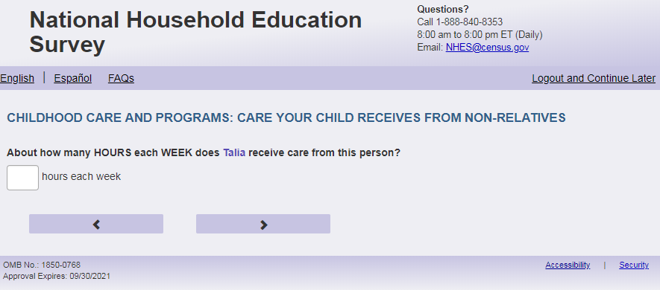
English Text Reads:

About how many HOURS each [unit] does [this child] receive care from this non-relative?

Spanish Text Reads:

Más o menos, ¿cuántas HORAS cada [unit] cuida esta persona que no es su pariente a [este niño (esta niña)]?

English and Spanish Answer:

ECPP_NCHRS, (0, 99), numeric, write-in

Skips:
Go to ECPP_ NCCVRWK
Logic Checks/Programming specifications:
English:

Fill for unit:
If ECPP_NCHRUNIT=1 or blank, then use “WEEK”
If ECPP_NCHRUNIT=2, then use “DAY”

If ECPP_NCHRUNIT=1 or blank, display “hours each week” to the right of box. Else display “hours each day” to the right of the box.

Spanish:
Fill for unit:
If ECPP_NCHRUNIT=1 or blank, then use “SEMANA”
If ECPP_NCHRUNIT=2, then use “DÍA”

if ECPP_NCHRUNIT=1 or blank, display “horas a la semana” to the right of box. Else display “horas al día” to the right of the box.
Mobile: Display numeric keypad

Text displayed for logic/range check violation
Logic/range check triggers a warning message, with the following text displayed.
For hours per day:
English: [If 0 or more than 16] Display “Please check your answer before continuing. Typically, children are in care between one and 16 hours per day.”
Spanish: [If 0 or more than 16] Display "Por favor, compruebe su respuesta antes de continuar. Por lo general, los niños están en cuidado entre una y 16 horas al día".
For hours per week:
English: [If 0 or more than 80] Display "Please check your answer before continuing. Typically, children are in care between one and 80 hours per week."
Spanish: [If 0 or more than 80] Display "Por favor, revise su respuesta antes de continuar. Por lo general, los niños están bajo cuidado entre una y 80 horas a la semana".

Item: Non-Relative Care Coverage For Work (ECPP_NCCVRWK)
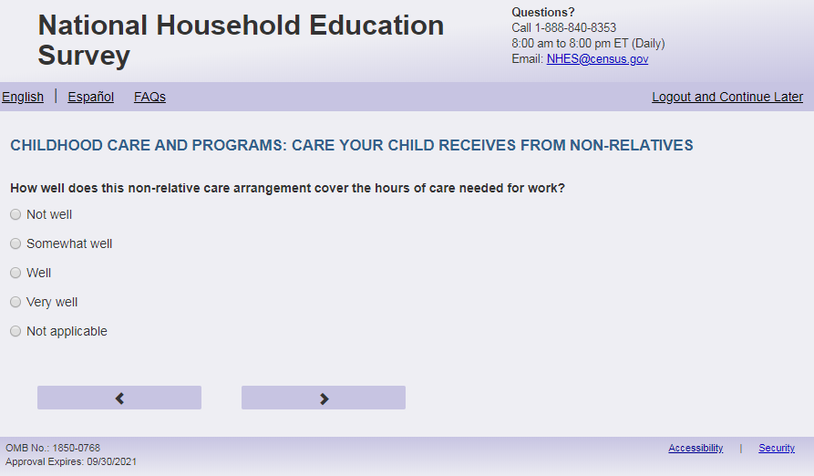
English Respondent text reads:
How well does this non-relative care arrangement cover the hours of care needed for work?
Spanish Respondent text reads:
¿Qué tan bien cubre esta persona que no es su pariente las horas que usted necesita para el cuidado de este niño(a) durante sus horas de trabajo??
English Admin/TQA text reads:
How well does this non-relative care arrangement cover the hours of care needed for work?
You can say they cover the hours needed for work “not well,” “somewhat well,” “well,” or “very well.”
{Do not read “Not applicable.” If the Respondent says they don’t work, select this answer, or if they hesitate, offer this “not applicable” option}
Spanish Admin/TQA text reads:
¿Qué tan bien cubre esta persona que no es su pariente las horas que usted necesita para el cuidado de este niño(a) durante sus horas de trabajo??
Puede decir que cubren las horas necesarias para el trabajo "nada bien", "más o menos bien", "bien" o "muy bien".
{No lea "No aplica". Si el encuestado dice que no trabaja, seleccione esta respuesta, o si duda, ofrezca la opción "no aplica".}
English Answers:
1=Not well
2=Somewhat well
3=Well
4=Very well
5=Not applicable

Spanish Answers:
1=Nada bien
2= Más o menos bien
3 = Bien
4=Muy Bien
5= No aplica

ECPP_ NCCVRWK, (1,5), numeric, radio
Skips:
Go to ECPP_ NCSTRTY
Logic Checks/Programming specifications
Increase spacing between response options “Very Well” (ECPP_NCCVRWK = 4) and “Not Applicable” (ECPP_NCCVRWK = 5) about double the typical spacing between response options Apply to Spanish response options.

Item: Child’s Age in Years at Start of Non-Relative Care (ECPP_NCSTRTY)
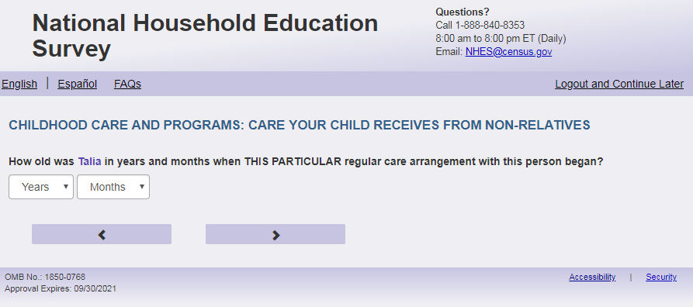
English Text Reads:
How old was [this child] in years and months when THIS PARTICULAR regular care arrangement with this non-relative began?

Spanish Text Reads:

¿Qué edad tenía [este niño (esta niña)], en años y meses, cuando comenzó este arreglo regular ESPECÍFICO con esta persona que no es su pariente?

English and Spanish Answer:

Drop down (ECPP_NCSTRTY), (0, 6), numeric, drop down
Drop down (ECPP_NCSTRTM), (0, 11), numeric, drop down

Skips:
Go to ECPP_NCALKNE
Logic Checks/Programming specifications:
Allow respondents to scroll the options within drop-down.
Only display options that are equal to or less than child's current age from Screener.

English:
Display ‘months’ as label above the ECPP_NCSTRTM dropdown box and leave the dropdown box blank.
Display ‘years’ as label above the ECPP_NCSTRTY dropdown box and leave the dropdown box blank.
Spanish:
Display ‘meses’ as label above the ECPP_NCSTRTM dropdown box and leave the dropdown box blank.
Display ‘años’ as label above the ECPP_NCSTRTY dropdown box and leave the dropdown box blank.

Item: Knew of Non-Relative Care (ECPP_NCALKNE)
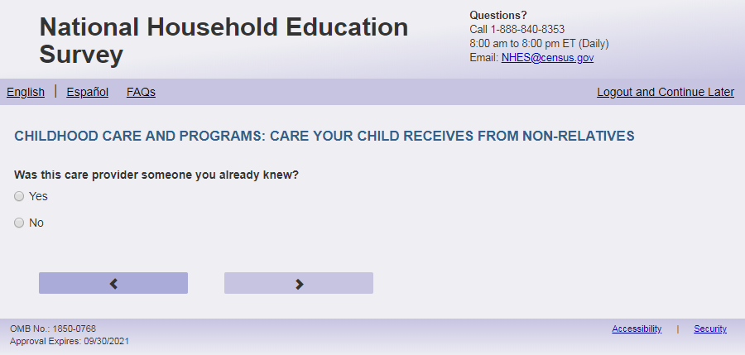
English Text Reads:
Was this care provider someone you already knew?

Spanish Text Reads:

¿Era esta persona que cuida niños(as) alguien a quien usted ya conocía?

English Answer:

1=Yes
2= No

Spanish Answer:

1= Sí
2=No

ECPP_ NCALKNE, (1,2), numeric, radio
Skips:
Go to ECPP_NCAGE

Item: Age of Non-Relative Care (ECPP_NCAGE)
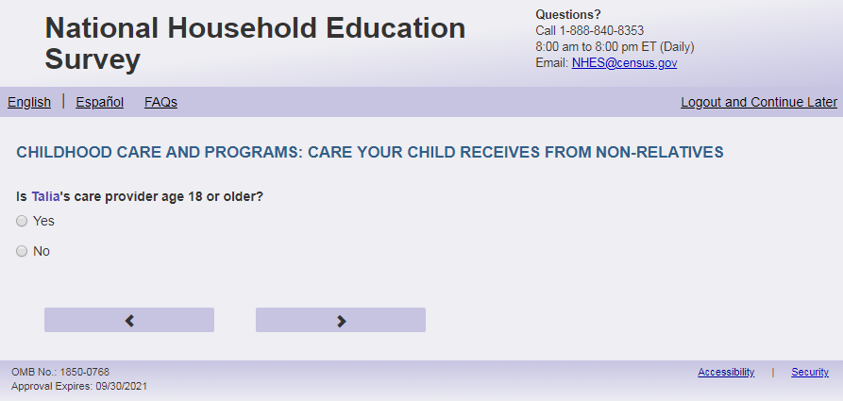
English Text Reads:
Is [this child]’s non-relative care provider age 18 or older?

Spanish Text Reads:

¿Es esta persona que no es su pariente y que cuida a [este niño (esta niña)] mayor de 18 años?

English Answer:

1=Yes
2=No

Spanish Answer:

1= Sí
2=No

ECPP_NCAGE, (1,2), numeric, radio

Skips:
Go to ECPP_NCSPEAK

Item: Language of Non-Relative Care Provider (ECPP_NCSPEAK)
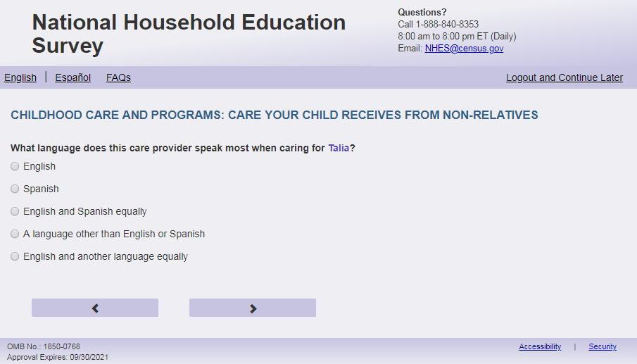
English Respondent Text Reads:
What language does this non-relative care provider speak most when caring for [this child]?

Spanish Respondent Text Reads:

¿Qué idioma habla más esta persona que no es su pariente cuando está cuidando a [este niño (esta niña)]?

English Admin/TQA Text Reads:
What language does this non-relative care provider speak most when caring for [this child]?
{Read answer options to the respondent.}

Spanish Admin/TQA Text Reads:

¿Qué idioma habla más esta persona que no es su pariente cuando está cuidando a [este niño (esta niña)]?
{Lea las opciones de respuesta al encuestado.}

English Answer:

1= English
2= Spanish
3= English and Spanish equally
4= A language other than English or Spanish
5= English and another language equally

Spanish Answer:

1= Inglés
2= Español
3= Inglés y español por igual
4= Otro idioma aparte del inglés o español
5= Inglés y otro idioma por igual

ECPP_NCSPEAK, (1,5), numeric, radio

Skips:
Go to ECPP_NCSKNFV

Item: Non-Relative Care with Sick Child but No Fever (ECPP_NCSKNFV)
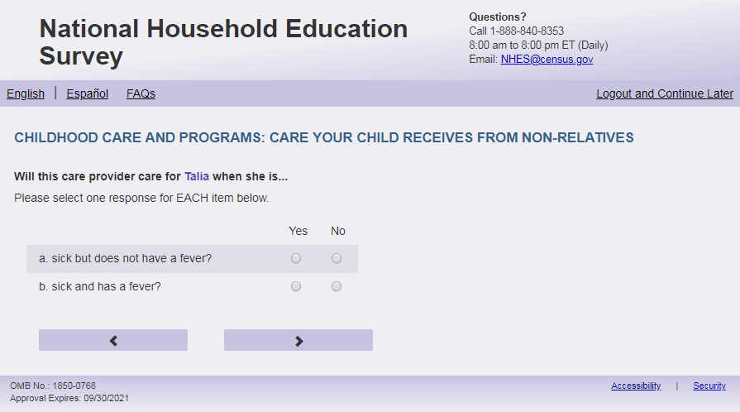
English Respondent Text Reads:
Will this non-relative care for [this child] when [he/she/he or she] is…

- sick but does not have a fever? (ECPP_NCSKNFV, (1=Yes, 2=No), numeric)
- sick and has a fever? (ECPP_ NCSKFV, (1=Yes, 2= No), numeric)

Spanish Respondent Text Reads:

¿Esta persona que no es su pariente lo/la cuida si [este niño (esta niña)]…

- enfermo pero no tiene fiebre? (ECPP_ NCSKNFV, (1=Sí, 2= No), numeric)
- enfermo y tiene fiebre? (ECPP_ NCSKFV, (1=Sí, 2= No), numeric)

English Admin/TQA Text Reads:
Will this non-relative care for [this child] when [he/she/he or she] is sick but does not have a fever? (ECPP_NCSKNFV, (1=Yes, 2=No), numeric)

Will this non-relative care for [this child] when [he/she/he or she] is sick and has a fever? (ECPP_ NCSKFV, (1=Yes, 2= No), numeric)

Spanish Admin/TQA Text Reads:

¿Esta persona que no es su pariente lo/la cuida si [este niño (esta niña)] está enfermo pero no tiene fiebre? (ECPP_ NCSKNFV, (1=Sí, 2= No), numeric)

¿Esta persona que no es su pariente lo/la cuida si [este niño (esta niña)] está enfermo y tiene fiebre? (ECPP_ NCSKFV, (1=Sí, 2= No), numeric)

Logic Checks/Programming specifications:
For respondent text display as grid and remove swim lanes
For Admin/TQA display as two items on the screen (not as a grid)
English:
If S1_Pxsex = 1, use ‘he’, if s1_pxsex = 2, use ‘she’, else use ‘he or she’
Skips:
Go to ECPP_NCOTCH

Item: Non-Relative Care Other Children (ECPP_NCOTCH)
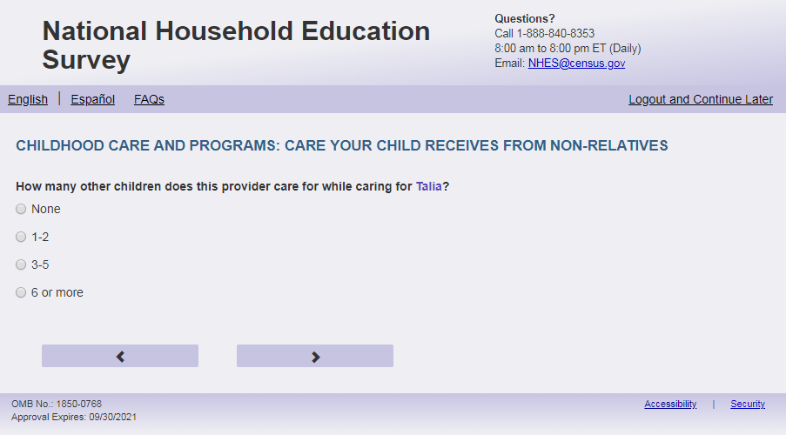
English text reads:
How many other children does this non-relative care for while caring for [this child]?
Spanish text reads:
¿Mientras esta persona que no es su pariente cuida a [este niño (esta niña)], a cuántos otros niños cuida?
English answer:
1=None
2=1 to 2
3=3 to 5
4=6 or more

Spanish answer:
1 = Ninguno
2=1 a 2
3=3 a 5
4=6 o más

ECPP_NCOTCH, (1,4), numeric, radio

Skips:
Go to ECPP_NCRCMDPT

Item: Non-Relative Care Recommendation (ECPP_NCRCMDPT)
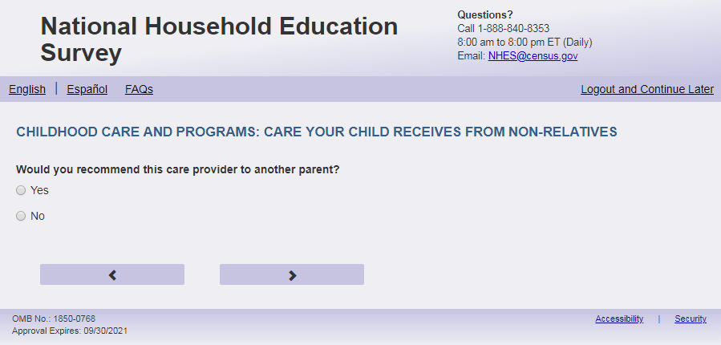
English Text Reads:
Would you recommend this non-relative care provider to another parent?

Spanish Text Reads:

¿Le recomendaría esta persona que no es su pariente a otros padres?

English Answer:

1=Yes
2=No

Spanish Answer:

1= Sí
2=No

ECPP_NCRCMDPT, (1,2), numeric, radio

Skips:
Go to ECPP_NCFEE

Item: Fee by Non-Relative Care Provider (ECPP_NCFEE)
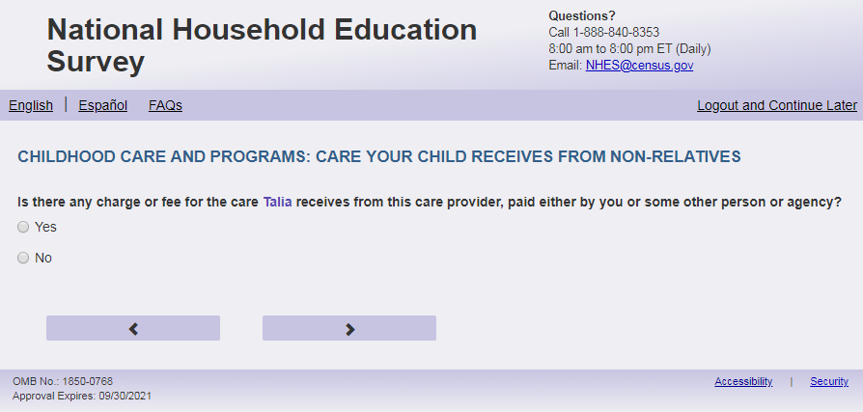
English Text Reads:
Is there any charge or fee for the care [this child] receives from this non-relative, paid either by you or some other person or agency?

Spanish Text Reads:

¿Hay algún costo o pago por el cuidado que [este niño (esta niña)] recibe por parte de esta persona que no es su pariente, ya sea que lo pague usted u otra persona o agencia?

English Answer:

1=Yes
2=No

Spanish Answer:

1= Sí
2=No

ECPP_NCFEE, (1,2), numeric, radio

Skips:
If ECPP_NCFEE = 2 then go to ECPP_NCOTHC. Else go to ECPP_NCREL.

tem: Non-Relative Care Paid by an Organization (ECPP_NCREL)
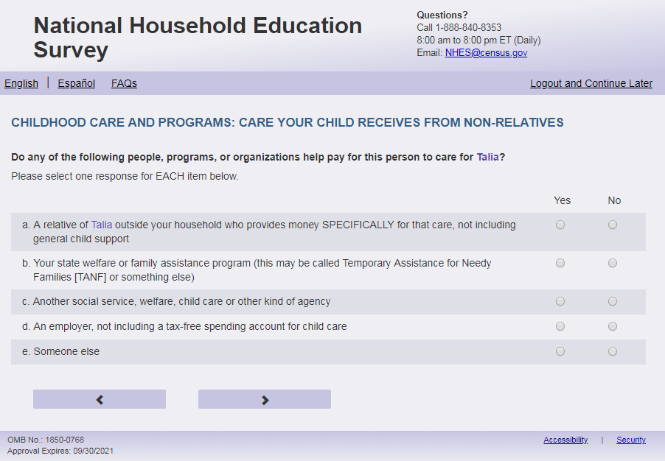
English Respondent Text Reads:
Do any of the following people, programs, or organizations help pay for this non-relative to care for [this child]?

Spanish Respondent Text Reads:
¿Alguna de las siguientes personas, programas u organizaciones le ayuda a pagarle a esta persona que no es su pariente por el cuidado de [este niño (esta niña)]?

English Admin/TQA Text Reads:
Do any of the following people, programs, or organizations help pay for this non-relative to care for [this child]?
Please answer ‘yes’ or ‘no’ for EACH item as I read them.
{Please re-read the question if the respondent asks or seems to have forgotten the question}

Spanish Admin/TQA Text Reads:
¿Algunas de las siguientes personas, programas u organizaciones le ayuda a pagarle a esta persona que no es su pariente por el cuidado de [este niño (esta niña)]?
Por favor, responda 'sí' o 'no' para CADA opción a medida que los leo.
{Por favor, vuelva a leer la pregunta si la encuestada pregunta o parece haber olvidado la pregunta}

English Answer:

- A relative of [this child] outside your household who provides money SPECIFICALLY for that care, not including general child support, ECPP_NCREL, (1=Yes, 2=No), numeric, radio
- Your state welfare or family assistance program (this may be called Temporary Assistance for Needy Families [TANF] or something else), ECPP_NCTANF, (1=Yes, 2=No), numeric, radio
- Another social service, welfare, child care, or other kind of agency, ECPPP_NCSSAC, (1=Yes, 2=No), numeric, radio
- An employer, not including a tax-free spending account for child care, ECPP_NCEMPL, (1=Yes, 2=No), numeric, radio
- Someone else, ECPP_NCOTHER, (1=Yes, 2=No), numeric, radio

Spanish Answer:

- Un pariente de [este niño (esta niña)] que no vive en su hogar y da dinero para pagar ESPECÍFICAMENTE por ese cuidado, sin incluir manutención para niños(as), ECPP_NCREL, (1=Sí, 2=No), numeric, radio
- Programa de asistencia social o familiar de su estado (puede ser Asistencia Temporal a Familias Necesitadas [TANF por sus siglas en ingles] o algo similar, ECPP_NCTANF, (1=Sí, 2=No), numeric, radio
- Otro servicio social, asistencia social, cuidado infantil, u otro tipo de agencia ECPP_NCSSAC, (1=Sí, 2=No), numeric, radio
- Un empleador, sin incluir cuentas especiales para pagos de cuidado infantil libres de impuestos, ECPP_NCEMPL, (1=Sí, 2=No), numeric, radio
- Alguien más, ECPP_NCOTHER, (1=Sí, 2=No), numeric, radio

Skips:
Go to ECPP_NCUNIT
Logic Checks/Programming specifications:
Display as grid
If child’s name is available on screener, use child’s name for response option a “A relative of [name of child] outside your household who provides money SPECIFICALLY for that care, not including general child support”. If child’s name is not available, use “this child” as fill. (Spanish: este niño (esta niña))

Item: Non-Relative Care Paid by Household (ECPP_NCUNIT)
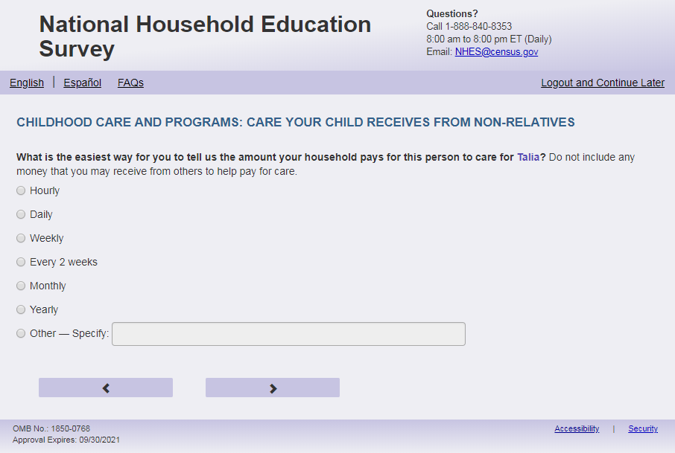
English Respondent Text Reads:
What is the easiest way for you to tell us the amount your household pays for this non-relative to care for [this child]? Do not include any money that you may receive from others to help pay for care.

Spanish Respondent Text Reads:

¿Cuál es la forma más fácil para decirnos cuánto le paga este hogar a esta persona que no es su pariente por el cuidado de [este niño]? No incluya el dinero que reciba de otras personas para pagar los gastos del cuidado.

English Admin/TQA Text Reads:
What is the easiest way for you to tell us the amount your household pays for this non-relative to care for [this child]? Do not include any money that you may receive from others to help pay for care.
{Read the answer options to the respondent. You do not need to read “Other.”}

Spanish Admin/TQA Text Reads:

¿Cuál es la forma más fácil para decirnos cuánto le paga este hogar a esta persona que no es su pariente por el cuidado de [este niño ]? No incluya el dinero que reciba de otras personas para pagar los gastos del cuidado.
{Lea las opciones de respuesta al encuestado. Tampoco es necesario leer "Otro."}

English Answer:
1= Hourly
2= Daily
3= Weekly
4= Every 2 weeks
5= Monthly
6= Yearly
7 = Other - Specify

Spanish Answer:
1= Por hora
2= Por día
3= Por semana
4= Quincena (cada 2 semanas)
5= Por mes
6= Por año
7= Otra - Especifíque:

ECPP_NCUNIT, (1,7), numeric, radio. If 7 selected, specify box should become active (ECPP_NCUNITOS): (0,200), character, write-in. Display specify response box 1 row by 50 characters.

Skips:

If only 1 person on Screener is under 18 years of age (s1_PxDOBYY gt 2005 or age lt 18), go to ECPP_NCCOST. Else if any age on screener is blank for any person, or there is more than 1 person under 18, then go to ECPP_NCCSTHNX.

Item: Non-Relative Care Fee for No. of Children (ECPP_NCCSTHNX)
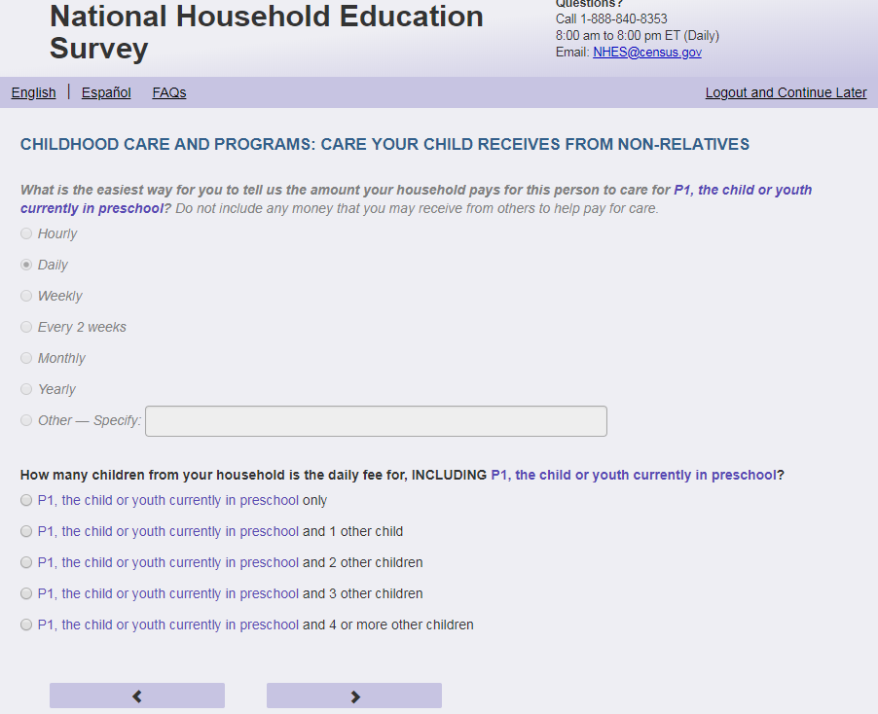
English Text Reads:
How many children from your household is this [ECPP_NCUNIT] amount for, INCLUDING [this child]?

Spanish Text Reads:

¿Para cuántos niños de su hogar, INCLUYENDO a [este(a) niño(a)] es la cantidad [ECPP_NCUNIT]?

English Answer

1= [This child] only
2= [This child] and 1 other child
3= [This child] and 2 other children
4= [This child] and 3 other children
5= [This child] and 4 or more other children

Spanish Answer

1= Sólo para [este niño (esta niña)]
2= [Este niño (esta niña)] y otro 1 niño(a)
3= [Este niño (esta niña)] y otros 2 niños(as)
4= [Este niño (esta niña)] y otros 3 niños(as)
5= [Este niño (esta niña)] y otros 4 o más niños(as)

ECPP_NCCSTHNX, (1,5), numeric, radio

Skips:

Go to ECPP_NCCOST
Logic Checks/Programming specifications:
Fill ECPP_NCUNIT with response category from ECPP_NCUNIT. If ECPP_NCUNIT = 7, and ECPP_NCUNITOS = ' ', do not include a fill. And have it read English: '..is the fee for, ..’ and Spanish: ‘..es la tarifa,..’.

Don’t display on same page as ECPP_NCUNIT. Display on a new screen.

Don't display this item if only one child (18 and under) was entered on the screener. If any age is blank show item.

Display options corresponding to number of children (18 and under) in HH from screener. If any age is blank, show all options.

For English answers, if child’s name is available on screener, use child’s name for response options 1 through 5. If child’s name is not available, use “this child”:
1= [Name of the child] only
2= [Name of the child] and 1 other child
3= [Name of the child] and 2 other children
4= [Name of the child] and 3 other children
5= [Name of the child] and 4 or more other children

For Spanish answers, if child’s name is available on screener, use child’s name for response options 1 through 5. If child’s name is not available, use “Este niño (esta niña)”:
1= Sólo para [este niño(a)]
2= [Este niño (esta niña)] y otro niño(a)
3= [Este niño (esta niña)] y otros 2 niños(as)
4= [Este niño (esta niña)] y otros 3 niños(as)
5= [Este niño (esta niña)] y otros 4 o más niños(as)

Item: Non-Relative Care Amount Paid by Household (ECPP_NCCOST)
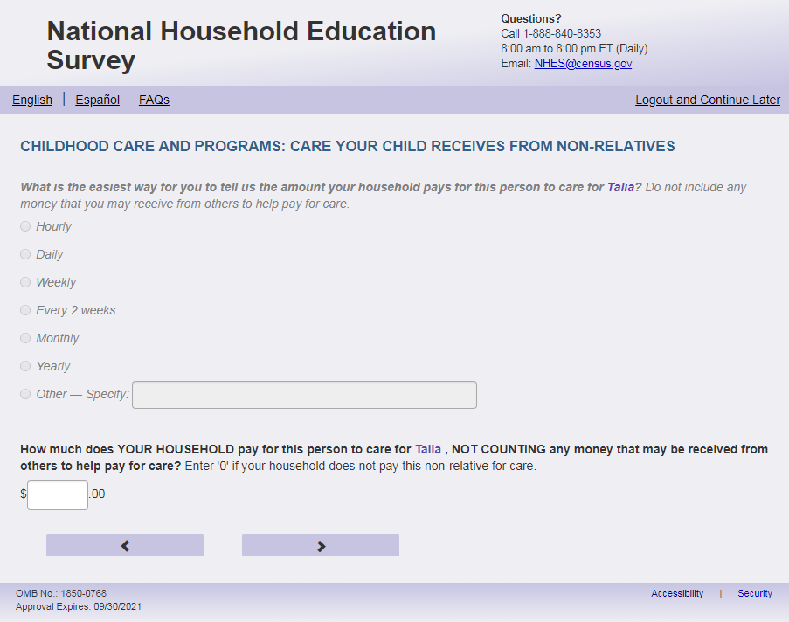
English Respondent Text Reads:
How much does YOUR HOUSEHOLD pay for this non-relative to care for [this child] [ECPP_NCUNIT], NOT COUNTING any money that may be received from others to help pay for care? Enter '0' if your household does not pay this non-relative for care.

Spanish Respondent Text Reads:

¿Cuánto paga SU HOGAR a esta persona que no es su pariente por el cuidado de [este(a) niño(a)] [ECPP_NCUNIT], SIN INCLUIR dinero que reciba de otras personas para ayudarle a pagar el cuidado del niño(a)? Ingrese ´0´si su hogar no le paga a esta persona que no es su pariente por el cuidado de este niño(a).

English Admin/TQA Text Reads:
How much does YOUR HOUSEHOLD pay for this non-relative to care for [this child] [ECPP_NCUNIT], NOT COUNTING any money that may be received from others to help pay for care?
{Enter '0' if the household does not pay this non-relative for care.}

Spanish Admin/TQA Text Reads:

¿Cuánto paga SU HOGAR a esta persona que no es su pariente por el cuidado de [este(a) niño(a)] [ECPP_NCUNIT], SIN INCLUIR dinero que reciba de otras personas para ayudarle a pagar el cuidado del niño(a)?
{ Ingrese ´0´si el hogar no le paga a esta persona que no es su pariente por el cuidado de este niño(a).}

English and Spanish Answer

ECPP_NCCOST, (0, 99999), numeric, write-in

Skips:

Go to ECPP_NCOTHC.

Logic Checks/Programming specifications:
Fill [ECPP_NCUNIT] with response category from ECPP_NCUNIT.

Right justify the numbers that the respondent types in, this way they may see the .00.

If ECPP_NCUNIT = 7, and ECPP_NCUNITOS = ' ', do not include a fill.

Display on a new screen. Don’t display on same page ECPP_NCUNIT and ECPP_NCCSTHNX.

Display "$" to the left of the box. Display ".00" to the right of the box. Right-justified and will enter the response box from the right side. If a numerical response contains more than three digits, a comma will be auto-filled.
Mobile: Display numeric keypad

Item: Other Non-Relative Care (ECPP_NCOTHC)
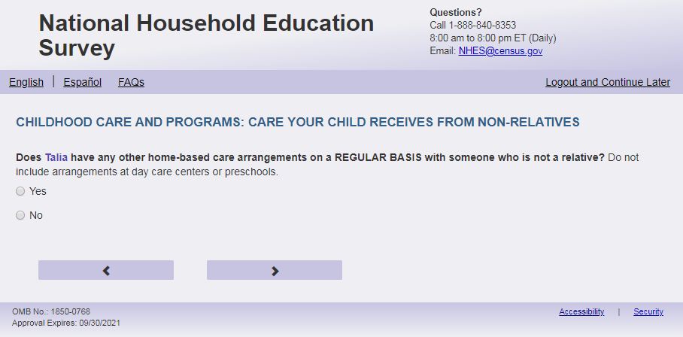
English Text Reads:
Does [this child] have any other home-based care arrangements on a REGULAR BASIS with someone who is not a relative? Do not include arrangements at day care centers or preschools.

Spanish Text Reads:

¿Alguna otra persona que no es pariente cuida a [este niño (esta niña)] con REGULARIDAD? No incluya el cuidado en guarderías o programas preescolares.

English Answer

1=Yes
2=No

Spanish Answer

1= Sí
2=No

ECPP_NCOTHC, (1,2), numeric, radio

Skips:

If ECPP_CARE_VER=2 and ECPP_NCOTHC = 2 then go to ECPP_CPNNOWX. Else if ECPP_CARE_VER=1 and ECPP_NCOTHC=2 and ECPP_CPPCARE=1 or blank, then go to ECPP_CPTYPE. Else if ECPP_CARE_VER=1 and ECPP_NCOTHC=2 and ECPP_CPPCARE=2 then go to ECPP_PCEVRHDX. Else go to ECPP_NCTLHR.

Item: Other Non-Relative Care Hours (ECPP_NCTLHR)
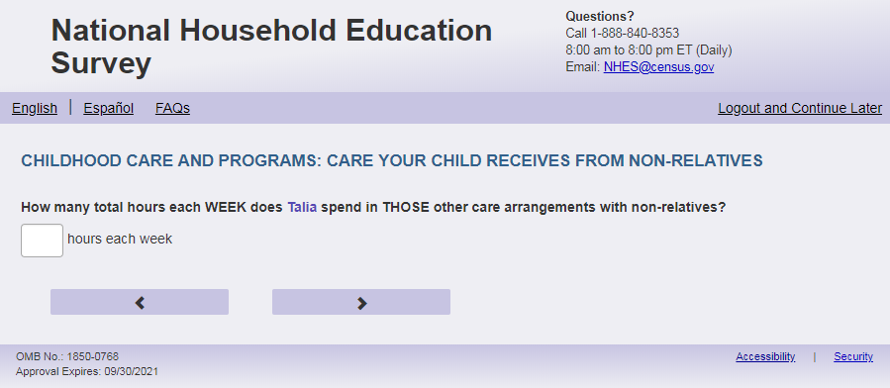
English Text Reads:
How many total hours each WEEK does [this child] spend in THOSE OTHER care arrangements with non-relatives?

Spanish Text Reads:

¿Cuántas horas en total a la SEMANA pasa [este niño (esta niña)] en el cuidado de ESAS OTRAS personas que no son parientes?

English and Spanish Answer

ECPP_NCTLHR, (0, 99), numeric, write-in

Skips:

If ECPP_CARE_VER = 1 and CPPCARE = 1 or blank, go to ECPP_CPTYPE. Else if ECPP_CARE_VER=1 and CPPCARE=2, go to ECPP_ PCEVRHDX.
Else go to ECPP_CPNNOWX.

Logic Checks/Programming specifications:
English: Display "hours each week" to right of box.
Spanish: Display “horas a la semana” to right of box.
Mobile: Display numeric keypad

Text displayed for logic/range check violation
Logic/range check triggers a warning message, with the following text displayed.
English: [If 0 or more than 80] Display "Please check your answer before continuing. Typically, children who are in care arrangements with two different non-relatives are with the second non-relative between one and 80 hours per week.”
Spanish: [If 0 or more than 80] Display "Por favor, compruebe su respuesta antes de continuar. Por lo general, los niños que están en arreglos de cuidado con dos personas que no son sus parientes están con la segunda persona que no es su pariente entre una y 80 horas a la semana."

Item: Childcare Centers and Programs (ECPP_CPNNOWX)
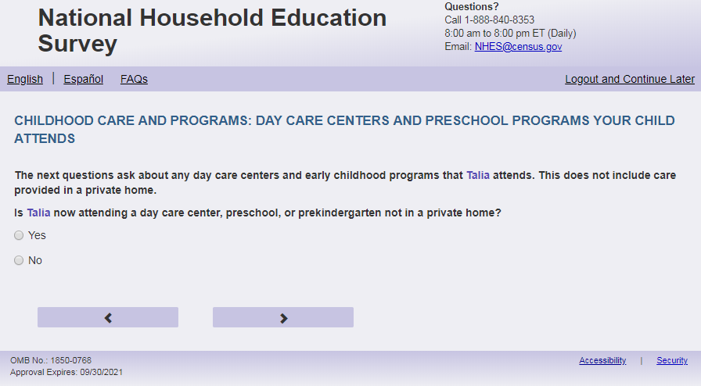
English Text Reads:
The next questions ask about any day care centers and early childhood programs that [this child] attends. This does not include care provided in a private home.

Is [this child] now attending a day care center, preschool, or prekindergarten not in a private home?

Spanish Text Reads:

Las siguientes preguntas se tratan de las guarderías y los programas de educación temprana a los que [este niño (esta niña)] asiste. Esto no incluye el cuidado que [este niño (esta niña)] recibe en un hogar privado.

Actualmente, ¿asiste [este niño (esta niña)] a una guardería, programa preescolar o prekindergarten que no sea en un hogar privado?

English Answers

1=Yes
2=No

Spanish Answers

1= Sí
2= No

ECPP_CPNNOWX, numeric, radio

Skips:
If ECPP_CPNNOWX = 2 then go to ECPP_PCEVRHDX. Else go to ECPP_CPWEEKX.
Logic Checks/Programming specifications:
Only display this screen if ECPP_CARE_VER =2

Item: Attends Childcare Centers and Programs (ECPP_CPWEEKX)
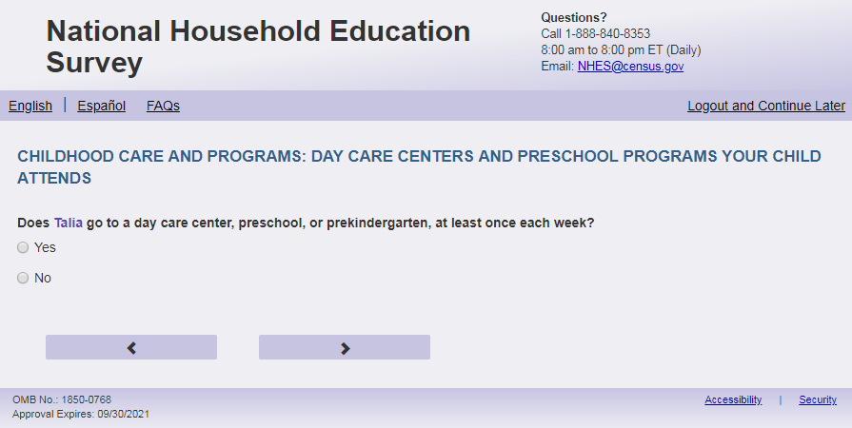
English Text Reads:
If not in the split panel (ECPP_CARE_VER = 2), then:

Does [this child] go to a day care center, preschool, or prekindergarten, at least once each week?

If in the split panel (ECPP_CARE_VER = 1), then:

Does [this child] attend the [program] regularly at least once a week?

Spanish Text Reads:

If not in the split panel (ECPP_CARE_VER = 2), then:

¿Va [este niño (esta niña)] a una guardería, programa preescolar o a un prekindergarten por lo menos una vez a la semana?

If in the split panel (ECPP_CARE_VER = 1), then:

¿Va [este niño (esta niña)] a el [programa] por lo menos una vez a la semana?

English Answer

1= Yes
2=No

Spanish Answer

1= Sí
2= No

ECPP_CPWEEKX, (1,2), numeric, radio

Skips: If ECPP_CARE_VER=1 and ECPP_CPWEEKX =1 or blank, go to ECPP_CPPLACEX. Else if ECPP_CARE_VER=2 and ECPP_CPWEEKX = 1 or blank then go to ECPP_CPTYPE. Else go to ECPP_PCEVRHDX.

Logic Checks/Programming specifications:
English:
If ECPP_CARE_VER=1, then use the following fill for program:
If ECPP_CPTYPE is not blank, use ECPP_CPTYPE + program answer as “program” fill. If ECPP_CPTYPE blank, simply use 'program'.
Spanish:
If ECPP_CARE_VER=1, then use the following fill for program:
If ECPP_CPTYPE is not blank, use programa + ECPP_CPTYPE answer as “programa” fill. If ECPP_CPTYPE blank, simply use 'programa'.

Item: Type of Childcare Centers and Programs (ECPP_CPTYPE)
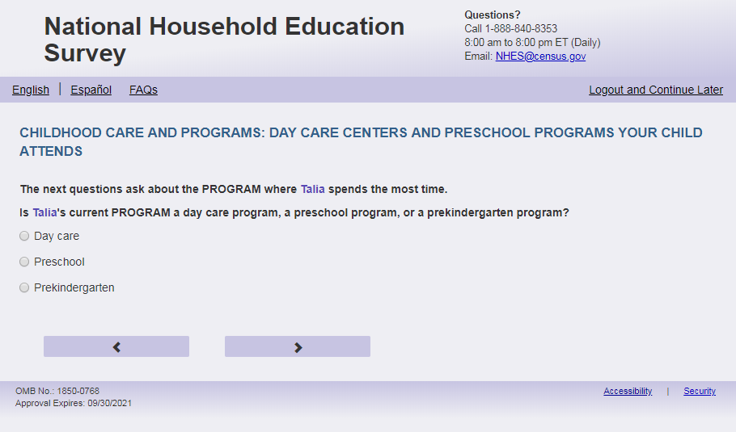
English text Reads:
If not in the split panel (ECPP_CARE_VER=2) then:
The next questions ask about the PROGRAM where [this child] spends the most time.

Is [this child]’s current PROGRAM a day care program, a childcare center program, a preschool program, or a prekindergarten program?

If in the split panel (ECPP_CARE_VER=1) then:
We are interested in learning more about day care centers and early childhood programs that [this child] attends. The next questions ask about the PROGRAM where [this child] spends the most time.

How would you like to refer to that program in these questions? There are no right or wrong answers.

Spanish text Reads:

If not in the split panel (ECPP_CARE_VER=2) then:

¿Es el PROGRAMA actual de [este niño (esta niña)] un programa de guardería, centro de cuidado infantil, preescolar o de prekindergarten?

Las siguientes preguntas se tratan del PROGRAMA en el cual [este niño (esta niña)] pasa la mayoría del tiempo.

If in the split panel (ECPP_CARE_VER=1) then:

Nos interesa saber sobre los centros de cuidado infantil y programas de educación temprana que atiende [este niño (esta niña)]. Las siguientes preguntas se tratan del PROGRAMA en el cual [este niño (esta niña)] pasa la mayoría del tiempo.

¿Cómo le gustaría referirse a ese programa en estas preguntas? No existen respuestas correctas o incorrectas.

English Answer:
1= Day care
2=Childcare center
3= Preschool
4= Prekindergarten

Spanish Answer:
1= Guardería
2= Centro de cuidado infantil
3= Preescolar
4= Prekindergarten

ECPP_CPTYPE, (1,4) numeric, radio

Skips:

If ECPP_CARE_VER=1, then go to CPWEEKX. Else, go to ECPP_CPPLACEX.

Item: Program Location (ECPP_CPPLACEX)
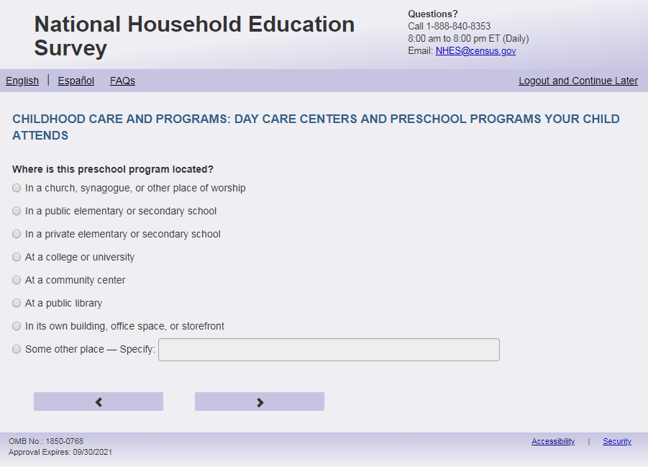
English Respondent Text Reads:
Where is this [program] located?

Spanish Respondent Text Reads:

¿Dónde queda este [programa]?

English Admin/TQA Text Reads:
Where is this [program] located?

{Please read response options}

Spanish Admin.TQA Text Reads:

¿Dónde queda este [programa]?

{Por favor, lea las opciones de respuesta.}

English Answers:

1= In a church, synagogue, or other place of worship
2= In a public elementary or secondary school
3= In a private elementary or secondary school
4= At a college or university
5= At a community center
6= At a public library
7= In its own building, office space, or storefront
8 = Some other place - Specify

Spanish Answers:

1= En una iglesia, sinagoga u otro lugar religioso
2= En una escuela primaria o secundaria pública
3= En una escuela primaria o secundaria privada
4= En una universidad
5= En un centro comunitario
6= En una biblioteca pública
7= Tiene su propio edificio, oficina o local
8= Algún otro lugar - especifique:

ECPP_CPPLACEX, (1,8) numeric, radio. If 8 is selected, have write-in next to radio box activate (ECPP_CPPLACEXOS, (0, 200), character, Write-in). Write-in box should be 1 row by 50 characters.

Skips:

Go to ECPP_CPRELIGC.

Logic Checks/Programming specifications:
English: Use ECPP_CPTYPE + program answer as “program” fill. If ECPP_CPTYPE blank, simply use 'program'.
Spanish: Use programa + ECPP_CPTYPE answer as “programa” fill. If ECPP_CPTYPE blank, simply use 'programa'.

Item: Program Teach Religion (ECPP_CPRELIGC)
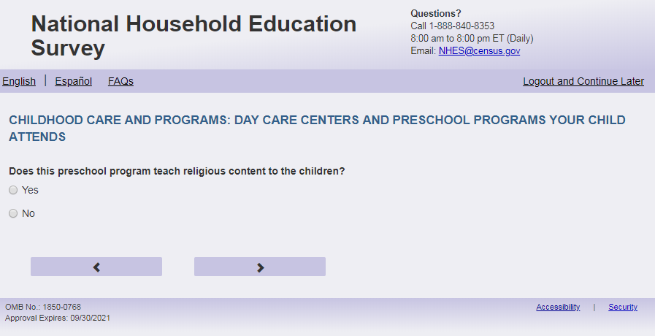
English Text Reads:
Does this [program] teach religious content to the children?

Spanish Text Reads:

¿Este [programa] enseña contenido religioso a los niños?

English Answers:

1=Yes
2=No

Spanish Answers:

1= Sí
2=No

ECPP_CPRELIGC, (1,2), numeric, radio

Skips:

Go to ECPP_CPWORK.

Logic Checks/Programming specifications:
English: Use ECPP_CPTYPE + program answer as “program” fill. If ECPP_CPTYPE blank, simply use 'program'.
Spanish: Use programa + ECPP_CPTYPE answer as “programa” fill. If ECPP_CPTYPE blank, simply use 'programa'.

Item: Program at Workplace (ECPP_CPWORK)
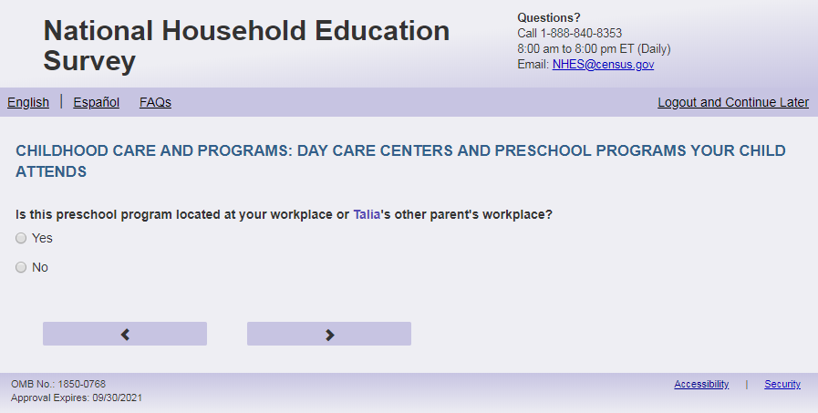
English Text Reads:
Is this [program] located at your workplace or [this child]’s other parent’s workplace?

Spanish Text Reads:

¿Está este [programa] en su lugar de trabajo o en el lugar de trabajo del otro padre o madre de [este niño (esta niña)]?

English Answers:

1=Yes
2=No

Spanish Answers:

1= Sí
2=No

ECPP_CPWORK, (1,2), numeric, radio

Skips:

Go to ECPP_CPHEADST.

Logic Checks/Programming specifications:
English: Use ECPP_CPTYPE + program answer as “program” fill. If ECPP_CPTYPE blank, simply use 'program'.
Spanish: Use programa + ECPP_CPTYPE answer as “programa” fill. If ECPP_CPTYPE blank, simply use 'programa'.

Item: Head Start Programs (ECPP_CPHEADST)
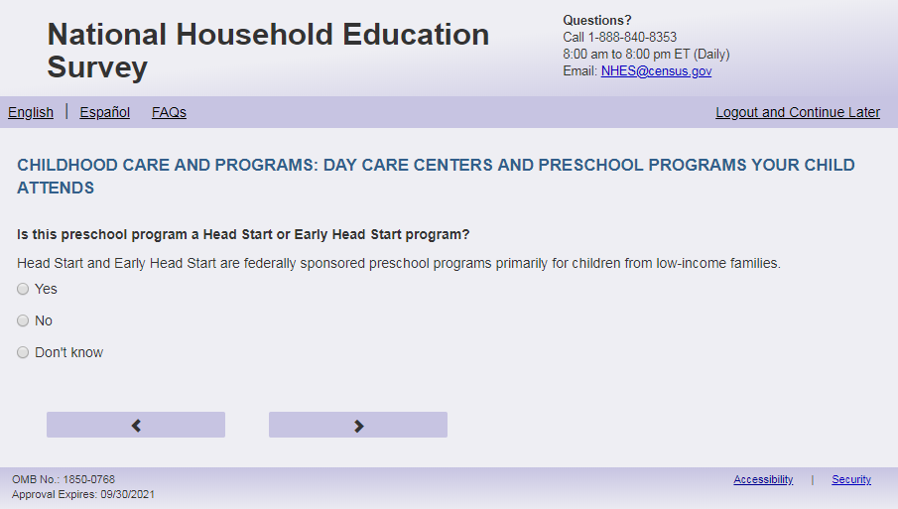
English Respondent Text Reads:
Is this [program] a Head Start or Early Head Start program?
Head Start and Early Head Start are federally sponsored preschool programs primarily for children from low-income families.

Spanish Respondent Text Reads:

¿Es este tipo de [programa] de Head Start o de Early Head Start?
Los programas de Head Start y de Early Head Start son programas preescolares patrocinados por el gobierno federal y orientados principalmente a niños(as) de familias de bajos ingresos.

English Admin/TQA Text Reads:
Is this [program] a Head Start or Early Head Start program?
{Read definition only if the respondent asks what Head Start is, or if they hesitate answering.}
[The term “Head Start or Early Head Start” should be an active link for the Admin/TQA screen. Add definition hover over “Head Start or Early Head Start”: Head Start and Early Head Start are federally sponsored preschool programs primarily for children from low-income families]

Spanish Admin/TQA Text Reads:

¿Es este tipo de [programa] de Head Start o de Early Head Start?
{Lea la definición solo si el encuestada pregunta qué es Head Start, o si duda al responder.}[The term “de Head Start o de Early Head Start” should be an active link for the Admin/TQA screen. Add definition hover over “de Head Start o de Early Head Start”: Los programas de Head Start y de Early Head Start son programas preescolares patrocinados por el gobierno federal y orientados principalmente a niños(as) de familias de bajos ingresos.]

English Answers:

1=Yes
2 =No
3= Don’t know

Spanish Answers:

1= Sí
2=No
3= No lo sé

ECPP_CPHEADST, (1,3), numeric, radio

Skips:

Go to ECPP_CPDAYS.

Logic Checks/Programming specifications:
English: Use ECPP_CPTYPE + program answer as “program” fill. If ECPP_CPTYPE blank, simply use 'program'.
Spanish: Use programa + ECPP_CPTYPE answer as “programa” fill. If ECPP_CPTYPE blank, simply use 'programa'.
For the Admin/TQA screen: Definition should appear as pop-out text boxes when clicking the phrase “Head Start or Early Head Start”/“ de Head Start o de Early Head Start”

Item: Days at Program (ECPP_CPDAYS)
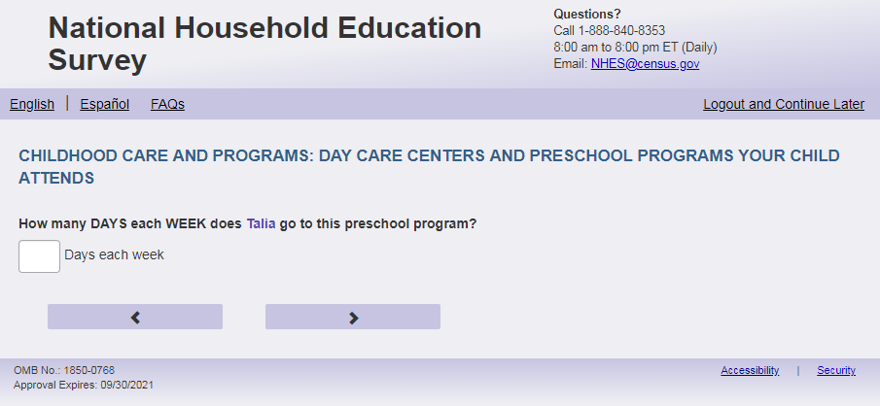
English Text Reads:
About how many DAYS each WEEK does [this child] go to this [program]?

Spanish Text Reads:

Más o menos, ¿cuántos DÍAS a la SEMANA asiste [este niño (esta niña)] a este [programa]?

English and Spanish Answers:

ECPP_CPDAYS, (1, 7), numeric, write-in

Skips:

Go to ECPP_CPHRUNIT

Logic Checks/Programming specifications:
English: Display "days each week” to the right of box. Use ECPP_CPTYPE + program answer as “program” fill. If ECPP_CPTYPE blank, simply use 'program'.
Spanish: Display "días a la semana” to the right of box. Use programa + ECPP_CPTYPE answer as “program” fill. If ECPP_CPTYPE blank, simply use 'programa'.
Mobile: Display numeric keypad
Text displayed for logic/range check violation
Logic/range check triggers a warning message, with the following text displayed.
English: [If 0 or more than 7] Display "Please check and make sure your answer is correct before continuing. Typically, care is between one and seven days."
Spanish [If 0 or more than 7] Display "Por favor, compruebe y asegúrese de que su respuesta es correcta antes de continuar. Por lo general, el cuidado es de entre uno y siete días"

Item: Hours at Program (ECPP_CPHRUNIT)
<New item for NHES:2023 – no screenshot available>
English Text Reads:
How would you like to report the hours that [this child] goes to this [program]?

Spanish Text Reads:

¿Cómo le gustaría responder sobre las horas que [este niño (esta niña)] va a este [programa]?

English Answer
1=hours per week
2=hours per day

Spanish Answer:

1=horas a la semana
2=horas al día
ECPP_CPHRUNIT, (1,2), numeric, radio

Skips:

Go to ECPP_CPHRS

Item: Hours at Program (ECPP_CPHRS)
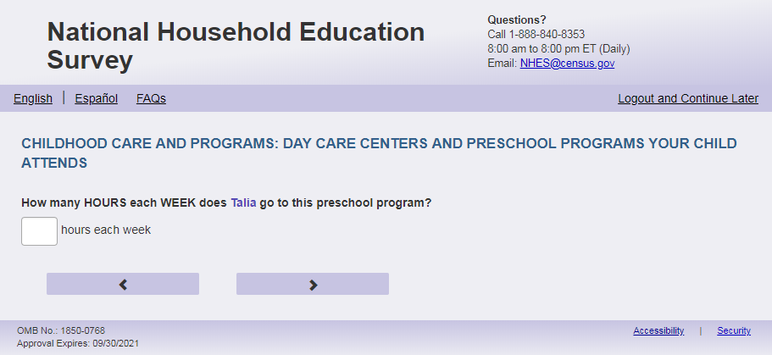
English Text Reads:

About how many HOURS each [unit] does [this child] go to this [program]?

Spanish Text Reads:

Más o menos, ¿cuántas HORAS por [unit] asiste [este niño (esta niña)] a este [programa]?

English and Spanish Answers:

ECPP_CPHRS, (0, 99), numeric, write-in

Skips:

Go to ECPP_ CPCVRWK.

Logic Checks/Programming specifications:
Only allow numeric entries.
English:
Fill for unit:
If ECPP_CPHRUNIT=1 or blank, then use “WEEK”
If ECPP_CPHRUNIT=2, then use “DAY”

If ECPP_CPHRUNIT=1 or blank, display “hours each week” to the right of box. Else display “hours each day” to the right of the box.

Use ECPP_CPTYPE + program answer as “program” fill. If ECPP_CPTYPE blank, simply use 'program'. Display ‘hours each week’ next to write in box.
Spanish:
Fill for unit:
If ECPP_CPHRUNIT=1 or blank, then use “SEMANA”
If ECPP_CPHRUNIT=2, then use “DÍA”

If ECPP_CPHRUNIT=1 or blank, display “horas a la semana” to the right of box. Else display “horas al día” to the right of the box.

Use programa + ECPP_CPTYPE answer as “programa” fill. If ECPP_CPTYPE blank, simply use 'program'. Display ‘horas a la semana’ next to write in box.
Mobile: Display numeric keypad

Text displayed for logic/range check violation
Logic/range check triggers a warning message, with the following text displayed.
For hours per day:
English: [If 0 or more than 16] Display “Please check your answer before continuing. Typically, children are in care between one and 16 hours per day.”
Spanish: [If 0 or more than 16] Display "Por favor, compruebe su respuesta antes de continuar. Por lo general, los niños están en cuidado entre una y 16 horas al día".
For hours per week:
English: [If 0 or more than 80] Display "Please check your answer before continuing. Typically, children are in care between one and 80 hours per week."
Spanish: [If 0 or more than 80] Display "Por favor, revise su respuesta antes de continuar. Por lo general, los niños están bajo cuidado entre una y 80 horas a la semana".

Item: Program Coverage For Work (ECPP_CPCVRWK)
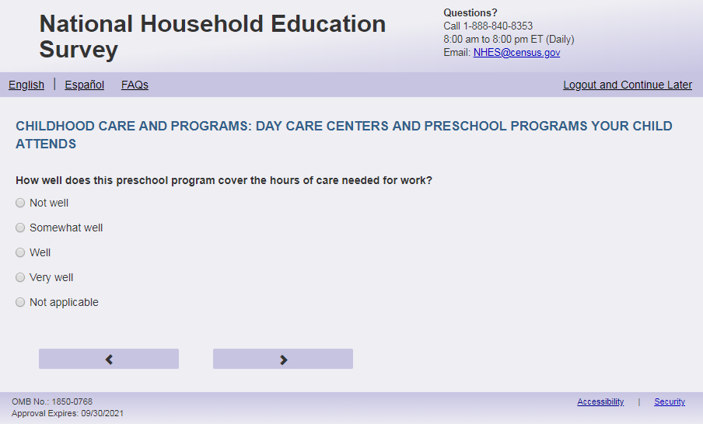
English Respondent text reads:
How well does this [program] cover the hours of care needed for work?
Spanish Respondent text reads:
¿Qué tan bien cubre este [programa] las horas que usted necesita para el cuidado de este niño(a) durante sus horas de trabajo?
English Admin/TQA text reads:
How well does this [program] cover the hours of care needed for work?
You can say they cover the hours needed for work “not well,” “somewhat well,” “well,” or “very well.”
{Do not read “Not applicable.” If the Respondent says they don’t work, select this answer, or if they hesitate, say ‘You can also say “not applicable.”’}
Spanish Admin/TQA text reads:
¿Qué tan bien cubre este [programa] las horas que usted necesita para el cuidado de este niño(a) durante sus horas de trabajo?
Se puede decir que cubren las horas necesarias para el trabajo "nada bien", "más o menos bien", "bien" o "muy bien".
{No lea "No aplica". Si el encuestado dice que no trabaja, seleccione esta respuesta, o si duda, diga 'También puede decir 'No aplica''.}
English Answers:
1=Not well
2=Somewhat well
3=Well
4=Very well
5=Not applicable

Spanish Answers:
1=Nada bien
2=Más o menosbien
3=Bien
4=Muy Bien
5=No aplica

ECPP_ CPCVRWK, (1,5), numeric, radio
Skips:
Go to ECPP_CPSTRTY
Logic Checks/Programming specifications:
English: Use ECPP_CPTYPE + program answer as “program” fill. If ECPP_CPTYPE blank, simply use 'program'.
Spanish: Use programa + ECPP_CPTYPE answer as “programa” fill. If ECPP_CPTYPE blank, simply use 'program'.
Increase spacing between response options “Very Well” (ECPP_CPCVRWK =4) and “Not Applicable” (ECPP_ CPCVRWK =5) with about double the spacing. Apply to Spanish response options.

Item: Child’s Age at Start of Program (ECPP_CPSTRTY)
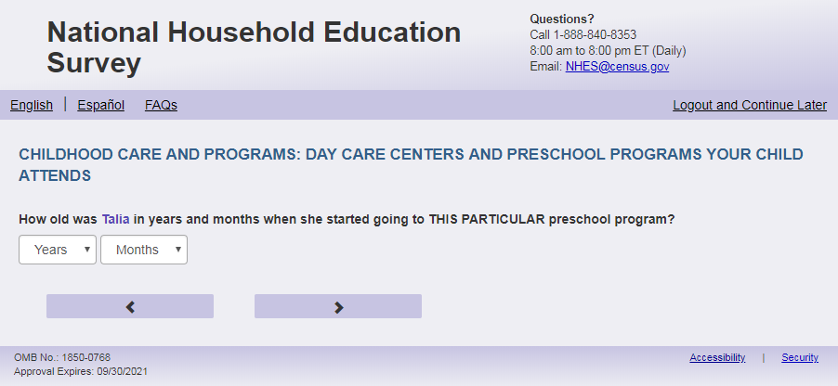
English Text Reads:
How old was [this child] in years and months when [he/she/he or she] started going to THIS PARTICULAR [program]?

Spanish Text Reads:

¿Qué edad tenía [este niño (esta niña)], en años y meses, cuando comenzó a asistir a [este programa] ESPECIFICAMENTE?

English and Spanish Answer:

ECPP_CPSTRTY, (0,6), numeric, drop down
ECPP_CPSTRTM, (0, 11), numeric, drop down

Skips:
Go to ECPP_CPSPEAK

Logic Checks/Programming specifications:
Allow respondents to scroll the options within drop-down.
Only display options that are equal to or less than child's current age from Screener.

English:
If S1_Pxsex = 1, use ‘he’, if s1_pxsex = 2, use ‘she’, else use ‘he or she’
English:
Display ‘months’ as label above the ECPP_CPSTRTM dropdown box and leave the dropdown box blank.
Display ‘years’ as label above the ECPP_CPSTRTY dropdown box and leave the dropdown box blank.
Spanish:
.
Display on same page as ECPP_CPSTRTM. Use ECPP_CPTYPE + program answer as “program” fill. If ECPP_CPTYPE blank, simply use 'program'.
Spanish:
Display ‘meses’ as label above the ECPP_CPSTRTM dropdown box and leave the dropdown box blank.
Display ‘años’ as label above the ECPP_CPSTRTY dropdown box and leave the dropdown box blank. Display on same page as ECPP_CPSTRTM. Use programa + ECPP_CPTYPE answer as “programa” fill. If ECPP_CPTYPE blank, simply use 'ESTE PROGRAMA'.

Item: Language of Main Care Provider (ECPP_CPSPEAK)
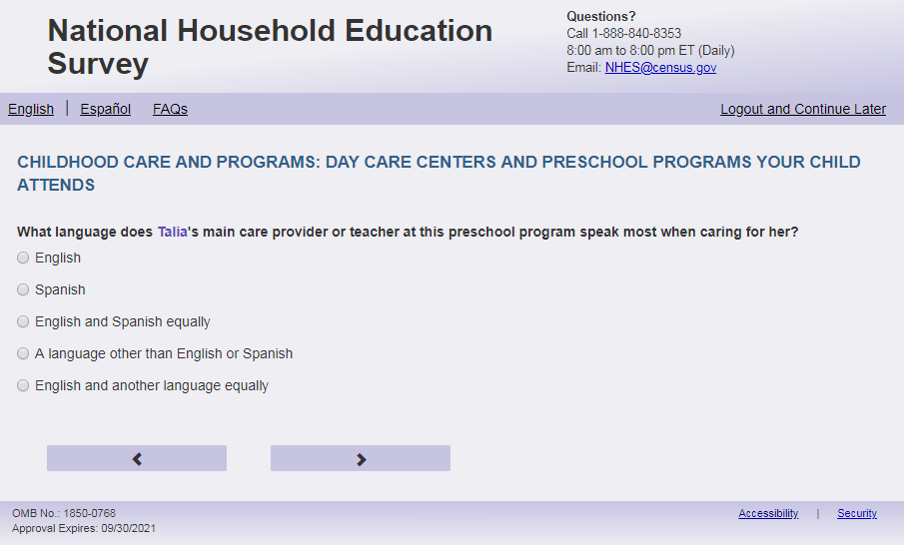
English Respondent Text Reads:
What language does [this child]’s main care provider or teacher at this [program] speak most when caring for [him/her/him or her]?

Spanish Respondent Text Reads:
¿Qué idioma habla más el maestro(a) o la persona a cargo de [este niño (esta niña)] en este [programa] cuando cuida a [él/ella/él o ella]?

English Admin/TQA Text Reads:
What language does [this child]’s main care provider or teacher at this [program] speak most when caring for [him/her/him or her]?

{Please read response options}

Spanish Admin/TQA Text Reads:

¿Qué idioma habla más el maestro o la persona a cargo de [este niño (esta niña)] en este [programa] cuando cuida a [él/ella/ él o ella]?

{Por favor, lea las opciones de respuesta.}

English Answers:

1= English
2= Spanish
3= English and Spanish equally
4= A language other than English or Spanish
5= English and another language equally

Spanish Answers:
1= Inglés
2= Español
3= Inglés y español por igual
4= Otro idioma aparte del inglés o español
5= Inglés y otro idioma por igual

ECPP_CPSPEAK, (1,5), numeric, radio

Skips:
Go to ECPP_CPTIME

Logic Checks/Programming specifications:
English:
Use ECPP_CPTYPE + program answer as “program” fill. If ECPP_CPTYPE blank, simply use 'program'.
Use ‘him’ if s1_pXsex = 1, use ‘her’ if s1_pXsex = 2, use ‘him or her’ if s1_pXsex = blank
Spanish:
Use programa + ECPP_CPTYPE answer as “programa” fill. If ECPP_CPTYPE blank, simply use 'programa’.
Use ‘él’ if s1_pXsex = 1, use ‘ella’ if s1_pXsex = 2, use ‘él o ella’ if s1_pXsex = blank

Item: Time to Program (ECPP_CPTIME)
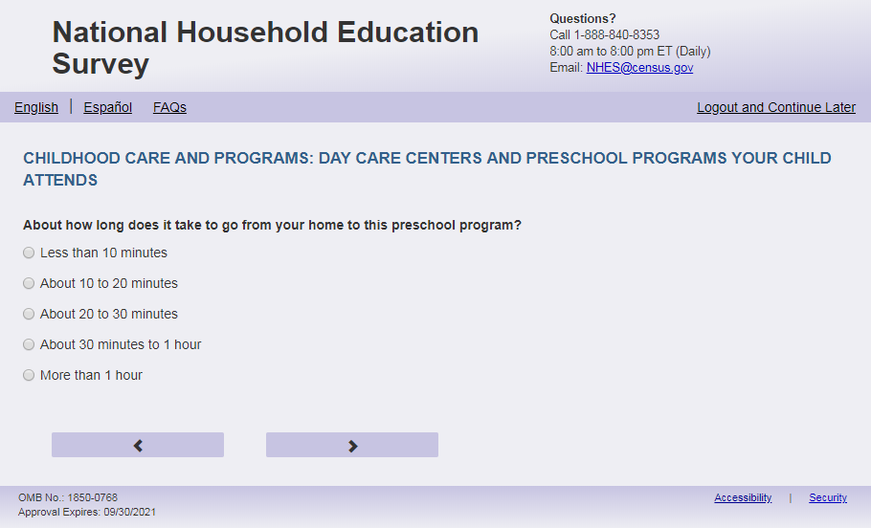
English Respondent Text Reads:
About how long does it take to go from your home to this [program]?
Spanish Respondent Text Reads:
Más o menos, ¿cuánto tiempo le toma el viaje de su casa a este [programa]?
English Admin/TQA Text Reads:
About how long does it take to go from your home to this [program]?
{Please read response options}
Spanish Admin/TQA Text Reads:
Más o menos, ¿cuánto tiempo le toma el viaje de su casa a este [programa]?
{Por favor, lea las opciones de respuesta.}
English Answer:
1=Less than 10 minutes
2=About 10 to 20 minutes
3=About 20 to 30 minutes
4=About 30 minutes to 1 hour
5=More than 1 hour

Spanish Answer
1=Menos de 10 minutos
2=De 10 a 20 minutos
3=De 20 a 30 minutos
4=De 30 minutos a 1 hora
5= Más de una hora

ECPP_CPTIME, (1,5), numeric, radio
Skip:
Go to ECPP_CPRCMDPT
Logic Checks/Programming specifications:
English:
Use ECPP_CPTYPE + program answer as “program” fill. If ECPP_CPTYPE blank, simply use 'program'.
Spanish:
Use programa + ECPP_CPTYPE answer as “programa” fill. If ECPP_CPTYPE blank, simply use 'programa’.

Item: Recommend Program (ECPP_CPRCMDPT)
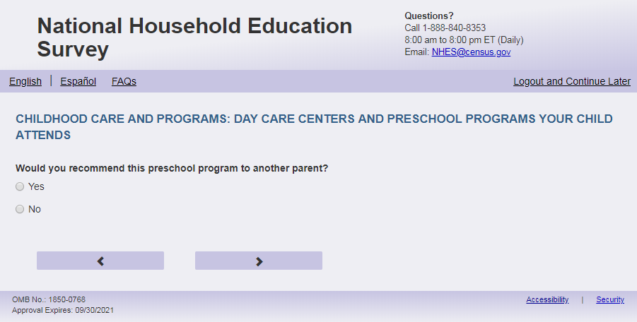
English Text Reads:
Would you recommend this [program] to another parent?

Spanish Text Reads:
¿Le recomendaría este [programa] a otros padres?

English Answers:

1=Yes
2=No

Spanish Answers:
1=Sí
2=No

ECPP_CPRCMDPT, (1,2), numeric, radio

Skips:
Go to ECPP_CPREMOVE

Logic Checks/Programming specifications:
English:
Use ECPP_CPTYPE + program answer as “program” fill. If ECPP_CPTYPE blank, simply use 'program'.
Spanish:
Use programa + ECPP_CPTYPE answer as “programa” fill. If ECPP_CPTYPE blank, simply use 'programa’.

Item: Remove From Program (ECPP_CPREMOVE)
<New item for NHES:2023 – no screenshot available>
English Text Reads:
Have you ever been asked to remove [this child] from care for the day due to one or more behavior issues, such as biting, being aggressive, not following directions, being overly active, being impulsive, or having little or no self-control?

Spanish Text Reads:

¿Alguna vez le han pedido que retire a [este niño(a)] de un lugar de cuidado infantil por el resto del día porque [él/ella/él o ella] estaba teniendo uno o más problemas de comportamiento, como morder, ser agresivo(a), no seguir instrucciones, ser excesivamente activo(a), ser impulsivo(a) o tener muy poco o nada de autocontrol?

English Answers:

1=Yes
2=No

Spanish Answers:
1=Sí
2=No

ECPP_CPRCMDPT, (1,2), numeric, radio

Skips:
Go to ECPP_CPTEST

Logic Checks/Programming specifications:
Spanish:
If S1_Pxsex = 1, use ‘él’, if s1_pxsex = 2, use ‘ella’, else use ‘él o ella’

Item: Program Services (ECPP_CPTEST)
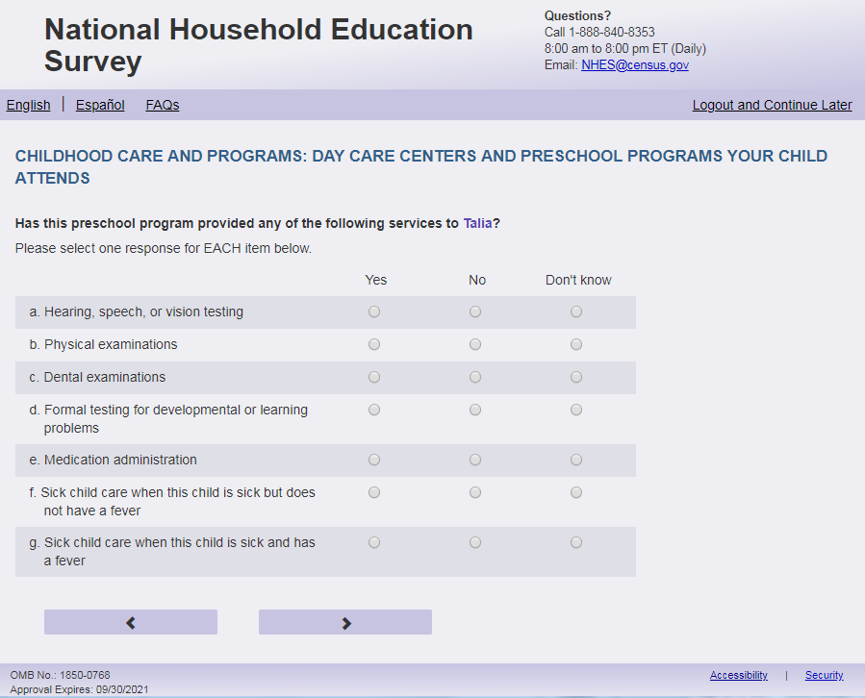
English Respondent Text Reads:
Has this [program] provided any of the following services to [this child]?

Spanish Respondent Text Reads:
¿Este [programa] le ha brindado a [este niño (esta niña)] alguno de los siguientes servicios?

English Admin/TQA Text Reads:
Has this [program] provided any of the following services to [this child]?
Please answer ‘yes’ or ‘no’ for EACH service as I read them.
{Please re-read the question if the respondent asks or seems to have forgotten the question.}

Spanish Admin/TQA Text Reads:
¿Este [programa] le ha brindado a [este niño (esta niña)] alguno de los siguientes servicios?
Por favor, responda 'sí' o 'no' para CADA servicio a medida que los leo.
{Por favor, vuelva a leer la pregunta si el encuestado pregunta o parece haber olvidado la pregunta.}

English Answers:

- Hearing or vision testing, ECPP_CPTEST, (1=Yes, 2=No, 3= Don’t know), numeric, radio
- Physical examinations, ECPP_CPPHYSE, (1=Yes, 2=No, 3= Don’t know), numeric, radio
- Dental examinations, ECPP_CPDENTA, (1=Yes, 2=No, 3= Don’t know), numeric, radio
- Developmental screenings for speech and language, social emotional, or motor skills, ECPP_CPDISAB, (1=Yes, 2=No, 3= Don’t know), numeric, radio
- Medication administration, ECPP_CPMEDAM (1=Yes, 2=No, 3= Don’t know), numeric, radio

Spanish Answers:

- Examen del oído o la vista, ECPP_CPTEST, (1= Sí, 2=No, 3= No lo sé), numeric, radio
- Exámenes físicos, ECPP_CPPHYSE, (1= Sí, 2=No, 3= No lo sé), numeric, radio
- Exámenes dentales, ECPP_CPDENTA, (1= Sí, 2=No, 3= No lo sé), numeric, radio
- Exámenes del desarrollo del habla y lenguaje, socioemocional, o motor, ECPP_CPDISAB, (1= Sí, 2=No, 3= No lo sé), numeric, radio
- Administración de medicamentos, ECPP_CPMEDAM (1= Sí, 2=No, 3= No lo sé), numeric, radio

Skips:
Go to ECPP_CPSKNFV

Logic Checks/Programming specifications:
Display as a grid
English:
Use ECPP_CPTYPE + program answer as “program” fill. If ECPP_CPTYPE blank, simply use 'program'.
Spanish:
Use programa + ECPP_CPTYPE answer as “programa” fill. If ECPP_CPTYPE blank, simply use 'programa’.

Item: Program Care for Child Sick Without Fever (ECPP_CPSKNFV)

English Respondent Text Reads:
Will this [program] care for [this child] when [he/she/he or she] is…

- sick but does not have a fever? (ECPP_CPSKNFV, (1=Yes, 2=No, 3=Don’t Know), numeric)
- sick and has a fever? (ECPP_ CPSKFV, (1=Yes, 2= No, 3=Don’t Know), numeric)

Spanish Respondent Text Reads:

¿Este [programa] lo/la cuida si [este niño (esta niña)] está…

- enfermo pero no tiene fiebre? (ECPP_ NCSKNFV, (1=Sí, 2= No, 3=No lo sé), numeric)
- enfermo y tiene fiebre? (ECPP_ NCSKFV, (1=Sí, 2= No, 3=No lo sé), numeric)

English Admin/TQA Text Reads:
Will this [program] care for [this child] when [he/she/he or she] is sick but does not have a fever? (ECPP_CPSKNFV, (1=Yes, 2=No), numeric)

Will this [program] care for [this child] when [he/she/he or she] is sick and has a fever? (ECPP_ CPSKFV, (1=Yes, 2= No), numeric)

Spanish Admin/TQA Text Reads:

¿Este [programa] lo/la cuida si [este niño (esta niña)] está enfermo pero no tiene fiebre? (ECPP_ CPSKNFV, (1=Sí, 2= No, 3=No lo sé), numeric)

¿Este [programa] lo/la cuida si [este niño (esta niña)] está enfermo y tiene fiebre? (ECPP_ CPSKFV, (1=Sí, 2= No, 3=No lo sé), numeric)

Logic Checks/Programming specifications:
For respondent text display as grid and remove swim lanes
For Admin/TQA display as two items on the screen (not as a grid)
English:
If S1_Pxsex = 1, use ‘he’, if s1_pxsex = 2, use ‘she’, else use ‘he or she’
Skips:
Go to ECPP_CPFEE

Item: Fee Paid by Other Party (ECPP_CPFEE)
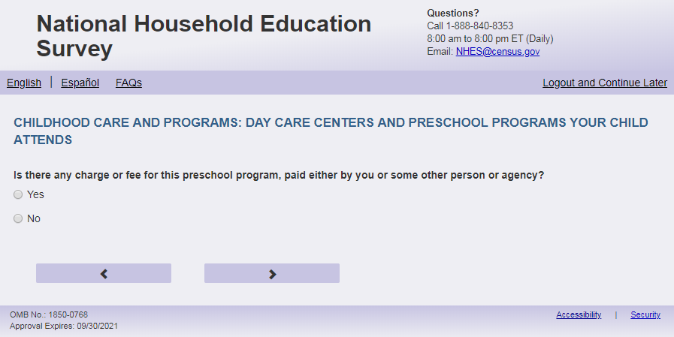
English Text Reads:
Is there any charge or fee for this [program], paid either by you or some other person or agency?

Spanish text reads:

¿Hay algún costo o pago por este [programa], ya sea que lo pague usted u otra persona o agencia?

English Answers:

1=Yes
2=No

Spanish Answers:
1=Sí
2=No

ECPP_CPFEE, (1,2), numeric, radio

Skips:
If ECPP_CPFEE = 2 then go to ECPP_CPOTHC. Else go to ECPP_ CPREL

Logic Checks/Programming specifications:
English:
Use ECPP_CPTYPE + program answer as “program” fill. If ECPP_CPTYPE blank, simply use 'program'.
Spanish:
Use programa + ECPP_CPTYPE answer as “programa” fill. If ECPP_CPTYPE blank, simply use 'programa’.

Item: Program Paid by Groups (ECPP_CPREL)
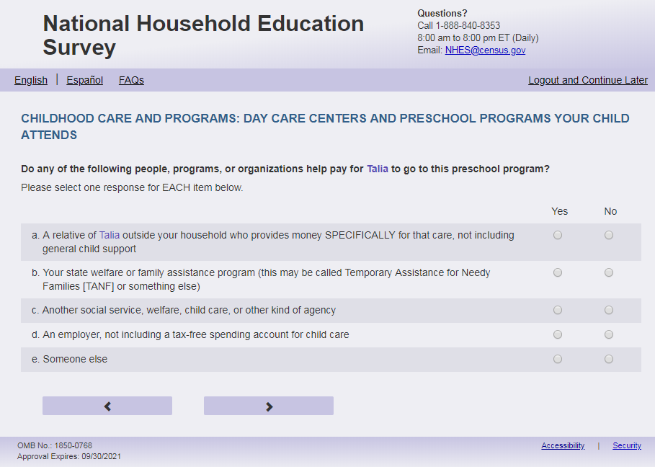
English Respondent Text Reads:
Do any of the following people, programs, or organizations help pay for [this child] to go to this [program]?

Spanish Respondent Text Reads:
¿Alguna de las siguientes personas, programas u organizaciones le ayuda a pagar para que [este niño (esta niña)] vaya a este [programa]?

English Admin/TQA Text Reads:
Do any of the following people, programs, or organizations help pay for [this child] to go to this [program]?
Please answer ‘yes’ or ‘no’ for EACH item as I read them.
{Please re-read the question if the respondent asks or seems to have forgotten the question.}

Spanish Admin/TQA Text Reads:
¿Alguna de las siguientes personas, programas u organizaciones le ayuda a pagar para que [este niño (esta niña)] vaya a este [programa]?
Por favor, responda 'sí' o 'no' para CADA opción a medida que las leo.
{Por favor, vuelva a leer la pregunta si el encuestado pregunta o parece haber olvidado la pregunta.}

English Answers:

- A relative of [this child] outside your household who provides money SPECIFICALLY for that care, not including general child support, ECPP_CPREL, (1=Yes, 2=No), numeric, radio
- Your state welfare or family assistance program (this may be called Temporary Assistance for Needy Families [TANF] or something else), ECPP_CPTANF, (1=Yes, 2=No), numeric, radio
- Another social service, welfare, child care, or other kind of agency, ECPP_CPSSAC, (1=Yes, 2=No), numeric, radio
- An employer, not including a tax-free spending account for child care, ECPP_CPEMPL, (1=Yes, 2=No), numeric, radio
- Someone else, ECPP_CPOTHER, (1=Yes, 2=No), numeric, radio

Spanish Answers:
- Un pariente de este niño que no vive en su hogar y da dinero para pagar ESPECÍFICAMENTE por ese cuidado, sin incluir manutención para niños(as), ECPP_CPREL, (1= Sí, 2=No), numeric, radio
- Programa de asistencia social o familiar de su estado (puede ser Asistencia Temporal a Familias Necesitadas [TANF por sus siglas en ingles] o algo similar), ECPP_CPTANF(1= Sí, 2=No), numeric, radio
- Otro servicio social, asistencia social, cuidado infantil, u otro tipo de agencia, ECPP_CPSSAC, (1= Sí, 2=No), numeric, radio
- Un empleador, sin incluir cuentas especiales para pagos de cuidado infantil libres de impuestos, ECPP_CPEMPL, (1= Sí, 2=No), numeric, radio
- Alguien más, ECPP_CPOTHER, (1= Sí, 2=No), numeric, radio

Skips:
Go to ECPP_CPUNIT

Logic Checks/Programming specifications:
Display as grid.
If child’s name is available on screener, use child’s name for response option a “A relative of [name of child] outside your household who provides money SPECIFICALLY for that care, not including general child support”. If child’s name is not available, use “this child” as fill. (Spanish: este niño (esta niña))
English:
Use ECPP_CPTYPE + program answer as “program” fill. If ECPP_CPTYPE blank, simply use 'program'.
Spanish:
Use programa + ECPP_CPTYPE answer as “programa” fill. If ECPP_CPTYPE blank, simply use 'programa’.

Item: Way of Paying for Program (ECPP_CPUNIT)
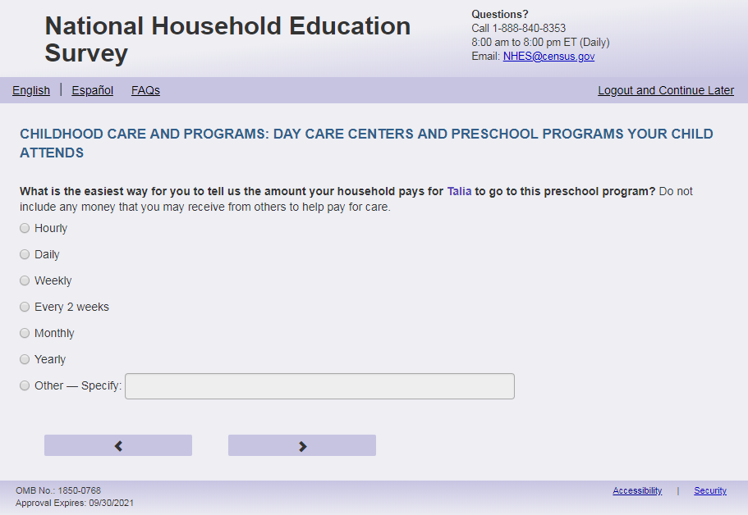
English Respondent Text Reads:
What is the easiest way for you to tell us the amount your household pays for [this child] to go to this [program]? Do not include any money that you may receive from others to help pay for care.

Spanish Respondent Text Reads:
¿Cuál es la forma más fácil para decirnos cuánto paga este hogar para que [este niño (esta niña)] vaya a este [programa]? No incluya el dinero que reciba de otras personas para pagar los gastos del cuidado.

English Admin/TQA Text Reads:
What is the easiest way for you to tell us the amount your household pays for [this child] to go to this [program]? Do not include any money that you may receive from others to help pay for care.
{Read the answer options to the respondent, but do not read the ‘Not applicable’ option unless the respondent hesitates or says that they don’t pay. You also do not need to read “Other.”}

Spanish Admin/TQA Text Reads:

¿Cuál es la forma más fácil para decirnos cuánto paga este hogar para que [este niño (esta niña)] vaya a este [programa]? No incluya el dinero que reciba de otras personas para pagar los gastos del cuidado.
{Lea las opciones de respuesta al encuestado, pero no lea la opción 'No aplica' a menos que el encuestado dude o diga que no paga. Tampoco es necesario leer "Otro."}

English Answers:
1= Hourly
2= Daily
3= Weekly
4= Every 2 weeks
5=Monthly
6= Yearly
7 = Other – Specify

Spanish Answers:

1= Por hora
2= Por día
3= Por semana
4= Quincena (cada 2 semanas)
5=Por mes
6= Por año
7= Otra - Especifique:

ECPP_CPUNIT, (1,7), numeric, radio. If 7 selected, specify box should become active (ECPP_CPUNITOS): (0,200), character, write-in. Display specify response box 1 row by 50 characters.

Skips:

If only 1 person on Screener is under 18 years of age (DOBYY gt 2005 or age lt 18), go to ECPP_CPCOST. Else if any age on screener is blank for any person, or there is more than 1 person under 18, then go to ECPP_CPCSTHNX

Logic Checks/Programming specifications:
English:
Use ECPP_CPTYPE + program answer as “program” fill. If ECPP_CPTYPE blank, simply use 'program'.

Spanish:
Use programa + ECPP_CPTYPE answer as “programa” fill. If ECPP_CPTYPE blank, simply use 'programa’.

Item: No. of Children Fee Covers (ECPP_CPCSTHNX)
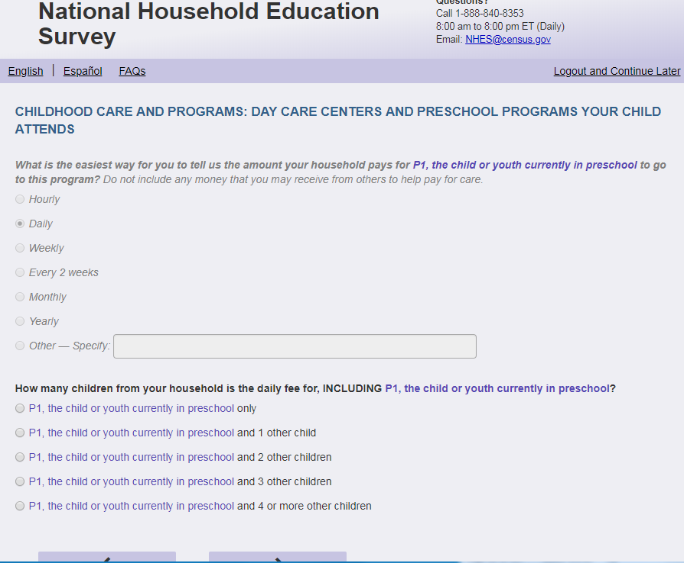
English Text Reads:
How many children from your household is this [ECPP_CPUNIT] amount for, INCLUDING [this child]?

Spanish Text Reads:
¿Para cuántos de los niños(as) de su hogar, INCLUYENDO a [este(a) niño(a)] es esta cantidad [ECPP_CPUNIT]?
English Answers:

1= [This child] only
2= [This child] and 1 other child
3= [This child] and 2 other children
4= [This child] and 3 other children
5= [This child] and 4 or more other children

Spanish Answers:

1= Sólo para [este niño (esta niña)]
2= [Este niño (esta niña)] y otro 1 niño(a)
3= [Este niño (esta niña)] y otros 2 niños(as)
4= [Este niño (esta niña)] y otros 3 niños(as)
5= [Este niño (esta niña)] y otros 4 o más niños(as)

ECPP_CPCSTHNX, (1,5), numeric, radio

Skips:
Go to ECPP_CPCOST.

Logic Checks/Programming specifications:
Fill ECPP_CPUNIT with response category from ECPP_CPUNIT. If ECPP_CPUNIT = 7, and ECPP_CPUNITOSS = ' ', do not include a fill. And have it read '...is the fee for..' and Spanish: ‘..es la cantidad,..’.
Do not display on same page as ECPP_CPUNIT. Display on a new screen.
Don't display if only one child (18 and under) was entered on the screener. If any age is blank show item.
Display options corresponding to number of children (18 and under) in HH from screener. If any age is blank, show all options.

Item: Amount Household Pays (ECPP_CPCOST)
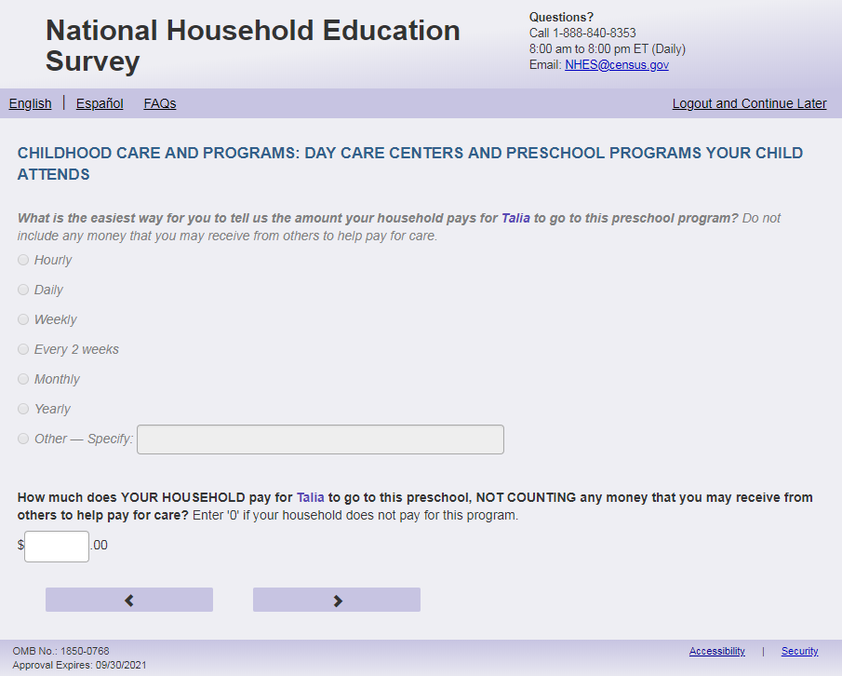
English Respondent Text Reads:
How much does YOUR HOUSEHOLD pay for [this child] to go to this [program] [ECPP_CPUNIT], NOT COUNTING any money that may be received from others to help pay for care? Enter '0' if your household does not pay for this program.

Spanish Respondent Text Reads:

¿Cuánto paga SU HOGAR para que este niño(a) vaya a este [programa][ECPP_CPUNIT] SIN INCLUIR dinero que reciba de otras personas para ayudarle a pagar el cuidado del niño(a)? Ingrese ‘0’ si su hogar no paga por este programa.

English Admin/TQA Text Reads:
How much does YOUR HOUSEHOLD pay for [this child] to go to this [program] [ECPP_CPUNIT], NOT COUNTING any money that you may receive from others to help pay for care?
{Enter '0' if the household does not pay for this program.}

Spanish Admin/TQA Text Reads:

¿Cuánto pagó SU HOGAR para que este niño(a) vaya a este [programa][ECPP_CPUNIT] SIN INCLUIR dinero que reciba de otras personas para ayudarle a pagar el cuidado del niño(a)? { Ingrese ‘0’ si el hogar no paga por este programa.}

English and Spanish Answer:
ECPP_CPCOST, (0, 99999), numeric, write-in

Skips:
Go to ECCP_CPOTHC

Logic Checks/Programming specifications:
Fill ECPP_CPUNIT with response category from ECPP_CPUNIT
If ECPP_CPUNIT = 7, and ECPP_CPUNITOS = ' ', do not include a fill. And have it read 'this [program], NOT COUNTING…' (Spanish: este [programa] SIN INCLUIR…)
Display on a new screen. Do not display on same page as ECPP_CPUNIT and ECPP_CPCSTHNX.
Fill ECPP_CPCSTHNX with response category from ECPP_CPCSTHNX.
Display "$" to the left of the box. Display ".00" to the right of the box. Right-justified and will enter the response box from the right side. If a numerical response contains more than three digits, a comma will be auto-filled.
English:
Use ECPP_CPTYPE + program answer as “program” fill. If ECPP_CPTYPE blank, simply use 'program'.
Spanish:
Use programa + ECPP_CPTYPE answer as “programa” fill. If ECPP_CPTYPE blank, simply use 'programa’.

Item: Other Care Arrangements (ECPP_CPOTHC)
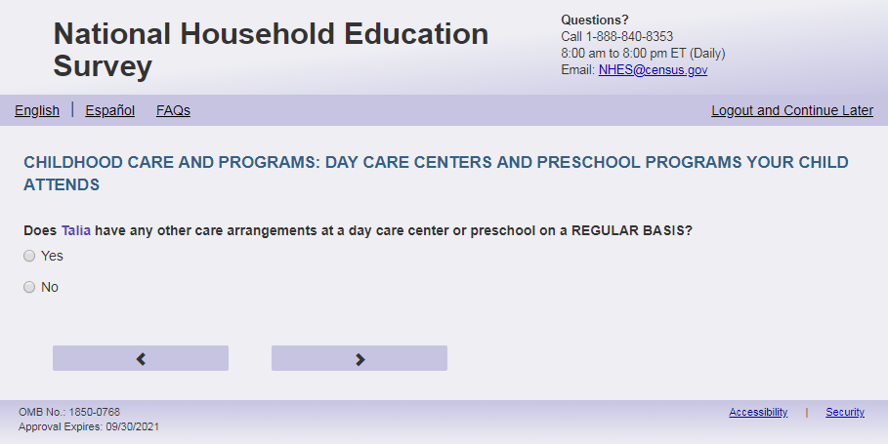
English Text Reads:
Does [this child] have any other care arrangements at a day care center or preschool on a REGULAR BASIS?

Spanish Text Reads:

¿Tiene [este niño (esta niña)] algún otro arreglo de cuidado en una guardería o programa preescolar CON REGULARIDAD?

English Answers:

1=Yes
2=No

Spanish Answers:

1=Sí
2=No

ECPP_CPOTHC, (1,2), numeric, radio

Skips:

If ECPP_CPOTHC = 2 and ECPP_CPHEADST=1 then go to ECPP_MAINRESN. Else if ECPP_CPOTHC = 2 and ECPP_CPHEADST ne 1, then go to ECPP_PCEVRHDX. Else if ECPP_CPOTHC ne 2, then go to ECPP_CPTLHR.

Item: Hours per week at Day Care (ECPP_CPTLHR)
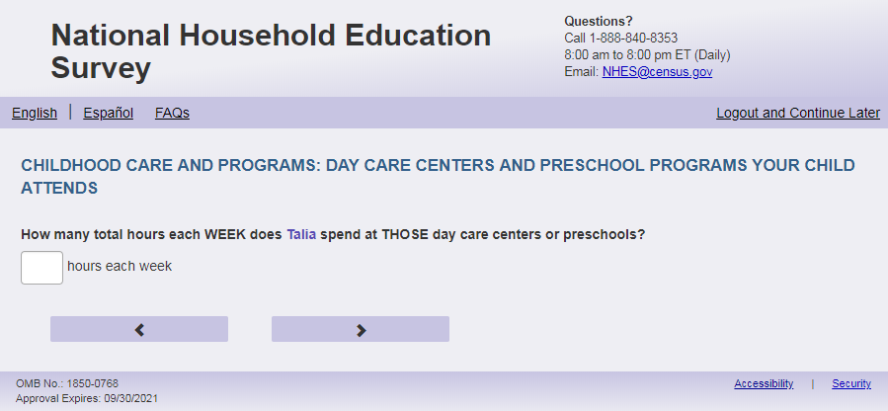
English Text Reads:
How many total hours each WEEK does [this child] spend at THOSE OTHER day care centers or preschools?

Spanish Text Reads:

¿Cuántas horas en total a la SEMANA pasa [este niño (esta niña)] en ESAS OTRAS guarderías o programas preescolares?

English and Spanish Answer:

ECPP_CPTLHR, (1, 99), numeric, write-in

Skips:

If ECPP_CPHEADST=1 then go to ECPP_MAINRESN. Else go to ECPP_PCEVRHDX.

Logic Checks/Programming specifications:
English: Display "hours each week" to right of box
Spanish: Display “horas a la semana” to the right of box
Mobile: Display numeric keypad

Text displayed for logic/range check violation
Logic/range check triggers a warning message, with the following text displayed.
English:
[If 0 or more than 80] Display "Please check your answer before continuing. Typically, children who attend two different centers for care are at the second center between one and 80 hours per week.."
Spanish:
[If 0] Display "Por favor, revise su respuesta antes de continuar. Por lo general, los niños que asisten a dos centros diferentes para la atención están en el segundo centro entre una y 80 horas a la semana.

Item: Attend Head Start Programs (ECPP_PCEVRHDX)
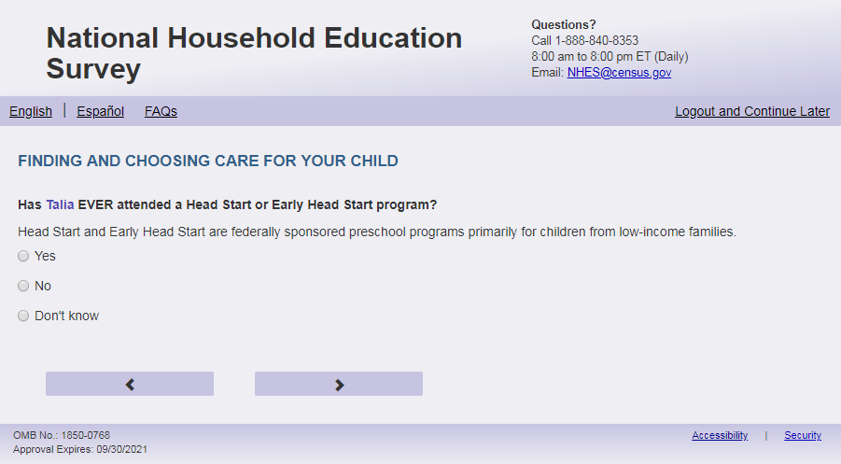
English Text Reads:
Has [this child] EVER attended a Head Start or Early Head Start program?
Head Start and Early Head Start are federally sponsored preschool programs primarily for children from low-income families.

Spanish Text Reads:
¿Ha asistido [este niño (esta niña)] ALGUNA VEZ a un programa de Head Start o de Early Head Start?
Los programas de Head Start y de Early Head Start son programas preescolares patrocinados por el gobierno federal y orientados principalmente a niños(as) de familias de bajos ingresos.

English Admin/TQA Text Reads:
Has [this child] EVER attended a Head Start or Early Head Start program?
{Read definition only if the respondent asks what Head Start is, or if they hesitate answering.}
[The term “Head Start or Early Head Start” should be an active link for the Admin/TQA screen. Add definition hover over “Head Start or Early Head Start”: Head Start and Early Head Start are federally sponsored preschool programs primarily for children from low-income families]

Spanish Admin/TQA Text Reads:

¿Ha asistido [este niño (esta niña)] ALGUNA VEZ a un programa de Head Start o de Early Head Start?
{Lea la definición solo si el encuestada pregunta qué es Head Start, o si duda al responder.}[The term “de Head Start o de Early Head Start” should be an active link for the Admin/TQA screen. Add definition hover over “de Head Start o de Early Head Start”: Los programas de Head Start y de Early Head Start son programas preescolares patrocinados por el gobierno federal y orientados principalmente a niños(as) de familias de bajos ingresos.]

English Answer:

1=Yes
2= No
3= Don’t know

Spanish Answer:

1= Sí
2= No
3= No lo sé

ECPP_PCEVRHDX, (1,3), numeric, radio

Skips:
Go to ECPP_MAINRESN

Logic Checks/Programming specifications:
For the Admin/TQA screen: Definition should appear as pop-out text boxes when clicking the phrase “Head Start or Early Head Start”/“ de Head Start o de Early Head Start”

Item: Reason for Childcare (ECPP_MAINRESN)
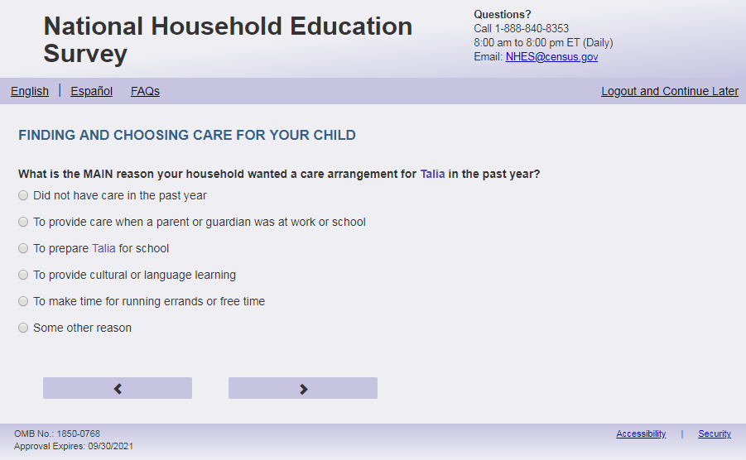
English Respondent Text Reads:
What is the MAIN reason your household wanted a care arrangement for [this child] in the past year?

Spanish Respondent Text Reads:
¿Cuál es la razón PRINCIPAL por la que su hogar quería un arreglo de cuidado infantil para [este niño (esta niña)] en el ultimo año?

English Admin/TQA Text Reads:
What is the MAIN reason your household wanted a care arrangement for [this child] in the past year?
{Please read response options.}

Spanish Admin/TQA Text Reads:
¿Cuál es la razón PRINCIPAL por la que su hogar quería un arreglo de cuidado infantil para [este niño (esta niña)] en el ultimo año?
{Por favor, lea las opciones de respuesta.}

English Respondent Answer:

1 = Did not want a care arrangement for [this child] in the past year
2=To provide care when a parent or guardian was at work or school
3=To prepare [this child] for school
4=To provide cultural or language learning
5= To make time for running errands or free time
6= Some other reason

Spanish Respondent Answer:
1= No quiso un arreglo de cuidado infantil para el año pasado
2= Para tener cuidado infantil cuando el padre, madre o tutor(a) legal estaba trabajando o estudiando
3= Para preparar a [este niño (esta niña)] para la escuela
4= Para tener aprendizaje cultural o aprender el idioma
5= Para tener tiempo libre o para hacer mandados
6= Por alguna otra razón

ECPP_MAINRESN, (1,6), numeric, radio

English Admin/TQA Answer:
2=To provide care when a parent or guardian was at work or school
3=To prepare [this child] for school
4=To provide cultural or language learning
5= To make time for running errands or free time
6= Some other reason
1 = Did not want a care arrangement for [this child] in the past year

Spanish Admin/TQA Answer:
2= Para tener cuidado infantil cuando el padre, madre o tutor(a) legal estaba trabajando o estudiando
3= Para preparar a [este niño (esta niña)] para la escuela
4= Para tener aprendizaje cultural o aprender el idioma
5= Para tener tiempo libre o para hacer mandados
6= Por alguna otra razón
1= No quiso un arreglo de cuidado infantil para el año pasadoSkips:
Go to ECPP_PPCHOIC

Logic Checks/Programming specifications:
Admin/TQA answers should list response option 1 last.

Item: Choices for Childcare (ECPP_ PPCHOIC)
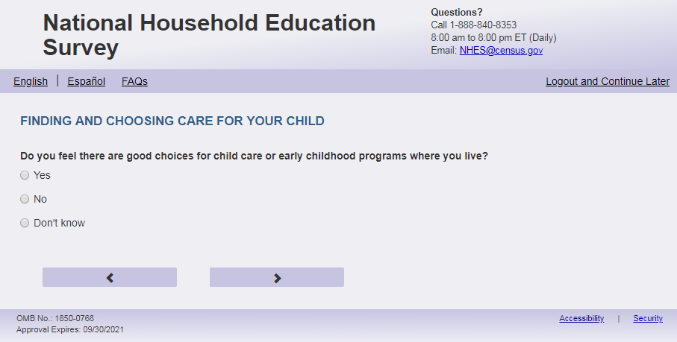
English text
Do you feel there are good choices for child care or early childhood programs where you live?
Spanish Text
¿Cree usted que hay buenas opciones de cuidado infantil o programas de educación temprana en el área donde usted vive?
English answers
1= Yes
2= No
3= Don’t know

Spanish answers
1= Sí
2= No
3= No lo sé
ECPP_ PPCHOIC, (1, 3), numeric, radio
Skips
Go to ECPP_CRSRCH

Item: Search for child care (ECPP_CRSRCH)
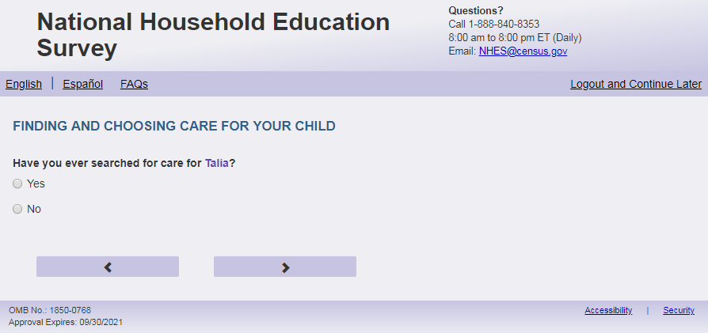
English text
Have you ever searched for care for [this child]?
Spanish text:
¿Alguna vez ha buscado un arreglo de cuidado para [este niño (esta niña)]?
English answer
1= Yes
2= No

Spanish answer

1= Sí
2= No

ECPP_CRSRCH, (1, 2), numeric, radio

Skips

If ECPP_CRSRCH =2 Go to ECPP_HABOOKS. Else Go to ECPP_PPDIFCLT

Item: Difficulty Finding Childcare (ECPP_PPDIFCLT)
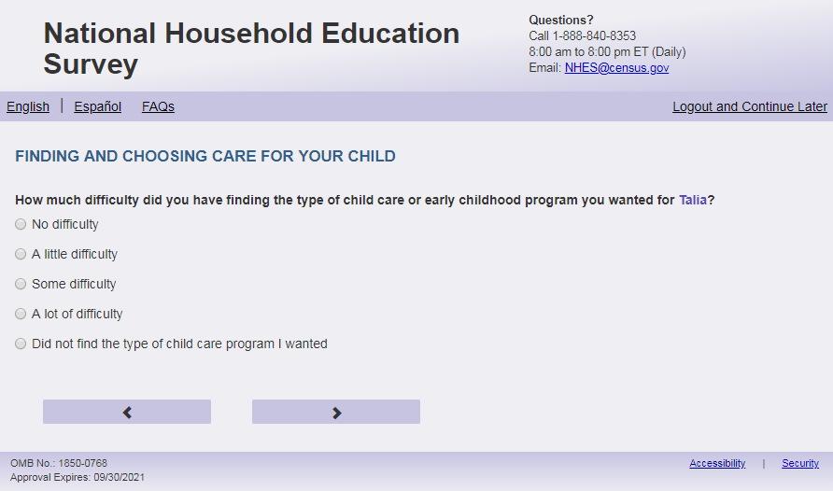
English Respondent Text Reads:
How much difficulty did you have finding the type of child care or early childhood program you wanted for [this child]?

Spanish Respondent Text Reads:
¿Cuánta dificultad tuvo para encontrar el tipo de cuidado infantil o programa de educación temprana que usted quería para [este niño (esta niña)]?

English Admin/TQA Text Reads:
How much difficulty did you have finding the type of child care or early childhood program you wanted for [this child]?

{Please read response options}

Spanish Admin/TQA Text Reads:
¿Cuánta dificultad tuvo para encontrar el tipo de cuidado infantil o programa de educación temprana que usted quería para [este niño (esta niña)]?

{Por favor, lea las opciones de respuesta.}

English Answer:
1= No difficulty
2= A little difficulty
3= Some difficulty
4= A lot of difficulty
5= (if respondent:) Did not find the type of child care program I wanted (if admin/TQA:) Did not find the type of child care program you wanted

Spanish Answer:

1= Ninguna dificultad
2= Muy poca dificultad
3= Algo de dificultad
4= Mucha dificultad
5= (if respondent:) No encontré el tipo de programa de cuidado infantil que quería (if admin/TQA:) No encontró el tipo del programa de cuidad infantile que queria

ECPP_PPDIFCLT, (1,5), numeric, radio

Skips:
If ECPP_PPDIFCLT in (2, 3, 4, 5, or blank) go to ECPP_WHYDIFCLT.

Else if ECPP_PPDIFCLT=1 and (ECPP_RCNOW = 1 or ECPP_RCPCARE = 1 or ECPP_NCNOW = 1 or ECPP_NCPCARE = 1 or ECPP_CPNNOWX = 1 or ECPP_CPPCARE = 1) then go to ECPP_CCREASN.
Else go to ECPP_CCPY

Logic Checks/Programming specifications
Increase spacing between response options “A lot of difficulty” and “Did not find the type of child care program I wanted.” To be about double the spacing between the other response options.

Admin/TQA answer options should adjust the phrasing of option 5 to second person as noted above

Item: Difficulty Reason in Finding Childcare (ECPP_WHYDIFCLT)
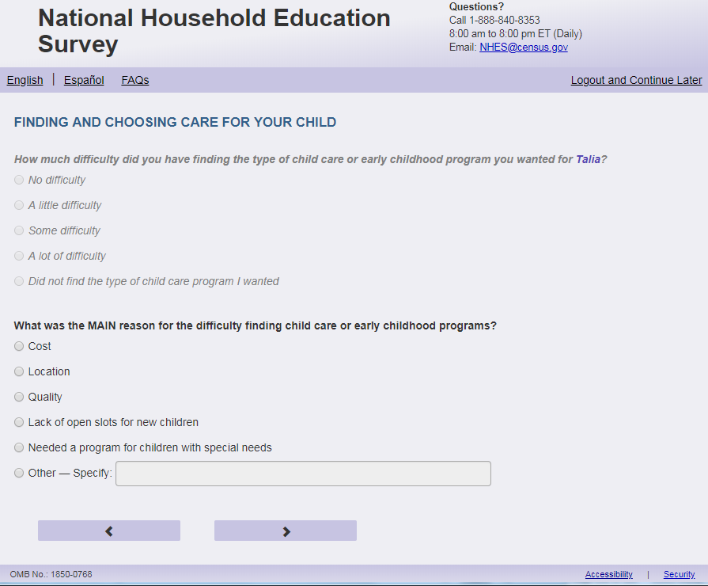
English Respondent Text Reads:
What was the MAIN reason for the difficulty finding child care or early childhood programs?

Spanish Respondent Text Reads:
¿Cuál fue la dificultad PRINCIPAL que enfrentó para encontrar un programa de cuidado infantil o programa de educación temprana?

English Admin/TQA Text Reads:
What was the MAIN reason for the difficulty finding child care or early childhood programs?
Please choose ONE of the following reasons.

{Please read response options}

Spanish Admin/TQA Text Reads:
¿Cuál fue la dificultad PRINCIPAL que enfrentó para encontrar un programa de cuidado infantil o programa de educación temprana?
Por favor seleccione UNA de las siguientes razones.

{Por favor lea las opciones de respuesta}

English Answer:

1 = Cost
2 = Location
3 = Quality
4 = Lack of open slots for new children
5 = Child has a special need, and could not find appropriate care
6 = Looking for specific hours or schedule
7 = Challenges receiving financial assistance
8 = Age requirements of the child care
9 = Other – Specify:

Spanish Answer:

1= Costo
2 = Ubicación
3= Calidad
4= Falta de vacantes para niños nuevos
5= El niño(a) tiene una necesidad especial y no pudimos encontrar el cuidado apropiado
6 =Encontrar horas u horario específico
7=Dificultad para recibir ayudas económicas
8=Requisitos de edad del cuidado infantil
9= Otra razón – Especifique:

ECPP_WHYDIFCLT, (1,9), numeric, radio. If 9 selected, specify box should become active (ECPP_WHYDIFCLTOS): (0,200), character, write-in. Display specify response box 1 row by 50 characters.

Skips:

If ECPP_RCNOW = 1 or ECPP_RCPCARE = 1 or ECPP_NCNOW = 1 or ECPP_NCPCARE = 1 or ECPP_CPNNOWX = 1 or ECPP_CPPCARE = 1 then go to ECPP_CCREASN.
Else go to ECPP_CCPY

Logic Checks/Programming specifications:
Only display this question if ECPP_PPDIFCLT = 2, 3, 4, 5, or blank.
Display this question on a new page.

Item: Receiving Care in the Past Year (ECPP_CCPY)
<New item for NHES:2023 – no screenshot available>
English Text Reads:
Did you have a care arrangement for this child in the past year?

Spanish Text Reads:
¿Ha tenido un arreglo de cuidado para este niño (a) en el último año?

English Answer:

1 = Yes
2 = No

Spanish Answer:

1= Sí
2=No

ECPP_CCPY, (1,2), numeric, radio

Skips:
If ECPP_CCPY=2 then go to ECPP_HABOOKS,
Else go to ECPP_CCREASN

Item: Main reason for Child Care (ECPP_CCREASN)
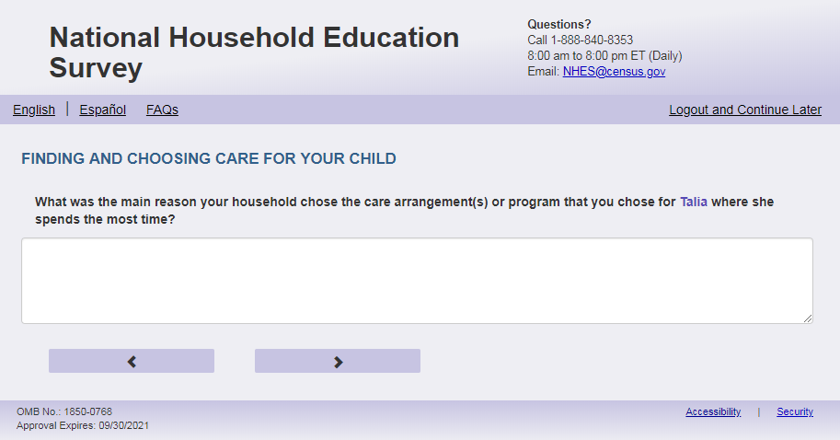
English Respondent Text Reads:
What were the main reasons your household chose the care arrangement or program where [this child] spends the most time?

We have provided space for you to tell us about up to 3 reasons. You may have fewer reasons to
tell us about. Please enter only one reason in each box.

Spanish Respondent Text Reads:

¿Cuáles fueron las razones principales por la que su hogar eligió el arreglo o los arreglos de cuidado o el programa en el que [este niño(a)] pasa más tiempo?

Hemos incluido espacio para que usted anote hasta 3 razones, pero puede que tenga menos de 3 razones. Por favor ingrese una razón en cada cuadro.

English Admin/TQA Text Reads:
What were the main reasons your household chose the care arrangement or program where [this child] spends the most time?

You can give me up to 3 reasons.
{Please enter only one reason in each box.}

Spanish Admin/TQA Text Reads:

¿Cuáles fueron las razones principales por la que su hogar eligió el arreglo o los arreglos de cuidado o el programa en el que [este niño(a)] pasa más tiempo?

Puedes darme hasta 3 razones.
{Por favor ingrese una razón en cada cuadro.}

English and Spanish Answer:

ECPP_CCREASN1, (300), character, write-in text box
ECPP_CCREASN2, (300), character, write-in text box
ECPP_CCREASN3, (300), character, write-in text box

Skips:
Go to ECPP_DCLOA

Logic Checks/Programming specifications:
Display with text box allowing 300 characters
Display each box with a number to the left of the box so that it looks like this: 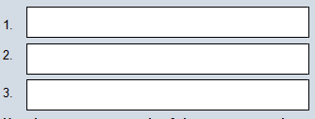

Item: Reason Importance in Finding Childcare (ECPP_DCLOA)
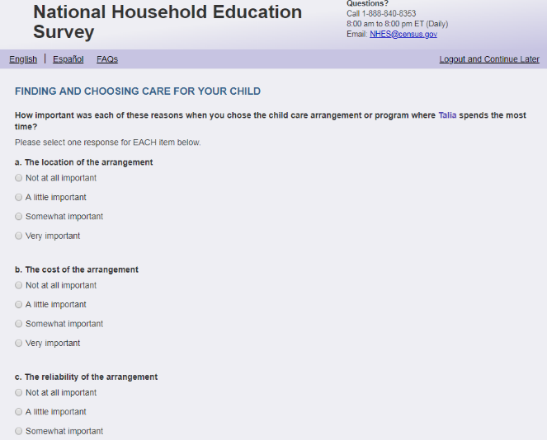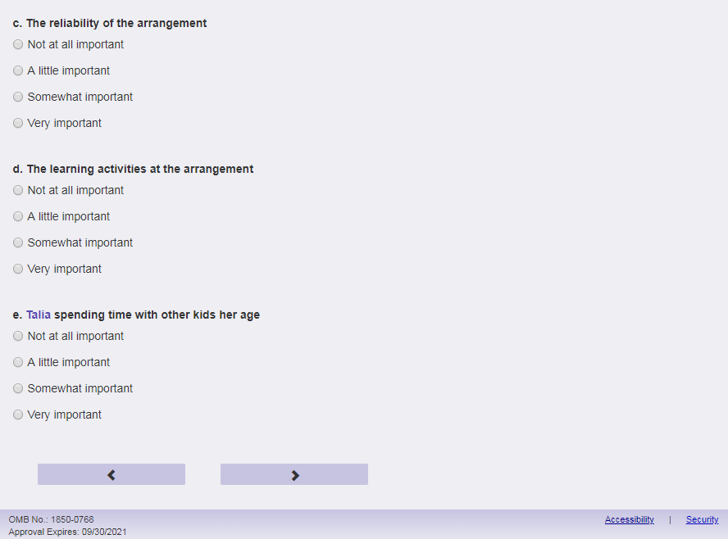
English Respondent Text Reads:
How important was each of these reasons when you chose the childcare arrangement or program where [this child] spends the most time?
Spanish Respondent Text Reads:
¿Qué tan importante fue cada una de estas razones cuando usted seleccionó el cuidado infantil o el programa en el que [este niño (esta niña] pasa la mayor parte del tiempo?
English Admin/TQA Text Reads:
How important was each of these reasons when you chose the childcare arrangement or program where [this child] spends the most time? For each reason you can say that it was: not at all important, a little important, somewhat important or very important.
Spanish Admin/TQA Text Reads:
¿Qué tan importante fue cada una de estas razones cuando usted seleccionó el cuidado infantil o el programa en el que [este niño (esta niña] pasa la mayor parte del tiempo? Por cada razón se puede decir que fue: nada importante, un poco importante, algo importante o muy importante.

English Respondent Answer:
- The location of the arrangement, ECPP_DCLOA, (1= Not at all important, 2= A little important, 3= Somewhat important, 4= Very important), numeric, radio
- The cost of the arrangement, ECPP_DCCOST, (1= Not at all important, 2= A little important, 3= Somewhat important, 4= Very important), numeric, radio
- The reliability of the arrangement, ECPP_DRELY, (1= Not at all important, 2= A little important, 3= Somewhat important, 4= Very important), numeric, radio
- The learning activities at the arrangement, ECPP_DLERN, (1= Not at all important, 2= A little important, 3= Somewhat important, 4= Very important), numeric, radio
- [This child] spending time with other kids [his/her/his or her] age, ECPP_DCHIL, (1= Not at all important, 2= A little important, 3= Somewhat important, 4= Very important) numeric, radio

Spanish Respondent Answer:
- La ubicación del lugar, ECPP_DCLOA, (1= No fue importante, 2= Muy poco importante , 3= Algo importante, 4= Muy importante), numeric, radio
- El costo del lugar, ECPP_DCCOST, (1= No fue importante, 2= Muy poco importante, 3= Algo importante, 4= Muy importante), numeric, radio
- La confiabilidad del lugar, ECPP_DRELY, (1= No fue importante, 2= Muy poco importante, 3= Algo importante, 4= Muy importante), numeric, radio
- Las actividades de aprendizaje del lugar, ECPP_DLERN, (1= No fue importante, 2= Muy poco importante, 3= Algo importante, 4= Muy importante), numeric, radio
- Que [este niño (esta niña)] pase tiempo con otros niños/otras niñas de su misma edad, ECPP_DCHIL, (1= No fue importante, 2= Muy poco importante, 3= Algo importante, 4= Muy importante) numeric, radio

English Admin/TQA Answer:
- How important was the location of the arrangement when you chose the childcare arrangement or program where [this child] spends the most time?, ECPP_DCLOA, (1= Not at all important, 2= A little important, 3= Somewhat important, 4= Very important), numeric, radio
- How important was the cost of the arrangement when you chose the childcare arrangement or program where [this child] spends the most time?, ECPP_DCCOST, (1= Not at all important, 2= A little important, 3= Somewhat important, 4= Very important), numeric, radio
- How important was the reliability of the arrangement when you chose the childcare arrangement or program where [this child] spends the most time?, ECPP_DRELY, (1= Not at all important, 2= A little important, 3= Somewhat important, 4= Very important), numeric, radio
- How important were the learning activities at the arrangement when you chose the childcare arrangement or program where [this child] spends the most time?, ECPP_DLERN, (1= Not at all important, 2= A little important, 3= Somewhat important, 4= Very important), numeric, radio
- How important was [this child] spending time with other kids [his/her/his or her] age when you chose the childcare arrangement or program where [she/he/he or she] spends the most time?, ECPP_DCHIL, (1= Not at all important, 2= A little important, 3= Somewhat important, 4= Very important) numeric, radio

Spanish Admin/TQA Answer:
- ¿Qué tan importante fue la ubicación del lugar cuando usted seleccionó el cuidado infantil o el programa en que [este niño (esta niña] pasa la mayoría del tiempo?, ECPP_DCLOA, (1= No fue importante, 2= Muy poco importante , 3= Algo importante, 4= Muy importante), numeric, radio
- ¿Qué tan importante fue el costo del lugar cuando usted seleccionó el cuidado infantil o el programa en que [este niño (esta niña] pasa la mayoría del tiempo?, ECPP_DCCOST, (1= No fue importante, 2= Muy poco importante, 3= Algo importante, 4= Muy importante), numeric, radio
- ¿Qué tan importante fue la confiabilidad del lugar cuando usted seleccionó el cuidado infantil o el programa en que [este niño (esta niña] pasa la mayoría del tiempo?, ECPP_DRELY, (1= No fue importante, 2= Muy poco importante, 3= Algo importante, 4= Muy importante), numeric, radio
- ¿Qué tan importantes fueron las actividades de aprendizaje del lugar cuando usted seleccionó el cuidado infantil o el programa en que [este niño (esta niña] pasa la mayoría del tiempo?, ECPP_DLERN, (1= No fue importante, 2= Muy poco importante, 3= Algo importante, 4= Muy importante), numeric, radio
- ¿Qué tan importante fue que [este niño (esta niña)] pase tiempo con otros niños/otras niñas de su misma edad cuando usted seleccionó el cuidado infantil o el programa en que [este niño (esta niña] pasa la mayoría del tiempo?, ECPP_DCHIL, (1= No fue importante, 2= Muy poco importante, 3= Algo importante, 4= Muy importante) numeric, radio

Skips:
Go to ECPP_DCLOA2

Logic Checks/Programming specifications:
This item will be split amongst screens with a-e (ECPP_DCLOA- ECPP_DCHIL) and f-j (ECPP_DHROP- ECPP_DRELOR ) on different pages. The question stem will repeat on each page. This page (DCLOA) only displays a – e. The next page ECPP_DCLOA2 will display f – j.
If child’s name is available on screener, use child’s name of child on response option e: [Name of child] spending time with other kids [his/her/his or her] age. If child’s name is not available, use “this child” as fill. (Spanish: este niño (esta niña))

English:
If S1_Pxsex = 1, use ‘his’, if s1_pxsex = 2, use ‘her’, else use ‘his or her’

Item: Reason Importance in Finding Childcare continued (ECPP_DCLOA2)
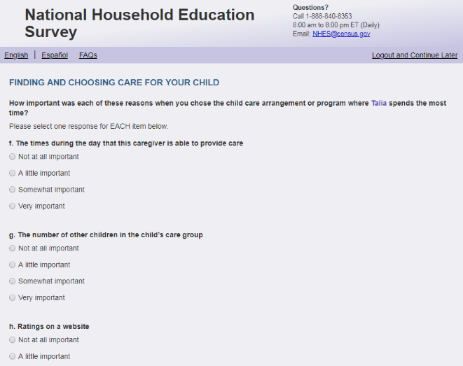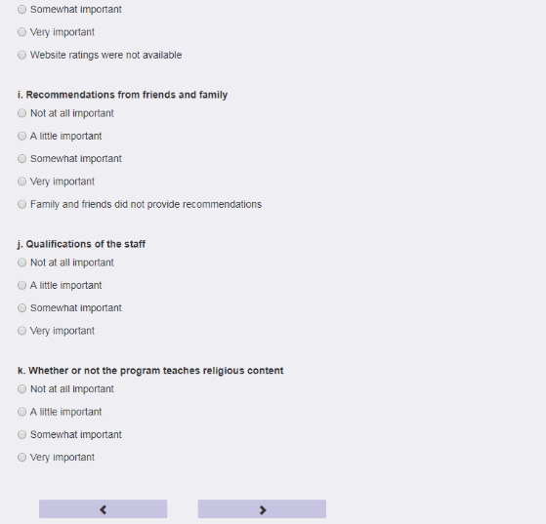
English Text Reads:
How important was each of these reasons when you chose the childcare arrangement or program where [this child] spends the most time?
Spanish Text Reads:
¿Qué tan importante fue cada una de estas razones cuando usted seleccionó el cuidado infantil o el programa en el que este(a) niño(a) pasa la mayor parte del tiempo?
English Admin/TQA Text Reads:
Continuing the question…
Again, you can say: not at all important, a little important, somewhat important, or very important.
How important was each of these reasons when you chose the childcare arrangement or program where [this child] spends the most time?
Spanish Admin/TQA Text Reads:
Continuando con la pregunta...
Una vez más, puede decir:no fue importante, muy poco importante, algo importante, muy importante
¿Qué tan importante fue cada una de estas razones cuando usted seleccionó el cuidado infantil o el programa en el que este(a) niño(a) pasa la mayor parte del tiempo?

English Respondent Answer:
- The times during the day that this caregiver is able to provide care, ECPP_DHROP, (1= Not at all important, 2= A little important, 3= Somewhat important, 4= Very important), numeric, radio
- The number of other children in the child’s care group, ECPP_DNBGRP, (1= Not at all important, 2= A little important, 3= Somewhat important, 4= Very important), numeric, radio
- Ratings on a website, ECPP_DRTWEB, (1= Not at all important, 2= A little important, 3= Somewhat important, 4= Very important, 5= Website ratings were not available), numeric, radio
- Recommendations from friends and family, ECPP_DRECFAM, (1= Not at all important, 2= A little important, 3= Somewhat important, 4= Very important, 5= Family and friends did not provide recommendations), numeric, radio
- Qualifications of the staff, ECPP_DQUAL, (1= Not at all important, 2= A little important, 3= Somewhat important, 4= Very important), numeric, radio
- Whether or not the program teaches religious content, ECPP_DRELOR, (1= Not at all important, 2= A little important, 3= Somewhat important, 4= Very important), numeric, radio

Spanish Respondent Answer:
- El horario durante el día en que se ofrece cuidado infantil en este lugar, ECPP_DHROP, (1= No fue importante, 2= Muy poco importante, 3= Algo importante, 4= Muy importante), numeric, radio
- La cantidad de niños(as) en el grupo de cuidado en que está su niño(a), ECPP_DNBGRP, (1= No fue importante, 2= Muy poco importante, 3= Algo importante, 4= Muy importante), numeric, radio
- Ranking/clasificación en una página de internet, ECPP_DRTWEB, (1= No fue importante, 2= Muy poco importante, 3= Algo importante, 4= Muy importante, 5= Las clasificaciones en internet no estaban disponibles), numeric, radio
- Recomendaciones de amigos o familia, ECPP_DRECFAM, (1= No fue importante, 2= Muy poco importante, 3= Algo importante, 4= Muy importante, 5= Familia y amigos no dieron
recomendaciones), numeric, radio
- Aptitud del personal, ECPP_DQUAL, (1= No fue importante, 2= Muy poco importante, 3= Algo importante, 4= Muy importante), numeric, radio
- Si el programa enseña o no un contenido religioso, ECPP_DRELOR, (1= No fue importante, 2= Muy poco importante, 3= Algo importante, 4= Muy importante), numeric, radio

English Admin/TQA Answer:
- How important were the times during the day that this caregiver is able to provide care when you chose the childcare arrangement or program where [this child] spends the most time?, ECPP_DHROP, (1= Not at all important, 2= A little important, 3= Somewhat important, 4= Very important), numeric, radio
- How important was the number of other children in the child’s care group when you chose the childcare arrangement or program where [this child] spends the most time?, ECPP_DNBGRP, (1= Not at all important, 2= A little important, 3= Somewhat important, 4= Very important), numeric, radio
- How important were ratings on a website when you chose the childcare arrangement or program where [this child] spends the most time?, ECPP_DRTWEB, (1= Not at all important, 2= A little important, 3= Somewhat important, 4= Very important, 5= Website ratings were not available), numeric, radio
- How important were recommendations from friends and family when you chose the childcare arrangement or program where [this child] spends the most time?, ECPP_DRECFAM, (1= Not at all important, 2= A little important, 3= Somewhat important, 4= Very important, 5= Family and friends did not provide recommendations), numeric, radio
- How important were qualifications of the staff when you chose the childcare arrangement or program where [this child] spends the most time?, ECPP_DQUAL, (1= Not at all important, 2= A little important, 3= Somewhat important, 4= Very important), numeric, radio
- How important was whether or not the program teaches religious content when you chose the childcare arrangement or program where [this child] spends the most time?, ECPP_DRELOR, (1= Not at all important, 2= A little important, 3= Somewhat important, 4= Very important), numeric, radio

Spanish Admin/TQA Answer:
- ¿Qué tan importantes fueron el horario durante el día en que ofrece cuidado infantil en este lugar cuando usted seleccionó el cuidado infantil o el programa en que [este niño (esta niña] pasa la mayoría del tiempo?, ECPP_DHROP, (1= No fue importante, 2= Muy poco importante, 3= Algo importante, 4= Muy importante), numeric, radio
- ¿Qué tan importante fue la cantidad de niños(as) en el grupo de cuidado en que está su niño(a) cuando usted seleccionó el cuidado infantil o el programa en que [este niño (esta niña] pasa la mayoría del tiempo?, ECPP_DNBGRP, (1= No fue importante, 2= Muy poco importante, 3= Algo importante, 4= Muy importante), numeric, radio
- ¿Qué tan importantes fueron ranking/clasificación en una página de internet, ECPP_DRTWEB cuando usted seleccionó el cuidado infantil o el programa en que [este niño (esta niña] pasa la mayoría del tiempo?, (1= No fue importante, 2= Muy poco importante, 3= Algo importante, 4= Muy importante, 5= Las clasificaciones en internet no estaban disponibles), numeric, radio
- ¿Qué tan importantes fueron recomendaciones de amigos o familia cuando usted seleccionó el cuidado infantil o el programa en que [este niño (esta niña] pasa la mayoría del tiempo?, ECPP_DRECFAM, (1= No fue importante, 2= Muy poco importante, 3= Algo importante, 4= Muy importante, 5= Familia y amigos no dieron recomendaciones), numeric, radio
- ¿Qué tan importantes fueron aptitud del personal cuando usted seleccionó el cuidado infantil o el programa en que [este niño (esta niña] pasa la mayoría del tiempo?, ECPP_DQUAL, (1= No fue importante, 2= Muy poco importante, 3= Algo importante, 4= Muy importante), numeric, radio
- ¿Qué tan importante fue si el programa enseña o no un contenido religioso cuando usted seleccionó el cuidado infantil o el programa en que [este niño (esta niña] pasa la mayoría del tiempo?, ECPP_DRELOR, (1= No fue importante, 2= Muy poco importante, 3= Algo importante, 4= Muy importante), numeric, radio

Skips:
Go to ECPP_HABOOKS

Logic Checks/Programming specifications:
This is the 2nd part of item DCLOA, with items f-j only displayed (ECPP_DHROP- ECPP_DRELOR ). The question stem will repeat on each page.
For option i (ECPP_DRECFAM) and j (ECPP_DQUAL), increase spacing between “Very important” and the fifth response options by double the typical spacing between response options.

Item: Number of Child’s Books (ECPP_HABOOKS)
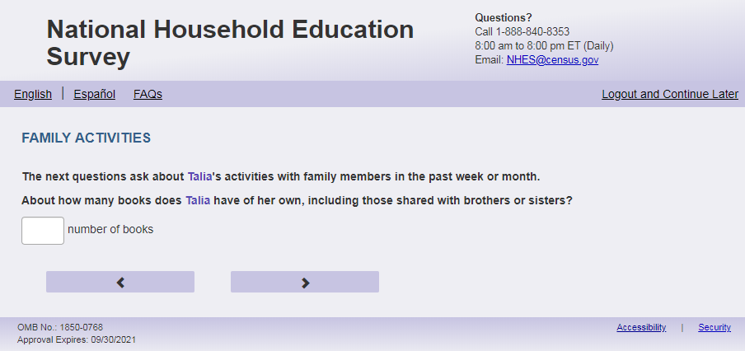
English Text Reads:
About how many books does [this child] have of [his/her/his or her] own, including those shared with brothers or sisters?
Spanish Text Reads:
¿Más o menos cuántos libros tiene [este niño (esta niña)], que sean de [él /ella/ él o ella], incluyendo los que comparte con los hermanos?
English and Spanish Answer:

ECPP_HABOOKS, (0, 999), numeric, write-in

Skips:
Go to ECPP_FOREADTOXA

Logic Checks/Programming specifications:
English: Display "books" to right of box.
Spanish: Display “libros” to the right of the box.
Mobile: Display numeric keypad

English:
If S1_Pxsex = 1, use ‘his’, if s1_pxsex = 2, use ‘her’, else use ‘his or her’
Spanish:
If S1_Pxsex = 1, use ‘él’, if s1_pxsex = 2, use ‘ella’, else use ‘él o ella’

Item: Number of Times Read to Child (ECPP_FOREADTOXA)
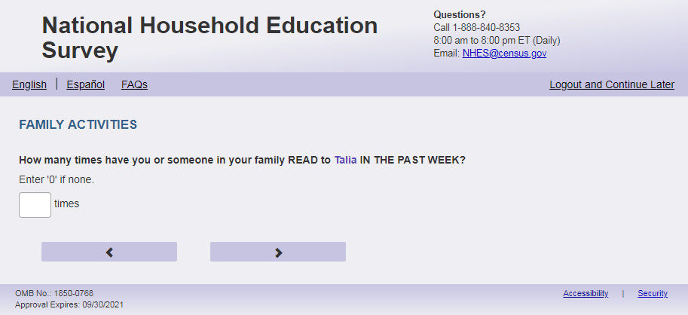
English Respondent Text Reads:
How many times have you or someone in your family READ to [this child] IN THE PAST WEEK?

Enter ‘0’ if not at all.

Spanish Respondent Text Reads:

¿Cuántas veces le LEYÓ usted o alguien de su familia a [este niño(a)] LA ÚLTIMA SEMANA?

Ingrese '0' si ninguna vez.
English Admin/TQA Text Reads:
How many times have you or someone in your family READ to [this child] IN THE PAST WEEK?

{Enter ‘0’ if not at all. (Clarify that it’s just asking for an estimated number if there is any confusion.)}

Spanish Admin/TQA Text Reads:

¿Cuántas veces le LEYÓ usted o alguien de su familia a [este niño(a)] LA ÚLTIMA SEMANA ?

{ Ingrese '0' si ninguna vez. (Aclarar que sólo está pidiendo un número estimado, si hay alguna confusión.)}
English and Spanish Answer:

ECPP_FOREADTOXA, (0, 99), numeric, write-in

Skips:

If ECPP_FOREADTOXA = blank or ‘0’, then go to ECPP_FOSTORYX, else go to ECPP_FORDDAYX

English:
Display 'times' next to the write-in box.
Spanish:
Display 'veces' next to the write-in box.
Mobile: Display numeric keypad

Item: Number of Minutes Read to Child (ECPP_FORDDAYX)
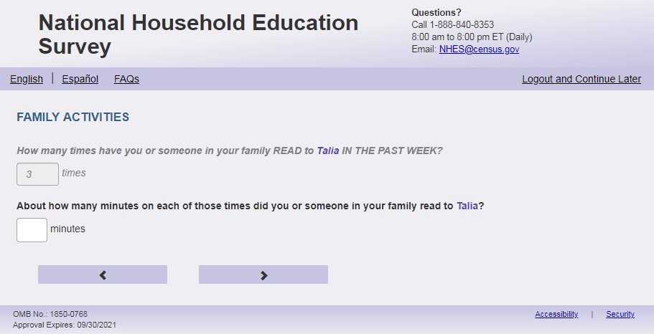
English Text Reads:
(if ECPP_FOREADTOXA = 1 display:) About how many minutes during that time did you or someone in your family read to [this child]?

(if ECPP_FOREADTOXA > 1 display:) About how many minutes on each of those times did you or someone in your family read to [this child]?

Spanish Text Reads:

(if ECPP_FOREADTOXA = 1 display:) ¿Más o menos cuántos minutos durante ese tiempo, usted o alguien de su familia leyó a [este niño (esta niña)]?

(if ECPP_FOREADTOXA > 1 display:) ¿Más o menos cuántos minutos en cada uno de esos días le leyó usted o alguien de su familia a [este niño (esta niña)]?

English and Spanish Answer:

ECPP_FORDDAYX, (1,999), numeric, write-in,

Skips:

Go to ECPP_FOSTORYX

Logic Checks/Programming specifications:
Display on a new screen. Do not display on same screen as ECPP_FOREADTOXA.
English: Display "minutes" to right of box. Spanish: Display "minutos" to right of box.
Mobile: Display numeric keypad

Text displayed for logic/range check violation:
Logic/range check triggers a warning message, with the following text displayed.
English: [If 0 or more than 120] Display "Please check your answer before continuing. Typically, adults read to children between one and 120 minutes at a time."
Spanish: [If 0 or more than 120] Display "Por favor, revise su respuesta antes de continuar. Por lo general, los adultos leen a los niños entre uno y 120 minutos de una vez.”

Item: Weekly Activities with Child (ECPP_FOSTORYX)
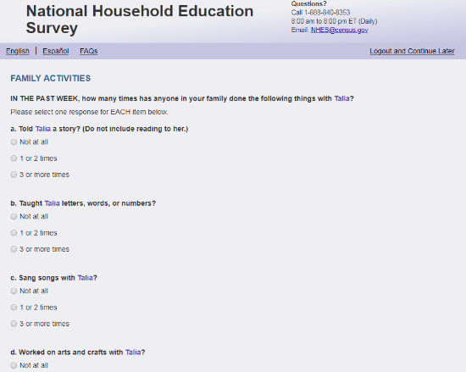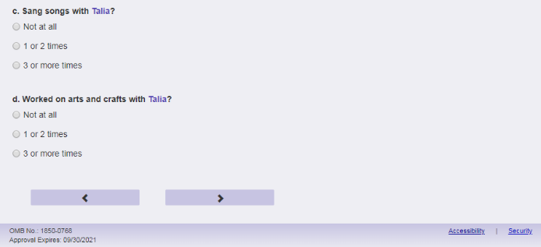
English Text Reads:
IN THE PAST WEEK, how many times has anyone in your family done the following things with [this child]?

Spanish Text Reads:
EN LA ÚLTIMA SEMANA, ¿cuántas veces alguien en su familia ha hecho las siguientes cosas con [este niño (esta niña)]?

English Admin/TQA Text Reads:
IN THE PAST WEEK, how many times has anyone in your family done the following things with [this child]?

I’m going to read four activities. You can answer: not at all, 1 or 2 times, or 3 or more times in the past week.

Spanish Admin/TQA Text Reads:
EN LA ÚLTIMA SEMANA, ¿cuántas veces alguien en su familia ha hecho las siguientes cosas con [este niño (esta niña)]?

Voy a leer cuatro actividades. Usted puede responder: ninguna vez, 1 o 2 veces, 3 o más veces durante la semana pasada.

English Answer:

- Told [this child] a story? (Do not include reading to [him/her/him or her].) ECPP_FOSTORYX, (1=Not at all, 2=1 or 2 times, 3=3 or more times), numeric, radio
- Taught [this child] letters, words, or numbers? ECPP_FOWORDSX, (1=Not at all, 2=1 or 2 times, 3=3 or more times), numeric, radio
- Sang songs with [this child]? ECPP_FOSANG, (1=Not at all, 2=1 or 2 times, 3=3 or more times), numeric, radio
- Worked on arts and crafts with [this child]? ECPP_FOCRAFTSX, (1=Not at all, 2=1 or 2 times, 3=3 or more times), numeric, radio

Spanish Answer:

- ¿Contarle a [este niño (esta niña)] un cuento, pero no leyéndoselo? (No incluya leerle a [él /ella/ él o ella]). ECPP_FOSTORYX, (1=Ninguna vez, 2=1 o 2 veces, 3= 3 o más veces), numeric, radio
- ¿Enseñarle a [este niño (esta niña)] letras, palabras o números? ECPP_FOWORDSX, (1=Ninguna vez, 2=1 o 2 veces, 3= 3 o más veces), numeric, radio
- ¿Cantar canciones con [este niño (esta niña)]? ECPP_FOSANG, (1=Ninguna vez, 2=1 o 2 veces, 3= 3 o más veces), numeric, radio
- ¿Hacer trabajos de artes y artesanías con [este niño (esta niña)]? ECPP_FOCRAFTSX, (1=Ninguna vez, 2=1 o 2 veces, 3= 3 o más veces), numeric, radio

Skips:

Go to ECPP_FODINNERX
Logic Checks/Programming specifications:
English:
If S1_Pxsex = 1, use ‘him’, if s1_pxsex = 2, use ‘her’, else use ‘him or her’
Spanish:
If S1_Pxsex = 1, use ‘él’, if s1_pxsex = 2, use ‘ella’, else use ‘él o ella’

Item: Number of Days Family Eaten Together (ECPP_FODINNERX)
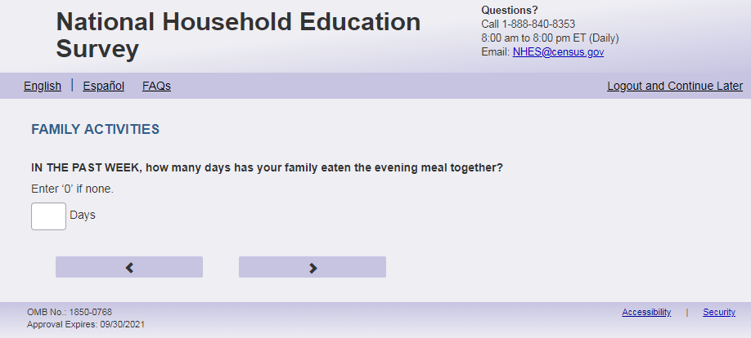
English Text Reads:
IN THE PAST WEEK, how many days has your family eaten the evening meal together?
Enter ‘0’ if none.

Spanish Text Reads:

EN LA ÚLTIMA SEMANA, ¿cuántos días cenó la familia junta?
Ingrese '0' si es nunca.

English and Spanish Answer:

ECPP_FODINNERX, (0,7), numeric, write-in

Skips:
Go to ECPP_FOLIBRAY

Logic Checks/Programming specifications:
English: Display "days in the past week” to the right of the write-in box.
Spanish: Display "días de la semana pasada" to the right of the write-in box.
Mobile: Display numeric keypad

Text displayed for logic/range check violation
English: [If more than 7] Display "Please check your answer before continuing. Answers between 0 and 7 are acceptable.”"
Spanish [If more than 7] Display "Por favor, compruebe su respuesta antes de continuar. Las respuestas entre 0 y 7 aceptables."

Item: Visited the Library (ECPP_FOLIBRAY)
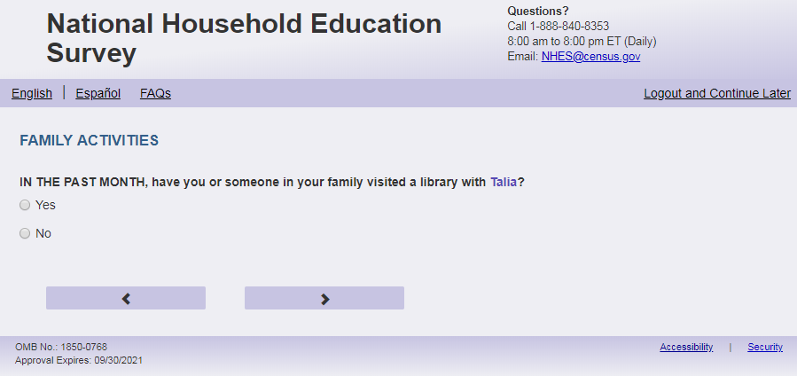
English Text Reads:
IN THE PAST MONTH, have you or someone in your family visited a library with [this child]?

Spanish Text Reads:

DURANTE EL MES PASADO, ¿ha ido usted o alguien de su familia a la biblioteca con [este niño (esta niña)]?

English Answer:

1=Yes
2=No

Spanish Answer:

1= Sí
2=No

ECPP_FOLIBRAY, (1,2), numeric, radio

Skips:
Go to ECPP_FOBOOKST

Item: Visited the Bookstore (ECPP_FOBOOKST)
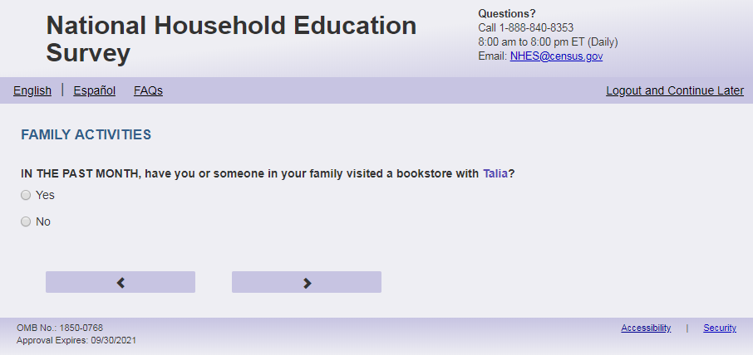
English Text Reads:
IN THE PAST MONTH, have you or someone in your family visited a bookstore with [this child]?

Spanish Text Reads:

DURANTE EL MES PASADO, ¿ha ido usted o alguien de su familia a una librería (tienda de libros) con [este niño (esta niña)]?

English Answer:

1=Yes
2=No

Spanish Answer:

1= Sí
2=No

ECPP_FOBOOKST, (1,2), numeric, radio

Skips:

If child’s s1_PxDOBMM is missing on the Screener, or, s1_PxDOBMM = current month and year of birth = 2021, go to ECPP_DPIAGE.

If age = (0 or 1 ) or S1_PxDOBMM is a month after the current month and s1_PxDOBYY = 2021, then follow the below logic based on ECPP_HEALTH_VER :
If ECPP_HEALTH_VER =2, then go to ECPP_HDHEALTH.
If ECPP_HEALTH_VER=1, then go to ECPP_HDEXCNRN.
Else go to ECPP_ DPLETTER.

Item: 2 Years of Age (ECPP_DPIAGE)
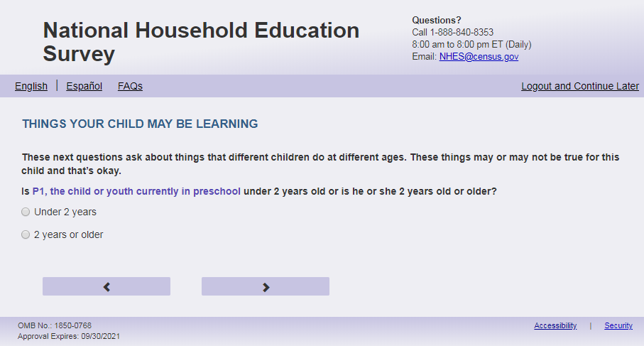
EnglishText Reads:
Is [this child] under 2 years old or is [he/she/he or she] 2 years old or older?

Spanish Text Reads:

¿Es [este niño (esta niña)] menor de 2 años o tiene 2 años o más?

English Answer:

1= Under 2 years
2= 2 years or older

Spanish Answer:

1= Menor de 2 años
2= 2 años o más

ECPP_DPIAGE, (1,2), numeric, radio

Skips:

If ECPP_DPIAGE = 1 then then follow the below logic based on ECPP_HEALTH_VER:
If ECPP_HEALTH_VER=2, then go to ECPP_HDHEALTH.
If ECPP_HEALTH_VER=1, then go to ECPP_HDEXCNRN.
Else go to ECPP_DPLETTER.

Logic checks/Programming specifications
Only display if child's s1_PxDOBMM is missing or birth month is the same as the month of the R's survey completion and the child has a birth year of 2021. Otherwise, please use the screener-reported age to filter babies, 1-year olds, and almost-2 year olds out of here.
English:
If S1_Pxsex = 1, use ‘he’, if s1_pxsex = 2, use ‘she’, else use ‘he or she’

Item: Name Letters (ECPP_DPLETTER)
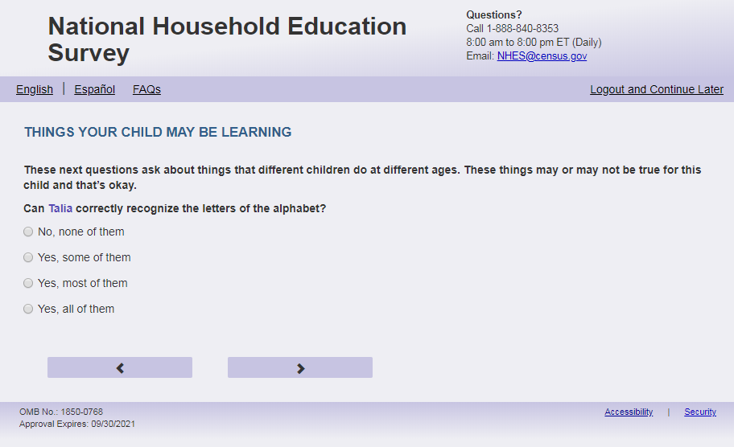
English Respondent Text Reads:
These next questions ask about things that different children do at different ages. These things may or may not be true for this child and that’s okay.
Can [this child] recognize the letters of the alphabet?

Spanish Respondent Text Reads:
Las siguientes preguntas se tratan de cosas que distintos niños(as) hacen a distintas edades. Estas cosas pueden ser ciertas o no para este niño(a), y eso es perfectamente normal.

¿Puede [este niño (esta niña)] reconocer correctamente las letras del alfabeto?

English Admin/TQA Text Reads:
These next questions ask about things that different children do at different ages. These things may or may not be true for this child and that’s okay.
Can [this child] recognize the letters of the alphabet?

{If ‘yes,’ read yes answer options to the respondent.}

Spanish Admin/TQA Text Reads:
Las siguientes preguntas se tratan de cosas que distintos niños(as) hacen a distintas edades. Estas cosas pueden ser ciertas o no para este niño(a), y eso es perfectamente normal.

¿Puede [este niño (esta niña)] reconocer correctamente las letras del alfabeto?

{Si 'sí', lea las opciones de respuesta sí al encuestado.}

English Answer:

1= No, none of them
2= Yes, some of them
3 = Yes, most of them
4= Yes, all of them

Spanish Answer:

1= No, ninguna
2= Sí, algunas
3= Sí, la mayoría
4= Sí, todas

ECPP_DPLETTER, (1,4), numeric, radio

Skips:
Go to ECPP_DPNAME

Item: Writing Name (ECPP_DPNAME)
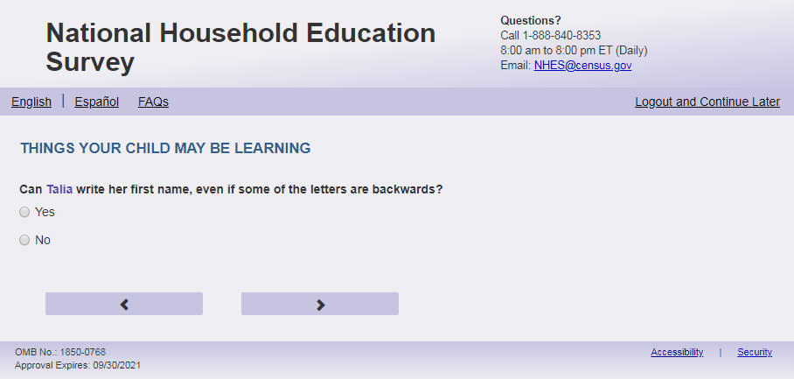
English Text Reads:
Can [this child] write [his/her/his or her] first name, even if some of the letters are backwards?

Spanish Text Reads:

¿Puede este niño escribir su nombre, incluso si escribe algunas letras al revés?

English Answer:

1=Yes
2=No

Spanish Answer:

1= Sí
2=No

ECPP_DPNAME, (1,2), numeric, radio
Skips:
Go to ECPP_DPLTRSND

Logic Checks/Programming specifications:
English:
If S1_Pxsex = 1, use ‘his’, if s1_pxsex = 2, use ‘her’, else use ‘his or her’

Item: Letter Sounds (ECPP_DPLTRSND)
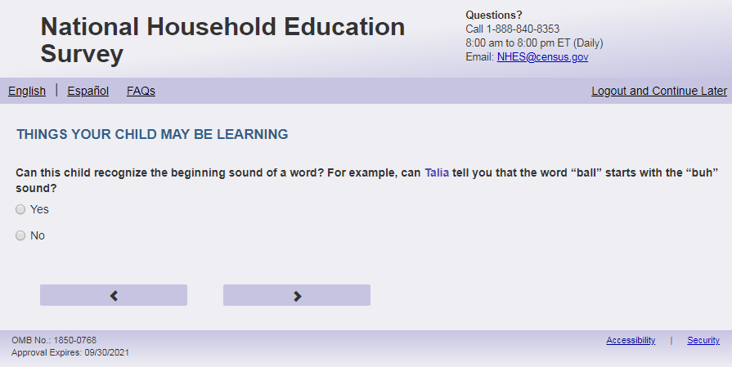
English Text Reads:
Can this child recognize the beginning sound of a word? For example, can [this child] tell you that the word “ball” starts with the “buh” sound?

Spanish Text Reads:

¿Puede este niño(a) reconocer el sonido inicial de una palabra? Por ejemplo, ¿Puede [este niño(a)] contarle que la palabra “pelota” empieza con el sonido “pe”?

English Answer:

1=Yes
2=No

Spanish Answer:

1= Sí
2=No

ECPP_DPLTRSND, (1,2), numeric, radio
Skips:
Go to ECPP_DPEXPLN

Item: Explain things (ECPP_DPEXPLN)
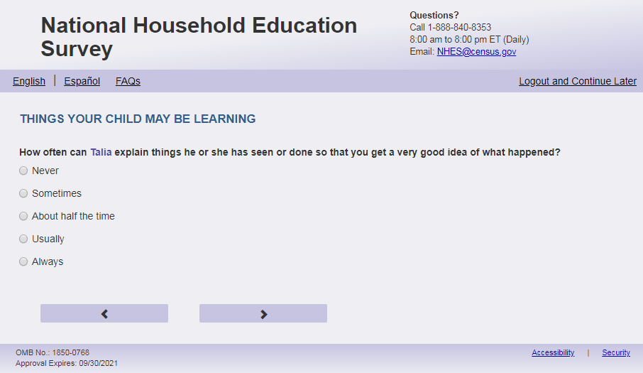
English Respondent Text Reads:
How often can [this child] explain things he or she has seen or done so that you get a very good idea of what happened?

Spanish Respondent Text Reads:

¿Con qué frecuencia puede [este niño(a)] explicar las cosas que ha visto o hecho para que usted tenga una muy buena idea de lo que sucedió?

English Admin/TQA Text Reads:
How often can [this child] explain things he or she has seen or done so that you get a very good idea of what happened?

{Please read response options}

Spanish Admin/TQA Text Reads:

¿Con qué frecuencia puede [este niño(a)] explicar las cosas que ha visto o hecho para que usted tenga una muy buena idea de lo que sucedió?

{Por favor, lea las opciones de respuesta.}

English Answer:

1=Never
2=Sometimes
3=About half the time
4= Usually
5=Always

Spanish Answer:

1= Nunca
2=A veces
3=La mitad del tiempo
4= Normalmente
5 = Siempre

ECPP_DPEXPLN, (1,5), numeric, radio
Skips:
Go to ECPP_DPCOUNT

Item: Counting (ECPP_DPCOUNT)
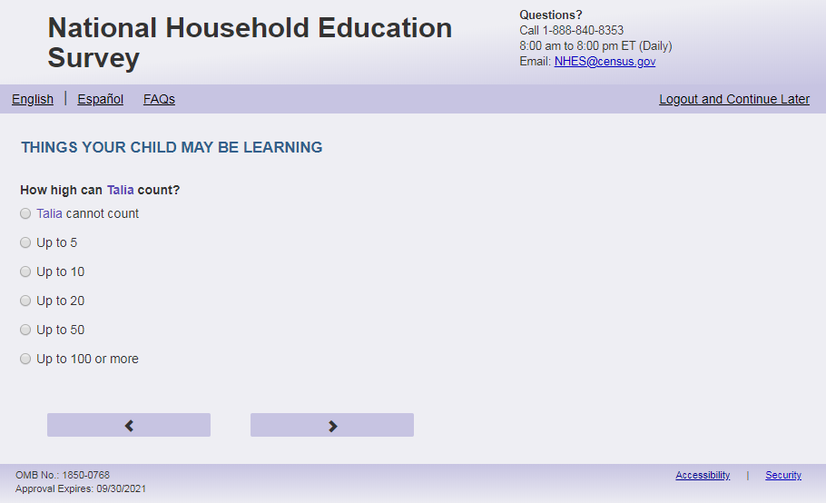
English Text Reads:
How high can [this child] count?

Spanish Text Reads:

¿Hasta cuánto puede contar [este niño (esta niña)]?

English Answer:

1= [This child] cannot count
2= Up to 5
3= Up to 10
4= Up to 20
5= Up to 50
6= Up to 100 or more

Spanish Answer:

1= [Este niño (esta niña)] no sabe contar
2= Hasta 5
3= Hasta 10
4= Hasta 20
5= Hasta 50
6= Hasta 100 o más

ECPP_DPCOUNT, (1,6), numeric, radio

Skips:
Go to ECPP_DPSHAPE

Item: Name Shapes (ECPP_DPSHAPE)
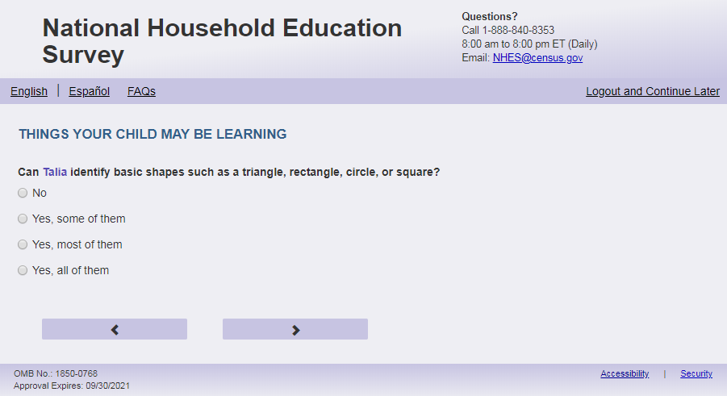
English Text Reads:
Can [this child] identify basic shapes such as a triangle, rectangle, circle, or square?

Spanish Text Reads:
¿Puede [este niño(a)] identificar formas básicas como un triángulo, rectángulo, círculo, o cuadrado?

English Admin/TQA Text Reads:
Can [this child] identify basic shapes such as a triangle, rectangle, circle, or square?
{If ‘yes,’ read yes answer options to the respondent.}

Spanish Admin/TQA Text Reads:
¿Puede [este niño(a)] identificar formas básicas como un triángulo, rectángulo, círculo, o cuadrado?
{Si 'sí', lea opciones de respuesta sí al encuestado.}

English Answer:

1= No, none of them
2= Yes, some of them
3= Yes, most of them
4= Yes, all of them

Spanish Answer:

1= No, ninguna
2= Sí, algunas
3= Sí, la mayoría
4= Sí, todas

ECPP_DPSHAPE, (1,4), numeric, radio

Skips:
Go to ECPP_HDEXCNRN.

Item: Child’s Health (ECPP_HDHEALTH)
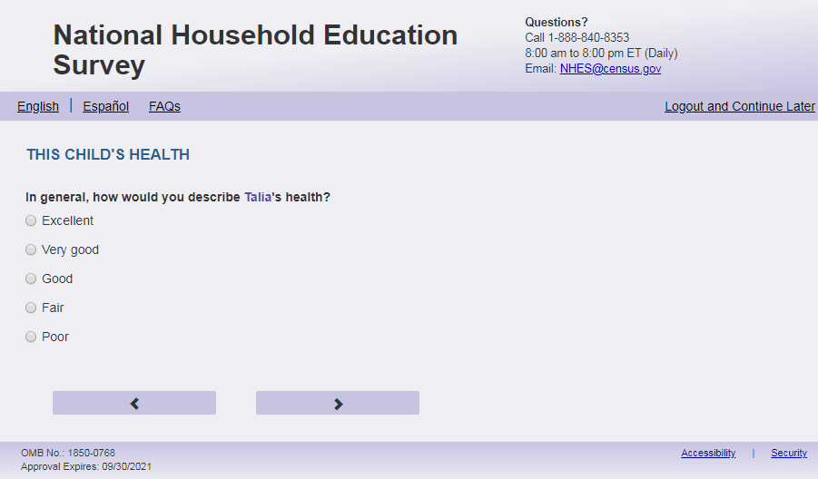
English Respondent Text Reads:
In general, how would you describe [this child]’s health?

Spanish Respondent Text Reads:

En general, ¿cómo describiría la salud de [este niño (esta niña)]?

English Admin/TQA Text Reads:
In general, how would you describe [this child]’s health?

{Please read response options.}

Spanish Admin/TQA Text Reads:

En general, ¿cómo describiría la salud de [este niño (esta niña)]?

{Por favor, lea las opciones de respuesta.}
English Answer:

1=Excellent
2=Very good
3=Good
4=Fair
5=Poor

Spanish Answer:

1= Excelente
2= Muy buena
3= Buena
4= Regular
5= Mala

ECPP_HDHEALTH, (1,5), numeric, radio
Skips:
If ECPP_HEALTH_VER =2 then go to ECPP_HDINTDIS. Else if ECPP_HEALTH_VER =1, then go to ECPP_CLIVYN.

Item: Express Health Concern (ECPP_HDEXCNRN)
<New item for NHES:2023 – no screenshot available>
English Text Reads:
Has a parent or guardian expressed concerns to a health, education, or early intervention professional about [this child]'s development (for example, speech and language, social emotional, or motor skill development)?

Spanish Text Reads:
¿ Ha expresado usted u otro padre, madre o tutor legal preocupaciones a un profesional de la salud, de educación o de intervención temprana sobre el desarrollo de [este niño (esta niña)] (por ejemplo, desarrollo del habla y el lenguaje, socio emocional o de habilidades motoras)?

English Answer:

1=Yes
2=No

Spanish Answer:

1= Sí
2= No

ECPP_HDEXCNRN, (1,2), numeric, radio
Skips:

If ECPP_HDEXCNRN = 1, then go to ECPP_HDSTCNRN.
Else if ECPP_HDEXCNRN = 2 or blank then do:
If ECPP_HEALTH_VER =2 then go to ECPP_HDHEALTH.
If ECPP_HEALTH_VER =1 go to ECPP_HDINTDIS

Item: Satisfaction with Health Providers Response (ECPP_HDSTCNRN)
<New item for NHES:2023 – no screenshot available>

English Text Reads:
Overall, how satisfied or dissatisfied are you with responses from health, education, or early intervention professionals about your concerns about [this child]’s development?

Spanish Text Reads:
En general, ¿qué tan satisfecho está con las respuestas de profesionales de la salud, de educación o de intervención temprana sobre sus preocupaciones acerca del desarrollo de [este niño (esta niña)]?
English Admin/TQA Text Reads:
Overall, how satisfied or dissatisfied are you with responses from health, education, or early intervention professionals about your concerns about [this child]’s development?

Very satisfied, somewhat satisfied, somewhat dissatisfied, or very dissatisfied?

Spanish Admin/TQA Text Reads:
En general, ¿qué tan satisfecho está con las respuestas de profesionales de la salud, de educación o de intervención temprana sobre sus preocupaciones acerca del desarrollo de [este niño (esta niña)]?

Muy satisfecho, algo satisfecho, algo insatisfecho, o muy insatisfecho?

English Answer:

1=Very satisfied
2=Somewhat satisfied
3=Somewhat dissatisfied
4=Very dissatisfied

Spanish Answer:

1=Muy satisfecho
2=Algo satisfecho
3=Algo insatisfecho
4=Muy insatisfecho

Skips:
If ECPP_HEALTH_VER =2 then go to ECPP_HDHEALTH.
If ECPP_HEALTH_VER =1 go to ECPP_HDINTDIS

Item: Child’s Health Conditions (ECPP_HDINTDIS)
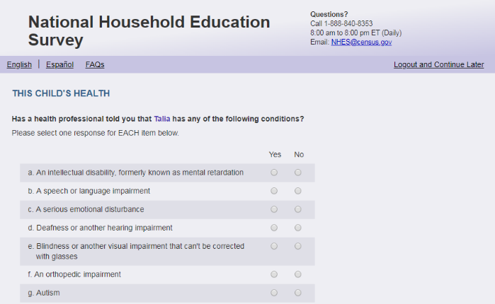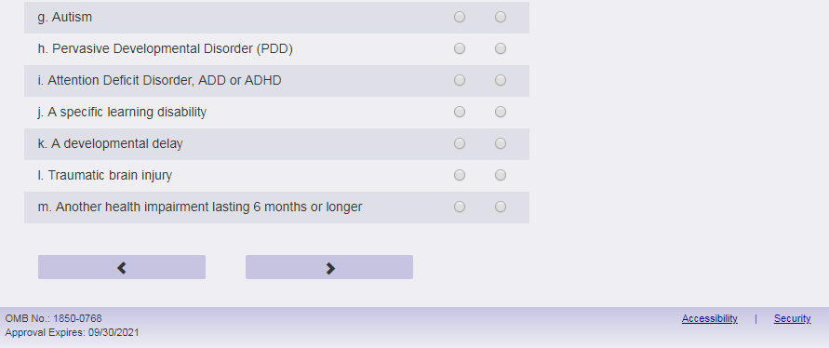
English Respondent Text Reads:
Has a health, education, or early intervention professional told you that [this child] has any of the following conditions?

Spanish Respondent Text Reads:

¿Le ha dicho un profesional de la salud, de educación o de intervención temprana que [este niño (esta niña)] tiene alguno de los siguientes problemas de salud?

English Admin/TQA Text Reads:
Has a health, education, or early intervention professional told you that [this child] has any of the following conditions?

Please respond ‘yes’ or ‘no for EACH item as I read them.
{Read definitions only if the respondent asks.}

Spanish Admin/TQA Text Reads:

¿Le ha dicho un profesional de la salud, de educación o de intervención temprana que [este niño (esta niña)] tiene alguno de los siguientes problemas de salud?

Por favor, responda 'sí' o 'no para CADA opción como las leí.
{Leer definiciones solo si el encuestado pregunta.}
English Respondent Answer:

If not in the split panel (ECPP_HEALTH_VER=2) then:

- A speech or language impairment, ECPP_HDSPEECHX, (1=Yes, 2=No), numeric, radio
- A serious emotional disturbance, ECPP_HDDISTRBX, (1=Yes, 2=No), numeric, radio
- Deafness or another hearing impairment, ECPP_HDDEAFIMX, (1=Yes, 2=No), numeric, radio
- Blindness or another visual impairment not corrected with glasses,ECPP_HDBLINDX, (1=Yes, 2=No), numeric, radio
- An orthopedic impairment, ECPP_HDORTHOX, (1=Yes, 2=No), numeric, radio
- Autism or autism spectrum disorder, ECPP_HDAUTISMX, (1=Yes, 2=No), numeric, radio
- Pervasive Developmental Disorder (PDD), ECPP_HDPDDX, (1=Yes, 2=No), numeric, radio
- Attention Deficit Hyperactivity Disorder, ADHD or ADD, ECPP_HDADDX, (1=Yes, 2=No), numeric, radio
- A specific learning disability, ECPP_HDLEARNX, (1=Yes, 2=No), numeric, radio
- A developmental delay, ECPP_HDDELAYX, (1=Yes, 2=No), numeric, radio
- Traumatic brain injury, ECPP_HDTRBRAIN, (1=Yes, 2=No), numeric, radio
- An intellectual disability, formerly known as mental retardation, ECPP_HDINTDIS, (1=Yes, 2=No), numeric, radio
- Another health impairment lasting 6 months or longer, ECPP_HDOTHERX, (1=Yes, 2=No), numeric, radio

If in the split panel (ECPP_HEALTH_VER = 1) then:

- A speech or language impairment, ECPP_HDSPEECHX, (1=Yes, 2=No), numeric, radio
- Autism or autism spectrum disorder, ECPP_HDAUTISMX, (1=Yes, 2=No), numeric, radio
- Attention Deficit Hyperactivity Disorder, ADHD or ADD, ECPP_HDADDX, (1=Yes, 2=No), numeric, radio
- Another disability or health impairment lasting 6 months or longer, ECPP_HDOTHERX2, (1=Yes, 2=No), numeric, radio
- Please specify (ECPP_HDOTHERXOS2)

Spanish Respondent Answer:

If not in the split panel (ECPP_HEALTH_VER =2) then:

- Un impedimento del habla o del lenguaje, ECPP_HDSPEECHX, (1= Sí, 2=No), numeric, radio
- Un trastorno emocional grave, ECPP_HDDISTRBX, (1= Sí, 2=No), numeric, radio
- Sordera u otro impedimento del oído, ECPP_HDDEAFIMX, (1= Sí, 2=No), numeric, radio
- Ceguera u otro impedimento de la vista que no se corrige con anteojos, ECPP_HDBLINDX, (1= Sí, 2=No), numeric, radio
- Un impedimento ortopédico, ECPP_HDORTHOX, (1= Sí, 2=No), numeric, radio
- Autismo o trastorno del espectro autista, ECPP_HDAUTISMX, (1= Sí, 2=No), numeric, radio
- Trastorno generalizado del desarrollo (PPD, en inglés), ECPP_HDPDDX, (1= Sí, 2=No), numeric, radio
- Trastorno de déficit de atención e hiperactividad (ADHD o ADD, por su siglas en inglés), ECPP_HDADDX, (1= Sí, 2=No), numeric, radio
- Una discapacidad específica de aprendizaje, ECPP_HDLEARNX, (1= Sí, 2=No), numeric, radio
- Un retraso del desarrollo, ECPP_HDDELAYX, (1= Sí, 2=No), numeric, radio
- Lesión traumática en el cerebro, ECPP_HDTRBRAIN, (1= Sí, 2=No), numeric, radio
- Una discapacidad intelectual, conocido antes como retraso mental, ECPP_HDINTDIS, (1= Sí, 2=No), numeric, radio
- Otro impedimento de la salud que dure 6 meses o más, ECPP_HDOTHERX, (1= Sí, 2=No), numeric, radio

If in the split panel (ECPP_HEALTH_VER = 1) then:

- Un impedimento del habla o del lenguaje, ECPP_HDSPEECHX, (1= Sí, 2=No), numeric, radio
- Autismo o trastorno del espectro autista, ECPP_HDAUTISMX, (1= Sí, 2=No), numeric, radio
- Trastorno de déficit de atención e hiperactividad (ADHD o ADD o, por su siglas en inglés), ECPP_HDADDX, (1= Sí, 2=No), numeric, radio
- Otra discapacidad o impedimento de la salud que dure 6 meses o más, ECPP_HDOTHERX2, (1= Sí, 2=No), numeric, radio
Por favor especifique (ECPP_HDOTHERXOS2)

English Admin/TQA Answer:

If not in the split panel (ECPP_HEALTH_VER=2) then:

- A speech or language impairment, ECPP_HDSPEECHX, (1=Yes, 2=No), numeric, radio
[The term “A speech or language impairment” should be an active link for the Admin/TQA screen. Add definition hover over “A speech or language impairment”: A disorder in one or more of the basic learning processes involved in understanding or in using spoken or written language.]
- A serious emotional disturbance, ECPP_HDDISTRBX, (1=Yes, 2=No), numeric, radio
[The term “A serious emotional disturbance” should be an active link for the Admin/TQA screen. Add definition hover over “A serious emotional disturbance”:] A diagnosable mental, behavioral, or emotional disorder of sufficient duration to meet diagnostic criteria specified within the Diagnostic and Statistical Manual of Mental Disorders (DSM).
- Deafness or another hearing impairment, ECPP_HDDEAFIMX, (1=Yes, 2=No), numeric, radio [The term “Deafness or another hearing impairment” should be an active link for the Admin/TQA screen. Add definition hover over “Deafness or another hearing impairment”:] A person who is not able to hear as well as someone with normal hearing.
- Blindness or another visual impairment not corrected with glasses, ECPP_HDBLINDX, (1=Yes, 2=No), numeric, radio [The term “Blindness or another visual impairment” should be an active link for the Admin/TQA screen. Add definition hover over “Blindness or another visual impairment”:] A decreased ability to see to a degree that causes problems not fixable by usual means, such as glasses.
- An orthopedic impairment, ECPP_HDORTHOX, (1=Yes, 2=No), numeric, radio
[The term “An orthopedic impairment” should be an active link for the Admin/TQA screen. Add definition hover over “An orthopedic impairment”:] A severe skeletal, muscular, or neuromuscular impairment.
- Autism or autism spectrum disorder, ECPP_HDAUTISMX, (1=Yes, 2=No), numeric, radio
[The term “Autism or autism spectrum disorder” should be an active link for the Admin/TQA screen. Add definition hover over “Autism or autism spectrum disorder”:] A complex developmental condition that involves persistent challenges in social interaction, speech and nonverbal communication, and restricted/repetitive behaviors.
- Pervasive Developmental Disorder (PDD), ECPP_HDPDDX, (1=Yes, 2=No), numeric, radio
[The term “Pervasive Developmental Disorder (PDD)” should be an active link for the Admin/TQA screen. Add definition hover over “Pervasive Developmental Disorder (PDD)”:] A group of disorders characterized by delays in the development of socialization and communication skills.
- Attention Deficit Hyperactivity Disorder, ADHD or ADD, ECPP_HDADDX, (1=Yes, 2=No), numeric, radio
[The term “Attention Deficit Hyperactivity Disorder, ADHD or ADD” should be an active link for the Admin/TQA screen. Add definition hover over “Attention Deficit Hyperactivity Disorder, ADHD or ADD”:] Any of a range of behavioral disorders occurring primarily in children, including such symptoms as poor concentration, hyperactivity, and impulsivity.
- A specific learning disability, ECPP_HDLEARNX, (1=Yes, 2=No), numeric, radio [The term “A specific learning disability” should be an active link for the Admin/TQA screen. Add definition hover over “A specific learning disability”:] A disorder in the basic psychological processes involved in understanding or in using language, spoken or written, that may manifest itself in an imperfect ability to listen, think, speak, read, write, spell, or to do mathematical calculations.
- A developmental delay, ECPP_HDDELAYX, (1=Yes, 2=No), numeric, radio [The term “A developmental delay” should be an active link for the Admin/TQA screen. Add definition hover over “A developmental delay”:] A significant delay in a child's development. Examples include cognitive, motor, speech, social, emotional and behavioral delays.
- Traumatic brain injury, ECPP_HDTRBRAIN, (1=Yes, 2=No), numeric, radio
[The term “Traumatic brain injury” should be an active link for the Admin/TQA screen. Add definition hover over “Traumatic brain injury”:] A form of acquired brain injury, occurs when a sudden trauma causes damage to the brain.
- An intellectual disability, formerly known as mental retardation, ECPP_HDINTDIS, (1=Yes, 2=No), numeric, radio [The term “An intellectual disability” should be an active link for the Admin/TQA screen. Add definition hover over “An intellectual disability”:] A disability characterized by significant limitations in both intellectual functioning and in adaptive behavior, which covers many everyday social and practical skills.
- Another health impairment lasting 6 months or longer, ECPP_HDOTHERX, (1=Yes, 2=No), numeric, radio

If in the split panel (ECPP_HEALTH_VER = 1) then:
- A speech or language impairment, ECPP_HDSPEECHX, (1=Yes, 2=No), numeric, radio
[The term “A speech or language impairment” should be an active link for the Admin/TQA screen. Add definition hover over “A speech or language impairment”: A disorder in one or more of the basic learning processes involved in understanding or in using spoken or written language.]
- Autism or autism spectrum disorder, ECPP_HDAUTISMX, (1=Yes, 2=No), numeric, radio
[The term “Autism or autism spectrum disorder” should be an active link for the Admin/TQA screen. Add definition hover over “Autism or autism spectrum disorder”:] A complex developmental condition that involves persistent challenges in social interaction, speech and nonverbal communication, and restricted/repetitive behaviors.
- Attention Deficit Hyperactivity Disorder, ADHD or ADD, ECPP_HDADDX, (1=Yes, 2=No), numeric, radio
[The term “Attention Deficit Hyperactivity Disorder, ADHD or ADD” should be an active link for the Admin/TQA screen. Add definition hover over “Attention Deficit Hyperactivity Disorder, ADHD or ADD”:] Any of a range of behavioral disorders occurring primarily in children, including such symptoms as poor concentration, hyperactivity, and impulsivity.
- Another disability or health impairment lasting 6 months or longer, ECPP_HDOTHERX2, (1=Yes, 2=No), numeric, radio
Please specify (ECPP_HDOTHERXOS2)
Spanish Admin/TQA Answer:

If not in the split panel (ECPP_HEALTH_VER=2) then:

- Un impedimento del habla o del lenguaje, ECPP_HDSPEECHX, (1= Sí, 2=No), numeric, radio
[The term “Un impedimento del habla o del lenguaje” should be an active link for the Admin/TQA screen. Add definition hover over “Un impedimento del habla o del lenguaje”:] Un trastorno en uno o más de los procesos básicos de aprendizaje involucrados en la comprensión o en el uso del lenguaje hablado o escrito.
- Un trastorno emocional grave, ECPP_HDDISTRBX, (1= Sí, 2=No), numeric, radio
[The term “Un trastorno emocional grave” should be an active link for the Admin/TQA screen. Add definition hover over “Un trastorno emocional grave”:] Un trastorno mental, del comportamiento o emocional diagnosticable de duración suficiente para cumplir con los criterios de diagnóstico especificados en el Manual Diagnóstico y Estadístico de los Trastornos Mentales (DSM en ingles).
- Sordera u otro impedimento del oído, ECPP_HDDEAFIMX, (1= Sí, 2=No), numeric, radio [The term “Sordera u otro impedimento del oído” should be an active link for the Admin/TQA screen. Add definition hover over “Sordera u otro impedimento del oído”:] Una persona que no es capaz de oír tan bien como alguien con audición normal.
- Ceguera u otro impedimento de la vista que no se corrige con anteojos, ECPP_HDBLINDX, (1= Sí, 2=No), numeric, radio [The term “Ceguera u otro impedimento de la vista” should be an active link for the Admin/TQA screen. Add definition hover over “Ceguera u otro impedimento de la vista”:] Una disminución de la capacidad de ver a un grado que causa problemas que no se pueden solucionar por medios habituales, tales como gafas.
- Un impedimento ortopédico, ECPP_HDORTHOX, (1= Sí, 2=No), numeric, radio
[The term “Un impedimento ortopédico” should be an active link for the Admin/TQA screen. Add definition hover over “Un impedimento ortopédico”: Un deterioro esquelético, muscular o neuromuscular grave.]
- Autismo o trastorno del espectro autista, ECPP_HDAUTISMX, (1= Sí, 2=No), numeric, radio
[The term “Autismo o trastorno del espectro autista” should be an active link for the Admin/TQA screen. Add definition hover over “Autismo o trastorno del espectro autista”: Una condición de desarrollo compleja que implica dificultades persistentes en la interacción social, el habla y la comunicación no verbal, y los comportamientos restringidos / repetitivos.]
- Trastorno generalizado del desarrollo (PPD, en inglés), ECPP_HDPDDX, (1= Sí, 2=No), numeric, radio[The term “Trastorno generalizado del desarrollo (PPD, en inglés)” should be an active link for the Admin/TQA screen. Add definition hover over “Trastorno generalizado del desarrollo (PPD, en inglés)”: Un grupo de trastornos caracterizados por retrasos en el desarrollo de las habilidades de socialización y comunicación.]
- Trastorno de déficit de atención e hiperactividad (ADHD o ADD o, por su siglas en inglés), ECPP_HDADDX, (1= Sí, 2=No), numeric, radio
[The term “Trastorno de déficit de atención e hiperactividad (ADHD o ADD o, por su siglas en inglés)” should be an active link for the Admin/TQA screen. Add definition hover over “Trastorno de déficit de atención e hiperactividad (ADHD o ADD o, por su siglas en inglés)”: Cualquiera de una gama de trastornos del comportamiento que ocurren principalmente en los niños, incluyendo síntomas tales como la concentración deficiente, la hiperactividad y la impulsividad.Una discapacidad específica de aprendizaje, ECPP_HDLEARNX, (1= Sí, 2=No), numeric, radio[The term “Una discapacidad específica de aprendizaje” should be an active link for the Admin/TQA screen. Add definition hover over “Una discapacidad específica de aprendizaje”:] Un trastorno en los procesos psicológicos básicos involucrados en la comprensión o en el uso del lenguaje, hablado o escrito, que puede manifestarse en una capacidad imperfecta para escuchar, pensar, hablar, leer, escribir, deletrear o hacer cálculos matemáticos.
- Un retraso del desarrollo, ECPP_HDDELAYX, (1= Sí, 2=No), numeric, radio [The term “Un retraso del desarrollo” should be an active link for the Admin/TQA screen. Add definition hover over “Un retraso del desarrollo”: Un retrasos significativo en el desarrollo de un niño. Los ejemplos incluyen retrasos cognitivos, motores, del habla, sociales, emocionales y del comportamient.
- Lesión traumática en el cerebro, ECPP_HDTRBRAIN, (1= Sí, 2=No), numeric, radio
[The term “Lesión traumática en el cerebro” should be an active link for the Admin/TQA screen. Add definition hover over “Lesión traumática en el cerebro”: Una forma de lesión cerebral adquirida, ocurre cuando un trauma repentino causa daño al cerebro.]
- Una discapacidad intelectual, conocido antes como retraso mental, ECPP_HDINTDIS, (1= Sí, 2=No), numeric, radio [The term “Una discapacidad intelectual” should be an active link for the Admin/TQA screen. Add definition hover over “Una discapacidad intelectual”: Una discapacidad caracterizada por limitaciones significativas tanto en el funcionamiento intelectual como en el comportamiento adaptativo, que abarca muchas habilidades sociales y prácticas cotidianas.]
- Otro impedimento de la salud que dure 6 meses o más, ECPP_HDOTHERX, (1= Sí, 2=No), numeric, radio

If in the split panel (ECPP_HEALTH_VER = 1) then:
- Un impedimento del habla o del lenguaje, ECPP_HDSPEECHX, (1= Sí, 2=No), numeric, radio
[The term “Un impedimento del habla o del lenguaje” should be an active link for the Admin/TQA screen. Add definition hover over “Un impedimento del habla o del lenguaje”:] Un trastorno en uno o más de los procesos básicos de aprendizaje involucrados en la comprensión o en el uso del lenguaje hablado o escrito.
- Autismo o trastorno del espectro autista, ECPP_HDAUTISMX, (1= Sí, 2=No), numeric, radio
[The term “Autismo o trastorno del espectro autista” should be an active link for the Admin/TQA screen. Add definition hover over “Autismo o trastorno del espectro autista”: Una condición de desarrollo compleja que implica dificultades persistentes en la interacción social, el habla y la comunicación no verbal, y los comportamientos restringidos/repetitivos.]
- Trastorno de déficit de atención e hiperactividad (ADHD o ADD o, por su siglas en inglés), ECPP_HDADDX, (1= Sí, 2=No), numeric, radio
[The term “Trastorno de déficit de atención e hiperactividad (ADHD o ADD o, por su siglas en inglés)” should be an active link for the Admin/TQA screen. Add definition hover over “Trastorno de déficit de atención e hiperactividad (ADHD o ADD o, por su siglas en inglés)”: Cualquiera de una gama de trastornos del comportamiento que ocurren principalmente en los niños, incluyendo síntomas tales como la concentración deficiente, la hiperactividad y la impulsividad.
- Otro impedimento de la salud que dure 6 meses o más, ECPP_HDOTHERX2, (1= Sí, 2=No), numeric, radio
Por favor especifique (ECPP_HDOTHERXOS2)

Skips: If ALL conditions ('a' to 'm' in ECPP_HEALTH_VER =2 OR 'a' to 'd' in ECPP_HEALTH_VER =1) are "No" (=2) OR a mix of “No” (=2) and blank in ECPP_HDINTDIS-ECPP_HDOTHERX (ECPP_HEALTH_VER=2) or ECPP_HDOTHERX2 (ECPP_HEALTH_VER=1) then do;
- If child is ge 3 years of age (meaning we know age from Screener) then go to ECPP_CPLCBRTH.
- Else if child is lt 3 years of age then go to ECPP_HDDLYRSK.
- Else if s1_P(x)DOBYY and s1_P(x)AGE for sampled child are missing from Screener go to ECPP_HDDLYRSK

If any item 'a' to 'm' in ECPP_HEALTH_VER =2 are "Yes" (=1) in ECPP_HDINTDIS-ECPP_HDOTHERX then do;
- If child is ge 3 years of age (meaning we know age from Screener) then go to ECPP_HDIFSPIEP.
- Else if child is lt 3 years of age then go to ECPP_HDDLYRSK.
- Else if s1_P(x)DOBYY and s1_P(x)AGE for sampled child are missing from Screener go to ECPP_HDDLYRSK.

If any item 'a' to 'd' in ECPP_HEALTH_VER =1 is “Yes”(=1) in ECPP_HDINTDIS-ECPP_HDOTHERX2, then go to ECPP_HDDLYRSK.

If ALL conditions ('a' to 'm' in ECPP_HEALTH_VER =2 , or 'a' to 'd' in ECPP_HEALTH_VER =1) are all blank in ECPP_HDINTDIS-ECPP_HDOTHERX (ECPP_HEALTH_VER=2) or ECPP_HDOTHERX2 (ECPP_HEALTH_VER=1) go to ECPP_HDCOND.

If respondents choose ECPP_HDCOND=2 and get routed to this screen the second time in both ECPP_HEALTH_VER=1 AND 2, and every item ECPP_HDSPEECHX-ECPP_HDOTHERX (ECPP_HEALTH_VER=2) or ECPP_HDOTHERX2 (ECPP_HEALTH_VER=1) is still blank, go to ECPP_HDDLYRSK.
Logic Checks/Programming specifications:
Display as grid
If ECPP_HEALTH_VER =2, display all response options from HDSPEECHX to HDOTHERX. If ECPP_HEALTH_VER =1, display only 4 response options: HDSPEECHX, HDAUTISMX, HDADDX, HDOTHERX2
IF ECPP_HEALTH_VER=1, If ECPP_HDOTHERX2 = 1, then activate ECPP_HDOTHERXOS2, (0,1000),

IF ECPP_HEALTH_VER = 1 Character, write in, ECPP_HDOTHERXOS2 should only be allowed if ECPP_HDOTHERX2 = 1

ECPP_HDOTHERXOS2 should be displayed as box 3 rows by 30 characters
IF ECPP_HEALTH_VER=2, do not activate ECPP_HDOTHERXOS2 regardless of ECPP_HDOTHERX response.
For the Admin/TQA screen: Definitions should appear as pop-out text boxes when clicking the phrases specified in blue text above.

Item: Confirm any listed conditions (ECPP_HDCOND)
<New item for NHES:2023 – no screenshot available>
English Respondent Text Reads:
You didn’t select any responses in the previous question. Please confirm that no health or education professionals have told you that [this child] has any of the listed conditions.

Spanish Respondent Text Reads:
Usted no seleccionó ninguna respuesta en la pregunta anterior. Por favor, confirme que ningún profesional de la salud o la educación le ha dicho que el niño tiene alguna de las condiciones enumeradas.

English TQA/Admin Text Reads:
You didn’t select any responses in the previous question. Can you confirm that no health or education professionals have told you that [this child] has any of the listed conditions.

Spanish TQA/Admin Text Reads:
Usted no seleccionó ninguna respuesta en la pregunta anterior. Por favor, confirme que ningún profesional de la salud o la educación le ha dicho que el niño tiene alguna de las condiciones enumeradas.

English Respondent Answer
1=I have not been told that [this child] has any of the conditions
2=I have been told that [this child] has one or more of those conditions
3=I am not sure

Spanish Respondent Answer
1=No me han dicho que [este niño (esta niña)] tenga ninguno de esos problemas de salud
2=Me han dicho que [este niño (esta niña)] tiene uno o más de esos problemas de salud
3=No estoy seguro(a)

English Admin/TQA Answer
1=You have not been told that [this child] has any of the conditions
2=You have been told that [this child] has one or more of those conditions
3=You not sure

Spanish Admin/TQA Answer:
1=No se le ha dicho que [este niño (esta niña)] tiene ninguna de las condiciones
2=Se le ha dicho que [este niño (esta niña)] tiene una o más de esas condiciones
3=No está seguro

ECPP_HDCOND, (1,3), numeric, radio

Skips:
If ECPP_HDCOND in (1 or blank) and child is ge 3 years of age, then go to ECPP_CPLCBRTH.
Else if ECPP_HDCOND=2, then go to ECPP_HDCONDWI
Else if ECPP_HEALTH_VER =2 and ECPP_HDCOND = 3 and child is ge 3 years of age, then go to ECPP_HDIFSPIEP. Else if ECPP_HEALTH_VER =1 and ECPP_HDCOND = 3 and child is ge 3 years of age, then go to ECPP_HDDLYRSK.
Else if child is lt 3 years of age, OR (s1_P(x)DOBYY and s1_P(x)AGE) for sampled child are missing from Screener, then go to ECPP_CDOBMM_WEB.
Logic checks/Programming specifications:
Display the options from ECPP_HDSPEECHX-ECPP_HDOTHERX as a grey out grid.

Item: Write-in conditions (ECPP_HDCONDWI)
<New item for NHES:2023 – no screenshot available>
English Text Reads:
What are those conditions?

Spanish Text Reads:
¿Cuáles son esas condiciones?

ECPP_HDCONDWI, Write-in, (0,1000), character, write-in. Display specify response box 3 rows by 30 characters.

Skips:
If ECPP_HDCONDWI is blank and child is ge 3 years of age, then go to ECPP_CPLCBRTH.
Else if ECPP_HEALTH_VER=2 and child is ge 3 years of age, then go to ECPP_HDIFSPIEP.
Else if ECPP_HEALTH_VER=1 then go to ECPP_HDDLYRSK. Else if child is lt 3 years of age, OR (s1_P(x)DOBYY and s1_P(x)AGE) for sampled child are missing from Screener, then go to ECPP_HDDLYRSK.

Item: Developmental Delay (ECPP_HDDLYRSK)
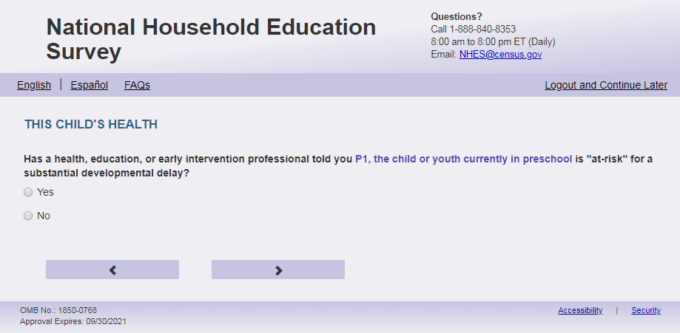
English Text Reads:
Has a health, education, or early intervention professional told you that [this child] is at risk for or has a developmental delay?

Spanish Text Reads:

¿Le ha dicho un profesional de la salud, de educación o de intervención temprana que [este niño (esta niña)] está en riesgo de tener un retraso del desarrollo?

English Answer:

1=Yes
2=No

Spanish Answer:

1= Sí
2=No

ECPP_HDDLYRSK, (1,2), numeric, radio
Skips:

If ALL conditions in ECPP_HDINTDIS ('a' to 'm' in ECPP_HEALTH_VER =2 , or 'a' to 'd' in ECPP_HEALTH_VER =1) are "No" (=2) OR a mix of “No” (=2) and blank in ECPP_HDINTDIS-ECPP_HDOTHERX and ECPP_HDCOND = 1 or blank, and ECPP_HDDLYRSK does not equal 1 and we have age from Screener, go to ECPP_CPLCBRTH,
If ALL conditions in ECPP_HDINTDIS ('a' to 'm' in ECPP_HEALTH_VER =2 , or 'a' to 'd' in ECPP_HEALTH_VER =1) are "No" (=2) OR a mix of “No” (=2) and blank in ECPP_HDINTDIS-ECPP_HDOTHERX and ECPP_HDCOND =1 or blank, and ECPP_HDDLYRSK does not equal 1 and we do not have year or birth or age from screener, go to ECPP_CDOBMM_WEB.

Else if ECPP_HEALTH_VER =2, go to ECPP_HDIFSPIEP. Else if ECPP_HEALTH_VER =1, go to ECPP_HDRECSERV.

Item: Receiving Service for Condition (ECPP_HDRECSERV)
<New item for NHES:2023 – no screenshot available>
English Text Reads:
Is [this child] receiving services for [his/her/his or her] condition (for example, speech therapy or physical therapy)?

Spanish Text Reads:
¿[Este niño (esta niña)] está recibiendo servicios para su problema o condición (por ejemplo, terapia del habla, terapia física, etc.)?
English Answer:

1=Yes
2=No

Spanish Answer:

1= Sí
2=No

Skips:
If ECPP_HDRECSERV =2, then go to ECPP_HDLEARN. Else go to ECPP_HDIFSPIEP
Logic Checks/Programming specifications:
English:
If S1_Pxsex = 1, use ‘his’, if s1_pxsex = 2, use ‘her’, else use ‘his or her’

Item: Service for Condition (ECPP_HDIFSPIEP)
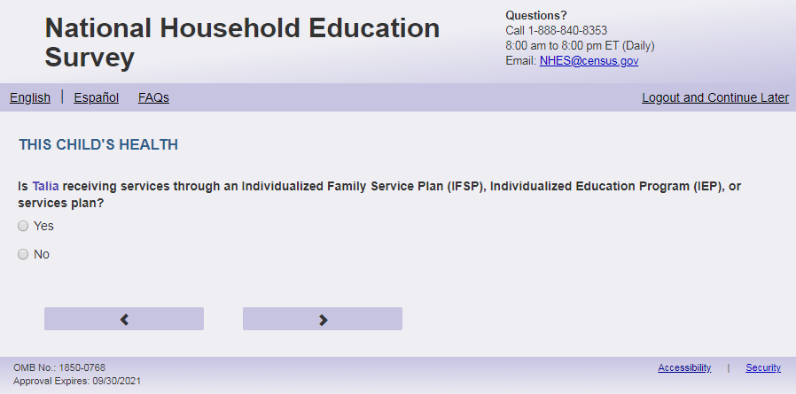
English Text Reads:

If not in the split panel (ECPP_HEALTH_VER =2) then:
Is [this child] receiving any services through an Individualized Family Service Plan (IFSP), Individualized Education Program (IEP), or services plan?

If in the split panel (ECPP_HEALTH_VER =1) then:
Are [this child]’s services through an Individualized Family Service Plan (IFSP) or Individualized Education Program (IEP)?

Spanish Text Reads:

If not in the split panel (ECPP_HEALTH_VER =2) then:
¿Está [este niño (esta niña)] recibiendo servicios de un Plan de Servicio Familiar Individualizado (IFSP), Programa Educativo Individual (IEP) o plan de servicios?

If in the split panel (ECPP_HEALTH_VER =1) then:
Los servicios que recibe [este niño (esta niña)], ¿son a través de un Plan de Servicio Individualizado para la Familia (IFSP, por sus siglas en inglés) o a través de un Programa Educativo Individualizado (IEP, pos sus siglas en inglés)?
English Answer:

1=Yes
2=No

Spanish Answer:

1= Sí
2=No

ECPP_HDIFSPIEP, (1,2), numeric, radio
Skips:

If ECPP_HDIFSPIEP = 2 then go to ECPP_HDLEARN

Else go to ECPP_HDCOMMUXX

Item: Satisfaction with IFSP or IEP Services (ECPP_HDCOMMUXX)
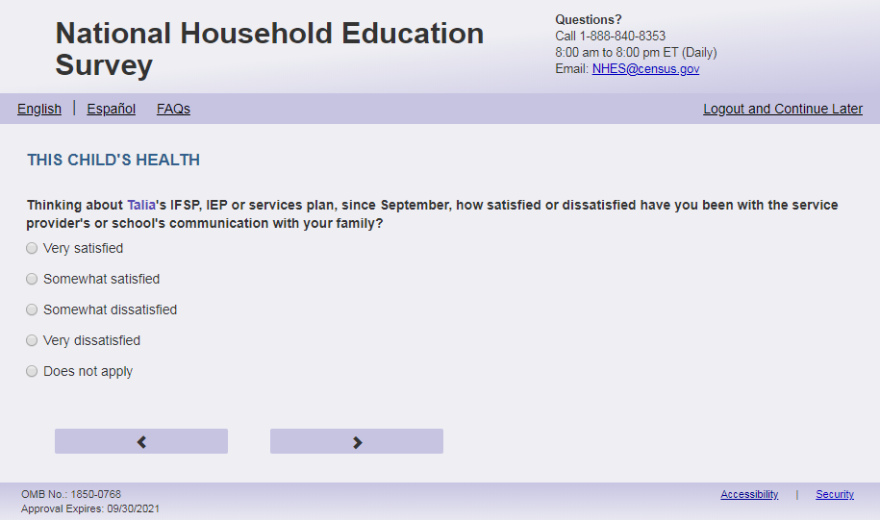
English Respondent Text Reads:
If not in the split panel (ECPP_HEALTH_VER=2) then:
Thinking about [this child’s] IFSP, IEP or services plan, since September, how satisfied or dissatisfied have you been with the service provider’s or school’s communication with your family?

If in the split panel (ECPP_ HEALTH _VER=1) then:
Thinking about [this child’s] IFSP or IEP, since September, how satisfied or dissatisfied have you been with the service provider’s or school’s communication with your family?

Spanish Respondent Text Reads:

If not in the split panel (ECPP_ HEALTH _VER=2) then:
Tomado en cuenta el IFSP, IEP o plan de servicios de [este niño (esta niña)], desde septiembre, ¿Cuán satisfecho o insatisfecho ha estado con la comunicación con su familia del proveedor de servicios o de la escuela?

If in the split panel (ECPP_ HEALTH _VER=1) then:
Pensando en el IFSP, por sus siglas en inglés, el IEP, por sus siglas en inglés, o el plan de servicios de este niño(a) a partir de septiembre, ¿qué tan satisfecho está usted con la comunicación que el proveedor de servicios o la escuela tiene con la familia?

English Admin/TQA Text Reads:
If not in the split panel (ECPP_ HEALTH _VER=2) then:
Thinking about [this child’s] IFSP, IEP or services plan, since September, how satisfied or dissatisfied have you been with the service provider’s or school’s communication with your family?

If in the split panel (ECPP_ HEALTH _VER=1) then:
Thinking about [this child’s] IFSP or IEP, since September, how satisfied or dissatisfied have you been with the service provider’s or school’s communication with your family?

Are you very satisfied, somewhat satisfied, somewhat dissatisfied, or very dissatisfied?

Spanish Admin.TQA Text Reads:

If not in the split panel (ECPP_ HEALTH _VER=2) then:
Tomado en cuenta el IFSP, IEP o plan de servicios de [este niño (esta niña)], desde septiembre, ¿Cuán satisfecho o insatisfecho ha estado con la comunicación con su familia del proveedor de servicios o de la escuela?

If in the split panel (ECPP_ HEALTH _VER=1) then:
Pensando en el IFSP, por sus siglas en inglés, el IEP, por sus siglas en inglés, o el plan de servicios de este niño(a) a partir de septiembre, ¿qué tan satisfecho está usted con la comunicación que el proveedor de servicios o la escuela tiene con la familia?

¿Está usted muy satisfecho, algo satisfecho, algo insatisfecho, o muy insatisfecho?

English Answers:

1=Very satisfied
2= Somewhat satisfied
3= Somewhat dissatisfied
4= Very dissatisfied
5= Does not apply

Spanish Answers:

1= Muy satisfecho
2= Algo satisfecho
3= Algo insatisfecho
4= Muy insatisfecho
5= No aplica

ECPP_HDCOMMUXX (1,5), numeric, radio

Skips:
Go to ECPP_HDLEARN

Logic Checks/Programming specifications
Increase spacing between response options “Very dissatisfied (4)” and “Does not apply (5)” (in English and Spanish) by double the spacing between the other response options..

Item: Child’s Ability (ECPP_HDLEARN)
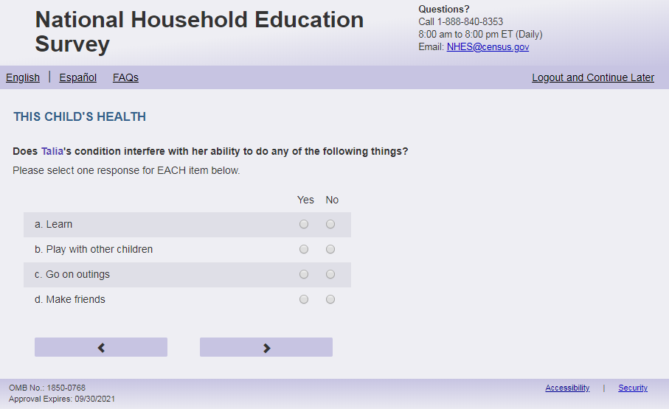
English Respondent Text Reads:
If in the split panel (ECPP_HEALTH_VER=1) then:
How often does [this child]'s condition interfere with his or her ability to do any of the following things?

If in the split panel (ECPP_HEALTH_VER=2) then:
Does [this child]’s condition interfere with [his/her/his or her] ability to do any of the following things?
Spanish Respondent Text Reads:
If in the split panel (ECPP_HEALTH_VER=1) then:
¿Con qué frecuencia afecta el problema de salud de [este niño (esta niña)] con su capacidad de hacer las siguientes cosas?

If in the split panel (ECPP_HEALTH_VER=2) then:
¿Afecta el problema de salud de [este niño (esta niña)] su capacidad para hacer algunas de las siguientes cosas?

English Admin/TQA Text Reads:
If in the split panel (ECPP_HEALTH_VER=1) then:
How often does [this child]'s condition interfere with [his/her/his or her] ability to do any of the following things?
Please respond ‘often,’ ‘sometimes,’ ‘never’ or ‘don’t know’ for EACH item as I read them.
If in the split panel (ECPP_HEALTH_VER=2) then
Does [this child]’s condition interfere with [his/her/his or her] ability to do any of the following things?
Please respond ‘yes’ or ‘no’ for EACH item as I read them.
Spanish Admin/TQA Text Reads:
If in the split panel (ECPP_HEALTH_VER=1) then:
¿Con qué frecuencia afecta el problema de salud de este niño(a) con su capacidad de hacer las si-guientes cosas?
Por favor, responda 'con frecuencia,' ‘a veces,’ 'nunca', ‘no le sé’ para CADA opción a medida que las leo.
If in the split panel (ECPP_HEALTH_VER=2) then
¿Afecta el problema de salud de [este niño (esta niña)] su capacidad para hacer algunas de las siguientes cosas?
Por favor, responda 'sí' o 'no' para CADA opción a medida que las leo.
If not in the split panel (ECPP_HEALTH_VER = 2) then:
English Respondent Answer:

- Learn, ECPP_HDLEARN, (1=Yes, 2=No), numeric, radio
- Play with other children, ECPP_HDPLAY, (1=Yes, 2=No), numeric, radio
- Go on outings, ECPP_HDOUT, (1=Yes, 2=No), numeric, radio
- Make friends, ECPP_HDFRNDS, (1=Yes, 2=No), numeric, radio

Spanish Respondent Answer:
- Aprender, ECPP_HDLEARN, (1= Sí, 2=No), numeric, radio
- Participar en juegos con otros niños(as), ECPP_HDPLAY, (1= Sí, 2=No), numeric, radio
- Asistir a los paseos, ECPP_HDOUT, (1= Sí, 2=No), numeric, radio
- Hacer amigos, ECPP_HDFRNDS, (1= Sí, 2=No), numeric, radio

If in the split panel (ECPP_HEALTH_VER = 1) then:

English Respondent Answer:

- Learn, ECPP_HDLEARN2, (1=Often, 2=Sometimes, 3 = Never, 4=Don’t know), numeric, radio
- Play with other children, ECPP_HDPLAY2, (1=Often, 2=Sometimes, 3 = Never, 4=Don’t know), numeric, radio
- Go on outings, ECPP_HDOUT2, (1=Often, 2=Sometimes, 3 = Never, 4=Don’t know), numeric, radio
- Make friends, ECPP_HDFRNDS2, (1=Often, 2=Sometimes, 3 = Never, 4=Don’t know), numeric, radio

Spanish Respondent Answer:
- Aprender, ECPP_HDLEARN2, (1=Con frecuencia, 2= A veces, 3 = Nunca, 4= No lo sé), numeric, radio
- Participar en juegos con otros niños(as), ECPP_HDPLAY2, (1=Con frecuencia, 2= A veces, 3 = Nunca, 4= No lo sé), numeric, radio
- Asistir a los paseos, ECPP_HDOUT2, (1=Con frecuencia, 2= A veces, 3 = Nunca, 4= No lo sé), numeric, radio
- Hacer amigos, ECPP_HDFRNDS2, (1=Con frecuencia, 2= A veces, 3 = Nunca, 4= No lo sé), numeric, radio

If not in the split panel (ECPP_HEALTH_VER = 2) then:

English Admin/TQA Answer:

- Does [this child]’s condition interfere with [his/her/his or her] ability to learn, ECPP_HDLEARN, (1=Yes, 2=No), numeric, radio
- Does [this child]’s condition interfere with [his/her/his or her] ability to play with other children, ECPP_HDPLAY, (1=Yes, 2=No), numeric, radio
- Does [this child]’s condition interfere with [his/her/his or her] ability to go on outings, ECPP_HDOUT, (1=Yes, 2=No), numeric, radio
- Does [this child]’s condition interfere with [his/her/his or her] ability to make friends, ECPP_HDFRNDS, (1=Yes, 2=No), numeric, radio

Spanish Admin/TQA Answer:
- ¿Interfiere la condición de [este niño (esta niña)] con su capacidad de aprender, ECPP_HDLEARN, (1= Sí, 2=No), numeric, radio
- ¿Interfiere la condición de [este niño (esta niña)] con su capacidad de participar en juegos con otros niños(as), ECPP_HDPLAY, (1= Sí, 2=No), numeric, radio
- ¿Interfiere la condición de [este niño (esta niña)] con su capacidad de asistir a los paseos, ECPP_HDOUT, (1= Sí, 2=No), numeric, radio
- ¿Interfiere la condición de [este niño (esta niña)] con su capacidad de hacer amigos, ECPP_HDFRNDS, (1= Sí, 2=No), numeric, radio

If in the split panel (ECPP_HEALTH_VER = 1) then:
English Admin/TQA Answer:

- How often does [this child]'s condition interfere with [his/her/his or her] ability to learn?, ECPP_HDLEARN, (1=Often, 2=Sometimes, 3 = Never, 4=Don’t know), numeric, radio
- How often does [this child]'s condition interfere with [his/her/his or her] ability to play with other children?, ECPP_HDPLAY, (1=Often, 2=Sometimes, 3 = Never, 4=Don’t know), numeric, radio
- How often does [this child]'s condition interfere with [his/her/his or her] ability to go on outings?, ECPP_HDOUT, (1=Often, 2=Sometimes, 3 = Never, 4=Don’t know), numeric, radio
- How often does [this child]'s condition interfere with [his/her/his or her] ability to make friends?, ECPP_HDFRNDS, (1=Often, 2=Sometimes, 3 = Never, 4=Don’t know), numeric, radio

Spanish Admin/TQA Answer:
- ¿Con qué frecuencia afecta el problema de salud de [este niño (esta niña)] con su capacidad de hacer aprender, ECPP_HDLEARN, (1=Con frecuencia, 2= A veces, 3 = Nunca, 4= No lo sé), numeric, radio
- ¿Con qué frecuencia afecta el problema de salud de [este niño (esta niña)] con su capacidad de participar en juegos con otros niños(as), ECPP_HDPLAY, (1=Con frecuencia, 2= A veces, 3 = Nunca, 4= No lo sé), numeric, radio
- ¿Con qué frecuencia afecta el problema de salud de [este niño (esta niña)] con su capacidad de asistir a los paseos, ECPP_HDOUT, (1=Con frecuencia, 2= A veces, 3 = Nunca, 4= No lo sé), numeric, radio
- ¿Con qué frecuencia afecta el problema de salud de [este niño (esta niña)] con su capacidad de hacer amigos, ECPP_HDFRNDS, (1=Con frecuencia, 2= A veces, 3 = Nunca, 4= No lo sé), numeric, radio

Skips:
If s1_P(x)DOBYY and s1_P(x)AGE for sampled child are missing from Screener, go to ECPP_CDOMM_WEB. Else, go to ECPP_CPLCBRTH.
Logic Checks/Programming specifications:
Display as grid
English:
If S1_Pxsex = 1, use ‘his’, if s1_pxsex = 2, use ‘her’, else use ‘his or her’

Item: Child’s Birth Date (ECPP_CDOBMM_WEB)
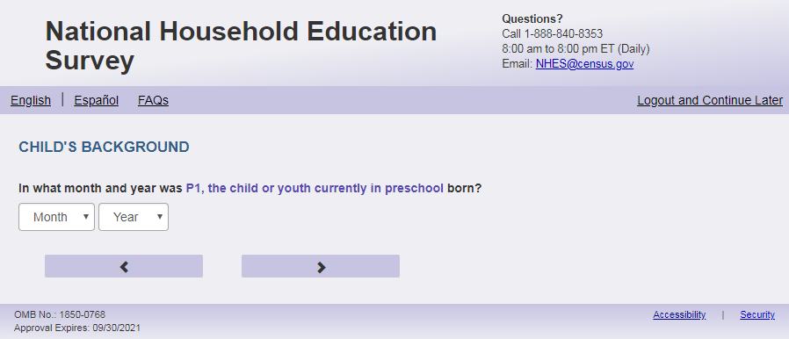
English Text Reads:
In what month and year was [this child] born?

Spanish Text Reads:
¿En qué mes y año nació [este niño (esta niña)]?

English and Spanish Answer:
ECPP_CDOBMM_WEB, (1,12), numeric, drop-down
ECPP_CDOBYY_WEB, (2016, 2023), numeric, drop-down
Skips:
If ECPP_CDOBYY_WEB is missing, go to ECPP_CAGE. Otherwise, skip to ECPP_CPLCBRTH

Logic Checks/Programming specifications:
Allow respondents to scroll the options within drop-down

English:
Display "month" label above the dropdown box and leave the dropdown box blank. Display "year" label above the dropdown box and leave the dropdown box blank.
Spanish:
Display ‘mes’ label above the dropdown box and leave the dropdown box blank.
Display "año" label above the dropdown box and leave the dropdown box blank.

Item: Child’s Age (ECPP_CAGE)
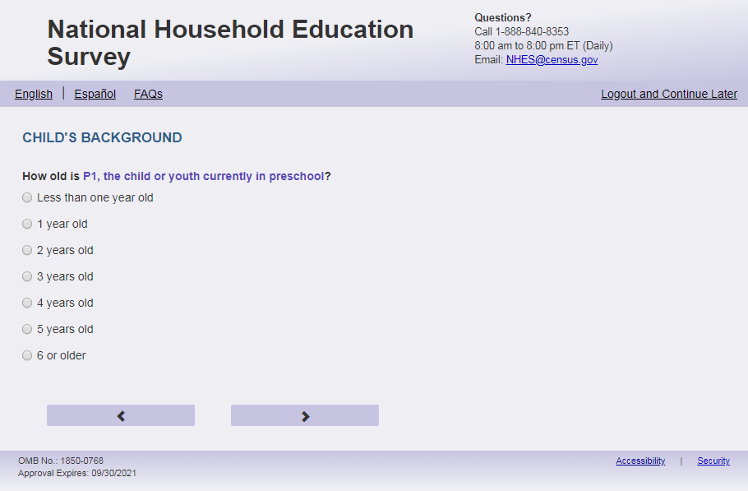
English Text Reads:
How old is [ this child]?

Spanish Text Reads:
¿Qué edad tiene [este niño (esta niña)]?

English Answer:

1= Less than one year old
2 = 1 year old
3 = 2 years old
4 = 3 years old
5 = 4 years old
6 = 5 years old
7 = 6 years old or older

Spanish Answer:

1= Menos de un año de edad
2 = 1 año de edad
3 = 2 años de edad
4 = 3 años de edad
5 = 4 años de edad
6 = 5 años de edad
7 = 6 años o más de edad

ECPP_CAGE, (1,7), numeric, radio

Skips:

Go to ECPP_CPLCBRTH

Item: Child’s Birth Place (ECPP_CPLCBRTH)
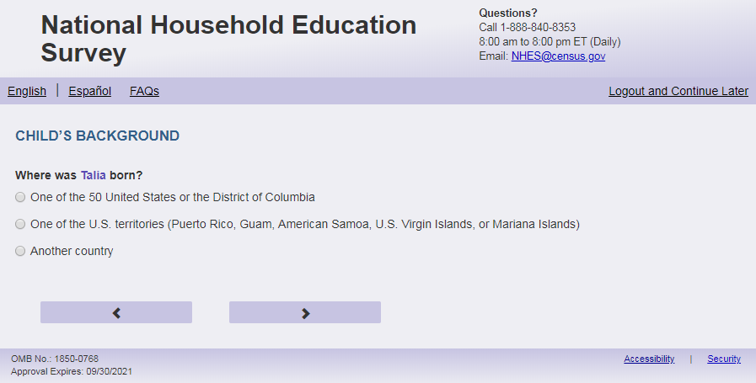
English Text Reads:
Where was [this child] born?

Spanish Text Reads:

¿Dónde nació [este niño (esta niña)]?

English Answer:

1= One of the 50 United States or the District of Columbia
2= One of the U.S. territories (Puerto Rico, Guam, American Samoa, U.S. Virgin Islands, or Mariana Islands)
3= Another country

Spanish Answer:
1= Uno de los 50 estados de los Estados Unidos o el Distrito de Columbia
2= Uno de los territorios incorporados de los Estados Unidos (Puerto Rico, Guam, Samoa Americana, Islas Vírgenes de los Estados Unidos o Islas Marianas del Norte)
3= Otro país

ECPP_CPLCBRTH, (1,3), numeric, radio

Skips:
If ECPP_CPLCBRTH = 1 or blank then go to ECPP_CHISPANX. Else go to ECPP_CMOVEAGE.

Item: Age when moving to U.S. (ECPP_CMOVEAGE)
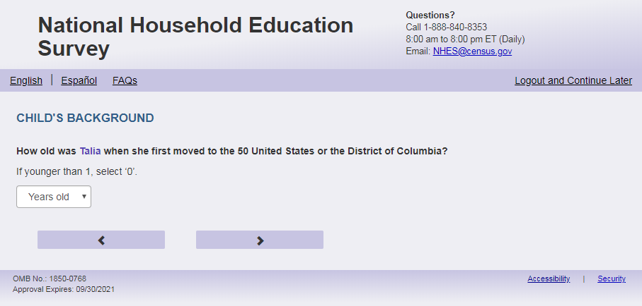
English Text Reads:
How old was [this child] when [he/she/he or she] first moved to the 50 United States or the District of Columbia?
If younger than 1, select ‘0’.

Spanish Text Reads:

¿Qué edad tenía [este niño (esta niña)] cuando se mudó por primera vez a uno de los 50 estados de los Estados Unidos o al Distrito de Columbia?
Si fue menor de un año, por favor seleccione ‘0’.

English and Spanish Answer:

ECPP_CMOVEAGE, (0,6), numeric, drop down

Skips:
Go to ECPP_CHISPANX

Logic Checks/Programming specifications:
If P(X) DOBYY of sampled child is not missing from screener: only display ages that are less than or equal to s1_P(x)DOBYY.
If s1_P(x)DOBYY of sampled child is missing and S1_P(x)AGE for sampled child from on Screener is not missing: then only display ages that are less than or equal to s1_P(X)age.
If s1_P(x)DOBYY and S1_P(x)AGE for sampled child are missing from Screener: Only display ages that are less than or equal to 2023-ECPP_CDOBYY_WEB. If ECPP_CDOBYY_WEB is missing, then only display ages that are less than or equal to ECPP_CAGE.
Else display all options.
Display instruction "if this child is younger than 1, select ‘0’.” (Spanish: “Si fue menor de un año, por favor seleccione ‘0’.”)
Allow respondents to scroll the options within drop-down.
English:
Display "years old” label above the dropdown box and leave the dropdown box blank.
If S1_Pxsex = 1, use ‘he’, if s1_pxsex = 2, use ‘she’, else use ‘he or she’

Spanish:
Display "edad en años" label above the dropdown box and leave the dropdown box blank.

Item: Hispanic Origin (ECPP_CHISPANX)
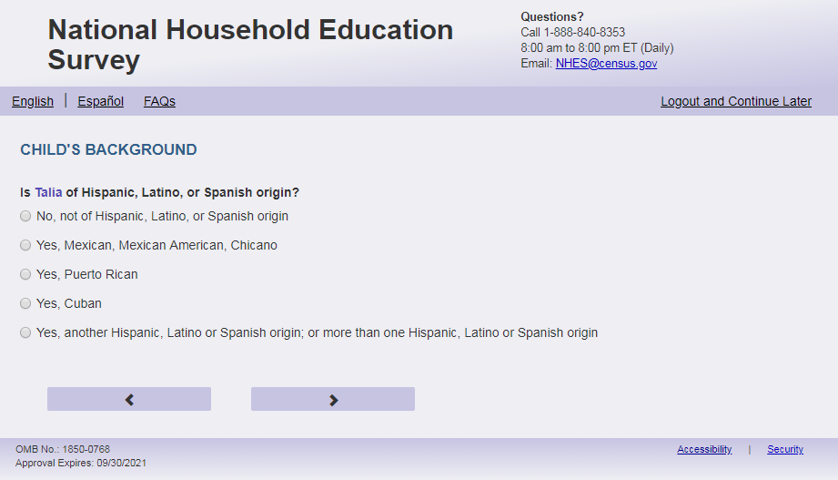
English Respondent Text Reads:
Is [this child] of Hispanic, Latino, or Spanish origin?

Spanish Respondent Text Reads:

¿Es [este niño(a)] de origen hispano, latino o español?

English Admin/TQA Text Reads:
{Please be sure to ask BOTH this question and the following race question, and record the respondent’s answer}
Is [this child] of Hispanic, Latino, or Spanish origin?

{If ‘yes,’ read the yes answer options to the respondent.}

Spanish Admin/TQA Text Reads:

{Por favor, asegúrese de hacer tanto esta pregunta como la siguiente pregunta de raza, y registrar la respuesta del encuestado}
¿Es [este niño(a)] de origen hispano, latino o español?

{En caso de 'sí', lea las opciones de respuesta sí al encuestado.}

English Answer
1 = No, not of Hispanic, Latino, or Spanish origin
2 = Yes, Mexican, Mexican American, Chicano
3 = Yes, Puerto Rican
4 = Yes, Cuban
5 = Yes, another Hispanic, Latino or Spanish origin; or more than one Hispanic, Latino or Spanish origin

Spanish Answer
1 = No, no es de origen hispano, latino o español
2 = Sí, Mexicano, Mexicano Americano, Chicano
3 = Sí, Puertorriqueño
4 = Sí, Cubano
5 = Sí, es de otro origen hispano, latino, o español; o de más de un origen hispano, latino o español
ECPP_CHISPANX, (1,5), numeric, radio

Skips:
Go to ECPP_CAMIND

Item: Child’s Race (ECPP_CAMIND)

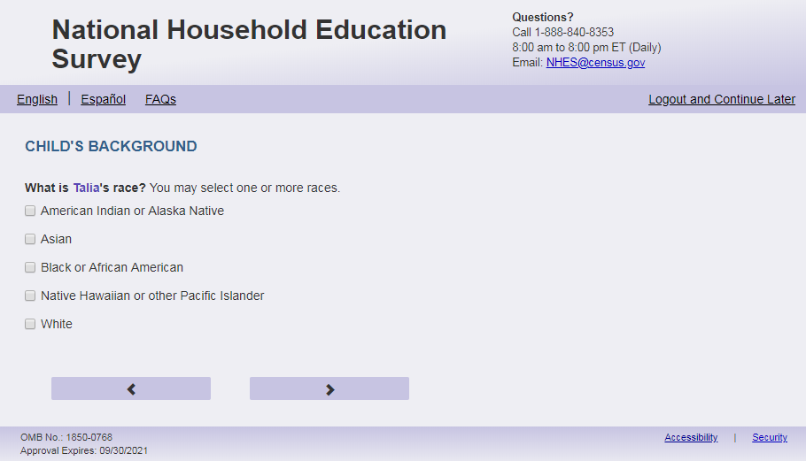
English Respondent Text Reads:
What is [this child]’s race? You may select one or more races.
Spanish Respondent Text Reads:
¿Cuál es la raza de [este niño (esta niña)]? Puede seleccionar una raza o más de una raza.
English Admin/TQA Text Reads:
What is [this child]’s race?
{You may select one or more races.}
{If the respondent answered yes to the previous item (Hispanic ethnicity) and does not identify with any other race, leave this item blank.}
Spanish Admin/TQA Text Reads:
¿Cuál es la raza de [este niño (esta niña)]?
{Puede seleccionar una o más razas.}
{Si el encuestado respondió sí a la pregunta anterior (etnia hispana) y no se identifica con ninguna otra raza, deje este ítem en blanco.}
English Answer:
American Indian or Alaska Native, ECPP_CAMIND, (1 = Item marked, 2=no/notmarked), numeric, checkbox
Asian, ECPP_CASIAN, (1 = Item marked, 2=no/notmarked), numeric, checkbox
Black or African American, ECPP_CBLACK, (1 = Item marked, 2=no/notmarked), numeric, checkbox
Native Hawaiian or other Pacific Islander, ECPP_CPACI, (1 = Item marked, 2=no/notmarked), numeric, checkbox
White, ECPP_CWHITE, (1 = Item marked, 2=no/not marked), numeric, checkbox
Spanish Answer:
Indígena de las Américas o nativa de Alaska, ECPP_CAMIND, (1 = Item marked, 2=no/not marked), numeric, checkbox
Asiática, ECPP_CASIAN, (1 = Item marked, 2=no/not marked), numeric, checkbox
Negra o afroamericana, ECPP_CBLACK, (1 = Item marked, 2=no/not marked), numeric, checkbox
Nativa de Hawái u otra de las islas del Pacífico, ECPP_CPACI, (1 = Item marked, 2=no/not marked), numeric, checkbox
Blanca, ECPP_CWHITE, (1 = Item marked, 2=no/not marked), numeric, checkbox

Skips:
If s1_P(x)SEX is missing for sampled child from Screener, go to ECPP_CSEX. Else if ECPP_HEALTH_VER =2 go to ECPP_CLIVYN. Else if ECPP_HEALTH_VER =1, go to ECPP_HDHEALTH.
Logic Checks/Programming specifications:
This is a mark all the apply item that will not show a “no/not marked” option on the screen.

Item: Child’s Sex (ECPP_CSEX)
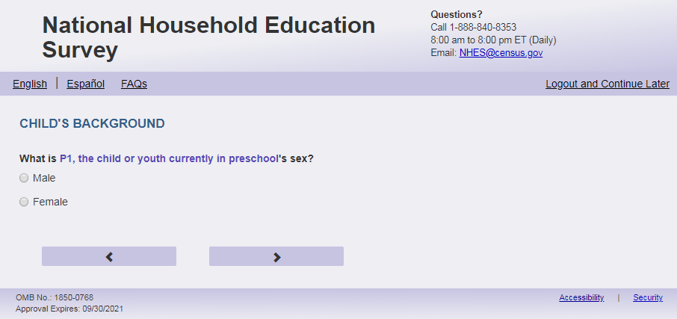
English Text Reads:
What is [this child’s] sex?

Spanish Text Reads:

¿De qué sexo es [este niño (esta niña)]?

English Answer:

1= Male
2= Female

Spanish Answer:

1= Masculino
2= Femenino

ECPP_CSEX, (1,2), numeric, radio

Skips:
If ECPP_HEALTH_VER =1 then go to ECPP_HDHEALTH. If ECPP_HEALTH_VER =2, then go to ECPP_CLIVYN

Item: Child’s Address (ECPP_CLIVYN)
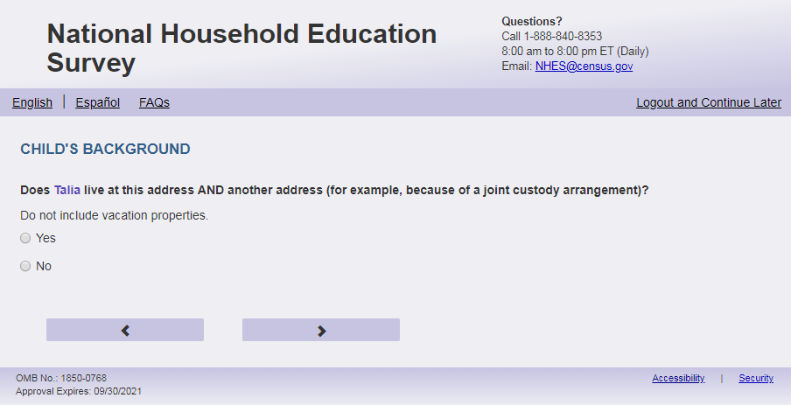
English Text Reads:
Does [this child] sometimes live at another address (for example, because of parents living apart)?
Do not include vacation properties.

Spanish Text Reads:

¿[Este niño (esta niña)] vive a veces en otra dirección más (por ejemplo, debido a que los padres viven separados)? No incluya casas de vacaciones.

English Answer:

1=Yes
2=No

Spanish Answer:

1= Sí
2=No

ECPP_CLIVYN, (1,2), numeric, radio

Skips:
If ECPP_CLIVYN = 2 then go to ECPP_CSPEAKX. Else go to ECPP_CLIVELSWX.

Item: Where Child Spends Most Time (ECPP_CLIVELSWX)
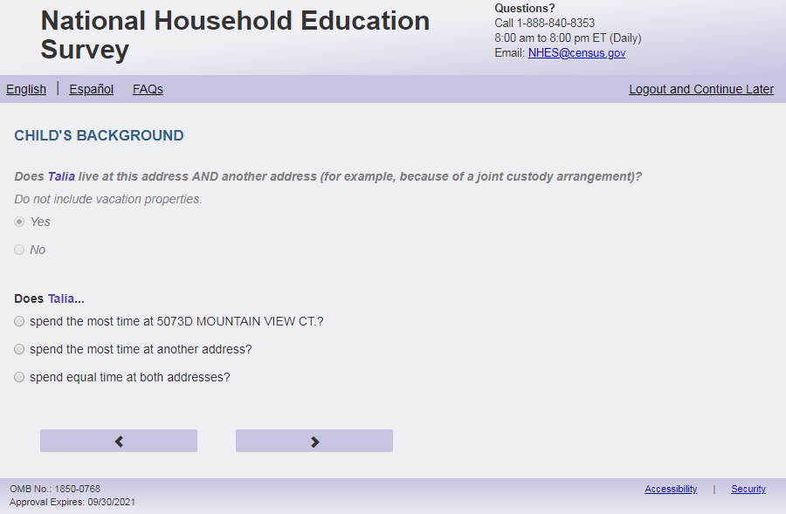
English Respondent Text Reads:
Does [this child]…

Spanish Respondent Text Reads:

[Este niño (esta niña)] ….

English Admin/TQA Text Reads:
Does [this child]…

{Please read response options.}

Spanish Admin/TQA Text Reads:

[Este niño (esta niña)] ….

{Por favor, lea las opciones de respuesta.}

English Answer:

1= spend the most time at [fill with PADDR SADDR]?
2= spend the most time at the other address?
3= spend equal time at both addresses?

Spanish Answer:

1= pasa la mayor parte del tiempo en [fill with PADDR SADDR]?
2= pasa la mayor parte del tiempo en otra dirección?
3= pasa la misma cantidad de tiempo en ambas direcciones?

ECPP_CLIVELSWX, (1,3), numeric, radio

Skips:

Go to ECPP_CSPEAKX.

Logic Checks/Programming specifications:
Display this question on a new screen. Do not display on same screen ECPP_CLIVYN
PADDR SADDR fill is the respondent’s address on the sampling frame.

Item: Child’s Language (ECPP_CSPEAKX)
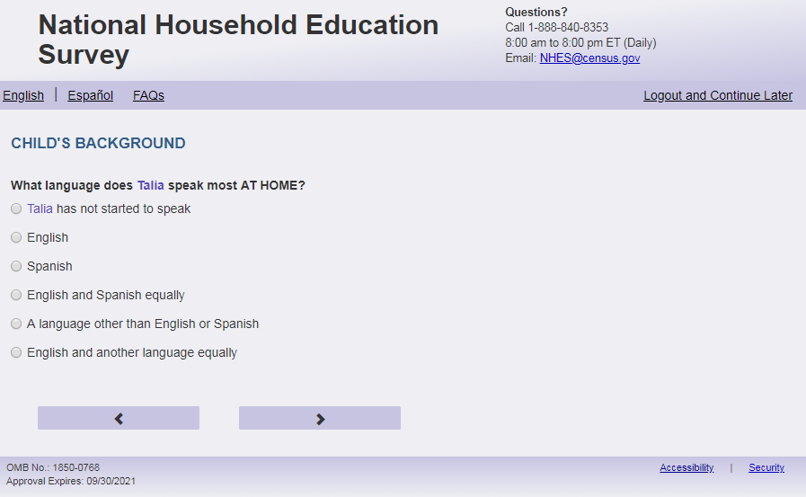
English Respondent Text Reads:
What language does [this child] speak most AT HOME?

Spanish Respondent Text Reads:
¿Qué idioma habla más [este niño (esta niña)] EN EL HOGAR?

English Admin/TQA Text Reads:
What language does [this child] speak most AT HOME?

{Please read response options.}

Spanish Admin/TQA Text Reads:

¿Qué idioma habla más [este niño (esta niña)] EN EL HOGAR?

{Por favor, lea las opciones de respuesta.}
English Answer:
6= [This child] has not started to speak
1= English
2= Spanish
3= English and Spanish equally
4= A language other than English or Spanish
5= English and another language equally

Spanish Answer:
6= [El niño(a)] no ha comenzado a hablar
1= Inglés
2= Español
3= Inglés y español por igual
4= Otro idioma aparte del inglés o español
5= Inglés y otro idioma por igual

ECPP_CSPEAKX (1,6), numeric, radio

Skips:
If ECPP_CSPEAKX in 2,3,4,5 go to ECPP_CENGLPRG.

Else go to ECPP_HHTOTALXX.

Item: Enrolled in 2nd Language (ECPP_CENGLPRG)
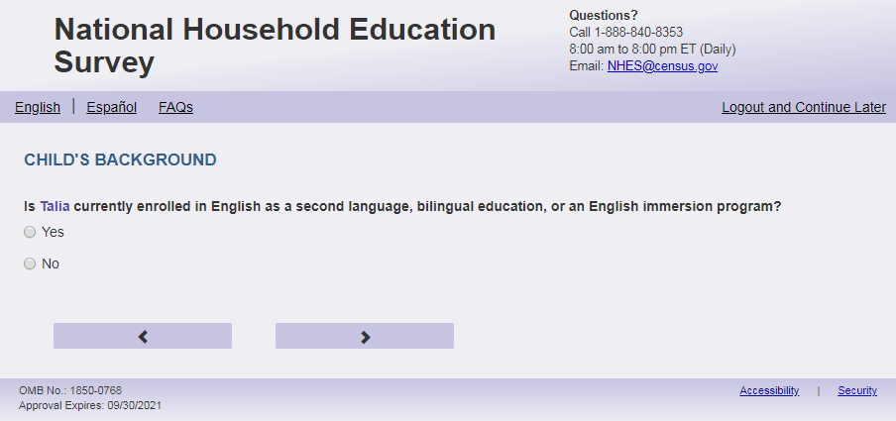
English Text Reads:
Is [this child] currently enrolled in English as a second language, bilingual education, or an English immersion program?

Spanish Text Reads:

Actualmente, ¿asiste [este niño (esta niña)] a clases de inglés como segundo idioma, educación biligüe o a un programa de inmersión al inglés?

English Answer:

1=Yes
2=No

Spanish Answer:

1= Sí
2=No

ECPP_CENGLPRG, (1,2), numeric, radio

Skips:
Go to ECPP_HHTOTALXX.

Item: Total Number in Household (ECPP_HHTOTALXX)
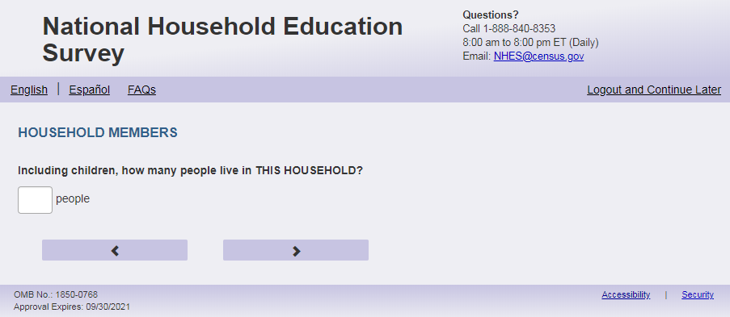
English text
Including children, how many people live in THIS HOUSEHOLD?
Spanish
Incluyendo a los niños, ¿cuántas personas viven en ESTE HOGAR?
ECPP_ HHTOTALXX, (0,99), numeric, write in

Skips:
If ps_ecpprelate is blank, go to ECPP_ HHREL1. Else if ps_ecpprelate in (1, 2, 5, 10) go to ECPP_P1REL. Else if ps_ecpprelate in (3, 4, 6, 7, 8, 9) go to ECPP_P1GUARD .
(ps_ecpprelate is from the screener)

English
Display 'people' next to the write-in box.
Spanish
Display ‘personas’ next to the write-in box.
Mobile: Display numeric keypad

Item: Relation to Child (ECPP_HHREL1)
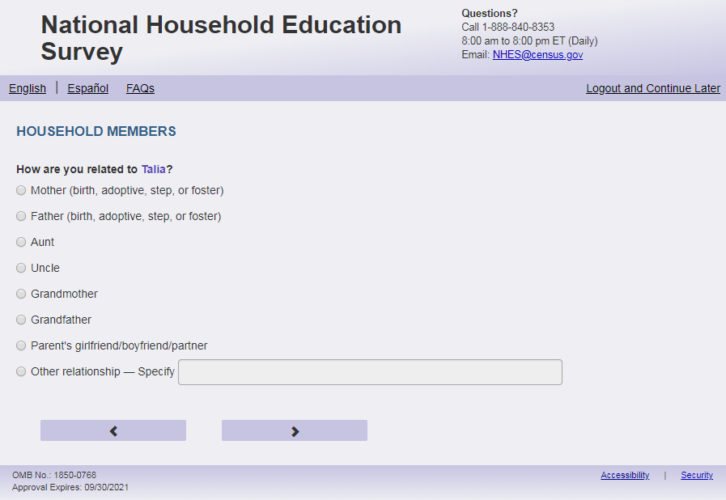
English Text Reads:
The next questions are about [this child]’s parent(s) and guardian(s). How are you related to [this child]?

Spanish Text Reads:
Las siguientes preguntas son acerca de los padres y tutores legales de [este niño (esta niña)].¿Cuál es su relación o parentesco con [este niño (esta niña)]?

English Answer:
1= Mother (birth, adoptive, step, or foster)
2= Father (birth, adoptive, step, or foster)
3= Grandmother
4 = Grandfather
5 = Parent’s girlfriend/boyfriend/partner
6= Aunt
7= Uncle
8 = Sister
9 = Brother
10 = Other relationship –Specify:

Spanish Answer:
1= Madre (biológica, adoptiva, madrastra o de crianza temporal (Foster))
2= Padre (biológico, adoptivo, padrastro o de crianza temporal (Foster))
3= Abuela
4= Abuelo
5= Novia/Novio o pareja de alguno de los padres
6= Tía
7= Tío
8 = Hermana
9 = Hermano
10 = Otra relación o parentesco - Especifique:

ECPP_HHREL1 (1,10), numeric, radio. If 10 selected, specify box should become active (ECPP_HHREL1OS): (0,50), character, write-in. Display specify response box 1 row by 30 characters.

Skip patterns:
If ECPP_HHREL1 in (1, 2, 5, 10) Go to ECPP_P1REL
Else if ECPP_HHREL1 in (3, 4, 6, 7, 8, 9) go to ECPP_P1GUARD.

Logic Checks/Programming specifications:
If ps_ecpprelate ne ' ' then do not ask this question, and follow skips if ps_ecpprelate in (1, 2, 5, 10) go to ECPP_P1REL. Else if ps_ecpprelate in (3, 4, 6, 7, 8, 9) go to ECPP_P1GUARD .
(ps_ecpprelate is from the screener).

Item: Parent or Guardian (ECPP_P1REL)
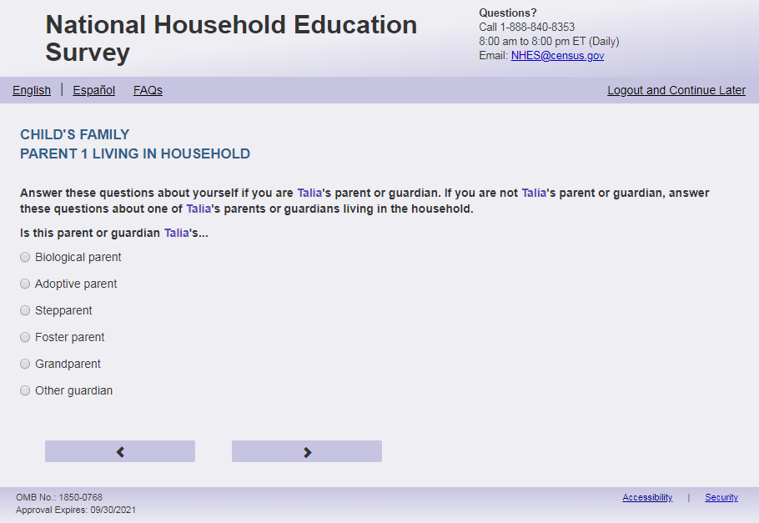
English Respondent Text Reads:
Are you/ [the child]’s…
Spanish Respondent Text Reads:

¿Es usted…
English Admin/TQA Text Reads:
Are you [the child]’s…
{Please read response options.}

Spanish Admin/TQA Text Reads:

¿Es usted…

{Por favor, lea las opciones de respuesta.}

English Answer:
1= Biological parent
2= Adoptive parent
3= Stepparent
4= Foster parent
5= Other guardian

Spanish Answer:
1= [El padre biológico o la madre biológica]
2= [El padre adoptivo o la madre adoptiva]
3= [El padrastro o madrastra]
4= [El padre de crianza temporal (Foster) o la madre de crianza temporal (Foster)]
5= Otro tutor(a) legal

ECPP_P1REL, (1,5), numeric, radio

Skips:

Go to ECPP_P1SEX.
Spanish Fills:
[El padre biológico o la madre biológica]:
if ps_ecpprelate or ECPP_ HHREL1 = 2 then El padre biológico
if ps_ecpprelate or ECPP_ HHREL1 = 1 then La madre biológica
if ps_ecpprelate or ECPP_ HHREL1 in (5, 10, blank) then El padre biológico o la madre biológica

[El padre adoptivo o la madre adoptiva]:
if ps_ecpprelate or ECPP_ HHREL1 = 2 then El padre adoptivo
if ps_ecpprelate or ECPP_ HHREL1 = 1 then La madre adoptiva
if ps_ecpprelate or ECPP_ HHREL1 in (5, 10, blank) then El padre adoptivo o la madre adoptiva

[El padrastro o madrastra]:
if ps_ecpprelate or ECPP_ HHREL1 = 2 then El padrastro
if ps_ecpprelate or ECPP_ HHREL1 = 1 then La madrastra
if ps_ecpprelate or ECPP_ HHREL1 in (5, 10, blank) then El padrastro o madrastra

[El padre de crianza temporal (Foster) o la madre de crianza temporal (Foster)]:
if ps_ecpprelate or ECPP_ HHREL1 = 2 then El padre de crianza temporal (Foster)
if ps_ecpprelate or ECPP_ HHREL1 = 1 then La madre de crianza temporal (Foster)
if ps_ecpprelate or ECPP_ HHREL1 in (5, 10, blank) then El padre de crianza temporal (Foster) o la madre de crianza temporal (Foster)

Item: Parent/Guardian (ECPP_P1GUARD)
English Respondent Text Reads:
Do you consider yourself one of [this child]'s parents or guardians?

Spanish Respondent Text Reads:

¿Se considera usted uno de los padres o tutores legales de [este niño (esta niña)]?

English Answer
1= Yes
2= No

Spanish Answer
1= Sí
2= No

ECPP_P1GUARD, (1,2), numeric, radio

Skips:
if ECPP_P1GUARD = 1 then go to ECPP_P1SEX. Else go to ECPP_P1HHREL2.

Item: Relation to this Child (ECPP_P1HHREL2)
<New item for NHES:2023 – no screenshot available>
English Text Reads:
Who is one of [this child]'s parents or guardians living in this household? We will ask about any other parent or guardian later.

Spanish Text Reads:
¿Quién es uno de los padres o tutores legales de [este niño (esta niña)] que vive en este hogar? Le preguntaremos sobre otro padre, madre, o tutor(a) legal más adelante.
English Answer
1= Mother (birth, adoptive, step, or foster)
2= Father (birth, adoptive, step, or foster)
3= Grandmother
4= Grandfather
5= Parent’s girlfriend/boyfriend/partner
6 = Aunt
7 = Uncle
8 = Sister
9 = Brother
10 = Other relationship – Specify:

Spanish Answer
1= Madre (biológica, adoptiva, madrastra o de crianza temporal (Foster))
2= Padre (biológico, adoptivo, padrastro o de crianza temporal (Foster))
3= Abuela
4= Abuelo
5= Novia/Novio o pareja de alguno de los padres
6= Tía
7= Tío
8 = Hermana
9 = Hermano
10 = Otra relación o parentesco – Especifique:

Items 1-8: ECPP_P1HHREL2 (1,10), numeric, radio. If 10 selected, specify box should become active: ECPP_P1HHREL2OS, (0,50), character, write-in. Display specify response box 1 row by 30 characters.

Skips:
If ECPP_P1HHREL2 in (1, 2, 5, 10) Go to ECPP_P1REL2
Else if ECPP_P1HHREL2 in (3, 4, 6, 7, 8, 9) go to ECPP_P1SEX.

Logic Checks/Programming specifications for the PARENT1 fill for the remainder of this section
English:
If parent or guardian:
To streamline the reference to the respondent being the parent or guardian please create P1Fill:
IF ps_pfirelate OR ECPP_HHREL1 in (1,2, 5, 10) OR ECPP_P1GUARD = 1 then P1Fill = 1
Then for the autofill see direction in specific item that will reference P1Fill = 1 and will use [you] or [your].
If not the parent or guardian:
Else use the following autofill references:
If ECPP_P1HHREL2 = 1 (mother) is selected then Parent 1 fill is [this child]’s mother; P1.Pronoun fill is she
If ECPP_P1HHREL2 = 2 (father) is selected then Parent 1 fill is [this child]’s father; P1.Pronoun fill is he
If ECPP_ P1HHREL2 = 3 (grandmother) is selected then Parent 1 fill is [this child]’s grandmother; P1.Pronoun fill is she
If ECPP_ P1HHREL2 = 4 (grandfather) is selected then Parent 1 fill is [this child]’s grandmother; P1.Pronoun fill is he
If ECPP_P1HHREL2 = 6 (aunt) is selected then Parent 1 fill is [this child]’s aunt; P1.Pronoun fill is she
If ECPP_P1HHREL2 = 7 (uncle) is selected then Parent 1 fill is [this child]’s uncle; P1.Pronoun fill is he
If ECPP_P1HHREL2 = 8 (sister) is selected then Parent 1 fill is [this child]’s sister; P1.Pronoun fill is she
If ECPP_P1HHREL2 = 9 (brother) is selected then Parent 1 fill is [this child]’s brother; P1.Pronoun fill is he
If ECPP_P1HHREL2 in (5, 10, blank) (boyfriend/girlfriend/partner or other relationship) is selected then Parent 1 fill is [this child]’s parent or guardian; P1.Pronoun fill is he or she

Spanish:
If parent or guardian:
To streamline the reference to the respondent being the parent or guardian please create P1Fill:
IF ps_pfirelate OR ECPP_HHREL1 in (1,2, 5, 10) OR ECPP_P1GUARD = 1 then P1Fill = 1
Then for the autofill see direction in specific item that will reference P1Fill = 1 and will use [usted].
If not the parent or guardian:
If ECPP_P1HHREL2 = 1 (madre) is selected then Parent 1 fill is la madre de [este niño (esta niña)]; P1.Pronoun fill is ella
If ECPP_P1HHREL2 = 4 (padre) is selected then Parent 1 fill is el padre de [este niño (esta niña)]; P1.Pronoun fill is él
If ECPP_P1HHREL2 = 3 (Abuela) is selected then Parent 1 fill is la abuela de [este niño (esta niña)]; P1.Pronoun fill is ella
If ECPP_P1HHREL2 = 4 (Abuelo) is selected then Parent 1 fill is el abuelo de [este niño (esta niña)]; P1.Pronoun fill is él
If ECPP_P1HHREL2 = 6 (Tía) is selected then Parent 1 fill is la tía de [este niño (esta niña)]; P1.Pronoun fill is ella
If ECPP_P1HHREL2 = 7 (Tío) is selected then Parent 1 fill is el tío de [este niño (esta niña)]; P1.Pronoun fill is él
If ECPP_P1HHREL2 = 8 (Hermana) is selected then Parent 1 fill is la hermana de [este niño (esta niña)]; P1.Pronoun fill is ella
If ECPP_P1HHREL2 = 9 (Hermano) is selected then Parent 1 fill is el hermano de [este niño (esta niña)]; P1.Pronoun fill is él
If ECPP_P1HHREL2 in (5, 10, blank) (Novia/Novio o pareja de alguno de los padres o otra relación o parentesco) is selected then Parent 1 fill is el padre, la madre o el tutor(a) legal de [este niño (esta niña)]; P1.Pronoun fill is él o ella

Item: Other Parent/Guardian Relationship (ECPP_P1REL2)
<New item for NHES:2023 – no screenshot available>
English Respondent Text Reads:
Is [PARENT 1] [his/her/his or her] …

Spanish Respondent Text Reads:

Es [PARENT 1] su…

English Admin/TQA Text Reads:
Is [PARENT 1] [his/her/his or her] …
{Please read response options.}

Spanish Admin/TQA Text Reads:
Es [PARENT 1] su…

{Por favor, lea las opciones de respuesta.}

English Answer
1= Biological parent
2= Adoptive parent
3= Stepparent
4= Foster parent
5= Grandparent
6= Other guardian

Spanish Answer
1= [El padre biológico o la madre biológica]
2= [El padre adoptivo o la madre adoptiva]
3= [El padrastro o la madrastra]
4= [El padre de crianza temporal (Foster) o la madre de crianza temporal (Foster)]
5= Abuelo o abuela
6= Otro tutor(a) legal

ECPP_P1REL2, (1,6), numeric, radio

Skips:
Go to ECPP_P1SEX

Logic Checks/Programming specifications:
English:
If S1_Pxsex = 1, use ‘his’, if s1_pxsex = 2, use ‘her’, else use ‘his or her’

If ECPP_P1HHREL2 = 1 (mother) is selected then PARENT 1 fill is “[this child]’s mother”
If ECPP_P1HHREL2 = 2 (father) is selected then PARENT 1 fill is “ [this child]’s father”
If ECPP_P1HHREL2 = 3 (grandmother) is selected then PARENT 1 fill is “[this child]’s grandmother”
If ECPP_P1HHREL2 = 4 (grandfather) is selected then PARENT 1 fill is “[this child]’s grandfather”
If ECPP_P1HHREL2 = 6 (aunt) is selected then PARENT 1 fill is “[this child]’s aunt”
If ECPP_P1HHREL2 = 7 (uncle) is selected then PARENT 1 fill is “[this child]’s uncle”
If ECPP_P1HHREL2 = 8 (sister) is selected then PARENT 1 fill is “[this child]’s sister”
If ECPP_P1HHREL2 = 9 (brother) is selected then PARENT 1 fill is “[this child]’s brother”
If ECPP_P1HHREL2 in (5, 10, blank) (boyfriend/girlfriend/partner or other relationship) is selected then PARENT 1 fill is “ [this child]’s parent or guardian”
Spanish:
If ECPP_P1HHREL2 = 1 (madre) is selected then Parent 1 fill is “la madre de [este niño (esta niña)]”
If ECPP_P1HHREL2 = 4 (padre) is selected then Parent 1 fill is “el padre de [este niño (esta niña)]”
If ECPP_P1HHREL2 = 3 (Abuela) is selected then Parent 1 fill is “la abuela de [este niño (esta niña)]”
If ECPP_P1HHREL2 = 4 (Abuelo) is selected then Parent 1 fill is “el abuelo de [este niño (esta niña)]”
If ECPP_P1HHREL2 = 6 (Tía) is selected then Parent 1 fill is “la tía de [este niño (esta niña)]”
If ECPP_P1HHREL2 = 7 (Tío) is selected then Parent 1 fill is “el tío de [este niño (esta niña)]”
If ECPP_P1HHREL2 = 8 (Hermana) is selected then Parent 1 fill is “la hermana de [este niño (esta niña)]”
If ECPP_P1HHREL2 = 9 (Hermano) is selected then Parent 1 fill is “el hermano de [este niño (esta niña)]”
If ECPP_P1HHREL2 in (5, 10, blank) (Novia/Novio o pareja de alguno de los padres o otra relación o parentesco) is selected then Parent 1 fill is “el padre, la madre o el tutor(a) legal de [este niño (esta niña)]”
Fills for Spanish response options:
[El padre biológico o la madre biológica]:
if ECPP_ P1HHREL2 = 2 then El padre biológico
if ECPP_ P1HHREL2 = 1 then La madre biológica
if ECPP_ P1HHREL2 in (5, 10, blank) then El padre biológico o la madre biológica

[El padre adoptivo o la madre adoptiva]:
if ECPP_ P1HHREL2 = 2 then El padre adoptivo
if ECPP_ P1HHREL2 = 1 then La madre adoptiva
if ECPP_ P1HHREL2 in (5, 10, blank) then El padre adoptivo o la madre adoptiva

[El padrastro o la madrastra]:
if ECPP_ P1HHREL2 = 2 then El padrastro
if ECPP_ P1HHREL2 = 1 then La madrastra
if ECPP_ P1HHREL2 in (5, 10, blank) then El padrastro o madrastra

[El padre de crianza temporal (Foster) o la madre de crianza temporal (Foster)]:
if ECPP_ P1HHREL2 = 2 then El padre de crianza temporal (Foster)
if ECPP_ P1HHREL2 = 1 then La madre de crianza temporal (Foster)
if ECPP_ P1HHREL2 in (5, 10, blank) then El padre de crianza temporal (Foster) o la madre de crianza temporal (Foster)

Item: Parent/Guardian Sex (ECPP_P1SEX)
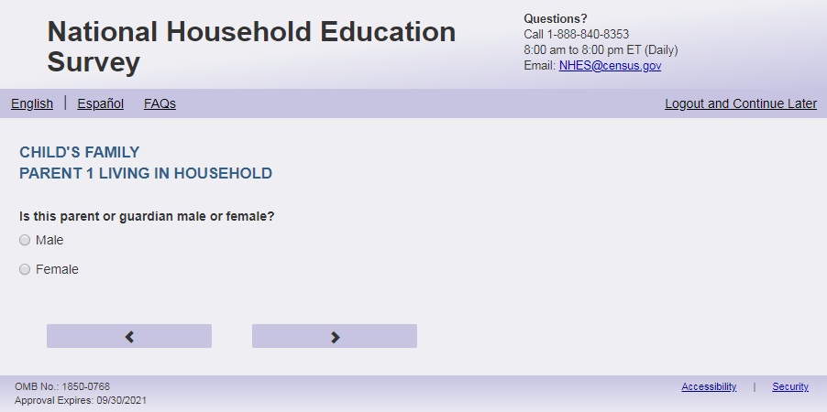

English Text Reads:
[PARENT 1] male or female?

Spanish Text Reads:
¿Es [PARENT 1] de sexo masculino o femenino?

English Answer
1= Male
2= Female

Spanish Answer
1= Masculino
2= Femenino

ECPP_P1SEX, (1,2), numeric, radio
Skips:
Go to ECPP_P1MRSTAR

Logic Checks/Programming specifications:
English:
If P1Fill = 1 (parent respondent) then PARENT 1 fill is “Are you”
If ECPP_P1HHREL2 = 1 (mother) is selected then PARENT 1 fill is “Is [this child]’s mother”
If ECPP_P1HHREL2 = 2 (father) is selected then PARENT 1 fill is “Is [this child]’s father”
If ECPP_P1HHREL2 = 3 (grandmother) is selected then PARENT 1 fill is “Is [this child]’s grandmother”
If ECPP_P1HHREL2 = 4 (grandfather) is selected then PARENT 1 fill is “Is [this child]’s grandfather”
If ECPP_P1HHREL2 = 6 (aunt) is selected then PARENT 1 fill is “Is [this child]’s aunt”
If ECPP_P1HHREL2 = 7 (uncle) is selected then PARENT 1 fill is “Is [this child]’s uncle”
If ECPP_P1HHREL2 = 8 (sister) is selected then PARENT 1 fill is “Is [this child]’s sister”
If ECPP_P1HHREL2 = 9 (brother) is selected then PARENT 1 fill is “Is [this child]’s brother”
If ECPP_P1HHREL2 in (5, 10, blank) (boyfriend/girlfriend/partner or other relationship) is selected then PARENT 1 fill is “Is [this child]’s parent or guardian”
Spanish:
If P1Fill = 1 (parent respondent) then PARENT 1 fill is “usted”
If ECPP_P1HHREL2 = 1 (madre) is selected then Parent 1 fill is “la madre de [este niño (esta niña)]”
If ECPP_P1HHREL2 = 4 (padre) is selected then Parent 1 fill is “el padre de [este niño (esta niña)]”
If ECPP_P1HHREL2 = 3 (Abuela) is selected then Parent 1 fill is “la abuela de [este niño (esta niña)]”
If ECPP_P1HHREL2 = 4 (Abuelo) is selected then Parent 1 fill is “el abuelo de [este niño (esta niña)]”
If ECPP_P1HHREL2 = 6 (Tía) is selected then Parent 1 fill is “la tía de [este niño (esta niña)]”
If ECPP_P1HHREL2 = 7 (Tío) is selected then Parent 1 fill is “el tío de [este niño (esta niña)]”
If ECPP_P1HHREL2 = 8 (Hermana) is selected then Parent 1 fill is “la hermana de [este niño (esta niña)]”
If ECPP_P1HHREL2 = 9 (Hermano) is selected then Parent 1 fill is “el hermano de [este niño (esta niña)]”
If ECPP_P1HHREL2 in (5, 10, blank) (Novia/Novio o pareja de alguno de los padres o otra relación o parentesco) is selected then Parent 1 fill is “el padre, la madre o el tutor(a) legal de [este niño (esta niña)]”

Item: Parent/Guardian Marital status (ECPP_P1MRSTAR)
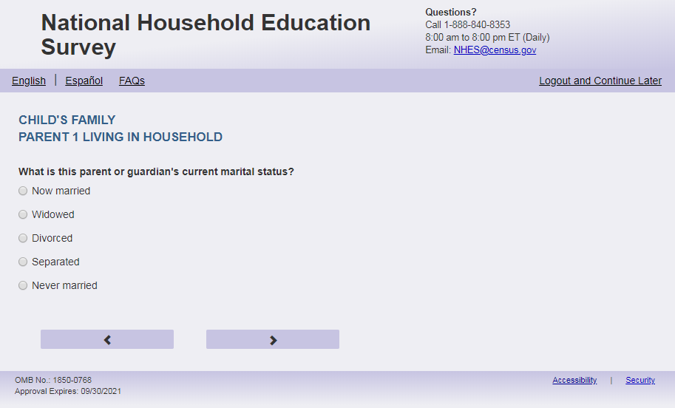
English Respondent Text Reads:
What is [PARENT 1] current marital status?
Spanish Respondent Text Reads:
[PARENT 1]
English Admin/TQA Text Reads:
What is [PARENT 1] current marital status?
{Please read response options.}
Spanish Admin/TQA Text Reads:
[PARENT 1]
{Por favor, lea las opciones de respuesta.}

English Answer
1= Now married
2= Widowed
3= Divorced
4= Separated
5= Never married

Spanish Answer
1= Actualmente casado(a)
2= Viudo(a)
3= Divorciado(a)
4= Separado(a)
5=Nunca se casó

ECPP_P1MRSTAR, (1,5), numeric, radio

Skips:
if ECPP_P1MRSTAR = 1 then go to ECPP_P1FRLNG. If ECPP_P1MRSTAR in (2, 3, 4, 5) and ECPP_HHREL1 = 5 or ECPP_P1HHREL2 = 5 then go to ECPP_P1FRLNG. Else go to ECPP_P1BFGF.

Logic Checks/Programming specifications:
English:
If P1Fill = 1 (parent respondent) then PARENT 1 fill is “your”
If ECPP_P1HHREL2 = 1 (mother) is selected then PARENT 1 fill is “ [this child]’s mother’s”
If ECPP_P1HHREL2 = 2 (father) is selected then PARENT 1 fill is “[this child]’s father’s”
If ECPP_P1HHREL2 = 3 (grandmother) is selected then PARENT 1 fill is “[this child]’s grandmother’s”
If ECPP_P1HHREL2 = 4 (grandfather) is selected then PARENT 1 fill is “[this child]’s grandfather’s”
If ECPP_P1HHREL2 = 6 (aunt) is selected then PARENT 1 fill is “[this child]’s aunt’s”
If ECPP_P1HHREL2 = 7 (uncle) is selected then PARENT 1 fill is “ [this child]’s uncle’s”
If ECPP_P1HHREL2 = 8 (sister) is selected then PARENT 1 fill is “ [this child]’s sister’s”
If ECPP_P1HHREL2 = 9 (brother) is selected then PARENT 1 fill is “ [this child]’s brother’s”
If ECPP_P1HHREL2 in (5, 10, blank) (boyfriend/girlfriend/partner or other relationship) is selected then PARENT 1 fill is “ [this child]’s parent or guardian’s”
Spanish:
If P1Fill = 1 (parent respondent) then PARENT 1 fill is “¿Cuál su estado civil actual?”
If ECPP_P1HHREL2 = 1 (madre) is selected then Parent 1 fill is “¿Cuál es el estado civil actual de la madre de [este niño (esta niña)]?”
If ECPP_P1HHREL2 = 4 (padre) is selected then Parent 1 fill is “¿Cuál es el estado civil actual del padre de [este niño (esta niña)]”
If ECPP_P1HHREL2 = 3 (Abuela) is selected then Parent 1 fill is “¿Cuál es el estado civil actual de la abuela de [este niño (esta niña)]”
If ECPP_P1HHREL2 = 4 (Abuelo) is selected then Parent 1 fill is “¿Cuál es el estado civil actual del abuelo de [este niño (esta niña)]”
If ECPP_P1HHREL2 = 6 (Tía) is selected then Parent 1 fill is “¿Cuál es el estado civil actual de la tía de [este niño (esta niña)]”
If ECPP_P1HHREL2 = 7 (Tío) is selected then Parent 1 fill is “¿Cuál es el estado civil actual del tío de [este niño (esta niña)]”
If ECPP_P1HHREL2 = 8 (Hermana) is selected then Parent 1 fill is “¿Cuál es el estado civil actual de la hermana de [este niño (esta niña)]”
If ECPP_P1HHREL2 = 9 (Hermano) is selected then Parent 1 fill is “¿Cuál es el estado civil actual del hermano de [este niño (esta niña)]”
If ECPP_P1HHREL2 in (5, 10, blank) (Novia/Novio o pareja de alguno de los padres o otra relación o parentesco) is selected then Parent 1 fill is “¿Cuál es el estado civil actual del padre, la madre o el tutor(a) legal de [este niño (esta niña)]”

Item: Living with Partner (ECPP_P1BFGF)
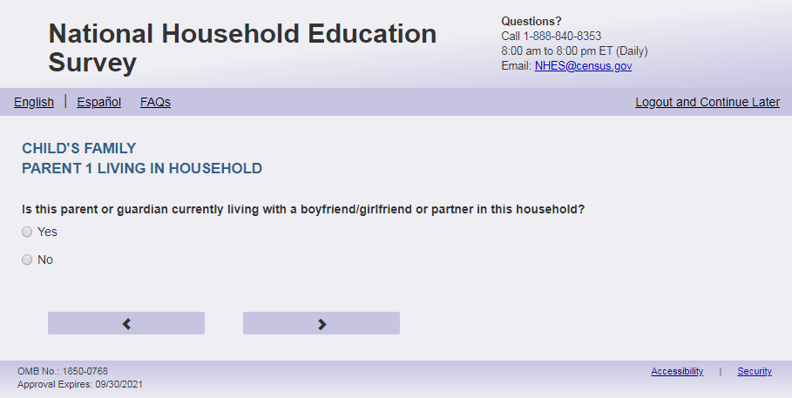
English Text Reads:
[PARENT 1] currently living with a boyfriend/girlfriend or partner in this household?
Spanish Text Reads:
¿ [PARENT 1] está viviendo actualmente con su pareja o novio(a) en este hogar?
English Answer
1 = Yes
2= No

Spanish Answer
1= Sí
2= No

ECPP_P1BFGF, (1,2), numeric, radio

Skips:
Go to ECPP_P1FRLNG

Logic Checks/Programming specifications:
English:
If P1Fill = 1 (parent respondent) then PARENT 1 fill is “Are you”
If ECPP_P1HHREL2 = 1 (mother) is selected then PARENT 1 fill is “Is [this child]’s mother”
If ECPP_P1HHREL2 = 2 (father) is selected then PARENT 1 fill is “Is [this child]’s father”
If ECPP_P1HHREL2 = 3 (grandmother) is selected then PARENT 1 fill is “Is [this child]’s grandmother”
If ECPP_P1HHREL2 = 4 (grandfather) is selected then PARENT 1 fill is “Is [this child]’s grandfather”
If ECPP_P1HHREL2 = 6 (aunt) is selected then PARENT 1 fill is “Is [this child]’s aunt”
If ECPP_P1HHREL2 = 7 (uncle) is selected then PARENT 1 fill is “Is [this child]’s uncle”
If ECPP_P1HHREL2 = 8 (sister) is selected then PARENT 1 fill is “Is [this child]’s sister”
If ECPP_P1HHREL2 = 9 (brother) is selected then PARENT 1 fill is “Is [this child]’s brother”
If ECPP_P1HHREL2 in (5, 10, blank) (boyfriend/girlfriend/partner or other relationship) is selected then PARENT 1 fill is “Is [this child]’s parent or guardian”
Spanish:
If P1Fill = 1 (parent respondent) then PARENT 1 fill is “usted”
If ECPP_P1HHREL2 = 1 (madre) is selected then Parent 1 fill is “la madre de [este niño (esta niña)]”
If ECPP_P1HHREL2 = 4 (padre) is selected then Parent 1 fill is “el padre de [este niño (esta niña)]”
If ECPP_P1HHREL2 = 3 (Abuela) is selected then Parent 1 fill is “la abuela de [este niño (esta niña)]”
If ECPP_P1HHREL2 = 4 (Abuelo) is selected then Parent 1 fill is “el abuelo de [este niño (esta niña)]”
If ECPP_P1HHREL2 = 6 (Tía) is selected then Parent 1 fill is “la tía de [este niño (esta niña)]”
If ECPP_P1HHREL2 = 7 (Tío) is selected then Parent 1 fill is “el tío de [este niño (esta niña)]”
If ECPP_P1HHREL2 = 8 (Hermana) is selected then Parent 1 fill is “la hermana de [este niño (esta niña)]”
If ECPP_P1HHREL2 = 9 (Hermano) is selected then Parent 1 fill is “elhermano de [este niño (esta niña)]”
If ECPP_P1HHREL2 in (5, 10, blank) (Novia/Novio o pareja de alguno de los padres o otra relación o parentesco) is selected then Parent 1 fill is “el padre, la madre o el tutor(a) legal de [este niño (esta niña)]”

Item: First Language of Parent/Guardian (ECPP_P1FRLNG)
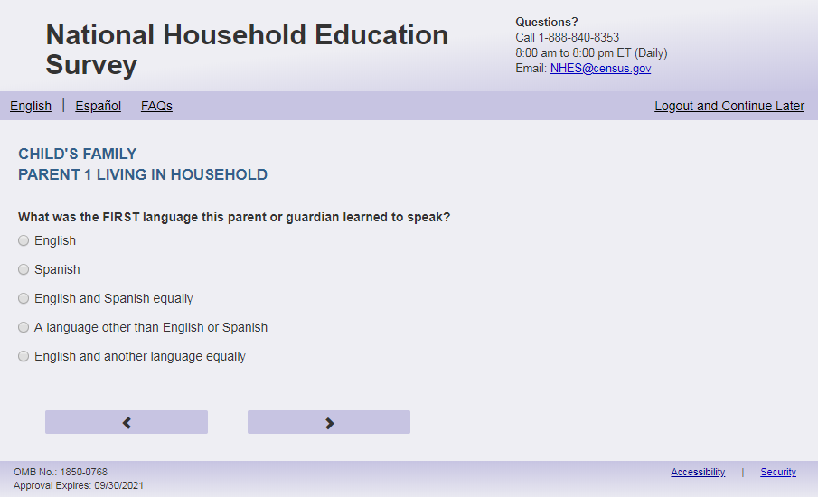
English Respondent Text Reads:
What was the FIRST language [PARENT 1] learned to speak?
Spanish Respondent Text Reads:
¿Cuál fue el PRIMER idioma que [PARENT 1] aprendió a hablar?

English Admin/TQA Text Reads:
What was the FIRST language [PARENT 1] learned to speak?
{Please read response options.}
Spanish Admin/TQA Text Reads:
¿Cuál fue el PRIMER idioma que [PARENT 1] aprendió a hablar?

{Por favor, lea las opciones de respuesta.}

English Answer
1= English
2= Spanish
3= English and Spanish equally
4= A language other than English or Spanish
5= English and another language equally

Spanish Answer
1= Inglés
2= Español
3= Inglés y español por igual
4= Otro idioma aparte del inglés o español
5= Inglés y otro idioma por igual

ECPP_P1FRLNG, (1,5), numeric, radio

Skips:
if ECPP_P1FRLNG = 1 then go to ECPP_P1PLCBRTH. Else go to ECPP_P1SPEAK

Logic Checks/Programming specifications:
English:
If P1Fill = 1 (parent respondent) then PARENT 1 fill is “you”
If ECPP_P1HHREL2 = 1 (mother) is selected then PARENT 1 fill is “ [this child]’s mother”
If ECPP_P1HHREL2 = 2 (father) is selected then PARENT 1 fill is “[this child]’s father”
If ECPP_P1HHREL2 = 3 (grandmother) is selected then PARENT 1 fill is “[this child]’s grandmother”
If ECPP_P1HHREL2 = 4 (grandfather) is selected then PARENT 1 fill is “[this child]’s grandfather”
If ECPP_P1HHREL2 = 6 (aunt) is selected then PARENT 1 fill is “[this child]’s aunt”
If ECPP_P1HHREL2 = 7 (uncle) is selected then PARENT 1 fill is “ [this child]’s uncle”
If ECPP_P1HHREL2 = 8 (sister) is selected then PARENT 1 fill is “ [this child]’s sister”
If ECPP_P1HHREL2 = 9 (brother) is selected then PARENT 1 fill is “ [this child]’s brother”
If ECPP_P1HHREL2 in (5, 10, blank) (boyfriend/girlfriend/partner or other relationship) is selected then PARENT 1 fill is “ [this child]’s parent or guardian”
Spanish:
If P1Fill = 1 (parent respondent) then PARENT 1 fill is “usted”
If ECPP_P1HHREL2 = 1 (madre) is selected then Parent 1 fill is “esta la madre de [este niño (esta niña)]”
If ECPP_P1HHREL2 = 4 (padre) is selected then Parent 1 fill is “este el padre de [este niño (esta niña)]”
If ECPP_P1HHREL2 = 3 (Abuela) is selected then Parent 1 fill is “esta la abuela de [este niño (esta niña)]”
If ECPP_P1HHREL2 = 4 (Abuelo) is selected then Parent 1 fill is “este el abuelo de [este niño (esta niña)]”
If ECPP_P1HHREL2 = 6 (Tía) is selected then Parent 1 fill is “esta la tía de [este niño (esta niña)]”
If ECPP_P1HHREL2 = 7 (Tío) is selected then Parent 1 fill is “este el tío de [este niño (esta niña)]”
If ECPP_P1HHREL2 = 8 (Hermana) is selected then Parent 1 fill is “esta la hermana de [este niño (esta niña)]”
If ECPP_P1HHREL2 = 9 (Hermano) is selected then Parent 1 fill is “este el hermano de [este niño (esta niña)]”
If ECPP_P1HHREL2 in (5, 10, blank) (Novia/Novio o pareja de alguno de los padres o otra relación o parentesco) is selected then Parent 1 fill is “este el padre, la madre o el tutor(a) legal de [este niño (esta niña)]”

Item: Current Language of Parent/Guardian (ECPP_P1SPEAK)
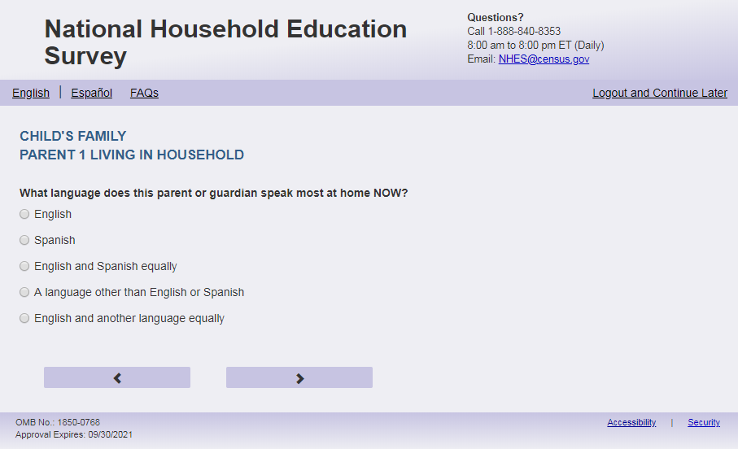
English Respondent Text Reads:
What language [PARENT 1] speak most at home NOW?
Spanish Respondent Text Reads:
ACTUALMENTE, ¿qué idioma habla [PARENT 1] más en el hogar?

English Admin/TQA Text Reads:
What language [PARENT 1] speak most at home NOW?
{Please read response options.}

Spanish Admin/TQA Text Reads:
ACTUALMENTE, ¿qué idioma habla [PARENT 1] más en el hogar?
{Por favor, lea las opciones de respuesta.}

English Answer
1= English
2= Spanish
3= English and Spanish equally
4= A language other than English or Spanish
5= English and another language equally

Spanish Answer
1= Inglés
2= Español
3= Inglés y español por igual
4 = Otro idioma aparte del inglés o español
5= Inglés y otro idioma por igual

ECPP_P1SPEAK, (1,5), numeric, radio

Skips:
Go to ECPP_P1PLCBRTH.

Logic Checks/Programming specifications:
English:
If P1Fill = 1 (parent respondent) then PARENT 1 fill is “do you”
If ECPP_P1HHREL2 = 1 (mother) is selected then PARENT 1 fill is “does [this child]’s mother”
If ECPP_P1HHREL2 = 2 (father) is selected then PARENT 1 fill is “does [this child]’s father”
If ECPP_P1HHREL2 = 3 (grandmother) is selected then PARENT 1 fill is “does [this child]’s grandmother”
If ECPP_P1HHREL2 = 4 (grandfather) is selected then PARENT 1 fill is “does [this child]’s grandfather”
If ECPP_P1HHREL2 = 6 (aunt) is selected then PARENT 1 fill is “does [this child]’s aunt”
If ECPP_P1HHREL2 = 7 (uncle) is selected then PARENT 1 fill is “does [this child]’s uncle”
If ECPP_P1HHREL2 = 8 (sister) is selected then PARENT 1 fill is “does [this child]’s sister”
If ECPP_P1HHREL2 = 9 (brother) is selected then PARENT 1 fill is “does [this child]’s brother”
If ECPP_P1HHREL2 in (5, 10, blank) (boyfriend/girlfriend/partner or other relationship) is selected then PARENT 1 fill is “does [this child]’s parent or guardian”
Spanish:
If P1Fill = 1 (parent respondent) then PARENT 1 fill is “usted”
If ECPP_P1HHREL2 = 1 (madre) is selected then Parent 1 fill is “la madre de [este niño (esta niña)]”
If ECPP_P1HHREL2 = 4 (padre) is selected then Parent 1 fill is “el padre de [este niño (esta niña)]”
If ECPP_P1HHREL2 = 3 (Abuela) is selected then Parent 1 fill is “la abuela de [este niño (esta niña)]”
If ECPP_P1HHREL2 = 4 (Abuelo) is selected then Parent 1 fill is “el abuelo de [este niño (esta niña)]”
If ECPP_P1HHREL2 = 6 (Tía) is selected then Parent 1 fill is “la tía de [este niño (esta niña)]”
If ECPP_P1HHREL2 = 7 (Tío) is selected then Parent 1 fill is “el tío de [este niño (esta niña)]”
If ECPP_P1HHREL2 = 8 (Hermana) is selected then Parent 1 fill is “la hermana de [este niño (esta niña)]”
If ECPP_P1HHREL2 = 9 (Hermano) is selected then Parent 1 fill is “el hermano de [este niño (esta niña)]”
If ECPP_P1HHREL2 in (5, 10, blank) (Novia/Novio o pareja de alguno de los padres o otra relación o parentesco) is selected then Parent 1 fill is “el padre, la madre o el tutor(a) legal de [este niño (esta niña)]”

Item: Parent/Guardian Place of Birth (ECPP_P1PLCBRTH)
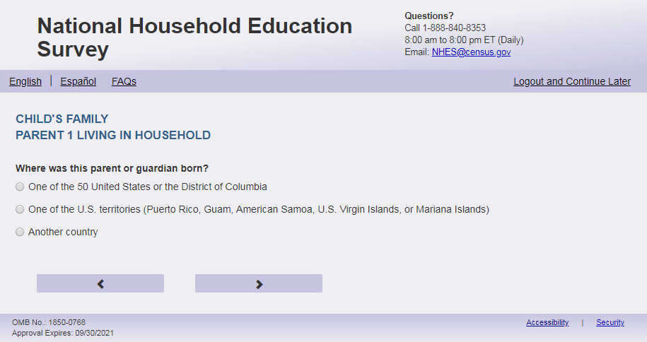
English Text Reads:
Where [PARENT 1] born?
Spanish Text Reads:
¿Dónde nació [PARENT 1]?

English Answer
1= One of the 50 United States or the District of Columbia
2= One of the U.S. territories (Puerto Rico, Guam, American Samoa, U.S. Virgin Islands, or Mariana Islands)
3= Another country

Spanish Answer
1= Uno de los 50 estados de los Estados Unidos o el Distrito de Columbia
2= Uno de los territorios incorporados de los Estados Unidos (Puerto Rico, Guam, Samoa Americana, Islas Vírgenes de los Estados Unidos o Islas Marianas del Norte)
3= Otro país

ECPP_P1PLCBRTH, (1,2), numeric, radio

Skips:
if ECPP_P1PLCBRTH = 1 or blank then go to ECPP_P1HISPANX else i go to ECPP_P1AGEMV.

Logic Checks/Programming specifications:
English:
If P1Fill = 1 (parent respondent) then PARENT 1 fill is “were you”
If ECPP_P1HHREL2 = 1 (mother) is selected then PARENT 1 fill is “was [this child]’s mother”
If ECPP_P1HHREL2 = 2 (father) is selected then PARENT 1 fill is “was [this child]’s father”
If ECPP_P1HHREL2 = 3 (grandmother) is selected then PARENT 1 fill is “was [this child]’s grandmother”
If ECPP_P1HHREL2 = 4 (grandfather) is selected then PARENT 1 fill is “was [this child]’s grandfather”
If ECPP_P1HHREL2 = 6 (aunt) is selected then PARENT 1 fill is “was [this child]’s aunt”
If ECPP_P1HHREL2 = 7 (uncle) is selected then PARENT 1 fill is “was [this child]’s uncle”
If ECPP_P1HHREL2 = 8 (sister) is selected then PARENT 1 fill is “was [this child]’s sister”
If ECPP_P1HHREL2 = 9 (brother) is selected then PARENT 1 fill is “was [this child]’s brother”
If ECPP_P1HHREL2 in (5, 10, blank) (boyfriend/girlfriend/partner or other relationship) is selected then PARENT 1 fill is “was [this child]’s parent or guardian”
Spanish:
If P1Fill = 1 (parent respondent) then PARENT 1 fill is “usted”
If ECPP_P1HHREL2 = 1 (madre) is selected then Parent 1 fill is “la madre de [este niño (esta niña)]”
If ECPP_P1HHREL2 = 4 (padre) is selected then Parent 1 fill is “el padre de [este niño (esta niña)]”
If ECPP_P1HHREL2 = 3 (Abuela) is selected then Parent 1 fill is “la abuela de [este niño (esta niña)]”
If ECPP_P1HHREL2 = 4 (Abuelo) is selected then Parent 1 fill is “el abuelo de [este niño (esta niña)]”
If ECPP_P1HHREL2 = 6 (Tía) is selected then Parent 1 fill is “la tía de [este niño (esta niña)]”
If ECPP_P1HHREL2 = 7 (Tío) is selected then Parent 1 fill is “el tío de [este niño (esta niña)]”
If ECPP_P1HHREL2 = 8 (Hermana) is selected then Parent 1 fill is “la hermana de [este niño (esta niña)]”
If ECPP_P1HHREL2 = 9 (Hermano) is selected then Parent 1 fill is “el hermano de [este niño (esta niña)]”
If ECPP_P1HHREL2 in (5, 10, blank) (Novia/Novio o pareja de alguno de los padres o otra relación o parentesco) is selected then Parent 1 fill is “el padre, la madre o el tutor(a) legal de [este niño (esta niña)]”

Item: Parent/Guardian Age when moved to U.S. (ECPP_P1AGEMV)
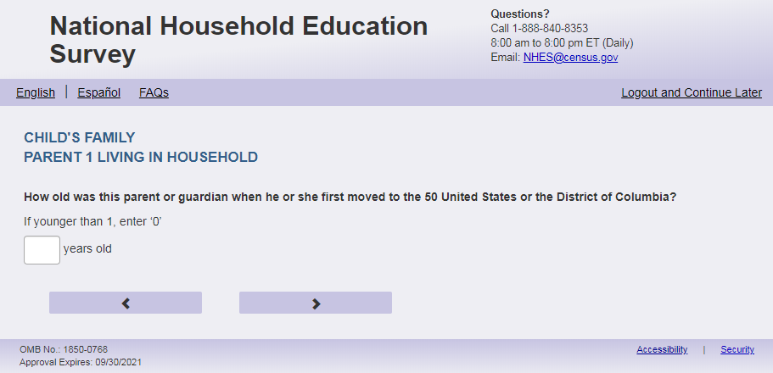
English Text Reads:
How old [PARENT 1] when [PARENT 1.2] first moved to the 50 United States or the District of Columbia?
If younger than 1, enter ‘0’
Spanish Text Reads:
¿Qué edad tenía [PARENT 1] cuando se mudó por primera vez a uno de los 50 estados de los Estados Unidos o al Distrito de Columbia?
Si fue menor de 1 año, ingrese ‘0’

ECPP_P1AGEMV, (0,99), numeric, write-in

Skips:
Go to ECPP_P1HISPANX

Logic Checks/Programming specifications:
English
display "years old" to the right of box.
Spanish
display "años" to the right of box.
Mobile: Display numeric keypad

Fills
English:
If P1Fill = 1 (parent respondent) then PARENT 1 fill is “were you”; PARENT 1.2 fill is “you”
If ECPP_P1HHREL2 = 1 (mother) is selected then PARENT 1 fill is “was [this child]’s mother”; PARENT 1.2 fill is “she”
If ECPP_P1HHREL2 = 2 (father) is selected then PARENT 1 fill is “was [this child]’s father”; PARENT 1.2 fill is “he”
If ECPP_P1HHREL2 = 3 (grandmother) is selected then PARENT 1 fill is “was [this child]’s grandmother”; PARENT 1.2 fill is “she”
If ECPP_P1HHREL2 = 4 (grandfather) is selected then PARENT 1 fill is “was [this child]’s grandfather”; PARENT 1.2 fill is “he”
If ECPP_P1HHREL2 = 6 (aunt) is selected then PARENT 1 fill is “was [this child]’s aunt”; PARENT 1.2 fill is “she”
If ECPP_P1HHREL2 = 7 (uncle) is selected then PARENT 1 fill is “was [this child]’s uncle”; PARENT 1.2 fill is “he”
If ECPP_P1HHREL2 = 8 (sister) is selected then PARENT 1 fill is “was [this child]’s sister”; PARENT 1.2 fill is “she”
If ECPP_P1HHREL2 = 9 (brother) is selected then PARENT 1 fill is “was [this child]’s brother”; PARENT 1.2 fill is “he”
If ECPP_P1HHREL2 in (5, 10, blank) (boyfriend/girlfriend/partner or other relationship) is selected then PARENT 1 fill is “was [this child]’s parent or guardian”; PARENT 1.2 fill is “he” if ECPP_P1SEX = 1, “she” if ECPP_P1SEX = 2, else “he or she”
Spanish:
If P1Fill = 1 (parent respondent) then PARENT 1 fill is “usted”
If ECPP_P1HHREL2 = 1 (madre) is selected then Parent 1 fill is “la madre de [este niño (esta niña)]”
If ECPP_P1HHREL2 = 4 (padre) is selected then Parent 1 fill is “el padre de [este niño (esta niña)]”
If ECPP_P1HHREL2 = 3 (Abuela) is selected then Parent 1 fill is “la abuela de [este niño (esta niña)]”
If ECPP_P1HHREL2 = 4 (Abuelo) is selected then Parent 1 fill is “el abuelo de [este niño (esta niña)]”
If ECPP_P1HHREL2 = 6 (Tía) is selected then Parent 1 fill is “la tía de [este niño (esta niña)]”
If ECPP_P1HHREL2 = 7 (Tío) is selected then Parent 1 fill is “el tío de [este niño (esta niña)]”
If ECPP_P1HHREL2 = 8 (Hermana) is selected then Parent 1 fill is “la hermana de [este niño (esta niña)]”
If ECPP_P1HHREL2 = 9 (Hermano) is selected then Parent 1 fill is “el hermano de [este niño (esta niña)]”
If ECPP_P1HHREL2 in (5, 10, blank) (Novia/Novio o pareja de alguno de los padres o otra relación o parentesco) is selected then Parent 1 fill is “el padre, la madre o el tutor(a) legal de [este niño (esta niña)]”

Item: Hispanic Origin (ECPP_P1HISPANX)
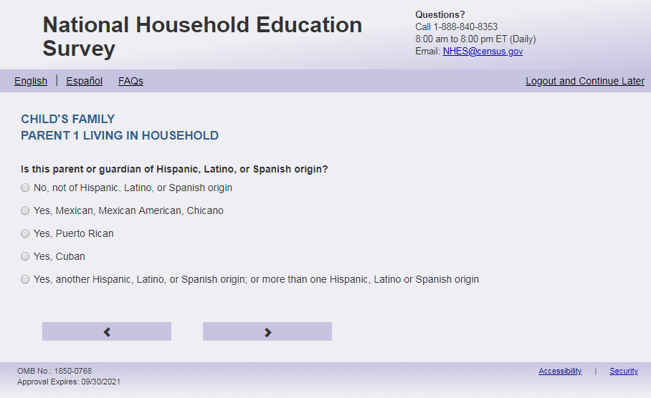
English Respondent Text Reads:
[PARENT 1] of Hispanic, Latino, or Spanish origin?
Spanish Respondent Text Reads:
¿Es [PARENT 1] de origen hispano, latino o español?

English Admin/TQA Text Reads:
{Please be sure to ask BOTH this question and the following race question, and record the respondent’s answer}
[PARENT 1] of Hispanic, Latino, or Spanish origin?
{If ‘yes,’ read yes answer options to the respondent.}
Spanish Admin/TQA Text Reads:
{Por favor asgúrese de leer esta pregunta Y TAMBIÉN la siguiente pregunta sobre la raza, y marque la respuesta del encuestado}
¿Es [PARENT 1] de origen hispano, latino o español?

{Si 'sí', lea opciones de respuesta sí al encuestado.}
English Answer
1 = No, not of Hispanic, Latino, or Spanish origin
2 = Yes, Mexican, Mexican American, Chicano
3 = Yes, Puerto Rican
4 = Yes, Cuban
5 = Yes, another Hispanic, Latino, or Spanish origin; or more than one Hispanic, Latino or Spanish origin

Spanish Answer
1 = No, no es de origen hispano, latino, o español
2 = Sí, Mexicano, Mexicano Americano, Chicano
3 = Sí, Puertorriqueño
4 = Sí, Cubano
5 = Sí, es de otro origen hispano, latino, o español; o de más de un origen hispano, latino o español

ECPP_P1HISPANX, (1,5), numeric, radio
Skips:
Go to ECPP_P1AMIND
Logic Checks/Programming specifications:

English:
If P1Fill = 1 (parent respondent) then PARENT 1 fill is “Are you”
If ECPP_P1HHREL2 = 1 (mother) is selected then PARENT 1 fill is “Is this [this child]’s mother”
If ECPP_P1HHREL2 = 2 (father) is selected then PARENT 1 fill is “Is this [this child]’s father”
If ECPP_P1HHREL2 = 3 (grandmother) is selected then PARENT 1 fill is “Is this [this child]’s grandmother”
If ECPP_P1HHREL2 = 4 (grandfather) is selected then PARENT 1 fill is “Is this [this child]’s grandfather”
If ECPP_P1HHREL2 = 6 (aunt) is selected then PARENT 1 fill is “Is this [this child]’s aunt”
If ECPP_P1HHREL2 = 7 (uncle) is selected then PARENT 1 fill is “Is this [this child]’s uncle”
If ECPP_P1HHREL2 = 8 (sister) is selected then PARENT 1 fill is “Is this [this child]’s sister”
If ECPP_P1HHREL2 = 9 (brother) is selected then PARENT 1 fill is “Is this [this child]’s brother”
If ECPP_P1HHREL2 in (5, 10, blank) (boyfriend/girlfriend/partner or other relationship) is selected then PARENT 1 fill is “Is this [this child]’s parent or guardian”
Spanish:
If P1Fill = 1 (parent respondent) then PARENT 1 fill is “usted”
If ECPP_P1HHREL2 = 1 (madre) is selected then Parent 1 fill is “la madre de [este niño (esta niña)]”
If ECPP_P1HHREL2 = 4 (padre) is selected then Parent 1 fill is “el padre de [este niño (esta niña)]”
If ECPP_P1HHREL2 = 3 (Abuela) is selected then Parent 1 fill is “la abuela de [este niño (esta niña)]”
If ECPP_P1HHREL2 = 4 (Abuelo) is selected then Parent 1 fill is “el abuelo de [este niño (esta niña)]”
If ECPP_P1HHREL2 = 6 (Tía) is selected then Parent 1 fill is “la tía de [este niño (esta niña)]”
If ECPP_P1HHREL2 = 7 (Tío) is selected then Parent 1 fill is “el tío de [este niño (esta niña)]”
If ECPP_P1HHREL2 = 8 (Hermana) is selected then Parent 1 fill is “la hermana de [este niño (esta niña)]”
If ECPP_P1HHREL2 = 9 (Hermano) is selected then Parent 1 fill is “el hermano de [este niño (esta niña)]”
If ECPP_P1HHREL2 in (5, 10, blank) (Novia/Novio o pareja de alguno de los padres o otra relación o parentesco) is selected then Parent 1 fill is “el padre, la madre o el tutor(a) legal de [este niño (esta niña)]”

Item: Parent/Guardian Race (ECPP_P1AMIND)
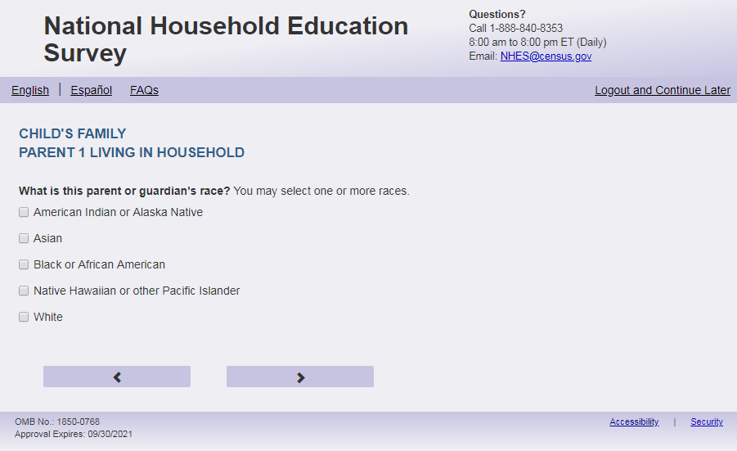
English Respondent Text Reads:
What is [PARENT 1] race? You may select one or more races.
Spanish Respondent Text Reads:
¿Cuál es la raza de [PARENT 1]? Puede seleccionar una raza o más de una raza.
English Admin/TQA Text Reads:
What is [PARENT 1] race?
{You may select one or more races.}
{If the respondent answered yes to the previous item (Hispanic ethnicity) and does not identify with any other race, leave this item blank.}
Spanish Admin/TQA Text Reads:
¿Cuál es [PARENT 1]?
{Puede seleccionar una o más razas.}
{Si el encuestado respondió sí a la pregunta anterior (etnia hispana) y no se identifica con ninguna otra raza, deje este ítem en blanco.}
English Answer:

American Indian or Alaska Native, ECPP_P1AMIND, (1 = Item Marked; 2=Not marked), numeric, checkbox
Asian, ECPP_P1ASIAN, (1 = Item Marked; 2=Not marked), numeric, checkbox
Black or African American, ECPP_P1BLACK, (1 = Item Marked; 2=Not marked), numeric, checkbox
Native Hawaiian or other Pacific Islander, ECPP_P1PACI, (1 = Item Marked; 2=Not marked), numeric, checkbox
White, ECPP_P1WHITE, (1 = Item Marked; 2=Not marked), numeric, checkbox

Spanish Answer:
Indígena de las Américas o nativa de Alaska, ECPP_P1AMIND, (1 = Item Marked; 2=Not marked), numeric, checkbox
Asiática, ECPP_P1ASIAN, , (1 = Item Marked; 2=Not marked), numeric, checkbox
Negra o afroamericana, ECPP_P1BLACK, , (1 = Item Marked; 2=Not marked), numeric, checkbox
Nativa de Hawái u otra de las islas del Pacífico, ECPP_P1PACI, , (1 = Item Marked; 2=Not marked), numeric, checkbox
Blanca, ECPP_P1WHITE, , (1 = Item Marked; 2=Not marked), numeric, checkbox

Skips:
Go to ECPP_P1EDUC
Logic Checks/Programming specifications:
This is a mark all that apply item
Fills
English:
If P1Fill = 1 (parent respondent) then PARENT 1 fill is “your”
If ECPP_P1HHREL2 = 1 (mother) is selected then PARENT 1 fill is “[this child]’s mother’s”
If ECPP_P1HHREL2 = 2 (father) is selected then PARENT 1 fill is “[this child]’s father’s”
If ECPP_P1HHREL2 = 3 (grandmother) is selected then PARENT 1 fill is “[this child]’s grandmother’s”
If ECPP_P1HHREL2 = 4 (grandfather) is selected then PARENT 1 fill is “[this child]’s grandfather’s”
If ECPP_P1HHREL2 = 6 (aunt) is selected then PARENT 1 fill is “[this child]’s aunt’s”
If ECPP_P1HHREL2 = 7 (uncle) is selected then PARENT 1 fill is “[this child]’s uncle’s”
If ECPP_P1HHREL2 = 8 (sister) is selected then PARENT 1 fill is “[this child]’s sister’s”
If ECPP_P1HHREL2 = 9 (brother) is selected then PARENT 1 fill is “[this child]’s brother’s”
If ECPP_P1HHREL2 in (5, 10, blank) (boyfriend/girlfriend/partner or other relationship) is selected then PARENT 1 fill is “[this child]’s parent or guardian’s”
Spanish:
If P1Fill = 1 (parent respondent) then PARENT 1 fill is “su raza”
If ECPP_P1HHREL2 = 1 (madre) is selected then Parent 1 fill is “la raza de la madre de [este niño (esta niña)]”
If ECPP_P1HHREL2 = 4 (padre) is selected then Parent 1 fill is “la raza del padre de [este niño (esta niña)]”
If ECPP_P1HHREL2 = 3 (Abuela) is selected then Parent 1 fill is “la raza de la abuela de [este niño (esta niña)]”
If ECPP_P1HHREL2 = 4 (Abuelo) is selected then Parent 1 fill is “la raza del abuelo de [este niño (esta niña)]”
If ECPP_P1HHREL2 = 6 (Tía) is selected then Parent 1 fill is “la raza de la tía de [este niño (esta niña)]”
If ECPP_P1HHREL2 = 7 (Tío) is selected then Parent 1 fill is “la raza del tío de [este niño (esta niña)]”
If ECPP_P1HHREL2 = 8 (Hermana) is selected then Parent 1 fill is “la raza de la hermana de [este niño (esta niña)]”
If ECPP_P1HHREL2 = 9 (Hermano) is selected then Parent 1 fill is “la raza del hermano de [este niño (esta niña)]”
If ECPP_P1HHREL2 in (5, 10, blank) (Novia/Novio o pareja de alguno de los padres o otra relación o parentesco) is selected then Parent 1 fill is “la raza del padre, la madre o el tutor(a) legal de [este niño (esta niña)]”

Item: Parent/ Guardian Highest Level of Education (ECPP_P1EDUC)
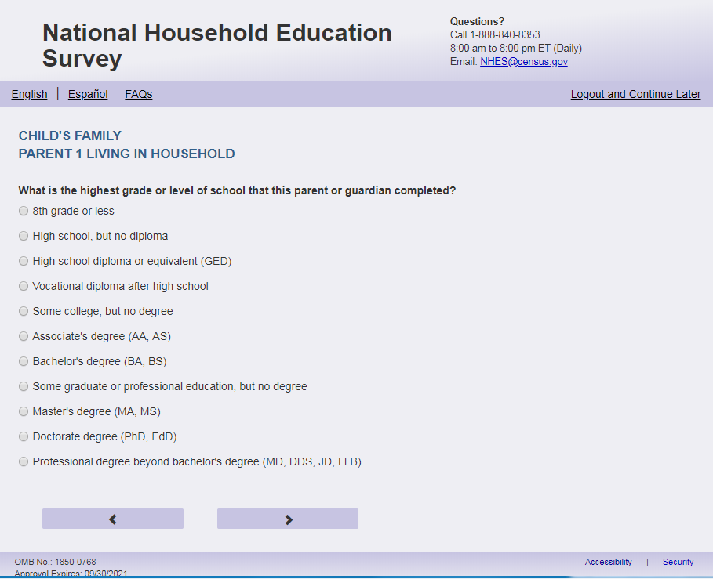
English Respondent Text Reads:
What is the highest grade or level of school that [PARENT 1] completed?
Spanish Respondent Text Reads:
¿Cuál es el grado o nivel más alto de estudios que [PARENT 1] ha completó?

English Admin/TQA Text Reads:
What is the highest grade or level of school that [PARENT 1] completed?
{Please read response options.}
Spanish Admin/TQA Text Reads:
¿Cuál es el grado o nivel escolar más alto que [PARENT 1] completó?

{Por favor, lea las opciones de respuesta.}

English Answer
1= 8th grade or less
2= High school, but no diploma
3= High school diploma or equivalent (GED)
4= Vocational diploma after high school
5= Some college, but no degree
6= Associate’s degree (AA, AS)
7= Bachelor’s degree (BA, BS)
8= Some graduate or professional education, but no degree
9= Master’s degree (MA, MS)
10= Doctorate degree (PhD, EdD)
11= Professional degree beyond bachelor’s degree (MD, DDS, JD, LLB)

Spanish Answer
1= 8° grado o menos
2= High school (grado 9 al 12), pero sin obtener el diploma
3= Diploma de high school o equivalencia (GED)
4= Diploma vocacional o de oficios posterior a high school
5= Algunos cursos de college o universidad, pero sin graduarse
6= Licenciatura o grado asociado (AA, AS)
7= Licenciatura o grado de bachelor (BA, BS)
8= Algo de educación profesional o graduada, pero sin título
9= Título de maestría (MA, MS)
10= Título de doctorado (PhD, EdD)
11= Título profesional posterior al grado de bachelor (médico, dentista, doctor en leyes)
ECPP_P1EDUC, (1,11), numeric, radio

Skips:
Go to ECPP_P1ENRL
Logic Checks/Programming specifications:
Fills:
English:
If P1Fill = 1 (parent respondent) then PARENT 1 fill is “you”
If ECPP_P1HHREL2 = 1 (mother) is selected then PARENT 1 fill is “[this child]’s mother”
If ECPP_P1HHREL2 = 2 (father) is selected then PARENT 1 fill is “[this child]’s father”
If ECPP_P1HHREL2 = 3 (grandmother) is selected then PARENT 1 fill is “[this child]’s grandmother”
If ECPP_P1HHREL2 = 4 (grandfather) is selected then PARENT 1 fill is “[this child]’s grandfather”
If ECPP_P1HHREL2 = 6 (aunt) is selected then PARENT 1 fill is “[this child]’s aunt”
If ECPP_P1HHREL2 = 7 (uncle) is selected then PARENT 1 fill is “[this child]’s uncle”
If ECPP_P1HHREL2 = 8 (sister) is selected then PARENT 1 fill is “[this child]’s sister”
If ECPP_P1HHREL2 = 9 (brother) is selected then PARENT 1 fill is “[this child]’s brother”
If ECPP_P1HHREL2 in (5, 10, blank) (boyfriend/girlfriend/partner or other relationship) is selected then PARENT 1 fill is “[this child]’s parent or guardian”
Spanish:
If P1Fill = 1 (parent respondent) then PARENT 1 fill is “usted”
If ECPP_P1HHREL2 = 1 (madre) is selected then Parent 1 fill is “la madre de [este niño (esta niña)]”
If ECPP_P1HHREL2 = 4 (padre) is selected then Parent 1 fill is “el padre de [este niño (esta niña)]”
If ECPP_P1HHREL2 = 3 (Abuela) is selected then Parent 1 fill is “la abuela de [este niño (esta niña)]”
If ECPP_P1HHREL2 = 4 (Abuelo) is selected then Parent 1 fill is “el abuelo de [este niño (esta niña)]”
If ECPP_P1HHREL2 = 6 (Tía) is selected then Parent 1 fill is “la tía de [este niño (esta niña)]”
If ECPP_P1HHREL2 = 7 (Tío) is selected then Parent 1 fill is “el tío de [este niño (esta niña)]”
If ECPP_P1HHREL2 = 8 (Hermana) is selected then Parent 1 fill is “la hermana de [este niño (esta niña)]”
If ECPP_P1HHREL2 = 9 (Hermano) is selected then Parent 1 fill is “el hermano de [este niño (esta niña)]”
If ECPP_P1HHREL2 in (5, 10, blank) (Novia/Novio o pareja de alguno de los padres o otra relación o parentesco) is selected then Parent 1 fill is “el padre, la madre o el tutor(a) legal de [este niño (esta niña)]”

Item: Parent/Guardian Currently Enrolled in Postsecondary Education (ECPP_P1ENRL)
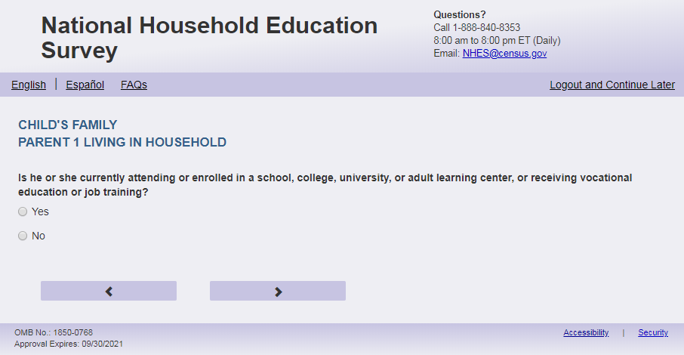
English Text Reads:
[PARENT 1] currently attending or enrolled in a school, college, university, or adult learning center, or receiving vocational education or job training?
Spanish Text Reads:
Actualmente, ¿asiste [PARENT 1] a una escuela, universidad o centro de educación para adultos o recibe educación vocacional o capacitación laboral?

English
1 = Yes
2=No

Spanish
1= Sí
2=No

ECPP_P1ENRL, (1,2), numeric, radio

Skips:
Go to ECPP_P1EMPL
Logic Checks/Programming specifications:

Fills:
English:
If P1Fill = 1 (parent respondent) then PARENT 1 fill is “Are you”
If ECPP_P1HHREL2 = 1 (mother); 3 (grandmother); 6 (aunt); 8 (sister) is selected then PARENT 1 fill is “Is she”
If ECPP_P1HHREL2 = 2 (father); 4 (grandfather); 7 (uncle); 9 (brother) is selected then PARENT 1 fill is “Is he”
If ECPP_P1HHREL2 = 10 (boyfriend/girlfriend/partner or other relationship) is selected then PARENT 1 fill is if ECPP_P1SEX = 1 then “Is he”, if ECPP_P1SEX = 2 then “Is she” else “Is he or she"
Spanish:
If P1Fill = 1 (parent respondent) then PARENT 1 fill is “usted”
If ECPP_P1HHREL2 = 1 (madre) is selected then Parent 1 fill is “la madre de [este niño (esta niña)]”
If ECPP_P1HHREL2 = 4 (padre) is selected then Parent 1 fill is “el padre de [este niño (esta niña)]”
If ECPP_P1HHREL2 = 3 (Abuela) is selected then Parent 1 fill is “la abuela de [este niño (esta niña)]”
If ECPP_P1HHREL2 = 4 (Abuelo) is selected then Parent 1 fill is “el abuelo de [este niño (esta niña)]”
If ECPP_P1HHREL2 = 6 (Tía) is selected then Parent 1 fill is “la tía de [este niño (esta niña)]”
If ECPP_P1HHREL2 = 7 (Tío) is selected then Parent 1 fill is “el tío de [este niño (esta niña)]”
If ECPP_P1HHREL2 = 8 (Hermana) is selected then Parent 1 fill is “la hermana de [este niño (esta niña)]”
If ECPP_P1HHREL2 = 9 (Hermano) is selected then Parent 1 fill is “el hermano de [este niño (esta niña)]”
If ECPP_P1HHREL2 in (5, 10, blank) (Novia/Novio o pareja de alguno de los padres u otra relación o parentesco) is selected then Parent 1 fill is “el padre, la madre o el tutor(a) legal de [este niño (esta niña)]”

Item: Parent/Guardian Employment Status (ECPP_P1EMPL)
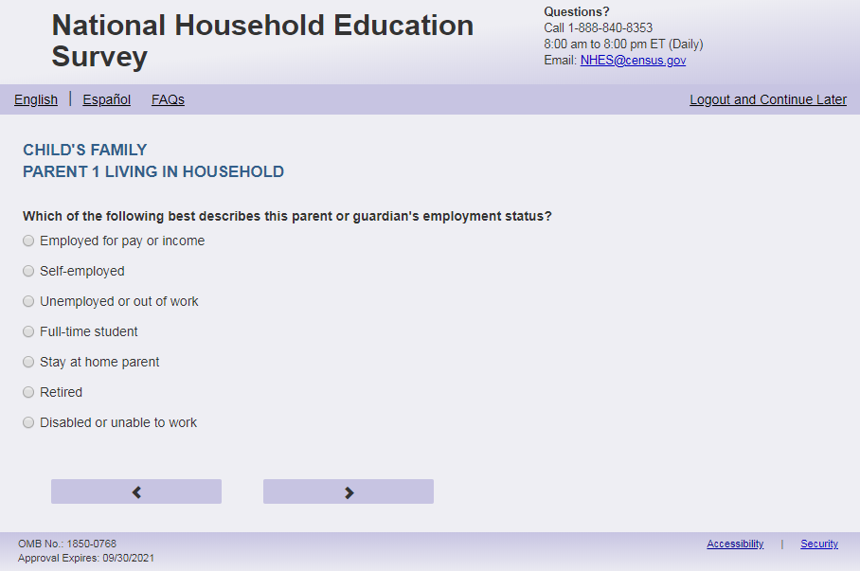
English Respondent Text Reads:
Which of the following BEST describes [PARENT 1] employment status?
Spanish Respondent Text Reads:

¿Cuál de las siguientes categorías describe MEJOR [PARENT 1]?
English Admin/TQA Text Reads:

Which of the following BEST describes [PARENT 1] employment status?
{Please read response options.}
Spanish Admin/TQA Text Reads:

¿Cuál de las siguientes categorías describe MEJOR [PARENT 1]?
{Por favor, lea las opciones de respuesta.}
English Answer
1= Employed for pay or income
2= Self-employed
3= Unemployed or out of work
4= Full-time student
5= Stay-at-home parent
6= Retired
7= Disabled or unable to work

Spanish Answer
1= Empleado(a) por pagos o ingresos
2= Trabaja por su propia cuenta
3= Desempleado(a) o no está trabajando
4= Estudiante de tiempo completo
5= Se dedica al hogar y al cuidado de los niños(as)
6= Jubilado(a)
7= Discapacitado(a) o no puede trabajar

ECPP_P1EMPL, (1,7), numeric, radio

Skips:
if ECPP_P1EMPL = 3 then go to ECPP_P1LKWRK
if ECPP_P1EMPL in (4, 5, 6, 7) then go to ECPP_P1MTHSWRK
Else if P1EMPL in (1,2) or blank, then go to ECPP_P1HRSWK

Logic Checks/Programming specifications:
Fills:
English:
If P1Fill = 1 (parent respondent) then PARENT 1 fill is “your”
If ECPP_P1HHREL2 = 1 (mother) is selected then PARENT 1 fill is “[this child]’s mother”
If ECPP_P1HHREL2 = 2 (father) is selected then PARENT 1 fill is “[this child]’s father”
If ECPP_P1HHREL2 = 3 (grandmother) is selected then PARENT 1 fill is “[this child]’s grandmother”
If ECPP_P1HHREL2 = 4 (grandfather) is selected then PARENT 1 fill is “[this child]’s grandfather”
If ECPP_P1HHREL2 = 6 (aunt) is selected then PARENT 1 fill is “[this child]’s aunt”
If ECPP_P1HHREL2 = 7 (uncle) is selected then PARENT 1 fill is “[this child]’s uncle”
If ECPP_P1HHREL2 = 8 (sister) is selected then PARENT 1 fill is “[this child]’s sister”
If ECPP_P1HHREL2 = 9 (brother) is selected then PARENT 1 fill is “[this child]’s brother”
If ECPP_P1HHREL2 in (5, 10, blank) (boyfriend/girlfriend/partner or other relationship) is selected then PARENT 1 fill is “[this child]’s parent or guardian”
Spanish:
If P1Fill = 1 (parent respondent) then PARENT 1 fill is “su situación de trabajo”
If ECPP_P1HHREL2 = 1 (madre) is selected then Parent 1 fill is “la situación de trabajo de la madre de [este niño (esta niña)]”
If ECPP_P1HHREL2 = 4 (padre) is selected then Parent 1 fill is “la situación de trabajo del padre de [este niño (esta niña)]”
If ECPP_P1HHREL2 = 3 (Abuela) is selected then Parent 1 fill is “la situación de trabajo de la abuela de [este niño (esta niña)]”
If ECPP_P1HHREL2 = 4 (Abuelo) is selected then Parent 1 fill is “la situación de trabajo del abuelo de [este niño (esta niña)]”
If ECPP_P1HHREL2 = 6 (Tía) is selected then Parent 1 fill is “la situación de trabajo de la tía de [este niño (esta niña)]”
If ECPP_P1HHREL2 = 7 (Tío) is selected then Parent 1 fill is “la situación de trabajo del tío de [este niño (esta niña)]”
If ECPP_P1HHREL2 = 8 (Hermana) is selected then Parent 1 fill is “la situación de trabajo de la hermana de [este niño (esta niña)]”
If ECPP_P1HHREL2 = 9 (Hermano) is selected then Parent 1 fill is “la situación de trabajo del hermano de [este niño (esta niña)]”
If ECPP_P1HHREL2 in (5, 10, blank) (Novia/Novio o pareja de alguno de los padres o otra relación o parentesco) is selected then Parent 1 fill is “la situación de trabajo del padre, la madre o el tutor(a) legal de [este niño (esta niña)]”

Item: Parent/Guardian Hours Worked Weekly (ECPP_P1HRSWK)

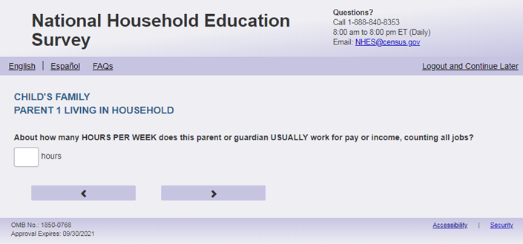
English Text Reads:
About how many hours PER WEEK [PARENT 1] USUALLY work for pay or income, counting all jobs?

Spanish Text Reads:
¿Más o menos cuántas horas POR SEMANA trabaja [PARENT 1] NORMALMENTE por pagos o ingresos, contando todos los trabajos?

English and Spanish Answer:

ECPP_P1HRSWK, (0,99), numeric, write-in

Skips:

Go to ECPP_P1MTHSWRK

Logic Checks/Programming specifications:

English
display "hours per week" to the right of the box.

Spanish
display "horas a la semana" to the right of the box.

Mobile: Display numeric keypad

Fills:
English:
If P1Fill = 1 (parent respondent) then PARENT 1 fill is “do you”
If ECPP_P1HHREL2 = 1 (mother) is selected then PARENT 1 fill is “does [this child]’s mother”
If ECPP_P1HHREL2 = 2 (father) is selected then PARENT 1 fill is “does [this child]’s father”
If ECPP_P1HHREL2 = 3 (grandmother) is selected then PARENT 1 fill is “does [this child]’s grandmother”
If ECPP_P1HHREL2 = 4 (grandfather) is selected then PARENT 1 fill is “does [this child]’s grandfather”
If ECPP_P1HHREL2 = 6 (aunt) is selected then PARENT 1 fill is “does [this child]’s aunt”
If ECPP_P1HHREL2 = 7 (uncle) is selected then PARENT 1 fill is “does [this child]’s uncle”
If ECPP_P1HHREL2 = 8 (sister) is selected then PARENT 1 fill is “does [this child]’s sister”
If ECPP_P1HHREL2 = 9 (brother) is selected then PARENT 1 fill is “does [this child]’s brother”
If ECPP_P1HHREL2 in (5, 10, blank) (boyfriend/girlfriend/partner or other relationship) is selected then PARENT 1 fill is “does [this child]’s parent or guardian”
Spanish:
If P1Fill = 1 (parent respondent) then PARENT 1 fill is “usted”
If ECPP_P1HHREL2 = 1 (madre) is selected then Parent 1 fill is “la madre de [este niño (esta niña)]”
If ECPP_P1HHREL2 = 4 (padre) is selected then Parent 1 fill is “el padre de [este niño (esta niña)]”
If ECPP_P1HHREL2 = 3 (Abuela) is selected then Parent 1 fill is “la abuela de [este niño (esta niña)]”
If ECPP_P1HHREL2 = 4 (Abuelo) is selected then Parent 1 fill is “el abuelo de [este niño (esta niña)]”
If ECPP_P1HHREL2 = 6 (Tía) is selected then Parent 1 fill is “la tía de [este niño (esta niña)]”
If ECPP_P1HHREL2 = 7 (Tío) is selected then Parent 1 fill is “el tío de [este niño (esta niña)]”
If ECPP_P1HHREL2 = 8 (Hermana) is selected then Parent 1 fill is “la hermana de [este niño (esta niña)]”
If ECPP_P1HHREL2 = 9 (Hermano) is selected then Parent 1 fill is “el hermano de [este niño (esta niña)]”
If ECPP_P1HHREL2 in (5, 10, blank) (Novia/Novio o pareja de alguno de los padres o otra relación o parentesco) is selected then Parent 1 fill is “el padre, la madre o el tutor(a) legal de [este niño (esta niña)]”
Text Displayed for logic/range check violation:
Logic/range check triggers a warning message, with the following text displayed.
English
[If 0] Display "Please check your answer before continuing. Typically, adults work between one and 99 hours per week."
Spanish
[If 0] Display "Por favor, compruebe su respuesta antes de continuar. Por lo general, los adultos trabajan entre una y 99 horas por semana.”.

Item: Hours Worked past 4 Weeks (ECPP_P1LKWRK)
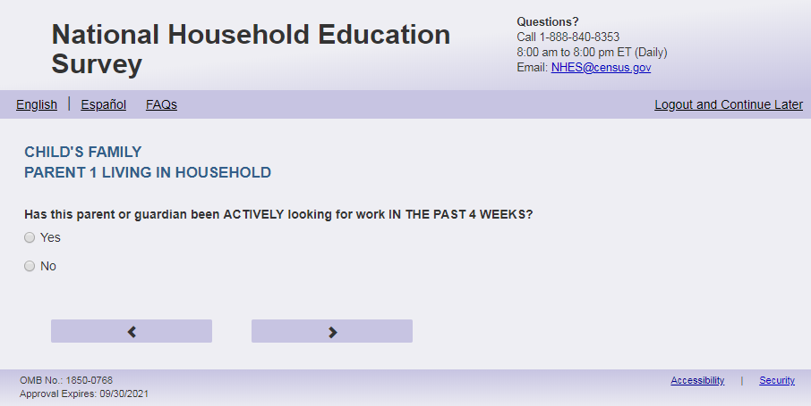
English Text Reads:
[PARENT 1] been ACTIVELY looking for work IN THE PAST 4 WEEKS?

Spanish Text Reads:
¿Ha estado [PARENT 1] buscando trabajo DE MANERA ACTIVA en LAS ÚLTIMAS 4 SEMANAS?

English
1 = Yes
2=No

Spanish
1= Sí
2=No

ECPP_P1LKWRK, (1,2), numeric, radio

Skips:

Go to ECPP_P1MTHSWRK

Logic Checks/Programming specifications:
Fills:
English:
If P1Fill = 1 (parent respondent) then PARENT 1 fill is “Have you”
If ECPP_P1HHREL2 = 1 (mother) is selected then PARENT 1 fill is “Has [this child]’s mother”
If ECPP_P1HHREL2 = 2 (father) is selected then PARENT 1 fill is “Has [this child]’s father”
If ECPP_P1HHREL2 = 3 (grandmother) is selected then PARENT 1 fill is “Has [this child]’s grandmother”
If ECPP_P1HHREL2 = 4 (grandfather) is selected then PARENT 1 fill is “Has [this child]’s grandfather”
If ECPP_P1HHREL2 = 6 (aunt) is selected then PARENT 1 fill is “Has [this child]’s aunt”
If ECPP_P1HHREL2 = 7 (uncle) is selected then PARENT 1 fill is “Has [this child]’s uncle”
If ECPP_P1HHREL2 = 8 (sister) is selected then PARENT 1 fill is “Has [this child]’s sister”
If ECPP_P1HHREL2 = 9 (brother) is selected then PARENT 1 fill is “Has [this child]’s brother”
If ECPP_P1HHREL2 in (5, 10, blank) (boyfriend/girlfriend/partner or other relationship) is selected then PARENT 1 fill is “Has [this child]’s parent or guardian”
Spanish:
If P1Fill = 1 (parent respondent) then PARENT 1 fill is “usted”
If ECPP_P1HHREL2 = 1 (madre) is selected then Parent 1 fill is “la madre de [este niño (esta niña)]”
If ECPP_P1HHREL2 = 4 (padre) is selected then Parent 1 fill is “el padre de [este niño (esta niña)]”
If ECPP_P1HHREL2 = 3 (Abuela) is selected then Parent 1 fill is “la abuela de [este niño (esta niña)]”
If ECPP_P1HHREL2 = 4 (Abuelo) is selected then Parent 1 fill is “el abuelo de [este niño (esta niña)]”
If ECPP_P1HHREL2 = 6 (Tía) is selected then Parent 1 fill is “la tía de [este niño (esta niña)]”
If ECPP_P1HHREL2 = 7 (Tío) is selected then Parent 1 fill is “el tío de [este niño (esta niña)]”
If ECPP_P1HHREL2 = 8 (Hermana) is selected then Parent 1 fill is “la hermana de [este niño (esta niña)]”
If ECPP_P1HHREL2 = 9 (Hermano) is selected then Parent 1 fill is “el hermano de [este niño (esta niña)]”
If ECPP_P1HHREL2 in (5, 10, blank) (Novia/Novio o pareja de alguno de los padres o otra relación o parentesco) is selected then Parent 1 fill is “el padre, la madre o el tutor(a) legal de [este niño (esta niña)]”

Item: Worked past 12 Months (ECPP_P1MTHSWRK)
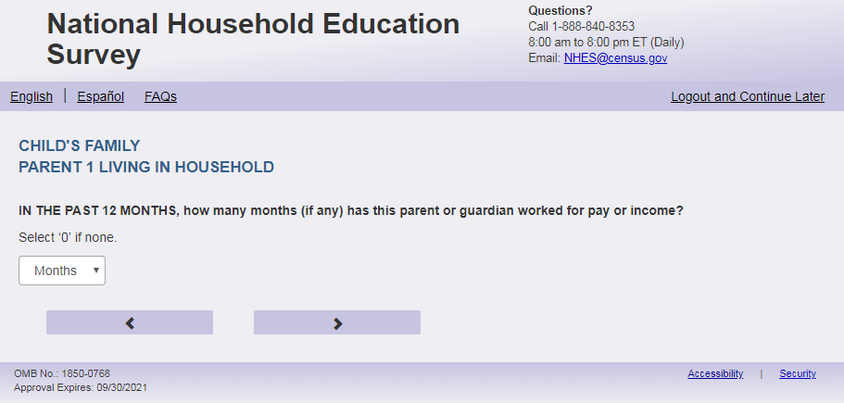

English Text Reads:
IN THE PAST 12 MONTHS, how many months (if any) [PARENT 1] worked for pay or income?
Enter ‘0’ if none.

Spanish Text Reads:
EN LOS ÚLTIMOS 12 MESES, ¿cuántos meses (si alguno) ha trabajado [PARENT 1] (si es que ha trabajado) para recibir pagos o ingresos?
Ingrese ‘0’ si no trabajó ningún mes.

English and Spanish Answer:
ECPP_P1MTHSWRK, (0,12), numeric, write-in

Skips:
Go to ECPP_P1INTSPHO.

Logic Checks/Programming specifications:

If English - display "month(s)" to the right of the text box.

If Spanish - display "mes(es)" to the right of the text box.
Mobile: Display numeric keypad

Fills:
English:
If P1Fill = 1 (parent respondent) then PARENT 1 fill is “have you”
If ECPP_P1HHREL2 = 1 (mother) is selected then PARENT 1 fill is “has [this child]’s mother”
If ECPP_P1HHREL2 = 2 (father) is selected then PARENT 1 fill is “has [this child]’s father”
If ECPP_P1HHREL2 = 3 (grandmother) is selected then PARENT 1 fill is “has [this child]’s grandmother”
If ECPP_P1HHREL2 = 4 (grandfather) is selected then PARENT 1 fill is “has [this child]’s grandfather”
If ECPP_P1HHREL2 = 6 (aunt) is selected then PARENT 1 fill is “has [this child]’s aunt”
If ECPP_P1HHREL2 = 7 (uncle) is selected then PARENT 1 fill is “has [this child]’s uncle”
If ECPP_P1HHREL2 = 8 (sister) is selected then PARENT 1 fill is “has [this child]’s sister”
If ECPP_P1HHREL2 = 9 (brother) is selected then PARENT 1 fill is “has [this child]’s brother”
If ECPP_P1HHREL2 in (5, 10, blank) (boyfriend/girlfriend/partner or other relationship) is selected then PARENT 1 fill is “has [this child]’s parent or guardian”
Spanish:
If P1Fill = 1 (parent respondent) then PARENT 1 fill is “usted”
If ECPP_P1HHREL2 = 1 (madre) is selected then Parent 1 fill is “la madre de [este niño (esta niña)]”
If ECPP_P1HHREL2 = 4 (padre) is selected then Parent 1 fill is “el padre de [este niño (esta niña)]”
If ECPP_P1HHREL2 = 3 (Abuela) is selected then Parent 1 fill is “la abuela de [este niño (esta niña)]”
If ECPP_P1HHREL2 = 4 (Abuelo) is selected then Parent 1 fill is “el abuelo de [este niño (esta niña)]”
If ECPP_P1HHREL2 = 6 (Tía) is selected then Parent 1 fill is “la tía de [este niño (esta niña)]”
If ECPP_P1HHREL2 = 7 (Tío) is selected then Parent 1 fill is “el tío de [este niño (esta niña)]”
If ECPP_P1HHREL2 = 8 (Hermana) is selected then Parent 1 fill is “la hermana de [este niño (esta niña)]”
If ECPP_P1HHREL2 = 9 (Hermano) is selected then Parent 1 fill is “el hermano de [este niño (esta niña)]”
If ECPP_P1HHREL2 in (5, 10, blank) (Novia/Novio o pareja de alguno de los padres o otra relación o parentesco) is selected then Parent 1 fill is “el padre, la madre o el tutor(a) legal de [este niño (esta niña)]”

Logic/range check triggers a warning message, with the following text displayed.

English
[If not within the range of 0-12] Display “Please check your answer before continuing. Typically, adults work between zero and 12 months per year.”
Spanish
[If not within the range of 0-12] Display "Por favor, compruebe su respuesta antes de continuar. Por lo general, los adultos trabajan entre cero y 12 meses al año."

Item: Parent/Guardian Cell Phone Internet Access (ECPP_P1INTSPHO)
<New item for NHES:2023 – no screenshot available>
English Text Reads:
[PARENT1] have Internet access on a cell phone?

Spanish Text Reads:
¿Tiene [PARENT1] acceso al Internet en un celular?
English Answer
1=Yes
2=No

Spanish Answer
1= Sí
2=No

ECPP_P1INTSPHO, (1,2), numeric, radio

Skips:

Go to ECPP_P1AGE.

Logic Checks/Programming specifications:

Fills:
English:
If P1Fill = 1 (parent respondent) then PARENT 1 fill is “Do you”
If ECPP_P1HHREL2 = 1 (mother) is selected then PARENT 1 fill is “Does [this child]’s mother”
If ECPP_P1HHREL2 = 2 (father) is selected then PARENT 1 fill is “Does [this child]’s father”
If ECPP_P1HHREL2 = 3 (grandmother) is selected then PARENT 1 fill is “Does [this child]’s grandmother”
If ECPP_P1HHREL2 = 4 (grandfather) is selected then PARENT 1 fill is “Does [this child]’s grandfather”
If ECPP_P1HHREL2 = 6 (aunt) is selected then PARENT 1 fill is “Does [this child]’s aunt”
If ECPP_P1HHREL2 = 7 (uncle) is selected then PARENT 1 fill is “Does [this child]’s uncle”
If ECPP_P1HHREL2 = 8 (sister) is selected then PARENT 1 fill is “Does [this child]’s sister”
If ECPP_P1HHREL2 = 9 (brother) is selected then PARENT 1 fill is “Does [this child]’s brother”
If ECPP_P1HHREL2 in (5, 10, blank) (boyfriend/girlfriend/partner or other relationship) is selected then PARENT 1 fill is “Does [this child]’s parent or guardian”
Spanish:
If P1Fill = 1 (parent respondent) then PARENT 1 fill is “usted”
If ECPP_P1HHREL2 = 1 (madre) is selected then Parent 1 fill is “la madre de [este niño (esta niña)]”
If ECPP_P1HHREL2 = 4 (padre) is selected then Parent 1 fill is “el padre de [este niño (esta niña)]”
If ECPP_P1HHREL2 = 3 (Abuela) is selected then Parent 1 fill is “la abuela de [este niño (esta niña)]”
If ECPP_P1HHREL2 = 4 (Abuelo) is selected then Parent 1 fill is “el abuelo de [este niño (esta niña)]”
If ECPP_P1HHREL2 = 6 (Tía) is selected then Parent 1 fill is “la tía de [este niño (esta niña)]”
If ECPP_P1HHREL2 = 7 (Tío) is selected then Parent 1 fill is “el tío de [este niño (esta niña)]”
If ECPP_P1HHREL2 = 8 (Hermana) is selected then Parent 1 fill is “la hermana de [este niño (esta niña)]”
If ECPP_P1HHREL2 = 9 (Hermano) is selected then Parent 1 fill is “el hermano de [este niño (esta niña)]”
If ECPP_P1HHREL2 in (5, 10, blank) (Novia/Novio o pareja de alguno de los padres o otra relación o parentesco) is selected then Parent 1 fill is “el padre, la madre o el tutor(a) legal de [este niño (esta niña)]”

Item: Parent/Guardian Age (ECPP_P1AGE)
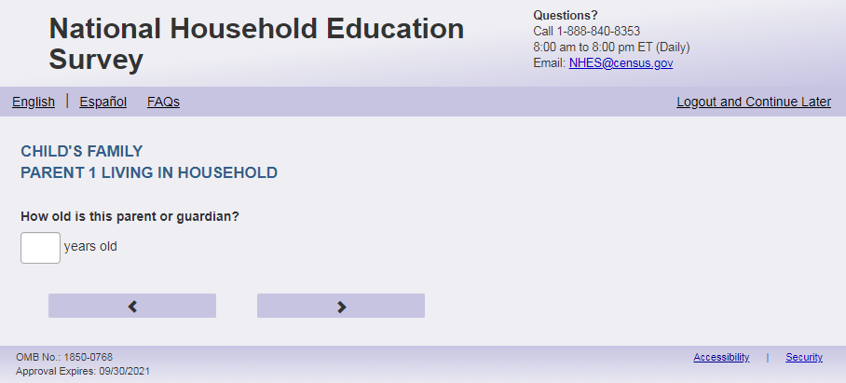
English Text Reads:
How old [PARENT 1]?

Spanish Text Reads:
¿Qué edad tiene [PARENT 1]?

English and Spanish Answer
ECPP_P1AGE, (12, 99), numeric, write-in

Skips:
Go to ECPP_P2GUARD

Logic Checks/Programming specifications:

English
display "years old" to the right of box.

Spanish
display "años" to the right of box.

Mobile: Display numeric keypad

Fills:
English:
If P1Fill = 1 (parent respondent) then PARENT 1 fill is “are you”
If ECPP_P1HHREL2 = 1 (mother) is selected then PARENT 1 fill is “is [this child]’s mother”
If ECPP_P1HHREL2 = 2 (father) is selected then PARENT 1 fill is “is [this child]’s father”
If ECPP_P1HHREL2 = 3 (grandmother) is selected then PARENT 1 fill is “is [this child]’s grandmother”
If ECPP_P1HHREL2 = 4 (grandfather) is selected then PARENT 1 fill is “is [this child]’s grandfather”
If ECPP_P1HHREL2 = 6 (aunt) is selected then PARENT 1 fill is “is [this child]’s aunt”
If ECPP_P1HHREL2 = 7 (uncle) is selected then PARENT 1 fill is “is [this child]’s uncle”
If ECPP_P1HHREL2 = 8 (sister) is selected then PARENT 1 fill is “is [this child]’s sister”
If ECPP_P1HHREL2 = 9 (brother) is selected then PARENT 1 fill is “is [this child]’s brother”
If ECPP_P1HHREL2 in (5, 10, blank) (boyfriend/girlfriend/partner or other relationship) is selected then PARENT 1 fill is “is [this child]’s parent or guardian”
Spanish:
If P1Fill = 1 (parent respondent) then PARENT 1 fill is “usted”
If ECPP_P1HHREL2 = 1 (madre) is selected then Parent 1 fill is “la madre de [este niño (esta niña)]”
If ECPP_P1HHREL2 = 4 (padre) is selected then Parent 1 fill is “el padre de [este niño (esta niña)]”
If ECPP_P1HHREL2 = 3 (Abuela) is selected then Parent 1 fill is “la abuela de [este niño (esta niña)]”
If ECPP_P1HHREL2 = 4 (Abuelo) is selected then Parent 1 fill is “el abuelo de [este niño (esta niña)]”
If ECPP_P1HHREL2 = 6 (Tía) is selected then Parent 1 fill is “la tía de [este niño (esta niña)]”
If ECPP_P1HHREL2 = 7 (Tío) is selected then Parent 1 fill is “el tío de [este niño (esta niña)]”
If ECPP_P1HHREL2 = 8 (Hermana) is selected then Parent 1 fill is “la hermana de [este niño (esta niña)]”
If ECPP_P1HHREL2 = 9 (Hermano) is selected then Parent 1 fill is “el hermano de [este niño (esta niña)]”
If ECPP_P1HHREL2 in (5, 10, blank) (Novia/Novio o pareja de alguno de los padres o otra relación o parentesco) is selected then Parent 1 fill is “el padre, la madre o el tutor(a) legal de [este niño (esta niña)]”
Text displayed for logic/range check violation

Logic/range check triggers a warning message, with the following text displayed.

English
[If less than 12] Display "You entered the age of this parent as less than 12 years old. Please check and make sure your answer is correct before continuing."

Spanish
[If less than 12] Display "Usted ingresó la edad de este padre o madre como menor de 12 años de edad. Por favor, compruebe y asegúrese de que su respuesta es correcta antes de continuar."

Item: 2nd Parent/Guardian (ECPP_P2GUARD)
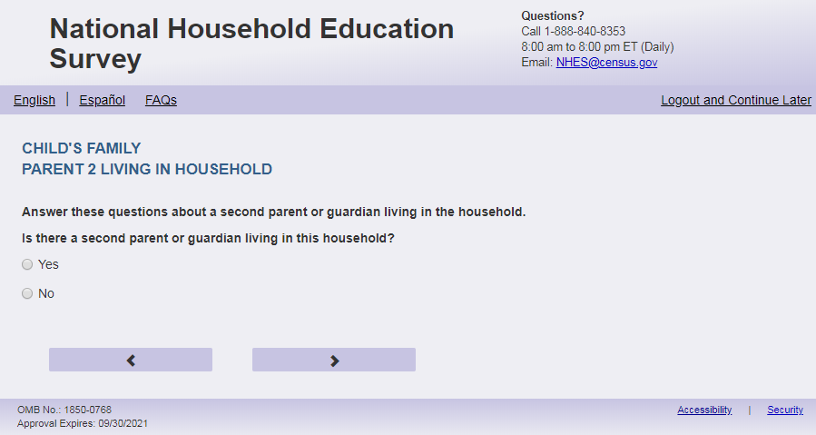
English Text Reads:
Besides [PARENT 1], is there a second parent or guardian of [this child] living in this household?

Spanish Text Reads:
Aparte de [PARENT 1], ¿vive otro padre, madre, o tutor(a) legal de [este niño (esta niña)] en este hogar?

English Answer
1 = Yes
2=No

Spanish Answer
1= Sí
2=No

ECPP_P2GUARD, (1,2) numeric, radio

Skips:
if ECPP_P2GUARD = 2 then go to ECPP_HWELFTAN. Else go to ECPP_P2HHREL.

Logic Checks/Programming specifications:
Fills:
English:
If P1Fill = 1 (parent respondent) then PARENT 1 fill is “you”
If ECPP_P1HHREL2 = 1 (mother) is selected then PARENT 1 fill is “[this child]’s mother”
If ECPP_P1HHREL2 = 2 (father) is selected then PARENT 1 fill is “[this child]’s father”
If ECPP_P1HHREL2 = 3 (grandmother) is selected then PARENT 1 fill is “[this child]’s grandmother”
If ECPP_P1HHREL2 = 4 (grandfather) is selected then PARENT 1 fill is “[this child]’s grandfather”
If ECPP_P1HHREL2 = 6 (aunt) is selected then PARENT 1 fill is “[this child]’s aunt”
If ECPP_P1HHREL2 = 7 (uncle) is selected then PARENT 1 fill is “[this child]’s uncle”
If ECPP_P1HHREL2 = 8 (sister) is selected then PARENT 1 fill is “[this child]’s sister”
If ECPP_P1HHREL2 = 9 (brother) is selected then PARENT 1 fill is “[this child]’s brother”
If ECPP_P1HHREL2 in (5, 10, blank) (boyfriend/girlfriend/partner or other relationship) is selected then PARENT 1 fill is “[this child]’s parent or guardian”
Spanish:
If P1Fill = 1 (parent respondent) then PARENT 1 fill is “usted”
If ECPP_P1HHREL2 = 1 (madre) is selected then Parent 1 fill is “la madre de [este niño (esta niña)]”
If ECPP_P1HHREL2 = 2 (padre) is selected then Parent 1 fill is “el padre de [este niño (esta niña)]”
If ECPP_P1HHREL2 = 3 (Abuela) is selected then Parent 1 fill is “la abuela de [este niño (esta niña)]”
If ECPP_P1HHREL2 = 4 (Abuelo) is selected then Parent 1 fill is “el abuelo de [este niño (esta niña)]”
If ECPP_P1HHREL2 = 6 (Tía) is selected then Parent 1 fill is “la tía de [este niño (esta niña)]”
If ECPP_P1HHREL2 = 7 (Tío) is selected then Parent 1 fill is “el tío de [este niño (esta niña)]”
If ECPP_P1HHREL2 = 8 (Hermana) is selected then Parent 1 fill is “la hermana de [este niño (esta niña)]”
If ECPP_P1HHREL2 = 9 (Hermano) is selected then Parent 1 fill is “el hermano de [este niño (esta niña)]”
If ECPP_P1HHREL2 in (5, 10, blank) (Novia/Novio o pareja de alguno de los padres o otra relación o parentesco) is selected then Parent 1 fill is “el padre, la madre o el tutor(a) legal de [este niño (esta niña)]”

Item: Relation to this Child (ECPP_P2HHREL)
<New item for NHES:2023 – no screenshot available>
English Text Reads:
How is this OTHER parent or guardian related to [this child]? Is this person [this child]’s…

Spanish Text Reads:
¿Cuál es la relación de parentesco de este OTRO padre, madre, o tutor(a) legal de con [este niño (esta niña)]? ¿Es esta persona…

English Answer
1= Mother (birth, adoptive, step, or foster)
2= Father (birth, adoptive, step, or foster)
3= Grandmother
4= Grandfather
5= Parent’s girlfriend/boyfriend/partner
6 = Aunt
7 = Uncle
8 = Sister
9 = Brother
10 = Other relationship – Specify:

Spanish Answer
1= Madre (biológica, adoptiva, madrastra o de crianza temporal (Foster))
2= Padre (biológico, adoptivo, padrastro o de crianza temporal (Foster))
3= Abuela
4= Abuelo
5= Novia/Novio o pareja de alguno de los padres
6= Tía
7= Tío
8 = Hermana
9 = Hermano
10 = Otra relación o parentesco – Especifique:

Items 1-8: ECPP_P2HHREL2 (1,10), numeric, radio. If 10 selected, specify box should become active: ECPP_P1HHREL2OS, (0,50), character, write-in. Display specify response box 1 row by 30 characters.

Skips:
If ECPP_P2HHREL in (1, 2, 5, 10) Go to ECPP_P2REL
Else if ECPP_P2HHREL in (3, 4, 6, 7, 8, 9) go to ECPP_P2SEX.

Logic Checks/Programming specifications for the PARENT2 fill for the remainder of this section
English:
If ECPP_P1HHREL2 = 1 (mother) is selected and ECPP_P2HHREL = 1 (mother) then PARENT 2 fill is [this child]’s other mother else PARENT 2 fill is [this child]’s mother; P2.Pronoun fill is she
If ECPP_P1HHREL2 = 2 (father) is selected and ECPP_P2HHREL = 2 (father) then PARENT 2 fill is [this child]’s other father else PARENT 2 fill is [this child]’s father; P2.Pronoun fill is he
If ECPP_P1HHREL2 = 3 (grandmother) is selected and ECPP_P2HHREL = 1 (grandmother) then PARENT 2 fill is [this child]’s other grandmother else PARENT 2 fill is [this child]’s grandmother; P2.Pronoun fill is she
If ECPP_P1HHREL2 = 4 (grandfather) is selected and ECPP_P2HHREL = 2 (grandfather) then PARENT 2 fill is [this child]’s other grandfather else PARENT 2 fill is [this child]’s grandfather; P2.Pronoun fill is he
If ECPP_P1HHREL2 = 6 (aunt) is selected and ECPP_P2HHREL = 1 (aunt) then PARENT 2 fill is [this child]’s other aunt else PARENT 2 fill is [this child]’s aunt; P2.Pronoun fill is she
If ECPP_P1HHREL2 = 7 (uncle) is selected and ECPP_P2HHREL = 2 (uncle) then PARENT 2 fill is [this child]’s other uncle else PARENT 2 fill is [this child]’s uncle; P2.Pronoun fill is he
If ECPP_P1HHREL2 = 8 (sister) is selected and ECPP_P2HHREL = 1 (sister) then PARENT 2 fill is [this child]’s other sister else PARENT 2 fill is [this child]’s sister; P2.Pronoun fill is she
If ECPP_P1HHREL2 = 9 (brother) is selected and ECPP_P2HHREL = 2 (brother) then PARENT 2 fill is [this child]’s other brother else PARENT 2 fill is [this child]’s brother; P2.Pronoun fill is he
If ECPP_P2HHREL in (5, 10, blank) (boyfriend/girlfriend/partner or other relationship) is selected then PARENT 2 fill is [this child]’s other parent or guardian; P2.Pronoun fill is he or she
Spanish:
If ECPP_P1HHREL2 = 1 (madre) is selected and ECPP_P2HHREL = 1 (madre) then PARENT 2 fill is la otra madre de [este niño (esta niña)] else PARENT 2 fill is la madre de [este niño (esta niña)]; P2.Pronoun fill is ella
If ECPP_P1HHREL2 = 2 (padre) is selected and ECPP_P2HHREL = 2 (padre) then PARENT 2 fill el otro padre de [este niño (esta niña)] else PARENT 2 fill is el padre de [este niño (esta niña)]; P2.Pronoun fill is él
If ECPP_P1HHREL2 = 3 (abuela) is selected and ECPP_P2HHREL = 1 (Abuela) then PARENT 2 fill is la otra abuela de [este niño (esta niña)] else PARENT 2 fill is la abuela de [este niño (esta niña)]; P2.Pronoun fill is ella
If ECPP_P1HHREL2 = 4 (abuelo) is selected and ECPP_P2HHREL = 2 (abuelo) then PARENT 2 fill el otro abuelo de [este niño (esta niña)] else PARENT 2 fill is el abuelo de [este niño (esta niña)]; P2.Pronoun fill is él
If ECPP_P1HHREL2 = 6 (tía) is selected and ECPP_P2HHREL = 1 (tía) then PARENT 2 fill is la otra tía de [este niño (esta niña)] else PARENT 2 fill is la tía de [este niño (esta niña)]; P2.Pronoun fill is ella
If ECPP_P1HHREL2 = 7 (tío) is selected and ECPP_P2HHREL = 2 (tío) then PARENT 2 fill el otro tío de [este niño (esta niña)] else PARENT 2 fill is el tío de [este niño (esta niña)]; P2.Pronoun fill is él
If ECPP_P1HHREL2 = 8 (hermana) is selected and ECPP_P2HHREL = 1 (hermana) then PARENT 2 fill is la otra hermana de [este niño (esta niña)] else PARENT 2 fill is la hermana de [este niño (esta niña)]; P2.Pronoun fill is ella
If ECPP_P1HHREL2 = 9 (hermano) is selected and ECPP_P2HHREL = 2 (hermano) then PARENT 2 fill el otro hermano de [este niño (esta niña)] else PARENT 2 fill is el hermano de [este niño (esta niña)]; P2.Pronoun fill is él
If ECPP_P2HHREL in (5, 10, blank) (boyfriend/girlfriend/partner or other relationship) is selected then PARENT 2 fill is el otro padre o el tutor(a) legal de [este niño (esta niña)]; P2.Pronoun fill is él o ella

Item: 2nd Parent/Guardian Relation to Child (ECPP_P2REL)
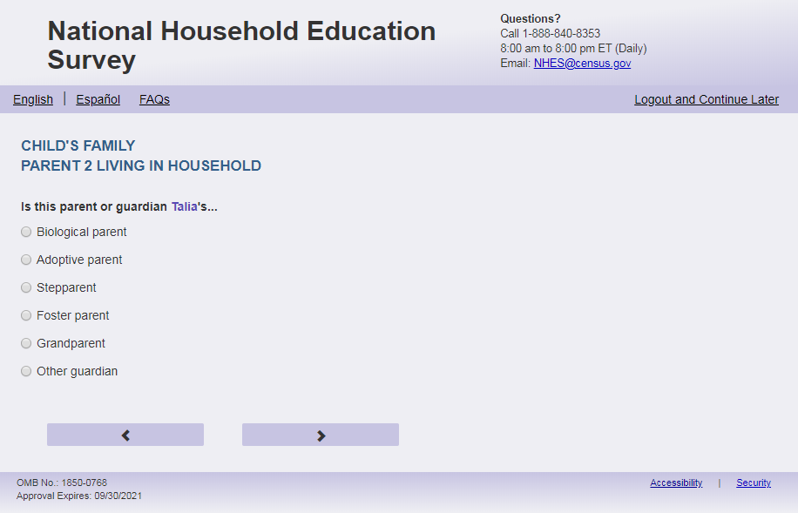
English Text Reads:

Is this [PARENT 2] [this child]’s…

Spanish Text Reads:
Es el [PARENT 2] su…

English Answer
1= Biological parent
2= Adoptive parent
3= Stepparent
4= Foster parent
6= Other guardian

Spanish Answer
1= [El padre biológico o la madre biológica]
2= [El padre adoptivo o la madre adoptiva]
3= [El padrastro o la madrastra]
4= [El padre de crianza temporal (Foster) o la madre de crianza temporal (Foster)]
5= Otro tutor(a) legal

ECPP_P2REL, (1,5), numeric, radio

Skips:
Go to ECPP_P2SEX.

Logic Checks/Programming specifications:
Fills
English:
Logic Checks/Programming specifications for the PARENT1 fill for the remainder of this section
English:
If ECPP_P1HHREL2 = 1 (mother) is selected and ECPP_P2HHREL = 1 (mother) then PARENT 2 fill is other mother else PARENT 2 fill mother
If ECPP_P1HHREL2 = 2 (father) is selected and ECPP_P2HHREL = 2 (father) then PARENT 2 fill is other father else PARENT 2 fill is father
If ECPP_P2HHREL in (5, 10, blank) (boyfriend/girlfriend/partner or other relationship) is selected then PARENT 2 fill is other parent or guardian
Spanish:
If ECPP_P1HHREL2 = 1 (madre) is selected and ECPP_P2HHREL = 1 (madre) then PARENT 2 fill is la otra madre else PARENT 2 fill is la madre
If ECPP_P1HHREL2 = 2 (padre) is selected and ECPP_P2HHREL = 2 (padre) then PARENT 2 fill el otro padre else PARENT 2 fill is el padre
If ECPP_P2HHREL in (5, 10, blank) (novia/novio o pareja de alguno de los padres o otra relación o parentesco) is selected then PARENT 2 fill is el otro padre o el tutor(a) legal
Fills for Spanish response options:
Spanish Fills:
[El padre biológico o la madre biológica]:
if ECPP_P2HHREL = 2 then El padre biológico
if ECPP_P2HHREL = 1 then La madre biológica
if ECPP_P2HHREL in (5, 10, blank) then El padre biológico o la madre biológica

[El padre adoptivo o la madre adoptiva]:
if ECPP_P2HHREL = 2 then El padre adoptivo
if ECPP_P2HHREL = 1 then La madre adoptiva
if ECPP_P2HHREL in (5, 10, blank) then El padre adoptivo o la madre adoptiva

[El padrastro o madrastra]:
if ECPP_P2HHREL = 2 then El padrastro
if ECPP_P2HHREL = 1 then La madrastra
if ECPP_P2HHREL in (5, 10, blank) then El padrastro o la madrastra

[El padre de crianza temporal (Foster) o la madre de crianza temporal (Foster)]:
if ECPP_P2HHREL = 2 then El padre de crianza temporal (Foster)
if ECPP_P2HHREL = 1 then La madre de crianza temporal (Foster)
if ECPP_P2HHREL in (5, 10, blank) then El padre de crianza temporal (Foster) o la madre de crianza temporal (Foster)

Item: 2nd Parent/Guardian Sex (ECPP_P2SEX)
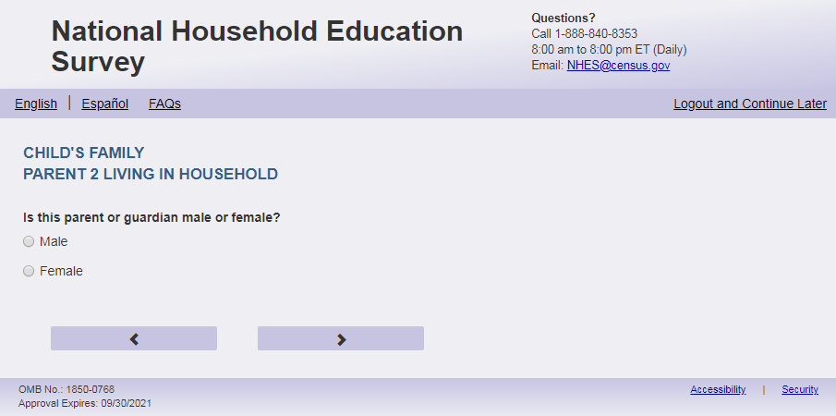
English
Is [PARENT 2] male or female?

Spanish
¿Es [PARENT 2] de sexo masculino o femenino?

English Answer
1= Male
2= Female

Spanish Answer
1= Masculino
2= Femenino

ECPP_P2SEX, (1,2), numeric, radio

Skips:

Go to ECPP_P2MRSTAR
Logic Checks/Programming specifications:
Fills
English:
If ECPP_P1HHREL2 = 1 (mother) is selected and ECPP_P2HHREL = 1 (mother) then PARENT 2 fill is [this child]’s other mother else PARENT 2 fill is [this child]’s mother
If ECPP_P1HHREL2 = 2 (father) is selected and ECPP_P2HHREL = 2 (father) then PARENT 2 fill is [this child]’s other father else PARENT 2 fill is [this child]’s father
If ECPP_P1HHREL2 = 3 (grandmother) is selected and ECPP_P2HHREL = 1 (grandmother) then PARENT 2 fill is [this child]’s other grandmother else PARENT 2 fill is [this child]’s grandmother;
If ECPP_P1HHREL2 = 4 (grandfather) is selected and ECPP_P2HHREL = 2 (grandfather) then PARENT 2 fill is [this child]’s other grandfather else PARENT 2 fill is [this child]’s grandfather
If ECPP_P1HHREL2 = 6 (aunt) is selected and ECPP_P2HHREL = 1 (aunt) then PARENT 2 fill is [this child]’s other aunt else PARENT 2 fill is [this child]’s aunt
If ECPP_P1HHREL2 = 7 (uncle) is selected and ECPP_P2HHREL = 2 (uncle) then PARENT 2 fill is [this child]’s other uncle else PARENT 2 fill is [this child]’s uncle
If ECPP_P1HHREL2 = 8 (sister) is selected and ECPP_P2HHREL = 1 (sister) then PARENT 2 fill is [this child]’s other sister else PARENT 2 fill is [this child]’s sister
If ECPP_P1HHREL2 = 9 (brother) is selected and ECPP_P2HHREL = 2 (brother) then PARENT 2 fill is [this child]’s other brother else PARENT 2 fill is [this child]’s brother
If ECPP_P2HHREL in (5, 10, blank) (boyfriend/girlfriend/partner or other relationship) is selected then PARENT 2 fill is [this child]’s other parent or guardian
Spanish:
If ECPP_P1HHREL2 = 1 (madre) is selected and ECPP_P2HHREL = 1 (madre) then PARENT 2 fill is la otra madre de [este niño (esta niña)] else PARENT 2 fill is la madre de [este niño (esta niña)]
If ECPP_P1HHREL2 = 2 (padre) is selected and ECPP_P2HHREL = 2 (padre) then PARENT 2 fill el otro padre de [este niño (esta niña)] else PARENT 2 fill is el padre de [este niño (esta niña)]
If ECPP_P1HHREL2 = 3 (abuela) is selected and ECPP_P2HHREL = 1 (Abuela) then PARENT 2 fill is la otra abuela de [este niño (esta niña)] else PARENT 2 fill is la abuela de [este niño (esta niña)]
If ECPP_P1HHREL2 = 4 (abuelo) is selected and ECPP_P2HHREL = 2 (abuelo) then PARENT 2 fill el otro abuelo de [este niño (esta niña)] else PARENT 2 fill is el abuelo de [este niño (esta niña)]
If ECPP_P1HHREL2 = 6 (tía) is selected and ECPP_P2HHREL = 1 (tía) then PARENT 2 fill is la otra tía de [este niño (esta niña)] else PARENT 2 fill is la tía de [este niño (esta niña)]
If ECPP_P1HHREL2 = 7 (tío) is selected and ECPP_P2HHREL = 2 (tío) then PARENT 2 fill el otro tío de [este niño (esta niña)] else PARENT 2 fill is el tío de [este niño (esta niña)]
If ECPP_P1HHREL2 = 8 (hermana) is selected and ECPP_P2HHREL = 1 (hermana) then PARENT 2 fill is la otra hermana de [este niño (esta niña)] else PARENT 2 fill is la hermana de [este niño (esta niña)]
If ECPP_P1HHREL2 = 9 (hermano) is selected and ECPP_P2HHREL = 2 (hermano) then PARENT 2 fill el otro hermano de [este niño (esta niña)] else PARENT 2 fill is el hermano de [este niño (esta niña)]
If ECPP_P2HHREL in (5, 10, blank) (boyfriend/girlfriend/partner or other relationship) is selected then PARENT 2 fill is el otro padre o el tutor(a) legal de [este niño (esta niña)]

Item: 2nd Parent/Guardian Marital Status (ECPP_P2MRSTAR)
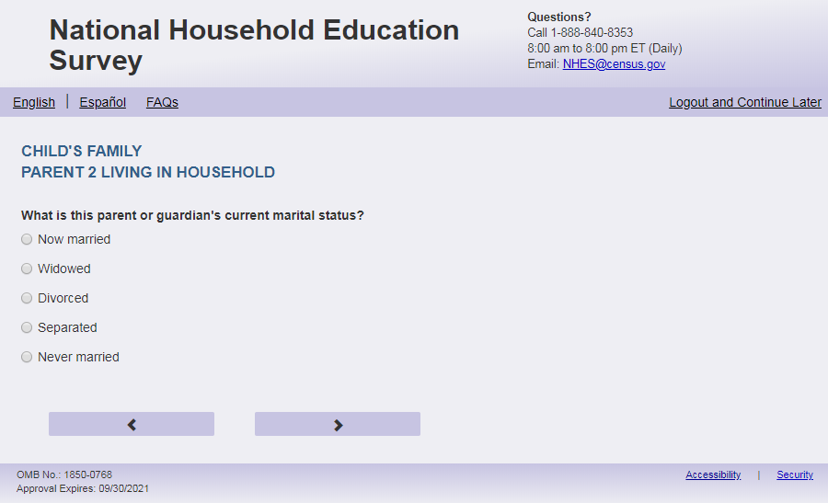
English Respondent Text Reads:
What is [PARENT 2] current marital status?

Spanish Respondent Text Reads:
¿Cuál es el estado civil actual de [PARENT 2]?

English Admin/TQA Text Reads:
What is [PARENT 2] current marital status?
{Please read response options.}

Spanish Admin/TQA Text Reads:
¿Cuál es el estado civil actual de [PARENT 2]?

{Por favor, lea las opciones de respuesta.}

English
1= Now married
2= Widowed
3= Divorced
4= Separated
5= Never married

Spanish
1= Actualmente casado(a)
2= Viudo(a)
3= Divorciado(a)
4= Separado(a)
5=Nunca se casó

ECPP_P2MRSTAR, (1,5), numeric, radio

Skips:
if ECPP_P2MRSTAR = 1 then go to ECPP_P2FRLNG. If ECPP_P2MRSTAR in (2, 3, 4, 5) and ECPP_P2HHREL = 5 then go to ECPP_P1FRLNG. Else go to ECPP_P2BFGF

Logic Checks/Programming specifications:

Fills
English:
If ECPP_P1HHREL2 = 1 (mother) is selected and ECPP_P2HHREL = 1 (mother) then PARENT 2 fill is [this child]’s other mother’s else PARENT 2 fill is [this child]’s mother’s
If ECPP_P1HHREL2 = 2 (father) is selected and ECPP_P2HHREL = 2 (father) then PARENT 2 fill is [this child]’s other father’s else PARENT 2 fill is [this child]’s father’s
If ECPP_P1HHREL2 = 3 (grandmother) is selected and ECPP_P2HHREL = 1 (grandmother) then PARENT 2 fill is [this child]’s other grandmother’s else PARENT 2 fill is [this child]’s grandmother’s;
If ECPP_P1HHREL2 = 4 (grandfather) is selected and ECPP_P2HHREL = 2 (grandfather) then PARENT 2 fill is [this child]’s other grandfather’s else PARENT 2 fill is [this child]’s grandfather’s
If ECPP_P1HHREL2 = 6 (aunt) is selected and ECPP_P2HHREL = 1 (aunt) then PARENT 2 fill is [this child]’s other aunt’s else PARENT 2 fill is [this child]’s aunt’s
If ECPP_P1HHREL2 = 7 (uncle) is selected and ECPP_P2HHREL = 2 (uncle) then PARENT 2 fill is [this child]’s other uncle’s else PARENT 2 fill is [this child]’s uncle’s
If ECPP_P1HHREL2 = 8 (sister) is selected and ECPP_P2HHREL = 1 (sister) then PARENT 2 fill is [this child]’s other sister’s else PARENT 2 fill is [this child]’s sister’s
If ECPP_P1HHREL2 = 9 (brother) is selected and ECPP_P2HHREL = 2 (brother) then PARENT 2 fill is [this child]’s other brother’s else PARENT 2 fill is [this child]’s brother’s
If ECPP_P2HHREL in (5, 10, blank) (boyfriend/girlfriend/partner or other relationship) is selected then PARENT 2 fill is [this child]’s other parent or guardian’s
Spanish:
If ECPP_P1HHREL2 = 1 (madre) is selected and ECPP_P2HHREL = 1 (madre) then PARENT 2 fill is la otra madre de [este niño (esta niña)] else PARENT 2 fill is la madre de [este niño (esta niña)]
If ECPP_P1HHREL2 = 2 (padre) is selected and ECPP_P2HHREL = 2 (padre) then PARENT 2 fill el otro padre de [este niño (esta niña)] else PARENT 2 fill is el padre de [este niño (esta niña)]
If ECPP_P1HHREL2 = 3 (abuela) is selected and ECPP_P2HHREL = 1 (Abuela) then PARENT 2 fill is la otra abuela de [este niño (esta niña)] else PARENT 2 fill is la abuela de [este niño (esta niña)]
If ECPP_P1HHREL2 = 4 (abuelo) is selected and ECPP_P2HHREL = 2 (abuelo) then PARENT 2 fill el otro abuelo de [este niño (esta niña)] else PARENT 2 fill is el abuelo de [este niño (esta niña)]
If ECPP_P1HHREL2 = 6 (tía) is selected and ECPP_P2HHREL = 1 (tía) then PARENT 2 fill is la otra tía de [este niño (esta niña)] else PARENT 2 fill is la tía de [este niño (esta niña)]
If ECPP_P1HHREL2 = 7 (tío) is selected and ECPP_P2HHREL = 2 (tío) then PARENT 2 fill el otro tío de [este niño (esta niña)] else PARENT 2 fill is el tío de [este niño (esta niña)]
If ECPP_P1HHREL2 = 8 (hermana) is selected and ECPP_P2HHREL = 1 (hermana) then PARENT 2 fill is la otra hermana de [este niño (esta niña)] else PARENT 2 fill is la hermana de [este niño (esta niña)]
If ECPP_P1HHREL2 = 9 (hermano) is selected and ECPP_P2HHREL = 2 (hermano) then PARENT 2 fill el otro hermano de [este niño (esta niña)] else PARENT 2 fill is el hermano de [este niño (esta niña)]
If ECPP_P2HHREL in (5, 10, blank) (boyfriend/girlfriend/partner or other relationship) is selected then PARENT 2 fill is el otro padre o el tutor(a) legal de [este niño (esta niña)]

Item: 2nd Parent/Guardian Partner (ECPP_P2BFGF)
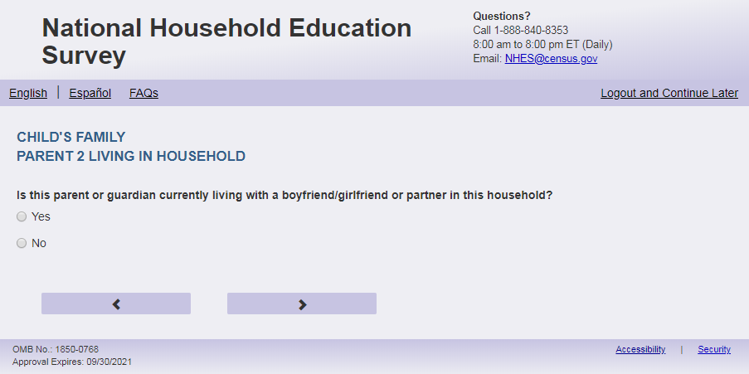
English Text Reads:
Is [PARENT 2] currently living with a boyfriend/girlfriend or partner in this household?

Spanish Text Reads:
¿ [PARENT 2] está viviendo actualmente con su pareja o novio(a) en este hogar??

English
1 = Yes
2=No

Spanish
1= Sí
2=No

ECPP_P2BFGF, (1,2), numeric, radio

Skips:
Go to ECPP_P2FRLNG

Logic Checks/Programming specifications:
Fills
English:
If ECPP_P1HHREL2 = 1 (mother) is selected and ECPP_P2HHREL = 1 (mother) then PARENT 2 fill is [this child]’s other mother else if PARENT 2 fill is [this child]’s mother
If ECPP_P1HHREL2 = 2 (father) is selected and ECPP_P2HHREL = 2 (father) then PARENT 2 fill is [this child]’s other father else PARENT 2 fill is [this child]’s father
If ECPP_P1HHREL2 = 3 (grandmother) is selected and ECPP_P2HHREL = 1 (grandmother) then PARENT 2 fill is [this child]’s other grandmother else PARENT 2 fill is [this child]’s grandmother
If ECPP_P1HHREL2 = 4 (grandfather) is selected and ECPP_P2HHREL = 2 (grandfather) then PARENT 2 fill is [this child]’s other grandfather else PARENT 2 fill is [this child]’s grandfather
If ECPP_P1HHREL2 = 6 (aunt) is selected and ECPP_P2HHREL = 1 (aunt) then PARENT 2 fill is [this child]’s other aunt else PARENT 2 fill is [this child]’s aunt
If ECPP_P1HHREL2 = 7 (uncle) is selected and ECPP_P2HHREL = 2 (uncle) then PARENT 2 fill is [this child]’s other uncle else PARENT 2 fill is [this child]’s uncle
If ECPP_P1HHREL2 = 8 (sister) is selected and ECPP_P2HHREL = 1 (sister) then PARENT 2 fill is [this child]’s other sister else PARENT 2 fill is [this child]’s sister
If ECPP_P1HHREL2 = 9 (brother) is selected and ECPP_P2HHREL = 2 (brother) then PARENT 2 fill is [this child]’s other brother else PARENT 2 fill is [this child]’s brother
If ECPP_P2HHREL in (5, 10, blank) (boyfriend/girlfriend/partner or other relationship) is selected then PARENT 2 fill is [this child]’s other parent or guardian
Spanish:
If ECPP_P1HHREL2 = 1 (madre) is selected and ECPP_P2HHREL = 1 (madre) then PARENT 2 fill is la otra madre de [este niño (esta niña)] else PARENT 2 fill is la madre de [este niño (esta niña)]
If ECPP_P1HHREL2 = 2 (padre) is selected and ECPP_P2HHREL = 2 (padre) then PARENT 2 fill el otro padre de [este niño (esta niña)] else PARENT 2 fill is el padre de [este niño (esta niña)]
If ECPP_P1HHREL2 = 3 (abuela) is selected and ECPP_P2HHREL = 1 (Abuela) then PARENT 2 fill is la otra abuela de [este niño (esta niña)] else PARENT 2 fill is la abuela de [este niño (esta niña)]
If ECPP_P1HHREL2 = 4 (abuelo) is selected and ECPP_P2HHREL = 2 (abuelo) then PARENT 2 fill el otro abuelo de [este niño (esta niña)] else PARENT 2 fill is el abuelo de [este niño (esta niña)]
If ECPP_P1HHREL2 = 6 (tía) is selected and ECPP_P2HHREL = 1 (tía) then PARENT 2 fill is la otra tía de [este niño (esta niña)] else PARENT 2 fill is la tía de [este niño (esta niña)]
If ECPP_P1HHREL2 = 7 (tío) is selected and ECPP_P2HHREL = 2 (tío) then PARENT 2 fill el otro tío de [este niño (esta niña)] else PARENT 2 fill is el tío de [este niño (esta niña)]
If ECPP_P1HHREL2 = 8 (hermana) is selected and ECPP_P2HHREL = 1 (hermana) then PARENT 2 fill is la otra hermana de [este niño (esta niña)] else PARENT 2 fill is la hermana de [este niño (esta niña)]
If ECPP_P1HHREL2 = 9 (hermano) is selected and ECPP_P2HHREL = 2 (hermano) then PARENT 2 fill el otro hermano de [este niño (esta niña)] else PARENT 2 fill is el hermano de [este niño (esta niña)]
If ECPP_P2HHREL in (5, 10, blank) (boyfriend/girlfriend/partner or other relationship) is selected then PARENT 2 fill is el otro padre o el tutor(a) legal de [este niño (esta niña)]

Item: 2nd Parent/Guardian First Language (ECPP_P2FRLNG)
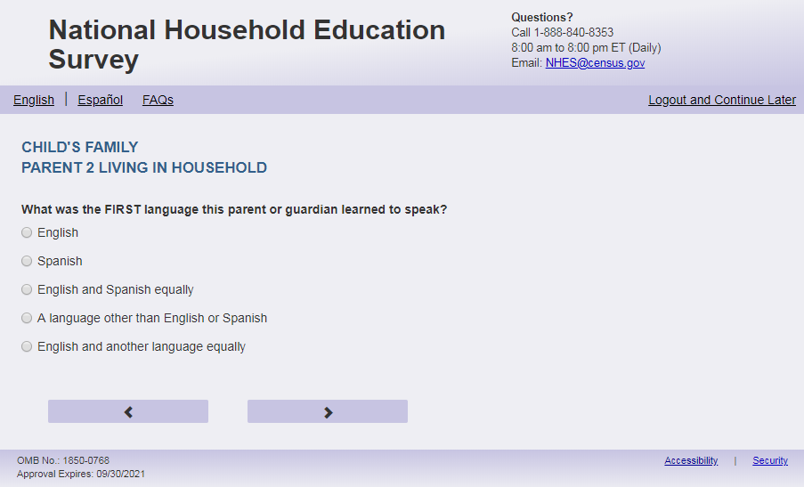
English Respondent Text Reads:
What was the FIRST language [PARENT 2] learned to speak?

Spanish Respondent Text Reads:
¿Cuál fue el PRIMER idioma que [PARENT 2] aprendió a hablar?

English Admin/TQA Text Reads:
What was the FIRST language [PARENT 2] learned to speak?
{Please read response options.}

Spanish Admin/TQA Text Reads:
¿Cuál fue el PRIMER idioma que [PARENT 2] aprendió a hablar?

{Por favor, lea las opciones de respuesta.}

English Answer
1= English
2= Spanish
3= English and Spanish equally
4= A language other than English or Spanish
5= English and another language equally

Spanish Answer
1= Inglés
2= Español
3= Inglés y español por igual
4= Otro idioma aparte del inglés o español
5= Inglés y otro idioma por igual

ECPP_P2FRLNG, (1,5), numeric, radio

Skips:
if ECPP_P2FRLNG = 1 then go to ECPP_P2PLCBRTH. Else go to ECPP_P2SPEAK.

Logic Checks/Programming specifications:

Fills
English:
If ECPP_P1HHREL2 = 1 (mother) is selected and ECPP_P2HHREL = 1 (mother) then PARENT 2 fill is [this child]’s other mother else if PARENT 2 fill is [this child]’s mother
If ECPP_P1HHREL2 = 2 (father) is selected and ECPP_P2HHREL = 2 (father) then PARENT 2 fill is [this child]’s other father else PARENT 2 fill is [this child]’s father
If ECPP_P1HHREL2 = 3 (grandmother) is selected and ECPP_P2HHREL = 1 (grandmother) then PARENT 2 fill is [this child]’s other grandmother else PARENT 2 fill is [this child]’s grandmother
If ECPP_P1HHREL2 = 4 (grandfather) is selected and ECPP_P2HHREL = 2 (grandfather) then PARENT 2 fill is [this child]’s other grandfather else PARENT 2 fill is [this child]’s grandfather
If ECPP_P1HHREL2 = 6 (aunt) is selected and ECPP_P2HHREL = 1 (aunt) then PARENT 2 fill is [this child]’s other aunt else PARENT 2 fill is [this child]’s aunt
If ECPP_P1HHREL2 = 7 (uncle) is selected and ECPP_P2HHREL = 2 (uncle) then PARENT 2 fill is [this child]’s other uncle else PARENT 2 fill is [this child]’s uncle
If ECPP_P1HHREL2 = 8 (sister) is selected and ECPP_P2HHREL = 1 (sister) then PARENT 2 fill is [this child]’s other sister else PARENT 2 fill is [this child]’s sister
If ECPP_P1HHREL2 = 9 (brother) is selected and ECPP_P2HHREL = 2 (brother) then PARENT 2 fill is [this child]’s other brother else PARENT 2 fill is [this child]’s brother
If ECPP_P2HHREL in (5, 10, blank) (boyfriend/girlfriend/partner or other relationship) is selected then PARENT 2 fill is [this child]’s other parent or guardian
Spanish:
If ECPP_P1HHREL2 = 1 (madre) is selected and ECPP_P2HHREL = 1 (madre) then PARENT 2 fill is la otra madre de [este niño (esta niña)] else PARENT 2 fill is la madre de [este niño (esta niña)]
If ECPP_P1HHREL2 = 2 (padre) is selected and ECPP_P2HHREL = 2 (padre) then PARENT 2 fill el otro padre de [este niño (esta niña)] else PARENT 2 fill is el padre de [este niño (esta niña)]
If ECPP_P1HHREL2 = 3 (abuela) is selected and ECPP_P2HHREL = 1 (Abuela) then PARENT 2 fill is la otra abuela de [este niño (esta niña)] else PARENT 2 fill is la abuela de [este niño (esta niña)]
If ECPP_P1HHREL2 = 4 (abuelo) is selected and ECPP_P2HHREL = 2 (abuelo) then PARENT 2 fill el otro abuelo de [este niño (esta niña)] else PARENT 2 fill is el abuelo de [este niño (esta niña)]
If ECPP_P1HHREL2 = 6 (tía) is selected and ECPP_P2HHREL = 1 (tía) then PARENT 2 fill is la otra tía de [este niño (esta niña)] else PARENT 2 fill is la tía de [este niño (esta niña)]
If ECPP_P1HHREL2 = 7 (tío) is selected and ECPP_P2HHREL = 2 (tío) then PARENT 2 fill el otro tío de [este niño (esta niña)] else PARENT 2 fill is el tío de [este niño (esta niña)]
If ECPP_P1HHREL2 = 8 (hermana) is selected and ECPP_P2HHREL = 1 (hermana) then PARENT 2 fill is la otra hermana de [este niño (esta niña)] else PARENT 2 fill is la hermana de [este niño (esta niña)]
If ECPP_P1HHREL2 = 9 (hermano) is selected and ECPP_P2HHREL = 2 (hermano) then PARENT 2 fill el otro hermano de [este niño (esta niña)] else PARENT 2 fill is el hermano de [este niño (esta niña)]
If ECPP_P2HHREL in (5, 10, blank) (boyfriend/girlfriend/partner or other relationship) is selected then PARENT 2 fill is el otro padre o el tutor(a) legal de [este niño (esta niña)]

Item: 2nd Parent/Guardian Current Language (ECPP_P2SPEAK) 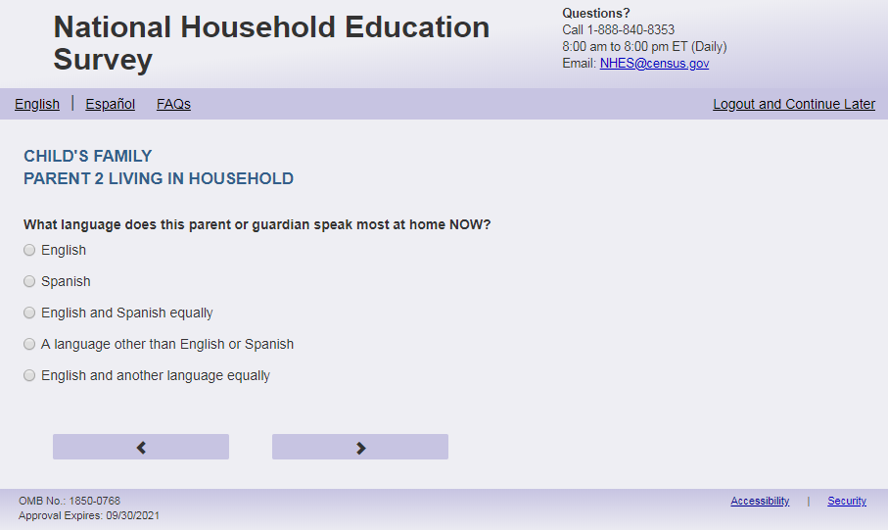
English Respondent Text Reads:
What language does [PARENT 2] speak most at home NOW?

Spanish Respondent Text Reads:
ACTUALMENTE, ¿qué idioma habla más [PARENT 2] en el hogar?

English Admin/TQA Text Reads:
What language does [PARENT 2] speak most at home NOW?
{Please read response options.}

Spanish Admin/TQA Text Reads:
ACTUALMENTE, ¿qué idioma habla más [PARENT 2] en el hogar?
{Por favor, lea las opciones de respuesta.}

English Answer
1= English
2= Spanish
3= English and Spanish equally
4= A language other than English or Spanish
5= English and another language equally

Spanish Answer
1= Inglés
2= Español
3= Inglés y español por igual
4= Otro idioma aparte del inglés o español
5= Inglés y otro idioma por igual

ECPP_P2SPEAK, (1,5), numeric, radio

Skips:
ECPP_P2PLCBRTH.

Logic Checks/Programming specifications:

Fills
English:
If ECPP_P1HHREL2 = 1 (mother) is selected and ECPP_P2HHREL = 1 (mother) then PARENT 2 fill is [this child]’s other mother else if PARENT 2 fill is [this child]’s mother
If ECPP_P1HHREL2 = 2 (father) is selected and ECPP_P2HHREL = 2 (father) then PARENT 2 fill is [this child]’s other father else PARENT 2 fill is [this child]’s father
If ECPP_P1HHREL2 = 3 (grandmother) is selected and ECPP_P2HHREL = 1 (grandmother) then PARENT 2 fill is [this child]’s other grandmother else PARENT 2 fill is [this child]’s grandmother
If ECPP_P1HHREL2 = 4 (grandfather) is selected and ECPP_P2HHREL = 2 (grandfather) then PARENT 2 fill is [this child]’s other grandfather else PARENT 2 fill is [this child]’s grandfather
If ECPP_P1HHREL2 = 6 (aunt) is selected and ECPP_P2HHREL = 1 (aunt) then PARENT 2 fill is [this child]’s other aunt else PARENT 2 fill is [this child]’s aunt
If ECPP_P1HHREL2 = 7 (uncle) is selected and ECPP_P2HHREL = 2 (uncle) then PARENT 2 fill is [this child]’s other uncle else PARENT 2 fill is [this child]’s uncle
If ECPP_P1HHREL2 = 8 (sister) is selected and ECPP_P2HHREL = 1 (sister) then PARENT 2 fill is [this child]’s other sister else PARENT 2 fill is [this child]’s sister
If ECPP_P1HHREL2 = 9 (brother) is selected and ECPP_P2HHREL = 2 (brother) then PARENT 2 fill is [this child]’s other brother else PARENT 2 fill is [this child]’s brother
If ECPP_P2HHREL in (5, 10, blank) (boyfriend/girlfriend/partner or other relationship) is selected then PARENT 2 fill is [this child]’s other parent or guardian
Spanish:
If ECPP_P1HHREL2 = 1 (madre) is selected and ECPP_P2HHREL = 1 (madre) then PARENT 2 fill is la otra madre de [este niño (esta niña)] else PARENT 2 fill is la madre de [este niño (esta niña)]
If ECPP_P1HHREL2 = 2 (padre) is selected and ECPP_P2HHREL = 2 (padre) then PARENT 2 fill el otro padre de [este niño (esta niña)] else PARENT 2 fill is el padre de [este niño (esta niña)]
If ECPP_P1HHREL2 = 3 (abuela) is selected and ECPP_P2HHREL = 1 (Abuela) then PARENT 2 fill is la otra abuela de [este niño (esta niña)] else PARENT 2 fill is la abuela de [este niño (esta niña)]
If ECPP_P1HHREL2 = 4 (abuelo) is selected and ECPP_P2HHREL = 2 (abuelo) then PARENT 2 fill el otro abuelo de [este niño (esta niña)] else PARENT 2 fill is el abuelo de [este niño (esta niña)]
If ECPP_P1HHREL2 = 6 (tía) is selected and ECPP_P2HHREL = 1 (tía) then PARENT 2 fill is la otra tía de [este niño (esta niña)] else PARENT 2 fill is la tía de [este niño (esta niña)]
If ECPP_P1HHREL2 = 7 (tío) is selected and ECPP_P2HHREL = 2 (tío) then PARENT 2 fill el otro tío de [este niño (esta niña)] else PARENT 2 fill is el tío de [este niño (esta niña)]
If ECPP_P1HHREL2 = 8 (hermana) is selected and ECPP_P2HHREL = 1 (hermana) then PARENT 2 fill is la otra hermana de [este niño (esta niña)] else PARENT 2 fill is la hermana de [este niño (esta niña)]
If ECPP_P1HHREL2 = 9 (hermano) is selected and ECPP_P2HHREL = 2 (hermano) then PARENT 2 fill el otro hermano de [este niño (esta niña)] else PARENT 2 fill is el hermano de [este niño (esta niña)]
If ECPP_P2HHREL in (5, 10, blank) (boyfriend/girlfriend/partner or other relationship) is selected then PARENT 2 fill is el otro padre, la otra madre o el tutor(a) legal de [este niño (esta niña)]

Item: 2nd Parent/Guardian Birth Place (ECPP_P2PLCBRTH)
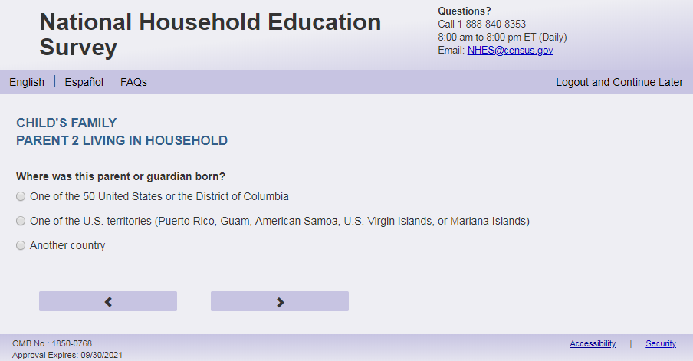
English Text Reads:
Where was [PARENT 2] born?

Spanish Text Reads:
¿Dónde nació [PARENT 2]?

English
1= One of the 50 United States or the District of Columbia
2= One of the U.S. territories (Puerto Rico, Guam, American Samoa, U.S. Virgin Islands, or Mariana Islands)
3= Another country

Spanish
1= Uno de los 50 estados de los Estados Unidos o el Distrito de Columbia
2= Uno de los territorios incorporados de los Estados Unidos (Puerto Rico, Guam, Samoa Americana, Islas Vírgenes de los Estados Unidos o Islas Marianas del Norte)
3= Otro país

ECPP_P2PLCBRTH, (1,3) numeric, radio

Skips:
if ECPP_P2PLCBRTH = 1 or blank then go to ECPP_P2HISPANX else if ECPP_P2PLCBRTH in (2,3) go to ECPP_P2AGEMV

Logic Checks/Programming specifications:
Fills
English:
If ECPP_P1HHREL2 = 1 (mother) is selected and ECPP_P2HHREL = 1 (mother) then PARENT 2 fill is [this child]’s other mother else if PARENT 2 fill is [this child]’s mother
If ECPP_P1HHREL2 = 2 (father) is selected and ECPP_P2HHREL = 2 (father) then PARENT 2 fill is [this child]’s other father else PARENT 2 fill is [this child]’s father
If ECPP_P1HHREL2 = 3 (grandmother) is selected and ECPP_P2HHREL = 1 (grandmother) then PARENT 2 fill is [this child]’s other grandmother else PARENT 2 fill is [this child]’s grandmother
If ECPP_P1HHREL2 = 4 (grandfather) is selected and ECPP_P2HHREL = 2 (grandfather) then PARENT 2 fill is [this child]’s other grandfather else PARENT 2 fill is [this child]’s grandfather
If ECPP_P1HHREL2 = 6 (aunt) is selected and ECPP_P2HHREL = 1 (aunt) then PARENT 2 fill is [this child]’s other aunt else PARENT 2 fill is [this child]’s aunt
If ECPP_P1HHREL2 = 7 (uncle) is selected and ECPP_P2HHREL = 2 (uncle) then PARENT 2 fill is [this child]’s other uncle else PARENT 2 fill is [this child]’s uncle
If ECPP_P1HHREL2 = 8 (sister) is selected and ECPP_P2HHREL = 1 (sister) then PARENT 2 fill is [this child]’s other sister else PARENT 2 fill is [this child]’s sister
If ECPP_P1HHREL2 = 9 (brother) is selected and ECPP_P2HHREL = 2 (brother) then PARENT 2 fill is [this child]’s other brother else PARENT 2 fill is [this child]’s brother
If ECPP_P2HHREL in (5, 10, blank) (boyfriend/girlfriend/partner or other relationship) is selected then PARENT 2 fill is [this child]’s other parent or guardian
Spanish:
If ECPP_P1HHREL2 = 1 (madre) is selected and ECPP_P2HHREL = 1 (madre) then PARENT 2 fill is la otra madre de [este niño (esta niña)] else PARENT 2 fill is la madre de [este niño (esta niña)]
If ECPP_P1HHREL2 = 2 (padre) is selected and ECPP_P2HHREL = 2 (padre) then PARENT 2 fill el otro padre de [este niño (esta niña)] else PARENT 2 fill is el padre de [este niño (esta niña)]
If ECPP_P1HHREL2 = 3 (abuela) is selected and ECPP_P2HHREL = 1 (Abuela) then PARENT 2 fill is la otra abuela de [este niño (esta niña)] else PARENT 2 fill is la abuela de [este niño (esta niña)]
If ECPP_P1HHREL2 = 4 (abuelo) is selected and ECPP_P2HHREL = 2 (abuelo) then PARENT 2 fill el otro abuelo de [este niño (esta niña)] else PARENT 2 fill is el abuelo de [este niño (esta niña)]
If ECPP_P1HHREL2 = 6 (tía) is selected and ECPP_P2HHREL = 1 (tía) then PARENT 2 fill is la otra tía de [este niño (esta niña)] else PARENT 2 fill is la tía de [este niño (esta niña)]
If ECPP_P1HHREL2 = 7 (tío) is selected and ECPP_P2HHREL = 2 (tío) then PARENT 2 fill el otro tío de [este niño (esta niña)] else PARENT 2 fill is el tío de [este niño (esta niña)]
If ECPP_P1HHREL2 = 8 (hermana) is selected and ECPP_P2HHREL = 1 (hermana) then PARENT 2 fill is la otra hermana de [este niño (esta niña)] else PARENT 2 fill is la hermana de [este niño (esta niña)]
If ECPP_P1HHREL2 = 9 (hermano) is selected and ECPP_P2HHREL = 2 (hermano) then PARENT 2 fill el otro hermano de [este niño (esta niña)] else PARENT 2 fill is el hermano de [este niño (esta niña)]
If ECPP_P2HHREL in (5, 10, blank) (boyfriend/girlfriend/partner or other relationship) is selected then PARENT 2 fill is el otro padre o el tutor(a) legal de [este niño (esta niña)]

Item: 2nd Parent/Guardian Age Once moved to U.S. (ECPP_P2AGEMV)
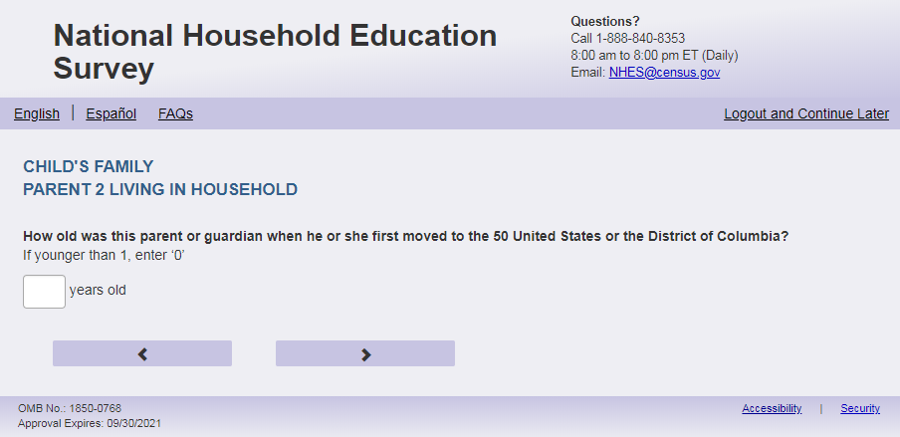
English Text Reads:
How old was [PARENT 2] when [PARENT 2.1] first moved to the 50 United States or the District of Columbia?
If younger than 1, enter ‘0’.

Spanish Text Reads:
¿Qué edad tenía [PARENT 2] cuando se mudó por primera vez a uno de los 50 estados de los Estados Unidos o al Distrito de Columbia?
Si fue menor de 1 año, ingrese ‘0’.

English and Spanish Answer
ECPP_P2AGEMV, (0, 99), numeric, write-in

Skips:
Go to ECPP_P2HISPANX

Logic Checks/Programming specifications:

English
Display ‘years old’ next to the text box.

Spanish
Display ‘años’ next to the text box.

Mobile: Display numeric keypad
Fills
English:
If ECPP_P1HHREL2 = 1 (mother) is selected and ECPP_P2HHREL = 1 (mother) then PARENT 2 fill is [this child]’s other mother else if PARENT 2 fill is [this child]’s mother; PARENT 2.1 fill is she
If ECPP_P1HHREL2 = 2 (father) is selected and ECPP_P2HHREL = 2 (father) then PARENT 2 fill is [this child]’s other father else PARENT 2 fill is [this child]’s father; PARENT 2.1 fill is he
If ECPP_P1HHREL2 = 3 (grandmother) is selected and ECPP_P2HHREL = 1 (grandmother) then PARENT 2 fill is [this child]’s other grandmother else PARENT 2 fill is [this child]’s grandmother; PARENT 2.1 fill is she
If ECPP_P1HHREL2 = 4 (grandfather) is selected and ECPP_P2HHREL = 2 (grandfather) then PARENT 2 fill is [this child]’s other grandfather else PARENT 2 fill is [this child]’s grandfather; PARENT 2.1 fill is he
If ECPP_P1HHREL2 = 6 (aunt) is selected and ECPP_P2HHREL = 1 (aunt) then PARENT 2 fill is [this child]’s other aunt else PARENT 2 fill is [this child]’s aunt; PARENT 2.1 fill is she
If ECPP_P1HHREL2 = 7 (uncle) is selected and ECPP_P2HHREL = 2 (uncle) then PARENT 2 fill is [this child]’s other uncle else PARENT 2 fill is [this child]’s uncle; PARENT 2.1 fill is he
If ECPP_P1HHREL2 = 8 (sister) is selected and ECPP_P2HHREL = 1 (sister) then PARENT 2 fill is [this child]’s other sister else PARENT 2 fill is [this child]’s sister; PARENT 2.1 fill is she
If ECPP_P1HHREL2 = 9 (brother) is selected and ECPP_P2HHREL = 2 (brother) then PARENT 2 fill is [this child]’s other brother else PARENT 2 fill is [this child]’s brother; PARENT 2.1 fill is he
If ECPP_P2HHREL in (5, 10, blank) (boyfriend/girlfriend/partner or other relationship) is selected then PARENT 2 fill is [this child]’s other parent or guardian; PARENT 2.1 fill is f ECPP_P2SEX = 1 use he if ECPP_P2SEX =2 use she, if ECPP_P2SEX Is blank, use he or she

Spanish:
If ECPP_P1HHREL2 = 1 (madre) is selected and ECPP_P2HHREL = 1 (madre) then PARENT 2 fill is la otra madre de [este niño (esta niña)] else PARENT 2 fill is la madre de [este niño (esta niña)]
If ECPP_P1HHREL2 = 2 (padre) is selected and ECPP_P2HHREL = 2 (padre) then PARENT 2 fill el otro padre de [este niño (esta niña)] else PARENT 2 fill is el padre de [este niño (esta niña)]
If ECPP_P1HHREL2 = 3 (abuela) is selected and ECPP_P2HHREL = 1 (Abuela) then PARENT 2 fill is la otra abuela de [este niño (esta niña)] else PARENT 2 fill is la abuela de [este niño (esta niña)]
If ECPP_P1HHREL2 = 4 (abuelo) is selected and ECPP_P2HHREL = 2 (abuelo) then PARENT 2 fill el otro abuelo de [este niño (esta niña)] else PARENT 2 fill is el abuelo de [este niño (esta niña)]
If ECPP_P1HHREL2 = 6 (tía) is selected and ECPP_P2HHREL = 1 (tía) then PARENT 2 fill is la otra tía de [este niño (esta niña)] else PARENT 2 fill is la tía de [este niño (esta niña)]
If ECPP_P1HHREL2 = 7 (tío) is selected and ECPP_P2HHREL = 2 (tío) then PARENT 2 fill el otro tío de [este niño (esta niña)] else PARENT 2 fill is el tío de [este niño (esta niña)]
If ECPP_P1HHREL2 = 8 (hermana) is selected and ECPP_P2HHREL = 1 (hermana) then PARENT 2 fill is la otra hermana de [este niño (esta niña)] else PARENT 2 fill is la hermana de [este niño (esta niña)]
If ECPP_P1HHREL2 = 9 (hermano) is selected and ECPP_P2HHREL = 2 (hermano) then PARENT 2 fill el otro hermano de [este niño (esta niña)] else PARENT 2 fill is el hermano de [este niño (esta niña)]
If ECPP_P2HHREL in (5, 10, blank) (boyfriend/girlfriend/partner or other relationship) is selected then PARENT 2 fill is el otro padre o el tutor(a) legal de [este niño (esta niña)]

Item: 2nd Parent/Guardian Hispanic Origin (ECPP_P2HISPANX)
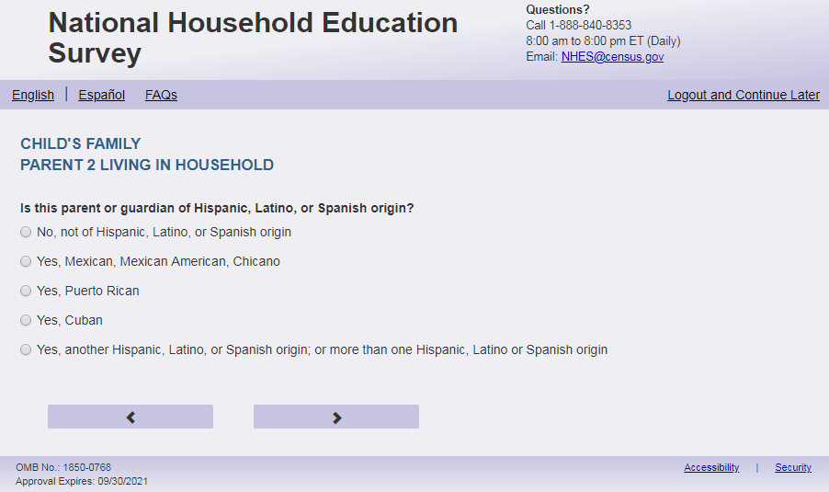
English Respondent Text Reads:
Is [PARENT 2] of Hispanic, Latino, or Spanish origin?

Spanish Respondent Text Reads:
¿Es [PARENT 2] de origen hispano, latino o español?

English Admin/TQA Text Reads:
{Please be sure to ask BOTH this question and the following race question, and record the respondent’s answer}
[PARENT 2] of Hispanic, Latino, or Spanish origin?
{If ‘yes,’ read yes answer options to the respondent.}
Spanish Admin/TQA Text Reads:
{Por favor asgúrese de leer esta pregunta Y TAMBIÉN la siguiente pregunta sobre la raza, y marque la respuesta del encuestado}
¿Es [PARENT 2] de origen hispano, latino o español?

{Si 'sí', lea opciones de respuesta sí al encuestado.}
English Text Reads:
1 = No, not of Hispanic, Latino, or Spanish origin
2 = Yes, Mexican, Mexican American, Chicano
3 = Yes, Puerto Rican
4 = Yes, Cuban
5 = Yes, another Hispanic, Latino, or Spanish origin; or more than one Hispanic, Latino, or Spanish origin

Spanish Text Reads:
1 = No, no es de origen hispano, latino, o español
2 = Sí, Mexicano, Mexicano Americano, Chicano
3 = Sí, Puertorriqueño
4 = Sí, Cubano
5 = Sí, es de otro origen hispano, latino, o español; o de más de un origen hispano, latino o español

ECPP_P2HISPANX, (1,5), numeric, radio

Skips:
Go to ECPP_P2AMIND

Logic Checks/Programming specifications:
Fills
English:
If ECPP_P1HHREL2 = 1 (mother) is selected and ECPP_P2HHREL = 1 (mother) then PARENT 2 fill is [this child]’s other mother else if PARENT 2 fill is [this child]’s mother
If ECPP_P1HHREL2 = 2 (father) is selected and ECPP_P2HHREL = 2 (father) then PARENT 2 fill is [this child]’s other father else PARENT 2 fill is [this child]’s father
If ECPP_P1HHREL2 = 3 (grandmother) is selected and ECPP_P2HHREL = 1 (grandmother) then PARENT 2 fill is [this child]’s other grandmother else PARENT 2 fill is [this child]’s grandmother
If ECPP_P1HHREL2 = 4 (grandfather) is selected and ECPP_P2HHREL = 2 (grandfather) then PARENT 2 fill is [this child]’s other grandfather else PARENT 2 fill is [this child]’s grandfather
If ECPP_P1HHREL2 = 6 (aunt) is selected and ECPP_P2HHREL = 1 (aunt) then PARENT 2 fill is [this child]’s other aunt else PARENT 2 fill is [this child]’s aunt
If ECPP_P1HHREL2 = 7 (uncle) is selected and ECPP_P2HHREL = 2 (uncle) then PARENT 2 fill is [this child]’s other uncle else PARENT 2 fill is [this child]’s uncle
If ECPP_P1HHREL2 = 8 (sister) is selected and ECPP_P2HHREL = 1 (sister) then PARENT 2 fill is [this child]’s other sister else PARENT 2 fill is [this child]’s sister
If ECPP_P1HHREL2 = 9 (brother) is selected and ECPP_P2HHREL = 2 (brother) then PARENT 2 fill is [this child]’s other brother else PARENT 2 fill is [this child]’s brother
If ECPP_P2HHREL in (5, 10, blank) (boyfriend/girlfriend/partner or other relationship) is selected then PARENT 2 fill is [this child]’s other parent or guardian
Spanish:
If ECPP_P1HHREL2 = 1 (madre) is selected and ECPP_P2HHREL = 1 (madre) then PARENT 2 fill is la otra madre de [este niño (esta niña)] else PARENT 2 fill is la madre de [este niño (esta niña)]
If ECPP_P1HHREL2 = 2 (padre) is selected and ECPP_P2HHREL = 2 (padre) then PARENT 2 fill el otro padre de [este niño (esta niña)] else PARENT 2 fill is el padre de [este niño (esta niña)]
If ECPP_P1HHREL2 = 3 (abuela) is selected and ECPP_P2HHREL = 1 (Abuela) then PARENT 2 fill is la otra abuela de [este niño (esta niña)] else PARENT 2 fill is la abuela de [este niño (esta niña)]
If ECPP_P1HHREL2 = 4 (abuelo) is selected and ECPP_P2HHREL = 2 (abuelo) then PARENT 2 fill el otro abuelo de [este niño (esta niña)] else PARENT 2 fill is el abuelo de [este niño (esta niña)]
If ECPP_P1HHREL2 = 6 (tía) is selected and ECPP_P2HHREL = 1 (tía) then PARENT 2 fill is la otra tía de [este niño (esta niña)] else PARENT 2 fill is la tía de [este niño (esta niña)]
If ECPP_P1HHREL2 = 7 (tío) is selected and ECPP_P2HHREL = 2 (tío) then PARENT 2 fill el otro tío de [este niño (esta niña)] else PARENT 2 fill is el tío de [este niño (esta niña)]
If ECPP_P1HHREL2 = 8 (hermana) is selected and ECPP_P2HHREL = 1 (hermana) then PARENT 2 fill is la otra hermana de [este niño (esta niña)] else PARENT 2 fill is la hermana de [este niño (esta niña)]
If ECPP_P1HHREL2 = 9 (hermano) is selected and ECPP_P2HHREL = 2 (hermano) then PARENT 2 fill el otro hermano de [este niño (esta niña)] else PARENT 2 fill is el hermano de [este niño (esta niña)]
If ECPP_P2HHREL in (5, 10, blank) (boyfriend/girlfriend/partner or other relationship) is selected then PARENT 2 fill is el otro padre o el tutor(a) legal de [este niño (esta niña)]

Item: 2nd Parent/Guardian Race (ECPP_P2AMIND)
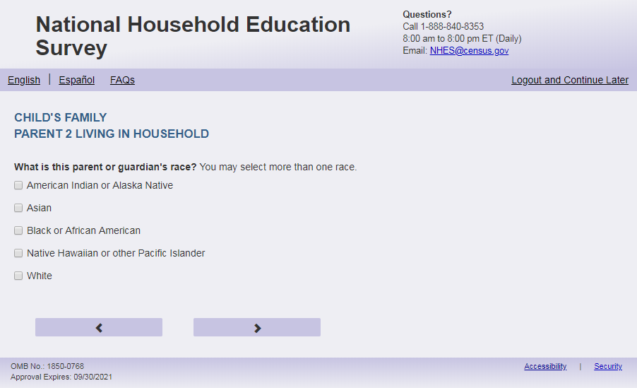
English Respondent Text Reads:
What is [PARENT 2] race? You may select one or more race.

Spanish Respondent Text Reads:
¿Cuál es la raza de [PARENT 2]? Puede seleccionar una raza o más de una raza.

English Admin/TQA Text Reads:
What is [PARENT 2] race?
{You may select one or more races.}
{If the respondent answered yes to the previous item (Hispanic ethnicity) and does not identify with any other race, leave this item blank.}
Spanish Admin/TQA Text Reads:
¿Cuál es la raza de [PARENT 2]?
{Puede seleccionar una o más razas.}
{Si el encuestado respondió sí a la pregunta anterior (etnia hispana) y no se identifica con ninguna otra raza, deje este ítem en blanco.}
English answers:

American Indian or Alaska Native, ECPP_P2AMIND, (1= Item Marked; 2=Not marked), numeric, checkbox
Asian, ECPP_P2ASIAN, (1= Item Marked; 2=Not marked), numeric, checkbox
Black or African American, ECPP_P2BLACK, (1= Item Marked; 2=Not marked), numeric, checkbox
Native Hawaiian or other Pacific Islander, ECPP_P2PACI, (1= Item Marked; 2=Not marked), numeric, checkbox
White, ECPP_P2WHITE, (1= Item Marked; 2=Not marked), numeric, checkbox

Spanish answers:
Indígena de las Américas o nativa de Alaska, ECPP_P2AMIND, (1= Item Marked; 2=Not marked), numeric, checkbox
Asiática, ECPP_P2ASIAN, (1= Item Marked; 2=Not marked), numeric, checkbox
Negra o afroamericana, ECPP_P2BLACK, (1= Item Marked; 2=Not marked), numeric, checkbox
Nativa de Hawái u otra de las islas del Pacífico, ECPP_P2PACI, (1= Item Marked; 2=Not marked), numeric, checkbox
Blanca, ECPP_P2WHITE, (1= Item Marked; 2=Not marked), numeric, checkbox

Skips:
Go to ECPP_P2EDUC

Logic Checks/Programming specifications:

This is a mark all the apply item.

Fills
English:
If ECPP_P1HHREL2 = 1 (mother) is selected and ECPP_P2HHREL = 1 (mother) then PARENT 2 fill is [this child]’s other mother’s else PARENT 2 fill is [this child]’s mother’s
If ECPP_P1HHREL2 = 2 (father) is selected and ECPP_P2HHREL = 2 (father) then PARENT 2 fill is [this child]’s other father’s else PARENT 2 fill is [this child]’s father’s
If ECPP_P1HHREL2 = 3 (grandmother) is selected and ECPP_P2HHREL = 1 (grandmother) then PARENT 2 fill is [this child]’s other grandmother’s else PARENT 2 fill is [this child]’s grandmother’s;
If ECPP_P1HHREL2 = 4 (grandfather) is selected and ECPP_P2HHREL = 2 (grandfather) then PARENT 2 fill is [this child]’s other grandfather’s else PARENT 2 fill is [this child]’s grandfather’s
If ECPP_P1HHREL2 = 6 (aunt) is selected and ECPP_P2HHREL = 1 (aunt) then PARENT 2 fill is [this child]’s other aunt’s else PARENT 2 fill is [this child]’s aunt’s
If ECPP_P1HHREL2 = 7 (uncle) is selected and ECPP_P2HHREL = 2 (uncle) then PARENT 2 fill is [this child]’s other uncle’s else PARENT 2 fill is [this child]’s uncle’s
If ECPP_P1HHREL2 = 8 (sister) is selected and ECPP_P2HHREL = 1 (sister) then PARENT 2 fill is [this child]’s other sister’s else PARENT 2 fill is [this child]’s sister’s
If ECPP_P1HHREL2 = 9 (brother) is selected and ECPP_P2HHREL = 2 (brother) then PARENT 2 fill is [this child]’s other brother’s else PARENT 2 fill is [this child]’s brother’s
If ECPP_P2HHREL in (5, 10, blank) (boyfriend/girlfriend/partner or other relationship) is selected then PARENT 2 fill is [this child]’s other parent or guardian’s
Spanish:
If ECPP_P1HHREL2 = 1 (madre) is selected and ECPP_P2HHREL = 1 (madre) then PARENT 2 fill is la raza de la otra madre de [este niño (esta niña)] else PARENT 2 fill is la raza de la madre de [este niño (esta niña)]
If ECPP_P1HHREL2 = 2 (padre) is selected and ECPP_P2HHREL = 2 (padre) then PARENT 2 fill la raza del otro padre de [este niño (esta niña)] else PARENT 2 fill is la raza del padre de [este niño (esta niña)]
If ECPP_P1HHREL2 = 3 (abuela) is selected and ECPP_P2HHREL = 1 (Abuela) then PARENT 2 fill is la raza de la otra abuela de [este niño (esta niña)] else PARENT 2 fill is la raza de la abuela de [este niño (esta niña)]
If ECPP_P1HHREL2 = 4 (abuelo) is selected and ECPP_P2HHREL = 2 (abuelo) then PARENT 2 fill la raza del otro abuelo de [este niño (esta niña)] else PARENT 2 fill is la raza del abuelo de [este niño (esta niña)]
If ECPP_P1HHREL2 = 6 (tía) is selected and ECPP_P2HHREL = 1 (tía) then PARENT 2 fill is la raza de la otra tía de [este niño (esta niña)] else PARENT 2 fill is la raza de la tía de [este niño (esta niña)]
If ECPP_P1HHREL2 = 7 (tío) is selected and ECPP_P2HHREL = 2 (tío) then PARENT 2 fill la raza del otro tío de [este niño (esta niña)] else PARENT 2 fill is la raza del tío de [este niño (esta niña)]
If ECPP_P1HHREL2 = 8 (hermana) is selected and ECPP_P2HHREL = 1 (hermana) then PARENT 2 fill is la raza de la otra hermana de [este niño (esta niña)] else PARENT 2 fill is la raza de la hermana de [este niño (esta niña)]
If ECPP_P1HHREL2 = 9 (hermano) is selected and ECPP_P2HHREL = 2 (hermano) then PARENT 2 fill la raza del otro hermano de [este niño (esta niña)] else PARENT 2 fill is la raza del hermano de [este niño (esta niña)]
If ECPP_P2HHREL in (5, 10, blank) (boyfriend/girlfriend/partner or other relationship) is selected then PARENT 2 fill is la raza del otro padre o el tutor(a) legal de [este niño (esta niña)]

Item: 2nd Parent/Guardian Highest Level of Education (ECPP_P2EDUC)
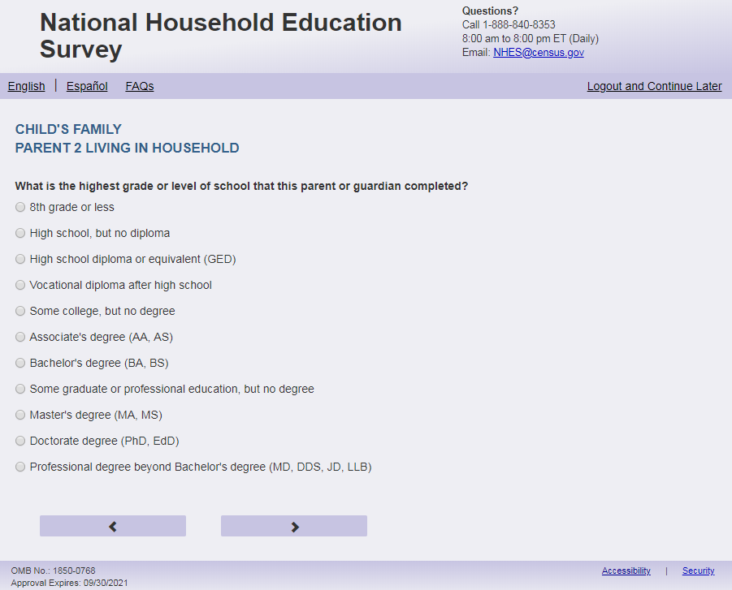
English Respondent Text Reads:
What is the highest grade or level of school that [PARENT 2] completed?

Spanish Respondent Text Reads:
¿Cuál es el grado o nivel más alto de estudios que [PARENT 2] ha completó?

English Admin/TQA Text Reads:
What is the highest grade or level of school that [PARENT 2] completed?
{Please read response options.}

Spanish Admin/TQA Text Reads:
¿Cuál es el grado o nivel más alto de estudios que [PARENT 2] ha completó?

{Por favor, lea las opciones de respuesta.}
English
1= 8th grade or less
2= High school, but no diploma
3= High school diploma or equivalent (GED)
4= Vocational diploma after high school
5= Some college, but no degree
6= Associate’s degree (AA, AS)
7= Bachelor’s degree (BA, BS)
8= Some graduate or professional education, but no degree
9= Master’s degree (MA, MS)
10= Doctorate degree (PhD, EdD)
11= Professional degree beyond bachelor’s degree (MD, DDS, JD, LLB)

Spanish
1= 8° grado o menos
2= High school (grado 9 al 12), pero sin obtener el diploma
3= Diploma de high school o equivalencia (GED)
4= Diploma vocacional o de oficios posterior a high school
5= Algunos cursos de college o universidad, pero sin graduarse
6= Licenciatura o grado asociado (AA, AS)
7= Licenciatura o grado de bachelor (BA, BS)
8= Algo de educación profesional o graduada, pero sin título
9= Título de maestría (MA, MS)
10= Título de doctorado (PhD, EdD)
11= Título profesional posterior al grado de bachelor (médico, dentista, doctor en leyes)
ECPP_P2EDUC, (1,11), numeric, radio

Skips:
Go to ECPP_P2ENRL

Logic Checks/Programming specifications:
Fills
English:
If ECPP_P1HHREL2 = 1 (mother) is selected and ECPP_P2HHREL = 1 (mother) then PARENT 2 fill is [this child]’s other mother else if PARENT 2 fill is [this child]’s mother
If ECPP_P1HHREL2 = 2 (father) is selected and ECPP_P2HHREL = 2 (father) then PARENT 2 fill is [this child]’s other father else PARENT 2 fill is [this child]’s father
If ECPP_P1HHREL2 = 3 (grandmother) is selected and ECPP_P2HHREL = 1 (grandmother) then PARENT 2 fill is [this child]’s other grandmother else PARENT 2 fill is [this child]’s grandmother
If ECPP_P1HHREL2 = 4 (grandfather) is selected and ECPP_P2HHREL = 2 (grandfather) then PARENT 2 fill is [this child]’s other grandfather else PARENT 2 fill is [this child]’s grandfather
If ECPP_P1HHREL2 = 6 (aunt) is selected and ECPP_P2HHREL = 1 (aunt) then PARENT 2 fill is [this child]’s other aunt else PARENT 2 fill is [this child]’s aunt
If ECPP_P1HHREL2 = 7 (uncle) is selected and ECPP_P2HHREL = 2 (uncle) then PARENT 2 fill is [this child]’s other uncle else PARENT 2 fill is [this child]’s uncle
If ECPP_P1HHREL2 = 8 (sister) is selected and ECPP_P2HHREL = 1 (sister) then PARENT 2 fill is [this child]’s other sister else PARENT 2 fill is [this child]’s sister
If ECPP_P1HHREL2 = 9 (brother) is selected and ECPP_P2HHREL = 2 (brother) then PARENT 2 fill is [this child]’s other brother else PARENT 2 fill is [this child]’s brother
If ECPP_P2HHREL in (5, 10, blank) (boyfriend/girlfriend/partner or other relationship) is selected then PARENT 2 fill is [this child]’s other parent or guardian
Spanish:
If ECPP_P1HHREL2 = 1 (madre) is selected and ECPP_P2HHREL = 1 (madre) then PARENT 2 fill is la otra madre de [este niño (esta niña)] else PARENT 2 fill is la madre de [este niño (esta niña)]
If ECPP_P1HHREL2 = 2 (padre) is selected and ECPP_P2HHREL = 2 (padre) then PARENT 2 fill el otro padre de [este niño (esta niña)] else PARENT 2 fill is el padre de [este niño (esta niña)]
If ECPP_P1HHREL2 = 3 (abuela) is selected and ECPP_P2HHREL = 1 (Abuela) then PARENT 2 fill is la otra abuela de [este niño (esta niña)] else PARENT 2 fill is la abuela de [este niño (esta niña)]
If ECPP_P1HHREL2 = 4 (abuelo) is selected and ECPP_P2HHREL = 2 (abuelo) then PARENT 2 fill el otro abuelo de [este niño (esta niña)] else PARENT 2 fill is el abuelo de [este niño (esta niña)]
If ECPP_P1HHREL2 = 6 (tía) is selected and ECPP_P2HHREL = 1 (tía) then PARENT 2 fill is la otra tía de [este niño (esta niña)] else PARENT 2 fill is la tía de [este niño (esta niña)]
If ECPP_P1HHREL2 = 7 (tío) is selected and ECPP_P2HHREL = 2 (tío) then PARENT 2 fill el otro tío de [este niño (esta niña)] else PARENT 2 fill is el tío de [este niño (esta niña)]
If ECPP_P1HHREL2 = 8 (hermana) is selected and ECPP_P2HHREL = 1 (hermana) then PARENT 2 fill is la otra hermana de [este niño (esta niña)] else PARENT 2 fill is la hermana de [este niño (esta niña)]
If ECPP_P1HHREL2 = 9 (hermano) is selected and ECPP_P2HHREL = 2 (hermano) then PARENT 2 fill el otro hermano de [este niño (esta niña)] else PARENT 2 fill is el hermano de [este niño (esta niña)]
If ECPP_P2HHREL in (5, 10, blank) (boyfriend/girlfriend/partner or other relationship) is selected then PARENT 2 fill is el otro padre o el tutor(a) legal de [este niño (esta niña)]

Item: 2nd Parent/Guardian Postsecondary Enrollment (ECPP_P2ENRL)
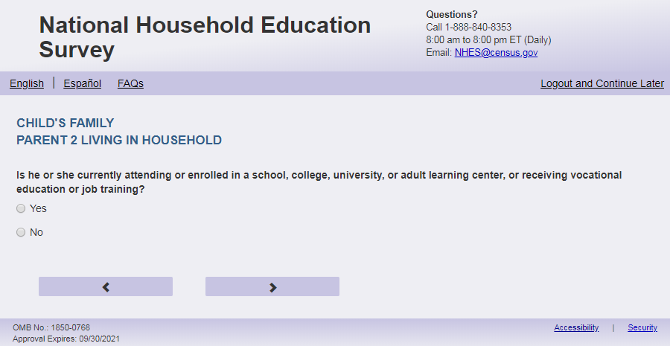
English Text Reads:
Is [PARENT 2] currently attending or enrolled in a school, college, university, or adult learning center, or receiving vocational education or job training?

Spanish Text Reads:
Actualmente ¿asiste [PARENT 2], a una escuela, universidad o centro de educación para adultos o recibe educación vocacional o capacitación laboral?

English Answer
1 = Yes
2=No

Spanish Answer
1= Sí
2=No

ECPP_P2ENRL, (1,2), numeric, radio

Skips:

Go to ECPP_P2EMPL

Logic Checks/Programming specifications:
Fills
English:
If ECPP_P1HHREL2 = 1 (mother) is selected and ECPP_P2HHREL = 1 (mother) then PARENT 2 fill is [this child]’s other mother else if PARENT 2 fill is [this child]’s mother
If ECPP_P1HHREL2 = 2 (father) is selected and ECPP_P2HHREL = 2 (father) then PARENT 2 fill is [this child]’s other father else PARENT 2 fill is [this child]’s father
If ECPP_P1HHREL2 = 3 (grandmother) is selected and ECPP_P2HHREL = 1 (grandmother) then PARENT 2 fill is [this child]’s other grandmother else PARENT 2 fill is [this child]’s grandmother
If ECPP_P1HHREL2 = 4 (grandfather) is selected and ECPP_P2HHREL = 2 (grandfather) then PARENT 2 fill is [this child]’s other grandfather else PARENT 2 fill is [this child]’s grandfather
If ECPP_P1HHREL2 = 6 (aunt) is selected and ECPP_P2HHREL = 1 (aunt) then PARENT 2 fill is [this child]’s other aunt else PARENT 2 fill is [this child]’s aunt
If ECPP_P1HHREL2 = 7 (uncle) is selected and ECPP_P2HHREL = 2 (uncle) then PARENT 2 fill is [this child]’s other uncle else PARENT 2 fill is [this child]’s uncle
If ECPP_P1HHREL2 = 8 (sister) is selected and ECPP_P2HHREL = 1 (sister) then PARENT 2 fill is [this child]’s other sister else PARENT 2 fill is [this child]’s sister
If ECPP_P1HHREL2 = 9 (brother) is selected and ECPP_P2HHREL = 2 (brother) then PARENT 2 fill is [this child]’s other brother else PARENT 2 fill is [this child]’s brother
If ECPP_P2HHREL in (5, 10, blank) (boyfriend/girlfriend/partner or other relationship) is selected then PARENT 2 fill is [this child]’s other parent or guardian
Spanish:
If ECPP_P1HHREL2 = 1 (madre) is selected and ECPP_P2HHREL = 1 (madre) then PARENT 2 fill is la otra madre de [este niño (esta niña)] else PARENT 2 fill is la madre de [este niño (esta niña)]
If ECPP_P1HHREL2 = 2 (padre) is selected and ECPP_P2HHREL = 2 (padre) then PARENT 2 fill el otro padre de [este niño (esta niña)] else PARENT 2 fill is el padre de [este niño (esta niña)]
If ECPP_P1HHREL2 = 3 (abuela) is selected and ECPP_P2HHREL = 1 (Abuela) then PARENT 2 fill is la otra abuela de [este niño (esta niña)] else PARENT 2 fill is la abuela de [este niño (esta niña)]
If ECPP_P1HHREL2 = 4 (abuelo) is selected and ECPP_P2HHREL = 2 (abuelo) then PARENT 2 fill el otro abuelo de [este niño (esta niña)] else PARENT 2 fill is el abuelo de [este niño (esta niña)]
If ECPP_P1HHREL2 = 6 (tía) is selected and ECPP_P2HHREL = 1 (tía) then PARENT 2 fill is la otra tía de [este niño (esta niña)] else PARENT 2 fill is la tía de [este niño (esta niña)]
If ECPP_P1HHREL2 = 7 (tío) is selected and ECPP_P2HHREL = 2 (tío) then PARENT 2 fill el otro tío de [este niño (esta niña)] else PARENT 2 fill is el tío de [este niño (esta niña)]
If ECPP_P1HHREL2 = 8 (hermana) is selected and ECPP_P2HHREL = 1 (hermana) then PARENT 2 fill is la otra hermana de [este niño (esta niña)] else PARENT 2 fill is la hermana de [este niño (esta niña)]
If ECPP_P1HHREL2 = 9 (hermano) is selected and ECPP_P2HHREL = 2 (hermano) then PARENT 2 fill el otro hermano de [este niño (esta niña)] else PARENT 2 fill is el hermano de [este niño (esta niña)]
If ECPP_P2HHREL in (5, 10, blank) (boyfriend/girlfriend/partner or other relationship) is selected then PARENT 2 fill is el otro padre, la madre o el tutor(a) legal de [este niño (esta niña)]

Item: 2nd Parent/Guardian Employment (ECPP_P2EMPL)
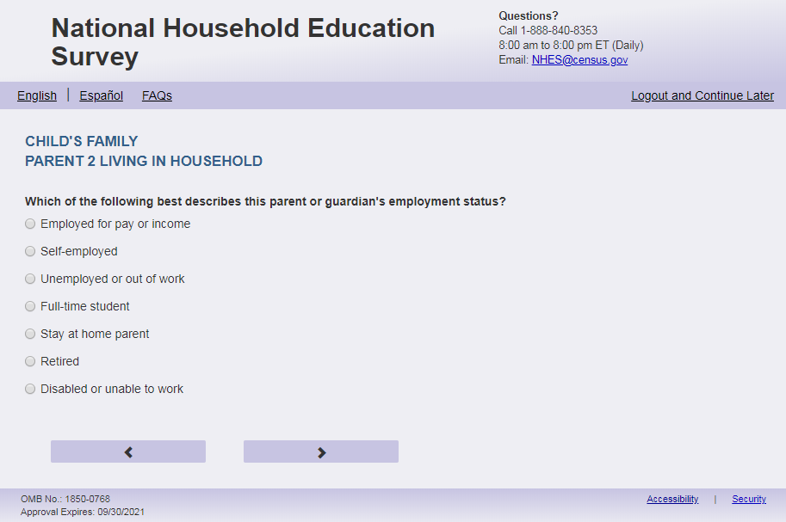
English Text Reads:
Which of the following BEST describes [PARENT 2] employment status?

Spanish Text Reads:
¿Cuál de las siguientes categorías describe MEJOR la situación de trabajo de [PARENT 2]?

English Admin/TQA Text Reads:

Which of the following BEST describes [PARENT 2] employment status?

{Please read response options.}
Spanish Admin/TQA Text Reads:

¿Cuál de las siguientes categorías describe MEJOR la situación laboral de [PARENT 2]?

{Por favor, lea las opciones de respuesta.}
English
1= Employed for pay or income
2= Self-employed
3= Unemployed or out of work
4= Full-time student
5= Stay-at-home parent
6= Retired
7= Disabled or unable to work

Spanish
1= Empleado por pagos o ingresos
2= Trabaja por su propia cuenta
3= Desempleado o no está trabajando
4= Estudiante de tiempo completo
5= Se dedica al hogar y al cuidado de los niños(as)
6= Jubilado
7= Discapacitado o no puede trabajar

ECPP_P2EMPL, (1, 7), numeric, radio

Skips:
if ECPP_P2EMPL = 3 then go to ECPP_P2LKWRK
if ECPP_P2EMPL in (4, 5, 6, 7) then go to ECPP_P2MTHSWRK
Else if ECPP_P2EMPL in 1,2, or blank, go to ECPP_P2HRSWK

Logic Checks/Programming specifications:
Fills
English:
If ECPP_P1HHREL2 = 1 (mother) is selected and ECPP_P2HHREL = 1 (mother) then PARENT 2 fill is [this child]’s other mother’s else PARENT 2 fill is [this child]’s mother’s
If ECPP_P1HHREL2 = 2 (father) is selected and ECPP_P2HHREL = 2 (father) then PARENT 2 fill is [this child]’s other father’s else PARENT 2 fill is [this child]’s father’s
If ECPP_P1HHREL2 = 3 (grandmother) is selected and ECPP_P2HHREL = 1 (grandmother) then PARENT 2 fill is [this child]’s other grandmother’s else PARENT 2 fill is [this child]’s grandmother’s;
If ECPP_P1HHREL2 = 4 (grandfather) is selected and ECPP_P2HHREL = 2 (grandfather) then PARENT 2 fill is [this child]’s other grandfather’s else PARENT 2 fill is [this child]’s grandfather’s
If ECPP_P1HHREL2 = 6 (aunt) is selected and ECPP_P2HHREL = 1 (aunt) then PARENT 2 fill is [this child]’s other aunt’s else PARENT 2 fill is [this child]’s aunt’s
If ECPP_P1HHREL2 = 7 (uncle) is selected and ECPP_P2HHREL = 2 (uncle) then PARENT 2 fill is [this child]’s other uncle’s else PARENT 2 fill is [this child]’s uncle’s
If ECPP_P1HHREL2 = 8 (sister) is selected and ECPP_P2HHREL = 1 (sister) then PARENT 2 fill is [this child]’s other sister’s else PARENT 2 fill is [this child]’s sister’s
If ECPP_P1HHREL2 = 9 (brother) is selected and ECPP_P2HHREL = 2 (brother) then PARENT 2 fill is [this child]’s other brother’s else PARENT 2 fill is [this child]’s brother’s
If ECPP_P2HHREL in (5, 10, blank) (boyfriend/girlfriend/partner or other relationship) is selected then PARENT 2 fill is [this child]’s other parent or guardian’s
Spanish:
If ECPP_P1HHREL2 = 1 (madre) is selected and ECPP_P2HHREL = 1 (madre) then PARENT 2 fill is la otra madre de [este niño (esta niña)] else PARENT 2 fill is la madre de [este niño (esta niña)]
If ECPP_P1HHREL2 = 2 (padre) is selected and ECPP_P2HHREL = 2 (padre) then PARENT 2 fill el otro padre de [este niño (esta niña)] else PARENT 2 fill is el padre de [este niño (esta niña)]
If ECPP_P1HHREL2 = 3 (abuela) is selected and ECPP_P2HHREL = 1 (Abuela) then PARENT 2 fill is la otra abuela de [este niño (esta niña)] else PARENT 2 fill is la abuela de [este niño (esta niña)]
If ECPP_P1HHREL2 = 4 (abuelo) is selected and ECPP_P2HHREL = 2 (abuelo) then PARENT 2 fill el otro abuelo de [este niño (esta niña)] else PARENT 2 fill is el abuelo de [este niño (esta niña)]
If ECPP_P1HHREL2 = 6 (tía) is selected and ECPP_P2HHREL = 1 (tía) then PARENT 2 fill is la otra tía de [este niño (esta niña)] else PARENT 2 fill is la tía de [este niño (esta niña)]
If ECPP_P1HHREL2 = 7 (tío) is selected and ECPP_P2HHREL = 2 (tío) then PARENT 2 fill el otro tío de [este niño (esta niña)] else PARENT 2 fill is el tío de [este niño (esta niña)]
If ECPP_P1HHREL2 = 8 (hermana) is selected and ECPP_P2HHREL = 1 (hermana) then PARENT 2 fill is la otra hermana de [este niño (esta niña)] else PARENT 2 fill is la hermana de [este niño (esta niña)]
If ECPP_P1HHREL2 = 9 (hermano) is selected and ECPP_P2HHREL = 2 (hermano) then PARENT 2 fill el otro hermano de [este niño (esta niña)] else PARENT 2 fill is el hermano de [este niño (esta niña)]
If ECPP_P2HHREL in (5, 10, blank) (boyfriend/girlfriend/partner or other relationship) is selected then PARENT 2 fill is el otro padre o el tutor(a) legal de [este niño (esta niña)]

Item: 2nd Parent/Guardian Hours Worked (ECPP_P2HRSWK)
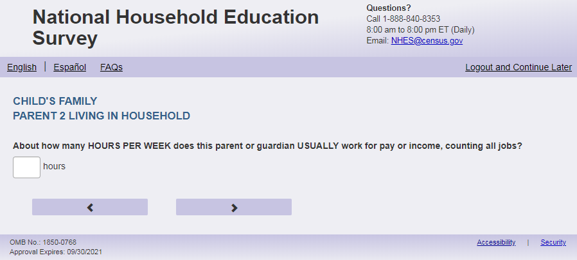
English
About how many hours PER WEEK does [PARENT 2] USUALLY work for pay or income, counting all jobs?

Spanish
¿Más o menos cuántas horas a POR SEMANA trabaja [PARENT 2] NORMALMENTE por pagos o ingresos, contando todos los trabajos?

English and Spanish Answer
ECPP_P2HRSWK, (0, 99), numeric, write-in

Skips:
go to ECPP_P2MTHSWRK

Logic Checks/Programming specifications:
English
display "hours per week" to the right of text box.

Spanish
display "horas a la semana" to the right of text box.

Mobile: Display numeric keypad

Fills
English:
If ECPP_P1HHREL2 = 1 (mother) is selected and ECPP_P2HHREL = 1 (mother) then PARENT 2 fill is [this child]’s other mother else if PARENT 2 fill is [this child]’s mother
If ECPP_P1HHREL2 = 2 (father) is selected and ECPP_P2HHREL = 2 (father) then PARENT 2 fill is [this child]’s other father else PARENT 2 fill is [this child]’s father
If ECPP_P1HHREL2 = 3 (grandmother) is selected and ECPP_P2HHREL = 1 (grandmother) then PARENT 2 fill is [this child]’s other grandmother else PARENT 2 fill is [this child]’s grandmother
If ECPP_P1HHREL2 = 4 (grandfather) is selected and ECPP_P2HHREL = 2 (grandfather) then PARENT 2 fill is [this child]’s other grandfather else PARENT 2 fill is [this child]’s grandfather
If ECPP_P1HHREL2 = 6 (aunt) is selected and ECPP_P2HHREL = 1 (aunt) then PARENT 2 fill is [this child]’s other aunt else PARENT 2 fill is [this child]’s aunt
If ECPP_P1HHREL2 = 7 (uncle) is selected and ECPP_P2HHREL = 2 (uncle) then PARENT 2 fill is [this child]’s other uncle else PARENT 2 fill is [this child]’s uncle
If ECPP_P1HHREL2 = 8 (sister) is selected and ECPP_P2HHREL = 1 (sister) then PARENT 2 fill is [this child]’s other sister else PARENT 2 fill is [this child]’s sister
If ECPP_P1HHREL2 = 9 (brother) is selected and ECPP_P2HHREL = 2 (brother) then PARENT 2 fill is [this child]’s other brother else PARENT 2 fill is [this child]’s brother
If ECPP_P2HHREL in (5, 10, blank) (boyfriend/girlfriend/partner or other relationship) is selected then PARENT 2 fill is [this child]’s other parent or guardian
Spanish:
If ECPP_P1HHREL2 = 1 (madre) is selected and ECPP_P2HHREL = 1 (madre) then PARENT 2 fill is la otra madre de [este niño (esta niña)] else PARENT 2 fill is la madre de [este niño (esta niña)]
If ECPP_P1HHREL2 = 2 (padre) is selected and ECPP_P2HHREL = 2 (padre) then PARENT 2 fill el otro padre de [este niño (esta niña)] else PARENT 2 fill is el padre de [este niño (esta niña)]
If ECPP_P1HHREL2 = 3 (abuela) is selected and ECPP_P2HHREL = 1 (Abuela) then PARENT 2 fill is la otra abuela de [este niño (esta niña)] else PARENT 2 fill is la abuela de [este niño (esta niña)]
If ECPP_P1HHREL2 = 4 (abuelo) is selected and ECPP_P2HHREL = 2 (abuelo) then PARENT 2 fill el otro abuelo de [este niño (esta niña)] else PARENT 2 fill is el abuelo de [este niño (esta niña)]
If ECPP_P1HHREL2 = 6 (tía) is selected and ECPP_P2HHREL = 1 (tía) then PARENT 2 fill is la otra tía de [este niño (esta niña)] else PARENT 2 fill is la tía de [este niño (esta niña)]
If ECPP_P1HHREL2 = 7 (tío) is selected and ECPP_P2HHREL = 2 (tío) then PARENT 2 fill el otro tío de [este niño (esta niña)] else PARENT 2 fill is el tío de [este niño (esta niña)]
If ECPP_P1HHREL2 = 8 (hermana) is selected and ECPP_P2HHREL = 1 (hermana) then PARENT 2 fill is la otra hermana de [este niño (esta niña)] else PARENT 2 fill is la hermana de [este niño (esta niña)]
If ECPP_P1HHREL2 = 9 (hermano) is selected and ECPP_P2HHREL = 2 (hermano) then PARENT 2 fill el otro hermano de [este niño (esta niña)] else PARENT 2 fill is el hermano de [este niño (esta niña)]
If ECPP_P2HHREL in (5, 10, blank) (boyfriend/girlfriend/partner or other relationship) is selected then PARENT 2 fill is el otro padre o el tutor(a) legal de [este niño (esta niña)]

Text displayed for logic/range check violation
Logic/range check triggers a warning message, with the following text displayed.

English:

[If 0] Display "Please check your answer before continuing. Typically, adults work between one and 99 hours per week."

Spanish:
[If 0] Display "Por favor, compruebe su respuesta antes de continuar. Por lo general, los adultos trabajan entre una y 99 horas por semana.”.

Item: 2nd Parent/Guardian Worked past 4 Weeks (ECPP_P2LKWRK)
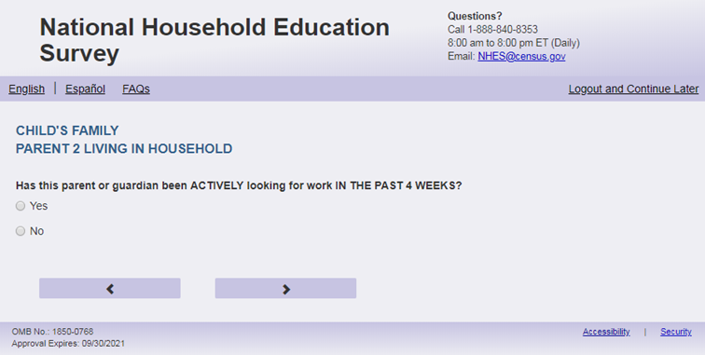
English Text Reads:
Has [PARENT 2] been ACTIVELY looking for work IN THE PAST 4 WEEKS?

Spanish Text Reads:
¿Ha estado [PARENT 2] buscando trabajo DE MANERA ACTIVA en LAS ÚLTIMAS 4 SEMANAS?

English
1 = Yes
2=No

Spanish
1= Sí
2=No

ECPP_P2LKWRK, (1,2), numeric, radio

Skips:
Go to ECPP_P2MTHSWRK

Logic Checks/Programming specifications:
Fills
English:
If ECPP_P1HHREL2 = 1 (mother) is selected and ECPP_P2HHREL = 1 (mother) then PARENT 2 fill is [this child]’s other mother else if PARENT 2 fill is [this child]’s mother
If ECPP_P1HHREL2 = 2 (father) is selected and ECPP_P2HHREL = 2 (father) then PARENT 2 fill is [this child]’s other father else PARENT 2 fill is [this child]’s father
If ECPP_P1HHREL2 = 3 (grandmother) is selected and ECPP_P2HHREL = 1 (grandmother) then PARENT 2 fill is [this child]’s other grandmother else PARENT 2 fill is [this child]’s grandmother
If ECPP_P1HHREL2 = 4 (grandfather) is selected and ECPP_P2HHREL = 2 (grandfather) then PARENT 2 fill is [this child]’s other grandfather else PARENT 2 fill is [this child]’s grandfather
If ECPP_P1HHREL2 = 6 (aunt) is selected and ECPP_P2HHREL = 1 (aunt) then PARENT 2 fill is [this child]’s other aunt else PARENT 2 fill is [this child]’s aunt
If ECPP_P1HHREL2 = 7 (uncle) is selected and ECPP_P2HHREL = 2 (uncle) then PARENT 2 fill is [this child]’s other uncle else PARENT 2 fill is [this child]’s uncle
If ECPP_P1HHREL2 = 8 (sister) is selected and ECPP_P2HHREL = 1 (sister) then PARENT 2 fill is [this child]’s other sister else PARENT 2 fill is [this child]’s sister
If ECPP_P1HHREL2 = 9 (brother) is selected and ECPP_P2HHREL = 2 (brother) then PARENT 2 fill is [this child]’s other brother else PARENT 2 fill is [this child]’s brother
If ECPP_P2HHREL in (5, 10, blank) (boyfriend/girlfriend/partner or other relationship) is selected then PARENT 2 fill is [this child]’s other parent or guardian
Spanish:
If ECPP_P1HHREL2 = 1 (madre) is selected and ECPP_P2HHREL = 1 (madre) then PARENT 2 fill is la otra madre de [este niño (esta niña)] else PARENT 2 fill is la madre de [este niño (esta niña)]
If ECPP_P1HHREL2 = 2 (padre) is selected and ECPP_P2HHREL = 2 (padre) then PARENT 2 fill el otro padre de [este niño (esta niña)] else PARENT 2 fill is el padre de [este niño (esta niña)]
If ECPP_P1HHREL2 = 3 (abuela) is selected and ECPP_P2HHREL = 1 (Abuela) then PARENT 2 fill is la otra abuela de [este niño (esta niña)] else PARENT 2 fill is la abuela de [este niño (esta niña)]
If ECPP_P1HHREL2 = 4 (abuelo) is selected and ECPP_P2HHREL = 2 (abuelo) then PARENT 2 fill el otro abuelo de [este niño (esta niña)] else PARENT 2 fill is el abuelo de [este niño (esta niña)]
If ECPP_P1HHREL2 = 6 (tía) is selected and ECPP_P2HHREL = 1 (tía) then PARENT 2 fill is la otra tía de [este niño (esta niña)] else PARENT 2 fill is la tía de [este niño (esta niña)]
If ECPP_P1HHREL2 = 7 (tío) is selected and ECPP_P2HHREL = 2 (tío) then PARENT 2 fill el otro tío de [este niño (esta niña)] else PARENT 2 fill is el tío de [este niño (esta niña)]
If ECPP_P1HHREL2 = 8 (hermana) is selected and ECPP_P2HHREL = 1 (hermana) then PARENT 2 fill is la otra hermana de [este niño (esta niña)] else PARENT 2 fill is la hermana de [este niño (esta niña)]
If ECPP_P1HHREL2 = 9 (hermano) is selected and ECPP_P2HHREL = 2 (hermano) then PARENT 2 fill el otro hermano de [este niño (esta niña)] else PARENT 2 fill is el hermano de [este niño (esta niña)]
If ECPP_P2HHREL in (5, 10, blank) (boyfriend/girlfriend/partner or other relationship) is selected then PARENT 2 fill is el otro padre o el tutor(a) legal de [este niño (esta niña)]

Item: 2nd Parent/Guardian Worked past 12 Months (ECPP_P2MTHSWRK)
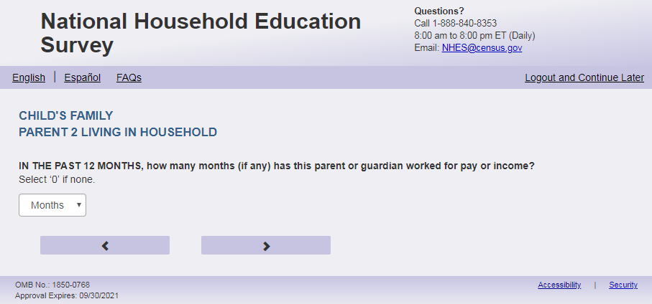
English Text Reads:
IN THE PAST 12 MONTHS, how many months (if any) has [PARENT 2] worked for pay or income?
Enter ‘0’ if none

Spanish Text Reads:
EN LOS ÚLTIMOS 12 MESES, ¿cuántos meses ha trabajado [PARENT 2] (si es que ha trabajado) por pagos o ingresos?
Ingrese ‘0’ si no trabajó ningún mes.

English and Spanish Answer
ECPP_P2MTHSWRK, (0,12), numeric, write-in

Skips:
Go to ECPP_P2INTSPHO

Logic Checks/Programming specifications:
English
display "month(s)" at the right of the text box.

Spanish
display " mes(es)’ " at the right of the text box..

Mobile: Display numeric keypad
Fills
English:
If ECPP_P1HHREL2 = 1 (mother) is selected and ECPP_P2HHREL = 1 (mother) then PARENT 2 fill is [this child]’s other mother else if PARENT 2 fill is [this child]’s mother
If ECPP_P1HHREL2 = 2 (father) is selected and ECPP_P2HHREL = 2 (father) then PARENT 2 fill is [this child]’s other father else PARENT 2 fill is [this child]’s father
If ECPP_P1HHREL2 = 3 (grandmother) is selected and ECPP_P2HHREL = 1 (grandmother) then PARENT 2 fill is [this child]’s other grandmother else PARENT 2 fill is [this child]’s grandmother
If ECPP_P1HHREL2 = 4 (grandfather) is selected and ECPP_P2HHREL = 2 (grandfather) then PARENT 2 fill is [this child]’s other grandfather else PARENT 2 fill is [this child]’s grandfather
If ECPP_P1HHREL2 = 6 (aunt) is selected and ECPP_P2HHREL = 1 (aunt) then PARENT 2 fill is [this child]’s other aunt else PARENT 2 fill is [this child]’s aunt
If ECPP_P1HHREL2 = 7 (uncle) is selected and ECPP_P2HHREL = 2 (uncle) then PARENT 2 fill is [this child]’s other uncle else PARENT 2 fill is [this child]’s uncle
If ECPP_P1HHREL2 = 8 (sister) is selected and ECPP_P2HHREL = 1 (sister) then PARENT 2 fill is [this child]’s other sister else PARENT 2 fill is [this child]’s sister
If ECPP_P1HHREL2 = 9 (brother) is selected and ECPP_P2HHREL = 2 (brother) then PARENT 2 fill is [this child]’s other brother else PARENT 2 fill is [this child]’s brother
If ECPP_P2HHREL in (5, 10, blank) (boyfriend/girlfriend/partner or other relationship) is selected then PARENT 2 fill is [this child]’s other parent or guardian
Spanish:
If ECPP_P1HHREL2 = 1 (madre) is selected and ECPP_P2HHREL = 1 (madre) then PARENT 2 fill is la otra madre de [este niño (esta niña)] else PARENT 2 fill is la madre de [este niño (esta niña)]
If ECPP_P1HHREL2 = 2 (padre) is selected and ECPP_P2HHREL = 2 (padre) then PARENT 2 fill el otro padre de [este niño (esta niña)] else PARENT 2 fill is el padre de [este niño (esta niña)]
If ECPP_P1HHREL2 = 3 (abuela) is selected and ECPP_P2HHREL = 1 (Abuela) then PARENT 2 fill is la otra abuela de [este niño (esta niña)] else PARENT 2 fill is la abuela de [este niño (esta niña)]
If ECPP_P1HHREL2 = 4 (abuelo) is selected and ECPP_P2HHREL = 2 (abuelo) then PARENT 2 fill el otro abuelo de [este niño (esta niña)] else PARENT 2 fill is el abuelo de [este niño (esta niña)]
If ECPP_P1HHREL2 = 6 (tía) is selected and ECPP_P2HHREL = 1 (tía) then PARENT 2 fill is la otra tía de [este niño (esta niña)] else PARENT 2 fill is la tía de [este niño (esta niña)]
If ECPP_P1HHREL2 = 7 (tío) is selected and ECPP_P2HHREL = 2 (tío) then PARENT 2 fill el otro tío de [este niño (esta niña)] else PARENT 2 fill is el tío de [este niño (esta niña)]
If ECPP_P1HHREL2 = 8 (hermana) is selected and ECPP_P2HHREL = 1 (hermana) then PARENT 2 fill is la otra hermana de [este niño (esta niña)] else PARENT 2 fill is la hermana de [este niño (esta niña)]
If ECPP_P1HHREL2 = 9 (hermano) is selected and ECPP_P2HHREL = 2 (hermano) then PARENT 2 fill el otro hermano de [este niño (esta niña)] else PARENT 2 fill is el hermano de [este niño (esta niña)]
If ECPP_P2HHREL in (5, 10, blank) (boyfriend/girlfriend/partner or other relationship) is selected then PARENT 2 fill is el otro padre o el tutor(a) legal de [este niño (esta niña)]

Logic/range check triggers a warning message, with the following text displayed.

English
[If not within the range of 0-12] Display “Please check your answer before continuing. Typically, adults work between zero and 12 months per year.”
Spanish
[If not within the range of 0-12] Display "Por favor, compruebe su respuesta antes de continuar. Por lo general, los adultos trabajan entre cero y 12 meses al año."

Item: 2nd Parent/Guardian Cell Phone Internet Access (ECPP_P2INTSPHO)
<New item for NHES:2023 – no screenshot available>

English Text Reads:
Does [PARENT 2] have Internet access on a cell phone?

Spanish Text Reads:
¿Tiene [PARENT 2] acceso al Internet en un celular?

English Answer
1=Yes
2=No

Spanish Answer
1= Sí
2=No

ECPP_P2INTSPHO, (1,2), numeric, radio

Skips:

Go to ECPP_ P2AGE

Logic Checks/Programming specifications:
Fills
English:
If ECPP_P1HHREL2 = 1 (mother) is selected and ECPP_P2HHREL = 1 (mother) then PARENT 2 fill is [this child]’s other mother else if PARENT 2 fill is [this child]’s mother
If ECPP_P1HHREL2 = 2 (father) is selected and ECPP_P2HHREL = 2 (father) then PARENT 2 fill is [this child]’s other father else PARENT 2 fill is [this child]’s father
If ECPP_P1HHREL2 = 3 (grandmother) is selected and ECPP_P2HHREL = 1 (grandmother) then PARENT 2 fill is [this child]’s other grandmother else PARENT 2 fill is [this child]’s grandmother
If ECPP_P1HHREL2 = 4 (grandfather) is selected and ECPP_P2HHREL = 2 (grandfather) then PARENT 2 fill is [this child]’s other grandfather else PARENT 2 fill is [this child]’s grandfather
If ECPP_P1HHREL2 = 6 (aunt) is selected and ECPP_P2HHREL = 1 (aunt) then PARENT 2 fill is [this child]’s other aunt else PARENT 2 fill is [this child]’s aunt
If ECPP_P1HHREL2 = 7 (uncle) is selected and ECPP_P2HHREL = 2 (uncle) then PARENT 2 fill is [this child]’s other uncle else PARENT 2 fill is [this child]’s uncle
If ECPP_P1HHREL2 = 8 (sister) is selected and ECPP_P2HHREL = 1 (sister) then PARENT 2 fill is [this child]’s other sister else PARENT 2 fill is [this child]’s sister
If ECPP_P1HHREL2 = 9 (brother) is selected and ECPP_P2HHREL = 2 (brother) then PARENT 2 fill is [this child]’s other brother else PARENT 2 fill is [this child]’s brother
If ECPP_P2HHREL in (5, 10, blank) (boyfriend/girlfriend/partner or other relationship) is selected then PARENT 2 fill is [this child]’s other parent or guardian
Spanish:
If ECPP_P1HHREL2 = 1 (madre) is selected and ECPP_P2HHREL = 1 (madre) then PARENT 2 fill is la otra madre de [este niño (esta niña)] else PARENT 2 fill is la madre de [este niño (esta niña)]
If ECPP_P1HHREL2 = 2 (padre) is selected and ECPP_P2HHREL = 2 (padre) then PARENT 2 fill el otro padre de [este niño (esta niña)] else PARENT 2 fill is el padre de [este niño (esta niña)]
If ECPP_P1HHREL2 = 3 (abuela) is selected and ECPP_P2HHREL = 1 (Abuela) then PARENT 2 fill is la otra abuela de [este niño (esta niña)] else PARENT 2 fill is la abuela de [este niño (esta niña)]
If ECPP_P1HHREL2 = 4 (abuelo) is selected and ECPP_P2HHREL = 2 (abuelo) then PARENT 2 fill el otro abuelo de [este niño (esta niña)] else PARENT 2 fill is el abuelo de [este niño (esta niña)]
If ECPP_P1HHREL2 = 6 (tía) is selected and ECPP_P2HHREL = 1 (tía) then PARENT 2 fill is la otra tía de [este niño (esta niña)] else PARENT 2 fill is la tía de [este niño (esta niña)]
If ECPP_P1HHREL2 = 7 (tío) is selected and ECPP_P2HHREL = 2 (tío) then PARENT 2 fill el otro tío de [este niño (esta niña)] else PARENT 2 fill is el tío de [este niño (esta niña)]
If ECPP_P1HHREL2 = 8 (hermana) is selected and ECPP_P2HHREL = 1 (hermana) then PARENT 2 fill is la otra hermana de [este niño (esta niña)] else PARENT 2 fill is la hermana de [este niño (esta niña)]
If ECPP_P1HHREL2 = 9 (hermano) is selected and ECPP_P2HHREL = 2 (hermano) then PARENT 2 fill el otro hermano de [este niño (esta niña)] else PARENT 2 fill is el hermano de [este niño (esta niña)]
If ECPP_P2HHREL in (5, 10, blank) (boyfriend/girlfriend/partner or other relationship) is selected then PARENT 2 fill is el otro padre o el tutor(a) legal de [este niño (esta niña)]

Item: Age of 2nd Parent/Guardian (ECPP_P2AGE)
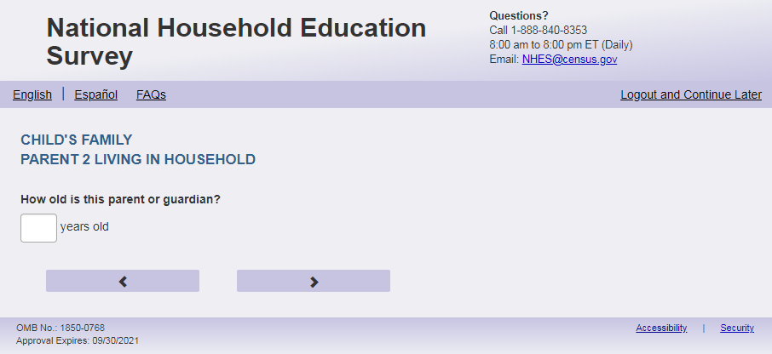
English Text Reads:
How old is [PARENT 2]?

Spanish Text Reads:
¿Qué edad tiene [PARENT 2]?

English and Spanish Answer
ECPP_P2AGE, (12, 99), numeric, write-in

Skips:
Go to ECPP_HWELFTAN

Logic Checks/Programming specifications:

English
display "years old" to the right of box.

Spanish
display "años” to the right of box.

Mobile: Display numeric keypad

Fills
English:
If ECPP_P1HHREL2 = 1 (mother) is selected and ECPP_P2HHREL = 1 (mother) then PARENT 2 fill is [this child]’s other mother else if PARENT 2 fill is [this child]’s mother
If ECPP_P1HHREL2 = 2 (father) is selected and ECPP_P2HHREL = 2 (father) then PARENT 2 fill is [this child]’s other father else PARENT 2 fill is [this child]’s father
If ECPP_P1HHREL2 = 3 (grandmother) is selected and ECPP_P2HHREL = 1 (grandmother) then PARENT 2 fill is [this child]’s other grandmother else PARENT 2 fill is [this child]’s grandmother
If ECPP_P1HHREL2 = 4 (grandfather) is selected and ECPP_P2HHREL = 2 (grandfather) then PARENT 2 fill is [this child]’s other grandfather else PARENT 2 fill is [this child]’s grandfather
If ECPP_P1HHREL2 = 6 (aunt) is selected and ECPP_P2HHREL = 1 (aunt) then PARENT 2 fill is [this child]’s other aunt else PARENT 2 fill is [this child]’s aunt
If ECPP_P1HHREL2 = 7 (uncle) is selected and ECPP_P2HHREL = 2 (uncle) then PARENT 2 fill is [this child]’s other uncle else PARENT 2 fill is [this child]’s uncle
If ECPP_P1HHREL2 = 8 (sister) is selected and ECPP_P2HHREL = 1 (sister) then PARENT 2 fill is [this child]’s other sister else PARENT 2 fill is [this child]’s sister
If ECPP_P1HHREL2 = 9 (brother) is selected and ECPP_P2HHREL = 2 (brother) then PARENT 2 fill is [this child]’s other brother else PARENT 2 fill is [this child]’s brother
If ECPP_P2HHREL in (5, 10, blank) (boyfriend/girlfriend/partner or other relationship) is selected then PARENT 2 fill is [this child]’s other parent or guardian
Spanish:
If ECPP_P1HHREL2 = 1 (madre) is selected and ECPP_P2HHREL = 1 (madre) then PARENT 2 fill is la otra madre de [este niño (esta niña)] else PARENT 2 fill is la madre de [este niño (esta niña)]
If ECPP_P1HHREL2 = 2 (padre) is selected and ECPP_P2HHREL = 2 (padre) then PARENT 2 fill el otro padre de [este niño (esta niña)] else PARENT 2 fill is el padre de [este niño (esta niña)]
If ECPP_P1HHREL2 = 3 (abuela) is selected and ECPP_P2HHREL = 1 (Abuela) then PARENT 2 fill is la otra abuela de [este niño (esta niña)] else PARENT 2 fill is la abuela de [este niño (esta niña)]
If ECPP_P1HHREL2 = 4 (abuelo) is selected and ECPP_P2HHREL = 2 (abuelo) then PARENT 2 fill el otro abuelo de [este niño (esta niña)] else PARENT 2 fill is el abuelo de [este niño (esta niña)]
If ECPP_P1HHREL2 = 6 (tía) is selected and ECPP_P2HHREL = 1 (tía) then PARENT 2 fill is la otra tía de [este niño (esta niña)] else PARENT 2 fill is la tía de [este niño (esta niña)]
If ECPP_P1HHREL2 = 7 (tío) is selected and ECPP_P2HHREL = 2 (tío) then PARENT 2 fill el otro tío de [este niño (esta niña)] else PARENT 2 fill is el tío de [este niño (esta niña)]
If ECPP_P1HHREL2 = 8 (hermana) is selected and ECPP_P2HHREL = 1 (hermana) then PARENT 2 fill is la otra hermana de [este niño (esta niña)] else PARENT 2 fill is la hermana de [este niño (esta niña)]
If ECPP_P1HHREL2 = 9 (hermano) is selected and ECPP_P2HHREL = 2 (hermano) then PARENT 2 fill el otro hermano de [este niño (esta niña)] else PARENT 2 fill is el hermano de [este niño (esta niña)]
If ECPP_P2HHREL in (5, 10, blank) (boyfriend/girlfriend/partner or other relationship) is selected then PARENT 2 fill is el otro padre, madre o el tutor(a) legal de [este niño (esta niña)]

Text displayed for logic/range check violation
Logic/range check triggers a warning message, with the following text displayed.
English
[If less than 12] Display "You entered the age of this parent as less than 12 years old. Please check and make sure your answer is correct before continuing."

Spanish
[If less than 12] Display "Usted ingresó la edad de este padre como menor de 12 años de edad. Por favor, compruebe y asegúrese de que su respuesta es correcta antes de continuar."

Item: Family Benefits (ECPP_HWELFTAN)
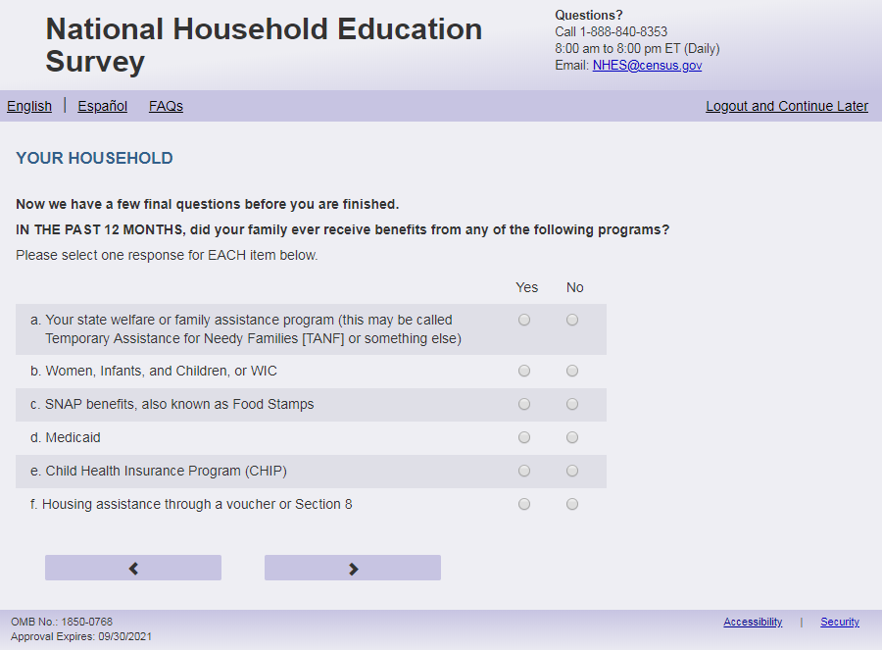
English Respondent Text Reads:
Now we have a few final questions before you are finished.
IN THE PAST 12 MONTHS, did your family ever receive benefits from any of the following programs?

Spanish Respondent Text Reads:
Antes de terminar, tenemos algunas preguntas finales.
EN LOS ÚLTIMOS 12 MESES, ¿recibió su familia beneficios de alguno de los siguientes programas alguna vez?

English Admin/TQA Text Reads:
Now we have a few final questions before you are finished.
IN THE PAST 12 MONTHS, did your family ever receive benefits from any of the following programs?

Please respond ‘yes’ or ‘no’ for EACH item as I read them.

Spanish Admin/TQA Text Reads:
Antes de terminar, tenemos algunas preguntas finales.
EN LOS ÚLTIMOS 12 MESES, ¿recibió su familia beneficios de alguno de los siguientes programas alguna vez?

Por favor, responda 'sí' o 'no' para CADA opción a medida que las leo.
English Answer
- Your state welfare or family assistance program (this may be called Temporary Assistance for Needy Families [TANF] or something else) ECPP_HWELFTAN,(1 = Yes, 2= No), numeric, radio
- Women, Infants, and Children, or WIC ECPP_HWIC (1 = Yes, 2= No), numeric, radio
- SNAP benefits, also known as Food Stamps ECPP_HFOODST, (1 = Yes, 2= No), numeric, radio
- Medicaid ECPP_HMEDICAID, (1 = Yes, 2= No), numeric, radio
- Child Health Insurance Program (CHIP) ECPP_HCHIP, (1 = Yes, 2= No), numeric, radio
- Housing assistance through a voucher or Section 8 ECPP_HSECN8, (1 = Yes, 2= No), numeric, radio

Spanish
- Programa de asistencia social o familiar de su estado (puede ser Asistencia Temporal a Familias
Necesitadas (TANF, por sus siglas en inglés) o algo similar) ( ECPP_HWELFTAN,(1= Sí, 2=No), numeric, radio
- Programa WIC (mujeres, bebés y niños) ECPP_HWIC, (1= Sí, 2=No), numeric, radio
- Beneficios de SNAP, conocido tambien como Estampillas de Comida ECPP_HFOODST, (1= Sí, 2=No), numeric, radio
- Medicaid ECPP_HMEDICAID, (1= Sí, 2=No), numeric, radio
- Programa de Seguro o Médico para Niños (CHIP, por sus siglas en inglés) ECPP_HCHIP, (1= Sí, 2=No), numeric, radio
- Asistencia de vivienda a través de un vale o sección 8 ECPP_HSECN8,(1= Sí, 2=No), numeric, radio

Skips:
Go to ECPP_TTLHHINC

Logic Checks/Programming specifications:
display as grid

Item: Household Income (ECPP_TTLHHINC)
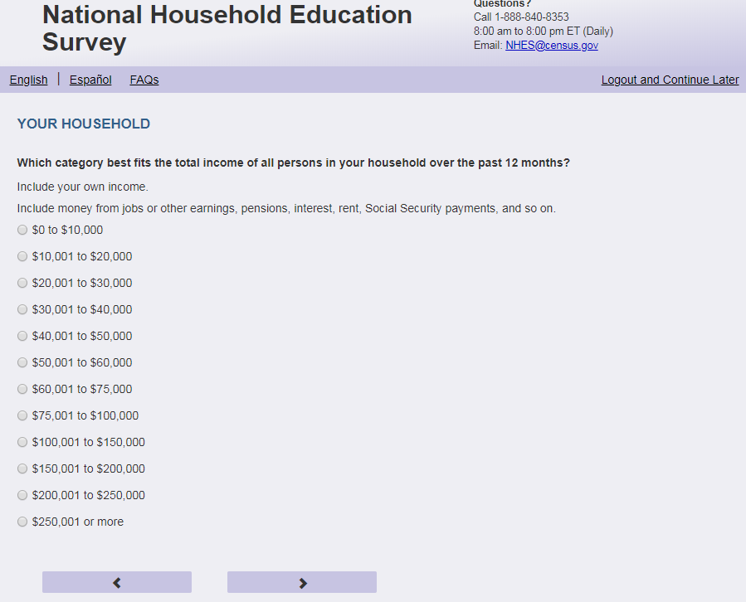
English Respondent Text Reads:

Which category best fits the total income of all persons in your household over the past 12 months?

Include your own income. Include money from jobs or other earnings, pensions, interest, rent, Social Security payments, and so on.

Spanish Respondent Text Reads

¿Qué categoría representa mejor el ingreso total de todas las personas en su hogar en los últimos 12 meses?

Incluya su propio ingreso. Incluya dinero de empleo su otras ganancias, pensiones, intereses, alquileres, pagos del seguro social, etc.

English Admin/TQA Text Reads:

Which category best fits the total income of all persons in your household over the past 12 months?
Include your own income. Include money from jobs or other earnings, pensions, interest, rent, Social Security payments, and so on.

You can give me a specific number, or choose from a range that I read to you.

[INC_DISP] Was it less than $50,000, or more than $50,000?
Spanish Admin/TQA Text Reads

¿Qué categoría representa mejor el ingreso total de todas las personas en su hogar en los últimos 12 meses?
Incluya su propio ingreso.
Incluya dinero de empleosu otras ganancias, pensiones, intereses, alquileres, pagos del seguro social, etc.

Puede darme un número específico, o elegir entre un rango que le leí.
[INC_DISP] ¿Fue menos de $50,000, o más de $50,000?

English Respondent Answer
1= $0 to $10,000
2= $10,001 to $20,000
3= $20,001 to $30,000
4= $30,001 to $40,000
5= $40,001 to $50,000
6= $50,001 to $60,000
7= $60,001 to $75,000
8= $75,001 to $100,000
9= $100,001 to $150,000
10= $150,001 to $200,000
11= $200,001 to $250,000
12= $250,001 or more

Spanish Respondent Answer
1= de $0 a $10,000
2= de $10,001 a $20,000
3= de $20,001 a $30,000
4= de $30,001 a $40,000
5= de $40,001 a $50,000
6= de $50,001 a $60,000
7= de $60,001 a $75,000
8= de $75,001 a $100,000
9= de $100,001 a $150,000
10= de $150,001 a $200,000
11= de $200,001 a $250,000
12= $250,001 o más

English Admin/TQA Answer
INC_DISP
1 = Less than $50,000
2 = More than $50,000

[SET 1, display if INC_DISP == 1]
1= $0 to $10,000
2= $10,001 to $20,000
3= $20,001 to $30,000
4= $30,001 to $40,000
5= $40,001 to $50,000
[SET 2, display if INC_DISP == 2]
6= $50,001 to $60,000
7= $60,001 to $75,000
8= $75,001 to $100,000
9= $100,001 to $150,000
10= $150,001 to $200,000
11= $200,001 to $250,000
12= $250,001 or more

Spanish Admin/TQA Answer
INC_DISP
1 = Menos de $50,000
2 = Más de $50,000

[SET 1, display if INC_DISP == 1]
1= de $0 a $10,000
2= de $10,001 a $20,000
3= de $20,001 a $30,000
4= de $30,001 a $40,000
5= de $40,001 a $50,000
[SET 2, display if INC_DISP == 2]
6= de $50,001 a $60,000
7= de $60,001 a $75,000
8= de $75,001 a $100,000
9= de $100,001 a $150,000
10= de $150,001 a $200,000
11= de $200,001 a $250,000
12= $250,001 o más

ECPP_TTLHHINC, (1, 12), numeric, radio

Skips:
Go to ECPP_OWNRNTHB.
Logic Checks/Programming specifications:
For the Admin/TQA Answer: Once INC_DISP is selected display SET 1 or SET 2 answer options on the same page, according to the answer to INC_DISP.

Item: House Status (ECPP_OWNRNTHB)
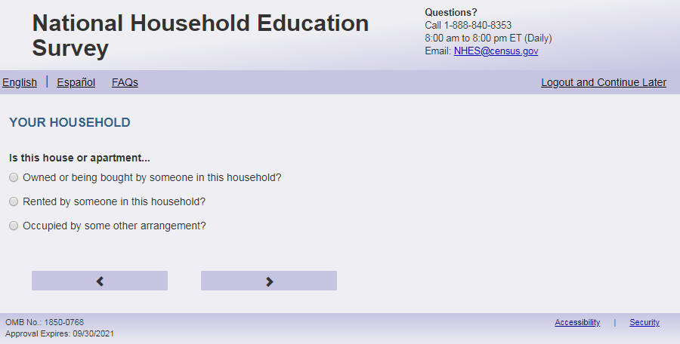
English Text Reads:
Is this house or apartment…

Spanish Text Reads:
¿Esta casa o apartamento…

English Admin/TQA Text Reads:
Is this house or apartment…

{Please read response options.}

Spanish Admin/TQA Text Reads:
¿Esta casa o apartamento…

{Por favor, lea las opciones de respuesta.}

English
1= Owned or being bought by someone in this household?
2= Rented by someone in this household?
3= Occupied by some other arrangement?

Spanish
1= ¿Es propiedad de alguien en el hogar o la está pagando alguien en este hogar?
2= ¿Es alquilada por alguien en este hogar?
3= ¿Es ocupada por algún otro tipo de acuerdo?

ECPP_OWNRNTHB, (1,3), numeric, radio

Skips:
Go to ECPP_HVINTCOM

Item: Household Internet Access (ECPP _HVINTCOM)
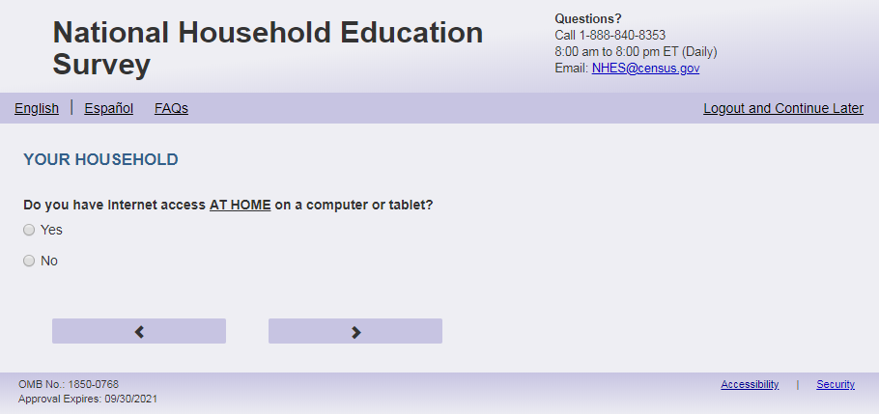
English Text Reads:
Does your household have Internet access AT HOME on a computer or tablet?

Spanish Text Reads:
¿Tiene su hogar acceso al internet EN LA CASA en una computadora o tableta?

English Answer
1=Yes
2=No

Spanish Answer
1= Sí
2=No

ECPP_HVINTCOM, (1,2), numeric, radio

Skips:

If ECPP_HVINTCOM = 2 and ECPP_P1INTSPHO = 2 and (ECPP_P2INTSPHO = 2 or missing) and (USE_CHOICE_PLUS = missing or 0) or (EBWP_FLAG = 1 and survey complete date is after 3/13/23) then go to thank_you
Else if ECPP_HVINTCOM = 2 and ECPP_P1INTSPHO = 2 and (ECPP_P2INTSPHO = 2 or missing) and (USE_CHOICE_PLUS = 1) or (EBWP_FLAG = 1 and survey complete date is on or before 3/13/23) then go to ECPP_Incent_Name
else go to ECPP_ CHLDNT

Item: Child’s Internet Use (ECPP_CHLDNT)
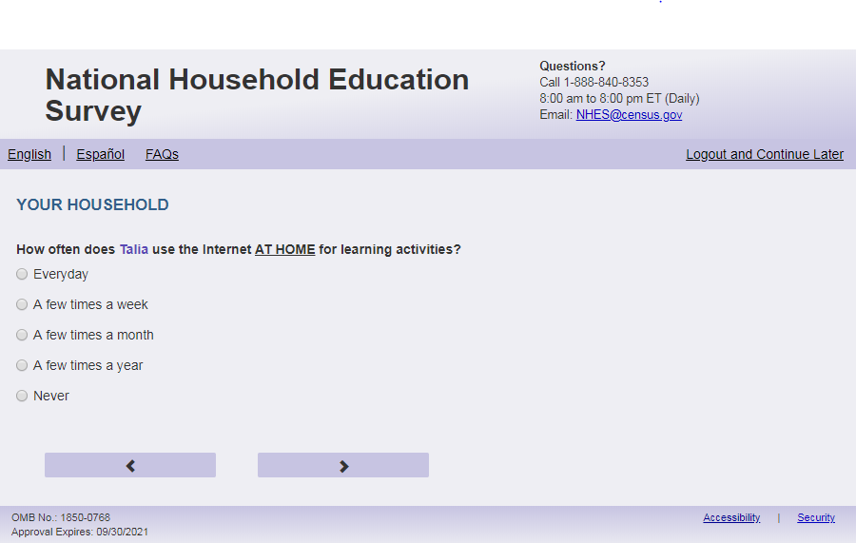
English Respondent Text
How often does [this child] use the Internet AT HOME for learning activities?

Spanish Respondent text:
¿Con qué frecuencia utiliza el internet [este niño (esta niña)] EN LA CASA para actividades de aprendizaje?

English Admin/TQA Text
How often does [this child] use the Internet AT HOME for learning activities?

{Please read response options.}
Spanish Admin/TQA text:
¿Con qué frecuencia utiliza el internet [este niño (esta niña)] EN LA CASA para actividades de aprendizaje?

{Por favor, lea las opciones de respuesta.}
English Answer
1= Every day
2 = A few times a week
3 = A few times a month
4 = A few times a year
5 = Never

Spanish Answer
1 = Todos los días
2 = Algunas veces a la semana
3 = Algunas veces al mes
4 = Algunas veces al año
5 = Nunca

ECPP_CHLDNT, (1,5) numeric, radio

Skips:
If ECPP_CHLDNT = 5 and (USE_CHOICE_PLUS = missing or 0) or (EBWP_FLAG = 1 and survey complete date is after 3/13/23) then go to thank_you
Else if ECPP_CHLDNT = 5 and (USE_CHOICE_PLUS = 1) or (EBWP_FLAG = 1 and survey complete date is on or before 3/13/23) then go to ECPP_Incent_Name

Else Go to ECPP_LRNCOMP

Item: Child’s Device for Learning Activities (ECPP_LRNCOMP)
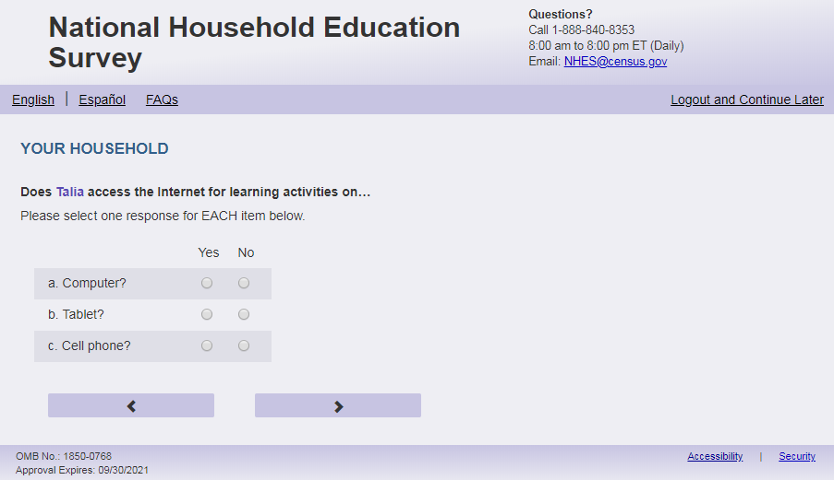
English Respondent Text:
Does this child use the Internet for learning activities on a…

- Computer? ECPP_LRNCOMP (1 = Yes 2 = No), numeric, radio
- Tablet? ECPP_LRNTAB (1 = Yes 2 = No), numeric, radio _
- Cell phone? ECPP_LRNCELL (1 = Yes 2 = No), numeric, radio

Spanish Respondent Text:
Utiliza el internet [este niño (esta niña)] para actividades de aprendizaje en…

- ¿Computadora? ECPP_LRNCOMP (1 = Sí 2 = No), numeric, radio
- ¿Tableta? ECPP_LRNTAB (1 = Sí 2 = No), numeric, radio
- ¿Teléfono celular? ECPP_LRNCELL (1 = Sí 2 = No), numeric, radio

English Admin/TQA Text:
Does this child use the Internet for learning activities on a computer? ECPP_LRNCOMP (1 = Yes 2 = No)
Does this child use the Internet for learning activities on a tablet? ECPP_LRNTAB (1 = Yes 2 = No)
Does this child use the Internet for learning activities on a cell phone? ECPP_LRNCELL (1 = Yes 2 = No)

Spanish Admin/TQA Text:
¿Utiliza el internet [este niño (esta niña)] para actividades de aprendizaje en una computadora? ECPP_LRNCOMP (1 = Sí 2 = No)
¿Utiliza el internet [este niño (esta niña)] para actividades de aprendizaje en una tableta? ECPP_LRNTAB (1 = Sí 2 = No)
¿Utiliza el internet [este niño (esta niña)] para actividades de aprendizaje en un teléfono celular? ECPP_LRNCELL (1 = Sí 2 = No)

Skips
If (USE_CHOICE_PLUS = missing or 0) or (EBWP_FLAG = 1 and survey complete date is after 3/13/23) then go to thank_you
Else if (USE_CHOICE_PLUS = 1) or (EBWP_FLAG = 1 and survey complete date is on or before 3/13/23) then go to ECPP_Incent_Name

Logic Checks/Programming specifications:
display as grid

Item: Confirm Information ECPP (ECPP_Incent_Name)
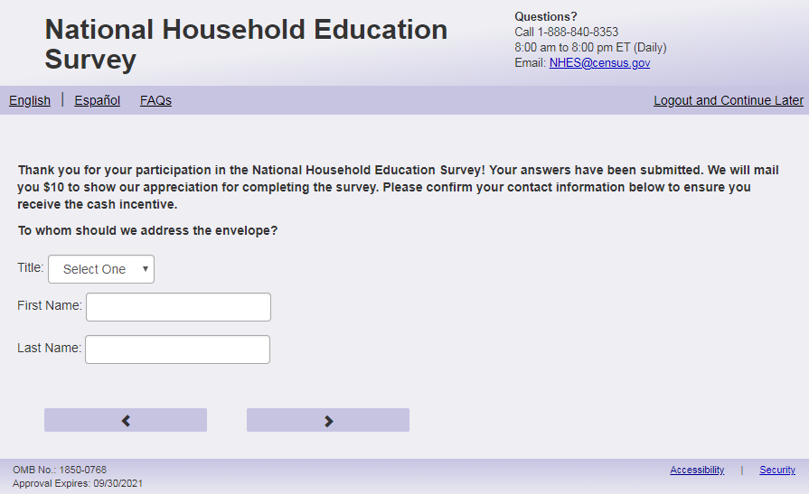
English Text Reads
Thank you for your participation in the National Household Education Survey! Your answers have been submitted. We will mail you $20 to show our appreciation for completing the survey. Please confirm your contact information below to ensure you receive the cash incentive.
To whom should we address the envelope?

Spanish Text Reads
Gracias por su participación en la Encuesta Nacional en Hogares sobre Educación. Sus respuestas han sido enviadas. Le enviaremos por correo $20 para mostrarle nuestro agradecimiento por completar la encuesta. Por favor, confirme su información de contacto a continuación para asegurarse de recibir el incentivo en efectivo.
¿A quién deberíamos dirigir el sobre?

English Answer
Title: (inc_title)
First Name: _____________________ (inc_gvname)
Last Name: _____________________ (inc_lstname)

Spanish Answer
Título: (inc_title)
Nombre de pila: _____________________ (inc_gvname)
Apellido: _____________________ (inc_lstname)

inc_title: Dropdown, char
inc_gvname: write-in (0, 100) character, write-in
inc_lstname: write-in (0, 100) character, write-in

Skip patterns:
Go to inc_address
Logic checks/Programming Specifications:
For inc_title use a standard dropdown for titles (for example: Mr., Ms., Mrs., Miss, Dr.)
Align inc_title dropdown with the other text boxes
English
Display “Title” to the left of the first dropdown box
Display “First Name” to the left of the first write-in box
Display “Last Name” to the left of the second write-in box

Item: Confirm address ECPP (ECPP_Inc_address )
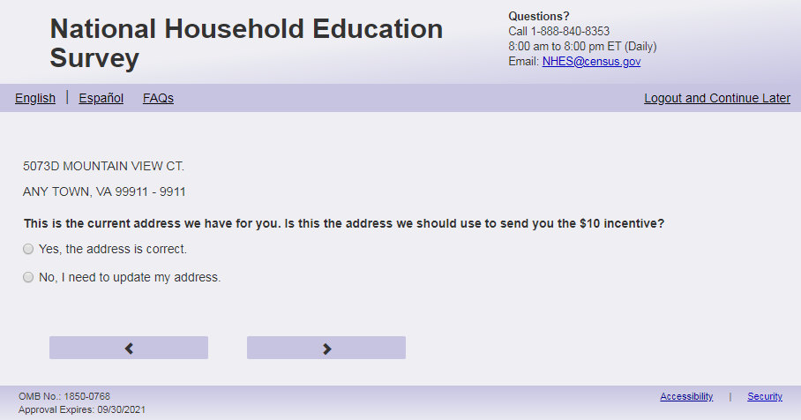
English Text Reads

PRIM_ADD
SEC_ADD
city, state zip-ZIP4

This is the current address we have for you. Is this the address we should use to send you the $20 incentive?
Spanish Text Reads
PRIM_ADD
SEC_ADD
city, state zip-ZIP4

Esta es la dirección actual que tenemos para usted. ¿Es esta la dirección que deberíamos usar para enviarle el incentivo de $20?
English Answer
1= Yes, the address is correct.
2= No, I need to update my address.
Spanish Answer
1= Sí, la dirección es correcta.
2= No, necesito actualizar mi dirección.
inc_address, (1,2), numeric, radio
Skip patterns:
Go to “ECPP_survey_end_inc” if ECPP_inc_address=1, else go to ECPP_prim_add_new
Logic checks/Programming specifications:
Display on the same page as inc_title, inc_gvname, inc_lstname
The variables PRIM_ADD, SEC_ADD, city, state, zip and ZIP4 are available on the frame file and specify the address of the household. These variables should be used to fill this item so that respondents can confirm their addresses.

Item: Address Information ECPP (ECPP_PRIM_ADD_new)
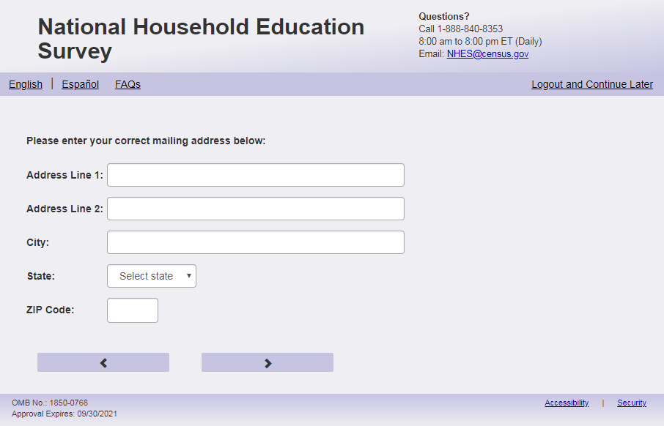
English Text reads:
Please enter your correct mailing address below:
Spanish Text reads:
Por favor ingrese su dirección postal correcta a continuación:
English Answer:
Address Line 1: _____________________________ (ECPP_PRIM_ADD_new)
Address Line 2: _____________________________ (ECPP_SEC_ADD_new)
City: _________________________ (ECPP_city_new)
State: ________________________ (ECPP_state_new)
ZIP:____________________ (ECPP_zip_new)
Spanish Answer:
Dirección Postal Line 1: _____________________________ (ECPP_PRIM_ADD_new)
Dirección Postal Line 2: _____________________________ (ECPP_SEC_ADD_new)
Ciudad: _________________________ (ECPP_city_new)
Estado: ________________________ (ECPP_state_new)
Código Postal:____________________ (ECPP_zip_new)

ECPP_PRIM_ADD_new: write-in (0, 100) character, write-in
ECPP_SEC_ADD_new: write-in (0, 100) character, write-in
ECPP_city_new: write-in (0, 100) character, write-in
ECPP_state_new: dropdown, numeric
ECPP_zip_new: write-in (0, 10) character, write-in, mobile: display numeric keypad
Skip patterns:
Go to “ECPP_survey_end_inc”
Logic checks/Programming Specifications:
For state_new dropdown, use a dropdown with the 50 states in the United States and the District of Columbia.
English
Display “Address Line 1” to the left of the first write-in box
Display “Address Line 2” to the left of the second write-in box
Display “City” to the left of the third write-in box
Display “State” to the left of the first dropdown box
Display “ZIP” to the left of the fourth write-in box
Spanish
Display “Dirección Postal 1” to the left of the first write-in box
Display “Dirección Postal 2” to the left of the second write-in box
Display “Ciudad” to the left of the third write-in box
Display “Estado” to the left of the first dropdown box
Display “Código Postal” to the left of the fourth write-in box

Item: Survey End (ECPP_survey_end_inc)
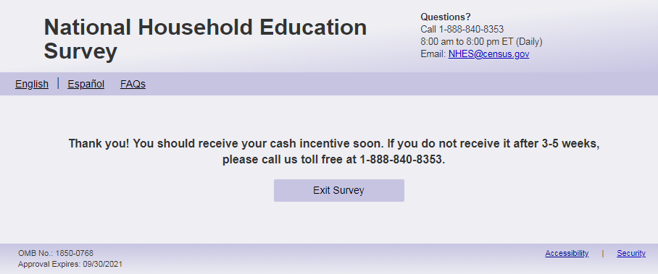
English Text reads:
Thank you! You should receive your cash incentive soon. If you do not receive it after 3-5 weeks, please call us toll free at 1-888-840-8353.
Spanish text reads:
¡Gracias! Debería recibir su incentivo en efectivo pronto. Si no lo recibe después de 3-5 semanas, llámenos grátis al 1-888-840-8353.

English Answer:
‘Exit Survey’ button
Spanish Answer:
‘Salir de la Encuesta button

Item: Thank You Page (ECPP_thank_you)
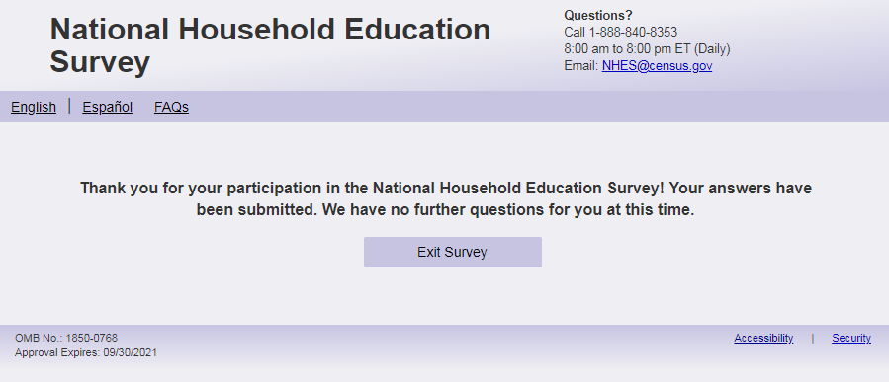
English: Thank you for your participation in the National Household Education Survey! Your answers have been submitted. We have no further questions for you.
Exit Survey button

Spanish: Gracias por su participación en la Encuesta Nacional en Hogares sobre Educación. Sus respuestas han sido enviadas. No tenemos más preguntas.

Salir de la Encuesta button

Item: After Exit Survey

After “Exit Survey” button is clicked the respondent goes to the login page and says “You have been logged out” (Spanish “Usted ha sido desconnectado”). See screenshots below. respondent doesn't have to select exit survey, reaching this page does submit their answer and their case would be considered submitted/complete. But selecting that exit survey re-affirms they are done and 'logged out'. Lastly, if you log back in for a case that has reached the page with 'exit survey' it simply takes you back to this page; you can't hit back and edit answers.

NHES:2023 Parent and Family Involvement Web Instrument Specification

WHERE TO START:
Prior to PFI_FDPDKIND: If sampled child's s1_p(X)enrol ne ‘1’ and s1_p(X)grade_web = 2 (Kindergarten) on Screener, ask PFI_FDPDKIND. If sampled child's s1_p(X)grade_web ne ' ' and ne 2 (Kindergarten), go to PFIC_EDCPUB. Else, if sampled child’s s1_p(X)grade_web is blank on screener for sampled child, go to PFI_PFIALLGRADEX_web. Note that the variable s1_p(X)enrol and s1_p(X)grade_web are from the screener.

Item: Full or Partial Kindergarten (PFIC_FDPDKIND)
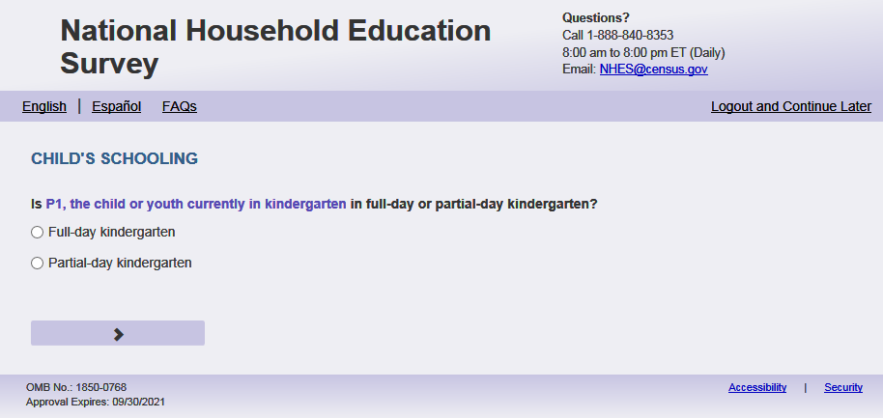
English Text Reads:

Is [this child] in full-day or partial-day kindergarten?

Spanish Text Reads:

¿Está [este niño (esta niña)] en kindergarten todo el día o parte del día?

English answer:

1= Full-day kindergarten
2= Partial-day kindergarten

Spanish answer:

1= Kindergarten todo el día
2= Kindergarten parte del día

PFI_FDPDKIND, (1,2) , numeric, radio

Skips:

go to PFIC_EDCPUB

Item: Child’s Current Grade (PFIC_ALLGRADEX_web)
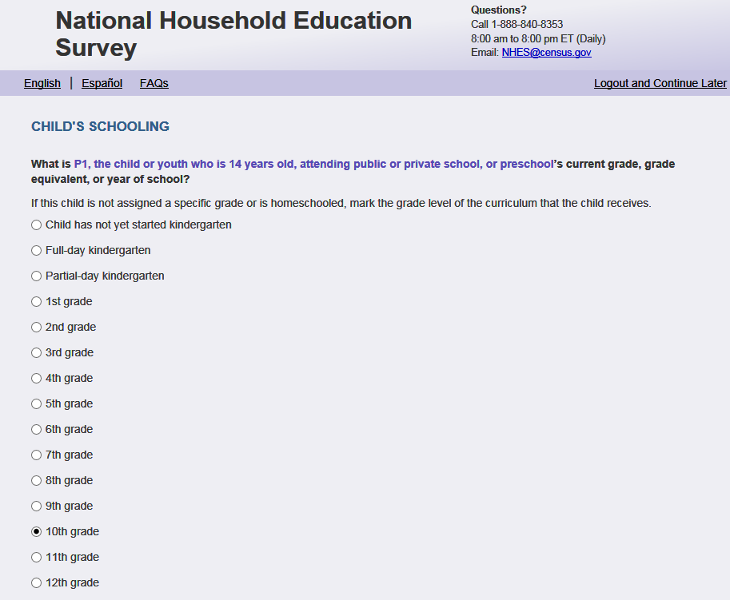
English Respondent Text Reads:

What is [this child]’s current grade, grade equivalent, or year of school?

If [he/she/he or she] is not assigned a specific grade or is homeschooled, select the grade level of the curriculum that the child receives.

Spanish Respondent Text Reads:

¿Cuál es el grado, equivalencia de grado o año escolar actual de [este niño(esta niña)]?

Si [el/ella/el o ella] no está asignado a un grado específico o recibe la enseñanza escolar en el hogar (homeschool), marque el nivel del grado del currículo que recibe [este niño (esta niña)].

English Admin/TQA Text Reads:

What is [this child]’s current grade, grade equivalent, or year of school?
{If needed:}
If [he/she/he or she] is not assigned a specific grade or is homeschooled, you can tell me the grade level of the curriculum that the child receives.
{If they say kindergarten ask them if it is full-day or partial-day}

Spanish Admin/TQA Text Reads:

¿Cuál es el grado, equivalencia de grado o año escolar actual de [este niño(esta niña)?
{If needed:}
Si [él /ella/él o ella] no está asignado a un grado específico o recibe la enseñanza escolar en el hogar (homeschool), puede decirme el nivel del grado del currículo que recibe [este niño (esta niña)].
{Si dicen kindergarten pregunte si es todo el día o parte del día}
English Answer:

1=Child has not yet started kindergarten
2= Full-day kindergarten
3= Partial-day kindergarten
4 = 1st grade
5 = 2nd grade
6 = 3rd grade
7 = 4th grade
8 = 5th grade
9 = 6th grade
10 = 7th grade
11 = 8th grade
12 = 9th grade
13 = 10th grade
14 = 11th grade
15 = 12th grade

Spanish Answer:

1=Niño(a) no ha empezado el kindergarten
2= Kindergarten todo el día
3= Kindergarten parte del día
4= Grado 1
5= Grado 2
6= Grado 3
7= Grado 4
8= Grado 5
9= Grado 6
10= Grado 7
11= Grado 8
12= Grado 9
13= Grado 10
14= Grado 11
15= Grado 12

PFIC_ALLGRADEX_web (1,15), numeric, radio

Skips:
if PFIALLGRADEX_web = 1, go to ECPPCHK on the ECPP questionnaire. Else, continue to PFIC_EDCPUB.

Logic Checks/Programming specifications:
English:
If S1_Pxsex = 1, use ‘he’, if s1_pxsex = 2, use ‘she’, else use ‘he or she’
Spanish:
If S1_Pxsex = 1, use ‘él’, if s1_pxsex = 2, use ‘ella’, else use ‘él o ella’

Item: Education Setting (PFIC_EDCPUB)
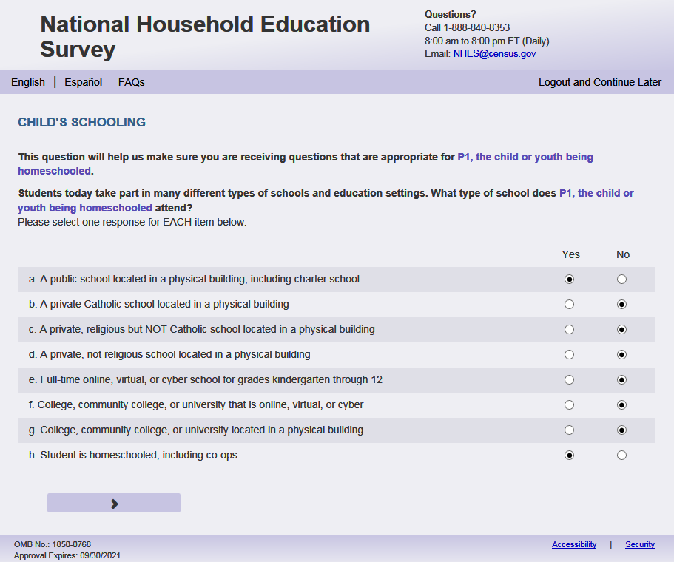
English Respondent Text Reads:
This question will help us make sure you are receiving questions that are appropriate for [this child].

Students today take part in many different types of schools and education settings. What type of school does [this child] attend?

Spanish Respondent Text Reads:
Esta pregunta nos ayudará a asegurarnos de que está recibiendo las preguntas adecuadas para [este niño (esta niña)].

En la actualidad, los estudiantes participan en muchos tipos diferentes de escuelas y ambientes educacionales. ¿A qué tipo de escuela asiste [este niño (esta niña)]?
English Admin/TQA Text Reads:
This question will help us make sure you are receiving questions that are appropriate for [this child].

Students today take part in many different types of schools and education settings.
Please answer ‘yes’ or ‘no’ for EACH item as I read them.

Spanish Admin/TQA Text Reads:
Esta pregunta nos ayudará a asegurarnos de que está recibiendo las preguntas adecuadas para [este niño (esta niña)].

En la actualidad, los estudiantes participan en muchos tipos diferentes de escuelas y ambientes educacionales. ¿A qué tipo de escuela asiste [este niño (esta niña)]? Por favor, responda ‘sí’ o ‘no’ para cada opción a medida que las leo.

English Respondent Answer:
- A public school located in a physical building, including charter school PFIC_EDCPUB, (1= Yes, 2= No), numeric, radio
- A private Catholic school located in a physical building PFIC_EDCCAT, (1= Yes, 2= No), numeric, radio
- A private, religious but NOT Catholic school located in a physical building PFIC_EDCREL, (1= Yes, 2= No), numeric, radio
- A private, not religious school located in a physical building PFIC_EDCPRI, (1= Yes, 2= No), numeric, radio
- Full-time online, virtual, or cyber school for grades kindergarten through 12 PFIC_EDCINTK12, (1= Yes, 2= No), numeric, radio
- College, community college, or university that is online, virtual, or cyber PFIC_EDCINTCOL, (1= Yes, 2= No), numeric, radio
- College, community college, or university located in a physical building PFIC_EDCCOL, (1= Yes, 2= No), numeric, radio
- Student is homeschooled, including co-ops PFIC_EDCHSFL, (1= Yes, 2= No), numeric, radio

Spanish Respondent Answer:
- Una escuela pública localizada en un edificio físico, incluyendo escuela charter PFIC_EDCPUB (1= Sí, 2= No), numeric, radio
- Una escuela católica privada localizada en un edificio físico PFIC_EDCCAT (1= Sí, 2= No), numeric, radio
- Una escuela religiosa privada pero NO católica, localizada en un edificio físico PFIC_EDCREL (1= Sí, 2= No), numeric, radio
- Una escuela privada, pero no religiosa localizada en un edificio físico PFIC_EDCPRI (1= Sí, 2= No), numeric, radio
- Escuela online, virtual o cyber de tiempo completo para grados de kindergarten hasta 12° gradoPFIC_EDCINTK12 (1= Sí, 2= No), numeric, radio
- Un college, colegio comunitario o universidad online, virtual, o cyber PFIC_EDCINTCOL (1= Sí, 2= No), numeric, radio
- College, colegio comunitario, o universidad localizado en un edificio físico PFIC_EDCCOL (1= Sí, 2= No), numeric, radio
- Estudiante recibe su enseñanza escolar en el hogar (homeschool), incluyendo materias cooperativas de padres para enseñanza escolar en el hogar, PFIC_EDCHSFL (1= Sí, 2= No), numeric, radio

English Admin/TQA Answer:
- Does [this child] attend a public school located in a physical building, including charter school? PFIC_EDCPUB, (1= Yes, 2= No), numeric, radio {If yes, ask if the child attends any other kind of school or is homeschooled. If no, skip to the question on the next screen. If yes, continue to b.}
- Does [this child] attend a private Catholic school located in a physical building? PFIC_EDCCAT, (1= Yes, 2= No), numeric, radio
- Does [this child] attend a private, religious but NOT Catholic school located in a physical? building PFIC_EDCREL, (1= Yes, 2= No), numeric, radio
- Does [this child] attend a private, not religious school located in a physical building? PFIC_EDCPRI, (1= Yes, 2= No), numeric, radio
- Does [this child] attend a full-time online, virtual, or cyber school for grades kindergarten? through 12 PFIC_EDCINTK12, (1= Yes, 2= No), numeric, radio
- Does [this child] attend a college, community college, or university that is online, virtual, or cyber? PFIC_EDCINTCOL, (1= Yes, 2= No), numeric, radio
- Does [this child] attend a college, community college, or university located in a physical building? PFIC_EDCCOL, (1= Yes, 2= No), numeric, radio
- Is [this child] homeschooled, including co-ops? PFIC_EDCHSFL, (1= Yes, 2= No), numeric, radio

Spanish Admin/TQA Answer:
- ¿Asiste [este niño (esta niña)] a una escuela pública localizada en un edificio físico, incluyendo escuela charter PFIC_EDCPUB (1= Sí, 2= No), numeric, radio {Si sí, pregunte si el niño(a) asiste a algún otro tipo de escuela o si recibel la enseñanza escolar en el hogar (homeschool). Si no, salte a la pregunta en la siguiente pantalla. Si sí continue con la opción b.}
- ¿Asiste [este niño (esta niña)] a una escuela católica privada localizada en un edificio físico PFIC_EDCCAT (1= Sí, 2= No), numeric, radio
- ¿Asiste [este niño (esta niña)] a una escuela religiosa privada pero NO católica localizada en un edificio físico PFIC_EDCREL (1= Sí, 2= No), numeric, radio
- ¿Asiste [este niño (esta niña)] a una escuela privada pero no religiosa localizada en un edificio físico PFIC_EDCPRI (1= Sí, 2= No), numeric, radio
- ¿Asiste [este niño (esta niña)] a una escuela online, virtual o cyber de tiempo completo para grados de kindergarten hasta 12° gradoPFIC_EDCINTK12 (1= Sí, 2= No), numeric, radio
- ¿Asiste [este niño (esta niña)] a un college, colegio comunitario o universidad online, virtual, o cyber PFIC_EDCINTCOL (1= Sí, 2= No), numeric, radio
- ¿Asiste [ este niño (esta niña)] a college, colegio comunitario, o universidad localizada PFIC_EDCCOL (1= Sí, 2= No), numeric, radio
- [Este niño (esta niña)] recibe la enseñanza escolar en el hogar (homeschool) solamente, incluyendo a coops, PFIC_EDCHSFL (1= Sí, 2= No), numeric, radio

Skips
  - Please use the following table. This logic is hierarchical.
Response | Paper Q skip to | Web spec
a. public school | 30 | If (PFIC_EDCPUB = 1 and all others are blank or 2) OR (PFIC_EDCPUB = 1 and (PFIC_EDCINTCOL=1 or PFIC_EDCCOL=1) and all others are blank or 2), go to PFIC_DISTASSI
b. private Catholic | 33 | If (PFIC_EDCCAT = 1 and all others are blank or 2) OR (PFIC_EDCCAT = 1 and (PFIC_EDCINTCOL=1 or PFIC_EDCCOL=1) and all others are blank or 2), go to PFIC_SNEIGHBRX
c. private religious | 33 | If (PFIC_EDCREL = 1 and all others are blank or 2) OR (PFIC_EDCREL = 1 and (PFIC_EDCINTCOL=1 or PFIC_EDCCOL=1) and all others are blank or 2), go to PFIC_SNEIGHBRX
d. private, not religious | 33 | If (PFIC_EDCPRI= 1 and all others are blank or 2) OR (PFIC_EDCPRI = 1 and (PFIC_EDCINTCOL=1 or PFIC_EDCCOL=1) and all others are blank or 2) go to PFIC_SNEIGHBRX
e. online/virtual/cyber | 30 | If PFIC_EDCINTK12= 1 and all others are 2 or blank or 2, go to PFIC_ DISTASSI
f. college, community college - virtual | [web only item] | If PFIC_EDCINTCOL = 1 and all others are 2 or blank then go to PFIC_OTHSCHL
g. college, community college - physical | [web only item] | If PFIC_EDCCOL = 1 and all others are 2 or blank then go to PFIC_OTHSCHL
h. homeschooled | 4 | If PFIC_EDCHSFL= 1 and all others are 2 or blank go to PFIC_HOMESCHLX
h. AND a. and any other choices | 4 | If PFIC_EDCHSFL= 1 and PFIC_EDCPUB = 1 then go to PFIC_HOMESCHLX
h. AND b., c., d. in any combination | 4 | If PFIC_EDCHSFL= 1 and at least one of (PFIC_EDCCAT, PFIC_EDCREL PFIC_EDCPRI) = 1 then go to PFIC_HOMESCHLX
h. AND e. | 4 | If PFIC_EDCHSFL= 1 and PFIC_EDCINTK12= 1, then go to PFIC_HOMESCHLX
h. and f., g. in any combination | 4 | If PFIC_EDCHSFL= 1 and at least one of (PFIC_EDCINTCOL, PFIC_EDCHSPR)=1then go to PFIC_HOMESCHLX
a. and any combination of b., c., d. | 30 | If PFIC_EDCPUB = 1 and at least one of (PFIC_EDCCAT, PFIC_EDCREL PFIC_EDCPRI) =1 go to PFIC_DISTASSI
a. and e. and any combination without h | 30 | If PFIC_EDCPUB = 1 and PFIC_EDCINTK12= 1 and PFIC_EDCHSFL ne 1 go to PFIC_DISTASSI
b. or c. or d. and e. and any combination without h | 33 | If (PFIC_EDCCAT = 1 or PFIC_EDCREL = 1 or PFIC_EDCPRI= 1) and PFIC_EDCINTK12= 1 and PFIC_EDCHSFL ne 1, go to PFIC_SNEIGHBRX
Any combination of b., c., d. alone | 33 | If any of (PFIC_EDCCAT, PFIC_EDCREL, PFIC_EDCPRI)= 1 and all others are blank or 2 go to PFIC_SNEIGHBRX
If f and g, alone | [web only item] | If (PFIC_EDCINTCOL = 1 and PFIC_EDCCOL = 1) and all others are blank or 2 go to PFIC_OTHSCHL
Blank on all a-h or No on all a – h or any combination of blank and no | [web only item] | If Blank on all a-h (PFIC_EDCPUB- PFIC_EDCHSFL) or No on all a – h (PFIC_EDCPUB- PFIC_EDCHSFL) or any combination of blank and no on all a – h (PFIC_EDCPUB- PFIC_EDCHSFL) Go to PFIC_OTHSCHL

Item: School Other than College (PFIC_OTHSCHL)
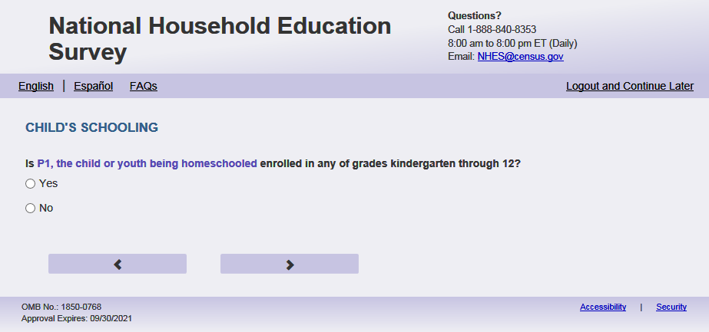
English Text
Is [this CHILD] enrolled in any of grades kindergarten through 12?
Spanish Text
¿Está inscrito [este niño (esta niña)] en cualquier grado del kínder hasta el grado 12?
English Answer
1= Yes
2= No

Spanish Answer
1= Sí
2=No

PFIC_OTHSCHL (1=Yes, 2= No), numeric, radio
Skips
If PFIC_OTHSCHL = 2 and (USE_CHOICE_PLUS = missing or 0) or (EBWP_FLAG = 1 and survey complete date is after 3/13/23) then go to thank_you
Else if PFIC_OTHSCHL = 2 and (USE_CHOICE_PLUS= 1) or (EBWP_FLAG = 1 and survey complete date is on or before 3/13/23) then go to Incent_Name
else go to PFIC_EDCPUB2

Item: Education Setting Type of School (PFIC_EDCPUB2)
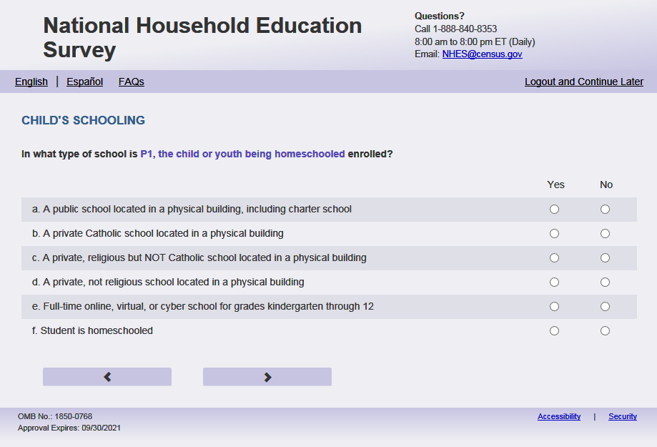
English Respondent Text
In what type of school is [this child] enrolled?
Spanish Respondent Text
¿En que clase de escuela está inscrito [este niño (esta niña)]?
English Admin/TQA Text
Please answer ‘yes’ or ‘no’ for each item as I read them.
Spanish Admin/TQA Text
Por favor, responda 'sí' o 'no' para cada opción a medida que las leo.
English Respondent Answers
- A public school located in a physical building, including charter school PFIC_EDCPUB2, (1= Yes, 2= No), numeric, radio
- A private Catholic school located in a physical building PFIC_EDCCAT2, (1= Yes, 2= No), numeric, radio
- A private, religious but NOT Catholic school located in a physical building PFIC_EDCREL2, (1= Yes, 2= No), numeric, radio
- A private, not religious school located in a physical building PFIC_EDCPRI2, (1= Yes, 2= No), numeric, radio
- Full-time online, virtual, or cyber school for grades kindergarten through 12 PFIC_EDCINTK122, (1= Yes, 2= No), numeric, radio
- Student is homeschooled PFIC_EDCHSFL2, (1= Yes, 2= No), numeric, radio

Spanish Respondent Answers
- Una escuela pública localizada en un edificio físico, incluyendo escuela charter PFIC_EDCPUB2 (1= Sí, 2= No), numeric, radio
- Una escuela católica privada localizada en un sitio físico PFIC_EDCCAT2 (1= Sí, 2= No), numeric, radio
- Una escuela religiosa privada pero NO católica, localizada en un edificio físico PFIC_EDCREL2 (1= Sí, 2= No), numeric, radio
- Una escuela privada, pero no religiosa localizada en un edificio físico PFIC_EDCPRI2 (1= Sí, 2= No), numeric, radio
- Escuela online, virtual o cyber de tiempo completo para grados de kindergarten hasta 12° gradoPFIC_EDCINTK122 (1= Sí, 2= No), numeric, radio
- Estudiante recibe la enseñanza escolar en el hogar (homeschool) solamente, incluyendo a coops, PFIC_EDCHSFL2 (1= Sí, 2= No), numeric, radio

English Admin/TQA Answers
- Does [this child] attend a public school located in a physical building, including charter school PFIC_EDCPUB2, (1= Yes, 2= No), numeric, radio
- Does [this child] attend a private Catholic school located in a physical building PFIC_EDCCAT2, (1= Yes, 2= No), numeric, radio
- Does [this child] attend a private, religious but NOT Catholic school located in a physical building PFIC_EDCREL2, (1= Yes, 2= No), numeric, radio
- Does [this child] attend a private, not religious school located in a physical building PFIC_EDCPRI2, (1= Yes, 2= No), numeric, radio
- Does [this child] attend a full-time online, virtual, or cyber school for grades kindergarten through 12 PFIC_EDCINTK122, (1= Yes, 2= No), numeric, radio
- Is [this child] homeschooled PFIC_EDCHSFL2, (1= Yes, 2= No), numeric, radio

Spanish Admin/TQA Answers
- ¿Asiste [este niño (esta niña)]a una escuela pública localizada en un edificio físico, incluyendo escuela charter PFIC_EDCPUB2 (1= Sí, 2= No), numeric, radio
- ¿Asiste [este niño (esta niña)]a una escuela católica privada localizada en un sitio físico PFIC_EDCCAT2 (1= Sí, 2= No), numeric, radio
- ¿Asiste [este niño (esta niña)]a una escuela religiosa privada pero NO católica localizada en un edificio físico PFIC_EDCREL2 (1= Sí, 2= No), numeric, radio
- ¿Asiste [este niño (esta niña)]a una escuela privada pero no religiosa localizada en un edificio físico PFIC_EDCPRI2 (1= Sí, 2= No), numeric, radio
- ¿Asiste [este niño (esta niña)] a una escuela online, virtual o cyber de tiempo completo para grados de kindergarten hasta 12° gradoPFIC_EDCINTK122 (1= Sí, 2= No), numeric, radio
- [Este niño (esta niña)]recibe la enseñanza escolar en el hogar (homeschool) solamente, incluyendo a coops, PFIC_EDCHSFL2 (1= Sí, 2= No), numeric, radio

Skips
Please use the following table. This logic is hierarchical.
Response | Paper Q skip to | Web spec
a. public school | 30 | If PFIC_EDCPUB2 = 1 and all others are blank or 2, go to PFIC_DISTASSI
b. private Catholic | 33 | If PFIC_EDCCAT2 = 1 and all others are blank or 2 go  to PFIC_SNEIGHBRX
c. private religious | 33 | If PFIC_EDCREL2 = 1 and all others are blank or 2 go to PFIC_SNEIGHBRX
d. private, not religious | 33 | If PFIC_EDCPRI2= 1 and all others are blank or 2 go to PFIC_SNEIGHBRX
e. online/virtual/cyber | 30 | If PFIC_EDCINTK122= 1 and all others are 2 or blank or 2, go to PFIC_DISTASSI
f. homeschooled | 4 | If PFIC_EDCHSFL2= 1 and all others are 2 or blank go to PFIC_HOMESCHLX
f. AND a. and any other choices | 4 | If PFIC_EDCHSFL2= 1 and PFIC_EDCPUB2 = 1 and (PFIC_EDCCAT2 = 1 or PFIC_EDCREL2 = 1 or PFIC_EDCPRI2 = 1 or PFIC_EDCINTK122 = 1) then go to PFIC_HOMESCHLX
f. AND b., c., d. in any combination | 4 | If PFIC_EDCHSFL2= 1 and at least one of (PFIC_EDCCAT2, PFIC_EDCREL2 PFIC_EDCPRI2) = 1 then go to PFIC_HOMESCHLX
f. AND e. | 4 | If PFIC_EDCHSFL2= 1 and PFIC_EDCINTK122= 1 then go to PFIC_HOMESCHLX
a. and any combination of b., c., d. | 30 | If PFIC_EDCPUB2 = 1 and at least one of (PFIC_EDCCAT2, PFIC_EDCREL2 PFIC_EDCPRI2) = 1 go to PFIC_DISTASSI
a. and e. and any combination without f | 30 | If PFIC_EDCPUB2 = 1 and PFIC_EDCINTK122= 1 and PFIC_EDCHSFL2 ne 1 go to PFIC_DISTASSI
b. or c. or d. and e. and any combination without f | 33 | If (PFIC_EDCCAT2 = 1 or PFIC_EDCREL2 = 1 or PFIC_EDCPRI2= 1) and PFIC_EDCINTK122= 1 and PFIC_EDCHSFL2 ne 1, go to PFIC_SNEIGHBRX
Any combination of b., c., d. alone | 33 | If any of (PFIC_EDCCAT2, PFIC_EDCREL2, PFIC_EDCPRI2)= 1 and all others are blank or 2 go to PFIC_SNEIGHBRX
Blank on all a-f or No on all a – f or any combination of blank and no | 4 | If Blank on all a-f (PFIC_EDCPUB2- PFIC_EDCHSFL2) or No on all a – f (PFIC_EDCPUB2- PFIC_EDCHSFL2) or any combination of blank and no on all a – f (PFIC_EDCPUB2- PFIC_EDCHSFL2) go to PFIC_HOMESCHLX

Item: Home School Alternative (PFIC_HOMESCHLX)
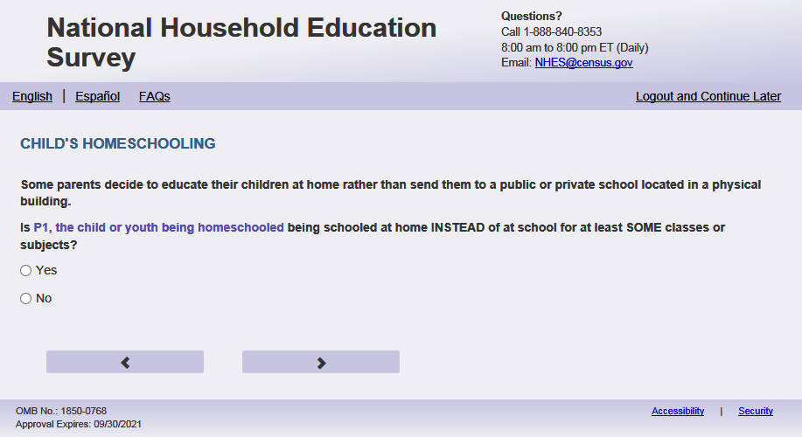
English Text Reads:
Some parents decide to educate their children at home rather than send them to a public or private school located in a physical building.

Is [this child] being schooled at home INSTEAD of at school for at least SOME classes or subjects?

Spanish Text Reads:
Algunos padres deciden dar a sus niños su educación escolar en el hogar en vez de enviarlos a una escuela pública o privada ubicada en un edificio.

¿[Este niño(a)] está recibiendo su enseñanza escolar en el hogar (homeschool) EN VEZ de en una escuela, al menos para ALGUNAS de las clases o materias?

English Answer
1 = Yes
2 = No

Spanish Answer
1= Sí
2=No
PFIC_HOMESCHLX, (1,2), numeric, radio

Skips:
  - Please use the following table. This logic is hierarchical.
Responses | Skip
If PFIC_HOMESCHLX = 1 or blank | Go to PFIC_HMSCHARR
If PFIC_HOMESCHLX = 2 and ((On EDCPUB: PFIC_EDCHSFL = 1 and all others are 2 or blank) OR if (On EDCPUB2: PFIC_EDCHSFL2 = 1 and all others are 2 or blank)) | Go to PFIC_EDCPUB
If (PFIC_HOMESCHLX = 2 and (PFIC_EDCHSFL = 1 and (PFIC_EDCPUB = 1) or (PFIC_EDCHSFL2 = 1 and PFIC_EDCPUB2 = 1)) OR (if no or blank to all of EDCPUB and EDCPUB2 and PFIC_HOMESCHLX = 2) | Go to PFIC_DISTASSI
If PFIC_HOMESCHLX = 2 and (((PFIC_EDCHSFL= 1 and at least one of (PFIC_EDCCAT , PFIC_EDCREL, PFIC_EDCPRI) = 1) OR if (PFIC_EDSCHSFL2 = 1 and at least one of ((PFIC_EDCCAT2, PFIC_EDCREL2, PFIC_EDCPRI122)=1))) | Go to PFIC_SNEIGHBRX
If PFIC_HOMESCHLX = 2 and ((PFIC_EDCHSFL= 1 and PFIC_EDCINTK12 = 1) or (PFIC_PFIC_EDCHSFL2 = 1 and PFIC_EDCINTK122 =1))) | Go to PFIC_ DISTASSI
If PFIC_HOMESCHLX = 2 and (PFIC_EDCHSFL= 1 and at least one of (PFIC_EDCINTCOL = 1 or PFIC_EDCHSFL2 = 1) | Go to PFIC_OTHSCHL

Item: Home School Arrangement (PFIC_HMSCHARR)
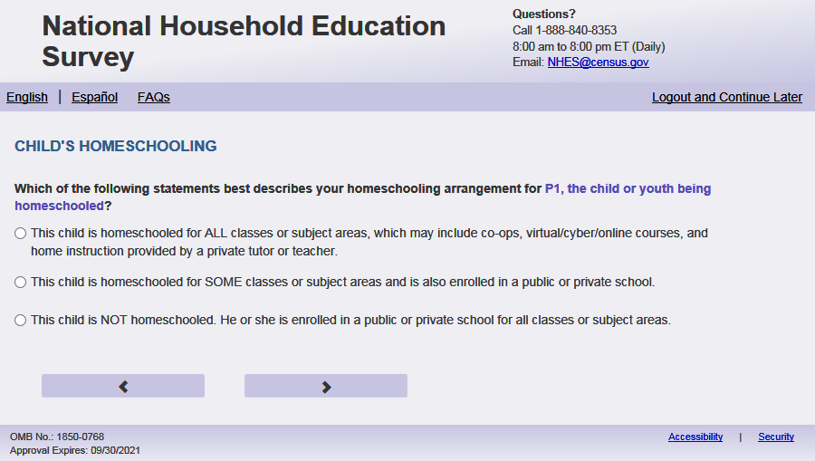
English Text Reads:
Which of the following statements best describes your homeschooling arrangement for [this child]?

Spanish Text Reads:
¿Cuál de las siguientes afirmaciones describe mejor el arreglo de enseñanza escolar en el hogar (homeschool) para [este niño (esta niña)]?

English Answer
1=[This child] is homeschooled for ALL classes or subject areas, which may include co-ops, virtual/cyber/online courses, and home instruction provided by a private tutor or teacher
2=[This child] is homeschooled for SOME classes or subject areas and is also enrolled in a public or private school
3=[This child] is NOT homeschooled. [He/She/He or She] is enrolled in a public or private school for all classes or subject areas

Spanish Answer
1= [Este niño (Esta niña)] recibe la enseñanza escolar en el hogar para TODAS las clases o asignaturas, lo cual puede incluir clases por cooperativas de padres, cursos virtual/cyber/online, e instrucción en el hogar proporcionada por un tutor o maestro particular
2= [Este niño (Esta niña)] recibe la enseñanza escolar en el hogar para ALGUNAS clases o asignaturas y también asiste a la escuela pública o privada
3= [Este niño (Esta niña)] NO recibe la enseñanza escolar en el hogar. [Este niño (Esta niña)] asiste a la escuela pública o privada para todas las clases o asignaturas

PFIC_HMSCHARR, (1,3) numeric, radio

Skips:
  - Please use the following table
Responses | Skip
If HMSCHARR in (1,2) or blank | Go to PFIC_HSCOOP
If PFIC_HMSCHARR =3 AND if (On EDCPUB: PFIC_EDCHSFL = 1 and all others are 2 or blank) OR if (On EDCPUB2: PFIC_EDCHSFL2 = 1 and all others are 2 or blank) OR (if no or blank to all of EDCPUB and EDCPUB2) | Go to PFIC_DISTASSI
If PFIC_HMSCHARR =3 AND if (PFIC_EDCHSFL = 1 and (PFIC_EDCPUB = 1) or (PFIC_EDCHSFL2 = 1 and PFIC_EDCPUB2 = 1) | Go to PFIC_DISTASSI
If PFIC_HMSCHARR =3 AND if ((PFIC_EDCHSFL= 1 and at least one of (PFIC_EDCCAT, PFIC_EDCREL, PFIC_EDCPRI) = 1) OR if (PFIC_EDSCHSFL2 = 1 and at least one of ((PFIC_EDCCAT2, PFIC_EDCREL2, PFIC_EDCPRI122)=1)) | Go to PFIC_SNEIGHBRX
If PFIC_HMSCHARR =3 AND if (PFIC_EDCHSFL= 1 and PFIC_EDCINTK12 = 1) or (PFIC_PFIC_EDCHSFL2 = 1 and PFIC_EDCINTK122 =1)) | Go to PFIC_DISTASSI
If PFIC_HMSCHARR =3 AND if (PFIC_EDCHSFL= 1 and at least one of (PFIC_EDCINTCOL = 1 or PFIC_EDCCOL = 1)) or PFIC_EDCHSFL2 = 1 | Go to PFIC_OTHSCHL
If PFIC_HMSCHARR =3 AND no other condition above holds true | Go to PFIC_DISTASSI

Logic checks/Programming specifications:
English:
If S1_Pxsex = 1, use ‘He’, if s1_pxsex = 2, use ‘She’, else use ‘He or she’

Item: Homeschooling in Co-op (PFIC_HSCOOP)
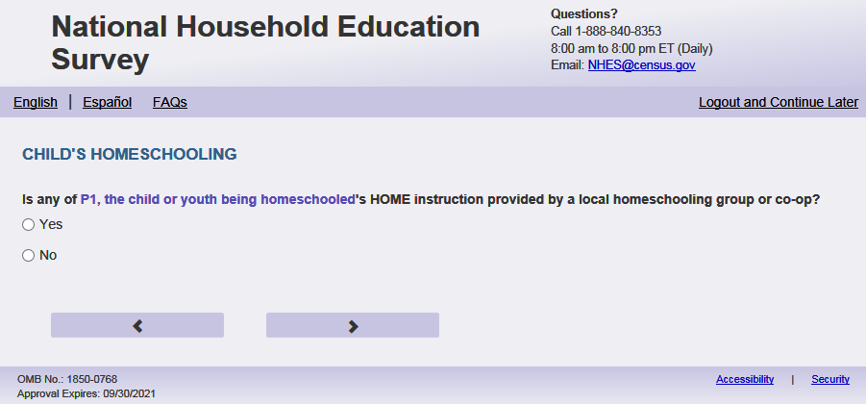
English Text Reads:
Is any of [this child]’s instruction provided by a local homeschooling group or co-op?

Spanish Text Reads:
¿Recibe [este niño(esta niña)] alguna parte de su instrucción en un grupo o cooperativa local para la enseñanza escolar en el hogar (homeschool)?

English Answer
1= Yes
2=No

Spanish Answer
1= Sí
2=No

PFIC_HSCOOP, (1,2), numeric, radio
Skip patterns:
Go to PFIC_HSWHOX

Item: Main Person Providing Instruction (PFIC_HSWHOX)
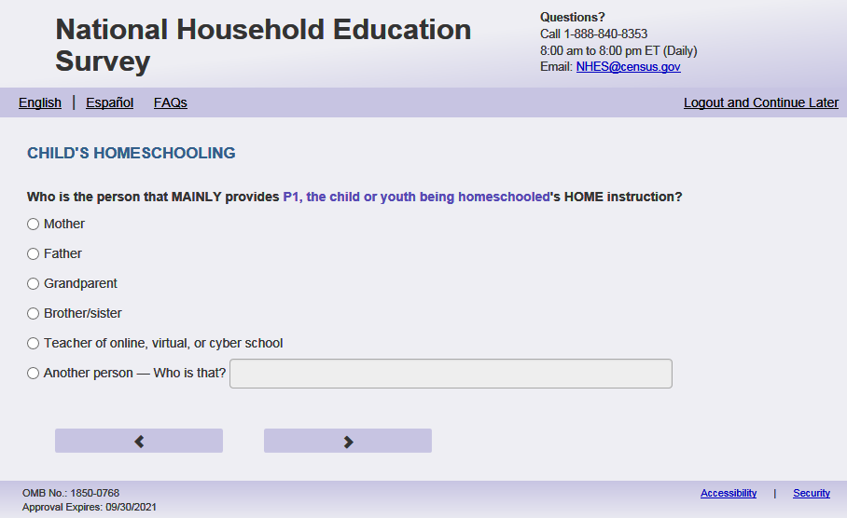
English Text Reads:

Who is the person that MAINLY provides [this child]’s HOME instruction?

Spanish Text Reads:

¿Quién es la persona que le ofrece PRINCIPALMENTE la enseñanza escolar en EL HOGAR (homeschool) a [este niño (esta niña)]?

English Answer
1= Mother
2= Father
3= Grandparent
4= Brother/sister
5 = Teacher of online, virtual, or cyber school
6 = Another person -Who is that? (PFIC_HSWOOSX)

Spanish Answer
1= Madre
2= Padre
3= Abuelo/abuela
4= Hermano/hermana
5 = Un maestro online, virtual o cyber
6= Otra persona - ¿Quién es la persona? (PFIC_HSWOOSX)

PFIC_HSWHOX, (1,6) numeric, radio
PFIC_HSWHOOSX (0, 100), character, write-in
Skip patterns:
Go to PFIC_HSTUTOR
Logic checks/Programming specifications:
If PFIC_HSWHOX = 6, then activate PFIC_HSWHOOSX., PFIC_HSWHOOSX should only be allowed if PFIC_HSWHOX=6
PFIC_HSWHOOSX should be displayed as box 1 row by 30 characters

Item: Home Instruction by Tutor (PFIC_HSTUTOR)
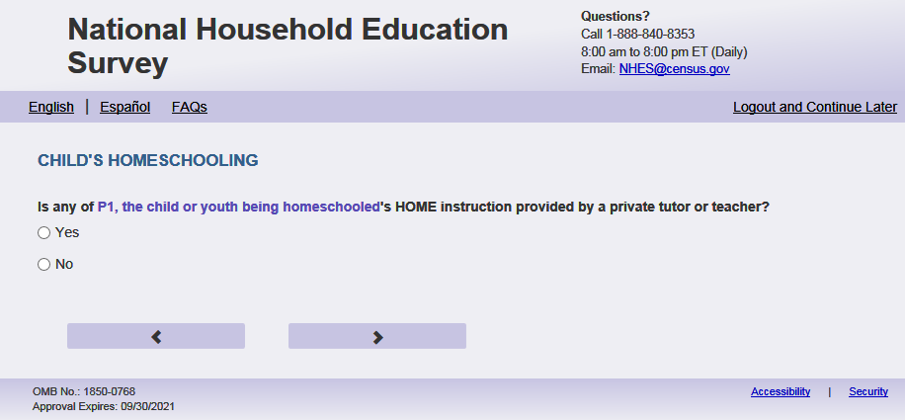
English Text Reads:
Excluding co-ops and online courses, is any of [this child]’s HOME instruction provided by a private tutor or teacher?

Spanish Text Reads:
¿[Este niño(Esta niña)] recibe de un tutor o maestro privado parte de su enseñanza escolar en el hogar (homeschool), sin incluir cooperativas y cursos online?

English Answer
1= Yes
2= No

Spanish Answer
1= Sí
2=No

PFIC_HSTUTOR, (1,2), numeric, radio
Skip patterns:
Go to PFIC_HSINTNET

Item: Online courses homeschool (PFIC_HSINTNET)
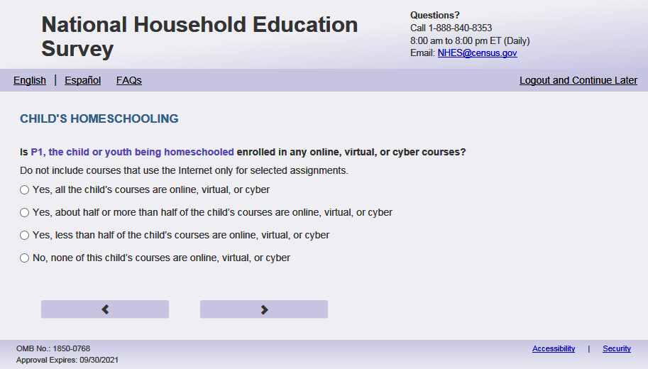
English Respondent Text Reads:
Is [this child] enrolled in any online, virtual, or cyber courses?

Do not include courses that use the Internet for only selected assignments.

Spanish Respondent Text Reads:
¿Está inscrito [este niño (esta niña)] en cursos online, virtuales, o cyber?

No incluya cursos que usan el internet solamente para tareas específicas.

English Admin/TQA Text Reads:
Is [this child] enrolled in any online, virtual, or cyber courses?

Do not include courses that use the Internet for only selected assignments.

[The term “online, virtual, or cyber course ” should be an active link for the Admin/TQA screen. Add definition hover over “online, virtual, or cyber courses:] In an online, virtual, or cyber course, instruction is conducted over the Internet. Students can access the course from a location with an Internet connection. These courses are generally conducted through an online platform where students can view their course syllabus and academic progress, as well as communicate with fellow students and their course instructor.
{If ‘yes,’ then read yes options to the respondent.}

Spanish Admin/TQA Text Reads:
¿Está inscrito [este niño(esta niña)] en cursos online, virtuales, o cyber?

No incluya cursos que usan el internet solamente para específicos tareas.

[The term “curso online, virtual, o cyber” should be an active link for the Admin/TQA screen. Add definition hover over “cursos online, virtuales, o cyber”:] En un curso online, virtual o cyber, la instrucción se lleva a cabo a través de Internet. Los estudiantes pueden acceder al curso desde una ubicación con conexión a Internet. Estos cursos generalmente se llevan a cabo a través de una plataforma en línea donde los estudiantes pueden ver su programa de estudios y el progreso académico, así como comunicarse con otros estudiantes y su instructor del curso.
{Si 'sí', entonces lea las opciones de sí al encuestado.}
English Answer
1= Yes, all [this child]’s courses are online, virtual, or cyber
2= Yes, about half or more than half of [this child]’s courses are online, virtual, or cyber
3= Yes, less than half of [this child]’s courses are online, virtual, or cyber
4= No, none of [this child]’s courses are online, virtual, or cyber

Spanish Answer
1= Sí, todos los cursos del [este niño(esta niña)] son online, virtuales o cyber
2=Sí, más o menos la mitad o más de la mitad de los cursos de [este niño(esta niña)] son online, virtuales o cyber
3= Sí, menos de la mitad de los cursos de [este niño(esta niña)] son online, virtuales o cyber
4= No, ninguno de los cursos de [este niño(esta niña)] son online, virtuales o cyber

PFIC_HSINTNET , (1,4), numeric, radio

Skip patterns:
IF PFIC_HSINTNET=4 go to PFIC_HSSTYL. Otherwise, go to PFIC_ONLNAP

Logic checks/Programming specifications

For the Admin/TQA screen: Definition should appear as pop-out text boxes when clicking the phrase “online, virtual or cyber course”/“curso online, virtual, o cyber”.

Item: Reasons for Online Schooling (PFIC_ONLNAP)
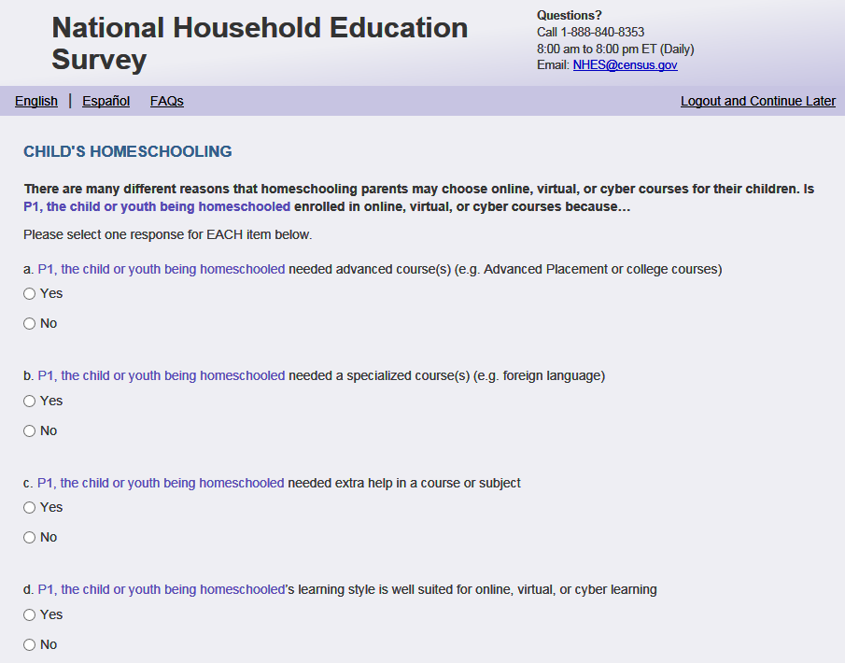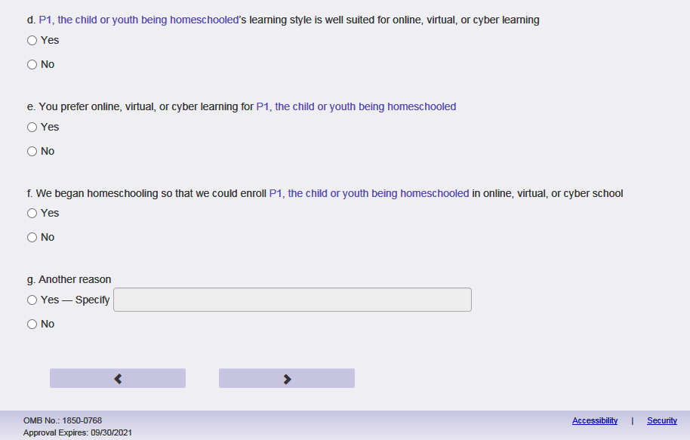
English Respondent Text Reads:
There are many different reasons that homeschooling parents may choose online, virtual, or cyber courses for their children. Is [this child] enrolled in online, virtual, or cyber courses because…

Spanish Respondent Text Reads:
Hay muchas razones por las cuales los padres que dan la enseñanza escolar en el hogar (homeschool) a sus hijos eligen cursos online, virtuales o cyber. ¿Está inscrito [este niño (esta niña)] en cursos online, virtuales o cyber porque…

English Admin/TQA Text Reads:
There are many different reasons that homeschooling parents may choose online, virtual, or cyber courses for their children. Please answer ‘yes’ or ‘no’ for each of these reasons as I read them. Is [this child] enrolled in online, virtual, or cyber courses because…

{Please re-read the question if the respondent asks or seems to have forgotten the question.}

Spanish Admin/TQA Text Reads:
Hay muchas razones por las cuales los padres que dan la enseñanza escolar en el hogar (homeschool) a sus hijos eligen cursos online, virtuales o cyber. Por favor, responda "sí" o "no" a cada una de estas razones a medida que las leo. ¿Está inscrito [este niño (esta niña)] en cursos online, virtuales o cyber porque…

{Por favor, vuelva a leer la pregunta si el encuestada pregunta o parece haber olvidado la pregunta.}

English Respondent Answer:
- [This child] needed an advanced course(s) (e.g. Advanced Placement or college courses)? PFIC_ONLNAP, (1=Yes, 2=No), numeric
- [This child] needed a specialized course(s) (e.g. foreign language)? PFIC_ONLNSC, (1=Yes, 2=No), numeric
- [This child] needed extra help in a course or subject? PFIC_ONLNEH, (1=Yes, 2=No), numeric
- [This child]’s learning style is well suited for online, virtual, or cyber learning? PFIC_ONLNLS, (1=Yes, 2=No), numeric
- You prefer online, virtual, or cyber learning for [this child]? PFIC_ONLNPR, (1=Yes, 2=No), numeric
- We began homeschooling so that we could enroll [this child] in online, virtual, or cyber school? PFIC_ONLNHS, (1=Yes, 2=No), numeric
- Another reason PFIC_ONLNOTH, (1=Yes, 2=No), numeric
- Specify (PFIC_ONLNOTHOS)

Spanish Respondent Answer:
- [Este niño (esta niña)] necesitaba curso(s) avanzado(s) (por ejemplo cursos de colocación avanzado o cursos universitarios))? PFIC_ONLNAP, (1= Sí, 2=No), numeric
- [Este niño (esta niña)]] necesitaba curso(s) especializado(s) (por ejemplo idioma extranjero)? PFIC_ONLNSC, (1= Sí, 2=No), numeric
- [Este niño (esta niña)] necesitaba ayuda adicional para algún curso o materia? PFIC_ONLNEH, (1= Sí, 2=No), numeric
- Por su estilo de aprendizaje a [este niño (esta niña)] le conviene un aprendizaje online, virtual o cyber? PFIC_ONLNLS, (1= Sí, 2=No), numeric
- Usted prefiere cursos online, virtuales o cyber para [este niño (esta niña)]? PFIC_ONLNPR, (1= Sí, 2=No), numeric
- Empezamos a dar la enseñanza escolar en el hogar (homeschool) a [este niño (esta niña)] para poder inscribirlo en una escuela online, virtual o cyber? PFIC_ONLNHS, (1= Sí, 2=No), numeric
- Otra razón? PFIC_ONLNOTH, (1= Sí, 2=No), numeric
- Specify (PFIC_ONLNOTHOS)

English Admin/TQA Answer:
- [This child] needed advanced course(s) (e.g. Advanced Placement or college courses)? PFIC_ONLNAP, (1=Yes, 2=No), numeric
- [This child] needed a specialized course(s) (e.g. foreign language)? PFIC_ONLNSC, (1=Yes, 2=No), numeric
- [This child] needed extra help in a course or subject? PFIC_ONLNEH, (1=Yes, 2=No), numeric
- [This child]’s learning style is well suited for online, virtual, or cyber learning? PFIC_ONLNLS, (1=Yes, 2=No), numeric
- You prefer online, virtual, or cyber learning for [this child]? PFIC_ONLNPR, (1=Yes, 2=No), numeric
- You began homeschooling so that you could enroll [this child] in online, virtual, or cyber school? PFIC_ONLNHS, (1=Yes, 2=No), numeric
- Another reason PFIC_ONLNOTH, (1=Yes, 2=No), numeric
- Specify (PFIC_ONLNOTHOS)

Spanish Admin/TQA Answer:
- Este niño (esta niña)] necesitaba curso(s) avanzado(s) (por ejemplo cursos de colocación avanzado o cursos universitarios))? PFIC_ONLNAP, (1= Sí, 2=No), numeric
- [Este niño (esta niña)]] necesitaba curso(s) especializado(s) (por ejemplo idioma extranjero)? PFIC_ONLNSC, (1= Sí, 2=No), numeric
- [Este niño (esta niña)] necesitaba ayuda adicional para algún curso o materia? PFIC_ONLNEH, (1= Sí, 2=No), numeric
- [Por su estilo de aprendizaje a [este niño (esta niña)] le conviene un aprendizaje online/virtual/cyber? PFIC_ONLNLS, (1= Sí, 2=No), numeric
- Usted prefiere cursos online, virtuales o cyber para [este niño (esta niña)] PFIC_ONLNPR, (1= Sí, 2=No), numeric
- Empezó a dar la enseñanza escolar en el hogar (homeschool) a [este niño (esta niña)] para poder inscribirlo en una escuela online, virtual o cyber? PFIC_ONLNHS, (1= Sí, 2=No), numeric
- Otra razón? PFIC_ONLNOTH, (1= Sí, 2=No), numeric
- Specify (PFIC_ONLNOTHOS)

Skip patterns:
If all of PFIC_ONLNAP- PFIC_ONLNOTH = 2 or blank go to PFIC_HSINTPUB
Else go to PFIC_HSIMPONLI
Logic checks/Programming specifications:
display as grid
If PFIC_ONLNOTH= 1, then activate PFIC_ONLNOTHOS, (0,1000), Character, write in, PFIC_ONLNOTHOS should only be allowed if PFIC_ONLNOTH =1
PFIC_ONLNOTHOS should be displayed as box 3 rows by 30 characters

Item: Important Reason for Online (PFIC_HSIMPONLI)
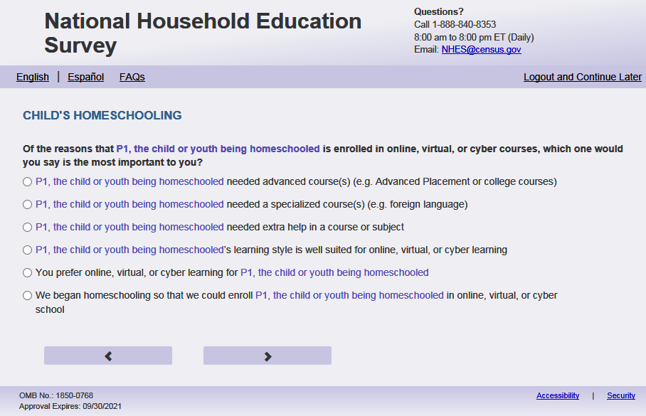
English Respondent Text Reads:
Of the reasons that [this child] is enrolled in online, virtual, or cyber courses, which ONE would you say is the most important to you?

Spanish Respondent Text Reads:
De todas las razones por las cuales [este niño (esta niña)] está inscrito en cursos online, virtuales o cyber, ¿CUÁL diría usted que fue la más importante?

English Admin/TQA Text Reads:
Of the reasons that [this child] is enrolled in online, virtual, or cyber courses, which one would you say is the most important to you?

{Please read response options.}
Spanish Admin/TQA Text Reads:
De todas las razones por las cuales [este niño (esta niña)] está inscrito en cursos online, virtuales o cyber, ¿CUÁL diría usted que fue la más importante?

{Por favor, lea las opciones de respuesta.}

English Answer:
[This child] needed advanced course(s) (e.g. Advanced Placement or college courses)
[This child] needed a specialized course(s) (e.g. foreign language)
[This child] needed extra help in a course or subject
[This child]’s learning style is well suited for online, virtual, or cyber learning
You prefer online, virtual, or cyber learning for [this child]
We began homeschooling so that we could enroll [this child] in online, virtual, or cyber school
[Answer written in PFIC_ONLNOTHOS]. If blank, then ‘Another reason - not specified’

Spanish Answer:
[Este niño (esta niña)] necesitaba curso(s) avanzado(s) (por ejemplo cursos de colocación avanzado o cursos universitarios)
[Este niño (esta niña)] necesitaba curso(s) especializado(s) (por ejemplo idioma extranjera)
[Este niño esta niñ(a)] necesitaba ayuda adicional para algún curso o materia
Por su estilo de aprendizaje a [este niño (esta niña)] le conviene un aprendizaje online, virtual o cyber
Usted prefiere cursos online, virtuales o cyber para [este niño (esta niña)]
Empezamos a dar la enseñanza escolar en el hogar (homeschool) a [este niño (esta niña)] para poder inscribirlo en una escuela online, virtual o cyber
[Answer written in PFIC_ONLNOTHOS]. If blank, then ‘Otra de las razones – no especificada’
PFIC_HSIMPONLI, (1,7) radio, numeric, radio
Skips
Go to PFIC_HSINTPUB

Logic checks/Programming specifications:
In output please put the value selected from the location in PFIC_ONLNAP. For example, if PFIC_ONLAP and PFIC_ONLNEH are the only two items displayed here and they select PFIC_ONLNEH put a value of 3 which is the placement on PFIC_ONLNAP.
English:
Display any options from PFIC_ONLNAP - PFIC_ONLNOTH that = 1. If PFIC_ONLNOTHOS ne blank, display text. Otherwise display “Another reason – not specified”.
Spanish
Display any options from PFIC_ONLNAP - PFIC_ONLNOTH that = 1. If PFIC_ONLNOTHOS ne blank, display text. Otherwise display “Otra de las razones – no especificada”.

Item: Online Instruction Provider (PFIC_HSINTPUB)
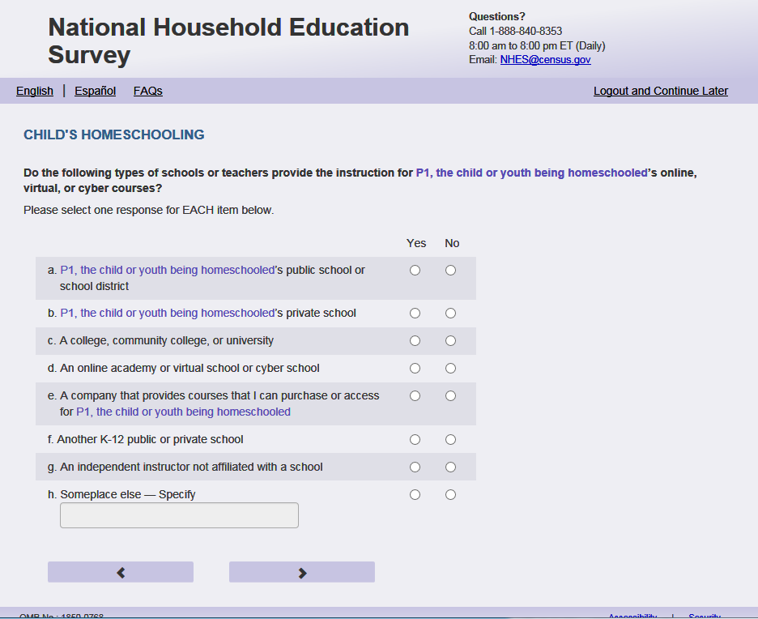
English Text Reads:
Do the following types of schools or teachers provide the instruction for [this child]’s online, virtual, or cyber courses?

Spanish Text Reads:
¿Proveen los siguientes tipos de escuela o maestros la instrucción para los cursos online, virtuales o cyber para [este niño(esta niña)]?

English Respondent Answer
a. [This child]’s public school or school district PFIC_HSINTPUB, (1= Yes, 2=No), numeric, radio
b. [This child]’s private school PFIC_HSINTPRI, (1= Yes, 2=No), numeric, radio
c. A college, community college, or university PFIC_HSINTCOL, (1= Yes, 2=No), numeric, radio
d. An online academy or virtual school or cyber school PFIC_HSINTVRT,(1= Yes, 2=No), numeric, radio
e. A company that provides courses that I can purchase or access for [this child] PFIC_HSINTCMP, (1= Yes, 2=No), numeric, radio
f. Another K to 12 public or private school PFIC_HSINTK12, (1= Yes, 2=No), numeric, radio
g. An independent instructor not affiliated with a school PFIC_HSINTIND, , (1= Yes, 2=No), numeric, radio
h. Someplace else –Specify: PFIC_HSINTOH, (1= Yes, 2=No), numeric, radio

Spanish Respondent Answer
a. La escuela pública o el distrito escolar de [este niño (esta niña)] PFIC_HSINTPUB, (1= Sí, 2=No), numeric, radio
b. La escuela privada de [este niño (esta niña)] PFIC_ HSINTPRI, , (1= Sí, 2=No), numeric, radio
c. Una universidad o colegio comunitario PFIC_ HSINTCOL, (1= Sí, 2=No), numeric, radio
d. Un instituto online, una escuela virtual o una escuela cyber PFIC_ HSINTVRT, (1= Sí, 2=No),numeric, radio
e. Una compañía que provee cursos que yo podría comprar o accede para [este niño (esta niña)] PFIC_ HSINTCMP, (1= Sí, 2=No), numeric, radio
f. Otra escuela kindergarten a 12 pública o privada PFIC_ HSINTK12, (1= Yes, 2=No), numeric, checkbox
g. Un instructor independiente y no afiliado con ninguna escuela PFIC_HSINTIND, (1= Sí, 2=No), numeric, radio
h. Otro lugar – Especifique: PFIC_HSINTOH, (1= Sí, 2=No), numeric, radio

English Admin/TQA Answer
a. [This child]’s public school or school district PFIC_HSINTPUB, (1= Yes, 2=No), numeric, radio
b. [This child]’s private school PFIC_HSINTPRI, (1= Yes, 2=No), numeric, radio
c. A college, community college, or university PFIC_HSINTCOL, (1= Yes, 2=No), numeric, radio
d. An online academy or virtual school or cyber school PFIC_HSINTVRT,(1= Yes, 2=No), numeric, radio
e. A company that provides courses that you can purchase or access for [this child] PFIC_HSINTCMP, (1= Yes, 2=No), numeric, radio
f. Another K to 12 public or private school PFIC_HSINTK12, (1= Yes, 2=No), numeric, radio
g. An independent instructor not affiliated with a school PFIC_HSINTIND, , (1= Yes, 2=No), numeric, radio
h. Someplace else –Specify: PFIC_HSINTOH, (1= Yes, 2=No), numeric, radio

Spanish Admin/TQA Answer
a. La escuela pública o el distrito escolar de [este niño (esta niña)] PFIC_HSINTPUB, (1= Sí, 2=No), numeric, radio
b. La escuela privada de [este niño (esta niña ] PFIC_ HSINTPRI, , (1= Sí, 2=No), numeric, radio
c. Una universidad o colegio comunitario PFIC_ HSINTCOL, , (1= Sí, 2=No), numeric, radio
d. Un instituto online, una escuela virtual o una escuela cyber PFIC_ HSINTVRT, (1= Sí, 2=No),numeric, radio
e. Una compania que provee cursos que yo podría comprar o accede para [este niño (esta niña)] PFIC_ HSINTCMP, (1= Sí, 2=No), numeric, radio
f. Otra escuela kindergarten a 12 pública o privada PFIC_ HSINTK12, (1= Yes, 2=No), numeric, checkbox
g. Un instructor independiente y no afiliado con ninguna escuela PFIC_HSINTIND, (1= Sí, 2=No), numeric, radio
h. Otro lugar – Especifique: PFIC_HSINTOH, (1= Sí, 2=No), numeric, radio

Skip patterns:
Go to PFIC_HSINTNUM
Logic checks/Programming specifications:
Display as grid. If PFIC_HSINTOH selected, specify box (PFIC_HSINTOTHOS) should become active
(PFIC_HSINTOHOS): (0,1000), character, write-in. Display specify response box 3 rows by 30 characters.

Item: Number of Online Course homeschool (PFIC_HSINTNUM)
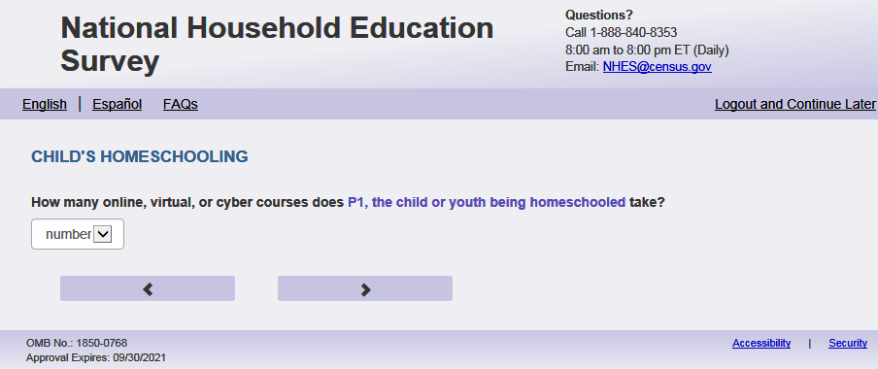
English Text Reads:
How many online, virtual, or cyber courses does [this child] take?

Spanish Text Reads:
¿Cuántos cursos online, virtuales o cyber toma [este niño (esta niña)]?

English and Spanish Answer

PFIC_HSINTNUM, (1, 30) numeric, t write-in

Skip patterns:

Go to PFIC_HSINTFEE

Logic checks/Programming specifications

English
Display “online, virtual or cyber course(s)” to the right of the text box and the text box should be blank
[If not within 1-30] Display "Please check your answer before continuing. Typically, students taking online, virtual, or cyber courses take between one and 30 online courses at a time."
Spanish:
Display “curso(s) online, virtuales o cyber” to the right of the text box and the text box should be blank
[if not within 1-30] Display "Por favor, compruebe su respuesta antes de continuar. Por lo general, los estudiantes que toman cursos en línea, virtuales o cibernéticos toman entre uno y 30 cursos en línea a la vez.”
Mobile: Display numeric keypad

Item: Fee for Instruction (PFIC_HSINTFEE)
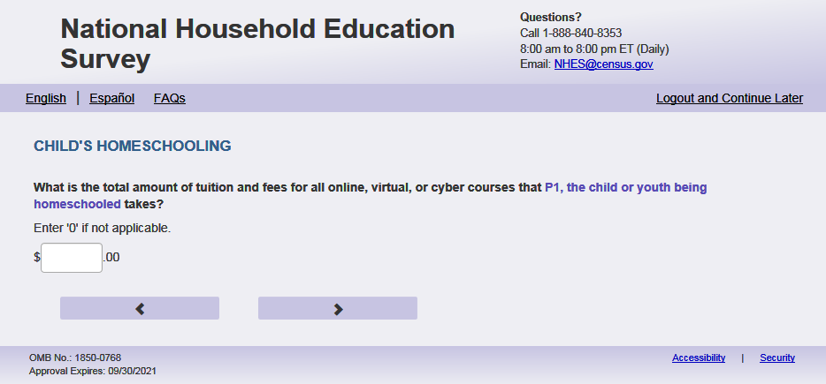
English Text Reads:
What is the total amount of tuition and fees for all online, virtual, or cyber courses that [this child] takes?

Enter ‘0’ if not applicable.

Spanish Text Reads:
¿Cuál es la cantidad total de la matrícula y cargos para todos los cursos online, virtuales o cyber que toma [este niño (esta niña)]?

Ingrese ‘0’ si no aplica.

English Admin/TQA Text Reads:
What is the total amount of tuition and fees for all online, virtual, or cyber courses that [this child] takes?

{Enter ‘0’ if not applicable.}

Spanish Admin/TQA Text Reads:
¿Cúal es la cantidad total de la matrícula y cargos para todos los cursos online, virtuales o cyber que toma [este niño (esta niña)]?

{Ingrese ‘0’ si no aplica.}

English and Spanish Answer

PFIC_HSINTFEE, (0,99999), numeric, write-in
Skip patterns:
Go to PFIC_HSINTHRS
Logic checks/Programming specifications: Display a “$” sign to the left of the write-in box, and ".00" to the right of the write-in box to indicate the required response is in a currency format. Right-justified and will enter the response box from the right side. If a numerical response contains more than three digits, a comma will be auto-filled. Please remove commas from output.

Mobile: Display numeric keypad

Text Displayed for logic/range check violation:
N/A

Item: Online Instructions Hours Homeschool (PFIC_HSINTHRS)
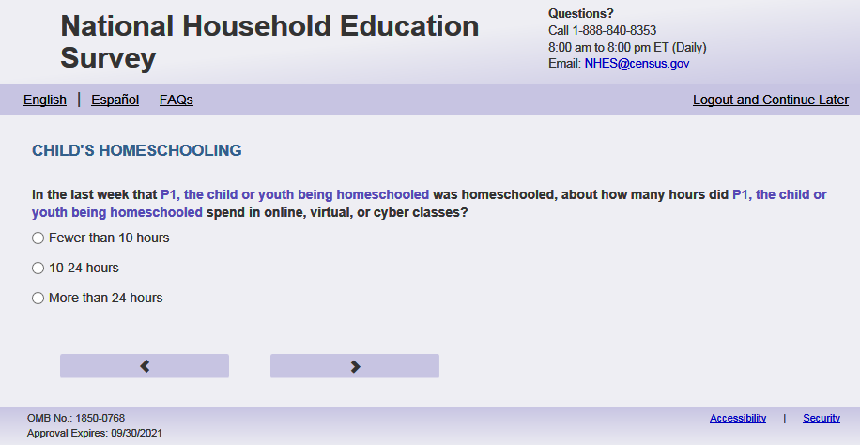

English Respondent Text Reads:
In the last week that [this child] was homeschooled, about how many hours did [he/she/he or she] spend in online, virtual, or cyber classes?

Spanish Respondent Text Reads:
En la última semana durante la cuál [este niño (esta niña)] recibió la enseñanza escolar en el hogar (homeschool), aproximadamente, ¿Cuántas horas pasó [este niño (esta niña)] en clases online, virtuales o cyber?

English Admin/TQA Text Reads:
In the last week that [this child] was homeschooled, about how many hours did [he/she/he or she] spend in online, virtual, or cyber classes?

{Please read response options.}

Spanish Admin/TQA Text Reads:
En la última semana durante la cuál [este niño (esta niña)] recibió la enseñanza escolar en el hogar (homeschool, aproximadamente, ¿Cuántas horas pasó [él/ella/él o ella] en clases online, virtuales o cyber?

{Por favor lea las opciones de respuesta.}
English Answer:
1= Fewer than 10 hours in that week
2=10 to 24 hours in that week
3=More than 24 hours in that week

Spanish Answers:
1= Menos de 10 horas en esa semana
2= 10 a 24 horas en esa semana
3= Más de 24 horas en esa semana

PFIC_HSINTHRS, (1,3), numeric, radio
Skip patterns:
Go to PFIC_HSSTYL
Logic checks/Programming specifications:
If s1_psex is 1, use “he”. If s1_psex=2, use “she”. If sex is not available, use “he or she”.
If s1_psex is 1, use “él”. If s1_psex=2, use “ella”. If sex is not available, use “él o ella”.

Item: Teaching Style Used to Homeschool (PFIC_HSSTYL)
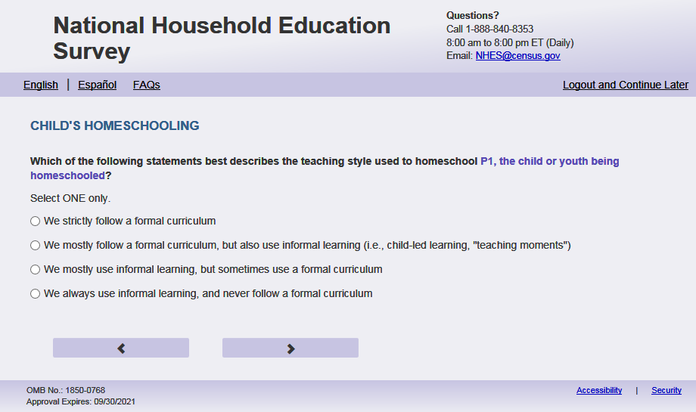
English Text Reads:
Which of the following statements best describes the teaching style used to homeschool [this child]?

Spanish Text Reads:
¿Cuál de las siguientes frases describe mejor el estilo de enseñanza que se usa para la enseñanza escolar en el hogar (homeschool) de [este niño (esta niña)]?

English Admin/TQA Text Reads:
Which of the following statements best describes the teaching style used to homeschool [this child]?

{Please read response options.}

Spanish Admin/TQA Text Reads:
¿Cuál de las siguientes frases describe mejor el estilo de enseñanza que se usa para la enseñanza escolar en el hogar (homeschool) de [este niño (esta niña)]?

{Por favor, lea las opciones de respuesta.}
English Respondent Answer
1= We strictly follow a formal curriculum
2= We mostly follow a formal curriculum, but also use informal learning (i.e., child-led learning, "teaching moments")
3= We mostly use informal learning, but sometimes use a formal curriculum
4= We always use informal learning, and never follow a formal curriculum

Spanish Respondent Answer
1= Seguimos estrictamente un currículo formal
2= Principalmente seguimos un currículo formal, pero también usamos aprendizaje informal (por ejemplo, aprendizaje dirigido por el niño(a), "momentos de enseñanza")
3= Principalmente usamos enseñanza informal, pero a veces usamos un currículo formal
4= Siempre usamos aprendizaje informal, y nunca seguimos un currículo formal

English Admin/TQA Answer
1= You strictly follow a formal curriculum
2= You mostly follow a formal curriculum, but also use informal learning (i.e., child-led learning, "teaching moments")
3= You mostly use informal learning, but sometimes use a formal curriculum
4= You always use informal learning, and never follow a formal curriculum

Spanish Admin/TQA Answer
1= Sigues estrictamente un currículo formal
2= Principalmente sigue un currículo formal, pero también utiliza el aprendizaje informal (por ejemplo, aprendizaje dirigido por el niño(a), "momentos de enseñanza")
3= Utilizas principalmente el enseñanza informal, pero a veces usas un currículo formal
4= Siempre usas aprendizaje informal, y nunca sigues un currículo formal

PFIC_HSSTYL(1,4), numeric, radio
Skip patterns:
Go to PFIC_HSKACTIV

Item: Homeschool Activities (PFIC_HSKACTIV)
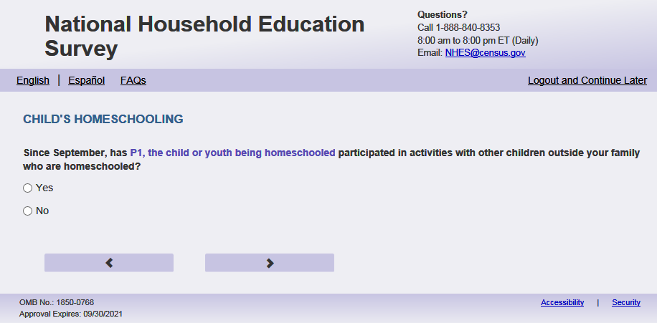
English Text Reads:
Since September, has [this child] participated in activities with other children outside of your family who are homeschooled?

Spanish Text Reads:
Desde septiembre, ¿ha participado [este niño (esta niña)] en actividades con niños de otras familias que reciben la enseñanza escolar en el hogar (homeschool)?

English Answer
1= Yes
2=No

Spanish Answer
1= Sí
2=No

PFIC_HSKACTIV, (1,2), numeric, radio
Skip patterns:
Go to PFIC_HSCOURS

Item: Online Instruction at Home (PFIC_HSCOURS)
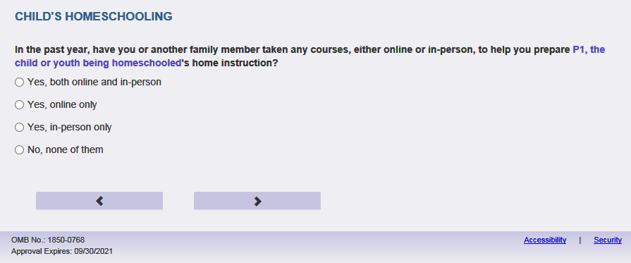
English Respondent Text Reads:
In the past year, have you or another family member taken any courses, either online or in-person, to help you prepare [this child]’s home instruction?

Spanish Respondent Text Reads:
En el año pasado, ¿ha recibido usted o algún otro miembro de su familia algún
curso, ya sea por internet o en persona, para ayudarle a preparar la enseñanza escolar en el hogar (homeschool) de [este niño (esta niña)]?

English Admin/TQA Text Reads:
In the past year, have you or another family member taken any courses, either online or in-person, to help you prepare [this child]’s home instruction?
{If ‘yes,’ read yes options to the respondent.}

Spanish Admin/TQA Text Reads:
En el año pasado, ¿ha recibido usted o algún otro miembro de su familia algún
curso, ya sea por internet o en persona, para ayudarle a preparar la enseñanza escolar en el hogar (homeschool) de [este niño (esta niña)]?
{Si 'sí', lea las opciones de sí al encuestado.}

English Answer
1= Yes, both online and in-person
2= Yes, online only
3= Yes, in-person only
4= No, none of them

Spanish Answer
1= Sí, tanto por internet como en persona
2= Sí, por internet solamente
3= Sí, en persona solamente
4= No, ninguno

PFIC_HSCOURS, (1,4), numeric, radio
Skip patterns:
Go to PFIC_HOMEKX

Item: Homeschooled grades (PFIC_HOMEKX )
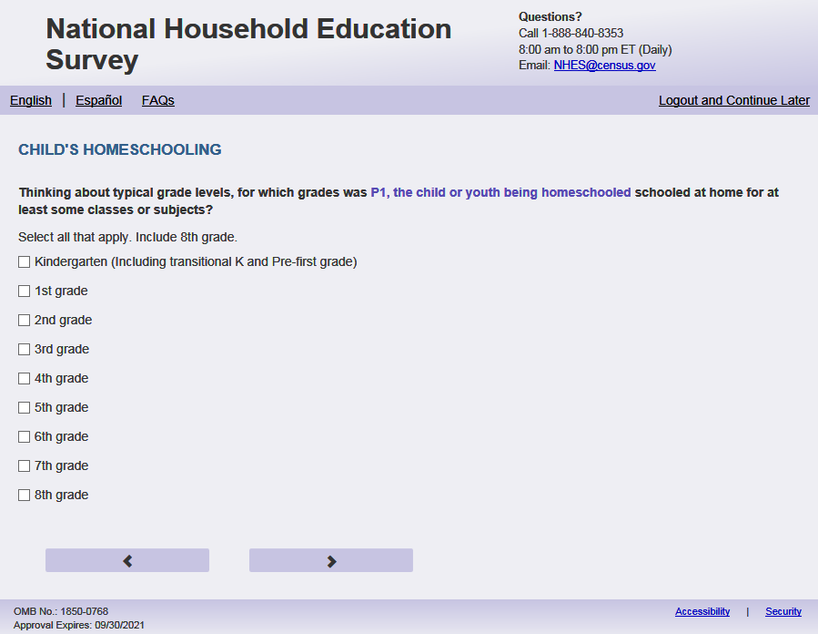
English Respondent Text Reads:
Select every grade that [this child] was homeschooled for at least some subjects, including the current grade or grade equivalent.

Select all that apply. Include [s1_PxGRADE_WEB/PFIC_ALLGRADEX_web].

Spanish Respondent Text Reads:

Seleccione todos los grados en que [este niño (esta niña)] recibió la enseñanza escolar en el hogar (homeschool) al menos para algunas asignaturas.

Seleccione todas las que correspondan. Incluya [s1_PxGRADE_WEB/PFIC_ALLGRADEX_web].

English Admin/TQA Text Reads:
Including the current grade or grade equivalent, for which grades was [this child] homeschooled for at least some subjects? Include [s1_PxGRADE_WEB/PFIC_ALLGRADEX_web].

{Select all that apply.}

Spanish Admin/TQA Text Reads:

Incluyendo el grado actual, ¿para qué grados recibió [este niño (esta niña)] la enseñanza escolar en el hogar (homeschool) al menos para algunas asignaturas?
Incluya [s1_PxGRADE_WEB/PFIC_ALLGRADEX_web].

{Seleccione todas las que correspondan.}

English Answer
Homeschooled in kindergarten (including transitional K and Pre-first grade), PFIC_HOMEKX, (1=Item marked), numeric, checkbox
Homeschooled in 1st grade PFIC_HOME1, (1=Item marked), numeric, checkbox
Homeschooled in 2nd grade PFIC_HOME2, (1=Item marked), numeric, checkbox
Homeschooled in 3rd grade PFIC_HOME3, (1=Item marked), numeric, checkbox
Homeschooled in 4th grade PFIC_HOME4, (1=Item marked), numeric, checkbox
Homeschooled in 5th grade PFIC_HOME5, (1=Item marked), numeric, checkbox
Homeschooled in 6th grade PFIC_HOME6, (1=Item marked), numeric, checkbox
Homeschooled in 7th grade PFIC_HOME7, (1=Item marked), numeric, checkbox
Homeschooled in 8th grade PFIC_HOME8, (1=Item marked), numeric, checkbox
Homeschooled in 9th grade – freshman PFIC_HOME9, (1=Item marked), numeric, checkbox
Homeschooled in 10th grade – sophomore PFIC_HOME10, (1=Item marked), numeric, checkbox
Homeschooled in 11th grade – junior PFIC_HOME11, (1=Item marked), numeric, checkbox
Homeschooled in 12th grade – senior PFIC_HOME12, (1=Item marked), numeric, checkbox

Spanish Answer

Enseñanza escolar en el hogar (homeschool) en kindergarten (incluyendo kindergarten de transición y pre-primer grado) PFIC_HOMEKx, (1=Item marked), numeric, checkbox
Enseñanza escolar en el hogar (homeschool) en 1er grado PFIC_HOME1, (1=Item marked), numeric, checkbox
Enseñanza escolar en el hogar (homeschool) en 2º grado PFIC_HOME2, (1=Item marked), numeric, checkbox
Enseñanza escolar en el hogar (homeschool) en 3er grado PFIC_HOME3, (1=Item marked), numeric, checkbox
Enseñanza escolar en el hogar (homeschool) en 4º grado PFIC_HOME4, (1=Item marked), numeric, checkbox
Enseñanza escolar en el hogar (homeschool) en 5º grado PFIC_HOME5, (1=Item marked), numeric, checkbox
Enseñanza escolar en el hogar (homeschool) en 6º grado PFIC_HOME6, (1=Item marked), numeric, checkbox
Enseñanza escolar en el hogar (homeschool) en 7º grado PFIC_HOME7, (1=Item marked), numeric, checkbox
Enseñanza escolar en el hogar (homeschool) en 8º grado PFIC_HOME8, (1=Item marked), numeric, checkbox
Enseñanza escolar en el hogar (homeschool) en 9º grado – freshman PFIC_HOME9, (1=Item marked), numeric, checkbox
Enseñanza escolar en el hogar (homeschool) en 10º grado – sophmore PFIC_HOME10, (1=Item marked), numeric, checkbox
Enseñanza escolar en el hogar (homeschool) en 11º grado – junior PFIC_HOME11, (1=Item marked), numeric, checkbox
Enseñanza escolar en el hogar (homeschool) en 12º grado – senior PFIC_HOME12, (1=Item marked), numeric, checkbox

Skip patterns:
Go to PFIC_HSSAFETYX
Logic checks/Programming specifications:
Select all that apply.
Display PFIC_HomeKx- PFIC_Home12 that are less or equal to S1_PxGRADE_WEB (from screener). If s1_PxGRADE_WEB = ' ' then display PFIC_HomeKx-PFIC_Home12 that are less or equal to PFIC_ALLGRADEX_web . If screener s1_PxGRADE_WEB and PFIC_ALLGRADEX_web are blank, display PFIC_HomeKx- PFIC_Home12.
English
Use s1_PxGRADE_WEB (from screener) to autofill: Include [s1_pxGRADE_WEB]. If s1_PxGRADE_WEB = ' ' then use PFIC_ALLGRADEX_web to autofill Include [PFIC_ALLGRADEX_web ]. If s1_PxGRADE_WEB and PFIC_ALLGRADEX_web = blank display 'Include the current year.'
Spanish
Use s1_PxGRADE_WEB (from screener) to autofill: Incluya [s1_pxGRADE_WEB]. If s1_PxGRADE_WEB = ' ' then use PFIC_ALLGRADEX_web to autofill Incluya [PFIC_ALLGRADEX_web ]. If s1_PxGRADE_WEB and PFIC_ALLGRADEX_web = blank display 'Incluya el año actual.''

Item: Reason for Choosing to Homeschool (PFIC_HSSAFETYX)
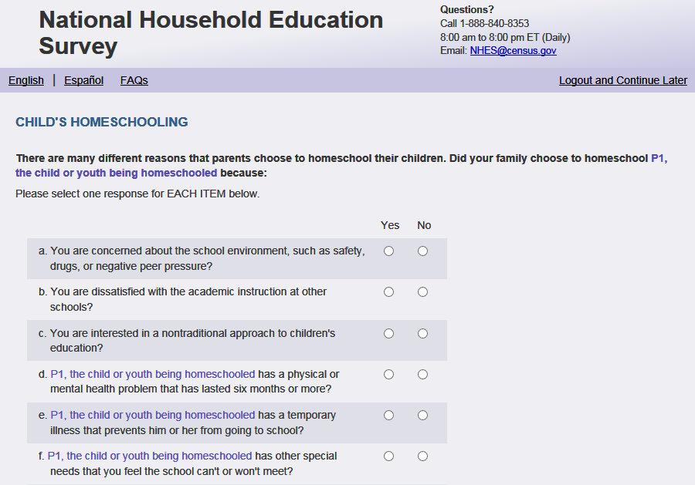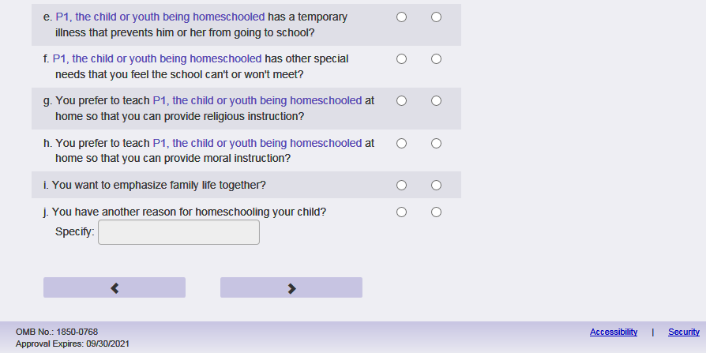
English Respondent Text Reads:
There are many different reasons that parents choose to homeschool their children. Did your family choose to homeschool [this child] because:

Spanish Respondent Text Reads:
Hay muchas razones por las cuales los padres eligen la enseñanza escolar en el hogar (homeschool) para sus hijos. Eligió su familia la enseñanza escolar en el hogar (homeschool) para [este niño (esta niña)] porque:
English Admin/TQA Text Reads:
There are many different reasons that parents choose to homeschool their children. Please answer ‘yes’ or ‘no’ to the following reasons as I read them.
Did your family choose to homeschool [this child] because:
{Please re-read the question if the respondent asks or seems to have forgotten the question.}

Spanish Admin/TQA Text Reads:
Hay muchas razones por las cuales los padres eligen la enseñanza escolar en el hogar (homeschool) para sus hijos. Por favor, responda "sí" o "no" a las siguientes razones a medida que las leo.
Eligió su familia la enseñanza escolar en el hogar (homeschool) para [este niño (esta niña)] porque:
{Por favor, vuelva a leer la pregunta si el encuestado pregunta o parece haber olvidado lapregunta.}

English Answer
- You are concerned about the school environment, such as safety, drugs, or negative peer pressure? PFIC_HSSAFETYX, (1= Yes, 2= No), numeric, radio
- You are dissatisfied with the academic instruction at other schools? PFIC_HSDISSATX, (1= Yes, 2= No), numeric, radio
- You prefer to teach [this child] at home so that you can provide religious instruction? PFIC_HSRELGON, (1= Yes, 2= No), numeric, radio
- You prefer to teach [this child] at home so that you can provide moral instruction? PFIC_HSMORAL, (1= Yes, 2= No), numeric, radio
- [This child] has a physical or mental health problem that has lasted six months or more? PFIC_HSDISABLX, (1= Yes, 2= No), numeric, radio
- [This child] has a temporary illness that prevents [him/her/him or her] from going to school? PFIC_HSILLX, (1= Yes, 2= No), numeric, radio
- [This child] has other special needs that you feel the school can’t or won’t meet? PFIC_HSSPCLNDX, (1= Yes, 2= No), numeric, radio
- You are interested in a nontraditional approach to children’s education? PFIC_HSALTX, (1= Yes, 2= No), numeric, radio
- You want to emphasize family life together? PFIC_HSFMLY, (1= Yes, 2= No), numeric, radio
- You have another reason for homeschooling [this child]? Specify: PFIC_HSOTHERX, (1= Yes, 2= No), numeric, radio
Spanish Answer
a. ¿Le preocupa el ambiente en la escuela, como la seguridad, las drogas, la influencia negativa de
otros alumnos? PFIC_HSSAFETYX, (1 = Sí, 2 = No), numeric, radio
b. ¿Está insatisfecho con la instrucción académica en otras escuelas? PFIC_HSDISSATX, (1 = Sí, 2 = No), numeric, radio
c. ¿Prefiere educar a [este niño (esta niña)] en casa para poder ofrecerle instrucción religiosa? PFIC_HSRELGON, (1 = Sí, 2 = No), numeric, radio
d. ¿Prefiere educar a [este niño (esta niña)] en casa para poder ofrecerle instrucción moral? PFIC_HSMORAL, (1 = Sí, 2 = No), numeric, radio
e. ¿[Este niño (Esta niña)] tiene un problema físico o mental que ha durado seis meses o más? PFIC_HSDISABLX, (1 = Sí, 2 = No), numeric, radio
f. ¿[Este niño (Esta niña)] tiene una enfermedad temporal que le impide asistir a la escuela? PFIC_HSILLX, (1 = Sí, 2 = No), numeric, radio
g. ¿[Este niño (Esta niña)] tiene alguna otra necesidad especial que usted siente que la escuela no puede satisfacer? PFIC_HSSPCLNDX, (1 = Sí, 2 = No), numeric, radio
h. ¿Usted está interesado(a) en un enfoque no tradicional hacia la educación de los niño(a)s? PFIC_HSALTX, (1 = Sí, 2 = No), numeric, radio
i. ¿Quieres enfatizar la vida familiar juntos? PFIC_HSFMLY? , (1= Yes, 2= No), numeric, radio
j. ¿Usted tiene otra razón para la enseñanza escolar en el hogar (homeschool) a [este niño (esta niña)]? - Especifique: PFIC_HSOTHERX, (1 = Sí, 2 = No), numeric, radio
If PFIC_HSOTHERX selected, specify box should become active (PFIC_HSOTHERXOS): Write-in, (0,1000), character, write-in. Display specify response box 3 rows by 30 characters.

Skip patterns:
If respondent leaves PFIC_HSSAFETYX-PFIC_HSOTHERXOS blank or provides all "no" (=2) responses or only 1 "yes" (=1), then go to PFIC_HSSUBJ1. Else go to PFIC_HSMOSTX
Logic checks/Programming specifications:
display as grid
English:
If S1_Pxsex = 1, use ‘him’, if s1_pxsex = 2, use ‘her’, else use ‘him or her’

Item: Most Important Reason for Choosing to Homeschool (PFIC_HSMOSTX)
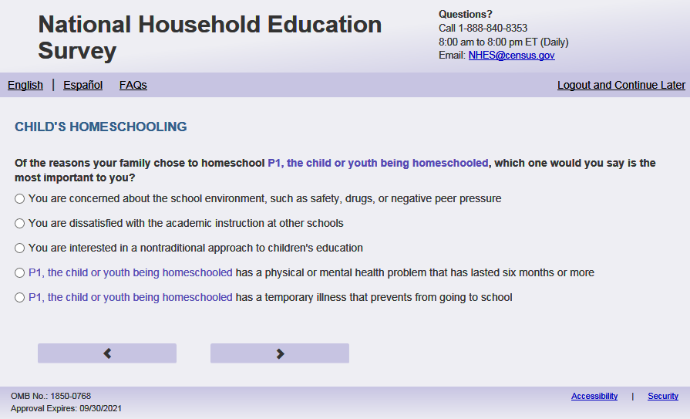
English Text Reads:
Of the reasons your family chose to homeschool [this child], which ONE would you say is the most important to you?
Spanish Text Reads:
Entre las razones por las cuales su familia decidió dar la enseñanza escolar en el hogar (homeschool) a [este niño (esta niña)], ¿CUÁL diría usted fue la más importante?

English Answer
You are concerned about the school environment, such as safety, drugs, or negative peer pressure
You are dissatisfied with the academic instruction at other schools
You prefer to teach [this child] at home so that you can provide religious instruction
You prefer to teach [this child] at home so that you can provide moral instruction
[This child] has a physical or mental health problem that has lasted six months or more
[This child] has a temporary illness that prevents [him/her/him or her] from going to school
[This child] has other special needs that you feel the school can’t or won’t meet
You are interested in a nontraditional approach to children’s education
You want to emphasize family life together
[Answer written in PFIC_HSOTHERXOS]. If blank, then ‘Another reason - not specified’
Spanish Answer
Le preocupa el ambiente en la escuela, como la seguridad, las drogas o la influencia negativa deotros alumnos
Está insatisfecho con la instrucción académica en otras escuelas
Prefiere educar en casa a [este niño (esta niña)] para ofrecerle instrucción religiosa
Prefiere educar en casa a [este niño (esta niña)] para ofrecerle instrucción moral
[Este niño (Esta niña)] tiene un problema físico o mental que ha durado seis meses o más
Tiene [este niño (esta niña)] una enfermedad temporaria que le impide asistir a la escuela
Tiene [este niño (esta niña)] alguna otra necesidad especial que usted piensa que la escuela no puede o no podrá satisfacer
Usted está interesado(a) en un enfoque no tradicional hacia la educación de los niños
Quieres enfatizar la vida familiar juntos
[Answer written in PFIC_HSOTHERXOS]. If blank, then ‘Otra de las razones - no especificada’
PFIC_HSMOSTX, (1,10), numeric, radio
Skip patterns:
Go to PFIC_HSSUBJ1
Logic checks/Programming specifications:
In output please put the value selected from the location in PFIC_HSSAFETYX. For example, if PFIC_HSSAFETYX and PFIC_HSRELGON are the only two items displayed here and they select PFIC_HSRELGON put a value of 3 which is the placement on PFIC_HSSAFETYX.
English
Answer options list ALL possible options. Only display list of items that were marked yes in [PFIC_HSSAFETYX-PFIC_HSOTHERX]. If they marked yes and wrote text into PFIC_HSOTHERXOS, display that text. If they marked PFIC_HSOTHERXOS and did not enter text, display "Another reason - not specified"
Spanish
Answer options list ALL possible options. Only display list of items that were marked yes in [PFIC_HSSAFETYX-PFIC_HSOTHERX]. If they marked yes and wrote text into PFIC_HSOTHERXOS, display that text. If they marked PFIC_HSOTHERXOS and did not enter text, display "Otra de las razones - no especificada"

Item: Current Subjects Taught in Homeschool (PFIC_HSSUBJ1)
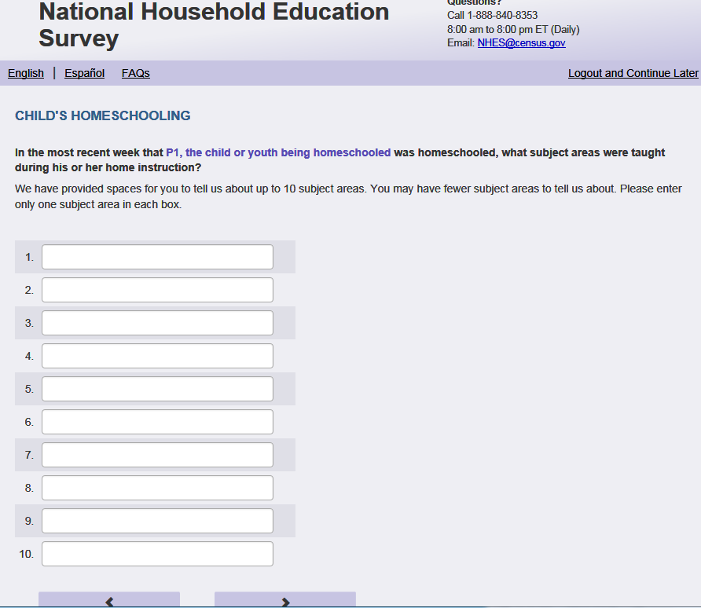
English Respondent Text Reads:
In the most recent week that [this child] was homeschooled, what subject areas were taught during [his/her/his or her] home instruction?
We have provided spaces for you to tell us about up to 10 subject areas. You may have fewer subject areas to tell us about. Please enter only one subject area in each box.
Spanish Respondent Text Reads:
¿En la semana más reciente en la cual [este niño (esta niña)] recibió la enseñanza escolar en el hogar (homeschool), ¿qué materias se enseñaron durante su instrucción en el hogar?
Hemos otorgado espacio para que anote hasta 10 materias. Tal vez tenga menos de 10 materias. Por favor escriba solamente una materia por cada caja.
English Admin/TQA Text Reads:
In the most recent week that [this child] was homeschooled, what subject areas were taught during [his/her/his or her] home instruction?
You can tell me about up to 10 subjects. {Enter only one subject area in each box.}
Spanish Admin/TQA Text Reads:
¿En la semana más reciente en la cual [este niño (esta niña)] recibió la enseñanza escolar en el hogar (homeschool), ¿qué materias se enseñaron a [este niño (esta niña)] durante la instrucción en el hogar?
Puede decirme hasta 10 asignaturas. {Escriba solamente una materia por cada caja.}
English and Spanish Answer

PFIC_HSSUBJ1- PFIC_HSSUBJ10, (0, 100), character, write-in

Skip patterns:
Go to PFIC_HSASSNX
Logic checks/Programming specifications:
Display write-in boxes PFIC_HSSUBJ1- PFIC_HSSUBJ10 as 1 row by 30 characters.
Display numbering of each box (i.e., 1-10) to the left of each write-in box.
If S1_Pxsex = 1, use ‘his’, if s1_pxsex = 2, use ‘her’, else use ‘his or her’

Item: Activities with Local Homeschooling Association (PFIC_HSASSNX)
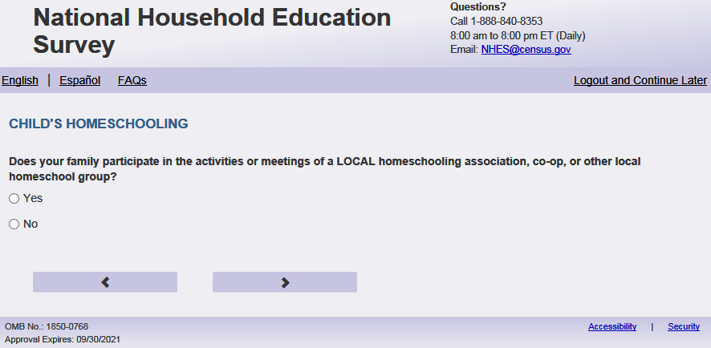
English Text Reads:
Does your family participate in the activities or meetings of a LOCAL homeschooling association, co-op, or other local homeschool group?
Spanish Text Reads:
¿Participa su familia en las actividades o reuniones de una asociación LOCAL de enseñanza escolar en el hogar (homeschool), cooperativa u otro grupo local de enseñanza escolar en el hogar (homeschool)?

English Answer
1= Yes
2=No

Spanish Answer
1= Sí
2=No

PFIC_HSASSNX, (1,2), numeric, radio

Skip patterns:
if PFIC_HSASSNX = 2 then go to PFIC_HSNATL. Else go to PFIC_HSFREQX

Item: Frequency of Activities with Local Homeschooling Association (PFIC_HSFREQX)
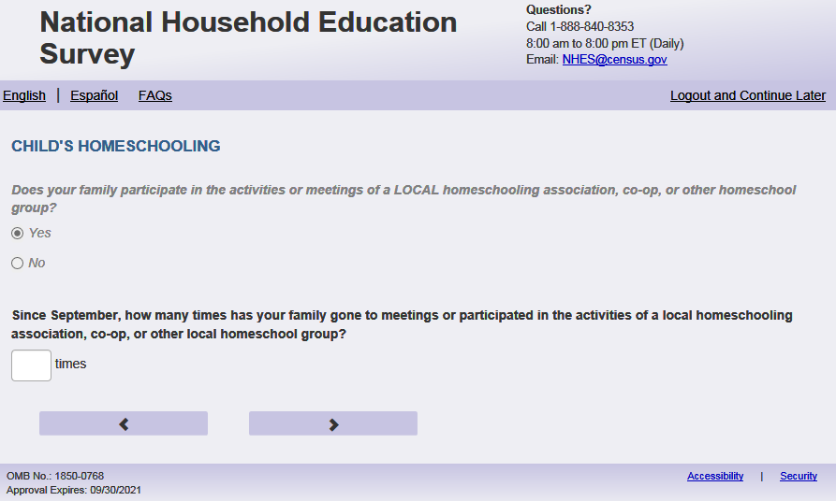
English Respondent Text Reads:
Since September, how many times has your family gone to meetings or participated in the activities of a local homeschooling association, co-op, or other local homeschool group?
Spanish Respondent Text Reads:
Desde septiembre, ¿cuántas veces ha ido su familia a reuniones o participado en actividades de una asociación local de enseñanza escolar en el hogar (homeschool), cooperativa u otro grupo local de enseñanza escolar en el hogar?

English Admin/TQA Text Reads:
Since September, how many times has your family gone to meetings or participated in the activities of a local homeschooling association, co-op, or other local homeschool group?
{Please read response options.}
Spanish Admin/TQA Text Reads:
Desde septiembre, ¿cuántas veces ha ido su familia a reuniones o participado en actividades de una asociación local de enseñanza escolar en el hogar (homeschool), cooperativa u otro grupo local de enseñanza escolar en el hogar?

{Por favor, lea las opciones de respuesta.}

English Answer:

1=0 times since September
2=1 to 5 times since September
3=6 to 10 times since September
4=11 to 20 times since September
5=21 to 30 times since September
6=More than 30 times since September

Spanish Answer:

1=0 veces desde septiembre
2=1 a 5 veces desde septiembre
3=6 a 10 veces desde septiembre
4=11 a 20 veces desde septiembre
5=21 a 30 veces desde septiembre
6=Más de 30 veces desde septiembre

PFIC_HSFREQX, (1,6), numeric, radio

Skip patterns:
Go to PFIC_HSNATL
Logic checks/Programming specifications:
Display on a new screen. Do not display on same page as PFIC_HSASSNX

Item: Household a Member of the National Homeschooling Association (PFIC_HSNATL)
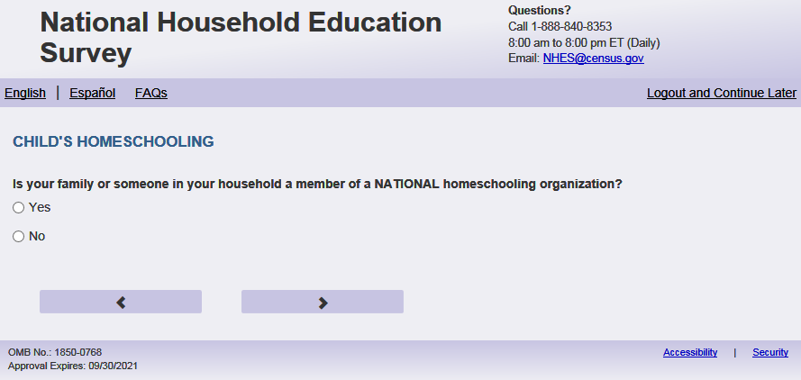
English Text Reads:
Is your family or someone in your household a member of a NATIONAL homeschooling organization?
Spanish Text Reads:
¿Es su familia o alguien en su hogar miembro de una organización NACIONAL de enseñanza escolar en el hogar (homeschool)?

English Answer
1= Yes
2=No

Spanish Answer
1= Sí
2= No

PFIC_HSNATL, (1,2), numeric, radio

Skip patterns:
Go to PFIC_HSMLTY

Item: Military family (PFIC_HSMLTY)
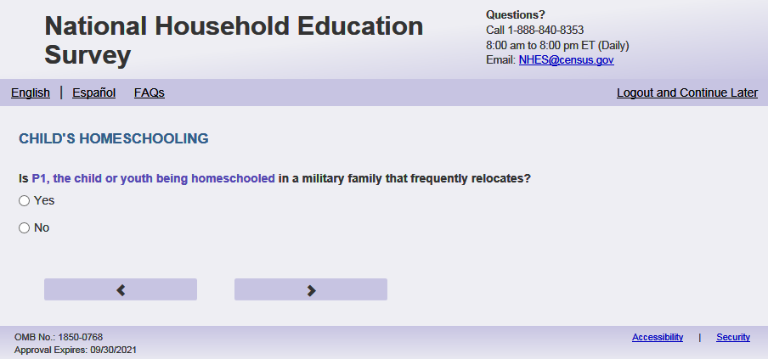
English Text Reads:
Is [this child] in a military family that frequently relocates?
Spanish Text Reads:
¿Es [este niño (esta niña)] parte de una familia militar que se traslada frecuentemente?
English Answer
1=Yes
2=No

Spanish Answer
1= Sí
2= No

PFIC_HSMLTY, (1,2), numeric, radio

Skip patterns:
Go to PFIC_HSENRL

Item: Enrolled in school (PFIC_HSENRL)
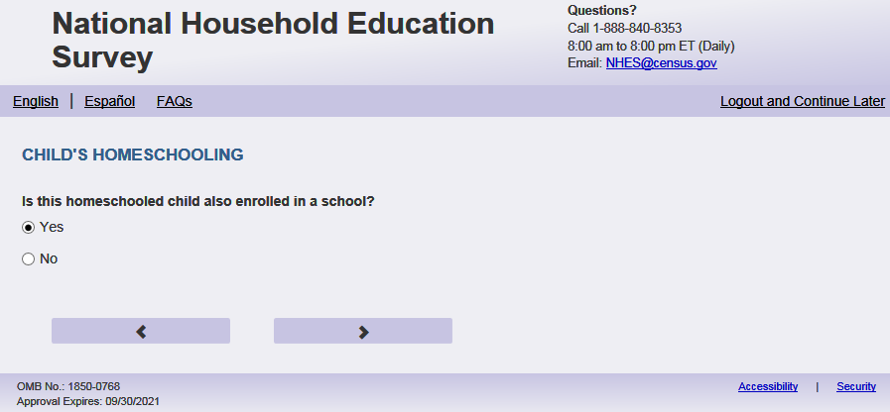
English Text Reads:
Is this homeschooled child also enrolled in a separate public or private school for any grades K to 12?
Spanish Text Reads:
[Este niño (esta niña)] que recibe la enseñanza escolar en el hogar (homeschool), ¿está también inscrito(a) en una escuela pública o privada para cualquier grado de kindergarten al 12?

English Answer
1=Yes
2=No

Spanish Answer
1= Sí
2= No

PFIC_HSENRL, (1,2), numeric, radio

Skip patterns:
If PFIC_HSENRL = 2, Go to PFIC_FOSTORY2X. Else, go to PFIC_SCHLHRSWK

Item: School Hours per Week (PFIC_SCHLHRSWK)
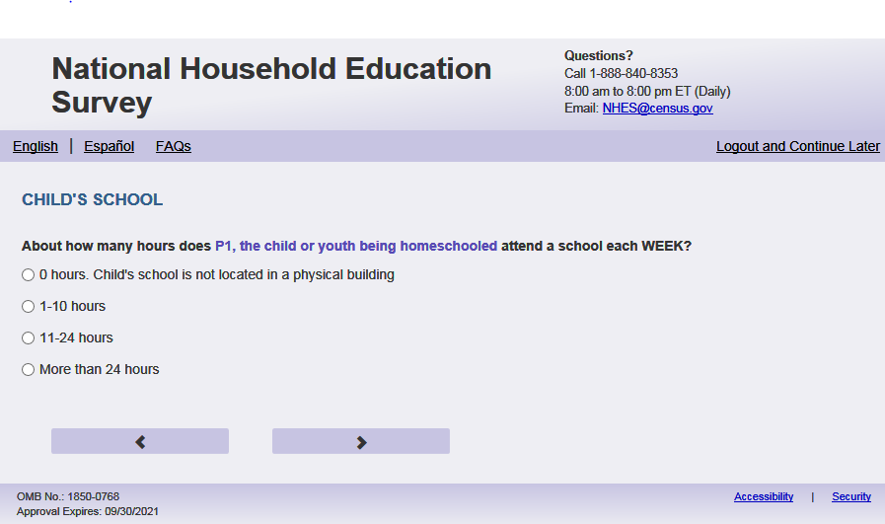
English Respondent Text Reads:
How many HOURS each WEEK does [this child] usually go to a school for instruction? Do not include time spent in extracurricular activities.
Spanish Respondent Text Reads:
¿Aproximadamente cuántas HORAS a la SEMANA asiste a una escuela [este niño(a)]? No incluya tiempo que pasa en actividades extraescolares.
English Admin/TQA Text Reads:
How many HOURS each WEEK does [this child] usually go to a school for instruction? Do not include time spent in extracurricular activities.
{Please read response options}
Spanish Admin/TQA Text Reads:
¿Aproximadamente cuántas HORAS a la SEMANA asiste a una escuela [este niño(a)]? No incluya tiempo que pasa en actividades extraescolares.
{Por favor, lea las opciones de respuesta.}

English Answer:
1= [This child] does not go to a school
2=10 or fewer hours each week
3=11 to 25 hours each week
4= More than 25 hours each week

Spanish Answer:
1=[Este niño (esta niña)] no va a una escuela
2=10 o menos horas a la semana
3=de 11 a 25 horas a la semana
4=Más de 25 horas a la semana

PFIC_SCHLHRSWK (1,4), numeric, radio
Skips:
  - Please use the following table
Responses | Skip
If ((PFIC_EDCHSFL = 1 and PFIC_EDCPUB = 1) or (PFIC_EDCHSFL2 = 1 and PFIC_EDCPUB2 = 1)) and (PFIC_ SCHLHRSWK ne 1) | Go to PFIC_DISTASSI
If ((PFIC_EDCHSFL= 1 and at least one of (PFIC_EDCCAT , PFIC_EDCREL, PFIC_EDCPRI) = 1) OR if (PFIC_EDSCHSFL2 = 1 and at least one of (PFIC_EDCCAT2, PFIC_EDCREL2, PFIC_EDCPRI122)=1)) and (PFIC_ SCHLHRSWK ne 1) | Go to PFIC_SNEIGHBRX
If ((PFIC_EDCHSFL= 1 and PFIC_EDCINTK12 = 1) or (PFIC_PFIC_EDCHSFL2 = 1 and PFIC_EDCINTK122 =1)) and (PFIC_ SCHLHRSWK ne 1) | Go to PFIC_ DISTASSI
If ((PFIC_EDCHSFL=1 and all others are blank or 2), or (PFIC_EDCHSFL2=1 and all others are blank or 2)) and PFIC_SCHLHRSWK ne 1 | Go to DISTASSI
Else if PFIC_SCHLHRSWK=1 | Go to PFIC_FOSTORY2X

Item: Attends Assigned School District (PFIC_DISTASSI)
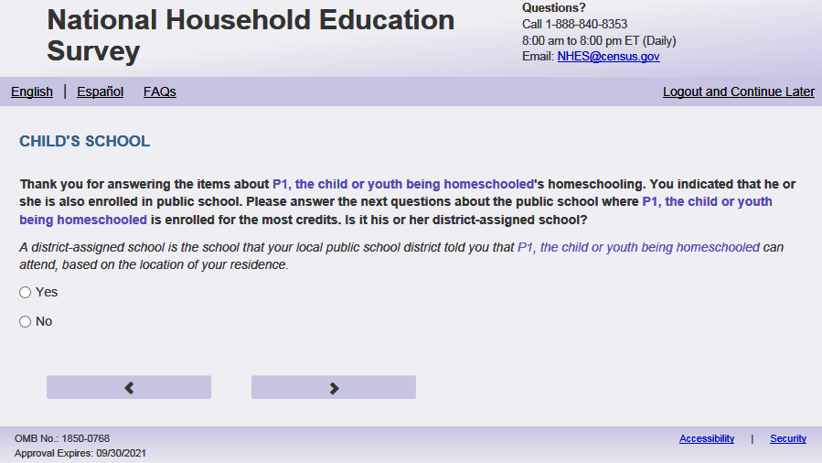
English Text:
Please answer the next questions about the school where [this child] is enrolled for the most hours.
Is it [his/her/his or her] district-assigned school?

A district-assigned school is the school that your local public school district told you that [this child] can attend, based on the location of your residence.

Spanish Text Reads:
Conteste por favor las siguientes preguntas acerca de la escuela donde [este niño (esta niña)] está inscrito para la mayoría de las horas. ¿Es esta la escuela designada por su distrito escolar?

Una escuela designada por un distrito es aquella que su distrito escolar público le indicó que [este niño (esta niña)] puede asistir de acuerdo con la ubicación de su domicilio.

English Answer:
1=Yes
2= No

Spanish
1= Sí
2= No

PFIC_DISTASSI, (1,2) , numeric, radio

Skips:

Go to PFIC_SCHRTSCHL.

Logic checks/Programming specifications:
English:
If PFIC_EDCPUB = 1 or PFIC_EDCPUB2 = 1 and all others are blank or 2, then use “Please answer the next questions about the school where [this child] is enrolled for most the hours. Is it [his/her/his or her] district-assigned school?”
Else if (PFIC_EDCPUB = 1 and at least one of (PFIC_EDCCAT, PFIC_EDCREL PFIC_EDCPRI) =1) or (PFIC_EDCPUB2 = 1and at least one of (PFIC_EDCCAT2, PFIC_EDCREL2, PFIC_EDCPRI2) =1) , use “You indicated that [this child] is enrolled in a public school and a private school. Please answer the next questions about the public school. Is it [his/her/his or her] district-assigned school?”

Else if ((PFIC_EDCPUB = 1 and PFIC_EDCHSFL = 1) or (PFIC_EDCPUB2 = 1 and PFIC_EDCHSFL2 = 1)) and PFIC_SCHLHRSWK ne 1 use: “Thank you for answering the items about [this child]’s homeschooling. You indicated that [he/she/he or she] is also enrolled in public school. Please answer the next questions about the public school where [he/she/he or she] is enrolled for the most hours. Is it [his/her/his or her] district-assigned school?

Else use “Please answer the next questions about the school where [this child] is enrolled for the most hours. Is it [his/her/his or her] district-assigned school?”

If S1_Pxsex = 1, use ‘he’, if s1_pxsex = 2, use ‘she’, else use ‘he or she’
If S1_Pxsex = 1, use ‘his’, if s1_pxsex = 2, use ‘her’, else use ‘his or her’
Spanish:
If PFIC_EDCPUB = 1 or PFIC_EDCPUB2 = 1and all others are blank or 2, then use “Conteste por favor las siguientes preguntas acerca de la escuela donde [este niño (esta niña)] está inscrito para la mayoría de las horas. ¿Es la escuela designada por su distrito?

Else if (PFIC_EDCPUB = 1 and at least one of (PFIC_EDCCAT, PFIC_EDCREL PFIC_EDCPRI) =1) or (PFIC_EDCPUB2 = 1and at least one of (PFIC_EDCCAT2, PFIC_EDCREL2, PFIC_EDCPRI2) =1) , use “Usted indicó que [este niño (esta niña)]está inscrito en una escuela pública y una escuela privada. Conteste por favor las siguientes preguntas acerca de la escuela pública. ¿Es la escuela designada por su distrito?

Else if ((PFIC_EDCPUB = 1 and PFIC_EDCHSFL = 1) or (PFIC_EDCPUB2 = 1 and PFIC_EDCHSFL2 = 1)) and PFIC_SCHLHRWK ne 1 use: “
Gracias por contestar las preguntas sobre la enseñanza escolar en el hogar (homeschool) de [este niño (esta niña)]. Usted indicó que [este niño (esta niña)] también está inscrito en una escuela pública. Conteste por favor las siguientes preguntas acerca de la escuela pública donde [este niño (esta niña)] está inscrito para la mayoría de las horas. ¿Es la escuela designada por su distrito?

Else use “Conteste por favor las siguientes preguntas acerca de la escuela pública donde [este niño (esta niña)] está inscrito para la mayoría de sus las horas. ¿Es la escuela designada por su distrito?

Item: Attends a Charter School (PFIC_SCHRTSCHL)
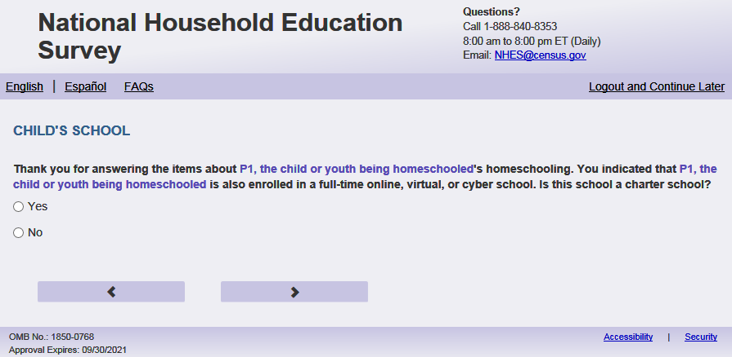

English Respondent Text Reads:
Is this school a charter school?

Spanish Respondent Text Reads:
¿Es esta escuela una escuela chárter?

English Admin/TQA Text Reads:
Is this school a charter school?

[The term “charter school” should be an active link for the Admin/TQA screen. Add definition hover over “charter school”:] A charter school is a public school that operates as a school of choice. Charter schools commit to obtaining specific educational objectives in return for a charter to operate a school. They are run by groups and organizations under a legislative contract rather than by school districts. Charter schools cannot charge tuition or be affiliated with a religious institution.

Spanish Admin/TQA Text Reads:
¿Es esta escuela una escuela chárter?

[The term “escuela chárter” should be an active link for the Admin/TQA screen. Add definition hover over “escuela chárter”:] Una escuela chárter es una escuela pública que opera como una escuela de elección. Las escuelas chárter se comprometen a obtener objetivos educativos específicos a cambio de un acta para operar una escuela. Son administrados por grupos y organizaciones bajo un contrato legislativo en lugar de por distritos escolares. Las escuelas chárter no pueden cobrar matrícula ni estar afiliadas a una institución religiosa.

English Answer:
1=Yes
2= No

Spanish Answer:
1= Sí
2= No

PFIC_SCHRTSCHL, (1,2), numeric, radio

Skips:

Go to PFIC_SCHLMAGNET

Logic checks/Programming specifications:
English:
Else if (PFIC_EDCHSFL= 1 and PFIC_EDCINTK12 = 1) OR (PFIC_EDCHSFL2 = 1 and PFIC_EDCINTK122 = 1) use: “Thank you for answering the items about [this child]’s homeschooling. You indicated that [he/she/he or she] is also enrolled in a full-time online, virtual, or cyber school. Is this school a charter school?”

If S1_Pxsex = 1, use ‘he’, if s1_pxsex = 2, use ‘she’, else use ‘he or she’
Else use “Is this school a charter school?”

Spanish:
Else if (PFIC_EDCHSFL= 1 and PFIC_EDCINTK12 = 1) OR (PFIC_EDCHSFL2 = 1 and PFIC_EDCINTK122 = 1) use: “ Gracias por contestar las preguntas sobre la enseñanza escolar en el hogar (homeschool) de [este niño (esta niña)]. Usted indicó que [este niño (esta niña)] también está inscrito en una escuela online, virtual o cyber de tiempo completo. ¿Es esta escuela una escuela chárter?

Else use ¿Es esta escuela una escuela chárter?
For the Admin/TQA screen: Definition should appear as pop-out text boxes when clicking the phrase “charter school”/“escuela charter”

Item: Attends a Magnet School (PFIC_SCHLMAGNET)
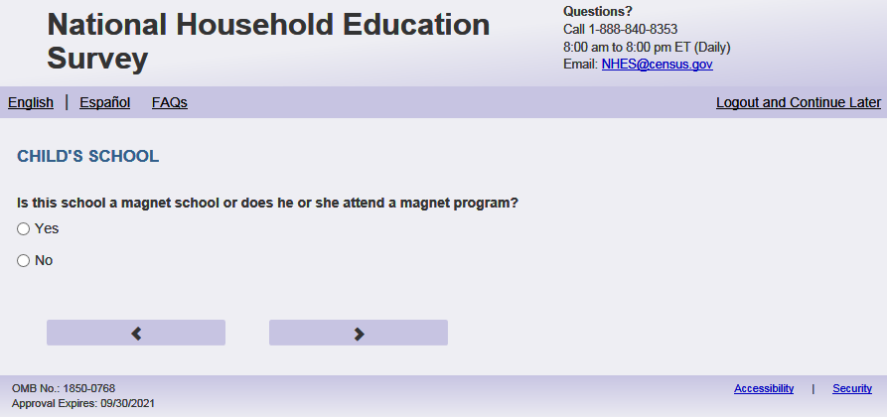
English Respondent Text Reads:
Is this school a magnet school or does [he/she/he or she] attend a magnet program?

Spanish Respondent Text Reads:
¿Es esta escuela una escuela especializada (magnet) o asiste [este niño (esta niña)] a un programa especializado (magnet program)?

English Admin/TQA Text Reads:
Is this school a magnet school or does [he/she/he or she] attend a magnet program?

[The term “magnet school” should be an active link for the Admin/TQA screen. Add definition hover over “magnet school”:] A magnet school is a free, public elementary and secondary “school of choice” that operates within existing public schools in a district, usually with a specific curricular focus or alternative mode of instruction. For example, a magnet school may be focused on science, technology, or art.

[The term “magnet program” should be an active link for the Admin/TQA screen. Add definition hover over “magnet program”:] A magnet program is a program in a public school that usually focuses on a special area of study, such as science, the performing arts, or career education.

Spanish Admin/TQA Text Reads:
¿Es esta escuela una escuela especializada (magnet) o asiste [este niño (esta niña)] a un programa especializado (magnet program)?

[The term “magnet school” should be an active link for the Admin/TQA screen. Add definition hover over “magnet school”:] Una escuela magnet es una "escuela de elección" primaria y secundaria pública y gratuita que opera dentro de las escuelas públicas existentes en un distrito, generalmente con un enfoque curricular específico o un modo alternativo de instrucción. Por ejemplo, una escuela magnet puede centrarse en la ciencia, la tecnología o el arte.

[The term “magnet program” should be an active link for the Admin/TQA screen. Add definition hover over “magnet program”:] Un programa magnet es un programa en una escuela pública que generalmente se enfoca en un área especial de estudio, como la ciencia, las artes escénicas o la educación profesional.

English Answer:
1=Yes
2= No
3=Don’t know

Spanish Answer:
1= Sí
2= No
3= No lo sé

PFIC_SCHLMAGNET, (1,3) , numeric, radio

Skips:
Go to PFIC_SNEIGHBRX

Logic Check/programming specification:
If S1_Pxsex = 1, use ‘he’, if s1_pxsex = 2, use ‘she’, else use ‘he or she’
For the Admin/TQA screen: Definitions should appear as pop-out text boxes when clicking the phrases “magnet school” and “magnet program”.

Item: Moved to Neighborhood for School (PFIC_SNEIGHBRX)
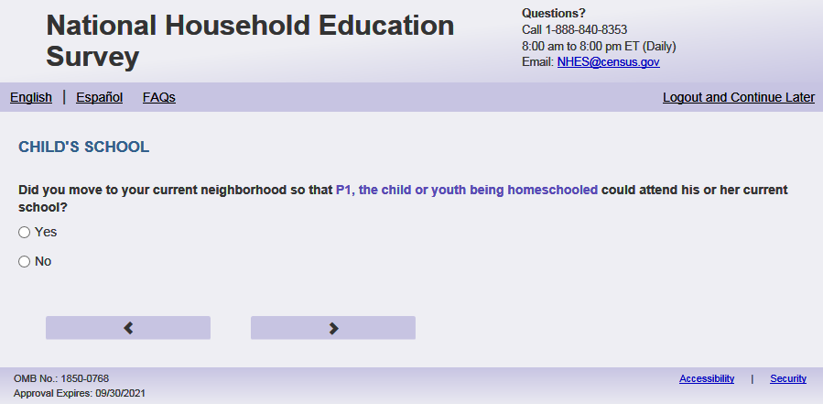

English Text Reads
Did you move to your current neighborhood so that [this child] could attend [his/her/his or her] current school?

Spanish Text Reads:
¿Se mudó usted a su vecindario actual para que [este niño (esta niña)] pudiera asistir a su escuela actual?

English Answer:
1=Yes
2= No

Spanish Answer:
1= Sí
2= No

PFIC_SNEIGHBRX, (1,2) , numeric, radio

Skips:

Go to PFIC_ SCCHOICE

Logic checks/Programming specifications:
English:
If ((PFIC_EDCHSFL= 1) and at least one of (PFIC_EDCCAT, PFIC_EDCREL PFIC_EDCPRI) =1) OR If ((PFIC_EDCHSFL2= 1) and at least one of (PFIC_EDCCAT2, PFIC_EDCREL2, PFIC_EDCPRI2) =1), use “Thank you for answering the items about [this child]’s homeschooling. You indicated that [this child] is also enrolled in a private school. Please answer the next questions about the private school [this child] is enrolled in for most hours. Did you move to your current neighborhood so that [this child] could attend [his/her/his or her] current school?”

Else use “Did you move to your current neighborhood so that [this child] could attend [his/her/his or her] current school?”

If S1_Pxsex = 1, use ‘his’, if s1_pxsex = 2, use ‘her’, else use ‘his or her’
Spanish:
If (PFIC_EDCHSFL= 1) and at least one of (PFIC_EDCCAT, PFIC_EDCREL PFIC_EDCPRI) =1 OR If ((PFIC_EDCHSFL2= 1) and at least one of (PFIC_EDCCAT2, PFIC_EDCREL2, PFIC_EDCPRI2) =1), use “Gracias por contestar las preguntas sobre la enseñanza escolar en el hogar (homeschool) de [este niño (esta niña)]. Usted indicó que [este niño (esta niña)] también está inscrito en una escuela privada. Conteste por favor las siguientes preguntas acerca de la escuela privada donde [este niño (esta niña)] está inscrito para la mayoría de las horas ¿Se mudó usted a su vecindario actual para que [este niño (esta niña)] pudiera asistir a su escuela actual?”

Else use “¿Se mudó usted a su vecindario actual para que [este niño (esta niña)] pudiera asistir a su escuela actual?”

Item: School Choice (PFIC_SCCHOICE)
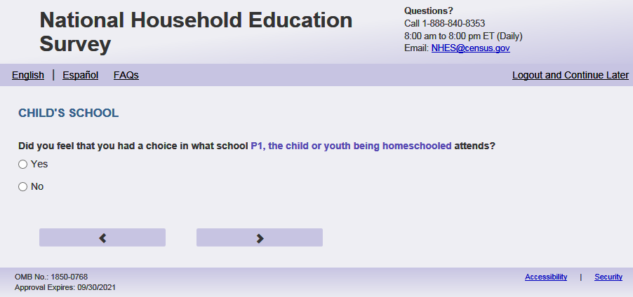
English text reads:
Did you feel that you had a choice in what school [this child] attends?
Spanish text reads:
¿Siente que usted tuvo opciones en decidir qué escuela asistiría [este niño (esta niña)]?
English Answer:
1=Yes
2= No

Spanish Answer:
1= Sí
2= No

PFIC_SCCHOICE, (1,2) , numeric, radio
Skips:

Go to PFIC_SPUBCHOIX.

Item: Public School Choice (PFIC_SPUBCHOIX)
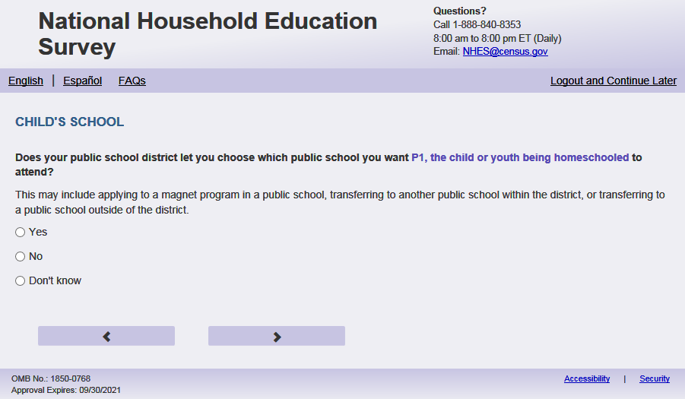
English Text Reads:
Does your public school district let you choose which public school you want [this child] to attend?
This may include applying to a magnet program in a public school, transferring to another public school within the district, or transferring to a public school outside of the district.

Spanish Text Reads:
¿Le permite su distrito escolar público escoger a qué escuela pública usted desea que [este niño (esta niña)] asista?
Esto puede incluir solicitar la admisión a un programa “magnet” en una escuela pública, transferirse a otra escuela pública dentro del distrito o transferirse a una escuela pública fuera del distrito.
English Answer:
1= Yes
2= No
3= Don't know

Spanish Answer:
1= Sí
2= No
3= No lo sé

PFIC_SPUBCHOIX, (1,3), numeric, radio

Skips:

Go to PFIC_SCONSIDR.

Item: Other Schools (PFIC_SCONSIDR)
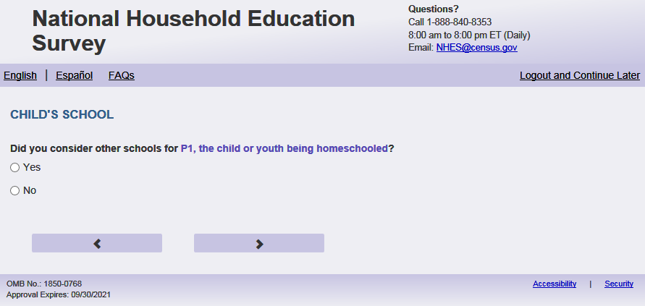
English Text Reads:
Did you consider other schools for [this child]?

Spanish Text Reads:
¿Consideró otras escuelas para [este niño (esta niña)]?

English Answer:
1= Yes
2= No

Spanish Answer:
1= Sí
2= No

PFIC_SCONSIDR, (1,2), numeric, radio

Skips:

if PFIC_SCONSIDR = 2 then go to PFIC_FINDSCHL. Else go to PFIC_LOCALE .

Item: Reasons School Chosen (PFIC_LOCALE )
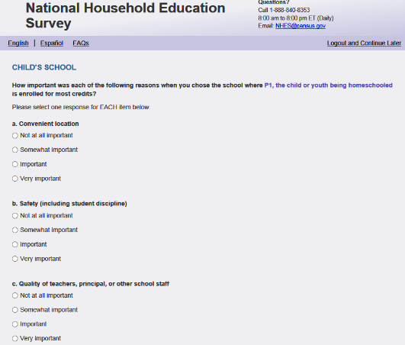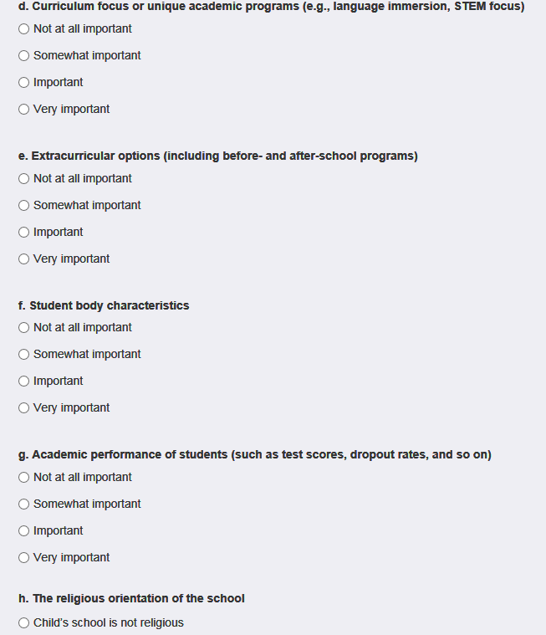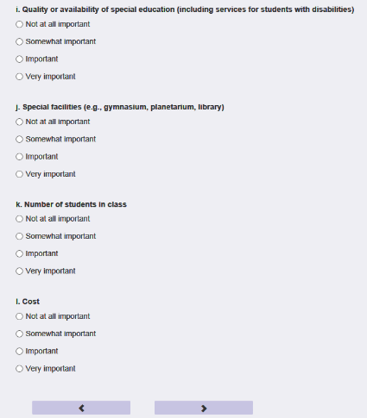
English Respondent Text:
How important was each of the following reasons when you chose the school where [this child] is enrolled for the most hours?
If this child is homeschooled, please answer about the physical or online/virtual/cyber school where [he/she/he or she] is enrolled.
Spanish Respondent Text:
¿Qué tan importante fue cada una de las siguientes razones cuando escogió la escuela donde [este niño(esta niña)] está inscrito para la mayoría de las horas?
Si este niño(a) recibe la enseñanza escolar en el hogar (homeschool), conteste por favor acerca escuela física u online, virtual o cyber donde este niño(a) está inscrito(a).

English Admin/TQA Text:
How important was each of the following reasons when you chose the school where [this child] is enrolled for the most hours?
If this child is homeschooled, please answer about the physical or online/virtual/cyber school where [he/she/he or she] is enrolled.
As I read them, please answer for EACH reason whether it was ‘not at all important, ‘somewhat important,’ ‘important,’ or ‘very important.’
{For item h. offer to the respondent that they can also say that the school is not religious. Also read the question again if the respondent forgets.}
Spanish Admin/TQA Text:
¿Qué tan importante fue cada una de las siguientes razones cuando escogió la escuela donde [este niño(esta niña] está inscrito para la mayoría de las horas?
Si este niño(a) recibe la enseñanza escolar en el hogar (homeschool), conteste por favor acerca escuela física u online, virtual o cyber donde este niño(a) está inscrito(a).
A medida que las leo, por favor responda por CADA razón si era 'nada importante', un poco importante', 'algo importante' o 'muy importante'.
{Para el punto h. ofrecer al encuestado que también puede decir que la escuela no es religiosa. También lea la pregunta de nuevo si el encuestado olvida. }

English Answers:
- Convenient location PFIC_LOCALE (1=Not at all important, 2=Somewhat important, 3=Important, 4=Very important), numeric, radio
- Safety (including student discipline) PFIC_SCHLSAFETY (1=Not at all important, 2=Somewhat important, 3=Important, 4=Very important), numeric, radio
- Quality of teachers, principal, or other school staff PFIC_SCHLSTFQUALITY (1=Not at all important, 2=Somewhat important, 3=Important, 4=Very important), numeric, radio
- Curriculum focus or unique academic programs (e.g., language immersion, STEM focus) PFIC_AVAILCOURSE (1=Not at all important, 2=Somewhat important, 3=Important, 4=Very important), numeric, radio
- Extracurricular options (including before- and after-school programs) PFIC_XTRACURRIC (1=Not at all important, 2=Somewhat important, 3=Important, 4=Very important), numeric, radio
- Student body characteristics PFIC_STUDNTCHAR (1=Not at all important, 2=Somewhat important, 3=Important, 4=Very important), numeric, radio
- Academic performance of students (such as test scores, dropout rates, and so on) PFIC_STUDNTPERFORM (1=Not at all important, 2=Somewhat important, 3=Important, 4=Very important), numeric, radio
- The religious orientation of the school PFIC_RELIGSOR (5=Child’s school is not religious, 1=Not at all important, 2=Somewhat important, 3=Important, 4=Very important), numeric, radio
- Quality or availability of special education (including services for students with disabilities) PFIC_SPECALEDSERVS (1=Not at all important, 2=Somewhat important, 3=Important, 4=Very important), numeric, radio
- Special facilities (e.g., gymnasium, planetarium, library) PFIC_SPECALFACILTS (1=Not at all important, 2=Somewhat important, 3=Important, 4=Very important), numeric, radio
- Number of students in class PFIC_CLSSIZE (1=Not at all important, 2=Somewhat important, 3=Important, 4=Very important), numeric, radio
- Cost PFIC_SCHLCOST (1=Not at all important, 2=Somewhat important, 3=Important, 4=Very important), numeric, radio
Spanish Answers:
- Local conveniente PFIC_LOCALE (1=No fue importante, 2=Algo importante, 3=Importante, 4=Muy importante), numeric, radio
- Seguridad (incluyendo la disciplina de los estudiantes) PFIC_SCHLSAFETY (1=No fue importante, 2=Algo importante, 3=Importante, 4=Muy importante), numeric, radio
- Calidad de los maestros, el director, u otro personal de la escuela PFIC_SCHLSTFQUALITY (1=No fue importante, 2=Algo importante, 3=Importante, 4=Muy importante), numeric, radio
- Enfoque del currículo o programas académicos especiales (por ejemplo, inmersión lingüística, concentración en STEM (ciencia, tecnología, ingeniería, y matemáticas)) PFIC_AVAILCOURSE (1=No fue importante, 2=Algo importante, 3=Importante, 4=Muy importante), numeric, radio
- Opciones extracurriculares (incluyendo programas para antes o después del día escolar) PFIC_XTRACURRIC (1=No fue importante, 2=Algo importante, 3=Importante, 4=Muy importante), numeric, radio
- Características del alumnado PFIC_STUDNTCHAR (1=No fue importante, 2=Algo importante, 3=Importante, 4=Muy importante), numeric, radio
- Rendimiento académico de los estudiantes (como resultados en exámenes, tasas de deserción, etcétera) PFIC_STUDNTPERFORM (1=No fue importante, 2=Algo importante, 3=Importante, 4=Muy importante), numeric, radio
- La orientación religiosa de la escuela PFIC_RELIGSOR (5=La escuela del niño(a) no es religiosa, 1=No fue importante, 2=Algo importante, 3=Importante, 4=Muy importante), numeric, radio
- Calidad o disponibilidad de educación especial (incluyendo servicios para estudiantes con discapacidades) PFIC_SPECALEDSERVS (1=No fue importante, 2=Algo importante, 3=Importante, 4=Muy importante), numeric, radio
- Instalaciones especiales (por ejemplo, gimnasio, planetario, biblioteca) PFIC_SPECALFACILTS (1=No fue importante, 2=Algo importante, 3=Importante, 4=Muy importante), numeric, radio
- Cantidad de estudiantes en las clases PFIC_CLSSIZE (1=No fue importante, 2=Algo importante, 3=Importante, 4=Muy importante), numeric, radio
- Costo PFIC_SCHLCOST (1=No fue importante, 2=Algo importante, 3=Importante, 4=Muy importante), numeric, radio
Skip Patterns:
Go to PFIC_FINDSCHL
Logic Check/programming specification:
Display the response option for PFIC_RELIGSOR “Child’s school is not religious”/”La orientación religiosa de la escuela” to have more space between this response option and the first response option than the spacing between the other response options (about double the normal spacing).
English:
If PFIC_EDCHSFL= 1 display after the question text but before the “Select one for each” instruction: “Please answer about the physical or online, virtual, or cyber school
where [he/she/he or she] is enrolled.”

If S1_Pxsex = 1, use ‘he’, if s1_pxsex = 2, use ‘she’, else use ‘he or she’
Spanish:
If PFIC_EDCHSFL= 1 display after the question text but before the “Select one for each” instruction: “Conteste por favor acerca de la escuela física o la escuela online, virtual o cyber donde [este niño (esta niña)] está inscrito.”

Item: Find School (PFIC_FINDSCHL)
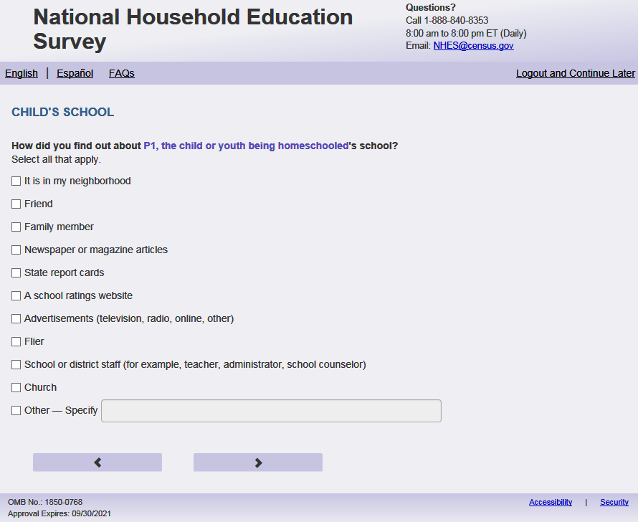
English Respondent Text:
How did you find out about [this child]’s school?
Select all that apply.
Spanish Respondent Text:
¿Como descubrió la escuela de [este niño (esta niña)]?
Seleccione todas las que correspondan.

English Admin/TQA Text:
How did you find out about [this child]’s school?
{Mark any answer that corresponds to the respondent’s answer, and record any that don’t correspond in the “Other, specify” box.}
Spanish Admin/TQA Text:
¿Como descubrió la escuela de [este niño (esta niña)]?
{Marque cualquier respuesta que corresponda a la respuesta del encuestado y registre las que no correspondan en el cuadro "Otro, especifique".}

English Answer:
1=It is in my neighborhood PFIC_FINDSCHL, (1=Marked, 2=Not Marked), checkbox
2=Friend PFIC_FINDFRND(1= Marked, 2=Not Marked), checkbox
3=Family member PFIC_FINDFAM(1= Marked, 2=Not Marked), checkbox
4=Newspaper or magazine articles PFIC_FINDNEWS(1= Marked, 2=Not Marked), checkbox
5=State report cards PFIC_FINDRPT(1= Marked, 2=Not Marked), checkbox
6=A school ratings website PFIC_FINDWEB(1= Marked, 2=Not Marked), checkbox
7=Advertisements (television, radio, online, other) PFIC_FINDADS(1= Marked, 2=Not Marked), checkbox
8=Flier PFIC_FINDFLY (1= Marked, 2=Not Marked), checkbox
9=School or district staff (for example, teacher, administrator, school counselor) PFIC_FINDSTF(1= Marked, 2=Not Marked), checkbox
10=Church PFIC_FINDCHRC(1= Marked, 2=Not Marked), checkbox
11=Other-Specify PFIC_FINDOTH(1= Marked, 2=Not Marked), checkbox

If PFIC_FINDOTH selected, specify box should become active (PFIC_FINDOTHOS): Write-in, (0,500), character, write-in. Display specify response box 1 row by 30 characters.

Spanish Answer:
1=Está localizada en mi vecindad PFIC_FINDSCHL, (1= Marked, 2=Not Marked), checkbox
2=Amigo PFIC_FINDFRND(1= Marked, 2=Not Marked), checkbox
3=Pariente PFIC_FINDFAM(1= Marked, 2=Not Marked), checkbox
4=Periódico o artículo en una revista PFIC_FINDNEWS(1= Marked, 2=Not Marked), checkbox
5=Calificaciones estatales PFIC_FINDRPT(1= Marked, 2=Not Marked), checkbox
6=Un sitio del internet con calificaciones de la escuela PFIC_FINDWEB(1= Marked, 2=Not Marked), checkbox
7=Propagandas (televisión, radio, online, otro) PFIC_FINDADS(1= Marked, 2=Not Marked), checkbox
8=Folleto PFIC_FINDFLY (1= Marked, 2=Not Marked), checkbox
9=Personal de la escuela o distrito escolar (Por ejemplo, maestro, administrador, consejero escolar) PFIC_FINDSTF(1= Marked, 2=Not Marked), checkbox
10=Iglesia PFIC_FINDCHRC(1= Marked, 2=Not Marked), checkbox
11= Otro - Especifíque PFIC_FINDOTH(1= Marked, 2=Not Marked), checkbox

Skips:
Go to PFIC_S1STCHOI
Logic Check/programming specification:
Display as a Mark all that apply-type item (like the race item) with checkmarks instead of radio buttons.

Item: First Choice School (PFIC_S1STCHOI)
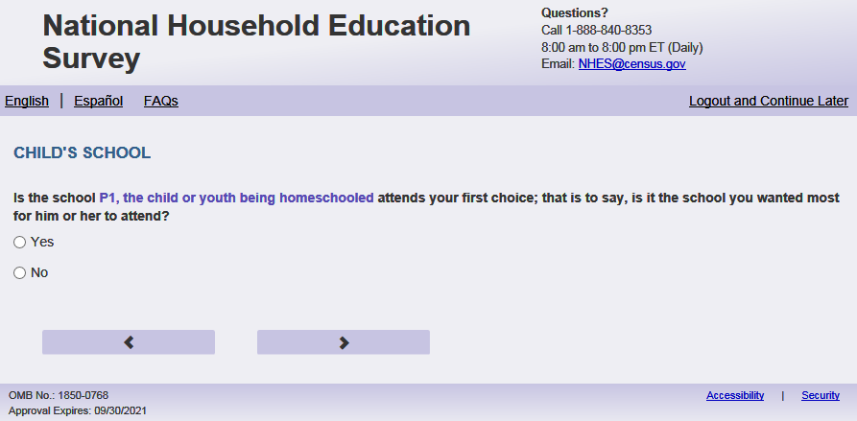
English Text Reads:
Is the school [this child] attends your first choice; that is to say, is it the school you wanted most for [him/her/him or her] to attend?

Spanish Text Reads:
¿Es la escuela a la que asiste [este niño (esta niña)] su primera opción, es decir, la escuela a la que usted más quería que [él/ella/él o ella] asistiera?

English Answer:
1 = Yes
2 = No

Spanish Answer:
1= Sí
2=No

PFIC_S1STCHOI, (1,2), numeric, radio

Skips:

Go to PFIC_SSAMSC
Logic checks/Programming specifications:
English:
If S1_Pxsex = 1, use ‘him’, if s1_pxsex = 2, use ‘her’, else use ‘him or her’
Spanish:
If S1_Pxsex = 1, use ‘él’, if s1_pxsex = 2, use ‘ella’, else use ‘él or ella’

Item: Same School since the Beginning of School Year (PFIC_SSAMSC)
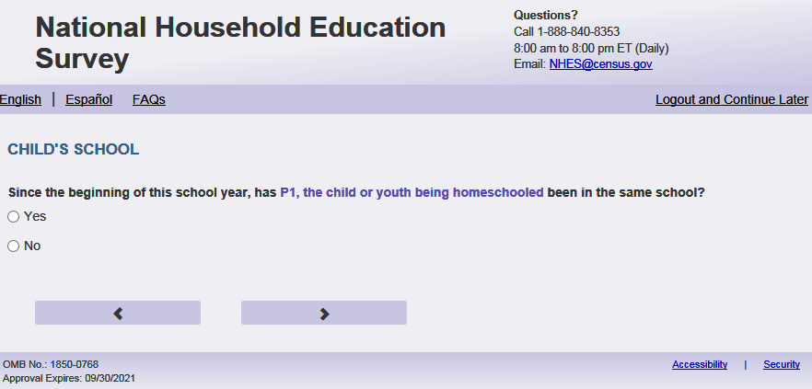
English Text Reads:
Since the beginning of this school year, has [this child] been in the same school?

Spanish Text Reads:
Desde el comienzo de este año escolar, ¿ha estado [este niño (esta niña)] en la misma escuela?

English Answer:
1= Yes
2=No

Spanish Answer:
1= Sí
2= No

PFIC_SSAMSC, (1,2), numeric, radio

Skips:

If PFIC_HSINTNET = 1, 2, 3, 4 go to PFIC_SEENJOY
else if PFIC_HSINTNET = blank go to PFIC_EINTNET

Item: Online courses (PFIC_EINTNET)
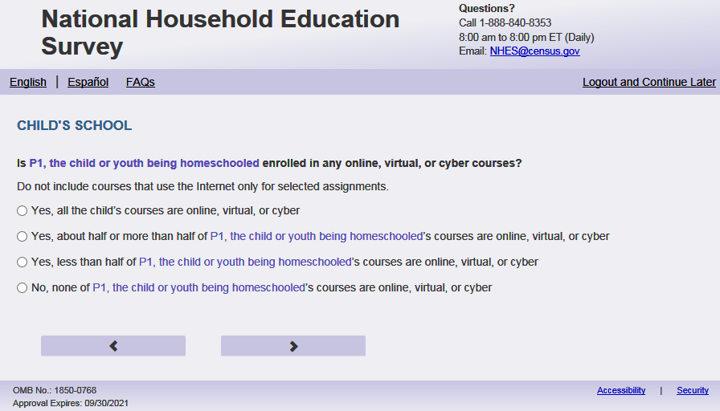
English Text Reads:
Is [this child] enrolled in any online, virtual, or cyber courses?

Do not include courses that use the Internet for only selected assignments.

Spanish Text Reads:
¿Está inscrito [este niño (esta niña)] en cursos online, virtuales o cyber?

No incluya cursos que usan el internet solamente para tareas específicas.

English Admin/TQA Text Reads:
Is [this child] enrolled in any online, virtual, or cyber courses?

Do not include courses that use the Internet for only selected assignments.
[The term “online, virtual, or cyber course ” should be an active link for the Admin/TQA screen. Add definition hover over “online, virtual, or cyber courses:] An online, virtual, or cyber course is instruction conducted over the Internet. These courses are generally conducted through an online platform where students can view their course syllabus and academic progress, as well as communicate with fellow students and their course instructor.
{If ‘yes,’ then read yes options to the respondent.}

Spanish Admin/TQA Text Reads:
¿Está inscrito [este niño (esta niña)] en cursos online, virtuales o cyber?

No incluya cursos que usan el internet solamente para tareas específicas.
[The term “curso online, virtual o cyber” should be an active link for the Admin/TQA screen. Add definition hover over “curso online, virtual, o cyber”:] Un curso online, virtuales o cyber es una instrucción realizada a través de Internet. Estos cursos generalmente se llevan a cabo a través de una plataforma en línea donde los estudiantes pueden ver su programa de estudios y el progreso académico, así como comunicarse con otros estudiantes y su instructor del curso.
{Si 'sí', entonces lea las opciones de sí al encuestado.}

English Answer
1= Yes, all [this child]’s courses are online, virtual, or cyber
2= Yes, about half or more than half of [this child]’s courses are online, virtual, or cyber
3= Yes, less than half of [this child]’s courses are online, virtual, or cyber
4= No, none of [this child]’s courses are online, virtual, or cyber

Spanish Answer
1= Sí, todos los cursos del [este niño (esta niña)] son online, virtuales o cyber
2=Sí, más o menos la mitad o más de la mitad de los cursos de [este niño(esta niña)] son online, virtuales o cyber
3= Sí, menos de la mitad de los cursos de [este niño(esta niña)] son online, virtuales o cyber
4= No, ninguno de los cursos de [este niño(esta niña)] son online, virtuales o cyber

PFIC_EINTNET, (1,4), numeric, radio

Skip patterns:
IF PFIC_EINTNET = 4 go to PFIC_SEENJOY. Otherwise, go to PFIC_ADVCCRSE
Logic checks/Programming specifications
For the Admin/TQA screen: Definition should appear as pop-out text boxes when clicking the phrase “online, virtual or cyber course”/“curso online, virtual, o cyber”.

Item: Reason for choosing online schooling (PFIC_ADVCCRSE)
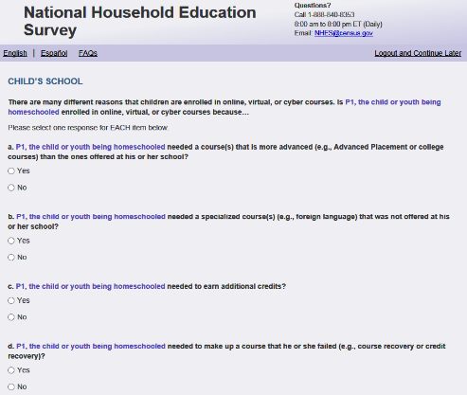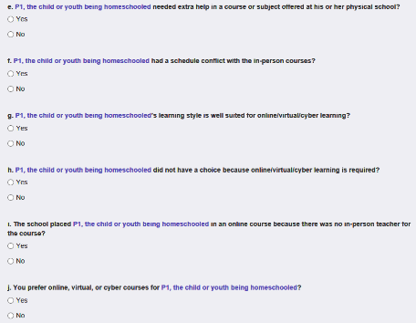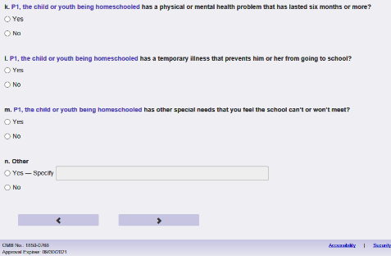
English Respondent Text Reads:
There are many different reasons that children are enrolled in online, virtual, or cyber courses. Is [this child] enrolled in online, virtual, or cyber courses because…
Spanish Respondent Text Reads:
Hay muchas razones diferentes por las cuales los niños se inscriben en cursos online, virtuales o cyber. [Este niño (esta niña)] está inscrito en cursos online, virtuales o cyber porque…
English Admin/TQA Text Reads:
There are many different reasons that children are enrolled in online, virtual, or cyber courses. Please answer ‘yes’ or ‘no’ for EACH reason as I read them. Is [this child] enrolled in online, virtual, or cyber courses because…
{Please re-read the question if the respondent asks or seems to have forgotten the question.}

Spanish Admin/TQA Text Reads:
Hay muchas razones diferentes por las cuales los niños se inscriben en cursos online, virtuales o cyber. Por favor, responda 'sí' o 'no' por cada razón a medida que las leo. [Este niño (esta niña)] está inscrito en cursos online, virtuales o cyber porque…
{Please re-read the question if the respondent asks or seems to have forgotten the question.}

English Answers:
- [This child] needed a course(s) that is more advanced (e.g., Advanced Placement or college courses) than the ones offered at [Fill 2: his, her, his or her] school? PFIC_ADVCCRSE, (1= Yes, 2= No), numeric, radio
- [This child] needed a specialized course(s) (e.g., foreign language) that was not offered at [Fill 2: his, her, his or her] school? PFIC_SPCLCRSE, (1= Yes, 2= No), numeric, radio
- [This child] needed to make up a course that [Fill 3: he/she or he or she] failed (e.g., course recovery or credit recovery)? PFIC_MKUPCRSE, (1= Yes, 2= No), numeric, radio
- [This child] needed to earn additional credits? PFIC_ADDCRSE, (1= Yes, 2= No), numeric, radio
- [This child] needed extra help in a course or subject offered at [Fill 2: his, her, his or her] physical school? PFIC_HELP, 1= Yes, 2= No), numeric, radio
- [This child] had a schedule conflict with the in-person courses? PFIC_CONFLCT, (1= Yes, 2= No), numeric, radio
- [This child] has a physical or mental health problem that has lasted six months or more? PFIC_DISABLX , (1= Yes, 2= No), numeric, radio
- [This child] has a temporary illness that prevents [Fill 1: him, her, him or her] from going to school? PFIC_TEMPILL , (1= Yes, 2= No), numeric, radio
- [This child] has other special needs that you feel the school can’t or won’t meet? PFIC_SPCLND, (1= Yes, 2= No), numeric, radio
- [This child]’s learning style is well suited for online, virtual, or cyber learning? PFIC_LRNSTYLE , (1= Yes, 2= No), numeric, radio
- [This child] did not have a choice because online, virtual, or cyber learning is required? PFIC_NOCHOICE , (1= Yes, 2= No), numeric, radio
- The school placed [this child] in an online course because there was no in-person teacher for the course? PFIC_SCHLPLCE , (1= Yes, 2= No), numeric, radio
- You prefer online, virtual, or cyber courses for [this child]? PFIC_ONLINEPREF , (1= Yes, 2= No), numeric, radio
- Another reason ‐ Specify: PFIC_ONLINEOTH , (1= Yes, 2= No), numeric, radio

Spanish Answers:
- ¿[Este niño (Esta niña)] necesitaba un curso(cursos) más avanzado(s) que los cursos ofrecidos por su escuela PFIC_ADVCCRSE, (1 = Sí, 2 = No), numeric, radio
- ¿[Este niño (Esta niña)] necesitaba un curso(cursos) especializado(s) (por ejemplo, idioma extranjero) no ofrecido por su escuela física? PFIC_SPCLCRSE , (1 = Sí, 2 = No), numeric, radio
- ¿[Este niño (Esta niña)] necesitaba completar un curso que aplazó (por ejemplo, recuperación de curso o recuperación de crédito)? PFIC_MKUPCRSE , (1 = Sí, 2 = No), numeric, radio
- ¿[Este niño (Esta niña)] necesitaba ganar créditos adicionales? PFIC_ADDCRSE , (1 = Sí, 2 = No), numeric, radio
- ¿[Este niño(a)] necesitaba ayuda extra en un curso o materia ofrecido en su escuela física? PFIC_HELP, (1 = Sí, 2 = No), numeric, radio
- ¿[Este niño (Esta niña)] tenía un conflicto de horario con el curso en persona? PFIC_CONFLCT, (1 = Sí, 2 = No), numeric, radio
- ¿[Este niño (Esta niña)] tiene un problema de salúd físico o mental que ha durado 6 meses o más? PFIC_DISABLX, (1 = Sí, 2 = No), numeric, radio
- ¿[Este niño (Esta niña)] tiene una enfermedad temporal que le impide ir a la escuela? PFIC_TEMPILL, (1 = Sí, 2 = No), numeric, radio
- ¿[Este niño (Esta niña)] tiene otras necesidades especiales que usted siente que la escuela no puede o no va a cumplir? PFIC_SPCLND, (1 = Sí, 2 = No), numeric, radio
- ¿El estilo de aprendizaje de [este niño (esta niña)] le conviene a un aprendizaje online, virtual o cyber? PFIC_LRNSTYLE, (1 = Sí, 2 = No), numeric, radio
- ¿[Este niño (Esta niña)] no tuvo opción porque el aprendizaje online, virtual o cyber es obligatorio? PFIC_NOCHOICE, (1 = Sí, 2 = No), numeric, radio
- ¿La escuela le puso a [este niño (esta niña)] en un curso online porque no había maestro para enseñar ese curso? PFIC_SCHLPLCE, (1 = Sí, 2 = No), numeric, radio
- ¿Usted prefiere cursos online, virtuales o cyber para [este niño (esta niña)]? PFIC_ONLINEPREF, (1 = Sí, 2 = No), numeric, radio
- Otra razón ‐ Especifique: PFIC_ONLINEOTH, (1 = Sí, 2 = No), numeric, radio

If PFIC_ONLINEOTH selected, specify box should become active (PFIC_ONLINEOTHOS): Write-in, (0,1000) character, write-in. Display specify response box 3 rows by 30 characters.

Skips:
If respondent leaves PFIC_ADVCCRSE - PFIC_ONLINEOTH blank or provides all “no” (=2) responses or only 1 “yes” (=1), then go to PFIC_SPBSCH. Else go to PFIC_MOSTIMPT
Logic checks/Programming specifications:
display as grid

English:
Fill 1: If S1_Pxsex = 1, use ‘him’, if s1_pxsex = 2, use ‘her’, else use ‘him or her’
Fill 2: If S1_Pxsex = 1, use ‘his’, if s1_pxsex = 2, use ‘her’, else use ‘his or her’
Fill 3: If S1_Pxsex = 1, use ‘he’, if s1_pxsex = 2, use ‘she’, else use ‘he or she’
Spanish:
If S1_Pxsex = 1, use ‘él’, if s1_pxsex = 2, use ‘ella’, else use ‘él or ella’

Item: Most Important Reason for Choosing Online Schooling (PFIC_MOSTIMPT)
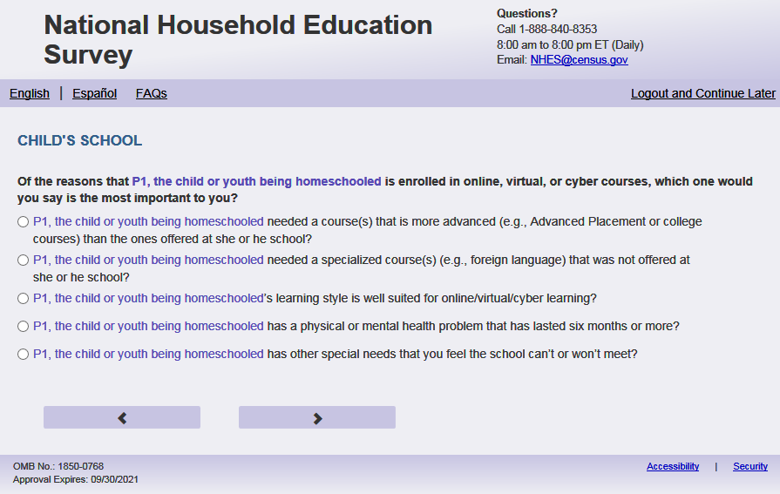
English Text Reads:
Of the reasons that [this child] is enrolled in online, virtual, or cyber courses, which ONE would you say is the most important to you?
Spanish Text Reads:
De todas las razones por las cuales [este niño (esta niña)] está inscrito en cursos online, virtuales o cyber, ¿CUÁL diría usted que fue la más importante?
English Answer
[This child] needed a course(s) that is more advanced (e.g., Advanced Placement or college courses) than the ones offered at [Fill 1: his/her/his or her] school
[This child] needed a specialized course(s) (e.g., foreign language) that was not offered at [his, her, his or her] school
[This child] needed to make up a course that [Fill 2: she/he/she or he] failed (e.g., course recovery or credit recovery)
[This child] needed to earn additional credits
[This child] needed extra help in a course or subject offered at [his, her, his or her] physical school
[This child] had a schedule conflict with the in-person courses
[This child] has a physical or mental health problem that has lasted six months or more
[This child] has a temporary illness that prevents [Fill 3: him/her/him or her] from going to school
[This child] has other special needs that you feel the school can’t or won’t meet
[This child]’s learning style is well suited for online, virtual, or cyber learning
[This child] did not have a choice because online, virtual, or cyber learning is required
The school placed [this child] in an online course because there was no in-person teacher for the course
You prefer online, virtual, or cyber courses for [this child]
[Answer written in PFIC_ONLINEOTHOS]. If blank then “Another reason – not specified

Spanish Answers:
[Este niño (esta niña)] necesitaba un curso(cursos) más avanzado(s) que los cursos ofrecidos por su escuela
[Este niño (esta niña)] necesitaba un curso(cursos) especializado(s) (por ejemplo, idioma extranjera) no ofrecido por su escuela
[Este niño (esta niña)] necesitaba completar un curso que aplazó (por ejemplo, recuperación de curso o recuperación de crédito)
[Este niño (esta niña)] necesitaba ganar créditos adicionales
[Este niño (esta niña)] necesitaba ayuda extra en un curso o materia ofrecido en su escuela física
[Este niño (esta niña)] tenía un conflicto de horario con el curso en persona
[Este niño (esta niña)] tiene un problema de salud física o mental que ha durado 6 meses o más
[Este niño (esta niña)] tiene una enfermedad temporal que le impide ir a la escuela
[Este niño (esta niña)] tiene otras necesidades especiales que usted siente que la escuela no puede o no quiere cumplirse
El estilo de aprendizaje de este niño/a le conviene a un aprendizaje online, virtual o cyber
[Este niño (esta niña)] no tuvo opción porque el aprendizaje online, virtual o cyber es obligatorio
La escuela le puso a mi hijo(a) en un curso online porque no había maestro para enseñar ese curso
Usted prefiere cursos online, virtuales o cyber para este niño/a

[Answer written in PFIC_ONLINEOTHOS]. If blank then “Otra de las razones – no especificada”

PFIC_MOSTIMPT, (1,14), numeric, radio
Skip
Go to PFIC_SPBSCH
Logic checks/Programming specifications:
In output please put the value selected from the location in PFIC_ADVCCRSE. For example, if PFIC_ADVCCRSE and PFIC_MKUPCRSE are the only two items displayed here and they select PFIC_MKUPCRSE put a value of 3 which is the placement on PFIC_ADVCCRSE.

English
Answer options list ALL possible options. Only display list of items that were marked yes in [PFIC_ADVCCRSE - PFIC_ONLINEOTH]. If they marked yes and wrote text into PFIC_ONLINEOTHOS, display that text. If they marked PFIC_ONLINEOTHOS and did not enter text, display “Another reason – not specified”
Spanish
Answer options list ALL possible options. Only display list of items that were marked yes in [PFIC_ADVCCRSE - PFIC_ONLINEOTH]. If they marked yes and wrote text into PFIC_ONLINEOTHOS, display that text. If they marked PFIC_ONLINEOTHEROS and did not enter text, display “Otra de las razones – no especificada”
English:
Fill 1: If S1_Pxsex = 1, use ‘his’, if s1_pxsex = 2, use ‘her’, else use ‘his or her’
Fill 2: If S1_Pxsex = 1, use ‘he’, if s1_pxsex = 2, use ‘she’, else use ‘he or she’
Fill 3: If S1_Pxsex = 1, use ‘him’, if s1_pxsex = 2, use ‘her’, else use ‘him or her’
Spanish:
If S1_Pxsex = 1, use ‘él’, if s1_pxsex = 2, use ‘ella’, else use ‘él or ella’

Item: Instruction Provider (PFIC_SPBSCH)
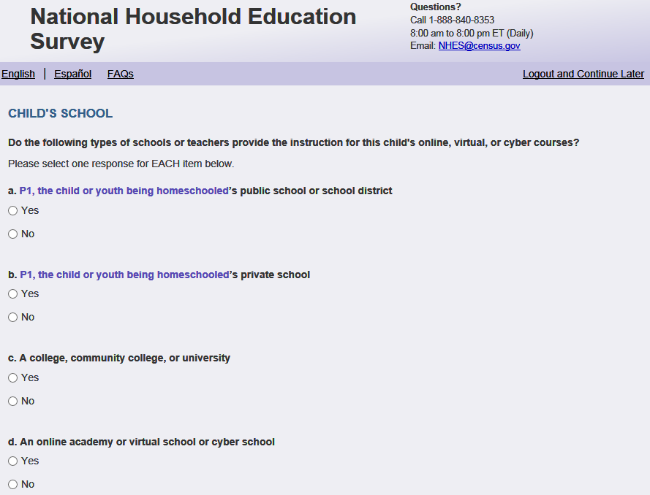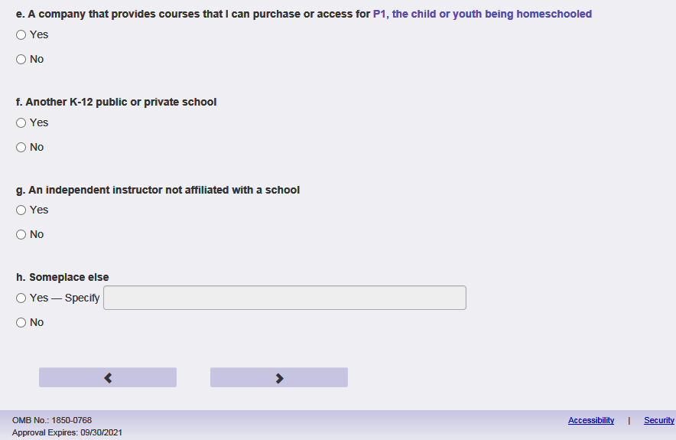
English Respondent Text Reads:
Do the following types of schools or teachers provide the instruction for [this child]'s online, virtual, or cyber courses?

Spanish Respondent Text Reads:
¿Proveen los siguientes tipos de escuela o maestros la instrucción para los cursos online, virtuales o cyber para [este niño (esta niña)]?

English Admin/TQA Text Reads:
Do the following types of schools or teachers provide the instruction for [this child]'s online, virtual, or cyber courses?
Please answer ‘yes’ or ‘no’ for EACH item as I read them.
{Please re-read the question if the respondent asks or seems to have forgotten the question.}

Spanish Admin/TQA Text Reads:
¿ Proveen los siguientes tipos de escuela o maestros la instrucción para los cursos online, virtuales o cyber para [este niño (esta niña)]?
Por favor, responda 'sí' o 'no' para cada opción a medida que las leo.
{Por favor, vuelva a leer la pregunta si el encuestado pregunta o parece haber olvidado la pregunta.}

English Respondent Answer
- [This child]’s public school or school district, PFIC_SPBSCH, (1=Yes 2=No), numeric, radio
- [This child]’s private school, PFIC_SPRIVT, (1=Yes 2=No), numeric, radio
- A college, community college, or university, PFIC_SUNIVSCH, (1=Yes 2=No), numeric, radio
- An online academy or virtual school or cyber school, PFIC_SCYBER, , (1=Yes 2=No), numeric, radio
- A company that provides courses that I can purchase or access for [this child], PFIC_SCOMPANY, (1=Yes 2=No), numeric, radio
- Another K to 12 public or private school, PFIC_ SOTHRSCH, , (1=Yes 2=No), numeric, radio
- An independent instructor not affiliated with a school, PFIC_STUTR, , (1=Yes 2=No), numeric, radio
- Someplace else –Specify:, PFIC_SOTHSCH, , (1=Yes 2=No), numeric, radio

Spanish Respondent Answer
- La escuela pública o el distrito escolar de [este niño (esta niña)] PFIC_SPBSCH, (1= Sí 2=No), numeric, radio
- La escuela privada de [este niño (esta niña)] PFIC_SPRIVT, (1= Sí 2=No), numeric, radio
- Una universidad o colegio comunitario PFIC_SUNIVSCH, (1= Sí 2=No), numeric, radio
- Un instituto online, una escuela virtual o una escuela cyber PFIC_SCYBER, (1= Sí 2=No), numeric, radio
- Una compañía que provee cursos que yo podría comprar o acceder para [este niño (esta niña)] PFIC_SCOMPANY, (1= Sí 2=No), numeric, radio
- Otra escuela kindergarten a 12 pública o privada PFIC_ SOTHRSCH, (1= Sí 2=No), numeric, radio
- Un instructor independiente y no afiliado con ninguna escuela PFIC_ STUTR, , (1= Sí 2=No), numeric, radio
- Otro lugar - Especifique: PFIC_SOTHSCH, (1= Sí 2=No), numeric, radio

English Admin/TQA Answer
- [This child]’s public school or school district, PFIC_SPBSCH, (1=Yes 2=No), numeric, radio
- [This child]’s private school, PFIC_SPRIVT, (1=Yes 2=No), numeric, radio
- A college, community college, or university, PFIC_SUNIVSCH, (1=Yes 2=No), numeric, radio
- An online academy or virtual school or cyber school, PFIC_SCYBER, , (1=Yes 2=No), numeric, radio
- A company that provides courses that you can purchase or access for [this child], PFIC_SCOMPANY, (1=Yes 2=No), numeric, radio
- Another K to 12 public or private school, PFIC_ SOTHRSCH, (1=Yes 2=No), numeric, radio
- An independent instructor not affiliated with a school, PFIC_STUTR, (1=Yes 2=No), numeric, radio
- Someplace else –Specify:, PFIC_SOTHSCH, (1=Yes 2=No), numeric, radio

Spanish Admin/TQA Answer
- La escuela pública o el distrito escolar de [este niño (esta niña)] PFIC_SPBSCH, (1= Sí 2=No), numeric, radio
- La escuela privada de [este niño (esta niña)] PFIC_SPRIVT, (1= Sí 2=No), numeric, radio
- Una universidad o colegio comunitario PFIC_SUNIVSCH, (1= Sí 2=No), numeric, radio
- Un instituto online, una escuela virtual o una escuela cyber PFIC_SCYBER, (1= Sí 2=No), numeric, radio
- Una compañía que provee cursos que puede comprar o acceder para [este niño (esta niña)] PFIC_SCOMPANY, (1= Sí 2=No), numeric, radio
- Otra escuela kindergarten a 12 pública o privada PFIC_ SOTHRSCH, (1= Sí 2=No), numeric, radio
- Un instructor independiente y no afiliado con ninguna escuela PFIC_ STUTR, (1= Sí 2=No), numeric, radio
- Otro lugar - Especifique: PFIC_SOTHSCH, (1= Sí 2=No), numeric, radio

Skips:
Go to PFIC_INTNUM
Logic checks/Programming specifications:
If PFIC_SOTHSCH selected, specify box should become active (PFIC_SOTHSCHOSOS): Write-in, (0,1000), character, write-in. Display specify response box 3 rows by 30 characters.

Item: Number of Online Course (PFIC_INTNUM)
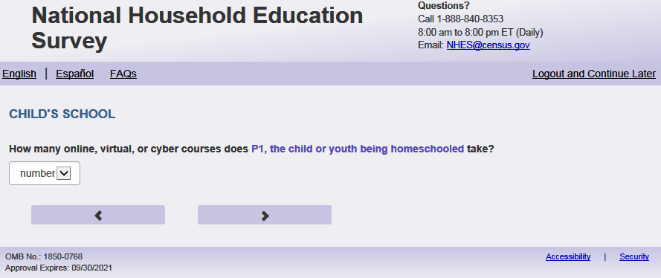
English Text Reads:
How many online, virtual, or cyber courses does [this child] take?

Spanish Text Reads:
¿Cuantos cursos online, virtuales o cyber toma [este niño (esta niña)]?

English and Spanish Answer

PFIC_INTNUM, (1, 50) numeric, write-in

Skip patterns:

Go to PFIC_SINSTFEE

Logic checks/Programming specifications

English
Display “ online, virtual, or cyber course(s)” to the right of the text box and blank in the dropdown
Spanish:
Display “curso(s) online, virtuales o cyber” to the right of the text box and blank in the dropdown

Logic/range check triggers a warning message, with the following text displayed.
English
[If not within 1-30] Display "Please check your answer before continuing. Typically, students taking online, virtual, or cyber courses take between one and 30 online courses at a time."
Spanish
[if not within 1-30] Display "Por favor, compruebe su respuesta antes de continuar. Por lo general, los estudiantes que toman cursos online, virtuales o cyber toman entre uno y 30 cursos en línea a la vez.”
Mobile: Display numeric keypad

Item: Charge Fee for Instruction (PFIC_SINSTFEE)
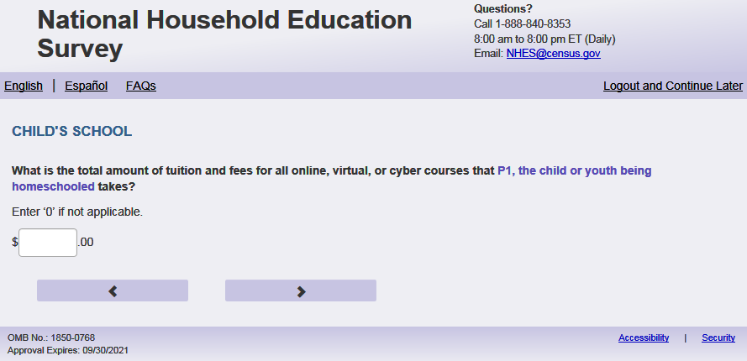
English Respondent Reads:
What is the total amount of tuition and fees for all online, virtual, or cyber courses that [this child] takes?

Enter ‘0’ if not applicable.

Spanish Respondent Text Reads:
¿Cúal es la cantidad total de la matrícula y cargos para todas las clases online, virtuales o cyber que toma [este niño (esta niña)]?

Ingrese ‘0’ si no aplica.

English Admin/TQA Text Reads:
What is the total amount of tuition and fees for all online, virtual, or cyber courses that [this child] takes?

{Enter ‘0’ if not applicable.}

Spanish Admin/TQA Text Reads:
¿Cúal es la cantidad total de la matrícula o cargos para todas las clases online, virtuales o cyber que toma [este niño (esta niña)]?

{Ingrese ‘0’ si no aplica.}

English and Spanish Answer

PFIC_ SINSTFEE, (0,99999), numeric, write-in
Skip patterns:
Go to PFIC_INTHRS
Logic checks/Programming specifications:
Display a “$” sign to the left of the write-in box, and ".00" to the right of the write-in box to indicate the required response is in a currency format. Right-justified and will enter the response box from the right side. If a numerical response contains more than three digits, a comma will be auto-filled. Please remove commas from output.
Mobile: Display numeric keypad

Item: Online Instructions Hours (PFIC_INTHRS)
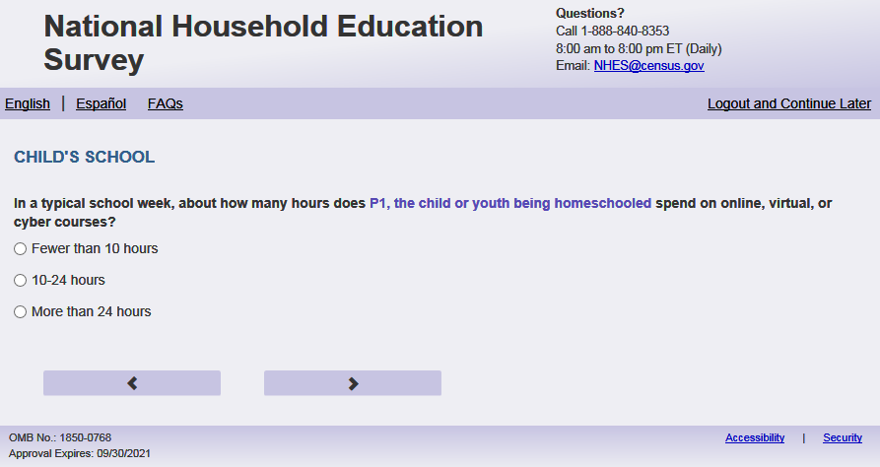

English Respondent Text Reads:
In a typical school week, about how many hours does [this child] spend in online, virtual, or cyber classes?

Spanish Respondent Text Reads:
En una semana escolar típica, ¿Cuántas horas pasa [este niño (esta niña)] en clases online, virtuales o cyber?

English Admin/TQA Text Reads:
In a typical school week, about how many hours does [this child] spend on online, virtual, or cyber classes?

{Please read response options.}

Spanish Admin/TQA Text Reads:
En una semana escolar típica, ¿Cuántas horas pasa [este niño (esta niña)] en clases online, virtuales o cyber?

{Por favor lea las opciones de respuesta.}
Answer:
1= Fewer than 10 hours in that week
2=10 to 24 hours in that week
3=More than 24 hours in that week

Spanish Ansers:
1= Menos de 10 horas en esa semana
2= 10 a 24 horas en esa semana
3= Más de 24 horas en esa semana

PFIC_INTHRS, (1,3), numeric, radio
Skip patterns:
Go to PFIC_SEENJOY

Item: Child Enjoys School (PFIC_SEENJOY)
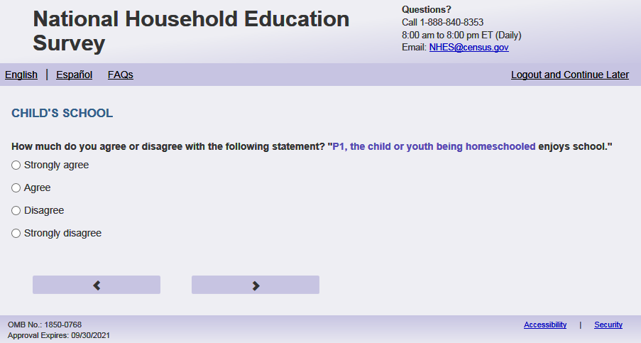
English Respondent Text Reads:
How much do you agree or disagree with the following statement? "[This child] enjoys school."

Spanish Respondent Text Reads:
¿Qué tan de acuerdo o en desacuerdo está usted con la siguiente frase: “[Este niño (esta niña)] disfruta de la escuela”.

English Respondent Text Reads:
How much do you agree or disagree with the following statement? "[This child] enjoys school."

{Please read response options.}

Spanish Respondent Text Reads:
¿Qué tan de acuerdo o en desacuerdo está usted con la siguiente frase: “[Este niño (esta niña)] disfruta de la escuela”.

{Por favor, lea las opciones de respuesta }
English Answer:
1= Strongly agree
2= Agree
3= Disagree
4= Strongly disagree

Spanish Answer:
1= Muy de acuerdo
2= De acuerdo
3= En desacuerdo
4= Muy en desacuerdo

PFIC_SEENJOY, (1,4), numeric, radio

Skips:

Go to PFIC_SEGRADES

Item: Child Grades (PFIC_SEGRADES)
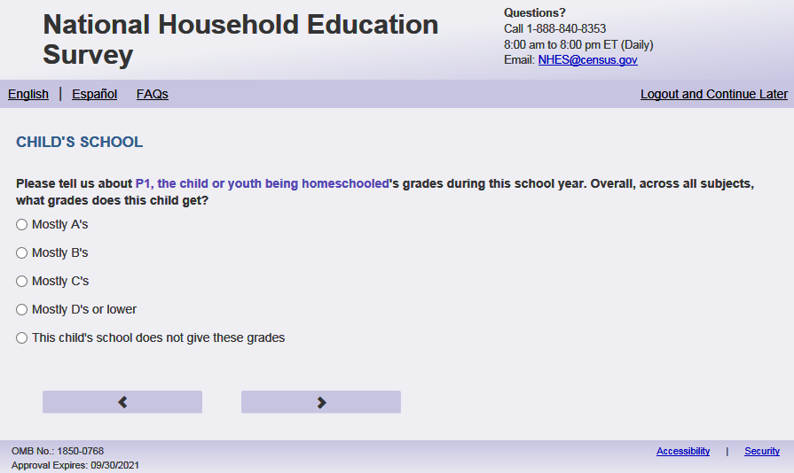
English Respondent Text Reads:
Please tell us about [this child]’s grades during this school year. Overall, across all subjects, what grades does [he/she/he or she] get?

Spanish Respondent Text Reads:
Por favor cuéntenos acerca de las calificaciones o notas de [este niño (está niña)] durante este año escolar. En general, en todas las asignaturas, ¿qué calificaciones o notas obtiene [este niño (está niña)]?

English Admin/TQA Text Reads:
Please tell us about [this child]’s grades during this school year. Overall, across all subjects, what grades does [he/she/he or she] get?

{Please read response options.}

Spanish Admin/TQA Text Reads:
Por favor cuéntenos acerca de las calificaciones o notas de [este niño (está niña)] durante este año escolar. En general, en todas las asignaturas, ¿qué calificaciones o notas obtiene [este niño (está niña)]?

{Por favor, lea las opciones de respuesta.}
English Answer:
1=Mostly As
2=Mostly Bs
3=Mostly Cs
4=Mostly Ds or lower
5=[This child]’s school does not give these grades

Spanish Answer:
1= Casi siempre A
2= Casi siempre B
3= Casi siempre C
4= Casi siempre D o menos
5= La escuela de [este niño (esta niña)] no da estas calificaciones

PFIC_SEGRADES, (1,5), numeric, radio

Skips:

If child's grade in Screener = missing or in 11-14 OR if PFIC_PFIALLGRADEX_web = missing or 12-15 then go PFIC_SEADPLCXX, else go to PFIC_SEBEHAVX.

Logic:
English (only):
If S1_Pxsex = 1, use ‘he’, if s1_pxsex = 2, use ‘she’, else use ‘he or she’

Item: AP Classes (PFIC_SEADPLCXX)
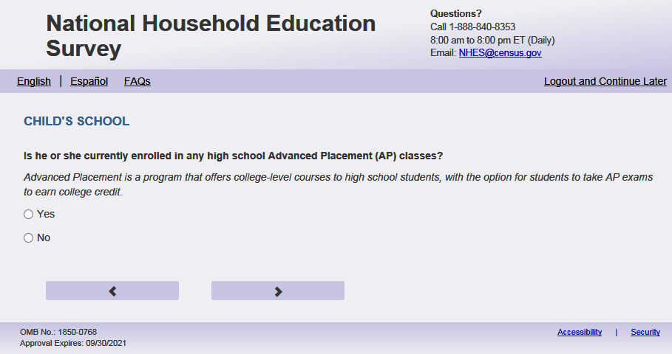
English Text Reads:
Is [he, she, he or she] currently enrolled in any high school Advanced Placement (AP) classes?
Advanced Placement is a program that offers college-level courses to high school students, with the option for students to take AP exams to earn college credit.

Spanish Text Reads:
¿Está [este niño (esta niña)] inscrito en algún curso avanzado llamado Colocación Avanzada (Advanced Placement o AP en inglés) en la secundaria?
Colocación Avanzada es un programa que ofrece cursos de nivel universitario a los estudiantes de high school, con la opción de que estos estudiantes puedan tomar el examen AP para recibir créditos universitarios.

English Answer:
1= Yes
2= No

Spanish Answer:
1= Sí
2= No

PFIC_SEADPLCXX, (1,2), numeric, radio

Skips:

Go to PFIC_SEBEHAVX.

Logic checks/Programming specifications:
English
If s1_pxsex = 1 then use ‘he, if s1_pxsex = 2 then use ‘she’ else use ‘he or she’

Item: Child’s Teacher Contacted Staff (PFIC_SEBEHAVX)
English Respondent Text Reads:
Since the beginning of this school year, how many times have any of [this child]’s teachers or school staff contacted your household about...
Enter '0' if none.

Spanish Respondent Text Reads:
Desde el comienzo de este año escolar, ¿cuántas veces se ha comunicado la escuela o alguno de los maestros de [este niño (esta niña)] con un adulto en su hogar respecto a lo siguiente...
Ingrese '0' si es nunca.

English Admin/TQA Text Reads:
{Enter '0' if none.}

Spanish Admin/TQA Text Reads:
{Ingrese '0' si es nunca.}

English Respondent Answer:
- Behavior problems [he/she/he or she] is having in school? PFIC_SEBEHAVX, (0,99), numeric, write-in
- Problems [he/she/he or she] is having with school work? PFIC_SESCHWRK, (0,99), numeric, write-in
- Very good behavior? PFIC_SEGBEHAV, (0,99), numeric, write-in
- Very good school work? PFIC_SEGWORK, (0,99), numeric, write-in

Spanish Respondent Answer:
- Problemas de comportamiento que [él/ella, él o ella] está teniendo en la escuela? PFIC_SEBEHAVX, (0,99), numeric, write-in
- Problemas que [él,ella, él o ella] está teniendo con los trabajos escolares? PFIC_SESCHWRK, (0,99) , numeric, write-in
- Muy buen comportamiento? PFIC_SEGBEHAV, (0,99) , numeric, write-in
- Muy buen trabajo escolar? PFIC_SEGWORK, (0,99), numeric, write-in

English Admin/TQA Text and Answer Reads:
- Since the beginning of this school year, how many times have any of [this child]’s teachers or school staff contacted your household about behavior problems [he/she/he or she] is having in school? PFIC_SEBEHAVX, (0,99), numeric, write-in
- Since the beginning of this school year, how many times have any of [this child]’s teachers or school staff contacted your household about problems [he/she/he or she] is having with school work? PFIC_SESCHWRK, (0,99), numeric, write-in
- Since the beginning of this school year, how many times have any of [this child]’s teachers or school staff contacted your household about very good behavior? PFIC_SEGBEHAV, (0,99), numeric, write-in
- Since the beginning of this school year, how many times have any of [this child]’s teachers or school staff contacted your household about very good school work? PFIC_SEGWORK, (0,99), numeric, write-in

Spanish Admin/TQA Text and Answer Reads:
- Desde el comienzo de este año escolar, ¿cuántas veces se ha puesto en contacto con su hogar alguno de los maestros o el personal de la escuela de [este niño (esta niña)] acerca de problemas de comportamiento que [él, ella, él o ella] está teniendo en la escuela? PFIC_SEBEHAVX, (0,99), numeric, write-in
- Desde el comienzo de este año escolar, ¿cuántas veces se ha puesto en contacto con su hogar alguno de los maestros o el personal de la escuela de [este niño(esta niña)] acerca de problemas que [él,/ella, él o ella] está teniendo con los trabajos escolares? PFIC_SESCHWRK, (0,99) , numeric, write-in
- Desde el comienzo de este año escolar, ¿cuántas veces se ha puesto en contacto con su hogar alguno de los maestros o el personal de la escuela de [este niño (esta niña)] acerca de muy buen comportamiento? PFIC_SEGBEHAV, (0,99) , numeric, write-in
- Desde el comienzo de este año escolar, ¿cuántas veces se ha puesto en contacto con su hogar alguno de los maestros o el personal de la escuela de [este niño (esta niña)] acerca de muy buen trabajo escolar? PFIC_SEGWORK, (0,99), numeric, write-in

Skips:
Go to PFIC_SEABSNT.

Logic Checks/Programming specifications:
Display as grid. Only allow numeric answers.
English: Display ‘Number of times’ once above all boxes.
Spanish: Display ‘Numero de veces’ once above all boxes.

Mobile: Display numeric keypad
Text Displayed for logic/range check violation:
English:
If s1_pxsex = 1 then use ‘he, if s1_pxsex = 2 then use ‘she’ else use ‘he or she’
Spanish:
If S1_Pxsex = 1, use ‘él’, if s1_pxsex = 2, use ‘ella’, else use ‘él or ella’

Item: Days Absent (PFIC_SEABSNT)
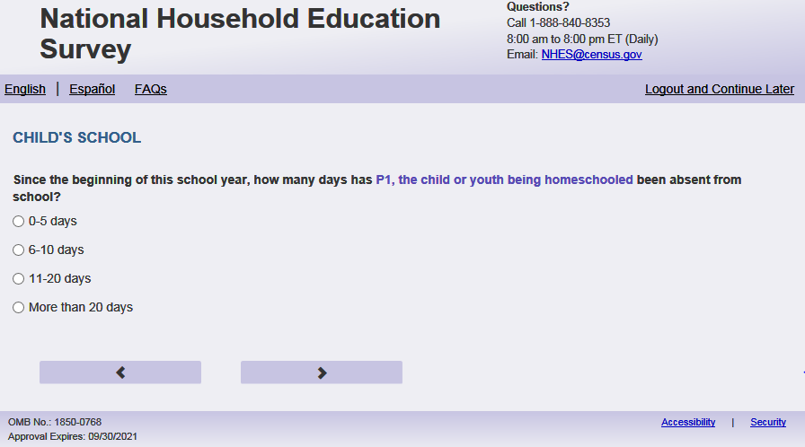
English Text Reads:
Since the beginning of this school year, how many days has [this child] been absent from school?

Spanish Text Reads:
Desde el comienzo del año escolar, ¿cuántos días ha faltado [este niño (esta niña)] a la escuela?
English Answer:
1= 0 to 5 days
2= 6 to 10 days
3= 11 to 20 days
4= More than 20 days

Spanish Answer:
1= 0 a 5 días
2= 6 a 10 días
3= 11 a 20 días
4= Más de 20 días

English and Spanish Answer:

PFIC_SEABSNT, (1,4), numeric, radio

Skips:

Go to PFIC_SEREPEAT.

Item: Repeat Grades (PFIC_SEREPEAT)
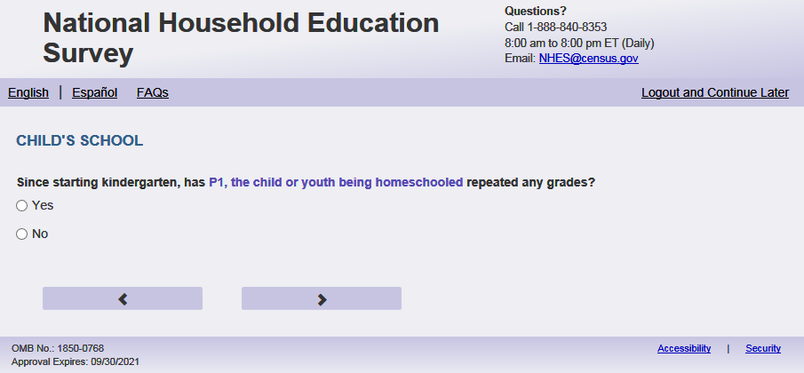
English Text Reads:
Since starting kindergarten, has [this child] repeated any grades?

Spanish Text Reads:
Desde que comenzó el kindergarten, ¿ha repetido [este niño (esta niña)] algún grado?

English Answer:
1= Yes
2=No

Spanish answer:
1= Sí
2=No

PFIC_SEREPEAT, (1,2), numeric, radio

Skips:

if PFIC_SEREPEAT = 2 then go to PFIC_SESUSOUT. Else go to PFIC_SEREPTK.

Item: Repeated Grades (PFIC_SEREPTK)
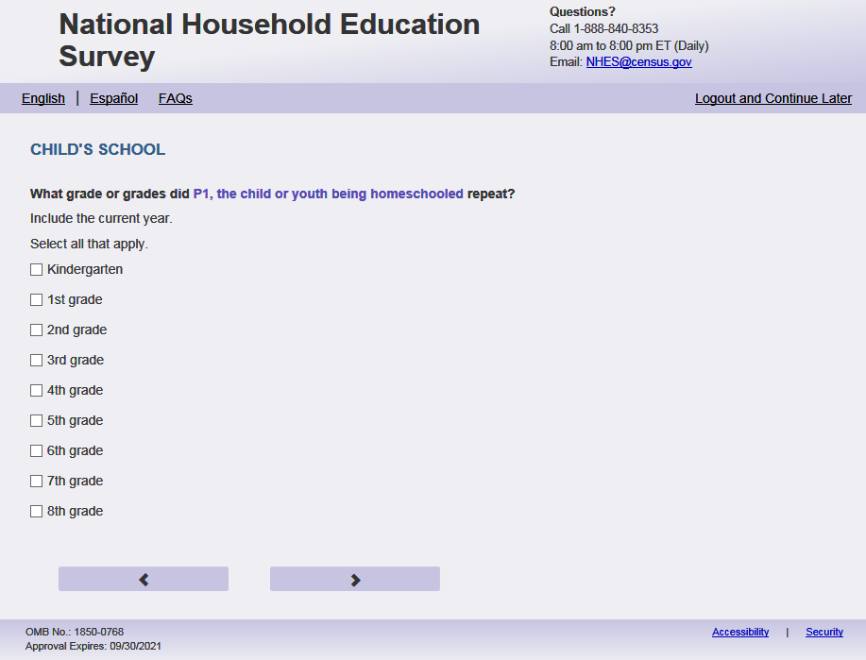
English Respondent Text Reads:
What grade or grades did [this child] repeat?
Include the current year.
Select all that apply.

Spanish Respondent Text Reads:
¿Qué grado o grados repitió?
Incluya el año actual.
Seleccione todos lo que correspondan.

English Admin/TQA Text Reads:
Including the current year, what grade or grades did [this child] repeat?

{Select all that apply.}

Spanish Admin/TQA Text Reads:
Incluyendo el año actual ¿Qué grado o grados repitió?

{Seleccione todos lo que correspondan.}

English Answer:
Kindergarten, PFIC_SEREPTK, (1= Item selected), numeric, check-box.
1st Grade, PFIC_SEREPT1, (1= Item selected), numeric, check-box.
2nd Grade, PFIC_SEREPT2, (1= Item selected), numeric, check-box.
3rd Grade, PFIC_SEREPT3, (1= Item selected), numeric, check-box.
4th Grade, PFIC_SEREPT4, (1= Item selected), numeric, check-box.
5th Grade, PFIC_SEREPT5, (1= Item selected), numeric, check-box.
6th Grade, PFIC_SEREPT6, (1= Item selected), numeric, check-box.
7th Grade, PFIC_SEREPT7, (1= Item selected), numeric, check-box.
8th Grade, PFIC_SEREPT8, (1= Item selected), numeric, check-box.
9th Grade – freshman, PFIC_SEREPT9, (1= Item selected), numeric, check-box.
10th Grade – sophomore, PFIC_SEREPT10, (1= Item selected), numeric, check-box.
11th Grade – junior, PFIC_SEREPT11, (1= Item selected), numeric, check-box.
12th Grade – senior, PFIC_SEREPT12, (1= Item selected), numeric, check-box.

Spanish Answer:
Kindergarten, PFIC_SEREPTK, (1= Item selected), numeric, check-box.
1er grado, PFIC_SEREPT1, (1= Item selected), numeric, check-box.
2^{do} grado, PFIC_SEREPT2, (1= Item selected), numeric, check-box.
3er grado, PFIC_SEREPT3, (1= Item selected), numeric, check-box.
4^{to} grado, PFIC_SEREPT4, (1= Item selected), numeric, check-box.
5^{to} grado, PFIC_SEREPT5, (1= Item selected), numeric, check-box.
6^{to} grado, PFIC_SEREPT6, (1= Item selected), numeric, check-box.
7^{mo} grado, PFIC_SEREPT7, (1= Item selected), numeric, check-box.
8^{vo} grado, PFIC_SEREPT8, (1= Item selected), numeric, check-box.
9º - freshman, PFIC_SEREPT9, (1= Item selected), numeric, check-box.
10º - sophomore, PFIC_SEREPT10, (1= Item selected), numeric, check-box.
11º - junior, PFIC_SEREPT11, (1= Item selected), numeric, check-box.
12º - senior, PFIC_SEREPT12, (1= Item selected), numeric, check-box.

Skips:

Go to PFIC_SESUSOUT.

Logic Checks/Programming specifications:

Display PFIC_SEREPTK-PFIC_SEREPT12 that are less or equal to s1_PxGRADE (from Screener). S1_PxGRADE = ' ' from Screener than display PFIC_SEREPTK-PFIC_SEREPT12 that are less or equal to PFIC_ALLGRADEX_web. If PFIC_ALLGRADEX_web is blank, display all of PFIC_SEREPTK-PFIC_SEREPT12.

Item: Child Experiences (PFIC_SESUSOUT)
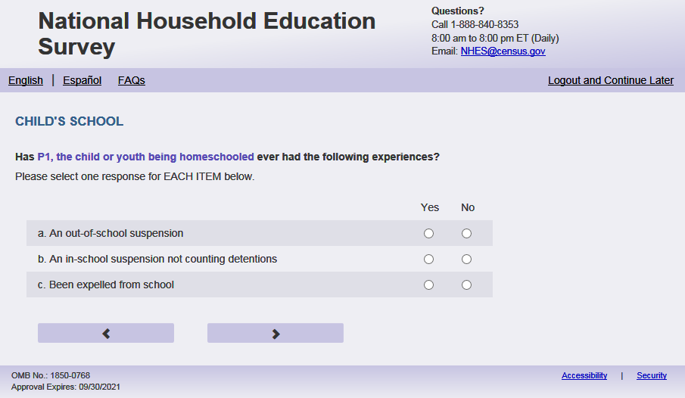
English Respondent Text Reads:
Has [this child] ever had the following experiences?

Spanish Respondent Text Reads:
¿Ha tenido [este niño (esta niña)] alguna vez las siguientes experiencias?

English Answer:
- An out-of-school suspension, PFIC_SESUSOUT, (1 = Yes, 2= No), numeric, radio
- An in-school suspension not counting detentions, PFIC_SESUSPIN, (1 = Yes, 2= No), numeric, radio
- Been expelled from school, PFIC_SEEXPEL, (1 = Yes, 2= No), numeric, radio

Spanish Answer:
- Suspensión fuera de la escuela PFIC_SESUSOUT, (1 = Sí, 2= No), numeric, radio
- Suspensión en la escuela, sin contar quedarse después de clases como castigo PFIC_SESUSPIN, (1 = Sí, 2= No), numeric, radio
- Ha sido expulsado(a) de la escuela PFIC_SEEXPEL, (1 = Sí, 2= No), numeric, radio

English Admin/TQA Text and Answer Reads:
- Has [this child] ever had an out-of-school suspension?, PFIC_SESUSOUT, (1 = Yes, 2= No), numeric, radio
- Has [this child] ever had an in-school suspension not counting detentions?, PFIC_SESUSPIN, (1 = Yes, 2= No), numeric, radio
- Has [this child] ever been expelled from school?, PFIC_SEEXPEL, (1 = Yes, 2= No), numeric, radio

Spanish Admin/TQA Text and Answer Reads:
- ¿Alguna vez ha tenido [este niño (esta niña)] suspensión fuera de la escuela? PFIC_SESUSOUT, (1 = Sí, 2= No), numeric, radio
- ¿Alguna vez ha tenido [este niño (esta niña)] suspensión en la escuela, sin contar quedarse después de clases como castigo? PFIC_SESUSPIN, (1 = Sí, 2= No), numeric, radio
- ¿Alguna vez [este niño (esta niña)] ha sido expulsado(a) de la escuela? PFIC_SEEXPEL, (1 = Sí, 2= No), numeric, radio

Skips:

Go to PFIC_SEGRADEQ.

Logic Checks/Programming specifications:

display as grid for both the Respondent and Admin/TQA items.

Item: Child’s Work at School (PFIC_SEGRADEQ)
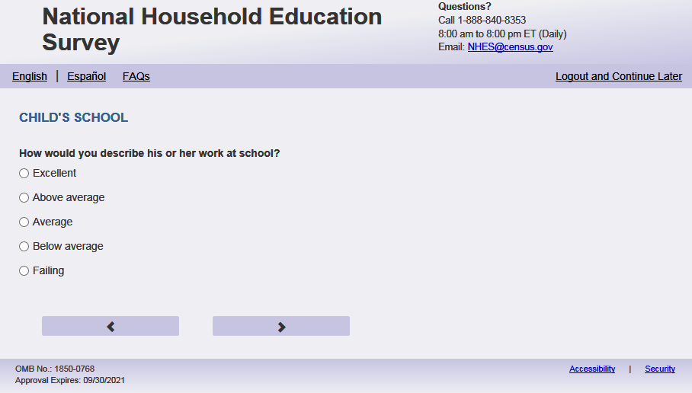
English Text Reads
How would you describe [this child]’s work at school?

Spanish Text Reads

¿Cómo describiría el desempeño de [este niño (esta niña)] en la escuela?

English Answer
1=Excellent
2=Above average
3=Average
4=Below average
5=Failing

Spanish Answer
1= Excelente
2= Más del promedio
3= Normal
4= Menos del promedio
5= Aplazando

PFIC_SEGRADEQ, (1,5) numeric, radio

Skips:
If (PFIC_EDCINTK12 = 1 or PFIC_EDCINTK122 =1) and (PFIC_EDCCAT or PFIC_EDCCAT2), (PFIC_EDCREL or PFIC_EDCREL2) (PFIC_EDCPRI or PFIC_EDCPRI2), (PFIC_EDCHSFL or PFIC_EDCHSFL2), (PFIC_EDCPUB or PFIC_EDCPUB2) ALL ne = 1 go to PFIC_FSNOTESX
Else go to PFIC_FSSPORTX

Item: Activities at School (PFIC_FSSPORTX)
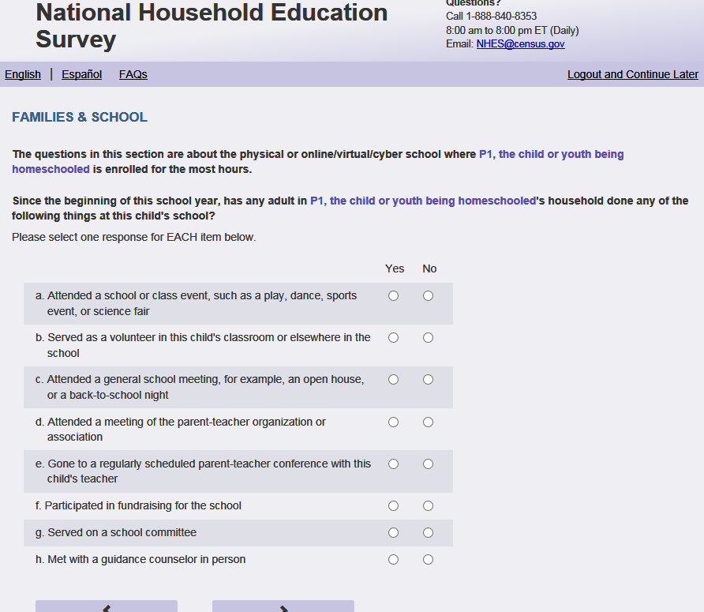
English Respondent Text Reads:
[Show this text in parentheticals only for respondents that marked yes for more than one item in EDCPUB (2a-2g)]
(The questions in this section are about the physical or online, virtual, orcyber school where [this child] is enrolled for the most hours.)

Since the beginning of this school year, has any adult in [this child]’s household done any of the following things at this child’s school?

Spanish Respondent Text Reads:
[Show this text in parentheticals only for respondents that marked yes for more than one item in EDCPUB (2a-2g)]
(Las preguntas en esta sección se tratan de la escuela física o la escuela online, virtual o cyber donde [este niño (está niña)] está inscrito para la mayor cantidad de horas.)

Desde el comienzo de este año escolar, ¿algún adulto en el hogar ha hecho alguna de lo siguientes cosas en la escuela de [este niño (esta niña)]?

English Admin/TQA Text Reads:
[Show this text in parentheticals only for respondents that marked yes for more than one item in EDCPUB (2a-2g)]:
(The questions in this section are about the physical or online, virtual, cyber school where [this child] is enrolled for the most hours.)

Since the beginning of this school year, has any adult in [this child]’s household done any of the following things at this child’s school?

Please answer ‘yes’ or ‘no’ for EACH item as I read them.
{Please re-read the question half-way through the response options, or if the respondent asks or seems to need a reminder.}

Spanish Admin/TQA Text Reads:
[Show this text in parentheticals only for respondents that marked yes for more than one item in EDCPUB (2a-2g)]:
(Las preguntas en esta sección se tratan de la escuela física o la escuela online, virtual o cyber donde [este niño (está niña)] está inscrito para la mayor cantidad de horas.)

Desde el comienzo de este año escolar, ¿algún adulto en el hogar ha hecho alguna de lo siguientes cosas en la escuela de [este niño (esta niña)]?

Por favor, responda 'sí' o 'no' para cada opción a medida que las leo.
{Por favor, vuelva a leer la pregunta a mitad de camino a través de las opciones de respuesta, o si el encuestado pregunta o parece necesitar un recordatorio.}

English Answer
- Attended a school or class event, such as a play, dance, sports event, or science fair PFIC_FSSPORTX, (1 = Yes, 2=No), numeric, radio
- Served as a volunteer in [this child]’s classroom or elsewhere in the school PFIC_FSVOL, (1 = Yes, 2=No), numeric, radio
- Attended a general school meeting, for example, an open house, or a back-to-school night PFIC_FSMTNG, (1 = Yes, 2=No), numeric, radio
- Attended a meeting of the parent-teacher organization or association PFIC_FSPTMTNG, (1 = Yes, 2=No), numeric, radio
- Gone to a regularly scheduled parent-teacher conference with [this child]’s teacher PFIC_FSATCNFN, (1 = Yes, 2=No), numeric, radio
- Participated in fundraising for the school PFIC_FSFUNDRS, (1 = Yes, 2=No), numeric, radio
- Served on a school committee PFIC_FSCOMMTE, (1 = Yes, 2=No), numeric, radio
- Met with a guidance counselor in person PFIC_FSCOUNSLR, (1 = Yes, 2=No), numeric, radio

Spanish Answer
- Asistió a una actividad de la escuela o clase, como una obra de teatro, baile, evento deportivo o feria de ciencias PFIC_FSSPORTX, (1 = Sí, 2=No), numeric, radio
- Prestó servicios voluntarios en la clase de [este niño (esta niña)] o en otro lugar de la escuela PFIC_FSVOL, (1 = Sí, 2=No), numeric, radio
- Asistió a una reunión general de la escuela, por ejemplo, open house o una noche de regreso a la escuela PFIC_FSMTNG, (1 = Sí, 2=No), numeric, radio
- Asistió a una reunión de la organización o asociación de padres y maestros PFIC_FSPTMTNG, (1 = Sí, 2=No), numeric, radio
- Fue a una reunión de padres programada periódicamente con elmaestro de [este niño (esta niña)] PFIC_FSATCNFN, (1 = Sí, 2=No), numeric, radio
- Participó en la recolección de fondos para la escuela PFIC_FSFUNDRS, (1 = Sí, 2=No), numeric, radio
- Participó en un comité escolar PFIC_FSCOMMTE, (1 = Sí, 2=No), numeric, radio
- Se reunió en persona con un consejero de la escuela PFIC_FSCOUNSLR, (1 = Sí, 2=No), numeric, radio

Skips:

Go to PFIC_FSFREQ.

Logic Checks/Programming specifications:

display as grid

Item: Adult Participation in School Activities (PFIC_FSFREQ)
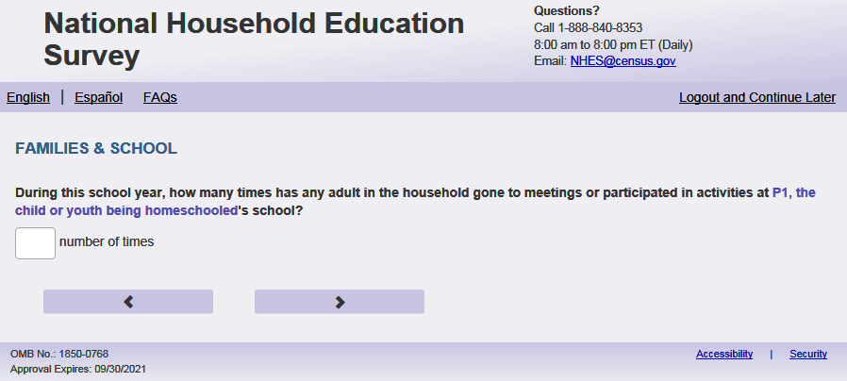
English Text Reads:
During this school year, how many times has any adult in the household gone to meetings or participated in activities at [this child]’s school?

Spanish Text Reads:
Durante este año escolar, ¿cuántas veces ha asistido algún adulto del hogar a las reuniones o ha participado en las actividades en la escuela de [este niño (esta niña)]?

PFIC_FSFREQ, (0, 99), numeric, write-in

Skips:

Go to PFIC_FSNOTESX.

Logic Checks/Programming specifications:
English
display "times" to right of write-in box
Spanish
display "veces" to right of write-in box

Mobile: Display numeric keypad

Item: School Communication (PFIC_FSNOTESX)
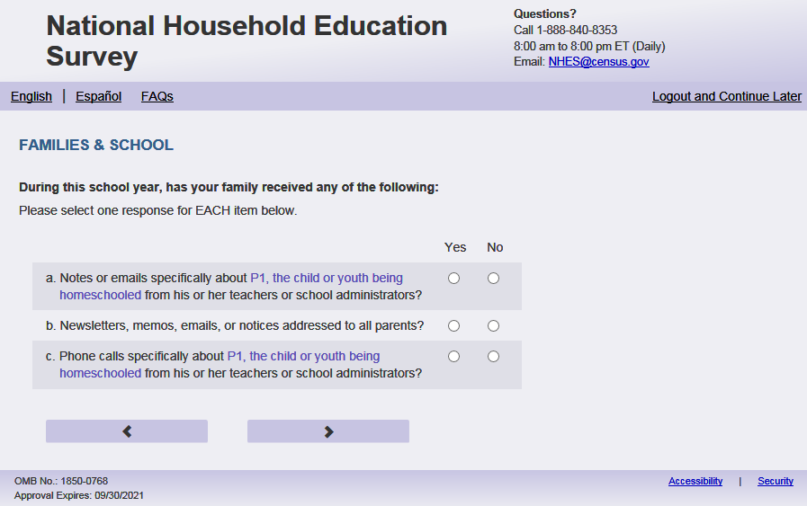
English Respondent Text Reads:
During this school year, has your family received any of the following:

Spanish Respondent Text Reads:
Durante este año escolar, ¿ha recibido su familia cualquiera de los siguientes?

English Admin/TQA Text Reads:
During this school year, has your family received any of the following:
Please answer ‘yes’ or no’ for EACH item as I read them.

Spanish Admin/TQA Text Reads:
Durante este año escolar, ¿ha recibido su familia cualquiera de los siguientes?

Por favor, responda 'sí' o no' para CADA opción a medida que las leo.

English Answer
- Notes or emails specifically about [this child] from [his/her/his or her] teachers or school administrators? PFIC_FSNOTESX, (1 = Yes, 2 =No), numeric, radio
- Newsletters, memos, emails, or notices addressed to all parents? PFIC_FSMEMO, (1 = Yes, 2 =No), numeric, radio
- Phone calls specifically about [this child] from [his/her/his or her] teachers or school administrators? PFIC_FSPHONCHX, (1 = Yes, 2 =No), numeric, radio
Spanish Answer
- Notas o correos electrónicos de maestros o administradores de la escuela específicamente sobre [este niño (esta niña)] PFIC_FSNOTESX, (1 = Sí, 2 =No), numeric, radio
- Boletines, memorandos, correos electrónicos o notificaciones a todos los padres PFIC_FSMEMO, (1 = Sí, 2 =No), numeric, radio
- Llamadas telefónicas de maestros o administradores de la escuela específicamente sobre [este niño (esta niña)] PFIC_FSPHONCHX, (1 = Sí, 2 =No), numeric, radio

Skips:
Go to PFIC_FSSPPERF.

Logic Checks/Programming specifications:
display as grid

if s1_pxsex = 1 then use ‘his’, if s1pxsex = 2 then use ‘her’, else use ‘his or her’

Item: Child’s Performance (PFIC_FSSPPERF)
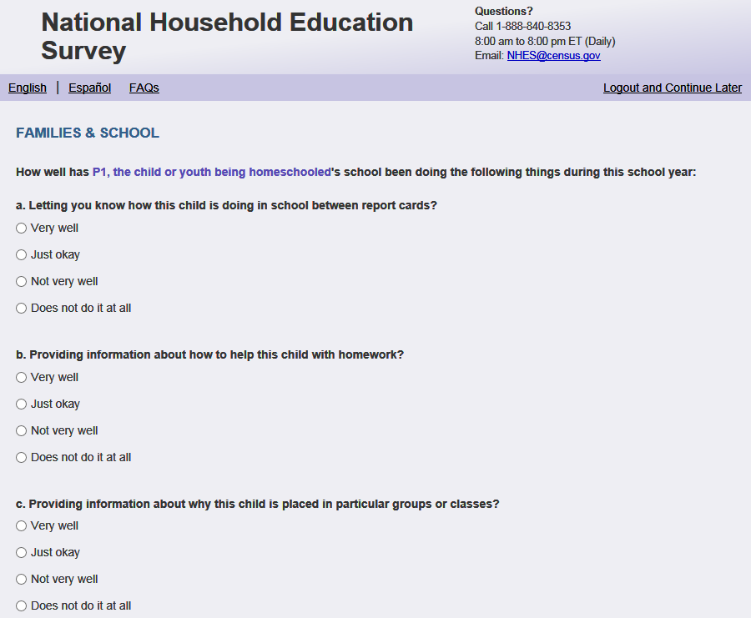
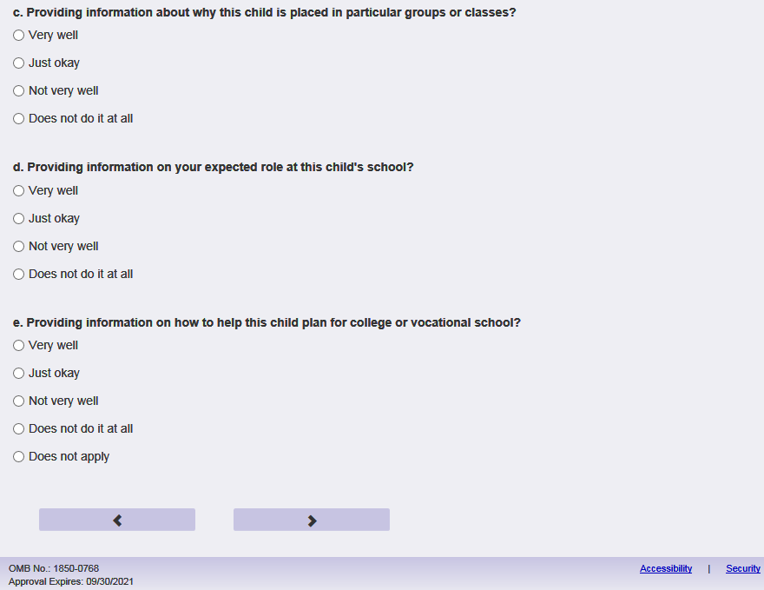
English Respondent Text Reads:
How well has [this child]’s school been doing the following things during this school year:

Spanish Respondent Text Reads:
Qué tan bien se ha desempeñado la escuela de [este niño (esta niña)] en los siguientes aspectos durante este año escolar:

English Admin/TQA Text Reads:
Please tell me how well [this child]’s school has been doing the following things during this school year. You can say ‘very well,’ ‘just okay,’ not very well,’ or ‘does not do it at all.’
{Read answer options to the respondent for each item until they start to remember them.}

Spanish Admin/TQA Text Reads:
Por favor, dígamequé tan bien se ha desempeñado la escuela de [este niño (esta niña)] en los siguientes aspectos durante este año escolar? Puede decir 'muy bien', 'bien', ‘no muy bien' o 'no lo hace en absoluto'.
{Leer las opciones de respuesta al encuestado para cada ítem hasta que comiencen a recordarlos.}

English Respondent Answer
- Letting you know how [this child] is doing in school between report cards?
1=Very well
2= Just okay
3 = Not very well
4= Does not do it at all
PFIC_FSSPPERF, (1,4), numeric, radio
- Providing information about how to help [this child] with homework?
1=Very well
2= Just okay
3 = Not very well
4= Does not do it at all
PFIC_FSSPHW, (1,4), numeric, radio
- Providing information about why [this child] is placed in particular groups or classes?
1=Very well
2= Just okay
3 = Not very well
4= Does not do it at all
PFIC_FSSPCOUR, (1,4) , numeric, radio
- Providing information on your expected role at [this child]’s school?
1=Very well
2= Just okay
3 = Not very well
4= Does not do it at all
PFIC_FSSPROLE, (1,4), numeric, radio
- [display if child is in grade 9-12 (PFIC_ALLGRADEX = 12-15)]: Providing information on how to help [this child] plan for college or vocational school?
1=Very well
2= Just okay
3 = Not very well
4= Does not do it at all
PFIC_ FSSPCOLL, (1,5), numeric, radio

Spanish Respondent Answer
- Avisarle sobre cómo [este niño (esta niña)] le va en la escuela entremedio entre las libretas de calificaciones
1= Muy bien
2= Bien
3= No muy bien
4= No lo hace en absoluto
PFIC_FSSPPERF, (1,4), numeric, radio
- Darle información sobre cómo ayudar a [este niño (esta niña)] con las tareas o trabajos escolares.1= Muy bien
2= Bien
3= No muy bien
4= No lo hace en absoluto
PFIC_FSSPHW, (1,4), numeric, radio
- Darle información sobre por qué [este niño (esta niña)] está en determinadosgrupos o clases
1= Muy bien
2= Bien
3= No muy bien
4= No lo hace en absoluto
PFIC_FSSPCOUR, (1,4), numeric, radio
- Darle información sobre lo que se espera de usted en la escuela de [este niño (esta niña)].
1= Muy bien
2= Bien
3= No muy bien
4= No lo hace en absoluto
PFIC_FSSPROLE, (1,4), numeric, radio
- [display if child is in grade 9-12 (PFIC_ALLGRADEX = 12-15)]: Darleinformación sobre cómo ayudar a [este niño (esta niña)] a hacer planes para la universidad, college o escuela vocacional o de oficios.
1= Muy bien
2= Bien
3= No muy bien
4= No lo hace en absoluto

PFIC_ FSSPCOLL , (1,5), numeric, radio

English Admin/TQA Answer
- How well has [this child]’s school done at letting you know how [this child] is doing in school between report cards?
1=Very well
2= Just okay
3 = Not very well
4= Does not do it at all
PFIC_FSSPPERF, (1,4), numeric, radio
- How well has [this child]’s school done at providing information about how to help [this child] with homework?
1=Very well
2= Just okay
3 = Not very well
4= Does not do it at all
PFIC_FSSPHW, (1,4), numeric, radio
- How well has [this child]’s school done at providing information about why [this child] is placed in particular groups or classes?
1=Very well
2= Just okay
3 = Not very well
4= Does not do it at all
PFIC_FSSPCOUR, (1,4) , numeric, radio
- How well has [this child]’s school done at providing information on your expected role at [this child]’s school?
1=Very well
2= Just okay
3 = Not very well
4= Does not do it at all
PFIC_FSSPROLE, (1,4), numeric, radio
- [display if child is in grade 9-12 (PFIC_ALLGRADEX = 12-15)]: How well has [this child]’s school done at providing information on how to help [this child] plan for college or vocational school?
1=Very well
2= Just okay
3 = Not very well
4= Does not do it at all
PFIC_ FSSPCOLL, (1,5), numeric, radio

Spanish Admin/TQA Answer
- Qué tan bien se ha desempeñado la escuela de [este niño (esta niña)] en avisarle cómo [este niño (esta niña)] le va en la escuela entre las libretas de calificaciones
1= Muy bien
2= Bien
3= No muy bien
4= No lo hace en absoluto
PFIC_FSSPPERF, (1,4), numeric, radio
- Qué tan bien se ha desempeñado la escuela de [este niño (esta niña)] en darle información sobre cómo ayudar a [este niño (esta niña)] con las tareas o trabajos escolares
1= Muy bien
2= Bien
3= No muy bien
4= No lo hace en absoluto
PFIC_FSSPHW, (1,4), numeric, radio
- Qué tan bien se ha desempeñado la escuela de [este niño (esta niña)] en darle información sobre por qué [este niño (esta niña)] está en determinados grupos o clases
1= Muy bien
2= Bien
3= No muy bien
4= No lo hace en absoluto
PFIC_FSSPCOUR, (1,4), numeric, radio
- Qué tan bien se ha desempeñado la escuela de [este niño (esta niña)] en darle información sobre lo que se espera de usted en la escuela de [este niño (esta niña)]
1= Muy bien
2= Bien
3= No muy bien
4= No lo hace en absoluto
PFIC_FSSPROLE, (1,4), numeric, radio
- [display if child is in grade 9-12 (PFIC_ALLGRADEX = 12-15)]: Qué tan bien se ha desempeñado la escuela de [este niño (esta niña)] en proporcionar información sobre cómo ayudar a [este niño (esta niña)] a hacer planes para la universidad, college o escuela vocacional o de oficios..
1= Muy bien
2= Bien
3= No muy bien
4= No lo hace en absoluto

Skips:
Go to PFIC_FCSCHOOL

Item: Satisfaction with School Components (PFIC_FCSCHOOL)
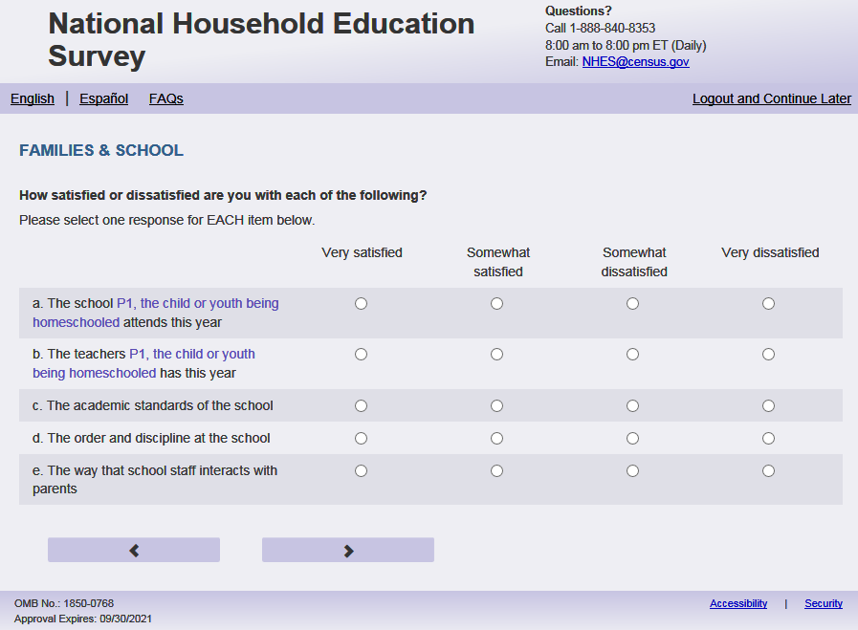
English Respondent Text Reads:
How satisfied or dissatisfied are you with each of the following:

Spanish Respondent Text Reads:
¿Qué tan satisfecho(a) o insatisfecho(a) está usted con cada uno de los siguientes aspectos?

English Admin/TQA Text Reads:
I’m going to ask you how satisfied or dissatisfied you are with different things about [this child]’s school. You can tell me you are ‘very satisfied,’ ‘somewhat satisfied, ‘somewhat dissatisfied,’ or ‘very dissatisfied.’

Please answer for EACH item as I read them.

{Please re-read the question if the respondent asks or seems to have forgotten the question.}

Spanish Admin/TQA Text Reads:
Le voy a preguntar qué tan satisfecho o insatisfecho está con diferentes aspectos acerca de la escuela [de este niño]. Puede decirme que está ‘muy satisfecho,’ ‘algo satisfecho, ‘algo insatisfecho,’ o ‘muy insatisfecho.’

Por favor, responda para CADA opción a medida que las leo.

{Por favor, vuelva a leer la pregunta si el encuestado pregunta o parece haber olvidado la pregunta.}

English Answer
- The school [this child] attends this year? PFIC_FCSCHOOL, (1=Very satisfied, 2=Somewhat satisfied, 3=Somewhat dissatisfied, 4=Very dissatisfied), numeric, radio
- The teachers [this child] has this year? PFIC_FCTEACHR, (1=Very satisfied, 2=Somewhat satisfied, 3=Somewhat dissatisfied, 4=Very dissatisfied), numeric, radio
- The academic standards of the school? PFIC_FCSTDS, (1=Very satisfied, 2=Somewhat satisfied, 3=Somewhat dissatisfied, 4=Very dissatisfied), numeric, radio
- The order and discipline at the school? PFIC_FCORDER, (1=Very satisfied, 2=Somewhat satisfied, 3=Somewhat dissatisfied, 4=Very dissatisfied), numeric, radio
- The way that school staff interacts with parents? PFIC_FCSUPPRT, (1=Very satisfied, 2=Somewhat satisfied, 3=Somewhat dissatisfied, 4=Very dissatisfied), numeric, radio

Spanish Answer
- La escuela a la que [este niño (esta niña)] asiste este año. PFIC_FCSCHOOL, (1= Muy satisfecho(a), 2= Algo satisfecho(a), 3= Algo insatisfecho(a), 4= Muy insatisfecho(a)), numeric, radio
- Los maestros que él o ella tiene este año. PFIC_FCTEACHR, (1= Muy satisfecho(a), 2= Algo satisfecho(a), 3= Algo insatisfecho(a), 4= Muy insatisfecho(a)), numeric, radio
- La calidad académica de la escuela. PFIC_FCSTDS, (1= Muy satisfecho(a), 2= Algo satisfecho(a), 3= Algo insatisfecho(a), 4= Muy insatisfecho(a)), numeric, radio
- El orden y la disciplina en la escuela. PFIC_FCORDER, (1= Muy satisfecho(a), 2= Algo satisfecho(a), 3= Algo insatisfecho(a), 4= Muy insatisfecho(a)), numeric, radio
- La forma en que el personal de la escuela interactúacon los padres. PFIC_FCSUPPRT, (1= Muy satisfecho(a), 2= Algo satisfecho(a), 3= Algo insatisfecho(a), 4= Muy insatisfecho(a)), numeric, radio

Skips:
Go to PFIC_FHHOME

Logic Checks/Programming specifications:
display as grid

Item: Homework Outside of School (PFIC_FHHOME)
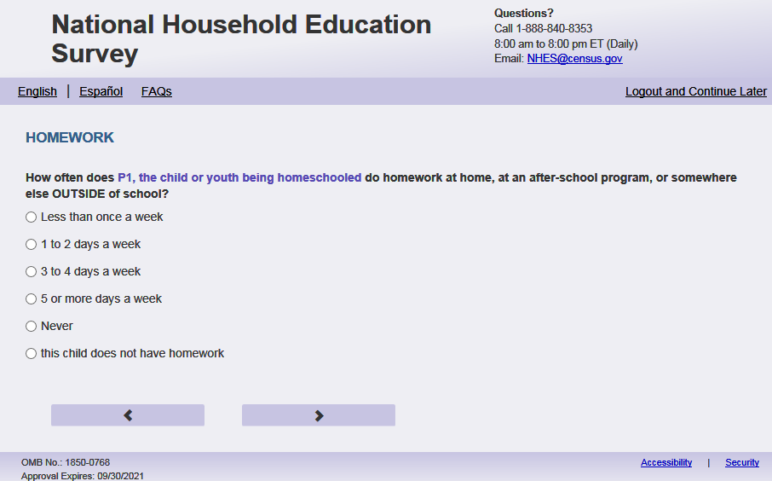
English Respondent Reads:
How often does [this child] do homework at home, at an after-school program, or somewhere else OUTSIDE of school?

Spanish Respondent Text Reads:
¿Con qué frecuencia hace las tareas [este niño (esta niña)], ya sea en casa, en un programa después de clases o en otro lugar FUERA de la escuela?

English Admin/TQA Text Reads:
How often does [this child] do homework at home, at an after-school program, or somewhere else OUTSIDE of school?

{Please read response options.}

Spanish Admin/TQA Text Reads:
¿Con qué frecuencia hace las tareas [este niño (esta niña)], ya sea en casa, en un programa después de clases o en otro lugar FUERA de la escuela?

{Por favor, lea las opciones de respuesta. }
English Answer
1=Less than once a week
2=1 to 2 days a week
3=3 to 4 days a week
4=5 or more days a week
5=Never
6=[This child] does not have homework

Spanish Answer
1= Menos de una vez a la semana
2= 1 a 2 días a la semana
3= 3 a 4 días a la semana
4= 5 días o más a la semana
5= Nunca
6= [Este niño (esta niña)] no tiene tareas o trabajo escolar

PFIC_FHHOME, (1,6), numeric, radio

Skips:
if PFIC_FHHOME in (5, 6) then go to PFIC_FOSTORY2X; else go to PFIC_FHWKHRS

Logic Checks/Programming specifications
Increase spacing between response options “Never” and “[This child] does not have homework” on PFIC_FHHOME (apply to Spanish response options). This should be double the normal spacing between response options.

Item: Hours of Homework per Week (PFIC_FHWKHRS)
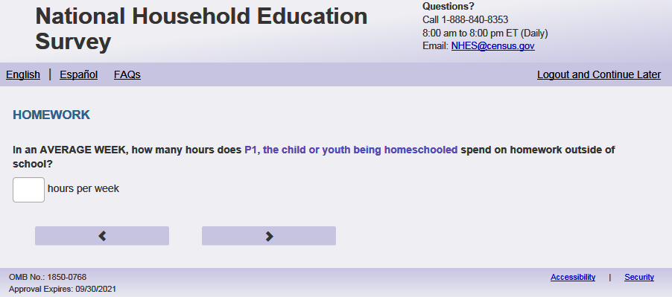
English Text Reads:
In an AVERAGE WEEK, how many hours does [this child] spend on homework outside of school?

Spanish Text Reads:
En una SEMANA COMÚN Y CORRIENTE, ¿cuántas horas pasa [este niño (esta niña)] haciendo tareas fuera de la escuela?

English and Spanish Answer
PFIC_FHWKHRS, (0,99), numeric, write-in

Skips:
Go to PFIC_FHAMOUNT

Logic Checks/Programming specifications:
Display "hours each week" to right of box on English pages.
Display ‘horas cada semana’ to right of box on Spanish pages.

Mobile: Display numeric keypad

Item: Parent’s Feelings about Amount of Homework (PFIC_FHAMOUNT)
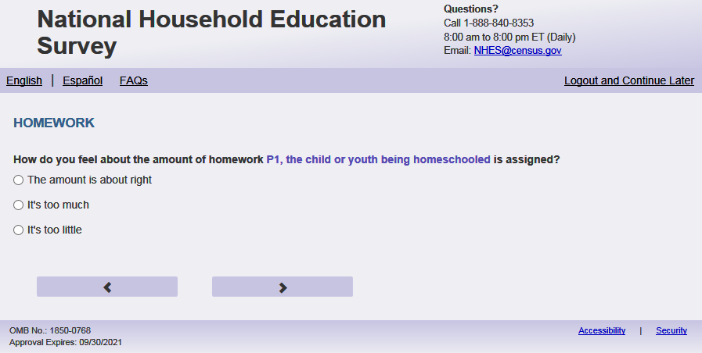
English Respondent Text Reads:
How do you feel about the amount of homework [this child] is assigned?

Spanish Respondent Text Reads:
¿Qué piensa usted sobre la cantidad de tareas que le asignan a [este niño (esta niña)]?

English Admin/TQA Text Reads:
How do you feel about the amount of homework [this child] is assigned?

{Please read response options.}

Spanish Admin/TQA Text Reads:
¿Qué piensa usted sobre la cantidad de tareas que le asignan a [este niño (esta niña)]?

{Por favor, lea las opciones de respuesta.}
English Answer
1=The amount is about right
2=It’s too much
3=It’s too little

Spanish Answer
1= La cantidad está bien
2= Es demasiado
3= Es muy poco

PFIC_FHAMOUNT, (1,3), numeric, radio

Skips:

Go to PFIC_ FH FHCAMT

Item: Child’s Feelings about Amount of Homework (PFIC_FHCAMT)
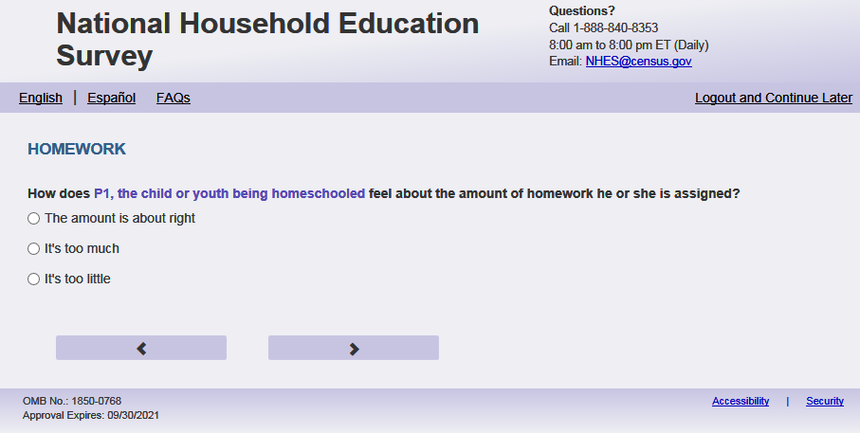
English Respondent Text Reads:
How does [this child] feel about the amount of homework [he/she/he or she] is assigned?

Spanish Respondent Text Reads:
¿Qué piensa [este niño (esta niña)] sobre la cantidad de tareas que le asignan?

English Admin/TQA Text Reads:
How does [this child] feel about the amount of homework [he/she/he or she] is assigned?

{Please read response options.}

Spanish Admin/TQA Text Reads:
¿Qué piensa [este niño (esta niña)] sobre la cantidad de tareas que le asignan?

{Por favor, lea las opciones de respuesta.}
English Answer
1=The amount is about right
2=It’s too much
3=It’s too little

Spanish Answer
1= La cantidad está bien
2= Es demasiado
3= Es muy poco

PFIC_FHCAMT, (1,3), numeric, radio

Skips:
Go to PFIC_FHPLACE
if s1_pxsex = 1 then use ‘his’, if s1pxsex = 2 then use ‘her’, else use ‘his or her’

Item: Child’s Place for Homework (PFIC_FHPLACE)
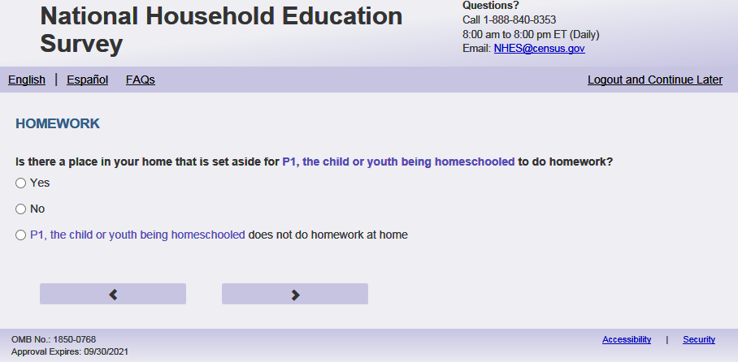
English Text Reads:
Is there a place in your home that is set aside for [this child] to do homework?

Spanish Text Reads:
¿Hay un lugar en su casa designado para que [este niño (esta niña)] haga su tarea?

English Answer
1=Yes
2=No
3=[This child] does not do homework at home

Spanish Answer
1= Sí
2= No
3= [El niño(la niña)] no hace tarea en casa

PFIC_FHPLACE, (1,3), numeric, radio

Skips:
Go to PFIC_FHCHECKX.

Logic Checks/Programming specifications
Increase spacing between response options “No” and “[This child] does not do homework at home” on PFIC_FHPLACE (apply to Spanish response options). This should be double the normal spacing between response options.

Item: Homework Checks (PFIC_FHCHECKX)
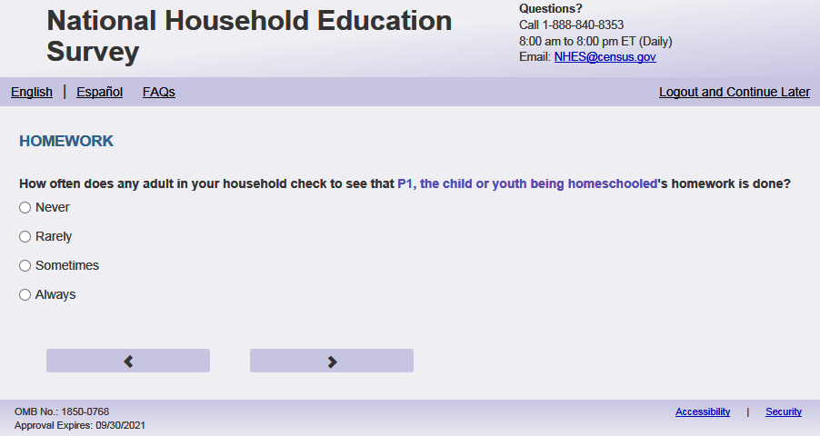
Text Reads:
English Respondent Text Reads:
How often does any adult in your household check to see that [this child]’s homework is done?

Spanish Respondent Text Reads:
¿Con qué frecuencia comprueba un adulto en el hogar si [este niño (esta niña)] ha hecho su tarea?

English Admin/TQA Text Reads:
How often does any adult in your household check to see that [this child]’s homework is done?

{Please read response options.}

Spanish Admin/TQA Text Reads:
¿Con qué frecuencia comprueba un adulto en el hogar si [este niño (esta niña)] ha hecho su tarea?

{Por favor, lea las opciones de respuesta.}
English Answer
1=Never
2=Rarely
3=Sometimes
4=Always

Spanish Answer
1= Nunca
2= Raramente
3= A veces
4= Siempre

PFIC_FHCHECKX, (1,4), numeric, radio

Skips:
Go to PFIC_FHHELP

Item: Days Homework Help (PFIC_FHHELP)
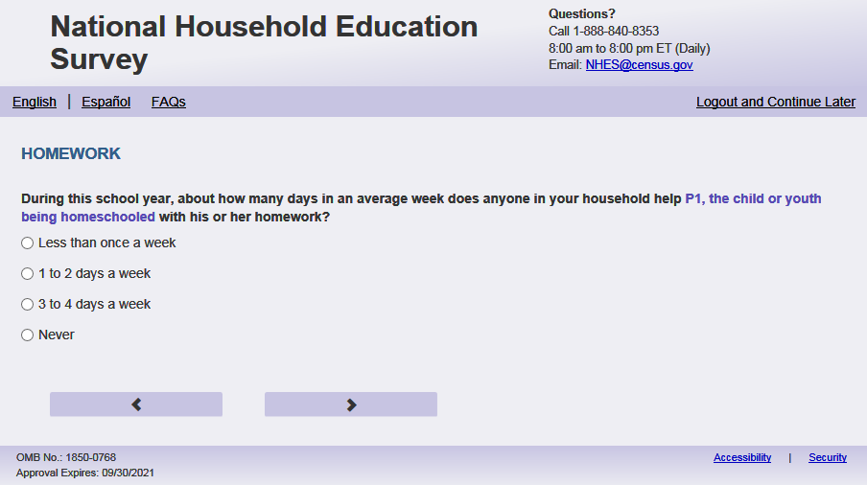
English Respondent Text Reads:
During this school year, about how many days in an average week does anyone in your household help [this child] with [his/her/his or her] homework?

Spanish Respondent Text Reads:
Durante este año escolar, ¿aproximadamente cuántos días a la semana ayuda alguien de su hogar a [este niño (esta niña)] con la tarea?

English Admin/TQA Text Reads:
During this school year, about how many days in an average week does anyone in your household help [this child] with [his/her/his or her] homework?

{Please read response options.}

Spanish Admin/TQA Text Reads:
Durante este año escolar, ¿aproximadamente cuántos días a la semana ayuda alguien de su hogar a [este niño (esta niña)] con la tarea?

{Por favor, lea las opciones de respuesta.}
English Answer
1=Less than once a week
2=1 to 2 days a week
3=3 to 4 days a week
4=5 or more days a week
5=Never

Spanish Answer
1= Menos de una vez a la semana
2= 1 a 2 días a la semana
3= 3 a 4 días a la semana
4= 5 días o más a la semana
5= Nunca
PFIC_FHHELP, (1,5), numeric, radio

Skips:

Go to PFIC_FOSTORY2X.

Logic Checks/Programming specifications:
Always display answer option never. Then, match the options 1-4 that are selected in PFIC_fhhome ...(i.e. if PFIC_fhhome = 3, then for PFIC_fhhelp display 1,2, 3, 5 options)

If s1_pxsex = 1 use ‘ his’, if s1_pxsex = 2, use ‘her’, else use ‘his or her’

Item: Weekly Family Activities (PFIC_FOSTORY2X)
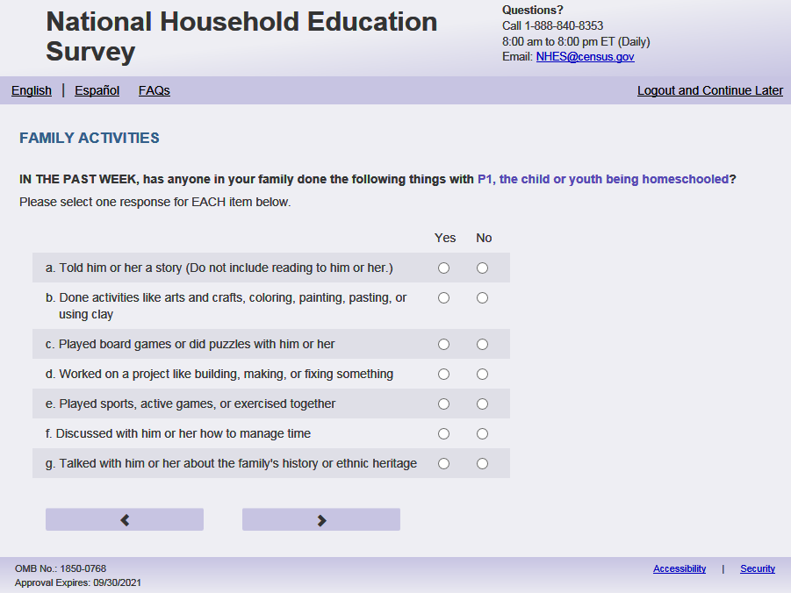
English Respondent Text Reads:
IN THE PAST WEEK, has anyone in your family done the following things with [this child]?

Spanish Respondent Text Reads:
EN LA ÚLTIMA SEMANA, ¿ha hecho alguien de su familia alguna de las siguientes actividades con [este niño (esta niña)]?

English Admin/TQA Text Reads:
IN THE PAST WEEK, has anyone in your family done the following things with [this child]?

Please answer ‘yes’ or ‘no’ for EACH item as I read them.

{Please re-read the question if the respondent asks or seems to have forgotten the question.}

Spanish Admin/TQA Text Reads:
EN LA ÚLTIMA SEMANA, ¿ha hecho alguien de su familia alguna de las siguientes actividades con [este niño (esta niña)]?

Por favor, responda 'sí' o 'no' para cada opción a medida que las leo.

{Por favor, vuelva a leer la pregunta si el encuestado pregunta o parece haber olvidado la pregunta.}

English Answer:
- Told [this child] a story (Do not include reading to [him/her/him or her].) PFIC_FOSTORY2X, (1 = Yes, 2=No ), numeric, radio
- Done activities like arts and crafts, coloring, painting, pasting, or using clay PFIC_FOCRAFTS, (1 = Yes, 2=No ), numeric, radio
- Played board games or did puzzles with [him/her/him or her] PFIC_FOGAMES, (1 = Yes, 2=No ), numeric, radio
- Worked on a project like building, making, or fixing something PFIC_FOBUILDX, (1 = Yes, 2=No ), numeric, radio
- Played sports, active games, or exercised together PFIC_FOSPORT, (1 = Yes, 2=No ), numeric, radio
- Discussed with [him/her/him or her] how to manage time PFIC_FORESPON, (1 = Yes, 2=No ), numeric, radio
- Talked with [him/her/him or her] about the family’s history or ethnic heritage PFIC_FOHISTX, (1 = Yes, 2=No ), numeric, radio
Spanish Answer:
- Contarle un cuento (no incluya leerle a [este niño (esta niña)]) PFIC_FOSTORY2X, (1 = Sí, 2 =No), numeric, radio
- Hacer actividades como artes y artesanías, colorear, pintar, pegar o usar plastilina PFIC_FOCRAFTS, (1 = Sí, 2 =No), numeric, radio
- Jugar a juegos de mesa o armar rompecabezas con [él/ella/él o ella] PFIC_FOGAMES, (1 = Sí, 2 =No), numeric, radio
- Trabajar en un proyecto como construir, hacer o arreglar algo PFIC_FOBUILDX, (1 = Sí, 2 =No), numeric, radio
- Hacer deportes, juegos activos o ejercicios juntos PFIC_FOSPORT, (1 = Sí, 2 =No), numeric, radio
- Hablar con [él/ella/él o ella] sobre cómo administrar el tiempo PFIC_FORESPON, (1 = Sí, 2 =No), numeric, radio
- Hablar con [él/ella/él o ella] sobre la historia de la familia o las raíces culturales de la familia PFIC_FOHISTX, (1 = Sí, 2 =No), numeric, radio

Skips:
Go to PFIC_FODINNERX.

Logic Checks/Programming specifications:
display as grid

If s1_pxsex = 1 use ‘ him’, if s1_pxsex = 2, use ‘her’, else use ‘him or her’
If s1_pxsex = 1 use ‘él’, if s1_pxsex = 2, use ‘ella’, else use ‘él o ella’

Item: Number of Days Family Eaten Together (PFIC_FODINNERX)
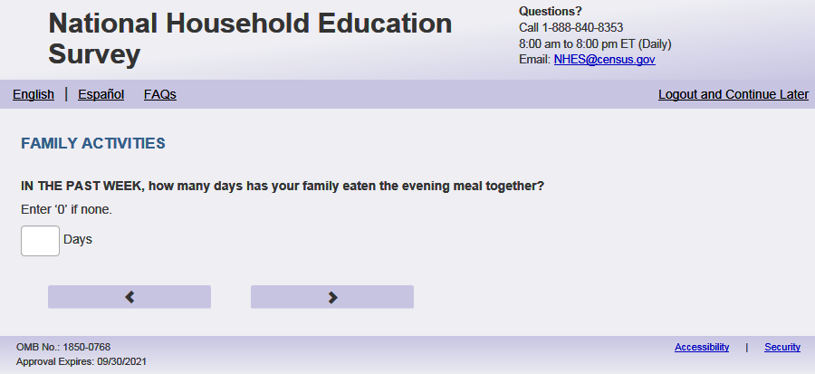
English Text Reads:
IN THE PAST WEEK, how many days has your family eaten the evening meal together?
Enter ‘0’ if none.

Spanish Text Reads:
EN LA ÚLTIMA SEMANA, ¿cuántos días cenó la familia junta?
Ingrese '0' si es nunca.

English and Spanish Answer
PFIC_FODINNERX, (0,9), numeric, write-in

Skips:
Go to PFIC_FOLIBRAYX

Logic Checks/Programming specifications:
English:
Display "days in the past week" to the right of the write-in box.
Spanish:
Display "días de la semana pasada " to the right of the write-in box.

Mobile: Display numeric keypad

Text displayed for logic/range check violation
English: [If more than 7] Display "We noticed you entered more than 7 days. Please check and make sure your answer is correct. "
Spanish [If more than 7] Display "Notamos que ingresó más de 7 días.. Compruebe que su respuesta es correcta."

Item: Monthly Family Activities (PFIC_FOLIBRAYX)
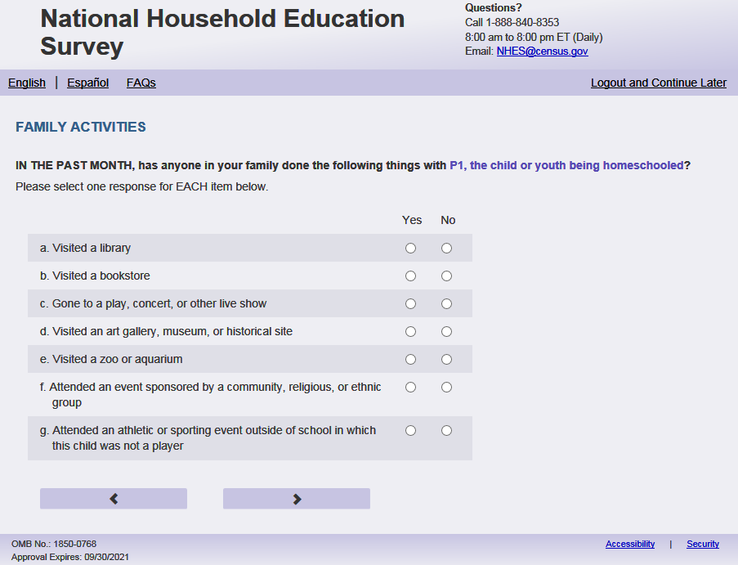
English Respondent Text Reads:
IN THE PAST MONTH, has anyone in your family done the following things with [this child]?

Spanish Respondent Text Reads:
EN EL MES PASADO, ¿ha hecho alguien de su familia alguna de las siguientes actividades con [este niño (esta niña)]?

English Admin/TQA Text Reads:
IN THE PAST MONTH, has anyone in your family done the following things with [this child]?

Please answer ‘yes’ or ‘no’ for EACH item as I read them.

{Please re-read the question if the respondent asks or seems to have forgotten the question.}

Spanish Admin/TQA Text Reads:
EN EL MES PASADO, ¿ha hecho alguien de su familia alguna de las siguientes actividades con [este niño (esta niña)]?

Por favor, responda 'sí' o 'no' para cada opción a medida que las leo.

{Por favor, vuelva a leer la pregunta si el encuestado pregunta o parece haber olvidado la pregunta.}

English Answer
- Visited a library PFIC_FOLIBRAYX, (1 = Yes, 2 = No), numeric, radio
- Visited a bookstore PFIC_FOBOOKSTX, (1 = Yes, 2 = No), numeric, radio
- Gone to a play, concert, or other live show PFIC_FOCONCRTX, (1 = Yes, 2 = No), numeric, radio
- Visited an art gallery, museum, or historical site PFIC_FOMUSEUMX, (1 = Yes, 2 = No), numeric, radio
- Visited a zoo or aquarium PFIC_FOZOOX, (1 = Yes, 2 = No), numeric, radio
- Attended an event sponsored by a community, religious, or ethnic group PFIC_FOGROUPX, (1 = Yes, 2 = No), numeric, radio
- Attended an athletic or sporting event outside of school in which [this child] was not a player PFIC_FOSPRTEVX, (1 = Yes, 2 = No), numeric, radio
Spanish Answer
- Ir a la biblioteca, PFIC_FOLIBRAYX (1 = Sí, 2= No), numeric, radio
- Ir a la librería (tienda de libros),, PFIC_FOBOOKSTX (1 = Sí, 2= No), numeric, radio
- Ir a una obra de teatro, concierto u otro espectáculo en vivo PFIC_FOCONCRTX, (1 = Sí, 2= No), numeric, radio
- Ir a una galería de arte, museo o sitio histórico PFIC_FOMUSEUMX, (1 = Sí, 2= No), numeric, radio
- Ir al zoológico o al acuario PFIC_FOZOOX, (1 = Sí, 2= No), numeric, radio
- Asistir a un evento patrocinado por un grupo comunitario, étnico o religioso PFIC_FOGROUPX, (1 = Sí, 2= No), numeric, radio
- Asistir a un evento deportivo fuera de la escuela en el cual [este niño (esta niña)] no era un jugador PFIC_FOSPRTEVX, (1 = Sí, 2= No), numeric, radio

Skips:
Go to PFIC_HDHEALTH

Logic Checks/Programming specifications:
display as grid

Item: Description of Child’s Health (PFIC_HDHEALTH)
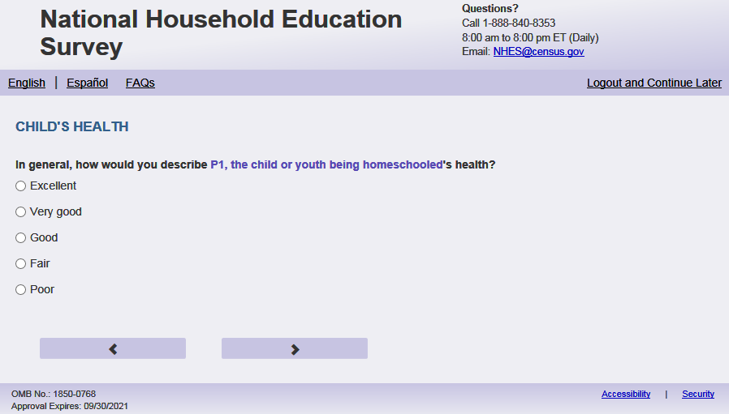
English Text Reads:
In general, how would you describe [this child]’s health?

Spanish Text Reads:
En general, ¿cómo describiría la salud de [este niño (esta niña)]?

English Admin/TQA Text Reads:
In general, how would you describe [this child]’s health?

{Please read response options.}

Spanish Admin/TQA Text Reads:

En general, ¿cómo describiría la salud de [este niño (esta niña)]?

{Por favor, lea las opciones de respuesta.}

English Answer
1= Excellent
2= Very good
3= Good
4= Fair
5= Poor

Spanish Answer
1= Excelente
2= Muy buena
3= Buena
4= Regular
5= Mala

PFIC_HDHEALTH, (1,5), numeric, radio
Skips:
Go to PFIC_HDINTIS

Item: Child’s Health Conditions (PFIC_HDINTDIS)
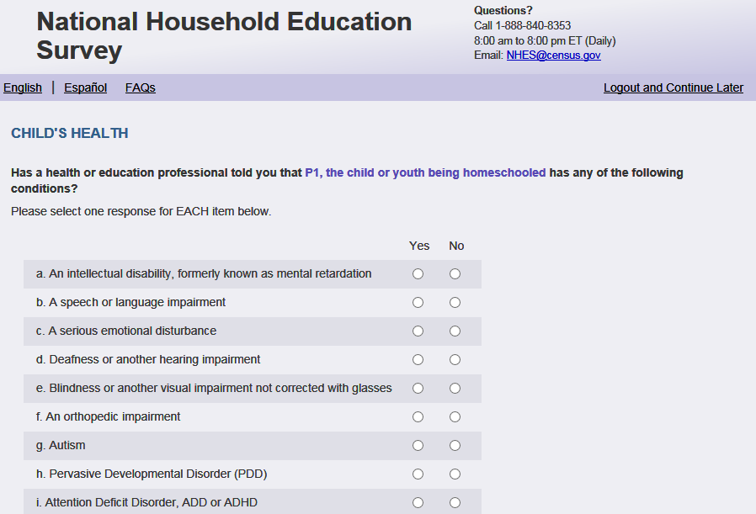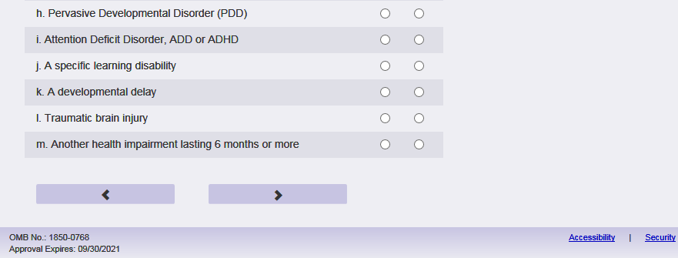
English Respondent Text Reads:
Has a health or education professional told you that [this child] has any of the following conditions?
Spanish Respondent Text Reads:
¿Le ha dicho un profesional de la salud o de educación que [este niño (esta niña)] tiene alguno de los siguientes problemas de salud?
English Admin/TQA Text Reads:
Has a health, education, or early intervention professional told you that [this child] has any of the following conditions?

Please respond ‘yes’ or ‘no’ for EACH item as I read them.
{Read definitions only if the respondent asks.}

Spanish Admin/TQA Text Reads:

¿Le ha dicho un profesional de la salud, de educación o de intervención temprana que [este niño (esta niña)] tiene alguno de los siguientes problemas de salud?

Por favor, responda 'sí' o 'no’ para CADA opción a medida que las leo.
{Leer definiciones solo si el encuestado pregunta.}

English Respondent Answer
- A speech or language impairment, PFIC_HDSPEECHX (1 = Yes, 2 = No), numeric, radio
- A serious emotional disturbance, PFIC_HDDISTRBX (1 = Yes, 2 = No), numeric, radio
- Deafness or another hearing impairment, PFIC_HDDEAFIMX (1 = Yes, 2 = No), numeric, radio
- Blindness or another visual impairment not corrected with glasses PFIC_HDBLINDX, (1 = Yes, 2 = No), numeric, radio
- An orthopedic impairment PFIC_ HDORTHOX, (1 = Yes, 2 = No), numeric, radio
- Autism or autism spectrum disorder PFIC_HDAUTISMX, (1 = Yes, 2 = No), numeric, radio
- Pervasive Developmental Disorder (PDD) PFIC_HDPDDX, (1 = Yes, 2 = No), numeric, radio
- Attention Deficit Hyperactivity Disorder, ADHD or ADD PFIC_HDADDX, (1 = Yes, 2 = No), numeric, radio
- A specific learning disability PFIC_HDLEARNX, (1 = Yes, 2 = No), numeric, radio
- A developmental delay PFIC_HDDELAYX, (1 = Yes, 2 = No), numeric, radio
- Traumatic brain injury PFIC_HDTRBRAIN, (1 = Yes, 2 = No), numeric, radio
- An intellectual disability, formerly known as mental retardation PFIC_HDINTDIS, (1 = Yes, 2 = No), numeric, radio
- Another health impairment lasting 6 months or longer PFIC_HDOTHERX, (1 = Yes, 2 = No), numeric, radio

Spanish Respondent Answer
- Un impedimento del habla o del lenguaje PFIC_HDSPEECHX, (1= Sí, 2 = No), numeric, radio
- Un trastorno emocional grave PFIC_HDDISTRBX, (1= Sí, 2 = No), numeric, radio
- Sordera u otro impedimento del oído PFIC_HDDEAFIMX, (1= Sí, 2 = No), numeric, radio
- Ceguera u otro impedimento de la vista que no se corrige con anteojos PFIC_HDBLINDX, (1= Sí, 2 = No), numeric, radio
- Un impedimento ortopédico PFIC_HDORTHOX, (1= Sí, 2 = No), numeric, radio
- Autismo o trastorno del espectro autista PFIC_HDAUTISMX, (1= Sí, 2 = No), numeric, radio
- Trastorno generalizado del desarrollo (PPD, en inglés) PFIC_HDPDDX, (1= Sí, 2 = No), numeric, radio
- Trastorno de deficiencia de atención (ADHD o ADD, en inglés) PFIC_HDADDX, (1= Sí, 2 = No),), numeric, radio
- Una discapacidad específica de aprendizaje PFIC_HDLEARNX, (1= Sí, 2 = No), numeric, radio
- Un retraso del desarrollo PFIC_HDDELAYX, (1= Sí, 2 = No), numeric, radio
- Lesión traumática en el cerebro PFIC_HDTRBRAIN, (1= Sí, 2 = No), numeric, radio
- Una discapacidad intelectual, conocido antes como retraso mental PFIC_HDINTDIS, (1= Sí, 2 = No), numeric, radio
- Otro impedimento de la salud que dure 6 meses o más PFIC_HDOTHERX, (1= Sí, 2 = No), numeric, radio

English Admin/TQA Answer:

- A speech or language impairment, PFIC_HDSPEECHX, (1=Yes, 2=No), numeric, radio
[The term “A speech or language impairment” should be an active link for the Admin/TQA screen. Add definition hover over “A speech or language impairment”: A disorder in one or more of the basic learning processes involved in understanding or in using spoken or written language.]
- A serious emotional disturbance, PFIC_HDDISTRBX, (1=Yes, 2=No), numeric, radio
[The term “A serious emotional disturbance” should be an active link for the Admin/TQA screen. Add definition hover over “A serious emotional disturbance”:] A diagnosable mental, behavioral, or emotional disorder of sufficient duration to meet diagnostic criteria specified within the Diagnostic and Statistical Manual of Mental Disorders (DSM).
- Deafness or another hearing impairment, PFIC_HDDEAFIMX, (1=Yes, 2=No), numeric, radio [The term “Deafness or another hearing impairment” should be an active link for the Admin/TQA screen. Add definition hover over “Deafness or another hearing impairment”:] A person who is not able to hear as well as someone with normal hearing.
- Blindness or another visual impairment that can’t be corrected with glasses, PFIC_HDBLINDX, (1=Yes, 2=No), numeric, radio [The term “Blindness or another visual impairment” should be an active link for the Admin/TQA screen. Add definition hover over “Blindness or another visual impairment”:] A decreased ability to see to a degree that causes problems not fixable by usual means, such as glasses.
- An orthopedic impairment, PFIC_HDORTHOX, (1=Yes, 2=No), numeric, radio
[The term “An orthopedic impairment” should be an active link for the Admin/TQA screen. Add definition hover over “An orthopedic impairment”:] A severe skeletal, muscular, or neuromuscular impairment.
- Autism or autism spectrum disorder, PFIC_HDAUTISMX, (1=Yes, 2=No), numeric, radio
[The term “Autism or autism spectrum disorder” should be an active link for the Admin/TQA screen. Add definition hover over “Autism or autism spectrum disorder”:] A complex developmental condition that involves persistent challenges in social interaction, speech and nonverbal communication, and restricted/repetitive behaviors.
- Pervasive Developmental Disorder (PDD), PFIC_HDPDDX, (1=Yes, 2=No), numeric, radio
[The term “Pervasive Developmental Disorder (PDD)” should be an active link for the Admin/TQA screen. Add definition hover over “Pervasive Developmental Disorder (PDD)”:] A group of disorders characterized by delays in the development of socialization and communication skills.
- Attention Deficit Hyperactivity Disorder, ADHD or ADD, PFIC_HDADDX, (1=Yes, 2=No), numeric, radio
[The term “Attention Deficit Hyperactivity Disorder, ADHD or ADD” should be an active link for the Admin/TQA screen. Add definition hover over “Attention Deficit Hyperactivity Disorder, ADHD or ADD”:] Any of a range of behavioral disorders occurring primarily in children, including such symptoms as poor concentration, hyperactivity, and impulsivity.
- A specific learning disability, PFIC_HDLEARNX, (1=Yes, 2=No), numeric, radio [The term “A specific learning disability” should be an active link for the Admin/TQA screen. Add definition hover over “A specific learning disability”:] A disorder in the basic psychological processes involved in understanding or in using language, spoken or written, that may manifest itself in an imperfect ability to listen, think, speak, read, write, spell, or to do mathematical calculations.
- A developmental delay, PFIC_HDDELAYX, (1=Yes, 2=No), numeric, radio [The term “A developmental delay” should be an active link for the Admin/TQA screen. Add definition hover over “A developmental delay”:] A significant delay in a child's development. Examples include cognitive, motor, speech, social, emotional and behavioral delays.
- Traumatic brain injury, PFIC_HDTRBRAIN, (1=Yes, 2=No), numeric, radio
[The term “Traumatic brain injury” should be an active link for the Admin/TQA screen. Add definition hover over “Traumatic brain injury”:] A form of acquired brain injury, occurs when a sudden trauma causes damage to the brain.
- An intellectual disability, formerly known as mental retardation, PFIC_HDINTDIS, (1=Yes, 2=No), numeric, radio [The term “An intellectual disability” should be an active link for the Admin/TQA screen. Add definition hover over “An intellectual disability”:] A disability characterized by significant limitations in both intellectual functioning and in adaptive behavior, which covers many everyday social and practical skills.
- Another health impairment lasting 6 months or longer, PFIC_HDOTHERX, (1=Yes, 2=No), numeric, radio

Spanish Admin/TQA Answer:

- Un impedimento del habla o del lenguaje, PFIC_HDSPEECHX, (1= Sí, 2=No), numeric, radio
[The term “Un impedimento del habla o del lenguaje” should be an active link for the Admin/TQA screen. Add definition hover over “Un impedimento del habla o del lenguaje”:] Un trastorno en uno o más de los procesos básicos de aprendizaje involucrados en la comprensión o en el uso del lenguaje hablado o escrito.
- Un trastorno emocional grave, PFIC_HDDISTRBX, (1= Sí, 2=No), numeric, radio
[The term “Un trastorno emocional grave” should be an active link for the Admin/TQA screen. Add definition hover over “Un trastorno emocional grave”:] Un trastorno mental, del comportamiento o emocional diagnosticable de duración suficiente para cumplir con los criterios de diagnóstico especificados en el Manual Diagnóstico y Estadístico de los Trastornos Mentales (DSM en ingles).
- Sordera u otro impedimento del oído, PFIC_HDDEAFIMX, (1= Sí, 2=No), numeric, radio [The term “Sordera u otro impedimento del oído” should be an active link for the Admin/TQA screen. Add definition hover over “Sordera u otro impedimento del oído”:] Una persona que no es capaz de oír tan bien como alguien con audición normal.
- Ceguera u otro impedimento de la vista que no se corrige con anteojos, PFIC_HDBLINDX, (1= Sí, 2=No), numeric, radio [The term “Ceguera u otro impedimento de la vista” should be an active link for the Admin/TQA screen. Add definition hover over “Ceguera u otro impedimento de la vista”:] Una disminución de la capacidad de ver a un grado que causa problemas que no se pueden solucionar por medios habituales, tales como gafas.
- Un impedimento ortopédico, PFIC_HDORTHOX, (1= Sí, 2=No), numeric, radio
[The term “Un impedimento ortopédico” should be an active link for the Admin/TQA screen. Add definition hover over “Un impedimento ortopédico”: Un deterioro esquelético, muscular o neuromuscular grave. ]
- Autismo o trastorno del espectro autista, PFIC_HDAUTISMX, (1= Sí, 2=No), numeric, radio
[The term “Autismo o trastorno del espectro autista” should be an active link for the Admin/TQA screen. Add definition hover over “Autismo o trastorno del espectro autista”: Una condición de desarrollo compleja que implica dificultades persistentes en la interacción social, el habla y la comunicación no verbal, y los comportamientos restringidos/repetitivos.]
- Trastorno generalizado del desarrollo (PPD, en inglés), PFIC_HDPDDX, (1= Sí, 2=No), numeric, radio[The term “Trastorno generalizado del desarrollo (PPD, en inglés)” should be an active link for the Admin/TQA screen. Add definition hover over “Trastorno generalizado del desarrollo (PPD, en inglés)”: Un grupo de trastornos caracterizados por retrasos en el desarrollo de las habilidades de socialización y comunicación.]
- Trastorno de déficit de atención e hiperactividad (ADHD o ADD o, por su siglas en inglés), PFIC_HDADDX, (1= Sí, 2=No), numeric, radio
[The term “Trastorno de déficit de atención e hiperactividad (ADHD o ADD o, por su siglas en inglés)” should be an active link for the Admin/TQA screen. Add definition hover over “Trastorno de déficit de atención e hiperactividad (ADHD o ADD o, por su siglas en inglés)”: Cualquiera de una gama de trastornos del comportamiento que ocurren principalmente en los niños, incluyendo síntomas tales como la concentración deficiente, la hiperactividad y la impulsividad.Una discapacidad específica de aprendizaje, PFIC_HDLEARNX, (1= Sí, 2=No), numeric, radio[The term “Una discapacidad específica de aprendizaje” should be an active link for the Admin/TQA screen. Add definition hover over “Una discapacidad específica de aprendizaje”:] Un trastorno en los procesos psicológicos básicos involucrados en la comprensión o en el uso del lenguaje, hablado o escrito, que puede manifestarse en una capacidad imperfecta para escuchar, pensar, hablar, leer, escribir, deletrear o hacer cálculos matemáticos.
- Un retraso del desarrollo, PFIC_HDDELAYX, (1= Sí, 2=No), numeric, radio [The term “Un retraso del desarrollo” should be an active link for the Admin/TQA screen. Add definition hover over “Un retraso del desarrollo”: Un retraso significativo en el desarrollo de un niño. Los ejemplos incluyen retrasos cognitivos, motores, del habla, sociales, emocionales y conductuales.
- Lesión traumática en el cerebro, PFIC_HDTRBRAIN, (1= Sí, 2=No), numeric, radio
[The term “Lesión traumática en el cerebro” should be an active link for the Admin/TQA screen. Add definition hover over “Lesión traumática en el cerebro”: Una forma de lesión cerebral adquirida, ocurre cuando un trauma repentino causa daño al cerebro.]
- Una discapacidad intelectual, conocido antes como retraso mental, PFIC_HDINTDIS, (1= Sí, 2=No), numeric, radio [The term “Una discapacidad intelectual” should be an active link for the Admin/TQA screen. Add definition hover over “Una discapacidad intelectual”: Una discapacidad caracterizada por limitaciones significativas tanto en el funcionamiento intelectual como en el comportamiento adaptativo, que abarca muchas habilidades sociales y prácticas cotidianas.]
- Otro impedimento de la salud que dure 6 meses o más, PFIC_HDOTHERX, (1= Sí, 2=No), numeric, radio

Skips:

If any item in PFIC_HDINTDIS = 1, go to PFIC_ HDIEPX. Else, IF all items in PFIC_HDINTDIS = '2' OR a mix of “No” (=2) and blank and if s1_PxDOBYY and s1_PxAGE for sampled child are missing from Screener, then go to PFIC_CDOBMM_WEB. Else if all items in PFIC_HDINTDIS is blank, go to PFIC_HDCOND. Else, go to PFIC_CPLCBRTH.

Logic Checks/Programming specifications:

display as grid
For the Admin/TQA screen: Definitions should appear as pop-out text boxes when clicking the phrases specified above.

Item: Confirm any listed conditions (PFIC_HDCOND)
<New item for NHES:2023 – no screenshot available>
English Respondent Text Reads:
You didn’t select any responses in the previous question. Please confirm that no health or education professionals have told you that [this child] has any of the listed conditions.

Spanish Respondent Text Reads:
Usted no seleccionó ninguna respuesta en la pregunta anterior. Por favor, confirme que ningún profesional de la salud o la educación le ha dicho que el niño tiene alguna de las condiciones enumeradas.

English TQA/Admin Text Reads:
Can you confirm that no health or education professionals have told you that [this child] has any of the listed conditions.

Spanish TQA/Admin Text Reads:
Por favor, confirme que ningún profesional de la salud o la educación le ha dicho que [el niño (la niña)] tiene alguna de las condiciones enumeradas.

English Respondent Answer
1=I have not been told that [this child] has any of the conditions
2=I have been told that [this child] has one or more of those conditions
3=I am not sure

Spanish Respondent Answer
1=No me han dicho que [este niño (esta niña)] tenga ninguno de esos problemas de salud
2=Me han dicho que [este niño (esta niña)] tiene uno o más de esos problemas de salud
3=No estoy seguro(a)

PFIC_HDCOND, (1,3), numeric, radio

Skips:
if PFIC_HDCOND in (1, 3) and s1_PxDOBYY and s1_PxAGE for sampled child are missing from Screener, then go to PFIC_CDOBMM_WEB. Else if PFIC_HDCOND in (1, 3) and sampled child’s age is not missing from Screener, go to CPLCBRTH. Else if PFIC_HDCOND=2 then go to PFIC_HDCONDWI. Else go to PFIC_HDIEPX.

Logic checks/Programming specifications:
Display the options from PFIC_HDSPEECHX-PFIC_HDOTHERX as a grey out grid.

Item: Write-in conditions (PFIC_HDCONDWI)
<New item for NHES:2023 – no screenshot available>
English Text Reads:
What are those conditions?

Spanish Text Reads:
¿Cuáles son esas condiciones?

PFIC_HDCONDWI, Write-in, (0,1000), character, write-in. Display specify response box 3 rows by 30 characters.

Skips:
if PFIC_HDCONDWI is blank and s1_PxDOBYY and s1_PxAGE for sampled child are missing from Screener, then go to PFIC_CDOBMM_WEB. Else if PFIC_HDCONDWI is blank and sampled child’s age is not missing from Screener, go to CPLCBRTH. Else if PFIC_HDCONDWI is not blank go to PFIC_HDIEPX.

Item: IEP Services (PFIC_HDIEPX)
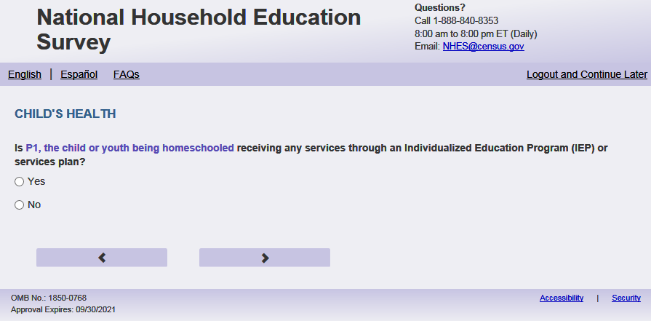
English Text Reads:
Is [this child] receiving any services through an Individualized Education Program (IEP) or services plan?

Spanish Text Reads:
¿Recibe [este niño (esta niña)] servicios a través de un Programa de Educación Individual (IEP, por sus siglas en inglés) o plan de servicios?

English Answer
1 = Yes
2=No

Spanish Answer
1= Sí
2=No

PFIC_HDIEPX, (1,2), numeric, radio

Skips:
if PFIC_HDIEPX = 2 then go to PFIC_HDLEARN. Else go to PFIC_ HDCOMMUXX

Item: Satisfaction of IEP Services (PFIC_HDCOMMUXX)
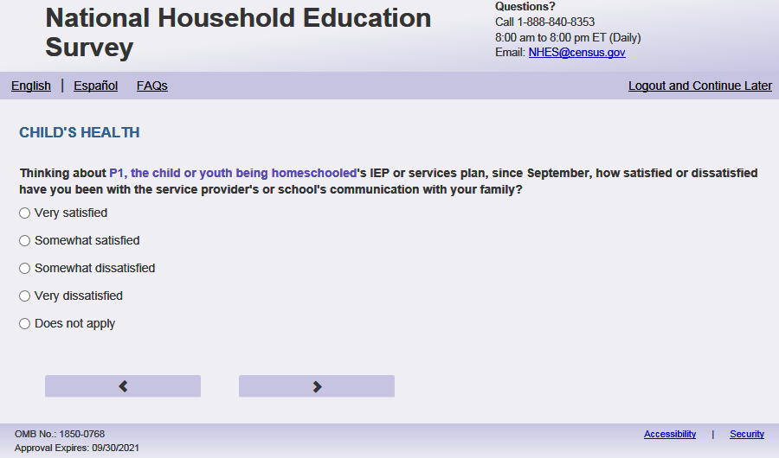
English Respondent Text Reads:
Thinking about [this child’s] IEP or services plan, since September, how satisfied or dissatisfied have you been with the service provider’s or school’s communication with your family?

Spanish Respondent Text Reads:
Pensando en el IEP, por sus siglas en inglés, o el plan de servicios de [este niño (esta niña)], a partir de septiembre, ¿qué tan satisfecho(a) está usted con la comunicación que el proveedor del servicios, o la escuela, tiene con la familia?
English Admin/TQA Text Reads:
Thinking about [this child’s] IEP or services plan, since September, how satisfied or dissatisfied have you been with the service provider’s or school’s communication with your family?

Are you very satisfied, somewhat satisfied, somewhat dissatisfied, or very dissatisfied?

Spanish Admin.TQA Text Reads:

Pensando en el IEP, por sus siglas en inglés, o el plan de servicios de [este niño (esta niña)], a partir de septiembre, ¿qué tan satisfecho(a) está usted con la comunicación que el proveedor del servicios, o la escuela, tiene con la familia?
¿Está usted muy satisfecho(a), algo satisfecho(a), algo insatisfecho(a), o muy insatisfecho(a)?

English Answer
1=Very satisfied
2=Somewhat satisfied
3=Somewhat dissatisfied
4=Very dissatisfied
5 = Does not apply

Spanish Answer
1= Muy satisfecho(a)
2= Algo satisfecho(a)
3= Algo insatisfecho(a)
4= Muy insatisfecho(a)
5= No aplica

PFIC_HDCOMMUXX, (1,5), numeric, radio

Skips:

Go to PFIC_HDLEARN

Logic Checks/Programming specifications
Increase spacing between response options “Very dissatisfied” and “Does not apply” response options by about double the normal spacing.

Item: Child’s Condition and Ability (PFIC_HDLEARN)
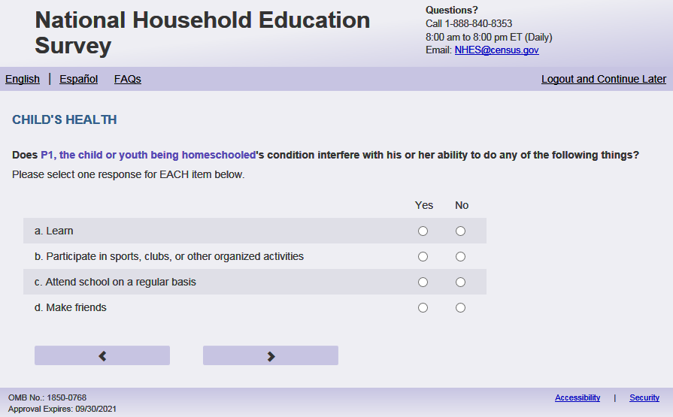
English Respondent Text Reads:
Does [this child]’s condition interfere with [his/her/his or her] ability to do any of the following things?
Spanish Respondent Text Reads:
¿Afecta el problema de salud de [este niño (esta niña)] su capacidad para hacer algunas de las siguientes cosas?

English Admin/TQA Text Reads:
Please respond ‘yes’ or ‘no’ for EACH item as I read them.
Spanish Admin/TQA Text Reads:
Por favor, responda 'sí' o 'no' para CADA opción a medida que las leo.
English Respondent Answer
a. Learn PFIC_HDLEARN, (1 = Yes, 2 = No), numeric, radio
b. Participate in sports, clubs, or other organized activities PFIC_HDPLAY, (1 = Yes, 2 = No), numeric, radio
c. Attend school on a regular basis PFIC_HDOUT, (1 = Yes, 2 = No), numeric, radio
d. Make friends PFIC_HDFRNDS,(1 = Yes, 2 = No), numeric, radio

Spanish Respondent Answer
a. Aprender PFIC_HDLEARN, (1= Sí, 2 = No), numeric, radio
b. Participar en deportes, clubs u otras actividades organizadas PFIC_HDPLAY, (1= Sí, 2 = No), numeric, radio
c. Asistir a la escuela de manera habitual PFIC_HDOUT, (1= Sí, 2 = No), numeric, radio
d. Hacer amigos PFIC_HDFRNDS, (1= Sí, 2 = No), numeric, radio

English Admin/TQA Answer:

- Does [this child]’s condition interfere with [his/her/his or her] ability to learn?, PFIC_HDLEARN, (1=Yes, 2=No), numeric, radio
- Does [this child]’s condition interfere with [his/her/his or her] ability to play with other children?, PFIC_HDPLAY, (1=Yes, 2=No), numeric, radio
- Does [this child]’s condition interfere with [his/her/his or her] ability to go on outings?, PFIC_HDOUT, (1=Yes, 2=No), numeric, radio
- Does [this child]’s condition interfere with [his/her/his or her] ability to make friends?, PFIC_HDFRNDS, (1=Yes, 2=No), numeric, radio

Spanish Admin/TQA Answer:
- ¿La condición de [este niño (esta niña)] interfiere con [él / ella / él or ella] capacidad de aprender, PFIC_HDLEARN, (1= Sí, 2=No), numeric, radio
- ¿La condición de [este niño (esta niña)] interfiere con [él / ella / él or ella] capacidad de participar en juegos con otros niños, PFIC_HDPLAY, (1= Sí, 2=No), numeric, radio
- ¿La condición de [este niño (esta niña)] interfiere con [él / ella / él or ella] capacidad de asistir a los paseos, PFIC_HDOUT, (1= Sí, 2=No), numeric, radio
- ¿La condición de [este niño (esta niña)] interfiere con [él / ella / él or ella] capacidad de hacer amigos, PFIC_HDFRNDS, (1= Sí, 2=No), numeric, radio

Skips:
if s1_PxDOBYY and S1_PxAGE for sampled child are missing from Screener, go to PFIC_CODBMM_WEB. Else, go to PFIC_CPLCBRTH.

Logic Checks/Programming specifications:
display as grid for both Respondent and Admin/TQA items.

if s1_pxsex = 1 use ‘his’ if p1_pxsex = 2 use ‘her’ else use ‘his or her’
if s1_pxsex = 1 use ‘él’ if p1_pxsex = 2 use ‘ella’ else use ‘él or ella’

Item: Child’s Birth Month and Year (PFIC_CDOBMM_WEB)
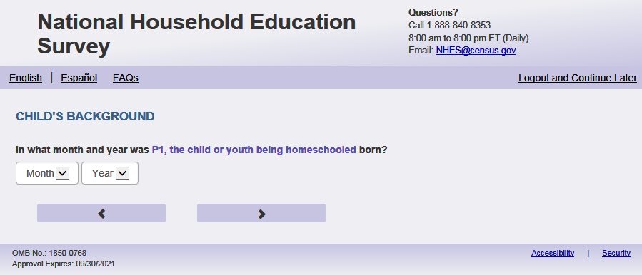
English Text Reads:
In what month and year was [this child] born?

Spanish Text Reads:
¿En qué mes y año nació [este niño (esta niña)]?

English and Spanish Answer:
PFIC_CDOBMM_WEB, (1,12), numeric, drop-down
PFIC_CDOBYY_WEB, (2002, 2023), numeric, drop-down
Skips:
If PFIC_CDOBYY_WEB is missing, go to PFIC_CAGE. Otherwise, skip to PFIC_CPLCBRTH

Logic Checks/Programming specifications:
Allow respondents to scroll the options within drop-down.

English
Display "months" as label above the dropdown box and leave the dropdown box blank. . (PFIC_CDOBMM_WEB)
Display "year" as label above the dropdown box and leave the dropdown box blank. (PFIC_CDOBYY_WEB)

Spanish
Display ‘mes’ as label above the dropdown box and leave the dropdown box blank. (PFIC_CDOBMM_WEB)
Display "año" as label above the dropdown box and leave the dropdown box blank. . (PFIC_CDOBYY_WEB)

Item: Child’s Age in Years (PFIC_CAGE)
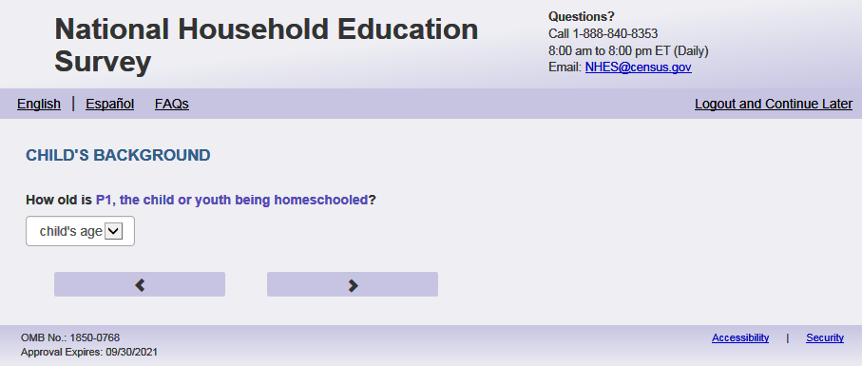
English Text Reads:
How old is [this child]?

Spanish Text Reads:
¿Qué edad tiene [este niño (esta niña)]?

PFIC_CAGE, (0,20), numeric, write-in
Skips:
Go to PFIC_CPLCBRTH

Logic Checks/Programming specifications:
Logic/range check triggers a warning message, with the following text displayed.

English
[If not within 0-20] Display "You entered the age of this child as older than 20 years old. Please check and make sure your answer is correct before continuing."
Spanish
[If not within 0-20] Display "Usted ingresó la edad de este niño como mayor de 20 años. Por favor, compruebe y asegúrese de que su respuesta es correcta antes descontinuar."

English
Display "years old" label above the dropdown box and leave the dropdown box blank.

Spanish
Display "edad en años" label above the dropdown box and leave the dropdown box blank..
Mobile: Display numeric keypad

Item: Child’s Place of Birth (PFIC_CPLCBRTH)
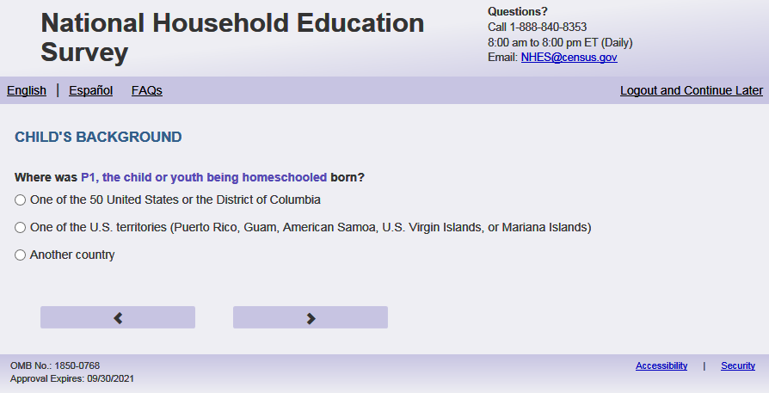
English Text Reads:
Where was [this child] born?

Spanish Text Reads:
¿Dónde nació [este niño (esta niña)]?

English Answer
1= One of the 50 United States or the District of Columbia 2= One of the U.S. territories (Puerto Rico, Guam, American Samoa, U.S. Virgin Islands, or Mariana Islands)
3= Another country

Spanish Answer
1= Uno de los 50 estados de los Estados Unidos o el Distrito de Columbia
2= Uno de los territorios incorporados de los Estados Unidos (Puerto Rico, Guam, Samoa Americana, Islas Vírgenes de los Estados Unidos o Islas Marianas del Norte)
3= Otro país

PFIC_CPLCBRTH, (1, 3), numeric, radio

Skips:
if PFIC_CPLCBRTH = 1 or blank then go to PFIC_CHISPANX. Else go to PFIC_CMOVEAGE.

Item: Child’s Age once moved to U.S. (PFIC_CMOVEAGE)
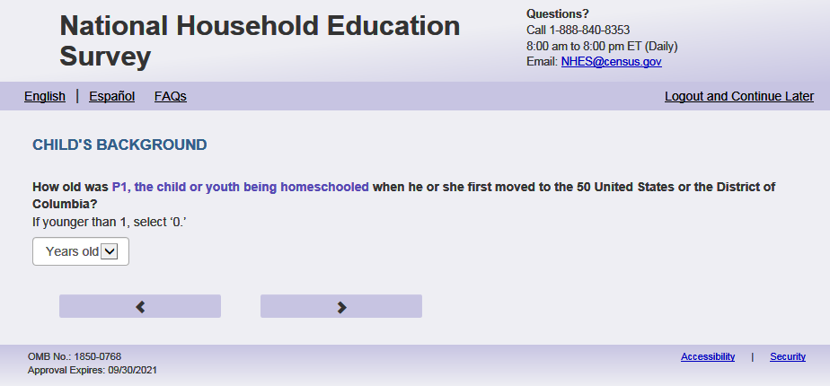
English Text Reads:
How old was [this child] when [he/she/he or she] first moved to the 50 United States or the District of Columbia?
If younger than 1, enter ‘0.’
Spanish Text Reads:
¿Qué edad tenía [este niño (esta niña)] cuando se mudó por primera vez a uno de los 50 estados de los Estados Unidos o al Distrito de Columbia?
Si fue menor de un año, por favor ingrese‘0’

English and Spanish Answer:
PFIC_CMOVEAGE, (0, 20), numeric, write-in.
Skips:
Go to PFIC_CHISPANX
Logic Checks/Programming specifications:
English
display “years old” to the right of the text box
if s1_pxsex = 1 use ‘he’ if p1_pxsex = 2 use ‘her’ else use ‘he or she’
Spanish
display “ edad” to the right of the text box
’Logic/range check triggers a warning message if answer is greater than child’s current age, with the following text displayed.

English
[If not within 0-20 or greater than child’s current age] Display “You entered an age that is greater than the child’s current age or is older than 20 years old. Please check and make sure your answer is correct before continuing.”

Spanish
[If not within 0-20 or greater than child’s current age] Display “Usted ingresó una edad que es mayor que la edad actual del niño o es mayor de 20 años. Por favor, compruebe y asegúrese de que su respuesta es correcta antes de continuar. “

Mobile: Display numeric keypad

Item: Child’s Hispanic Origin(PFIC_CHISPANX)
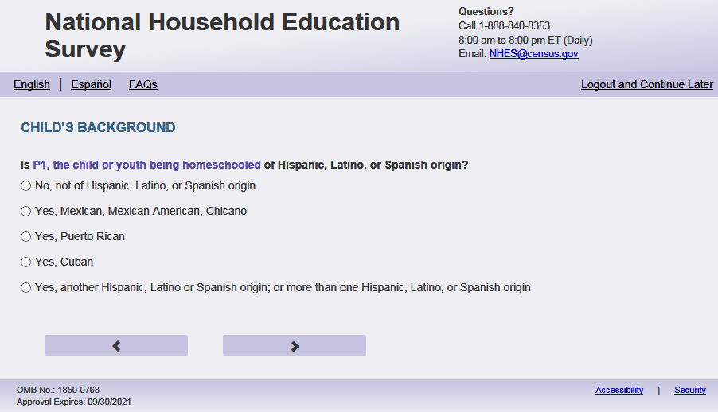
English Respondent Text Reads:
Is [this child] of Hispanic, Latino, or Spanish origin?

Spanish Respondent Text Reads:
¿Es [este niño (esta niña)] de origen hispano, latino o español?

English Admin/TQA Text Reads:
{Please be sure to ask BOTH this question and the following race question, and record the respondent’s answer}
Is [this child] of Hispanic, Latino, or Spanish origin?

{If ‘yes,’ read the yes answer options to the respondent.}

Spanish Admin/TQA Text Reads:

{Por favor, asegúrese de hacer tanto esta pregunta como la siguiente pregunta sobre raza, y registrar la respuesta del encuestado}
¿Es [este niño(a)] de origen hispano, latino o español?

{En caso de 'sí', lea las opciones de respuesta de sí al encuestado.}

English Answers
1 = No, not of Hispanic, Latino, or Spanish origin
2 = Yes, Mexican, Mexican American, Chicano
3 = Yes, Puerto Rican
4 = Yes, Cuban
5 = Yes, another Hispanic, Latino or Spanish origin; or more than one Hispanic, Latino, or Spanish origin

Spanish Answers
1 = No, no es de origen hispano, latino o español
2 = Sí, Mexicano, Mexicano Americano, Chicano
3 = Sí, Puertorriqueño
4 = Sí, Cubano
5 = Sí, es de otro origen hispano, latino, o español; o de más de un origen hispano, latino o español

PFIC_CHISPANX, (1,5), numeric, radio

Skips:

Go to PFIC_CAMIND

Item: Race of Child (PFIC_CAMIND)
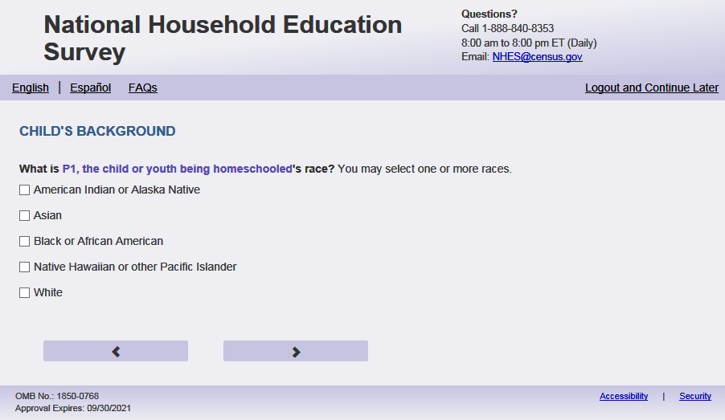

English Respondent Text Reads:
What is [this child]’s race? You may select one or more races.
Spanish Respondent Text Reads:
¿Cuál es la raza de [este niño (esta niña)]? Puede seleccionar una o más razas.
English Admin/TQA Text Reads:
What is [this child]’s race?
{You may select one or more races.}
{If the respondent answered yes to the previous item (Hispanic ethnicity) and does not identify with any other race, leave this item blank.}
Spanish Admin/TQA Text Reads:
¿Cuál es la raza de [este niño (esta niña)]?
{Puede seleccionar una o más razas.}
{Si el encuestado respondió sí a la pregunta anterior (etnia hispana) y no se identifica con ninguna otra raza, deje este ítem en blanco.}
English Answer
American Indian or Alaska Native, PFIC_CAMIND, (1=Item Marked, 2=no/not marked), numeric, check-box
Asian, PFIC_CASIAN, (1=Item Marked, 2=no/not marked), numeric, check-box
Black or African American, PFIC_CBLACK, (1=Item Marked, 2=no/not marked), numeric, check-box
Native Hawaiian or other Pacific Islander, PFIC_CPACI, (1=Item Marked, 2=no/not marked), numeric, check-box
White, PFIC_CWHITE, (1= Yes/ Marked, 2= No/ Not Marked), numeric, check-box
Spanish Answer
Indígena de las Américaso nativa de Alaska, PFIC_CAMIND, (1=Item Marked, 2=no/not marked), numeric, check-box
Asiática, PFIC_CASIAN, (1=Item Marked, 2=no/not marked), numeric, check-box
Negra o afroamericana, PFIC_CBLACK, (1=Item Marked, 2=no/not marked), numeric, check-box
Nativa de Hawái u otra de las islas del Pacífico, PFIC_CPACI, (1=Item Marked, 2=no/not marked), numeric, check-box
Blanca, PFIC_CWHITE, (1=Item Marked, 2=no/not marked), numeric, check-box

Skips:
If S1_PxSEX is missing for sampled child from Screener, go to PFIC_CSEX. Else go to PFIC_CLIVYN

Logic Checks/Programming specifications:
This is a mark all the apply item

Item: Sex of Child (PFIC_CSEX)
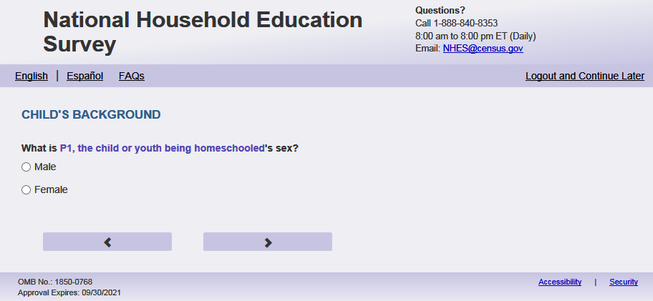
English Text Reads:
What is [this child]’s sex?
Spanish Text Reads:
¿De qué sexo es [este niño (esta niña)]?
English answer
1= Male
2= Female

Spanish answer
1= Masculino
2= Femenino

PFIC_CSEX, (1,2), numeric, radio

Skips:

Go to PFIC_CLIVYN

Item: Address of Child (PFIC_CLIVYN)
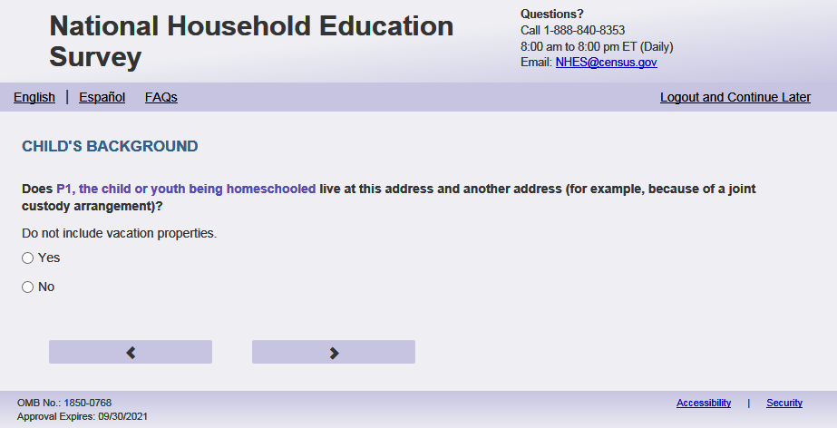

English Text Reads:
Does [this child] sometimes live at another address (for example, because of parents living apart)?
Do not include vacation properties.
Spanish Text Reads:
¿[Este niño (esta niña)] vive a veces en otra dirección más (por ejemplo, debido a que los padres viven separados)?
No incluya casas de vacaciones..
English
1 = Yes
2=No

Spanish
1 = Sí
2=No

PFIC_CLIVYN, (1,2), numeric, radio

Skips:
If PFIC_CLIVYN = 1 or blank, then go to PFIC_CLIVELSWX. Else if PFIC_CLIVYN = 2 then go to PFIC_CSPEAKX.

Item: Where This Child Spends Most Time (PFIC_CLIVELSWX)
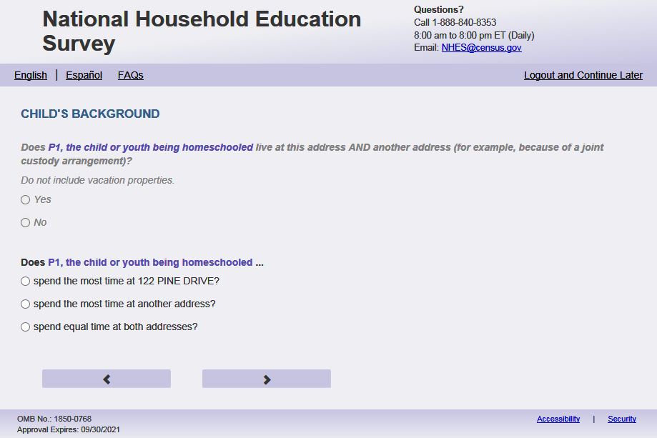
English Text Reads:
Does [this child]…
Spanish Text Reads:
[Este niño (esta niña)]….

English Admin/TQA Text Reads:
Does [this child]…

{Please read response options.}

Spanish Admin/TQA Text Reads:

[Este niño (esta niña)] ….

{Por favor, lea las opciones de respuesta.}

English Answer
1= spend the most time at [fill with PADDR SADDR]?
2= spend the most time at the other address?
3= spend equal time at both addresses?

Spanish Answer
1= pasa la mayor parte del tiempo en [fill with PADDR SADDR]?
2= pasa la mayor parte del tiempo en otra dirección ?
3= pasa la misma cantidad de tiempo en ambas direcciones?
?

PFIC_CLIVELSWX, (1,3), numeric, radio

Skips:
Go to PFIC_CPSEAKX.

Logic Checks/Programming specifications:
Use only pri_add + sec_add for fill.
Display on a new screen. Do not display on same screen PFIC_CLIVYN.

PADDR SADDR fill is the respondent’s address on the sampling frame.

Item: Language Most Spoken at Home by this child (PFIC_CSPEAKX)
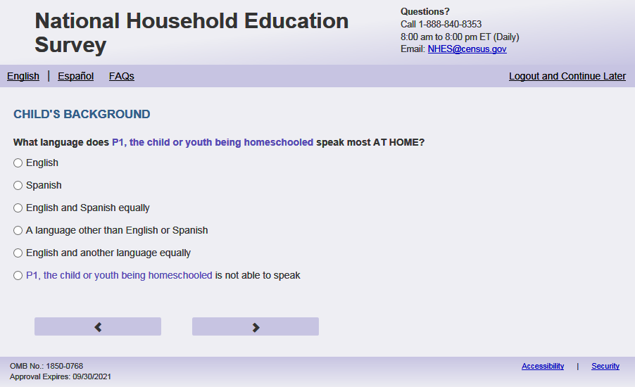
English Text Reads:
What language does [this child] speak most AT HOME?

Spanish Text Reads:
¿Qué idioma habla más [este niño (esta niña)] EN EL HOGAR?

English Admin/TQA Text Reads:
What language does [this child] speak most AT HOME?
{Please read response options.}

Spanish Admin/TQA Text Reads:
¿Qué idioma habla más [este niño (esta niña)] EN EL HOGAR?

{Por favor, lea las opciones de respuesta.}

English Answer
1= English
2= Spanish
3= English and Spanish equally
4= A language other than English or Spanish
5= English and another language equally

Spanish Answer
1= Inglés
2= Español
3= Inglés y español por igual
4= Otro idioma aparte del inglés o español
5= Inglés y otro idioma por igual

PFIC_CSPEAKX, (1,5), numeric, radio

Skips:
If PFIC_CSPEAKX in 2, 3,4,5 go to PFIC_CENGLPRG.
Else go to PFIC_HHTOTALXX

Item: English as Second Language (PFIC_CENGLPRG)
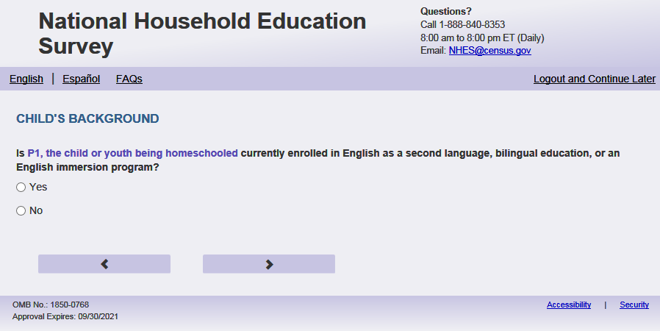
English Text Reads:
Is [this child] currently enrolled in English as a second language, bilingual education, or an English immersion program?
Spanish Text Reads:
Actualmente,¿ Asiste [este niño (esta niña)] a clases de inglés como segundo idioma, educación bilingüe o a un programa de inmersión al inglés?
English Answer
1 = Yes
2 = No

Spanish Answer
1 = Sí
2= No

PFIC_CENGLPRG, (1,2), numeric, radio

Skips:
Else go to PFIC_HHTOTALXX

Item: Total in Household Number (PFIC_HHTOTALXX)
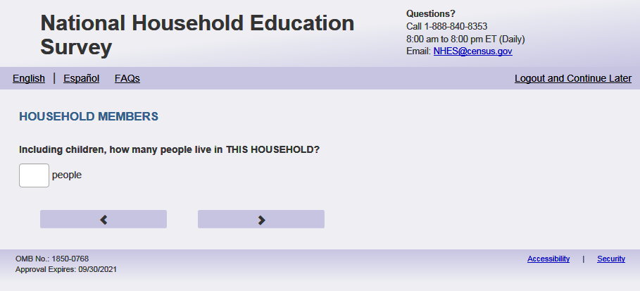
English text
Including children, how many people live in THIS HOUSEHOLD?
Spanish Text Reads:
Incluyendo a los niños, ¿cuántas personas viven en ESTE HOGAR?
PFIC_ HHTOTALXX, (0,99), write in

Skips:
If ps_pfirelate is blank, go to PFIC_ HHREL1. Else if ps_pfirelate in (1, 2, 5, 10) go to PFIC_P1REL. Else if ps_pfirelate in (3, 4, 6, 7, 8, 9) go to PFIC_P1GUARD .
(ps_pfirelate is from the screener)

Logic Checks/Programming specifications:
English:
Display ‘people’ next to write in box.
Spanish
Display ‘personas‘ next to write in box.

Mobile: Display numeric keypad

Item: Relation to this Child (PFIC_HHREL1)
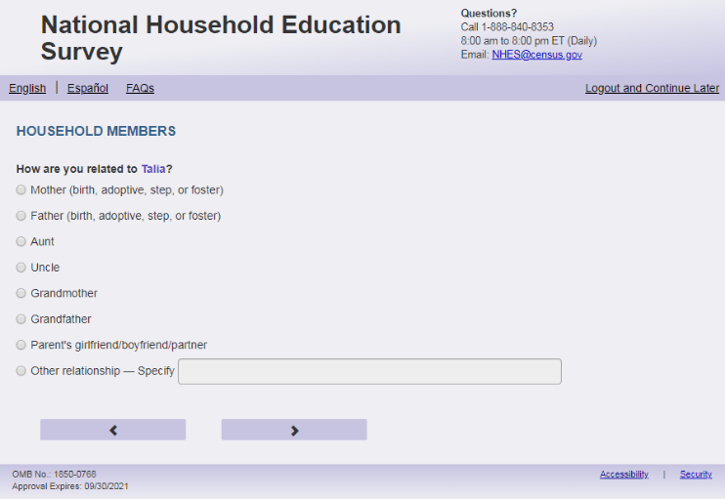
English Text Reads:
The next questions are about [this child]’s parent(s) and guardian(s).
How are you related to [this child]?

Spanish Text Reads:
Las siguientes preguntas son acerca de los padres y tutores legales de [CHILD].
¿Cuál es su relación o parentesco con [este niño (esta niña)]?

English Answer
1= Mother (birth, adoptive, step, or foster)
2= Father (birth, adoptive, step, or foster)
3= Grandmother
4= Grandfather
5= Parent’s girlfriend/boyfriend/partner
6 = Aunt
7 = Uncle
8 = Sister
9 = Brother
10 = Other relationship – Specify:

Spanish Answer
1= Madre (biológica, adoptiva, madrastra o de crianza temporal (Foster))
2= Padre (biológico, adoptivo, padrastro o de crianza temporal (Foster))
3= Abuela
4= Abuelo
5= Novia/Novio o pareja de alguno de los padres
6= Tía
7= Tío
8 = Hermana
9 = Hermano
10 = Otra relación o parentesco – Especifique:

Items 1-8: PFIC_HHREL1 (1,10), numeric, radio. If 10 selected, specify box should become active: PFIC_HHREL1OS, (0,50), character, write-in. Display specify response box 1 row by 30 characters.

Skips:
If PFIC_HHREL1 in (1, 2, 5, 10) Go to PFIC_P1REL
Else if PFIC_HHREL1 in (3, 4, 6, 7, 8, 9) go to PFIC_P1GUARD.

Logic Checks/Programming specifications:
If ps_PFIRELATE ne ‘ ‘ then do not ask this question, and follow skips if ps_pfirelate in (1, 2, 5, 10) go to PFIC_P1REL. Else if ps_ pfirelate in (3, 4, 6, 7, 8, 9) go to PFIC_P1GUARD .
(ps_ pfirelate is from the screener)

Item: Parent/Guardian (PFIC_P1REL)
English Respondent Text Reads:
Are you [this child]’s…

Spanish Respondent Text Reads:
¿Es usted…

English Admin/TQA Text Reads:
Are you [this child]’s…
{Please read response options.}

Spanish Admin/TQA Text Reads:
¿Es usted…

{Por favor, lea las opciones de respuesta.}

English Answer
1= Biological parent
2= Adoptive parent
3= Stepparent
4= Foster parent
5= Other guardian

Spanish Answer
1= [El padre biológico o la madre biológica]
2= [El padre adoptivo o la madre adoptiva]
3= [El padrastro o la madrastra]
4= [El padre de crianza temporal (Foster) o la madre de crianza temporal (Foster)]
5= Otro tutor(a) legal

PFIC_P1REL, (1,5), numeric, radio

Skips:
Go to PFIC_P1SEX

Spanish Fills:
[El padre biológico o la madre biológica]:
if ps_ecpprelate or PFIC_ HHREL1 = 2 then El padre biológico
if ps_ecpprelate or PFIC_ HHREL1 = 1 then La madre biológica
if ps_ecpprelate or PFIC_ HHREL1 in (5, 10, blank) then El padre biológico o la madre biológica

[El padre adoptivo o la madre adoptiva]:
if ps_ecpprelate or PFIC_ HHREL1 = 2 then El padre adoptivo
if ps_ecpprelate or PFIC_ HHREL1 = 1 then La madre adoptiva
if ps_ecpprelate or PFIC_ HHREL1 in (5, 10, blank) then El padre adoptivo o la madre adoptiva

[El padrastro o madrastra]:
if ps_ecpprelate or PFIC_ HHREL1 = 2 then El padrastro
if ps_ecpprelate or PFIC_ HHREL1 = 1 then La madrastra
if ps_ecpprelate or PFIC_ HHREL1 in (5, 10, blank) then El padrastro o madrastra

[El padre de crianza temporal (Foster) o la madre de crianza temporal (Foster)]:
if ps_ecpprelate or PFIC_ HHREL1 = 2 then El padre de crianza temporal (Foster)
if ps_ecpprelate or PFIC_ HHREL1 = 1 then La madre de crianza temporal (Foster)
if ps_ecpprelate or PFIC_ HHREL1 in (5, 10, blank) then El padre de crianza temporal (Foster) o la madre de crianza temporal (Foster)

Item: Parent/Guardian (PFIC_P1GUARD)
<New item for NHES:2023 – no screenshot available>
English Respondent Text Reads:
Do you consider yourself one of [this child]'s parents or guardians?

Spanish Respondent Text Reads:

¿Se considera usted uno de los padres o tutores legales de [este niño (esta niña)]?

English Answer
1= Yes
2= No

Spanish Answer
1= Sí
2= No

PFIC_P1GUARD, (1,2), numeric, radio

Skips:
if PFIC_P1GUARD = 1 then go to PFIC_P1SEX. Else go to PFIC_P1HHREL2.

Item: Relation to this Child (PFIC_P1HHREL2)
<New item for NHES:2023 – no screenshot available>
English Text Reads:
Who is one of [this child]'s parents or guardians living in this household? We will ask about any other parent or guardian later.

Spanish Text Reads:
¿Quién es uno de los padres o tutores legales de [este niño (esta niña)] que vive en este hogar? Le preguntaremos sobre otro padre, madre, o tutor(a) legal más adelante.
English Answer
1= Mother (birth, adoptive, step, or foster)
2= Father (birth, adoptive, step, or foster)
3= Grandmother
4= Grandfather
5= Parent’s girlfriend/boyfriend/partner
6 = Aunt
7 = Uncle
8 = Sister
9 = Brother
10 = Other relationship – Specify:

Spanish Answer
1= Madre (biológica, adoptiva, madrastra o de crianza temporal (Foster))
2= Padre (biológico, adoptivo, padrastro o de crianza temporal (Foster))
3= Abuela
4= Abuelo
5= Novia/Novio o pareja de alguno de los padres
6= Tía
7= Tío
8 = Hermana
9 = Hermano
10 = Otra relación o parentesco – Especifique:

Items 1-8: PFIC_P1HHREL2 (1,10), numeric, radio. If 10 selected, specify box should become active: PFIC_P1HHREL2OS, (0,50), character, write-in. Display specify response box 1 row by 30 characters.

Skips:
If PFIC_P1HHREL2 in (1, 2, 5, 10) Go to PFIC_P1REL2
Else if PFIC_P1HHREL2 in (3, 4, 6, 7, 8, 9) go to PFIC_P1SEX.

Logic Checks/Programming specifications for the PARENT1 fill for the remainder of this section
English:
If parent or guardian:
To streamline the reference to the respondent being the parent or guardian please create P1Fill:
IF ps_pfirelate OR PFIC_P1HHREL1 in (1,2, 5, 10) OR PFIC_P1GUARD = 1 then P1Fill = 1
Then for the autofill see direction in specific item that will reference P1Fill = 1 and will use [you] or [your].
If not the parent or guardian:
Else use the following autofill references:
If PFIC_P1HHREL2 = 1 (mother) is selected then Parent 1 fill is [this child]’s mother; P1.Pronoun fill is she
If PFIC_P1HHREL2 = 2 (father) is selected then Parent 1 fill is [this child]’s father; P1.Pronoun fill is he
If PFIC_P1HHREL2 = 3 (grandmother) is selected then Parent 1 fill is [this child]’s grandmother; P1.Pronoun fill is she
If PFIC_P1HHREL2 = 4 (grandfather) is selected then Parent 1 fill is [this child]’s grandmother; P1.Pronoun fill is he
If PFIC_P1HHREL2 = 6 (aunt) is selected then Parent 1 fill is [this child]’s aunt; P1.Pronoun fill is she
If PFIC_P1HHREL2 = 7 (uncle) is selected then Parent 1 fill is [this child]’s uncle; P1.Pronoun fill is he
If PFIC_P1HHREL2 = 8 (sister) is selected then Parent 1 fill is [this child]’s sister; P1.Pronoun fill is she
If PFIC_P1HHREL2 = 9 (brother) is selected then Parent 1 fill is [this child]’s brother; P1.Pronoun fill is he
If PFIC_P1HHREL2 in (5, 10, blank) (boyfriend/girlfriend/partner or other relationship) is selected then Parent 1 fill is [this child]’s parent or guardian
Spanish:
If parent or guardian:
To streamline the reference to the respondent being the parent or guardian please create P1Fill:
IF ps_pfirelate OR PFIC_HHREL1 in (1,2, 5, 10) OR PFIC_P1GUARD = 1 then P1Fill = 1
Then for the autofill see direction in specific item that will reference P1Fill = 1 and will use [usted].
If not the parent or guardian:
If PFIC_P1HHREL2 = 1 (madre) is selected then Parent 1 fill is la madre de [este niño (esta niña)]; P1.Pronoun fill is ella
If PFIC_P1HHREL2 = 2 (padre) is selected then Parent 1 fill is el padre de [este niño (esta niña)]; P1.Pronoun fill is él
If PFIC_P1HHREL2 = 3 (Abuela) is selected then Parent 1 fill is la abuela de [este niño (esta niña)]; P1.Pronoun fill is ella
If PFIC_P1HHREL2 = 4 (Abuelo) is selected then Parent 1 fill is el abuelo de [este niño (esta niña)]; P1.Pronoun fill is él
If PFIC_P1HHREL2 = 6 (Tía) is selected then Parent 1 fill is la tía de [este niño (esta niña)]; P1.Pronoun fill is ella
If PFIC_P1HHREL2 = 7 (Tío) is selected then Parent 1 fill is el tío de [este niño (esta niña)]; P1.Pronoun fill is él
If PFIC_P1HHREL2 = 8 (Hermana) is selected then Parent 1 fill is la hermana de [este niño (esta niña)]; P1.Pronoun fill is ella
If PFIC_P1HHREL2 = 9 (Hermano) is selected then Parent 1 fill is el hermano de [este niño (esta niña)]; P1.Pronoun fill is él
If PFIC_P1HHREL2 in (5, 10, blank) (Novia/Novio o pareja de alguno de los padres o otra relación o parentesco) is selected then Parent 1 fill is el padre, la madre o el tutor(a) legal de [este niño (esta niña)]

Item: Parent/Guardian (PFIC_P1REL2)
English Respondent Text Reads:
Is [PARENT 1] [his/her/his or her] …

Spanish Respondent Text Reads:

¿Es [PARENT 1] su…

English Admin/TQA Text Reads:
Is [PARENT 1] [his/her/his or her] …
{Please read response options.}

Spanish Admin/TQA Text Reads:
¿Es [PARENT 1] su…

{Por favor, lea las opciones de respuesta.}

English Answer
1= Biological parent
2= Adoptive parent
3= Stepparent
4= Foster parent
5= Grandparent
6= Other guardian

Spanish Answer
1= [El padre biológico o la madre biológica]
2= [El padre adoptivo o la madre adoptiva]
3= [El padrastro o la madrastra]
4= [El padre de crianza temporal (Foster) o la madre de crianza temporal (Foster)]
5= Abuelo o abuela
6= Otro tutor(a) legal

PFIC_P1REL2, (1,6), numeric, radio

Skips:
Go to PFIC_P1SEX

Logic Checks/Programming specifications:
English:
if s1_pxsex = 1 use ‘his’ if p1_pxsex = 2 use ‘her’ else use ‘his or her’
If PFIC_P1HHREL2 = 1 (mother) is selected then PARENT 1 fill is “[this child]’s mother”
If PFIC_P1HHREL2 = 2 (father) is selected then PARENT 1 fill is “ [this child]’s father”
If PFIC_P1HHREL2 = 3 (grandmother) is selected then PARENT 1 fill is “[this child]’s grandmother”
If PFIC_P1HHREL2 = 4 (grandfather) is selected then PARENT 1 fill is “[this child]’s grandfather”
If PFIC_P1HHREL2 = 6 (aunt) is selected then PARENT 1 fill is “[this child]’s aunt”
If PFIC_P1HHREL2 = 7 (uncle) is selected then PARENT 1 fill is “[this child]’s uncle”
If PFIC_P1HHREL2 = 8 (sister) is selected then PARENT 1 fill is “[this child]’s sister”
If PFIC_P1HHREL2 = 9 (brother) is selected then PARENT 1 fill is “[this child]’s brother”
If PFIC_P1HHREL2 in (5, 10, blank) (boyfriend/girlfriend/partner or other relationship) is selected then PARENT 1 fill is “ [this child]’s parent or guardian”
Spanish:
If PFIC_P1HHREL2 = 1 (madre) is selected then Parent 1 fill is “la madre de [este niño (esta niña)]”
If PFIC_P1HHREL2 = 2 (padre) is selected then Parent 1 fill is “el padre de [este niño (esta niña)]”
If PFIC_P1HHREL2 = 3 (Abuela) is selected then Parent 1 fill is “la abuela de [este niño (esta niña)]”
If PFIC_P1HHREL2 = 4 (Abuelo) is selected then Parent 1 fill is “el abuelo de [este niño (esta niña)]”
If PFIC_P1HHREL2 = 6 (Tía) is selected then Parent 1 fill is “la tía de [este niño (esta niña)]”
If PFIC_P1HHREL2 = 7 (Tío) is selected then Parent 1 fill is “el tío de [este niño (esta niña)]”
If PFIC_P1HHREL2 = 8 (Hermana) is selected then Parent 1 fill is “la hermana de [este niño (esta niña)]”
If PFIC_P1HHREL2 = 9 (Hermano) is selected then Parent 1 fill is “el hermano de [este niño (esta niña)]”
If PFIC_P1HHREL2 in (5, 10, blank) (Novia/Novio o pareja de alguno de los padres o otra relación o parentesco) is selected then Parent 1 fill is “el padre, la madre o el tutor(a) legal de [este niño (esta niña)]”
[El padre biológico o la madre biológica]:
if PFIC_ P1HHREL2 = 2 then El padre biológico
if PFIC_ P1HHREL2 = 1 then La madre biológica
if PFIC_ P1HHREL2 in (5, 10, blank) then El padre biológico o la madre biológica

[El padre adoptivo o la madre adoptiva]:
if PFIC_ P1HHREL2 = 2 then El padre adoptivo
if PFIC_ P1HHREL2 = 1 then La madre adoptiva
if PFIC_ P1HHREL2 in (5, 10, blank) then El padre adoptivo o la madre adoptiva

[El padrastro o la madrastra]:
if PFIC_ P1HHREL2 = 2 then El padrastro
if PFIC_ P1HHREL2 = 1 then La madrastra
if PFIC_ P1HHREL2 in (5, 10, blank) then El padrastro o madrastra

[El padre de crianza temporal (Foster) o la madre de crianza temporal (Foster)]:
if PFIC_ P1HHREL2 = 2 then El padre de crianza temporal (Foster)
if PFIC_ P1HHREL2 = 1 then La madre de crianza temporal (Foster)
if PFIC_ P1HHREL2 in (5, 10, blank) then El padre de crianza temporal (Foster) o la madre de crianza temporal (Foster)

Item: Parent or Guardian Sex (PFIC_P1SEX)
English Text Reads:
[PARENT 1] male or female?

Spanish Text Reads:
¿Es [PARENT 1] de sexo masculino o femenino?

English Answer
1= Male
2= Female

Spanish Answer
1= Masculino
2= Femenino

PFIC_P1SEX, (1,2), numeric, radio
Skips:
Go to PFIC_P1MRSTAR

Logic Checks/Programming specifications:
English:
If P1Fill = 1 (parent respondent) then PARENT 1 fill is “Are you”
If PFIC_P1HHREL2 = 1 (mother) is selected then PARENT 1 fill is “Is [this child]’s mother”
If PFIC_P1HHREL2 = 2 (father) is selected then PARENT 1 fill is “Is [this child]’s father”
If PFIC_P1HHREL2 = 3 (grandmother) is selected then PARENT 1 fill is “Is [this child]’s grandmother”
If PFIC_P1HHREL2 = 4 (grandfather) is selected then PARENT 1 fill is “Is [this child]’s grandfather”
If PFIC_P1HHREL2 = 6 (aunt) is selected then PARENT 1 fill is “Is [this child]’s aunt”
If PFIC_P1HHREL2 = 7 (uncle) is selected then PARENT 1 fill is “Is [this child]’s uncle”
If PFIC_P1HHREL2 = 8 (sister) is selected then PARENT 1 fill is “Is [this child]’s sister”
If PFIC_P1HHREL2 = 9 (brother) is selected then PARENT 1 fill is “Is [this child]’s brother”
If PFIC_P1HHREL2 in (5, 10, blank) (boyfriend/girlfriend/partner or other relationship) is selected then PARENT 1 fill is “Is [this child]’s parent or guardian”
Spanish:
If P1Fill = 1 (parent respondent) then PARENT 1 fill is “usted”
If PFIC_P1HHREL2 = 1 (madre) is selected then Parent 1 fill is “la madre de [este niño (esta niña)]”
If PFIC_P1HHREL2 = 2 (padre) is selected then Parent 1 fill is “el padre de [este niño (esta niña)]”
If PFIC_P1HHREL2 = 3 (Abuela) is selected then Parent 1 fill is “la abuela de [este niño (esta niña)]”
If PFIC_P1HHREL2 = 4 (Abuelo) is selected then Parent 1 fill is “el abuelo de [este niño (esta niña)]”
If PFIC_P1HHREL2 = 6 (Tía) is selected then Parent 1 fill is “la tía de [este niño (esta niña)]”
If PFIC_P1HHREL2 = 7 (Tío) is selected then Parent 1 fill is “el tío de [este niño (esta niña)]”
If PFIC_P1HHREL2 = 8 (Hermana) is selected then Parent 1 fill is “la hermana de [este niño (esta niña)]”
If PFIC_P1HHREL2 = 9 (Hermano) is selected then Parent 1 fill is “el hermano de [este niño (esta niña)]”
If PFIC_P1HHREL2 in (5, 10, blank) (Novia/Novio o pareja de alguno de los padres o otra relación o parentesco) is selected then Parent 1 fill is “el padre, la madre o el tutor(a) legal de [este niño (esta niña)]”

Item: Parent or Guardian Marital status (PFIC_P1MRSTAR)
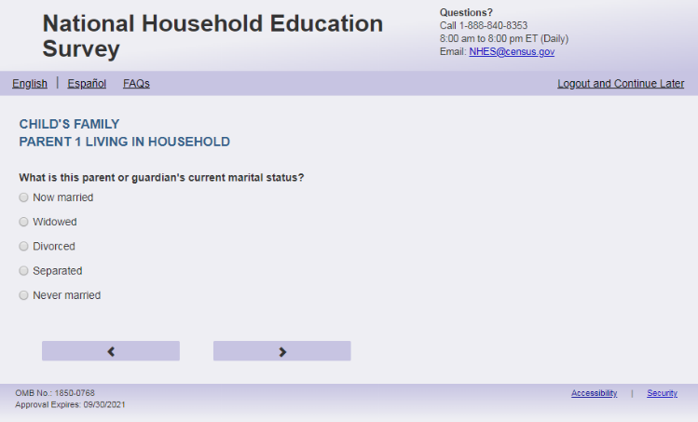
English Respondent Text Reads:
What is [PARENT 1] current marital status?
Spanish Respondent Text Reads:
¿Cuál es el estado civil actual de [PARENT 1]?
English Admin/TQA Text Reads:
What is [PARENT 1] current marital status?
{Please read response options.}
Spanish Admin/TQA Text Reads:
¿Cuál es [su] el estado civil actual de [PARENT 1]?
{Por favor, lea las opciones de respuesta.}

English Answer
1= Now married
2= Widowed
3= Divorced
4= Separated
5= Never married

Spanish Answer
1= Actualmente casado(a)
2= Viudo(a)
3= Divorciado(a)
4= Separado(a)
5=Nunca se casó

PFIC_P1MRSTAR, (1,5), numeric, radio

Skips:
if PFIC_P1MRSTAR = 1 then go to PFIC_P1FRLNG. If PFIC_P1MRSTAR in (2, 3, 4, 5) and PFIC_HHREL1 = 5 or PFIC_P1HHREL2 = 5 then go to PFIC_P1FRLNG. Else go to PFIC_P1BFGF.

Logic Checks/Programming specifications:
English:
If P1Fill = 1 (parent respondent) then PARENT 1 fill is “your”
If PFIC_P1HHREL2 = 1 (mother) is selected then PARENT 1 fill is “ [this child]’s mother’s”
If PFIC_P1HHREL2 = 2 (father) is selected then PARENT 1 fill is “[this child]’s father’s”
If PFIC_P1HHREL2 = 3 (grandmother) is selected then PARENT 1 fill is “[this child]’s grandmother’s”
If PFIC_P1HHREL2 = 4 (grandfather) is selected then PARENT 1 fill is “[this child]’s grandfather’s”
If PFIC_P1HHREL2 = 6 (aunt) is selected then PARENT 1 fill is “[this child]’s aunt’s”
If PFIC_P1HHREL2 = 7 (uncle) is selected then PARENT 1 fill is “ [this child]’s uncle’s”
If PFIC_P1HHREL2 = 8 (sister) is selected then PARENT 1 fill is “ [this child]’s sister’s”
If PFIC_P1HHREL2 = 9 (brother) is selected then PARENT 1 fill is “ [this child]’s brother’s”
If PFIC_P1HHREL2 in (5, 10, blank) (boyfriend/girlfriend/partner or other relationship) is selected then PARENT 1 fill is “ [this child]’s parent or guardian’s”
Spanish:
If P1Fill = 1 (parent respondent) then PARENT 1 fill is “¿Cuál su estado civil actual?”
If PFIC_HHREL2 = 1 (madre) is selected then Parent 1 fill is “¿Cuál es el estado civil actual de la madre de [este niño (esta niña)]?”
If PFIC_HHREL2 = 4 (padre) is selected then Parent 1 fill is “¿Cuál es el estado civil actual del padre de [este niño (esta niña)]”
If PFIC_HHREL2 = 3 (Abuela) is selected then Parent 1 fill is “¿Cuál es el estado civil actual de la abuela de [este niño (esta niña)]”
If PFIC_HHREL2 = 4 (Abuelo) is selected then Parent 1 fill is “¿Cuál es el estado civil actual del abuelo de [este niño (esta niña)]”
If PFIC_HHREL2 = 6 (Tía) is selected then Parent 1 fill is “¿Cuál es el estado civil actual de la tía de [este niño (esta niña)]”
If PFIC_HHREL2 = 7 (Tío) is selected then Parent 1 fill is “¿Cuál es el estado civil actual del tío de [este niño (esta niña)]”
If PFIC_HHREL2 = 8 (Hermana) is selected then Parent 1 fill is “¿Cuál es el estado civil actual de la hermana de [este niño (esta niña)]”
If PFIC_HHREL2 = 9 (Hermano) is selected then Parent 1 fill is “¿Cuál es el estado civil actual del hermano de [este niño (esta niña)]”
If PFIC_HHREL2 in (5, 10, blank) (Novia/Novio o pareja de alguno de los padres o otra relación o parentesco) is selected then Parent 1 fill is “¿Cuál es el estado civil actual del padre, la madre o el tutor(a) legal de [este niño (esta niña)]”

Item: Parent or Guardian Living with Partner (PFIC_P1BFGF)
English Text Reads:
[PARENT 1] currently living with a boyfriend/girlfriend or partner in this household?
Spanish Text Reads:
¿ [PARENT 1] está viviendo actualmente con su pareja o novio(a) en este hogar?
English Answer
1 = Yes
2= No

Spanish Answer
1= Sí
2= No

PFIC_P1BFGF, (1,2), numeric, radio

Skips:
Go to PFIC_P1FRLNG

Logic Checks/Programming specifications:
English:
If P1Fill = 1 (parent respondent) then PARENT 1 fill is “Are you”
If PFIC_P1HHREL2 = 1 (mother) is selected then PARENT 1 fill is “Is [this child]’s mother”
If PFIC_P1HHREL2 = 2 (father) is selected then PARENT 1 fill is “Is [this child]’s father”
If PFIC_P1HHREL2 = 3 (grandmother) is selected then PARENT 1 fill is “Is [this child]’s grandmother”
If PFIC_P1HHREL2 = 4 (grandfather) is selected then PARENT 1 fill is “Is [this child]’s grandfather”
If PFIC_P1HHREL2 = 6 (aunt) is selected then PARENT 1 fill is “Is [this child]’s aunt”
If PFIC_P1HHREL2 = 7 (uncle) is selected then PARENT 1 fill is “Is [this child]’s uncle”
If PFIC_P1HHREL2 = 8 (sister) is selected then PARENT 1 fill is “Is [this child]’s sister”
If PFIC_P1HHREL2 = 9 (brother) is selected then PARENT 1 fill is “Is [this child]’s brother”
If PFIC_P1HHREL2 in (5, 10, blank) (boyfriend/girlfriend/partner or other relationship) is selected then PARENT 1 fill is “Is [this child]’s parent or guardian”
Spanish:
If P1Fill = 1 (parent respondent) then PARENT 1 fill is “usted”
If PFIC_P1HHREL2 = 1 (madre) is selected then Parent 1 fill is “la madre de [este niño (esta niña)]”
If PFIC_P1HHREL2 = 2 (padre) is selected then Parent 1 fill is “el padre de [este niño (esta niña)]”
If PFIC_P1HHREL2 = 3 (Abuela) is selected then Parent 1 fill is “la abuela de [este niño (esta niña)]”
If PFIC_P1HHREL2 = 4 (Abuelo) is selected then Parent 1 fill is “el abuelo de [este niño (esta niña)]”
If PFIC_P1HHREL2 = 6 (Tía) is selected then Parent 1 fill is “la tía de [este niño (esta niña)]”
If PFIC_P1HHREL2 = 7 (Tío) is selected then Parent 1 fill is “el tío de [este niño (esta niña)]”
If PFIC_P1HHREL2 = 8 (Hermana) is selected then Parent 1 fill is “la hermana de [este niño (esta niña)]”
If PFIC_P1HHREL2 = 9 (Hermano) is selected then Parent 1 fill is “el hermano de [este niño (esta niña)]”
If PFIC_P1HHREL2 in (5, 10, blank) (Novia/Novio o pareja de alguno de los padres o otra relación o parentesco) is selected then Parent 1 fill is “el padre, la madre o el tutor(a) legal de [este niño (esta niña)]”

Item: First Language of Parent or Guardian (PFIC_P1FRLNG)
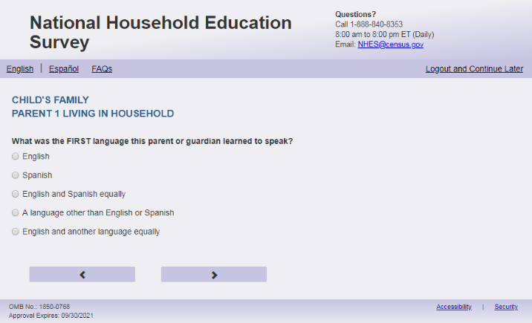
English Respondent Text Reads:
What was the FIRST language [PARENT 1] learned to speak?
Spanish Respondent Text Reads:
¿Cuál fue el PRIMER idioma que [PARENT 1] aprendió a hablar?

English Admin/TQA Text Reads:
What was the FIRST language [PARENT 1] learned to speak?
{Please read response options.}

Spanish Admin/TQA Text Reads:
¿Cuál fue el PRIMER idioma que [PARENT 1] aprendió a hablar?

{Por favor, lea las opciones de respuesta.}

English Answer
1= English
2= Spanish
3= English and Spanish equally
4= A language other than English or Spanish
5= English and another language equally

Spanish Answer
1= Inglés
2= Español
3= Inglés y español por igual
4= Otro idioma aparte del inglés o español
5= Inglés y otro idioma por igual

PFIC_P1FRLNG, (1,5), numeric, radio

Skips:
If PFIC_P1FRLNG=1, go to PFIC_P1PLCBRTH. Else go to PFIC_P1SPEAK.

Logic Checks/Programming specifications:

English:
If P1Fill = 1 (parent respondent) then PARENT 1 fill is “you”
If PFIC_P1HHREL2 = 1 (mother) is selected then PARENT 1 fill is “ [this child]’s mother”
If PFIC_P1HHREL2 = 2 (father) is selected then PARENT 1 fill is “[this child]’s father”
If PFIC_P1HHREL2 = 3 (grandmother) is selected then PARENT 1 fill is “[this child]’s grandmother”
If PFIC_P1HHREL2 = 4 (grandfather) is selected then PARENT 1 fill is “[this child]’s grandfather”
If PFIC_P1HHREL2 = 6 (aunt) is selected then PARENT 1 fill is “[this child]’s aunt”
If PFIC_P1HHREL2 = 7 (uncle) is selected then PARENT 1 fill is “ [this child]’s uncle”
If PFIC_P1HHREL2 = 8 (sister) is selected then PARENT 1 fill is “ [this child]’s sister”
If PFIC_P1HHREL2 = 9 (brother) is selected then PARENT 1 fill is “ [this child]’s brother”
If PFIC_P1HHREL2 in (5, 10, blank) (boyfriend/girlfriend/partner or other relationship) is selected then PARENT 1 fill is “ [this child]’s parent or guardian”
Spanish:
If P1Fill = 1 (parent respondent) then PARENT 1 fill is “usted”
If PFIC_P1HHREL2 = 1 (madre) is selected then Parent 1 fill is “la madre de [este niño (esta niña)]”
If PFIC_P1HHREL2 = 2 (padre) is selected then Parent 1 fill is “el padre de [este niño (esta niña)]”
If PFIC_P1HHREL2 = 3 (Abuela) is selected then Parent 1 fill is “la abuela de [este niño (esta niña)]”
If PFIC_P1HHREL2 = 4 (Abuelo) is selected then Parent 1 fill is “el abuelo de [este niño (esta niña)]”
If PFIC_P1HHREL2 = 6 (Tía) is selected then Parent 1 fill is “la tía de [este niño (esta niña)]”
If PFIC_P1HHREL2 = 7 (Tío) is selected then Parent 1 fill is “el tío de [este niño (esta niña)]”
If PFIC_P1HHREL2 = 8 (Hermana) is selected then Parent 1 fill is “la hermana de [este niño (esta niña)]”
If PFIC_P1HHREL2 = 9 (Hermano) is selected then Parent 1 fill is “el hermano de [este niño (esta niña)]”
If PFIC_P1HHREL2 in (5, 10, blank) (Novia/Novio o pareja de alguno de los padres o otra relación o parentesco) is selected then Parent 1 fill is “el padre, la madre o el tutor(a) legal de [este niño (esta niña)]”

Item: Current Language of Parent or Guardian (PFIC_P1SPEAK)
English Respondent Text Reads:
What language [PARENT 1] speak most at home NOW?
Spanish Respondent Text Reads:
ACTUALMENTE, ¿qué idioma habla [PARENT 1] más en el hogar?

English Admin/TQA Text Reads:
What language [PARENT 1] speak most at home NOW?
{Please read response options.}
Spanish Admin/TQA Text Reads:
ACTUALMENTE, ¿qué idioma habla [PARENT 1] más en el hogar?
{Por favor, lea las opciones de respuesta.}

English Answer
1= English
2= Spanish
3= English and Spanish equally
4=A language other than English or Spanish
5= English and another language equally

Spanish Answer
1= Inglés
2= Español
3= Inglés y español por igual
4= Otro idioma aparte del inglés o español
5= Inglés y otro idioma por igual

PFIC_P1SPEAK, (1,5), numeric, radio

Skips:
if PFIC_P1SPEAK = 1, 3, or 5, then go to PFIC_P1PLCBRTH. Else go to PFIC_P1DIFFI.

Logic Checks/Programming specifications:

English:
If P1Fill = 1 (parent respondent) then PARENT 1 fill is “do you”
If PFIC_P1HHREL2 = 1 (mother) is selected then PARENT 1 fill is “does [this child]’s mother”
If PFIC_P1HHREL2 = 2 (father) is selected then PARENT 1 fill is “does [this child]’s father”
If PFIC_P1HHREL2 = 3 (grandmother) is selected then PARENT 1 fill is “does [this child]’s grandmother”
If PFIC_P1HHREL2 = 4 (grandfather) is selected then PARENT 1 fill is “does [this child]’s grandfather”
If PFIC_P1HHREL2 = 6 (aunt) is selected then PARENT 1 fill is “does [this child]’s aunt”
If PFIC_P1HHREL2 = 7 (uncle) is selected then PARENT 1 fill is “does [this child]’s uncle”
If PFIC_P1HHREL2 = 8 (sister) is selected then PARENT 1 fill is “does [this child]’s sister”
If PFIC_P1HHREL2 = 9 (brother) is selected then PARENT 1 fill is “does [this child]’s brother”
If PFIC_P1HHREL2 in (5, 10, blank) (boyfriend/girlfriend/partner or other relationship) is selected then PARENT 1 fill is “does [this child]’s parent or guardian”
Spanish:
If P1Fill = 1 (parent respondent) then PARENT 1 fill is “usted”
If PFIC_P1HHREL2 = 1 (madre) is selected then Parent 1 fill is “la madre de [este niño (esta niña)]”
If PFIC_P1HHREL2 = 2 (padre) is selected then Parent 1 fill is “el padre de [este niño (esta niña)]”
If PFIC_P1HHREL2 = 3 (Abuela) is selected then Parent 1 fill is “la abuela de [este niño (esta niña)]”
If PFIC_P1HHREL2 = 4 (Abuelo) is selected then Parent 1 fill is “el abuelo de [este niño (esta niña)]”
If PFIC_P1HHREL2 = 6 (Tía) is selected then Parent 1 fill is “la tía de [este niño (esta niña)]”
If PFIC_P1HHREL2 = 7 (Tío) is selected then Parent 1 fill is “el tío de [este niño (esta niña)]”
If PFIC_P1HHREL2 = 8 (Hermana) is selected then Parent 1 fill is “la hermana de [este niño (esta niña)]”
If PFIC_P1HHREL2 = 9 (Hermano) is selected then Parent 1 fill is “el hermano de [este niño (esta niña)]”
If PFIC_P1HHREL2 in (5, 10, blank) (Novia/Novio o pareja de alguno de los padres o otra relación o parentesco) is selected then Parent 1 fill is “el padre, la madre o el tutor(a) legal de [este niño (esta niña)]”

Item: Difficulty Participating in School Activities (PFIC_P1DIFFI)
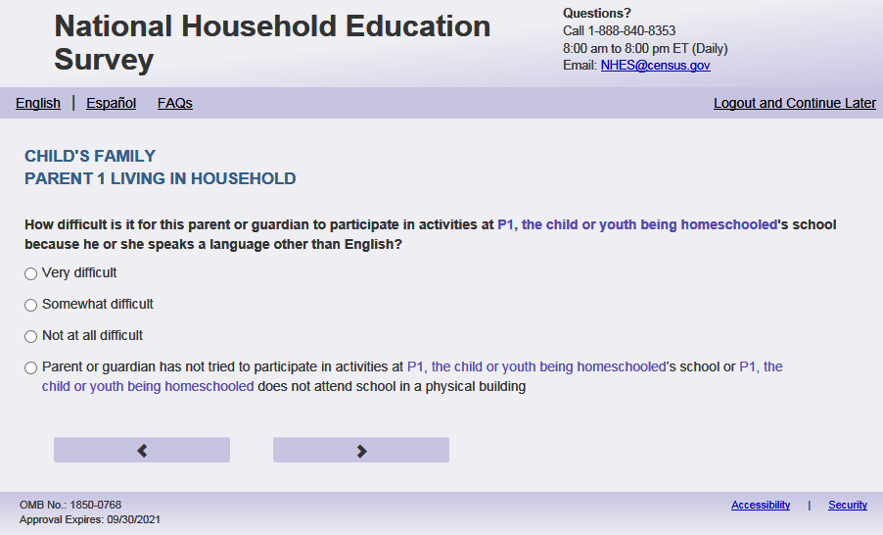
English Respondent Text Reads:
How difficult is it for [PARENT 1] to participate in activities at [this child]’s school because [PARENT 1.2] a language other than English?

Spanish Respondent Text Reads:
¿Qué tan difícil es para [PARENT 1] participar en actividades en la escuela de [este niño (esta niña)] debido a que habla un idioma que no es inglés?

English Admin/TQA Text Reads:
How difficult is it for [PARENT 1] to participate in activities at [this child]’s school because [PARENT 1.2] a language other than English?

{Please read response options.}
Spanish Admin/TQA Text Reads:
¿Qué tan difícil es para [PARENT 1] participar en actividades en la escuela de [este niño (esta niña)] debido a que habla un idioma que no es inglés?

{Por favor, lea las opciones de respuesta.}

English Answer
1= Very difficult
2= Somewhat difficult
3= Not at all difficult
4= [PARENT 1.3] not tried to participate in activities at [this child]’s school or [this child] does not attend school in a physical building

Spanish Answer
1= Muy difícil
2= Un poco difícil
3= Nada difícil
4 = [PARENT 1.3] no ha intentado participar en actividades en la escuela de [este niño (esta niña)] o [este niño (esta niña)] no asiste a una escuela que está en un edificio físico

PFIC_P1DIFFI, (1,4), numeric, radio

Skips:
Go to PFIC_P1SCINT

Logic Checks/Programming specifications:

Increase spacing between response options “Not at all difficult” and “[I have/Parent or guardian has] not tried to participate in activities at [this child]’s school or [this child] does not attend school in a physical building” to be about double the spacing.

English:
If P1Fill = 1 (parent respondent) then PARENT 1 fill is “you”; PARENT 1.2 fill is “you speak”; PARENT 1.3 fill is “I have”
If PFIC_P1HHREL2 = 1 (mother) is selected then PARENT 1 fill is “[this child]’s mother”; PARENT 1.2 fill is “she speaks”; PARENT 1.3 fill is “[this child]’s mother has”
If PFIC_P1HHREL2 = 2 (father) is selected then PARENT 1 fill is “[this child]’s father”; PARENT 1.2 fill is “he speaks”; PARENT 1.3 fill is “[this child]’s father has”
If PFIC_P1HHREL2 = 3 (grandmother) is selected then PARENT 1 fill is “[this child]’s grandmother”; PARENT 1.2 fill is “she speaks”; PARENT 1.3 fill is “[this child]’s grandmother has”
If PFIC_P1HHREL2 = 4 (grandfather) is selected then PARENT 1 fill is “[this child]’s grandfather”; PARENT 1.2 fill is “he speaks”; PARENT 1.3 fill is “[this child]’s grandfather has”
If PFIC_P1HHREL2 = 6 (aunt) is selected then PARENT 1 fill is “[this child]’s aunt”; PARENT 1.2 fill is “she speaks”; PARENT 1.3 fill is “[this child]’s aunt has”
If PFIC_P1HHREL2 = 7 (uncle) is selected then PARENT 1 fill is “[this child]’s uncle”; PARENT 1.2 fill is “he speaks”; PARENT 1.3 fill is “[this child]’s uncle has”
If PFIC_P1HHREL2 = 8 (sister) is selected then PARENT 1 fill is “[this child]’s sister”; PARENT 1.2 fill is “she speaks”; PARENT 1.3 fill is “[this child]’s sister has”
If PFIC_P1HHREL2 = 9 (brother) is selected then PARENT 1 fill is “[this child]’s brother”; PARENT 1.2 fill is “he speaks”; PARENT 1.3 fill is “[this child]’s brother has”
If PFIC_P1HHREL2 = 10 (boyfriend/girlfriend/partner or other relationship) is selected then PARENT 1 fill is “[this child]’s parent or guardian”; PARENT 1.2 fill is if PFIC_P1SEX = 1 then “he speaks”, if PFIC_P1SEX = 2 then “she speaks” else “he or she speaks”; PARENT 1.3 fill is “[this child]’s parent or guardian has”
Spanish:
If P1Fill = 1 (parent respondent) then PARENT 1 fill is “usted”; PARENT 1.3 fill is “Usted”
If PFIC_P1HHREL2 = 1 (madre) is selected then Parent 1 fill is “la madre de [este niño (esta niña)]”; PARENT 1.3 fill is “La madre de [este niño (esta niña)]”
If PFIC_P1HHREL2 = 2 (padre) is selected then Parent 1 fill is “el padre de [este niño (esta niña)]” ; PARENT 1.3 fill is “El padre de [este niño (esta niña)]”
If PFIC_P1HHREL2 = 3 (abuela) is selected then Parent 1 fill is “la abuela de [este niño (esta niña)]” ; PARENT 1.3 fill is “La abuela de [este niño (esta niña)]” If PFIC_P1HHREL2 = 4 (abuelo) is selected then Parent 1 fill is “el abuelo de [este niño (esta niña)]” ; PARENT 1.3 fill is “El abuelo de [este niño (esta niña)]”If PFIC_P1HHREL2 = 6 (Tía) is selected then Parent 1 fill is “la tía de [este niño (esta niña)]” ; PARENT 1.3 fill is “La tía de [este niño (esta niña)]”
If PFIC_P1HHREL2 = 7 (Tío) is selected then Parent 1 fill is “el tío de [este niño (esta niña)]” ; PARENT 1.3 fill is “El tío de [este niño (esta niña)]”
If PFIC_P1HHREL2 = 8 (Hermana) is selected then Parent 1 fill is “la hermana de [este niño (esta niña)]” ; PARENT 1.3 fill is “La hermana de [este niño (esta niña)]”
If PFIC_P1HHREL2 = 9 (Hermano) is selected then Parent 1 fill is “el hermano de [este niño (esta niña)]” ; PARENT 1.3 fill is “El hermano de [este niño (esta niña)]” If PFIC_P1HHREL2 in (5, 10, blank) (Novia/Novio o pareja de alguno de los padres o otra relación o parentesco) is selected then Parent 1 fill is “el padre, la madre o el tutor(a) legal de [este niño (esta niña)]” ; PARENT 1.3 fill is “El padre, la madre o el tutor(a) legal de [este niño (esta niña)]”

Item: School Interpreters (PFIC_P1SCINT)
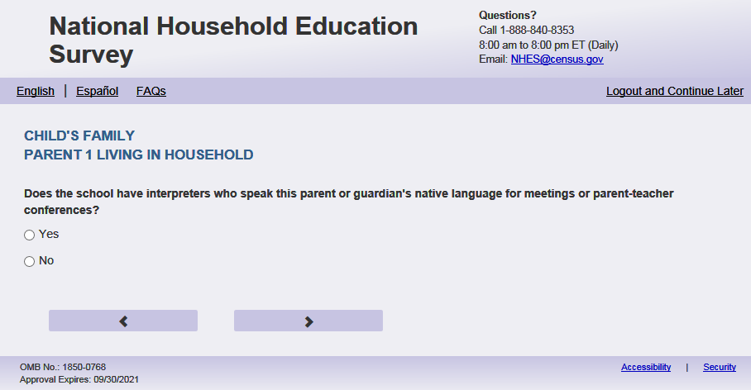
English Text Reads:
Does the school have interpreters who speak [PARENT 1] native language for meetings or parent-teacher conferences?

Spanish Text Reads:
¿Tiene esta escuela intérpretes que hablan [PARENT 1] para reuniones o conferencias entre padres y maestros?

English Answer
1 = Yes
2= No

Spanish Answer
1= Sí
2= No

PFIC_P1SCINT, (1,2), numeric, radio

Skips:
Go to PFIC_P1WRMTL

Logic Checks/Programming specifications:
English:
If P1Fill = 1 (parent respondent) then PARENT 1 fill is “your”
If PFIC_P1HHREL2 = 1 (mother) is selected then PARENT 1 fill is “ [this child]’s mother’s”
If PFIC_P1HHREL2 = 2 (father) is selected then PARENT 1 fill is “[this child]’s father’s”
If PFIC_P1HHREL2 = 3 (grandmother) is selected then PARENT 1 fill is “[this child]’s grandmother’s”
If PFIC_P1HHREL2 = 4 (grandfather) is selected then PARENT 1 fill is “[this child]’s grandfather’s”
If PFIC_P1HHREL2 = 6 (aunt) is selected then PARENT 1 fill is “[this child]’s aunt’s”
If PFIC_P1HHREL2 = 7 (uncle) is selected then PARENT 1 fill is “ [this child]’s uncle’s”
If PFIC_P1HHREL2 = 8 (sister) is selected then PARENT 1 fill is “ [this child]’s sister’s”
If PFIC_P1HHREL2 = 9 (brother) is selected then PARENT 1 fill is “ [this child]’s brother’s”
If PFIC_P1HHREL2 in (5, 10, blank) (boyfriend/girlfriend/partner or other relationship) is selected then PARENT 1 fill is “ [this child]’s parent or guardian’s”
Spanish:
If P1Fill = 1 (parent respondent) then PARENT 1 fill is “su lengua materna”
If PFIC_P1HHREL2 = 1 (madre) is selected then Parent 1 fill is “la lengua materna de la madre de [este niño (esta niña)]”
If PFIC_P1HHREL2 = 2 (padre) is selected then Parent 1 fill is “la lengua materna del padre de [este niño (esta niña)]”
If PFIC_P1HHREL2 = 3 (Abuela) is selected then Parent 1 fill is “la lengua materna de la abuela de [este niño (esta niña)]”
If PFIC_P1HHREL2 = 4 (Abuelo) is selected then Parent 1 fill is “la lengua materna del abuelo de [este niño (esta niña)]”
If PFIC_P1HHREL2 = 6 (Tía) is selected then Parent 1 fill is “la lengua materna de la tía de [este niño (esta niña)]”
If PFIC_P1HHREL2 = 7 (Tío) is selected then Parent 1 fill is “la lengua materna del tío de [este niño (esta niña)]”
If PFIC_P1HHREL2 = 8 (Hermana) is selected then Parent 1 fill is “la lengua materna de la hermana de [este niño (esta niña)]”
If PFIC_P1HHREL2 = 9 (Hermano) is selected then Parent 1 fill is “la lengua materna del hermano de [este niño (esta niña)]”
If PFIC_P1HHREL2 in (5, 10, blank) (Novia/Novio o pareja de alguno de los padres o otra relación o parentesco) is selected then Parent 1 fill is “la lengua materna del padre, la madre o el tutor(a) legal de [este niño (esta niña)]”

Item: School Written Materials (PFIC_P1WRMTL)
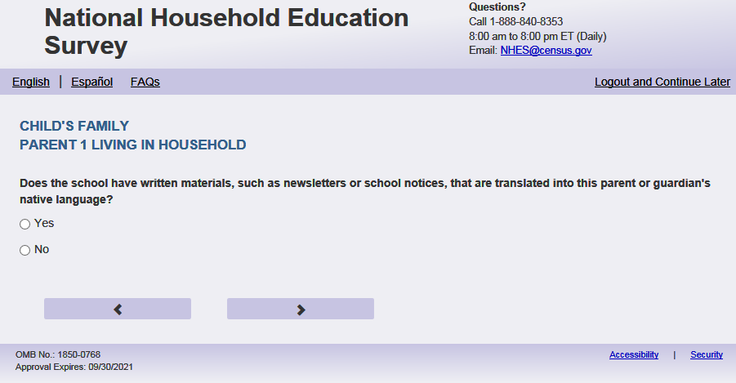
English Text Reads:
Does the school have written materials, such as newsletters or school notices, that are translated into [PARENT 1] native language?

Spanish Text Reads:
¿Tiene esta escuela materiales escritos como boletines informativos o notificaciones escolares traducidos a [PARENT 1]?

English Answer
1 = Yes
2=No

Spanish Answer
1= Sí
2=No

PFIC_P1WRMTL, (1,2), numeric, radio

Skips:
Go to PFIC_P1PLCBRTH

Logic Checks/Programming specifications:

English:
If P1Fill = 1 (parent respondent) then PARENT 1 fill is “your”
If PFIC_P1HHREL2 = 1 (mother) is selected then PARENT 1 fill is “ [this child]’s mother’s”
If PFIC_P1HHREL2 = 2 (father) is selected then PARENT 1 fill is “[this child]’s father’s”
If PFIC_P1HHREL2 = 3 (grandmother) is selected then PARENT 1 fill is “[this child]’s grandmother’s”
If PFIC_P1HHREL2 = 4 (grandfather) is selected then PARENT 1 fill is “[this child]’s grandfather’s”
If PFIC_P1HHREL2 = 6 (aunt) is selected then PARENT 1 fill is “[this child]’s aunt’s”
If PFIC_P1HHREL2 = 7 (uncle) is selected then PARENT 1 fill is “ [this child]’s uncle’s”
If PFIC_P1HHREL2 = 8 (sister) is selected then PARENT 1 fill is “ [this child]’s sister’s”
If PFIC_P1HHREL2 = 9 (brother) is selected then PARENT 1 fill is “ [this child]’s brother’s”
If PFIC_P1HHREL2 in (5, 10, blank) (boyfriend/girlfriend/partner or other relationship) is selected then PARENT 1 fill is “ [this child]’s parent or guardian’s”
Spanish:
If P1Fill = 1 (parent respondent) then PARENT 1 fill is “su lengua materna”
If PFIC_P1HHREL2 = 1 (madre) is selected then Parent 1 fill is “la lengua materna de la madre de [este niño (esta niña)]”
If PFIC_P1HHREL2 = 2 (padre) is selected then Parent 1 fill is “la lengua materna del padre de [este niño (esta niña)]”
If PFIC_P1HHREL2 = 3 (Abuela) is selected then Parent 1 fill is “la lengua materna de la abuela de [este niño (esta niña)]”
If PFIC_P1HHREL2 = 4 (Abuelo) is selected then Parent 1 fill is “la lengua materna del abuelo de [este niño (esta niña)]”
If PFIC_P1HHREL2 = 6 (Tía) is selected then Parent 1 fill is “la lengua materna de la tía de [este niño (esta niña)]”
If PFIC_P1HHREL2 = 7 (Tío) is selected then Parent 1 fill is “la lengua materna del tío de [este niño (esta niña)]”
If PFIC_P1HHREL2 = 8 (Hermana) is selected then Parent 1 fill is “la lengua materna de la hermana de [este niño (esta niña)]”
If PFIC_P1HHREL2 = 9 (Hermano) is selected then Parent 1 fill is “la lengua materna del hermano de [este niño (esta niña)]”
If PFIC_P1HHREL2 in (5, 10, blank) (Novia/Novio o pareja de alguno de los padres o otra relación o parentesco) is selected then Parent 1 fill is “la lengua materna del padre, la madre o el tutor(a) legal de [este niño (esta niña)]”

Item: Parent or Guardian Place of Birth (PFIC_P1PLCBRTH)
English Text Reads:
Where [PARENT 1] born?
Spanish Text Reads:
¿Dónde nació [PARENT 1]?

English Answer
1= One of the 50 United States or the District of Columbia
2= One of the U.S. territories (Puerto Rico, Guam, American Samoa, U.S. Virgin Islands, or Mariana Islands)
3= Another country

Spanish Answer
1= Uno de los 50 estados de los Estados Unidos o el Distrito de Columbia
2= Uno de los territorios incorporados de los Estados Unidos (Puerto Rico, Guam, Samoa Americana, Islas Vírgenes de los Estados Unidos o Islas Marianas del Norte)
3= Otro país

PFIC_P1PLCBRTH, (1,3), numeric, radio

Skips:
if PFIC_P1PLCBRTH = 1 or blank then go to PFIC_P1HISPANX else go to PFIC_P1AGEMV.

Logic Checks/Programming specifications:
English:
If P1Fill = 1 (parent respondent) then PARENT 1 fill is “were you”
If PFIC_P1HHREL2 = 1 (mother) is selected then PARENT 1 fill is “was [this child]’s mother”
If PFIC_P1HHREL2 = 2 (father) is selected then PARENT 1 fill is “was [this child]’s father”
If PFIC_P1HHREL2 = 3 (grandmother) is selected then PARENT 1 fill is “was [this child]’s grandmother”
If PFIC_P1HHREL2 = 4 (grandfather) is selected then PARENT 1 fill is “was [this child]’s grandfather”
If PFIC_P1HHREL2 = 6 (aunt) is selected then PARENT 1 fill is “was [this child]’s aunt”
If PFIC_P1HHREL2 = 7 (uncle) is selected then PARENT 1 fill is “was [this child]’s uncle”
If PFIC_P1HHREL2 = 8 (sister) is selected then PARENT 1 fill is “was [this child]’s sister”
If PFIC_P1HHREL2 = 9 (brother) is selected then PARENT 1 fill is “was [this child]’s brother”
If PFIC_P1HHREL2 in (5, 10, blank) (boyfriend/girlfriend/partner or other relationship) is selected then PARENT 1 fill is “was [this child]’s parent or guardian”
Spanish:
If P1Fill = 1 (parent respondent) then PARENT 1 fill is “usted”
If PFIC_P1HHREL2 = 1 (madre) is selected then Parent 1 fill is “la madre de [este niño (esta niña)]”
If PFIC_P1HHREL2 = 2 (padre) is selected then Parent 1 fill is “el padre de [este niño (esta niña)]”
If PFIC_P1HHREL2 = 3 (Abuela) is selected then Parent 1 fill is “la abuela de [este niño (esta niña)]”
If PFIC_P1HHREL2 = 4 (Abuelo) is selected then Parent 1 fill is “el abuelo de [este niño (esta niña)]”
If PFIC_P1HHREL2 = 6 (Tía) is selected then Parent 1 fill is “la tía de [este niño (esta niña)]”
If PFIC_P1HHREL2 = 7 (Tío) is selected then Parent 1 fill is “el tío de [este niño (esta niña)]”
If PFIC_P1HHREL2 = 8 (Hermana) is selected then Parent 1 fill is “la hermana de [este niño (esta niña)]”
If PFIC_P1HHREL2 = 9 (Hermano) is selected then Parent 1 fill is “el hermano de [este niño (esta niña)]”
If PFIC_P1HHREL2 in (5, 10, blank) (Novia/Novio o pareja de alguno de los padres o otra relación o parentesco) is selected then Parent 1 fill is “el padre, la madre o el tutor(a) legal de [este niño (esta niña)]”

Item: Parent or Guardian Age when moved to U.S. (PFIC_P1AGEMV)
English Text Reads:
How old [PARENT 1] when [PARENT 1.2] first moved to the 50 United States or the District of Columbia?
If younger than 1, enter ‘0’.
Spanish Text Reads:
¿Qué edad tenía [PARENT 1] cuando se mudó por primera vez a uno de los 50 estados de los Estados Unidos o al Distrito de Columbia?
Si fue menor de 1 año, por favor ingrese ‘0’.

PFIC_P1AGEMV, (0,99), numeric, write-in

Skips:
Go to PFIC_P1HISPANX

Logic Checks/Programming specifications:
English
display “years old” to the right of box.
Spanish
display “años” to the right of box.

Mobile: Display numeric keypad

English:
If P1Fill = 1 (parent respondent) then PARENT 1 fill is “were you”; PARENT 1.2 fill is “you”
If PFIC_P1HHREL2 = 1 (mother) is selected then PARENT 1 fill is “was [this child]’s mother”; PARENT 1.2 fill is “she”
If PFIC_P1HHREL2 = 2 (father) is selected then PARENT 1 fill is “was [this child]’s father”; PARENT 1.2 fill is “he”
If PFIC_P1HHREL2 = 3 (grandmother) is selected then PARENT 1 fill is “was [this child]’s grandmother”; PARENT 1.2 fill is “she”
If PFIC_P1HHREL2 = 4 (grandfather) is selected then PARENT 1 fill is “was [this child]’s grandfather”; PARENT 1.2 fill is “he”
If PFIC_P1HHREL2 = 6 (aunt) is selected then PARENT 1 fill is “was [this child]’s aunt”; PARENT 1.2 fill is “she”
If PFIC_P1HHREL2 = 7 (uncle) is selected then PARENT 1 fill is “was [this child]’s uncle”; PARENT 1.2 fill is “he”
If PFIC_P1HHREL2 = 8 (sister) is selected then PARENT 1 fill is “was [this child]’s sister”; PARENT 1.2 fill is “she”
If PFIC_P1HHREL2 = 9 (brother) is selected then PARENT 1 fill is “was [this child]’s brother”; PARENT 1.2 fill is “he”
If PFIC_P1HHREL2 in (5, 10, blank) (boyfriend/girlfriend/partner or other relationship) is selected then PARENT 1 fill is “was [this child]’s parent or guardian”; PARENT 1.2 fill is “he” if PFIC_P1SEX = 1, “she” if PFIC_P1SEX = 2, else “he or she”
Spanish:
If P1Fill = 1 (parent respondent) then PARENT 1 fill is “usted”
If PFIC_P1HHREL2 = 1 (madre) is selected then Parent 1 fill is “la madre de [este niño (esta niña)]”
If PFIC_P1HHREL2 = 2 (padre) is selected then Parent 1 fill is “el padre de [este niño (esta niña)]”
If PFIC_P1HHREL2 = 3 (Abuela) is selected then Parent 1 fill is “la abuela de [este niño (esta niña)]”
If PFIC_P1HHREL2 = 4 (Abuelo) is selected then Parent 1 fill is “el abuelo de [este niño (esta niña)]”
If PFIC_P1HHREL2 = 6 (Tía) is selected then Parent 1 fill is “la tía de [este niño (esta niña)]”
If PFIC_P1HHREL2 = 7 (Tío) is selected then Parent 1 fill is “el tío de [este niño (esta niña)]”
If PFIC_P1HHREL2 = 8 (Hermana) is selected then Parent 1 fill is “la hermana de [este niño (esta niña)]”
If PFIC_P1HHREL2 = 9 (Hermano) is selected then Parent 1 fill is “el hermano de [este niño (esta niña)]”
If PFIC_P1HHREL2 in (5, 10, blank) (Novia/Novio o pareja de alguno de los padres o otra relación o parentesco) is selected then Parent 1 fill is “el padre, la madre o el tutor(a) legal de [este niño (esta niña)]”

Item: Parent or Guardian Hispanic Origin (PFIC_P1HISPANX)
English Respondent Text Reads:
[PARENT 1] of Hispanic, Latino, or Spanish origin?
Spanish Respondent Text Reads:
¿Es [PARENT 1] de origen hispano, latino o español?

English Admin/TQA Text Reads:
{Please be sure to ask BOTH this question and the following race question, and record the respondent’s answer}
[PARENT 1] of Hispanic, Latino, or Spanish origin?
{If ‘yes,’ read yes answer options to the respondent.}
Spanish Admin/TQA Text Reads:
{Please be sure to ask BOTH this question and the following race question, and record the respondent’s answer}
¿Es [PARENT 1] de origen hispano, latino o español?

{Si 'sí', lea sí opciones de respuesta al encuestado.}
English Answer
1 = No, not of Hispanic, Latino, or Spanish origin
2 = Yes, Mexican, Mexican American, Chicano
3 = Yes, Puerto Rican
4 = Yes, Cuban
5 = Yes, another Hispanic, Latino, or Spanish origin; or more than one Hispanic, Latino, or Spanish origin

Spanish Answer
1 = No, no es de origen hispano, latino, o español
2 = Sí, Mexicano, Mexicano Americano, Chicano
3 = Sí, Puertorriqueño
4 = Sí, Cubano
5 = Sí, es de otro origen hispano, latino, o español; o de más de un origen hispano, latino o español

PFIC_P1HISPANX, (1,5), numeric, radio
Skips:
Go to PFIC_P1AMIND
Logic Checks/Programming specifications:

English:
If P1Fill = 1 (parent respondent) then PARENT 1 fill is “Are you”
If PFIC_P1HHREL2 = 1 (mother) is selected then PARENT 1 fill is “Is this [this child]’s mother”
If PFIC_P1HHREL2 = 2 (father) is selected then PARENT 1 fill is “Is this [this child]’s father”
If PFIC_P1HHREL2 = 3 (grandmother) is selected then PARENT 1 fill is “Is this [this child]’s grandmother”
If PFIC_P1HHREL2 = 4 (grandfather) is selected then PARENT 1 fill is “Is this [this child]’s grandfather”
If PFIC_P1HHREL2 = 6 (aunt) is selected then PARENT 1 fill is “Is this [this child]’s aunt”
If PFIC_P1HHREL2 = 7 (uncle) is selected then PARENT 1 fill is “Is this [this child]’s uncle”
If PFIC_P1HHREL2 = 8 (sister) is selected then PARENT 1 fill is “Is this [this child]’s sister”
If PFIC_P1HHREL2 = 9 (brother) is selected then PARENT 1 fill is “Is this [this child]’s brother”
If PFIC_P1HHREL2 in (5, 10, blank) (boyfriend/girlfriend/partner or other relationship) is selected then PARENT 1 fill is “Is this [this child]’s parent or guardian”
Spanish:
If P1Fill = 1 (parent respondent) then PARENT 1 fill is “usted”
If PFIC_P1HHREL2 = 1 (madre) is selected then Parent 1 fill is “la madre de [este niño (esta niña)]”
If PFIC_P1HHREL2 = 2 (padre) is selected then Parent 1 fill is “el padre de [este niño (esta niña)]”
If PFIC_P1HHREL2 = 3 (Abuela) is selected then Parent 1 fill is “la abuela de [este niño (esta niña)]”
If PFIC_P1HHREL2 = 4 (Abuelo) is selected then Parent 1 fill is “el abuelo de [este niño (esta niña)]”
If PFIC_P1HHREL2 = 6 (Tía) is selected then Parent 1 fill is “la tía de [este niño (esta niña)]”
If PFIC_P1HHREL2 = 7 (Tío) is selected then Parent 1 fill is “el tío de [este niño (esta niña)]”
If PFIC_P1HHREL2 = 8 (Hermana) is selected then Parent 1 fill is “la hermana de [este niño (esta niña)]”
If PFIC_P1HHREL2 = 9 (Hermano) is selected then Parent 1 fill is “el hermano de [este niño (esta niña)]”
If PFIC_P1HHREL2 in (5, 10, blank) (Novia/Novio o pareja de alguno de los padres o otra relación o parentesco) is selected then Parent 1 fill is “el padre, la madre o el tutor(a) legal de [este niño (esta niña)]”

Item: Parent or Guardian Race (PFIC_P1AMIND)
English Respondent Text Reads:
What is [PARENT 1] race? You may select one or more races.

Spanish Respondent Text Reads:
¿Cuál es [[PARENT 1]? Puede seleccionar una raza o más de una raza.

English Admin/TQA Text Reads:
What is [PARENT 1] race
{You may select one or more races.}
{If the respondent answered yes to the previous item (Hispanic ethnicity) and does not identify with any other race, leave this item blank.}
Spanish Admin/TQA Text Reads:
¿Cuál es [PARENT 1]?
{Puede seleccionar una o más razas.}
{Si el encuestado respondió sí a la pregunta anterior (etnia hispana) y no se identifica con ninguna otra raza, deje esta pregunta en blanco.}
English Answer:
American Indian or Alaska Native, PFIC_P1AMIND, (1 = Item Marked; 2=Not marked), numeric, checkbox
Asian, PFIC_P1ASIAN, (1 = Item Marked; 2=Not marked), numeric, checkbox
Black or African American, PFIC_P1BLACK, (1 = Item Marked; 2=Not marked), numeric, checkbox
Native Hawaiian or other Pacific Islander, PFIC_P1PACI, (1 = Item Marked; 2=Not marked), numeric, checkbox
White, PFIC_P1WHITE, , (1 = Item Marked; 2=Not marked), numeric, checkbox

Spanish Answer:
Indígena de las Américas o nativa de Alaska, PFIC_P1AMIND, (1 = Item Marked; 2=Not marked), numeric, checkbox
Asiática, PFIC_P1ASIAN, (1 = Item Marked; 2=Not marked), numeric, checkbox
Negra o afroamericana, PFIC_P1BLACK, (1 = Item Marked; 2=Not marked), numeric, checkbox
Nativa de Hawái u otra de las islas del Pacífico, PFIC_P1PACI, (1 = Item Marked; 2=Not marked), numeric, checkbox
Blanca, PFIC_P1WHITE, (1 = Item Marked; 2=Not marked), numeric, checkbox

Skips:
Go to PFIC_P1EDUC
Logic Checks/Programming specifications:
This is a mark all that apply item

English:
If P1Fill = 1 (parent respondent) then PARENT 1 fill is “your”
If PFIC_P1HHREL2 = 1 (mother) is selected then PARENT 1 fill is “[this child]’s mother’s”
If PFIC_P1HHREL2 = 2 (father) is selected then PARENT 1 fill is “[this child]’s father’s”
If PFIC_P1HHREL2 = 3 (grandmother) is selected then PARENT 1 fill is “[this child]’s grandmother’s”
If PFIC_P1HHREL2 = 4 (grandfather) is selected then PARENT 1 fill is “[this child]’s grandfather’s”
If PFIC_P1HHREL2 = 6 (aunt) is selected then PARENT 1 fill is “[this child]’s aunt’s”
If PFIC_P1HHREL2 = 7 (uncle) is selected then PARENT 1 fill is “[this child]’s uncle’s”
If PFIC_P1HHREL2 = 8 (sister) is selected then PARENT 1 fill is “[this child]’s sister’s”
If PFIC_P1HHREL2 = 9 (brother) is selected then PARENT 1 fill is “[this child]’s brother’s”
If PFIC_P1HHREL2 in (5, 10, blank) (boyfriend/girlfriend/partner or other relationship) is selected then PARENT 1 fill is “[this child]’s parent or guardian’s”
Spanish:
If P1Fill = 1 (parent respondent) then PARENT 1 fill is “su raza”
If PFIC_P1HHREL2 = 1 (madre) is selected then Parent 1 fill is “la raza de la madre de [este niño (esta niña)]”
If PFIC_P1HHREL2 = 2 (padre) is selected then Parent 1 fill is “la raza del padre de [este niño (esta niña)]”
If PFIC_P1HHREL2 = 3 (Abuela) is selected then Parent 1 fill is “la raza de la abuela de [este niño (esta niña)]”
If PFIC_P1HHREL2 = 4 (Abuelo) is selected then Parent 1 fill is “la raza del abuelo de [este niño (esta niña)]”
If PFIC_P1HHREL2 = 6 (Tía) is selected then Parent 1 fill is “la raza de la tía de [este niño (esta niña)]”
If PFIC_P1HHREL2 = 7 (Tío) is selected then Parent 1 fill is “la raza del tío de [este niño (esta niña)]”
If PFIC_P1HHREL2 = 8 (Hermana) is selected then Parent 1 fill is “la raza de la hermana de [este niño (esta niña)]”
If PFIC_P1HHREL2 = 9 (Hermano) is selected then Parent 1 fill is “la raza del hermano de [este niño (esta niña)]”
If PFIC_P1HHREL2 in (5, 10, blank) (Novia/Novio o pareja de alguno de los padres o otra relación o parentesco) is selected then Parent 1 fill is “la raza del padre, la madre o el tutor(a) legal de [este niño (esta niña)]”

Item: Parent or Guardian Highest Level of Education (PFIC_P1EDUC)
English Respondent Text Reads:
What is the highest grade or level of school that [PARENT 1] completed?
Spanish Respondent Text Reads:
¿Cuál es el grado o nivel más alto de estudios que [PARENT 1] ha completado?

English Admin/TQA Text Reads:
What is the highest grade or level of school that [PARENT 1] completed?
{Please read response options.}
Spanish Admin/TQA Text Reads:
¿Cuál es el grado o nivel más alto de estudios que [PARENT 1] completó?

{Por favor, lea las opciones de respuesta.}

English Answer
1= 8th grade or less
2= High school, but no diploma
3= High school diploma or equivalent (GED)
4= Vocational diploma after high school
5= Some college, but no degree
6= Associate’s degree (AA, AS)
7= Bachelor’s degree (BA, BS)
8= Some graduate or professional education, but no degree
9= Master’s degree (MA, MS)
10= Doctorate degree (PhD, EdD)
11= Professional degree beyond bachelor’s degree (MD, DDS, JD, LLB)

Spanish Answer
1= 8° grado o menos
2= High school (grado 9 al 12), pero sin obtener el diploma
3= Diploma de high school o equivalencia (GED) 4= Diploma vocacional o de oficios posterior a high school
5= Algunos cursos de college o universidad, pero sin graduarse
6= Licenciatura o grado asociado (AA, AS)
7= Licenciatura o grado de bachelor (BA, BS)
8= Algo de educación profesional o graduada, pero sin título
9= Título de maestría (MA, MS)
10= Título de doctorado (PhD, EdD)
11= Título profesional posterior al grado de bachelor (médico, dentista, doctor en leyes)
PFIC_P1EDUC, (1,11), numeric, radio

Skips:

Go to PFIC_P1ENRL
Logic Checks/Programming specifications:

Fills:
English:
If P1Fill = 1 (parent respondent) then PARENT 1 fill is “you”
If PFIC_P1HHREL2 = 1 (mother) is selected then PARENT 1 fill is “[this child]’s mother”
If PFIC_P1HHREL2 = 2 (father) is selected then PARENT 1 fill is “[this child]’s father”
If PFIC_P1HHREL2 = 3 (grandmother) is selected then PARENT 1 fill is “[this child]’s grandmother”
If PFIC_P1HHREL2 = 4 (grandfather) is selected then PARENT 1 fill is “[this child]’s grandfather”
If PFIC_P1HHREL2 = 6 (aunt) is selected then PARENT 1 fill is “[this child]’s aunt”
If PFIC_P1HHREL2 = 7 (uncle) is selected then PARENT 1 fill is “[this child]’s uncle”
If PFIC_P1HHREL2 = 8 (sister) is selected then PARENT 1 fill is “[this child]’s sister”
If PFIC_P1HHREL2 = 9 (brother) is selected then PARENT 1 fill is “[this child]’s brother”
If PFIC_P1HHREL2 in (5, 10, blank) (boyfriend/girlfriend/partner or other relationship) is selected then PARENT 1 fill is “[this child]’s parent or guardian”
Spanish:
If P1Fill = 1 (parent respondent) then PARENT 1 fill is “usted”
If PFIC_P1HHREL2 = 1 (madre) is selected then Parent 1 fill is “la madre de [este niño (esta niña)]”
If PFIC_P1HHREL2 = 2 (padre) is selected then Parent 1 fill is “el padre de [este niño (esta niña)]”
If PFIC_P1HHREL2 = 3 (Abuela) is selected then Parent 1 fill is “la abuela de [este niño (esta niña)]”
If PFIC_P1HHREL2 = 4 (Abuelo) is selected then Parent 1 fill is “el abuelo de [este niño (esta niña)]”
If PFIC_P1HHREL2 = 6 (Tía) is selected then Parent 1 fill is “la tía de [este niño (esta niña)]”
If PFIC_P1HHREL2 = 7 (Tío) is selected then Parent 1 fill is “el tío de [este niño (esta niña)]”
If PFIC_P1HHREL2 = 8 (Hermana) is selected then Parent 1 fill is “la hermana de [este niño (esta niña)]”
If PFIC_P1HHREL2 = 9 (Hermano) is selected then Parent 1 fill is “el hermano de [este niño (esta niña)]”
If PFIC_P1HHREL2 in (5, 10, blank) (Novia/Novio o pareja de alguno de los padres o otra relación o parentesco) is selected then Parent 1 fill is “el padre, la madre o el tutor(a) legal de [este niño (esta niña)]”

Item: Parent or Guardian Currently Enrolled in Postsecondary Education (PFIC_P1ENRL)
English Text Reads:
[PARENT 1] currently attending or enrolled in a school, college, university, or adult learning center, or receiving vocational education or job training?
Spanish Text Reads:
Actualmente, ¿asiste [PARENT 1] a una escuela, universidad o centro de educación para adultos o recibe educación vocacional o capacitación laboral?
English
1 = Yes
2=No

Spanish
1= Sí
2=No

PFIC_P1ENRL, (1,2), numeric, radio

Skips:
Go to PFIC_P1EMPL

Logic Checks/Programming specifications:

Fills:
English:
If P1Fill = 1 (parent respondent) then PARENT 1 fill is “Are you”
If PFIC_P1HHREL2 = 1 (mother); 3 (grandmother); 6 (aunt); 8 (sister) is selected then PARENT 1 fill is “Is she”
If PFIC_P1HHREL2 = 2 (father); 4 (grandfather); 7 (uncle); 9 (brother) is selected then PARENT 1 fill is “Is he”
If PFIC_P1HHREL2 = 10 (boyfriend/girlfriend/partner or other relationship) is selected then PARENT 1 fill is if PFIC_P1SEX = 1 then “Is he”, if PFIC_P1SEX = 2 then “Is she” else “Is he or she"
Spanish:
If P1Fill = 1 (parent respondent) then PARENT 1 fill is “usted”
If PFIC_P1HHREL2 = 1 (madre) is selected then Parent 1 fill is “la madre de [este niño (esta niña)]”
If PFIC_P1HHREL2 = 2 (padre) is selected then Parent 1 fill is “el padre de [este niño (esta niña)]”
If PFIC_P1HHREL2 = 3 (Abuela) is selected then Parent 1 fill is “la abuela de [este niño (esta niña)]”
If PFIC_P1HHREL2 = 4 (Abuelo) is selected then Parent 1 fill is “el abuelo de [este niño (esta niña)]”
If PFIC_P1HHREL2 = 6 (Tía) is selected then Parent 1 fill is “la tía de [este niño (esta niña)]”
If PFIC_P1HHREL2 = 7 (Tío) is selected then Parent 1 fill is “el tío de [este niño (esta niña)]”
If PFIC_P1HHREL2 = 8 (Hermana) is selected then Parent 1 fill is “la hermana de [este niño (esta niña)]”
If PFIC_P1HHREL2 = 9 (Hermano) is selected then Parent 1 fill is “el hermano de [este niño (esta niña)]”
If PFIC_P1HHREL2 in (5, 10, blank) (Novia/Novio o pareja de alguno de los padres u otra relación o parentesco) is selected then Parent 1 fill is “el padre, la madre o el tutor(a) legal de [este niño (esta niña)]”

Item: Parent or Guardian Employment Status (PFIC_P1EMPL)
English Text Reads:
Which of the following BEST describes [PARENT 1]’s employment status?
Spanish Text Reads:
¿Cuál de las siguientes categorías describe MEJOR[PARENT 1]?
English Admin/TQA Text Reads:

Which of the following BEST describes [PARENT 1] employment status?
{Please read response options.}
Spanish Admin/TQA Text Reads:

¿Cuál de las siguientes categorías describe MEJOR la situación de trabajo de [PARENT 1]?
{Por favor, lea las opciones de respuesta.}

English Answer
1= Employed for pay or income
2= Self-employed
3= Unemployed or out of work
4= Full-time student
5= Stay-at-home parent
6= Retired
7= Disabled or unable to work

Spanish Answer
1= Empleado(a) por pagos o ingresos
2= Trabaja por su propia cuenta
3= Desempleado(a) o sin trabajo
4= Estudiante de tiempo completo
5= Se dedica al hogar y al cuidado de los niños
6= Jubilado(a)
7= Discapacitado(a) o no puede trabajar

PFIC_P1EMPL, (1,7), numeric, radio

Skips:
if PFIC_P1EMPL = 3 then go to PFIC_P1LKWRK
if PFIC_P1EMPL in (4, 5, 6, 7) then go to PFIC_P1MTHSWRK
Else if P1EMPL in (1,2) or blank, then go to PFIC_P1HRSWK

Logic Checks/Programming specifications:

Fills:
English:
If P1Fill = 1 (parent respondent) then PARENT 1 fill is “your”
If PFIC_P1HHREL2 = 1 (mother) is selected then PARENT 1 fill is “[this child]’s mother”
If PFIC_P1HHREL2 = 2 (father) is selected then PARENT 1 fill is “[this child]’s father”
If PFIC_P1HHREL2 = 3 (grandmother) is selected then PARENT 1 fill is “[this child]’s grandmother”
If PFIC_P1HHREL2 = 4 (grandfather) is selected then PARENT 1 fill is “[this child]’s grandfather”
If PFIC_P1HHREL2 = 6 (aunt) is selected then PARENT 1 fill is “[this child]’s aunt”
If PFIC_P1HHREL2 = 7 (uncle) is selected then PARENT 1 fill is “[this child]’s uncle”
If PFIC_P1HHREL2 = 8 (sister) is selected then PARENT 1 fill is “[this child]’s sister”
If PFIC_P1HHREL2 = 9 (brother) is selected then PARENT 1 fill is “[this child]’s brother”
If PFIC_P1HHREL2 in (5, 10, blank) (boyfriend/girlfriend/partner or other relationship) is selected then PARENT 1 fill is “[this child]’s parent or guardian”
Spanish:
If P1Fill = 1 (parent respondent) then PARENT 1 fill is “su situación de trabajo”
If PFIC_P1HHREL2 = 1 (madre) is selected then Parent 1 fill is “la situación de trabajo de la madre de [este niño (esta niña)]”
If PFIC_P1HHREL2 = 2 (padre) is selected then Parent 1 fill is “la situación de trabajo del padre de [este niño (esta niña)]”
If PFIC_P1HHREL2 = 3 (Abuela) is selected then Parent 1 fill is “la situación de trabajo de la abuela de [este niño (esta niña)]”
If PFIC_P1HHREL2 = 4 (Abuelo) is selected then Parent 1 fill is “la situación de trabajo del abuelo de [este niño (esta niña)]”
If PFIC_P1HHREL2 = 6 (Tía) is selected then Parent 1 fill is “la situación de trabajo de la tía de [este niño (esta niña)]”
If PFIC_P1HHREL2 = 7 (Tío) is selected then Parent 1 fill is “la situación de trabajo del tío de [este niño (esta niña)]”
If PFIC_P1HHREL2 = 8 (Hermana) is selected then Parent 1 fill is “la situación de trabajo de la hermana de [este niño (esta niña)]”
If PFIC_P1HHREL2 = 9 (Hermano) is selected then Parent 1 fill is “la situación de trabajo del hermano de [este niño (esta niña)]”
If PFIC_P1HHREL2 in (5, 10, blank) (Novia/Novio o pareja de alguno de los padres o otra relación o parentesco) is selected then Parent 1 fill is “la situación de trabajo del padre, la madre o el tutor(a) legal de [este niño (esta niña)]”

Item: Parent or Guardian Hours Worked Weekly (PFIC_P1HRSWK)

English Text Reads:
About how many hours PER WEEK [PARENT 1] USUALLY work for pay or income, counting all jobs?

Spanish Text Reads:
¿Más o menos cuántas horas POR SEMANA trabaja [PARENT 1] NORMALMENTE por pagos o ingresos, contando todos los trabajos?

English and Spanish Answer:

PFIC_P1HRSWK, (0,99), numeric, write-in

Skips:

Go to PFIC_P1MTHSWRK

Logic Checks/Programming specifications:

English
display “hours per week “ to the right the box.

Spanish
display “horas a la semana” to the right of the box.

Mobile: Display numeric keypad
Fills:
English:
If P1Fill = 1 (parent respondent) then PARENT 1 fill is “do you”
If PFIC_P1HHREL2 = 1 (mother) is selected then PARENT 1 fill is “does [this child]’s mother”
If PFIC_P1HHREL2 = 2 (father) is selected then PARENT 1 fill is “does [this child]’s father”
If PFIC_P1HHREL2 = 3 (grandmother) is selected then PARENT 1 fill is “does [this child]’s grandmother”
If PFIC_P1HHREL2 = 4 (grandfather) is selected then PARENT 1 fill is “does [this child]’s grandfather”
If PFIC_P1HHREL2 = 6 (aunt) is selected then PARENT 1 fill is “does [this child]’s aunt”
If PFIC_P1HHREL2 = 7 (uncle) is selected then PARENT 1 fill is “does [this child]’s uncle”
If PFIC_P1HHREL2 = 8 (sister) is selected then PARENT 1 fill is “does [this child]’s sister”
If PFIC_P1HHREL2 = 9 (brother) is selected then PARENT 1 fill is “does [this child]’s brother”
If PFIC_P1HHREL2 in (5, 10, blank) (boyfriend/girlfriend/partner or other relationship) is selected then PARENT 1 fill is “does [this child]’s parent or guardian”
Spanish:
If P1Fill = 1 (parent respondent) then PARENT 1 fill is “usted”
If PFIC_P1HHREL2 = 1 (madre) is selected then Parent 1 fill is “la madre de [este niño (esta niña)]”
If PFIC_P1HHREL2 = 2 (padre) is selected then Parent 1 fill is “el padre de [este niño (esta niña)]”
If PFIC_P1HHREL2 = 3 (Abuela) is selected then Parent 1 fill is “la abuela de [este niño (esta niña)]”
If PFIC_P1HHREL2 = 4 (Abuelo) is selected then Parent 1 fill is “el abuelo de [este niño (esta niña)]”
If PFIC_P1HHREL2 = 6 (Tía) is selected then Parent 1 fill is “la tía de [este niño (esta niña)]”
If PFIC_P1HHREL2 = 7 (Tío) is selected then Parent 1 fill is “el tío de [este niño (esta niña)]”
If PFIC_P1HHREL2 = 8 (Hermana) is selected then Parent 1 fill is “la hermana de [este niño (esta niña)]”
If PFIC_P1HHREL2 = 9 (Hermano) is selected then Parent 1 fill is “el hermano de [este niño (esta niña)]”
If PFIC_P1HHREL2 in (5, 10, blank) (Novia/Novio o pareja de alguno de los padres o otra relación o parentesco) is selected then Parent 1 fill is “el padre, la madre o el tutor(a) legal de [este niño (esta niña)]”
Text Displayed for logic/range check violation:
Logic/range check triggers a warning message, with the following text displayed.
English
[If 0] Display “Please check your answer before continuing. Typically, adults work between one and 99 hours per week.”
Spanish
[If 0] Display “Por favor, compruebe su respuesta antes de continuar. Por lo general, los adultos trabajan entre una y 99 horas por semana.”.

Item: Hours Parent or Guardian Worked past 4 Weeks (PFIC_P1LKWRK)
English Text Reads:
[PARENT 1] been ACTIVELY looking for work IN THE PAST 4 WEEKS?

Spanish Text Reads:
¿Ha estado [PARENT 1] buscando trabajo DE MANERA ACTIVA en LAS ÚLTIMAS 4 SEMANAS?

English
1 = Yes
2=No

Spanish
1= Sí
2=No

PFIC_P1LKWRK, (1,2), numeric, radio

Skips:

Go to PFIC_P1MTHSWRK

Logic Checks/Programming specifications:
Fills:
English:
If P1Fill = 1 (parent respondent) then PARENT 1 fill is “Have you”
If PFIC_P1HHREL2 = 1 (mother) is selected then PARENT 1 fill is “Has [this child]’s mother”
If PFIC_P1HHREL2 = 2 (father) is selected then PARENT 1 fill is “Has [this child]’s father”
If PFIC_P1HHREL2 = 3 (grandmother) is selected then PARENT 1 fill is “Has [this child]’s grandmother”
If PFIC_P1HHREL2 = 4 (grandfather) is selected then PARENT 1 fill is “Has [this child]’s grandfather”
If PFIC_P1HHREL2 = 6 (aunt) is selected then PARENT 1 fill is “Has [this child]’s aunt”
If PFIC_P1HHREL2 = 7 (uncle) is selected then PARENT 1 fill is “Has [this child]’s uncle”
If PFIC_P1HHREL2 = 8 (sister) is selected then PARENT 1 fill is “Has [this child]’s sister”
If PFIC_P1HHREL2 = 9 (brother) is selected then PARENT 1 fill is “Has [this child]’s brother”
If PFIC_P1HHREL2 in (5, 10, blank) (boyfriend/girlfriend/partner or other relationship) is selected then PARENT 1 fill is “Has [this child]’s parent or guardian”
Spanish:
If P1Fill = 1 (parent respondent) then PARENT 1 fill is “usted”
If PFIC_P1HHREL2 = 1 (madre) is selected then Parent 1 fill is “la madre de [este niño (esta niña)]”
If PFIC_P1HHREL2 = 2 (padre) is selected then Parent 1 fill is “el padre de [este niño (esta niña)]”
If PFIC_P1HHREL2 = 3 (Abuela) is selected then Parent 1 fill is “la abuela de [este niño (esta niña)]”
If PFIC_P1HHREL2 = 4 (Abuelo) is selected then Parent 1 fill is “el abuelo de [este niño (esta niña)]”
If PFIC_P1HHREL2 = 6 (Tía) is selected then Parent 1 fill is “la tía de [este niño (esta niña)]”
If PFIC_P1HHREL2 = 7 (Tío) is selected then Parent 1 fill is “el tío de [este niño (esta niña)]”
If PFIC_P1HHREL2 = 8 (Hermana) is selected then Parent 1 fill is “la hermana de [este niño (esta niña)]”
If PFIC_P1HHREL2 = 9 (Hermano) is selected then Parent 1 fill is “el hermano de [este niño (esta niña)]”
If PFIC_P1HHREL2 in (5, 10, blank) (Novia/Novio o pareja de alguno de los padres o otra relación o parentesco) is selected then Parent 1 fill is “el padre, la madre o el tutor(a) legal de [este niño (esta niña)]”

Item: Months Parent or Guardian Worked (PFIC_P1MTHSWRK)
English Text Reads:
IN THE PAST 12 MONTHS, how many months (if any) [PARENT 1] worked for pay or income?
Enter ‘0’ if none.

Spanish Text Reads:
EN LOS ÚLTIMOS 12 MESES, ¿cuántos meses ha trabajado [PARENT 1] (si es que ha trabajado) para recibir pagos o ingresos?
Ingrese ‘0’ si no trabajó ningún mes.

English and Spanish Answer:
PFIC_P1MTHSWRK, (0,12), numeric, write-in

Skips:
Go to PFIC_P1INTSPHO.

Logic Checks/Programming specifications:

English
display “month(s)” at the right of the text box.

Spanish
display "mes(es)" at the right of the text box.

Mobile: Display numeric keypad
Fills:
English:
If P1Fill = 1 (parent respondent) then PARENT 1 fill is “have you”
If PFIC_P1HHREL2 = 1 (mother) is selected then PARENT 1 fill is “has [this child]’s mother”
If PFIC_P1HHREL2 = 2 (father) is selected then PARENT 1 fill is “has [this child]’s father”
If PFIC_P1HHREL2 = 3 (grandmother) is selected then PARENT 1 fill is “has [this child]’s grandmother”
If PFIC_P1HHREL2 = 4 (grandfather) is selected then PARENT 1 fill is “has [this child]’s grandfather”
If PFIC_P1HHREL2 = 6 (aunt) is selected then PARENT 1 fill is “has [this child]’s aunt”
If PFIC_P1HHREL2 = 7 (uncle) is selected then PARENT 1 fill is “has [this child]’s uncle”
If PFIC_P1HHREL2 = 8 (sister) is selected then PARENT 1 fill is “has [this child]’s sister”
If PFIC_P1HHREL2 = 9 (brother) is selected then PARENT 1 fill is “has [this child]’s brother”
If PFIC_P1HHREL2 in (5, 10, blank) (boyfriend/girlfriend/partner or other relationship) is selected then PARENT 1 fill is “has [this child]’s parent or guardian”
Spanish:
If P1Fill = 1 (parent respondent) then PARENT 1 fill is “usted”
If PFIC_P1HHREL2 = 1 (madre) is selected then Parent 1 fill is “la madre de [este niño (esta niña)]”
If PFIC_P1HHREL2 = 2 (padre) is selected then Parent 1 fill is “el padre de [este niño (esta niña)]”
If PFIC_P1HHREL2 = 3 (Abuela) is selected then Parent 1 fill is “la abuela de [este niño (esta niña)]”
If PFIC_P1HHREL2 = 4 (Abuelo) is selected then Parent 1 fill is “el abuelo de [este niño (esta niña)]”
If PFIC_P1HHREL2 = 6 (Tía) is selected then Parent 1 fill is “la tía de [este niño (esta niña)]”
If PFIC_P1HHREL2 = 7 (Tío) is selected then Parent 1 fill is “el tío de [este niño (esta niña)]”
If PFIC_P1HHREL2 = 8 (Hermana) is selected then Parent 1 fill is “la hermana de [este niño (esta niña)]”
If PFIC_P1HHREL2 = 9 (Hermano) is selected then Parent 1 fill is “el hermano de [este niño (esta niña)]”
If PFIC_P1HHREL2 in (5, 10, blank) (Novia/Novio o pareja de alguno de los padres o otra relación o parentesco) is selected then Parent 1 fill is “el padre, la madre o el tutor(a) legal de [este niño (esta niña)]”
Logic/range check triggers a warning message, with the following text displayed.
English
[If not within the range of 0-12] Display “Please check your answer before continuing. Typically, adults work between zero and 12 months per year.”
Spanish
[If not within the range of 0-12] Display “Por favor, compruebe su respuesta antes de continuar. Por lo general, los adultos trabajan entre cero y 12 meses al año.”

Item: Parent/Guardian Cell Phone Internet Access (PFIC_P1INTSPHO)
English Text Reads:
[PARENT1] have Internet access on a cell phone?

Spanish Text Reads:
¿Tiene [PARENT1] acceso al Internet en un celular?

English Answer
1=Yes
2=No

Spanish Answer
1= Sí
2=No

PFIC_P1INTSPHO, (1,2), numeric, radio

Skips:

Go to PFIC_P1AGE.

Logic Checks/Programming specifications:

Fills:
English:
If P1Fill = 1 (parent respondent) then PARENT 1 fill is “Do you”
If PFIC_P1HHREL2 = 1 (mother) is selected then PARENT 1 fill is “Does [this child]’s mother”
If PFIC_P1HHREL2 = 2 (father) is selected then PARENT 1 fill is “Does [this child]’s father”
If PFIC_P1HHREL2 = 3 (grandmother) is selected then PARENT 1 fill is “Does [this child]’s grandmother”
If PFIC_P1HHREL2 = 4 (grandfather) is selected then PARENT 1 fill is “Does [this child]’s grandfather”
If PFIC_P1HHREL2 = 6 (aunt) is selected then PARENT 1 fill is “Does [this child]’s aunt”
If PFIC_P1HHREL2 = 7 (uncle) is selected then PARENT 1 fill is “Does [this child]’s uncle”
If PFIC_P1HHREL2 = 8 (sister) is selected then PARENT 1 fill is “Does [this child]’s sister”
If PFIC_P1HHREL2 = 9 (brother) is selected then PARENT 1 fill is “Does [this child]’s brother”
If PFIC_P1HHREL2 in (5, 10, blank) (boyfriend/girlfriend/partner or other relationship) is selected then PARENT 1 fill is “Does [this child]’s parent or guardian”
Spanish:
If P1Fill = 1 (parent respondent) then PARENT 1 fill is “usted”
If PFIC_P1HHREL2 = 1 (madre) is selected then Parent 1 fill is “la madre de [este niño (esta niña)]”
If PFIC_P1HHREL2 = 2 (padre) is selected then Parent 1 fill is “el padre de [este niño (esta niña)]”
If PFIC_P1HHREL2 = 3 (Abuela) is selected then Parent 1 fill is “la abuela de [este niño (esta niña)]”
If PFIC_P1HHREL2 = 4 (Abuelo) is selected then Parent 1 fill is “el abuelo de [este niño (esta niña)]”
If PFIC_P1HHREL2 = 6 (Tía) is selected then Parent 1 fill is “la tía de [este niño (esta niña)]”
If PFIC_P1HHREL2 = 7 (Tío) is selected then Parent 1 fill is “el tío de [este niño (esta niña)]”
If PFIC_P1HHREL2 = 8 (Hermana) is selected then Parent 1 fill is “la hermana de [este niño (esta niña)]”
If PFIC_P1HHREL2 = 9 (Hermano) is selected then Parent 1 fill is “el hermano de [este niño (esta niña)]”
If PFIC_P1HHREL2 in (5, 10, blank) (Novia/Novio o pareja de alguno de los padres o otra relación o parentesco) is selected then Parent 1 fill is “el padre, la madre o el tutor(a) legal de [este niño (esta niña)]”

Item: Parent or Guardian Age (PFIC_P1AGE)
English Text Reads:
How old [ PARENT 1]?

Spanish Text Reads:
¿Qué edad tiene [PARENT 1]?

English and Spanish Answer
PFIC_P1AGE, (12, 99), numeric, write-in

Skips:
Go to PFIC_P2GUARD.

Logic Checks/Programming specifications:
English
display “years old” to the right of box.

Spanish
display “años” to the right of box.

Mobile: Display numeric keypad

Fills:
English:
If P1Fill = 1 (parent respondent) then PARENT 1 fill is “are you”
If PFIC_P1HHREL2 = 1 (mother) is selected then PARENT 1 fill is “is [this child]’s mother”
If PFIC_P1HHREL2 = 2 (father) is selected then PARENT 1 fill is “is [this child]’s father”
If PFIC_P1HHREL2 = 3 (grandmother) is selected then PARENT 1 fill is “is [this child]’s grandmother”
If PFIC_P1HHREL2 = 4 (grandfather) is selected then PARENT 1 fill is “is [this child]’s grandfather”
If PFIC_P1HHREL2 = 6 (aunt) is selected then PARENT 1 fill is “is [this child]’s aunt”
If PFIC_P1HHREL2 = 7 (uncle) is selected then PARENT 1 fill is “is [this child]’s uncle”
If PFIC_P1HHREL2 = 8 (sister) is selected then PARENT 1 fill is “is [this child]’s sister”
If PFIC_P1HHREL2 = 9 (brother) is selected then PARENT 1 fill is “is [this child]’s brother”
If PFIC_P1HHREL2 in (5, 10, blank) (boyfriend/girlfriend/partner or other relationship) is selected then PARENT 1 fill is “is [this child]’s parent or guardian”
Spanish:
If P1Fill = 1 (parent respondent) then PARENT 1 fill is “usted”
If PFIC_P1HHREL2 = 1 (madre) is selected then Parent 1 fill is “la madre de [este niño (esta niña)]”
If PFIC_P1HHREL2 = 2 (padre) is selected then Parent 1 fill is “el padre de [este niño (esta niña)]”
If PFIC_P1HHREL2 = 3 (Abuela) is selected then Parent 1 fill is “la abuela de [este niño (esta niña)]”
If PFIC_P1HHREL2 = 4 (Abuelo) is selected then Parent 1 fill is “el abuelo de [este niño (esta niña)]”
If PFIC_P1HHREL2 = 6 (Tía) is selected then Parent 1 fill is “la tía de [este niño (esta niña)]”
If PFIC_P1HHREL2 = 7 (Tío) is selected then Parent 1 fill is “el tío de [este niño (esta niña)]”
If PFIC_P1HHREL2 = 8 (Hermana) is selected then Parent 1 fill is “la hermana de [este niño (esta niña)]”
If PFIC_P1HHREL2 = 9 (Hermano) is selected then Parent 1 fill is “el hermano de [este niño (esta niña)]”
If PFIC_P1HHREL2 in (5, 10, blank) (Novia/Novio o pareja de alguno de los padres o otra relación o parentesco) is selected then Parent 1 fill is “el padre, la madre o el tutor(a) legal de [este niño (esta niña)]”

Text displayed for logic/range check violation
Logic/range check triggers a warning message, with the following text displayed.
English
[If less than 12] Display “You entered the age of this parent as less than 12 years old. Please check and make sure your answer is correct before continuing.”

Spanish
[If less than 12] Display “Usted ingresó la edad de este padre como menor de 12 años de edad. Por favor, compruebe y asegúrese de que su respuesta es correcta antes de continuar.”

Item: 2nd Parent or Guardian (PFIC_P2GUARD)
English Text Reads:
Besides [PARENT 1], is there a second parent or guardian of [this child] living in this household?

Spanish Text Reads:
Aparte de [PARENT 1], ¿vive otro padre, madre, o tutor(a) legal de [este niño (esta niña)] en este hogar?

English Answer
1 = Yes
2 = No

Spanish Answer
1= Sí
2 = No

PFIC_P2GUARD, (1,2) numeric, radio

Skips:
if PFIC_P2GUARD = 2 then go to PFIC_HWELFTAN. Else go to PFIC_P2HHREL.

Logic Checks/Programming specifications:
Fills:
English:
If P1Fill = 1 (parent respondent) then PARENT 1 fill is “you”
If PFIC_P1HHREL2 = 1 (mother) is selected then PARENT 1 fill is “[this child]’s mother”
If PFIC_P1HHREL2 = 2 (father) is selected then PARENT 1 fill is “[this child]’s father”
If PFIC_P1HHREL2 = 3 (grandmother) is selected then PARENT 1 fill is “[this child]’s grandmother”
If PFIC_P1HHREL2 = 4 (grandfather) is selected then PARENT 1 fill is “[this child]’s grandfather”
If PFIC_P1HHREL2 = 6 (aunt) is selected then PARENT 1 fill is “[this child]’s aunt”
If PFIC_P1HHREL2 = 7 (uncle) is selected then PARENT 1 fill is “[this child]’s uncle”
If PFIC_P1HHREL2 = 8 (sister) is selected then PARENT 1 fill is “[this child]’s sister”
If PFIC_P1HHREL2 = 9 (brother) is selected then PARENT 1 fill is “[this child]’s brother”
If PFIC_P1HHREL2 in (5, 10, blank) (boyfriend/girlfriend/partner or other relationship) is selected then PARENT 1 fill is “[this child]’s parent or guardian”
Spanish:
If P1Fill = 1 (parent respondent) then PARENT 1 fill is “usted”
If PFIC_P1HHREL2 = 1 (madre) is selected then Parent 1 fill is “la madre de [este niño (esta niña)]”
If PFIC_P1HHREL2 = 2 (padre) is selected then Parent 1 fill is “el padre de [este niño (esta niña)]”
If PFIC_P1HHREL2 = 3 (Abuela) is selected then Parent 1 fill is “la abuela de [este niño (esta niña)]”
If PFIC_P1HHREL2 = 4 (Abuelo) is selected then Parent 1 fill is “el abuelo de [este niño (esta niña)]”
If PFIC_P1HHREL2 = 6 (Tía) is selected then Parent 1 fill is “la tía de [este niño (esta niña)]”
If PFIC_P1HHREL2 = 7 (Tío) is selected then Parent 1 fill is “el tío de [este niño (esta niña)]”
If PFIC_P1HHREL2 = 8 (Hermana) is selected then Parent 1 fill is “la hermana de [este niño (esta niña)]”
If PFIC_P1HHREL2 = 9 (Hermano) is selected then Parent 1 fill is “el hermano de [este niño (esta niña)]”
If PFIC_P1HHREL2 in (5, 10, blank) (Novia/Novio o pareja de alguno de los padres o otra relación o parentesco) is selected then Parent 1 fill is “el padre, la madre o el tutor(a) legal de [este niño (esta niña)]”

Item: Relation to this Child (PFIC_P2HHREL)
<New item for NHES:2023 – no screenshot available>
English Text Reads:
How is this OTHER parent or guardian related to [CHILD]? Is this person [CHILD]’s…

Spanish Text Reads:
¿Cuál es la relación de parentesco de este OTRO padre, madre, o tutor(a) legal de con [CHILD]? ¿Es esta persona…

English Answer
1= Mother (birth, adoptive, step, or foster)
2= Father (birth, adoptive, step, or foster)
3= Grandmother
4= Grandfather
5= Parent’s girlfriend/boyfriend/partner
6 = Aunt
7 = Uncle
8 = Sister
9 = Brother
10 = Other relationship – Specify:

Spanish Answer
1= Madre (biológica, adoptiva, madrastra o de crianza temporal (Foster))
2= Padre (biológico, adoptivo, padrastro o de crianza temporal (Foster))
3= Abuela
4= Abuelo
5= Novia/Novio o pareja de alguno de los padres
6= Tía
7= Tío
8 = Hermana
9 = Hermano
10 = Otra relación o parentesco – Especifique:

Items 1-8: PFIC_P2HHREL (1,10), numeric, radio. If 10 selected, specify box should become active: PFIC_P1HHREL2OS, (0,50), character, write-in. Display specify response box 1 row by 30 characters.

Skips:
If PFIC_P2HHREL in (1, 2, 5, 10) Go to PFIC_P2REL
Else if PFIC_P2HHREL in (3, 4, 6, 7, 8, 9) go to PFIC_P2SEX.

Logic Checks/Programming specifications for the PARENT2 fill for the remainder of this section
English:
If PFIC_P1HHREL2 = 1 (mother) is selected and PFIC_P2HHREL = 1 (mother) then PARENT 2 fill is [this child]’s other mother else PARENT 2 fill is [this child]’s mother; P2.Pronoun fill is she
If PFIC_P1HHREL2 = 2 (father) is selected and PFIC_P2HHREL = 2 (father) then PARENT 2 fill is [this child]’s other father else PARENT 2 fill is [this child]’s father; P2.Pronoun fill is he
If PFIC_P1HHREL2 = 3 (grandmother) is selected and PFIC_P2HHREL = 1 (grandmother) then PARENT 2 fill is [this child]’s other grandmother else PARENT 2 fill is [this child]’s grandmother; P2.Pronoun fill is she
If PFIC_P1HHREL2 = 4 (grandfather) is selected and PFIC_P2HHREL = 2 (grandfather) then PARENT 2 fill is [this child]’s other grandfather else PARENT 2 fill is [this child]’s grandfather; P2.Pronoun fill is he
If PFIC_P1HHREL2 = 6 (aunt) is selected and PFIC_P2HHREL = 1 (aunt) then PARENT 2 fill is [this child]’s other aunt else PARENT 2 fill is [this child]’s aunt; P2.Pronoun fill is she
If PFIC_P1HHREL2 = 7 (uncle) is selected and PFIC_P2HHREL = 2 (uncle) then PARENT 2 fill is [this child]’s other uncle else PARENT 2 fill is [this child]’s uncle; P2.Pronoun fill is he
If PFIC_P1HHREL2 = 8 (sister) is selected and PFIC_P2HHREL = 1 (sister) then PARENT 2 fill is [this child]’s other sister else PARENT 2 fill is [this child]’s sister; P2.Pronoun fill is she
If PFIC_P1HHREL2 = 9 (brother) is selected and PFIC_P2HHREL = 2 (brother) then PARENT 2 fill is [this child]’s other brother else PARENT 2 fill is [this child]’s brother; P2.Pronoun fill is he
If PFIC_P2HHREL in (5, 10, blank) (boyfriend/girlfriend/partner or other relationship) is selected then PARENT 2 fill is [this child]’s other parent or guardian
Spanish:
If PFIC_P1HHREL2 = 1 (madre) is selected and PFIC_P2HHREL = 1 (madre) then PARENT 2 fill is la otra madre de [este niño (esta niña)] else PARENT 2 fill is la madre de [este niño (esta niña)]; P2.Pronoun fill is ella
If PFIC_P1HHREL2 = 2 (padre) is selected and PFIC_P2HHREL = 2 (padre) then PARENT 2 fill el otro padre de [este niño (esta niña)] else PARENT 2 fill is el padre de [este niño (esta niña)]; P2.Pronoun fill is él
If PFIC_P1HHREL2 = 3 (abuela) is selected and PFIC_P2HHREL = 1 (Abuela) then PARENT 2 fill is la otra abuela de [este niño (esta niña)] else PARENT 2 fill is la abuela de [este niño (esta niña)]; P2.Pronoun fill is ella
If PFIC_P1HHREL2 = 4 (abuelo) is selected and PFIC_P2HHREL = 2 (abuelo) then PARENT 2 fill el otro abuelo de [este niño (esta niña)] else PARENT 2 fill is el abuelo de [este niño (esta niña)]; P2.Pronoun fill is él
If PFIC_P1HHREL2 = 6 (tía) is selected and PFIC_P2HHREL = 1 (tía) then PARENT 2 fill is la otra tía de [este niño (esta niña)] else PARENT 2 fill is la tía de [este niño (esta niña)]; P2.Pronoun fill is ella
If PFIC_P1HHREL2 = 7 (tío) is selected and PFIC_P2HHREL = 2 (tío) then PARENT 2 fill el otro tío de [este niño (esta niña)] else PARENT 2 fill is el tío de [este niño (esta niña)]; P2.Pronoun fill is él
If PFIC_P1HHREL2 = 8 (hermana) is selected and PFIC_P2HHREL = 1 (hermana) then PARENT 2 fill is la otra hermana de [este niño (esta niña)] else PARENT 2 fill is la hermana de [este niño (esta niña)]; P2.Pronoun fill is ella
If PFIC_P1HHREL2 = 9 (hermano) is selected and PFIC_P2HHREL = 2 (hermano) then PARENT 2 fill el otro hermano de [este niño (esta niña)] else PARENT 2 fill is el hermano de [este niño (esta niña)]; P2.Pronoun fill is él
If PFIC_P2HHREL in (5, 10, blank) (boyfriend/girlfriend/partner or other relationship) is selected then PARENT 2 fill is el otro padre o el tutor(a) legal de [este niño (esta niña)]

Item: 2nd Parent or Guardian Relation to Child (PFIC_P2REL)
English Text Reads:
Is this [PARENT 2] [this child]’s…

Spanish Text Reads:
¿Es el [PARENT 2] su…

English Answer
1= Biological parent
2= Adoptive parent
3= Stepparent
4= Foster parent
5= Other guardian

Spanish Answer
1= [El padre biológico o la madre biológica]
2= [El padre adoptivo o la madre adoptiva]
3= [El padrastro o la madrastra]
4= [El padre de crianza temporal (Foster) o la madre de crianza temporal (Foster)]
5= Otro tutor(a) legal
5= Otro tutor(a) legal

PFIC_P2REL, (1,5), numeric, radio

Skips:
Go to PFIC_P2SEX.

Logic Checks/Programming specifications:
Fills
English:
Logic Checks/Programming specifications for the PARENT1 fill for the remainder of this section
English:
If PFIC_P1HHREL2 = 1 (mother) is selected and PFIC_P2HHREL = 1 (mother) then PARENT 2 fill is other mother else PARENT 2 fill mother
If PFIC_P1HHREL2 = 2 (father) is selected and PFIC_P2HHREL = 2 (father) then PARENT 2 fill is other father else PARENT 2 fill is father
If PFIC_P2HHREL in (5, 10, blank) (boyfriend/girlfriend/partner or other relationship) is selected then PARENT 2 fill is other parent or guardian
Spanish:
If PFIC_P1HHREL2 = 1 (madre) is selected and PFIC_P2HHREL = 1 (madre) then PARENT 2 fill is la otra madre else PARENT 2 fill is la madre
If PFIC_P1HHREL2 = 2 (padre) is selected and PFIC_P2HHREL = 2 (padre) then PARENT 2 fill el otro padre else PARENT 2 fill is el padre
If PFIC_P2HHREL in (5, 10, blank) (novia/novio o pareja de alguno de los padres o otra relación o parentesco) is selected then PARENT 2 fill is el otro padre o el tutor(a) legal
Fills for Spanish response options:
Spanish Fills:
[El padre biológico o la madre biológica]:
if PFIC_P2HHREL = 2 then El padre biológico
if PFIC_P2HHREL = 1 then La madre biológica
if PFIC_P2HHREL in (5, 10, blank) then El padre biológico o la madre biológica

[El padre adoptivo o la madre adoptiva]:
if PFIC_P2HHREL = 2 then El padre adoptivo
if PFIC_P2HHREL = 1 then La madre adoptiva
if PFIC_P2HHREL in (5, 10, blank) then El padre adoptivo o la madre adoptiva

[El padrastro o madrastra]:
if PFIC_P2HHREL = 2 then El padrastro
if PFIC_P2HHREL = 1 then La madrastra
if PFIC_P2HHREL in (5, 10, blank) then El padrastro o la madrastra

[El padre de crianza temporal (Foster) o la madre de crianza temporal (Foster)]:
if PFIC_P2HHREL = 2 then El padre de crianza temporal (Foster)
if PFIC_P2HHREL = 1 then La madre de crianza temporal (Foster)
if PFIC_P2HHREL in (5, 10, blank) then El padre de crianza temporal (Foster) o la madre de crianza temporal (Foster)

Item: 2nd Parent or Guardian Sex (PFIC_P2SEX)
English Text Reads:
Is [PARENT 2] male or female?

Spanish Text Reads:
¿Es [PARENT 2] de sexo masculino o femenino?

English Answer
1= Male
2= Female

Spanish Answer
1= Masculino
2= Femenino

PFIC_P2SEX, (1,2), numeric, radio

Skips:

Go to PFIC_P2MRSTAR

Logic Checks/Programming specifications:
Fills
English:
If PFIC_P1HHREL2 = 1 (mother) is selected and PFIC_P2HHREL = 1 (mother) then PARENT 2 fill is [this child]’s other mother else PARENT 2 fill is [this child]’s mother
If PFIC_P1HHREL2 = 2 (father) is selected and PFIC_P2HHREL = 2 (father) then PARENT 2 fill is [this child]’s other father else PARENT 2 fill is [this child]’s father
If PFIC_P1HHREL2 = 3 (grandmother) is selected and PFIC_P2HHREL = 1 (grandmother) then PARENT 2 fill is [this child]’s other grandmother else PARENT 2 fill is [this child]’s grandmother;
If PFIC_P1HHREL2 = 4 (grandfather) is selected and PFIC_P2HHREL = 2 (grandfather) then PARENT 2 fill is [this child]’s other grandfather else PARENT 2 fill is [this child]’s grandfather
If PFIC_P1HHREL2 = 6 (aunt) is selected and PFIC_P2HHREL = 1 (aunt) then PARENT 2 fill is [this child]’s other aunt else PARENT 2 fill is [this child]’s aunt
If PFIC_P1HHREL2 = 7 (uncle) is selected and PFIC_P2HHREL = 2 (uncle) then PARENT 2 fill is [this child]’s other uncle else PARENT 2 fill is [this child]’s uncle
If PFIC_P1HHREL2 = 8 (sister) is selected and PFIC_P2HHREL = 1 (sister) then PARENT 2 fill is [this child]’s other sister else PARENT 2 fill is [this child]’s sister
If PFIC_P1HHREL2 = 9 (brother) is selected and PFIC_P2HHREL = 2 (brother) then PARENT 2 fill is [this child]’s other brother else PARENT 2 fill is [this child]’s brother
If PFIC_P2HHREL in (5, 10, blank) (boyfriend/girlfriend/partner or other relationship) is selected then PARENT 2 fill is [this child]’s other parent or guardian
Spanish:
If PFIC_P1HHREL2 = 1 (madre) is selected and PFIC_P2HHREL = 1 (madre) then PARENT 2 fill is la otra madre de [este niño (esta niña)] else PARENT 2 fill is la madre de [este niño (esta niña)]
If PFIC_P1HHREL2 = 2 (padre) is selected and PFIC_P2HHREL = 2 (padre) then PARENT 2 fill el otro padre de [este niño (esta niña)] else PARENT 2 fill is el padre de [este niño (esta niña)]
If PFIC_P1HHREL2 = 3 (abuela) is selected and PFIC_P2HHREL = 1 (Abuela) then PARENT 2 fill is la otra abuela de [este niño (esta niña)] else PARENT 2 fill is la abuela de [este niño (esta niña)]
If PFIC_P1HHREL2 = 4 (abuelo) is selected and PFIC_P2HHREL = 2 (abuelo) then PARENT 2 fill el otro abuelo de [este niño (esta niña)] else PARENT 2 fill is el abuelo de [este niño (esta niña)]
If PFIC_P1HHREL2 = 6 (tía) is selected and PFIC_P2HHREL = 1 (tía) then PARENT 2 fill is la otra tía de [este niño (esta niña)] else PARENT 2 fill is la tía de [este niño (esta niña)]
If PFIC_P1HHREL2 = 7 (tío) is selected and PFIC_P2HHREL = 2 (tío) then PARENT 2 fill el otro tío de [este niño (esta niña)] else PARENT 2 fill is el tío de [este niño (esta niña)]
If PFIC_P1HHREL2 = 8 (hermana) is selected and PFIC_P2HHREL = 1 (hermana) then PARENT 2 fill is la otra hermana de [este niño (esta niña)] else PARENT 2 fill is la hermana de [este niño (esta niña)]
If PFIC_P1HHREL2 = 9 (hermano) is selected and PFIC_P2HHREL = 2 (hermano) then PARENT 2 fill el otro hermano de [este niño (esta niña)] else PARENT 2 fill is el hermano de [este niño (esta niña)]
If PFIC_P2HHREL in (5, 10, blank) (boyfriend/girlfriend/partner or other relationship) is selected then PARENT 2 fill is el otro padre o el tutor(a) legal de [este niño (esta niña)]

Item: 2nd Parent or Guardian Marital Status (PFIC_P2MRSTAR)
English Respondent Text Reads:
What is [PARENT 2] current marital status?

Spanish Respondent Text Reads:
¿Cuál es el estado civil actual de [PARENT 2]?

English Admin/TQA Text Reads:
What is [PARENT 2] current marital status?
{Please read response options.}
Spanish Admin/TQA Text Reads:
¿Cuál es el estado civil actual de [PARENT 2]?

{Por favor, lea las opciones de respuesta.}
English
1= Now married
2= Widowed
3= Divorced
4= Separated
5= Never married

Spanish
1= Actualmente casado(a)
2= Viudo(a)
3= Divorciado(a)
4= Separado(a)
5=Nunca se casó

PFIC_P2MRSTAR, (1,5), numeric, radio

Skips:
if PFIC_P2MRSTAR = 1 then go to PFIC_P2FRLNG. If PFIC_P2MRSTAR in (2, 3, 4, 5) and PFIC_P2HHREL = 5 then go to PFIC_P1FRLNG. Else go to PFIC_P2BFGF

Logic Checks/Programming specifications:
English:

Logic Checks/Programming specifications:
Fills
English:
If PFIC_P1HHREL2 = 1 (mother) is selected and PFIC_P2HHREL = 1 (mother) then PARENT 2 fill is [this child]’s other mother’s else PARENT 2 fill is [this child]’s mother’s
If PFIC_P1HHREL2 = 2 (father) is selected and PFIC_P2HHREL = 2 (father) then PARENT 2 fill is [this child]’s other father’s else PARENT 2 fill is [this child]’s father’s
If PFIC_P1HHREL2 = 3 (grandmother) is selected and PFIC_P2HHREL = 1 (grandmother) then PARENT 2 fill is [this child]’s other grandmother’s else PARENT 2 fill is [this child]’s grandmother’s;
If PFIC_P1HHREL2 = 4 (grandfather) is selected and PFIC_P2HHREL = 2 (grandfather) then PARENT 2 fill is [this child]’s other grandfather’s else PARENT 2 fill is [this child]’s grandfather’s
If PFIC_P1HHREL2 = 6 (aunt) is selected and PFIC_P2HHREL = 1 (aunt) then PARENT 2 fill is [this child]’s other aunt’s else PARENT 2 fill is [this child]’s aunt’s
If PFIC_P1HHREL2 = 7 (uncle) is selected and PFIC_P2HHREL = 2 (uncle) then PARENT 2 fill is [this child]’s other uncle’s else PARENT 2 fill is [this child]’s uncle’s
If PFIC_P1HHREL2 = 8 (sister) is selected and PFIC_P2HHREL = 1 (sister) then PARENT 2 fill is [this child]’s other sister’s else PARENT 2 fill is [this child]’s sister’s
If PFIC_P1HHREL2 = 9 (brother) is selected and PFIC_P2HHREL = 2 (brother) then PARENT 2 fill is [this child]’s other brother’s else PARENT 2 fill is [this child]’s brother’s
If PFIC_P2HHREL in (5, 10, blank) (boyfriend/girlfriend/partner or other relationship) is selected then PARENT 2 fill is [this child]’s other parent or guardian’s
Spanish:
If PFIC_P1HHREL2 = 1 (madre) is selected and PFIC_P2HHREL = 1 (madre) then PARENT 2 fill is la otra madre de [este niño (esta niña)] else PARENT 2 fill is la madre de [este niño (esta niña)]
If PFIC_P1HHREL2 = 2 (padre) is selected and PFIC_P2HHREL = 2 (padre) then PARENT 2 fill el otro padre de [este niño (esta niña)] else PARENT 2 fill is el padre de [este niño (esta niña)]
If PFIC_P1HHREL2 = 3 (abuela) is selected and PFIC_P2HHREL = 1 (Abuela) then PARENT 2 fill is la otra abuela de [este niño (esta niña)] else PARENT 2 fill is la abuela de [este niño (esta niña)]
If PFIC_P1HHREL2 = 4 (abuelo) is selected and PFIC_P2HHREL = 2 (abuelo) then PARENT 2 fill el otro abuelo de [este niño (esta niña)] else PARENT 2 fill is el abuelo de [este niño (esta niña)]
If PFIC_P1HHREL2 = 6 (tía) is selected and PFIC_P2HHREL = 1 (tía) then PARENT 2 fill is la otra tía de [este niño (esta niña)] else PARENT 2 fill is la tía de [este niño (esta niña)]
If PFIC_P1HHREL2 = 7 (tío) is selected and PFIC_P2HHREL = 2 (tío) then PARENT 2 fill el otro tío de [este niño (esta niña)] else PARENT 2 fill is el tío de [este niño (esta niña)]
If PFIC_P1HHREL2 = 8 (hermana) is selected and PFIC_P2HHREL = 1 (hermana) then PARENT 2 fill is la otra hermana de [este niño (esta niña)] else PARENT 2 fill is la hermana de [este niño (esta niña)]
If PFIC_P1HHREL2 = 9 (hermano) is selected and PFIC_P2HHREL = 2 (hermano) then PARENT 2 fill el otro hermano de [este niño (esta niña)] else PARENT 2 fill is el hermano de [este niño (esta niña)]
If PFIC_P2HHREL in (5, 10, blank) (boyfriend/girlfriend/partner or other relationship) is selected then PARENT 2 fill is el otro padre o el tutor(a) legal de [este niño (esta niña)]

Item: 2nd Parent or Guardian Partner (PFIC_P2BFGF)
English Text Reads:
Is [PARENT 2] currently living with a boyfriend/girlfriend or partner in this household?

Spanish Text Reads:
¿ [PARENT 2] está viviendo actualmente con su pareja o novio(a) en este hogar?
English Answer
1 = Yes
2=No

Spanish Answer
1= Sí
2=No

PFIC_P2BFGF, (1,2), numeric, radio

Skips:
Go to PFIC_P2FRLNG

Logic Checks/Programming specifications:
Fills
English:
If PFIC_P1HHREL2 = 1 (mother) is selected and PFIC_P2HHREL = 1 (mother) then PARENT 2 fill is [this child]’s other mother else if PARENT 2 fill is [this child]’s mother
If PFIC_P1HHREL2 = 2 (father) is selected and PFIC_P2HHREL = 2 (father) then PARENT 2 fill is [this child]’s other father else PARENT 2 fill is [this child]’s father
If PFIC_P1HHREL2 = 3 (grandmother) is selected and PFIC_P2HHREL = 1 (grandmother) then PARENT 2 fill is [this child]’s other grandmother else PARENT 2 fill is [this child]’s grandmother
If PFIC_P1HHREL2 = 4 (grandfather) is selected and PFIC_P2HHREL = 2 (grandfather) then PARENT 2 fill is [this child]’s other grandfather else PARENT 2 fill is [this child]’s grandfather
If PFIC_P1HHREL2 = 6 (aunt) is selected and PFIC_P2HHREL = 1 (aunt) then PARENT 2 fill is [this child]’s other aunt else PARENT 2 fill is [this child]’s aunt
If PFIC_P1HHREL2 = 7 (uncle) is selected and PFIC_P2HHREL = 2 (uncle) then PARENT 2 fill is [this child]’s other uncle else PARENT 2 fill is [this child]’s uncle
If PFIC_P1HHREL2 = 8 (sister) is selected and PFIC_P2HHREL = 1 (sister) then PARENT 2 fill is [this child]’s other sister else PARENT 2 fill is [this child]’s sister
If PFIC_P1HHREL2 = 9 (brother) is selected and PFIC_P2HHREL = 2 (brother) then PARENT 2 fill is [this child]’s other brother else PARENT 2 fill is [this child]’s brother
If PFIC_P2HHREL in (5, 10, blank) (boyfriend/girlfriend/partner or other relationship) is selected then PARENT 2 fill is [this child]’s other parent or guardian
Spanish:
If PFIC_P1HHREL2 = 1 (madre) is selected and PFIC_P2HHREL = 1 (madre) then PARENT 2 fill is la otra madre de [este niño (esta niña)] else PARENT 2 fill is la madre de [este niño (esta niña)]
If PFIC_P1HHREL2 = 2 (padre) is selected and PFIC_P2HHREL = 2 (padre) then PARENT 2 fill el otro padre de [este niño (esta niña)] else PARENT 2 fill is el padre de [este niño (esta niña)]
If PFIC_P1HHREL2 = 3 (abuela) is selected and PFIC_P2HHREL = 1 (Abuela) then PARENT 2 fill is la otra abuela de [este niño (esta niña)] else PARENT 2 fill is la abuela de [este niño (esta niña)]
If PFIC_P1HHREL2 = 4 (abuelo) is selected and PFIC_P2HHREL = 2 (abuelo) then PARENT 2 fill el otro abuelo de [este niño (esta niña)] else PARENT 2 fill is el abuelo de [este niño (esta niña)]
If PFIC_P1HHREL2 = 6 (tía) is selected and PFIC_P2HHREL = 1 (tía) then PARENT 2 fill is la otra tía de [este niño (esta niña)] else PARENT 2 fill is la tía de [este niño (esta niña)]
If PFIC_P1HHREL2 = 7 (tío) is selected and PFIC_P2HHREL = 2 (tío) then PARENT 2 fill el otro tío de [este niño (esta niña)] else PARENT 2 fill is el tío de [este niño (esta niña)]
If PFIC_P1HHREL2 = 8 (hermana) is selected and PFIC_P2HHREL = 1 (hermana) then PARENT 2 fill is la otra hermana de [este niño (esta niña)] else PARENT 2 fill is la hermana de [este niño (esta niña)]
If PFIC_P1HHREL2 = 9 (hermano) is selected and PFIC_P2HHREL = 2 (hermano) then PARENT 2 fill el otro hermano de [este niño (esta niña)] else PARENT 2 fill is el hermano de [este niño (esta niña)]
If PFIC_P2HHREL in (5, 10, blank) (boyfriend/girlfriend/partner or other relationship) is selected then PARENT 2 fill is el otro padre o el tutor(a) legal de [este niño (esta niña)]

Item: 2nd Parent or Guardian First Language (PFIC_P2FRLNG)
English Respondent Text Reads:
What was the FIRST language [PARENT 2] learned to speak?

Spanish Respondent Text Reads:
¿Cuál fue el PRIMER idioma que [PARENT 2] aprendió a hablar?

English Admin/TQA Text Reads:
What was the FIRST language [PARENT 2] learned to speak?
{Please read response options.}
Spanish Admin/TQA Text Reads:
¿Cuál fue el PRIMER idioma que [PARENT 2] aprendió a hablar?

{Por favor, lea las opciones de respuesta.}

English Answer
1= English
2= Spanish
3= English and Spanish equally
4=A language other than English or Spanish
5= English and another language equally

Spanish Answer
1= Inglés
2= Español
3= Inglés y español por igual
4= Otro idioma aparte del inglés o español
5= Inglés y otro idioma por igual

PFIC_P2FRLNG, (1,5), numeric, radio

Skips:
if PFIC_P2FRLNG = 1 then go to PFIC_P2PLCBRTH. Else go to PFIC_P2SPEAK.

Logic Checks/Programming specifications:
Fills
English:
If PFIC_P1HHREL2 = 1 (mother) is selected and PFIC_P2HHREL = 1 (mother) then PARENT 2 fill is [this child]’s other mother else if PARENT 2 fill is [this child]’s mother
If PFIC_P1HHREL2 = 2 (father) is selected and PFIC_P2HHREL = 2 (father) then PARENT 2 fill is [this child]’s other father else PARENT 2 fill is [this child]’s father
If PFIC_P1HHREL2 = 3 (grandmother) is selected and PFIC_P2HHREL = 1 (grandmother) then PARENT 2 fill is [this child]’s other grandmother else PARENT 2 fill is [this child]’s grandmother
If PFIC_P1HHREL2 = 4 (grandfather) is selected and PFIC_P2HHREL = 2 (grandfather) then PARENT 2 fill is [this child]’s other grandfather else PARENT 2 fill is [this child]’s grandfather
If PFIC_P1HHREL2 = 6 (aunt) is selected and PFIC_P2HHREL = 1 (aunt) then PARENT 2 fill is [this child]’s other aunt else PARENT 2 fill is [this child]’s aunt
If PFIC_P1HHREL2 = 7 (uncle) is selected and PFIC_P2HHREL = 2 (uncle) then PARENT 2 fill is [this child]’s other uncle else PARENT 2 fill is [this child]’s uncle
If PFIC_P1HHREL2 = 8 (sister) is selected and PFIC_P2HHREL = 1 (sister) then PARENT 2 fill is [this child]’s other sister else PARENT 2 fill is [this child]’s sister
If PFIC_P1HHREL2 = 9 (brother) is selected and PFIC_P2HHREL = 2 (brother) then PARENT 2 fill is [this child]’s other brother else PARENT 2 fill is [this child]’s brother
If PFIC_P2HHREL in (5, 10, blank) (boyfriend/girlfriend/partner or other relationship) is selected then PARENT 2 fill is [this child]’s other parent or guardian
Spanish:
If PFIC_P1HHREL2 = 1 (madre) is selected and PFIC_P2HHREL = 1 (madre) then PARENT 2 fill is la otra madre de [este niño (esta niña)] else PARENT 2 fill is la madre de [este niño (esta niña)]
If PFIC_P1HHREL2 = 2 (padre) is selected and PFIC_P2HHREL = 2 (padre) then PARENT 2 fill el otro padre de [este niño (esta niña)] else PARENT 2 fill is el padre de [este niño (esta niña)]
If PFIC_P1HHREL2 = 3 (abuela) is selected and PFIC_P2HHREL = 1 (Abuela) then PARENT 2 fill is la otra abuela de [este niño (esta niña)] else PARENT 2 fill is la abuela de [este niño (esta niña)]
If PFIC_P1HHREL2 = 4 (abuelo) is selected and PFIC_P2HHREL = 2 (abuelo) then PARENT 2 fill el otro abuelo de [este niño (esta niña)] else PARENT 2 fill is el abuelo de [este niño (esta niña)]
If PFIC_P1HHREL2 = 6 (tía) is selected and PFIC_P2HHREL = 1 (tía) then PARENT 2 fill is la otra tía de [este niño (esta niña)] else PARENT 2 fill is la tía de [este niño (esta niña)]
If PFIC_P1HHREL2 = 7 (tío) is selected and PFIC_P2HHREL = 2 (tío) then PARENT 2 fill el otro tío de [este niño (esta niña)] else PARENT 2 fill is el tío de [este niño (esta niña)]
If PFIC_P1HHREL2 = 8 (hermana) is selected and PFIC_P2HHREL = 1 (hermana) then PARENT 2 fill is la otra hermana de [este niño (esta niña)] else PARENT 2 fill is la hermana de [este niño (esta niña)]
If PFIC_P1HHREL2 = 9 (hermano) is selected and PFIC_P2HHREL = 2 (hermano) then PARENT 2 fill el otro hermano de [este niño (esta niña)] else PARENT 2 fill is el hermano de [este niño (esta niña)]
If PFIC_P2HHREL in (5, 10, blank) (boyfriend/girlfriend/partner or other relationship) is selected then PARENT 2 fill is el otro padre o el tutor(a) legal de [este niño (esta niña)]

Item: 2nd Parent or Guardian Current Language (PFIC_P2SPEAK)
English Respondent Text Reads:
What language does [PARENT 2] speak most at home NOW?

Spanish Respondent Text Reads:
ACTUALMENTE, ¿qué idioma habla más [PARENT 2] en el hogar?

English Admin/TQA Text Reads:
What language does [PARENT 2] speak most at home NOW?
{Please read response options.}
Spanish Admin/TQA Text Reads:
ACTUALMENTE, ¿qué idioma habla más [PARENT 2] en el hogar?
{Por favor, lea las opciones de respuesta.}
English Answer
1= English
2= Spanish
3= English and Spanish equally
4=A language other than English or Spanish
5= English and another language equally

Spanish Answer
1= Inglés
2= Español
3= Inglés y español por igual
4= Otro idioma aparte del inglés o español
5= Inglés y otro idioma por igual

PFIC_P2SPEAK, (1,5), numeric, radio

Skips:
if PFIC_P2SPEAK = 1, 3, or 5, then go to PFIC_P2PLCBRTH. Else go to PFIC_P2DIFFI.

Logic Checks/Programming specifications:
Fills
English:
If PFIC_P1HHREL2 = 1 (mother) is selected and PFIC_P2HHREL = 1 (mother) then PARENT 2 fill is [this child]’s other mother else if PARENT 2 fill is [this child]’s mother
If PFIC_P1HHREL2 = 2 (father) is selected and PFIC_P2HHREL = 2 (father) then PARENT 2 fill is [this child]’s other father else PARENT 2 fill is [this child]’s father
If PFIC_P1HHREL2 = 3 (grandmother) is selected and PFIC_P2HHREL = 1 (grandmother) then PARENT 2 fill is [this child]’s other grandmother else PARENT 2 fill is [this child]’s grandmother
If PFIC_P1HHREL2 = 4 (grandfather) is selected and PFIC_P2HHREL = 2 (grandfather) then PARENT 2 fill is [this child]’s other grandfather else PARENT 2 fill is [this child]’s grandfather
If PFIC_P1HHREL2 = 6 (aunt) is selected and PFIC_P2HHREL = 1 (aunt) then PARENT 2 fill is [this child]’s other aunt else PARENT 2 fill is [this child]’s aunt
If PFIC_P1HHREL2 = 7 (uncle) is selected and PFIC_P2HHREL = 2 (uncle) then PARENT 2 fill is [this child]’s other uncle else PARENT 2 fill is [this child]’s uncle
If PFIC_P1HHREL2 = 8 (sister) is selected and PFIC_P2HHREL = 1 (sister) then PARENT 2 fill is [this child]’s other sister else PARENT 2 fill is [this child]’s sister
If PFIC_P1HHREL2 = 9 (brother) is selected and PFIC_P2HHREL = 2 (brother) then PARENT 2 fill is [this child]’s other brother else PARENT 2 fill is [this child]’s brother
If PFIC_P2HHREL in (5, 10, blank) (boyfriend/girlfriend/partner or other relationship) is selected then PARENT 2 fill is [this child]’s other parent or guardian
Spanish:
If PFIC_P1HHREL2 = 1 (madre) is selected and PFIC_P2HHREL = 1 (madre) then PARENT 2 fill is la otra madre de [este niño (esta niña)] else PARENT 2 fill is la madre de [este niño (esta niña)]
If PFIC_P1HHREL2 = 2 (padre) is selected and PFIC_P2HHREL = 2 (padre) then PARENT 2 fill el otro padre de [este niño (esta niña)] else PARENT 2 fill is el padre de [este niño (esta niña)]
If PFIC_P1HHREL2 = 3 (abuela) is selected and PFIC_P2HHREL = 1 (Abuela) then PARENT 2 fill is la otra abuela de [este niño (esta niña)] else PARENT 2 fill is la abuela de [este niño (esta niña)]
If PFIC_P1HHREL2 = 4 (abuelo) is selected and PFIC_P2HHREL = 2 (abuelo) then PARENT 2 fill el otro abuelo de [este niño (esta niña)] else PARENT 2 fill is el abuelo de [este niño (esta niña)]
If PFIC_P1HHREL2 = 6 (tía) is selected and PFIC_P2HHREL = 1 (tía) then PARENT 2 fill is la otra tía de [este niño (esta niña)] else PARENT 2 fill is la tía de [este niño (esta niña)]
If PFIC_P1HHREL2 = 7 (tío) is selected and PFIC_P2HHREL = 2 (tío) then PARENT 2 fill el otro tío de [este niño (esta niña)] else PARENT 2 fill is el tío de [este niño (esta niña)]
If PFIC_P1HHREL2 = 8 (hermana) is selected and PFIC_P2HHREL = 1 (hermana) then PARENT 2 fill is la otra hermana de [este niño (esta niña)] else PARENT 2 fill is la hermana de [este niño (esta niña)]
If PFIC_P1HHREL2 = 9 (hermano) is selected and PFIC_P2HHREL = 2 (hermano) then PARENT 2 fill el otro hermano de [este niño (esta niña)] else PARENT 2 fill is el hermano de [este niño (esta niña)]
If PFIC_P2HHREL in (5, 10, blank) (boyfriend/girlfriend/partner or other relationship) is selected then PARENT 2 fill is el otro padre o el tutor(a) legal de [este niño (esta niña)]

Item: 2nd Parent or Guardian Difficulty with School Activities (PFIC_P2DIFFI)
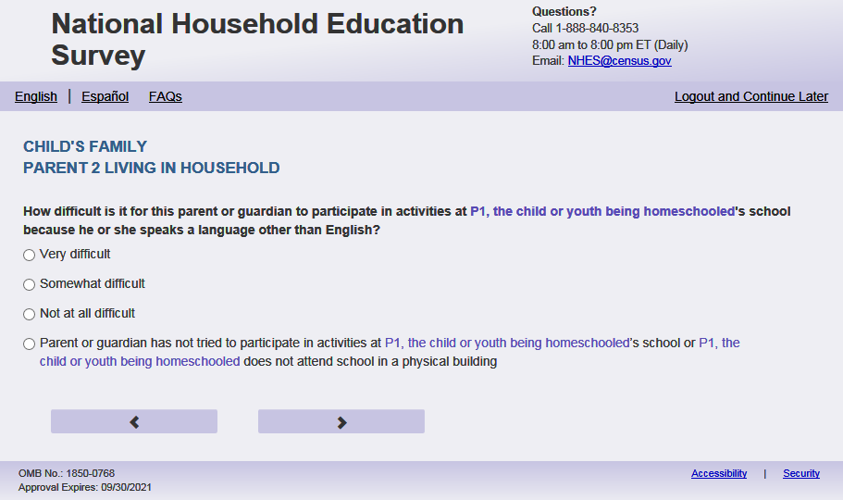
English Respondent Text Reads:
How difficult is it for [PARENT 2] to participate in activities at [this child]’s school because [PARENT 2.1] speaks a language other than English?

Spanish Respondent Text Reads:
¿Qué tan difícil es para [PARENT 2] participar en actividades en la escuela de [este niño (esta niña)] debido a que habla un idioma que no es inglés?

English Admin/TQA Text Reads:
How difficult is it for [PARENT 2] to participate in activities at [this child]’s school because [PARENT 2.1] speaks a language other than English?

{Please read response options.}

Spanish Admin/TQA Text Reads:
¿Qué tan difícil es para [PARENT 2] participar en actividades en la escuela de [este niño (esta niña)] debido a que habla un idioma que no es inglés?

{Por favor, lea las opciones de respuesta.}
English Answer
1= Very difficult
2= Somewhat difficult
3= Not at all difficult
4 = Parent or guardian has not tried to participate in activities at [this child]’s school or [this child] does not attend school in a physical building

Spanish Answer
1= Muy difícil
2= Un poco difícil
3= Nada difícil
4 = Padre, madre o tutor(a) legal no ha intentado participar en actividades en la escuela de [este niño (esta niña)] o [este niño (esta niña)] no asiste a una escuela que está en un edificio físico

PFIC_P2DIFFI, (1,4), numeric, radio

Skips:
Go to PFIC_P2SCINT.

Logic Checks/Programming specifications:
English
Increase spacing between response options “Not at all difficult” and “Parent or guardian has not tried to participate in activities at [this child]’s school or [this child] does not attend school in a physical building” that is about double the typical spacing between response options.

Spanish
Increase spacing between response options “Nada difícil” and “Padre no ha intentado participar en actividades en la escuela de [este niño (esta niña)] o [este niño (esta niña)] no asiste una escuela que está en un edificio físico” that is about double the typical spacing between response options.

Fills
English:
If PFIC_P1HHREL2 = 1 (mother) is selected and PFIC_P2HHREL = 1 (mother) then PARENT 2 fill is [this child]’s other mother else if PARENT 2 fill is [this child]’s mother; PARENT 2.1 fill is she
If PFIC_P1HHREL2 = 2 (father) is selected and PFIC_P2HHREL = 2 (father) then PARENT 2 fill is [this child]’s other father else PARENT 2 fill is [this child]’s father; PARENT 2.1 fill is he
If PFIC_P1HHREL2 = 3 (grandmother) is selected and PFIC_P2HHREL = 1 (grandmother) then PARENT 2 fill is [this child]’s other grandmother else PARENT 2 fill is [this child]’s grandmother; PARENT 2.1 fill is she
If PFIC_P1HHREL2 = 4 (grandfather) is selected and PFIC_P2HHREL = 2 (grandfather) then PARENT 2 fill is [this child]’s other grandfather else PARENT 2 fill is [this child]’s grandfather; PARENT 2.1 fill is he
If PFIC_P1HHREL2 = 6 (aunt) is selected and PFIC_P2HHREL = 1 (aunt) then PARENT 2 fill is [this child]’s other aunt else PARENT 2 fill is [this child]’s aunt; PARENT 2.1 fill is she
If PFIC_P1HHREL2 = 7 (uncle) is selected and PFIC_P2HHREL = 2 (uncle) then PARENT 2 fill is [this child]’s other uncle else PARENT 2 fill is [this child]’s uncle; PARENT 2.1 fill is he
If PFIC_P1HHREL2 = 8 (sister) is selected and PFIC_P2HHREL = 1 (sister) then PARENT 2 fill is [this child]’s other sister else PARENT 2 fill is [this child]’s sister; PARENT 2.1 fill is she
If PFIC_P1HHREL2 = 9 (brother) is selected and PFIC_P2HHREL = 2 (brother) then PARENT 2 fill is [this child]’s other brother else PARENT 2 fill is [this child]’s brother; PARENT 2.1 fill is he
If PFIC_P2HHREL in (5, 10, blank) (boyfriend/girlfriend/partner or other relationship) is selected then PARENT 2 fill is [this child]’s other parent or guardian; PARENT 2.1 fill is f PFIC_P2SEX = 1 use he if PFIC_P2SEX =2 use she, if PFIC_P2SEX Is blank, use he or she
Spanish:
If PFIC_P1HHREL2 = 1 (madre) is selected and PFIC_P2HHREL = 1 (madre) then PARENT 2 fill is la otra madre de [este niño (esta niña)] else PARENT 2 fill is la madre de [este niño (esta niña)]
If PFIC_P1HHREL2 = 2 (padre) is selected and PFIC_P2HHREL = 2 (padre) then PARENT 2 fill el otro padre de [este niño (esta niña)] else PARENT 2 fill is el padre de [este niño (esta niña)]
If PFIC_P1HHREL2 = 3 (abuela) is selected and PFIC_P2HHREL = 1 (Abuela) then PARENT 2 fill is la otra abuela de [este niño (esta niña)] else PARENT 2 fill is la abuela de [este niño (esta niña)]
If PFIC_P1HHREL2 = 4 (abuelo) is selected and PFIC_P2HHREL = 2 (abuelo) then PARENT 2 fill el otro abuelo de [este niño (esta niña)] else PARENT 2 fill is el abuelo de [este niño (esta niña)]
If PFIC_P1HHREL2 = 6 (tía) is selected and PFIC_P2HHREL = 1 (tía) then PARENT 2 fill is la otra tía de [este niño (esta niña)] else PARENT 2 fill is la tía de [este niño (esta niña)]
If PFIC_P1HHREL2 = 7 (tío) is selected and PFIC_P2HHREL = 2 (tío) then PARENT 2 fill el otro tío de [este niño (esta niña)] else PARENT 2 fill is el tío de [este niño (esta niña)]
If PFIC_P1HHREL2 = 8 (hermana) is selected and PFIC_P2HHREL = 1 (hermana) then PARENT 2 fill is la otra hermana de [este niño (esta niña)] else PARENT 2 fill is la hermana de [este niño (esta niña)]
If PFIC_P1HHREL2 = 9 (hermano) is selected and PFIC_P2HHREL = 2 (hermano) then PARENT 2 fill el otro hermano de [este niño (esta niña)] else PARENT 2 fill is el hermano de [este niño (esta niña)]
If PFIC_P2HHREL in (5, 10, blank) (boyfriend/girlfriend/partner or other relationship) is selected then PARENT 2 fill is el otro padre o el tutor(a) legal de [este niño (esta niña)]

Item: 2nd Parent or Guardian School Interpreters (PFIC_P2SCINT)
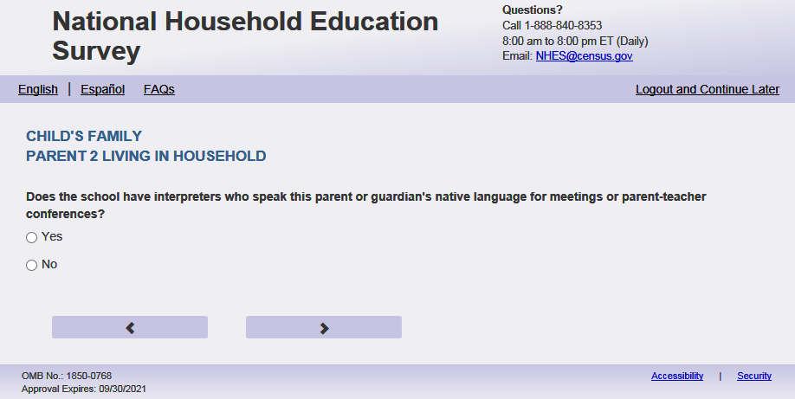
English Text Reads:
Does the school have interpreters who speak [PARENT 2] native language for meetings or parent-teacher conferences?

Spanish Text Reads:
¿Tiene la escuela intérpretes que hablan la lengua materna de [PARENT 2] para reuniones o conferencias entre padres y maestros?

English Answer
1 = Yes
2=No

Spanish Answer
1= Sí
2=No

PFIC_P2SCINT, (1,2), numeric, radio

Skips:
Go to PFIC_P2WRMTL

Logic Checks/Programming specifications:
Fills
English:
If PFIC_P1HHREL2 = 1 (mother) is selected and PFIC_P2HHREL = 1 (mother) then PARENT 2 fill is [this child]’s other mother’s else PARENT 2 fill is [this child]’s mother’s
If PFIC_P1HHREL2 = 2 (father) is selected and PFIC_P2HHREL = 2 (father) then PARENT 2 fill is [this child]’s other father’s else PARENT 2 fill is [this child]’s father’s
If PFIC_P1HHREL2 = 3 (grandmother) is selected and PFIC_P2HHREL = 1 (grandmother) then PARENT 2 fill is [this child]’s other grandmother’s else PARENT 2 fill is [this child]’s grandmother’s;
If PFIC_P1HHREL2 = 4 (grandfather) is selected and PFIC_P2HHREL = 2 (grandfather) then PARENT 2 fill is [this child]’s other grandfather’s else PARENT 2 fill is [this child]’s grandfather’s
If PFIC_P1HHREL2 = 6 (aunt) is selected and PFIC_P2HHREL = 1 (aunt) then PARENT 2 fill is [this child]’s other aunt’s else PARENT 2 fill is [this child]’s aunt’s
If PFIC_P1HHREL2 = 7 (uncle) is selected and PFIC_P2HHREL = 2 (uncle) then PARENT 2 fill is [this child]’s other uncle’s else PARENT 2 fill is [this child]’s uncle’s
If PFIC_P1HHREL2 = 8 (sister) is selected and PFIC_P2HHREL = 1 (sister) then PARENT 2 fill is [this child]’s other sister’s else PARENT 2 fill is [this child]’s sister’s
If PFIC_P1HHREL2 = 9 (brother) is selected and PFIC_P2HHREL = 2 (brother) then PARENT 2 fill is [this child]’s other brother’s else PARENT 2 fill is [this child]’s brother’s
If PFIC_P2HHREL in (5, 10, blank) (boyfriend/girlfriend/partner or other relationship) is selected then PARENT 2 fill is [this child]’s other parent or guardian’s
Spanish:
If PFIC_P1HHREL2 = 1 (madre) is selected and PFIC_P2HHREL = 1 (madre) then PARENT 2 fill is la otra madre de [este niño (esta niña)] else PARENT 2 fill is la madre de [este niño (esta niña)]
If PFIC_P1HHREL2 = 2 (padre) is selected and PFIC_P2HHREL = 2 (padre) then PARENT 2 fill el otro padre de [este niño (esta niña)] else PARENT 2 fill is el padre de [este niño (esta niña)]
If PFIC_P1HHREL2 = 3 (abuela) is selected and PFIC_P2HHREL = 1 (Abuela) then PARENT 2 fill is la otra abuela de [este niño (esta niña)] else PARENT 2 fill is la abuela de [este niño (esta niña)]
If PFIC_P1HHREL2 = 4 (abuelo) is selected and PFIC_P2HHREL = 2 (abuelo) then PARENT 2 fill el otro abuelo de [este niño (esta niña)] else PARENT 2 fill is el abuelo de [este niño (esta niña)]
If PFIC_P1HHREL2 = 6 (tía) is selected and PFIC_P2HHREL = 1 (tía) then PARENT 2 fill is la otra tía de [este niño (esta niña)] else PARENT 2 fill is la tía de [este niño (esta niña)]
If PFIC_P1HHREL2 = 7 (tío) is selected and PFIC_P2HHREL = 2 (tío) then PARENT 2 fill el otro tío de [este niño (esta niña)] else PARENT 2 fill is el tío de [este niño (esta niña)]
If PFIC_P1HHREL2 = 8 (hermana) is selected and PFIC_P2HHREL = 1 (hermana) then PARENT 2 fill is la otra hermana de [este niño (esta niña)] else PARENT 2 fill is la hermana de [este niño (esta niña)]
If PFIC_P1HHREL2 = 9 (hermano) is selected and PFIC_P2HHREL = 2 (hermano) then PARENT 2 fill el otro hermano de [este niño (esta niña)] else PARENT 2 fill is el hermano de [este niño (esta niña)]
If PFIC_P2HHREL in (5, 10, blank) (boyfriend/girlfriend/partner or other relationship) is selected then PARENT 2 fill is el otro padre o el tutor(a) legal de [este niño (esta niña)]

Item: School Communication for 2nd Parent or Guardian (PFIC_P2WRMTL)
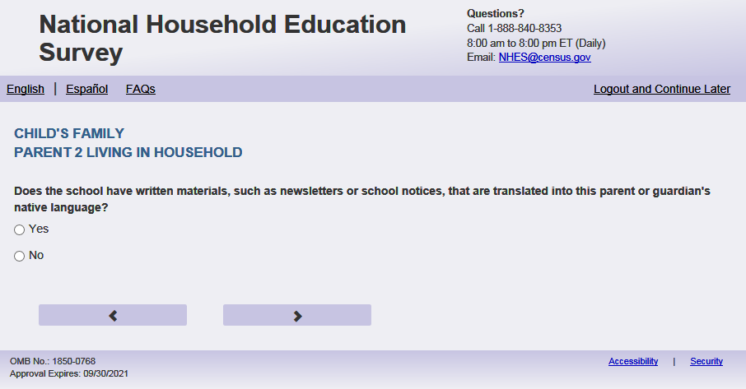
English Text Reads:
Does the school have written materials, such as newsletters or school notices, that are translated into [PARENT 2] native language?

Spanish Text Reads:
¿Tiene esta escuela materiales escritos como boletines informativos o notificaciones escolares traducidos al idioma materno de [PARENT 2]?

English
1 = Yes
2=No

Spanish
1= Sí
2=No

PFIC_P2WRMTL, (1,2), numeric, radio

Skips:

Go to PFIC_P2PLCBRTH

Logic Checks/Programming specifications:
Fills
English:
If PFIC_P1HHREL2 = 1 (mother) is selected and PFIC_P2HHREL = 1 (mother) then PARENT 2 fill is [this child]’s other mother’s else PARENT 2 fill is [this child]’s mother’s
If PFIC_P1HHREL2 = 2 (father) is selected and PFIC_P2HHREL = 2 (father) then PARENT 2 fill is [this child]’s other father’s else PARENT 2 fill is [this child]’s father’s
If PFIC_P1HHREL2 = 3 (grandmother) is selected and PFIC_P2HHREL = 1 (grandmother) then PARENT 2 fill is [this child]’s other grandmother’s else PARENT 2 fill is [this child]’s grandmother’s;
If PFIC_P1HHREL2 = 4 (grandfather) is selected and PFIC_P2HHREL = 2 (grandfather) then PARENT 2 fill is [this child]’s other grandfather’s else PARENT 2 fill is [this child]’s grandfather’s
If PFIC_P1HHREL2 = 6 (aunt) is selected and PFIC_P2HHREL = 1 (aunt) then PARENT 2 fill is [this child]’s other aunt’s else PARENT 2 fill is [this child]’s aunt’s
If PFIC_P1HHREL2 = 7 (uncle) is selected and PFIC_P2HHREL = 2 (uncle) then PARENT 2 fill is [this child]’s other uncle’s else PARENT 2 fill is [this child]’s uncle’s
If PFIC_P1HHREL2 = 8 (sister) is selected and PFIC_P2HHREL = 1 (sister) then PARENT 2 fill is [this child]’s other sister’s else PARENT 2 fill is [this child]’s sister’s
If PFIC_P1HHREL2 = 9 (brother) is selected and PFIC_P2HHREL = 2 (brother) then PARENT 2 fill is [this child]’s other brother’s else PARENT 2 fill is [this child]’s brother’s
If PFIC_P2HHREL in (5, 10, blank) (boyfriend/girlfriend/partner or other relationship) is selected then PARENT 2 fill is [this child]’s other parent or guardian’s
Spanish:
If PFIC_P1HHREL2 = 1 (madre) is selected and PFIC_P2HHREL = 1 (madre) then PARENT 2 fill is la otra madre de [este niño (esta niña)] else PARENT 2 fill is la madre de [este niño (esta niña)]
If PFIC_P1HHREL2 = 2 (padre) is selected and PFIC_P2HHREL = 2 (padre) then PARENT 2 fill el otro padre de [este niño (esta niña)] else PARENT 2 fill is el padre de [este niño (esta niña)]
If PFIC_P1HHREL2 = 3 (abuela) is selected and PFIC_P2HHREL = 1 (Abuela) then PARENT 2 fill is la otra abuela de [este niño (esta niña)] else PARENT 2 fill is la abuela de [este niño (esta niña)]
If PFIC_P1HHREL2 = 4 (abuelo) is selected and PFIC_P2HHREL = 2 (abuelo) then PARENT 2 fill el otro abuelo de [este niño (esta niña)] else PARENT 2 fill is el abuelo de [este niño (esta niña)]
If PFIC_P1HHREL2 = 6 (tía) is selected and PFIC_P2HHREL = 1 (tía) then PARENT 2 fill is la otra tía de [este niño (esta niña)] else PARENT 2 fill is la tía de [este niño (esta niña)]
If PFIC_P1HHREL2 = 7 (tío) is selected and PFIC_P2HHREL = 2 (tío) then PARENT 2 fill el otro tío de [este niño (esta niña)] else PARENT 2 fill is el tío de [este niño (esta niña)]
If PFIC_P1HHREL2 = 8 (hermana) is selected and PFIC_P2HHREL = 1 (hermana) then PARENT 2 fill is la otra hermana de [este niño (esta niña)] else PARENT 2 fill is la hermana de [este niño (esta niña)]
If PFIC_P1HHREL2 = 9 (hermano) is selected and PFIC_P2HHREL = 2 (hermano) then PARENT 2 fill el otro hermano de [este niño (esta niña)] else PARENT 2 fill is el hermano de [este niño (esta niña)]
If PFIC_P2HHREL in (5, 10, blank) (boyfriend/girlfriend/partner or other relationship) is selected then PARENT 2 fill is el otro padre o el tutor(a) legal de [este niño (esta niña)]

Item: 2nd Parent or Guardian Birth Place (PFIC_P2PLCBRTH)
English Text Reads:
Where was [PARENT 2] born?

Spanish Text Reads:
¿Dónde nació [PARENT 2]?

English
1= One of the 50 United States or the District of Columbia
2= One of the U.S. territories (Puerto Rico, Guam, American Samoa, U.S. Virgin Islands, or Mariana Islands)
3= Another country

Spanish
1= Uno de los 50 estados de los Estados Unidos o el Distrito de Columbia
2= Uno de los territorios incorporados de los Estados Unidos (Puerto Rico, Guam, Samoa Americana, Islas Vírgenes de los Estados Unidos o Islas Marianas del Norte)
3= Otro país

PFIC_P2PLCBRTH, (1,3), numeric, radio

Skips:
if PFIC_P2PLCBRTH = 1 or blank then go to PFIC_P2HISPANX else go to PFIC_P2AGEMV

Logic Checks/Programming specifications:
Fills
English:
If PFIC_P1HHREL2 = 1 (mother) is selected and PFIC_P2HHREL = 1 (mother) then PARENT 2 fill is [this child]’s other mother else if PARENT 2 fill is [this child]’s mother
If PFIC_P1HHREL2 = 2 (father) is selected and PFIC_P2HHREL = 2 (father) then PARENT 2 fill is [this child]’s other father else PARENT 2 fill is [this child]’s father
If PFIC_P1HHREL2 = 3 (grandmother) is selected and PFIC_P2HHREL = 1 (grandmother) then PARENT 2 fill is [this child]’s other grandmother else PARENT 2 fill is [this child]’s grandmother
If PFIC_P1HHREL2 = 4 (grandfather) is selected and PFIC_P2HHREL = 2 (grandfather) then PARENT 2 fill is [this child]’s other grandfather else PARENT 2 fill is [this child]’s grandfather
If PFIC_P1HHREL2 = 6 (aunt) is selected and PFIC_P2HHREL = 1 (aunt) then PARENT 2 fill is [this child]’s other aunt else PARENT 2 fill is [this child]’s aunt
If PFIC_P1HHREL2 = 7 (uncle) is selected and PFIC_P2HHREL = 2 (uncle) then PARENT 2 fill is [this child]’s other uncle else PARENT 2 fill is [this child]’s uncle
If PFIC_P1HHREL2 = 8 (sister) is selected and PFIC_P2HHREL = 1 (sister) then PARENT 2 fill is [this child]’s other sister else PARENT 2 fill is [this child]’s sister
If PFIC_P1HHREL2 = 9 (brother) is selected and PFIC_P2HHREL = 2 (brother) then PARENT 2 fill is [this child]’s other brother else PARENT 2 fill is [this child]’s brother
If PFIC_P2HHREL in (5, 10, blank) (boyfriend/girlfriend/partner or other relationship) is selected then PARENT 2 fill is [this child]’s other parent or guardian
Spanish:
If PFIC_P1HHREL2 = 1 (madre) is selected and PFIC_P2HHREL = 1 (madre) then PARENT 2 fill is la otra madre de [este niño (esta niña)] else PARENT 2 fill is la madre de [este niño (esta niña)]
If PFIC_P1HHREL2 = 2 (padre) is selected and PFIC_P2HHREL = 2 (padre) then PARENT 2 fill el otro padre de [este niño (esta niña)] else PARENT 2 fill is el padre de [este niño (esta niña)]
If PFIC_P1HHREL2 = 3 (abuela) is selected and PFIC_P2HHREL = 1 (Abuela) then PARENT 2 fill is la otra abuela de [este niño (esta niña)] else PARENT 2 fill is la abuela de [este niño (esta niña)]
If PFIC_P1HHREL2 = 4 (abuelo) is selected and PFIC_P2HHREL = 2 (abuelo) then PARENT 2 fill el otro abuelo de [este niño (esta niña)] else PARENT 2 fill is el abuelo de [este niño (esta niña)]
If PFIC_P1HHREL2 = 6 (tía) is selected and PFIC_P2HHREL = 1 (tía) then PARENT 2 fill is la otra tía de [este niño (esta niña)] else PARENT 2 fill is la tía de [este niño (esta niña)]
If PFIC_P1HHREL2 = 7 (tío) is selected and PFIC_P2HHREL = 2 (tío) then PARENT 2 fill el otro tío de [este niño (esta niña)] else PARENT 2 fill is el tío de [este niño (esta niña)]
If PFIC_P1HHREL2 = 8 (hermana) is selected and PFIC_P2HHREL = 1 (hermana) then PARENT 2 fill is la otra hermana de [este niño (esta niña)] else PARENT 2 fill is la hermana de [este niño (esta niña)]
If PFIC_P1HHREL2 = 9 (hermano) is selected and PFIC_P2HHREL = 2 (hermano) then PARENT 2 fill el otro hermano de [este niño (esta niña)] else PARENT 2 fill is el hermano de [este niño (esta niña)]
If PFIC_P2HHREL in (5, 10, blank) (boyfriend/girlfriend/partner or other relationship) is selected then PARENT 2 fill is el otro padre o el tutor(a) legal de [este niño (esta niña)]

Item: 2nd Parent or Guardian Age Once moved to U.S. (PFIC_P2AGEMV)
English Text Reads:
How old was [PARENT 2] when [PARENT 2.1] first moved to the 50 United States or the District of Columbia?
If younger than 1, enter ‘0’.

Spanish Text Reads:
¿Qué edad tenía [PARENT 2] cuando se mudó por primera vez a uno de los 50 estados de los Estados Unidos o al Distrito de Columbia?
Si fue menor de 1 año, ingrese ‘0’

English and Spanish Answer
PFIC_P2AGEMV, (0,99), numeric, write-in

Skips:
Go to PFIC_P2HISPANX

Logic Checks/Programming specifications:
English:
English
display "years old" to the right of box.

Spanish
display "años" to the right of box.
Mobile: Display numeric keypad
Fills
English:
If PFIC_P1HHREL2 = 1 (mother) is selected and PFIC_P2HHREL = 1 (mother) then PARENT 2 fill is [this child]’s other mother else if PARENT 2 fill is [this child]’s mother; PARENT 2.1 fill is she
If PFIC_P1HHREL2 = 2 (father) is selected and PFIC_P2HHREL = 2 (father) then PARENT 2 fill is [this child]’s other father else PARENT 2 fill is [this child]’s father; PARENT 2.1 fill is he
If PFIC_P1HHREL2 = 3 (grandmother) is selected and PFIC_P2HHREL = 1 (grandmother) then PARENT 2 fill is [this child]’s other grandmother else PARENT 2 fill is [this child]’s grandmother; PARENT 2.1 fill is she
If PFIC_P1HHREL2 = 4 (grandfather) is selected and PFIC_P2HHREL = 2 (grandfather) then PARENT 2 fill is [this child]’s other grandfather else PARENT 2 fill is [this child]’s grandfather; PARENT 2.1 fill is he
If PFIC_P1HHREL2 = 6 (aunt) is selected and PFIC_P2HHREL = 1 (aunt) then PARENT 2 fill is [this child]’s other aunt else PARENT 2 fill is [this child]’s aunt; PARENT 2.1 fill is she
If PFIC_P1HHREL2 = 7 (uncle) is selected and PFIC_P2HHREL = 2 (uncle) then PARENT 2 fill is [this child]’s other uncle else PARENT 2 fill is [this child]’s uncle; PARENT 2.1 fill is he
If PFIC_P1HHREL2 = 8 (sister) is selected and PFIC_P2HHREL = 1 (sister) then PARENT 2 fill is [this child]’s other sister else PARENT 2 fill is [this child]’s sister; PARENT 2.1 fill is she
If PFIC_P1HHREL2 = 9 (brother) is selected and PFIC_P2HHREL = 2 (brother) then PARENT 2 fill is [this child]’s other brother else PARENT 2 fill is [this child]’s brother; PARENT 2.1 fill is he
If PFIC_P2HHREL in (5, 10, blank) (boyfriend/girlfriend/partner or other relationship) is selected then PARENT 2 fill is [this child]’s other parent or guardian; PARENT 2.1 fill is f PFIC_P2SEX = 1 use he if PFIC_P2SEX =2 use she, if PFIC_P2SEX Is blank, use he or she

Spanish:
If PFIC_P1HHREL2 = 1 (madre) is selected and PFIC_P2HHREL = 1 (madre) then PARENT 2 fill is la otra madre de [este niño (esta niña)] else PARENT 2 fill is la madre de [este niño (esta niña)]
If PFIC_P1HHREL2 = 2 (padre) is selected and PFIC_P2HHREL = 2 (padre) then PARENT 2 fill el otro padre de [este niño (esta niña)] else PARENT 2 fill is el padre de [este niño (esta niña)]
If PFIC_P1HHREL2 = 3 (abuela) is selected and PFIC_P2HHREL = 1 (Abuela) then PARENT 2 fill is la otra abuela de [este niño (esta niña)] else PARENT 2 fill is la abuela de [este niño (esta niña)]
If PFIC_P1HHREL2 = 4 (abuelo) is selected and PFIC_P2HHREL = 2 (abuelo) then PARENT 2 fill el otro abuelo de [este niño (esta niña)] else PARENT 2 fill is el abuelo de [este niño (esta niña)]
If PFIC_P1HHREL2 = 6 (tía) is selected and PFIC_P2HHREL = 1 (tía) then PARENT 2 fill is la otra tía de [este niño (esta niña)] else PARENT 2 fill is la tía de [este niño (esta niña)]
If PFIC_P1HHREL2 = 7 (tío) is selected and PFIC_P2HHREL = 2 (tío) then PARENT 2 fill el otro tío de [este niño (esta niña)] else PARENT 2 fill is el tío de [este niño (esta niña)]
If PFIC_P1HHREL2 = 8 (hermana) is selected and PFIC_P2HHREL = 1 (hermana) then PARENT 2 fill is la otra hermana de [este niño (esta niña)] else PARENT 2 fill is la hermana de [este niño (esta niña)]
If PFIC_P1HHREL2 = 9 (hermano) is selected and PFIC_P2HHREL = 2 (hermano) then PARENT 2 fill el otro hermano de [este niño (esta niña)] else PARENT 2 fill is el hermano de [este niño (esta niña)]
If PFIC_P2HHREL in (5, 10, blank) (boyfriend/girlfriend/partner or other relationship) is selected then PARENT 2 fill is el otro padre o el tutor(a) legal de [este niño (esta niña)]

Item: 2nd Parent or Guardian Hispanic Origin (PFIC_P2HISPANX)
English Respondent Text Reads:
Is [PARENT 2] of Hispanic, Latino, or Spanish origin?

Spanish Respondent Text Reads:
¿Es [PARENT 2] de origen hispano, latino o español?

English Admin/TQA Text Reads:
{Please be sure to ask BOTH this question and the following race question, and record the respondent’s answer}
[PARENT 2] of Hispanic, Latino, or Spanish origin?
{If ‘yes,’ read yes answer options to the respondent.}
Spanish Admin/TQA Text Reads:
{Por favor asgúrese de leer esta pregunta Y TAMBIÉN la siguiente pregunta sobre la raza, y marque la respuesta del encuestado}
¿Es [PARENT 2] de origen hispano, latino o español?

{Si 'sí', lea sí opciones de respuesta al encuestado.}
English Text Reads:
1 = No, not of Hispanic, Latino, or Spanish origin
2 = Yes, Mexican, Mexican American, Chicano
3 = Yes, Puerto Rican
4 = Yes, Cuban
5 = Yes, another Hispanic, Latino, or Spanish origin; or more than one Hispanic, Latino, or Spanish origin

Spanish Text Reads:
1 = No, no es de origen hispano, latino, o español
2 = Sí, Mexicano, Mexicano Americano, Chicano
3 = Sí, Puertorriqueño
4 = Sí, Cubano
5 = Sí, es de otro origen hispano, latino, o español; o de más de un origen hispano, latino o español

PFIC_P2HISPANX, (1,5), numeric, radio

Skips:

Go to PFIC_P2AMIND

Logic Checks/Programming specifications:
Fills
English:
If PFIC_P1HHREL2 = 1 (mother) is selected and PFIC_P2HHREL = 1 (mother) then PARENT 2 fill is [this child]’s other mother else if PARENT 2 fill is [this child]’s mother
If PFIC_P1HHREL2 = 2 (father) is selected and PFIC_P2HHREL = 2 (father) then PARENT 2 fill is [this child]’s other father else PARENT 2 fill is [this child]’s father
If PFIC_P1HHREL2 = 3 (grandmother) is selected and PFIC_P2HHREL = 1 (grandmother) then PARENT 2 fill is [this child]’s other grandmother else PARENT 2 fill is [this child]’s grandmother
If PFIC_P1HHREL2 = 4 (grandfather) is selected and PFIC_P2HHREL = 2 (grandfather) then PARENT 2 fill is [this child]’s other grandfather else PARENT 2 fill is [this child]’s grandfather
If PFIC_P1HHREL2 = 6 (aunt) is selected and PFIC_P2HHREL = 1 (aunt) then PARENT 2 fill is [this child]’s other aunt else PARENT 2 fill is [this child]’s aunt
If PFIC_P1HHREL2 = 7 (uncle) is selected and PFIC_P2HHREL = 2 (uncle) then PARENT 2 fill is [this child]’s other uncle else PARENT 2 fill is [this child]’s uncle
If PFIC_P1HHREL2 = 8 (sister) is selected and PFIC_P2HHREL = 1 (sister) then PARENT 2 fill is [this child]’s other sister else PARENT 2 fill is [this child]’s sister
If PFIC_P1HHREL2 = 9 (brother) is selected and PFIC_P2HHREL = 2 (brother) then PARENT 2 fill is [this child]’s other brother else PARENT 2 fill is [this child]’s brother
If PFIC_P2HHREL in (5, 10, blank) (boyfriend/girlfriend/partner or other relationship) is selected then PARENT 2 fill is [this child]’s other parent or guardian
Spanish:
If PFIC_P1HHREL2 = 1 (madre) is selected and PFIC_P2HHREL = 1 (madre) then PARENT 2 fill is la otra madre de [este niño (esta niña)] else PARENT 2 fill is la madre de [este niño (esta niña)]
If PFIC_P1HHREL2 = 2 (padre) is selected and PFIC_P2HHREL = 2 (padre) then PARENT 2 fill el otro padre de [este niño (esta niña)] else PARENT 2 fill is el padre de [este niño (esta niña)]
If PFIC_P1HHREL2 = 3 (abuela) is selected and PFIC_P2HHREL = 1 (Abuela) then PARENT 2 fill is la otra abuela de [este niño (esta niña)] else PARENT 2 fill is la abuela de [este niño (esta niña)]
If PFIC_P1HHREL2 = 4 (abuelo) is selected and PFIC_P2HHREL = 2 (abuelo) then PARENT 2 fill el otro abuelo de [este niño (esta niña)] else PARENT 2 fill is el abuelo de [este niño (esta niña)]
If PFIC_P1HHREL2 = 6 (tía) is selected and PFIC_P2HHREL = 1 (tía) then PARENT 2 fill is la otra tía de [este niño (esta niña)] else PARENT 2 fill is la tía de [este niño (esta niña)]
If PFIC_P1HHREL2 = 7 (tío) is selected and PFIC_P2HHREL = 2 (tío) then PARENT 2 fill el otro tío de [este niño (esta niña)] else PARENT 2 fill is el tío de [este niño (esta niña)]
If PFIC_P1HHREL2 = 8 (hermana) is selected and PFIC_P2HHREL = 1 (hermana) then PARENT 2 fill is la otra hermana de [este niño (esta niña)] else PARENT 2 fill is la hermana de [este niño (esta niña)]
If PFIC_P1HHREL2 = 9 (hermano) is selected and PFIC_P2HHREL = 2 (hermano) then PARENT 2 fill el otro hermano de [este niño (esta niña)] else PARENT 2 fill is el hermano de [este niño (esta niña)]
If PFIC_P2HHREL in (5, 10, blank) (boyfriend/girlfriend/partner or other relationship) is selected then PARENT 2 fill is el otro padre o el tutor(a) legal de [este niño (esta niña)]

Item: 2nd Parent or Guardian Race (PFIC_P2AMIND)
English Respondent Text Reads:
What is [PARENT 2] race? You may select one or more races.

Spanish Respondent Text Reads:
¿Cuál es [PARENT 2]? Puede seleccionar una raza o más de una raza.

English Admin/TQA Text Reads:
What is [PARENT 2] race?
{You may select one or more races.}
{If the respondent answered yes to the previous item (Hispanic ethnicity) and does not identify with any other race, leave this item blank.}
Spanish Admin/TQA Text Reads:
¿Cuál es [PARENT 2]?
{Puede seleccionar una o más razas.}
{Si el encuestado respondió sí a la pregunta anterior (etnia hispana) y no se identifica con ninguna otra raza, deje este ítem en blanco.}
English
American Indian or Alaska Native, PFIC_P2AMIND, (1= Item Marked; 2=Not marked), numeric, checkbox
Asian, PFIC_P2ASIAN, (1= Item Marked; 2=Not marked), numeric, checkbox
Black or African American, PFIC_P2BLACK, (1= Item Marked; 2=Not marked), numeric, checkbox
Native Hawaiian or other Pacific Islander, PFIC_P2PACI, (1= Item Marked; 2=Not marked), numeric, checkbox
White, PFIC_P2WHITE, (1= Item Marked; 2=Not marked), numeric, checkbox

Spanish
Indígena de las Américas o nativa de Alaska, PFIC_P2AMIND, (1= Item Marked; 2=Not marked), numeric, checkbox
Asiática, PFIC_P2ASIAN, (1= Item Marked; 2=Not marked), numeric, checkbox
Negra o afroamericana, PFIC_P2BLACK, (1= Item Marked; 2=Not marked), numeric, checkbox
Nativa de Hawái u otra de las islas del Pacífico, PFIC_P2PACI, (1= Item Marked; 2=Not marked), numeric, checkbox
Blanca, PFIC_P2WHITE, (1= Item Marked; 2=Not marked), numeric, checkbox

Skips:
Go to PFIC_P2EDUC

Logic Checks/Programming specifications:

This is a mark all that apply item.

Fills
English:
If PFIC_P1HHREL2 = 1 (mother) is selected and PFIC_P2HHREL = 1 (mother) then PARENT 2 fill is [this child]’s other mother’s else PARENT 2 fill is [this child]’s mother’s
If PFIC_P1HHREL2 = 2 (father) is selected and PFIC_P2HHREL = 2 (father) then PARENT 2 fill is [this child]’s other father’s else PARENT 2 fill is [this child]’s father’s
If PFIC_P1HHREL2 = 3 (grandmother) is selected and PFIC_P2HHREL = 1 (grandmother) then PARENT 2 fill is [this child]’s other grandmother’s else PARENT 2 fill is [this child]’s grandmother’s;
If PFIC_P1HHREL2 = 4 (grandfather) is selected and PFIC_P2HHREL = 2 (grandfather) then PARENT 2 fill is [this child]’s other grandfather’s else PARENT 2 fill is [this child]’s grandfather’s
If PFIC_P1HHREL2 = 6 (aunt) is selected and PFIC_P2HHREL = 1 (aunt) then PARENT 2 fill is [this child]’s other aunt’s else PARENT 2 fill is [this child]’s aunt’s
If PFIC_P1HHREL2 = 7 (uncle) is selected and PFIC_P2HHREL = 2 (uncle) then PARENT 2 fill is [this child]’s other uncle’s else PARENT 2 fill is [this child]’s uncle’s
If PFIC_P1HHREL2 = 8 (sister) is selected and PFIC_P2HHREL = 1 (sister) then PARENT 2 fill is [this child]’s other sister’s else PARENT 2 fill is [this child]’s sister’s
If PFIC_P1HHREL2 = 9 (brother) is selected and PFIC_P2HHREL = 2 (brother) then PARENT 2 fill is [this child]’s other brother’s else PARENT 2 fill is [this child]’s brother’s
If PFIC_P2HHREL in (5, 10, blank) (boyfriend/girlfriend/partner or other relationship) is selected then PARENT 2 fill is [this child]’s other parent or guardian’s
Spanish:
If PFIC_P1HHREL2 = 1 (madre) is selected and PFIC_P2HHREL = 1 (madre) then PARENT 2 fill is la raza de la otra madre de [este niño (esta niña)] else PARENT 2 fill is la raza de la madre de [este niño (esta niña)]
If PFIC_P1HHREL2 = 2 (padre) is selected and PFIC_P2HHREL = 2 (padre) then PARENT 2 fill la raza del otro padre de [este niño (esta niña)] else PARENT 2 fill is la raza del padre de [este niño (esta niña)]
If PFIC_P1HHREL2 = 3 (abuela) is selected and PFIC_P2HHREL = 1 (Abuela) then PARENT 2 fill is la raza de la otra abuela de [este niño (esta niña)] else PARENT 2 fill is la raza de la abuela de [este niño (esta niña)]
If PFIC_P1HHREL2 = 4 (abuelo) is selected and PFIC_P2HHREL = 2 (abuelo) then PARENT 2 fill la raza del otro abuelo de [este niño (esta niña)] else PARENT 2 fill is la raza del abuelo de [este niño (esta niña)]
If PFIC_P1HHREL2 = 6 (tía) is selected and PFIC_P2HHREL = 1 (tía) then PARENT 2 fill is la raza de la otra tía de [este niño (esta niña)] else PARENT 2 fill is la raza de la tía de [este niño (esta niña)]
If PFIC_P1HHREL2 = 7 (tío) is selected and PFIC_P2HHREL = 2 (tío) then PARENT 2 fill la raza del otro tío de [este niño (esta niña)] else PARENT 2 fill is la raza del tío de [este niño (esta niña)]
If PFIC_P1HHREL2 = 8 (hermana) is selected and PFIC_P2HHREL = 1 (hermana) then PARENT 2 fill is la raza de la otra hermana de [este niño (esta niña)] else PARENT 2 fill is la raza de la hermana de [este niño (esta niña)]
If PFIC_P1HHREL2 = 9 (hermano) is selected and PFIC_P2HHREL = 2 (hermano) then PARENT 2 fill la raza del otro hermano de [este niño (esta niña)] else PARENT 2 fill is la raza del hermano de [este niño (esta niña)]
If PFIC_P2HHREL in (5, 10, blank) (boyfriend/girlfriend/partner or other relationship) is selected then PARENT 2 fill is la raza del otro padre o el tutor(a) legal de [este niño (esta niña)]

Item: 2nd Parent or Guardian Highest Level of Education (PFIC_P2EDUC)
English Respondent Text Reads:
What is the highest grade or level of school that [PARENT 2] completed?

Spanish Respondent Text Reads:
¿Cuál es el grado o nivel más alto de estudios que [PARENT 2] ha completado?

English Admin/TQA Text Reads:
What is the highest grade or level of school that [PARENT 2] completed?
{Please read response options.}
Spanish Admin/TQA Text Reads:
¿Cuál es el grado o nivel más alto de estudios que [PARENT 2] ha completó?

{Por favor, lea las opciones de respuesta. }
English Answer
1= 8th grade or less
2= High school, but no diploma
3= High school diploma or equivalent (GED)
4= Vocational diploma after high school
5= Some college, but no degree
6= Associate’s degree (AA, AS)
7= Bachelor’s degree (BA, BS)
8= Some graduate or professional education, but no degree
9= Master’s degree (MA, MS)
10= Doctorate degree (PhD, EdD)
11= Professional degree beyond bachelor’s degree (MD, DDS, JD, LLB)

Spanish Answer
1= 8° grado o menos
2= High school (grado 9 al 12), pero sin obtener el diploma
3= Diploma de high school o equivalencia (GED)
4= Diploma vocacional o de oficios posterior a high school
5= Algunos cursos de college o universidad, pero sin graduarse
6= Licenciatura o grado asociado (AA, AS)
7= Licenciatura o grado de bachelor (BA, BS)
8= Algo de educación profesional o graduada, pero sin título
9= Título de maestría (MA, MS)
10= Título de doctorado (PhD, EdD)
11= Título profesional posterior al grado de bachelor (médico, dentista, doctor en leyes)
PFIC_P2EDUC, (1,11), numeric, radio

Skips:
Go to PFIC_P2ENRL

Logic Checks/Programming specifications:
Fills
English:
If PFIC_P1HHREL2 = 1 (mother) is selected and PFIC_P2HHREL = 1 (mother) then PARENT 2 fill is [this child]’s other mother else if PARENT 2 fill is [this child]’s mother
If PFIC_P1HHREL2 = 2 (father) is selected and PFIC_P2HHREL = 2 (father) then PARENT 2 fill is [this child]’s other father else PARENT 2 fill is [this child]’s father
If PFIC_P1HHREL2 = 3 (grandmother) is selected and PFIC_P2HHREL = 1 (grandmother) then PARENT 2 fill is [this child]’s other grandmother else PARENT 2 fill is [this child]’s grandmother
If PFIC_P1HHREL2 = 4 (grandfather) is selected and PFIC_P2HHREL = 2 (grandfather) then PARENT 2 fill is [this child]’s other grandfather else PARENT 2 fill is [this child]’s grandfather
If PFIC_P1HHREL2 = 6 (aunt) is selected and PFIC_P2HHREL = 1 (aunt) then PARENT 2 fill is [this child]’s other aunt else PARENT 2 fill is [this child]’s aunt
If PFIC_P1HHREL2 = 7 (uncle) is selected and PFIC_P2HHREL = 2 (uncle) then PARENT 2 fill is [this child]’s other uncle else PARENT 2 fill is [this child]’s uncle
If PFIC_P1HHREL2 = 8 (sister) is selected and PFIC_P2HHREL = 1 (sister) then PARENT 2 fill is [this child]’s other sister else PARENT 2 fill is [this child]’s sister
If PFIC_P1HHREL2 = 9 (brother) is selected and PFIC_P2HHREL = 2 (brother) then PARENT 2 fill is [this child]’s other brother else PARENT 2 fill is [this child]’s brother
If PFIC_P2HHREL in (5, 10, blank) (boyfriend/girlfriend/partner or other relationship) is selected then PARENT 2 fill is [this child]’s other parent or guardian
Spanish:
If PFIC_P1HHREL2 = 1 (madre) is selected and PFIC_P2HHREL = 1 (madre) then PARENT 2 fill is la otra madre de [este niño (esta niña)] else PARENT 2 fill is la madre de [este niño (esta niña)]
If PFIC_P1HHREL2 = 2 (padre) is selected and PFIC_P2HHREL = 2 (padre) then PARENT 2 fill el otro padre de [este niño (esta niña)] else PARENT 2 fill is el padre de [este niño (esta niña)]
If PFIC_P1HHREL2 = 3 (abuela) is selected and PFIC_P2HHREL = 1 (Abuela) then PARENT 2 fill is la otra abuela de [este niño (esta niña)] else PARENT 2 fill is la abuela de [este niño (esta niña)]
If PFIC_P1HHREL2 = 4 (abuelo) is selected and PFIC_P2HHREL = 2 (abuelo) then PARENT 2 fill el otro abuelo de [este niño (esta niña)] else PARENT 2 fill is el abuelo de [este niño (esta niña)]
If PFIC_P1HHREL2 = 6 (tía) is selected and PFIC_P2HHREL = 1 (tía) then PARENT 2 fill is la otra tía de [este niño (esta niña)] else PARENT 2 fill is la tía de [este niño (esta niña)]
If PFIC_P1HHREL2 = 7 (tío) is selected and PFIC_P2HHREL = 2 (tío) then PARENT 2 fill el otro tío de [este niño (esta niña)] else PARENT 2 fill is el tío de [este niño (esta niña)]
If PFIC_P1HHREL2 = 8 (hermana) is selected and PFIC_P2HHREL = 1 (hermana) then PARENT 2 fill is la otra hermana de [este niño (esta niña)] else PARENT 2 fill is la hermana de [este niño (esta niña)]
If PFIC_P1HHREL2 = 9 (hermano) is selected and PFIC_P2HHREL = 2 (hermano) then PARENT 2 fill el otro hermano de [este niño (esta niña)] else PARENT 2 fill is el hermano de [este niño (esta niña)]
If PFIC_P2HHREL in (5, 10, blank) (boyfriend/girlfriend/partner or other relationship) is selected then PARENT 2 fill is el otro padre o el tutor(a) legal de [este niño (esta niña)]

Item: 2nd Parent or Guardian Postsecondary Enrollment (PFIC_P2ENRL)
English Text Reads:
Is [PARENT 2] currently attending or enrolled in a school, college, university, or adult learning center, or receiving vocational education or job training?

Spanish Text Reads:
Actualmente, ¿asiste [PARENT 2], a una escuela, universidad o centro de educación para adultos o recibe educación vocacional o capacitación laboral?

English Answer
1 = Yes
2=No

Spanish Answer
1= Sí
2=No

PFIC_P2ENRL, (1,2), numeric, radio

Skips:

Go to PFIC_P2EMPL

Logic Checks/Programming specifications:
Fills
English:
If PFIC_P1HHREL2 = 1 (mother) is selected and PFIC_P2HHREL = 1 (mother) then PARENT 2 fill is [this child]’s other mother else if PARENT 2 fill is [this child]’s mother
If PFIC_P1HHREL2 = 2 (father) is selected and PFIC_P2HHREL = 2 (father) then PARENT 2 fill is [this child]’s other father else PARENT 2 fill is [this child]’s father
If PFIC_P1HHREL2 = 3 (grandmother) is selected and PFIC_P2HHREL = 1 (grandmother) then PARENT 2 fill is [this child]’s other grandmother else PARENT 2 fill is [this child]’s grandmother
If PFIC_P1HHREL2 = 4 (grandfather) is selected and PFIC_P2HHREL = 2 (grandfather) then PARENT 2 fill is [this child]’s other grandfather else PARENT 2 fill is [this child]’s grandfather
If PFIC_P1HHREL2 = 6 (aunt) is selected and PFIC_P2HHREL = 1 (aunt) then PARENT 2 fill is [this child]’s other aunt else PARENT 2 fill is [this child]’s aunt
If PFIC_P1HHREL2 = 7 (uncle) is selected and PFIC_P2HHREL = 2 (uncle) then PARENT 2 fill is [this child]’s other uncle else PARENT 2 fill is [this child]’s uncle
If PFIC_P1HHREL2 = 8 (sister) is selected and PFIC_P2HHREL = 1 (sister) then PARENT 2 fill is [this child]’s other sister else PARENT 2 fill is [this child]’s sister
If PFIC_P1HHREL2 = 9 (brother) is selected and PFIC_P2HHREL = 2 (brother) then PARENT 2 fill is [this child]’s other brother else PARENT 2 fill is [this child]’s brother
If PFIC_P2HHREL in (5, 10, blank) (boyfriend/girlfriend/partner or other relationship) is selected then PARENT 2 fill is [this child]’s other parent or guardian
Spanish:
If PFIC_P1HHREL2 = 1 (madre) is selected and PFIC_P2HHREL = 1 (madre) then PARENT 2 fill is la otra madre de [este niño (esta niña)] else PARENT 2 fill is la madre de [este niño (esta niña)]
If PFIC_P1HHREL2 = 2 (padre) is selected and PFIC_P2HHREL = 2 (padre) then PARENT 2 fill el otro padre de [este niño (esta niña)] else PARENT 2 fill is el padre de [este niño (esta niña)]
If PFIC_P1HHREL2 = 3 (abuela) is selected and PFIC_P2HHREL = 1 (Abuela) then PARENT 2 fill is la otra abuela de [este niño (esta niña)] else PARENT 2 fill is la abuela de [este niño (esta niña)]
If PFIC_P1HHREL2 = 4 (abuelo) is selected and PFIC_P2HHREL = 2 (abuelo) then PARENT 2 fill el otro abuelo de [este niño (esta niña)] else PARENT 2 fill is el abuelo de [este niño (esta niña)]
If PFIC_P1HHREL2 = 6 (tía) is selected and PFIC_P2HHREL = 1 (tía) then PARENT 2 fill is la otra tía de [este niño (esta niña)] else PARENT 2 fill is la tía de [este niño (esta niña)]
If PFIC_P1HHREL2 = 7 (tío) is selected and PFIC_P2HHREL = 2 (tío) then PARENT 2 fill el otro tío de [este niño (esta niña)] else PARENT 2 fill is el tío de [este niño (esta niña)]
If PFIC_P1HHREL2 = 8 (hermana) is selected and PFIC_P2HHREL = 1 (hermana) then PARENT 2 fill is la otra hermana de [este niño (esta niña)] else PARENT 2 fill is la hermana de [este niño (esta niña)]
If PFIC_P1HHREL2 = 9 (hermano) is selected and PFIC_P2HHREL = 2 (hermano) then PARENT 2 fill el otro hermano de [este niño (esta niña)] else PARENT 2 fill is el hermano de [este niño (esta niña)]
If PFIC_P2HHREL in (5, 10, blank) (boyfriend/girlfriend/partner or other relationship) is selected then PARENT 2 fill is el otro padre, la madre o el tutor(a) legal de [este niño (esta niña)]

Item: 2nd Parent or Guardian Employment (PFIC_P2EMPL)
English Text Reads:
Which of the following BEST describes [PARENT 2] employment status?

Spanish Text Reads:
¿Cuál de las siguientes categorías describe MEJOR la situación de trabajo de [PARENT 2]?

English Admin/TQA Text Reads:

Which of the following BEST describes [PARENT 2] employment status?

{Please read response options.}
Spanish Admin/TQA Text Reads:

¿Cuál de las siguientes categorías describe MEJOR la situación de trabajo de [PARENT 2]?

{Por favor, lea las opciones de respuesta.}

English Answer
1= Employed for pay or income
2= Self- employed
3= Unemployed or out of work
4= Full-time student
5= Stay-at-home parent
6= Retired
7= Disabled or unable to work

Spanish Answer
1= Empleado por pagos o ingresos
2= Trabaja por su propia cuenta
3= Desempleado o no está trabajando
4= Estudiante de tiempo completo
5= Se dedica al hogar y al cuidado de los niños(as)
6= Jubilado
7= Discapacitado o no puede trabajar

PFIC_P2EMPL, (1,7), numeric,radio

Skips:
if PFIC_P2EMPL = 3 then go to PFIC_P2LKWRK
if PFIC_P2EMPL in (4, 5, 6, 7) then go to PFIC_P2MTHSWRK
Else if PFIC_P2EMPL in 1,2, or blank, go to PFIC_P2HRSWK

Logic Checks/Programming specifications:
Fills
English:
If PFIC_P1HHREL2 = 1 (mother) is selected and PFIC_P2HHREL = 1 (mother) then PARENT 2 fill is [this child]’s other mother’s else PARENT 2 fill is [this child]’s mother’s
If PFIC_P1HHREL2 = 2 (father) is selected and PFIC_P2HHREL = 2 (father) then PARENT 2 fill is [this child]’s other father’s else PARENT 2 fill is [this child]’s father’s
If PFIC_P1HHREL2 = 3 (grandmother) is selected and PFIC_P2HHREL = 1 (grandmother) then PARENT 2 fill is [this child]’s other grandmother’s else PARENT 2 fill is [this child]’s grandmother’s;
If PFIC_P1HHREL2 = 4 (grandfather) is selected and PFIC_P2HHREL = 2 (grandfather) then PARENT 2 fill is [this child]’s other grandfather’s else PARENT 2 fill is [this child]’s grandfather’s
If PFIC_P1HHREL2 = 6 (aunt) is selected and PFIC_P2HHREL = 1 (aunt) then PARENT 2 fill is [this child]’s other aunt’s else PARENT 2 fill is [this child]’s aunt’s
If PFIC_P1HHREL2 = 7 (uncle) is selected and PFIC_P2HHREL = 2 (uncle) then PARENT 2 fill is [this child]’s other uncle’s else PARENT 2 fill is [this child]’s uncle’s
If PFIC_P1HHREL2 = 8 (sister) is selected and PFIC_P2HHREL = 1 (sister) then PARENT 2 fill is [this child]’s other sister’s else PARENT 2 fill is [this child]’s sister’s
If PFIC_P1HHREL2 = 9 (brother) is selected and PFIC_P2HHREL = 2 (brother) then PARENT 2 fill is [this child]’s other brother’s else PARENT 2 fill is [this child]’s brother’s
If PFIC_P2HHREL in (5, 10, blank) (boyfriend/girlfriend/partner or other relationship) is selected then PARENT 2 fill is [this child]’s other parent or guardian’s
Spanish:
If PFIC_P1HHREL2 = 1 (madre) is selected and PFIC_P2HHREL = 1 (madre) then PARENT 2 fill is la otra madre de [este niño (esta niña)] else PARENT 2 fill is la madre de [este niño (esta niña)]
If PFIC_P1HHREL2 = 2 (padre) is selected and PFIC_P2HHREL = 2 (padre) then PARENT 2 fill el otro padre de [este niño (esta niña)] else PARENT 2 fill is el padre de [este niño (esta niña)]
If PFIC_P1HHREL2 = 3 (abuela) is selected and PFIC_P2HHREL = 1 (Abuela) then PARENT 2 fill is la otra abuela de [este niño (esta niña)] else PARENT 2 fill is la abuela de [este niño (esta niña)]
If PFIC_P1HHREL2 = 4 (abuelo) is selected and PFIC_P2HHREL = 2 (abuelo) then PARENT 2 fill el otro abuelo de [este niño (esta niña)] else PARENT 2 fill is el abuelo de [este niño (esta niña)]
If PFIC_P1HHREL2 = 6 (tía) is selected and PFIC_P2HHREL = 1 (tía) then PARENT 2 fill is la otra tía de [este niño (esta niña)] else PARENT 2 fill is la tía de [este niño (esta niña)]
If PFIC_P1HHREL2 = 7 (tío) is selected and PFIC_P2HHREL = 2 (tío) then PARENT 2 fill el otro tío de [este niño (esta niña)] else PARENT 2 fill is el tío de [este niño (esta niña)]
If PFIC_P1HHREL2 = 8 (hermana) is selected and PFIC_P2HHREL = 1 (hermana) then PARENT 2 fill is la otra hermana de [este niño (esta niña)] else PARENT 2 fill is la hermana de [este niño (esta niña)]
If PFIC_P1HHREL2 = 9 (hermano) is selected and PFIC_P2HHREL = 2 (hermano) then PARENT 2 fill el otro hermano de [este niño (esta niña)] else PARENT 2 fill is el hermano de [este niño (esta niña)]
If PFIC_P2HHREL in (5, 10, blank) (boyfriend/girlfriend/partner or other relationship) is selected then PARENT 2 fill is el otro padre o el tutor(a) legal de [este niño (esta niña)]

Item: 2nd Parent or Guardian Hours Worked (PFIC_P2HRSWK)
English Text Reads:
About how many hours PER WEEK does [PARENT 2] USUALLY work for pay or income, counting all jobs?

Spanish Text Reads:
¿Más o menos cuántas horas a POR SEMANA trabaja [PARENT 2] NORMALMENTE por pagos o ingresos, contando todos los trabajos?

English and Spanish Answer
PFIC_P2HRSWK, (0,99), numeric, write-in

Skips:
go to PFIC_P2MTHSWRK

Logic Checks/Programming specifications:
English
display "hours per week " to the right of the text box.

Spanish
display "horas a la semana" to the right of the text box.

Mobile: Display numeric keypad

Fills
English:
If PFIC_P1HHREL2 = 1 (mother) is selected and PFIC_P2HHREL = 1 (mother) then PARENT 2 fill is [this child]’s other mother else if PARENT 2 fill is [this child]’s mother
If PFIC_P1HHREL2 = 2 (father) is selected and PFIC_P2HHREL = 2 (father) then PARENT 2 fill is [this child]’s other father else PARENT 2 fill is [this child]’s father
If PFIC_P1HHREL2 = 3 (grandmother) is selected and PFIC_P2HHREL = 1 (grandmother) then PARENT 2 fill is [this child]’s other grandmother else PARENT 2 fill is [this child]’s grandmother
If PFIC_P1HHREL2 = 4 (grandfather) is selected and PFIC_P2HHREL = 2 (grandfather) then PARENT 2 fill is [this child]’s other grandfather else PARENT 2 fill is [this child]’s grandfather
If PFIC_P1HHREL2 = 6 (aunt) is selected and PFIC_P2HHREL = 1 (aunt) then PARENT 2 fill is [this child]’s other aunt else PARENT 2 fill is [this child]’s aunt
If PFIC_P1HHREL2 = 7 (uncle) is selected and PFIC_P2HHREL = 2 (uncle) then PARENT 2 fill is [this child]’s other uncle else PARENT 2 fill is [this child]’s uncle
If PFIC_P1HHREL2 = 8 (sister) is selected and PFIC_P2HHREL = 1 (sister) then PARENT 2 fill is [this child]’s other sister else PARENT 2 fill is [this child]’s sister
If PFIC_P1HHREL2 = 9 (brother) is selected and PFIC_P2HHREL = 2 (brother) then PARENT 2 fill is [this child]’s other brother else PARENT 2 fill is [this child]’s brother
If PFIC_P2HHREL in (5, 10, blank) (boyfriend/girlfriend/partner or other relationship) is selected then PARENT 2 fill is [this child]’s other parent or guardian
Spanish:
If PFIC_P1HHREL2 = 1 (madre) is selected and PFIC_P2HHREL = 1 (madre) then PARENT 2 fill is la otra madre de [este niño (esta niña)] else PARENT 2 fill is la madre de [este niño (esta niña)]
If PFIC_P1HHREL2 = 2 (padre) is selected and PFIC_P2HHREL = 2 (padre) then PARENT 2 fill el otro padre de [este niño (esta niña)] else PARENT 2 fill is el padre de [este niño (esta niña)]
If PFIC_P1HHREL2 = 3 (abuela) is selected and PFIC_P2HHREL = 1 (Abuela) then PARENT 2 fill is la otra abuela de [este niño (esta niña)] else PARENT 2 fill is la abuela de [este niño (esta niña)]
If PFIC_P1HHREL2 = 4 (abuelo) is selected and PFIC_P2HHREL = 2 (abuelo) then PARENT 2 fill el otro abuelo de [este niño (esta niña)] else PARENT 2 fill is el abuelo de [este niño (esta niña)]
If PFIC_P1HHREL2 = 6 (tía) is selected and PFIC_P2HHREL = 1 (tía) then PARENT 2 fill is la otra tía de [este niño (esta niña)] else PARENT 2 fill is la tía de [este niño (esta niña)]
If PFIC_P1HHREL2 = 7 (tío) is selected and PFIC_P2HHREL = 2 (tío) then PARENT 2 fill el otro tío de [este niño (esta niña)] else PARENT 2 fill is el tío de [este niño (esta niña)]
If PFIC_P1HHREL2 = 8 (hermana) is selected and PFIC_P2HHREL = 1 (hermana) then PARENT 2 fill is la otra hermana de [este niño (esta niña)] else PARENT 2 fill is la hermana de [este niño (esta niña)]
If PFIC_P1HHREL2 = 9 (hermano) is selected and PFIC_P2HHREL = 2 (hermano) then PARENT 2 fill el otro hermano de [este niño (esta niña)] else PARENT 2 fill is el hermano de [este niño (esta niña)]
If PFIC_P2HHREL in (5, 10, blank) (boyfriend/girlfriend/partner or other relationship) is selected then PARENT 2 fill is el otro padre o el tutor(a) legal de [este niño (esta niña)]

Text displayed for logic/range check violation
Logic/range check triggers a warning message, with the following text displayed.
English
[If 0] Display "Please check your answer before continuing. Typically, adults work between one and 99 hours per week."
Spanish
[If 0] Display "Por favor, compruebe su respuesta antes de continuar. Por lo general, los adultos trabajan entre una y 99 horas por semana.”.

Item: 2nd Parent or Guardian Worked past 4 Weeks (PFIC_P2LKWRK)
English Text Reads:
Has [PARENT 2] been ACTIVELY looking for work IN THE PAST 4 WEEKS?

Spanish Text Reads:
¿Ha estado [PARENT 2] buscando trabajo DE MANERA ACTIVA en LAS ÚLTIMAS 4 SEMANAS?

English Answer
1 = Yes
2=No

Spanish Answer
1= Sí
2=No

PFIC_P2LKWRK, (1,2), numeric, radio

Skips:
Go to PFIC_P2MTHSWRK

Logic Checks/Programming specifications:
Fills
English:
If PFIC_P1HHREL2 = 1 (mother) is selected and PFIC_P2HHREL = 1 (mother) then PARENT 2 fill is [this child]’s other mother else if PARENT 2 fill is [this child]’s mother
If PFIC_P1HHREL2 = 2 (father) is selected and PFIC_P2HHREL = 2 (father) then PARENT 2 fill is [this child]’s other father else PARENT 2 fill is [this child]’s father
If PFIC_P1HHREL2 = 3 (grandmother) is selected and PFIC_P2HHREL = 1 (grandmother) then PARENT 2 fill is [this child]’s other grandmother else PARENT 2 fill is [this child]’s grandmother
If PFIC_P1HHREL2 = 4 (grandfather) is selected and PFIC_P2HHREL = 2 (grandfather) then PARENT 2 fill is [this child]’s other grandfather else PARENT 2 fill is [this child]’s grandfather
If PFIC_P1HHREL2 = 6 (aunt) is selected and PFIC_P2HHREL = 1 (aunt) then PARENT 2 fill is [this child]’s other aunt else PARENT 2 fill is [this child]’s aunt
If PFIC_P1HHREL2 = 7 (uncle) is selected and PFIC_P2HHREL = 2 (uncle) then PARENT 2 fill is [this child]’s other uncle else PARENT 2 fill is [this child]’s uncle
If PFIC_P1HHREL2 = 8 (sister) is selected and PFIC_P2HHREL = 1 (sister) then PARENT 2 fill is [this child]’s other sister else PARENT 2 fill is [this child]’s sister
If PFIC_P1HHREL2 = 9 (brother) is selected and PFIC_P2HHREL = 2 (brother) then PARENT 2 fill is [this child]’s other brother else PARENT 2 fill is [this child]’s brother
If PFIC_P2HHREL in (5, 10, blank) (boyfriend/girlfriend/partner or other relationship) is selected then PARENT 2 fill is [this child]’s other parent or guardian
Spanish:
If PFIC_P1HHREL2 = 1 (madre) is selected and PFIC_P2HHREL = 1 (madre) then PARENT 2 fill is la otra madre de [este niño (esta niña)] else PARENT 2 fill is la madre de [este niño (esta niña)]
If PFIC_P1HHREL2 = 2 (padre) is selected and PFIC_P2HHREL = 2 (padre) then PARENT 2 fill el otro padre de [este niño (esta niña)] else PARENT 2 fill is el padre de [este niño (esta niña)]
If PFIC_P1HHREL2 = 3 (abuela) is selected and PFIC_P2HHREL = 1 (Abuela) then PARENT 2 fill is la otra abuela de [este niño (esta niña)] else PARENT 2 fill is la abuela de [este niño (esta niña)]
If PFIC_P1HHREL2 = 4 (abuelo) is selected and PFIC_P2HHREL = 2 (abuelo) then PARENT 2 fill el otro abuelo de [este niño (esta niña)] else PARENT 2 fill is el abuelo de [este niño (esta niña)]
If PFIC_P1HHREL2 = 6 (tía) is selected and PFIC_P2HHREL = 1 (tía) then PARENT 2 fill is la otra tía de [este niño (esta niña)] else PARENT 2 fill is la tía de [este niño (esta niña)]
If PFIC_P1HHREL2 = 7 (tío) is selected and PFIC_P2HHREL = 2 (tío) then PARENT 2 fill el otro tío de [este niño (esta niña)] else PARENT 2 fill is el tío de [este niño (esta niña)]
If PFIC_P1HHREL2 = 8 (hermana) is selected and PFIC_P2HHREL = 1 (hermana) then PARENT 2 fill is la otra hermana de [este niño (esta niña)] else PARENT 2 fill is la hermana de [este niño (esta niña)]
If PFIC_P1HHREL2 = 9 (hermano) is selected and PFIC_P2HHREL = 2 (hermano) then PARENT 2 fill el otro hermano de [este niño (esta niña)] else PARENT 2 fill is el hermano de [este niño (esta niña)]
If PFIC_P2HHREL in (5, 10, blank) (boyfriend/girlfriend/partner or other relationship) is selected then PARENT 2 fill is el otro padre o el tutor(a) legal de [este niño (esta niña)]

Item: 2nd Parent or Guardian Worked past 12 Months (PFIC_P2MTHSWRK)
English Text Reads:
IN THE PAST 12 MONTHS, how many months (if any) has [PARENT 2] worked for pay or income?
Enter ‘0’ if none.

Spanish Text Reads:
EN LOS ÚLTIMOS 12 MESES, ¿cuántos meses ha trabajado [PARENT 2] (si es que ha trabajado) por pagos o ingresos?
Ingrese ‘0’ si no trabajó ningún mes.

English and Spanish Answer
PFIC_P2MTHSWRK, (0,12), numeric, write-in

Skips:
Go to PFIC_P2INTSPHO

Logic Checks/Programming specifications:

English
display "month(s)" to the right of the text box.

Spanish
display "mes(es)" to the right of the text box.

Mobile: Display numeric keypad

Fills
English:
If PFIC_P1HHREL2 = 1 (mother) is selected and PFIC_P2HHREL = 1 (mother) then PARENT 2 fill is [this child]’s other mother else if PARENT 2 fill is [this child]’s mother
If PFIC_P1HHREL2 = 2 (father) is selected and PFIC_P2HHREL = 2 (father) then PARENT 2 fill is [this child]’s other father else PARENT 2 fill is [this child]’s father
If PFIC_P1HHREL2 = 3 (grandmother) is selected and PFIC_P2HHREL = 1 (grandmother) then PARENT 2 fill is [this child]’s other grandmother else PARENT 2 fill is [this child]’s grandmother
If PFIC_P1HHREL2 = 4 (grandfather) is selected and PFIC_P2HHREL = 2 (grandfather) then PARENT 2 fill is [this child]’s other grandfather else PARENT 2 fill is [this child]’s grandfather
If PFIC_P1HHREL2 = 6 (aunt) is selected and PFIC_P2HHREL = 1 (aunt) then PARENT 2 fill is [this child]’s other aunt else PARENT 2 fill is [this child]’s aunt
If PFIC_P1HHREL2 = 7 (uncle) is selected and PFIC_P2HHREL = 2 (uncle) then PARENT 2 fill is [this child]’s other uncle else PARENT 2 fill is [this child]’s uncle
If PFIC_P1HHREL2 = 8 (sister) is selected and PFIC_P2HHREL = 1 (sister) then PARENT 2 fill is [this child]’s other sister else PARENT 2 fill is [this child]’s sister
If PFIC_P1HHREL2 = 9 (brother) is selected and PFIC_P2HHREL = 2 (brother) then PARENT 2 fill is [this child]’s other brother else PARENT 2 fill is [this child]’s brother
If PFIC_P2HHREL in (5, 10, blank) (boyfriend/girlfriend/partner or other relationship) is selected then PARENT 2 fill is [this child]’s other parent or guardian
Spanish:
If PFIC_P1HHREL2 = 1 (madre) is selected and PFIC_P2HHREL = 1 (madre) then PARENT 2 fill is la otra madre de [este niño (esta niña)] else PARENT 2 fill is la madre de [este niño (esta niña)]
If PFIC_P1HHREL2 = 2 (padre) is selected and PFIC_P2HHREL = 2 (padre) then PARENT 2 fill el otro padre de [este niño (esta niña)] else PARENT 2 fill is el padre de [este niño (esta niña)]
If PFIC_P1HHREL2 = 3 (abuela) is selected and PFIC_P2HHREL = 1 (Abuela) then PARENT 2 fill is la otra abuela de [este niño (esta niña)] else PARENT 2 fill is la abuela de [este niño (esta niña)]
If PFIC_P1HHREL2 = 4 (abuelo) is selected and PFIC_P2HHREL = 2 (abuelo) then PARENT 2 fill el otro abuelo de [este niño (esta niña)] else PARENT 2 fill is el abuelo de [este niño (esta niña)]
If PFIC_P1HHREL2 = 6 (tía) is selected and PFIC_P2HHREL = 1 (tía) then PARENT 2 fill is la otra tía de [este niño (esta niña)] else PARENT 2 fill is la tía de [este niño (esta niña)]
If PFIC_P1HHREL2 = 7 (tío) is selected and PFIC_P2HHREL = 2 (tío) then PARENT 2 fill el otro tío de [este niño (esta niña)] else PARENT 2 fill is el tío de [este niño (esta niña)]
If PFIC_P1HHREL2 = 8 (hermana) is selected and PFIC_P2HHREL = 1 (hermana) then PARENT 2 fill is la otra hermana de [este niño (esta niña)] else PARENT 2 fill is la hermana de [este niño (esta niña)]
If PFIC_P1HHREL2 = 9 (hermano) is selected and PFIC_P2HHREL = 2 (hermano) then PARENT 2 fill el otro hermano de [este niño (esta niña)] else PARENT 2 fill is el hermano de [este niño (esta niña)]
If PFIC_P2HHREL in (5, 10, blank) (boyfriend/girlfriend/partner or other relationship) is selected then PARENT 2 fill is el otro padre o el tutor(a) legal de [este niño (esta niña)]

Logic Checks/Programming specifications:
Logic/range check triggers a warning message, with the following text displayed.
English
[If not within the range of 0-12] Display “Please check your answer before continuing. Typically, adults work between zero and 12 months per year.”

Spanish
[If not within the range of 0-12] Display "Por favor, compruebe su respuesta antes de continuar. Por lo general, los adultos trabajan entre cero y 12 meses al año."

Item: 2nd Parent/Guardian Cell Phone have Internet Access (PFIC_P2INTSPHO)
English Text Reads:
Does [PARENT 2] have Internet access on a cell phone?

Spanish Text Reads:
¿Tiene [PARENT 2] acceso al Internet en un celular?

English Answer
1=Yes
2=No

Spanish Answer
1= Sí
2=No

PFIC_P2INTSPHO, (1,2), numeric, radio

Skips:

Go to PFIC_ P2AGE

Logic Checks/Programming specifications:

Fills
English:
If PFIC_P1HHREL2 = 1 (mother) is selected and PFIC_P2HHREL = 1 (mother) then PARENT 2 fill is [this child]’s other mother else if PARENT 2 fill is [this child]’s mother
If PFIC_P1HHREL2 = 2 (father) is selected and PFIC_P2HHREL = 2 (father) then PARENT 2 fill is [this child]’s other father else PARENT 2 fill is [this child]’s father
If PFIC_P1HHREL2 = 3 (grandmother) is selected and PFIC_P2HHREL = 1 (grandmother) then PARENT 2 fill is [this child]’s other grandmother else PARENT 2 fill is [this child]’s grandmother
If PFIC_P1HHREL2 = 4 (grandfather) is selected and PFIC_P2HHREL = 2 (grandfather) then PARENT 2 fill is [this child]’s other grandfather else PARENT 2 fill is [this child]’s grandfather
If PFIC_P1HHREL2 = 6 (aunt) is selected and PFIC_P2HHREL = 1 (aunt) then PARENT 2 fill is [this child]’s other aunt else PARENT 2 fill is [this child]’s aunt
If PFIC_P1HHREL2 = 7 (uncle) is selected and PFIC_P2HHREL = 2 (uncle) then PARENT 2 fill is [this child]’s other uncle else PARENT 2 fill is [this child]’s uncle
If PFIC_P1HHREL2 = 8 (sister) is selected and PFIC_P2HHREL = 1 (sister) then PARENT 2 fill is [this child]’s other sister else PARENT 2 fill is [this child]’s sister
If PFIC_P1HHREL2 = 9 (brother) is selected and PFIC_P2HHREL = 2 (brother) then PARENT 2 fill is [this child]’s other brother else PARENT 2 fill is [this child]’s brother
If PFIC_P2HHREL in (5, 10, blank) (boyfriend/girlfriend/partner or other relationship) is selected then PARENT 2 fill is [this child]’s other parent or guardian
Spanish:
If PFIC_P1HHREL2 = 1 (madre) is selected and PFIC_P2HHREL = 1 (madre) then PARENT 2 fill is la otra madre de [este niño (esta niña)] else PARENT 2 fill is la madre de [este niño (esta niña)]
If PFIC_P1HHREL2 = 2 (padre) is selected and PFIC_P2HHREL = 2 (padre) then PARENT 2 fill el otro padre de [este niño (esta niña)] else PARENT 2 fill is el padre de [este niño (esta niña)]
If PFIC_P1HHREL2 = 3 (abuela) is selected and PFIC_P2HHREL = 1 (Abuela) then PARENT 2 fill is la otra abuela de [este niño (esta niña)] else PARENT 2 fill is la abuela de [este niño (esta niña)]
If PFIC_P1HHREL2 = 4 (abuelo) is selected and PFIC_P2HHREL = 2 (abuelo) then PARENT 2 fill el otro abuelo de [este niño (esta niña)] else PARENT 2 fill is el abuelo de [este niño (esta niña)]
If PFIC_P1HHREL2 = 6 (tía) is selected and PFIC_P2HHREL = 1 (tía) then PARENT 2 fill is la otra tía de [este niño (esta niña)] else PARENT 2 fill is la tía de [este niño (esta niña)]
If PFIC_P1HHREL2 = 7 (tío) is selected and PFIC_P2HHREL = 2 (tío) then PARENT 2 fill el otro tío de [este niño (esta niña)] else PARENT 2 fill is el tío de [este niño (esta niña)]
If PFIC_P1HHREL2 = 8 (hermana) is selected and PFIC_P2HHREL = 1 (hermana) then PARENT 2 fill is la otra hermana de [este niño (esta niña)] else PARENT 2 fill is la hermana de [este niño (esta niña)]
If PFIC_P1HHREL2 = 9 (hermano) is selected and PFIC_P2HHREL = 2 (hermano) then PARENT 2 fill el otro hermano de [este niño (esta niña)] else PARENT 2 fill is el hermano de [este niño (esta niña)]
If PFIC_P2HHREL in (5, 10, blank) (boyfriend/girlfriend/partner or other relationship) is selected then PARENT 2 fill is el otro padre o el tutor(a) legal de [este niño (esta niña)]

Item: Age of 2nd Parent or Guardian (PFIC_P2AGE)
English Text Reads:
How old is [PARENT 2]?

Spanish Text Reads:
¿Qué edad tiene [PARENT 2]?

English and Spanish Answer
PFIC_P2AGE, (12,99), numeric, write-in

Skips:
Go to PFIC_HWELFTAN

Logic Checks/Programming specifications:

English
display "years old" to the right of box.

Spanish
display "años" to the right of box.

Mobile: Display numeric keypad

Fills
English:
If PFIC_P1HHREL2 = 1 (mother) is selected and PFIC_P2HHREL = 1 (mother) then PARENT 2 fill is [this child]’s other mother else if PARENT 2 fill is [this child]’s mother
If PFIC_P1HHREL2 = 2 (father) is selected and PFIC_P2HHREL = 2 (father) then PARENT 2 fill is [this child]’s other father else PARENT 2 fill is [this child]’s father
If PFIC_P1HHREL2 = 3 (grandmother) is selected and PFIC_P2HHREL = 1 (grandmother) then PARENT 2 fill is [this child]’s other grandmother else PARENT 2 fill is [this child]’s grandmother
If PFIC_P1HHREL2 = 4 (grandfather) is selected and PFIC_P2HHREL = 2 (grandfather) then PARENT 2 fill is [this child]’s other grandfather else PARENT 2 fill is [this child]’s grandfather
If PFIC_P1HHREL2 = 6 (aunt) is selected and PFIC_P2HHREL = 1 (aunt) then PARENT 2 fill is [this child]’s other aunt else PARENT 2 fill is [this child]’s aunt
If PFIC_P1HHREL2 = 7 (uncle) is selected and PFIC_P2HHREL = 2 (uncle) then PARENT 2 fill is [this child]’s other uncle else PARENT 2 fill is [this child]’s uncle
If PFIC_P1HHREL2 = 8 (sister) is selected and PFIC_P2HHREL = 1 (sister) then PARENT 2 fill is [this child]’s other sister else PARENT 2 fill is [this child]’s sister
If PFIC_P1HHREL2 = 9 (brother) is selected and PFIC_P2HHREL = 2 (brother) then PARENT 2 fill is [this child]’s other brother else PARENT 2 fill is [this child]’s brother
If PFIC_P2HHREL in (5, 10, blank) (boyfriend/girlfriend/partner or other relationship) is selected then PARENT 2 fill is [this child]’s other parent or guardian
Spanish:
If PFIC_P1HHREL2 = 1 (madre) is selected and PFIC_P2HHREL = 1 (madre) then PARENT 2 fill is la otra madre de [este niño (esta niña)] else PARENT 2 fill is la madre de [este niño (esta niña)]
If PFIC_P1HHREL2 = 2 (padre) is selected and PFIC_P2HHREL = 2 (padre) then PARENT 2 fill el otro padre de [este niño (esta niña)] else PARENT 2 fill is el padre de [este niño (esta niña)]
If PFIC_P1HHREL2 = 3 (abuela) is selected and PFIC_P2HHREL = 1 (Abuela) then PARENT 2 fill is la otra abuela de [este niño (esta niña)] else PARENT 2 fill is la abuela de [este niño (esta niña)]
If PFIC_P1HHREL2 = 4 (abuelo) is selected and PFIC_P2HHREL = 2 (abuelo) then PARENT 2 fill el otro abuelo de [este niño (esta niña)] else PARENT 2 fill is el abuelo de [este niño (esta niña)]
If PFIC_P1HHREL2 = 6 (tía) is selected and PFIC_P2HHREL = 1 (tía) then PARENT 2 fill is la otra tía de [este niño (esta niña)] else PARENT 2 fill is la tía de [este niño (esta niña)]
If PFIC_P1HHREL2 = 7 (tío) is selected and PFIC_P2HHREL = 2 (tío) then PARENT 2 fill el otro tío de [este niño (esta niña)] else PARENT 2 fill is el tío de [este niño (esta niña)]
If PFIC_P1HHREL2 = 8 (hermana) is selected and PFIC_P2HHREL = 1 (hermana) then PARENT 2 fill is la otra hermana de [este niño (esta niña)] else PARENT 2 fill is la hermana de [este niño (esta niña)]
If PFIC_P1HHREL2 = 9 (hermano) is selected and PFIC_P2HHREL = 2 (hermano) then PARENT 2 fill el otro hermano de [este niño (esta niña)] else PARENT 2 fill is el hermano de [este niño (esta niña)]
If PFIC_P2HHREL in (5, 10, blank) (boyfriend/girlfriend/partner or other relationship) is selected then PARENT 2 fill is el otro padre, madre o el tutor(a) legal de [este niño (esta niña)]

Text displayed for logic/range check violation
Logic/range check triggers a warning message, with the following text displayed.
English
[If less than 12] Display "You entered the age of this parent as less than 12 years old. Please check and make sure your answer is correct before continuing."

Spanish
[If less than 12] Display "Usted ingresó la edad de este padre como menor de 12 años de edad. Por favor, compruebe y asegúrese de que su respuesta es correcta antes de continuar."

Item: This Family’s Benefits (PFIC_HWELFTAN)
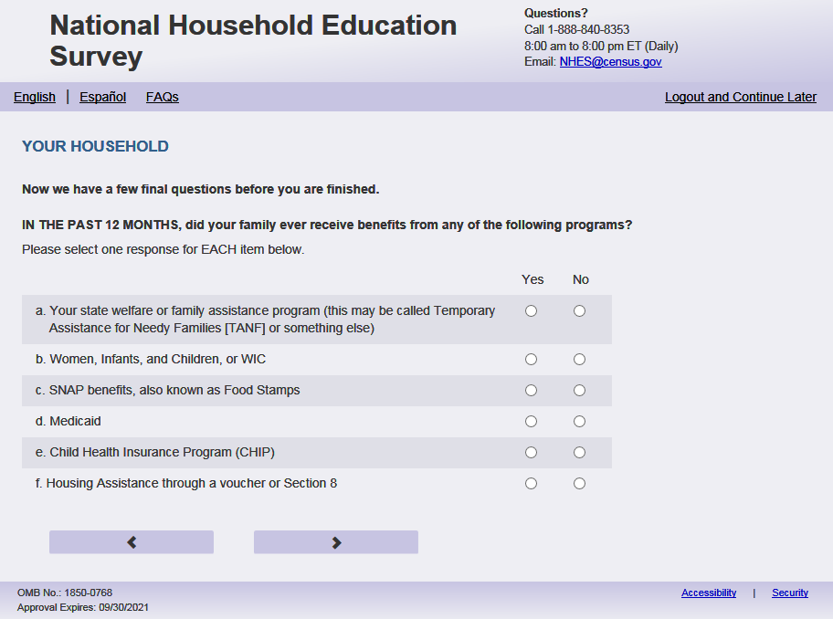
English Respondent Text Reads:
Now we have a few final questions before you are finished.
IN THE PAST 12 MONTHS, did your family ever receive benefits from any of the following programs?

Spanish Respondent Text Reads:
Antes de terminar, tenemos algunas preguntas finales.
EN LOS ÚLTIMOS 12 MESES, ¿recibió su familia beneficios de alguno de los siguientes programas alguna vez?

English Admin/TQA Text Reads:
Now we have a few final questions before you are finished.
IN THE PAST 12 MONTHS, did your family ever receive benefits from any of the following programs?
Please respond ‘yes’ or ‘no’ for EACH item as I read them.
Spanish Admin/TQA Text Reads:
Antes de terminar, tenemos algunas preguntas finales.
EN LOS ÚLTIMOS 12 MESES, ¿recibió su familia beneficios de alguno de los siguientes programas alguna vez?
Por favor, responda 'sí' o 'no' para CADA opción a medida que las leo.
English Answer
- Your state welfare or family assistance program (this may be called Temporary Assistance for Needy Families [TANF] or something else) PFIC_HWELFTAN, (1 = Yes, 2= No), numeric, radio
- Women, Infants, and Children, or WIC PFIC_HWIC (1 = Yes, 2= No), numeric, radio
- SNAP benefits, also known as Food Stamps PFIC_HFOODST, (1 = Yes, 2= No), numeric, radio
- Medicaid PFIC_HMEDICAID, (1 = Yes, 2= No), numeric, radio
- Child Health Insurance Program (CHIP) PFIC_HCHIP, (1 = Yes, 2= No), numeric, radio
- Housing assistance through a voucher or Section 8 PFIC_HSECN8, (1 = Yes, 2= No), numeric, radio

Spanish Answer

- Programa de asistencia social o familiar de su estado (puede ser Asistencia Temporal a Familias Necesitadas (TANF, por sus siglas en inglés) o algo similar) PFIC_HWELFTAN, (1= Sí, 2=No), numeric, radio
- Programa WIC (mujeres, bebés y niños) PFIC_HWIC, (1= Sí, 2=No), numeric, radio
- Beneficios de SNAP, conocido tambien como Estampillas de Comida PFIC_HFOODST, (1= Sí, 2=No), numeric, radio
- Medicaid PFIC_HMEDICAID, (1= Sí, 2=No), numeric, radio
- Programa de Seguro o Médico para Niños (CHIP, por sus siglas en inglés) PFIC_HCHIP, (1= Sí, 2=No), numeric, radio
- Asistencia de vivienda a través de un vale o sección 8 PFIC_HSECN8, (1= Sí, 2=No), numeric, radio

Skips:
Go to PFIC_TTLHHINC

Logic Checks/Programming specifications:
display as grid

Item: This Household’s Income (PFIC_TTLHHINC)
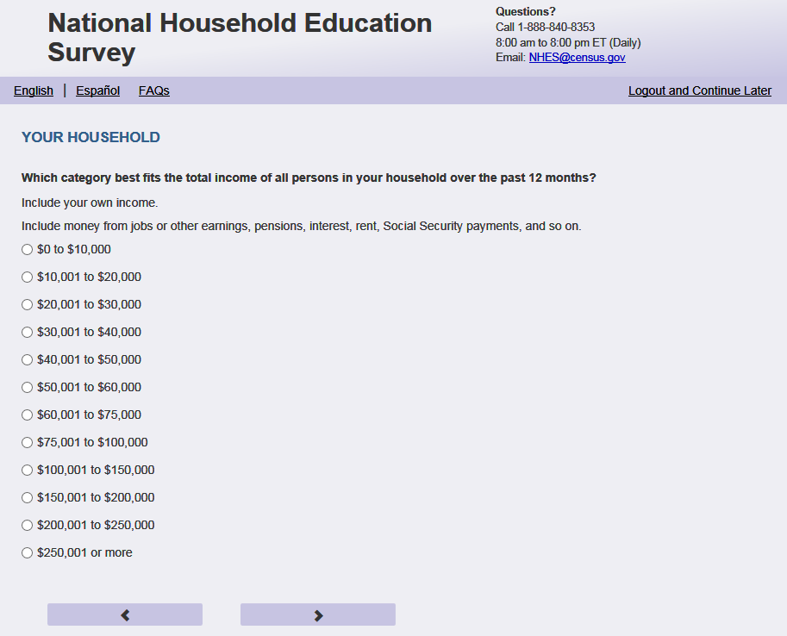
English Respondent Text Reads:
Which category best fits the total income of all persons in your household over the past 12 months?

Include your own income. Include money from jobs or other earnings, pensions, interest, rent, Social Security payments, and so on.

Spanish Respondent Text Reads
¿Qué categoría representa mejor el ingreso total de todas las personas en su hogar en los últimos 12 meses?

Incluya su propio ingreso. Incluya dinero de empleos u otras ganancias, pensiones, intereses, alquileres, pagos del seguro social, etc.

English Admin/TQA Text Reads:
Which category best fits the total income of all persons in your household over the past 12 months?
Include your own income. Include money from jobs or other earnings, pensions, interest, rent, Social Security payments, and so on.

You can give me a specific number, or choose from a range that I read to you.

[INC_DISP] Was it less than $50,000, or more than $50,000?
Spanish Admin/TQA Text Reads
¿Qué categoría representa mejor el ingreso total de todas las personas en su hogar en los últimos 12 meses?
Incluya su propio ingreso.
Incluya dinero de empleos u otras ganancias, pensiones, intereses, alquileres, pagos del seguro social, etc.

Puede darme un número específico, o elegir entre un rango que le lea.
[INC_DISP] ¿Fue menos de $50,000, o más de $50,000?
English Respondent Answer
1= $0 to $10,000
2= $10,001 to $20,000
3= $20,001 to $30,000
4= $30,001 to $40,000
5= $40,001 to $50,000
6= $50,001 to $60,000
7= $60,001 to $75,000
8= $75,001 to $100,000
9= $100,001 to $150,000
10= $150,001 to $200,000
11= $200,001 to $250,000
12= $250,001 or more

Spanish Respondent Answer
1= de $0 a $10,000
2= de $10,001 a $20,000
3= de $20,001 a $30,000
4= de $30,001 a $40,000
5= de $40,001 a $50,000
6= de $50,001 a $60,000
7= de $60,001 a $75,000
8= de $75,001 a $100,000
9= de $100,001 a $150,000
10= de $150,001 a $200,000
11= de $200,001 a $250,000
12= $250,001 o más

English Admin/TQA Answer
1 = Less than $50,000
2 = More than $50,000

[SET 1, display if INC_DISP == 1]
1= $0 to $10,000
2= $10,001 to $20,000
3= $20,001 to $30,000
4= $30,001 to $40,000
5= $40,001 to $50,000
[SET 2, display if INC_DISP == 2]
6= $50,001 to $60,000
7= $60,001 to $75,000
8= $75,001 to $100,000
9= $100,001 to $150,000
10= $150,001 to $200,000
11= $200,001 to $250,000
12= $250,001 or more

Spanish Admin/TQA Answer
1 = Menos de $50,000
2 = Más de $50,000

[SET 1, display if INC_DISP == 1]
1= de $0 a $10,000
2= de $10,001 a $20,000
3= de $20,001 a $30,000
4= de $30,001 a $40,000
5= de $40,001 a $50,000
[SET 2, display if INC_DISP == 2]
6= de $50,001 a $60,000
7= de $60,001 a $75,000
8= de $75,001 a $100,000
9= de $100,001 a $150,000
10= de $150,001 a $200,000
11= de $200,001 a $250,000
12= $250,001 o más
PFIC_TTLHHINC, (1,12), numeric, radio

Skips:
Go to PFIC_ OWNRNTHB
Logic Checks/Programming specifications:
For the Admin/TQA Answer: Once INC_DISP is selected display SET 1 or SET 2 answer options on the same page, according to the answer to INC_DISP.

Item: House or Apartment Status (PFIC_OWNRNTHB)
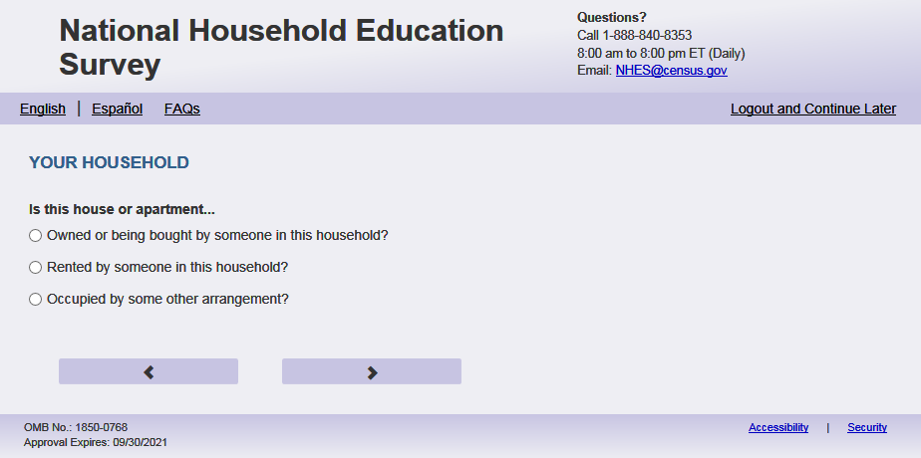
English Text Reads:
Is this house or apartment…

Spanish Text Reads:
¿Esta casa o apartamento…

English Admin/TQA Text Reads:
Is this house or apartment…

{Please read response options.}

Spanish Admin/TQA Text Reads:
¿Esta casa o apartamento…

{Por favor, lea las opciones de respuesta.}

English
1= Owned or being bought by someone in this household?
2= Rented by someone in this household?
3= Occupied by some other arrangement?

Spanish
1= ¿Es propiedad de alguien en el hogar o la está pagando alguien en este hogar?
2= ¿Es alquilada por alguien en este hogar?
3= ¿Es ocupada por algún otro tipo de acuerdo?

PFIC_OWNRNTHB, (1,3), numeric, radio

Skips:
Go to PFIC_HVINTCOM

Item: Household Internet Access (PFIC _HVINTCOM)
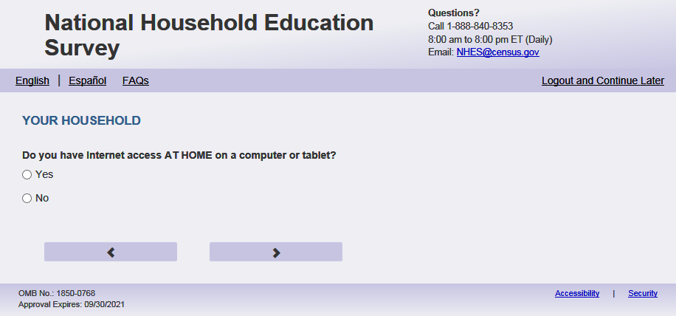
English Text Reads:
Does your household have Internet access AT HOME on a computer or tablet?

Spanish Text Reads:

¿Tiene su hogar acceso al internet EN LA CASA en una computadora o tableta?

English Answer
1=Yes
2=No

Spanish Answer
1= Sí
2=No

PFIC_HVINTCOM, (1,2), numeric, radio

Skips:

If PFIC_HVINTCOM = 2 and PFIC_P1INTSPHO = 2 and (PFIC_P2INTSPHO = 2 or missing) go to PFIC_SEFUTUREX else go to PFIC_ CHLDNT

Item: Internet Use of This Child (PFIC_CHLDNT)
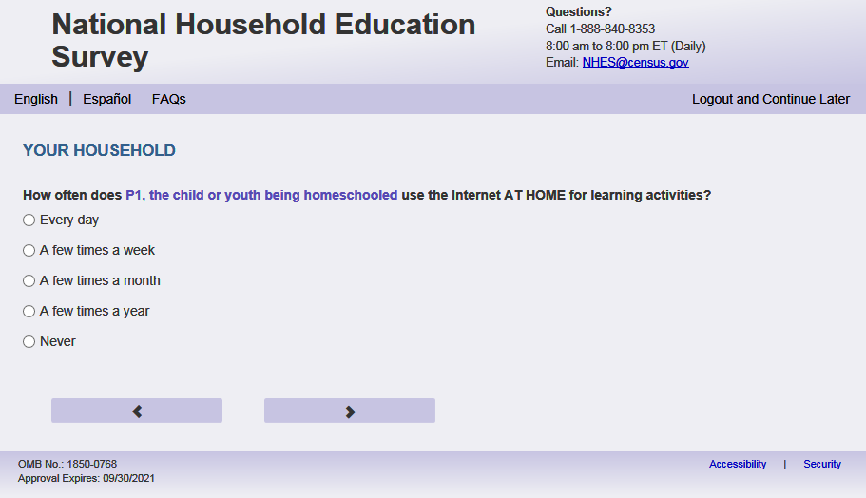
English Respondent Text
How often does [this child] use the Internet AT HOME for learning activities?

Spanish Respondent text:
¿Con qué frecuencia utiliza el internet [este niño (esta niña)] EN LA CASA para actividades de aprendizaje?

English Admin/TQA Text
How often does [this child] use the Internet AT HOME for learning activities?

{Please read response options.}
Spanish Admin/TQA text:
¿Con qué frecuencia utiliza el internet [este niño (esta niña)] EN LA CASA para actividades de aprendizaje?

{Por favor, lea las opciones de respuesta.}
English Answer
1= Every day
2 = A few times a week
3 = A few times a month
4 = A few times a year
5 = Never

Spanish Answer
1 = Todos los días
2 = Algunas veces a la semana
3 = Algunas veces al mes
4 = Algunas veces al año
5 = Nunca

PFIC_CHLDNT, (1,5) numeric, radio

Skips:

If PFIC_CHLDNT = 5 then go to PFIC_ SEFUTUREX
Else go to PFIC_LRNCOMP

Item: This Child’s Device for Learning Activities (PFIC_LRNCOMP)
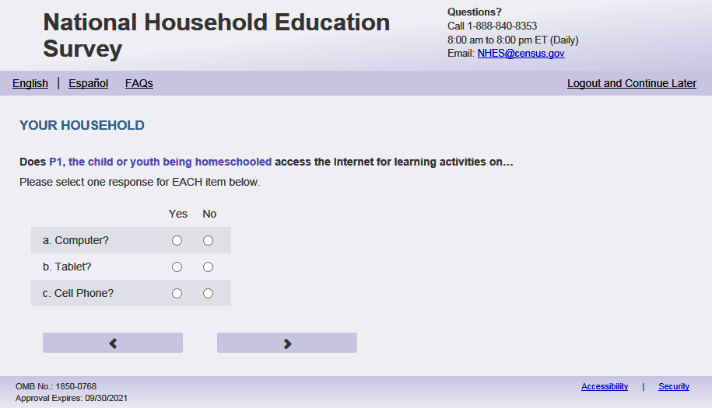
English Respondent Text Reads:
Does [this child] use the Internet for learning activities on a…
Please select one response for EACH item below.

Spanish Respondent Text Reads:
Utiliza el internet [este niño (esta niña)] para actividades de aprendizaje en…
Seleccione una respuesta para CADA opción a continuación.

English Admin/TQA Text:
Does this child use the Internet for learning activities on a computer? PFIC_LRNCOMP (1 = Yes 2 = No)
Does this child use the Internet for learning activities on a tablet? PFIC_LRNTAB (1 = Yes 2 = No)
Does this child use the Internet for learning activities on a cell phone? PFIC_LRNCELL (1 = Yes 2 = No)

Spanish Admin/TQA Text:
¿Utiliza el internet [este niño (esta niña)] para actividades de aprendizaje en una computadora? PFIC_LRNCOMP (1 = Sí 2 = No)
¿Utiliza el internet [este niño (esta niña)] para actividades de aprendizaje en una tableta? PFIC_LRNTAB (1 = Sí 2 = No)
¿Utiliza el internet [este niño (esta niña)] para actividades de aprendizaje en un teléfono celular? PFIC_LRNCELL (1 = Sí 2 = No)

English Respondent Answers:
- Computer? PFIC_LRNCOMP (1 = Yes 2 = No), numeric, radio
- Tablet? PFIC_LRNTAB (1 = Yes 2 = No), numeric, radio
- Cell phone? PFIC_LRNCELL (1 = Yes 2 = No), numeric, radio

Spanish Respondent Answers:
- ¿Computadora? PFI_LRNCOMP (1 = Sí 2 = No), numeric, radio
- ¿Tableta? PFI_LRNTAB (1 = Sí 2 = No), numeric, radio
- ¿Teléfono celular? PFI_LRNCELL (1 = Sí 2 = No), numeric, radio

Skips
Go to PFIC_ SEFUTUREX

Logic Checks/Programming specifications:
display as grid

Item: Education Expectation (PFIC_ SEFUTUREX)
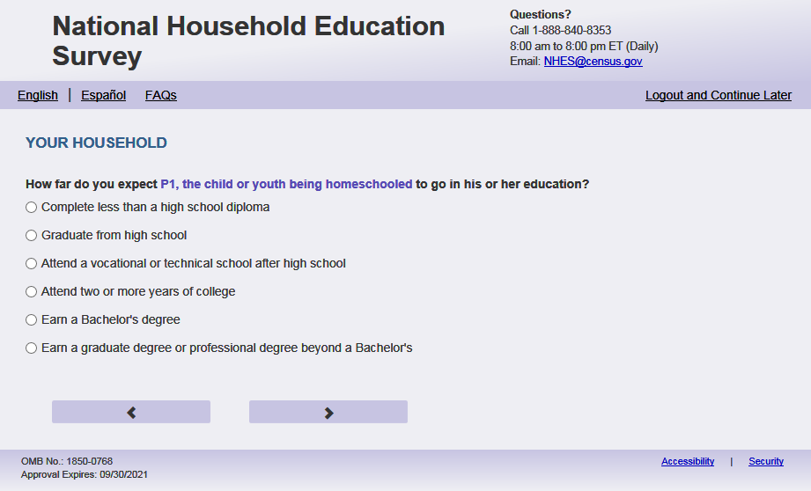
English Respondent Text Reads:
How far do you expect [this child] to go in [his/her/his or her] education?

Spanish Respondent Text Reads:
¿Qué tan lejos espera usted que [este niño (esta niña)] llegue con su educación?

English Respondent Text Reads:
How far do you expect [this child] to go in [his/her/his or her] education?

{Please read response options.}
Spanish Respondent Text Reads:
¿Qué tan lejos espera usted que [este niño (esta niña)] llegue con su educación?

{Por favor, lea las opciones de respuesta.}
English Answer
1= Complete less than a high school diploma
2 = Graduate from high school
3 = Attend a vocational or technical school after high school
4 = Attend two or more years of college
5 = Earn a bachelor’s degree
6 = Earn a graduate degree or professional degree beyond a bachelor’s

Spanish Answer:
1= Que complete menos de high school
2= Que se gradúe de high school 3= Que asista a una escuela vocacional o de oficios o escuela técnica después de completar high school
4= Que asista al college o universidad durante dos años o más
5= Que obtenga un grado de bachelor
6= Que obtenga un título de posgrado o título profesional después del título de bachelor
PFIC_ SEFUTUREX, (1,6) numeric, radio

Skips:

If (PFIC_HSENRL = 1 or blank) and PFIC_SCHLHRSWK ne 1 (includes PFIC_SCHLHRSWK 2, 3, 4 or blank), go to PFIC_RSCHOOL
Else if PFIC_EDCINTK12 = 1 or PFIC_EDCHSFL = 1 or PFIC_HMSCHARR in (1, 2) or PFIC_HSINTNET in (1, 2, 3) or PFIC_EINTNET in (1, 2, 3) go to PFIC_DEBRIEF
Else if (PFIC_HSENRL = 2 or PFIC_SCHLHRSWK = 1) and USE_CHOICE_PLUSflg = ‘ ‘ or (EBWP_FLAG = 1 and survey complete date is after 3/13/23) then go to thank_you
Else if (PFIC_HSENRL = 2 or PFIC_SCHLHRSWK=1) and USE_CHOICE_PLUSflg = 1 or (EBWP_FLAG = 1 and survey complete date is on or before 3/13/23) then go to PFIC_Incent_Name

Logic Checks/Programming specifications:
English
if PFIC_CSEX = 1 use [his] if PFIC_CSEX =2 use [her], if PFIC_CSEX Is blank, use [his or her]

Item: Child’s School (PFIC_RSCHOOL)
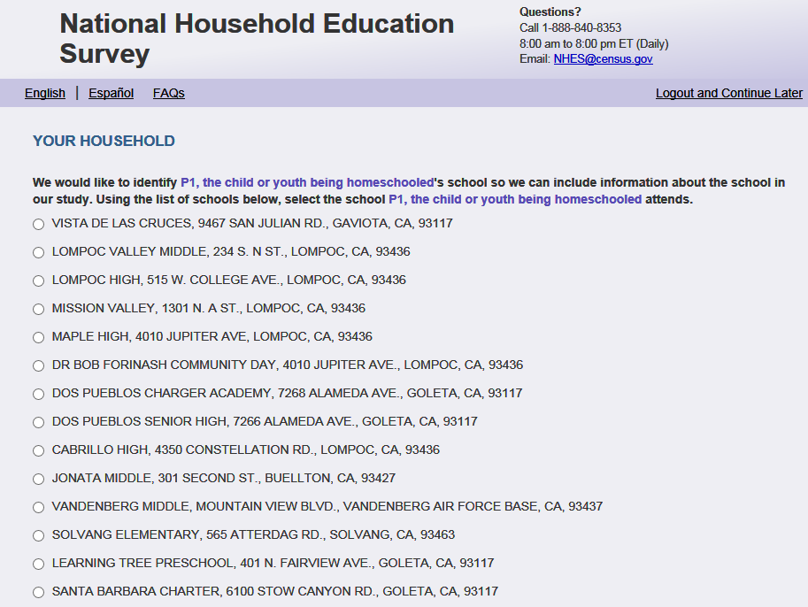
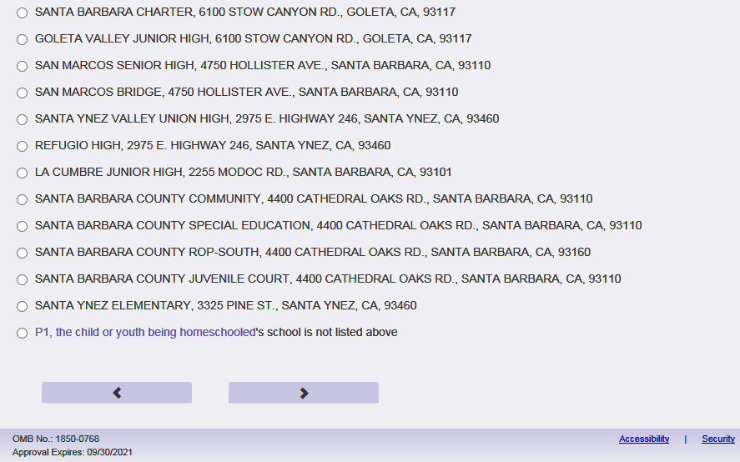
English Respondent Text Reads:
We would like to identify [this child's] school so we can include information about the school in our study. Using the list of schools below, select the school [he/she/he or she] attends.

Spanish Respondent Text Reads:
Quisiéramos identificar la escuela de [este niño(a)] para poder incluir información de la escuela en nuestro estudio.

English Admin/TQA Text Reads:
We would like to identify [this child's] school so we can include information about the school in our study. Please tell me the name of the school [he/she/he or she] attends.
{Using the list of schools below, select the school the respondent tells you this child attends. If not on this list select “[This child’s] school is not listed]}

Spanish Admin/TQA Text Reads:
Quisiéramos identificar la escuela de [este niño(a)] para poder incluir información de la escuela en nuestro estudio. Por favor, dígame el nombre de la escuela a la que asiste [él/ ella/ este niño].
{Usando la lista de escuelas a continuación, seleccione la escuela a la que el encuestado le dice que asiste este niño. Si no está en esta lista, seleccione "[La escuela de este niño] no está en la lista]}

English Answer:
list of schools
1= [This child's] school is not listed above.

Spanish Answer:
lista de escuelas
1 = no puedo encontrar la escuela de [este niño/esta niña]

Skips:
If school is selected from list and (PFIC_EDCINTK12 = 1 or PFIC_EDCHSFL = 1 or PFIC_HMSCHARR in (1, 2) or PFIC_HSINTNET in (1, 2, 3) or PFIC_EINTNET in (1, 2, 3)) go to PFIC_DEBRIEF
Else if school is selected from list and (USE_CHOICE_PLUS = missing or 0) or (EBWP_FLAG = 1 and survey complete date is after 3/13/23) then go to thank_you
Else if school is selected from list and (USE_CHOICE_PLUS= 1) or (EBWP_FLAG = 1 and survey complete date is on or before 3/13/23) then go to PFIC_Incent_Name
Else if PFIC_RSCHOOL = 1 (school is not listed) or blank (school is not selected) then go to PFIC_SCHNAME

Logic Checks/Programming specifications:
Page 1. Displays complete list of 20 nearest schools with address and city, and a radio button next to each school for respondent’s selection. If school selected, populate PFIC_SCHNAME - PFIC_SCHZIP with appropriate fields in output. Output NCES ID associated with selected school (provided on input file). Output complete projected school list (20 nearest schools) if PFIC_HSENRL = 1 or blank and PFIC_SCHLHRSWK ne 1.
NCES IDs are 8 or 12 character length and are unique for each school. Ensure there are no duplicate IDs in the listing.

POPULATING SCHOOLS:
- In addition to filtering by state; filter by grade, age, or school type. For instance:
- For filtering by school type:
If the parent indicated the child attended public school (on the topical) we only showed schools from the CCD. If they indicated private, we showed schools from the PSS. (If needed, we could provide two in put files for the look up OR include a flag if it was from CCS or PSS file). If they left it blank, we showed both. Please note, we used TOPICAL data for all the school lookup filtering, not screener level data. The only time there is screener data used would be for grade or DOB if it was collected in the screener and NOT collected or revised in the topical.
Filter school type (private or public) based on the answer on either EDCPUB, or EDCPUB2 if EDCPUB does not provide enough information.
- Use reported grade level to filter schools by available grade level as follows:
WHEN child's grade = 0 and school has (KG or PK or first) then use this school
WHEN child's grade = 1 and school has (first or KG or PK or second) then use this school
WHEN child's grade = 2 and school has (first or second or third) then use this school
WHEN child's grade = 3 and school has (second or third or fourth) then use this school
WHEN child's grade = 4 and school has (third or fourth or fifth) then use this school
WHEN child's grade = 5 and school has (fourth or fifth or sixth) then use this school
WHEN child's grade = 6 and school has (fifth or sixth or seventh) then use this school
WHEN child's grade = 7 and school has (sixth or seventh or eighth) then use this school
WHEN child's grade = 8 and school has (seventh or eighth or ninth) then use this school
WHEN child's grade = 9 and school has (eighth or ninth or tenth) then use this school
WHEN child's grade = 10 and school has (ninth or tenth or eleventh) then use this school
WHEN child's grade = 11 and school has (tenth or eleventh or twelfth) then use this school
WHEN child's grade = 12 and school has (eleventh or twelfth) then use this school

- Use reported age of the child’s date of birth to filter schools by available grade level as follows. Note, only use AGE if we do not have a grade reported:
WHEN child's age in (0,1,2,3,4) and school has (KG or PK or first) then use this school
WHEN child's age = 5 and school has (first or KG or PK or second) then use this school
WHEN child's age = 6 and school has (PK or KG or first or second or third) then use this school
WHEN child's age = 7 and school has (KG or first or second or third or fourth) then use this school
WHEN child's age = 8 and school has (first or second or third or fourth or fifth) then use this school
WHEN child's age = 9 and school has (second or third or fourth or fifth or sixth) then use this school
WHEN child's age = 10 and school has (third or fourth or fifth or sixth or seventh) then use this school
WHEN child's age = 11 and school has (fourth or fifth or sixth or seventh or eighth) then use this school
WHEN child's age = 12 and school has (fifth or sixth or seventh or eighth or ninth) then use this school
WHEN child's age = 13 and school has (sixth or seventh or eighth or ninth or tenth) then use this school
WHEN child's age = 14 and school has (seventh or eighth or ninth or tenth or eleventh) then use this school
WHEN child's age = 15 and school has (eighth or ninth or tenth or eleventh or twelfth) then use this school
WHEN child's age = 16-20 and school has (ninth or tenth or eleventh or twelfth) then use this school

English:
Last response option is "[This child's] school is not listed above."

Spanish:
Last response option is "no puedo encontrar la escuela de [este niño/esta niña]"

Item: Child’s School Write-In (PFIC_SCHNAME)
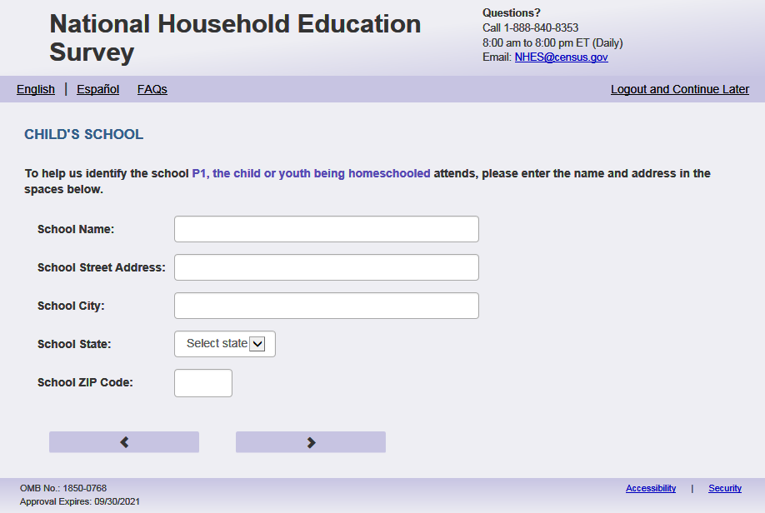
English Respondent text reads:
To help us identify the school [this child] attends, please enter the name and address in the spaces below.
Spanish Respondent text reads:
Para ayudarnos a identificar la escuela a la que asiste [este niño (esta niña)], por favor ingrese el nombre y la dirección en los espacios a continuación.
English Admin/TQA text reads:
To help us identify the school [this child] attends, please provide some additional information about [this child]’s school’s name and address.
{Ask for the following information that has not been provided yet.}
Spanish Admin/TQA text reads:
Para ayudarnos a identificar la escuela a la que asiste [este niño (esta niña)], por favor proporcione información adicional sobre el nombre y la dirección de la escuela de [este niño (esta niña)].
{Solicitar la siguiente información que aún no se ha proporcionado.}

English Answers:
- School Name, PFIC_SCHNAME, (0,500), character, write-in
- School Street Address, PFIC_SCHADDRE, (0,500), character, write-in
- School City, PFIC_SCHCITY, (0,250), character, write-in
- School State, PFIC_SCHST, (1,51), character, drop-down
- School ZIP Code, PFIC_SCHZIP, (0,99999), numeric, write-in

Spanish Answers:
- Nombre de la escuela, PFIC_SCHNAME, (0,500), character, write-in
- Dirección de la escuela, PFIC_SCHADDRE, (0,500), character, write-in
- Ciudad de la escuela, PFIC_SCHCITY, (0,250), character, write-in
- Estado de la escuela, PFIC_SCHST, (1,51), character, drop-down
- Código Postal de la escuela, PFIC_SCHZIP, (0,99999), numeric, write-in

Skips:
When respondent selected ‘Next’ and (PFIC_EDCINTK12 = 1 or PFIC_EDCHSFL = 1 or PFIC_HMSCHARR in (1, 2) or PFIC_HSINTNET in (1, 2, 3) or PFIC_EINTNET in (1, 2, 3)) go to PFIC_DEBRIEF
Else when respondent selected ‘Next’ and (USE_CHOICE_PLUS = missing or 0) or (EBWP_FLAG = 1 and survey complete date is after 3/13/23) then go to thank_you
Else if respondent selected ‘Next’ and (USE_CHOICE_PLUS= 1) or (EBWP_FLAG = 1 and survey complete date is on or before 3/13/23)then go to PFIC_Incent_Name

Logic Checks/Programming specifications:
a.- c. display box 1 row by 50 characters
d. dropdown of states
e. display box 1 row by 5 characters, mobile: display numeric keypad

Item: PFI Debrief Request (PFIC_DEBRIEF)
<New item for NHES:2023 – no screenshot available>
English Text Reads
We would like to know more about the experiences of homeschooled students, virtual school students, and students in online courses. Would you be interested in participating in a one-on-one virtual interview to help us understand your survey responses in greater detail? We offer a $40 cash incentive for participation in the interview. The interview will be conducted via Zoom and will last approximately 1 hour.
Spanish Text Reads
Nos gustaría saber más sobre las experiencias de los estudiantes educados en el hogar, los estudiantes de escuelas virtuales y los estudiantes en cursos online. ¿Estaría interesado en participar en una entrevista virtual individual para ayudarnos a entender las respuestas de su encuesta con mayor detalle? Ofrecemos un incentivo en efectivo de $40 por la participación en entrevista. La entrevista tendrá lugar en Zoom y durará aproximadamente 1 hora.
English Answer
1 = Yes, I am interested.
2 = No, I am not interested and please do not contact me further

Spanish Answer
1 = Sí, me interesa.
2 = No, no estoy interesado y por favor no me contacte más

Skips:
If “Yes, I am interested” go to PFIC_DEBRIEFmd
Else (USE_CHOICE_PLUS = missing or 0) or (EBWP_FLAG = 1 and survey complete date is after 3/13/23) then go to thank_you
Else if (USE_CHOICE_PLUS = 1) or (EBWP_FLAG = 1 and survey complete date is on or before 3/13/23) then go to PFIC_Incent_Name

Item: PFI Debrief Request (PFIC_DEBRIEFmd)
<New item for NHES:2023 – no screenshot available>
English Text Reads
Do you prefer to be contacted by email or phone?
NOTE: You will not at any time be solicited, nor will your email address or phone number be shared, traded, or sold.
Spanish Text Reads
¿Prefiere ser contactado por correo electrónico o por teléfono?
NOTA: En ningún momento se le ofrecerán servicios, ni se compartirá, comercializará ni venderá su dirección de correo electrónico o número de teléfono.
English Answer
1 = Email
2 = Phone

Spanish Answer
1 = Correo electrónico
2 = Teléfono

Skips:
Go to PFIC_DEBRIEFcntct
Else (USE_CHOICE_PLUS = 0 or missing) or (EBWP_FLAG = 1 and survey complete date is after 3/13/23) then go to thank_you
Else if (USE_CHOICE_PLUS = 1) or (EBWP_FLAG = 1 and survey complete date is on or before 3/13/23) then go to PFIC_Incent_Name

Item: PFI Debrief Request (PFIC_DEBRIEFcntct)
<New item for NHES:2023 – no screenshot available>
English Text Reads
Please provide the following information so that we may contact you about the study.
Spanish Text Reads
Por favor, proporcione la siguiente información para que podamos ponernos en contacto con usted acerca del estudio.
English Answer
Title: (dbrf _title)
First Name: _____________________ (dbrf _gvname)
Last Name: _____________________ (dbrf _lstname)
Email: _________________________(dbrf_email)
Phone:__________________________(dbrf_phone)
Spanish Answer
Título: (dbrf _title)
Nombre de pila: _____________________ (dbrf _gvname)
Apellido: _____________________ ______(dbrf _lstname)
Correo electrónico: ____________________(dbrf_email)
Teléfono:____________________________(dbrf_phone)

dbrf _title: Dropdown, character
dbrf _gvname: write-in (0, 100) character, write-in
dbrf _lstname: write-in (0, 100) character, write-in
dbrf_email: write-in (0, 100) character, write-in
dbrf_phone: write-in (0, 100) character, write-in, mobile: display numeric keypad
Skips:
If (USE_CHOICE_PLUS = missing or 0) or (EBWP_FLAG = 1 and survey complete date is after 3/13/23) then go to thank_you
Else if (USE_CHOICE_PLUS = 1) or (EBWP_FLAG = 1 and survey complete date is on or before 3/13/23) then go to PFIC_Incent_Name

Logic checks/Programming Specifications:
if PFIC_DEBRIEFmd = 1 only display dbrf _gvname, dbrf _lstname, and dbrf_email
if PFIC_DEBRIEFmd = 2 only display dbrf _gvname, dbrf _lstname, and dbrf_phone
if PFIC_DEBRIEFmd = blank display dbrf _gvname, dbrf _lstname, dbrf_email, and dbrf_phone
English
Display “Title” to the left of the first dropdown box if PFIC_DEBRIEFmd in (1, 2)
Display “First Name” to the left of the first write-in box if PFIC_DEBRIEFmd in (1, 2)
Display “Last Name” to the left of the second write-in box if PFIC_DEBRIEFmd in (1, 2)
Display “Email” to the left of the first write-in box if PFIC_DEBRIEFmd = 1
Display “Phone” to the left of the first write-in box if PFIC_DEBRIEFmd = 2
Display “Email” to the left of the first write-in box if PFIC_DEBRIEFmd = 1 and blank
Display “Phone” to the left of the first write-in box if PFIC_DEBRIEFmd = 2 and blank

Spanish
Display “Título” to the left of the first dropdown box if PFIC_DEBRIEFmd in (1, 2)
Display “Nombre de pila” to the left of the first write-in box if PFIC_DEBRIEFmd in (1, 2)
Display “Apellido” to the left of the second write-in box if PFIC_DEBRIEFmd in (1, 2)
Display “Correo electrónico” to the left of the first write-in box if PFIC_DEBRIEFmd = 1 and blank
Display “Teléfono” to the left of the first write-in box if PFIC_DEBRIEFmd = 2 and blank

Item: Confirm information PFI (PFIC_Incent_Name)
English Text Reads
Thank you for your participation in the National Household Education Survey! Your answers have been submitted. We will mail you $20 to show our appreciation for completing the survey. Please confirm your contact information below to ensure you receive the cash incentive.
To whom should we address the envelope?

Spanish Text Reads
Gracias por su participación en la Encuesta Nacional en Hogares sobre Educación. Sus respuestas han sido enviadas. Le enviaremos por correo $20 para mostrarle nuestro agradecimiento por completar la encuesta. Por favor, confirme su información de contacto a continuación para asegurarse de recibir el incentivo en efectivo.
¿A quién deberíamos dirigir el sobre?

English Answer
Title: (inc_title)
First Name: _____________________ (inc_gvname)
Last Name: _____________________ (inc_lstname)

Spanish Answer
Título: (inc_title)
Nombre de pila: _____________________ (inc_gvname)
Apellido: _____________________ (inc_lstname)

inc_title: Dropdown, character
inc_gvname: write-in (0, 100) character, write-in
inc_lstname: write-in (0, 100) character, write-in

Skip patterns:
Go to inc_address
Logic checks/Programming Specifications:
For inc_title use a standard dropdown for titles (for example: Mr., Ms., Mrs., Miss, Dr.)
Align inc_title dropdown with the other text boxes
English
Display “Title” to the left of the first dropdown box
Display “First Name” to the left of the first write-in box
Display “Last Name” to the left of the second write-in box

Item: Confirm address PFIC (PFIC_inc_address)
English Text Reads

PRIM_ADD
SEC_ADD
city, state zip-ZIP4

This is the current address we have for you. Is this the address we should use to send you the $20 incentive?
Spanish Text Reads
PRIM_ADD
SEC_ADD
city, state zip-ZIP4

Esta es la dirección actual que tenemos para usted. ¿Es esta la dirección que deberíamos usar para enviarle el incentivo de $20?
English Answer
1= Yes, the address is correct.
2= No, I need to update my address.
Spanish Answer
1= Sí, la dirección es correcta.
2= No, necesito actualizar mi dirección.
inc_address, (1,2), numeric, radio
Skip patterns:
Go to “PFIC_survey_end_inc” if PFIC_inc_address=1, else go to PFIC_prim_add_new
Logic checks/Programming specifications:
Display on the same page as inc_title, inc_gvname, inc_lstname
The variables PRIM_ADD, SEC_ADD, city, state, zip and ZIP4 are available on the frame file and specify the address of the household. These variables should be used to fill this item so that respondents can confirm their addresses.

Item: Address Information (PFIC_PRIM_ADD_new)
English Text reads:
Please enter your correct mailing address below:
Spanish Text reads:
Por favor ingrese su dirección postal correcta a continuación:
English Answer:
Address Line 1: _____________________________ (PFIC_PRIM_ADD_new)
Address Line 2: _____________________________ (PFIC_SEC_ADD_new)
City: _________________________ (PFIC_city_new)
State: ________________________ (PFIC_state_new)
ZIP:____________________ (PFIC_zip_new)
Spanish Answer:
Dirección Postal Line 1: _____________________________ (PFIC_PRIM_ADD_new)
Dirección Postal Line 2: _____________________________ (PFIC_SEC_ADD_new)
Ciudad: _________________________ (PFIC_city_new)
Estado: ________________________ (PFIC_state_new)
Código Postal:____________________ (PFIC_zip_new)

PFIC_PRIM_ADD_new: write-in (0, 100) character, write-in
PFIC_SEC_ADD_new: write-in (0, 100) character, write-in
PFIC_city_new: write-in (0, 100) character, write-in
PFIC_state_new: dropdown, numeric
PFIC_zip_new: write-in (0, 10) character, write-in, mobile: display numeric keypad
Skip patterns:
Go to “PFIC_survey_end_inc”
Logic checks/Programming Specifications:
For PFIC_state_new dropdown, use a dropdown with the 50 states in the United States and the District of Columbia.
English
Display “Address Line 1” to the left of the first write-in box
Display “Address Line 2” to the left of the second write-in box
Display “City” to the left of the third write-in box
Display “State” to the left of the first dropdown box
Display “ZIP” to the left of the fourth write-in box
Spanish
Display “Dirección Postal 1” to the left of the first write-in box
Display “Dirección Postal 2” to the left of the second write-in box
Display “Ciudad” to the left of the third write-in box
Display “Estado” to the left of the first dropdown box
Display “Código Postal” to the left of the fourth write-in box

Item: Survey End (PFIC_survey_end_inc)
English Text reads:
Thank you! You should receive your cash incentive soon. If you do not receive it after 3-5 weeks, please call us toll free at 1-888-840-8353.
Spanish text reads:
¡Gracias! Debería recibir su incentivo en efectivo pronto. Si no lo recibe después de 3-5 semanas, llámenos grátis al 1-888-840-8353.

English Answer:
‘Exit Survey’ button
Spanish Answer:
‘Salir de la Encuesta’ button

Item: Thank You Page (PFIC_thank_you)

English: Thank you for your participation in the National Household Education Survey! Your answers have been submitted. We have no further questions for you.
Exit Survey button

Spanish: Gracias por su participación en la Encuesta Nacional en Hogares sobre Educación. Sus respuestas han sido enviadas. No tenemos más preguntas.

Salir de la Encuesta’ button

Item: After Exit Survey

After “Exit Survey” button is clicked the respondent goes to the login page and says “You have been logged out” (Spanish “Usted ha sido desconnectado”). See screenshots below. respondent doesn't have to select exit survey, reaching this page does submit their answer and their case would be considered submitted/complete. But selecting that exit survey re-affirms they are done and 'logged out'. Lastly, if you log back in for a case that has reached the page with 'exit survey' it simply takes you back to this page; you can't hit back and edit answers.

