February 04, 2022

MEMORANDUM
To: Robert Sivinski, OMB
From: Deanne Swan, NCES
Through: Carrie Clarady, NCES
Re: School Survey on Crime and Safety (SSOCS) 2022 Communication Change Request (OMB# 1850-0761 v.22)
The School Survey on Crime and Safety (SSOCS) is a nationally representative survey of elementary and secondary school principals that serves as the primary source of school-level data on crime and safety in public schools. SSOCS is the only recurring federal survey collecting detailed information on the incidence, frequency, seriousness, and nature of violence affecting students and school personnel from the school’s perspective. Data are also collected on frequency and types of disciplinary actions taken for select offenses; perceptions of other disciplinary problems, such as bullying, verbal abuse and disorder in the classroom; the presence and role of school security staff; parent and community involvement; staff training; mental health services available to students; and, school policies and programs concerning crime and safety. Prior administrations of SSOCS were conducted in 2000, 2004, 2006, 2008, 2010, 2016, 2018, and 2020. The 2022 SSOCS full-scale data collection were approved in July 2021 (OMB# 1850-0761 v.21).
This submission provides updated versions of the SSOCS 2022 communication materials and focuses on two changes: (a) the addition of an experiment to look at the effect of the timing of communication, (b) changes to communication materials, and (c) changes to the instrument based on cognitive testing. These changes result in no changes to participant burden or cost to the federal government.
SSOCS:2022 will include an experiment to test the timing of email notification. The goal of the experiment is to refine the email strategy by comparing response rates, indicators of nonresponse bias, and time-to-respond metrics between two groups: the traditional schedule (mail-out package followed by email reminder) and the “email-first” treatment (email invitation prior to receipt of mail-out package). Schools in the “email-first” treatment group will receive an email invitation prior to receiving a mail-out package. This treatment group will be evaluated against the control group, while will receive the email reminders following the delivery of the mail-out packages.
Communication materials have been updated with more current information. Changes have been made to the brochure, the questionnaire, and the letters and emails. These changes include changes in the signature for letters and emails and to include updated prevalence estimates from the most recent SSOCS collection (SSOCS: 2020). In addition, based on guidance from ED leadership, branding has been changed to be more consistent and focused on the Department. Thus, study-specific branding, such as the SSOCS logo, has been removed and replaced with logos from the Department and Center.
The SSOCS 2022 instrument has been updated. The questionnaire has been changed based on revisions to CDC guidelines and resulting revisions to the item language during cognitive testing. Cognitive testing was done with school administrators during the winter and spring of 2021, per the OMB package as approved in July 2021. Based on results of cognitive testing, items 7 and 8 were combined. All subsequent numbers were changed to adjust for this action (e.g., item 9 became item 8).
Part B has been updated to reflect the addition of the email timing experiment. Part C has been updated with the changes to the instrument. Appendix A has been updated with the revised brochure, letters, emails, and instrument. Appendix B has been updated with the revised questionnaire instrument.
The noteworthy changes to the approved materials are listed below. Text added since the last approved version of each document is marked in red font color, all text deleted since the last approved version is marked in crossed-out red font color, and all unchanged text is shown in black font.

Supporting Statement Part B – SSOCS 2022 Methodology

Summary of Changes to SSOCS: 2022 Methodology

- Addition of an experiment to test the timing of email notifications (Section B4).
- Addition of key staff (Section B5).

Addition of experiment to test the Timing of Email Notifications (p. 9)

Experiments
SSOCS:2022 will include an experimental treatment group to test the timing of email notifications. Schools in the “email-first” treatment group will receive an email invitation prior to receiving a mail-out package. This treatment group will be evaluated against the control group, which will receive the email reminders following the delivery of the mail-out packages.
Among a total sample of 4,800 schools, approximately 2,400 schools will be selected at random to be included in the “email-first” treatment group and the remaining 2,400 schools will be in the control group. Given these sample sizes, the minimal detectable difference between treatment and control is estimated to be 5%. The actual experiment will gain additional power as the response rates for each group deviate from 50 percent.
The goal of this experiment is to refine the SSOCS email strategy by comparing response rates, indicators of nonresponse bias, and time-to-respond metrics for the early email strategy, relative to the traditional email strategy.

Addition of Key Staff Member (p. 9)

- Deanne Swan, Project Director, National Center for Education Statistics

Supporting Statement Part C – SSOCS 2022 Item Justification

- Following cognitive testing, items 7 & 8 were revised and combined into one item, which is now Item 7 on the SSOCS:2022 questionnaire. As a result, the reference to item 8 has been deleted from this section. (p. 4) These items are shown on p. 52 of this change memo.
  - Questions 7 and 8 asks if school emergency readiness practices like fire drills and active shooter drills have been modified in response to CDC safety guidelines and what specific modifications have been made. These emergency readiness practices are important in preparing students and teachers for disasters but require special considerations in order to practice them while adhering to CDC guidelines for protecting the health and safety of students and staff and slowing the spread of COVID-19.
- Since item 8 was combined with item 7; all following item numbers referenced in this section (pp. 4-8) were revised – i.e., items 9-51 have been revised to 8-50.
- Descriptive text for new item 8 was modified based on revisions to CDC guidelines and resulting revisions to the item language during cognitive testing. Previously the item and description specified a recommended distance between students; it has been revised to more broadly mention social distancing. (p. 4)
  - Question 9 8 asks if a site assessment has been conducted to evaluate schools’ preparedness to operate according to CDC safety guidelines for operating schools during COVID-19. A site assessment evaluates the safety, accessibility, and emergency preparedness of the school’s buildings and grounds. Specific CDC guidelines covered by a site assessment may include ensuring that there is adequate room to maintain 6-foot distance social distancing between students and using appropriate air filtration systems. These assessments can help schools identify health and safety threats and risks, informing the understanding of issues and resources that may need to be addressed in the development or updating of pandemic disease response plans.
- Following cognitive testing, items 7 & 8 were revised and combined into one item, which is now Item 7 on the SSOCS:2022 questionnaire. As a result, the reference to item 8 has been deleted from this section and language has been reincorporated into the item 7 rationale. (p. 10)
  - Item 7. This item has been added to gather information on whether schools have made modifications to emergency readiness practices (such as drills) to adhere to strategies for mitigating the spread of COVID-19 and the specific ways in which these emergency readiness practices were modified.
- Since item 8 was combined with item 7; all following item numbers referenced in this section were revised – i.e., item 9 has been revised to item 8. (p. 10)

Appendix A – SSOCS 2022 Communication Materials
Summary of Changes to Contact Materials (Physical and E-mail) for SSOCS:2022

- The SSOCS 2022 trifold brochure (pp. 3-6) has been updated with new prevalence estimates from the SSOCS 2020 data collection, new images of students, and to be consistent with new guidelines for branding at the Department and the Center.
- The letters have been revised.
  - All letters have been revised to reflect a change in leadership staff (replacing the signature from the former NCES Commissioner to the current Associate Commissioner of NCES Sample Surveys Division).
  - All letters in which there had been language referring to the COVID-19 pandemic have been updated to present tense to indicate that the pandemic is still ongoing, as opposed to past tense.
  - All letters with the SSOCS logo have been updated to remove the study-specific branding, consistent with Department guidelines.
  - All letters with reference to prevalence estimates have been updated with more recent data from SSOCS 2020.
- Emails have been revised.
  - One new email has been added as part of the timing experiment. This email will go to half of the sample, based on assignment to the “email-first” treatment.
  - All emails in which there had been language referring to the COVID-19 pandemic have been updated to present tense to indicate that the pandemic is still ongoing.
  - All emails with reference to prevalence estimates have been updated with more recent data from SSOCS 2020.
- Web Instrument has been updated with the date (2021-22), time to complete, and OMB expiration date, and new screenshots have been added.

Changes to SSOCS 2022 Trifold Brochure

Front Page: Image updated; Layout position of title and logos (ED and Census) adjusted
Front Page: SSOCS Logo removed from primary image
Section: WHAT TOPICS ARE COVERED IN THE QUESTIONNAIRE?
- “School policies and programs to promote a safe school environment:” changed to “School policies and programs concerning crime and safety;”
- Added “School preparedness and practices for operating during the COVID-19 pandemic;”
- “Responsibilities of sworn law enforcement officers and SROs;” changed to “Responsibilities of sworn law enforcement officers and school resource officers;”
Section: DO INDIVIDUAL SCHOOL DATA REMAIN CONFIDENTIAL
- “Any attempt on the part of the data user to identify a school or a specific respondent is prohibited by law and punishable with a fine of up to $250,000 and/or a prison term up to 5 years” changed to “Any attempt on the part of the data user to identify a school or a specific respondent is prohibited by law and punishable with a fine of up to $250,000 or up to 5 years in prison, or both (Class E felony).”
Second Page: Image updated
Second Page: Graphics updated with estimates from SSOCS 2020
- Upper pie chart has been updated to display estimate from 2019-2020 school year: “71% of schools reported violent incidents” changed to “70% of schools reported violent incidents”
- Lower pie chart has been updated to display estimate from 2019-2020 school year: 45% of schools reported having a School Resource Officer present at least once a week changed to “52% of schools had a written plan for procedures in the event of a pandemic disease”
Section: WHAT IS THE SCHOOL SURVEY ON CRIME AND SAFETY (SSOCS)?
- “… it has been administered seven times since 2000 to nationally representative samples of schools and will be conducted again in the spring of the 2019-20 school year. On average, the survey takes 45 minutes to complete” changed to “… it has been administered eight times since 2000 to nationally representative samples of schools and will be conducted again in the spring of the 2020-21 school year. On average, the survey takes 50 minutes to complete.”
Section: WHY WAS MY SCHOOL SELECTED?
- “The SSOCS sample is designed to provide national estimates of primary, middle, high, and combined grade public schools.” changed to “The SSOCS sample is designed to provide national estimates of elementary, middle, high, and combined grade public schools.”
Section: WHY IS THE SSOCS IMPORTANT?
- “The U.S. Department of Education recognizes that schools are essential for learning: without a safe and secure environment, teachers and students cannot learn.” This has been separated into two sentences for readability: “The U.S. Department of Education recognizes that schools are essential for learning. Without a safe and secure environment, teachers and students cannot learn.”

Changes to Communication Materials (printed and email)

2022 Advance Letter to District Superintendent (02/10/22)
SSOCS-10L

Dear SUPERINTENDENT:

The National Center for Education Statistics (NCES) of the U.S. Department of Education is conducting
the only regular national study about crime and safety in public schools.

The School Survey on Crime and Safety (SSOCS) was previously conducted in the 1999–2000,
2003–04, 2005–06, 2007–08, 2009–10, 2015–16, 2017–18, and 2019–20 school years, which allows study of change over time. It collects information on the incidence, frequency, and nature of unsafe behaviors affecting students and school personnel, as well as school characteristics associated with school crime.

At least one school in your district has been selected to participate in SSOCS. Enclosed are materials pertaining to the survey for your reference; you do not need to take any action. Each school will receive a letter asking them to participate, list of endorsements, and brochure describing the survey.

Participating in SSOCS may create apprehension of sharing school information related to crime. Please
be assured that by federal mandate we are required to protect the responses of all schools included in
our survey. Individual responses will be combined with those from other participants to produce
summary statistics and reports only.

With your district’s participation, we can provide data to state and federal agencies about various types
of crime and discipline in schools. These data inform policy and funding used to make schools safer.
Though SSOCS is voluntary, we ask principals of all sampled schools to complete the survey, as a way
of providing an accurate picture of the diversity in our nation’s schools.

Thank you for your consideration. We hope that you will encourage the selected school(s) in your district
to participate. If you have any questions about the study, please contact the U.S. Census Bureau, the
survey collection agency, at 1–888–595–1332 or email at ssocs@census.gov. To learn more about
SSOCS, please visit http://www.nces.ed.gov/surveys/ssocs.

Sincerely,

Chris Chapman
Associate Commissioner
National Center for Education Statistics
U.S. Department of Education
James (Lynn) Woodworth, Ph. D.
Commissioner
National Center for Education Statistics
U.S. Department of Education

Enclosures

Brochure
2022 SSOCS Questionnaire
Endorsements

NCES is authorized to conduct this survey by the Education Sciences Reform Act of 2002 (ESRA 2002, 20 U.S.C. §9543). All of the information schools provide may be used only for statistical purposes and may not be disclosed, or used, in identifiable form for any other purpose except as required by law (20 U.S.C. §9573 and 6 U.S.C. §151). Reports of the findings from the survey will not identify participating districts, schools, or staff. Individual responses will be combined with those from other participants to produce summary statistics and reports.

2022 Advance Letter to Chief State School Officer (02/10/22)
SSOCS-11L

Dear <insert name>:

The National Center for Education Statistics (NCES) of the U.S. Department of Education is conducting
the only regular national study about crime and safety in public schools.

The School Survey on Crime and Safety (SSOCS) was previously conducted in the 1999–2000,
2003–04, 2005–06, 2007–08, 2009–10, 2015–16, 2017–18, and 2019-20 school years, which allows study of change over time. It collects information on the incidence, frequency, and nature of unsafe behaviors affecting students and school personnel, as well as school characteristics associated with school crime.

At least one school in your state has been selected to participate in SSOCS. Enclosed are materials
pertaining to the survey for your reference; you do not need to take any action. Each school will receive
a letter asking them to participate, a list of endorsements, and brochure describing the survey.

Participating in SSOCS may create apprehension of sharing school information related to crime. Please
be assured that reports of the findings from the survey will not identify schools by name. Individual
responses will be combined with those from other participants to produce summary statistics and
reports only.

With your state’s participation, we can provide data to state and federal agencies about various types
of crime and discipline in schools. This data informs policy and funding used to make schools safer.
Though SSOCS is voluntary, we ask principals of all sampled schools to complete the survey, as a way
of providing an accurate picture of the diversity in our nation’s schools.

Thank you for your assistance. We hope that you will encourage districts within your state to participate.
If you have any questions about the study, please contact the U.S. Census Bureau, the survey collection
agency, at 1–888–595–1332 or email at ssocs@census.gov. To learn more about SSOCS, please visit http://www.nces.ed.gov/surveys/ssocs.

Sincerely,

Chris Chapman
Associate Commissioner
National Center for Education Statistics
U.S. Department of Education
James (Lynn) Woodworth, Ph. D.
Commissioner
National Center for Education Statistics
U.S. Department of Education

Enclosures

2022 SSOCS Questionnaire
Endorsements
Brochure

NCES is authorized to conduct this survey by the Education Sciences Reform Act of 2002 (ESRA 2002, 20 U.S.C. §9543). All of the information schools provide may be used only for statistical purposes and may not be disclosed, or used, in identifiable form for any other purpose except as required by law (20 U.S.C. §9573 and 6 U.S.C. §151). Reports of the findings from the survey will not identify participating districts, schools, or staff. Individual responses will be combined with those from other participants to produce summary statistics and reports.

2022 Initial Letter to Principal - No Incentive, No E-mail (02/15/22)
SSOCS-13L(W)

Dear <insert name>:

We at the National Center for Education Statistics (NCES) within the U.S. Department of Education, need
your help by completing the 2022 School Survey on Crime and Safety (SSOCS). SSOCS is the only
national recurring survey that focuses on the frequency of crime and violence in public schools and the
programs and practices developed to provide a safe school environment.

The COVID-19 pandemic is an unprecedented moment in history that has affected how schools keep students and staff safe. The COVID-19 pandemic was an unprecedented moment in history that caused global social and economic disruption, including long-term effects on how K-12 education is administered and how schools keep students and staff safe. In response to the pandemic, Congress approved various relief packages to assist schools with implementing safety measures and getting the equipment needed to safely open back up for in-school instruction. However, to provide evidence for the need for continued funds, we need accurate data to show where schools need the most help. Therefore, we need your help by responding to the 2022 SSOCS.

Your survey responses will be collected on a secure website. Please complete the survey online within two weeks.

Respond now at https://respond.census.gov/ssocs
Log in using this User ID: <USERID>

Please be assured that reports of the findings from the survey will not identify schools by name. Individual responses will be combined with those from other participants to produce summary statistics and reports. For more information regarding SSOCS, please refer to the Frequently Asked Questions on the back of this letter,
enclosed brochure, and list of endorsers.

If you have any general questions about the study, contact the U.S. Census Bureau, the survey collection agency, at 1–888–595–1332 or via e-mail at ssocs@census.gov. To learn more about SSOCS, visit http://www.nces.ed.gov/surveys/ssocs.

We look forward to your school’s participation in this important data collection effort.

Sincerely,

Chris Chapman
Associate Commissioner
National Center for Education Statistics
U.S. Department of Education
James (Lynn) Woodworth, Ph. D.
Commissioner
National Center for Education Statistics
U.S. Department of Education

Enclosures

Brochure
Endorsements

NCES is authorized to conduct this survey by the Education Sciences Reform Act of 2002 (ESRA 2002, 20 U.S.C. §9543). All of the information you provide may be used only for statistical purposes and may not be disclosed, or used, in identifiable form for any other purpose except as required by law (20 U.S.C. §9573 and 6 U.S.C. §151). Reports of the findings from the survey will not identify participating districts, schools, or staff. Individual responses will be combined with those from other participants to produce summary statistics and reports.

2022 Initial Letter to Principal - No Incentive, E-mail (02/15/22)
SSOCS-13L(WE)

Dear <insert name>:

We at the National Center for Education Statistics (NCES) within the U.S. Department of Education, need your
help by completing the 2022 School Survey on Crime and Safety (SSOCS). SSOCS is the only national recurring
survey that focuses on the frequency of crime and violence in public schools and the programs and practices
developed to provide a safe school environment.

The COVID-19 pandemic is an unprecedented moment in history that has affected how schools keep students and staff safe. The COVID-19 pandemic was an unprecedented moment in history that caused global social and economic disruption, including long-term effects on how K-12 education is administered and how schools keep students and staff safe. In response to the pandemic, Congress approved various relief packages to assist schools with implementing safety measures and getting the equipment needed to safely open back up for in-school instruction. However, to provide evidence for the need for continued funds, we need accurate data to show where schools need the most help. Therefore, we need your help by responding to the 2022 SSOCS.

- Your survey responses will be collected on a secure website. Please complete the survey online within two weeks.

Respond now at https://respond.census.gov/ssocs
Log in using this User ID: <USERID>

For your convenience, the Internet link to the survey, as well as your User ID, will be sent to you via e-mail at the following address: <address>

Please be assured that reports of the findings from the survey will not identify schools by name. Individual responses will be combined with those from other participants to produce summary statistics and reports. For more information regarding SSOCS, please refer to the Frequently Asked Questions on the back of this letter, enclosed brochure, and list of endorsers.

If you have any general questions about the study, contact the U.S. Census Bureau, the survey collection agency, at 1–888–595–1332 or via e-mail at ssocs@census.gov. To learn more about SSOCS, visit http://www.nces.ed.gov/surveys/ssocs.

We look forward to your school’s participation in this important data collection effort.

Sincerely,

Chris Chapman
Associate Commissioner
National Center for Education Statistics
U.S. Department of Education
James (Lynn) Woodworth, Ph. D.
Commissioner
National Center for Education Statistics
U.S. Department of Education

Enclosures

Brochure
Endorsements

NCES is authorized to conduct this survey by the Education Sciences Reform Act of 2002 (ESRA 2002, 20 U.S.C. §9543). All of the information you provide may be used only for statistical purposes and may not be disclosed, or used, in identifiable form for any other purpose except as required by law (20 U.S.C. §9573 and 6 U.S.C. §151). Reports of the findings from the survey will not identify participating districts, schools, or staff. Individual responses will be combined with those from other participants to produce summary statistics and reports.

2022 Initial Letter to Principal - Incentive, No E-mail (02/15/22)
SSOCS-13L(WI)

Dear <insert name>:

We at the National Center for Education Statistics (NCES) within the U.S. Department of Education, need
your help by completing the 2022 School Survey on Crime and Safety (SSOCS). SSOCS is the only
national recurring survey that focuses on the frequency of crime and violence in public schools and the
programs and practices developed to provide a safe school environment. Please accept the enclosed
token of our appreciation for your participation in the SSOCS.

The COVID-19 pandemic is an unprecedented moment in history that has affected how schools keep students and staff safe. The COVID-19 pandemic was an unprecedented moment in history that caused global social and economic disruption, including long-term effects on how K-12 education is administered and how schools keep students and staff safe. In response to the pandemic, Congress approved various relief packages to assist schools with implementing safety measures and getting the equipment needed to safely open back up for in-school instruction. However, to provide evidence for the need for continued funds, we need accurate data to show where schools need the most help. Therefore, we need your help by responding to the 2022 SSOCS.

Your survey responses will be collected on a secure website. Please complete the survey online within two weeks.

Respond now at https://respond.census.gov/ssocs
Log in using this User ID: <USERID>

Please be assured that reports of the findings from the survey will not identify schools by name. Individual responses will be combined with those from other participants to produce summary statistics and reports. For more information regarding SSOCS, please refer to the Frequently Asked Questions on the back of this letter,
enclosed brochure, and list of endorsers.

If you have any general questions about the study, contact the U.S. Census Bureau, the survey collection agency, at 1–888–595–1332 or via e-mail at ssocs@census.gov. To learn more about SSOCS, visit http://www.nces.ed.gov/surveys/ssocs.

We look forward to your school’s participation in this important data collection effort.

Sincerely,

Chris Chapman
Associate Commissioner
National Center for Education Statistics
U.S. Department of Education
James (Lynn) Woodworth, Ph. D.
Commissioner
National Center for Education Statistics
U.S. Department of Education

Enclosures

Brochure
Endorsements

NCES is authorized to conduct this survey by the Education Sciences Reform Act of 2002 (ESRA 2002, 20 U.S.C. §9543). All of the information you provide may be used only for statistical purposes and may not be disclosed, or used, in identifiable form for any other purpose except as required by law (20 U.S.C. §9573 and 6 U.S.C. §151). Reports of the findings from the survey will not identify participating districts, schools, or staff. Individual responses will be combined with those from other participants to produce summary statistics and reports.

2022 Initial Letter to Principal - Incentive, E-mail (02/15/22)
SSOCS-13L(WIE)

Dear <insert name>:

We at the National Center for Education Statistics (NCES) within the U.S. Department of Education, need your
help by completing the 2022 School Survey on Crime and Safety (SSOCS). SSOCS is the only national recurring
survey that focuses on the frequency of crime and violence in public schools and the programs and practices
developed to provide a safe school environment. Please accept the enclosed token of our appreciation for
your participation in the SSOCS.

The COVID-19 pandemic is an unprecedented moment in history that has affected how schools keep students and staff safe. The COVID-19 pandemic was an unprecedented moment in history that caused global social and economic disruption, including long-term effects on how K-12 education is administered and how schools keep students and staff safe. In response to the pandemic, Congress approved various relief packages to assist schools with implementing safety measures and getting the equipment needed to safely open back up for in-school instruction. However, to provide evidence for the need for continued funds, we need accurate data to show where schools need the most help. Therefore, we need your help by responding to the 2022 SSOCS.

Your survey responses will be collected on a secure website. Please complete the survey online within two weeks.

Respond now at https://respond.census.gov/ssocs
Log in using this User ID: <USERID>

For your convenience, the Internet link to the survey, as well as your User ID, will be sent to you via e-mail at the following address: <address>:

Please be assured that reports of the findings from the survey will not identify schools by name. Individual responses will be combined with those from other participants to produce summary statistics and reports. For more information regarding SSOCS, please refer to the Frequently Asked Questions on the back of this letter, enclosed brochure, and list of endorsers.

If you have any general questions about the study, contact the U.S. Census Bureau, the survey collection agency, at 1–888–595–1332 or via e-mail at ssocs@census.gov. To learn more about SSOCS, visit http://www.nces.ed.gov/surveys/ssocs.

We look forward to your school’s participation in this important data collection effort.

Sincerely,

Chris Chapman
Associate Commissioner
National Center for Education Statistics
U.S. Department of Education
James (Lynn) Woodworth, Ph. D.
Commissioner
National Center for Education Statistics
U.S. Department of Education

Enclosures

Brochure
Endorsements

NCES is authorized to conduct this survey by the Education Sciences Reform Act of 2002 (ESRA 2002, 20 U.S.C. §9543). All of the information you provide may be used only for statistical purposes and may not be disclosed, or used, in identifiable form for any other purpose except as required by law (20 U.S.C. §9573 and 6 U.S.C. §151). Reports of the findings from the survey will not identify participating districts, schools, or staff. Individual responses will be combined with those from other participants to produce summary statistics and reports.

2022 Special District Approval Notice
SSOCS-13

Dear School Principal:

We know that your school district requires that researchers obtain approval to conduct surveys. The National Center for Education Statistics (NCES) of the U.S. Department of Education completed the application process and received permission to conduct the School Survey on Crime and Safety (SSOCS) in your district. If you have any questions, please contact your district or the U.S. Census Bureau, the survey collection agency, at 1–888–595–1332 or ssocs@census.gov.

I would like to thank you in advance for your help in completing this survey.

Sincerely,

Chris Chapman
Associate Commissioner
National Center for Education Statistics
U.S. Department of Education
James (Lynn) Woodworth, Ph. D.
Commissioner
National Center for Education Statistics
U.S. Department of Education

Remove SSOCS logo
[Add Department logo with approval language]

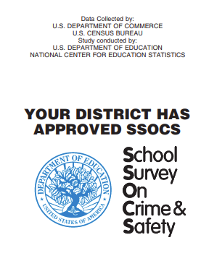

2022 First Reminder Letter to Principal; 2nd Package – All treatments (03/08/22)
SSOCS-14L(W)

Dear <insert name>:

As of today, we have not received your completed School Survey on Crime and Safety (SSOCS). If you recently completed the online questionnaire, thank you for your participation. If you have not yet completed the questionnaire, I encourage you to do so.

Your survey responses can be collected on the secure website listed below.

Respond now at https://respond.census.gov/ssocs
Log in using this User ID: <USERID>

SSOCS is the only national study that collects information about crime and safety in public schools. Findings from the 2019–20 survey indicated:

- About [placeholder statistic] of schools provided diagnostic mental health assessments to evaluate students for mental health disorders and [placeholder statistic] provided treatment to students for mental health disorders.
- About 52 percent of schools had a written plan for procedures in the event of a pandemic disease.

- A higher percentage of schools located in towns reported at least one incident of theft at school than did schools located in cities, suburbs, and rural areas.

We know that you are very busy and receive many survey requests. However, we urge you to take time to complete this very important survey. While your decision to participate is voluntary, your response is crucial to understand the state of crime and safety issues in U.S. schools. Schools will not be identified by name in any reports.

If you have any general questions about the study, contact the U.S. Census Bureau, the survey collection agency, at 1–888–595–1332 or via e-mail at ssocs@census.gov. To learn more about SSOCS, visit http://www.nces.ed.gov/surveys/ssocs.

Sincerely,

Chris Chapman
Associate Commissioner
National Center for Education Statistics
U.S. Department of Education
James (Lynn) Woodworth, Ph. D.
Commissioner
National Center for Education Statistics
U.S. Department of Education

NCES is authorized to conduct this survey by the Education Sciences Reform Act of 2002 (ESRA 2002, 20 U.S.C. §9543). All of the information you provide may be used only for statistical purposes and may not be disclosed, or used, in identifiable form for any other purpose except as required by law (20 U.S.C. §9573 and 6 U.S.C. §151). Reports of the findings from the survey will not identify participating districts, schools, or staff. Individual responses will be combined with those from other participants to produce summary statistics and reports.

2022 Second Reminder Letter to Principal: 3rd Package, First Questionnaire
(03/28/22)
SSOCS: 2022 – 15LC

Dear <insert name>:

We recently sent you an invitation to complete the School Survey on Crime and Safety (SSOCS) online. SSOCS is the only national study that collects information about crime and safety in public schools.

According to our records, you have not yet completed the SSOCS questionnaire online. If you have recently completed the online questionnaire, thank you for your participation, and please disregard this letter. If you have not, I encourage you to complete the enclosed questionnaire or go to the link below to access the questionnaire online. We have extended the deadline to <insert date>.

Your survey responses can be collected on the secure website listed below.

Respond now at https://respond.census.gov/ssocs
Log in using this User ID: <USERID>

Although your decision to participate is voluntary, your response is crucial to understand the overall state of school climate crime and safety issues in U.S. schools. Data from previous SSOCS collections are used by the Department of Education’s Office of Safe and Supportive Schools to inform decisions for guidance to states and local education agencies pertinent to providing a safe school environment for students. Specifically, SSOCS asks about schools’ implementation of safety measures in response to pandemic disease. Having accurate information on this helps to inform the need for more resources to provide to states during unprecedented times, such as the COVID-19 pandemic of 2020. As a reminder, schools will not be identified by name in any reports.

A postage-paid return envelope is enclosed for your convenience. If you have any questions about the study, please do not hesitate to contact the U.S. Census Bureau at 1–888–595–1332. If you have any general questions about the study, contact the U.S. Census Bureau, the survey collection agency, at 1-888-595-1332, or via e-mail at ssocs@census.gov. The U.S. Census Bureau, the survey collection agency, is also available to answer your questions via e-mail at ssocs@census.gov. To learn more about the SSOCS, please visit http://www.nces.ed.gov/surveys/ssocs.

Sincerely,

Chris Chapman
Associate Commissioner
National Center for Education Statistics
U.S. Department of Education
James (Lynn) Woodworth, Ph.D.
Commissioner
National Center for Education Statistics
U.S. Department of Education

Enclosures

2022 SSOCS Questionnaire

NCES is authorized to conduct this survey by the Education Sciences Reform Act of 2002 (ESRA 2002, 20 U.S.C. §9543). All of the information you provide may be used only for statistical purposes and may not be disclosed, or used, in identifiable form for any other purpose except as required by law (20 U.S.C. §9573 and 6 U.S.C. §151). Reports of the findings from the survey will not identify participating districts, schools, or staff. Individual responses will be combined with those from other participants to produce summary statistics and reports.

2022 Third Reminder Letter to Principal; 4th Package, Second Questionnaire (04/28/22)
SSOCS-16L

Dear <insert name>:

Over the past two months, we have contacted you to ask for your participation in the 2022 School Survey on Crime and Safety (SSOCS). If you have already returned the completed questionnaire, thank you for your participation, and please disregard this letter. If you have not yet had the opportunity to complete the questionnaire, I encourage you to complete the enclosed questionnaire as soon as possible.

Your survey responses can also be collected on the secure website listed below.

Respond now at https://respond.census.gov/ssocs
Log in using this User ID: <USERID>

We know that you are very busy and receive many survey requests. However, we urge you to take time to complete this very important survey. While your decision to participate is voluntary, your response is crucial to understand the state of crime and safety issues in U.S. schools. Schools will not be identified by name in any reports. Your responses help the policy and program offices at the U.S. Department of Education design grant programs intended to address school safety, violence prevention, and school climate.

A postage-paid return envelope is enclosed for your convenience. If you have any questions about the study, please do not hesitate to contact the U.S. Census Bureau at 1–888–595–1332. The U.S. Census Bureau, the survey collection agency, is also available to answer your questions via e-mail at ssocs@census.gov. To learn more about SSOCS, please visit http://www.nces.ed.gov/surveys/ssocs.

Sincerely,

Chris Chapman
Associate Commissioner
National Center for Education Statistics
U.S. Department of Education
James (Lynn) Woodworth, Ph. D.
Commissioner
National Center for Education Statistics
U.S. Department of Education

Enclosures
2022 SSOCS Questionnaire

NCES is authorized to conduct this survey by the Education Sciences Reform Act of 2002 (ESRA 2002, 20 U.S.C. §9543). All of the information you provide may be used only for statistical purposes and may not be disclosed, or used, in identifiable form for any other purpose except as required by law (20 U.S.C. §9573 and 6 U.S.C. §151). Reports of the findings from the survey will not identify participating districts, schools, or staff. Individual responses will be combined with those from other participants to produce summary statistics and reports.

2022 Initial E-mail to Principal – “Email-First” Before Treatment Group
SSOCS-P1A

Subject: U.S. Department of Education Survey!

Dear <PRINCIPAL>:
<SCHNAM>

We at the National Center for Education Statistics (NCES) within the U.S. Department of Education, need your help by completing the 2022 School Survey on Crime and Safety (SSOCS). SSOCS is the only national recurring survey that focuses on the frequency of crime and violence in public schools and the programs and practices developed to provide a safe school environment.

The COVID-19 pandemic is an unprecedented moment in history that has affected how schools keep students and staff safe. In response to the pandemic, Congress approved various relief packages to assist schools with implementing safety measures and getting the equipment needed to safely open back up for in-school instruction. The Department of Education relies on studies including SSOCS to help determine how to allocate funds. Your school is one of a small number of schools selected to represent the needs of many other schools. Your response is critical to ensuring that we have accurate data to base these decisions on. Therefore, we need your help by responding to the 2022 SSOCS. We will be sending you a package at the school listed above with more information about the SSOCS<< and $10 as a token of our appreciation>>.

Your survey responses will be collected on a secure website. Please take time now to complete the SSOCS.

Respond now at https://respond.census.gov/ssocs
Log in using this User ID: <USERID>

Please be assured that reports of the findings from the survey will not identify schools by name. Individual responses will be combined with those from other participants to produce summary statistics and reports.

If you have any general questions about the study, contact the U.S. Census Bureau, the survey collection agency, at 1–888–595–1332 or via e-mail at ssocs@census.gov. To learn more about SSOCS, visit http://www.nces.ed.gov/surveys/ssocs.

We look forward to your school’s participation in this important data collection effort.

Sincerely,

Chris Chapman
Associate Commissioner
National Center for Education Statistics
U.S. Department of Education

2022 Initial E-mail to Principal – After Treatment / Control Group
SSOCS-P1B

Subject line: U.S. Department of Education Survey!

Dear <PRINCIPAL>:
<SCHNAM>
We at the National Center for Education Statistics (NCES) within the U.S. Department of Education, need your help by completing the 2022 School Survey on Crime and Safety (SSOCS). SSOCS is the only national recurring survey that focuses on the frequency of crime and violence in public schools and the programs and practices developed to provide a safe school environment.

The COVID-19 pandemic is an unprecedented moment in history that has affected how schools keep students and staff safe. The COVID-19 pandemic was an unprecedented moment in history that caused global social and economic disruption, including long-term effects on how K-12 education is administered and how schools keep students and staff safe. In response to the pandemic, Congress approved various relief packages to assist schools with implementing safety measures and getting the equipment needed to safely open back up for in-school instruction. The Department of Education relies on studies including SSOCS to help determine how to allocate funds. Your school is one of a small number of schools selected to represent the needs of many other schools. Your response is critical to ensuring that we have accurate data to base these decisions on. Therefore, we need your help by responding to the 2022 SSOCS. We recently sent you a package at the school listed above with more information about the SSOCS<< and $10 as a token of our appreciation>>.

Your survey responses will be collected on a secure website. Please take time now to complete the SSOCS.

Respond now at https://respond.census.gov/ssocs
Log in using this User ID: <USERID>

Please be assured that reports of the findings from the survey will not identify schools by name. Individual responses will be combined with those from other participants to produce summary statistics and reports.

If you have any general questions about the study, contact the U.S. Census Bureau, the survey collection agency, at 1–888–595–1332 or via e-mail at ssocs@census.gov. To learn more about SSOCS, visit http://www.nces.ed.gov/surveys/ssocs.

We look forward to your school’s participation in this important data collection effort.

Sincerely,

James (Lynn) Woodworth, Ph. D.
Chris Chapman
Associate Commissioner
National Center for Education Statistics
U.S. Department of Education

2022 First reminder e-mail to principals – All Treatments (03/15/22)

Subject line: U.S. Department of Education Survey Reminder

Dear <PRINCIPAL>(name):

We need your help completing the 2022 School Survey on Crime and Safety (SSOCS), to gather statistics on the prevalence of programs and practices implemented to provide a safe school environment. Findings from the 2019–20 SSOCS indicated that [placeholder statistic]94 percent of all public schools reported having activities for students that included social emotional learning. We know social emotional learning is an important aspect of providing a safe environment in schools, therefore it is imperative to continue to collect updated information on this topic, as well as other similar topics.

If you have already logged in and completed your questionnaire, thank you very much for your participation. If not, I encourage you to take the time to do so. Your survey responses will be collected on a secure website.

Respond now at https://respond.census.gov/ssocs

Log in using this User ID: <USERID>

The success of this national survey depends on your participation. Only a small percentage of principals are selected to participate. We cannot substitute another principal for you. Please note that reports of the findings from the survey will not identify schools by name. Individual responses will be combined with those from other participants to produce summary statistics and reports.

If you have any general questions about the study, please contact the U.S. Census Bureau, the survey collection agency, at 1–888–595–1332 or via e-mail at ssocs@census.gov. To learn more about SSOCS, visit http://www.nces.ed.gov/surveys/ssocs.

Sincerely,

James (Lynn) Woodworth, Ph. D.
Chris Chapman
Associate Commissioner
National Center for Education Statistics
U.S. Department of Education

2022 Second reminder E-mail – All Treatments (04/05/22)

Subject line: U.S. Department of Education Survey – Survey Reminder

Dear <PRINCIPAL>(name):

Your school was selected to participate in the School Survey on Crime and Safety (SSOCS). If you have already completed the survey, thank you for your assistance and please disregard this email. If you haven’t had the opportunity to log on and complete the survey yet, we encourage you to do so. Your survey responses will be collected on a secure website.

Respond now at https://respond.census.gov/ssocs

Log in using this User ID: <USERID>

Your completed questionnaire will provide the nation accurate statistics on school crime and safety for the 2021–22 school year. Please note that reports of the findings from the survey will not identify schools by name. Individual responses will be combined with those from other participants to produce summary statistics and reports.

You may call with any questions or may complete the survey over the phone by calling the U.S. Census Bureau at 1–888–595–1332 or via e-mail at ssocs@census.gov. To learn more about SSOCS, visit http://www.nces.ed.gov/surveys/ssocs.

Sincerely,

James (Lynn) Woodworth, Ph. D.
Chris Chapman
Associate Commissioner
National Center for Education Statistics
U.S. Department of Education

2022 Third reminder e-mail – All Treatments (04/19/22)

Subject Line: Reminder! U.S. Department of Education Survey – Help Provide Information on Emergency Plans and Procedures

Dear <PRINCIPAL>(name):

Did you know that during the 2019–20 school year, [placeholder statistic]52 percent of all public schools reported having a written plan describing procedures to be performed in the event of a pandemic disease?

This information is collected on the School Survey on Crime and Safety (SSOCS), the only national recurring survey on the frequency of crime and violence in public schools and the programs and practices developed to provide a safe school environment. There is still time for your school to participate in the study. If you have already completed and returned your questionnaire, thank you! If not, in order for your school to be included in this study, which is used by Congress and the U.S. Department of Education program offices to determine where schools are in need of the most help with dealing with unprecedented circumstances, such as pandemics, it is critical that you respond now by clicking on the link below.

Respond now at https://respond.census.gov/ssocs

Log in using this User ID: <USERID>

Please note that reports of the findings from the survey will not identify schools by name. Individual responses will be combined with those from other participants to produce summary statistics and reports.

You may call with any questions or may complete the survey over the phone by calling the U.S. Census Bureau at 1–888–595–1332 or via e-mail at ssocs@census.gov. To learn more about SSOCS, visit http://www.nces.ed.gov/surveys/ssocs.

Sincerely,

James (Lynn) Woodworth, Ph. D.
Chris Chapman
Associate Commissioner
National Center for Education Statistics
U.S. Department of Education

2022 Fourth Reminder e-mail – All Treatments (05/05/22)

Subject Line: Reminder! U.S. Department of Education Survey

Dear <PRINCIPAL>(name):

Did you know that during the 2019–20 school year, about [placeholder statistic] 55 percent of schools provided diagnostic mental health assessments to evaluate students for mental health disorders and [placeholder statistic] 42 percent provided treatment to students for mental health disorders?

This information is collected on the School Survey on Crime and Safety (SSOCS), the only national recurring survey on the frequency of crime and violence in public schools and the programs and practices developed to provide a safe school environment. There is still time for your school to participate in the study. If you have already completed and returned your questionnaire, thank you! If not, in order for your school to be included in this study, which is used by Congress and the U.S. Department of Education program offices to determine where schools are in need of the most help for providing resources to students, such as mental health services, it is critical that you respond now by clicking on the link below.

Respond now at https://respond.census.gov/ssocs

Log in using this User ID: <USERID>

Please note that reports of the findings from the survey will not identify schools by name. Individual responses will be combined with those from other participants to produce summary statistics and reports.

You may call with any questions or may complete the survey over the phone by calling the U.S. Census Bureau at 1–888–595–1332 or via e-mail at ssocs@census.gov. To learn more about SSOCS, visit http://www.nces.ed.gov/surveys/ssocs.

Sincerely,

James (Lynn) Woodworth, Ph. D.
Chris Chapman
Associate Commissioner
National Center for Education Statistics
U.S. Department of Education

2022 Fifth Reminder e-mail – All Treatments (TBD date in late May 2022)

Subject line: We Need Your Input! U.S. Department of Education Survey Reminder

Dear <PRINCIPAL>(name):

We need your help by participating in this study! Your responses to the 2022 School Survey on Crime and Safety (SSOCS) help the policy and program offices at the U.S. Department of Education design grant programs intended to address school safety, violence prevention, and school climate.

If you haven’t had the opportunity to log on and complete the survey yet, we encourage you to do so now by clicking the link below. Your survey responses will be collected on a secure website.

Respond now at https://respond.census.gov/ssocs

Log in using this User ID: <USERID>

Your completed questionnaire will provide the nation accurate statistics on school crime and safety for the 2021–22 school year. Please note that reports of the findings from the survey will not identify schools by name. Individual responses will be combined with those from other participants to produce summary statistics and reports.

You may call with any questions or may complete the survey over the phone by calling the U.S. Census Bureau at 1–888–595–1332 or via email at ssocs@census.gov. To learn more about SSOCS, visit http://www.nces.ed.gov/surveys/ssocs.

Sincerely,

James (Lynn) Woodworth, Ph. D.
Chris Chapman
Associate Commissioner
National Center for Education Statistics
U.S. Department of Education

2022 Sixth Reminder e-mail – All Treatments (TBD date in early June 2022)

Subject line: There is Still Time! U.S. Department of Education Survey Reminder

Dear <PRINCIPAL>(name):

We need your help completing the 2022 School Survey on Crime and Safety (SSOCS), a federal survey that gathers statistics on programs and practices implemented across our nation to provide a safe school environment.

If you haven’t had the opportunity to log on and complete the survey yet, we encourage you to do so. Your survey responses will be collected on a secure website.

Respond now at https://respond.census.gov/ssocs

Log in using this User ID: <USERID>

Please note that reports of the findings from the survey will not identify schools by name. Individual responses will be combined with those from other participants to produce summary statistics and reports.

If you have any questions contact the U.S. Census Bureau, the survey collection agency, by phone at 1–888–595–1332 or via email at ssocs@census.gov. To learn more about SSOCS, visit http://www.nces.ed.gov/surveys/ssocs.

Sincerely,

James (Lynn) Woodworth, Ph. D.
Chris Chapman
Associate Commissioner
National Center for Education Statistics
U.S. Department of Education

2022 Seventh Reminder e-mail – All Treatments (TBD data in June 2022)

Subject line: We need your response today- U.S. Department of Education Survey Reminder

Dear <PRINCIPAL>(name):

There is still time to complete the School Survey on Crime and Safety (SSOCS). You may respond now by clicking on the link below.

Respond now at https://respond.census.gov/ssocs

Log in using this User ID: <USERID>

Your completed questionnaire will provide the nation accurate statistics of programs and policies implemented to provide a safe school environment. Please note that reports of the findings from the survey will not identify schools by name. Your survey responses will be collected on a secure website. Individual responses will be combined with those from other participants to produce summary statistics and reports.

If you have any questions contact the U.S. Census Bureau, the survey collection agency, by phone at 1–888–595–1332 or via email at ssocs@census.gov. To learn more about SSOCS, visit http://www.nces.ed.gov/surveys/ssocs.

Sincerely,

James (Lynn) Woodworth, Ph. D.
Chris Chapman
Associate Commissioner
National Center for Education Statistics
U.S. Department of Education

2022 Reminder email – All Treatments (TBD in the Spring or Summer of 2022)

Subject line: U.S. Department of Education Survey – Please respond!

Dear <PRINCIPAL>(name):

Data collection for the School Survey on Crime and Safety (SSOCS) is coming to a close. Don’t miss your opportunity to contribute to data that are used by the U.S. Department of Education’s policy and program offices for making policy decisions and designing grant programs intended to address school safety, violence prevention programs, and school climate.

If you have already responded to our survey, thank you! If you have not responded yet, please click on the link below

Respond now at https://respond.census.gov/ssocs

Log in using this User ID: <USERID>

Your survey responses will be collected on a secure website and schools will not be identified by name in any reports. We appreciate your help in this important data collection effort!

SSOCS is conducted by the National Center for Education Statistics (NCES) within the U.S. Department of Education and collected by the U.S. Census Bureau. If you have any general questions about the study or if you wish to complete the survey with assistance, please contact the U.S. Census Bureau at 1–888–595–1332 or via email at ssocs@census.gov. To learn more about SSOCS, visit http://www.nces.ed.gov/surveys/ssocs.

Sincerely,

James (Lynn) Woodworth, Ph. D.
Chris Chapman
Associate Commissioner
National Center for Education Statistics
U.S. Department of Education

2022 Thank You Email to Principals (August 2022)

Subject line: Thank You!

Dear <PRINCIPAL>:

The National Center for Education Statistics (NCES) of the U.S. Department of Education would like to thank you for making the 2022 School Survey on Crime and Safety (SSOCS) a success!

SSOCS is the only nationally representative survey that collects data on crime and safety from a principal’s perspective, so we appreciate you taking time out of your busy schedule to represent your school in this important effort. Overall, we were able to gather data from over <insert number> schools. Your participation was crucial in helping us achieve this success.

Please visit https://ies.ed.gov/newsflash/ and sign up to receive up-to-date alerts about a number of education topics, including crime and safety in schools. Tables and reports based on data from the 2019–20 SSOCS and earlier SSOCS administrations are available on the NCES website. In addition to these data products, tables and reports based on the 2021–22 SSOCS will be posted to our website at http://www.nces.ed.gov/surveys/ssocs upon release.

Again, thank you for your time and participation.

Sincerely,

Chris Chapman
Associate Commissioner
National Center for Education Statistics
U.S. Department of Education

2022 Letter to Principal – Replacement Questionnaire
SSOCS-17L

Dear <PRINCIPAL>:

Recently, someone in your school contacted the U.S. Census Bureau regarding the School Survey on Crime and Safety (SSOCS), a national study that collects information about crime and safety in public schools. Enclosed is the replacement questionnaire requested.

Your survey responses can also be collected on the secure website listed below.

Respond now at https://respond.census.gov/ssocs
Log in using this User ID: <USERID>

Please complete within two weeks. A postage-paid return envelope is enclosed for your convenience. If you have any general questions about the survey, please contact the U.S. Census Bureau, the survey collection agency at 1–888–595–1332 or via e-mail at ssocs@census.gov. To learn more about SSOCS, please visit http://www.nces.ed.gov/surveys/ssocs.

Sincerely,

James (Lynn) Woodworth, Ph. D.
Chris Chapman
Associate Commissioner
National Center for Education Statistics
U.S. Department of Education

Enclosures
2022 SSOCS Questionnaire

NCES is authorized to conduct this survey by the Education Sciences Reform Act of 2002 (ESRA 2002, 20 U.S.C. §9543). All of the information you provide may be used only for statistical purposes and may not be disclosed, or used, in identifiable form for any other purpose except as required by law (20 U.S.C. §9573 and 6 U.S.C. §151). Reports of the findings from the survey will not identify participating districts, schools, or staff. Individual responses will be combined with those from other participants to produce summary statistics and reports.

2022 Thank You Letter to Principal (August 2022)
SSOCS-18L

Dear <PRINCIPAL>:

The National Center for Education Statistics (NCES) of the U.S. Department of Education would like to thank you for making the 2022 School Survey on Crime and Safety (SSOCS) a success!

SSOCS is the only nationally representative survey that collects data on crime and safety from a principal’s perspective, so we appreciate you taking time out of your busy schedule to represent your school in this important effort. This school year, we were able to gather data from over <insert number> schools. Your participation was crucial in helping us achieve this success.

Please visit http://ies.ed.gov/newsflash/#nces and sign up to receive up-to-date alerts about a number of education topics, including crime and safety in schools. Tables based on data from the 2019-20 SSOCS and earlier SSOCS administrations are available on the NCES website. In addition to these data products, tables and reports based on the 2021–22 SSOCS will be posted to our website at http://www.nces.ed.gov/surveys/ssocs upon release.

Again, thank you for your time and participation.

Sincerely,

Chris Chapman
Associate Commissioner
National Center for Education Statistics
U.S. Department of Education
James (Lynn) Woodworth, Ph. D.
Commissioner
National Center for Education Statistics
U.S. Department of Education

2022 Thank You Letter to District (August 2022)
SSOCS-18L(D)

Dear <insert name>:

The National Center for Education Statistics (NCES) of the U.S. Department of Education would like to thank you for making the 2021–22 School Survey on Crime and Safety (SSOCS) a success!

SSOCS is the only nationally representative survey that collects data on crime and safety from a principal’s perspective, so we appreciate your approval of our application to conduct research within your district. Overall, we were able to gather data from over <insert number> schools. Your approval was crucial in helping us achieve this success.

Please visit http://ies.ed.gov/newsflash/#nces and sign up to receive up-to-date alerts about a number of education topics, including crime and safety in schools. Tables based on data from the 2019-20 SSOCS and earlier SSOCS administrations are available on the NCES website. In addition to these data products, tables and reports based on the 2021–22 SSOCS will be posted to our website at http://www.nces.ed.gov/surveys/ssocs upon release.

Again, thank you for your approval.

Sincerely,

James (Lynn) Woodworth, Ph. D.
Chris Chapman
Associate Commissioner
National Center for Education Statistics
U.S. Department of Education

2022 Frequently Asked Questions (to be included on the back of initial letter to principal)

What is the SSOCS?
The School Survey on Crime and Safety (SSOCS) is a national survey of elementary and secondary public schools that collects information on school safety, including school practices related to the prevention and reduction of crime, the frequency of school crime and violence, and disciplinary actions used to handle infractions. This survey does not involve students, parents, or teachers, and does not involve any use of classroom time.

What happens if a school refuses to participate?
All participation is voluntary. There are no penalties for not participating in the study. However, each school in the SSOCS sample was selected to represent schools with similar characteristics. When a school refuses to participate, we’re unable to replace that school. This means we’ll have fewer responses which will result in less precision in our estimates and the potential to not be able to report out estimates for schools like yours. When completing the questionnaire, respondents can skip any question they do not want to answer. If you are hesitant to be a part of the study, please reach out to the 2022 SSOCS staff at 1–888–595–1332 or via e-mail at ssocs@census.gov to address any concerns you may have.

How will the names of participants and their responses be kept confidential?
Under law, all of the information provided by schools may be used only for statistical purposes and may not be disclosed, or used, in identifiable form for any other purpose except as required by law (20 U.S.C. §9573 and 6 U.S.C. §151). All staff working on the study have signed an Affidavit of Nondisclosure where they swear to abide by this law. Employees, including temporary employees, or other persons who have sworn to observe the limitations imposed by this law, who knowingly publish or communicate any individually identifiable information will be subject to fines of up to $250,000, or up to 5 years in prison, or both (Class E felony).

That sounds like governmentese. What are you really telling me?
By law, we can only use your responses for reporting crime and safety information at an aggregate level, which means we’re combining your information with those from other participating schools to produce summary statistics and reports. All staff working on the project have sworn to abide by the law to not disclose information provided by participants in the study. Check out the 2018 SSOCS First Look Report to see how the estimates are displayed at https://nces.ed.gov/pubs2019/2019061.pdf.

The letter says this is a U.S. Department of Education survey. Who is NCES and why is the Census Bureau involved?
We understand this is confusing. The National Center for Education Statistics (NCES) is the primary federal entity for collecting and analyzing data related to education in the United States. NCES is located within the U.S. Department of Education and the Institute of Education Sciences. NCES fulfills a Congressional mandate to collect, collate, analyze, and report complete statistics on the condition of education in the United States; conduct and publish reports; and review and report on education activities internationally. While NCES conducts the surveys, we partner with the U.S. Census Bureau to fulfill the data collection operations. This is why you see mailing labels, email addresses, and contact information from the Census Bureau.

Do public school and school safety organizations endorse the SSOCS?
Yes! Check out the insert in the package to see a list of public school and school safety organizations that endorse the SSOCS.

What is SSOCS?
The School Survey on Crime and Safety (SSOCS) is a national survey of elementary and secondary public schools that collects information on school safety, including school practices related to the prevention and reduction of crime, the frequency of school crime and violence, and disciplinary actions used to handle infractions. This survey does not involve students, parents, or teachers, and does not involve any use of classroom time.

What happens if a school refuses to participate?
All participation is voluntary. There are no penalties for not participating in the study. However, each school in the SSOCS sample was selected to represent schools with similar characteristics. When a school refuses to participate, we’re unable to replace that school. This means we’ll have fewer responses which will result in less precision in our estimates and the potential to not be able to report out estimates for schools like yours. When completing the questionnaire, respondents can skip any question they do not want to answer. If you are hesitant to be a part of the study, please reach out to SSOCS 2022 staff so we can address any concerns you may have.

How will the names of participants and their responses be kept confidential?
Under law, all the information provided by schools may be used only for statistical purposes and may not be disclosed, or used, in identifiable form for any other purpose except as required by law (20 U.S.C. §9573 and 6 U.S.C. §151). All staff working on the study have signed an Affidavit of Nondisclosure where they swear to abide by this law. Employees, including temporary employees, or other persons who have sworn to observe the limitations imposed by this law, who knowingly publish or communicate any individually identifiable information will be subject to fines of up to $250,000, or up to 5 years in prison, or both (Class E felony).

That sounds like governmentese. What are you really telling me?
By law, we can only use your responses for reporting crime and safety information at an aggregate level, which means we’re combining your information with those from other participating schools to produce summary statistics and reports. All staff working on the project have sworn to abide by the law to not disclose information provided by participants in the study. Check out the 2018 SSOCS First Look Report to see how the estimates are displayed https://nces.ed.gov/pubs2019/2019061.pdf.

The letter says this is a U.S. Department of Education survey. Who is NCES and why is the Census Bureau involved?
We understand this is confusing. The National Center for Education Statistics (NCES) is the primary federal entity for collecting and analyzing data related to education in the United States. NCES is located within the U.S. Department of Education and the Institute of Education Sciences. NCES fulfills a Congressional mandate to collect, collate, analyze, and report complete statistics on the condition of education in the United States; conduct and publish reports; and review and report on education activities internationally. While NCES conducts the surveys, we partner with the U.S. Census Bureau to fulfill the data collection operations. This is why you see mailing labels, email addresses, and contact information from the Census Bureau.

Do public school and school safety organizations endorse SSOCS?
Yes! Check out the insert in the package to see a list of public school and school safety organizations that endorse SSOCS.

Final Web Instrument

Change all dates from “2019-20” to “2021-22”
Change time to complete from “45 minutes” to “50 minutes”
Update OMB expiration date to “07/31/2024”

Item: Welcome Page
Removed 2020 placeholder and replaced with updated 2022 instrument
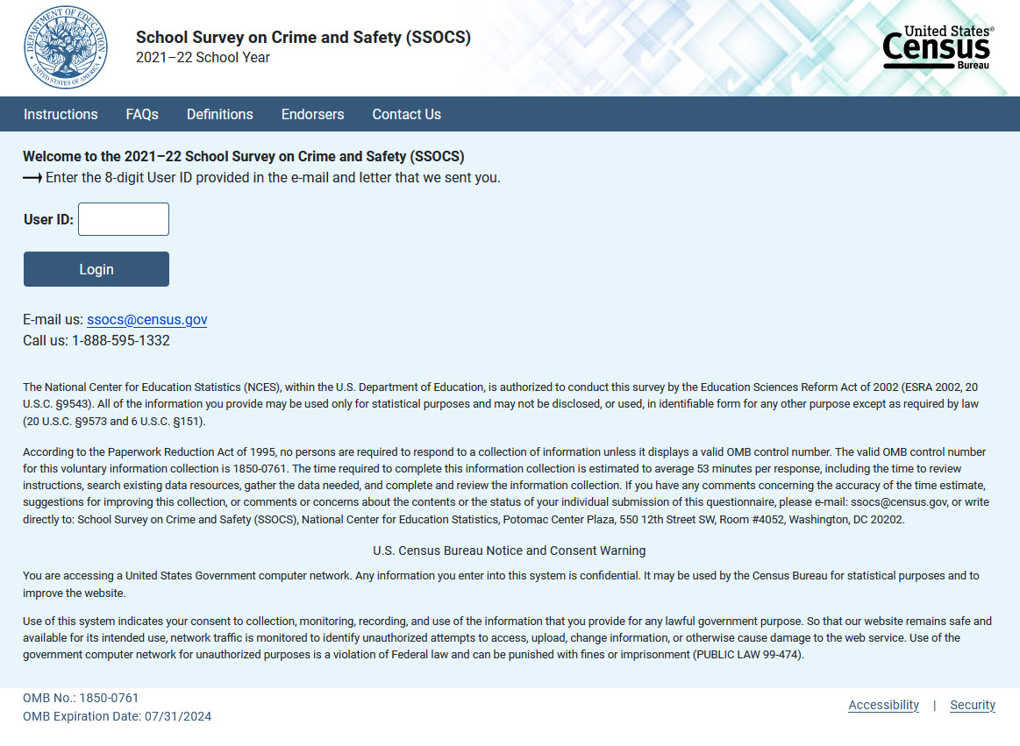

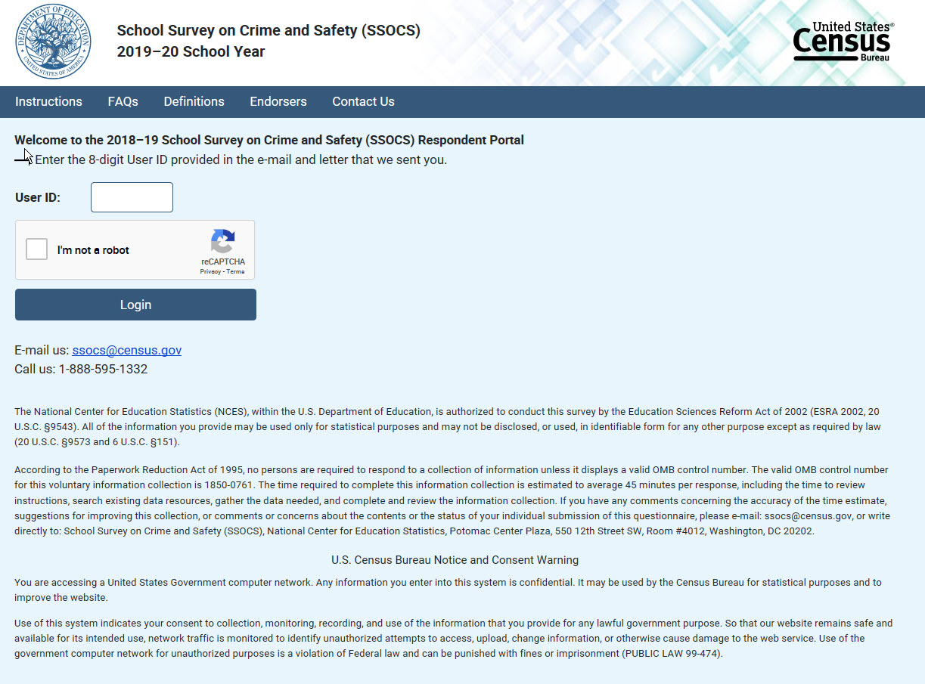

Item: PIN & Security Question:
Removed 2020 placeholder and replaced with updated 2022 instrument
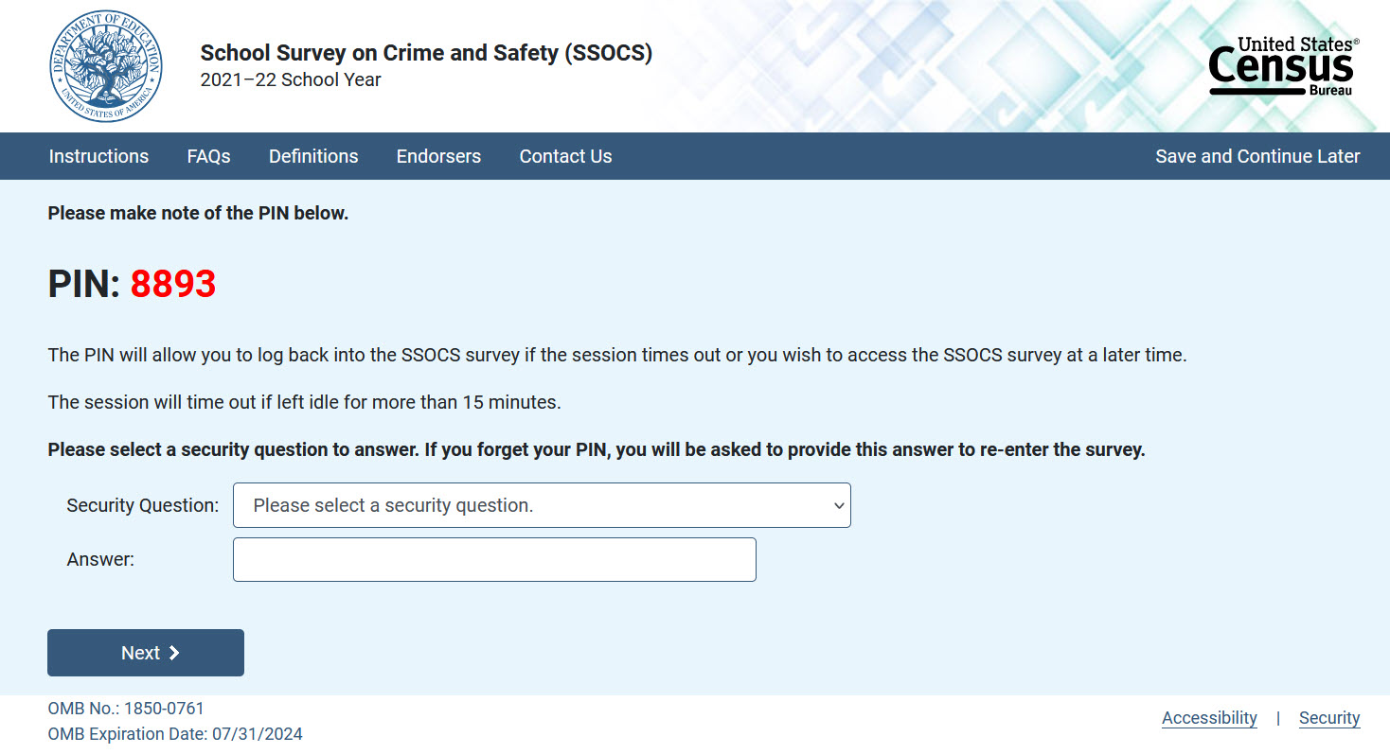

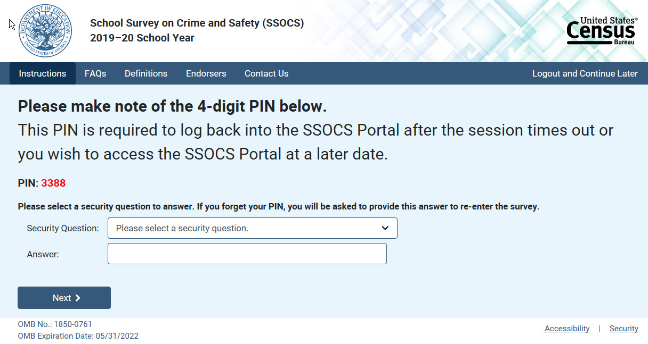

Item: PIN Reset:
Removed 2020 placeholder and replaced with updated 2022 instrument
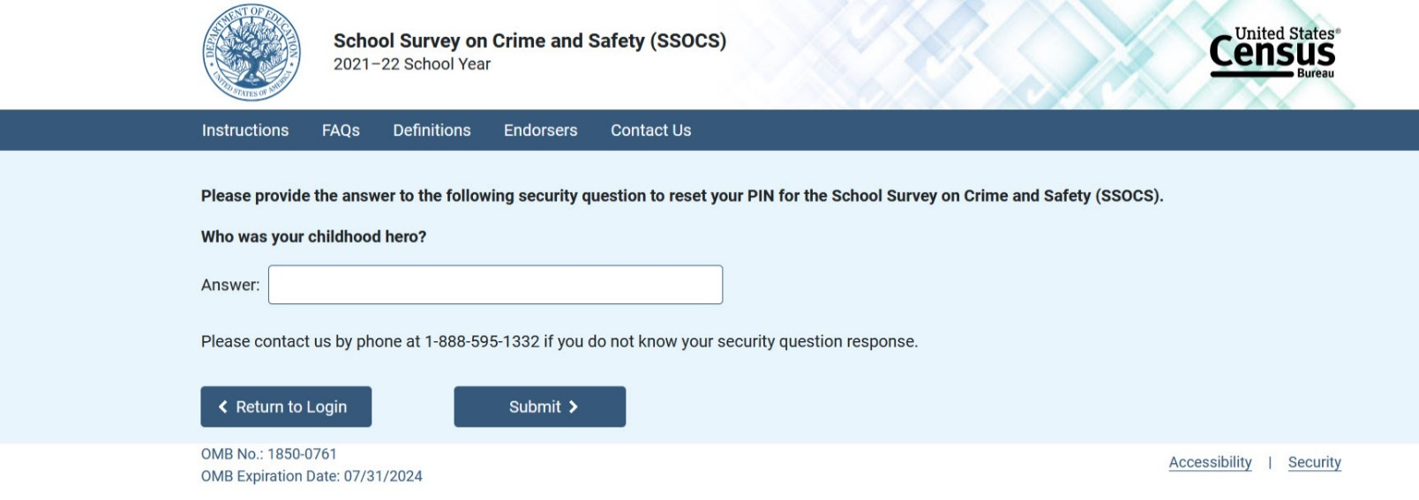

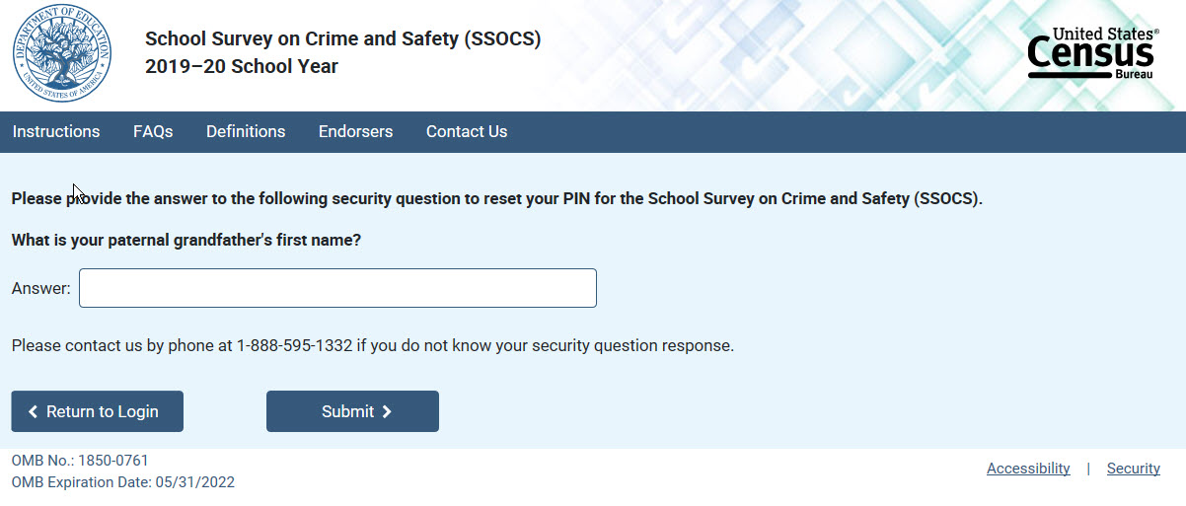

Item: New PIN:
Removed 2020 placeholder and replaced with updated 2022 instrument
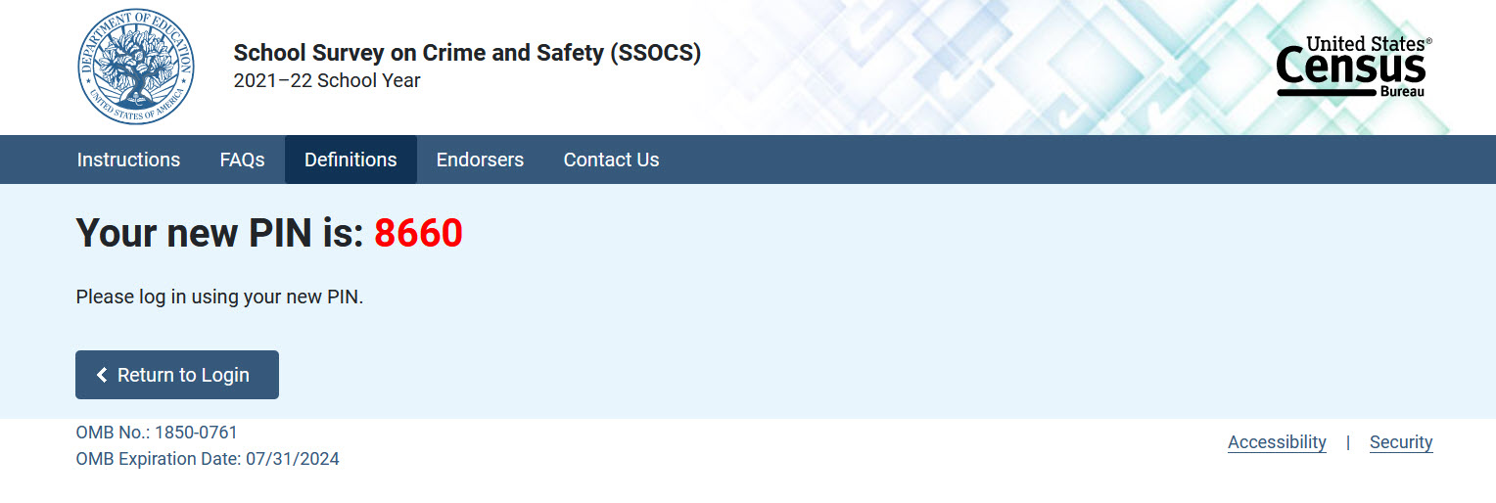

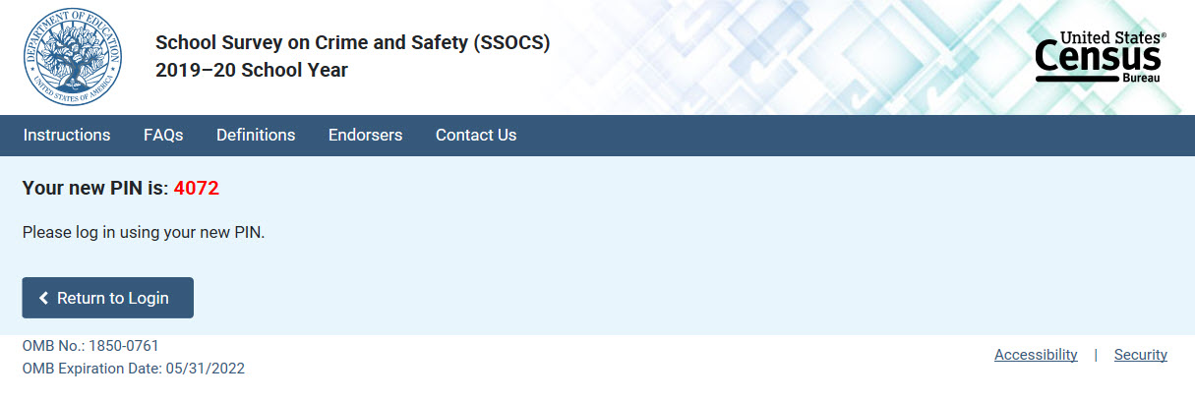

Item: Welcome page for returning users:
Removed 2020 placeholder and replaced with updated 2022 instrument
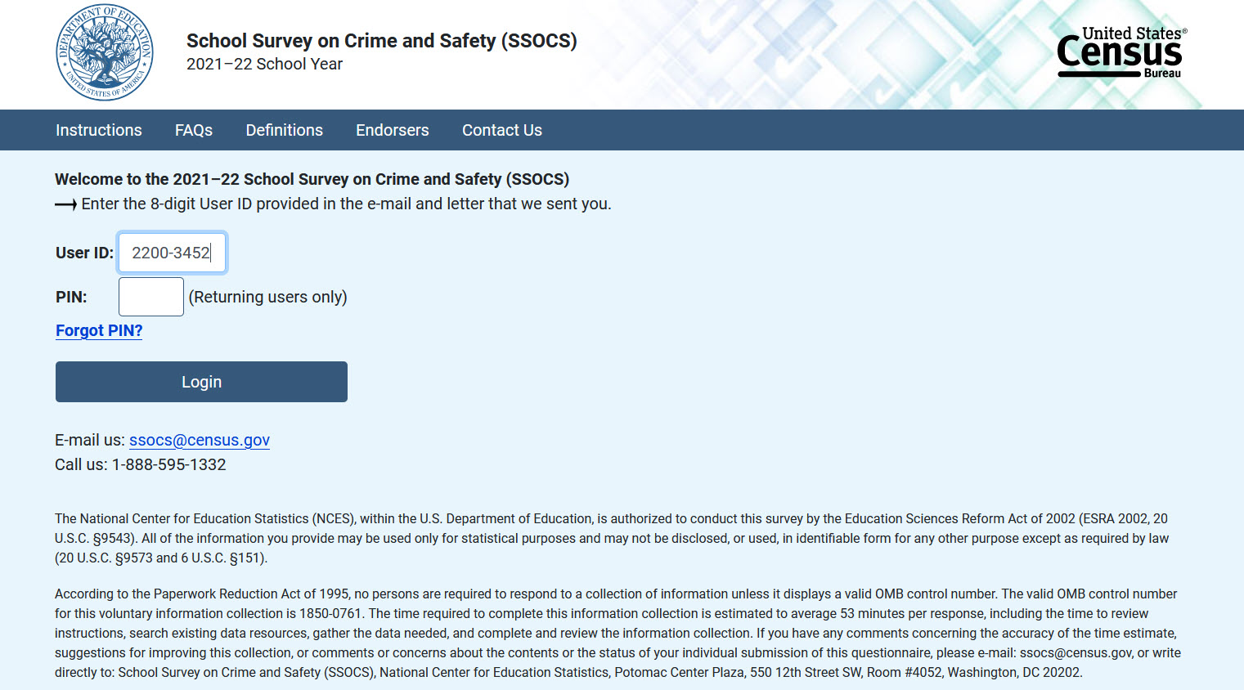

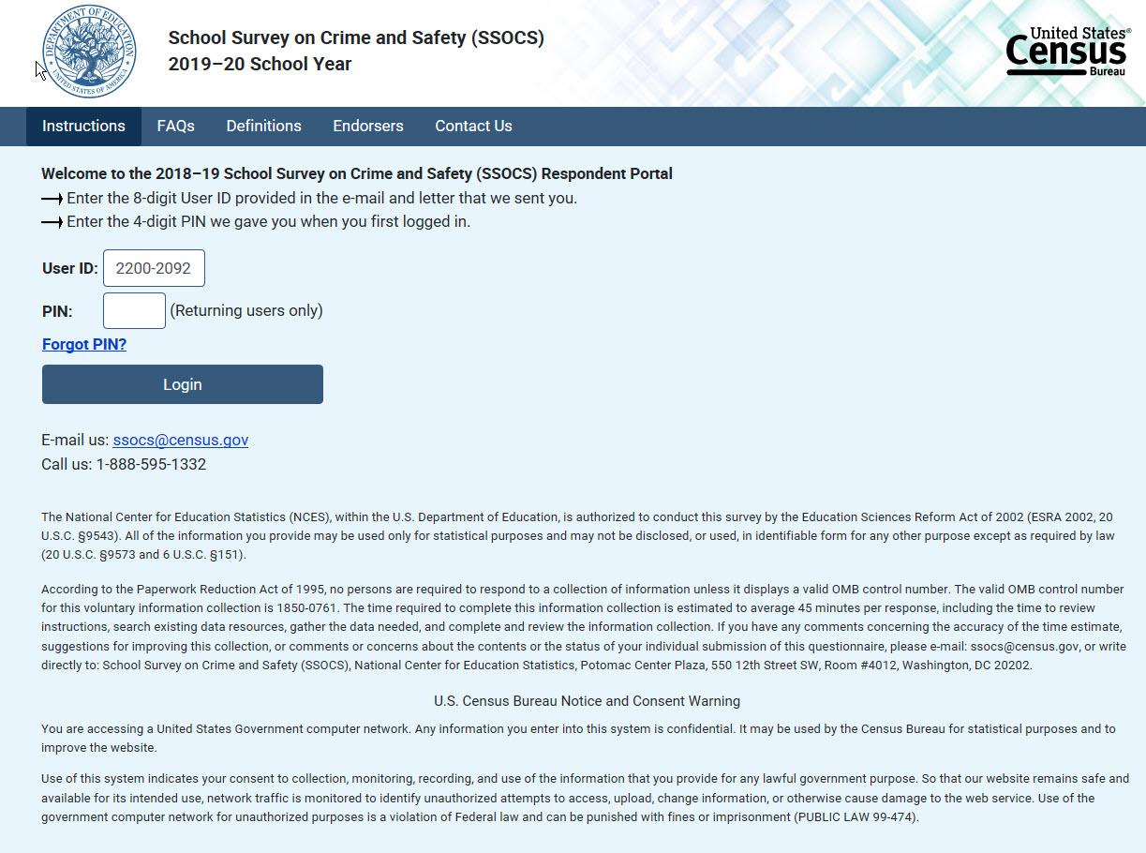

Item: Thank You Page
Removed 2020 placeholder and replaced with updated 2022 instrument
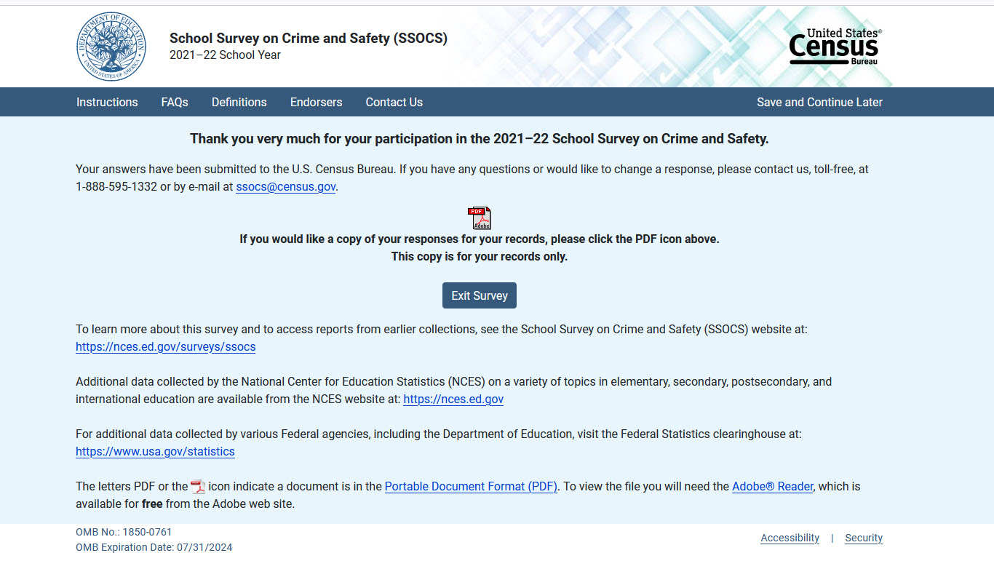

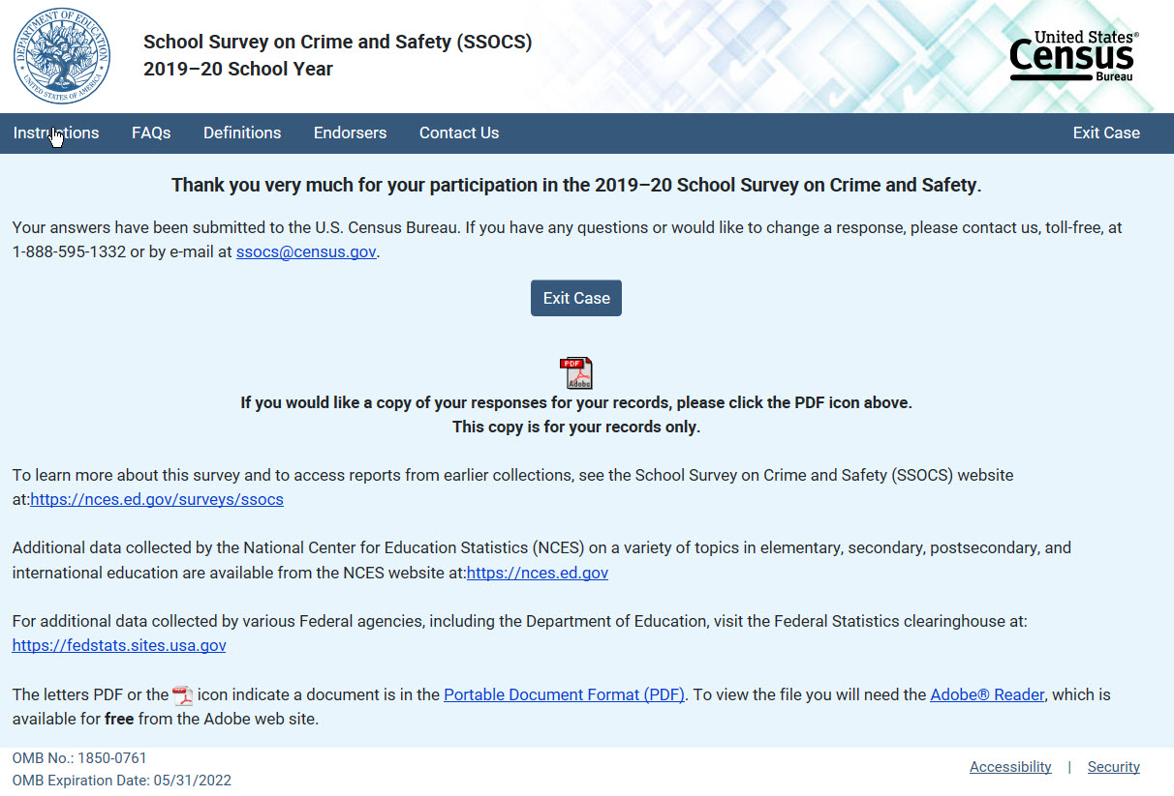

Item: Instructions Tab (instructions)
Removed 2020 placeholder and replaced with updated 2022 instrument
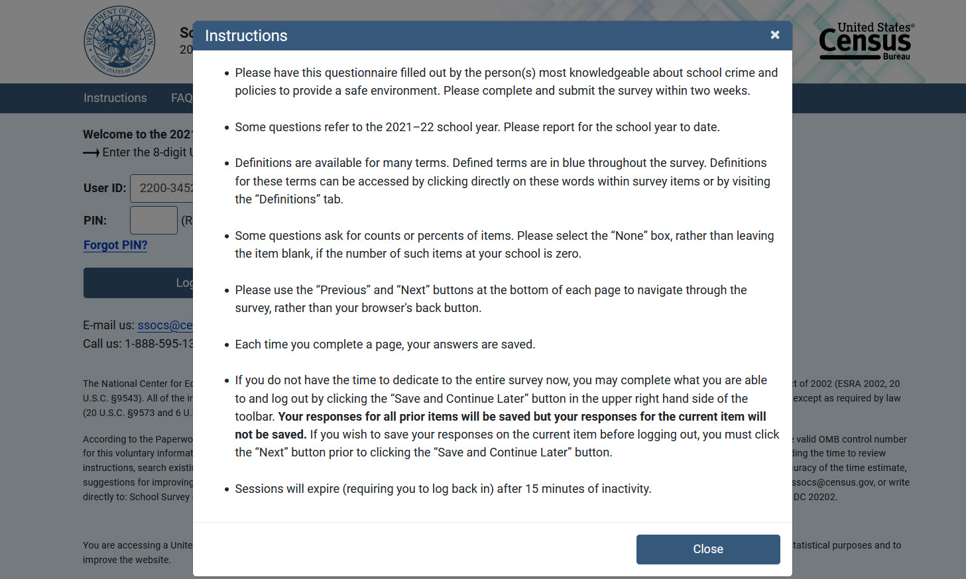

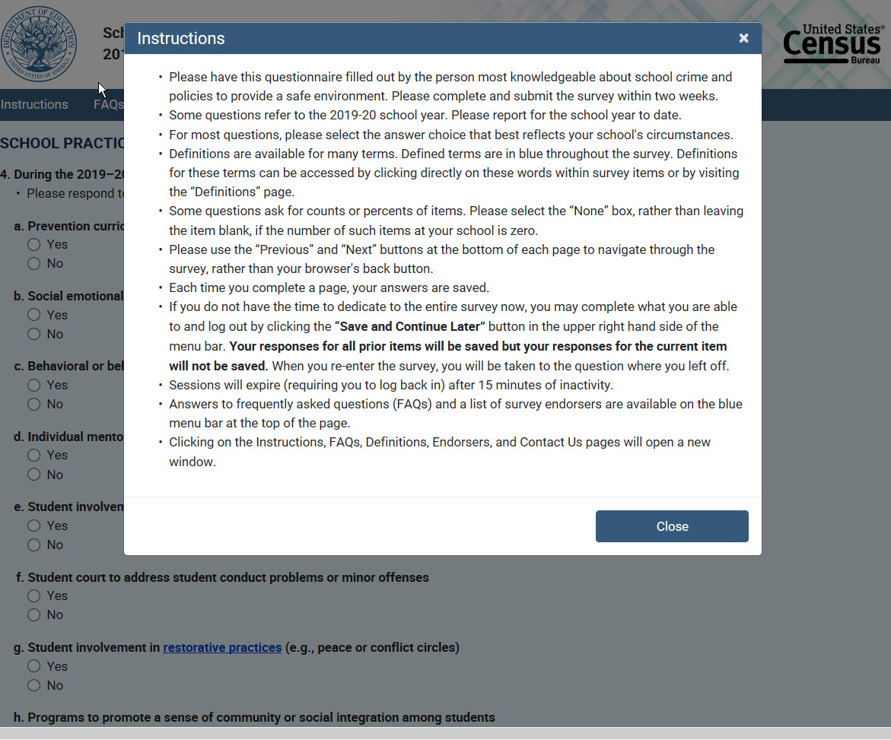

Item: Endorsers Tab [There was no change to this information]
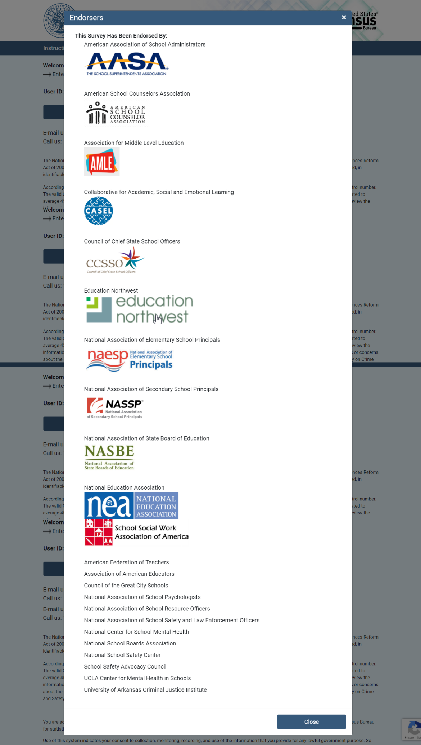

Item: FAQs Tab (pop out)
Removed 2020 placeholder and replaced with updated 2022 instrument
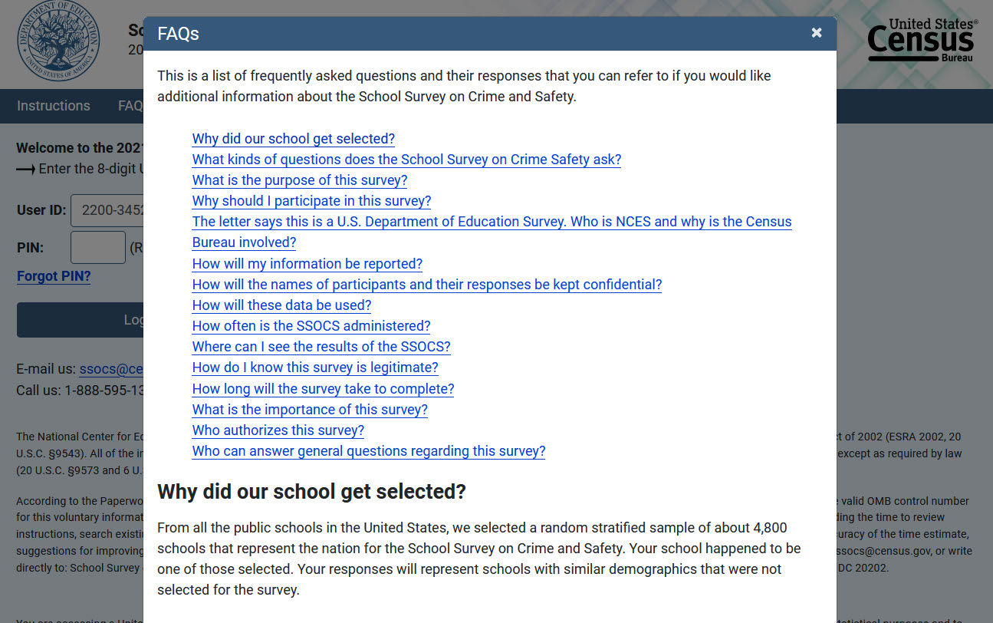

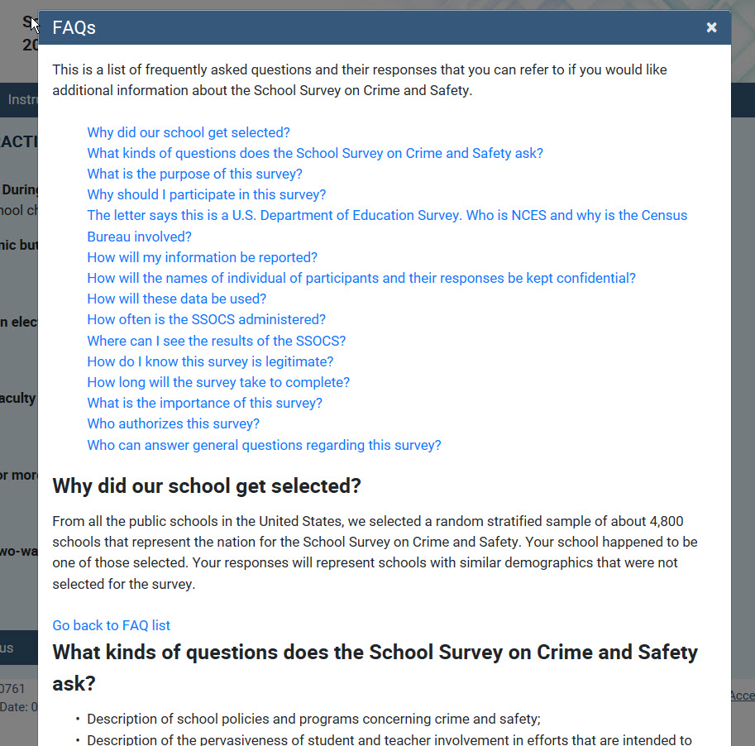

Appendix B – SSOCS 2022 Questionnaire
Summary of Changes to 2022 Questionnaire

As indicated in the revisions to Part C, the questionnaire has been changed:

- Following cognitive testing, items 7 & 8 were revised and combined into one item, which is now Item 7 on the SSOCS:2022 questionnaire. As a result, the reference to item 8 has been deleted from this section and language has been reincorporated into the item 7 rationale.
- Because item 8 was combined with item 7; all following item numbers referenced in this section were revised – i.e., item 9 has been revised to item 8.

7. During the 2021–22 school year, were any of the following modifications made to do your school’s emergency readiness practices (e.g., fire drills, active shooter drills) include modifications made in response to the Centers for Disease Control and Prevention (CDC) safety guidelines for operating schools during COVID-19? (Yes/No)
8. Do your school’s modifications to emergency readiness practices include the following?
a. Having staff talk through security drills rather than acting them out (Yes/No)
b. Modifying security drills to accommodate social distancing measures (e.g., conducting multiple drills with small groups, increasing number of evacuation locations) (Yes/No)
c. Providing increased student supports for social-emotional needs or trauma following security drills (e.g., enhanced post-drill debriefings) and student supports for social-emotional needs or trauma (Yes/No)

