Program for the International Assessment of Adult Competencies (PIAAC) Cycle II
2022 Main Study

Appendix A
Respondent Outreach Materials

OMB # 1850-0870 v.11
Submitted by
National Center for Education Statistics
U.S. Department of Education

February 2022
revised May 2022

Contents
I. Summary of Respondent Outreach Materials 1
A. Advance Letter 1
B. Post-Card 2
C. Follow-up Letter 3
D. Respondent Brochure 4
E. Doorknob Notification 6
F. Informational Fliers 7
G. Household Refusal Letter – Locked Building 10
H. Household Refusal Letter – No Selling 11
I. Household Refusal Letter – Refusal After Initial Contact 12
J. Household Refusal Letter – Too Busy 13
K. Tribal Communications Recruitment Letter 14

I. Summary of Respondent Outreach Materials
The materials described below are for use during the efforts of recruiting and contacting households and sampled participants in these households.

Materials include:

- Advance Letter– This letter is sent to all sampled households at the start of data collection to notify the residents (a) that their household has been sampled for the PIAAC 2022 Main Study and (b) that an interviewer will be visiting their house in the near future. Interviewers also carry copies of this letter with them and will give another copy of the letter to the screener respondent if he or she does not remember receiving the letter in the mail.
- Recruitment Postcard -- A reminder postcard mailed after the advance letter targeted nonrespondents.
- Follow-up Letter (to accompany the paper screener questionnaire, see Appendix B).
- PIAAC Study Brochure This brochure is given to the sampled respondent and serves as the informed consent for the study.
- Doorknob Notification – This notification can be left behind to notify respondents that an interviewer has visited. It may also be used by interviewers at video doorbells to provide brief information about the study.
- Informational Fliers Three informational fliers for interviewers to address specific respondent questions or concerns.

- Household Refusal Letter – Locked Building – A letter sent to sampled households if the household resides within a locked building or community and the interviewer is unable to enter the building or community when attempting to contact the sampled household for screening.
- Household Refusal Letter – No Selling – A letter sent to sampled households who will not open the door when initially approached by interviewer because they are suspicious about the reason for the interviewer’s visit.
- Household Refusal Letter – Refusal After Initial Contact – A letter sent to sampled households who refuse to participate when initially approached by interviewer.
- Household Refusal Letter – Too Busy – A letter sent to sampled households who refuse to participate when initially approached by interviewer because they are too busy.
- Tribal Communications Recruitment Letter – A letter sent to leaders of Tribal Nations with households have been sampled.

Advance Letter
Date

Hello,

We are inviting you and others in your household to be in a study. The study is called the Program for the International Assessment of Adult Competencies, or PIAAC. Information from the study will help national, state, and local groups build and improve education, skills training programs and job training programs.

PIAAC is taking place in 32 countries around the world. In the United States, the U.S. Department of Education is running the study.

As a thank you, everyone who completes the study gets $100.

To see if you or others in your home are eligible to be in the study, we need you to answer a few questions:

- Call 1-855-917-1999 to speak to the study representative, Alex Scott, and set up a time for a staff person from the study to come to your home. It is a free call.

- A staff person from the study will visit your home to talk to you about the study and ask you these questions in person. If you are eligible for the study, they will set up a time for you to answer the study questions. You may complete the study in a public location such as a local library, if you choose.

To learn more about PIAAC, please visit our website at https://nces.ed.gov/surveys/piaac/
Thank you for helping. You are very important and unique to the PIAAC study!
Sincerely,

Peggy Carr, Ph.D.
Commissioner
U.S. Department of Education’s National Center of Education Statistics

The National Center for Education Statistics within the U.S. Department of Education is authorized to conduct this study under the Education Sciences Reform Act of 2002 (ESRA 2002; 20 U.S.C. § 9543). All of the information you provide may be used only for statistical purposes and may not be disclosed, or used, in identifiable form for any other purpose except as required by law (20 U.S.C. §9573 and 6 U.S.C. §151). Individuals are never identified in any reports. All reported statistics refer to the U.S. as a whole or to national subgroups.
According to the Paperwork Reduction Act of 1995, no persons are required to respond to a collection of information unless it displays a valid OMB control number. The valid OMB control number for this voluntary survey is 1850-0870. The time required to complete this survey is estimated to take up to two hours, including the time to review instructions, gather the data needed, and complete and review the PIAAC Cycle II questionnaire and exercise. If you have any comments concerning the accuracy of the time estimate, suggestions for improving this survey, or any comments or concerns regarding this survey, please write directly to: PIAAC, National Center for Education Statistics, Potomac Center Plaza, 550 12th Street, SW, Washington, DC 20202. Approval expires MM/DD/YYYY.

Post-Card

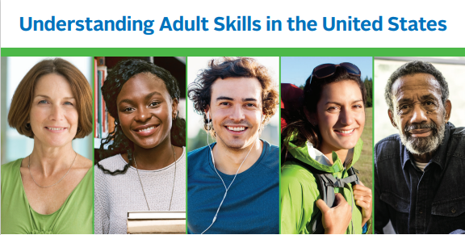
1600 Research Boulevard
WB 42F
Rockville, MD 20850
Your household has been selected to participate in the Program for the International Assessment of Adult Competencies. Anyone selected in your household to participate would receive $100 upon completing the study.

Please contact us today to schedule a visit from a study representative!
1-855-917-1999
https://nces.ed.gov/surveys/piaac/

Photos are for illustrative purposes only. Any person depicted in the photos is a model .

Follow-up Letter

Date

Hello,

We have tried to reach you to invite you and others in your household to be in a study. The study is called the Program for the International Assessment of Adult Competencies, or PIAAC. Information from the study will help national, state, and local groups build and improve education, skills training programs and job training programs.

PIAAC is taking place in 32 countries around the world. In the United States, the U.S. Department of Education is running the study. To learn more about PIAAC, please visit our website at https://nces.ed.gov/surveys/piaac/.

To see if you or others in your home are eligible to be in the study, we need you to answer a few questions. Since we have not been able to reach you at home, we are enclosing a short questionnaire. Please take a few minutes to complete the eligibility questions and return it to us in the postage-paid envelope.

If you or another member of your household is eligible to participate in PIAAC, one of our professional interviewers will contact you about how you can participate in PIAAC. If you have questions about the study you can speak to a PIAAC study representative by calling toll-free 1-855-917-1999.

As a thank you, everyone who completes the study gets $100.

Thank you for helping. You are very important and unique to the PIAAC study!
Sincerely,

Peggy Carr, Ph.D.
Commissioner
U.S. Department of Education’s National Center of Education Statistics

The National Center for Education Statistics within the U.S. Department of Education is authorized to conduct this study under the Education Sciences Reform Act of 2002 (ESRA 2002; 20 U.S.C. § 9543). All of the information you provide may be used only for statistical purposes and may not be disclosed, or used, in identifiable form for any other purpose except as required by law (20 U.S.C. §9573 and 6 U.S.C. §151). Individuals are never identified in any reports. All reported statistics refer to the U.S. as a whole or to national subgroups.
According to the Paperwork Reduction Act of 1995, no persons are required to respond to a collection of information unless it displays a valid OMB control number. The valid OMB control number for this voluntary survey is 1850-0870. The time required to complete this survey is estimated to take up to two hours, including the time to review instructions, gather the data needed, and complete and review the PIAAC Cycle II questionnaire and exercise. If you have any comments concerning the accuracy of the time estimate, suggestions for improving this survey, or any comments or concerns regarding this survey, please write directly to: PIAAC, National Center for Education Statistics, Potomac Center Plaza, 550 12th Street, SW, Washington, DC 20202. Approval expires MM/DD/YYYY.

Respondent Brochure
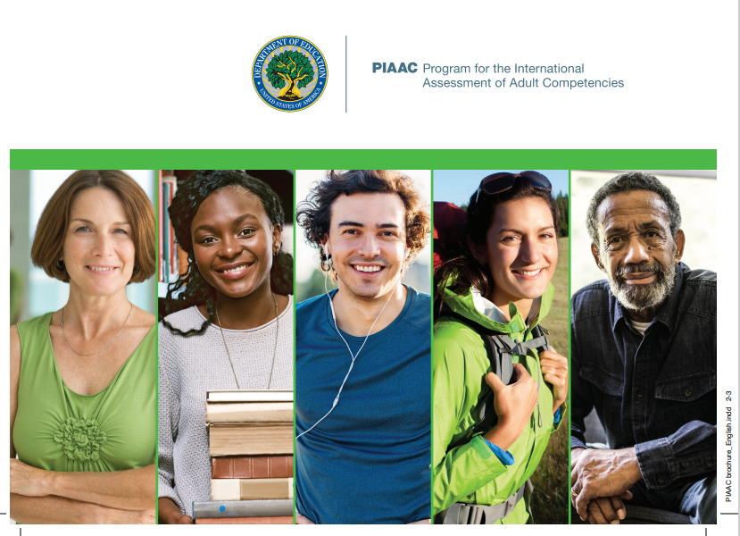
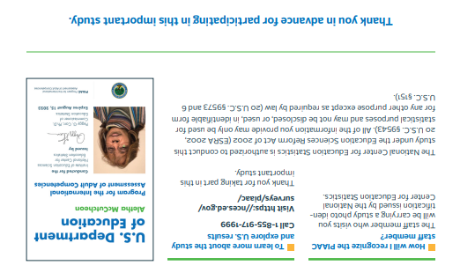
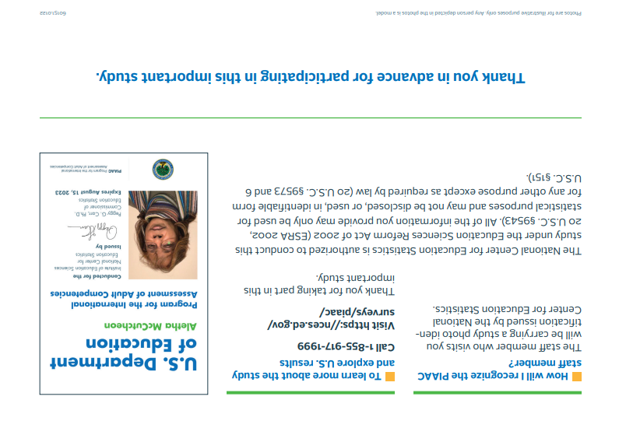

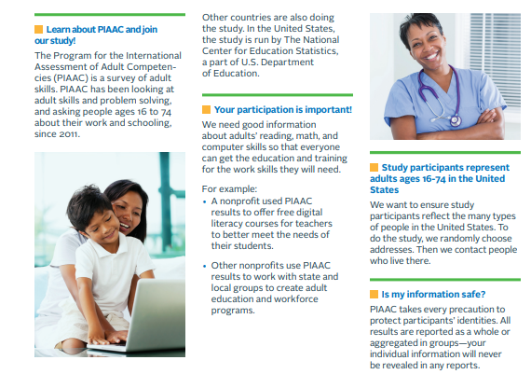
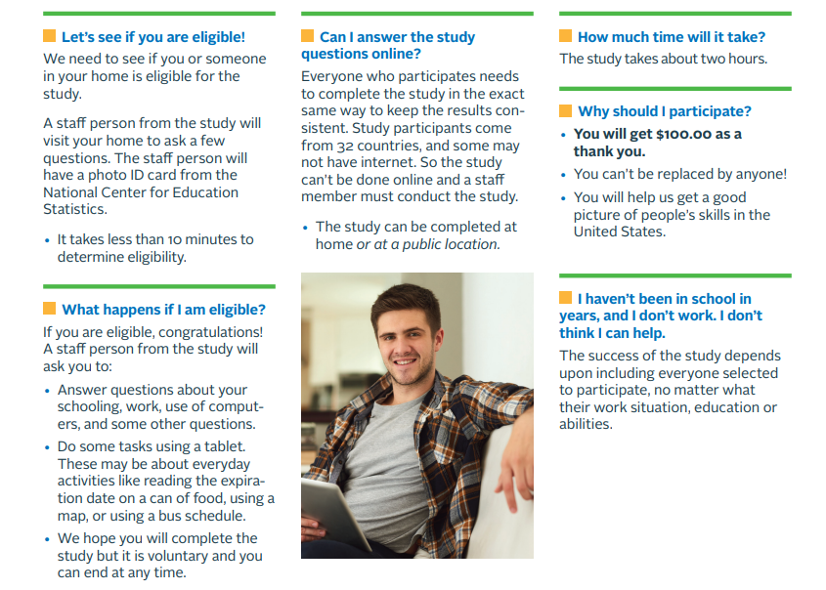

Doorknob Notification

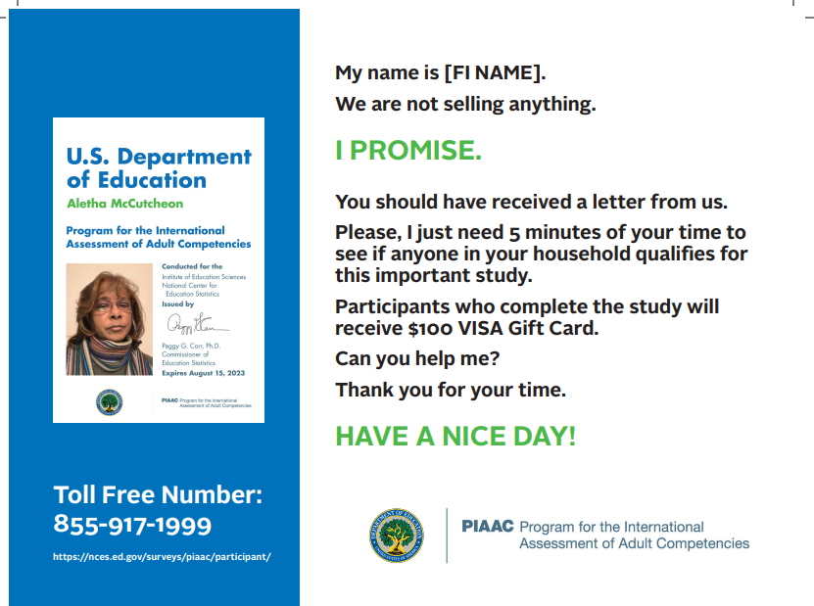

Informational Fliers
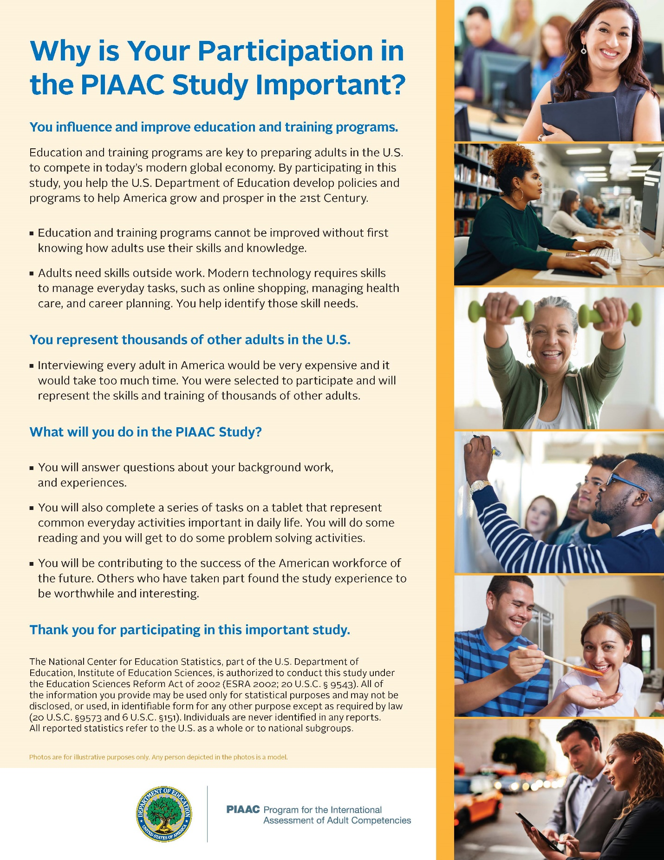
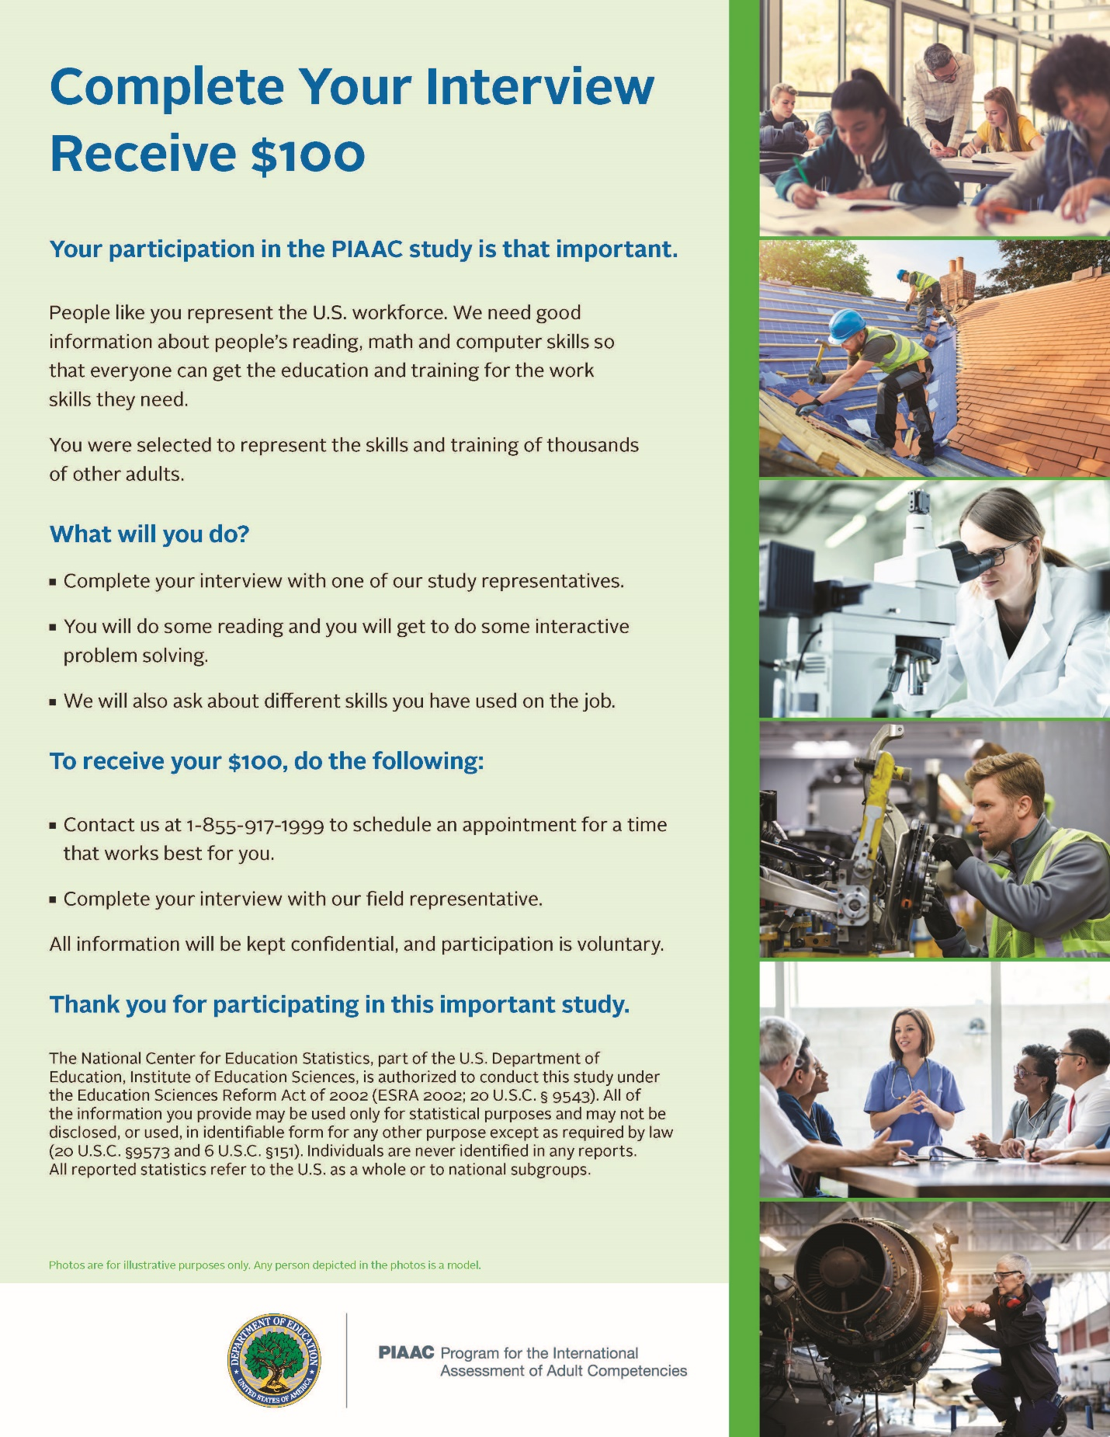

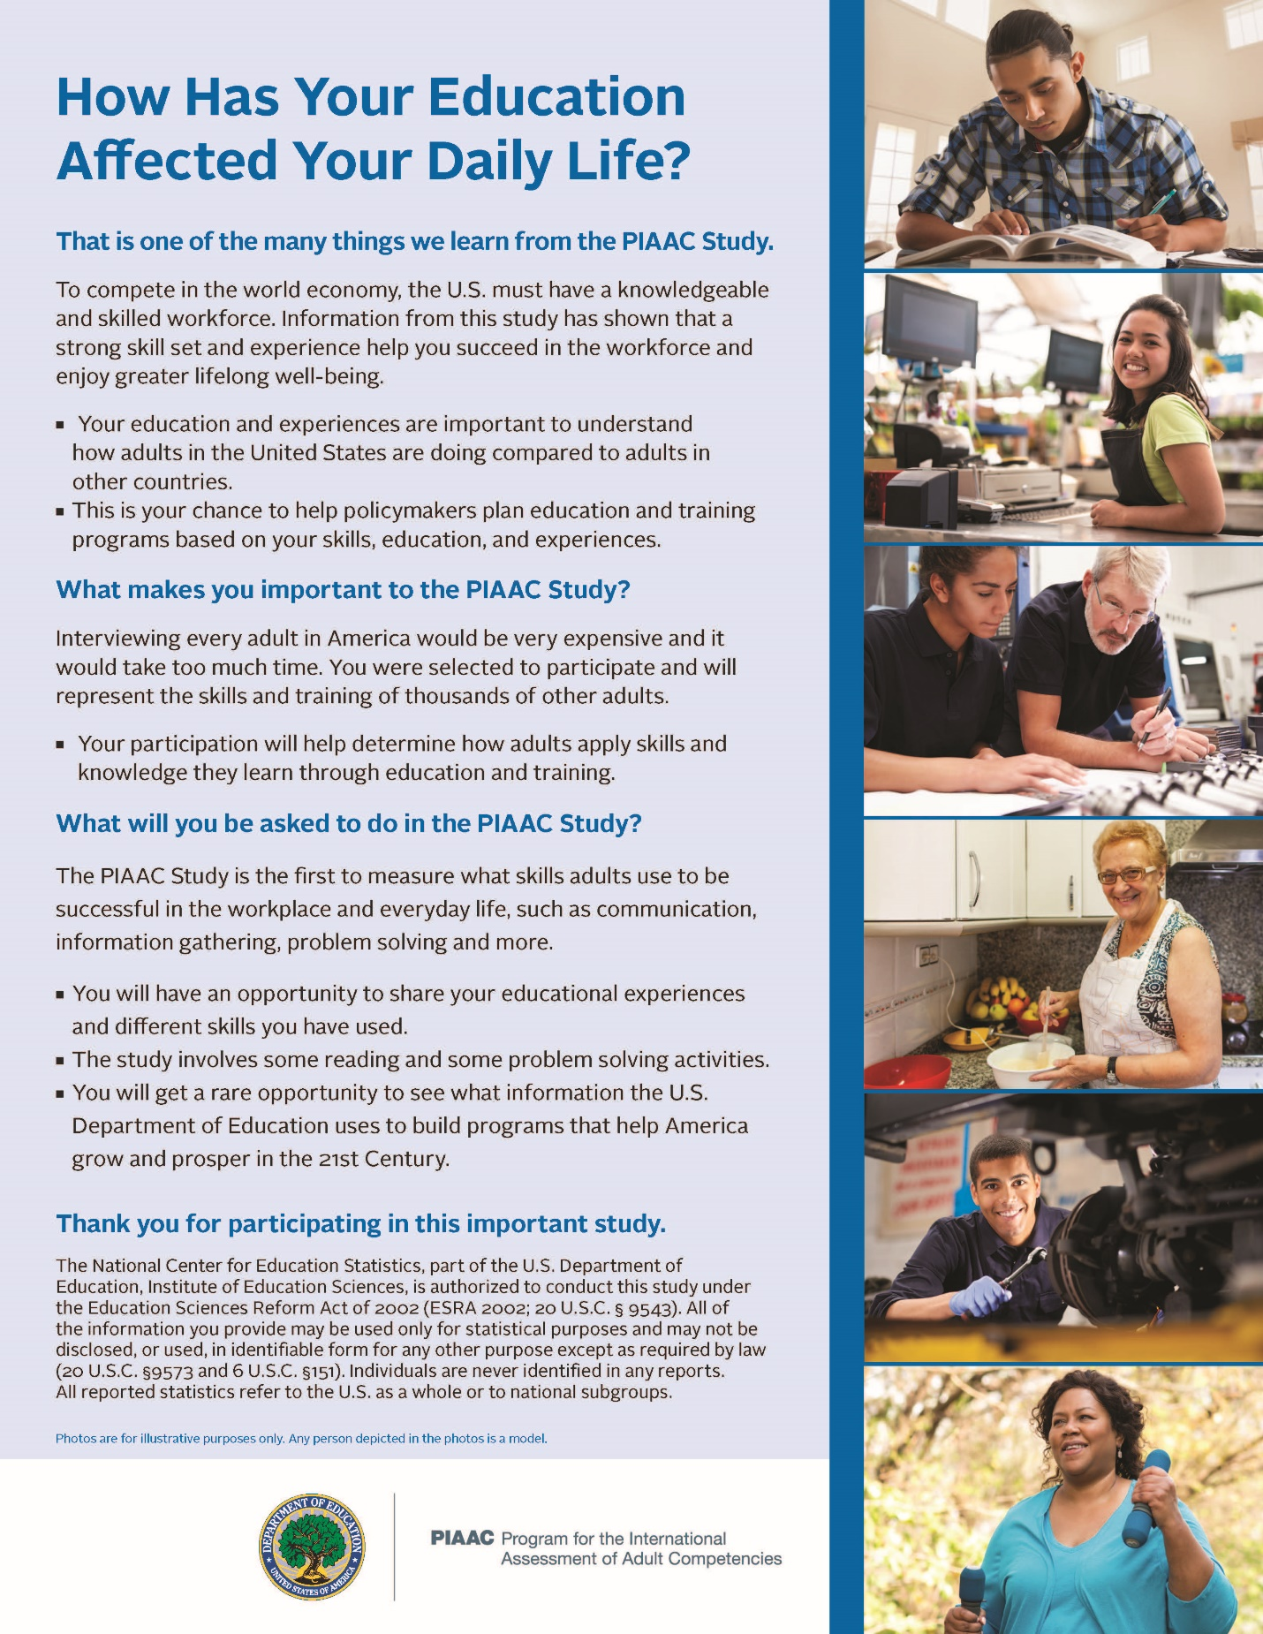

Household Refusal Letter – Locked Building
[date]

Dear Sir or Madam:

Recently your household should have received a letter like this one, from the National Center for Education Statistics (NCES), explaining that it has been selected to participate in an important international study called the Program for the International Assessment of Adult Competencies. We sent one of our field representatives to contact your household, but without success.

This study is designed to tell us what skills adults in the United States have and how those skills relate to their employment and education. This information will help us develop educational and training programs to prepare our workforce to meet the challenges of the 21st century.

Since we cannot conduct an interview in every household in this country, we use scientific methods to randomly select addresses throughout the United States, and your household has been selected. Please help us determine if anyone in your household qualifies to participate in the study. If an adult in the household is selected to participate and completes the study, that person will receive $100.00 as a thank you. Participation is entirely voluntary and is a service to the community and the nation.
Please take a moment and call our study’s toll-free number (1-855-917-1999) to arrange a time to meet with our field representative.

The National Center for Education Statistics is authorized to conduct this study under the Education Sciences Reform Act of 2002 (ESRA 2002, 20 U.S.C. §9543). All of the information you provide may only be used for statistical purposes and may not be disclosed, or used, in identifiable form for any other purpose except as required by law (20 U.S.C. §9573 and 6 U.S.C. §151). Individuals are never identified in any reports. All reported statistics refer to the U.S. as a whole or to national subgroups.

Thank you very much for your cooperation and your contribution to this important study.

Sincerely,

Peggy G. Carr, Ph.D.
Commissioner
National Center of Education Statistics

Household Refusal Letter – No Selling

[date]

Dear Sir or Madam,

Recently a field representative contacted your household on behalf of the National Center for Education Statistics (NCES), explaining that your household has been selected to participate in an important international study called the Program for the International Assessment of Adult Competencies. It is understandable that you may have suspicions these days when a stranger knocks on the door. Therefore, as the Commissioner of the National Center of Education Statistics, I want to assure you that this is a legitimate nationwide study conducted by the U.S. Department of Education’s National Center for Education Statistics. We are NOT advertising or selling anything, and at no time will we attempt to collect money from you.

This study is designed to tell us what skills adults in the Unites States have and how those skills relate to their employment and education. This information will help us develop educational and training programs to prepare our workforce to meet the challenges of the 21st century.

Since we cannot conduct an interview in every household in this country, we use scientific methods to randomly select addresses throughout the United States. Your household has been selected to represent thousands of others across the country. Please help us determine if anyone in your household qualifies to participate in the study. If an adult in the household is selected to participate and completes the study, that person will receive $100.00 as a thank you.

Our field representative will contact your household again shortly to schedule a time to meet with you. Our field representative will be wearing a photo ID badge, will provide you with a brochure describing the study, and can address any concerns or questions you may have. Please help us complete this study. If you still have questions, please call our toll-free number (1-855-917-1999). Your participation is entirely voluntary and is a service to your community and the nation.

The National Center for Education Statistics is authorized to conduct this study under the Education Sciences Reform Act of 2002 (ESRA 2002, 20 U.S.C. §9543). All of the information you provide may only be used for statistical purposes and may not be disclosed, or used, in identifiable form for any other purpose except as required by law (20 U.S.C. §9573 and 6 U.S.C. §151). Individuals are never identified in any reports. All reported statistics refer to the U.S. as a whole or to national subgroups.

Thank you very much for your cooperation and your contribution to this important study.

Sincerely,

Peggy G. Carr, Ph.D.
Commissioner
National Center of Education Statistics

Household Refusal Letter – Refusal After Initial Contact
[date]

Dear [RESPONDENT NAME, SIR OR MADAM],

Recently one of our field representatives contacted you about representing the United States in the international study called Program for the International Assessment of Adult Competencies, which is being conducted by the U.S. Department of Education’s National Center for Education Statistics. You were reluctant to begin the study, so I am writing to give you more information and ask for your help.

This study is designed to tell us what skills adults in the United States have and how those skills relate to their employment and education. This information will help us develop educational and training programs to prepare our workforce to meet the challenges of the 21st century.

Contacting every adult in the United States is very expensive and difficult. Therefore, we have used statistical methods to randomly select several thousand adults who can represent the entire nation. If you do not participate, adults like you across the country will not be accurately represented in this study.

I understand that you are very busy and that time can be hard to come by. Your participation is entirely voluntary. But I would not ask you for your time if it were not so important to include every selected adult in the study. If you complete the study, you will receive $100.00 as a thank you for your time and participation.

The National Center for Education Statistics is authorized to conduct this study under the Education Sciences Reform Act of 2002 (ESRA 2002, 20 U.S.C. §9543). All of the information you provide may only be used for statistical purposes and may not be disclosed, or used, in identifiable form for any other purpose except as required by law (20 U.S.C. §9573 and 6 U.S.C. §151). Individuals are never identified in any reports. All reported statistics refer to the U.S. as a whole or to national subgroups.

If you have additional questions, our field representative will be glad to answer them. You may also call the study’s toll free number (1-855-917-1999), or visit the study’s website at https://nces.ed.gov/surveys/piaac/

Thank you very much for your cooperation and your contribution to this important study.

Sincerely,

Peggy G. Carr, Ph.D.
Commissioner
National Center of Education Statistics

Household Refusal Letter – Too Busy

[date]

Dear [RESPONDENT NAME],

Recently a field representative contacted you on behalf of the National Center for Education Statistics, explaining that you have been selected to represent the United States in an important international study called the Program for the International Assessment of Adult Competencies. At that time you were unable to begin the study. I am writing now to tell you a little more about why this study is important and why we have contacted you.

This study is designed to tell us what skills adults in the United States have and how those skills relate to their employment and education. This information will help us develop educational and training programs to prepare our workforce to meet the challenges of the 21st century.

Your participation is important because you represent thousands of other individuals who are like you across the country. Contacting every adult in the United States is very expensive and difficult. Therefore, we have used statistical methods to randomly select several thousand adults who can represent the entire nation. I understand that you are very busy and that time can be hard to come by. But please see if you can make time for this study because if you do not participate, adults like you who have busy lives will not be accurately represented in this study.

I have taken the liberty of asking our field representative to contact you again shortly to schedule a time to meet with you. Your participation is entirely voluntary and is a service to your community and the nation. If you complete the study, you will receive $100.00 as a thank you for your time and participation.

The National Center for Education Statistics is authorized to conduct this study under the Education Sciences Reform Act of 2002 (ESRA 2002, 20 U.S.C. §9543). All of the information you provide may only be used for statistical purposes and may not be disclosed, or used, in identifiable form for any other purpose except as required by law (20 U.S.C. §9573 and 6 U.S.C. §151). Individuals are never identified in any reports. All reported statistics refer to the U.S. as a whole or to national subgroups.

Thank you very much for your cooperation and your contribution to this important study.

Sincerely,

Peggy G. Carr, Ph.D.
Commissioner
National Center of Education Statistics

Tribal Communications Recruitment Letter

[date]
Dear [Leader NAME],

The National Center for Education Statistics (NCES), part of the U.S. Department of Education, is conducting the Programme for the International Assessment of Adult Competencies (PIAAC), a major study that will collect information about the education, work experiences, and skills of our country’s adult population. This information will assist national and local government leaders, educators, and policymakers better understand the skills of the American workforce, to help make important updates to education and social policies.

NCES has contracted with Westat, a research and policy firm, to conduct the data collection for this important international study. Beginning in September, 2022, we plan to collect information from a random sample of approximately 10,000 individuals across the country. This will include persons living on and near your reservation. As a thank you for participating fully in the two hour PIAAC study session, we will offer eligible participants [$75/ $100 gift Mastercard].

The PIAAC Study is important for current and future generations of all Americans because the results can help to improve government and nonprofit education policies and programs. For example, the study results may inform approaches to job training and adult education courses to better align adult skills to local jobs. Also, this study takes place in more than 30 nations and results will show how the United States compares to other countries and can better prepare us all for changes in the global economy.

In order to maximize the impact of the study for your membership, we will provide your organization and any interested tribal leaders with a summary of the study results.

A PIAAC staff member will contact you in the next week to provide additional information on the PIAAC Study and answer your questions about it. In the meantime, please feel free to contact Jacquie Hogan, PIAAC Study Director at (301) 610-4967 or jacquiehogan@westat.com; for information, you can also visit the PIAAC Study website: https://nces.ed.gov/surveys/piaac/. Once you are fully informed about it, we hope that you will encourage your membership to support and participate in the PIAAC Study.

Thank you for your cooperation in this important national research effort.

Sincerely,

Peggy G. Carr, Ph.D.
Commissioner
National Center for Education Statistics (NCES)

