NATIONAL CENTER FOR EDUCATION STATISTICS NATIONAL ASSESSMENT OF EDUCATIONAL PROGRESS

National Assessment of Educational Progress (NAEP)2022

Appendix J2

2022 Teacher Questionnaires

OMB# 1850-0928 v.25

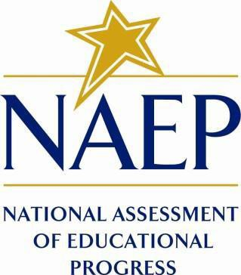

September 2021

Appendix J2 provides updated teacher survey questionnaires to be used in NAEP 2022. The change tables indicate any revisions that have been made to the previous versions of the SQs.
Table of Contents
Teacher Questionnaires
Sample Teacher Questionnaire Login Screens 3
Sample Teacher Questionnaire Booklet Covers 4
Appendix J2-1: Summary of Changes Operational Grade 4 CORE 5
Appendix J2-2: Operational Grade 4 CORE 12
Appendix J2-3: Summary of Changes Operational Grade 8 CORE 20
Appendix J2-4: Operational Grade 8 CORE 28
Appendix J2-5: Summary of Changes Operational Grade 4 Mathematics 38
Appendix J2-6: Operational Grade 4 Mathematics 43
Appendix J2-7: Summary of Changes Operational Grade 8 Mathematics 50
Appendix J2-8: Operational Grade 8 Mathematics 56
Appendix J2-9: Summary of Changes Operational Grade 4 Reading 64
Appendix J2-10: Operational Grade 4 Reading 68
Appendix J2-11: Summary of Changes Operational Grade 8 Reading 73
Appendix J2-12: Operational Grade 8 Reading 78
Appendix J2-13: Summary of Changes Operational Grade 8 Social Studies 83
Appendix J2-14: Operational Grade 8 Social Studies 92
Appendix J2-15: Summary of Operational Grade 4 COVID-19 101
Appendix J2-16: Operational Grade 4 COVID-19 106
Appendix J2-17: Summary of Operational Grade 8 COVID-19 110
Appendix J2-18: Operational Grade 8 COVID-19 114

Sample Teacher Questionnaire Login Screens

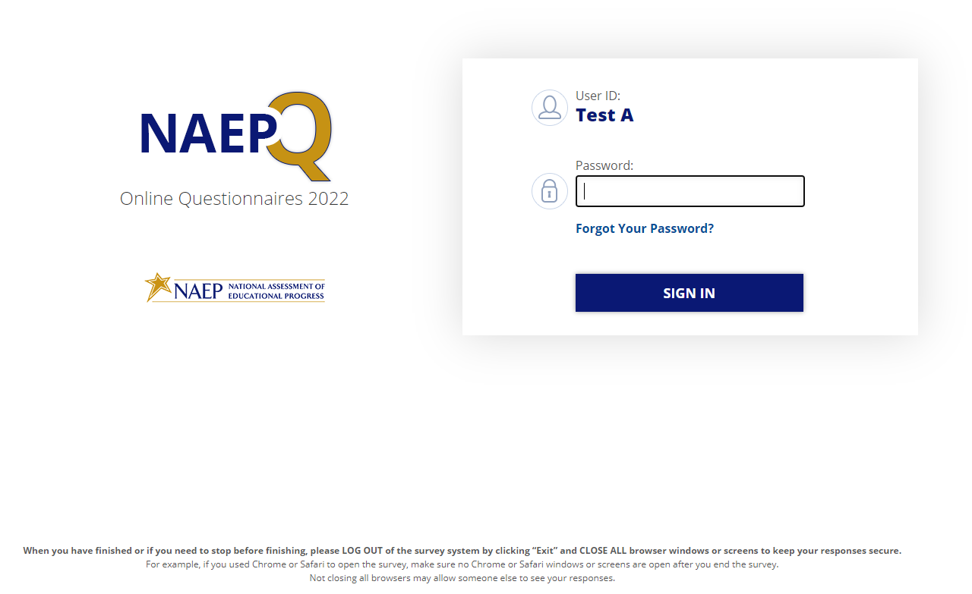
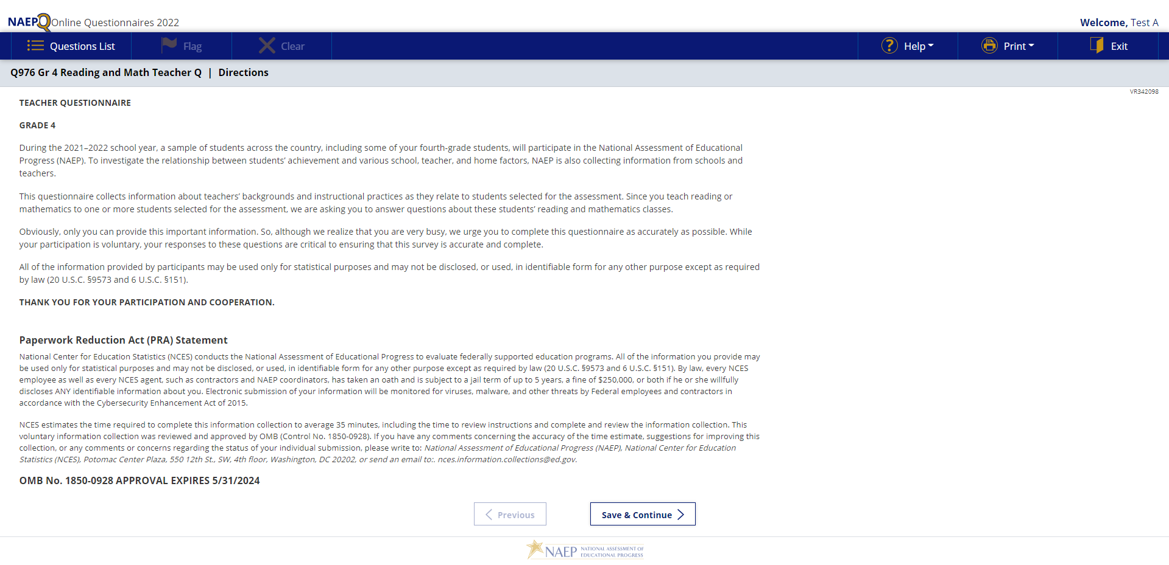

Sample Teacher Questionnaire Booklet Covers
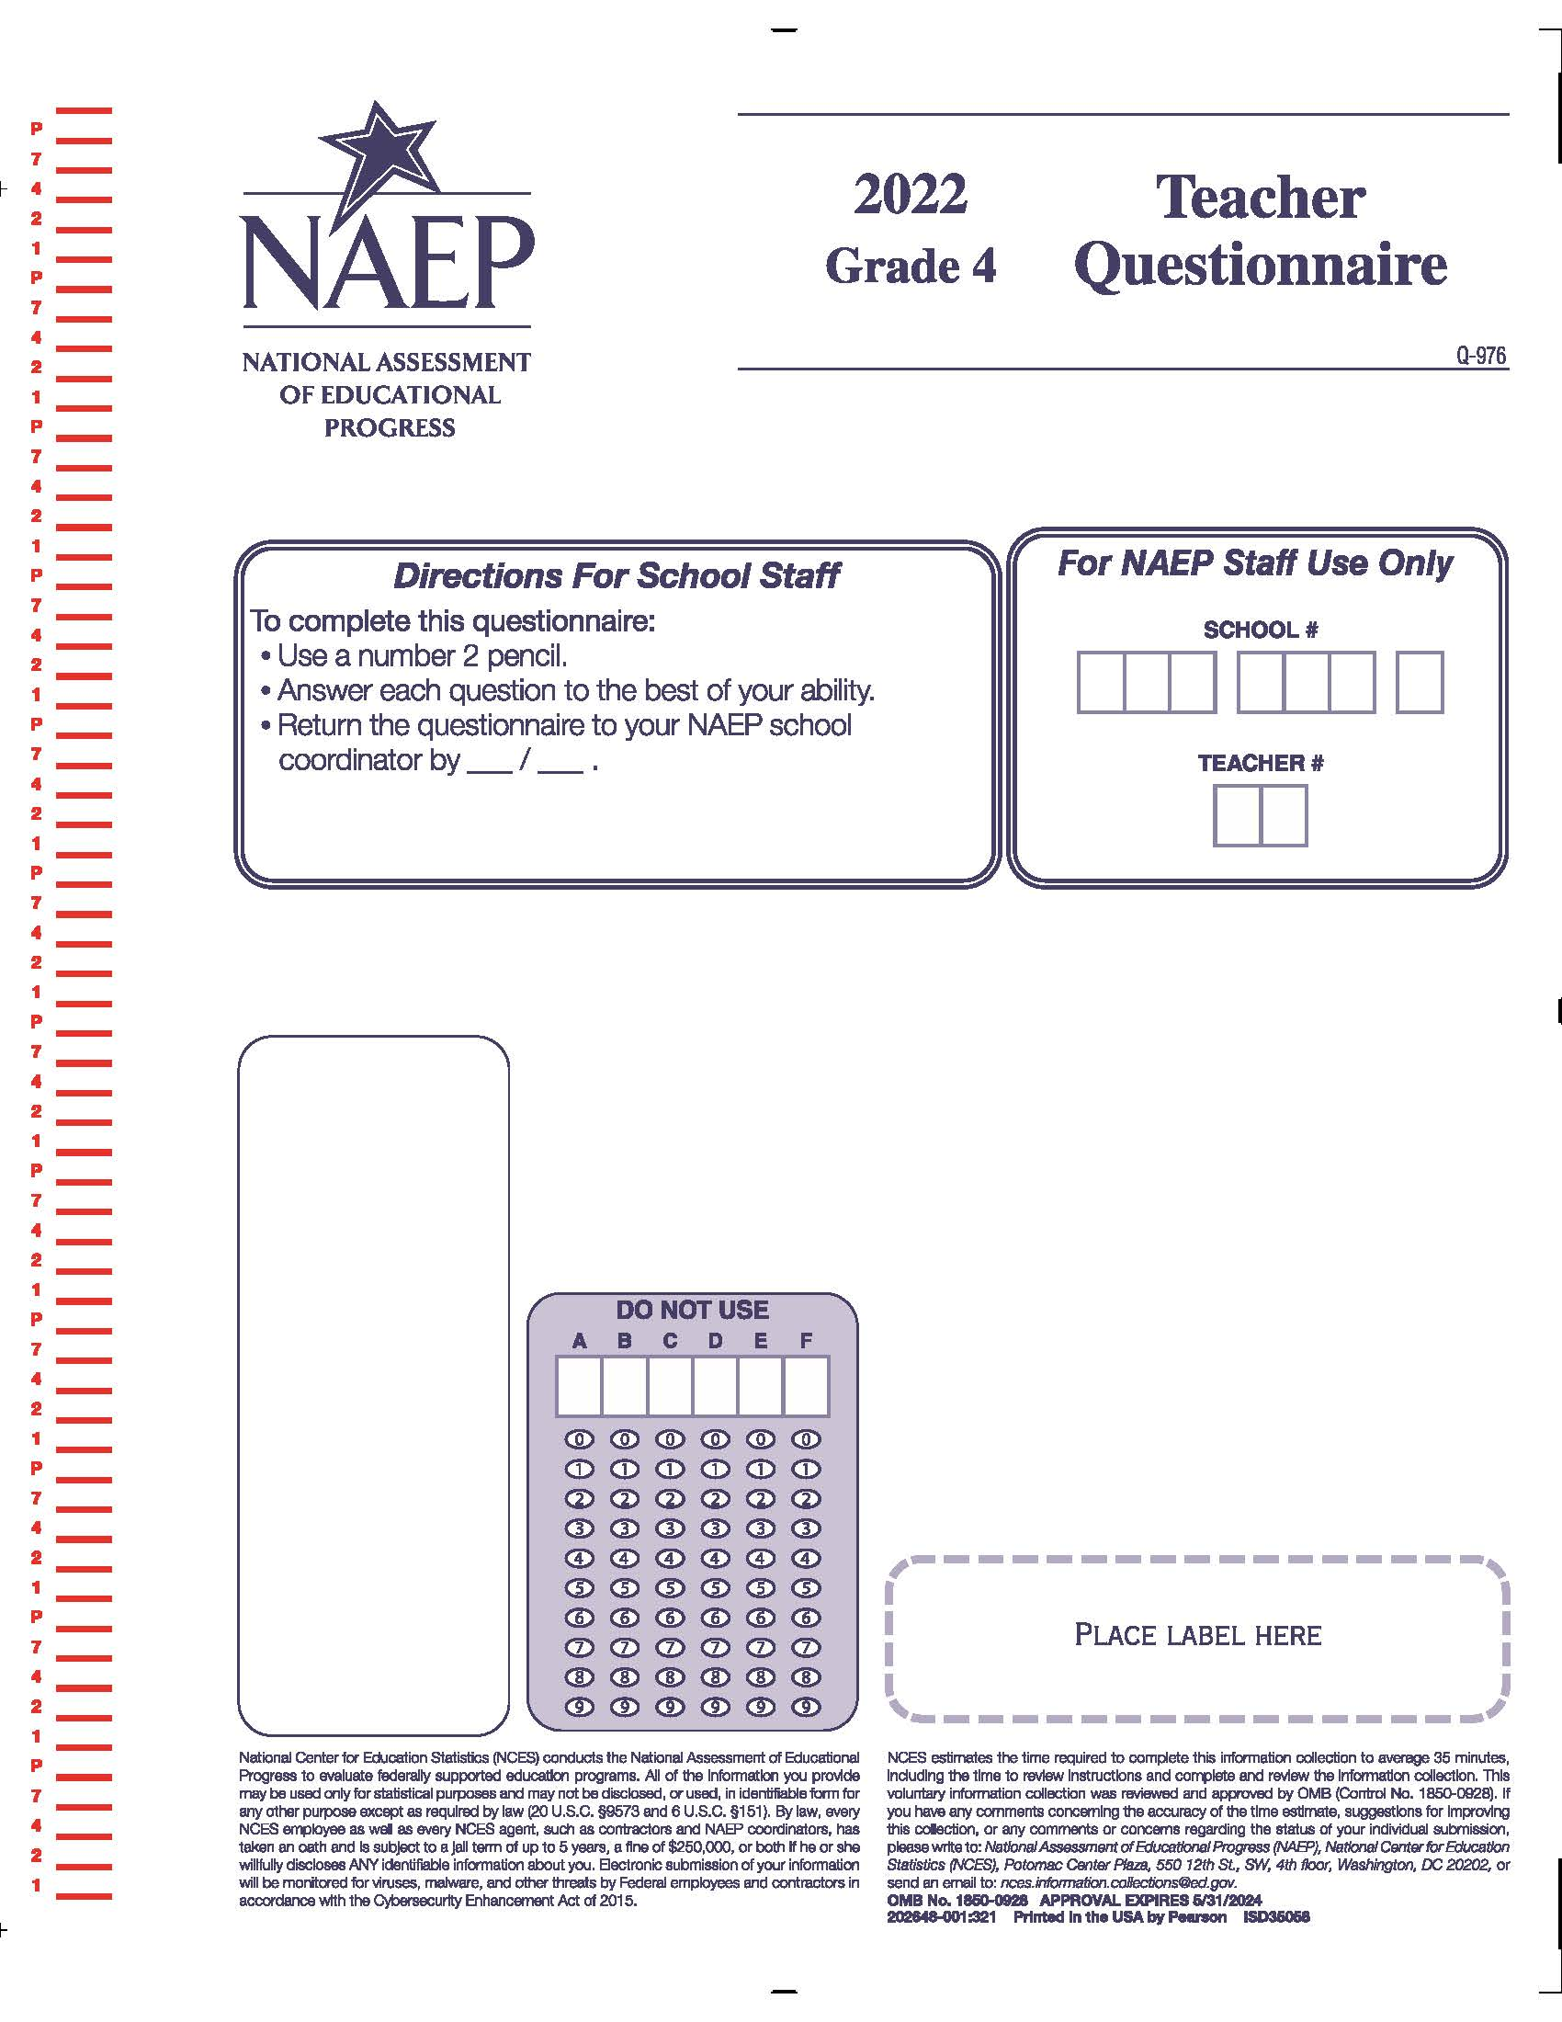

Appendix J2-1: Summary of Changes Operational Grade 4 CORE
2022 Operational Grade 4 Core Teacher

Previous item | 2022 item | D/A/ R/NC+ | Rationale
(2021 Grade 4) | Issue: Gender | NC | N/A
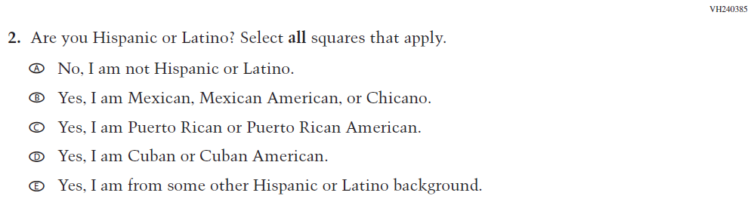  (2021 Grade 4) | 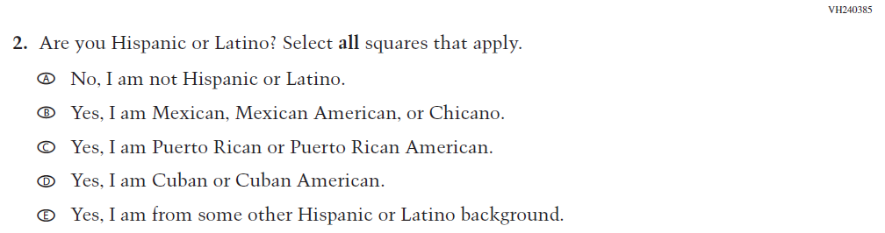  Issue: Race/Ethnicity | NC | N/A
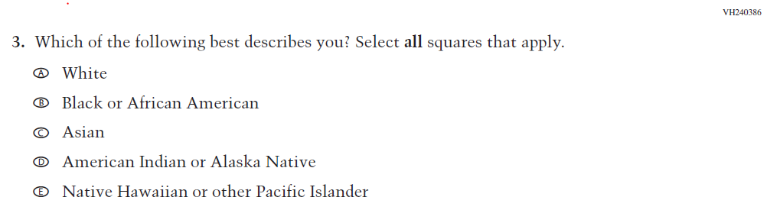  (2021 Grade 4) | 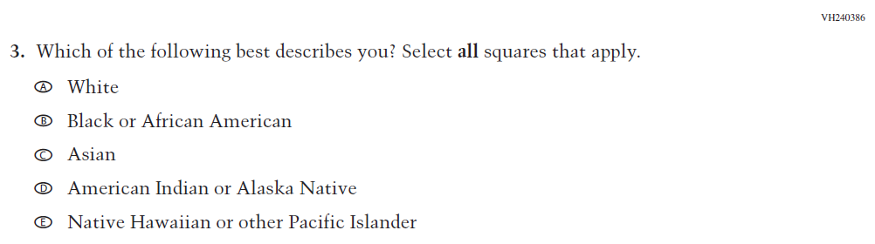  Issue: Race/Ethnicity | NC | N/A
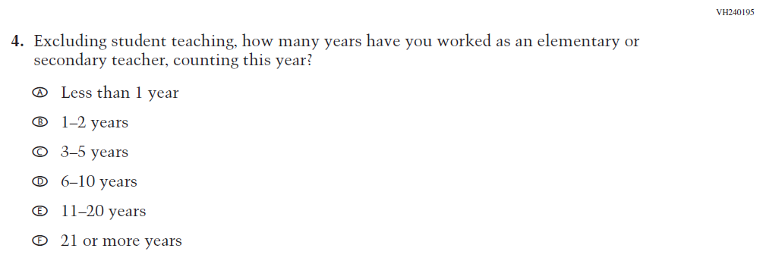  (2021 Grade 4) | 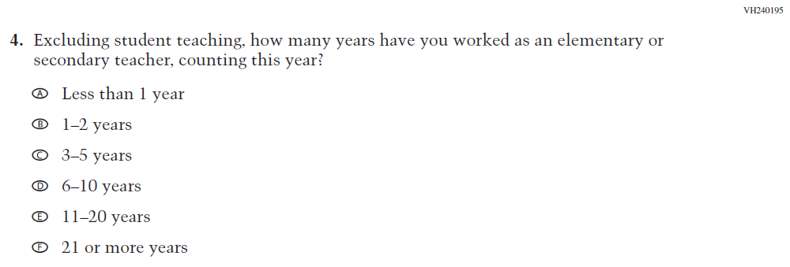  Issue: Teacher Preparation | NC | N/A

2022 Operational Grade 4 Core Teacher

Previous item | 2022 item | D/A/ R/NC+ | Rationale
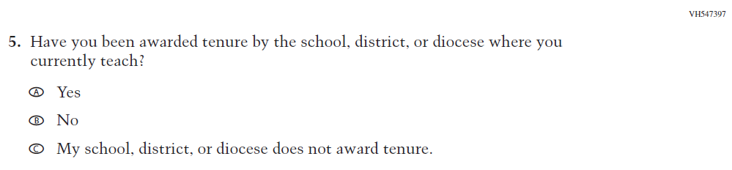  (2021 Grade 4) | 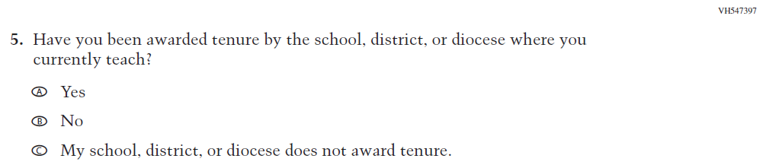  Issue: Teacher Preparation | NC | N/A
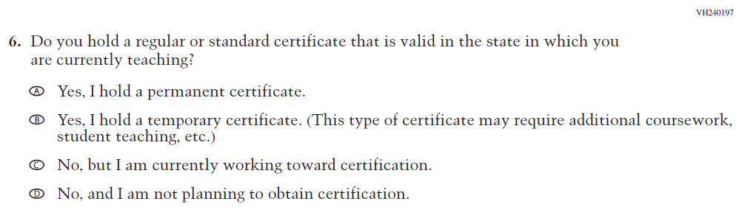  (2021 Grade 4) | 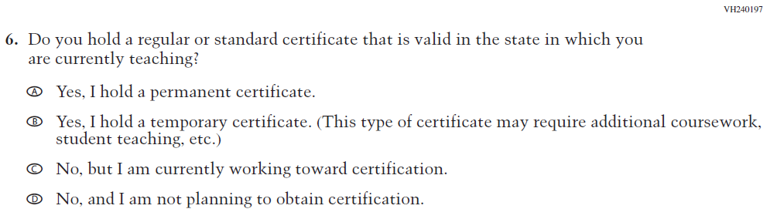  Issue: Teacher Preparation | NC | N/A
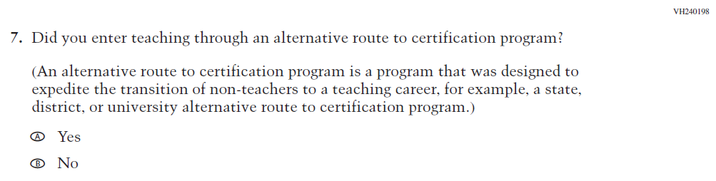  (2021 Grade 4) | 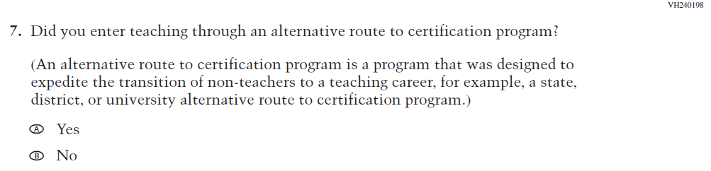  Issue: Teacher Preparation | NC | N/A

2022 Operational Grade 4 Core Teacher

Previous item | 2022 item | D/A/ R/NC+ | Rationale
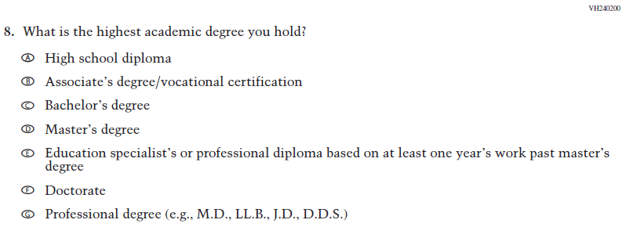  (2021 Grade 4) | Issue: Teacher Preparation | NC | N/A
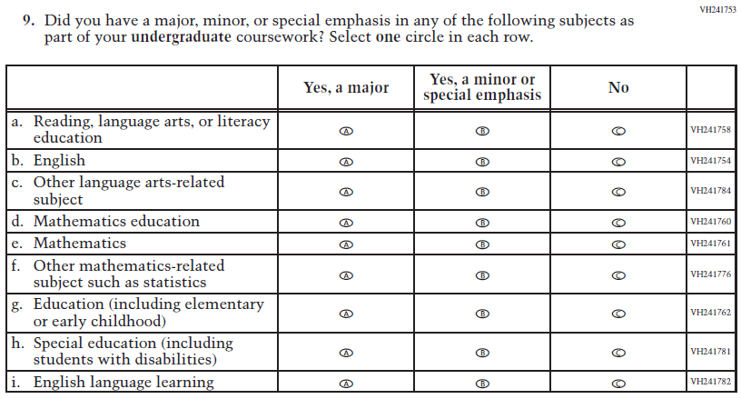  (2021 Grade 4) | Issue: Teacher Preparation | NC | N/A
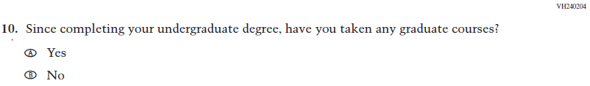  (2021 Grade 4) | Issue: Teacher Preparation | NC | N/A

2022 Operational Grade 4 Core Teacher

Previous item | 2022 item | D/A/ R/NC+ | Rationale
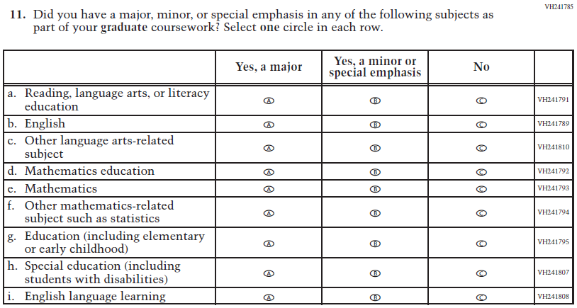  (2021 Grade 4) | Issue: Teacher Preparation | NC | N/A
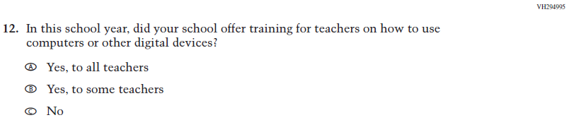  (2021 Grade 4) | 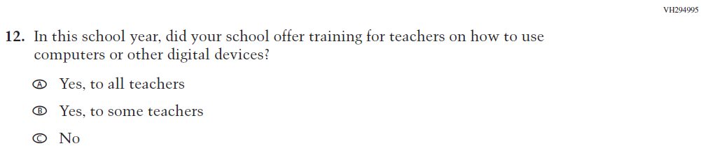  Issue: Technology Use | NC | N/A
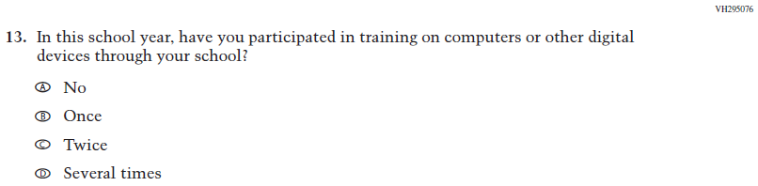  (2021 Grade 4) | Issue: Technology Use | NC | N/A
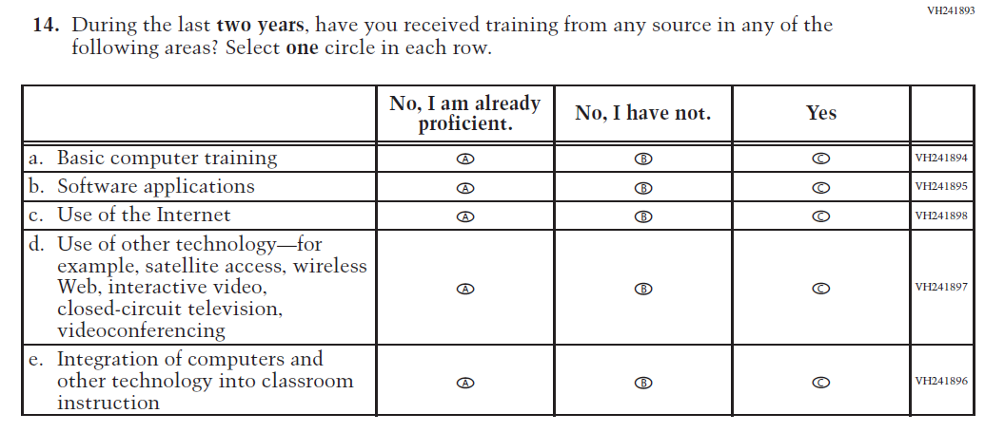  (2021 Grade 4) | 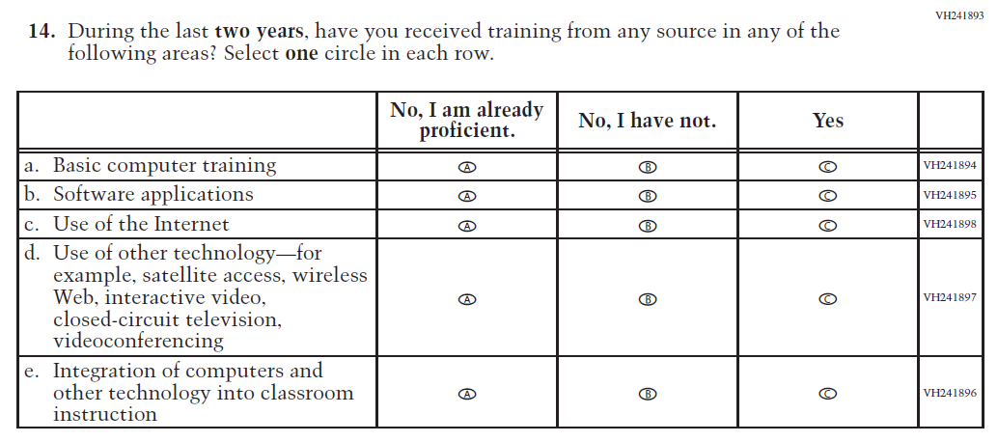  Issue: Teacher Preparation | NC | N/A
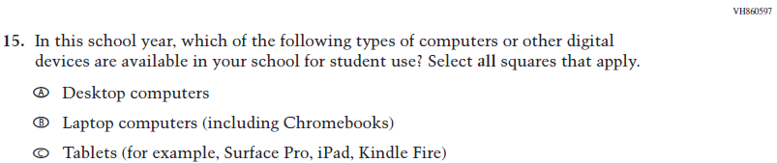  (2021 Grade 4) | Issue: Technology Use | NC | N/A
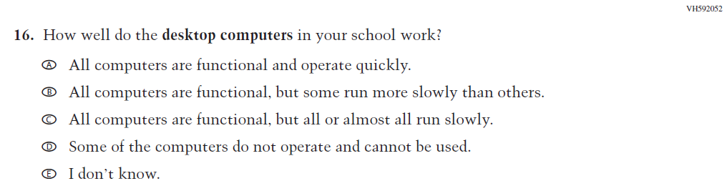  (2021 Grade 4) | Issue: Technology Use | NC | N/A
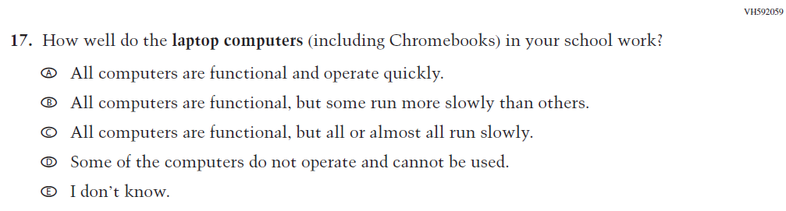  (2021 Grade 4) | Issue: Technology Use | NC | N/A

2022 Operational Grade 4 Core Teacher

Previous item | 2022 item | D/A/ R/NC+ | Rationale
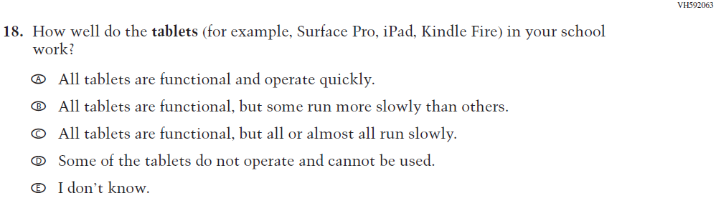  (2021 Grade 4) | Issue: Technology Use | NC | N/A
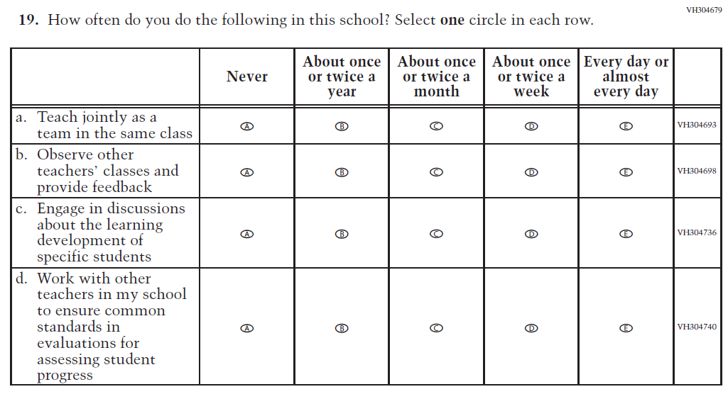  (2021 Grade 4) | Issue: School Climate | NC | N/A
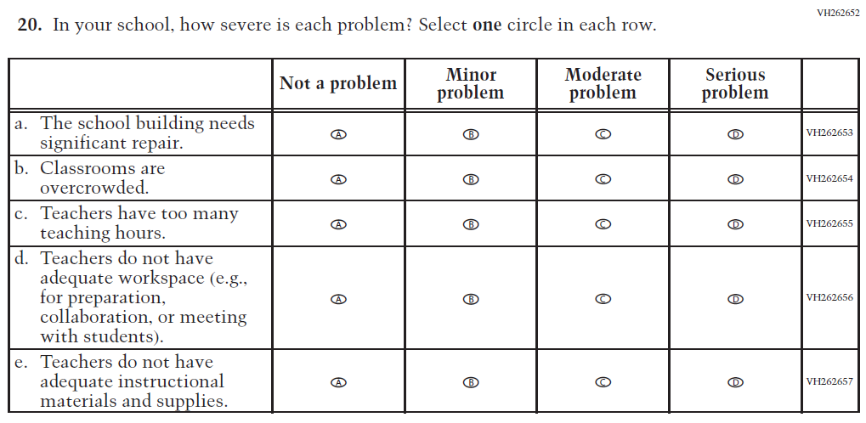  (2021 Grade 4) | Issue: School Climate | NC | N/A

2022 Operational Grade 4 Core Teacher

Previous item | 2022 item | D/A/ R/NC+ | Rationale
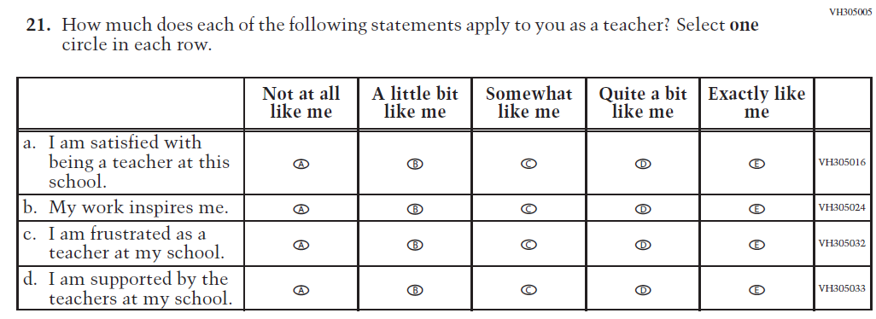  (2021 Grade 4) | Issue: School Climate | NC | N/A
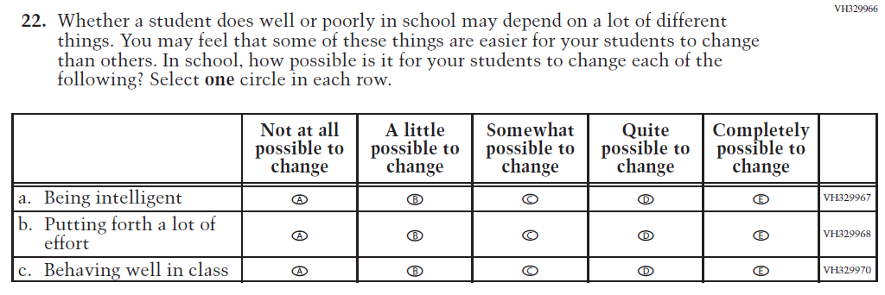  (2021 Grade 4) | Issue: Desire for Learning | NC | N/A

Appendix J2-2: Operational Grade 4 CORE
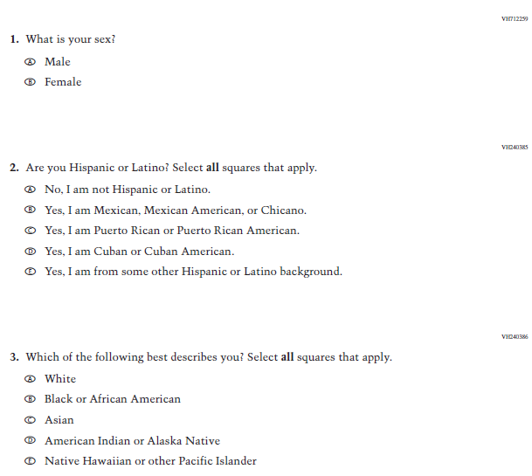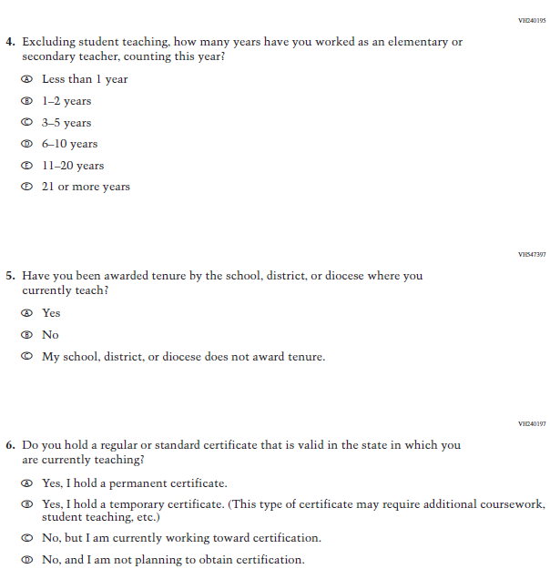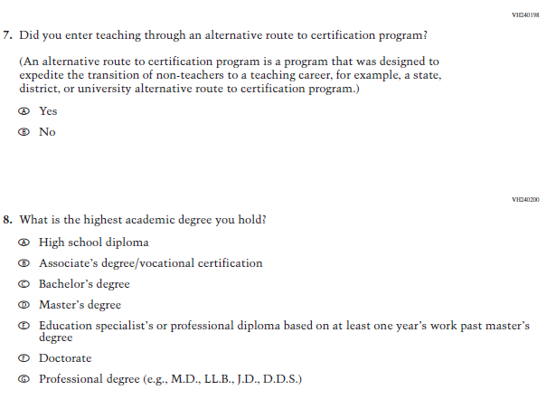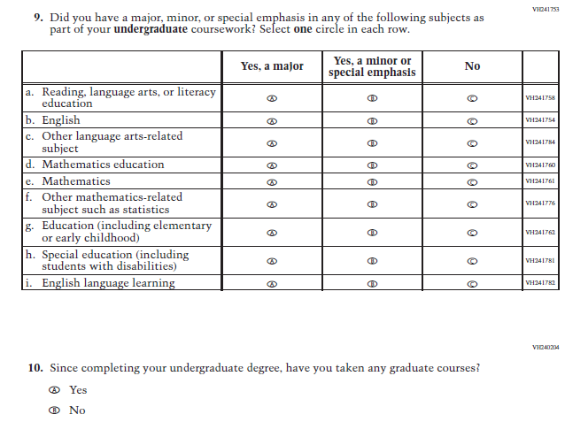
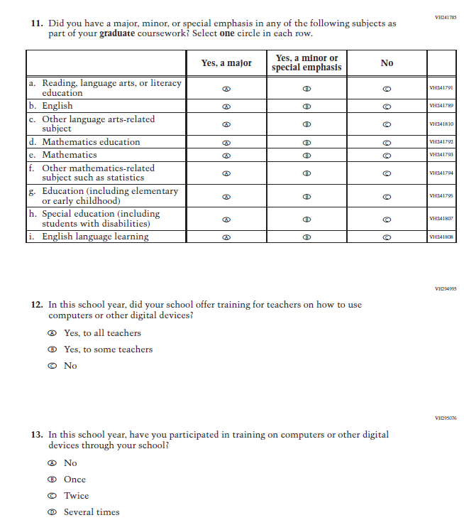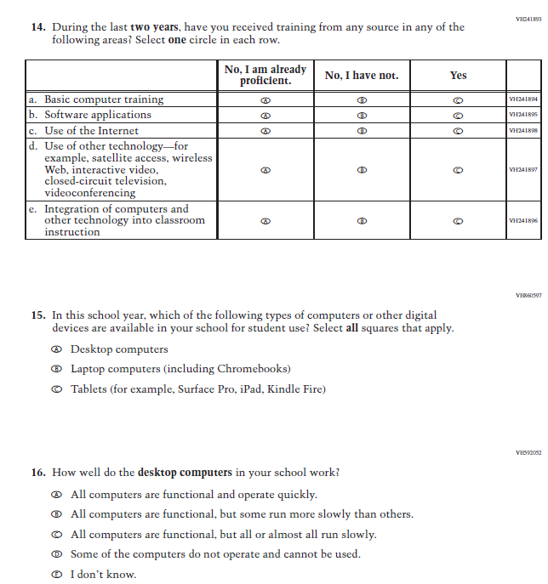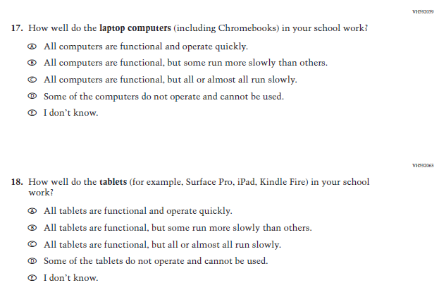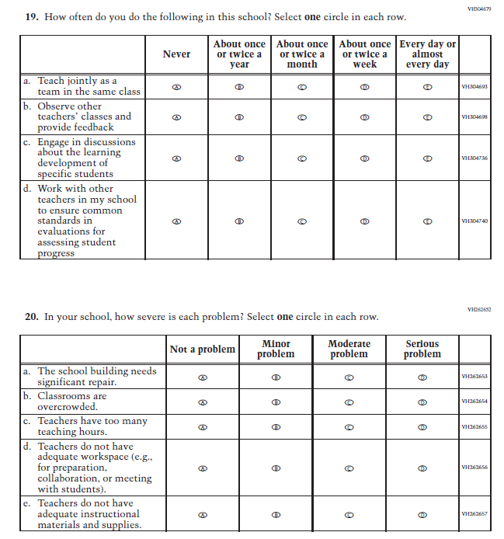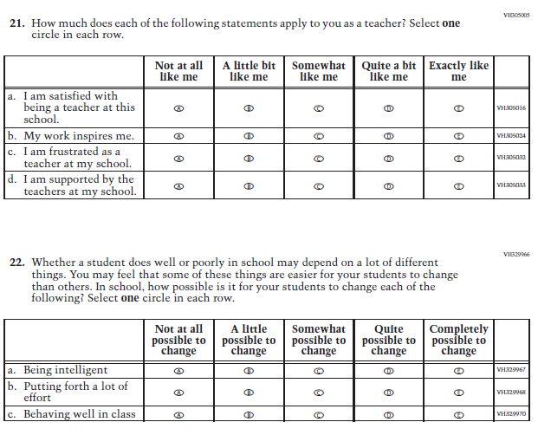

Appendix J2-3: Summary of Changes Operational Grade 8 CORE
2022 Operational Grade 8 Core Teacher

Previous item | 2022 item | D/A/ R/NC+ | Rationale
(2021 Grade 8) | Issue: Gender | NC | N/A
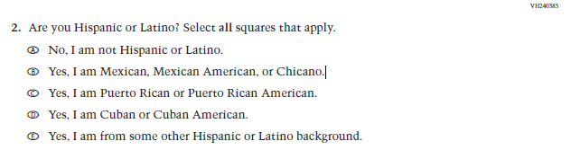  (2021 Grade 8) | Issue: Race/Ethnicity | NC | N/A
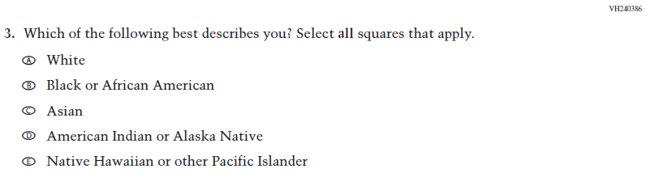  (2021 Grade 8) | Issue: Race/Ethnicity | NC | N/A
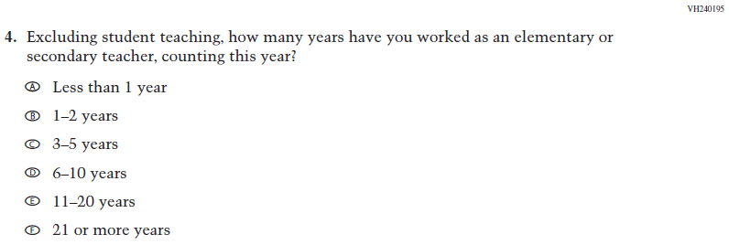  (2021 Grade 8) | Issue: Teacher Preparation | NC | N/A
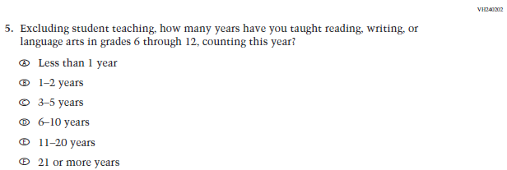  (2021 Grade 8) | Issue: Teacher Preparation | NC | N/A
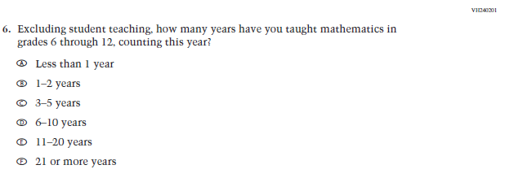  (2021 Grade 8) | Issue: Teacher Preparation | NC | N/A
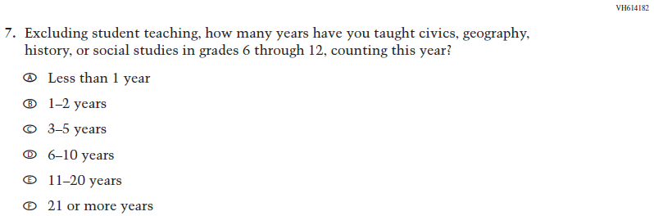  (2021 Grade 8) | Issue: Teacher Preparation | NC | N/A
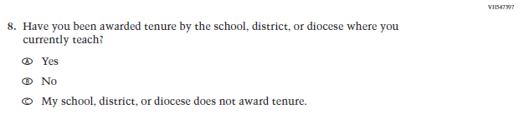  (2021 Grade 8) | Issue: Teacher Preparation | NC | N/A
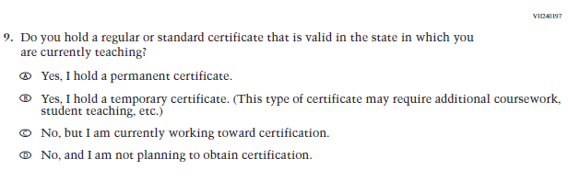  (2021 Grade 8) | Issue: Teacher Preparation | NC | N/A
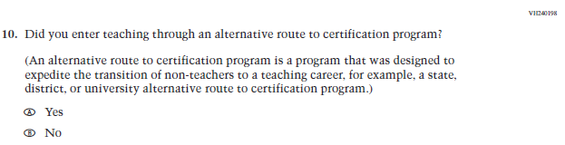  (2021 Grade 8) | Issue: Teacher Preparation | NC | N/A
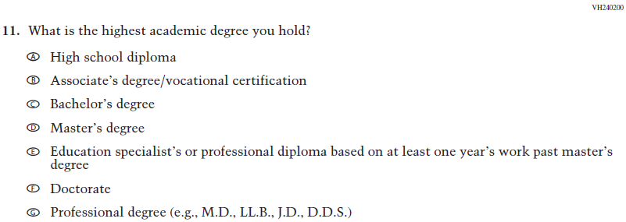  (2021 Grade 8) | Issue: Teacher Preparation | NC | N/A
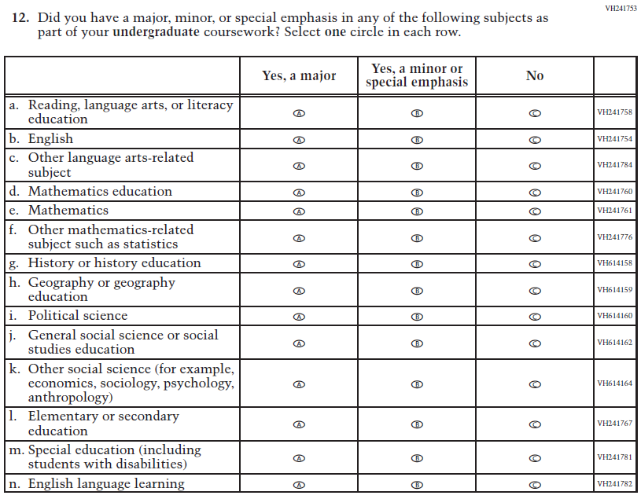  (2021 Grade 8) | Issue: Teacher Preparation | NC | N/A
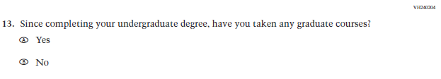  (2021 Grade 8) | Issue: Teacher Preparation | NC | N/A
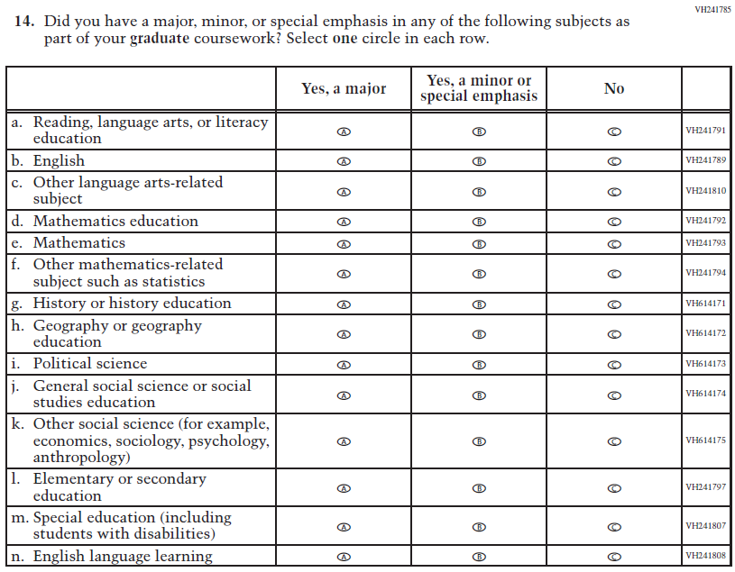  (2021 Grade 8) | Issue: Teacher Preparation | NC | N/A
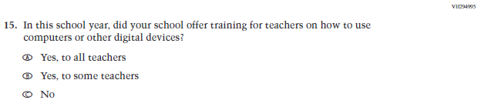  (2021 Grade 8) | Issue: Technology Use | NC | N/A
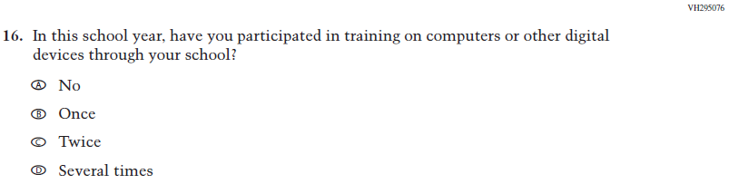  (2021 Grade 8) | Issue: Technology Use | NC | N/A
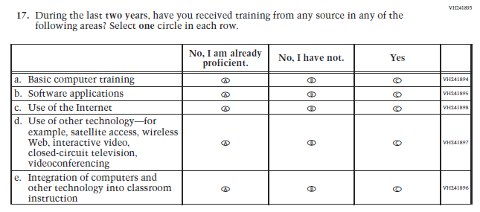  (2021 Grade 8) | Issue: Teacher Preparation | NC | N/A
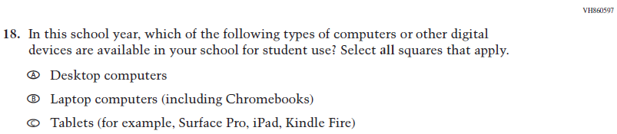  (2021 Grade 8) | Issue: Technology Use | NC | N/A
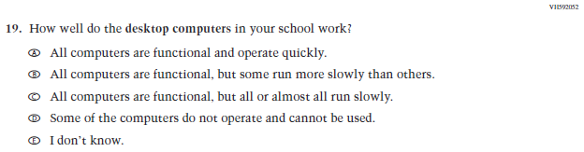  (2021 Grade 8) | Issue: Technology Use | NC | N/A
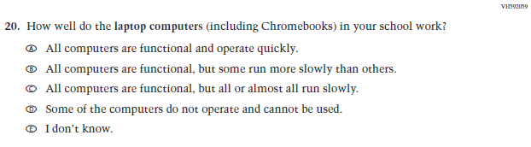  (2021 Grade 8) | Issue: Technology Use | NC | N/A
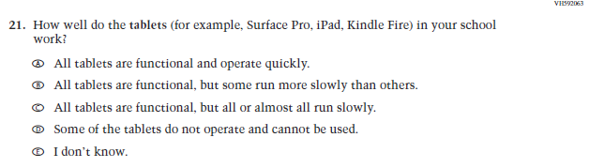  (2021 Grade 8) | Issue: Technology Use | NC | N/A
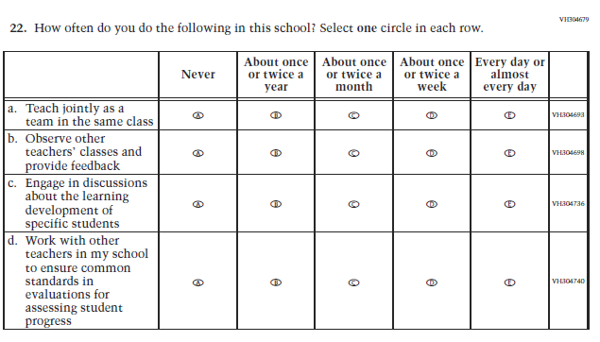  (2021 Grade 8) | Issue: School Climate | NC | N/A
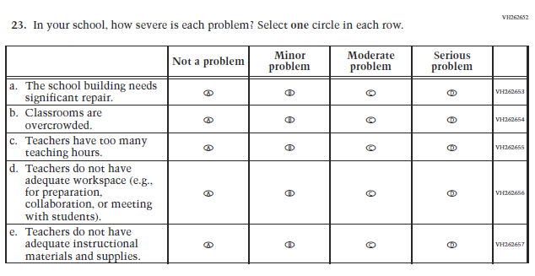  (2021 Grade 8) | Issue: School Climate | NC | N/A
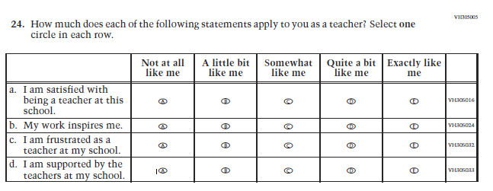  (2021 Grade 8) | Issue: School Climate | NC | N/A
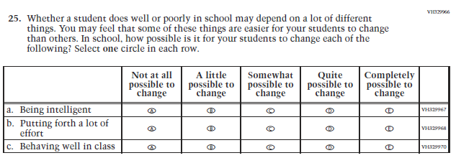  (2021 Grade 8) | Issue: Desire for Learning | NC | N/A

Appendix J2-4: Operational Grade 8 CORE
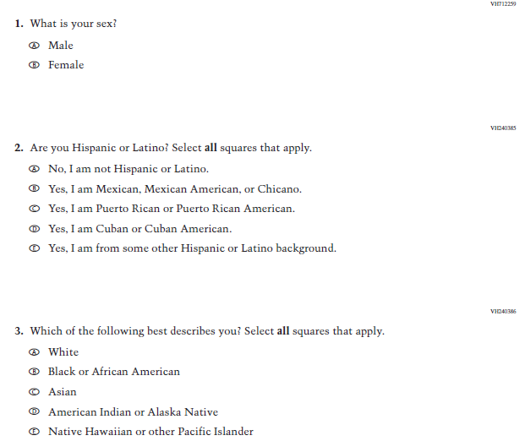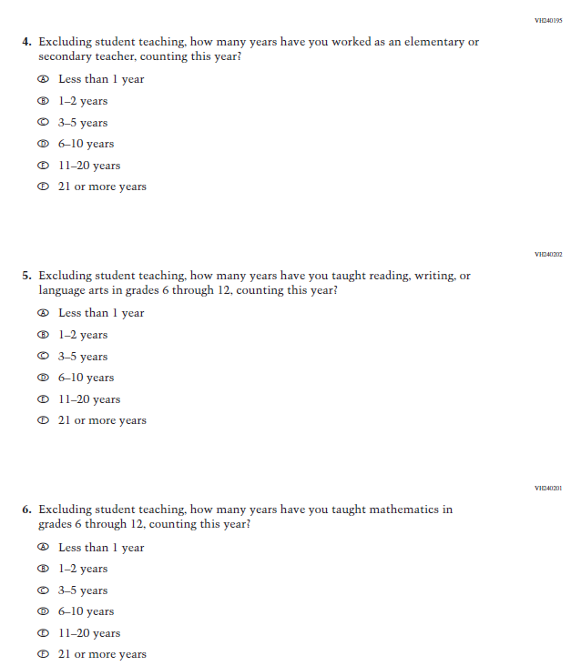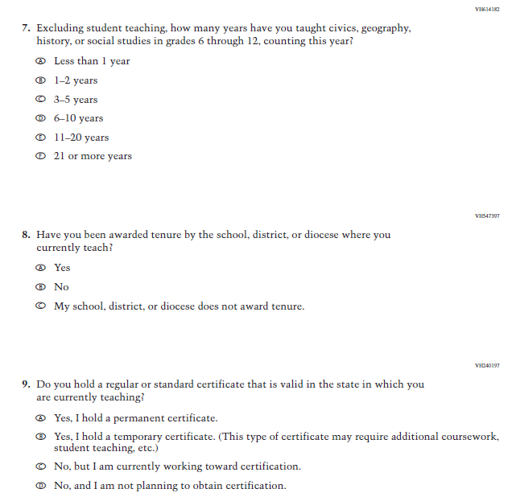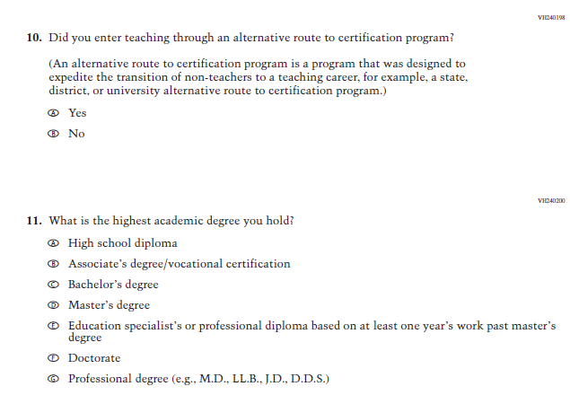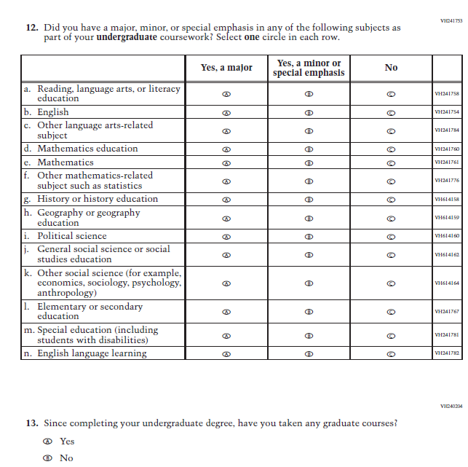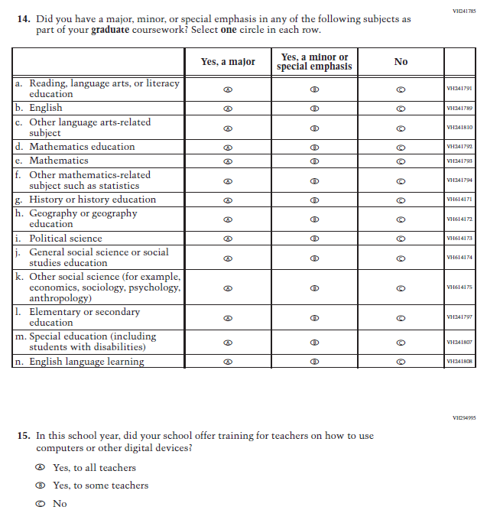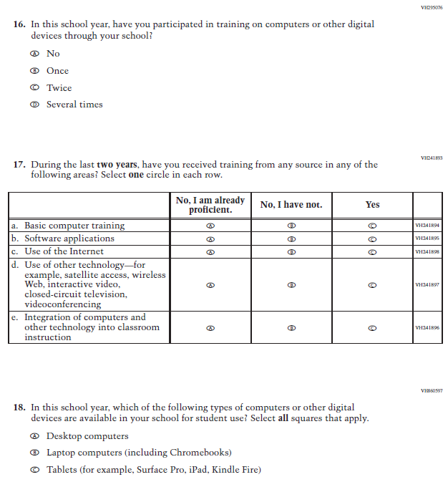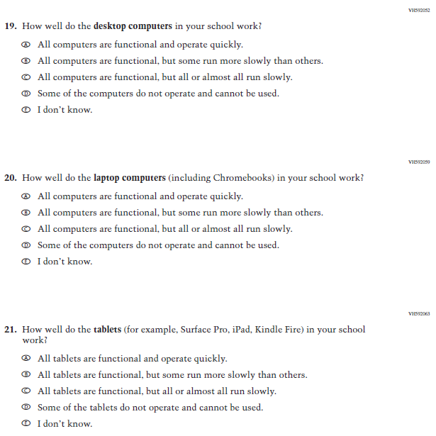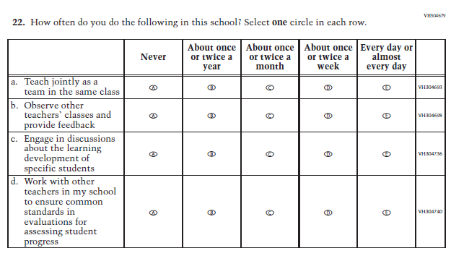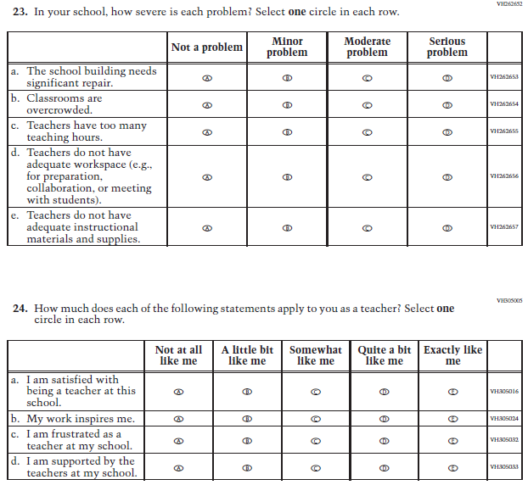
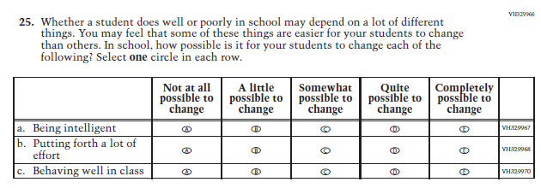

Appendix J2-5: Summary of Changes Operational Grade 4 Mathematics
2022 Operational Grade 4 Mathematics Teacher

Previous item | 2022 item | D/A/ R/NC+ | Rationale
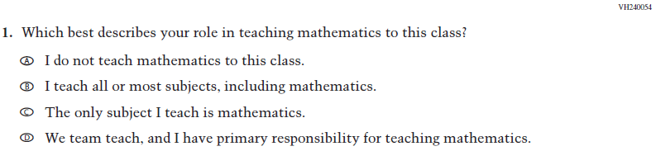  (2021 Grade 4) | Issue: Resources for Learning and Instruction | NC | N/A
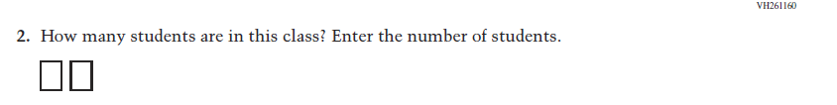  (2021 Grade 4) | Issue: Resources for Learning and Instruction | NC | N/A
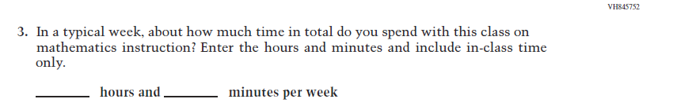  (2021 Grade 4) | Issue: Resources for Learning and Instruction | NC | N/A
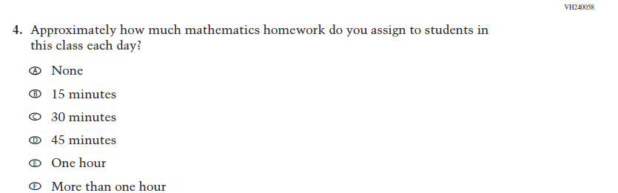  (2021 Grade 4) | Issue: Organization of Instruction | NC | N/A
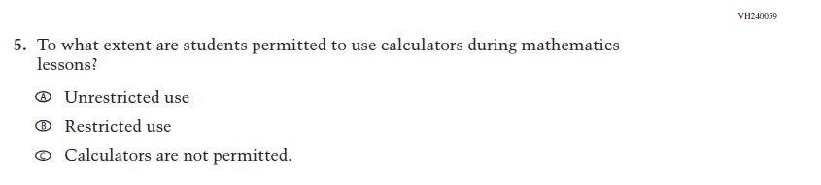  (2021 Grade 4) | Issue: Organization of Instruction | NC | N/A
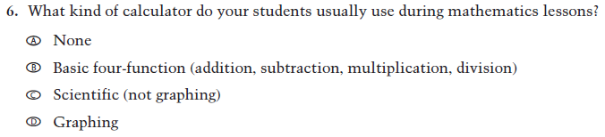  (2021 Grade 4) | Issue: Resources for learning and instruction | NC | N/A
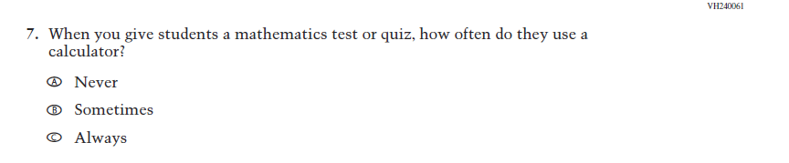  (2021 Grade 4) | Issue: Organization of Instruction | NC | N/A
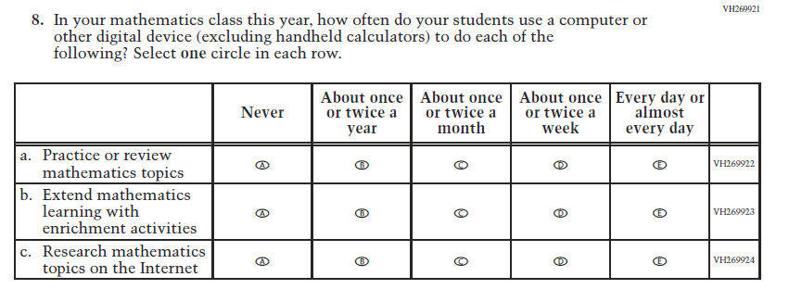  (2021 Grade 4) | Issue: Organization of Instruction | NC | N/A
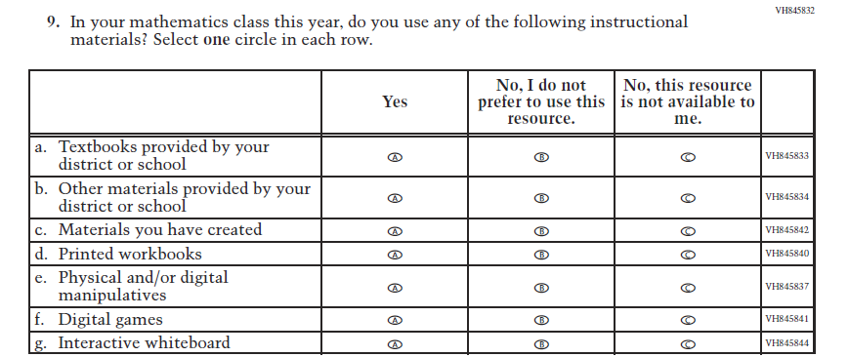  (2021 Grade 4) | Issue: Resources for Learning and Instruction | NC | N/A
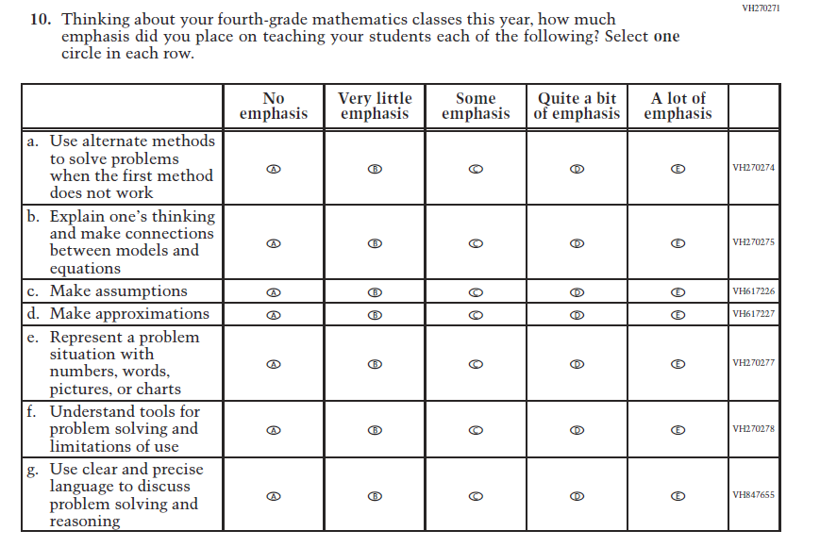  (2021 Grade 4) | Issue: Organization of Instruction | NC | N/A
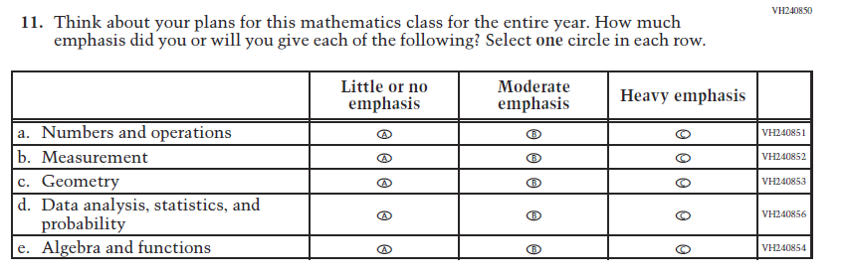  (2021 Grade 4) | Issue: Organization of Instruction | NC | N/A
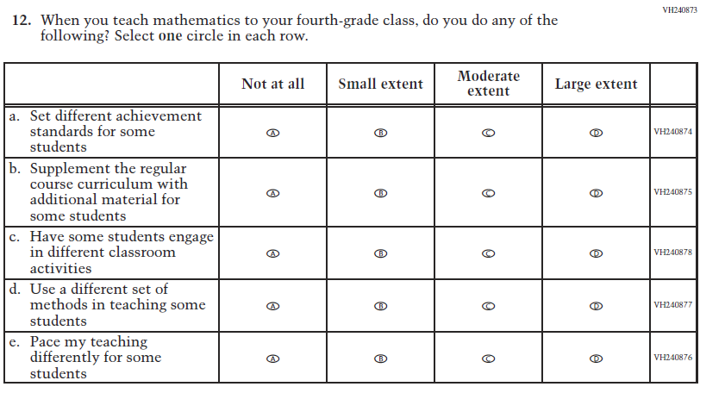  (2021 Grade 4) | Issue: Organization of Instruction | NC | N/A
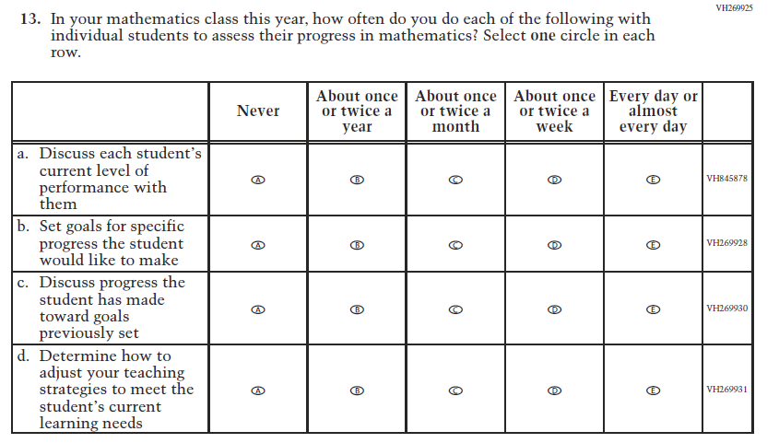  (2021 Grade 4) | Issue: Organization of Instruction | NC | N/A
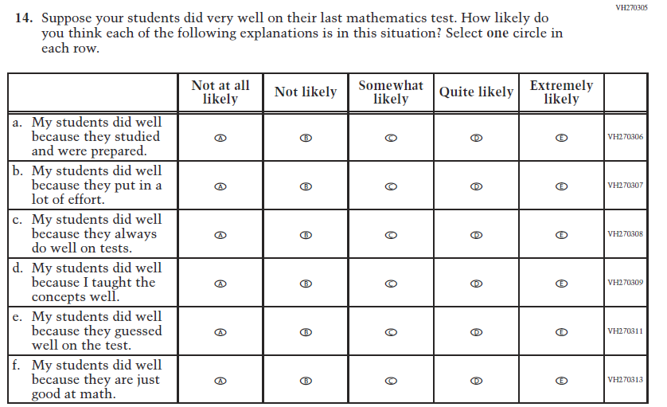  (2021 Grade 4) | Issue: Teacher Preparation | NC | N/A
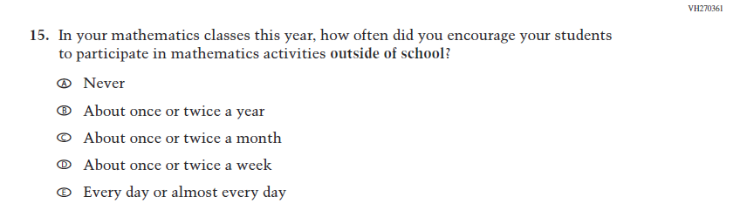  (2021 Grade 4) | Issue: Resources for Learning and Instruction | NC | N/A
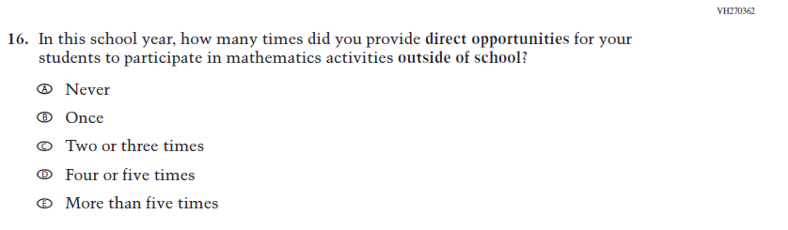  (2021 Grade 4) | Issue: Resources for Learning and Instruction | NC | N/A

Appendix J2-6: Operational Grade 4 Mathematics

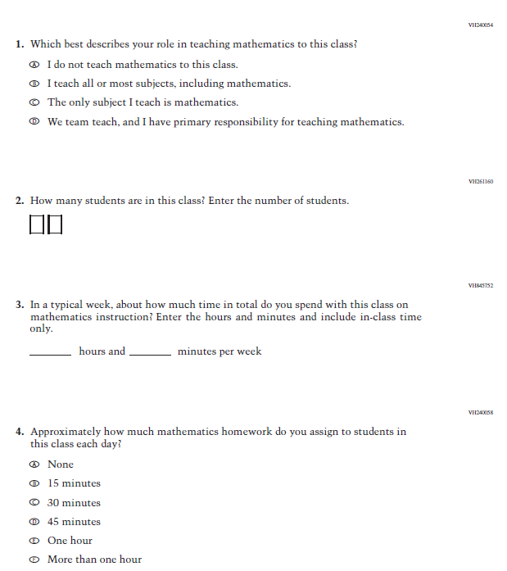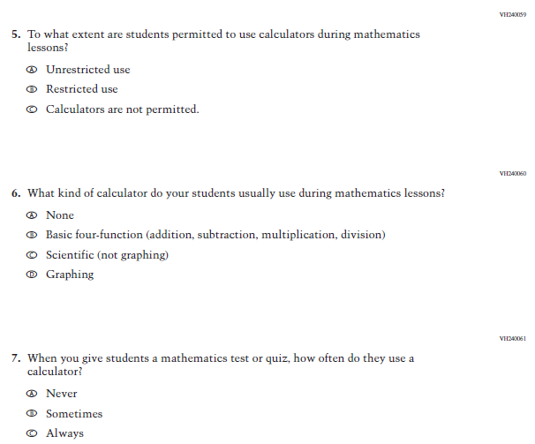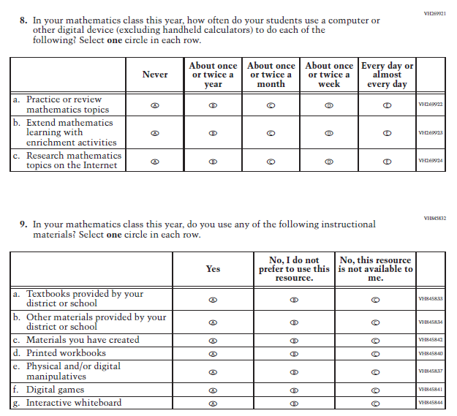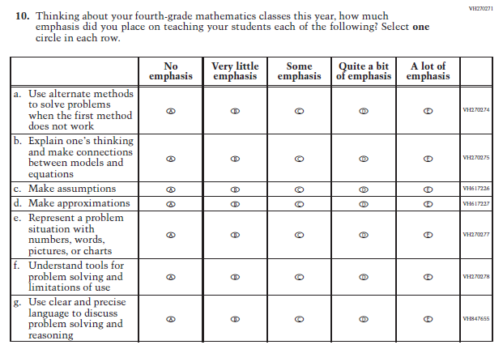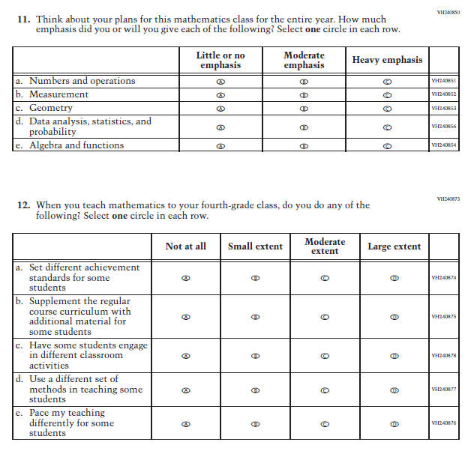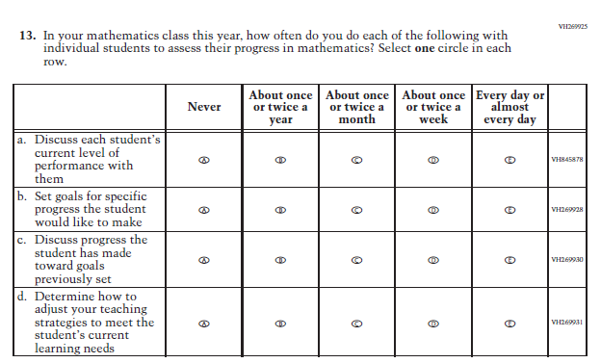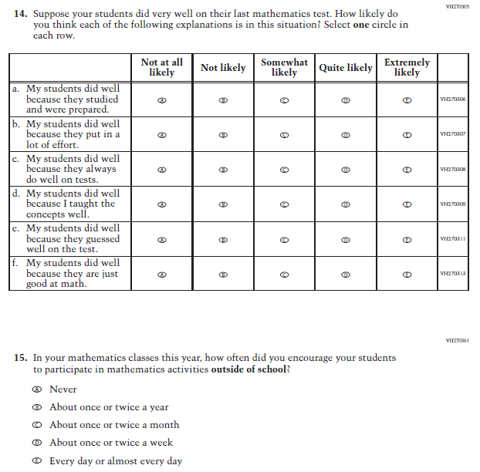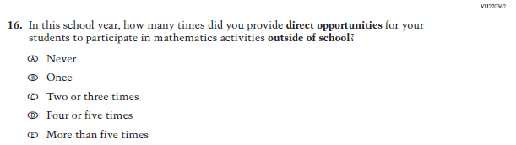

Appendix J2-7: Summary of Changes Operational Grade 8 Mathematics
2022 Operational Grade 8 Mathematics Teacher

Previous item | 2022 item | D/A/ R/NC+ | Rationale
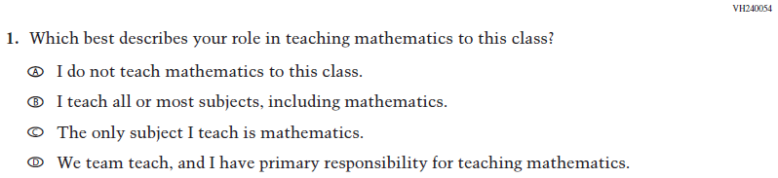  (2021 Grade 8) | Issue: Resources for Learning and Instruction | NC | N/A
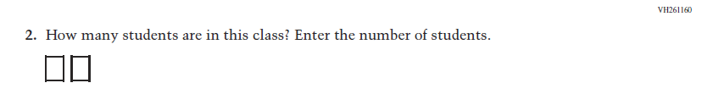  (2021 Grade 8) | 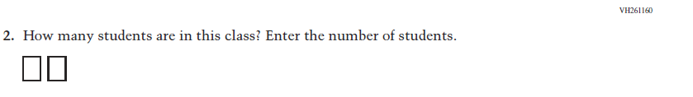  Issue: Resources for Learning and Instruction | NC | N/A
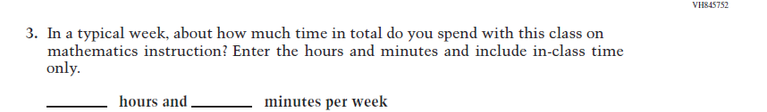  (2021 Grade 8) | Issue: Resources for Learning and Instruction | NC | N/A
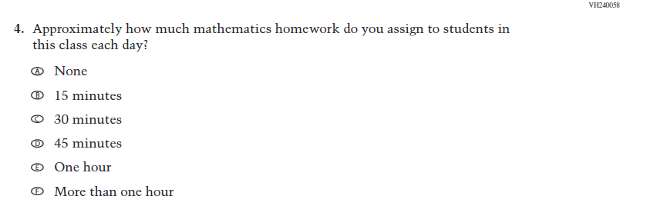  (2021 Grade 8) | Issue: Organization of Instruction | NC | N/A
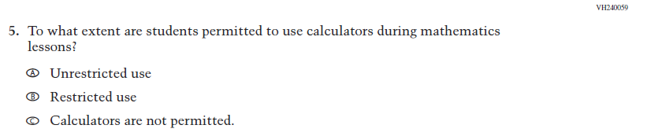  (2021 Grade 8) | Issue: Organization of Instruction | NC | N/A
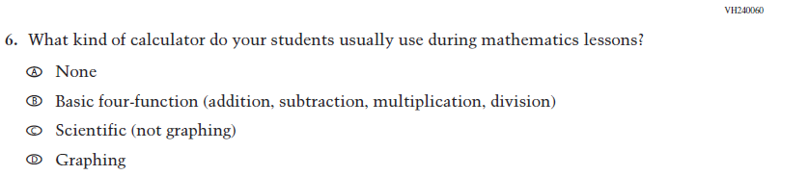  (2021 Grade 8) | Issue: Resources for Learning and Instruction | NC | N/A
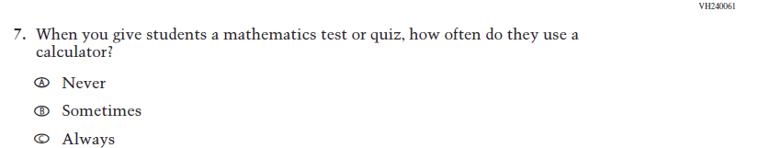  (2021 Grade 8) | Issue: Organization of Instruction | NC | N/A
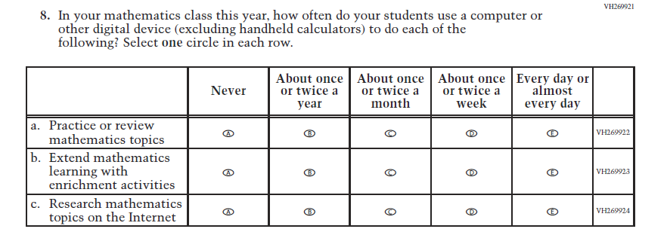  (2021 Grade 8) | Issue: Organization of Instruction | NC | N/A
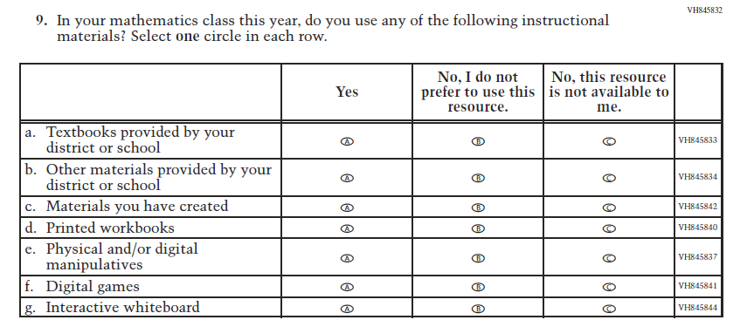  (2021 Grade 8) | Issue: Resources for Learning and Instruction | NC | N/A

2022 Operational Grade 8 Mathematics Teacher

Previous item | 2022 item | D/A/ R/NC+ | Rationale
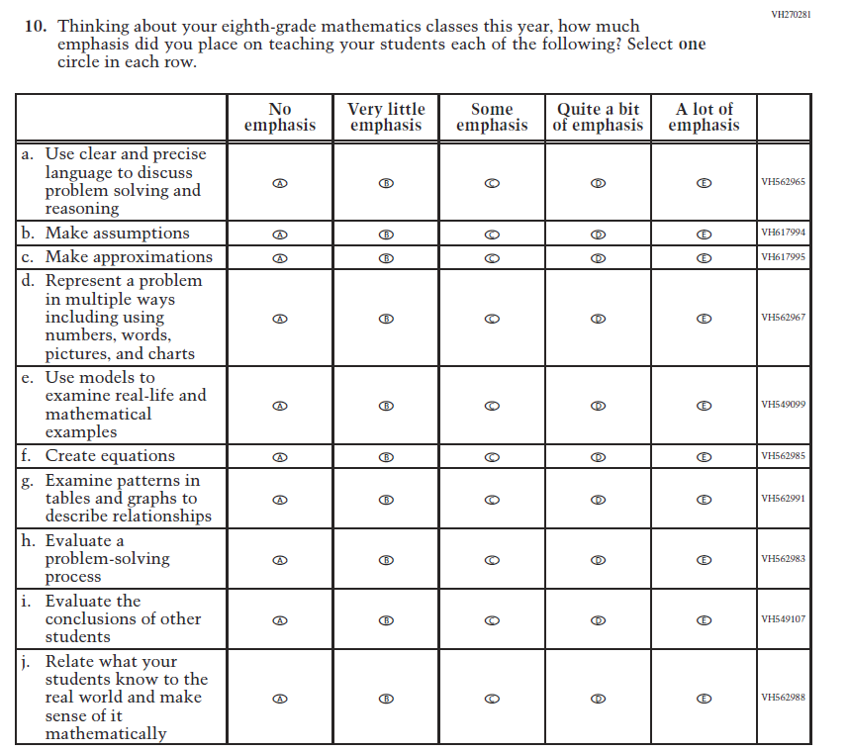  (2021 Grade 8) | Issue: Organization of Instruction | NC | N/A
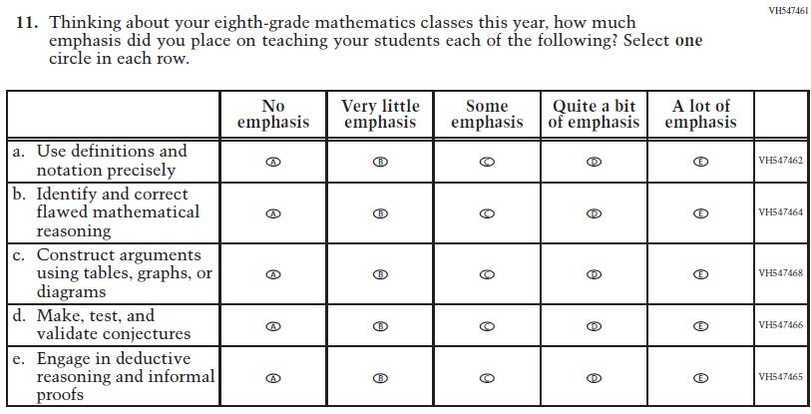  (2021 Grade 8) | Issue: Organization of Instruction | NC | N/A

2022 Operational Grade 8 Mathematics Teacher

Previous item | 2022 item | D/A/ R/NC+ | Rationale
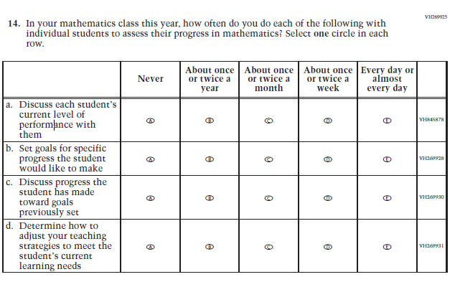  (2021 Grade 8) | Issue: Organization of Instruction | NC | N/A
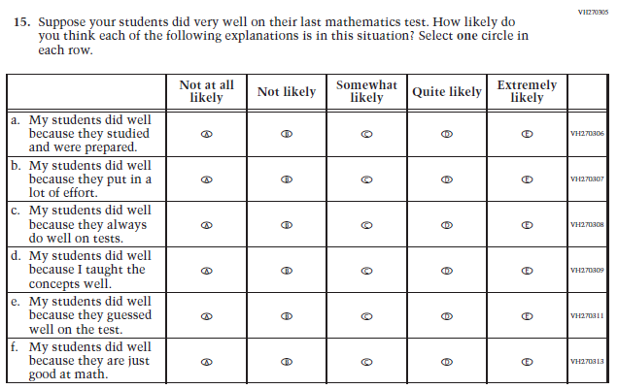  (2021 Grade 8) | Issue: Teacher Preparation | NC | N/A

2022 Operational Grade 8 Mathematics Teacher

Previous item | 2022 item | D/A/ R/NC+ | Rationale
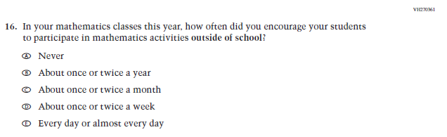  (2021 Grade 8) | Issue: Resources for Learning and Instruction | NC | N/A
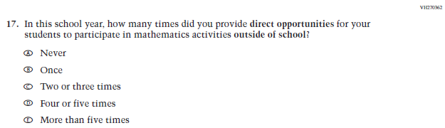  (2021 Grade 8) | Issue: Resources for Learning and Instruction | NC | N/A
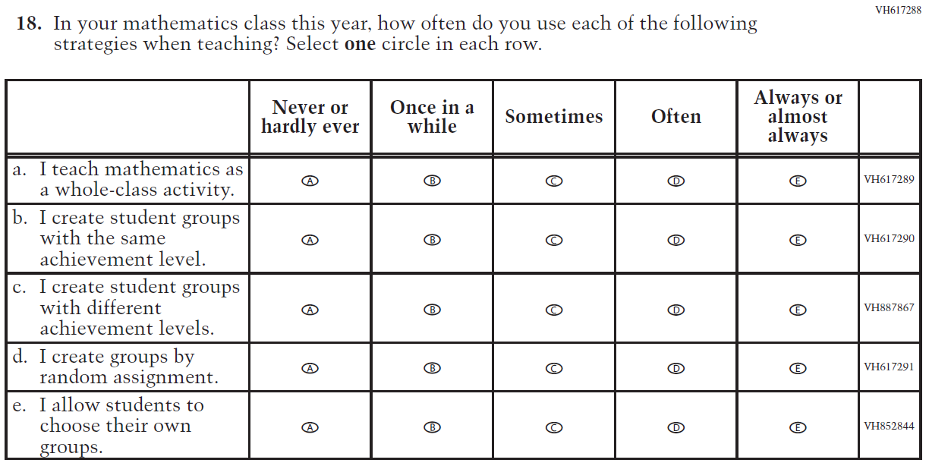  (2021 Grade 8) | Issue: Organization of Instruction | NC | N/A

Appendix J2-8: Operational Grade 8 Mathematics
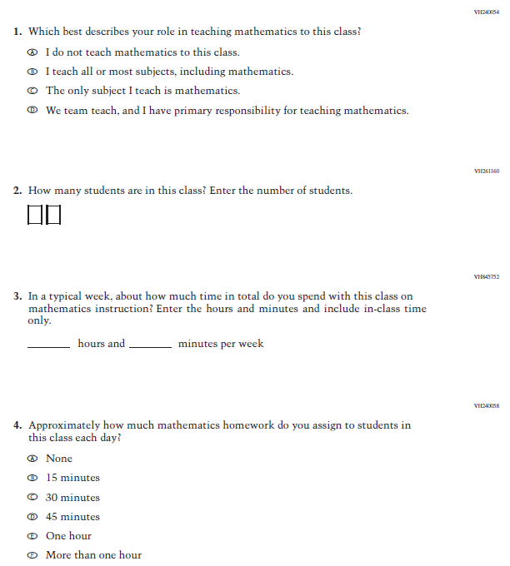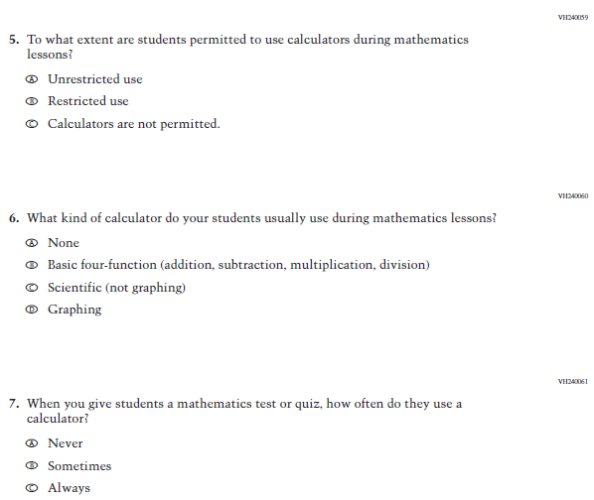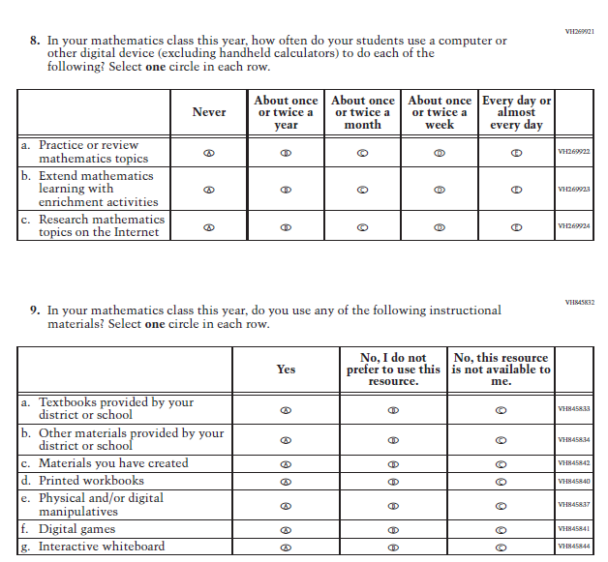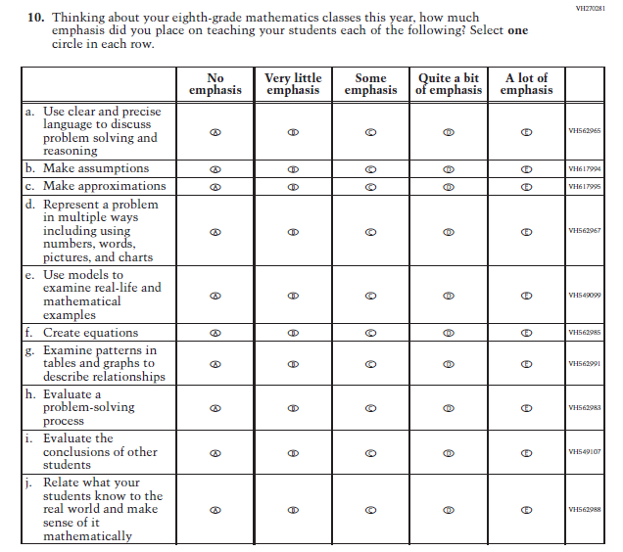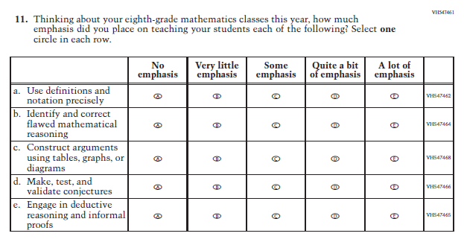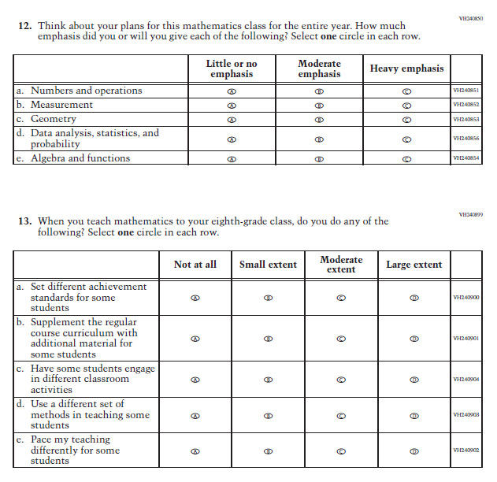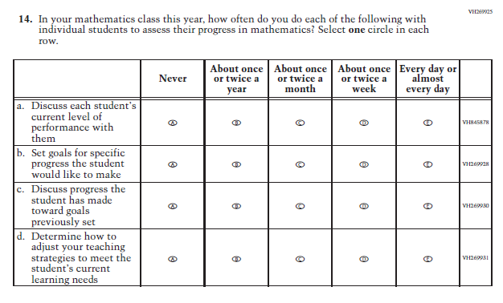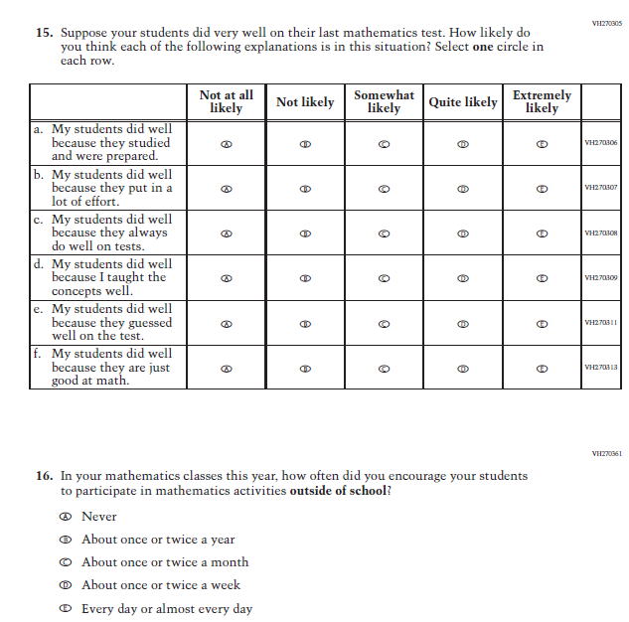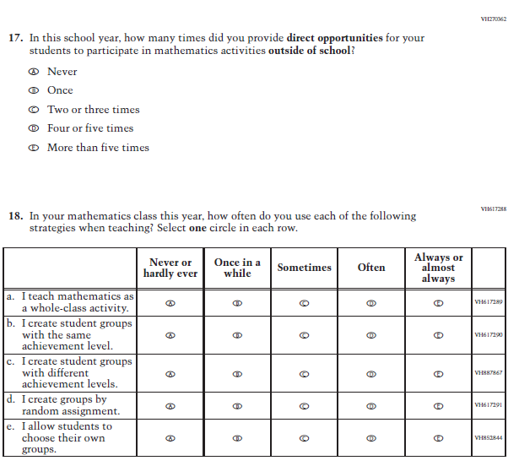

Appendix J2-9: Summary of Changes Operational Grade 4 Reading
2022 Operational Grade 4 Reading Teacher

Previous item | 2022 item | D/A/ R/NC+ | Rationale
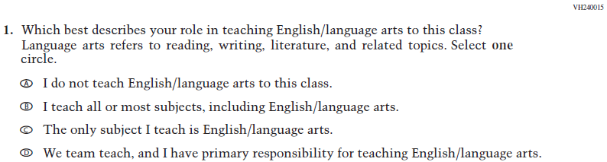  (2021 Grade 4) | Issue: Resources for Learning and Instruction | NC | N/A
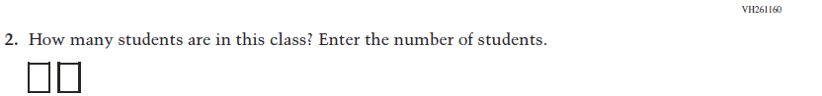  (2021 Grade 4) | Issue: Resources for Learning and Instruction | NC | N/A
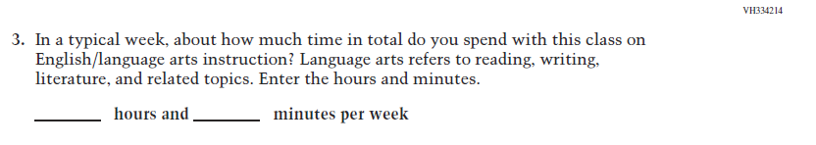  (2021 Grade 4) | Issue: Resources for Learning and Instruction | NC | N/A
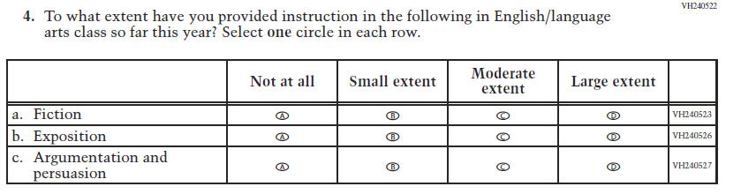  (2021 Grade 4) | Issue: Organization of Instruction | NC | N/A

2022 Operational Grade 4 Reading Teacher

Previous item | 2022 item | D/A/ R/NC+ | Rationale
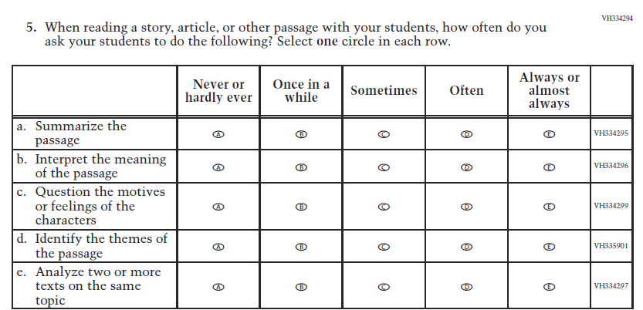  (2021 Grade 4) | Issue: Organization of Instruction | NC | N/A
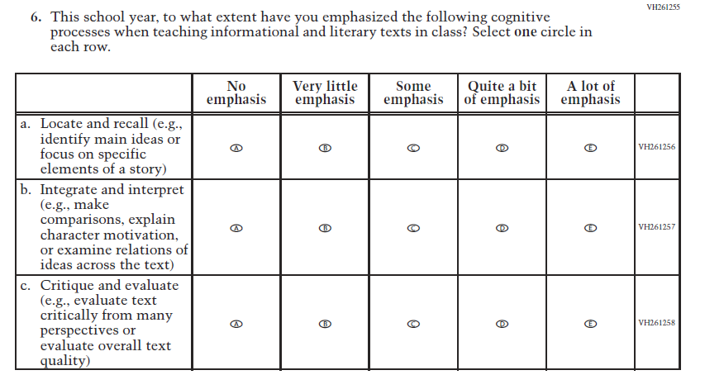  (2021 Grade 4) | Issue: Organization of Instruction | NC | N/A

2022 Operational Grade 4 Reading Teacher

Previous item | 2022 item | D/A/ R/NC+ | Rationale
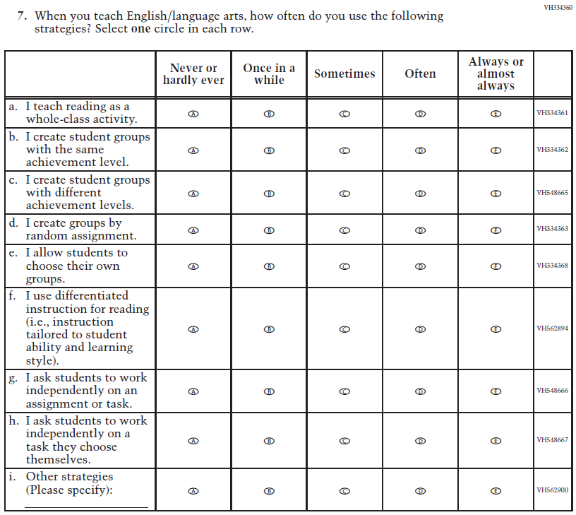  (2021 Grade 4) | Issue: Organization of Instruction | NC | N/A

2022 Operational Grade 4 Reading Teacher

Previous item | 2022 item | D/A/ R/NC+ | Rationale
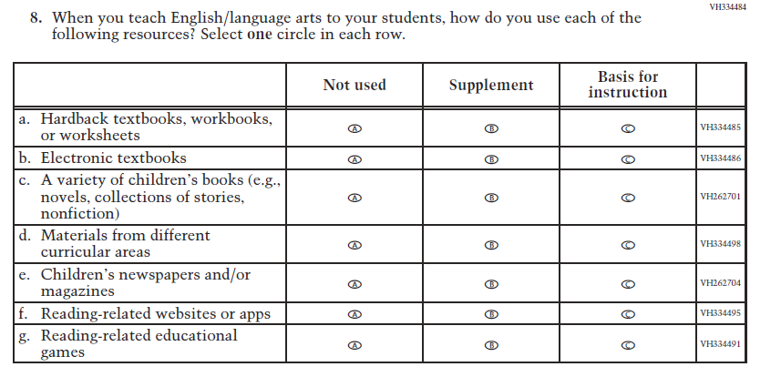  (2021 Grade 4) | Issue: Organization of Instruction | NC | N/A
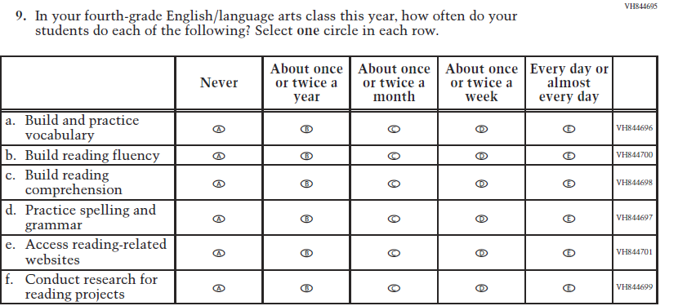  (2021 Grade 4) | Issue: Organization of Instruction | NC | N/A

2022 Operational Grade 4 Reading Teacher

Previous item | 2022 item | D/A/ R/NC+ | Rationale
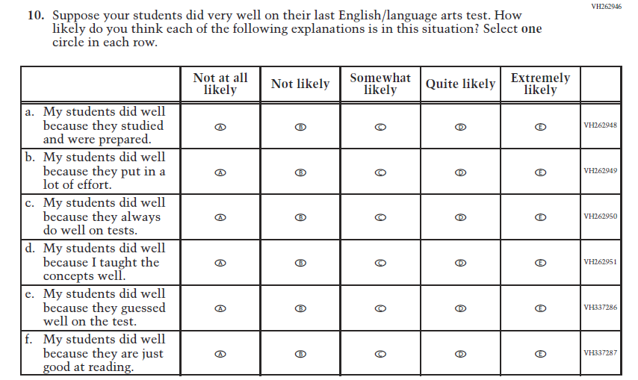  (2021 Grade 4) | Issue: Teacher Preparation | NC | N/A
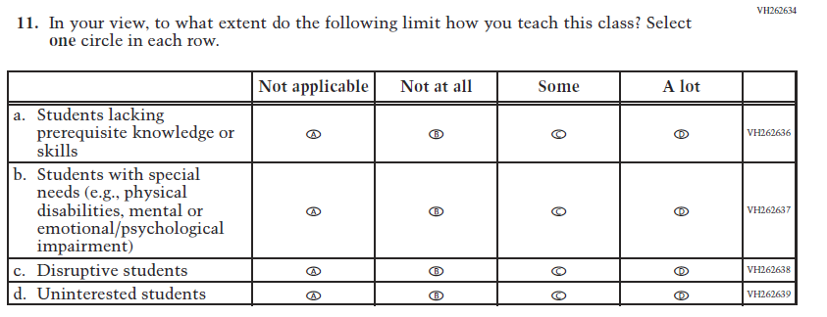  (2021 Grade 4) | Issue: Resources for Learning and Instruction | NC | N/A

Appendix J2-10: Operational Grade 4 Reading
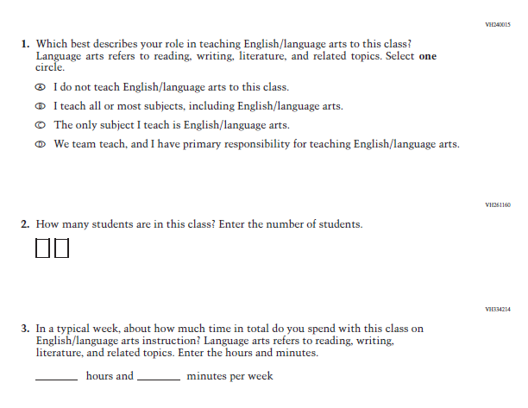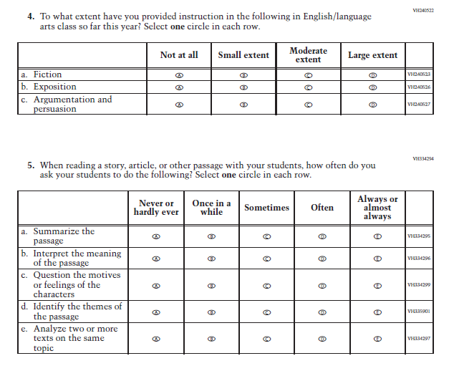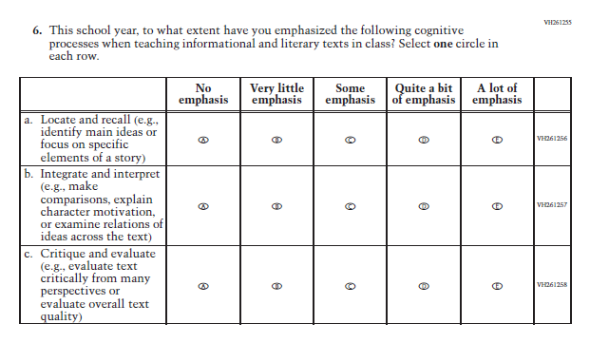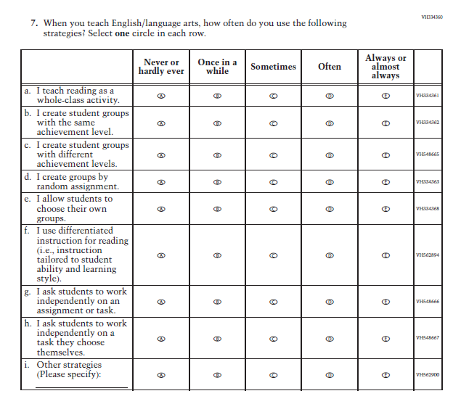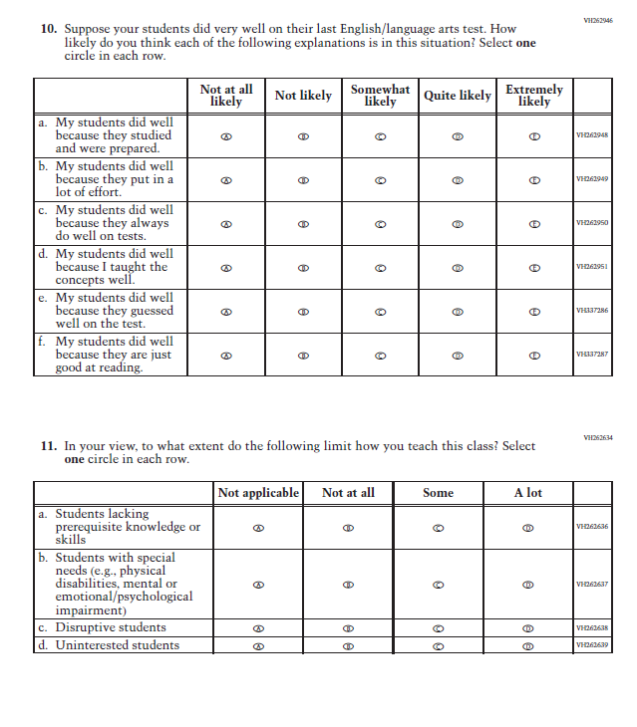

Appendix J2-11: Summary of Changes Operational Grade 8 Reading
2022 Operational Grade 8 Reading Teacher

Previous item | 2022 item | D/A/ R/NC+ | Rationale
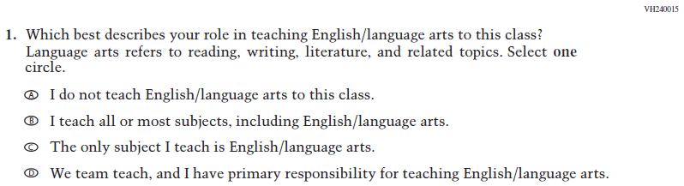  (2021 Grade 8) | Issue: Resources for Learning and Instruction | NC | N/A
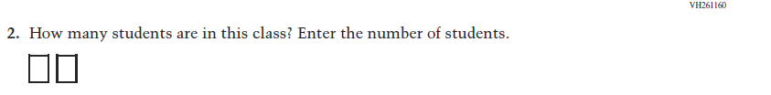  (2021 Grade 8) | Issue: Resources for Learning and Instruction | NC | N/A
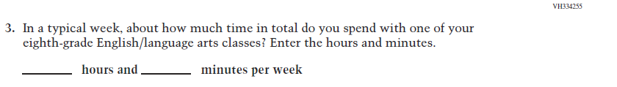  (2021 Grade 8) | Issue: Resources for Learning and Instruction | NC | N/A
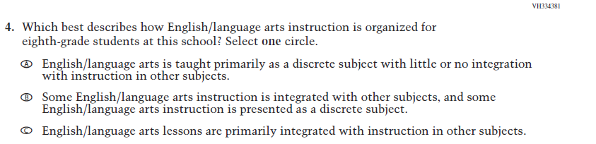  (2021 Grade 8) | Issue: Organization of Instruction | NC | N/A

2022 Operational Grade 8 Reading Teacher

Previous item | 2022 item | D/A/ R/NC+ | Rationale
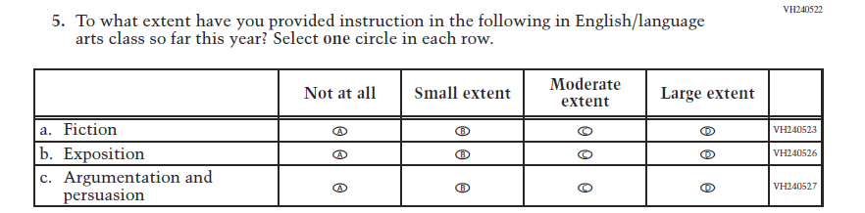  (2021 Grade 8) | Issue: Organization of Instruction | NC | N/A
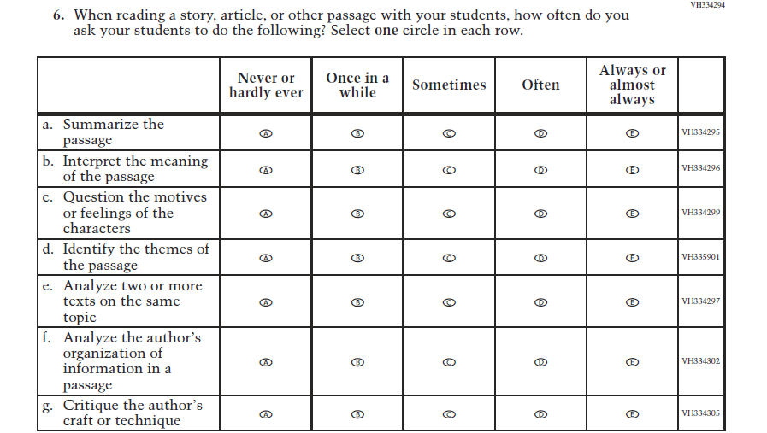  (2021 Grade 8) | Issue: Organization of Instruction | NC | N/A

2022 Operational Grade 8 Reading Teacher

Previous item | 2022 item | D/A/ R/NC+ | Rationale
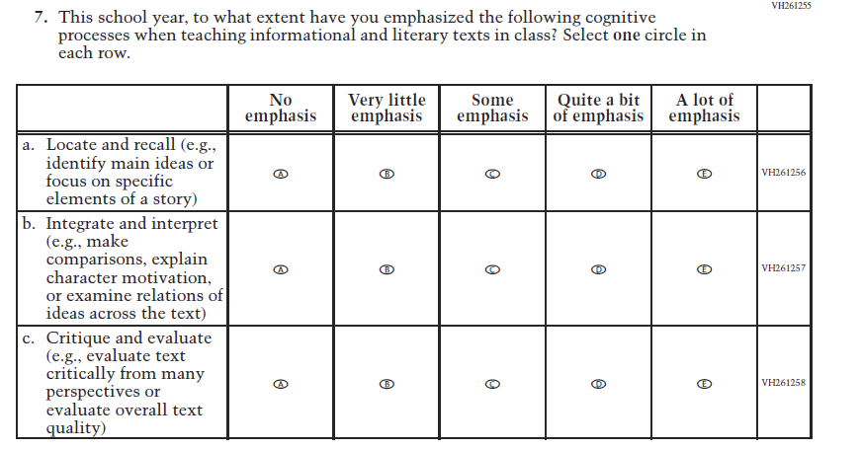  (2021 Grade 8) | Issue: Organization of Instruction | NC | N/A
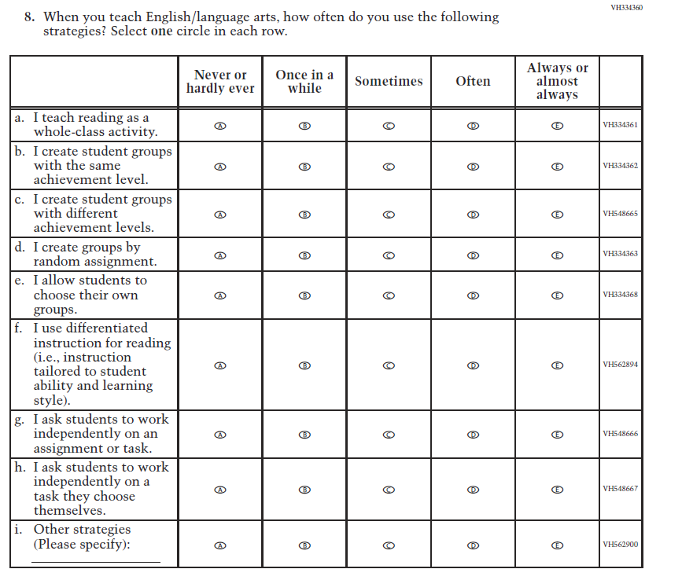  (2021 Grade 8) | Issue: Organization of Instruction | NC | N/A

2022 Operational Grade 8 Reading Teacher

Previous item | 2022 item | D/A/ R/NC+ | Rationale
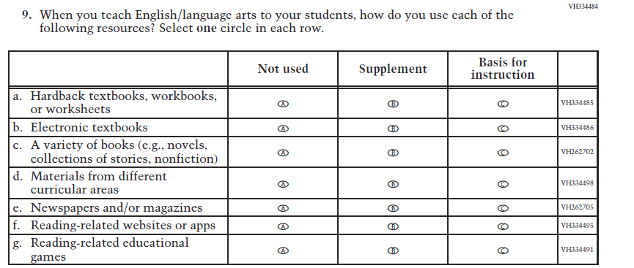  (2021 Grade 8) | Issue: Organization of Instruction | NC | N/A
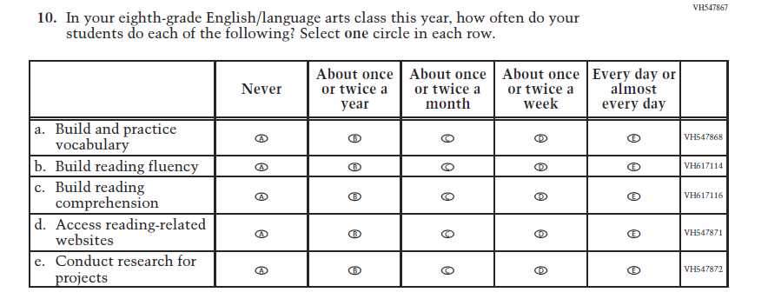  (2021 Grade 8) | Issue: Organization of Instruction | NC | N/A

2022 Operational Grade 8 Reading Teacher

Previous item | 2022 item | D/A/ R/NC+ | Rationale
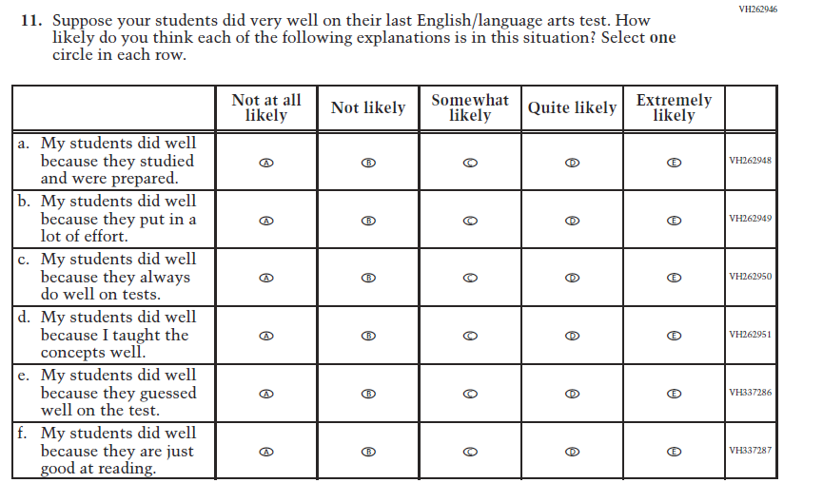  (2021 Grade 8) | Issue: Teacher Preparation | NC | N/A
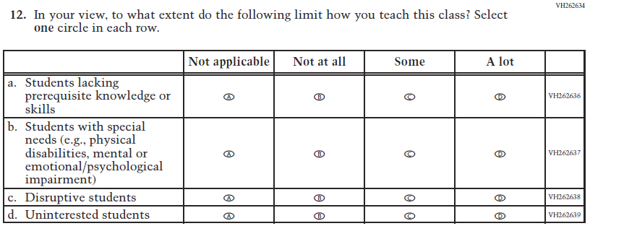  (2021 Grade 8) | Issue: Resources for Learning and Instruction | NC | N/A

Appendix J2-12: Operational Grade 8 Reading
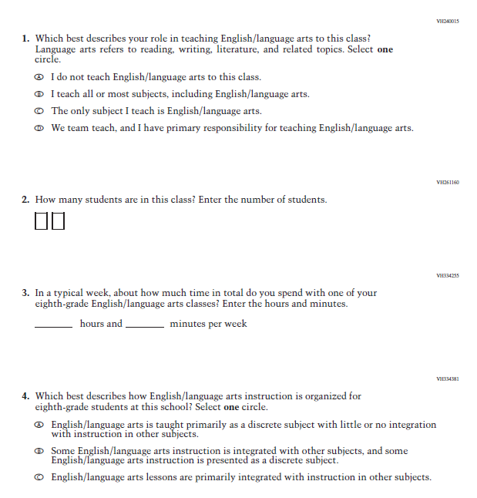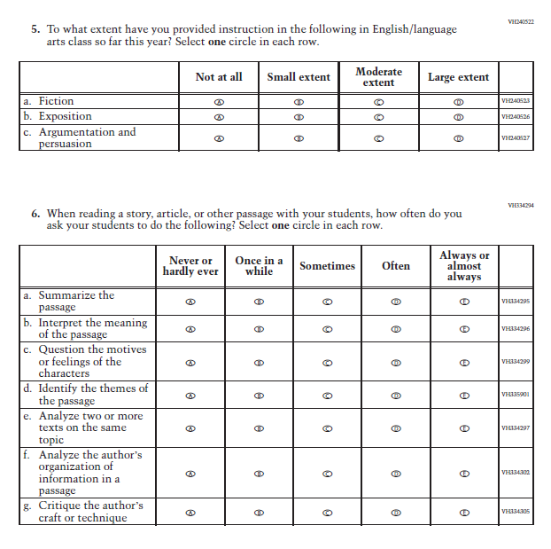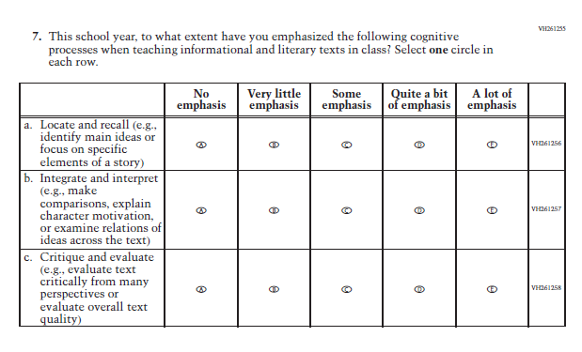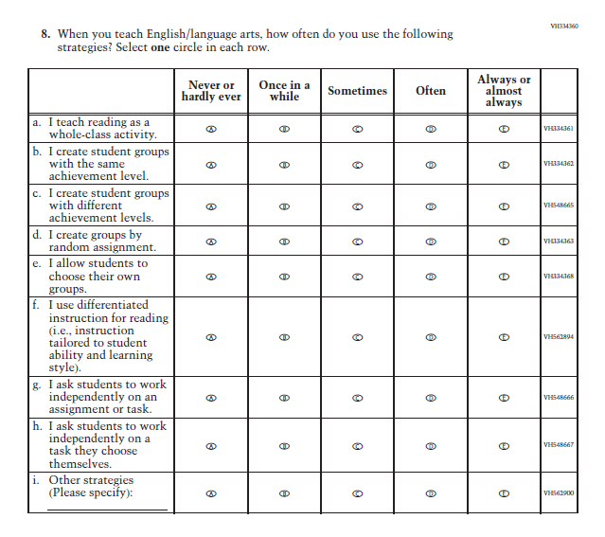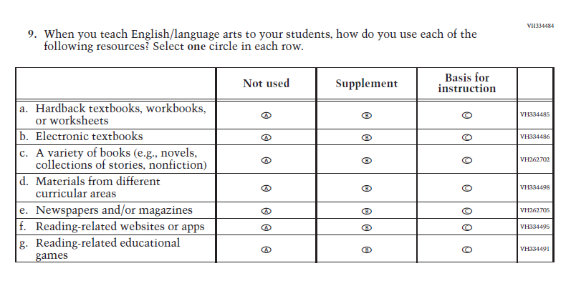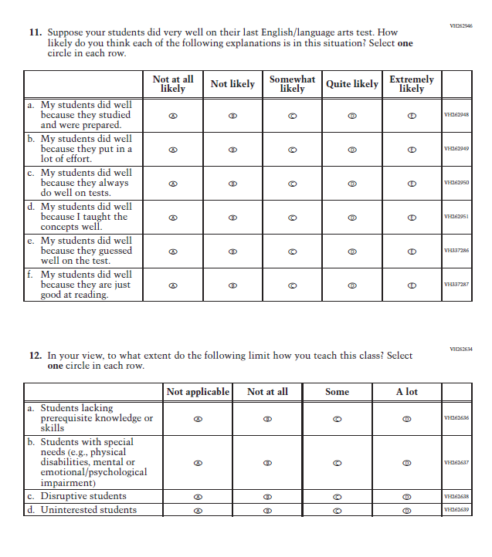

Appendix J2-13: Summary of Changes Operational Grade 8 Social Studies
2022 Operational Grade 8 Social Studies Teacher
Previous item | 2022 item | D/A/ R/NC+ | Rationale
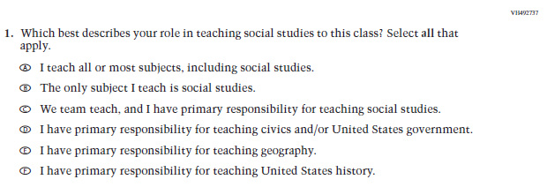  (2018 Grade 8) | Issue: Resources for Learning and Instruction | NC | N/A
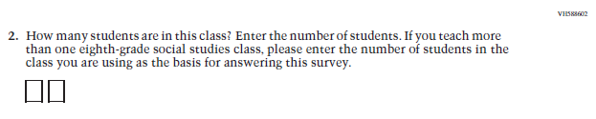  (2018 Grade 8) | Issue: Resources for Learning and Instruction | NC | N/A
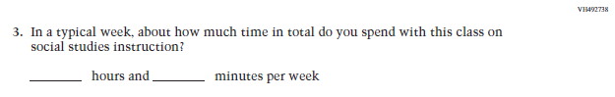  (2018 Grade 8) | Issue: Resources for Learning and Instruction | NC | N/A
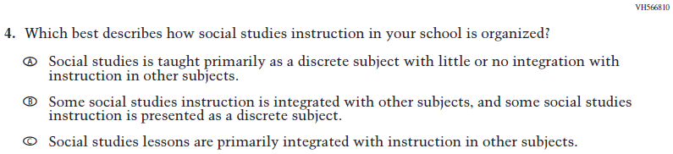  (2018 Grade 8) | Issue: Organization of Instruction | NC | N/A
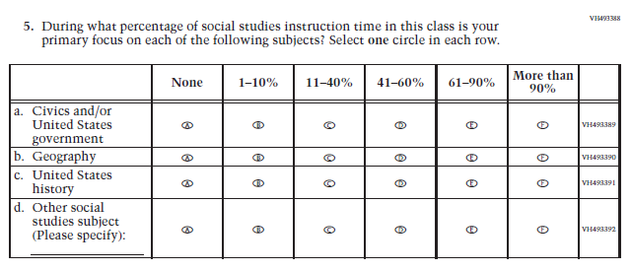  (2018 Grade 8) | Issue: Resources for Learning and Instruction | NC | N/A
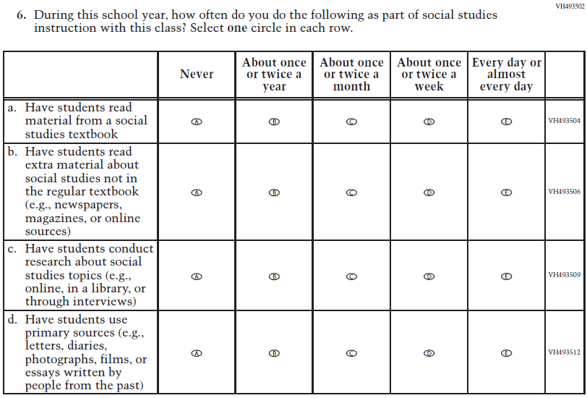  (2018 Grade 8) | Issue: Organization of Instruction | NC | N/A
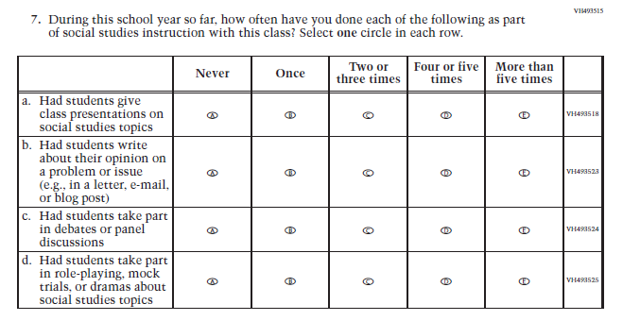  (2018 Grade 8) | Issue: Organization of Instruction | NC | N/A
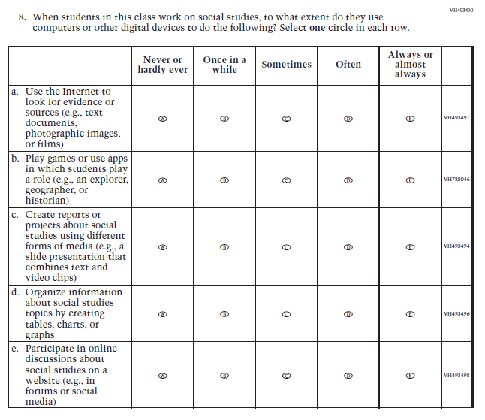  (2018 Grade 8) | Issue: Organization of Instruction | NC | N/A
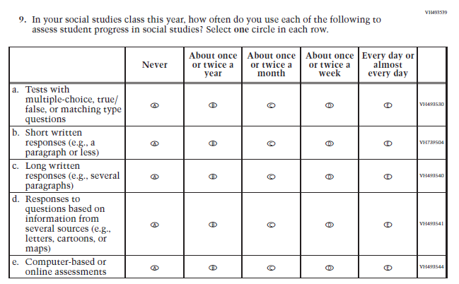  (2018 Grade 8) | Issue: Organization of Instruction | NC | N/A
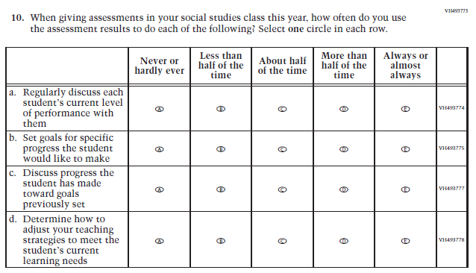  (2018 Grade 8) | Issue: Organization of Instruction | NC | N/A
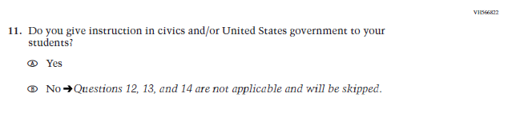  (2018 Grade 8) | 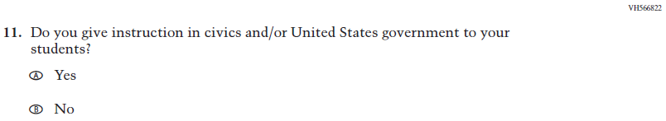  Issue: Organization of Instruction | NC | Please note skip pattern directions have been removed given the transition from PPT to DBA.
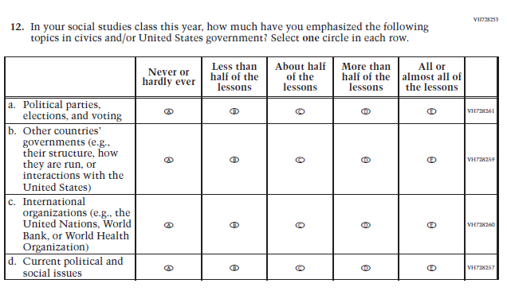  (2018 Grade 8) | Issue: Organization of Instruction | NC | N/A
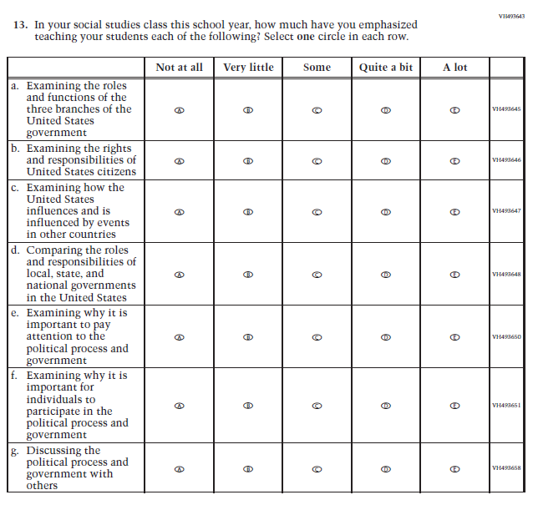  (2018 Grade 8) | Issue: Organization of Instruction | NC | N/A
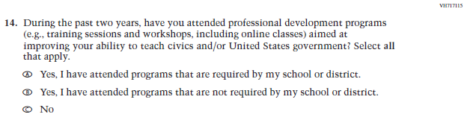  (2018 Grade 8) | Issue: Teacher Preparation | NC | N/A
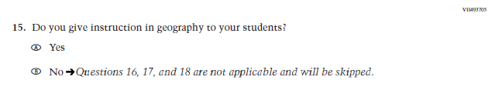  (2018 Grade 8) | N/A | D | The item was dropped because geography will not be administered in 2022.
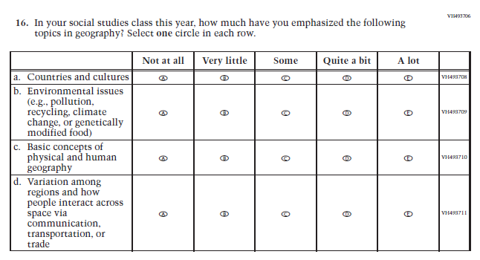  (2018 Grade 8) | N/A | D | The item was dropped because geography will not be administered in 2022.
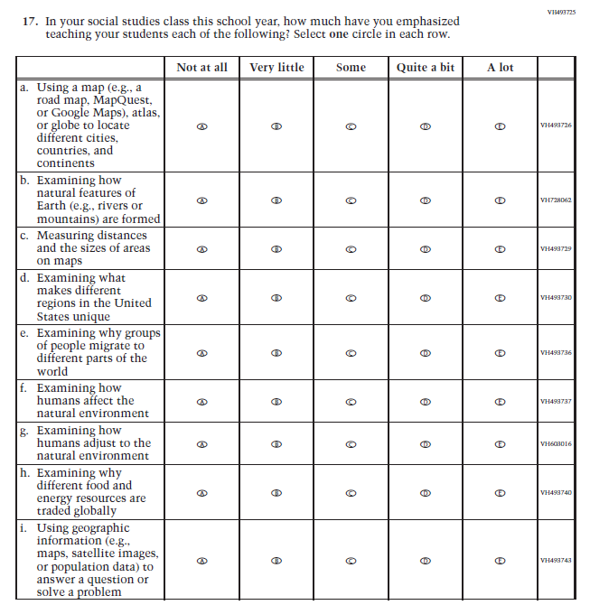  (2018 Grade 8) | N/A | D | The item was dropped because geography will not be administered in 2022.
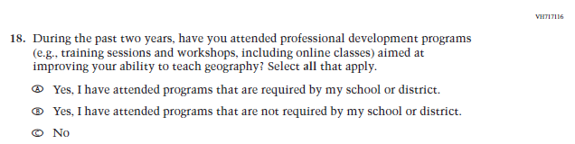  (2018 Grade 8) | N/A | D | The item was dropped because geography will not be administered in 2022.
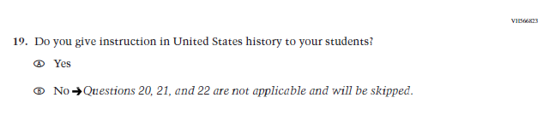  (2018 Grade 8) | 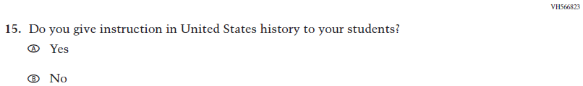  Issue: Organization of Instruction | NC | Please note skip pattern directions have been removed given the transition from PPT to DBA.
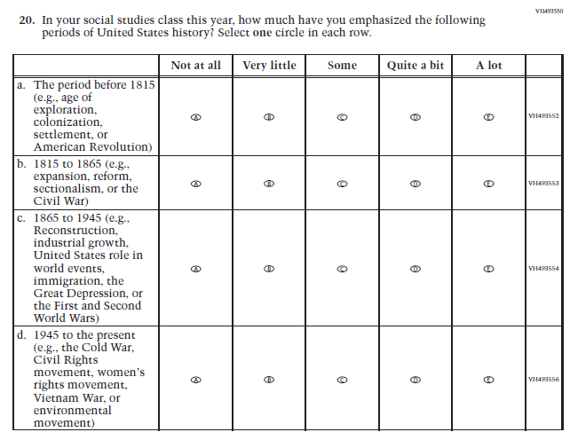  (2018 Grade 8) | 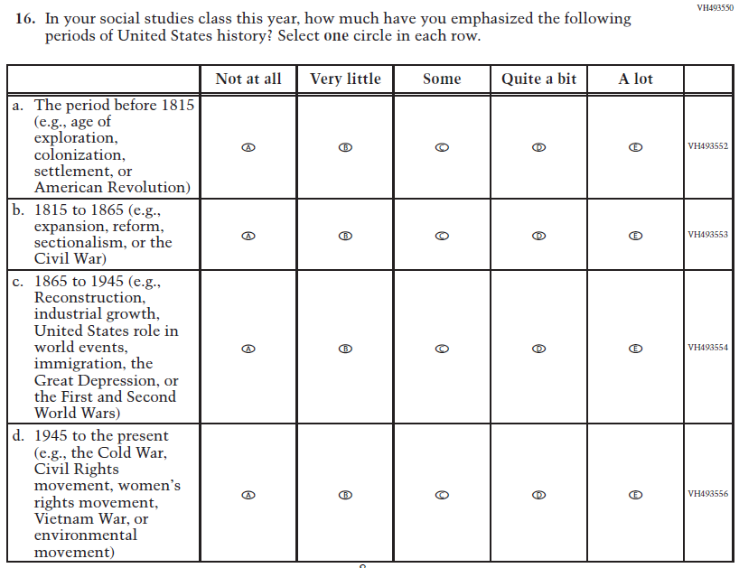  Issue: Organization of Instruction | NC | N/A
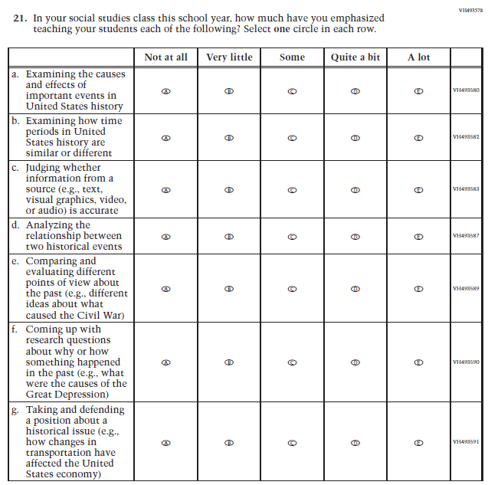  (2018 Grade 8) | 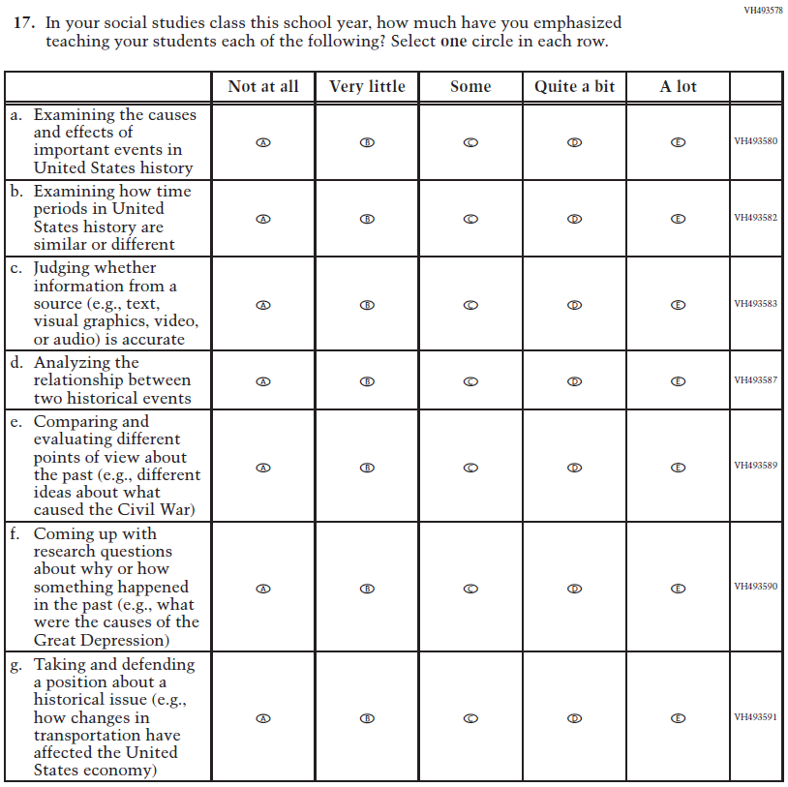  Issue: Organization of Instruction | NC | N/A
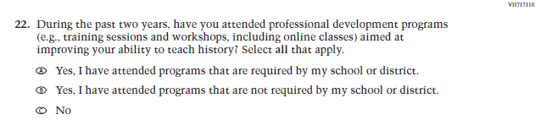  (2018 Grade 8) | 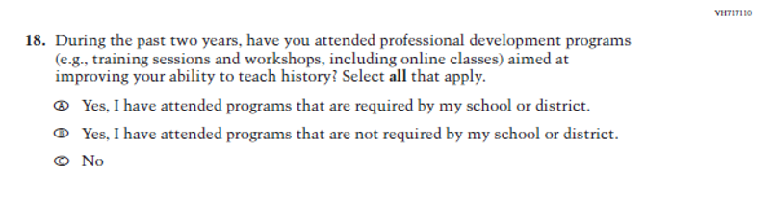Issue: Teacher Preparation | NC | N/A
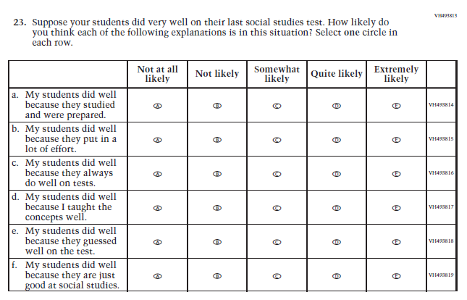  (2018 Grade 8) | 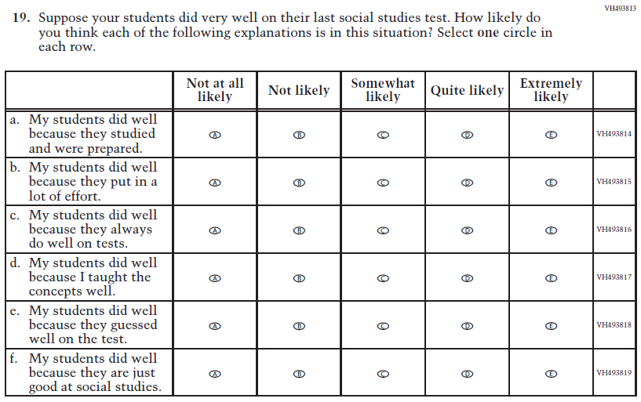  Issue: Teacher Preparation | NC | N/A

Appendix J2-14: Operational Grade 8 Social Studies
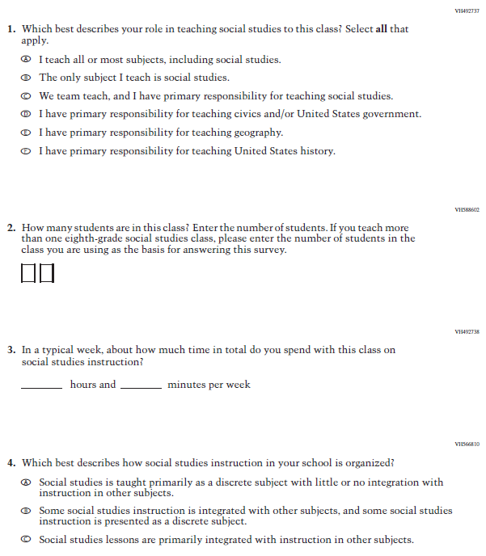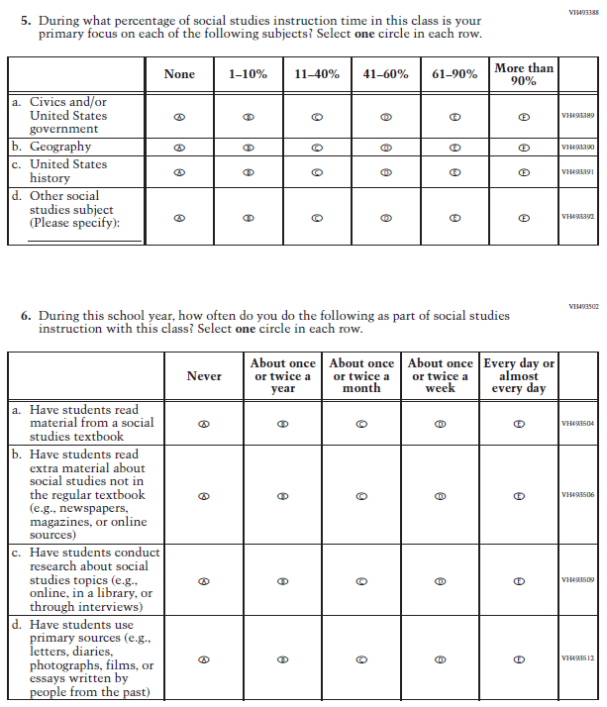
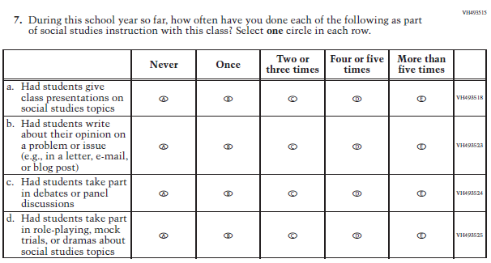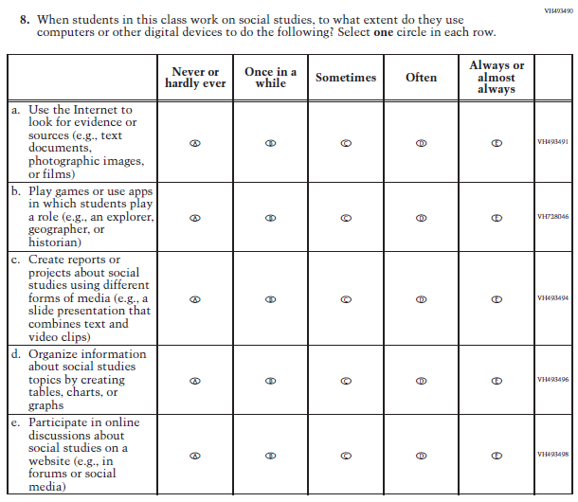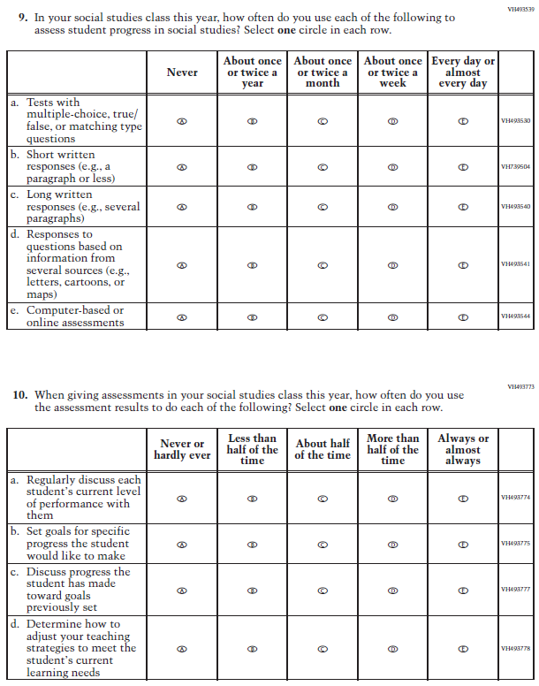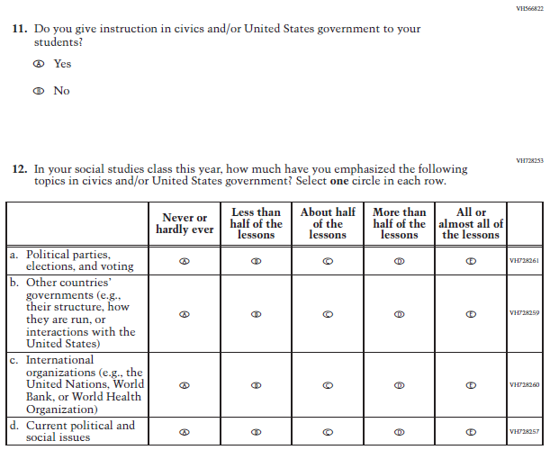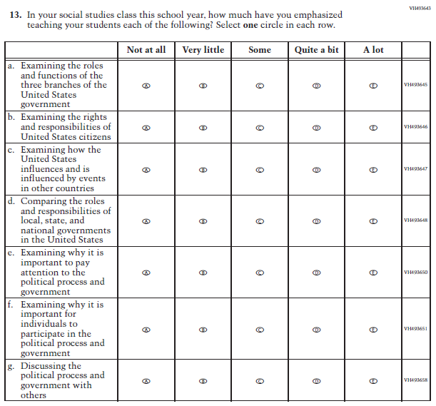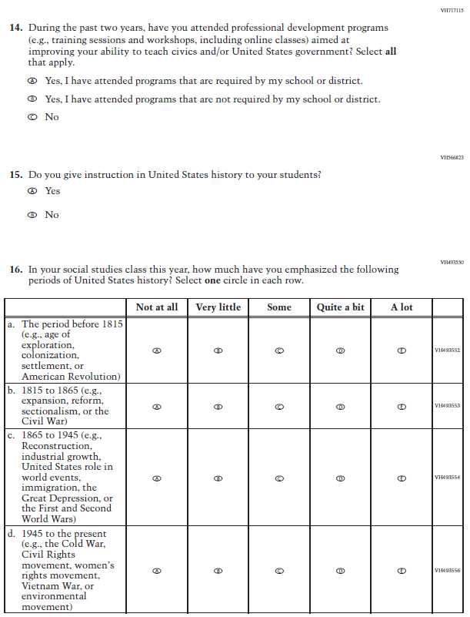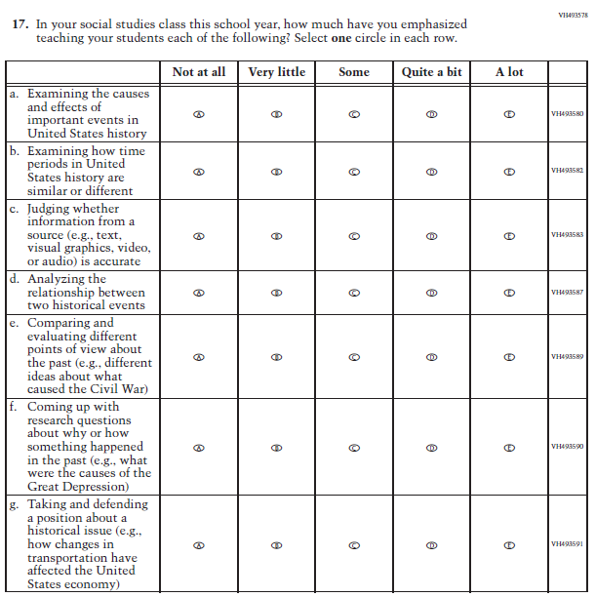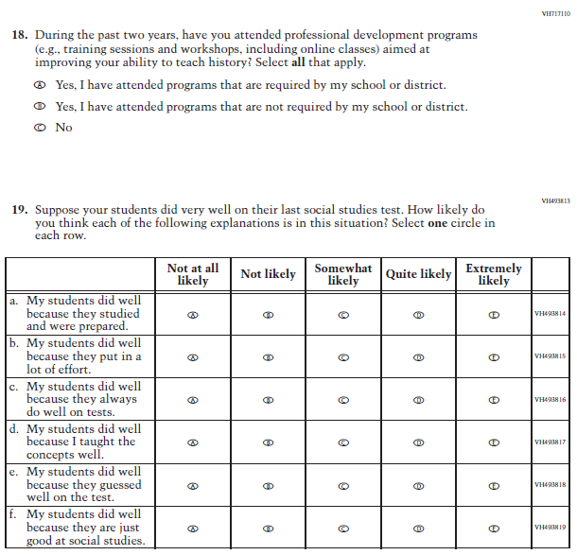

Appendix J2-15: Summary of Operational Grade 4 COVID-19
2022 Operational Grade 4 COVID-19 Teacher Items
Previous item | 2022 item | D/A/R/NC+ | Rationale
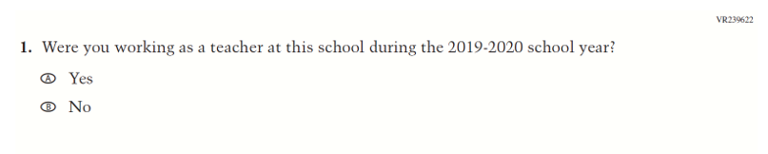  (2021 Grade 4) | 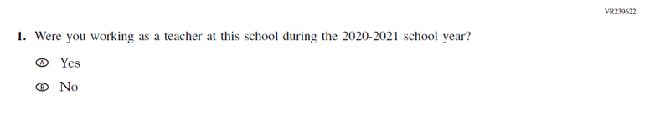  Issue: Organization of Instruction | R | This item has been updated to reference the correct academic year for the 2022 administration.
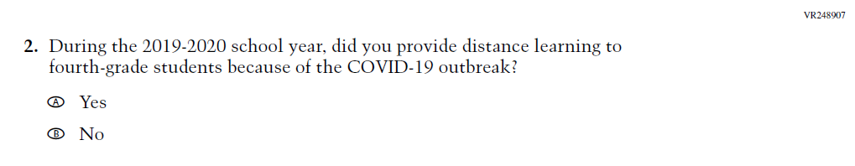  (2021 Grade 4) | 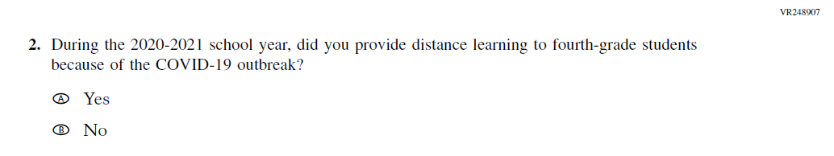  Issue: Organization of Instruction | R | This item has been updated to reference the correct academic year for the 2022 administration.

2022 Operational Grade 4 COVID-19 Teacher Items
Previous item | 2022 item | D/A/R/NC+ | Rationale
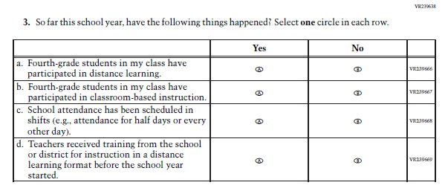  (2021 Grade 4) | Issue: Organization of Instruction | NC | N/A
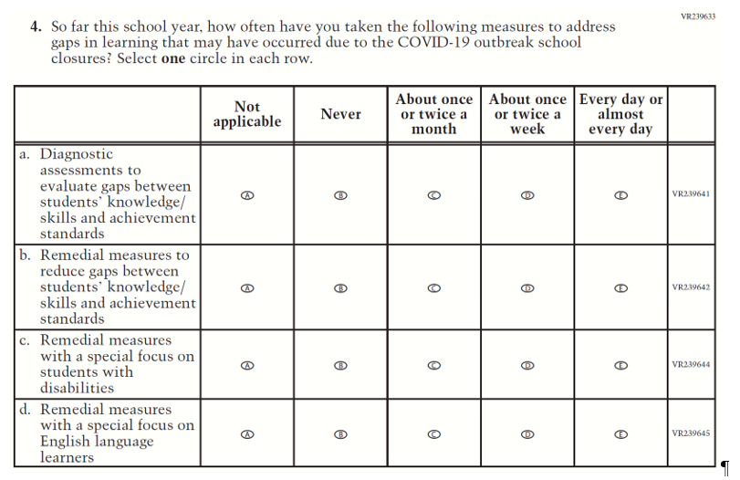  (2021 Grade 4) | Issue: Organization of Instruction | NC | N/A

2022 Operational Grade 4 COVID-19 Teacher Items
Previous item | 2022 item | D/A/R/NC+ | Rationale
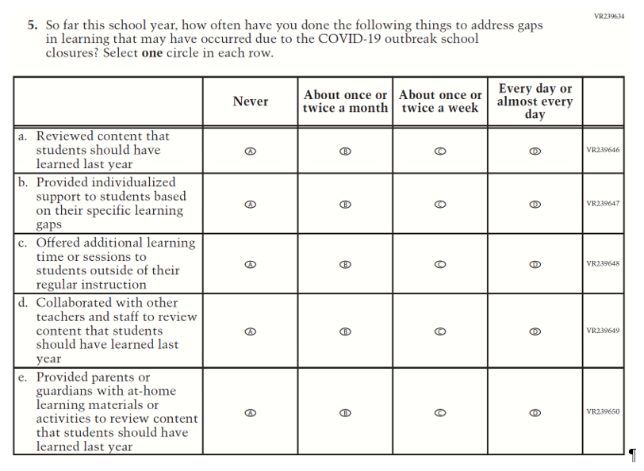  (2021 Grade 4) | Issue: Organization of Instruction | NC | N/A
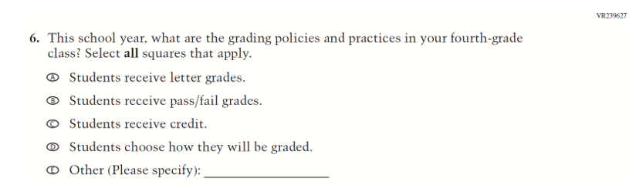  (2021 Grade 4) | Issue: Organization of Instruction | NC | N/A

2022 Operational Grade 4 COVID-19 Teacher Items
Previous item | 2022 item | D/A/R/NC+ | Rationale
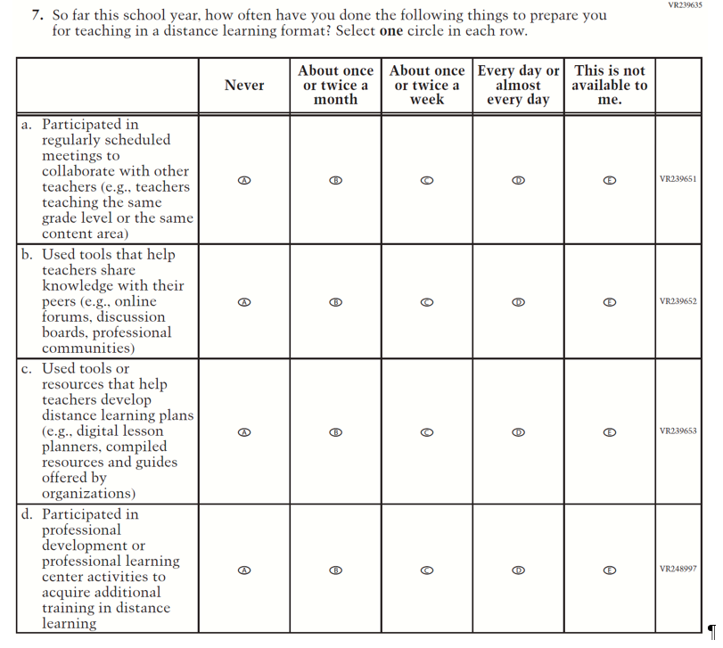  (2021 Grade 4) | Issue: Teacher Preparation | NC | N/A
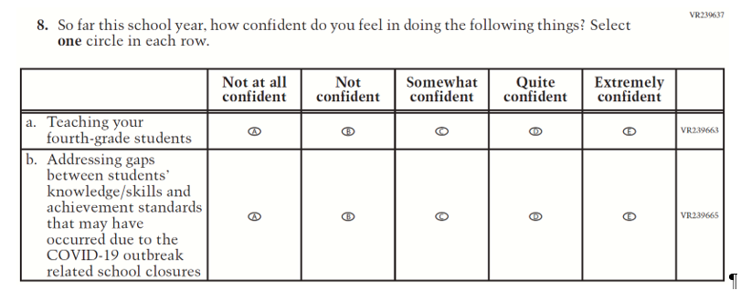  (2021 Grade 4) | Issue: Self-efficacy | NC | N/A

2022 Operational Grade 4 COVID-19 Teacher Items
Previous item | 2022 item | D/A/R/NC+ | Rationale
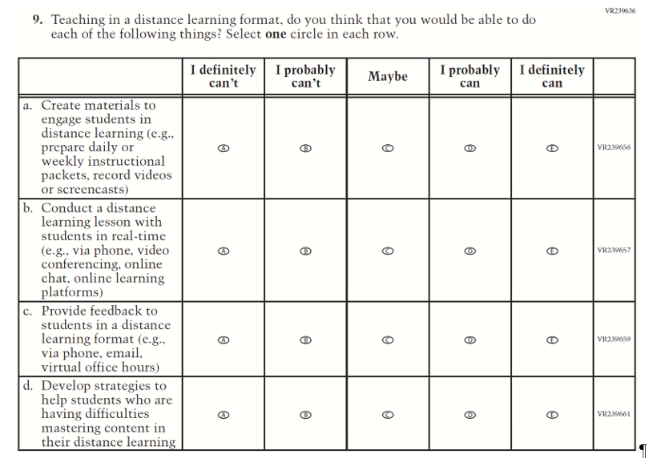  (2021 Grade 4) | Issue: Self-efficacy | NC | N/A

Appendix J2-16: Operational Grade 4 COVID-19
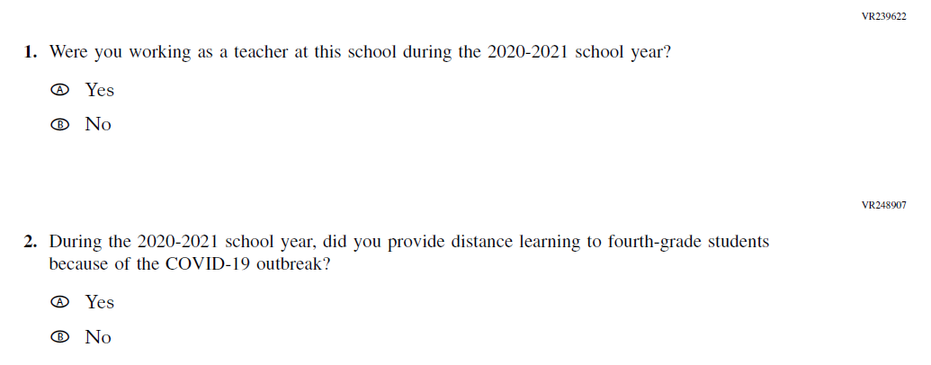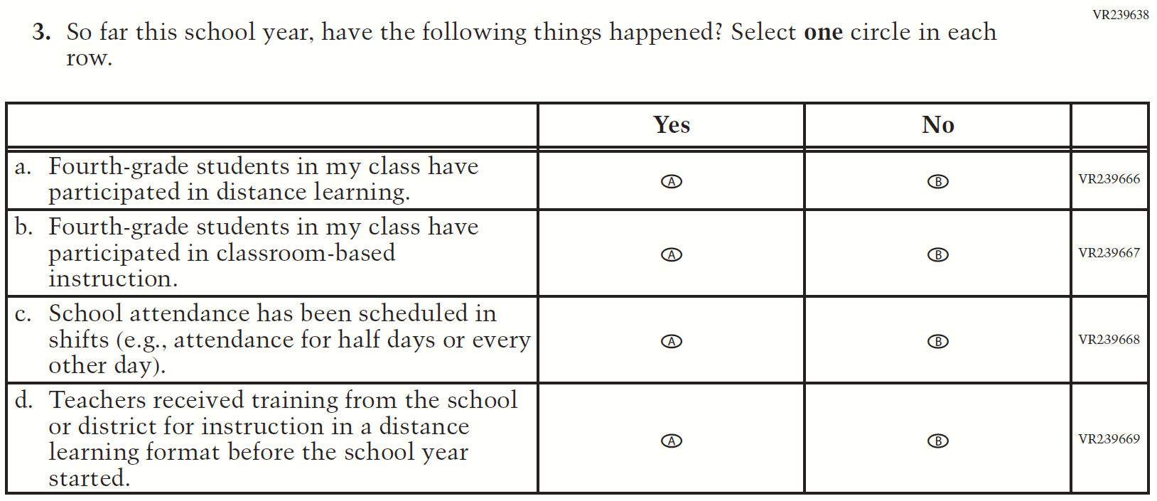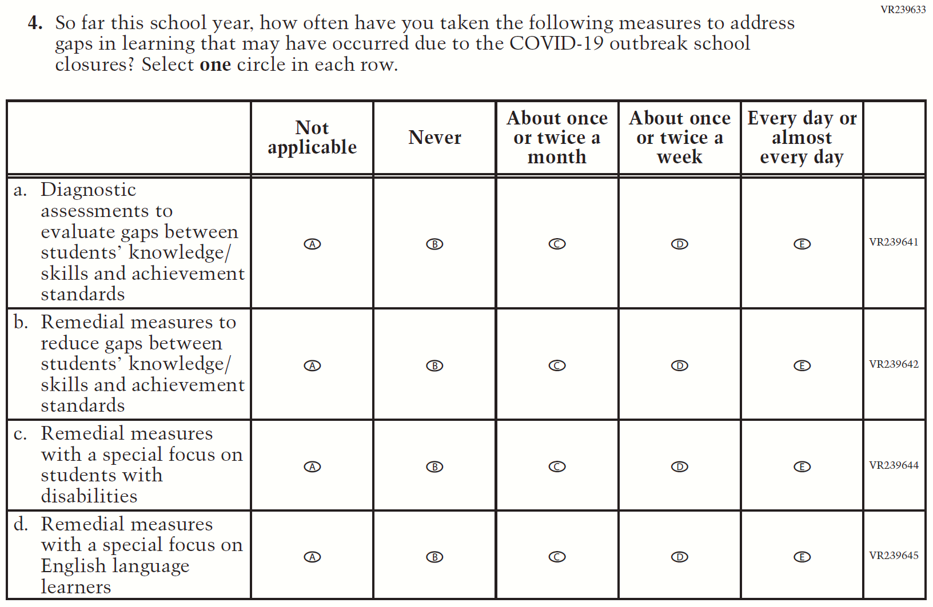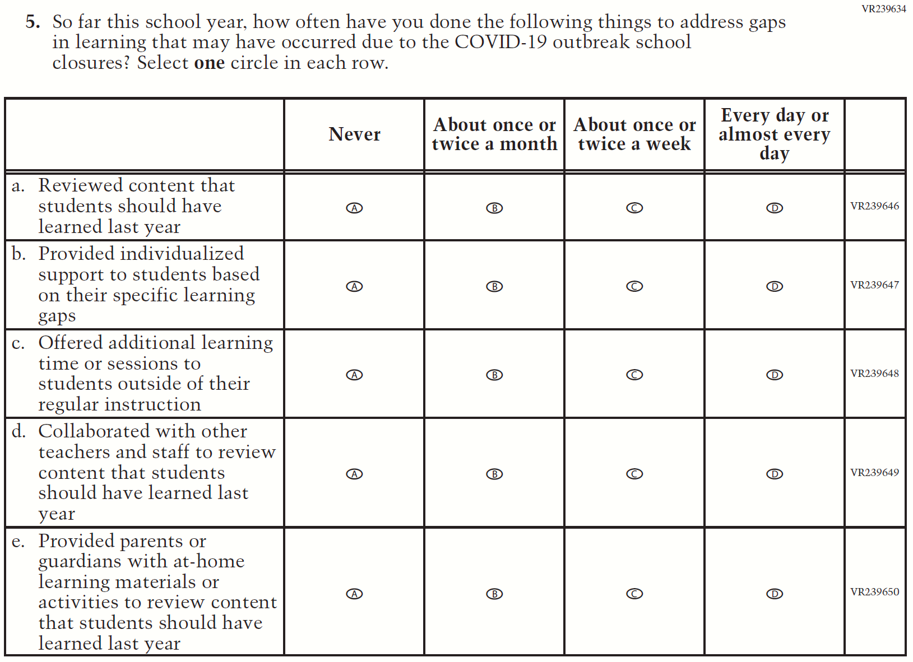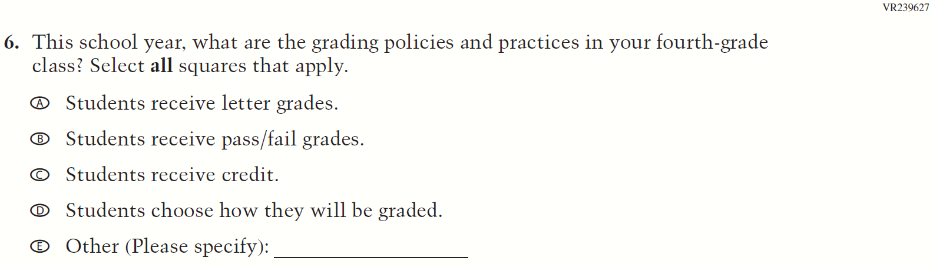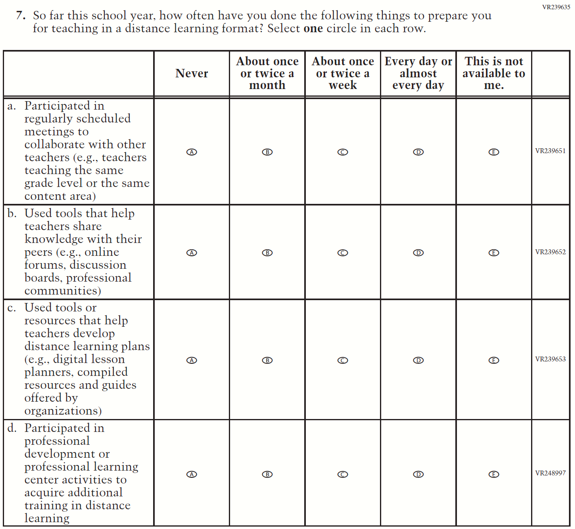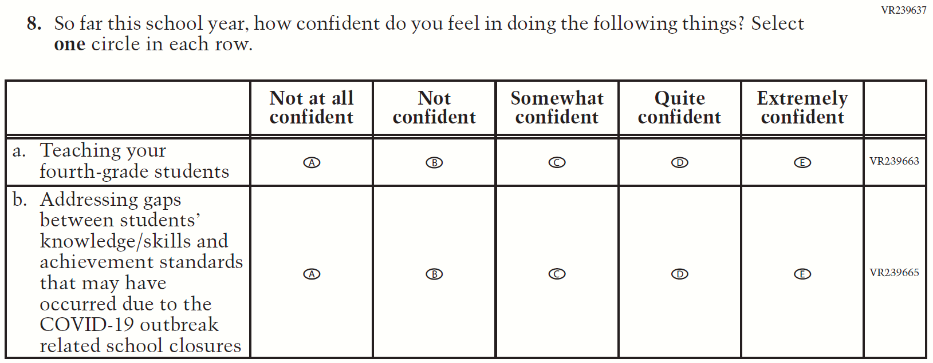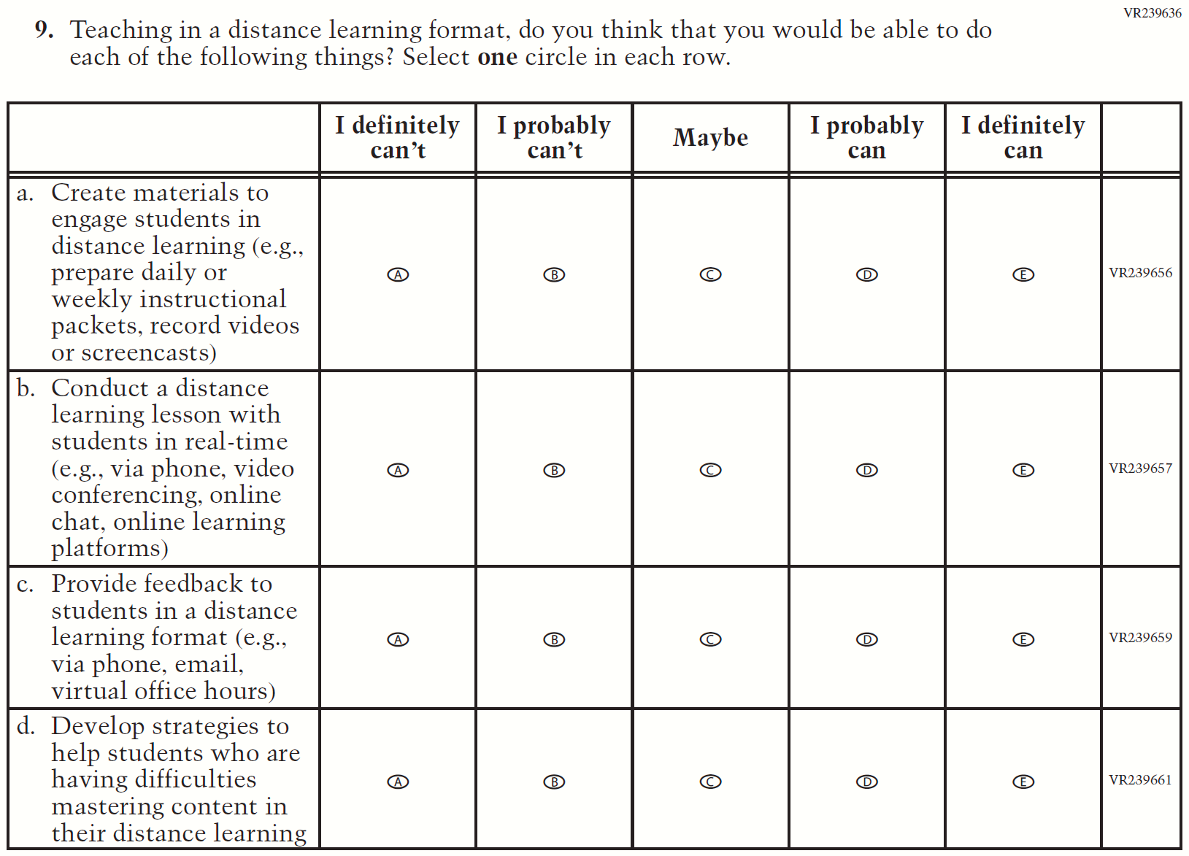

Appendix J2-17: Summary of Operational Grade 8 COVID-19
2022 Operational Grade 8 COVID-19 Teacher Items
Previous item | 2022 item | D/A/R/NC+ | Rationale
(2021 Grade 8) | Issue: Organization of Instruction | R | This item has been updated to reference the correct academic year for the 2022 administration.
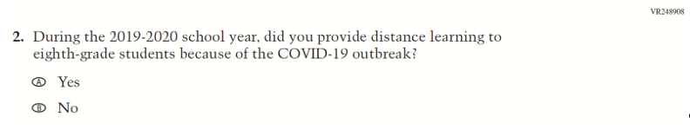  (2021 Grade 8) | 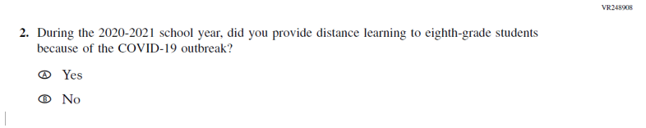  Issue: Organization of Instruction | R | This item has been updated to reference the correct academic year for the 2022 administration.

2022 Operational Grade 8 COVID-19 Teacher Items
Previous item | 2022 item | D/A/R/NC+ | Rationale
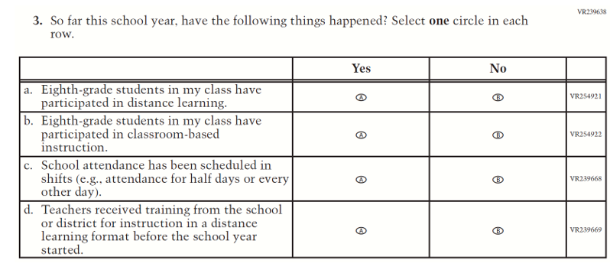  (2021 Grade 8) | Issue: Organization of Instruction | NC | N/A
(2021 Grade 8) | Issue: Organization of Instruction | NC | N/A

2022 Operational Grade 8 COVID-19 Teacher Items
Previous item | 2022 item | D/A/R/NC+ | Rationale
(2021 Grade 8) | Issue: Organization of Instruction | NC | N/A
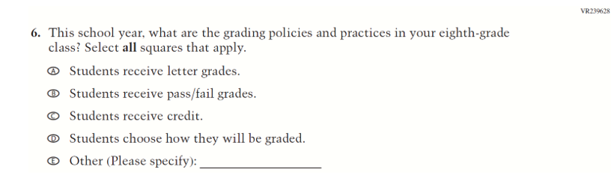  (2021 Grade 8) | Issue: Organization of Instruction | NC | N/A

2022 Operational Grade 8 COVID-19 Teacher Items
Previous item | 2022 item | D/A/R/NC+ | Rationale
(2021 Grade 8) | Issue: Teacher Preparation | NC | N/A
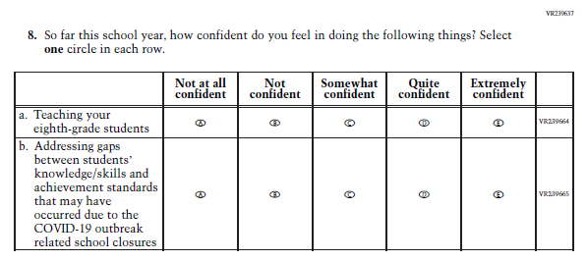  (2021 Grade 8) | Issue: Self-efficacy | NC | N/A

2022 Operational Grade 8 COVID-19 Teacher Items
Previous item | 2022 item | D/A/R/NC+ | Rationale
(2021 Grade 8) | Issue: Self-efficacy | NC | N/A

Appendix J2-18: Operational Grade 8 COVID-19
