NATIONAL CENTER FOR EDUCATION STATISTICS NATIONAL ASSESSMENT OF EDUCATIONAL PROGRESS

National Assessment of Educational Progress (NAEP) 2022
Materials Update #2

Appendix J3

2022 School Questionnaires

OMB# 1850-0928 v.25

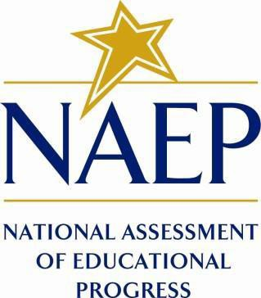

September 2021

Appendix J3 provides updated school survey questionnaires to be used in NAEP 2022. The change tables indicate any revisions that have been made to the previous versions of the SQs.
Table of Contents
School Questionnaires
School Administrator Questionnaire Login Screen 5
Sample School Questionnaire Booklet Covers 6
Appendix J3-1: Summary of Changes Operational Grade 4 CORE 7
Appendix J3-2: Operational Grade 4 CORE 16
Appendix J3-3: Summary of Changes Operational Grade 8 CORE 25
Appendix J3-4: Operational Grade 8 CORE 35
Appendix J3-4: Summary of Changes Operational Grade 4 and 8 Charter School 44
Appendix J3-6: Operational Grade 4 and 8 Charter School 46
Appendix J3-7: Summary of Changes Operational Grade 4 Mathematics 48
Appendix J3-8: Operational Grade 4 Mathematics 51
Appendix J3-9: Summary of Changes Operational Grade 8 Mathematics 54
Appendix J3-10: Operational Grade 8 Mathematics 57
Appendix J3-11: Summary of Changes Operational Grade 4 Reading 61
Appendix J3-12: Operational Grade 4 Reading 64
Appendix J3-13: Summary of Changes Operational Grade 8 Reading 68
Appendix J3-14: Operational Grade 8 Reading 72
Appendix J3-15: Summary of Operational Grade 8 Social Studies School Items 76
Appendix J3-16: Operational Grade 8 Social Studies School Items 79
Appendix J3-17: Summary of Operational Grade 4 COVID-19 School Items 82
Appendix J3-18: Operational Grade 4 COVID-19 School Items 90
Appendix J3-19: Summary of Operational Grade 8 COVID-19 School Items 99
Appendix J3-20: Operational Grade 8 COVID-19 School Items 107

School Administrator Questionnaire Login Screen
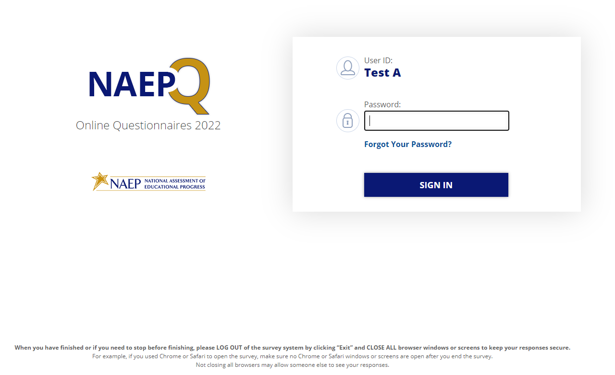
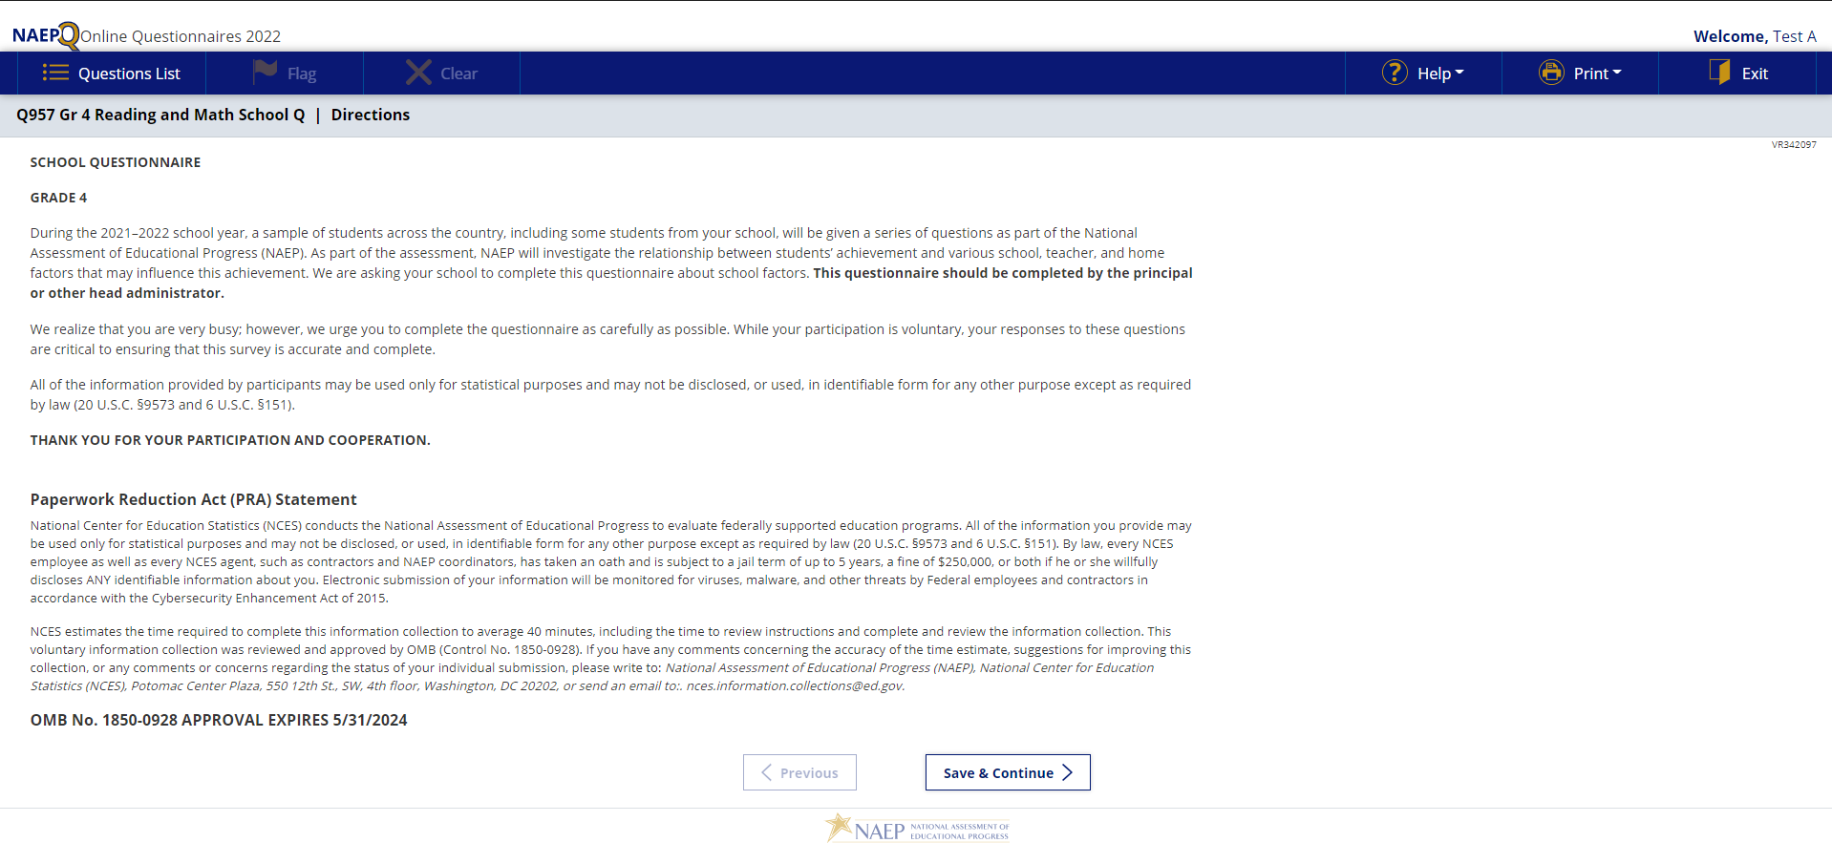

Sample School Questionnaire Booklet Covers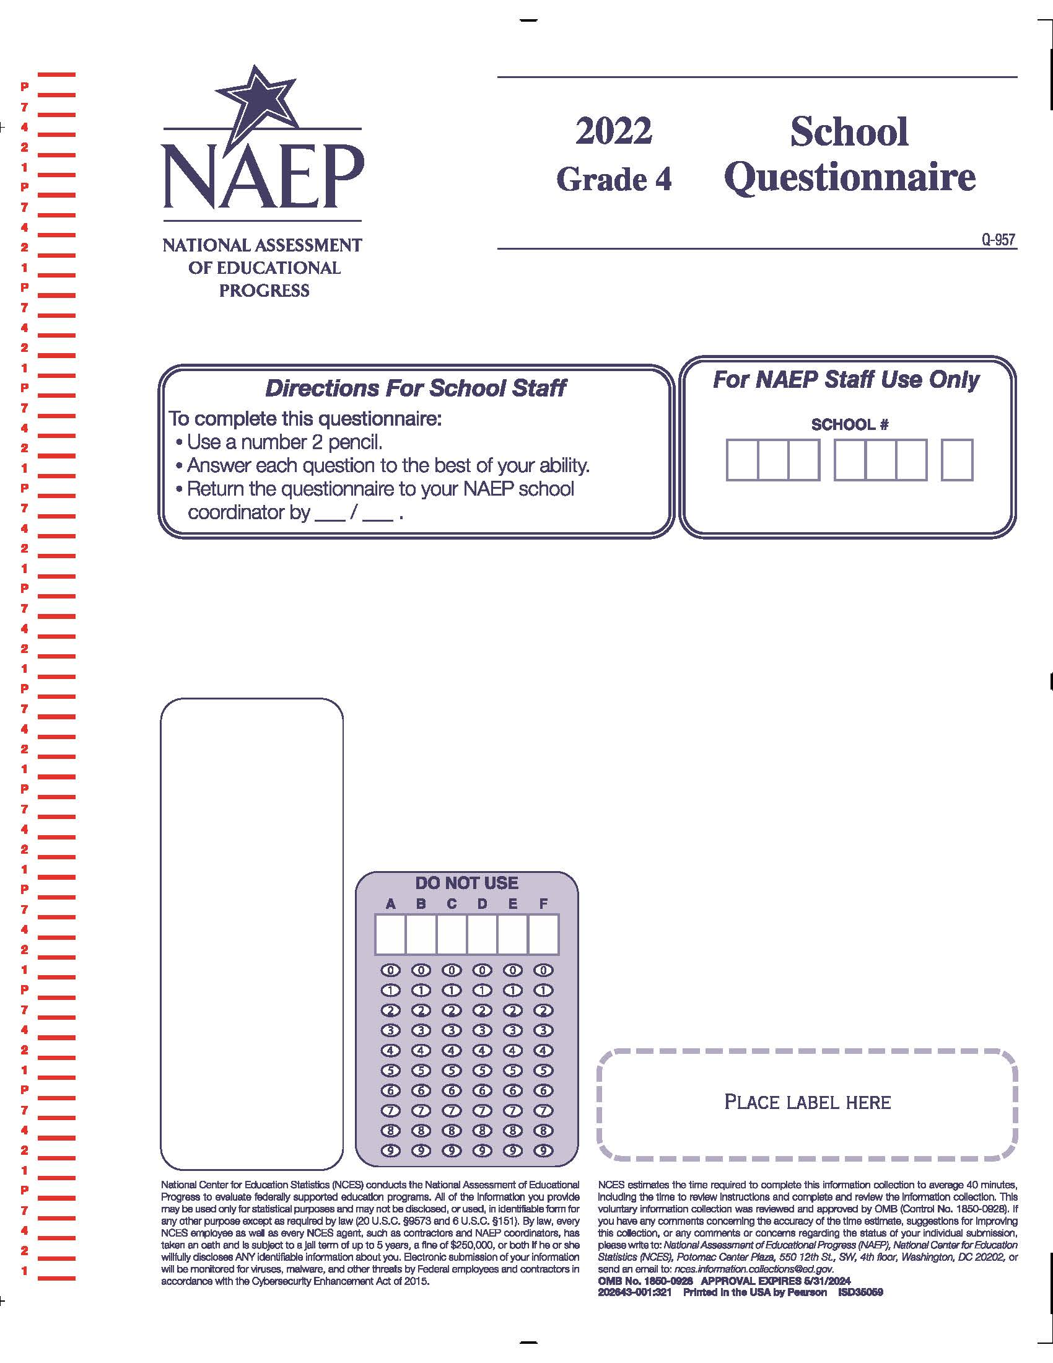

Appendix J3-1: Summary of Changes Operational Grade 4 CORE
2022 Operational Grade 4 Core School

Previous item | 2022 item | D/A/ R/NC+ | Rationale
(2021 Grade 4) | N/A | D | This item is recommended to be dropped due to concerns about data validity and a lack of inclusiveness in the response options.
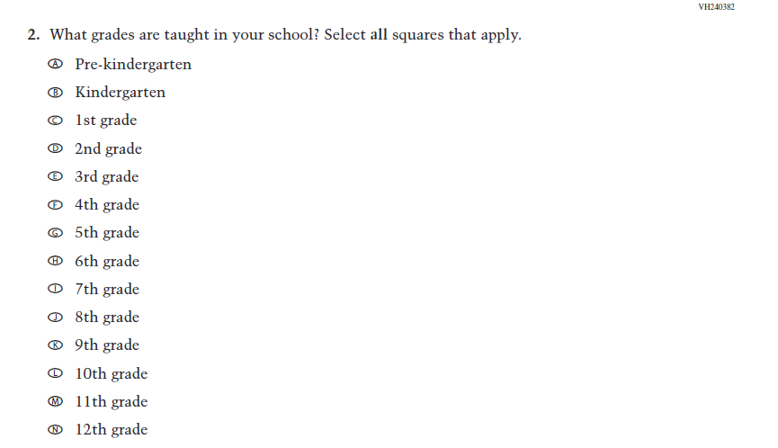  (2021 Grade 4) | 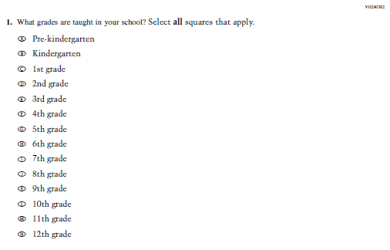  Issue: School Climate | NC | N/A

2022 Operational Grade 4 Core School

Previous item | 2022 item | D/A/ R/NC+ | Rationale
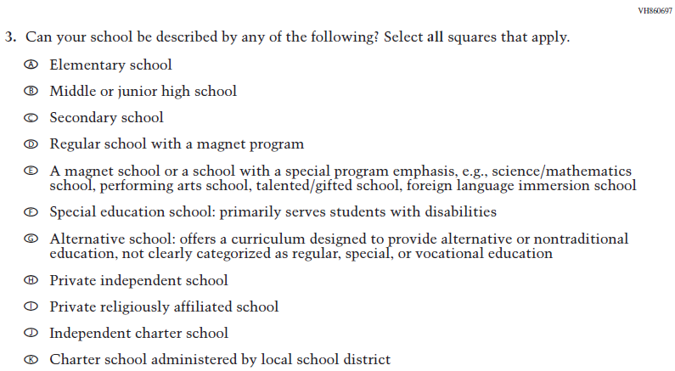  (2021 Grade 4) | 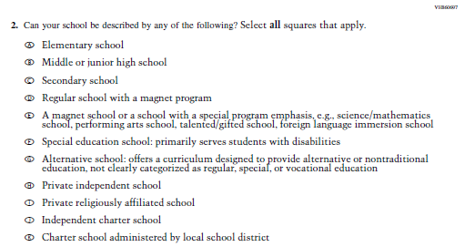  Issue: School Climate | NC | N/A
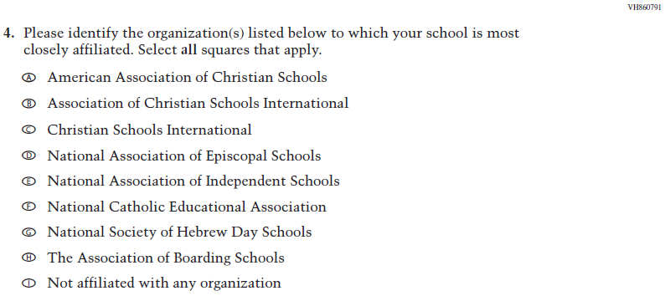  (2021 Grade 4) | 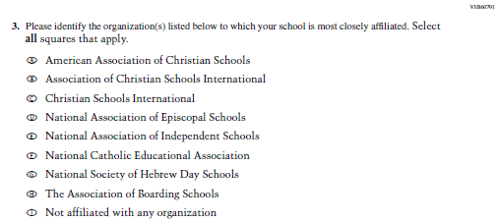  Issue: School Climate | NC | N/A
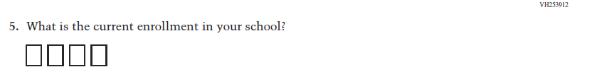  (2021 Grade 4) | Issue: School Climate | NC | N/A
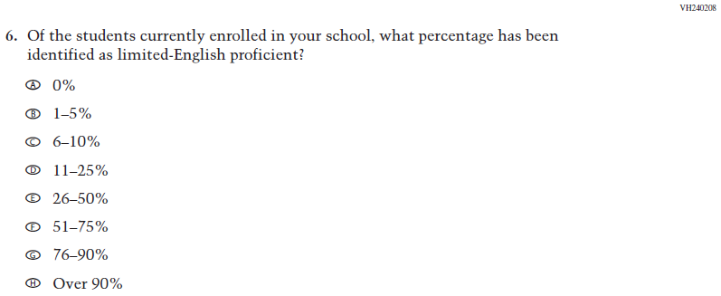  (2021 Grade 4) | 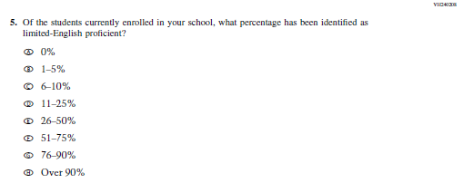  Issue: School Climate | NC | N/A
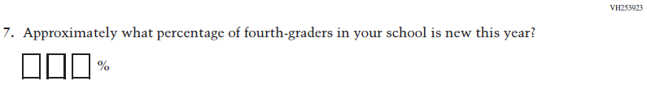  (2021 Grade 4) | 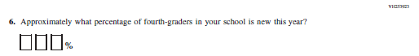  Issue: School Climate | NC | N/A
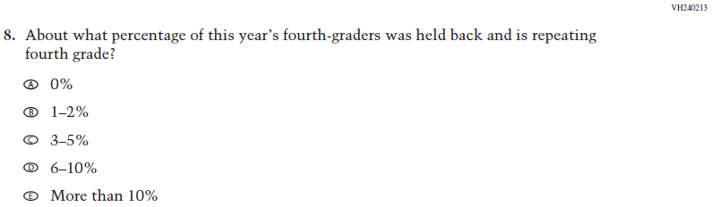  (2021 Grade 4) | 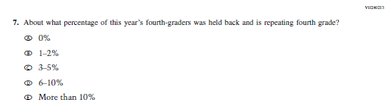  Issue: School Climate | NC | N/A
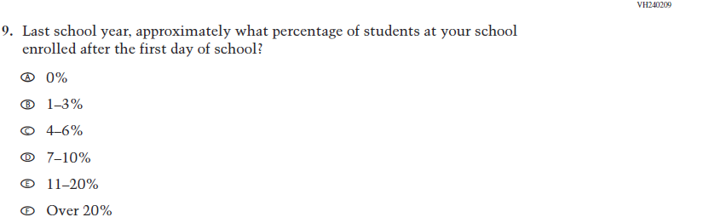  (2021 Grade 4) | 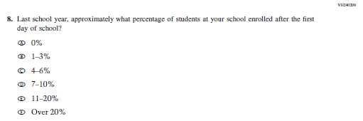  Issue: School Climate | NC | N/A

2022 Operational Grade 4 Core School

Previous item | 2022 item | D/A/ R/NC+ | Rationale
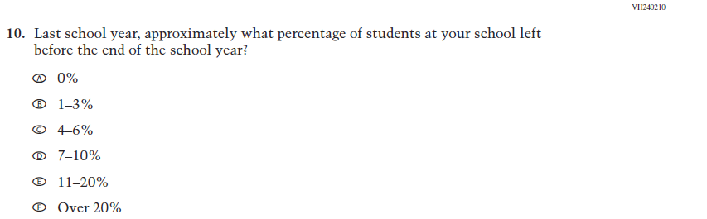  (2021 Grade 4) | 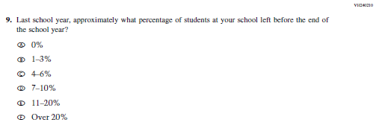  Issue: School Climate | NC | N/A
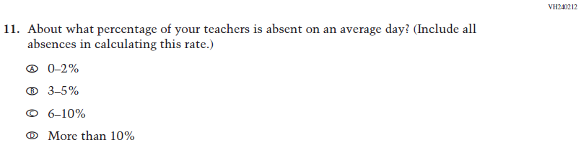  (2021 Grade 4) | 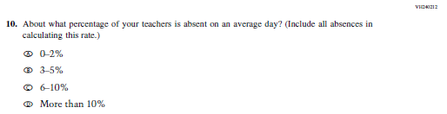  Issue: School Climate | NC | N/A
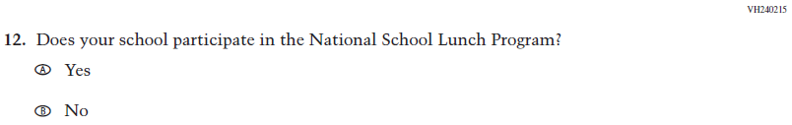  (2021 Grade 4) | 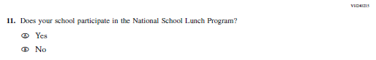  Issue: Socioeconomic Status | NC | N/A
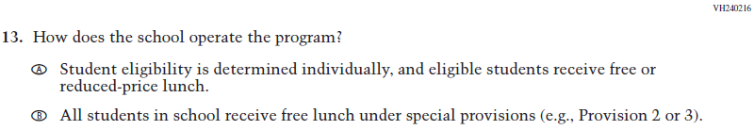  (2021 Grade 4) | 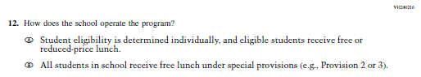  Issue: Socioeconomic Status | NC | N/A

2022 Operational Grade 4 Core School

Previous item | 2022 item | D/A/ R/NC+ | Rationale
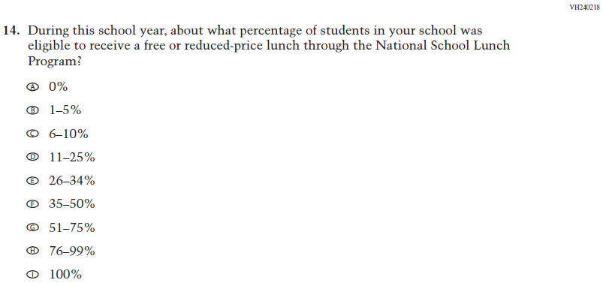  (2021 Grade 4) | 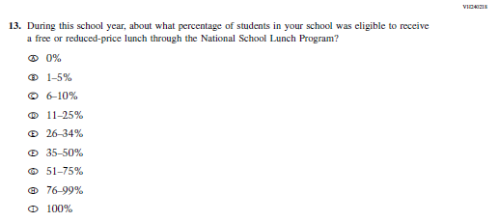  Issue: Socioeconomic Status | NC | N/A
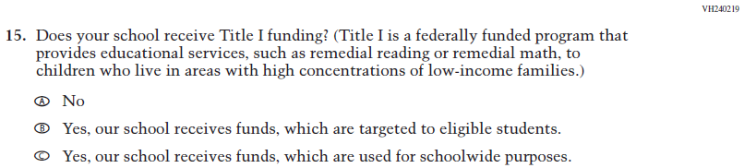  (2021 Grade 4) | 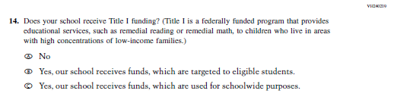  Issue: Socioeconomic Status | NC | N/A
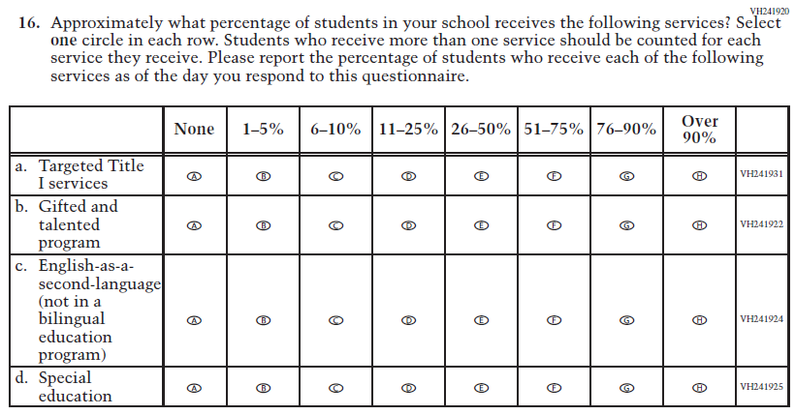  (2021 Grade 4) | 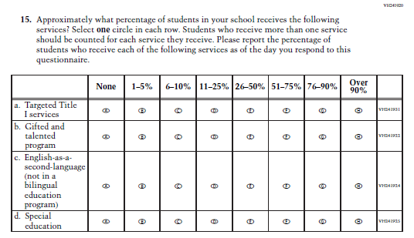  Issue: School Climate | NC | N/A
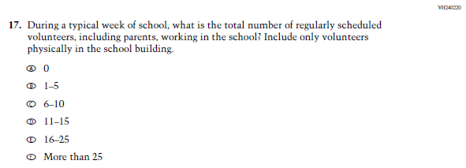  (2021 Grade 4) | 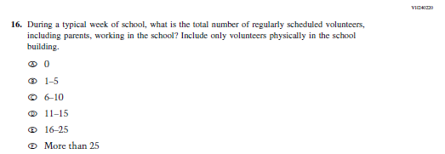  Issue: School Climate | NC | N/A
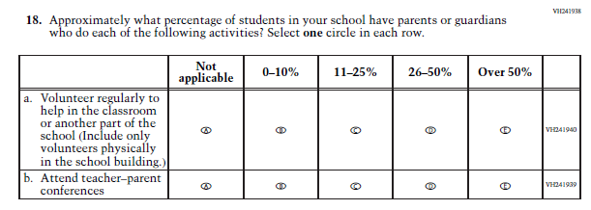  (2021 Grade 4) | 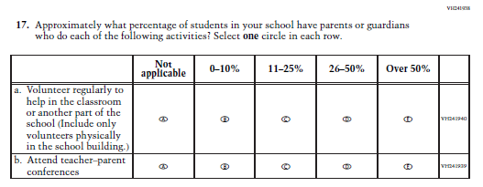  Issue: School Climate | NC | N/A
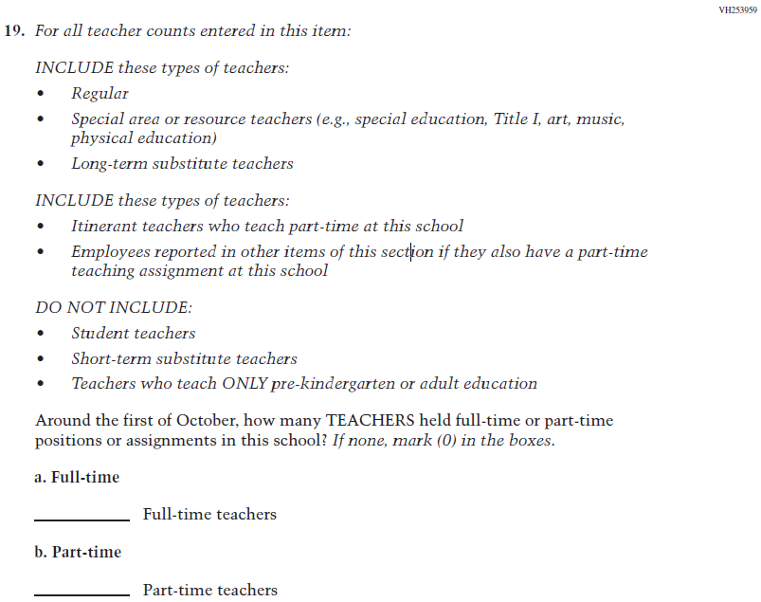  (2021 Grade 4) | 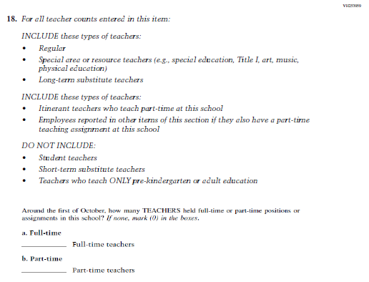  Issue: School Climate | NC | N/A
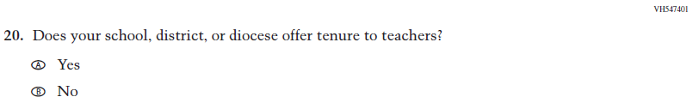  (2021 Grade 4) | 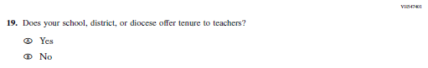  Issue: School Climate | NC | N/A

2022 Operational Grade 4 Core School

Previous item | 2022 item | D/A/ R/NC+ | Rationale
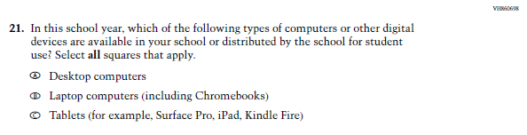  (2021 Grade 4) | 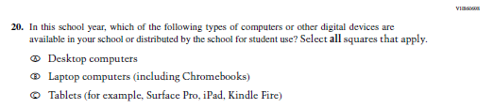  Issue: Technology Use | NC | N/A
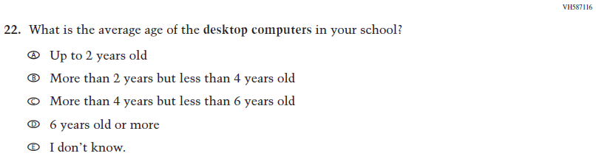  (2021 Grade 4) | 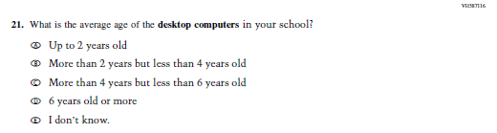  Issue: Technology Use | NC | N/A
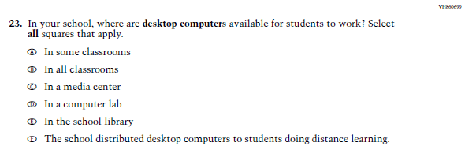  (2021 Grade 4) | 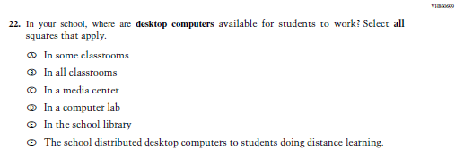  Issue: Technology Use | NC | N/A
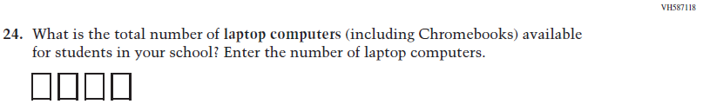  (2021 Grade 4) | 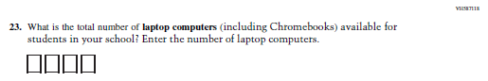  Issue: Technology Use | NC | N/A
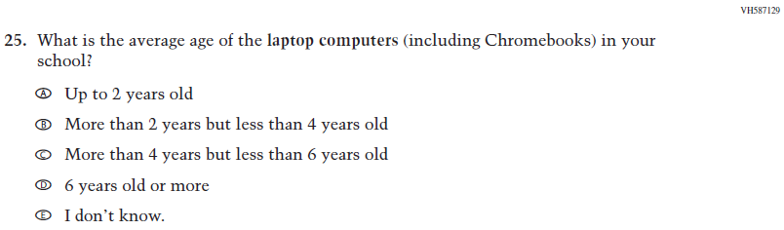  (2021 Grade 4) | 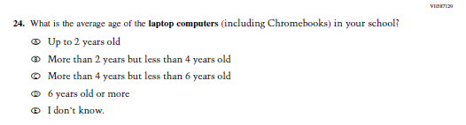  Issue: Technology Use | NC | N/A
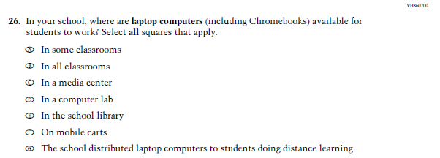  (2021 Grade 4) | 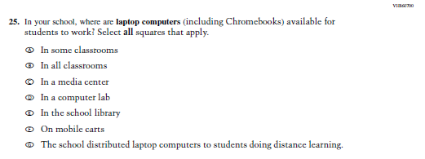  Issue: Technology Use | NC | N/A
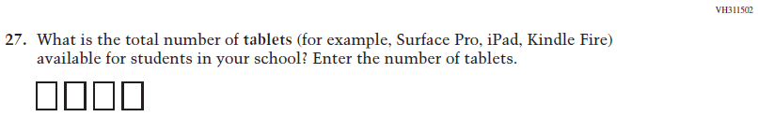  (2021 Grade 4) | 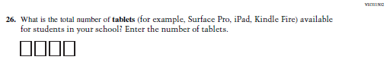  Issue: Technology Use | NC | N/A
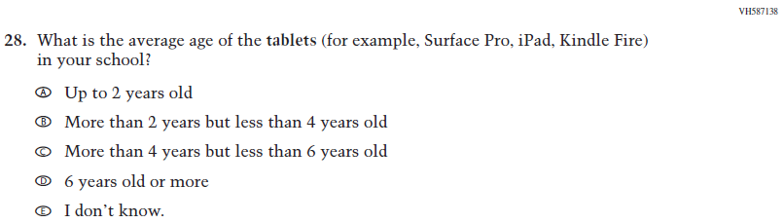  (2021 Grade 4) | 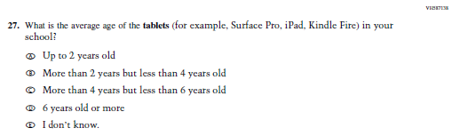  Issue: Technology Use | NC | N/A
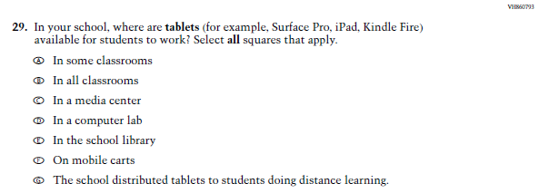  (2021 Grade 4) | 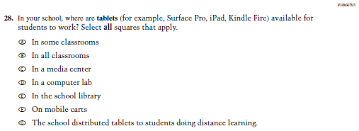  Issue: Technology Use | NC | N/A
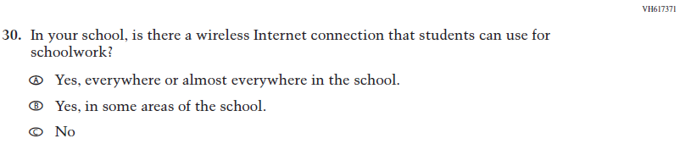  (2021 Grade 4) | 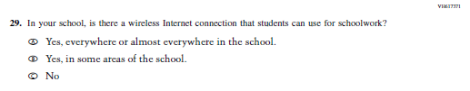  Issue: Technology Use | NC | N/A

Appendix J3-2: Operational Grade 4 CORE
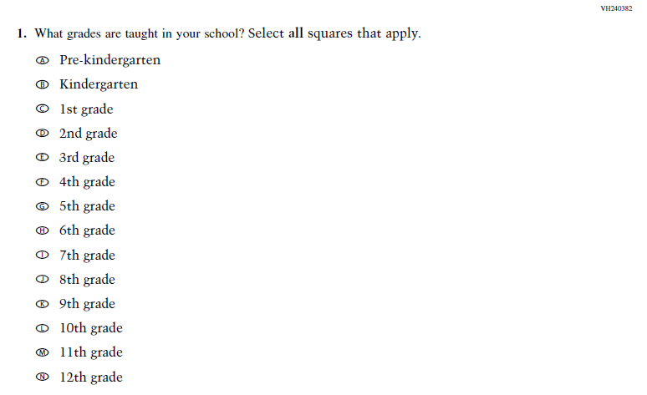
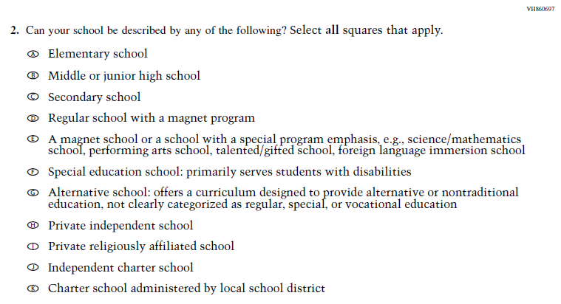

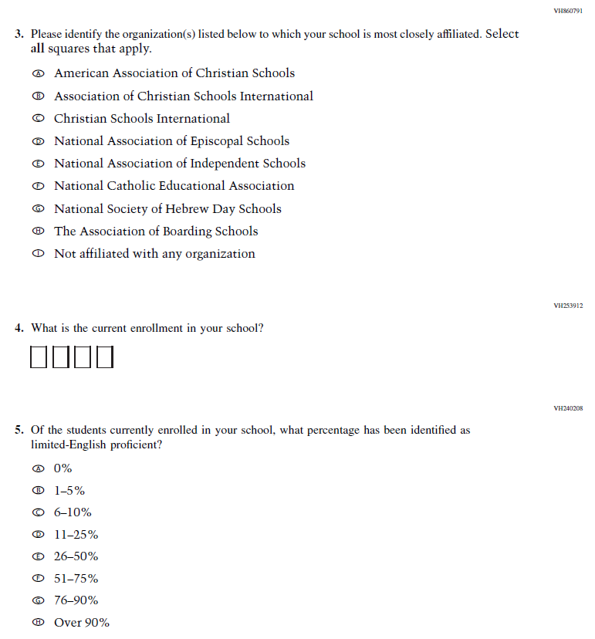
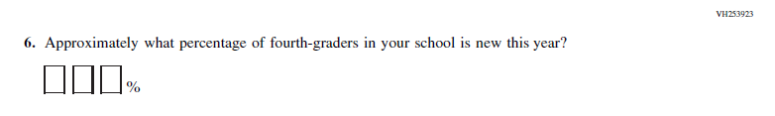

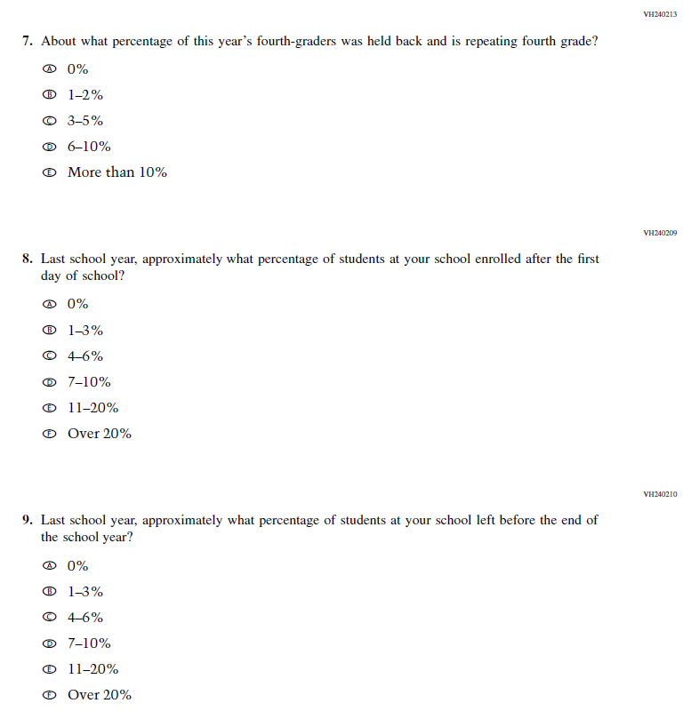
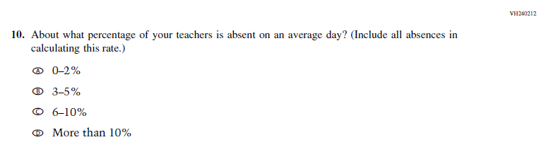

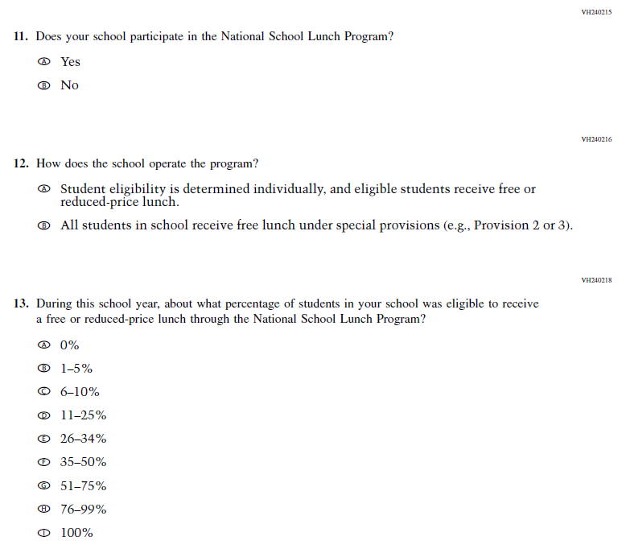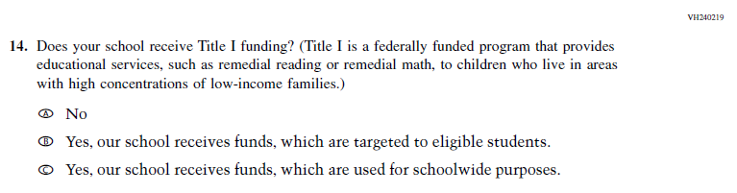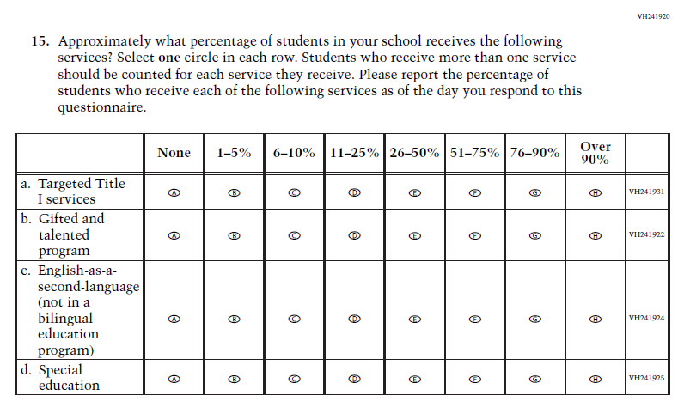
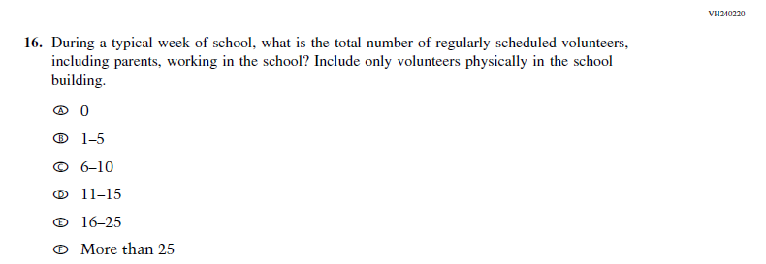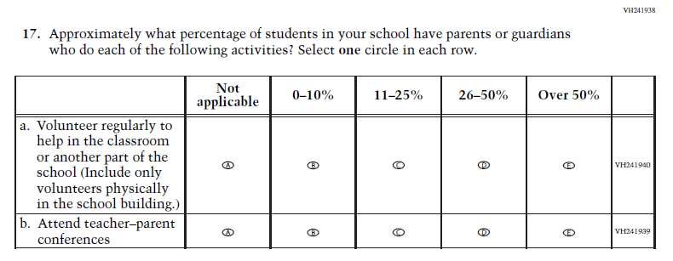
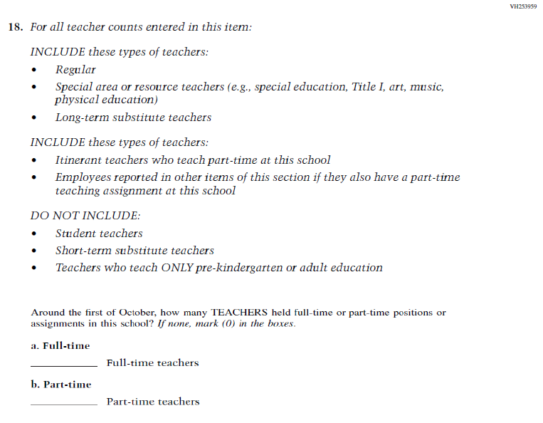
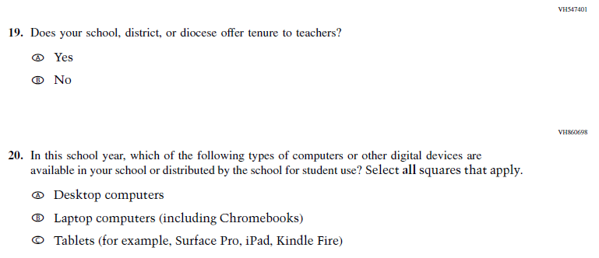

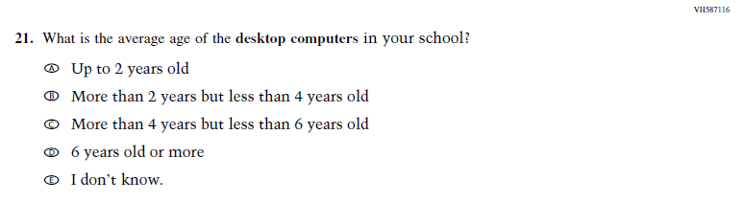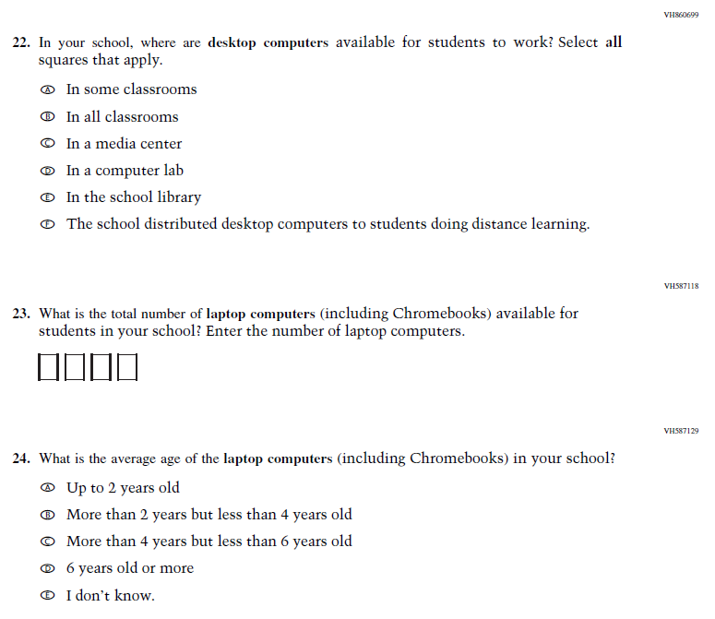

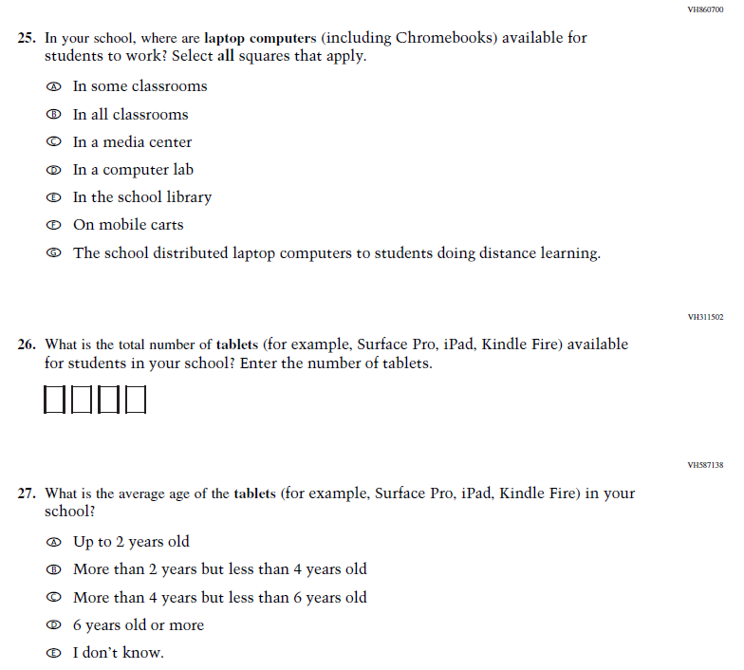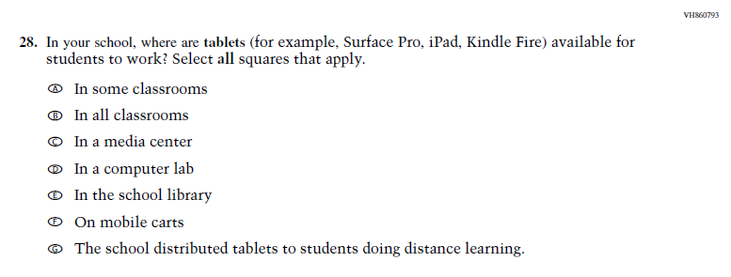

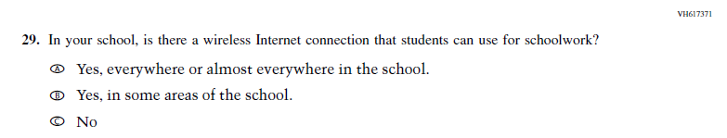

Appendix J3-3: Summary of Changes Operational Grade 8 CORE
2022 Operational Grade 8 Core School

Previous item | 2022 item | D/A/ R/NC+ | Rationale
(2021 Grade 8) | N/A | D | This item is recommended to be dropped due to concerns about data validity and a lack of inclusiveness in the response options.
(2021 Grade 8) | 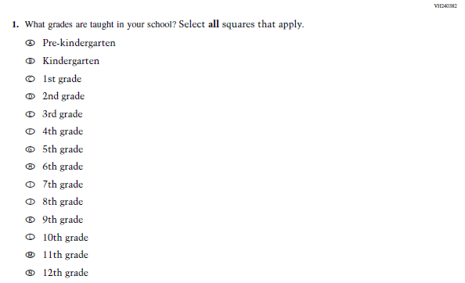  Issue: School Climate | NC | N/A

2022 Operational Grade 8 Core School

Previous item | 2022 item | D/A/ R/NC+ | Rationale
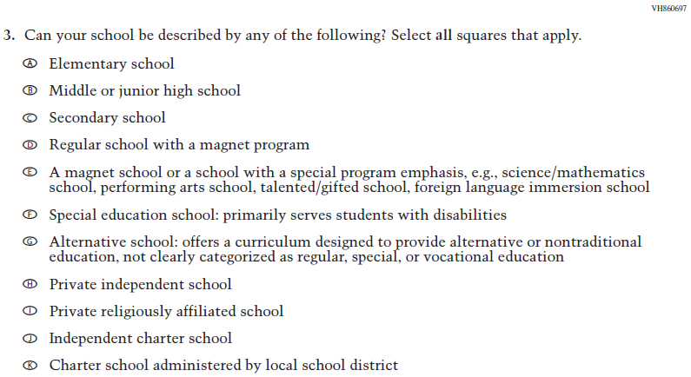  (2021 Grade 8) | 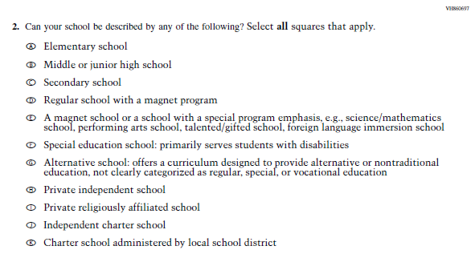  Issue: School Climate | NC | N/A
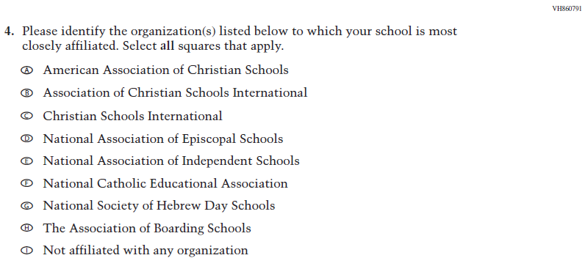  (2021 Grade 8) | 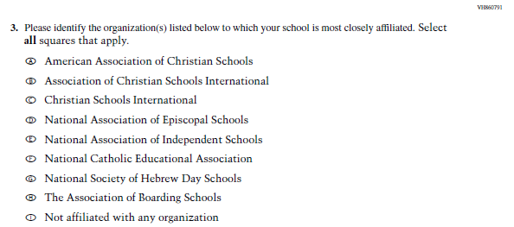  Issue: School Climate | NC | N/A
(2021 Grade 8) | 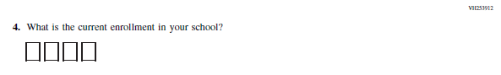  Issue: School Climate | NC | N/A
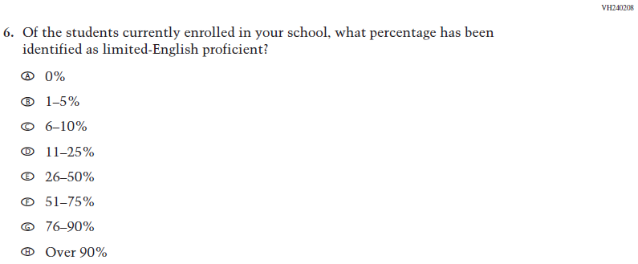  (2021 Grade 8) | 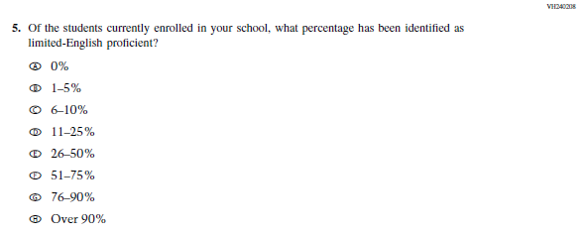  Issue: School Climate | NC | N/A
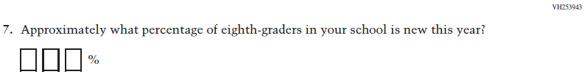  (2021 Grade 8) | 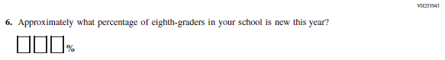  Issue: School Climate | NC | N/A
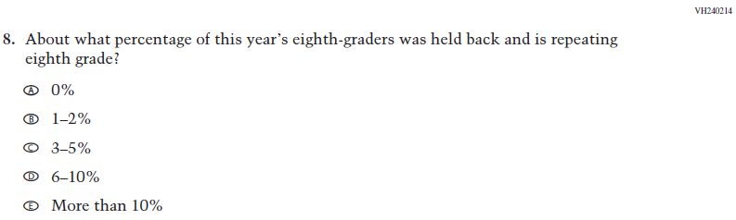  (2021 Grade 8) | 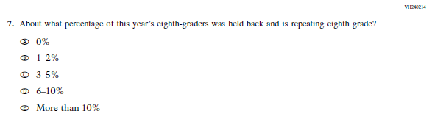  Issue: School Climate | NC | N/A
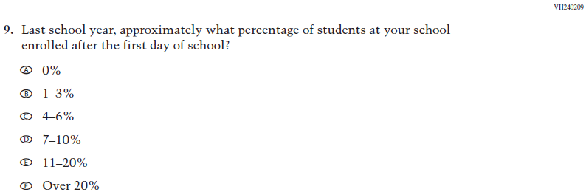  (2021 Grade 8) | 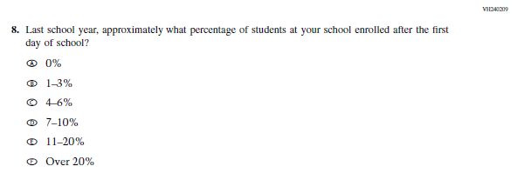  Issue: School Climate | NC | N/A

2022 Operational Grade 8 Core School

Previous item | 2022 item | D/A/ R/NC+ | Rationale
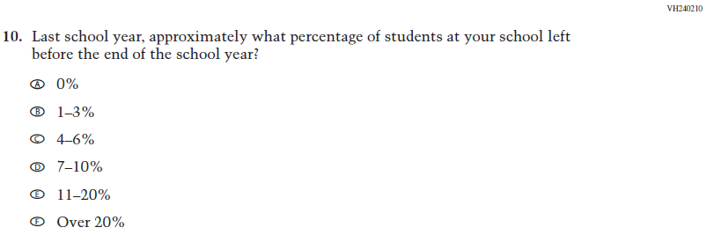  (2021 Grade 8) | 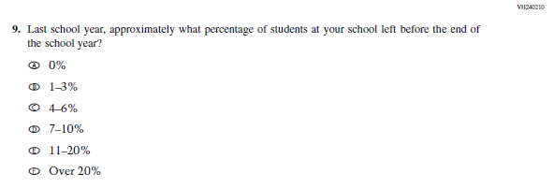  Issue: School Climate | NC | N/A
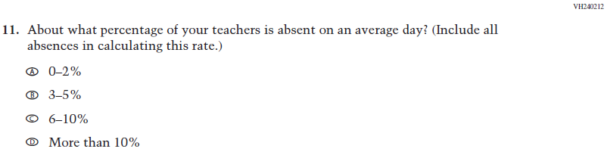  (2021 Grade 8) | 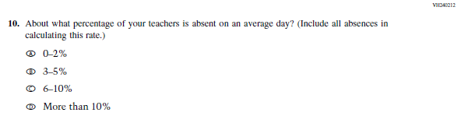  Issue: School Climate | NC | N/A
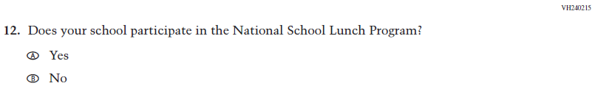  (2021 Grade 8) | 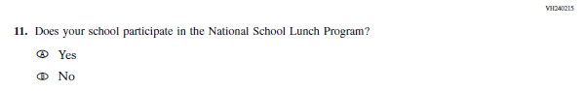  Issue: Socioeconomic Status | NC | N/A
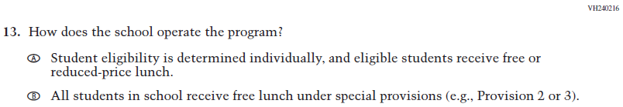  (2021 Grade 8) | 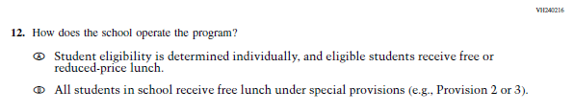  Issue: Socioeconomic Status | NC | N/A

2022 Operational Grade 8 Core School

Previous item | 2022 item | D/A/ R/NC+ | Rationale
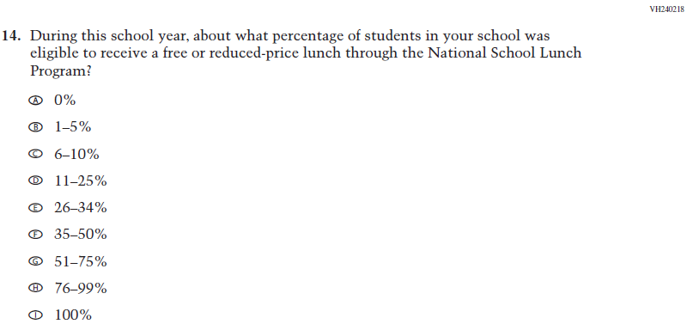  (2021 Grade 8) | 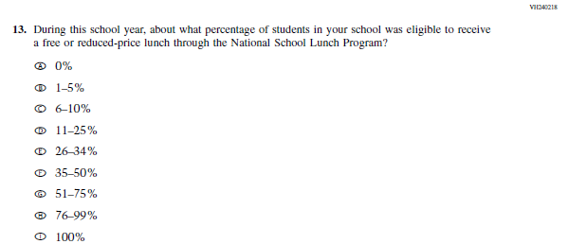  Issue: Socioeconomic Status | NC | N/A
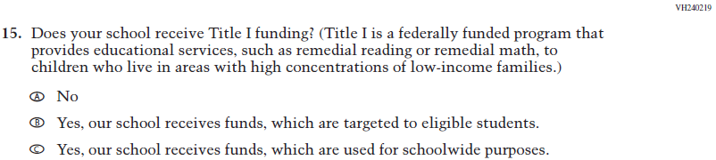  (2021 Grade 8) | 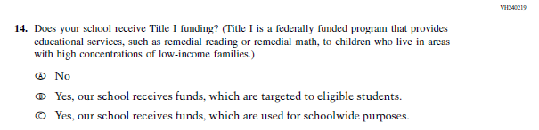  Issue: Socioeconomic Status | NC | N/A
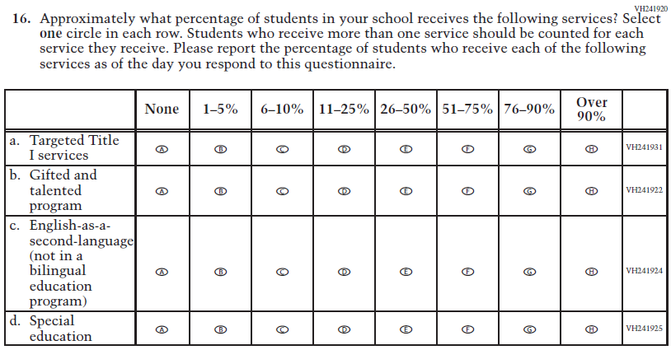  (2021 Grade 8) | 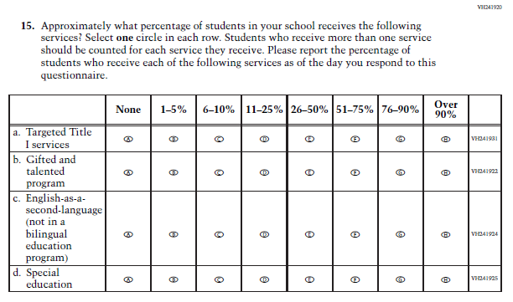  Issue: School Climate | NC | N/A
(2021 Grade 8) | 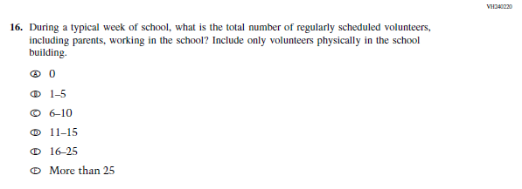  Issue: School Climate | NC | N/A
(2021 Grade 8) | 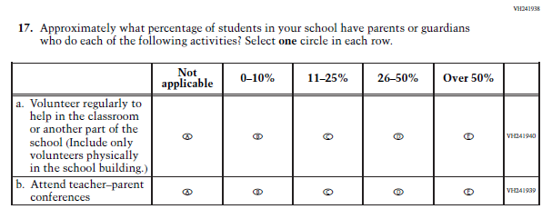  Issue: School Climate | NC | N/A
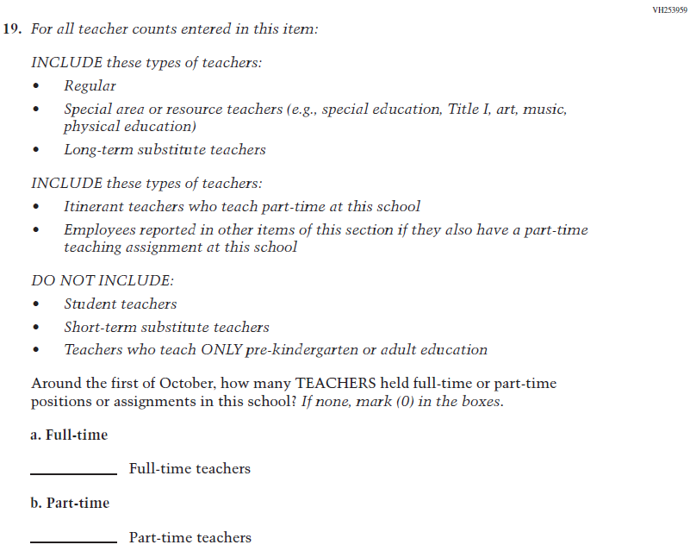  (2021 Grade 8) | 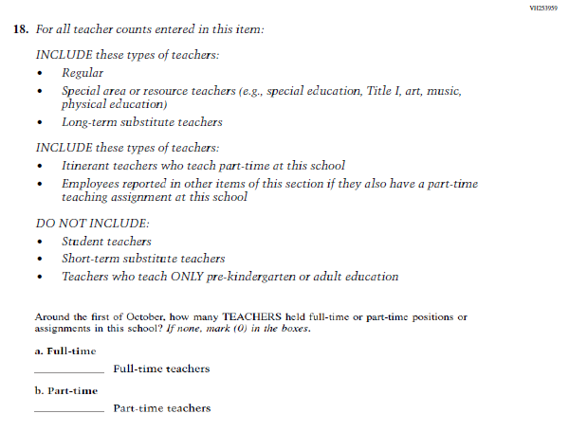  Issue: School Climate | NC | N/A
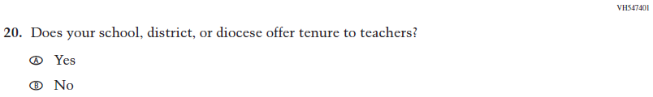  (2021 Grade 8) | 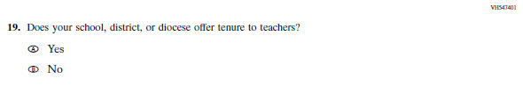  Issue: School Climate | NC | N/A
(2021 Grade 8) | 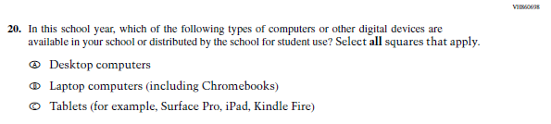  Issue: Technology Use | NC | N/A

2022 Operational Grade 8 Core School

Previous item | 2022 item | D/A/ R/NC+ | Rationale
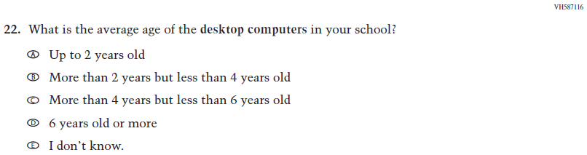  (2021 Grade 8) | 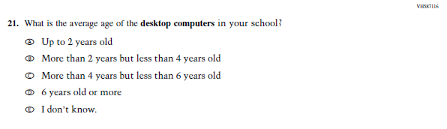  Issue: Technology Use | NC | N/A
(2021 Grade 8) | 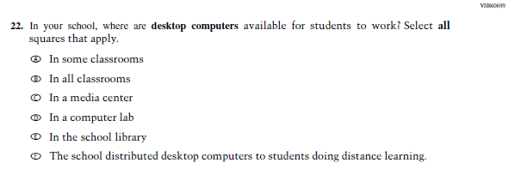  Issue: Technology Use | NC | N/A
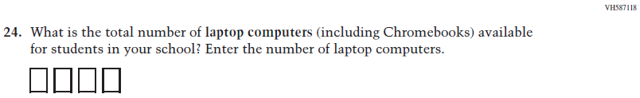  (2021 Grade 8) | 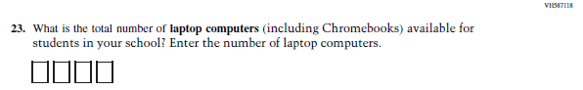  Issue: Technology Use | NC | N/A
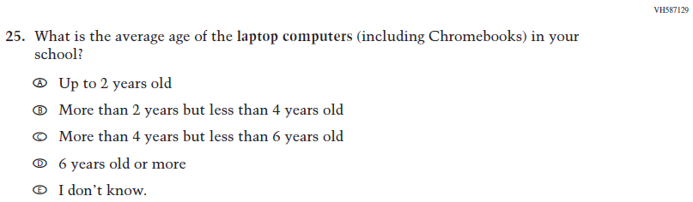  (2021 Grade 8) | 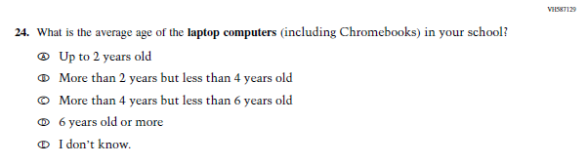  Issue: Technology Use | NC | N/A
(2021 Grade 8) | 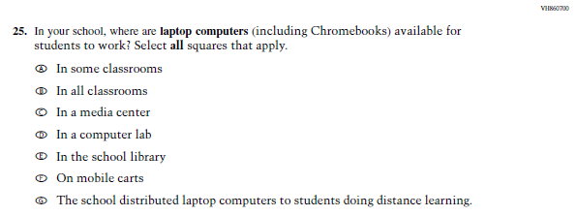  Issue: Technology Use | NC | N/A
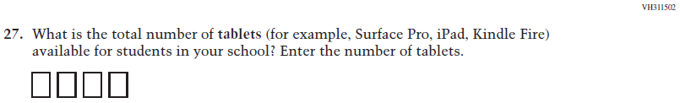  (2021 Grade 8) | 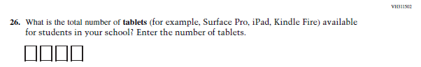  Issue: Technology Use | NC | N/A
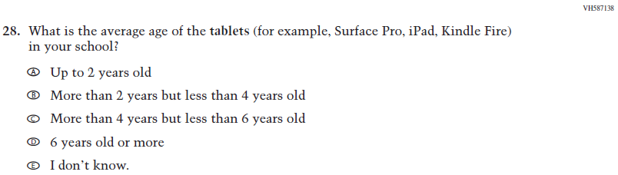  (2021 Grade 8) | 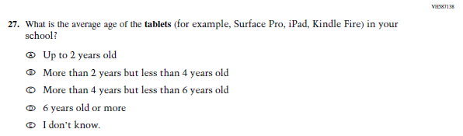  Issue: Technology Use | NC | N/A
(2021 Grade 8) | 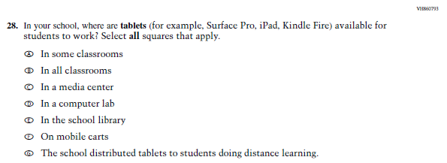  Issue: Technology Use | NC | N/A
2022 Operational Grade 8 Core School

Previous item | 2022 item | D/A/ R/NC+ | Rationale
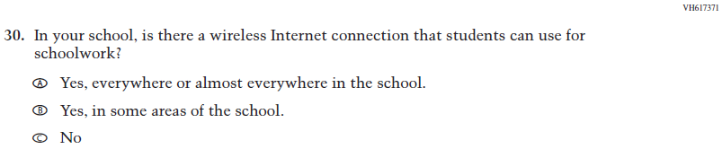  (2021 Grade 8) | 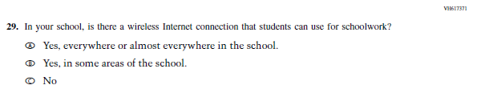  Issue: Technology Use | NC | N/A

Appendix J3-4: Operational Grade 8 CORE

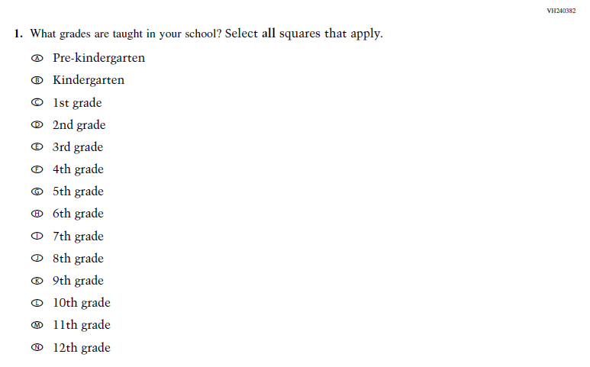
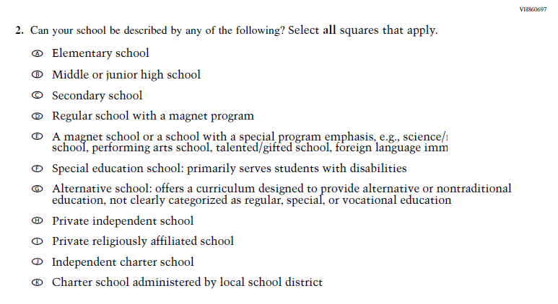

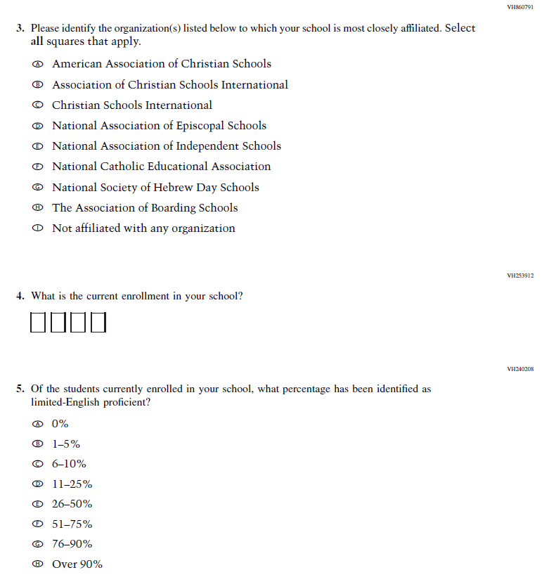
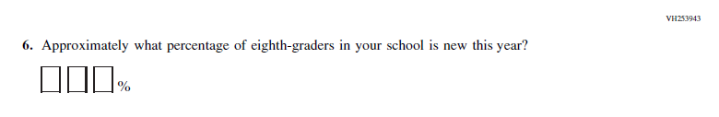
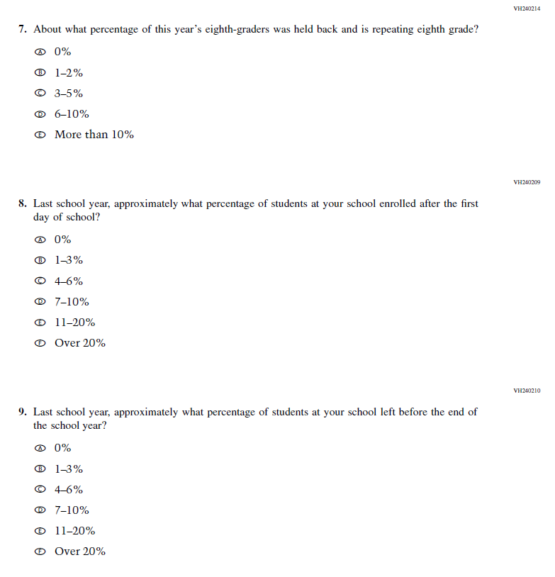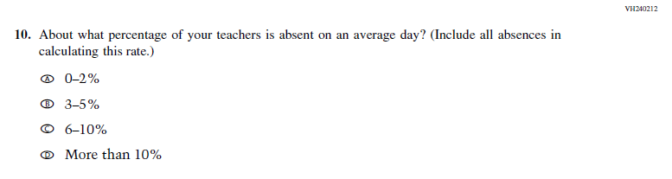

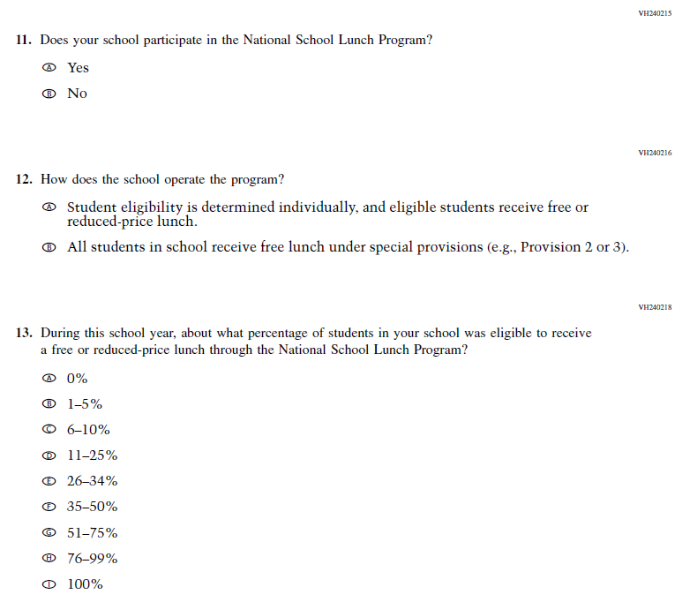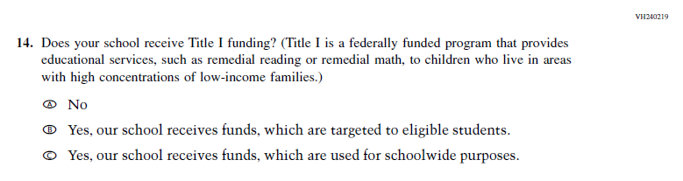

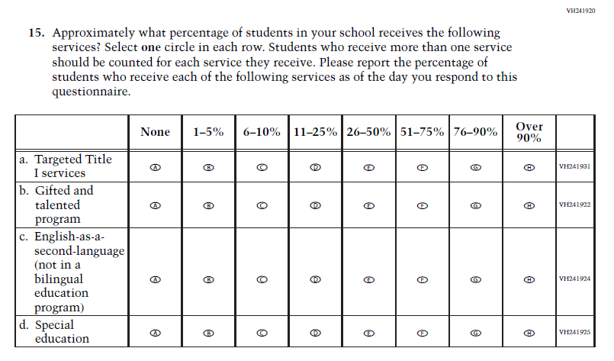
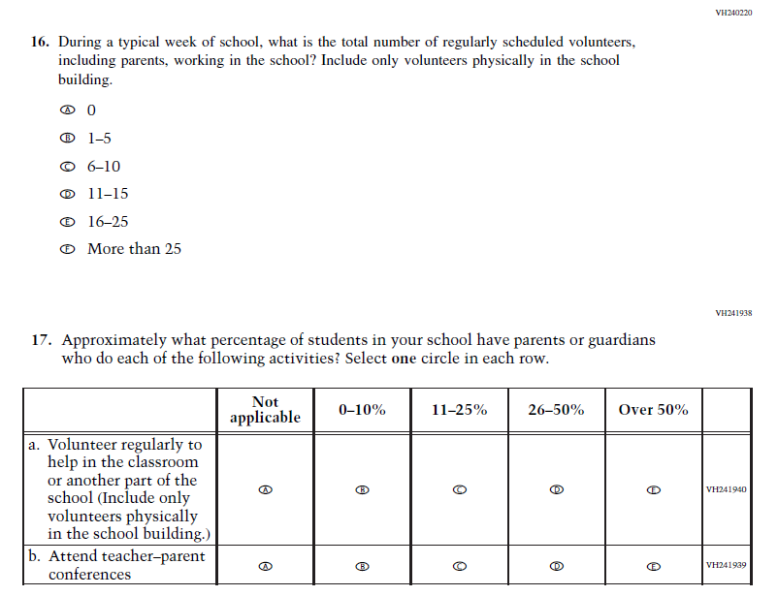
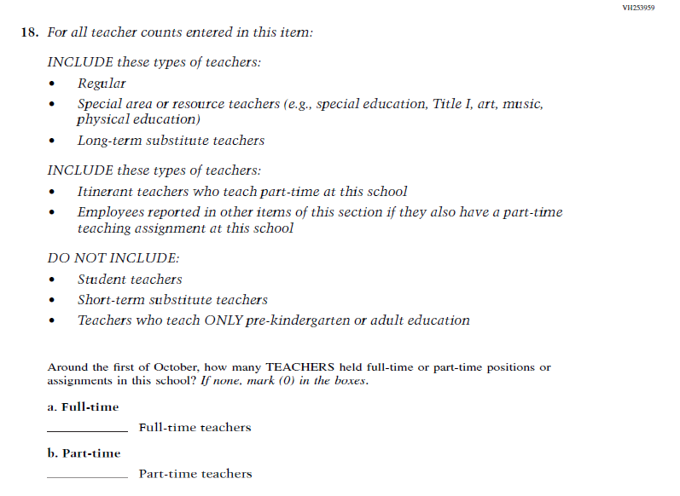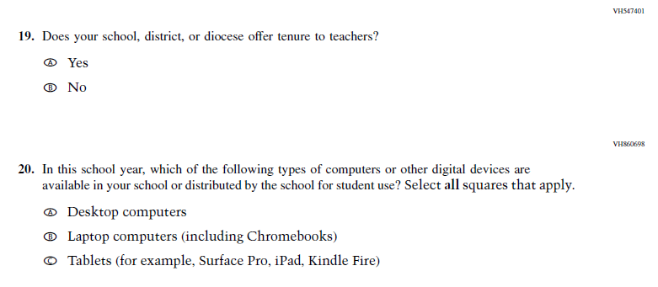
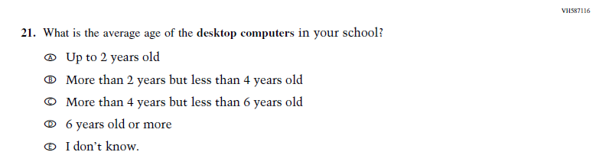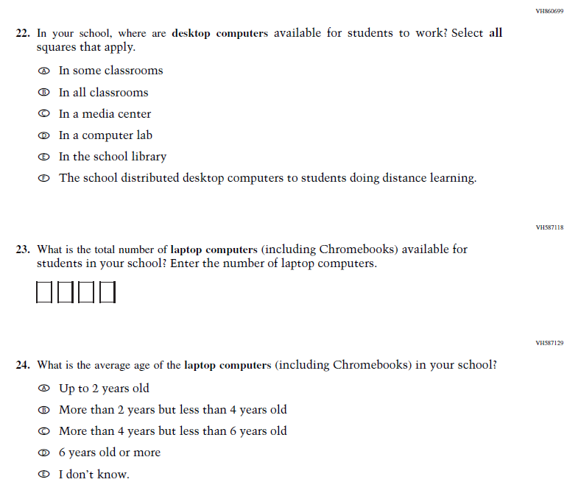

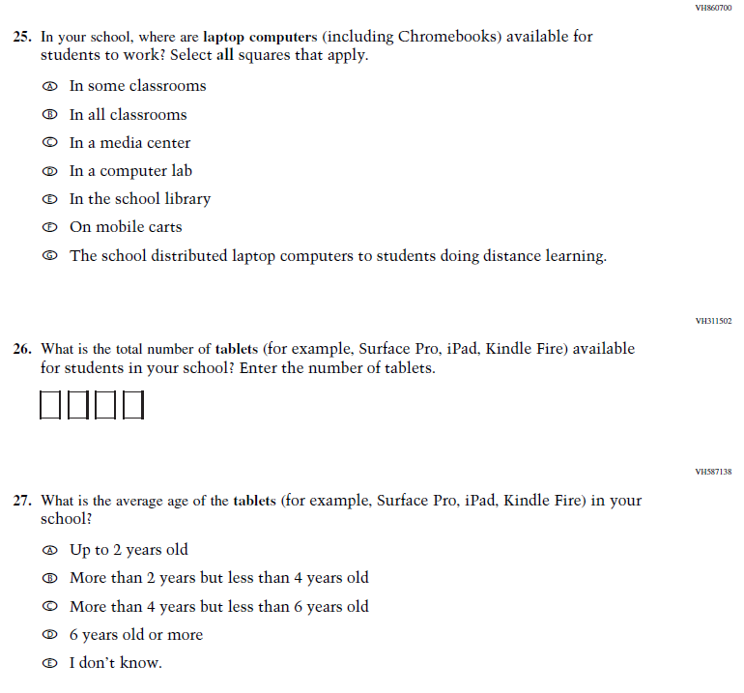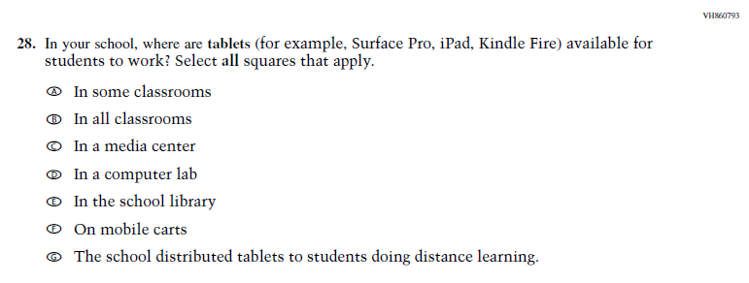

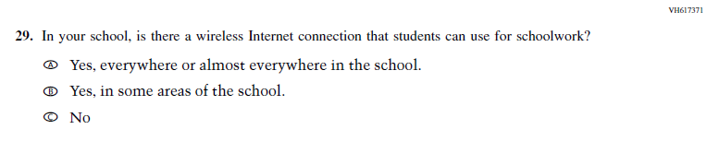

Appendix J3-4: Summary of Changes Operational Grade 4 and 8 Charter School
2022 Operational Grade 4 and 8 Charter School

Previous item | 2022 item | D/A/ R/NC+ | Rationale
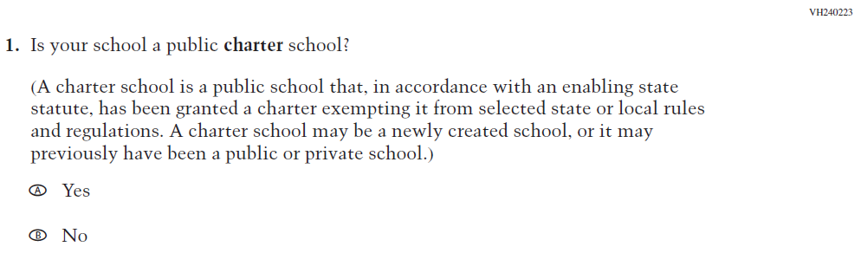  (2021 Grade 4, 8, and 12) | 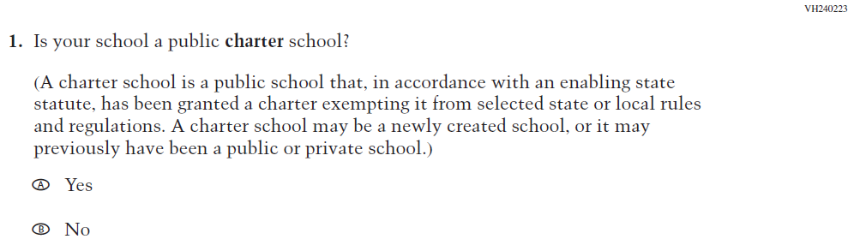  Issue: School Climate | NC | N/A
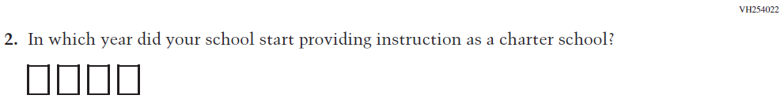  (2021 Grade 4, 8, and 12) | 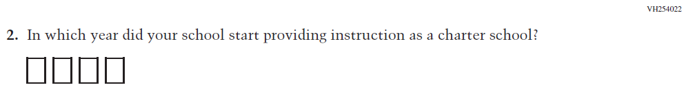  Issue: School Climate | NC | N/A
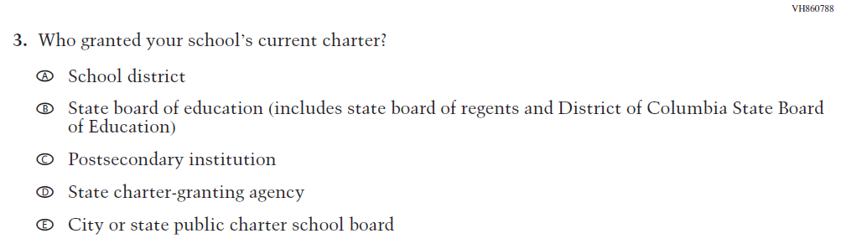  (2021 Grade 4, 8, and 12) | Issue: School Climate | NC | N/A
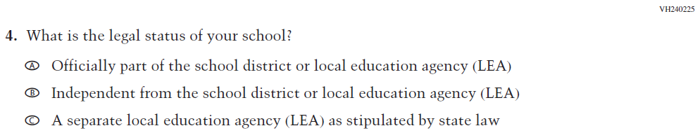  (2021 Grade 4, 8, and 12) | 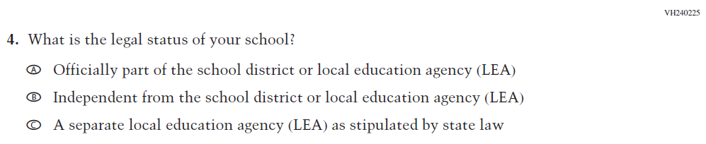  Issue: School Climate | NC | N/A

2022 Operational Grade 4 and 8 Charter School

Previous item | 2022 item | D/A/ R/NC+ | Rationale
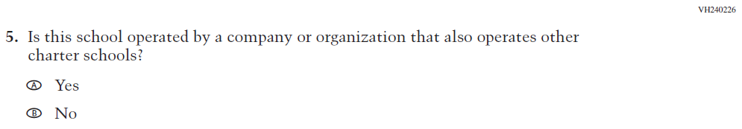  (2021 Grade 4, 8, and 12) | 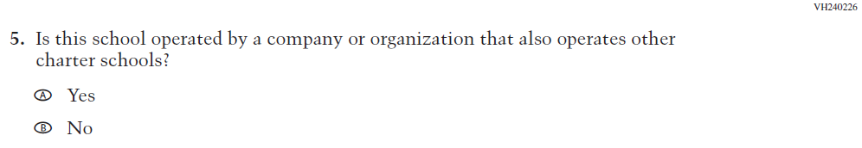  Issue: School Climate | NC | N/A
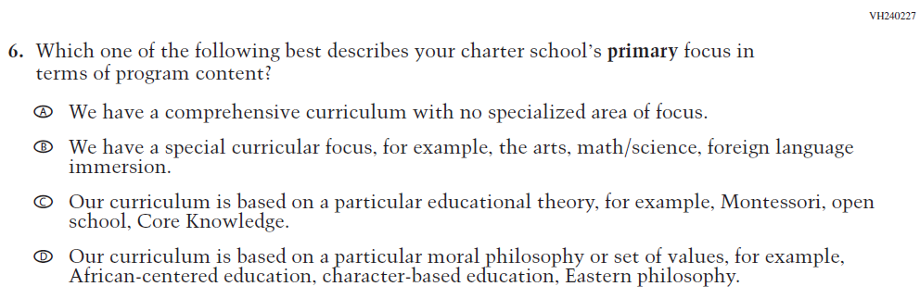  (2021 Grade 4, 8, and 12) | 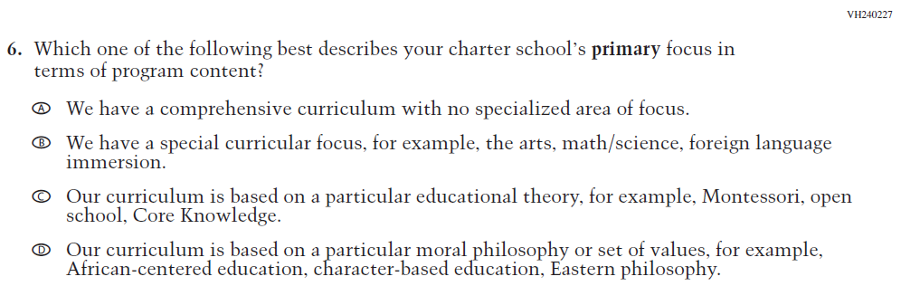  Issue: School Climate | NC | N/A
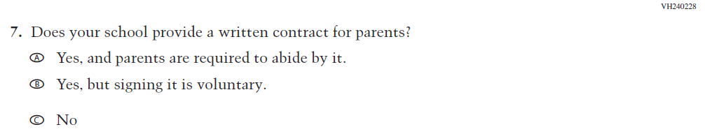  (2021 Grade 4, 8, and 12) | 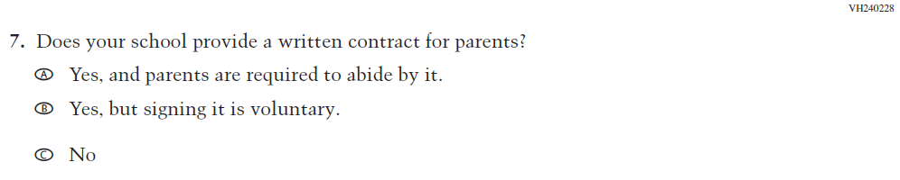  Issue: School Climate | NC | N/A
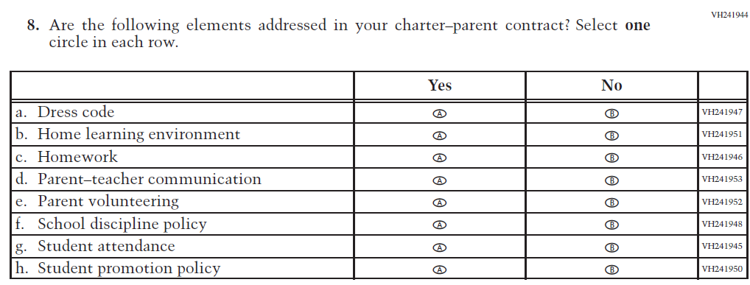  (2021 Grade 4, 8, and 12) | Issue: School Climate | NC | N/A

Appendix J3-6: Operational Grade 4 and 8 Charter School
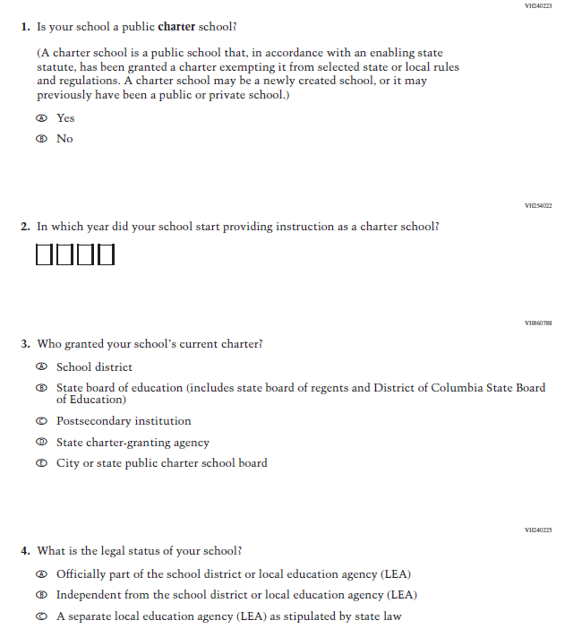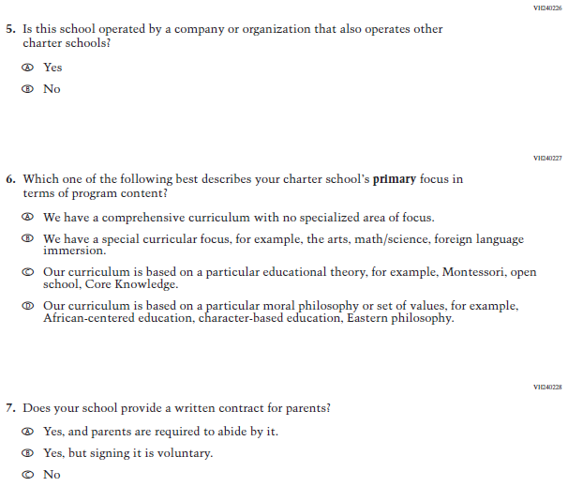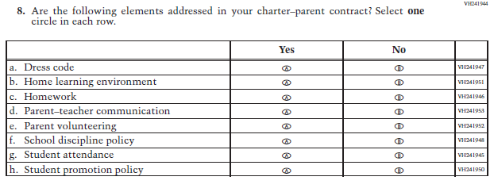

Appendix J3-7: Summary of Changes Operational Grade 4 Mathematics
2022 Operational Grade 4 Mathematics School

Previous item | 2022 item | D/A/ R/NC+ | Rationale
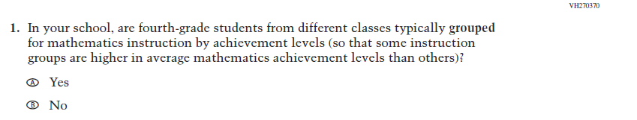  (2021 Grade 4) | Issue: Resources for Learning and Instruction | NC | N/A
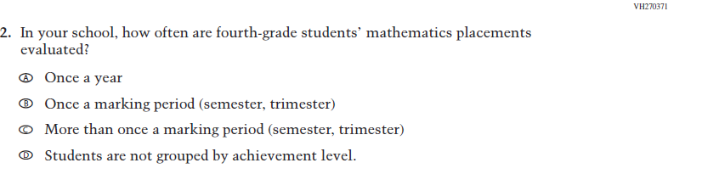  (2021 Grade 4) | Issue: Organization of Instruction | NC | N/A
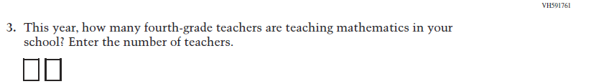  (2021 Grade 4) | Issue: Resources for Learning and Instruction | NC | N/A
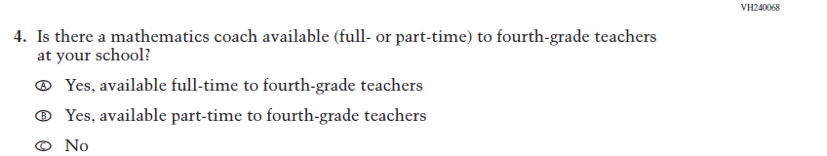  (2021 Grade 4) | Issue: Resources for Learning and Instruction | NC | N/A

2022 Operational Grade 4 Mathematics School

Previous item | 2022 item | D/A/ R/NC+ | Rationale
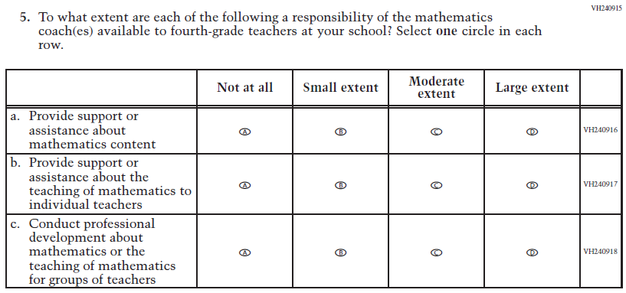  (2021 Grade 4) | Issue: Resources for Learning and Instruction | NC | N/A
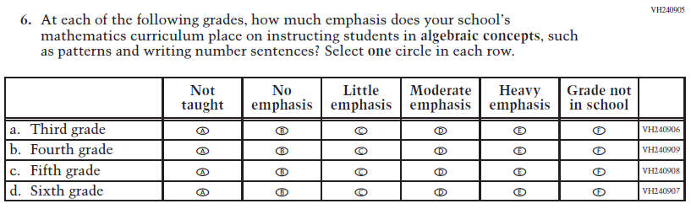  (2021 Grade 4) | Issue: Organization of Instruction | NC | N/A
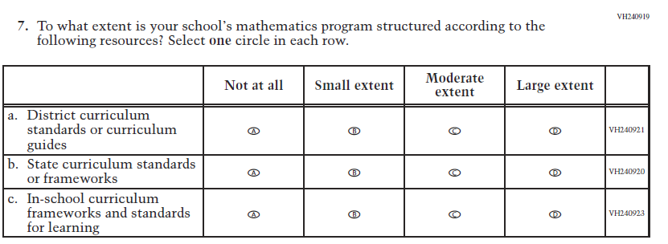  (2021 Grade 4) | Issue: Organization of Instruction | NC | N/A

2022 Operational Grade 4 Mathematics School

Previous item | 2022 item | D/A/ R/NC+ | Rationale
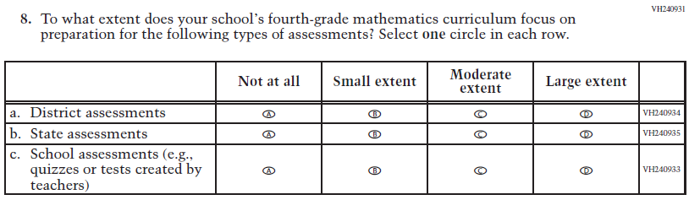  (2021 Grade 4) | Issue: Organization of Instruction | NC | N/A
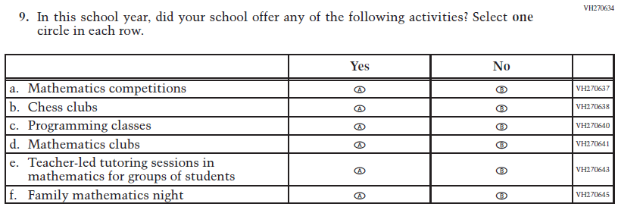  (2021 Grade 4) | Issue: Resources for Learning and Instruction | NC | N/A

Appendix J3-8: Operational Grade 4 Mathematics
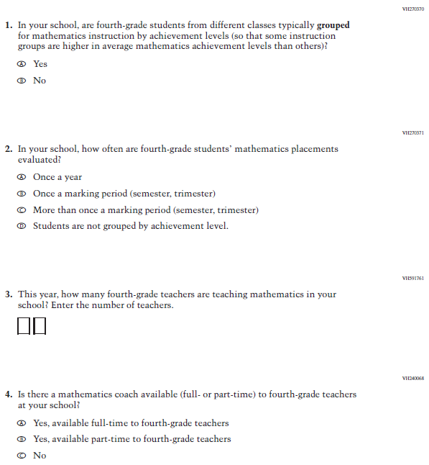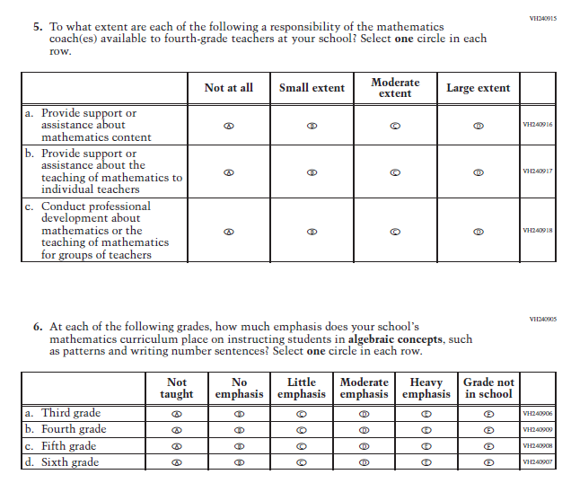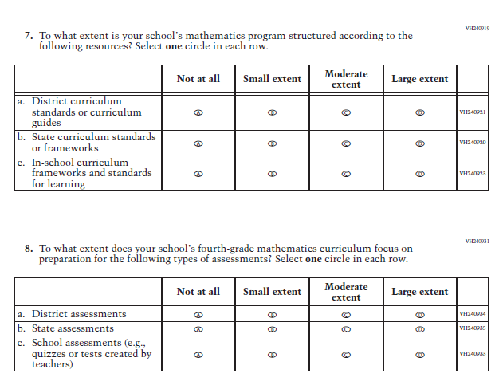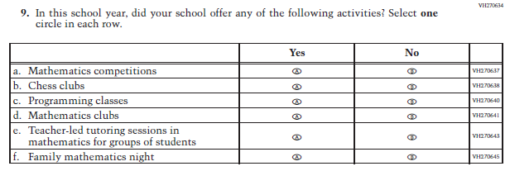

Appendix J3-9: Summary of Changes Operational Grade 8 Mathematics
2022 Operational Grade 8 Mathematics School

Previous item | 2022 item | D/A/ R/NC+ | Rationale
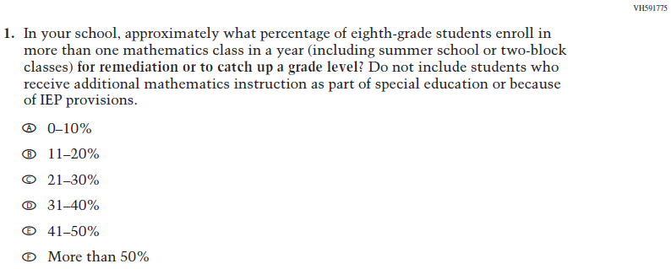  (2021 Grade 8) | Issue: Organization of Instruction | NC | N/A
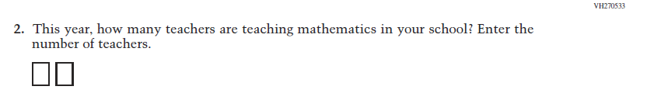  (2021 Grade 8) | Issue: Resources for Learning and Instruction | NC | N/A
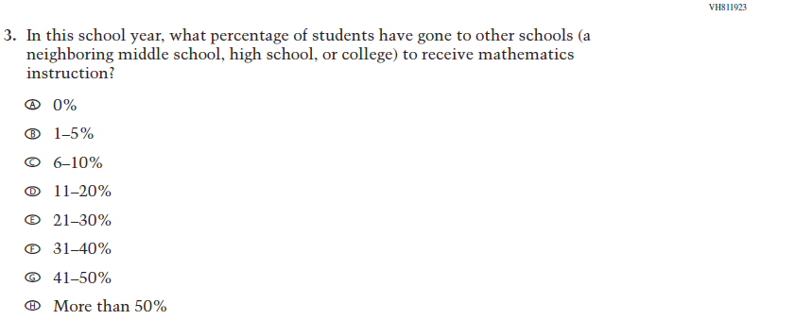  (2021 Grade 8) | Issue: Resources for Learning and Instruction | NC | N/A
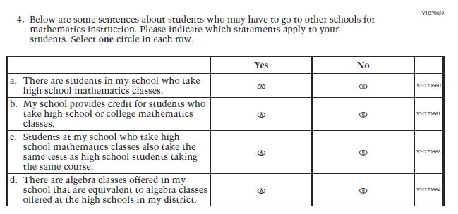(2021 Grade 8) | Issue: Resources for Learning and Instruction | NC | N/A
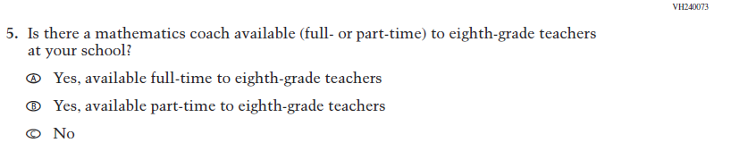  (2021 Grade 8) | Issue: Resources for Learning and Instruction | NC | N/A
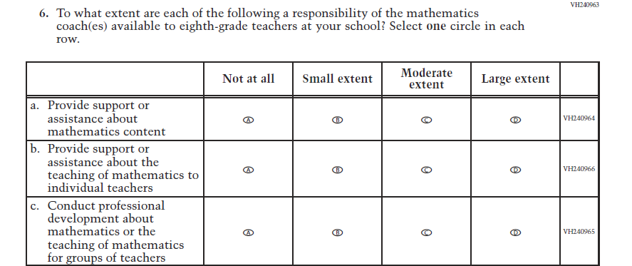  (2021 Grade 8) | Issue: Resources for Learning and Instruction | NC | N/A
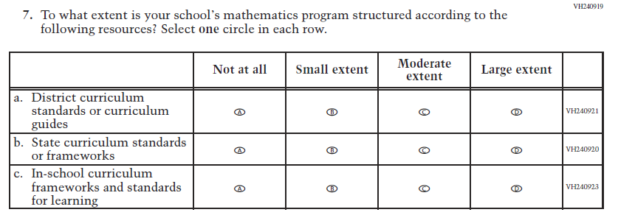  (2021 Grade 8) | Issue: Organization of instruction | NC | N/A
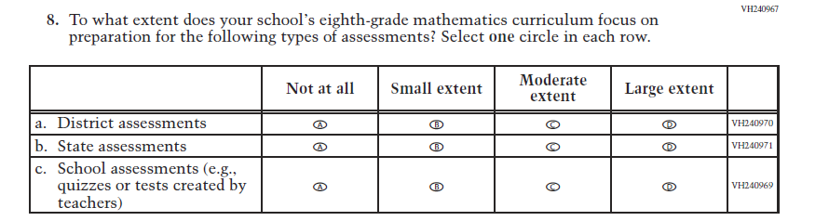  (2021 Grade 8) | Issue: Organization of instruction | NC | N/A
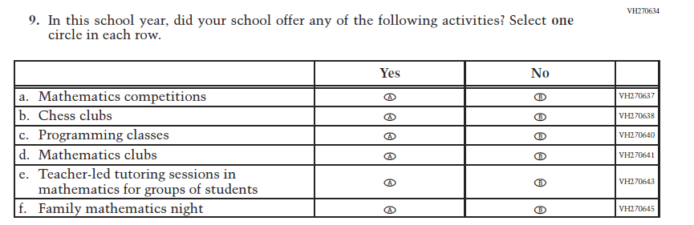  (2021 Grade 8) | Issue: Resources for Learning and Instruction | NC | N/A

Appendix J3-10: Operational Grade 8 Mathematics
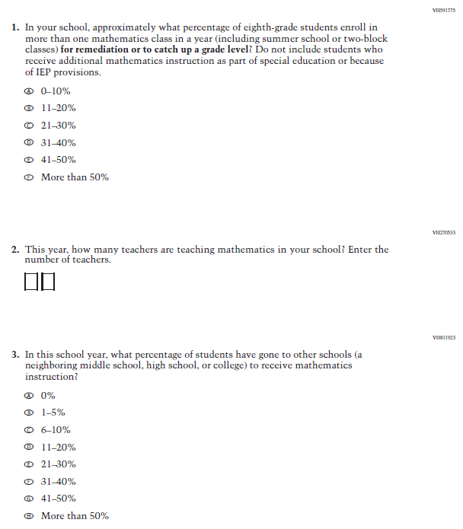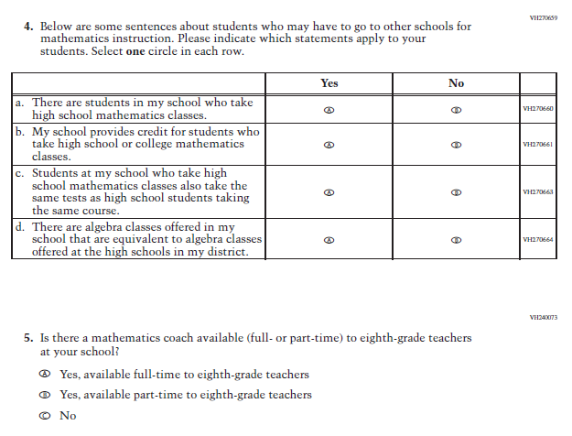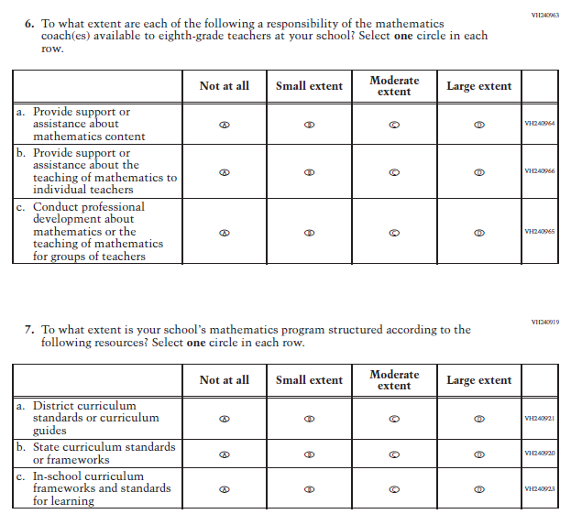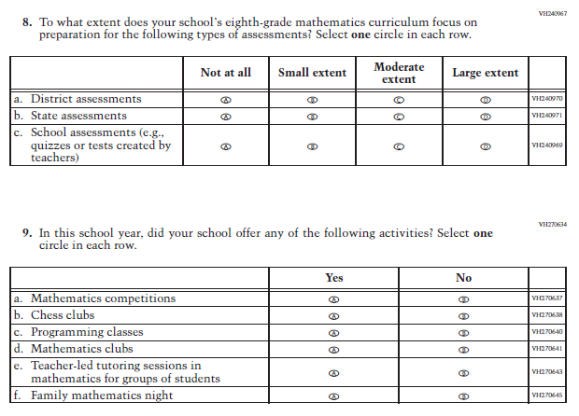

Appendix J3-11: Summary of Changes Operational Grade 4 Reading
2022 Operational Grade 4 Reading School

Previous item | 2022 item | D/A/ R/NC+ | Rationale
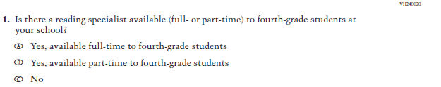  (2021 Grade 4) | Issue: Resources for Learning and Instruction | NC | N/A
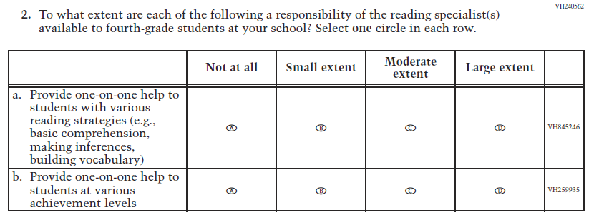  (2021 Grade 4) | Issue: Resources for Learning and Instruction | NC | N/A
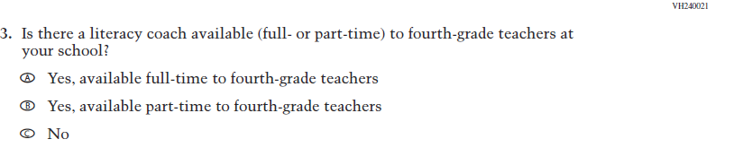  (2021 Grade 4) | Issue: Resources for Learning and Instruction | NC | N/A

2022 Operational Grade 4 Reading School

Previous item | 2022 item | D/A/ R/NC+ | Rationale
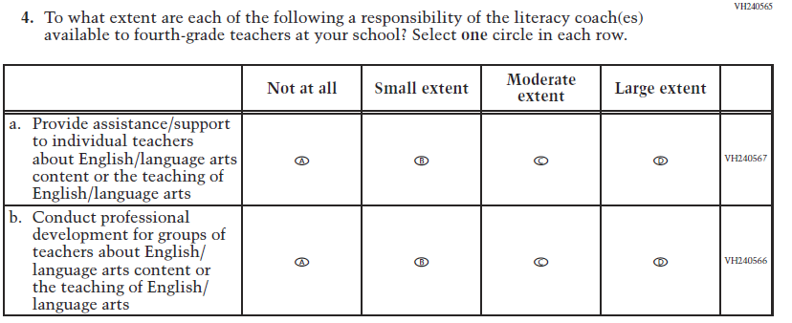  (2021 Grade 4) | Issue: Resources for Learning and Instruction | NC | N/A
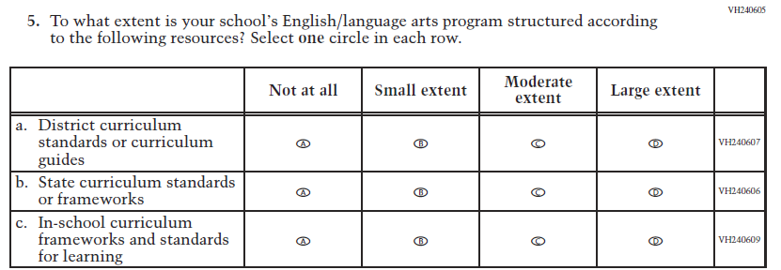  (2021 Grade 4) | Issue: Organization of Instruction | NC | N/A
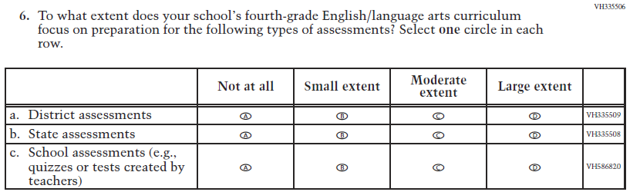  (2021 Grade 4) | Issue: Organization of Instruction | NC | N/A

2022 Operational Grade 4 Reading School

Previous item | 2022 item | D/A/ R/NC+ | Rationale
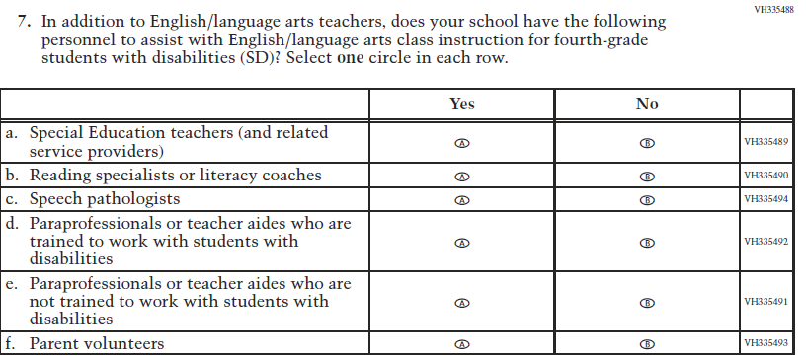  (2021 Grade 4) | Issue: Resources for Learning and Instruction | NC | N/A
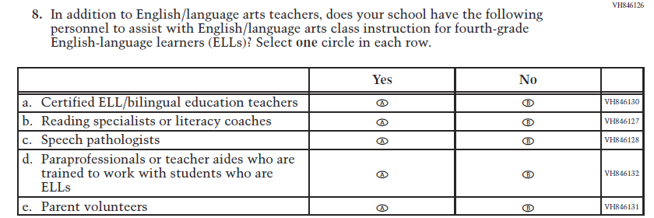  (2021 Grade 4) | Issue: Resources for Learning and Instruction | NC | N/A
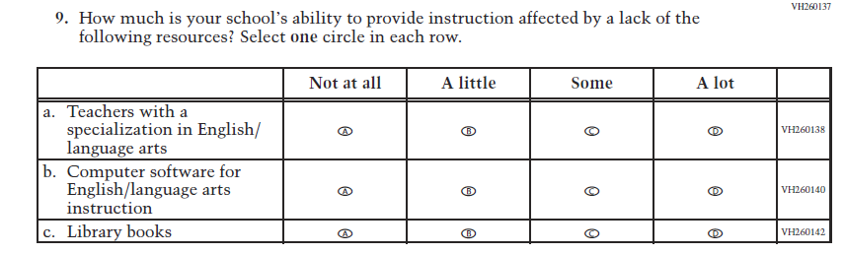  (2021 Grade 8) | Issue: Resources for Learning and Instruction | NC | N/A

Appendix J3-12: Operational Grade 4 Reading
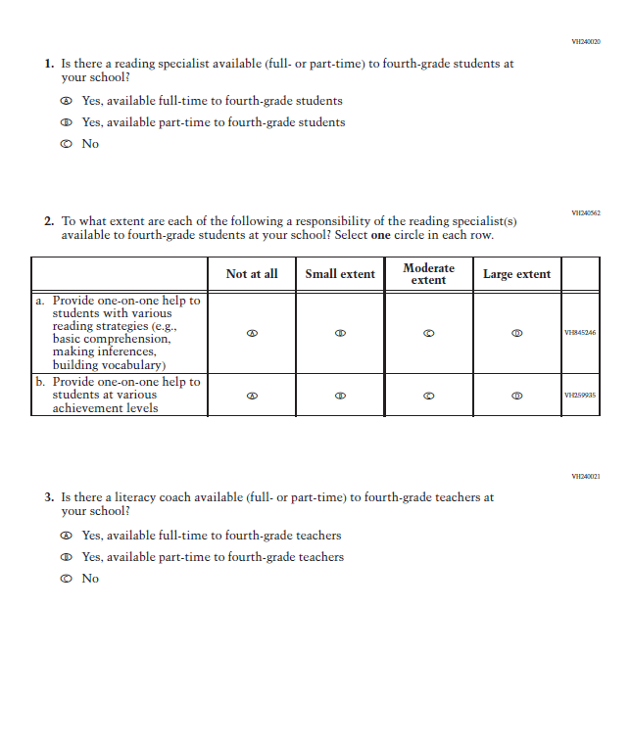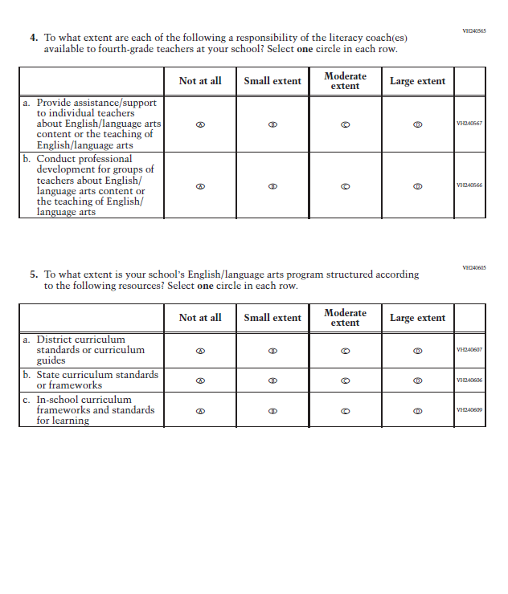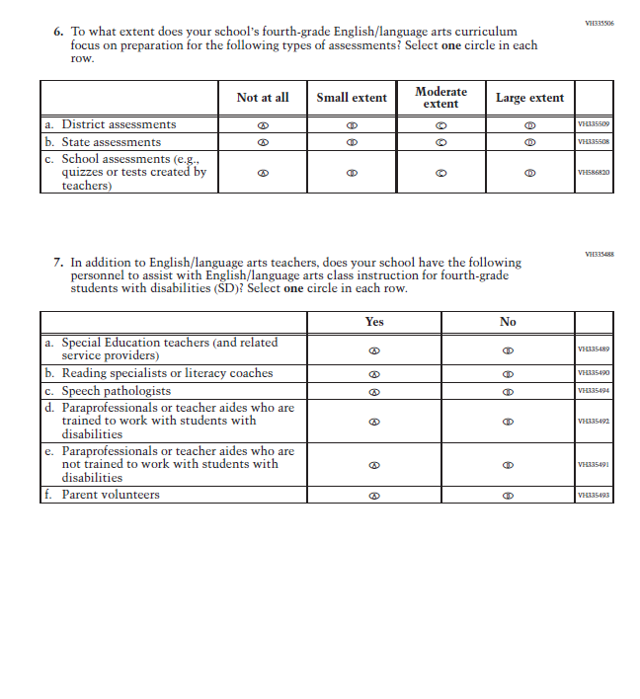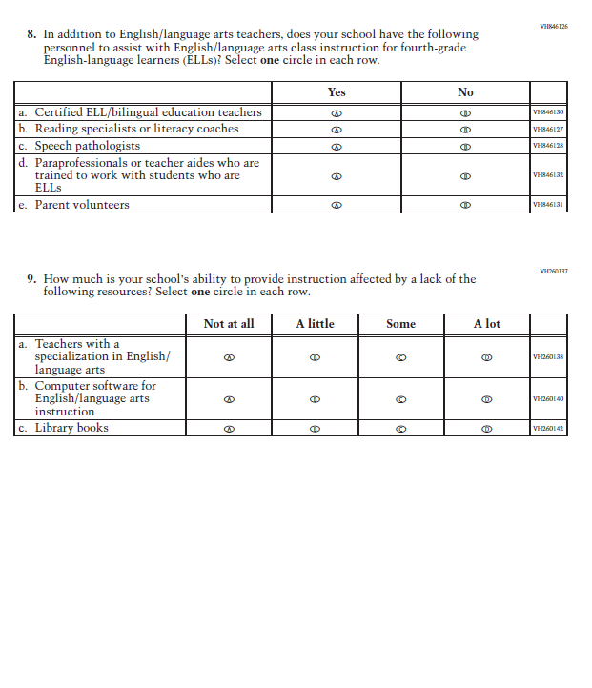

Appendix J3-13: Summary of Changes Operational Grade 8 Reading
2022 Operational Grade 8 Reading School

Previous item | 2022 item | D/A/ R/NC+ | Rationale
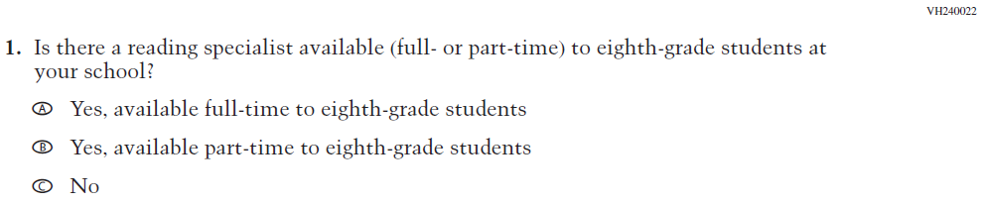  (2021 Grade 8) | Issue: Resources for Learning and Instruction | NC | N/A
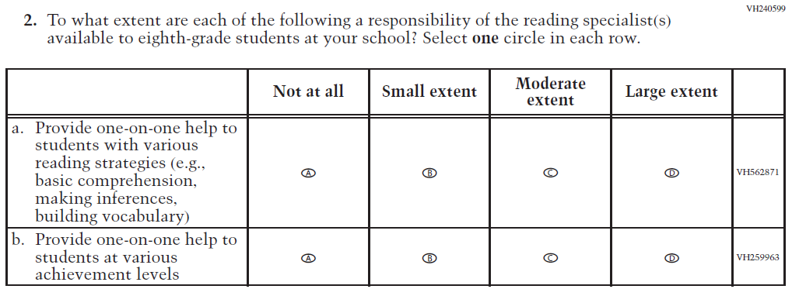  (2021 Grade 8) | Issue: Resources for Learning and Instruction | NC | N/A

2022 Operational Grade 8 Reading School

Previous item | 2022 item | D/A/ R/NC+ | Rationale
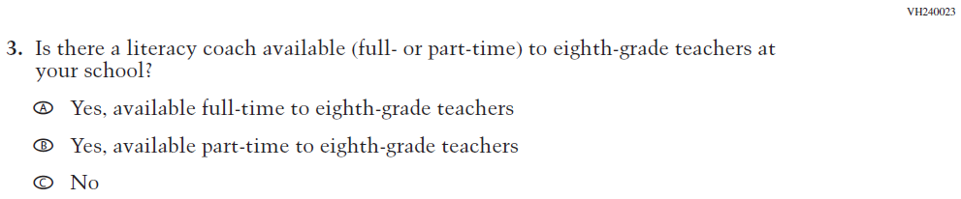  (2021 Grade 8) | Issue: Resources for Learning and Instruction | NC | N/A
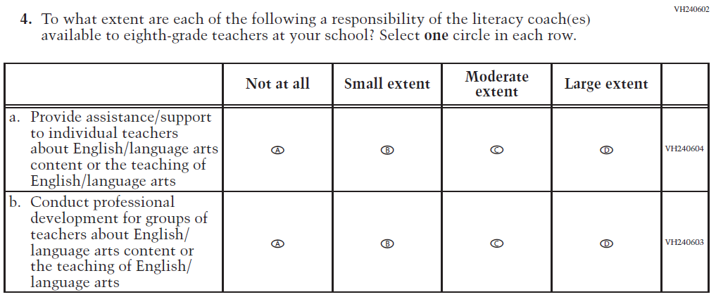  (2021 Grade 8) | Issue: Resources for Learning and Instruction | NC | N/A
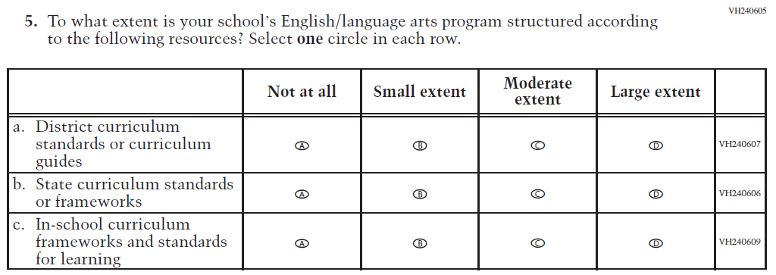  (2021 Grade 8) | Issue: Organization of Instruction | NC | N/A

2022 Operational Grade 8 Reading School

Previous item | 2022 item | D/A/ R/NC+ | Rationale
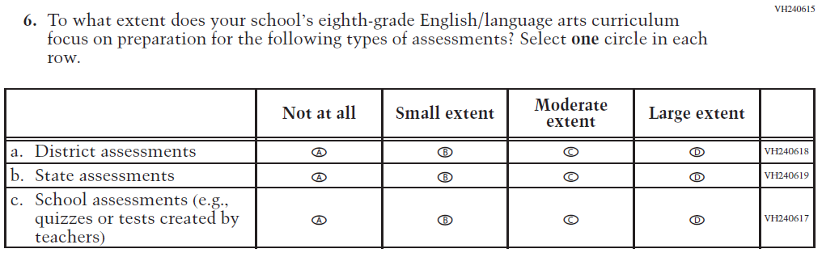  (2021 Grade 8) | Issue: Organization of Instruction | NC | N/A
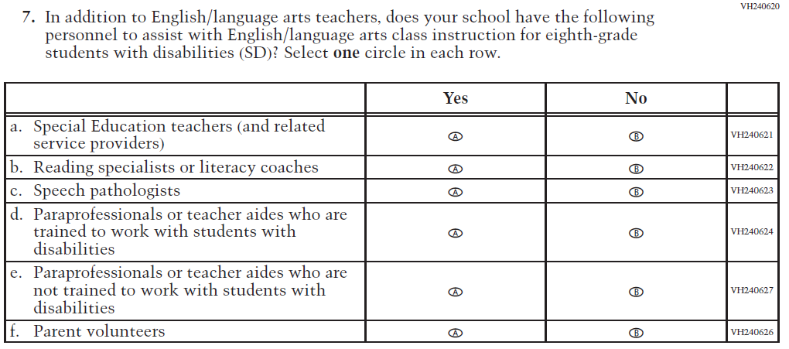  (2021 Grade 8) | Issue: Resources for Learning and Instruction | NC | N/A

2022 Operational Grade 8 Reading School

Previous item | 2022 item | D/A/ R/NC+ | Rationale
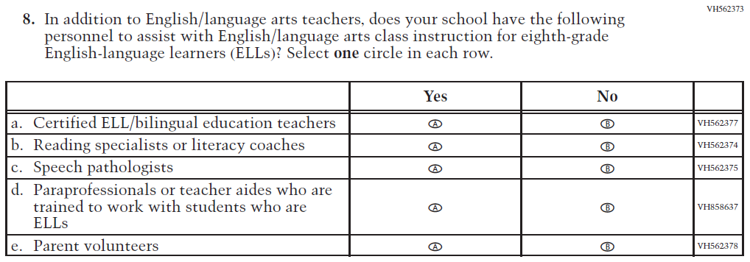  (2021 Grade 8) | Issue: Resources for Learning and Instruction | NC | N/A
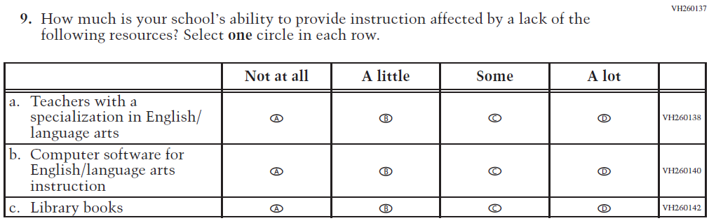  (2021 Grade 8) | Issue: Resources for Learning and Instruction | NC | N/A

Appendix J3-14: Operational Grade 8 Reading
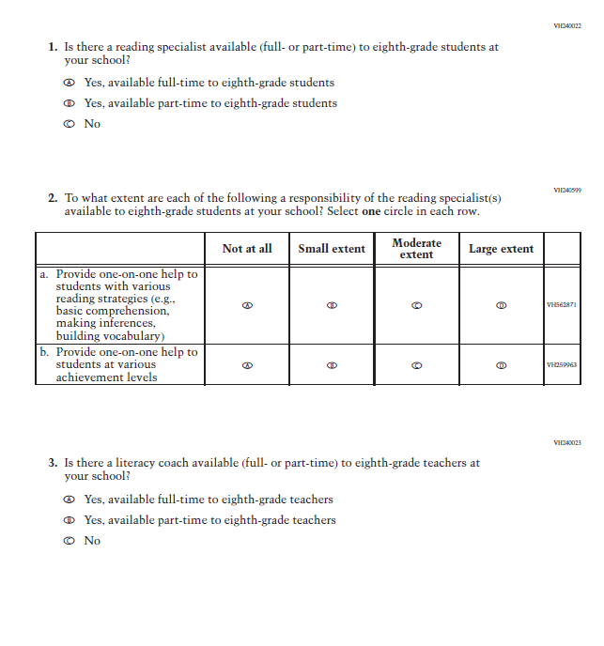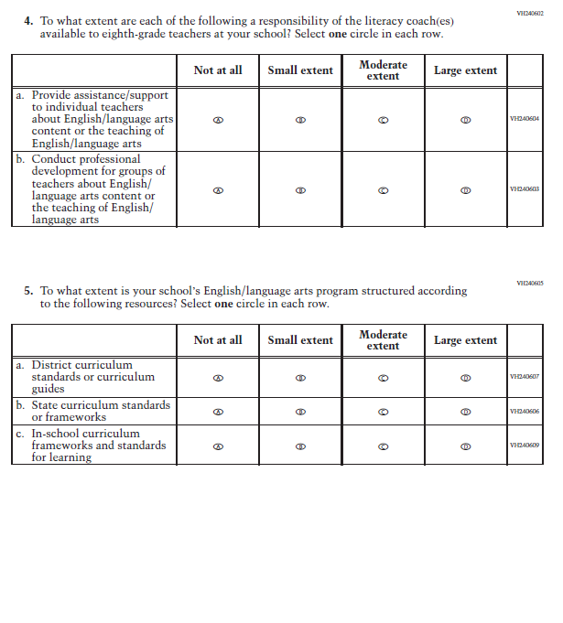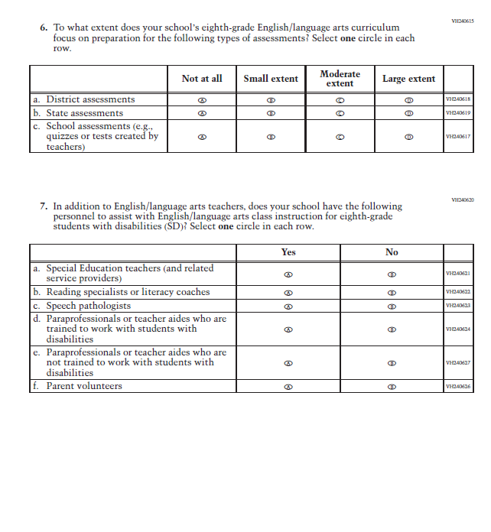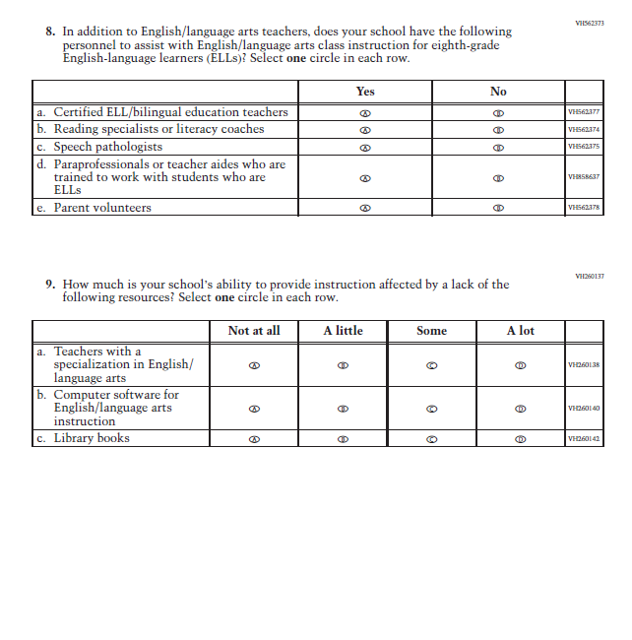

Appendix J3-15: Summary of Operational Grade 8 Social Studies School Items
2022 Operational Grade 8 Social Studies School
Previous item | 2022 item | D/A/ R/NC+ | Rationale
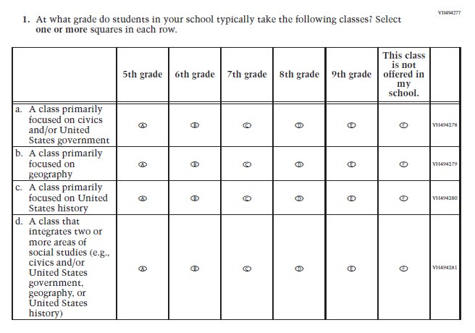  (2018 Grade 8) | Issue: Organization of Instruction | NC | N/A
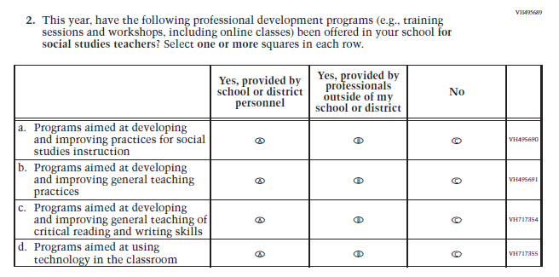  (2018 Grade 8) | Issue: Teacher Preparation | NC | N/A
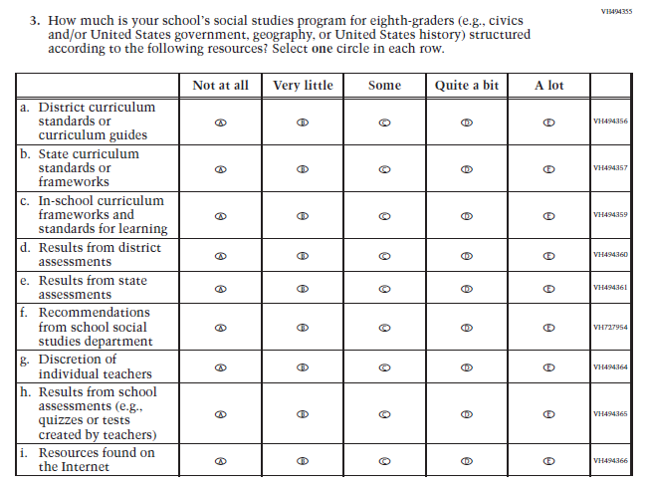  (2018 Grade 8) | Issue: Organization of Instruction | NC | N/A
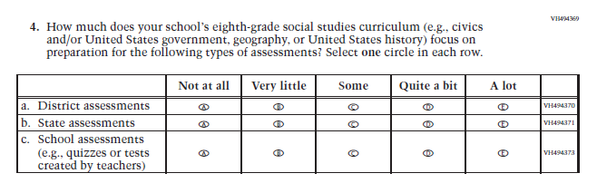  (2018 Grade 8) | Issue: Organization of Instruction | NC | N/A
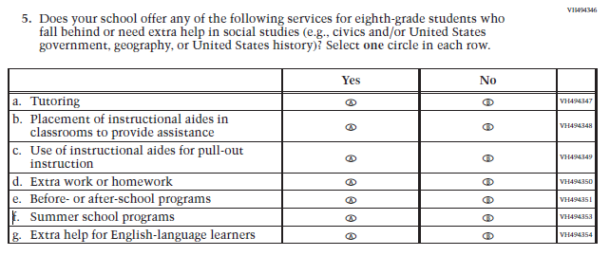  (2018 Grade 8) | Issue: Resources for Learning and Instruction | NC | N/A
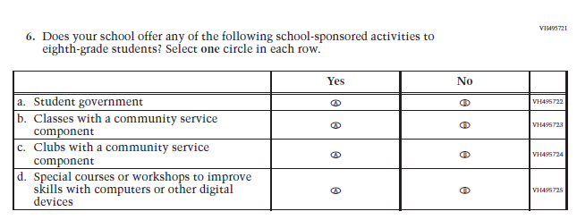  (2018 Grade 8) | Issue: Student Factors | NC | N/A

Appendix J3-16: Operational Grade 8 Social Studies School Items
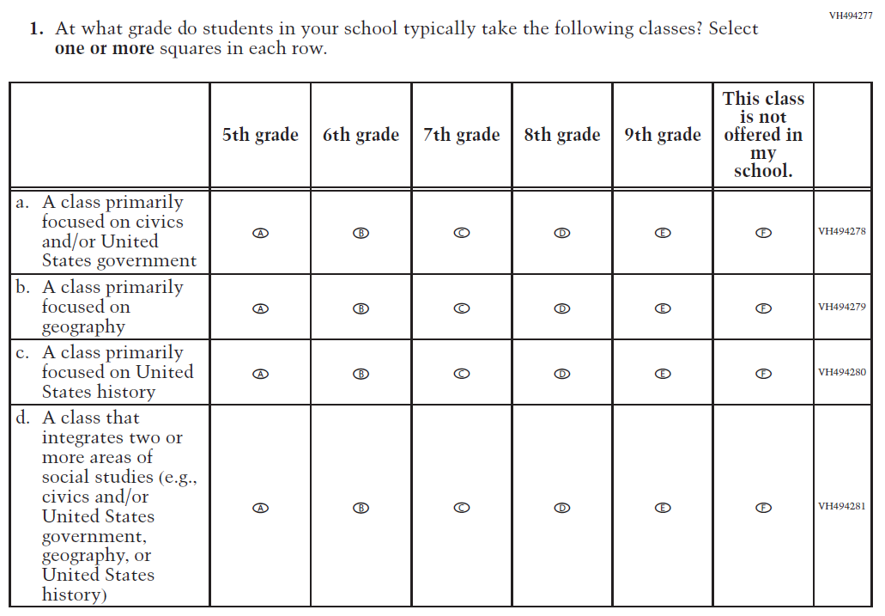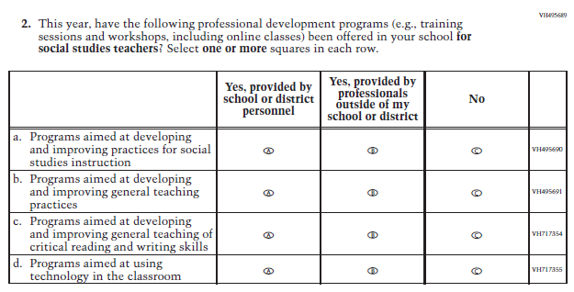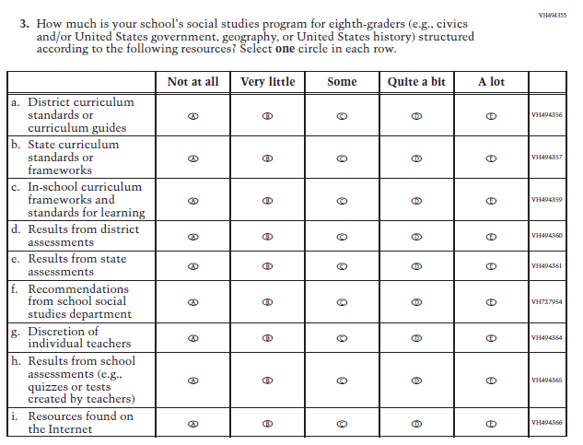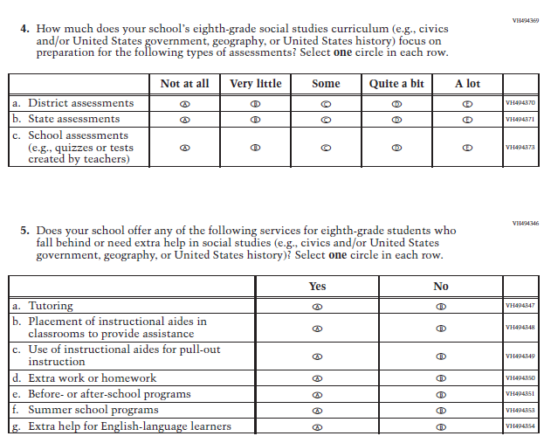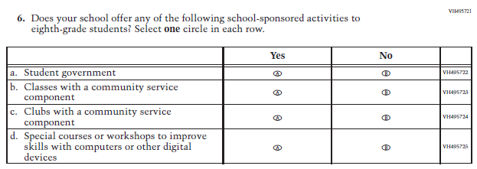

Appendix J3-17: Summary of Operational Grade 4 COVID-19 School Items
2022 Operational Grade 4 COVID-19 School Items

Previous item | 2022 item | D/A/ R/NC+ | Rationale
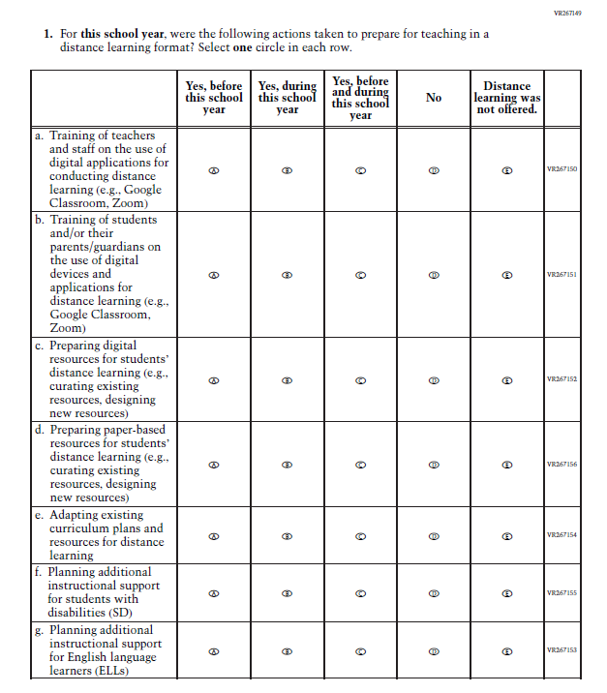  (2021 Grade 4) | Issue: Resources for Learning and Instruction | NC | N/A
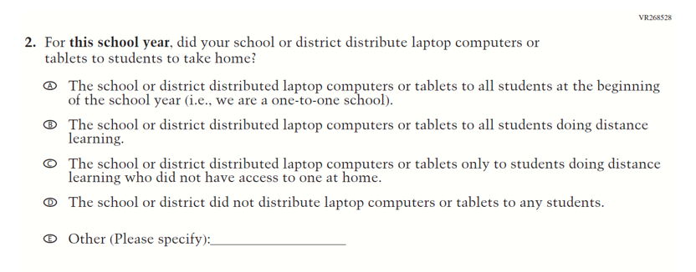  (2021 Grade 4) | Issue: Technology Use and Access | NC | N/A
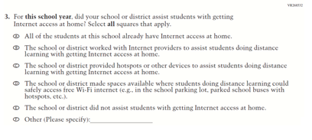  (2021 Grade 4) | 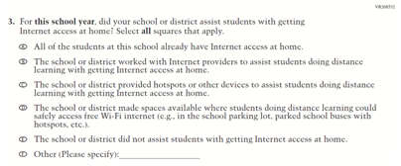  Issue: Technology Use and Access | NC | N/A
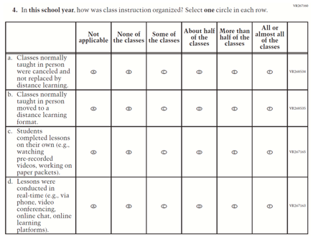  (2021 Grade 4) | 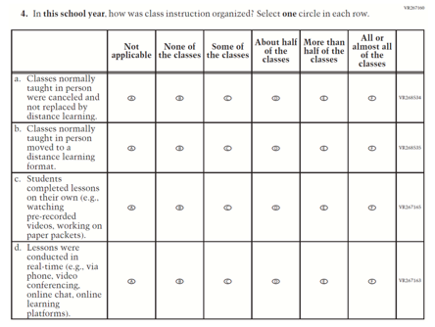  Issue: Organization of Instruction | NC | N/A
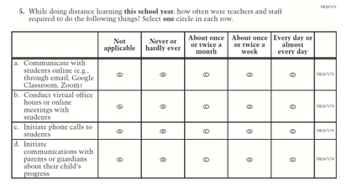  (2021 Grade 4) | 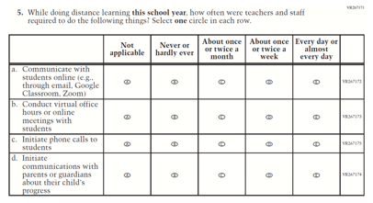  Issue: Resources for Learning and Instruction | NC | N/A
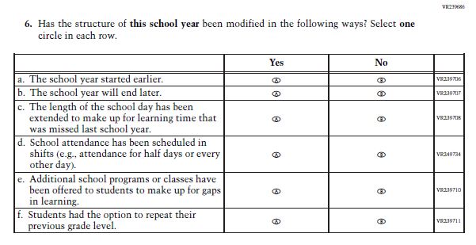  (2021 Grade 4) | Issue: Organization of Instruction | NC | N/A
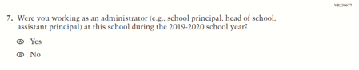  (2021 Grade 4) | 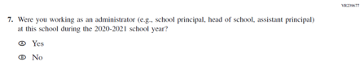  Issue: Organization of Instruction | R | This item was revised to reference the correct academic year for the 2022 administration.
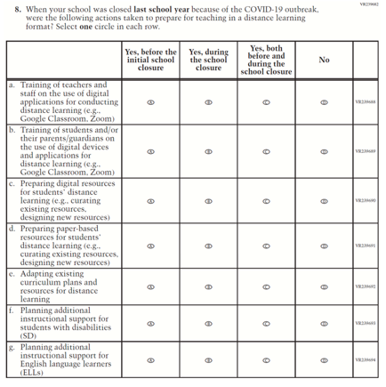  (2021 Grade 4) | 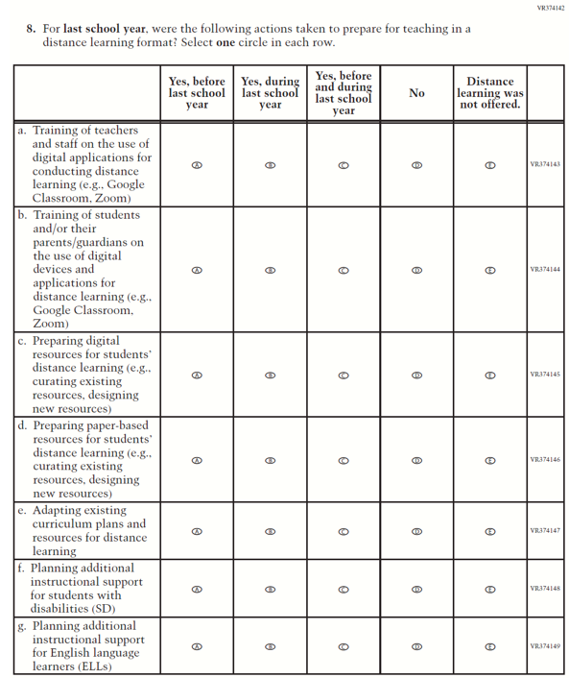  Issue: Resources for Learning and Instruction | R | The stem of this item was revised from "when your school was closed last school year" to "for last school year" to remove references to school closures. The last response option (i.e. “Distance learning was not offered.”) was also added.
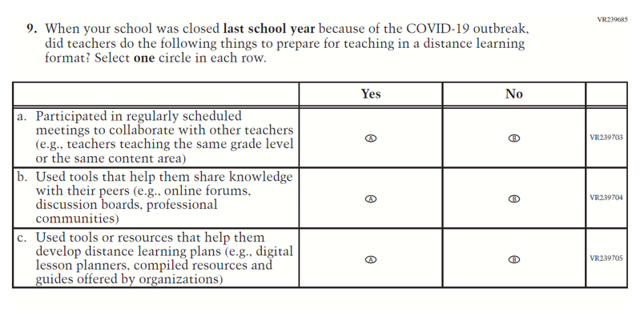  (2021 Grade 4) | N/A | D | This item was dropped.
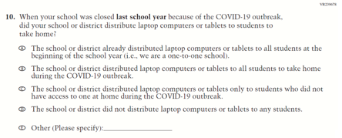  (2021 Grade 4) | 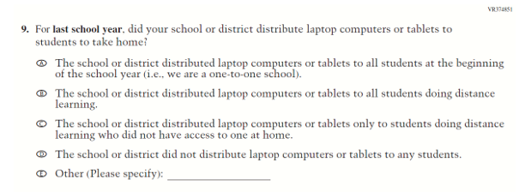  Issue: Technology Use and Access | R | The stem of this item was revised from "when your school was closed last school year" to "for last school year" to remove references to school closures.
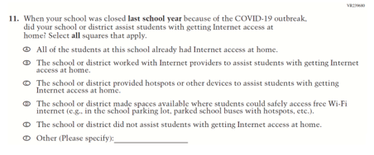  (2021 Grade 4) | 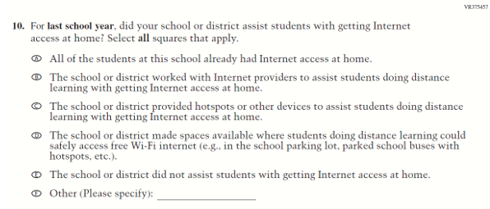  Issue: Technology Use and Access | R | The stem of this item was revised from "when your school was closed last school year" to "for last school year" to remove references to school closures.
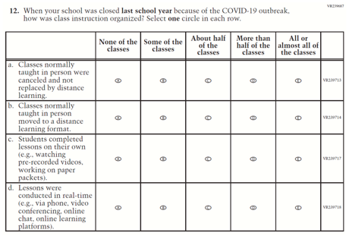  (2021 Grade 4) | 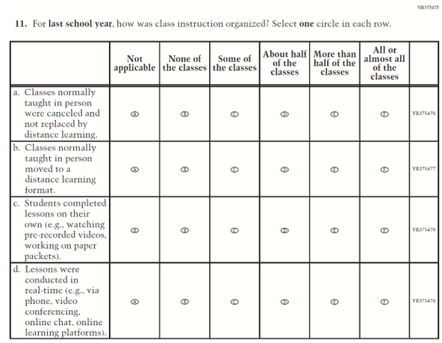  Issue: Organization of Instruction | R | The stem of this item was revised from "when your school was closed last school year" to "for last school year" to remove references to school closures. The first response option (i.e. “Not applicable”) was added.
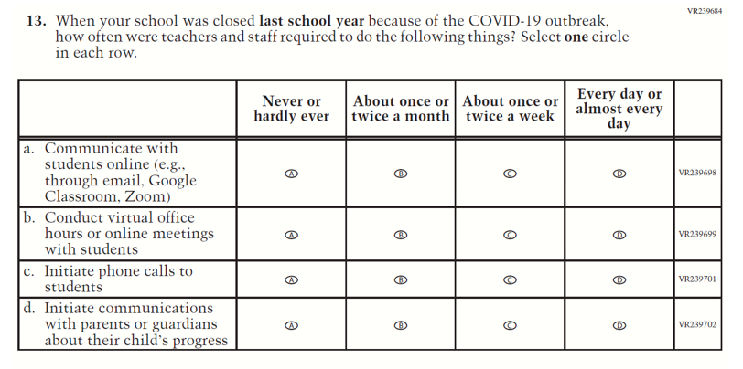  (2021 Grade 4) | 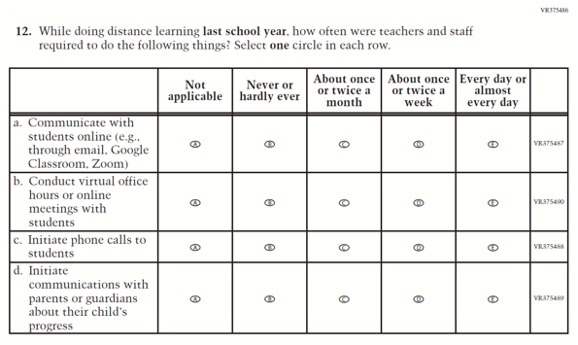  Issue: Resources for Learning and Instruction | R | The stem of this item was revised from "when your school was closed last school year" to "for last school year" to remove references to school closures. The first response option (i.e. “Not applicable”) was added.
N/A | 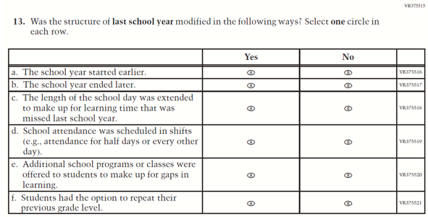  Issue: Organization of Instruction | A | This item is based on Question 6 above and was added to understand school structures in distance learning format. The stem is revised from “has the structure of this school year been modified” to “was the structure of last school year modified”.
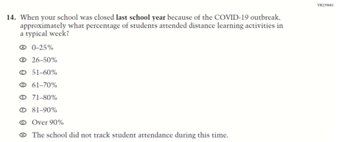  (2021 Grade 4) | N/A | D | This item was dropped.

Appendix J3-18: Operational Grade 4 COVID-19 School Items
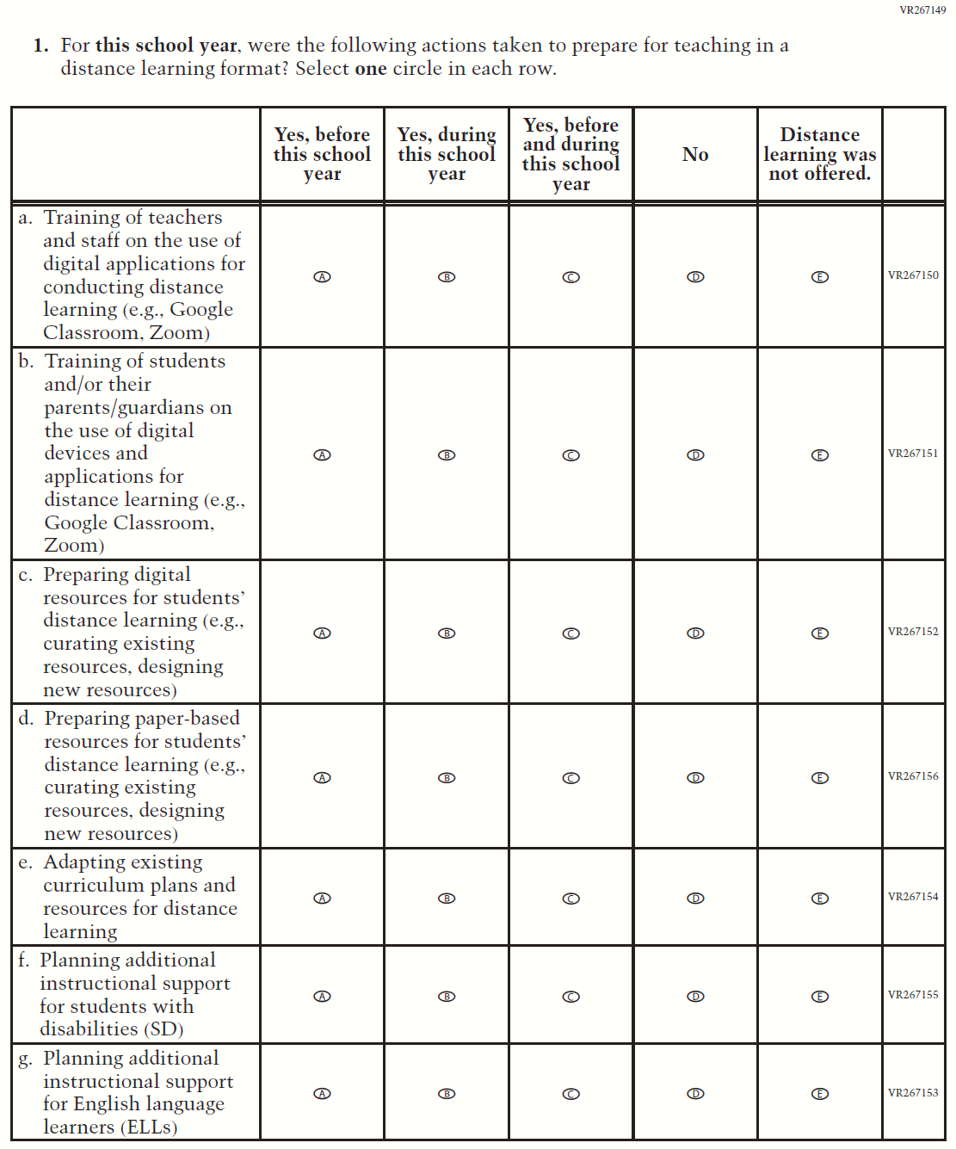

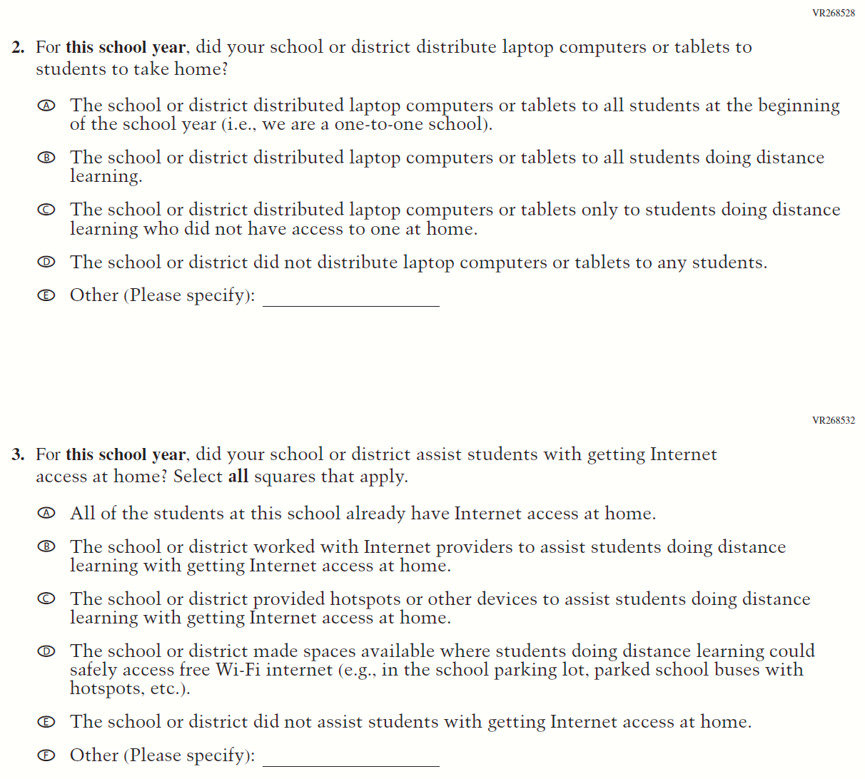

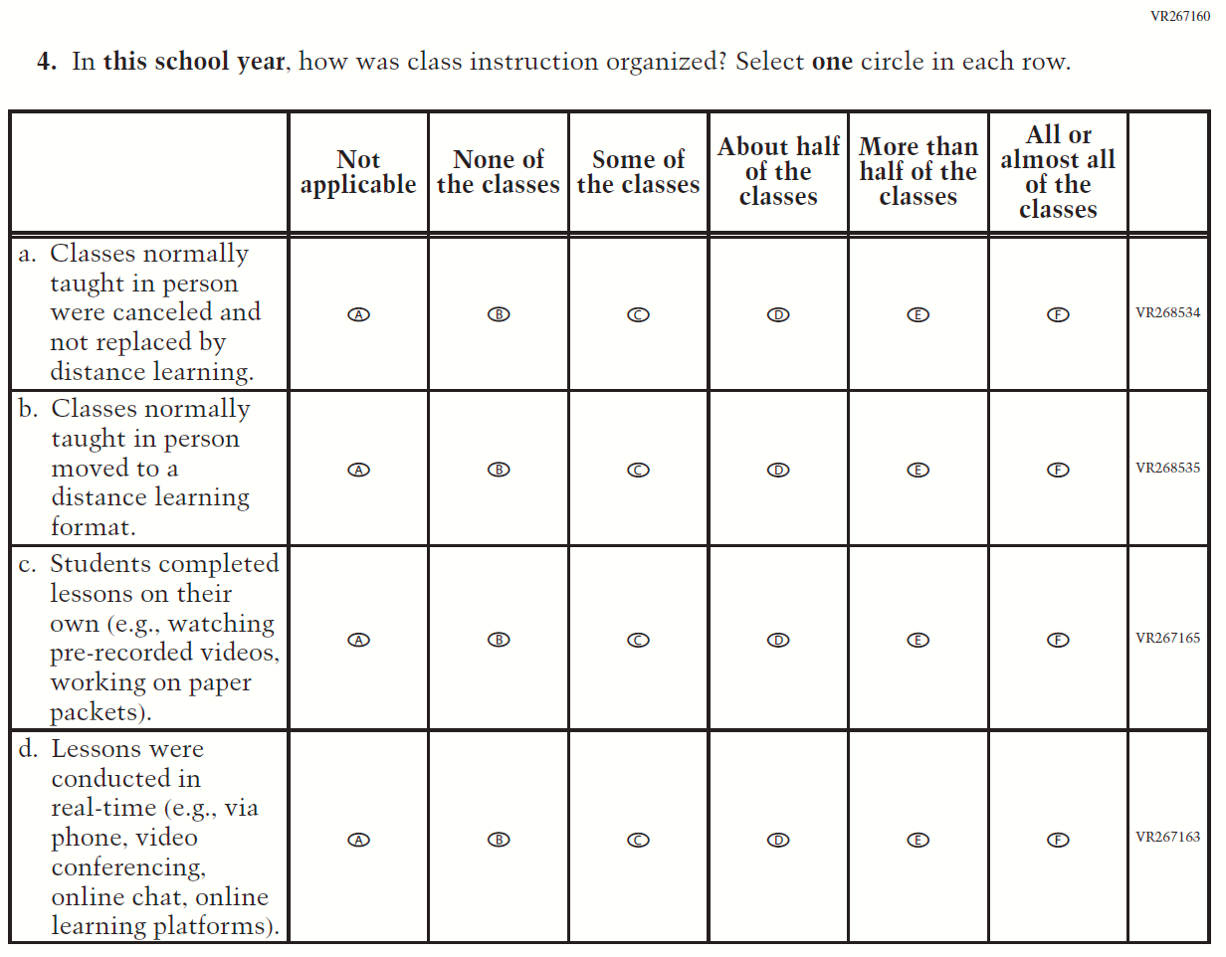

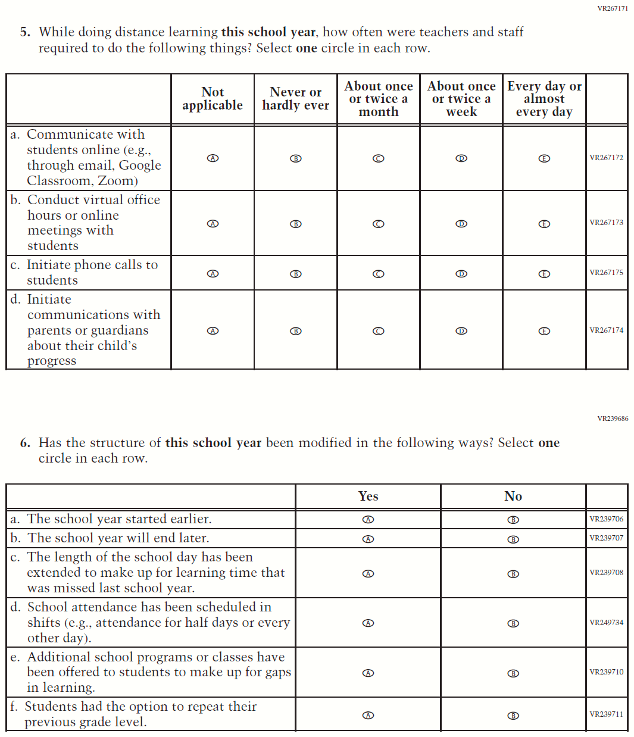

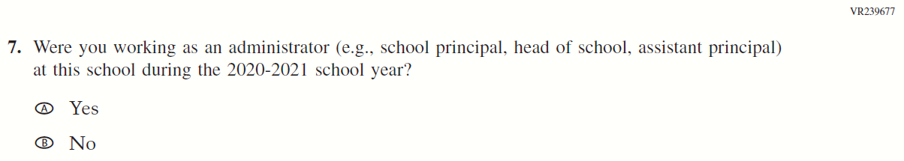

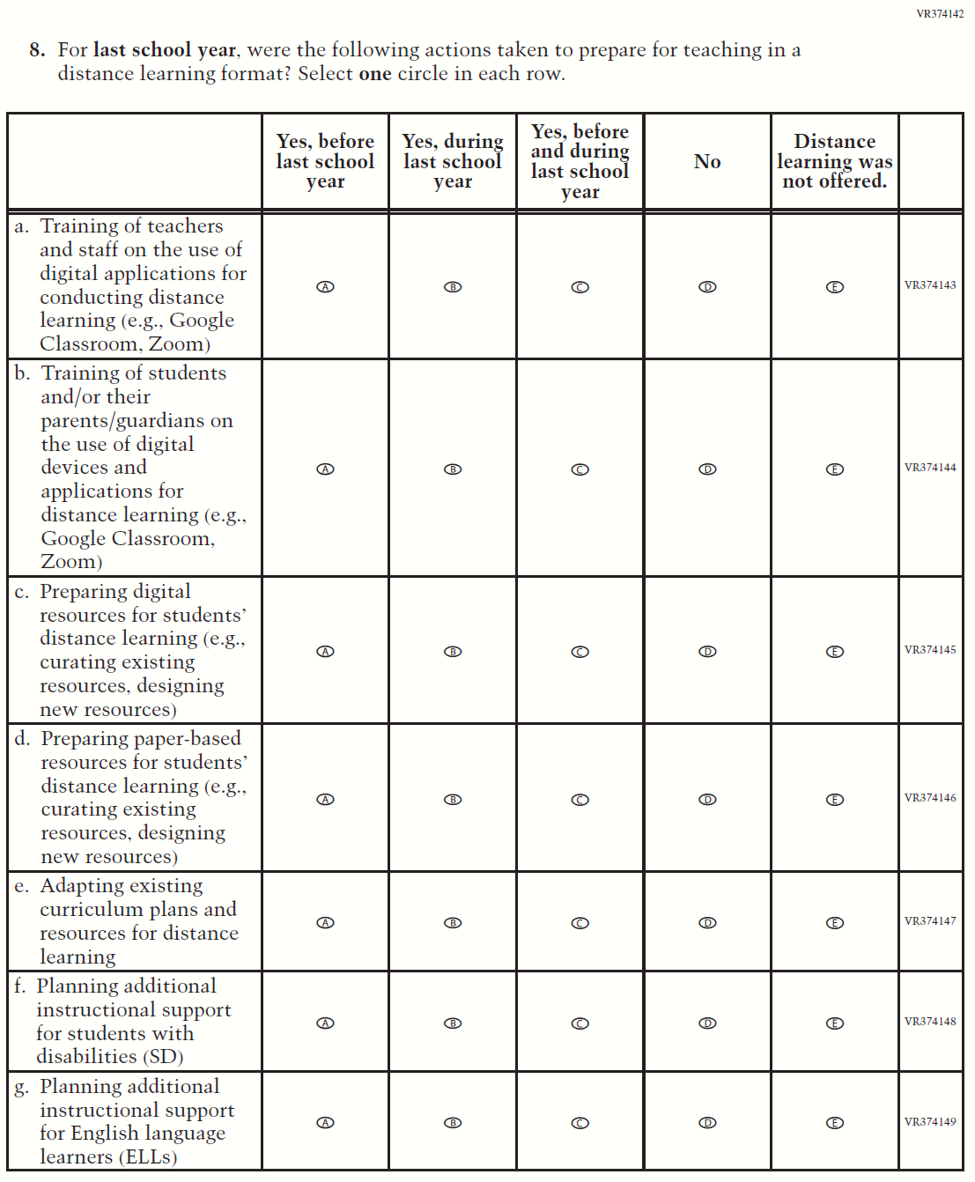

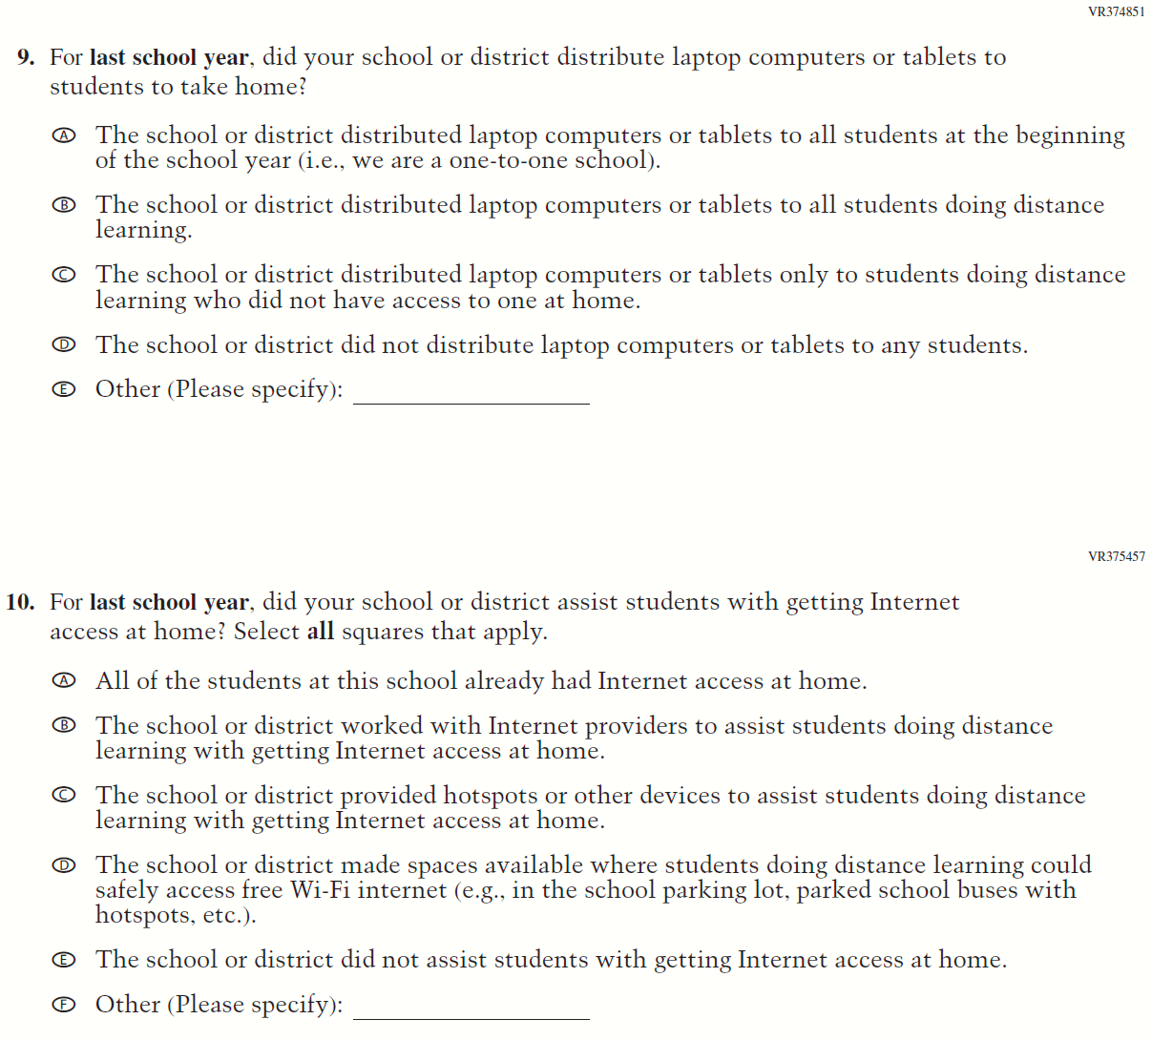

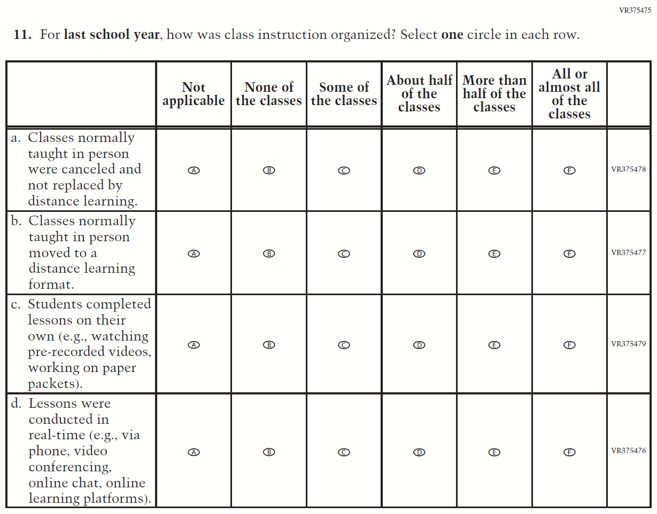

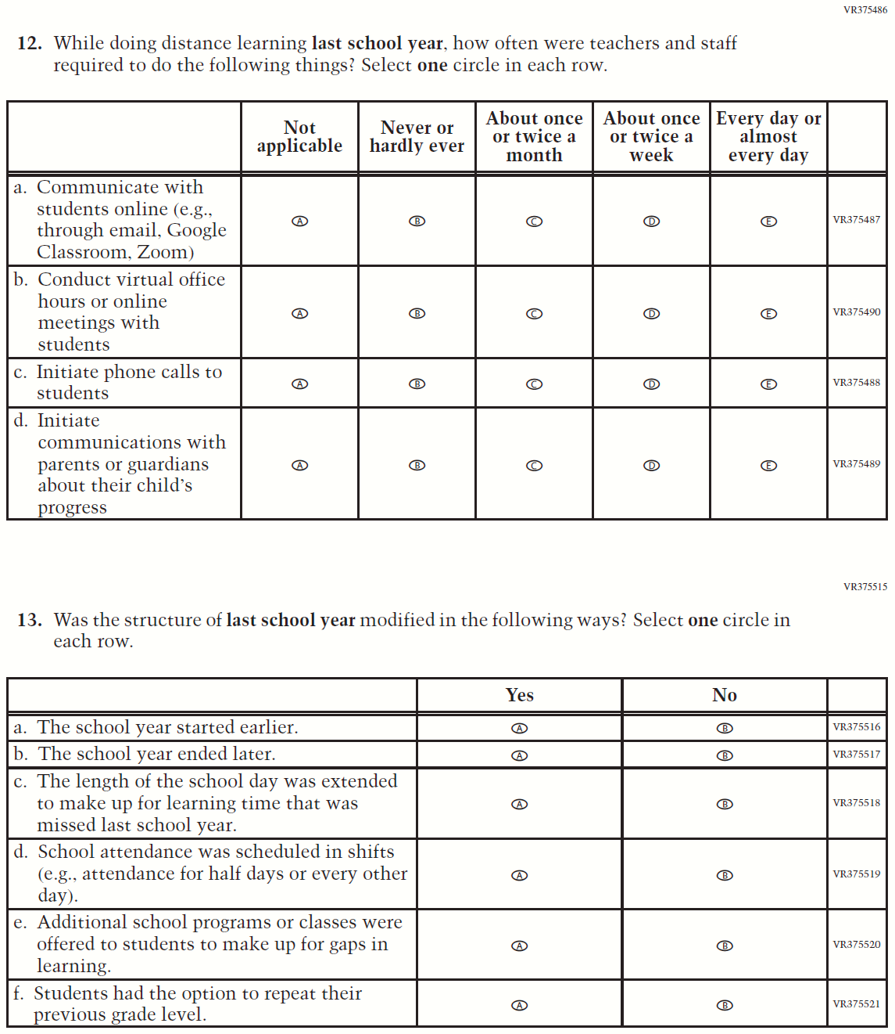

Appendix J3-19: Summary of Operational Grade 8 COVID-19 School Items
2022 Operational Grade 8 COVID-19 School Items

Previous item | 2022 item | D/A/ R/NC+ | Rationale
(2021 Grade 8) | Issue: Resources for Learning and Instruction | NC | N/A
(2021 Grade 8) | Issue: Technology Use and Access | NC | N/A
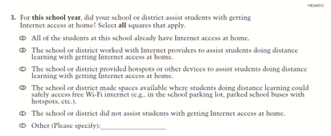  (2021 Grade 8) | 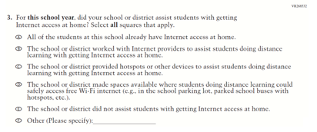  Issue: Technology Use and Access | NC | N/A
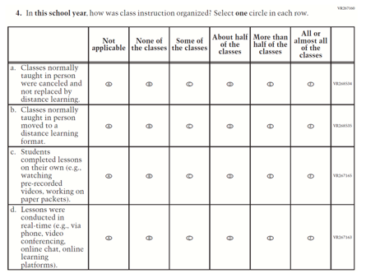  (2021 Grade 8) | 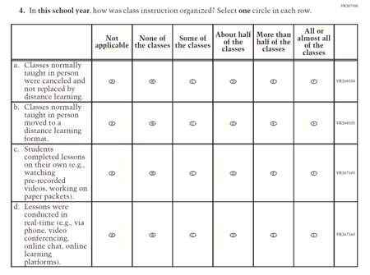  Issue: Organization of Instruction | NC | N/A
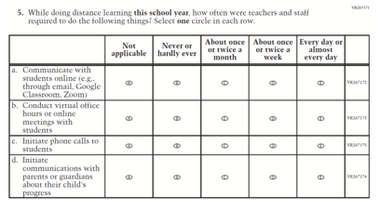  (2021 Grade 8) | 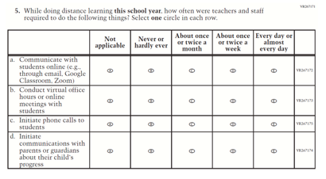  Issue: Resources for Learning and Instruction | NC | N/A
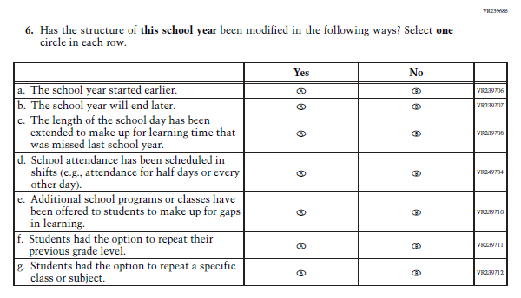  (2021 Grade 8) | 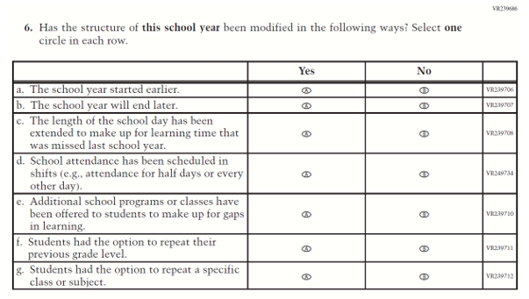  Issue: Organization of Instruction | NC | N/A
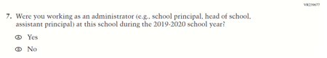  (2021 Grade 8) | 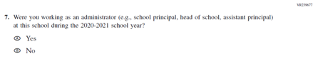  Issue: Organization of Instruction | R | This item was revised to reference the correct academic year for the 2022 administration.
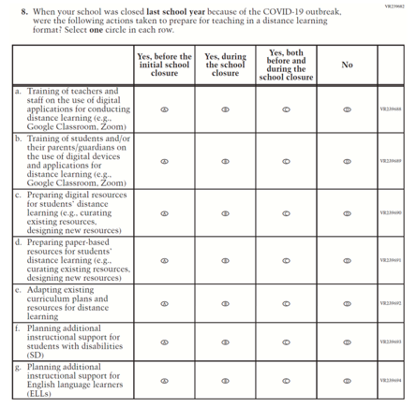  (2021 Grade 8) | Issue: Resources for Learning and Instruction | R | The stem of this item was revised from "when your school was closed last school year" to "for last school year" to remove references to school closures. The last response option (i.e. “Distance learning was not offered.”) was also added.
(2021 Grade 8) | N/A | D | This item was dropped.
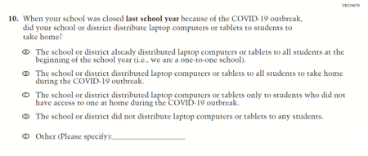  (2021 Grade 8) | Issue: Technology Use and Access | R | The stem of this item was revised from "when your school was closed last school year" to "for last school year" to remove references to school closures.
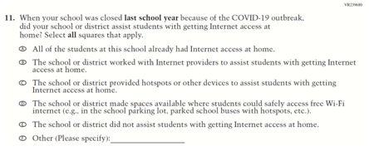  (2021 Grade 8) | Issue: Technology Use and Access | R | The stem of this item was revised from "when your school was closed last school year" to "for last school year" to remove references to school closures.
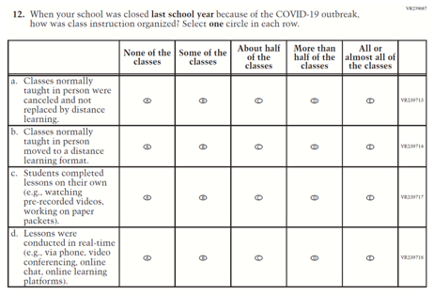  (2021 Grade 8) | Issue: Organization of Instruction | R | The stem of this item was revised from "when your school was closed last school year" to "for last school year" to remove references to school closures. The first response option (i.e. “Not applicable”) was added.
(2021 Grade 8) | Issue: Resources for Learning and Instruction | R | The stem of this item was revised from "when your school was closed last school year" to "for last school year" to remove references to school closures. The first response option (i.e. “Not applicable”) was added.
N/A | 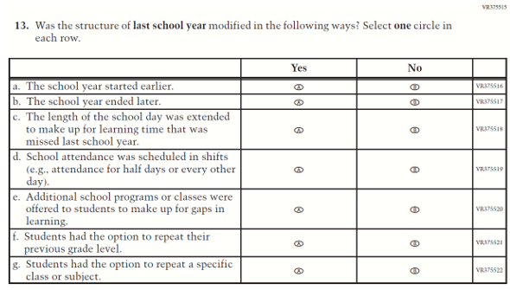  Issue: Organization of Instruction | A | This item is based on Question 6 above and was added to understand school structures in distance learning format. The stem is revised from “has the structure of this school year been modified” to “was the structure of last school year modified”.
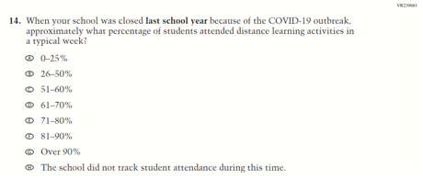  (2021 Grade 8) | N/A | D | This item was dropped.

Appendix J3-20: Operational Grade 8 COVID-19 School Items
