NATIONAL CENTER FOR EDUCATION STATISTICS NATIONAL ASSESSMENT OF EDUCATIONAL PROGRESS

National Assessment of Education Progress (NAEP) 2022
Long-Term Trend (LTT) 2022
Materials Update #3

Appendix K4

Long Term Trend (LTT) 2022 Survey Questionnaires

OMB# 1850-0928 v.26

February 2022

LTT Age 9 Core Math and Reading Survey Questionnaires were previously approved by OMB (OMB# 1850-0928 v.16).
This appendix includes the new addition of the COVID-19 student and school items for the LTT Age 9 administration (approved in OMB# 1850-0928 v.25) and the LTT Age 13 administration in Fall 2022. These items were approved in Amendment 1 (OMB# 1850-0928 v.23) for the 2022 Main NAEP administration.

Table of Contents
Sample NAEP Student Questionnaire Cover Page (LTT Age 9) 3
Appendix K4-1: Operational LTT Age 9 Mathematics (Previously approved by OMB – OMB# 1850-0928 v.16) 4
Appendix K4-2: Operational Age 9 Reading (Previously approved by OMB – OMB# 1850-0928 v.16) 7
Appendix K4-3: Operational LTT Age 9 COVID-19 Student Items (ELA) Approved in OMB# 1850-0928 v.25 10
Appendix K4-4: Operational LTT Age 9 COVID-19 Student Items (Math) Approved in OMB# 1850-0928 v.25 13
Appendix K4-5: Operational LTT Age 9 Core School Items (Previously approved by OMB – OMB# 1850-0928 v.23) 17
Appendix K4-6: Operational LTT Age 9 COVID-19 School Items Approved in OMB# 1850-0928 v.25 25
Sample NAEP Student Questionnaire Cover Page (LTT Age 13) 34
Appendix K4-7: Operational LTT Age 13 Mathematics NEW 35
Appendix K4-8: Operational LTT Age 13 Reading NEW 38
Appendix K4-9: Operational LTT Age 13 COVID-19 Student Items (Math) NEW 41
Appendix K4-10: Operational LTT Age 13 COVID-19 Student Items (Reading) NEW 45
Sample NAEP School Questionnaire Cover Page (LTT Age 13) 49
Appendix K4-11: Operational LTT Age 13 Core School Items NEW 50
Appendix K4-12: Operational LTT Age 13 COVID-19 School Items NEW 58

Sample NAEP Student Questionnaire Cover Page (LTT Age 9)
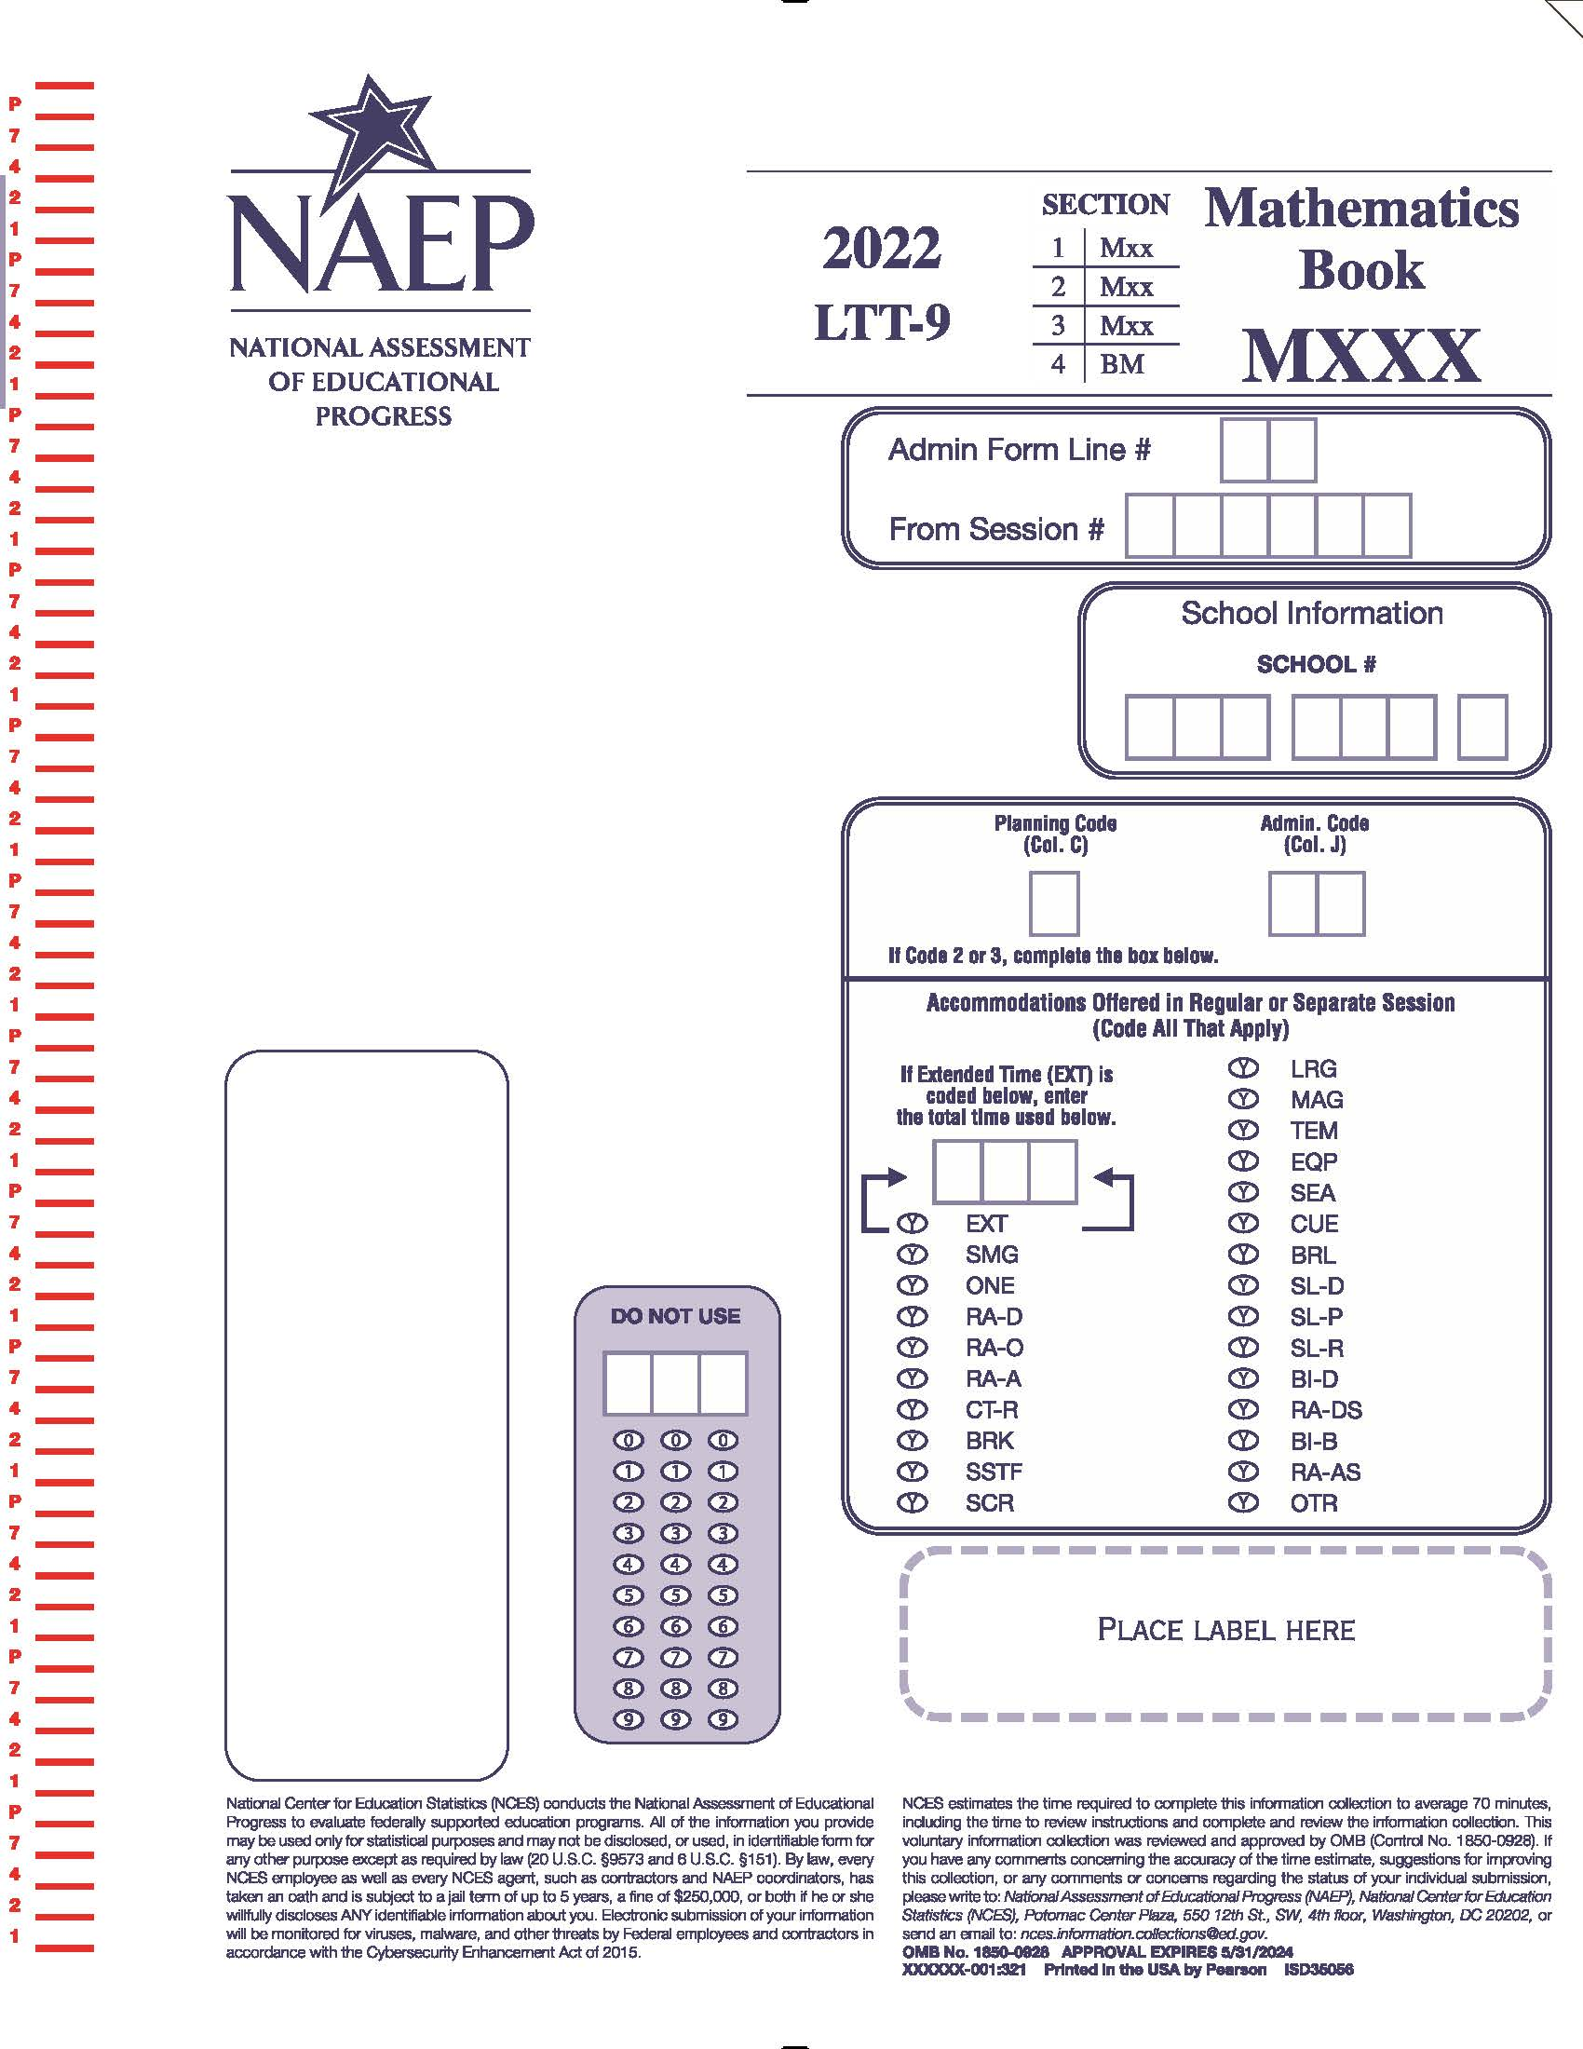

Appendix K4-1: Operational LTT Age 9 Mathematics
(Previously approved by OMB – OMB# 1850-0928 v.16)

VB331330
- Are you Hispanic or Latino? Fill in one or more ovals.
  - No, I am not Hispanic or Latino.
  - Yes, I am Mexican, Mexican American, or Chicano.
  - Yes, I am Puerto Rican or Puerto Rican American.
  - Yes, I am Cuban or Cuban American.
  - Yes, I am from some other Hispanic or Latino background.
VB331331
- Which of the following best describes you? Fill in one or more ovals.
  - White
  - Black or African American
  - Asian
  - American Indian or Alaska Native
  - Native Hawaiian or other Pacific Islander
VB331335
- About how many books are there in your home?
  - Few (0–10)
  - Enough to fill one shelf (11–25)
  - Enough to fill one bookcase (26–100)
  - Enough to fill several bookcases (more than 100)
VB331336
- Is there a computer at home that you use?
  - Yes
  - No

TB001101
- About how many pages a day do you have to read in school and for homework?
  - 5 or fewer
  - 6–10
  - 11–15
  - 16–20
E More than 20
BO001200
- How much time did you spend on homework yesterday?
  - No homework was assigned.
  - I had homework but didn’t do it.
  - Less than 1 hour
  - 1 to 2 hours
  - More than 2 hours
VB331339
- How often do you talk about things you have studied in school with someone in your family?
  - Never or hardly ever
  - Once every few weeks
  - About once a week
  - Two or three times a week
  - Every day
VB331447
- How many days were you absent from school in the last month?
  - None
  - 1 or 2 days
  - 3 or 4 days
  - 5 to 10 days
  - More than 10 days

VB331451
- How often do people in your home talk to each other in a language other than English?
  - Never
  - Once in a while
  - About half of the time
  - All or most of the time

Appendix K4-2: Operational Age 9 Reading
(Previously approved by OMB – OMB# 1850-0928 v.16)

VB331330
- Are you Hispanic or Latino? Fill in one or more ovals.
  - No, I am not Hispanic or Latino.
  - Yes, I am Mexican, Mexican American, or Chicano.
  - Yes, I am Puerto Rican or Puerto Rican American.
  - Yes, I am Cuban or Cuban American.
  - Yes, I am from some other Hispanic or Latino background.
VB331331
- Which of the following best describes you? Fill in one or more ovals.
  - White
  - Black or African American
  - Asian
  - American Indian or Alaska Native
  - Native Hawaiian or other Pacific Islander
VB331335
- About how many books are there in your home?
  - Few (0–10)
  - Enough to fill one shelf (11–25)
  - Enough to fill one bookcase (26–100)
  - Enough to fill several bookcases (more than 100)
VB331336
- Is there a computer at home that you use?
  - Yes
  - No

TB001101
- About how many pages a day do you have to read in school and for homework?
  - 5 or fewer
  - 6–10
  - 11–15
  - 16–20
  - More than 20
BO001200
- How much time did you spend on homework yesterday?
  - No homework was assigned.
  - I had homework but didn’t do it.
  - Less than 1 hour
  - 1 to 2 hours
  - More than 2 hours
VB331339
- How often do you talk about things you have studied in school with someone in your family?
  - Never or hardly ever
  - Once every few weeks
  - About once a week
  - Two or three times a week
  - Every day
VB331447
- How many days were you absent from school in the last month?
  - None
  - 1 or 2 days
  - 3 or 4 days
  - 5 to 10 days
  - More than 10 days

VB331451
- How often do people in your home talk to each other in a language other than English?
  - Never
  - Once in a while
  - About half of the time
  - All or most of the time
SO003500
- How often do you do each of the following things?
 | Almost every day | Once or twice a week | Once or twice a month | A few times a year | Never or hardly ever
a. Read for fun on your own time. | A | B | C | D | E | VC375071
b. Tell a friend about a good book. | A | B | C | D | E | VC375073

Appendix K4-3: Operational LTT Age 9 COVID-19 Student Items (ELA)
Approved in OMB# 1850-0928 v.25
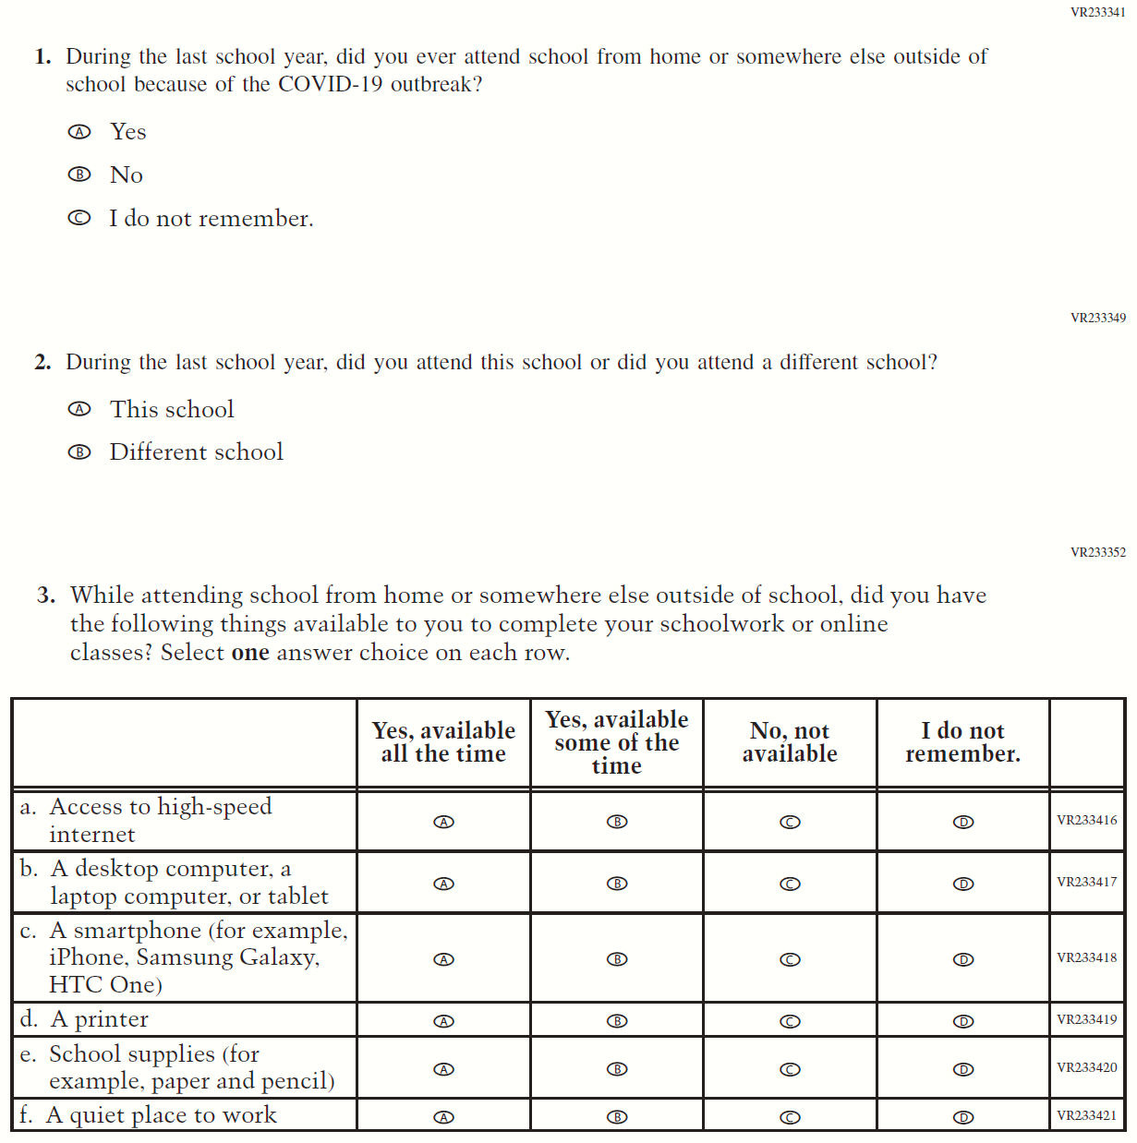

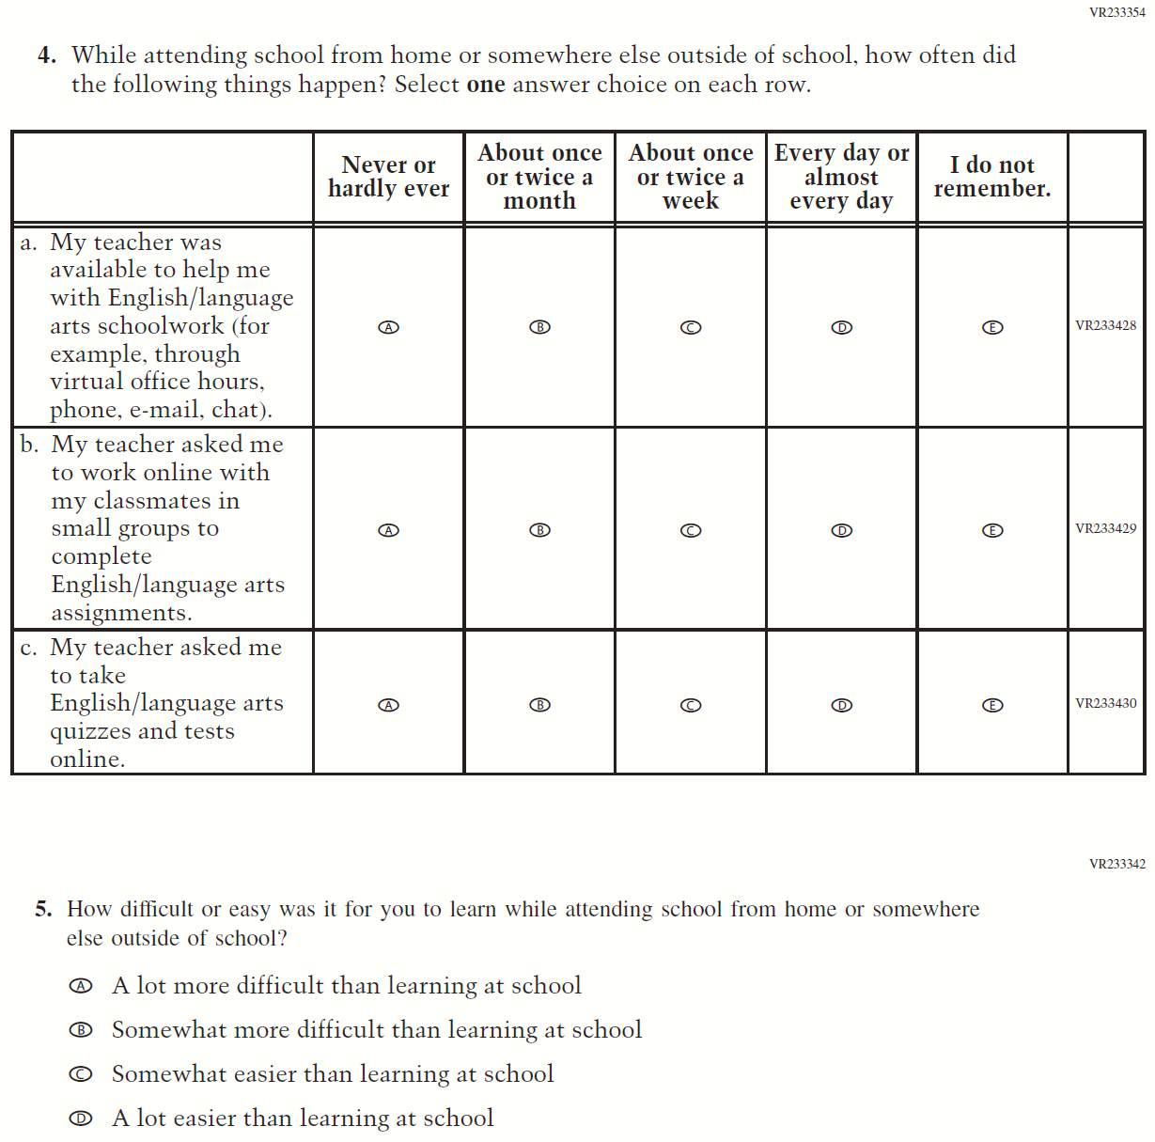

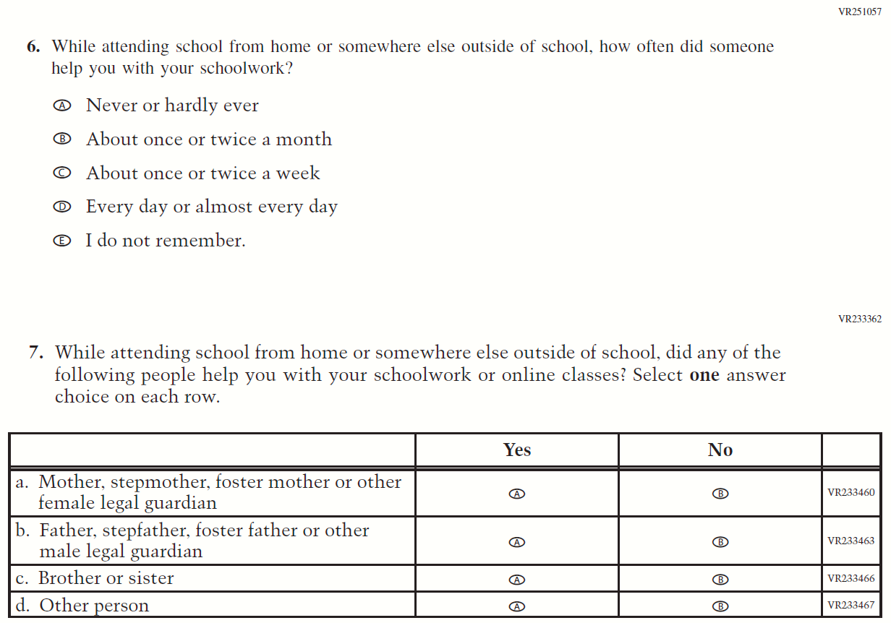
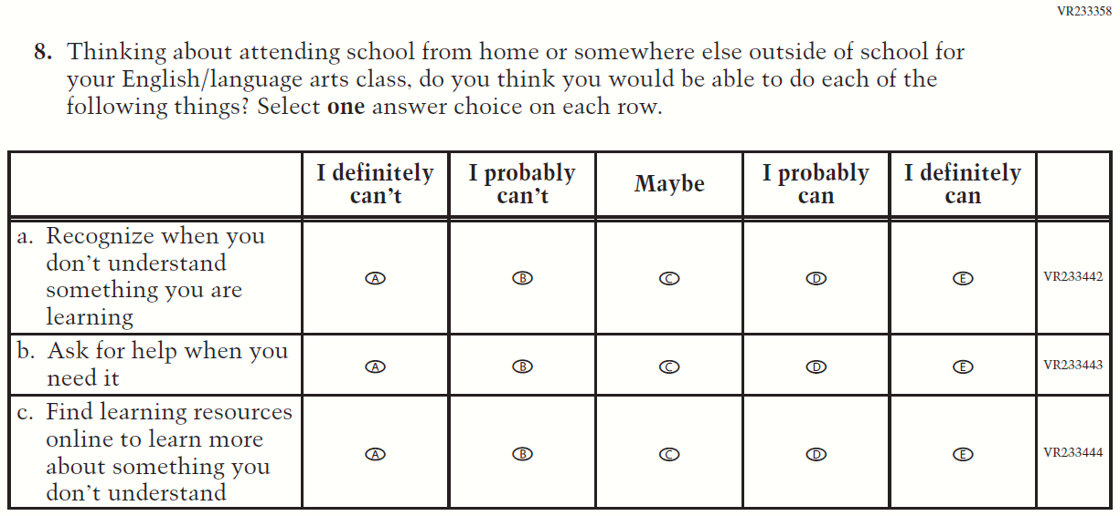

Appendix K4-4: Operational LTT Age 9 COVID-19 Student Items (Math)
Approved in OMB# 1850-0928 v.25
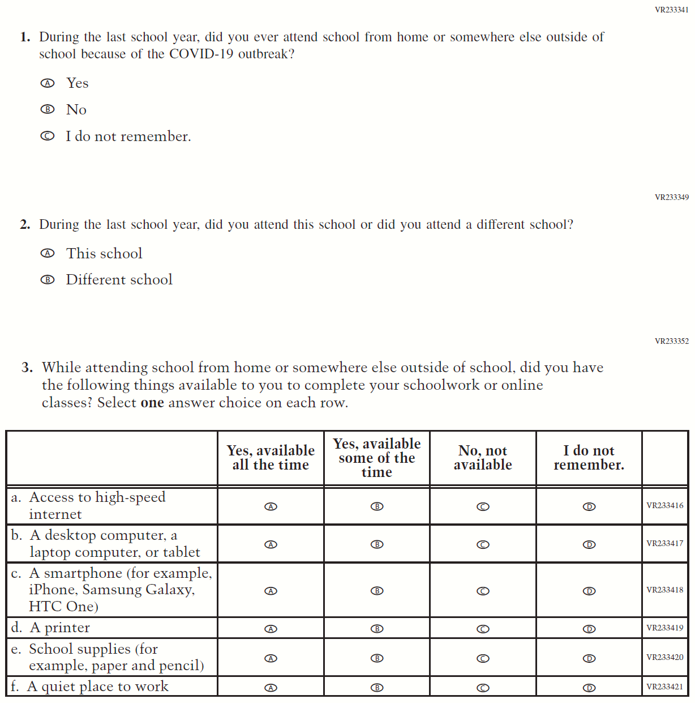

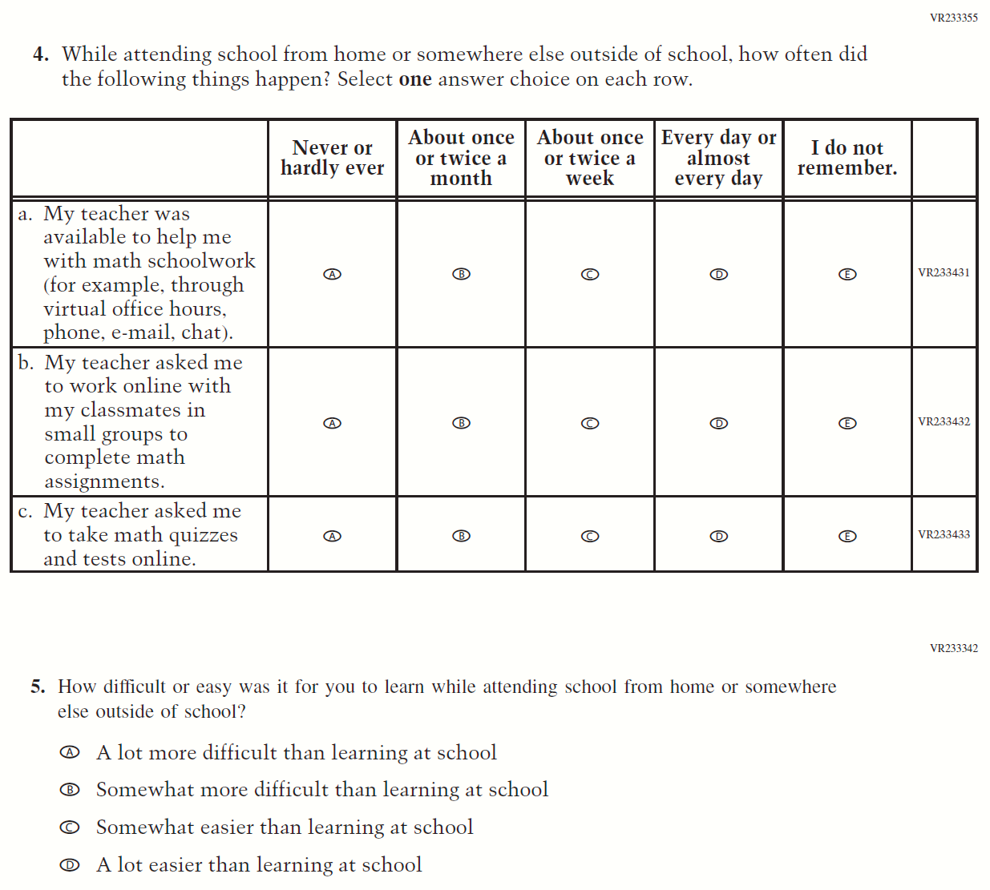

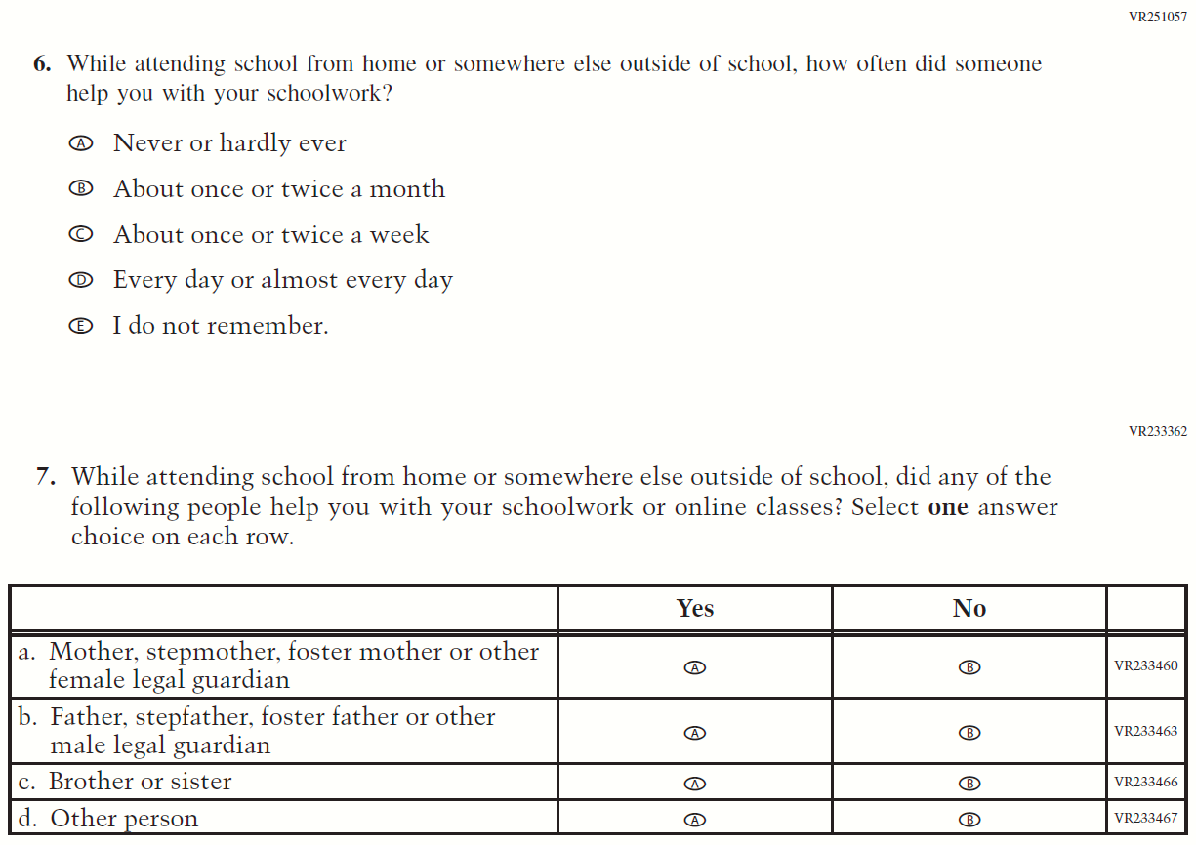

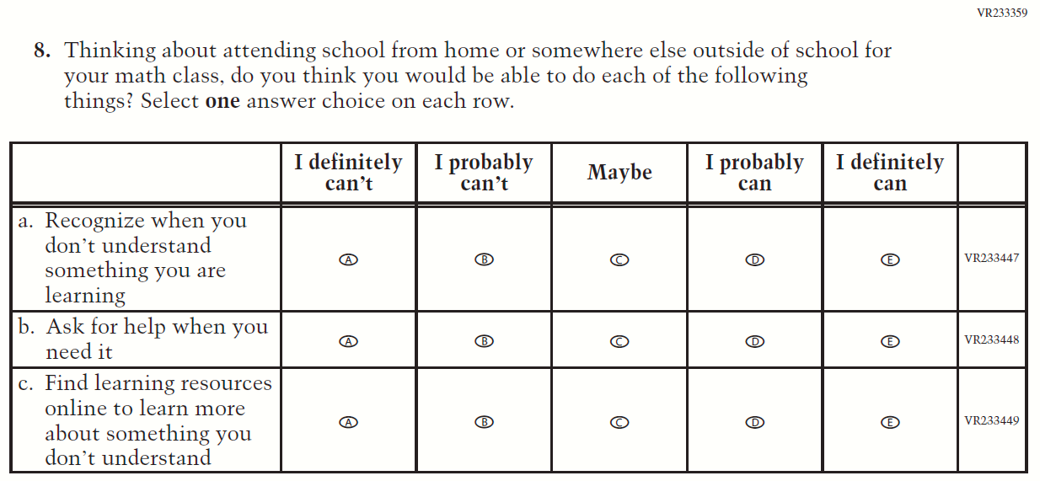

Sample NAEP School Questionnaire Cover Page
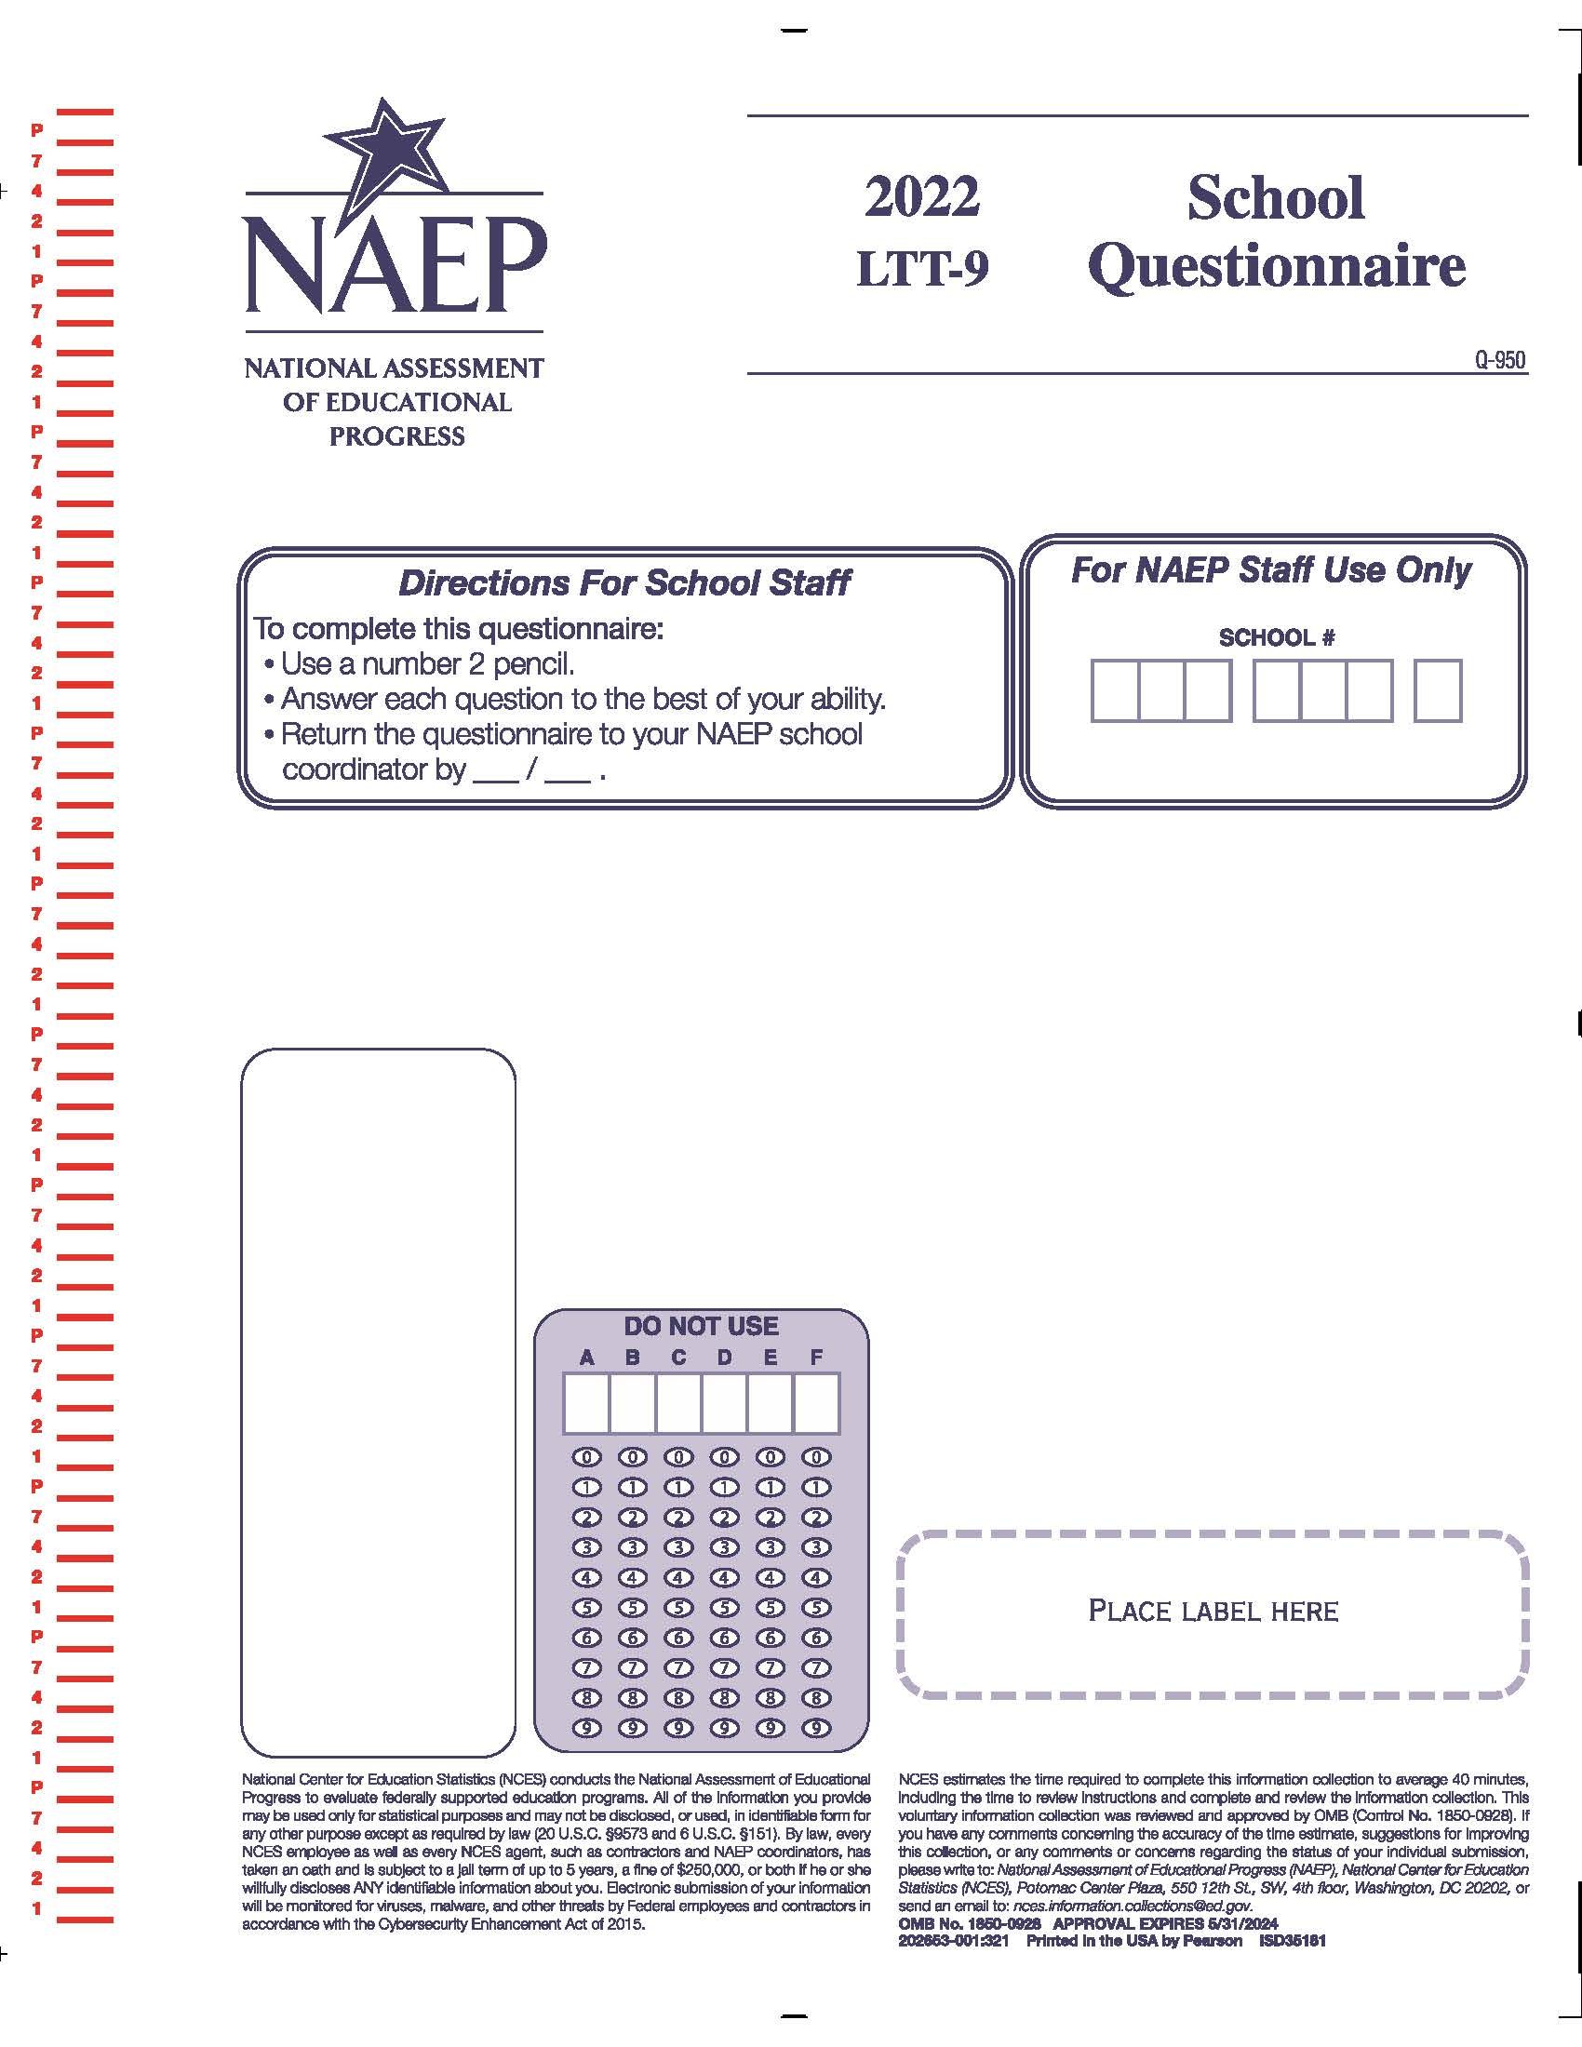

Appendix K4-5: Operational LTT Age 9 Core School Items
(Previously approved by OMB – OMB# 1850-0928 v.23)
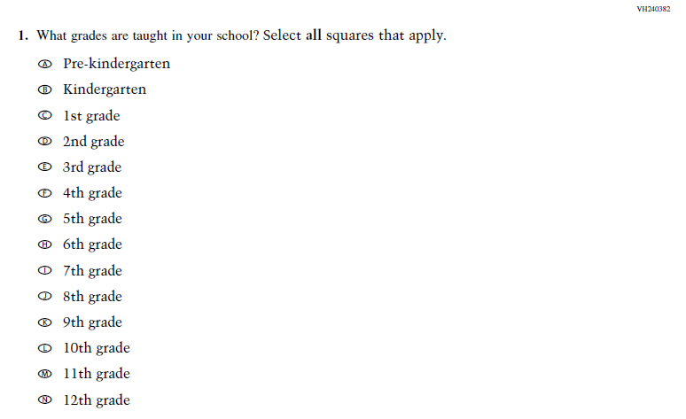
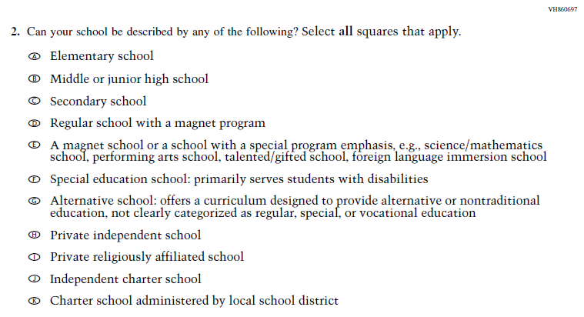

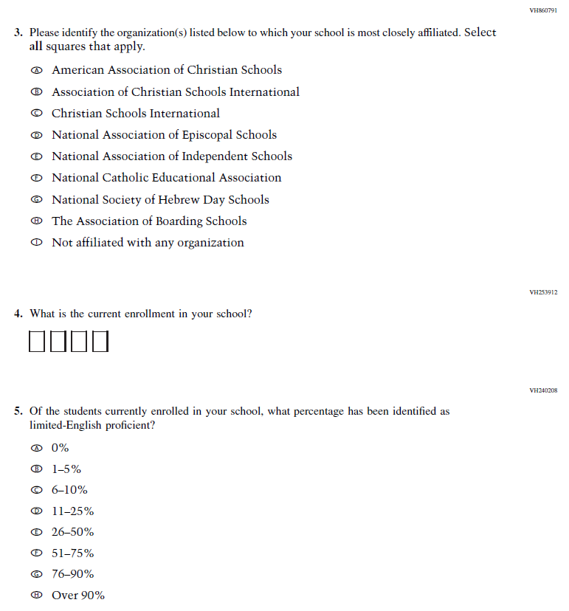

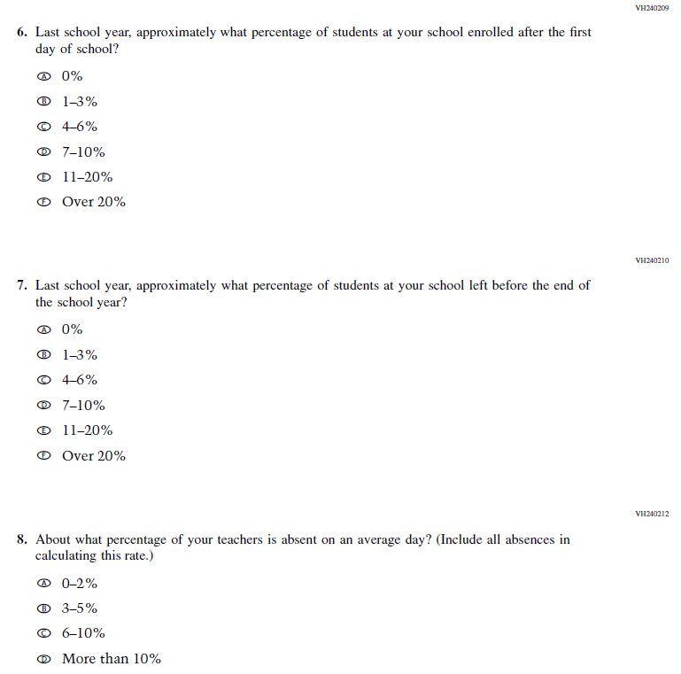
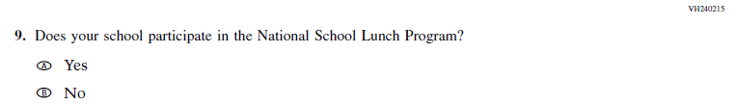
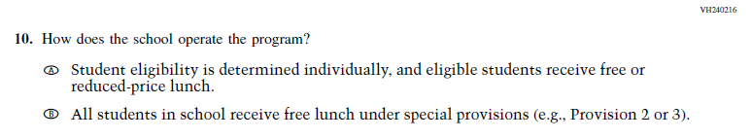
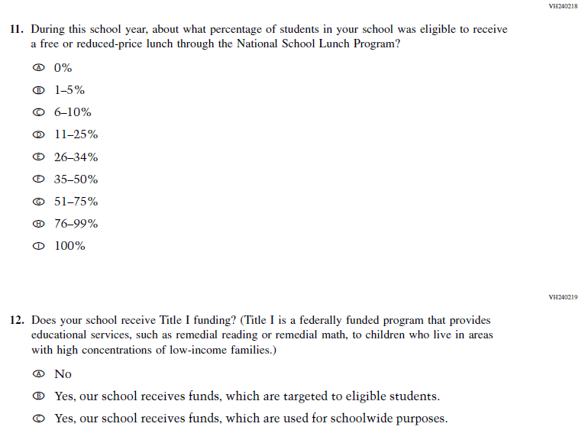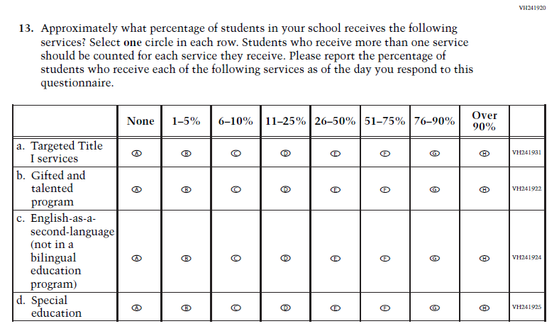
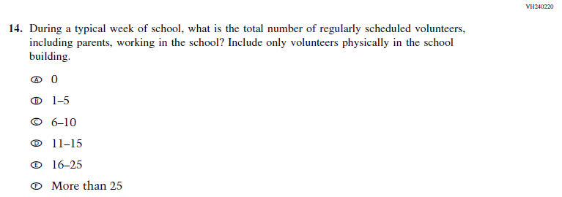
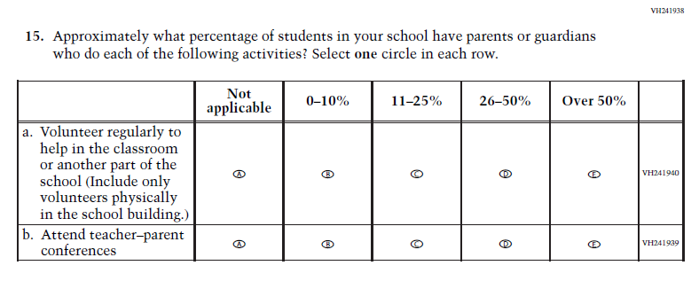
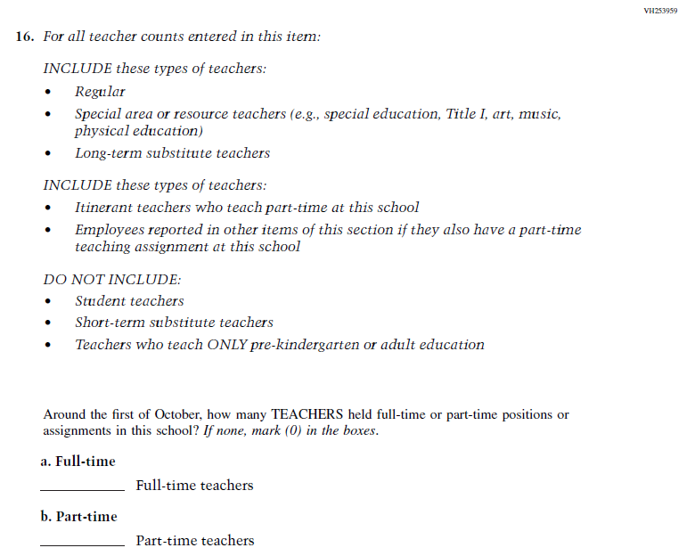
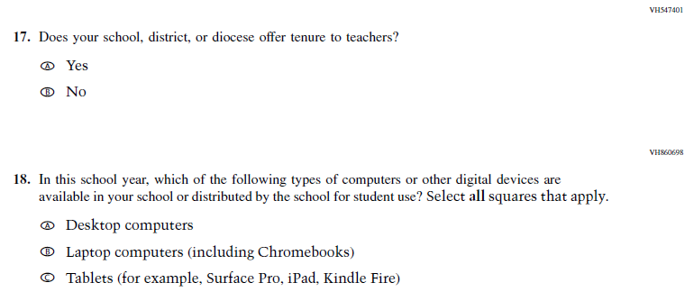
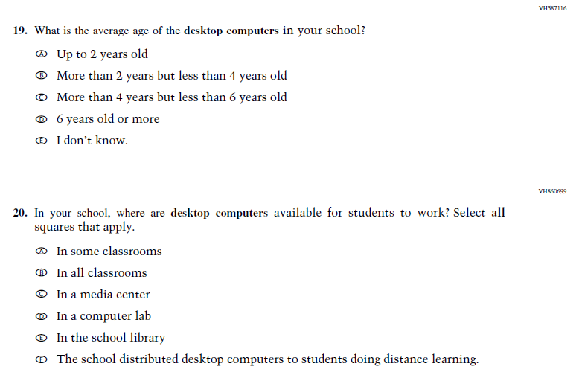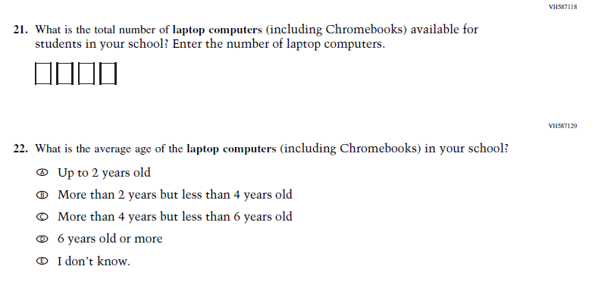
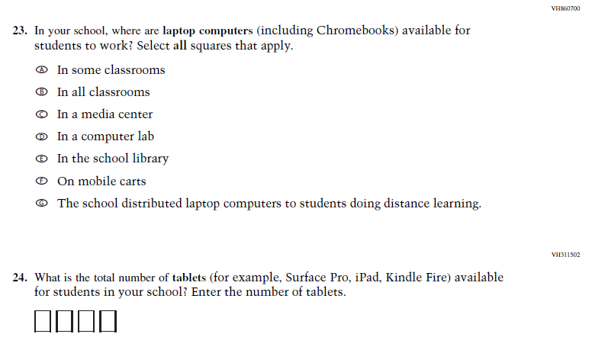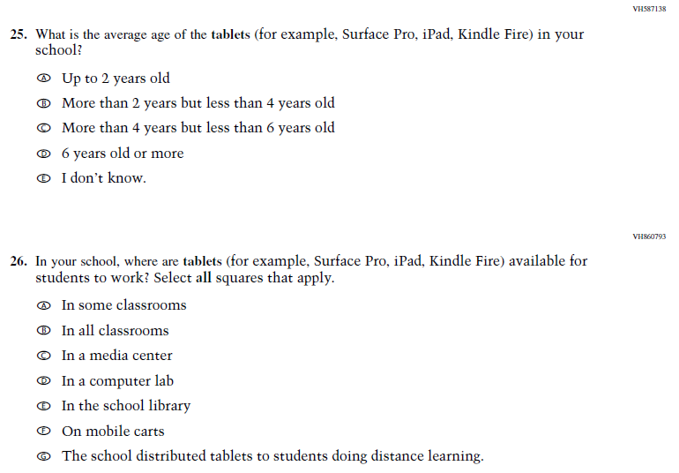
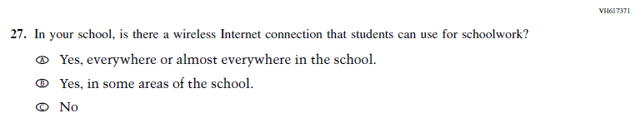

Appendix K4-6: Operational LTT Age 9 COVID-19 School Items
Approved in OMB# 1850-0928 v.25
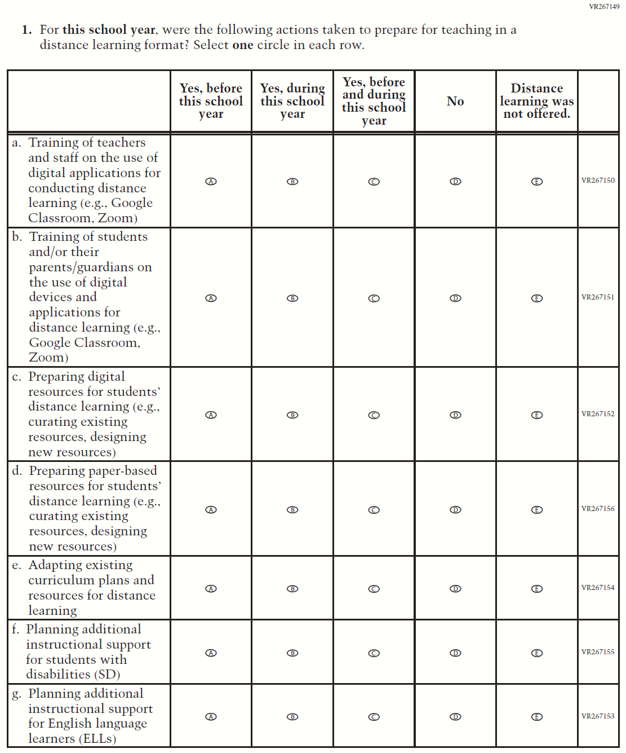

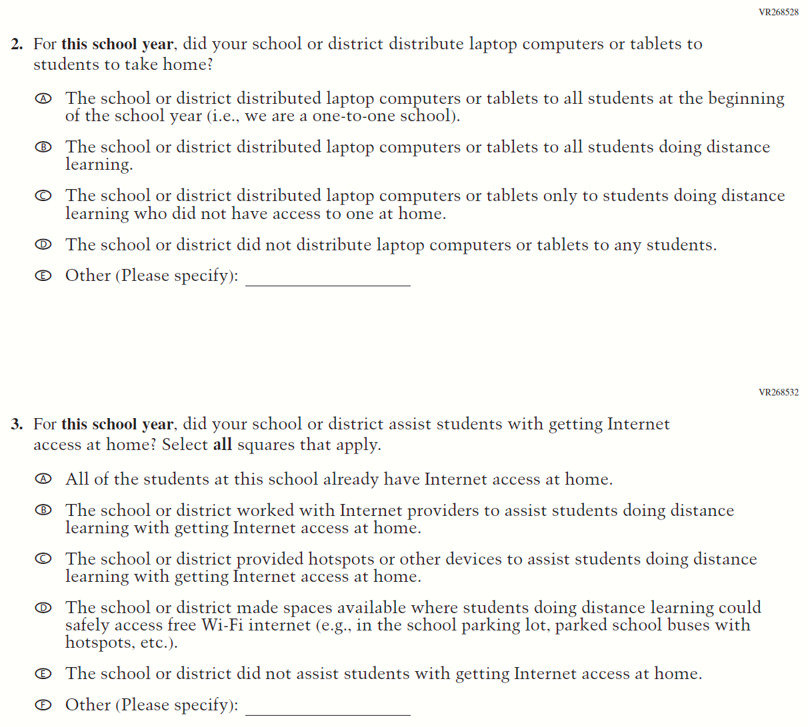

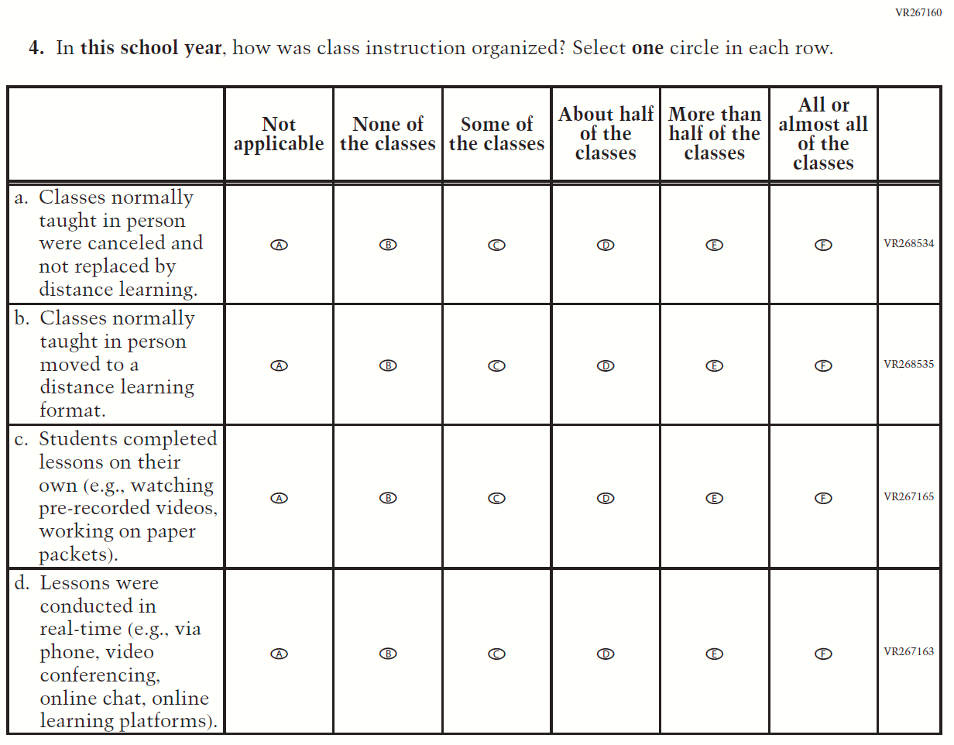

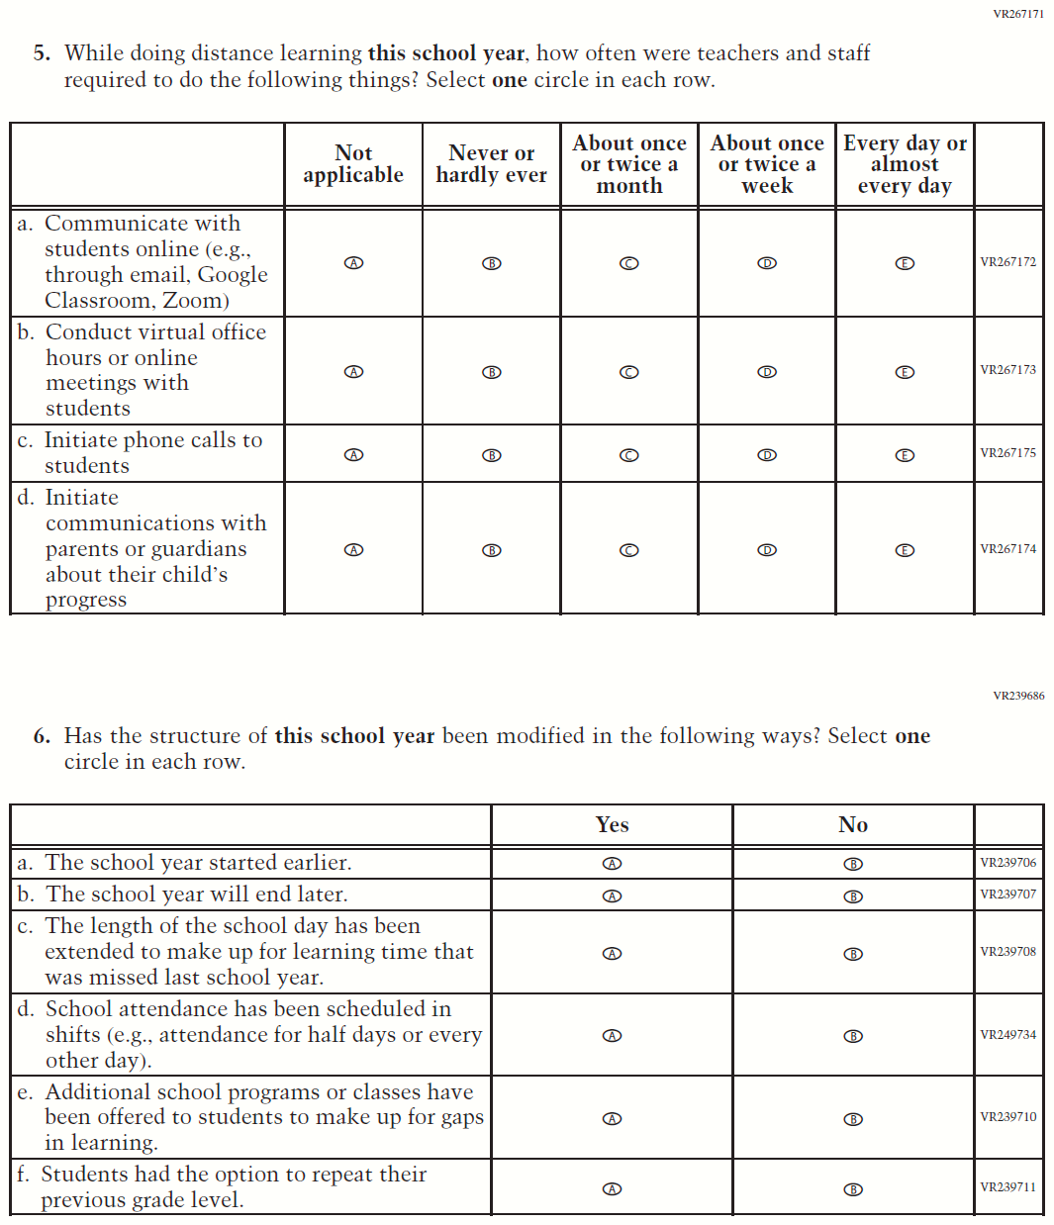

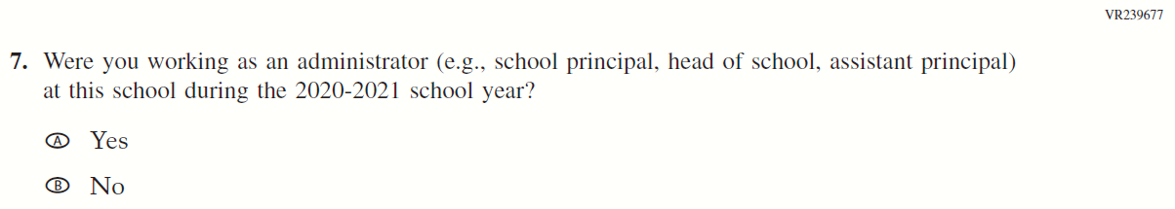

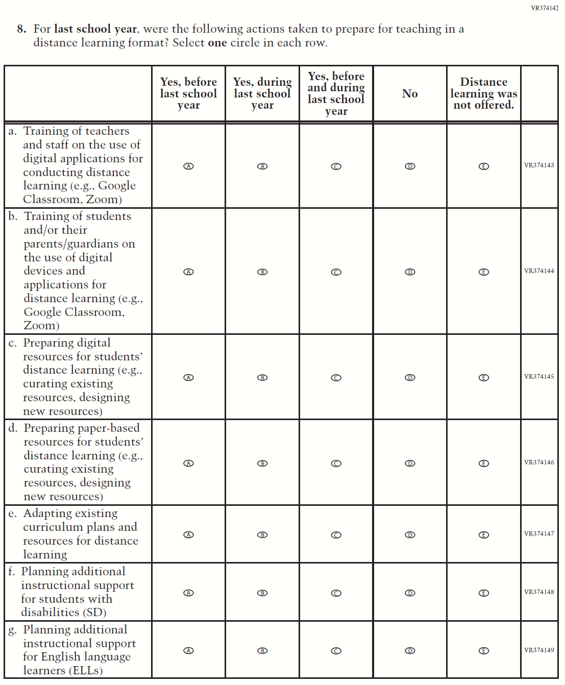

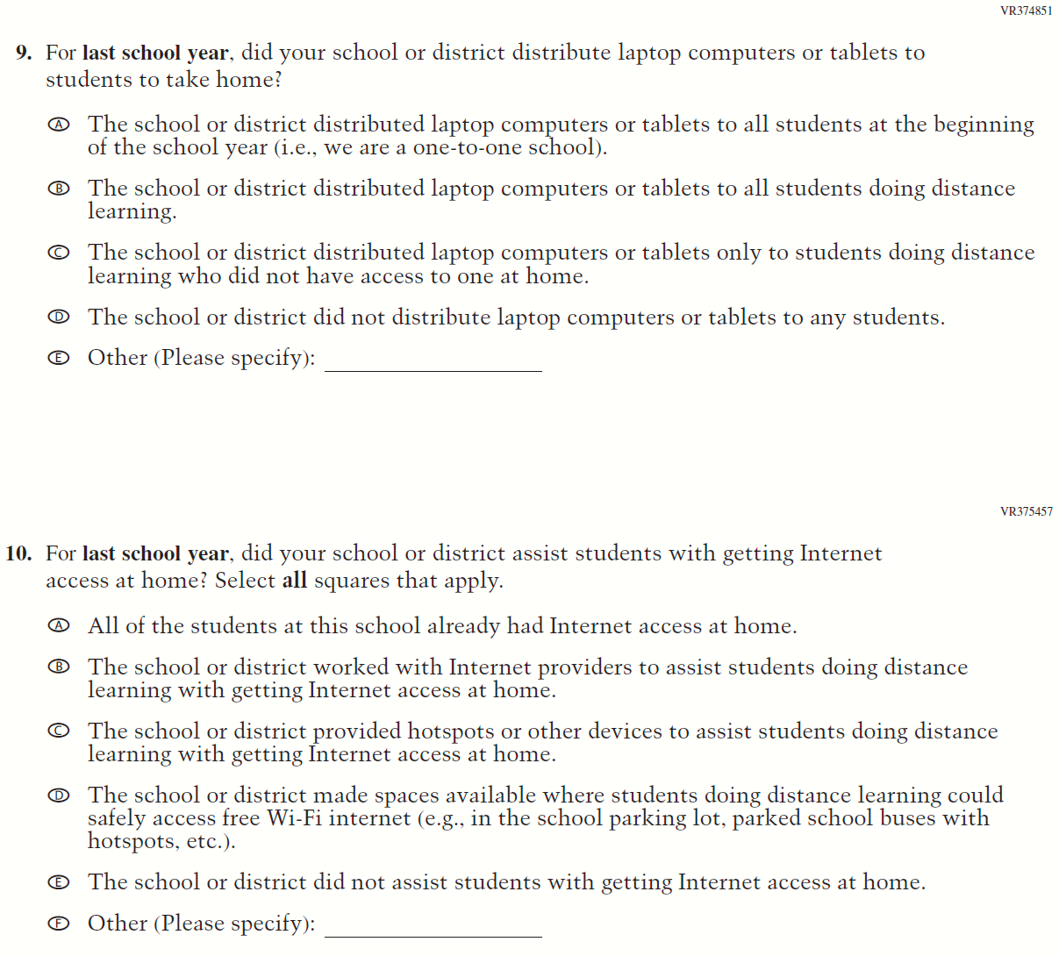

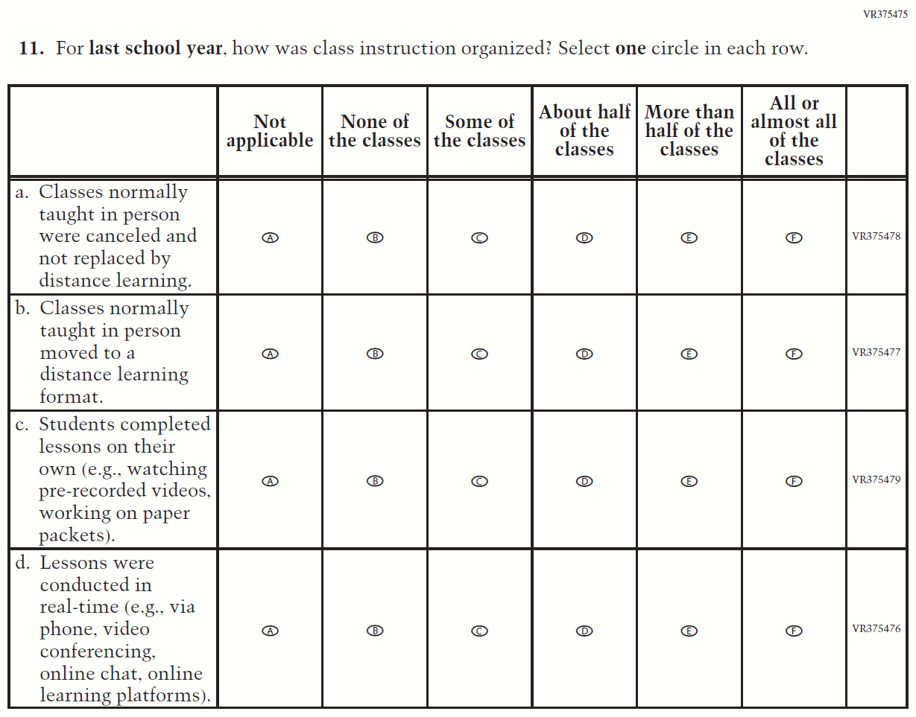

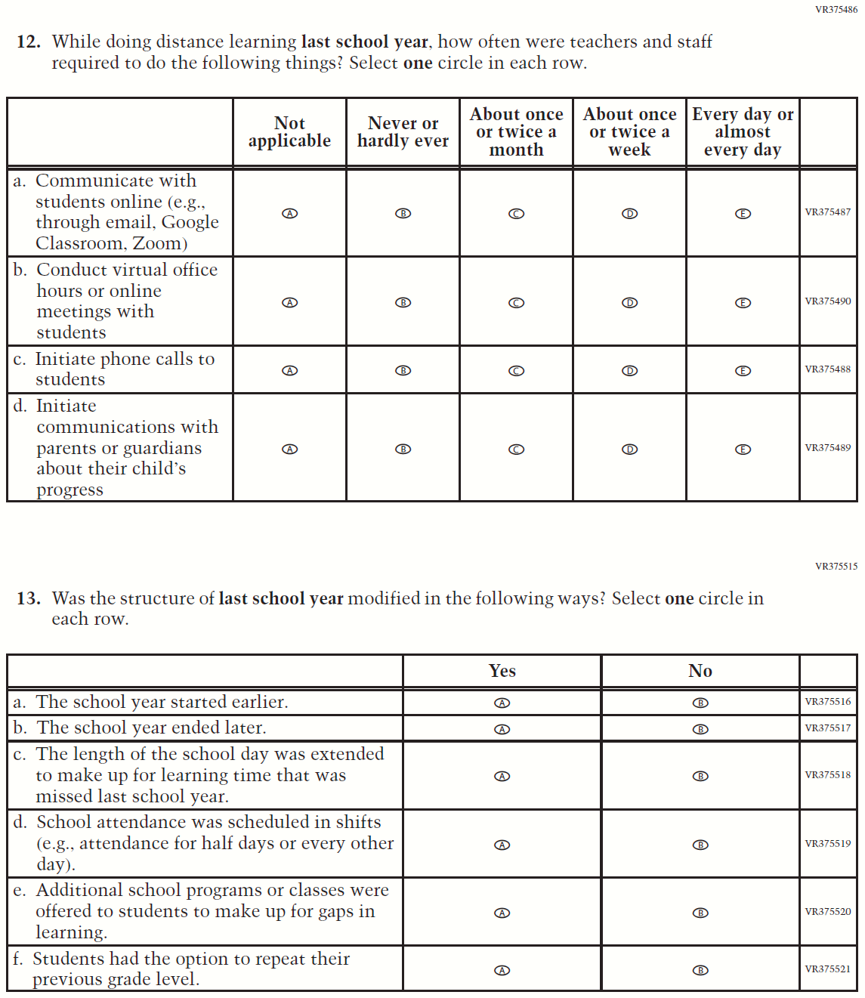

Sample NAEP Student Questionnaire Cover Page (LTT Age 13)
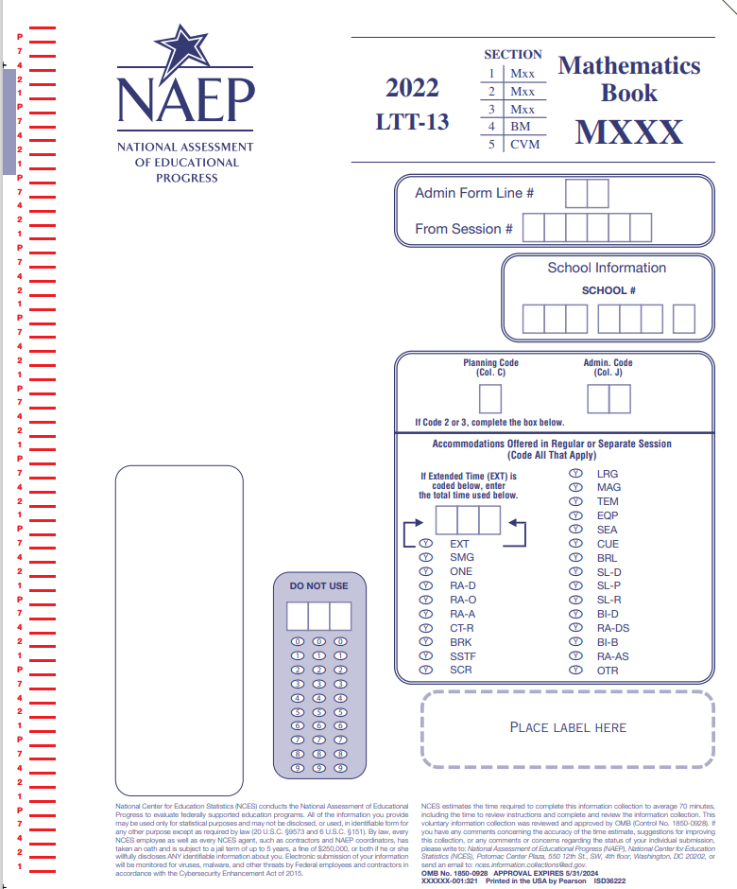

Appendix K4-7: Operational LTT Age 13 Mathematics NEW
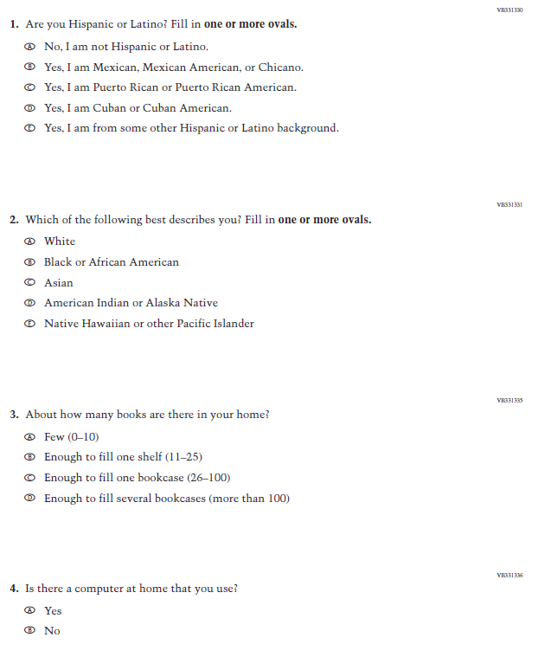
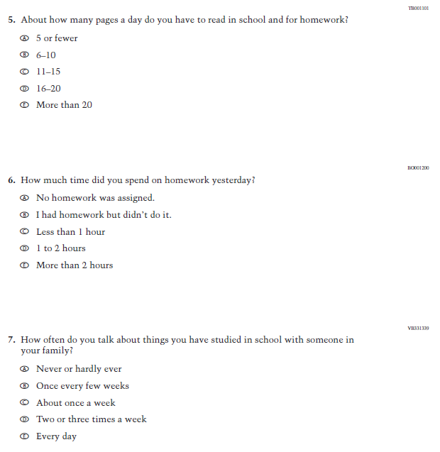

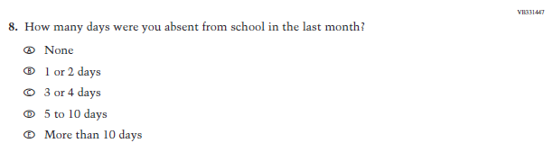
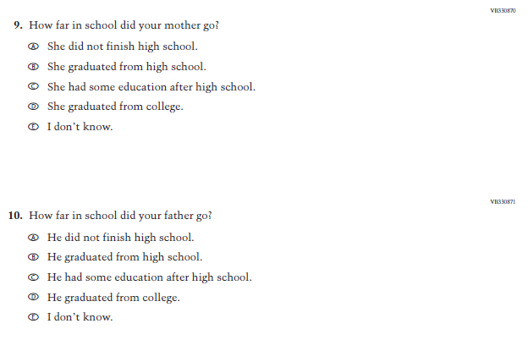

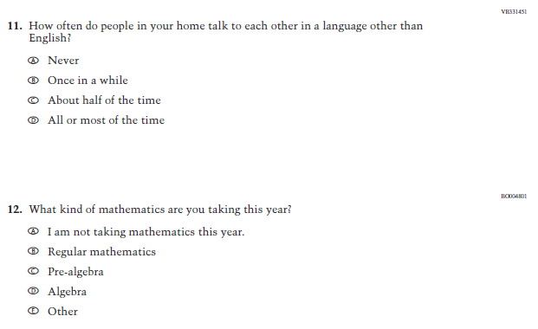

Appendix K4-8: Operational LTT Age 13 Reading NEW
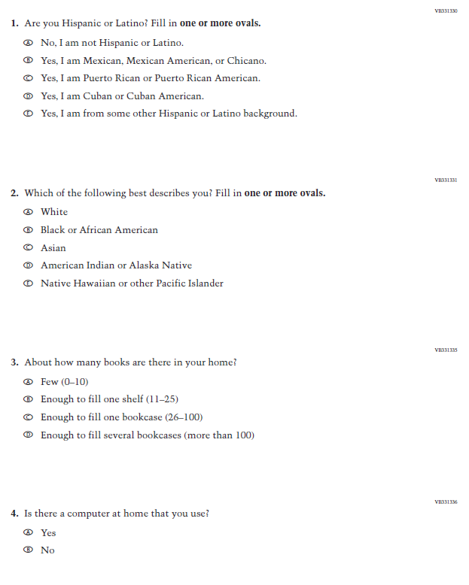
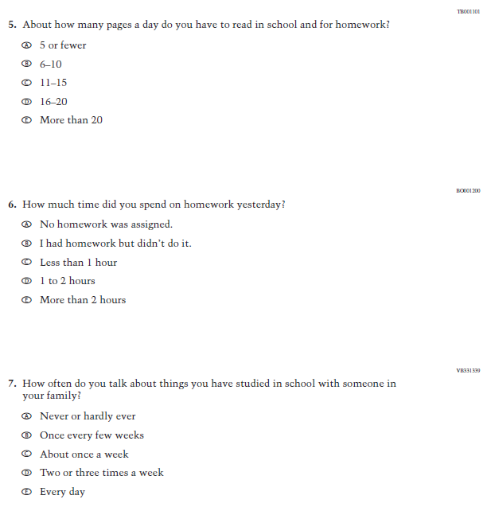

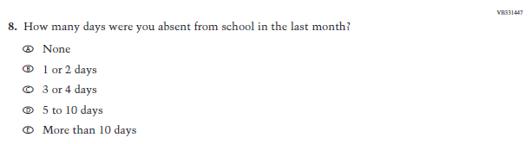
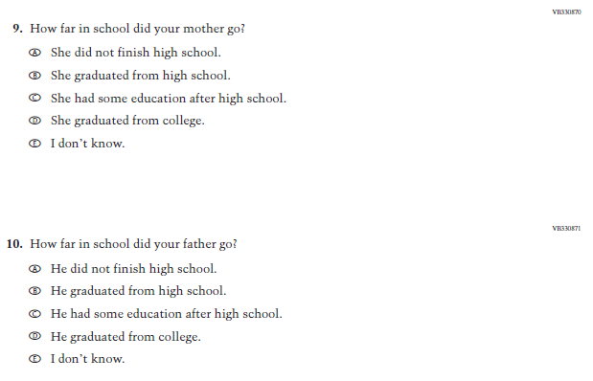

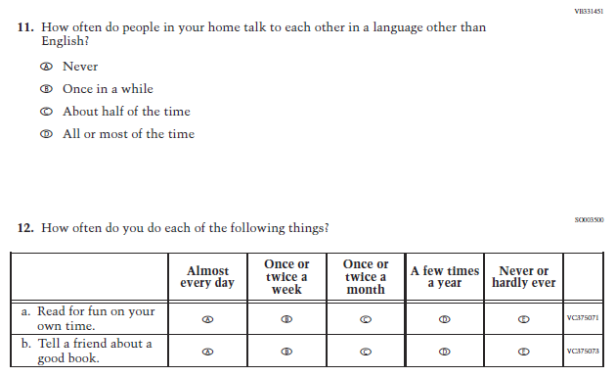

Appendix K4-9: Operational LTT Age 13 COVID-19 Student Items (Math) NEW
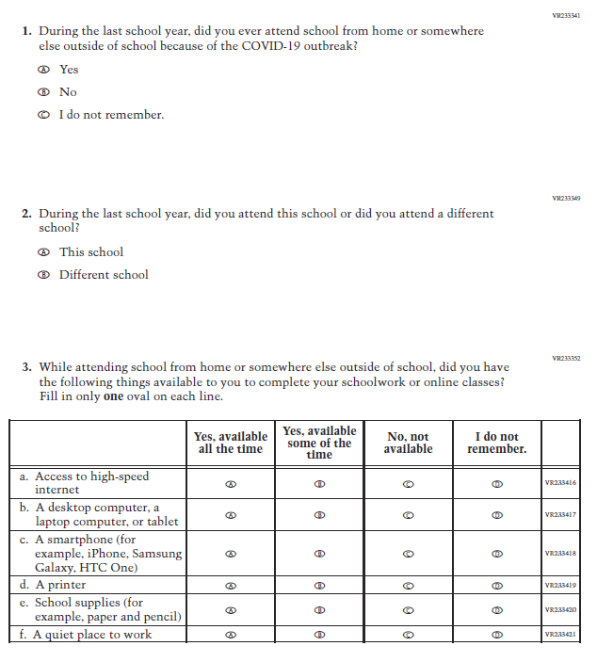
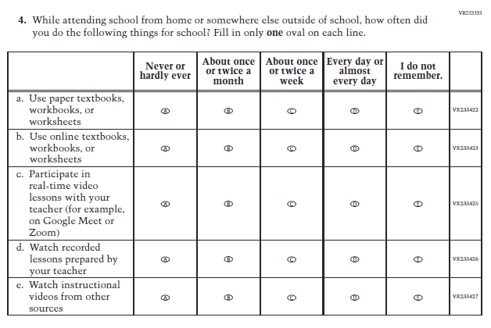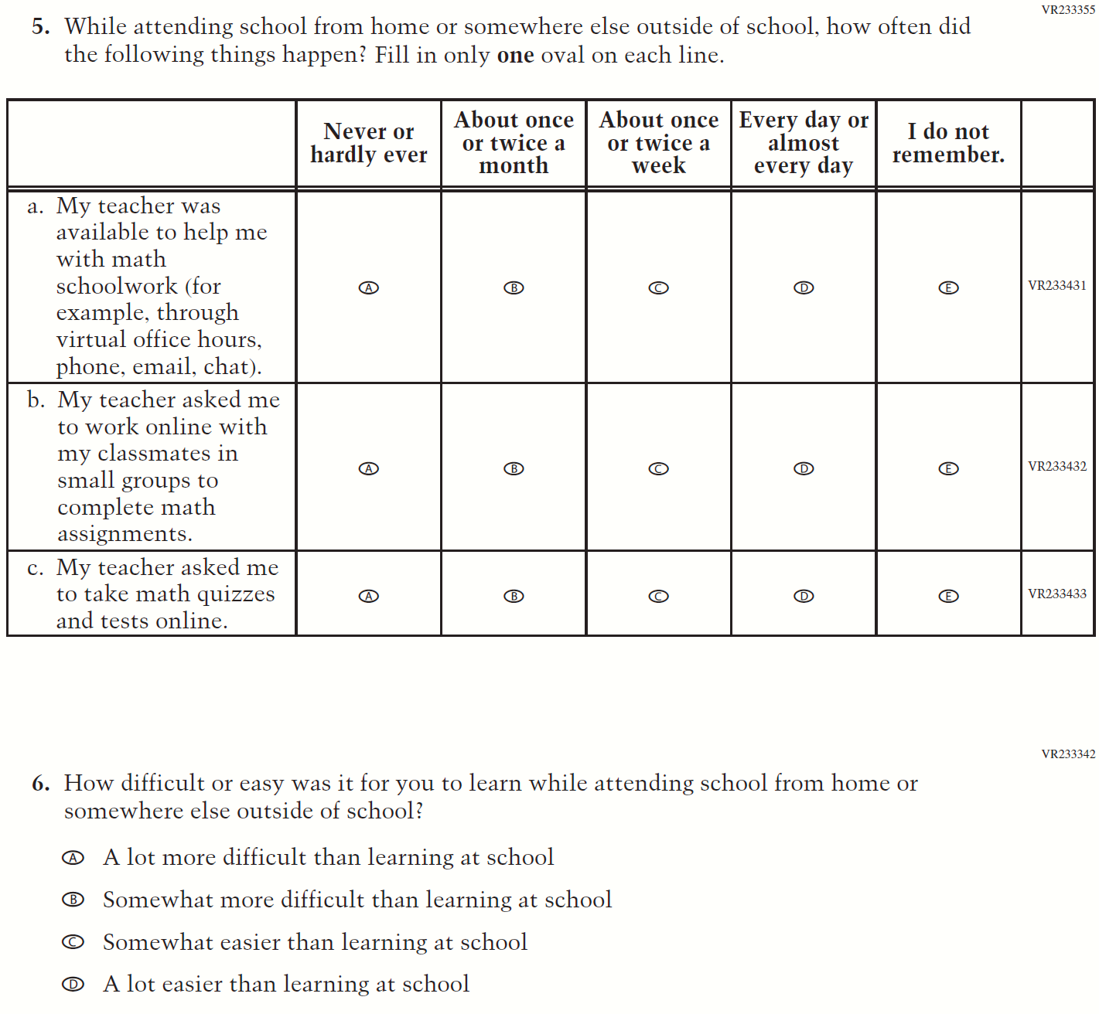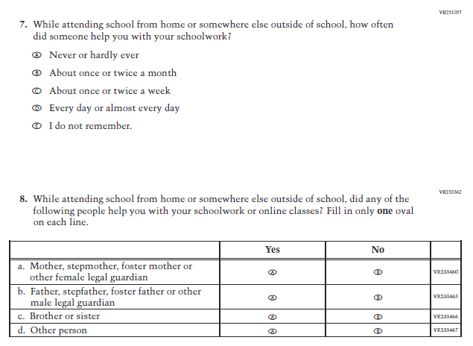

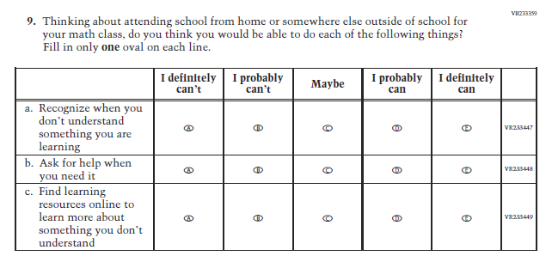

Appendix K4-10: Operational LTT Age 13 COVID-19 Student Items (Reading) NEW
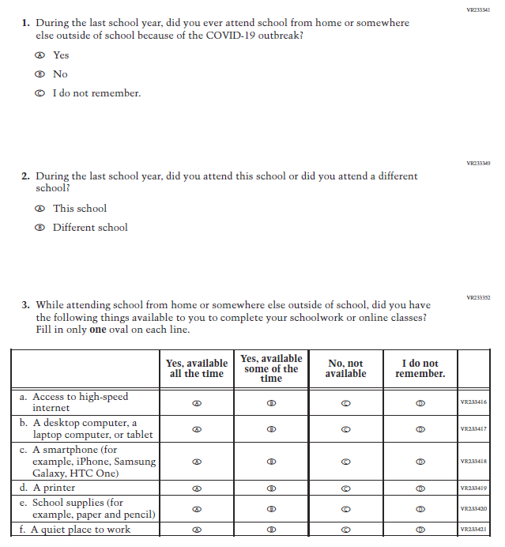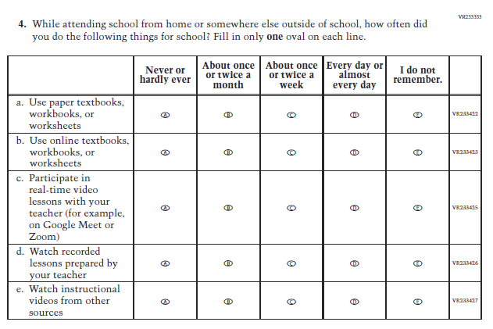
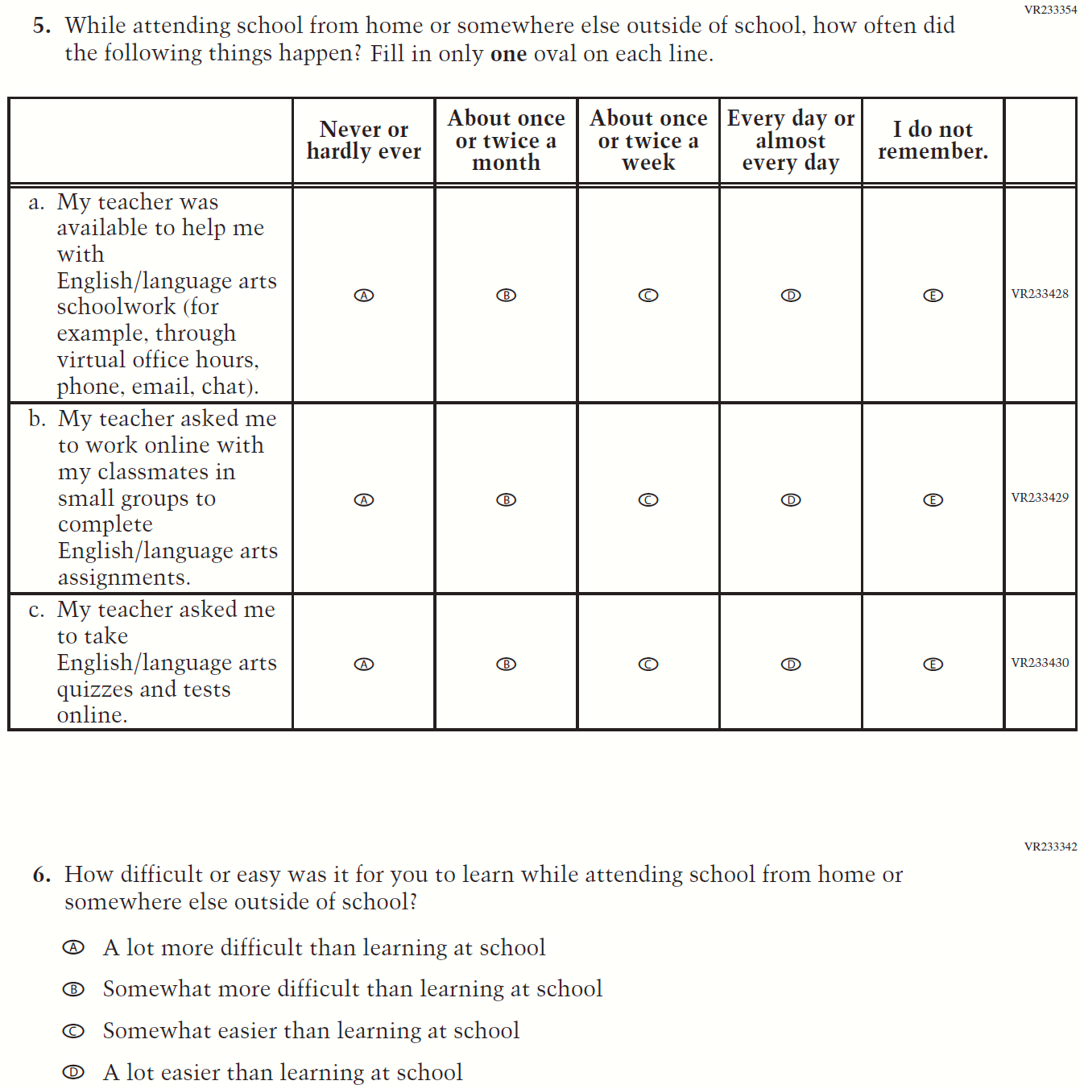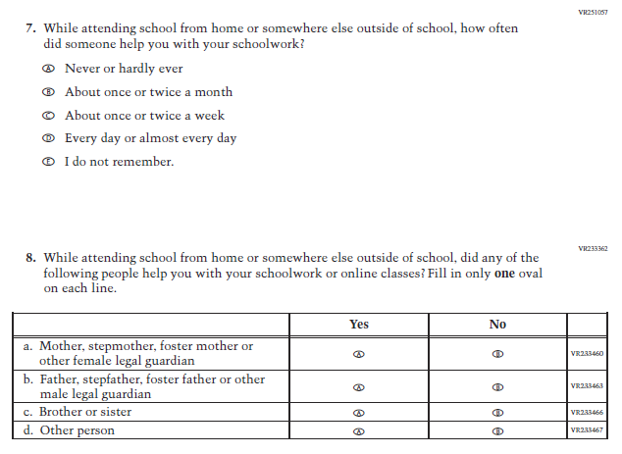

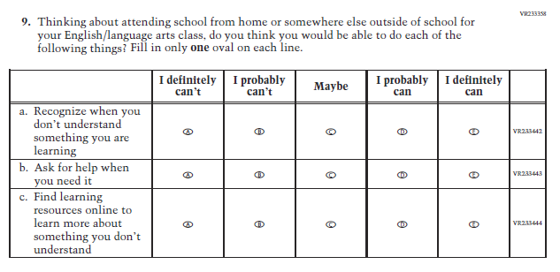

Sample NAEP School Questionnaire Cover Page (LTT Age 13)
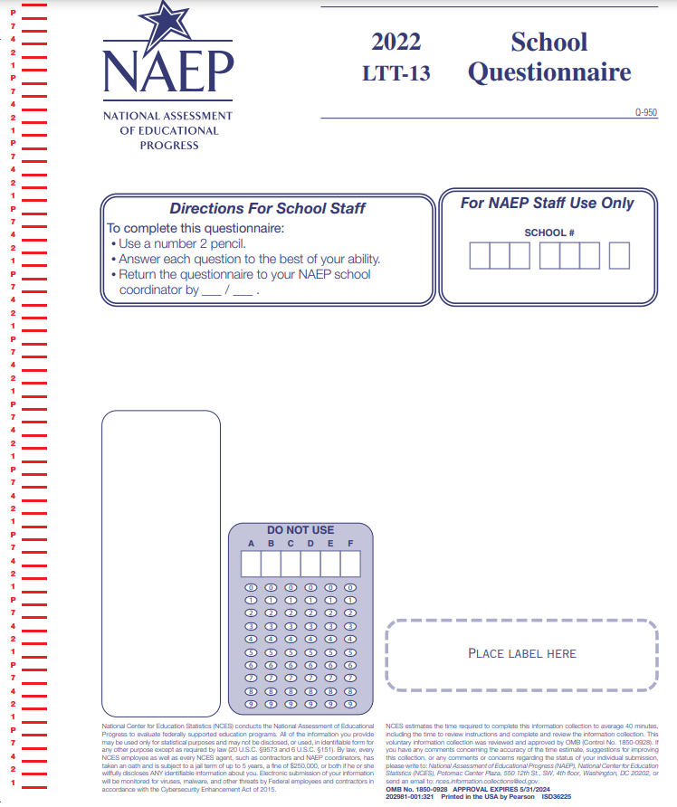

Appendix K4-11: Operational LTT Age 13 Core School Items NEW

Appendix K4-12: Operational LTT Age 13 COVID-19 School Items NEW
