NATIONAL CENTER FOR EDUCATION STATISTICS NATIONAL ASSESSMENT OF EDUCATIONAL PROGRESS

National Assessment of Educational Progress (NAEP) 2022
Materials Update #2

Appendix I
NAEP 2022 Content of MyNAEP System

OMB# 1850-0928 v.25

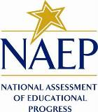

September 2021

Appendix I has been updated to include the remaining sections of MyNAEP needed by November 2021, specifically: a) Prepare for Assessment; b) Review and Verify List of Students Selected for NAEP; c) Complete SD/EL Student Information; d) Manage Questionnaires; e) Plan for Assessment Day; f) Update Student Lists; g) Support Assessment Activities; h) Wrap Up. The MyNAEP log-in screen were updated to reflect the new Paperwork Reduction Act (PRA) statement.
The following areas may need to change from 2021 to 2022:
- Update year/date
- Update assessment window
- Update subjects and grades to be assessed
- Update calendar year and schedule
- Remove references to any activity different from 2021 activities
- Update Exclusion Summary Screen for 2022
- Remove designate method screen
- Pending final design, update testing times, assessment length and assessment session details

Table of Contents

MyNAEP Login Screen – NEW 5
Home Page – Approved in v.23 7
Provide School Information – Approved v.23 9
Student Attendance (NEW - Provide School Information Questions) 10
NAEP Representative Protocols (NEW Provide School Information Questions) 12
Prepare for Assessment - NEW 14
Review and Verify List of Students Selected for NAEP - NEW 15
Review and Verify Student Information 17
Print Reports 24
Complete SD/EL Student Information - NEW 25
Review NAEP Inclusion Policy 27
Give Access to SD and/or EL Specialists 28
Provide Information for Students Who Are Both SD and EL 30
Provide Information for SD (IEP or 504 Plan) Only 36
Provide Information for EL Only 41
Print Reports 46
Create Accommodation Sessions (Field Staff Only) 51
Plan for Assessment Day - NEW 52
Record Assessment Details 53
Provide NAEP Team Instructions 58
Notify Parents – Approved v.23 66
Download Parent/Guardian Notification Template 68
Upload Letter 69
Verify Parent/Guardian Notification 70
Manage Questionnaires - NEW 71
Identify Questionnaire Respondents 72
Send Welcome Emails and Questionnaires 74
Monitor Questionnaire Completion and Send Reminder Emails 75
Encourage Participation – Approved v.23 76
Review Resources 77
Notify Students about NAEP 79
Videos 80
NAEP Online 81
Thank Students for Their Participation 82
Select Strategies to Encourage Participation 83
Update Student List - NEW 84
Give Access for Student Data Specialist 86
Submit Current List 87
Support Assessment Activities - NEW 94
Wrap Up - NEW 95
Additional Resources 96
Prepare for Assessment 96
Instructions for the School Coordinator brochure 96
Digitally-based Assessments 101
Review and Verify List of Students Selected for NAEP 102
Information Needed to Review and Verify List of Students Selected for NAEP 102
Dept. of Agriculture Memo Authorizing Release of NSLP to NAEP 104
Complete SD/EL Student Information 105
Inclusion on NAEP Fact Sheet 105
Letter from Department of Education Encouraging Inclusion 109
Information Needed to Include SD/EL Students 110
Notify Parents 112
Parent’s page on Nation’s Report Card website 112
Manage Questionnaires 113
Manage Questionnaires Welcome Email 113
Manage Questionnaires Reminder Email 114
Encourage Participation 115
Digitally-based Assessments 115
Update Student List 116
Student List Requirements and Instructions 116
Support Assessment Activities 118
Teacher Notification Letter 118
Appointment Cards 119

Description of MyNAEP: The school coordinators are responsible for preparing for the assessment in their school using the MyNAEP system, which is an online secure site that provides participating schools with a convenient way to prepare for the upcoming assessment. MyNAEP serves as the primary resource and action center throughout the assessment process. The site also offers school coordinators an electronic way to prepare for the assessment at their own pace. The NAEP field representative will schedule an initial call in December to pre-review the major areas of the MyNAEP system with the school coordinator. A description of the tasks completed in the MyNAEP system can be found in Part B. The content of the MyNAEP system is included in this appendix.
Notes on the organization of Appendix I
- Red text indicates descriptive notes and references to Appendices other than I.
- Green text indicates text from hyperlinks or references within this document.
- The Additional Resources section of this document (beginning on page 97) contains the text of hyperlinks.
- For confidentiality reasons, the state name is represented by “99.” The “99” will be updated accordingly when the NAEP state coordinator logs into the system.

MyNAEP Login Screen – NEW

Welcome
MyNAEP is a restricted-use website that contains information on the National Assessment of Educational Progress (NAEP), widely known as The Nation's Report Card.
Login
Email or Username:
Password:
Forgot Username or Password
Having trouble logging in?
First time visiting the 2022 MyNAEP site?
Please register
Paperwork Reduction Act (PRA) Statement
National Center for Education Statistics (NCES) conducts the National Assessment of Educational Progress to evaluate federally supported education programs. All of the information you provide may be used only for statistical purposes and may not be disclosed, or used, in identifiable form for any other purpose except as required by law (20 U.S.C. §9573 and 6 U.S.C. §151). By law, every NCES employee as well as every NCES agent, such as contractors and NAEP coordinators, has taken an oath and is subject to a jail term of up to 5 years, a fine of $250,000, or both if he or she willfully discloses ANY identifiable information about you. Electronic submission of your information will be monitored for viruses, malware, and other threats by Federal employees and contractors in accordance with the Cybersecurity Enhancement Act of 2015.
NCES estimates the time required to complete this information collection to average 270 minutes for schools that do not submit student sample information or 390 minutes for schools that submit student sample information manually, plus an additional 10 minutes for each student identified as SD or EL, including the time to review instructions, search existing data resources, gather the data needed, and complete and review the information collection. This voluntary information collection was reviewed and approved by OMB (Control No. 1850-0928). If you have any comments concerning the accuracy of the time estimate, suggestions for improving this collection, or any comments or concerns regarding the status of your individual submission, please write to: National Assessment of Educational Progress (NAEP), National Center for Education Statistics (NCES), Potomac Center Plaza, 550 12th St., SW, 4th floor, Washington, DC 20202, or send an email to: nces.information.collections@ed.gov.
When you have finished or if you need to stop before finishing, please LOG OUT of the survey system by clicking "Save and exit" and CLOSE ALL browser windows or screens to keep your responses secure. For example, if you used Chrome or Safari to open the survey, make sure no Chrome or Safari windows or screens are open after you end the survey. Not closing all browsers may allow someone else to see your responses.
OMB No. 1850-0928 APPROVAL EXPIRES 5/31/2024

Summary of Changes from 2021 to 2022:
- Updated the year from 2021 to 2022.
- The Paperwork Reduction (PRA) Statement has been updated to reflect the 2022 NAEP administration.
Screenshot
NOTE: The screenshot below has been revised with the NEW PRA statement and expiration date in this Amendment #2 (see full PRA Statement above).
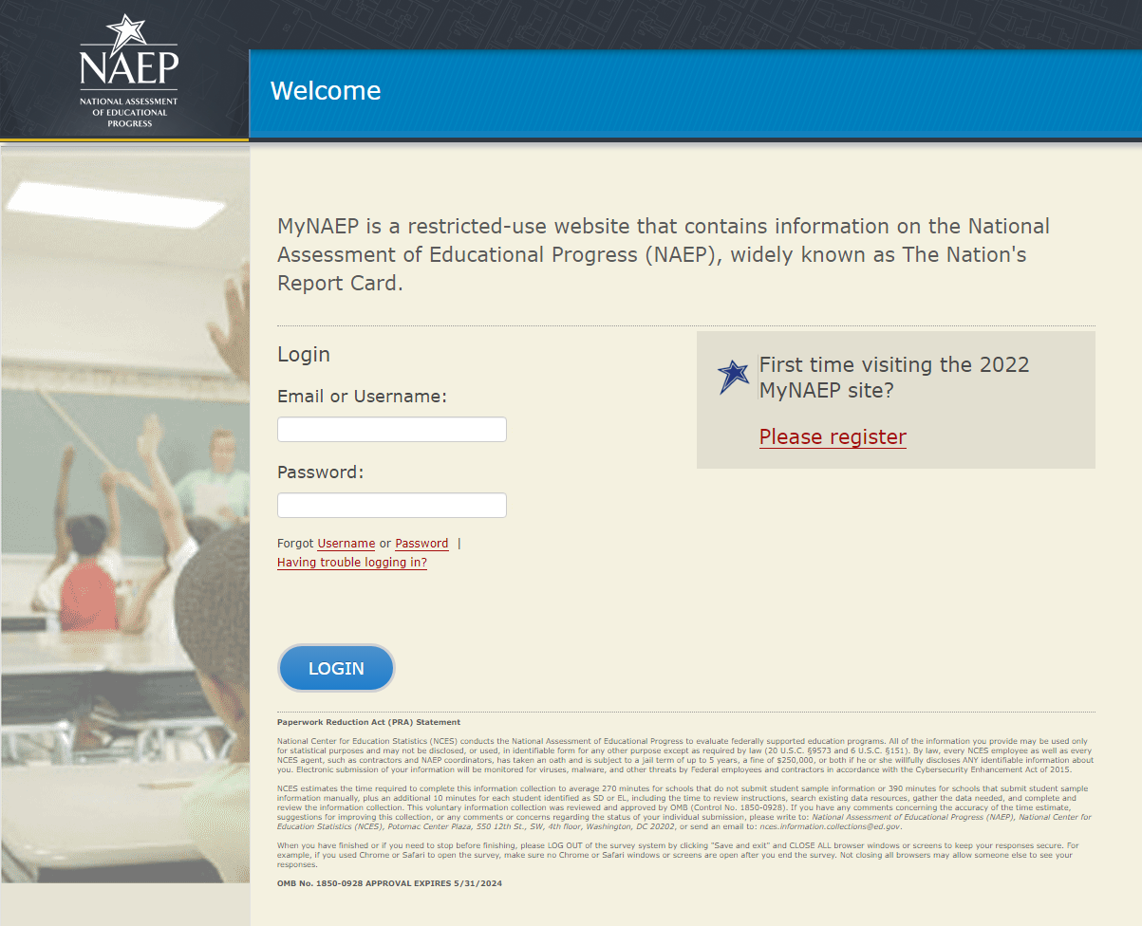

Home Page – Approved in v.23
Welcome to the National Assessment of Educational Progress!
The MyNAEP website will help you prepare for the assessment.
Assessment Details
Grade:
Subject(s):
Assessment Date:
Preassessment Review Call Date:
NAEP Representative:
MyNAEP Registration ID:
NAEP School Coordinator:
*If a school coordinator name does not appear above, then no one is currently assigned as school coordinator. Notify your NAEP State Coordinator, __(name)__, at __(email address)__ if this information is missing. School coordinators must register their own MyNAEP account.
Prepare for Assessment
It's time to prepare for your school's upcoming assessment date.
- The first step is to watch this quick tutorial video (https://bcove.video/2rHlh6v), which will give you an overview of the Prepare for Assessment menu.
- Complete the activities in the menu before your scheduled preassessment review call.
What's Next?
Download teacher notification letters and student appointment cards in the Support Assessment Activities section.

Summary of Changes from 2021 to 2022:
- No changes

Screenshot
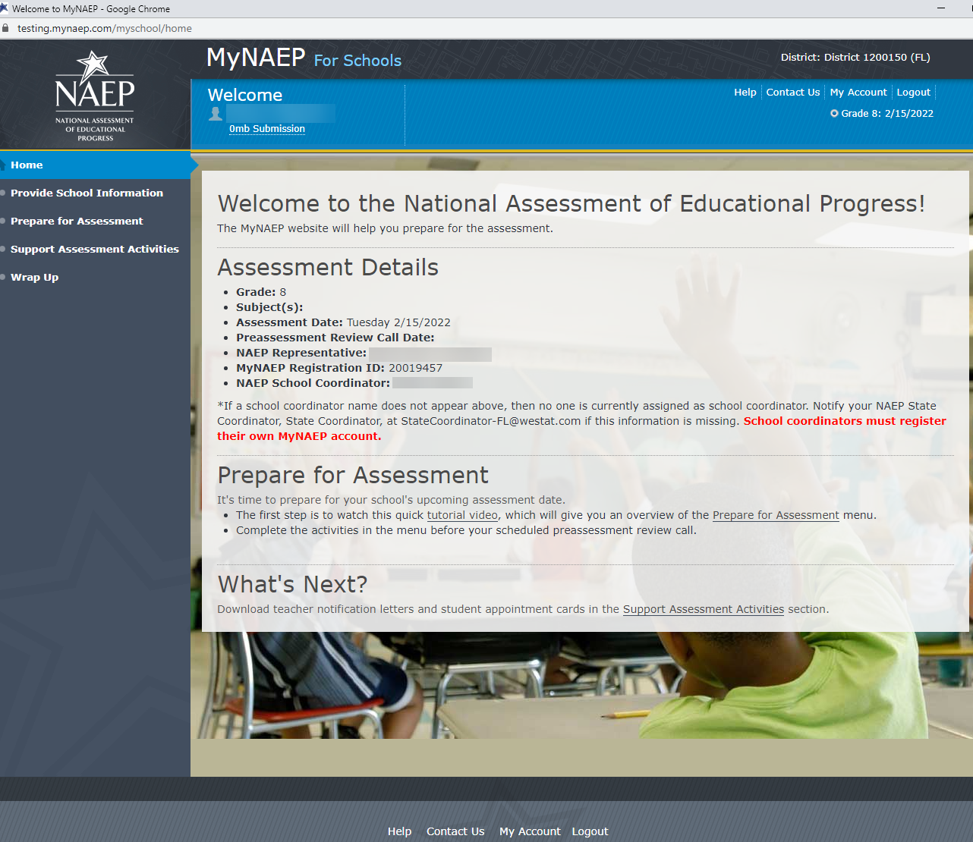

Provide School Information – Approved v.23
Provide School Information
Please use the links below to ensure that NAEP has the most up-to-date information about your school.
Complete the following:
School Contact Information
- School name and address
- Shipping address
- Principal contact information
- School coordinator contact information
School Characteristics Information
- Student enrollment
- Charter school status
- Date school adjourns for winter break in December
- Date school returns from winter break in January
- School calendar type (traditional or year round)
- School start and end times
Student Attendance and NAEP Representative Protocols
- Student Attendance
- NAEP Representative Protocols
Summary of Changes from 2021 to 2022:
- Updated text in third link on landing page from “Student Attendance and Schedules” to “Student Attendance and NAEP Representative Protocols”.
- Same change was applied to sub-link in left-hand menu.

Screenshot
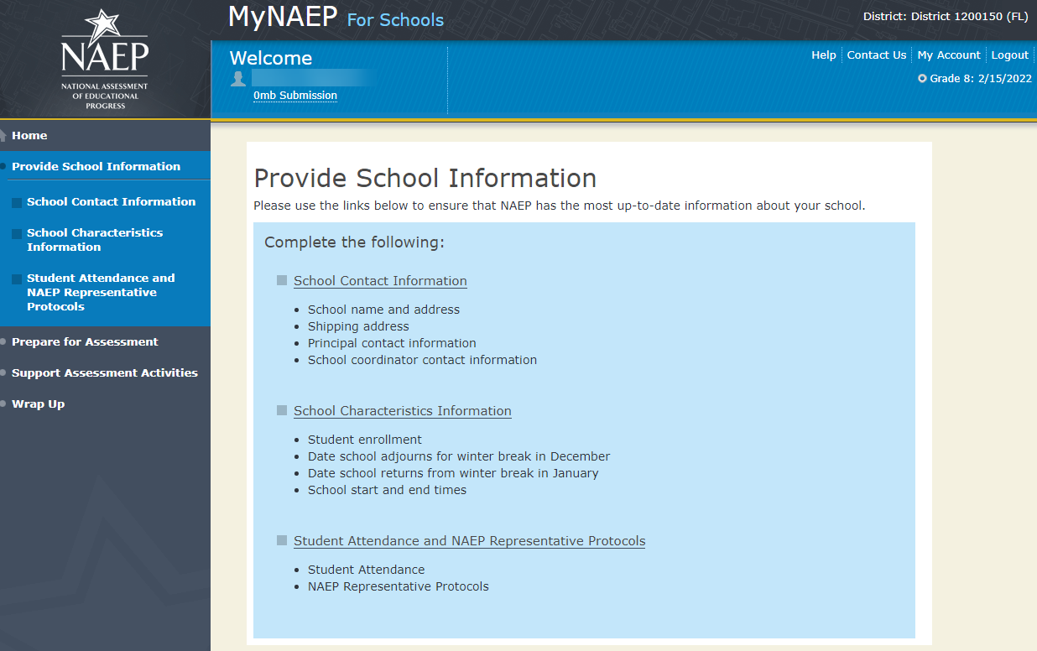

Student Attendance (NEW - Provide School Information Questions)

Student Attendance
NAEP assessments are administered to a sample of students on a single day. Each student takes an assessment in one subject area: <mathematics or reading or civics or U.S. history>. The assessment takes approximately 2 hours of student time to complete.
Please answer the following questions so NAEP can conduct the assessments in your schools.
Refer to the following definitions to answer the questions.
- In Person: Your school building is open, and learning is conducted through face-to-face instruction at least one day a week.
- Full time remote/virtual: Students attending school at home, using computers and/or at-home packets to learn remotely. Students do not attend any classes on campus.
- Currently: As of today what is your enrollment. You only need to enter this once and you do not need to update as enrollment changes.
1. Select all days during which grade X students attend school in your school building.
Monday
Tuesday
Wednesday
Thursday
Friday

2. Your grade X enrollment is XX. <Note: if this number is missing, the following text will appear instead, “Your grade X enrollment is missing from the School Characteristics section.”>. How many enrolled grade X students currently attend school full time remotely/virtually?
Note: The sum of in-person and full time remote/virtual students should equal your total grade X enrollment.
3. How many enrolled grade X students currently attend school in person (full time or at least one day a week) in your school building?
Note: The sum of in-person and full time remote/virtual students should equal your total grade X enrollment.
Summary of Changes from 2021 to 2022:
- Removed all of the student attendance questions from NAEP 2021.
- Replaced with six new questions, three of the new questions are on the “Student Attendance” page.

Screenshot
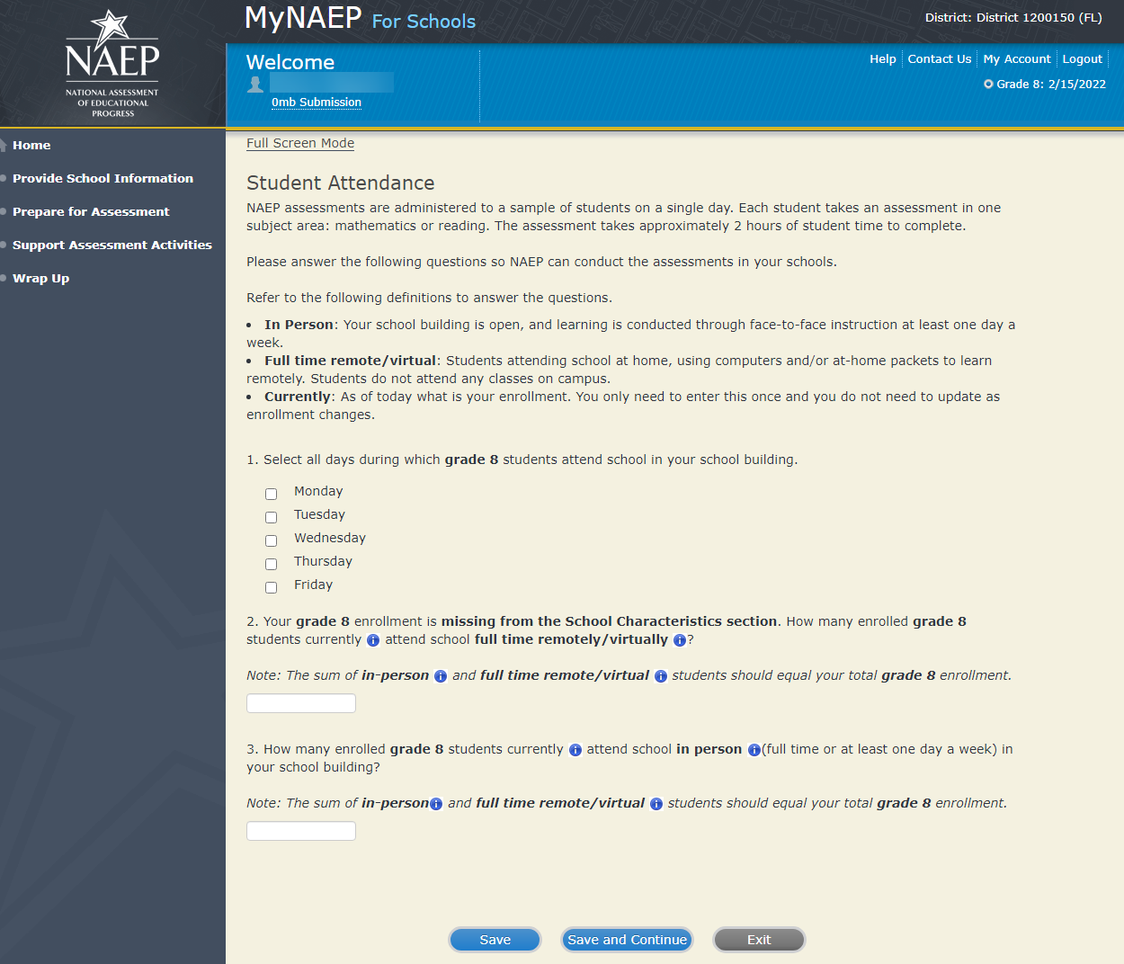

NAEP Representative Protocols (NEW Provide School Information Questions)

NAEP Representative Protocols
NAEP representatives provide significant support to your school by administering the assessment and bringing all necessary materials and equipment. NAEP representatives’ top priority is to protect the health and safety of students and school staff.
Please answer the following questions so the NAEP representatives are prepared to administer assessments to the students in your school.
1. NAEP representatives follow the protocols in the COVID-19 Protocols fact sheet. Do NAEP representatives need to follow additional protocols when administering assessments to students in your school?
Yes
No

2. Do any state or district policies require NAEP representatives to be vaccinated for COVID-19 to administer assessments to students in your school?
Yes
No

3. Do any state or district policies require NAEP representatives to test negative for COVID-19 prior to administering assessments to students in your school?

Yes
No

Summary of Changes from 2021 to 2022:
- Removed all of the student attendance questions from NAEP 2021.
- Replaced with six new questions, three of the new questions are on the “NAEP Representative Protocols” page.

Screenshot
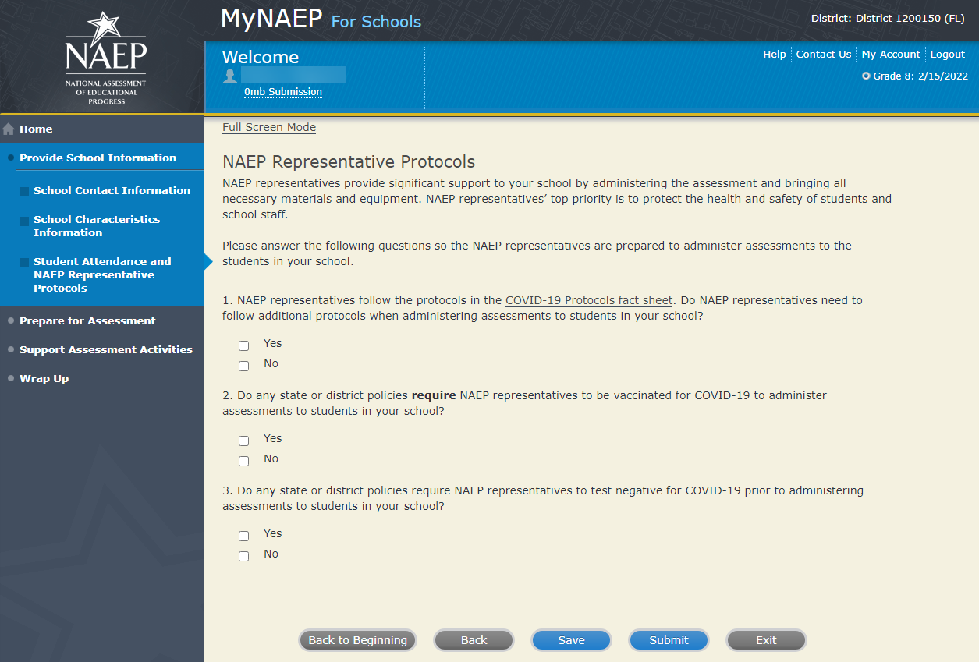

Prepare for Assessment - NEW
Prepare for Assessment
In early December, use the links on the left-hand menu under Prepare for Assessment to:
- Review and verify the list of students selected for NAEP
- Complete information about how students with disabilities and English learners will participate in NAEP
- Plan assessment day logistics
- Notify parents/guardians of sampled students
- Manage school and/or teacher questionnaires
- Encourage participation and motivate students to do their best
After winter break:
- Update the student list to include any new grade X students at your school
Your NAEP representative will contact the school in December to schedule a January call and review the completed preassessment activities.
Additional Resources
- Instructions for the School Coordinator (see Additional Resources section of this document)

Summary of Changes from 2019 to 2021:
- Removed references to storage envelope, since schools will not receive envelopes for NAEP 2022.
- The Instructions for School Coordinator brochure will be e-mailed, not mailed.
- Added thumbnail/link to new video that describes preassessment tasks.
Screenshot
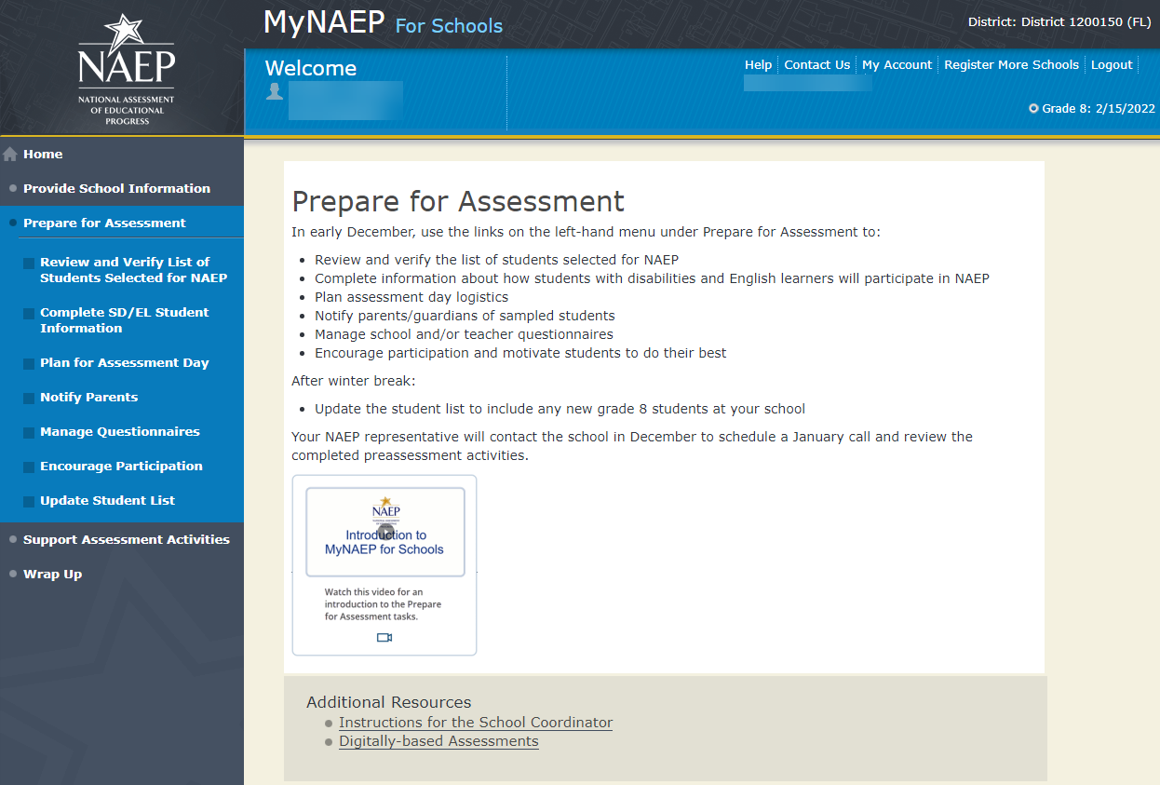

Review and Verify List of Students Selected for NAEP - NEW

Note: The student list is initially submitted outside of the MyNAEP system and the information is loaded into MyNAEP for the school coordinator to review and verify for accuracy.
Prepare for Assessment
Review and Verify List of Students Selected for NAEP
NAEP reports results for student demographic groups, so it is important to collect accurate data. Review the list of students to be tested at your school and update their enrollment status and demographic information as needed.
Complete the following:
- Watch the Review and Verify List of Students Selected for NAEP Tutorial (5:03) (https://bcove.video/2fEo6iA)
- Review and Verify Student Information
- Print Reports
Additional Resources
- Information Needed to Review and Verify List of Students Selected for NAEP
(see Additional Resources section of this document)
- Dept. of Agriculture Memo Authorizing Release of NSLP to NAEP
(see Additional Resources section of this document)
Summary of Changes from 2021 to 2022:
- Eliminated the word “Coordinator” from both of the Additional Resources links.

Screenshot
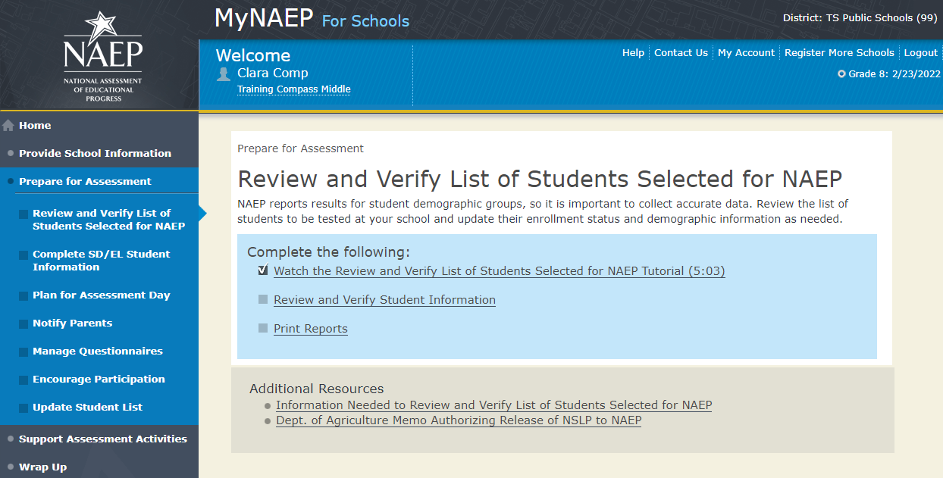

Review and Verify Student Information

Review and Verify Student Information
Print Worksheet – REV-INFO-1
Select Print Worksheet to review and note changes to student enrollment status and demographics on a hardcopy worksheet. Select Continue when you are ready to enter information into MyNAEP.
Some students may not be eligible to participate in NAEP. A list of possible reasons is available here.
(Note the content of the list is below for convenience of reviewing this appendix)
Reasons Student Cannot Take NAEP:
- Withdrawn
- Graduated
- Expelled
- Attends all classes on a different campus
- Traditional homeschool learner - parent provides curriculum and may/may not act as instructor
- Student listed more than once
- Not in tested grade
- Foreign exchange student
- Student deceased
- Long-term illness/homebound
- Parent notified about NAEP and refused NAEP testing
- Student notified about NAEP and refused NAEP testing
- Enrolled in U.S. schools less than one full academic year before the NAEP assessment and cannot access NAEP (applies only to English learners)
- Meets (or met) participation criteria for one or more state alternative assessments (applies only to students with disabilities)
- Full-time virtual learner

Summary of Changes from 2021 to 2022:
- Replaced “Does not attend any academic classes on campus” with “Attends all classes on a different campus”.
- Replaced “Home schooled and receives limited services on campus” with “Traditional homeschool learner - parent provides curriculum and may/may not act as instructor”.
- Added “Full-time virtual learner.”

Screenshot
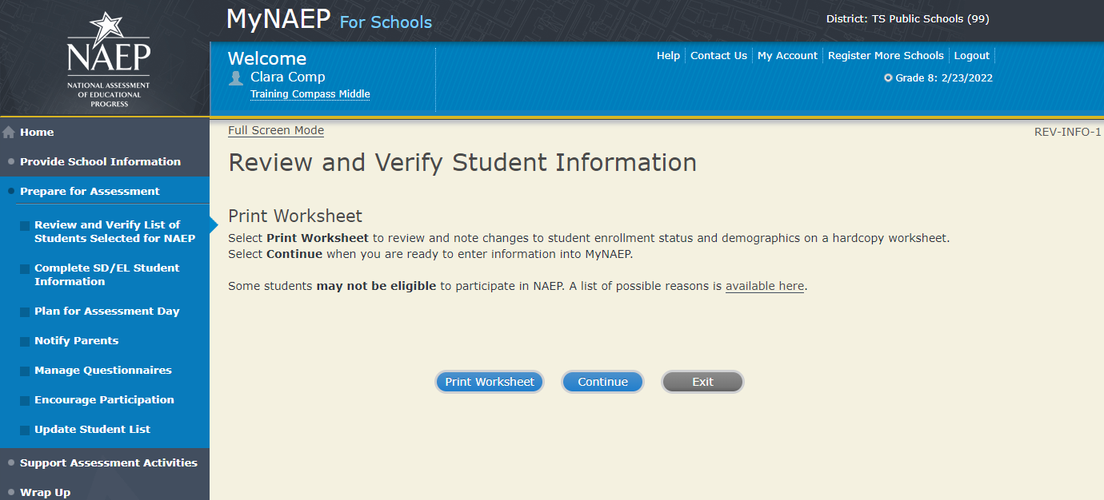
Review and Verify Student Information
Demographic Data-REV-INFO-2
Note: School coordinators will be asked to review and verify student demographic information (as shown in the screenshot below), and also to indicate whether students were displaced from a natural disaster (screen REV-INFO-7).
Review all demographic data for the students listed below.
- Select the Edit pencil next to the student name to enter a student's correct or missing information, indicate a reason the student cannot take NAEP, and update their in-person or virtual learning status. It is important for NAEP to know if students are attending school in-person, or are part-time or full-time virtual/remote learners.
- Icons in the column header indicate missing data. Hover over the icon to see how many students have missing data.
- All columns can be sorted by clicking on the column header. Missing data will filter to the top.
- Update students with a Section 504 Plan that require an accommodation in the Student with Disability column to Yes, 504.
- Indicate students who are hybrid (part-time) virtual learners in the "Is this student a virtual learner" column.
Summary of Changes from 2021 to 2022:
- Added text about part- and full-time virtual learners to the first paragraph because the data was previously collected on another page.
- Eliminated bullets related to COVID-19.
- Reworded bulleted text regarding the Missing Data icon.
- Reworded bulleted text related to students with a Section 504 Plan.
- Added bulleted text related to the “Is This Student a Virtual Learner” column because the data was previously collected on another page.
- Updated ELL to EL.

Screenshot
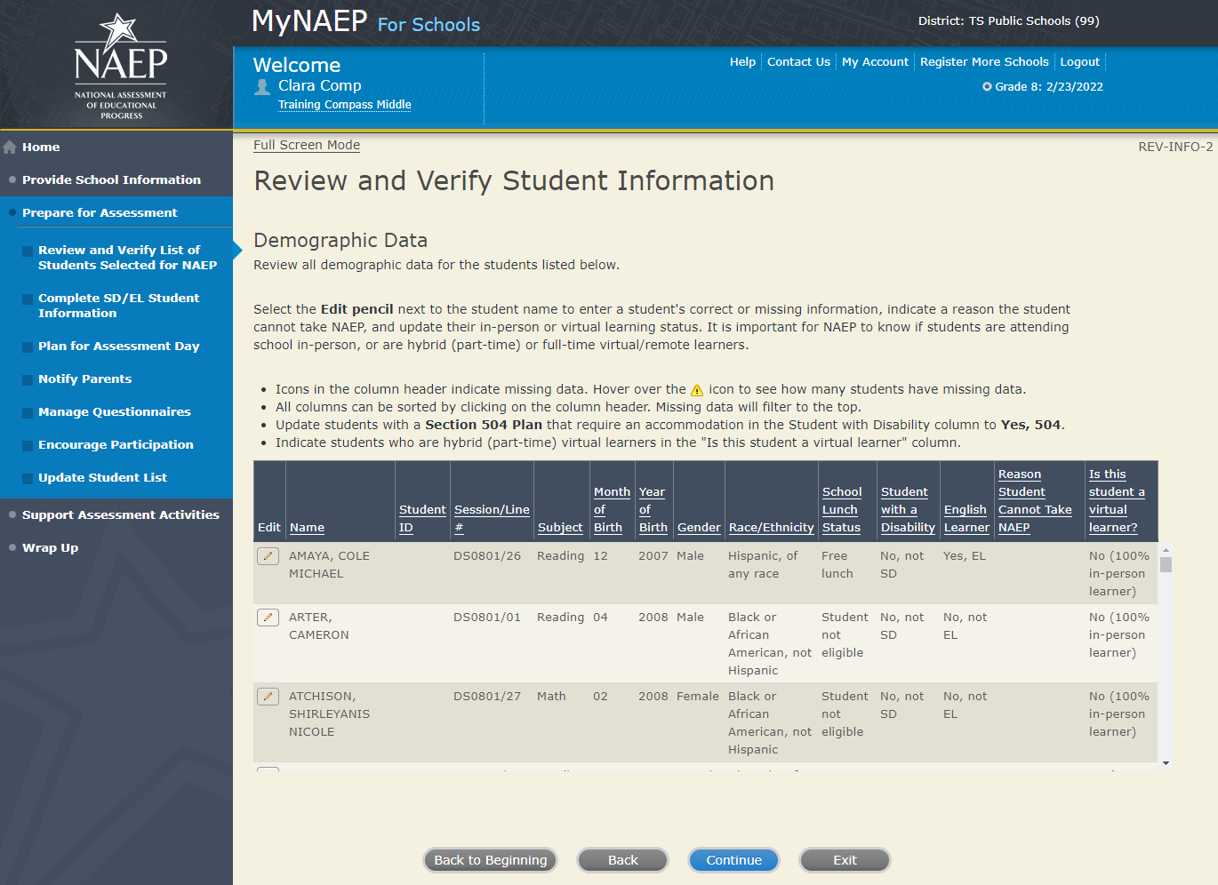

Review and Verify Student Information
Review and Verify Student Information-REV-INFO-5
The students listed below have been identified as American Indian or Alaska native. These students will complete an additional shorty questionnaire for the National Indian Education Study. Please review and confirm the race of each student.
Summary of Changes from 2021 to 2022:
- This screen will not be used for NAEP 2022 since the National Indian Education Study will not be conducted.

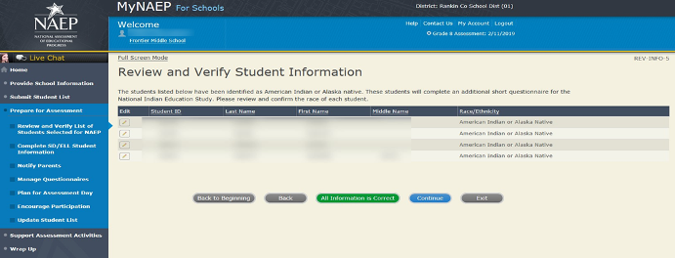

Review and Verify Student Information
Identify Displaced Students -REV-INFO-6
Due to natural disasters, families may be forced from their homes, displacing students who have enrolled outside their home district or state. For reporting purposes, NAEP is collecting information about displaced students.
Are any of the students listed below enrolled in your school because they were displaced from another district or state by a disaster, such as a hurricane?
Note: The choices for the “Is this a displaced student?” drop-down menu are:
- No
- Yes
- Information unavailable
Summary of Changes from 2021 to 2022:
- Due to the combination of the virtual learner status into REV-INFO-2, the screen identifier for Identify Displaced Students was updated to follow numerical order.

Screenshot
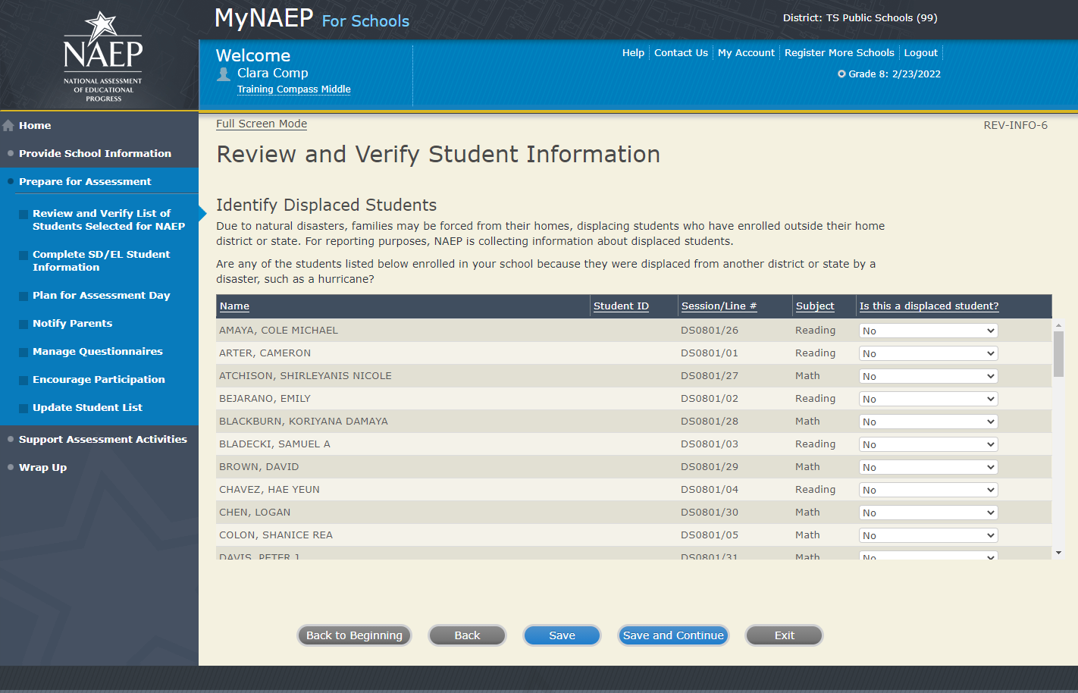

Review and Verify Student Information
Print Summary Report -REV-INFO-7
Select Print Summary to print a record of the student information entered into MyNAEP. Keep this report in a secure location and refer to it during the preassessment review call.
Select Submit when you are finished with this section.
Please certify that you have reviewed all the demographic data, have updated any students to 504 that need accommodations, and updated any students who are not able to participate on NAEP by typing your name in the box.
In January, you will need to return to MyNAEP for Schools to complete the Update Student List section in the left hand menu. If you would like to learn more about Update Student List tasks you will complete, you can click here.

Summary of Changes from 2021 to 2022:
- Due to the altered screen identifier for Identify Displaced Students, the screen identifier for Print Summary Reports was updated to follow numerical order.

Screenshot
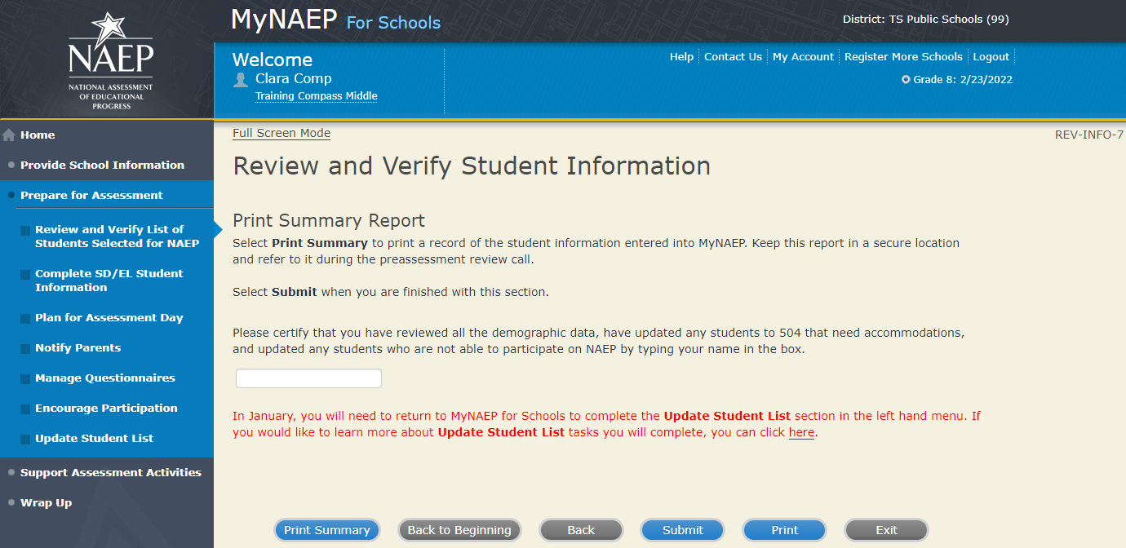

Print Reports

Print Reports – REV-REP-1
Before entering student data in the system
Print this worksheet and use it to review and verify student enrollment status and demographics before entering the data into the system.
After entering student data in the system
Select Print Summary Report to print a record of the student information entered in the system. Keep this report in a secure location and refer to it during the preassessment review call.

Select submit to indicate you are finished with this section.
Summary of Changes from 2021 to 2022:
- Added a prompt for school coordinators to select submit to indicate they have finished with the section.
Screenshot
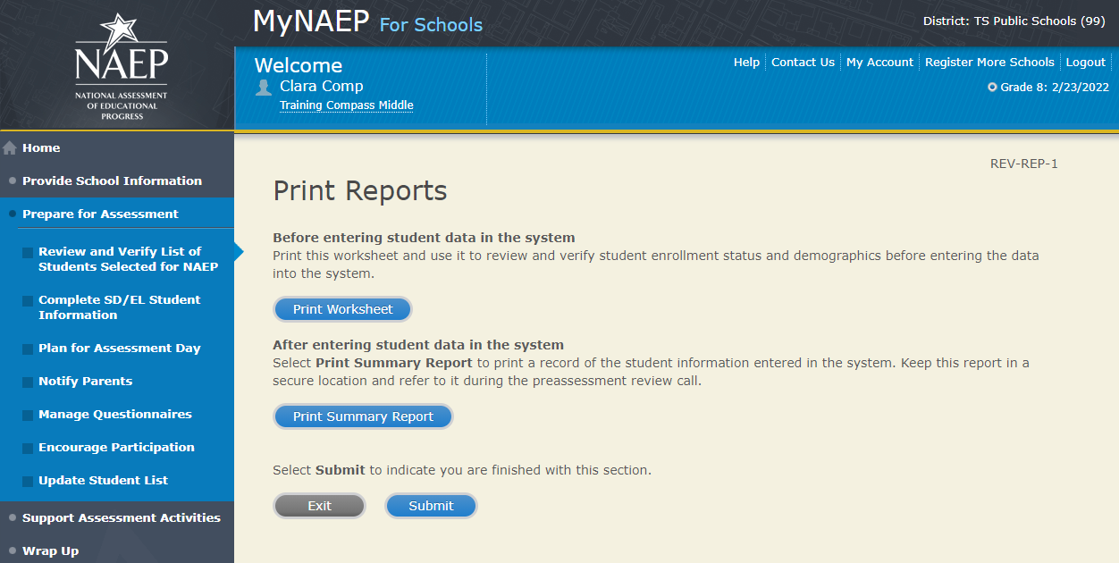

Sample of information included in the worksheet and summary report (note the worksheet is a resource to assist teachers in collecting the information that will be contained in the summary report)
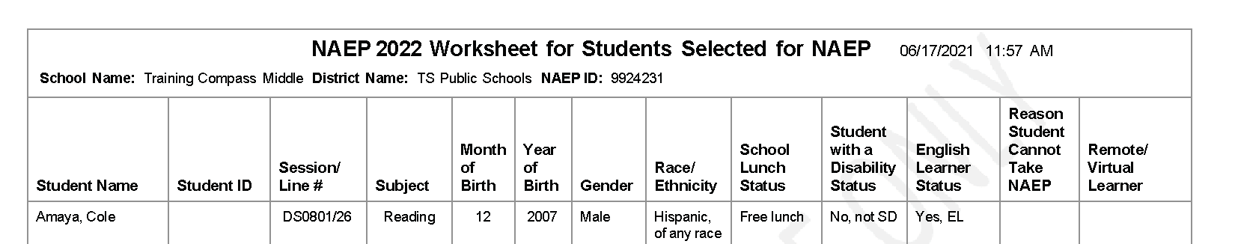

Complete SD/EL Student Information - NEW
Note: In this section the school coordinator will provide information to determine how students participate in NAEP (i.e., without accommodations, with accommodations, or do not test). The school coordinator will provide the Individuals with Disabilities Education Act (IDEA) disability status, English proficiency, primary language, grade-level performance, and accommodations, using the state-specific NAEP inclusion policies (see Appendices D1-5 and D1-6 for templates of the SD and EL inclusion policies, which are customized by the NAEP State Coordinators). The purpose of providing this information is to make sure students have appropriate supports to access the NAEP assessment.
Prepare for Assessment
Complete SD/EL Student Information
To ensure that NAEP reflects the educational progress of all students, students with disabilities (SD) and English learners (EL) must be included to the fullest extent possible.
NAEP provides accommodations only for SD and EL. Therefore, this section only includes students whose SD status is "Yes, IEP" or "Yes, 504" or EL status is "Yes, EL." Changes to these status codes can only be made in the Review and Verify List of Students Selected for NAEP section.
The information that you provide in this section indicates how students will participate in NAEP and the accommodations they will receive.
Complete the following:
- Watch Complete SD/EL Student Information Tutorial (5:59) (https://bcove.video/2fECUxM)
- Review NAEP Inclusion Policy
- Give Access to SD and/or EL Specialist(s) (optional)
- Provide Information for Students Who Are Both SD and EL
- Provide Information for SD (IEP or 504 Plan) Only
- Provide Information for EL Only
- Print Reports
- Create Accommodation Sessions (Field Staff Only)
Additional Resources
- Inclusion on NAEP Fact Sheet
- Letter from Department of Education Encouraging Inclusion
- Information Needed to Include SD/EL Students

Summary of Changes from 2021 to 2022:
- Updated references to English Language Learners (ELL) to English Learners (EL)
Screenshot
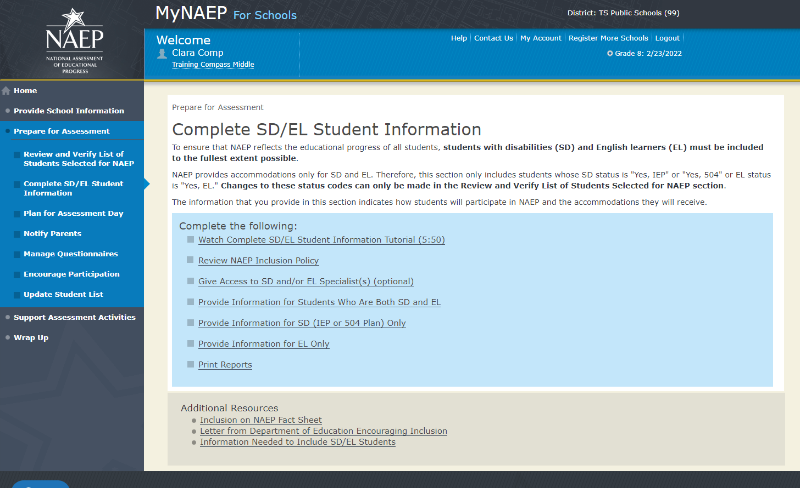

Review NAEP Inclusion Policy

Review NAEP Inclusion Policy-COMP-INCL 1-1 (see Appendices D1-5 and D1-6)
<state name> NAEP 2022 Inclusion Policy for Students with Disabilities and English Learners
The policy provides inclusion expectations, lists the NAEP accommodations, and describes how the accommodations are administered.
SD Inclusion Policy (see Appendix D1-5)
EL Inclusion Policy (see Appendix D1-6)
We expect most students with disabilities and English learners to participate. The only students eligible for exclusion are:
Students who meet (or met) participation criteria for the State Alternate Assessment
English learners who have been enrolled in U.S. schools less than 1 full academic year before the NAEP assessment and cannot access NAEP
All other SD and EL students should participate with or without NAEP accommodations.
Monitoring Exclusions
Your NAEP State Coordinator will monitor exclusions and may contact you regarding excluded students. If you have any questions about how to include a student, contact your NAEP State Coordinator, NAME, at EMAIL ADDRESS.
I downloaded and reviewed the <state name> NAEP Inclusion Policy for Students with Disabilities and English Learners.
Yes No
Select the Submit button to record your response above.
Summary of Changes from 2021 to 2022:
- Updated references to English Language Learners (ELL) to English Learners (EL)
- Add text to prompt school coordinator to select submit

Screenshot
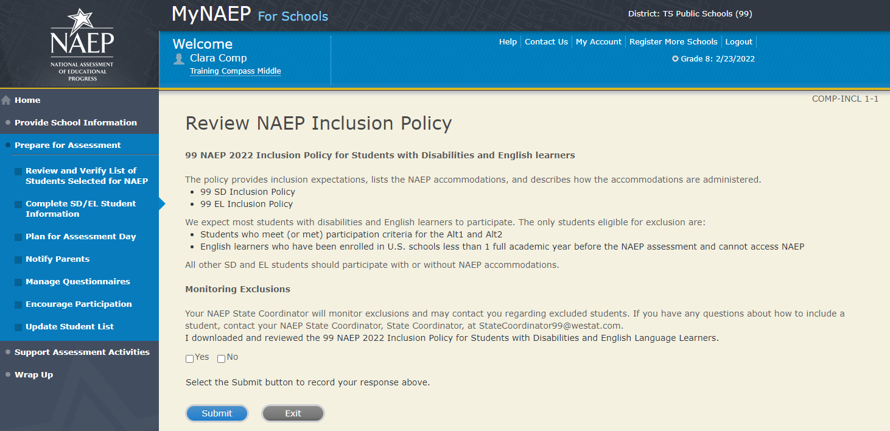

Give Access to SD and/or EL Specialists

Please complete the Review and Verify List of Students Selected for NAEP section before giving access to SD and/or EL Specialists
Give Access to SD and/or EL Specialists-COMP-SPEC 1-1
The person most familiar with how students with disabilities (SD) and English learners (EL) are tested should provide the information for these students. Complete and submit the information below to give access to the Complete SD/EL Student Information section for one or more SD/EL specialists.

For confidentiality reasons, access is limited to you and five additional school staff.
- Enter all names and email addresses then select Save.
- Select the Send Email button for each record.
- Select Submit.
Summary of Changes from 2021 to 2022:
- Updated references to English Language Learners (ELL) to English Learners (EL)

Screenshot
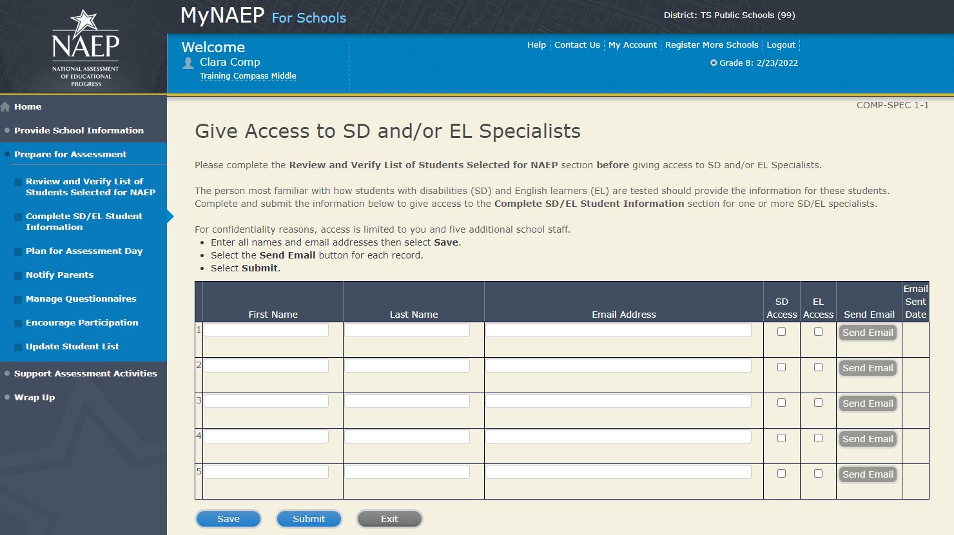

Provide Information for Students Who Are Both SD and EL

Print Worksheet-COMP-BOTH-2
Select Print Worksheet to record the information for each student on a hardcopy worksheet. Select Continue when you're ready to enter information into MyNAEP.
Review the <State name> NAEP 2022 inclusion policy (see appendices D1-5 and D1-6) to see the universal design elements and accommodations for NAEP, and to determine how students should participate.
Summary of Changes from 2021 to 2022:
- No changes.

Screenshot
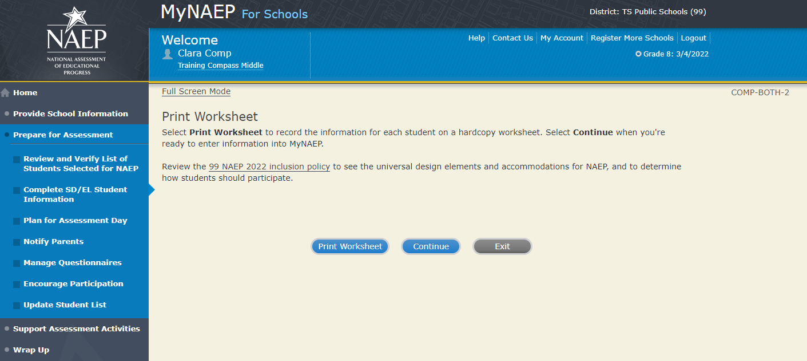

EL Details-COMP-BOTH-3
For each student listed below, record the following information by selecting the Edit pencil next to the student name. Review the NAEP inclusion policy (see appendices D1-5 and D1-6) prior to completing.
- What is the student's primary language?
- Including this year, how long has this student been receiving academic instruction primarily in English? (note a hover note displays in the system that reads: Instructor presents academic content in English and the student receives only occasional translation of words or explanation of ideas/concepts in his/her native language.)
- At what grade level (note a hover note displays in the system that reads: For example, a grade 4 student is selected to take the NAEP math assessment who performs at a second-grade level should be marked as two or more years below grade level.) does this student perform in the NAEP subject?
- How would you characterize this student’s English proficiency (note a hover note displays in the system that reads: How this student's English language proficiency compares to other ELS in the same grade.) in listening comprehension, reading, speaking, and writing?
All columns can be sorted by selecting the column header.
Summary of Changes from 2021 to 2022:
- Updated references to English Language Learners (ELL) to English Learners (EL)

Screenshot
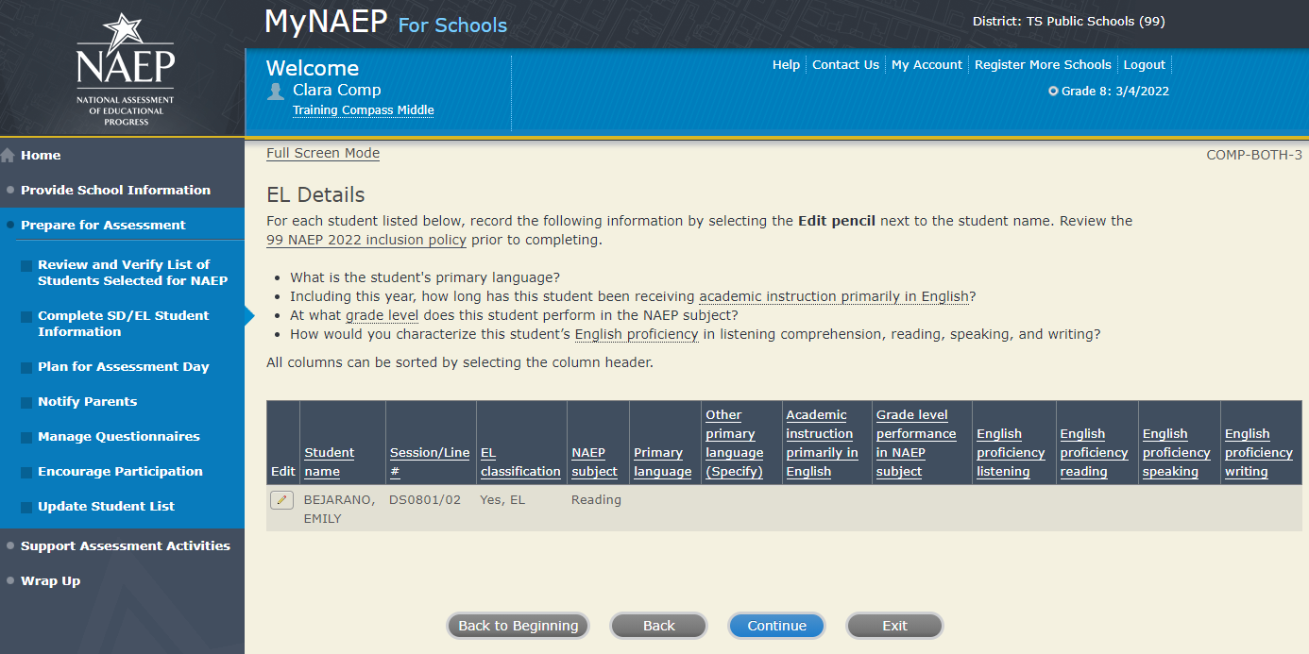

SD Details-COMP-BOTH-4
For each student listed below, record the following information by selecting the Edit pencil next to the student name. Review the NAEP inclusion policy prior to completing.
- Which of the following IDEA categories (see list below) best describes each student’s identified disability(ies)? (Note: This question is not applicable to students marked as Yes, 504.)
  - Autism
  - Deaf-blindness
  - Developmental delay
  - Emotional disturbance
  - Hearing impairment, including deafness
  - Intellectual disability
  - Multiple disabilities
  - Orthopedic impairment
  - Other health impairment
  - Specific learning disability
  - Speech or language impairment
  - Traumatic brain injury
  - Visual impairment, including blindness
- What is the degree (note that in the system a hover note appears that reads: The response should be based on the knowledge of the person most familiar with this student's disability(ies) and based on the professional judgment how it/they might compare to other students with similar) of each student's disability(ies)?
All columns can be sorted by selecting the column header.
Summary of Changes from 2021 to 2022:
- Screen identifier updated to keep numerical order.
Screenshot
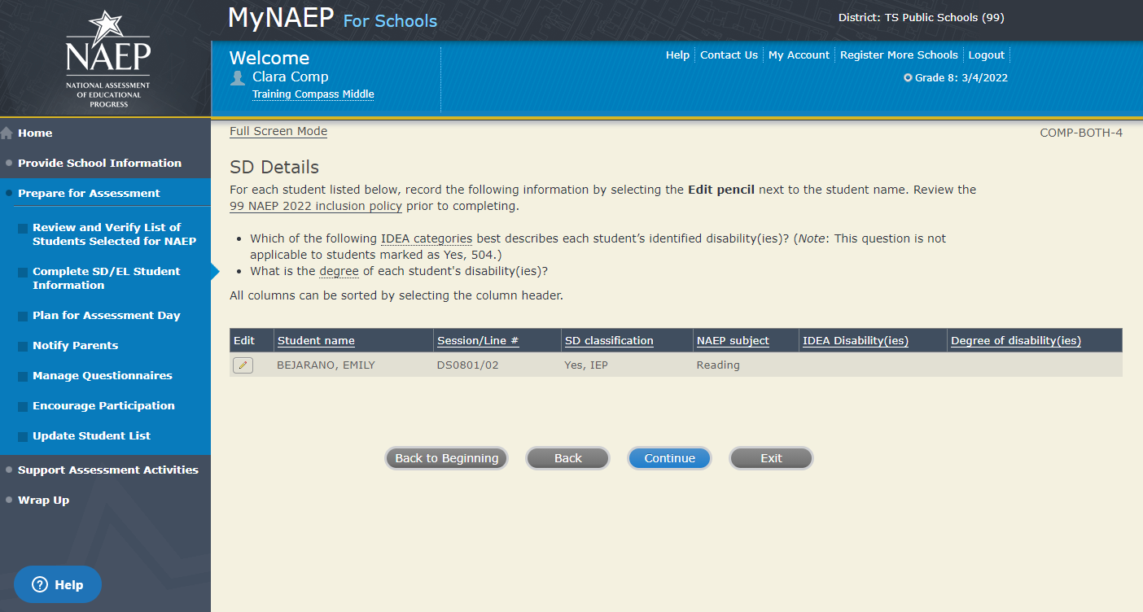

How Students Should Participate-COMP-BOTH-5
For each student listed below, record the following information by selecting the Edit pencil next to the student name. Review the <State name> NAEP 2022 inclusion policy (see Appendices D1-5 and D1-6) prior to completing. If you have any questions on how to include students, contact your NAEP State Coordinator, <State Coordinator Name>, at <State Coordinator email address>.
- How long has each student been enrolled in U.S. schools?
- How is each student assessed on the state or classroom assessments in the NAEP subject?
- How should each student be assessed on NAEP?
- (If appropriate) What universal design elements and accommodations does the student need to access NAEP?
- (If appropriate) Reason student cannot take NAEP?
- (If appropriate) Is the decision to exclude each student a school decision or a parent/student decision?
All columns can be sorted by selecting the column header.
Summary of Changes from 2021 to 2022:
- Updated references to English Language Learners (ELL) to English Learners (EL)
- Screen identifier updated to keep numerical order.

Screenshot
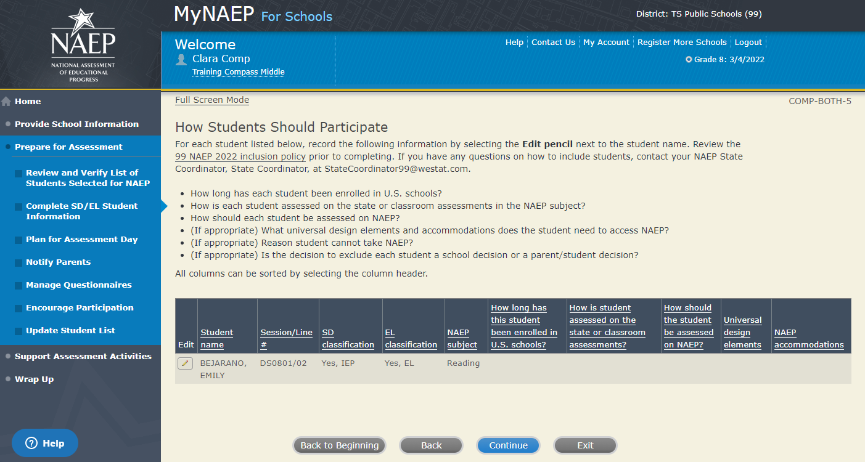

Exclusions Summary-COMP-BOTH-9

The student(s) listed below are marked as “Do not test” and will be excluded from the NAEP assessment.

Your NAEP State Coordinator will monitor exclusions and may contact you regarding excluded students. If you have any further questions on how to include students, contact your NAEP State Coordinator, First and Last Name, at Email address and/or review the <State name> NAEP 2022 inclusion policy (see Appendices D1-5 and D1-6).

Select Back to make any changes for the students on the previous screen.

All columns can be sorted by selecting the column header.

Summary of Changes from 2021 to 2022:
- Updated references to English Language Learners (ELL) to English Learners (EL)
- Screen identifier updated to keep numerical order.

Screenshot

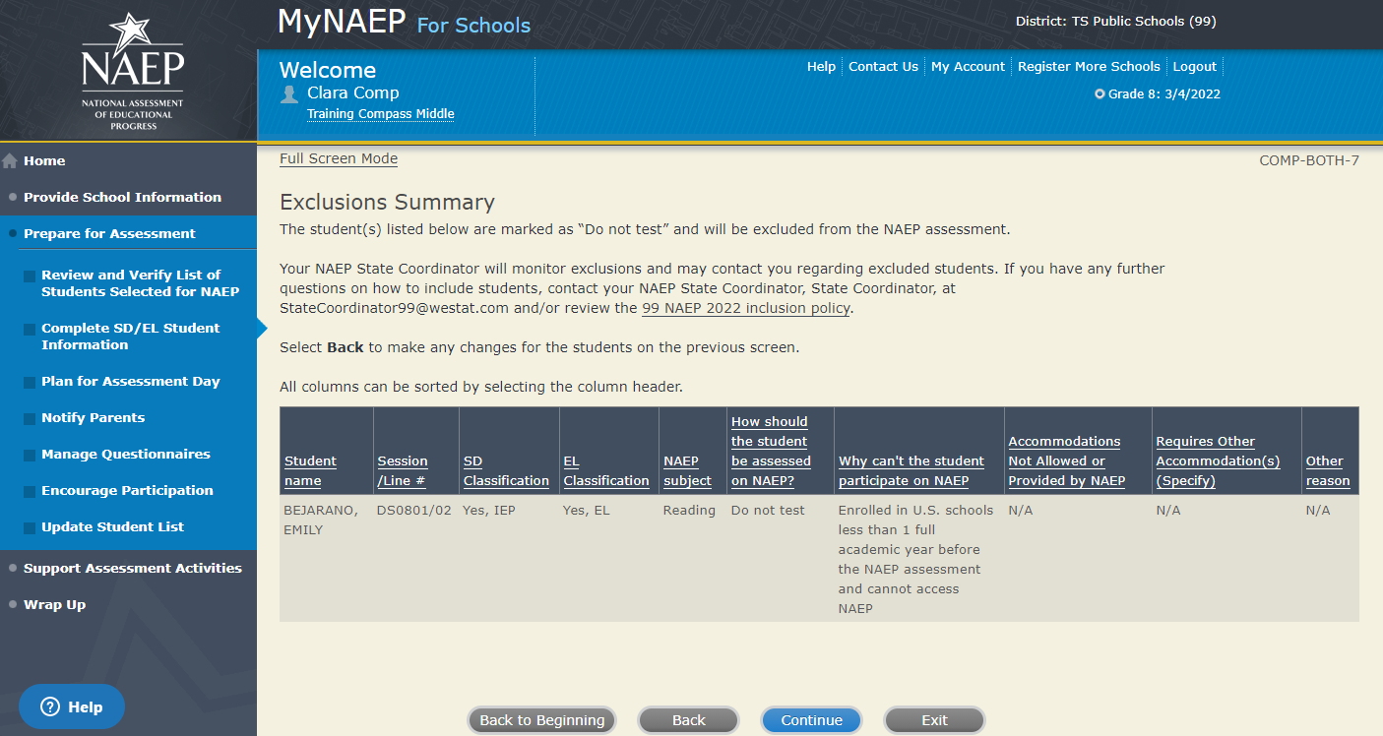
Print Summary Report-COMP-BOTH-11
Thank you for providing student data. If you have any further questions, contact your NAEP State Coordinator, <State Coordinator name>, at <State Coordinator email>.
Your NAEP State Coordinator will monitor exclusions and may contact you regarding excluded students.
Select Print Summary to print a record of the student information entered into MyNAEP. Keep this report in a secure location and refer to it during the preassessment review call.
Select Submit when you are finished with this section.
Summary of Changes from 2021 to 2022:
- Updated references to English Language Learners (ELL) to English Learners (EL)
- Screen identifier updated to keep numerical order.
Screenshot
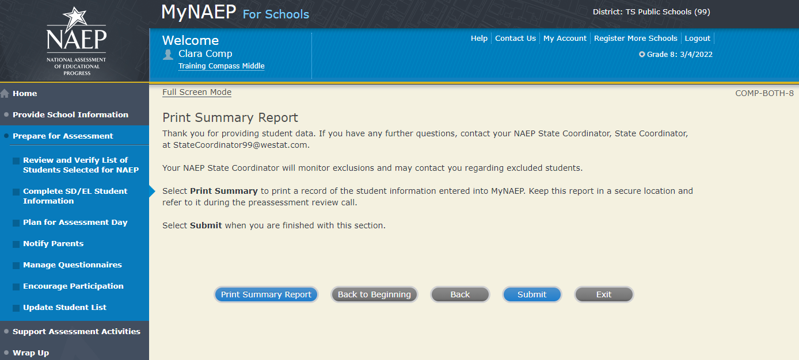

Provide Information for SD (IEP or 504 Plan) Only

Print Worksheet-COMP-SD-2
Select Print Worksheet to record the information for each student on a hardcopy worksheet. Select Continue when you're ready to enter information into MyNAEP.
Review the <State name> NAEP 2022 inclusion policy (see Appendix D1-5) to see the universal design elements and accommodations for NAEP, and to determine how students should participate.
Summary of Changes from 2021 to 2022:
- No changes.
Screenshot
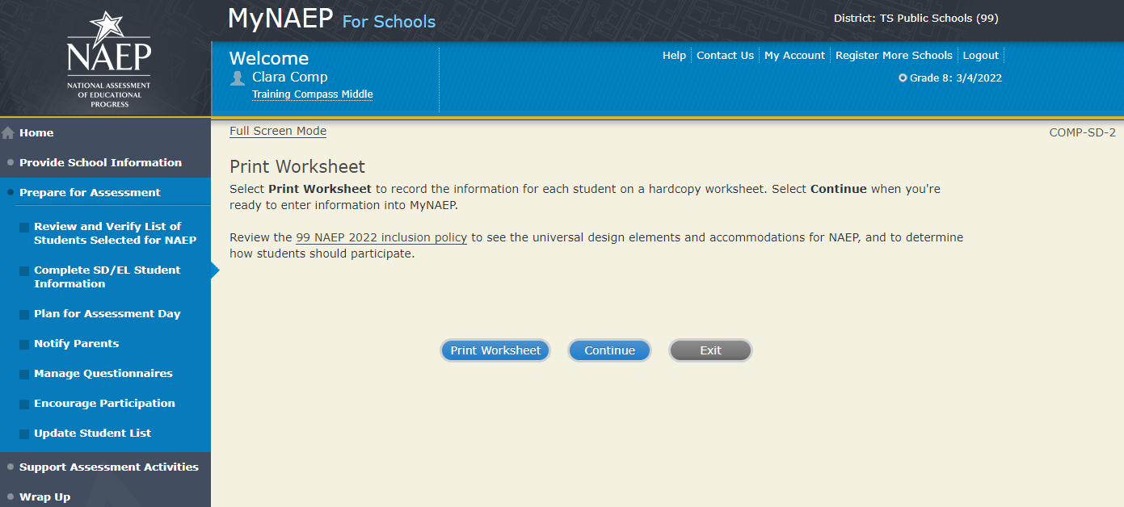

SD Details-COMP-SD-3
For each student listed below, record the following information by selecting the Edit pencil next to the student name:
- Which of the following IDEA categories (see list below) best describes each student’s identified disability(ies)? (Note: This question is not applicable to students marked as Yes, 504.)
  - Autism
  - Deaf-blindness
  - Developmental delay
  - Emotional disturbance
  - Hearing impairment, including deafness
  - Intellectual disability
  - Multiple disabilities
  - Orthopedic impairment
  - Other health impairment
  - Specific learning disability
  - Speech or language impairment
  - Traumatic brain injury
  - Visual impairment, including blindness
- What is the degree (note that in the system a hover note appears that reads: The response should be based on the knowledge of the person most familiar with this student's disability(ies) and based on the professional judgment how it/they might compare to other students with similar) of each student's disability(ies)?
- At what grade level (note that in the system a hover note appears that reads: For example, a grade 4 student is selected to take the NAEP math assessment who performs at a second-grade level should be marked as two or more years below grade level) does this student perform in the NAEP subject?
All columns can be sorted by selecting the column header.
Summary of Changes from 2021 to 2022:
- No changes.
Screenshot
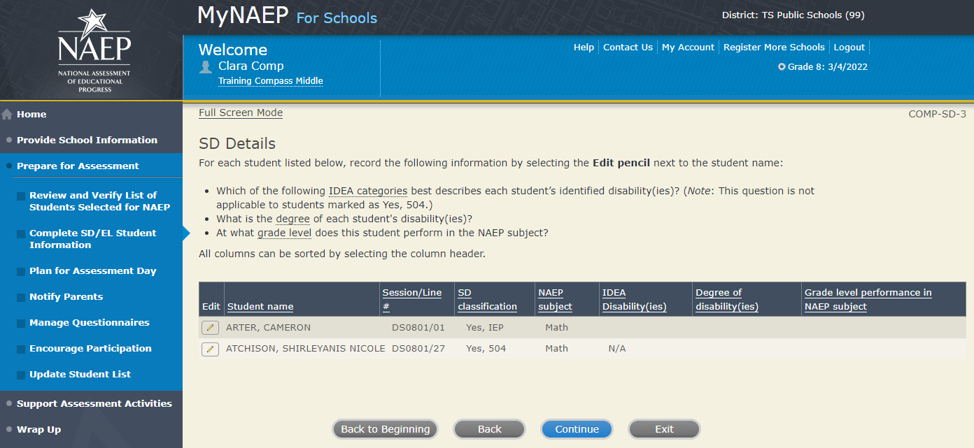

How Students Should Participate-COMP-SD-4
For each student listed below, record the following information by selecting the Edit pencil next to the student name. Review the <State name> NAEP 2022 inclusion policy (see Appendix D1-5) prior to completing. If you have any questions on how to include students, contact your NAEP State Coordinator, <State Coordinator name>, at <State Coordinator email>.
- How is each student assessed on the state or classroom assessments in the NAEP subject?
- How should each student be assessed on NAEP?
- (If appropriate) What universal design elements and accommodations does the student need to access NAEP?
- (If appropriate) Reason student cannot take NAEP?
- (If appropriate) Is the decision to exclude each student a school decision or a parent/student decision?
All columns can be sorted by selecting the column header.

Summary of Changes from 2021 to 2022:
- No changes.

Screenshot
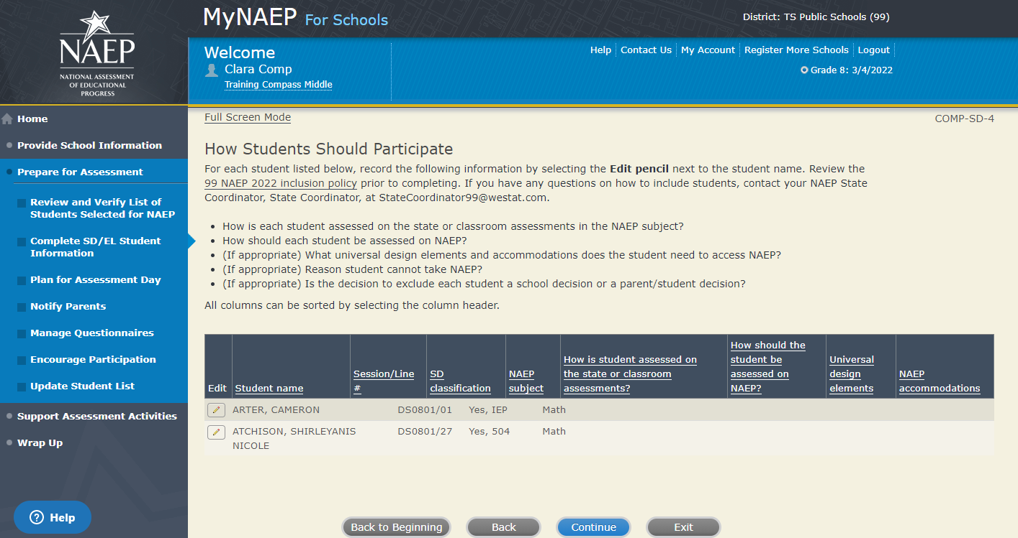

Exclusions Summary COMP-SD-6

The student(s) listed below are marked as “Do not test” and will be excluded from the NAEP assessment.

Your NAEP State Coordinator will monitor exclusions and may contact you regarding excluded students. If you have any further questions on how to include students, contact your NAEP State Coordinator, <State Coordinator name>, at <State Coordinator email> and/or review the <State name> NAEP 2022 inclusion policy (see Appendix D1-6) NAEP 2022 inclusion policy.

Select Back to make any changes for the students on the previous screen.

All columns can be sorted by selecting the column header.

Summary of Changes from 2021 to 2022:
- Screen identifier updated to keep numerical order
Screenshot
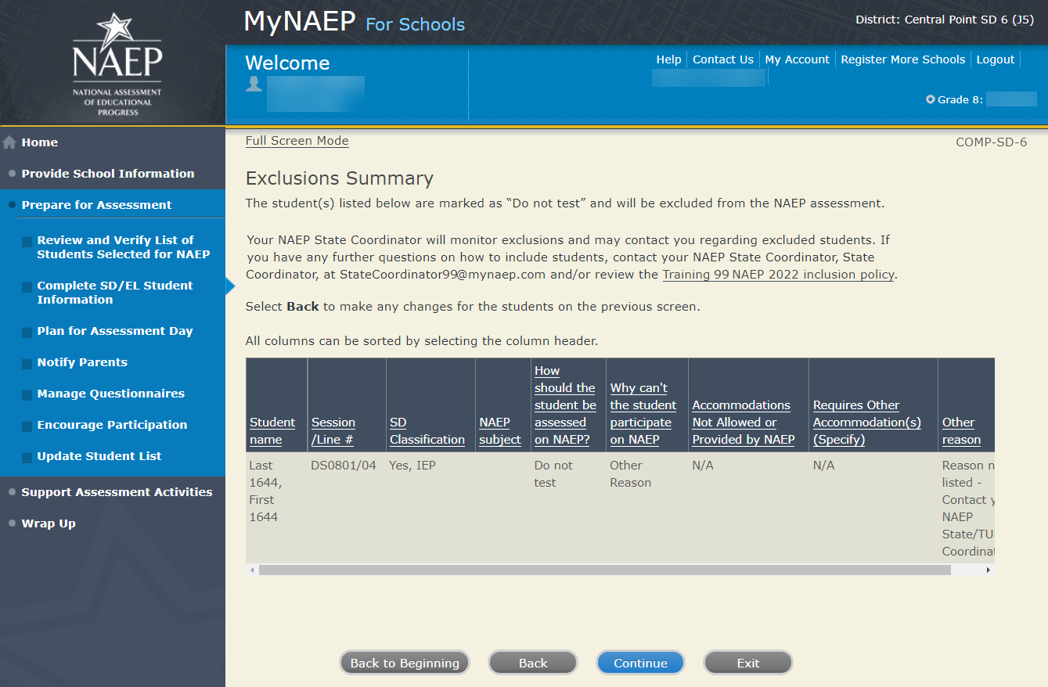

Print Summary Report-COMP-SD-7

Thank you for providing student data. If you have any further questions, contact your NAEP State Coordinator, <State Coordinator name>, at <State Coordinator email>.
Your NAEP State Coordinator will monitor exclusions and may contact you regarding excluded students.
Select Print Summary to print a record of the student information entered into MyNAEP. Keep this report in a secure location and refer to it during the preassessment review call.
Select Submit when you are finished with this section.

Summary of Changes from 2021 to 2022:
- Screen identifier updated to keep numerical order

Screenshot
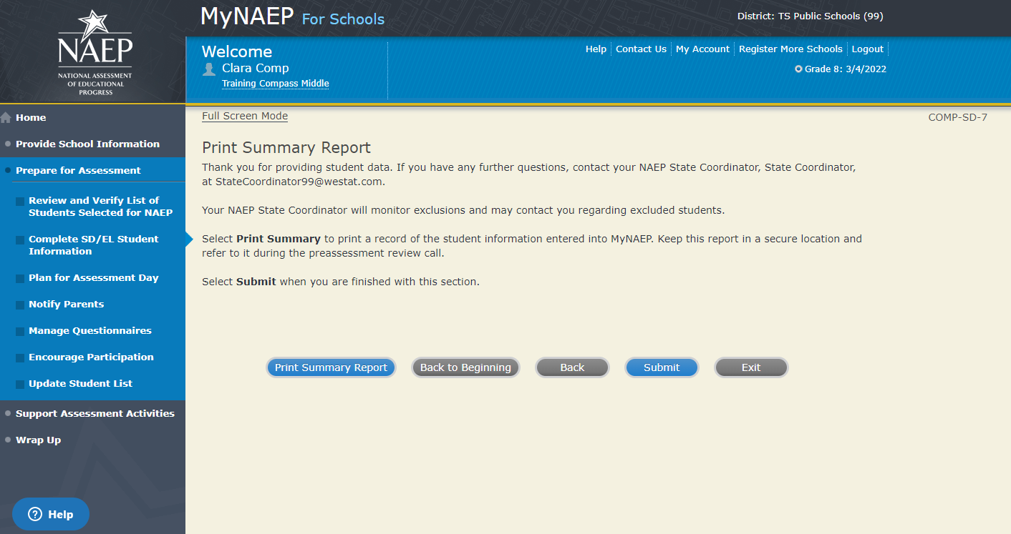

Provide Information for EL Only

Print Worksheet-COMP-EL-2
Select Print Worksheet to record the information for each student on a hardcopy worksheet. Select Continue when you're ready to enter information into MyNAEP.
Review the <State name> NAEP 2022 inclusion policy (see Appendix D1-6) to see the universal design elements and accommodations for NAEP, and to determine how students should participate.
Summary of Changes from 2021 to 2022:
- Updated references to English Language Learners (ELL) to English Learners (EL)

Screenshot
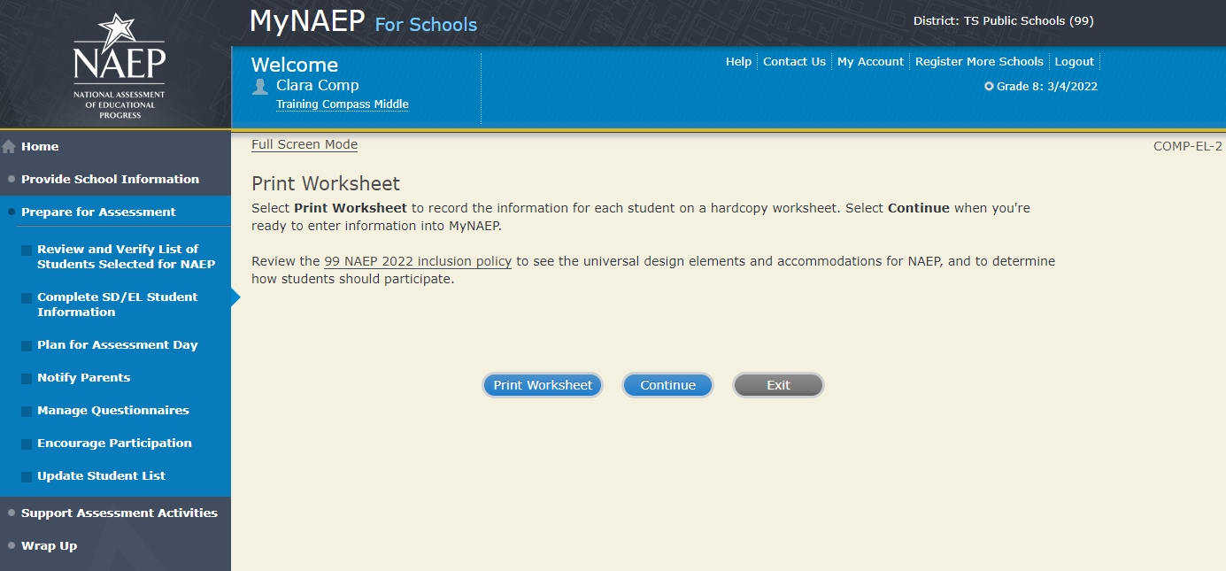

EL Details-COMP-EL-3
For each student listed below, record the following information by selecting the Edit pencil next to the student name. Review the <State name> NAEP 2022 inclusion policy (see Appendix D1-6) prior to completing.
- What is the student's primary language?
- Including this year, how long has this student been receiving academic instruction primarily in English? (note a hover note displays in the system that reads: Instructor presents academic content in English and the student receives only occasional translation of words or explanation of ideas/concepts in his/her native language.)
- At what grade level (note a hover note displays in the system that reads: For example, a grade 4 student is selected to take the NAEP math assessment who performs at a second-grade level should be marked as two or more years below grade level) does this student perform in the NAEP subject?
- How would you characterize this student’s English proficiency (note a hover note displays in the system that reads: How this student's English language proficiency compares to other ELs in the same grade.) in listening comprehension, reading, speaking, and writing?
All columns can be sorted by selecting the column header.
Summary of Changes from 2021 to 2022:
- Updated references to English Language Learners (ELL) to English Learners (EL)

Screenshot
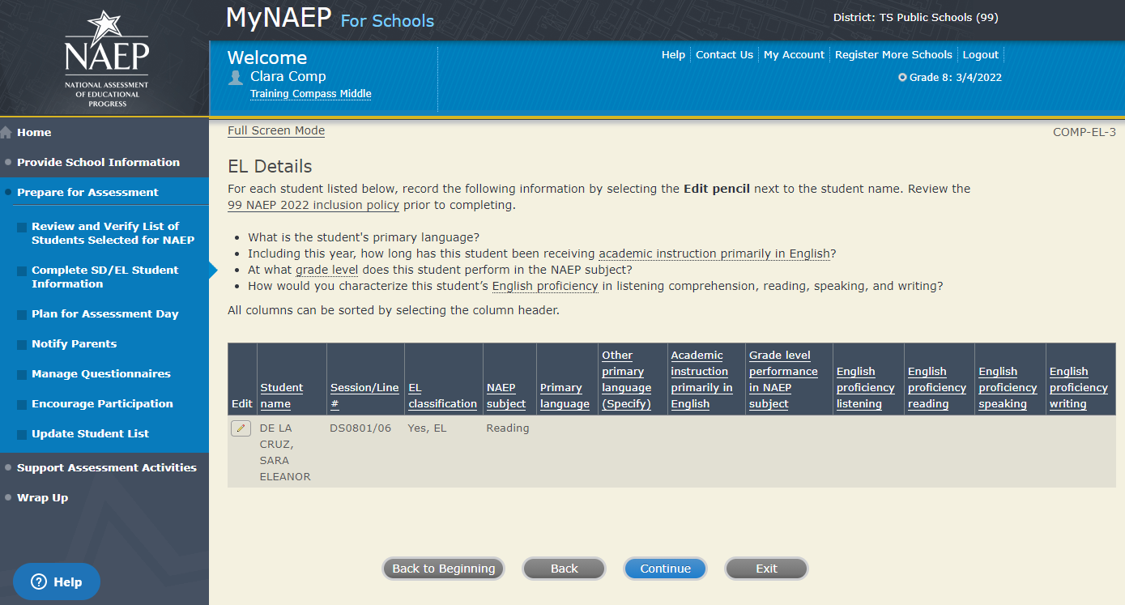

How Students Should Participate-COMP-EL-4
For each student listed below, record the following information by selecting the Edit pencil next to the student name. Review the <State name> NAEP 2022 inclusion policy (see Appendix D1-6) prior to completing. If you have any questions on how to include students, contact your NAEP State Coordinator, <State Coordinator name>, at <State Coordinator email>.
- How long has each student been enrolled in U.S. schools? (One full academic year is defined as one full school year before the assessment)
- How should the student be assessed on NAEP?
- (If appropriate) What universal design elements and accommodations does the student need to access NAEP?
- (If appropriate) Reason student cannot take NAEP?
- (If appropriate) Is the decision to exclude each student a school decision or a parent/student decision?
All columns can be sorted by selecting the column header.
Summary of Changes from 2021 to 2022:
- Updated references to English Language Learners (ELL) to English Learners (EL)
- Screen identifier updated to keep numerical order
Screenshot
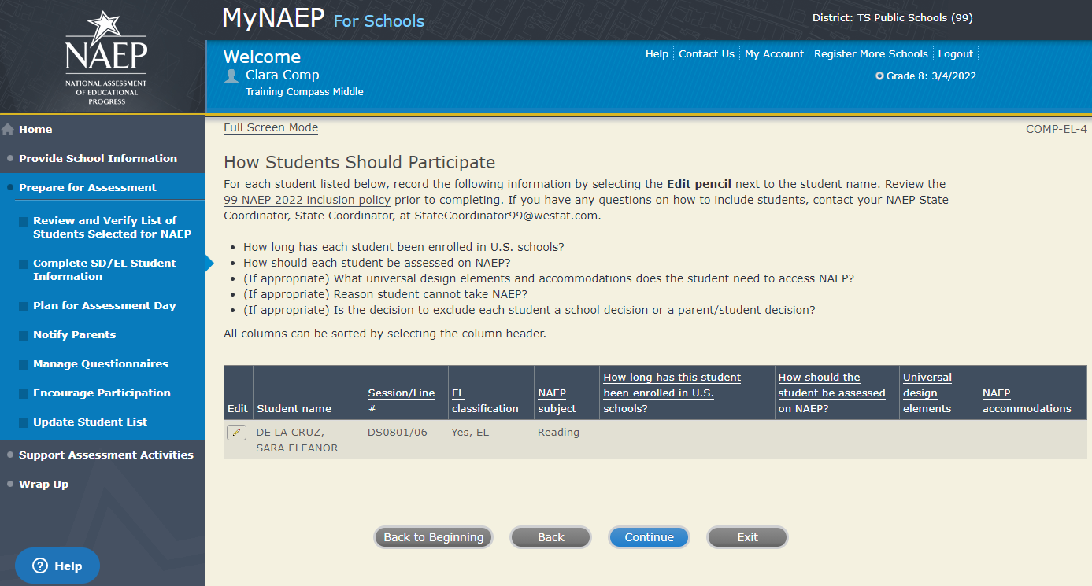

Exclusions Summary COMP-EL-5

The student(s) listed below are marked as “Do not test” and will be excluded from the NAEP assessment.

Your NAEP State Coordinator will monitor exclusions and may contact you regarding excluded students. If you have any further questions on how to include students, contact your NAEP State Coordinator, <State Coordinator name>, at <State Coordinator email> and/or review the <State name> NAEP 2022 inclusion policy (see Appendix D1-6) NAEP 2022 inclusion policy.

Select Back to make any changes for the students on the previous screen.

All columns can be sorted by selecting the column header.

Summary of Changes from 2021 to 2022:
- Updated references to English Language Learners (ELL) to English Learners (EL)
- Screen identifier updated to keep numerical order
Screenshot
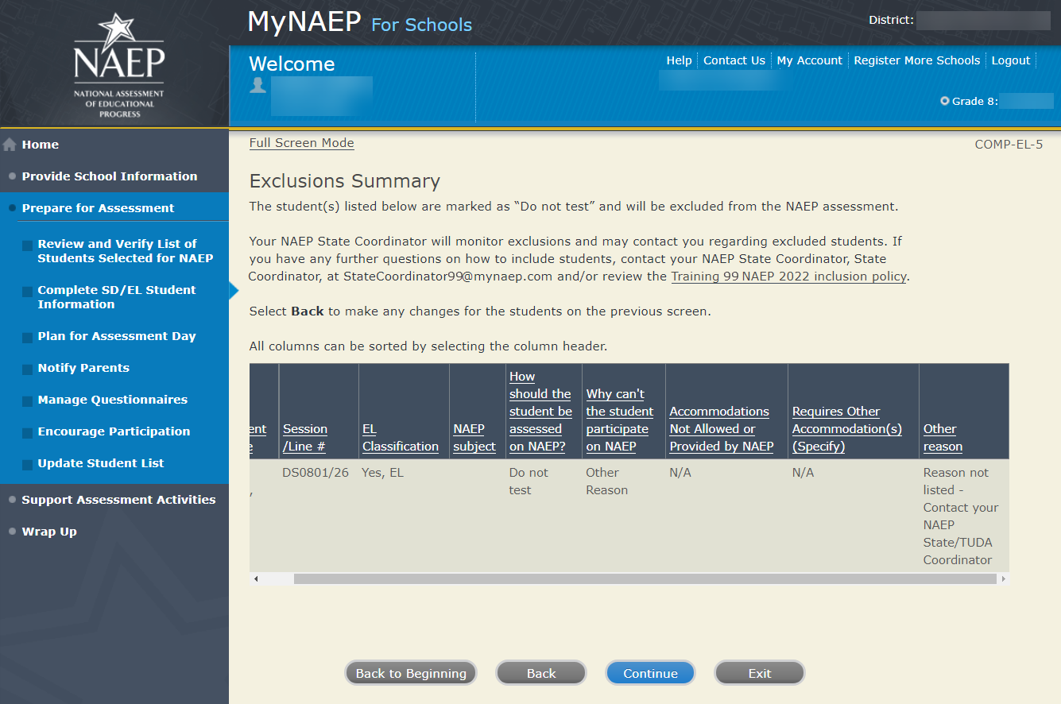
Print Summary Report-COMP-EL-6
Thank you for providing student data. If you have any further questions, contact your NAEP State Coordinator, <State Coordinator name>, at <State Coordinator email>.
Your NAEP State Coordinator will monitor exclusions and may contact you regarding excluded students.
Select Print Summary to print a record of the student information entered into MyNAEP. Keep this report in a secure location and refer to it during the preassessment review call.
Select Submit when you are finished with this section.

Summary of Changes from 2021 to 2022:
- Updated references to English Language Learners (ELL) to English Learners (EL)
- Screen identifier updated to keep numerical order

Screenshot
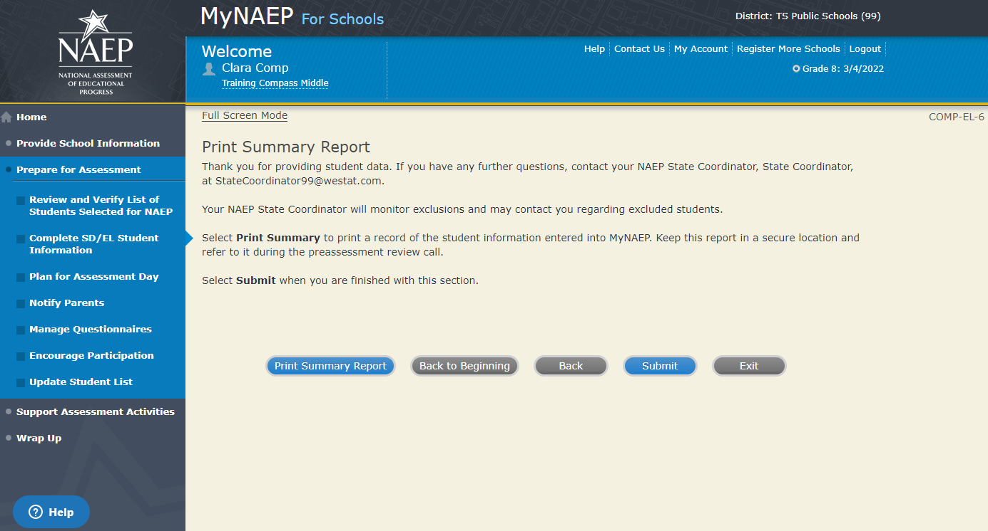

Print Reports

Print Reports-COMP-REP-1
Before entering student data in the system
Print the worksheets to record student information.
After entering student data in the system
Select Print Summary Report to print a record of the student information entered in the system. Keep this report in a secure location and refer to it during the preassessment review call. Print the Exclusion Report to discuss with the NAEP State Coordinator.
Select Submit to indicate you are finished with this section.
Summary of Changes from 2021 to 2022:
- Updated references to English Language Learners (ELL) to English Learners (EL)
Screenshot
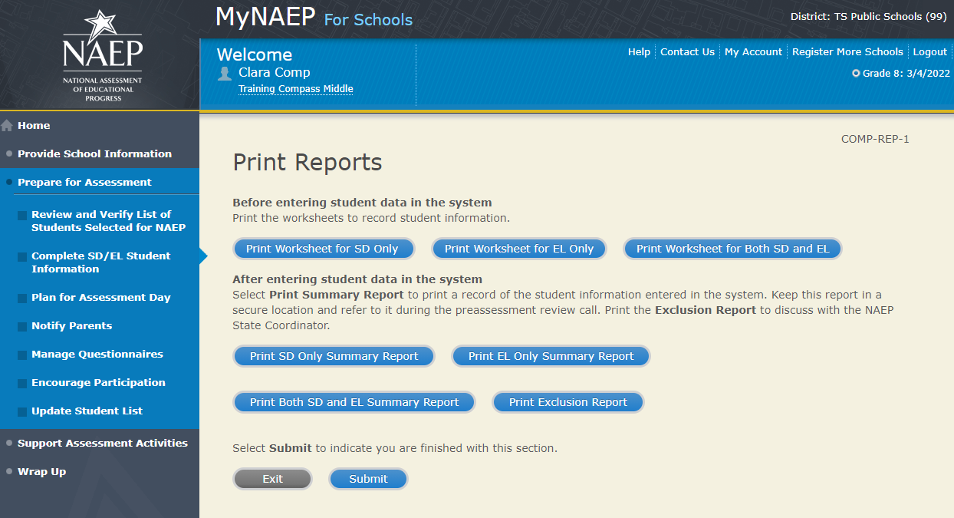

Sample of information contained in worksheets and reports:
(note the worksheets are resources to assist teachers in collecting the information that will be contained in the summary reports)
Both SD and EL
Worksheet page 1
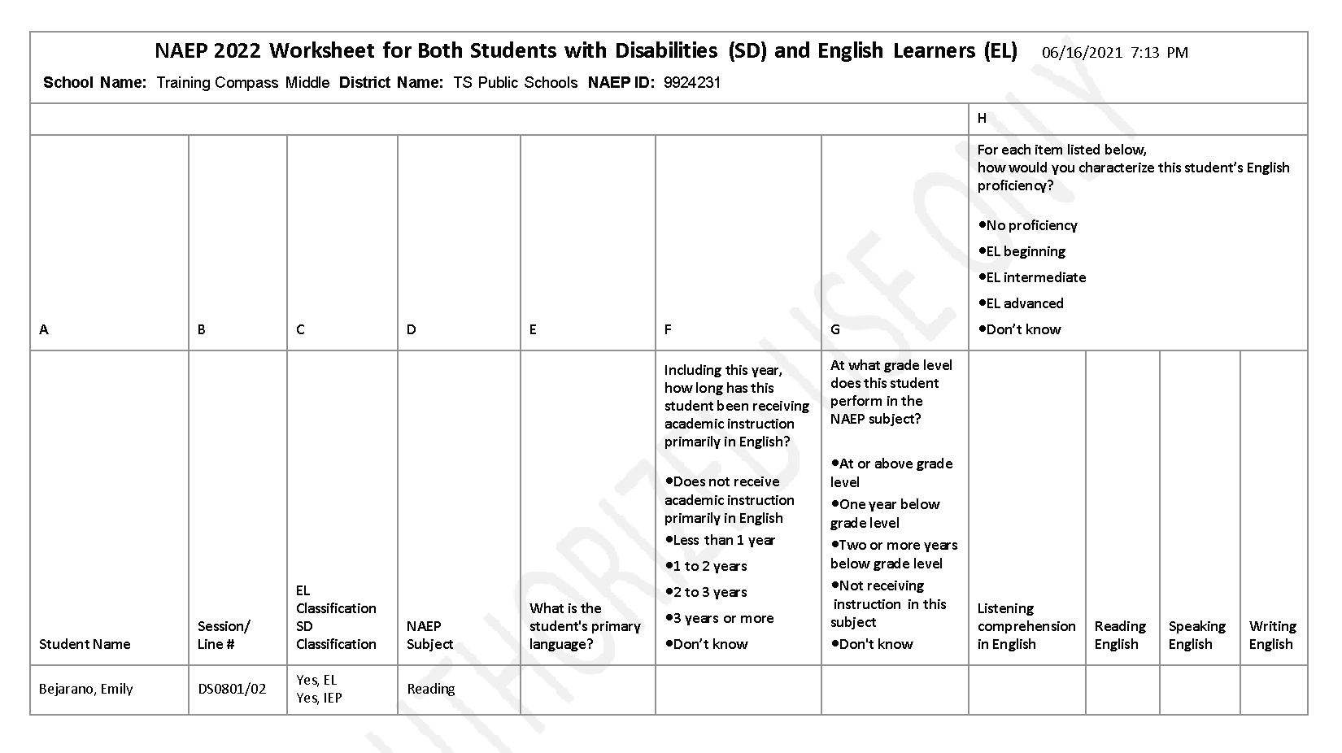

Worksheet page 2
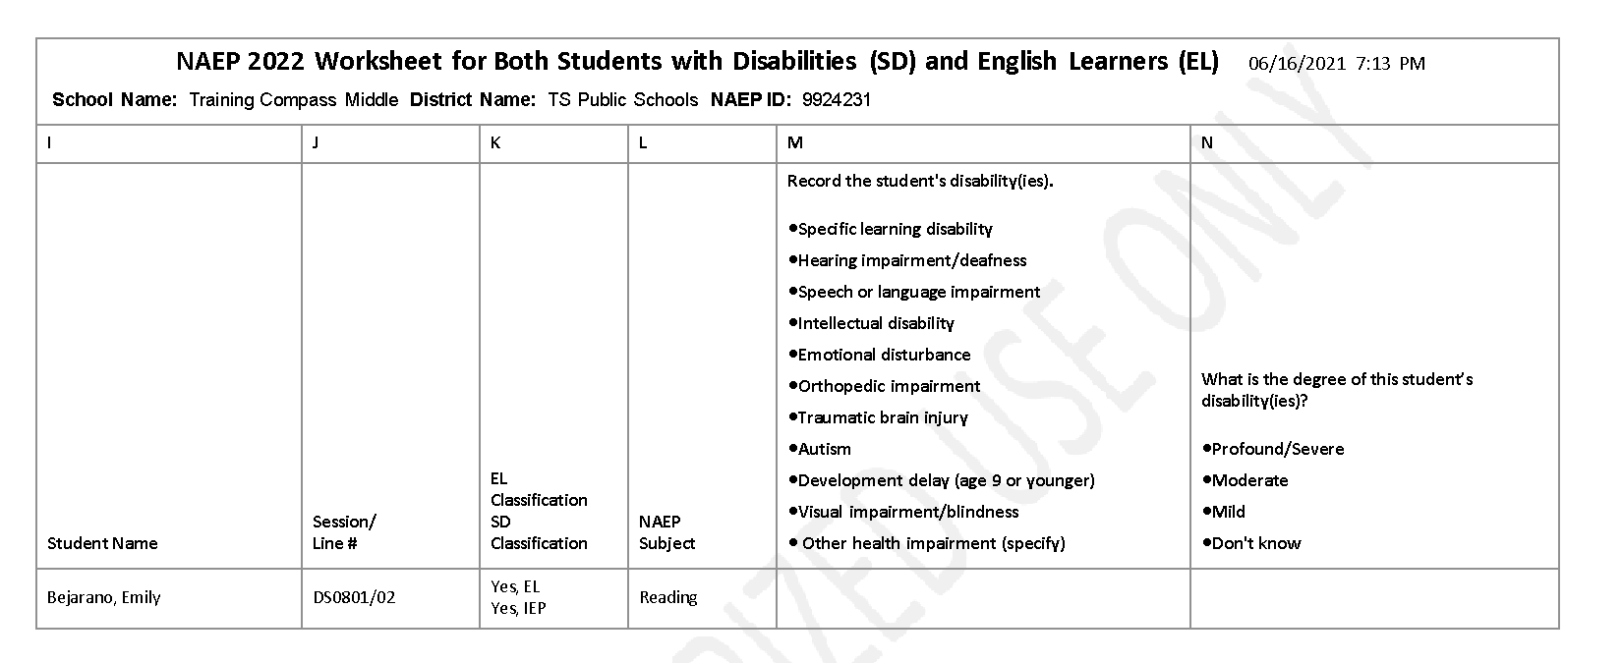
Worksheet page 3
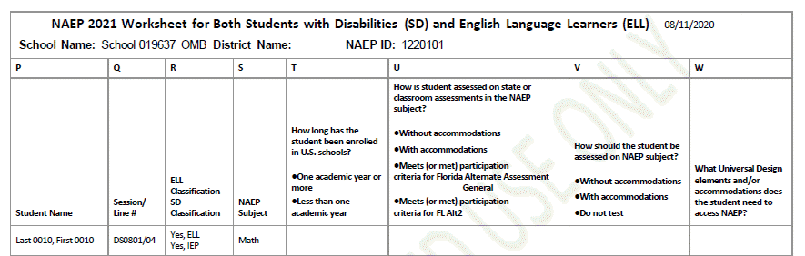

For SD Only
Worksheet Page 1
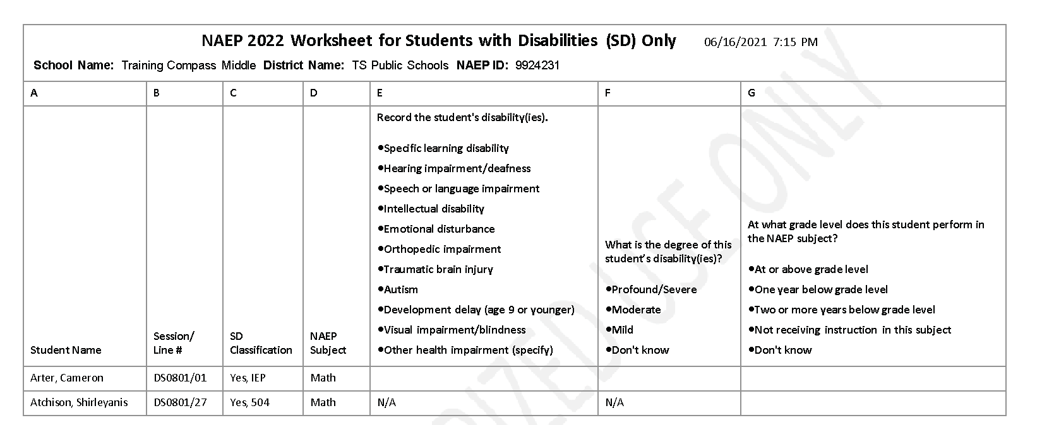

Worksheet Page 2
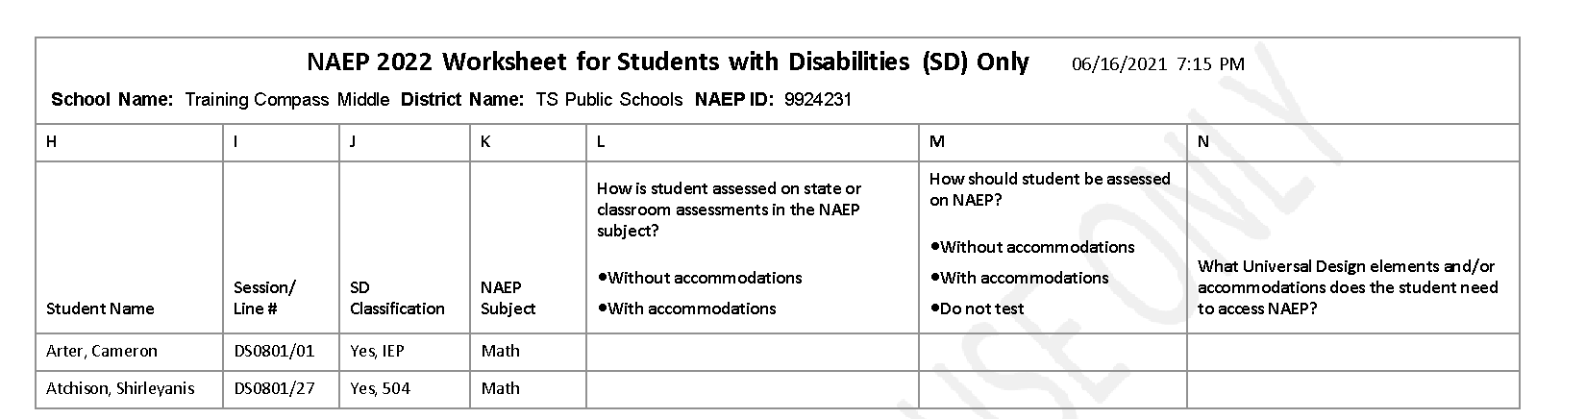

For EL Only
Worksheet Page 1
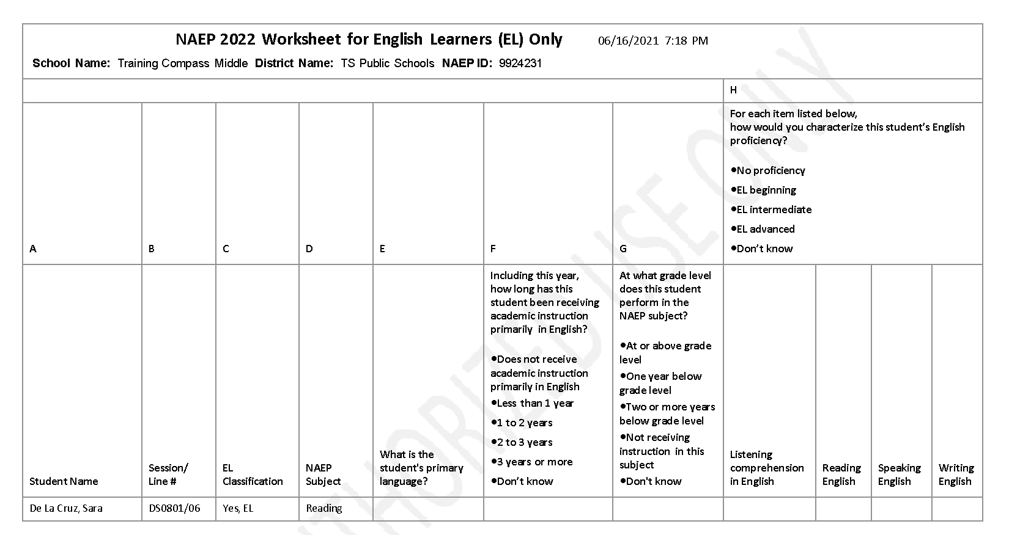

Worksheet Page 2
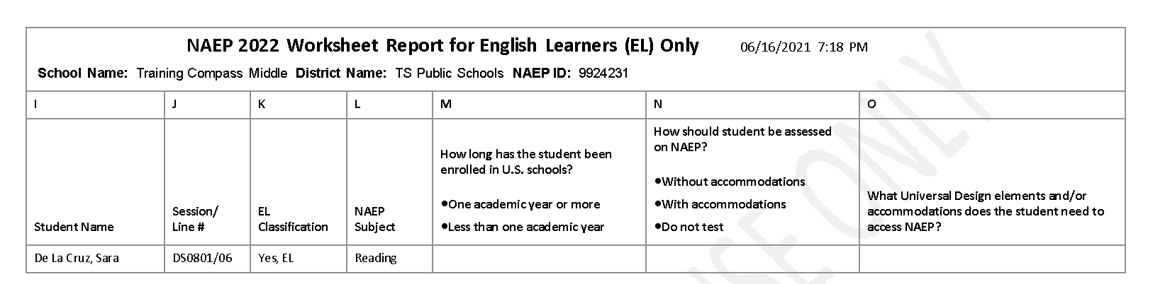

Create Accommodation Sessions (Field Staff Only)
COMP-ACCOM-1
The Submit button will be greyed out until you have green checkmarks for all the following links:
- Provide Information for Students Who Are Both SD and EL
- Provide Information for SD (IEP or 504 Plan) Only
- Provide Information for EL Only
Once you select Submit, the system will create accommodation sessions based on the accommodations recorded for each student.
Do not select Submit until you have confirmed the SD/EL data for each student, as you can only complete this task once.
Summary of Changes from 2021 to 2022:
- Updated references to English Language Learners (ELL) to English Learners (EL)

Screenshot
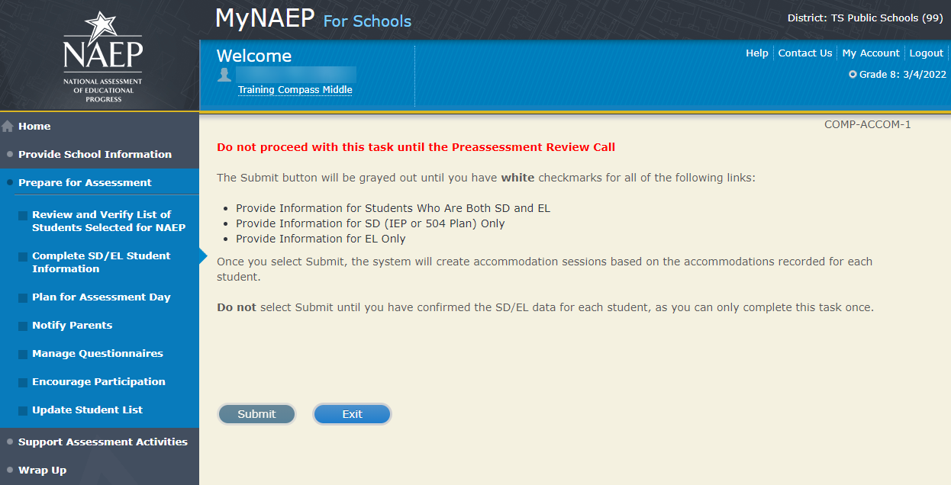

Plan for Assessment Day - NEW

Note: In this section the school coordinator will determine assessment session times and locations, share cell phone policy to ensure security of NAEP items, and make a plan to encourage student participation. This is meant to ensure that the school is prepared for a successful administration of NAEP.
Prepare for Assessment
Plan for Assessment Day
In this section, record assessment details and provide logistical instructions for the NAEP team to ensure that assessment day runs smoothly.
Note: If less than 90% of the selected students attend the assessment, the NAEP team may need to return to your school for a makeup assessment at a later date. Your NAEP representative will discuss this with you after the original assessment has been conducted.
Complete the following:
- Watch Plan for Assessment Day Tutorial (3:53) (https://bcove.video/2fDAvDb)
- Record Assessment Details
- Provide NAEP Team Instructions
Summary of Changes from 2021 to 2022:
- No changes.

Screenshot
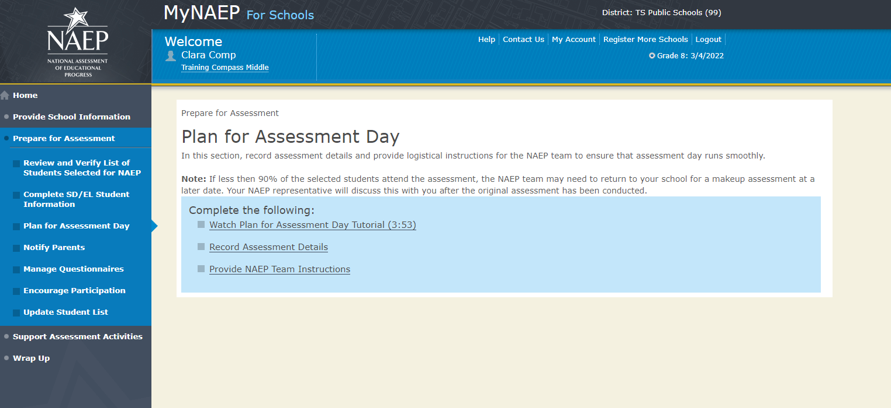

Record Assessment Details

Record Assessment Details-PLN-DET-1
Print Worksheet
Select Print Worksheet to download and print a copy of students selected to take NAEP. Use the worksheet to take notes as you scheduled assessment times and locations. Select Continue when you are ready.
Summary of Changes from 2021 to 2022:
- Added a worksheet to assist with organizing assigning students to groups for the assessment

Screenshot
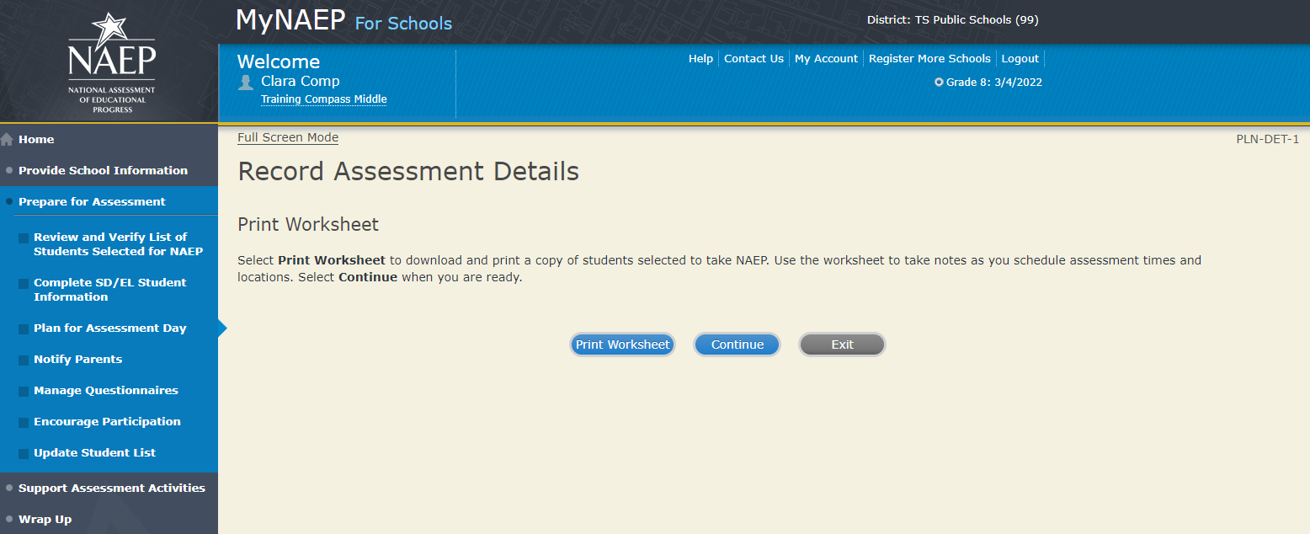
Record Assessment Details PLN-DET-2
School Schedules
Use the report link below (same from the previous screen) to answer the following question.
Record Assessment Details Summary Report
Will all selected students (except full-time virtual students) attend school in person on {scheduled assessment date}?
Summary of Changes from 2021 to 2022:
- Add a screen to allow for confirmation of in-person student attendance for the assessment date

Screenshot
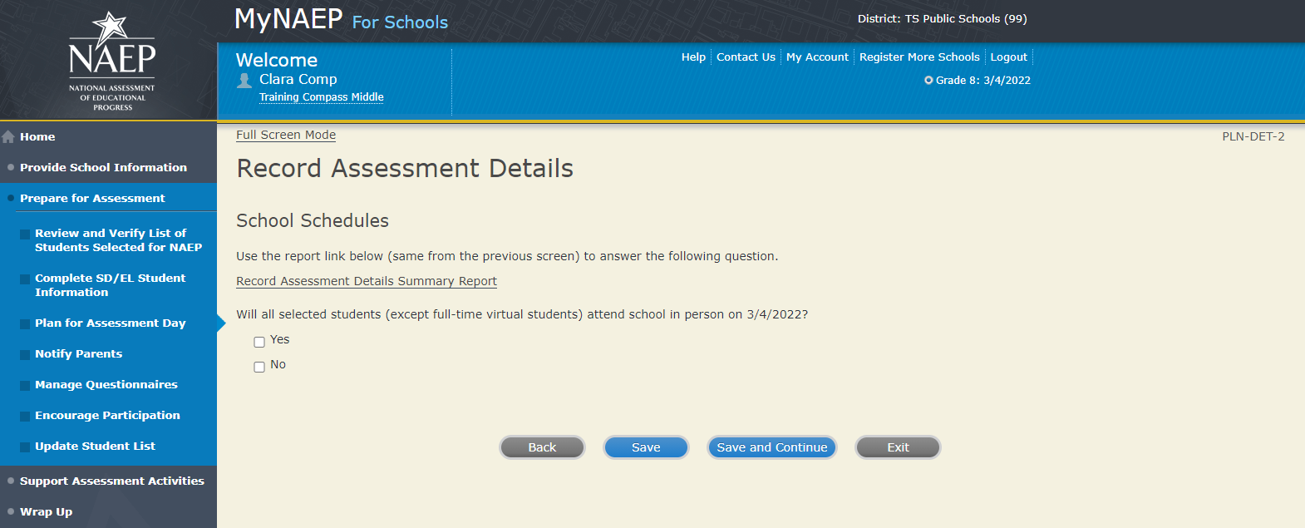
Record Assessment Details PLN-DET-3
Testing Locations and Time Requirements
You’re about to select assessment locations and start times for NAEP.
Review the information below, and indicate when grade X students break for lunch. On the next couple of screens, you will schedule testing locations and start times for each session.
Testing Locations
Select locations that…
- has enough seats and adequate space for all students
- are free of distractions and interruptions
- has a board available for the NAEP team to write information
- is on the first floor or is elevator-accessible (NAEP team will transport heavy equipment)
- have flat desks or tables (no slanted and/or small desks)
- has electric outlets that are easily accessible
Time Requirements
- Locations should be available 90 minutes before the start time so that the NAEP team can set up.
- Sessions will last about 120 minutes.
- The morning assessments need to begin at least two hours before lunch.
- Allow 60 minutes between tablet sessions for equipment refresh.
Enter the time that grade X students take their lunch break.
Start Time: End Time:
Start Time: End Time:
Start Time: End Time:
Start Time: End Time:
Start Time: End Time:
Summary of Changes from 2021 to 2022:
- Separated the testing locations and time requirements screen into two separate screens
- Changed time requirements for testing locations to allow for school required social distancing or spatial requirements

Screenshot
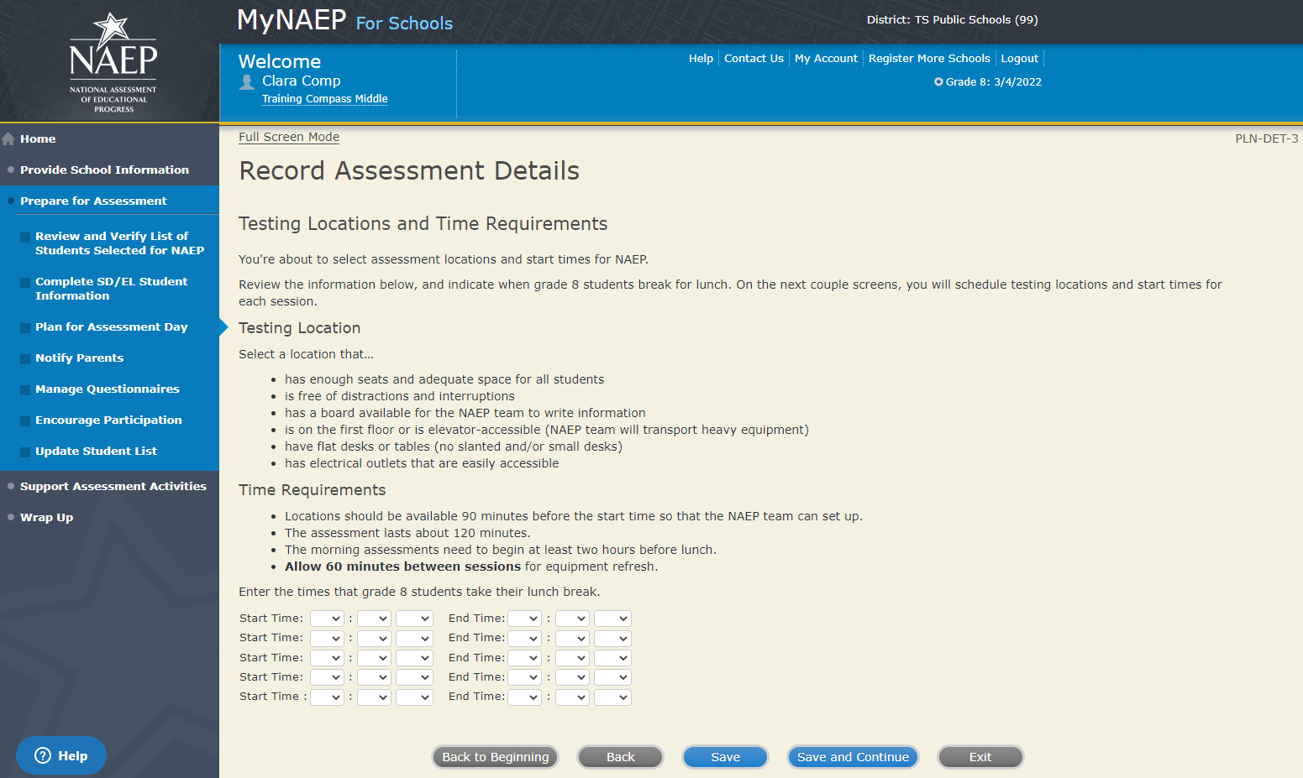

Record Assessment Details-PLN-DET-4
NAEP brings enough equipment to assess up to 25 students at a time, so the team can assess 25 students in the morning and another 25 students in the afternoon. Students can be divided into smaller groups to promote social distancing.
Do you require students to be divided into smaller groups?
Yes
No
Note: XX students are expected to participate
Schedule Assessment Groups
Summary of Changes from 2021 to 2022:
- Added a question to see if the school requires students to be assessed in smaller groups due to social distancing guidelines
- Field staff only can create smaller groups if the school requires it with the Add Group (Field Staff Only) button

Screenshot
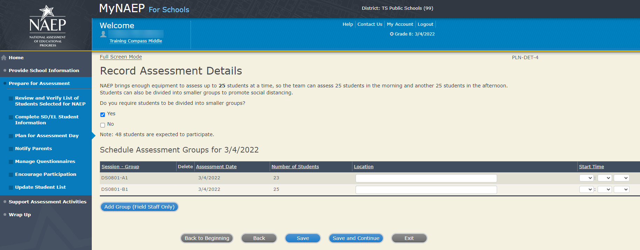

Record Assessment Details-PLN-DET-7
Combined Sessions
You’ve combined one or more sessions together.
To help the NAEP team conduct the assessment as smoothly as possible, please review these guidelines:
- check the Number of Students column and make sure that your assessment location has enough seats
- ask if a school staff member can help monitor room entrances during the assessment
- provide a microphone for the NAEP team to use while giving instructions to the students
Summary of Changes from 2021 to 2022:
- This screen is not needed for 2022.
Screenshot
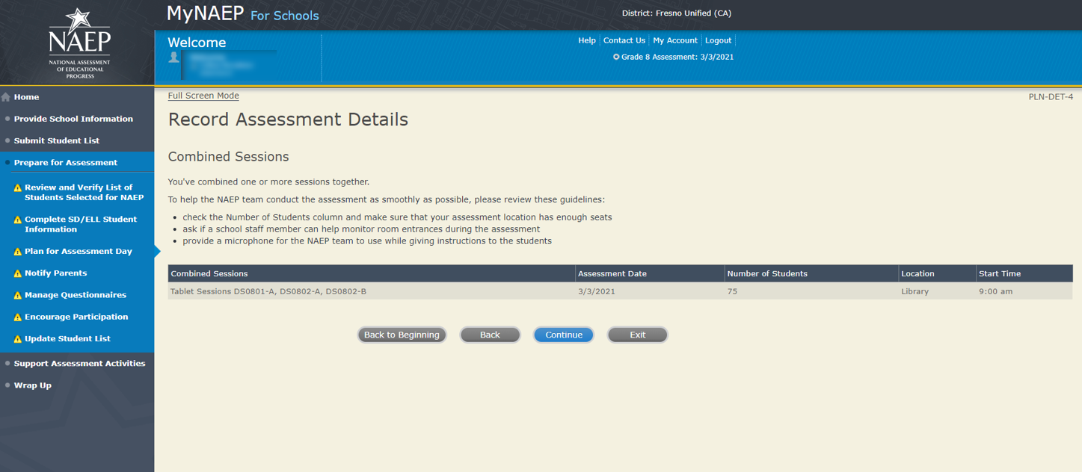
Record Assessment Details-PLN-DET-6
Tips
- Students taking NAEP with extended time should be placed in the group that allows ample time for their accommodation.
- Students who will not be taking NAEP and students who will be assessed in separate sessions do not appear on this page.
Assessment Groups
NAEP has assigned each student taking the assessment to a group.
If there is a scheduling conflict, you can use the group drop-downs to switch students below. Select Submit when you are finished.
<assessment date>
Group A, <location>: XX student(s)
Group B, <location>: XX student(s)
Total: XX
Summary of Changes from 2021 to 2022:
- Added assessment date to group column
- Updated screen name to Assessment Groups and removed all references to tablets to make this screen universal.
Screenshot
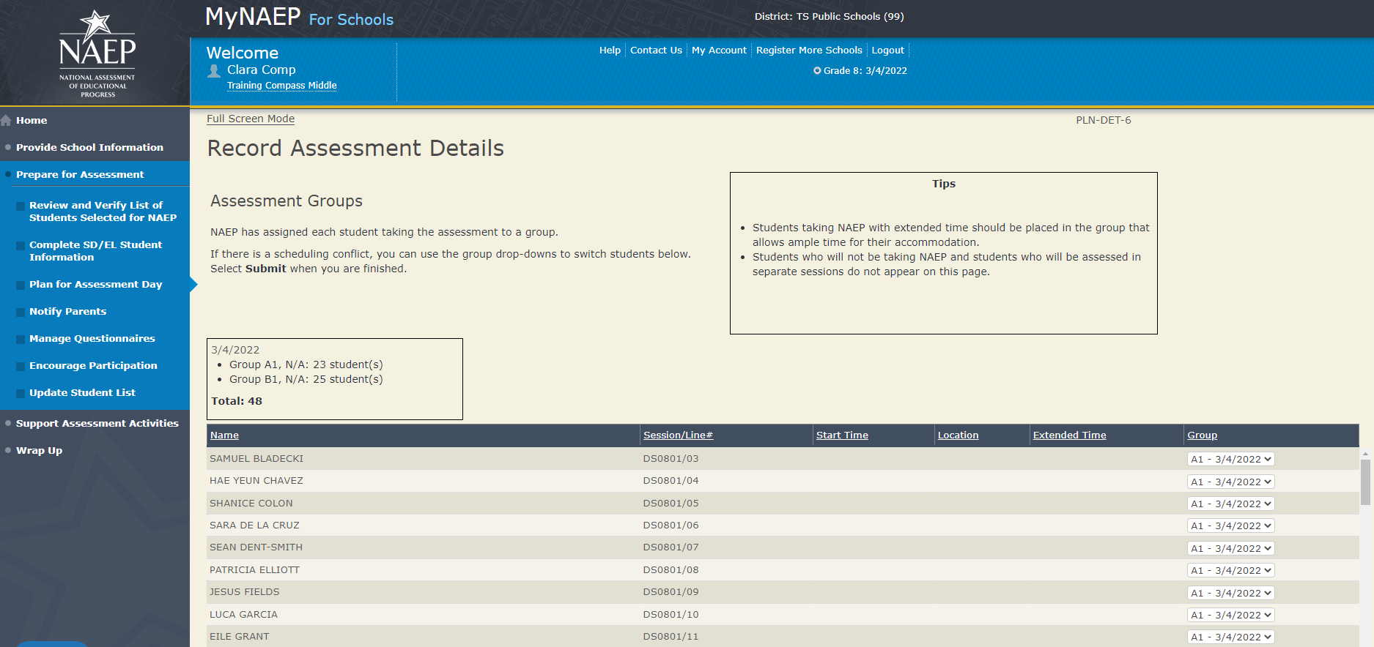

Provide NAEP Team Instructions

Provide NAEP Team Instructions
COVID-19 Policies PLN-TEAM-1
As described in the NAEP COVID-19 Protocol document, field staff will use a variety of PPE and sanitizing tools, monitor their health, and follow strict testing and sanitizing protocols.
1. Besides the information outlined in the NAEP protocol document, are there any school specific COVID protocols that the field staff should follow?
2. NAEP representatives follow the protocols in the COVID-19 Protocols fact sheet. Do any state or district policies require NAEP representatives to be vaccinated for COVID-19 to administer assessments to students in your school?
Yes
No
If Yes to Q2, show additional question
2a. Which of the following statements best describes your school’s COVID-19 vaccination requirements for NAEP representatives. Please choose only one response.
- NAEP representatives must be fully vaccinated against COVID-19 in order to enter our school, with no exceptions.
- NAEP representatives must be fully vaccinated against COVID-19 in order to enter our school unless they have an exemption/accommodation for medical, religious, or other reasons protected by law and must otherwise adhere to the requirements described in the COVID-19 Protocols fact sheet.
- NAEP representatives either must be fully vaccinated against COVID-19 in order to enter our school or must otherwise adhere to the requirements described in the COVID-19 Protocols fact sheet.
If the user selects b or c, show this follow up question
Please select one of the following statements regarding exempted unvaccinated NAEP representatives.
- Unvaccinated NAEP representatives must show a recent negative COVID-19 test to enter our school.
- Unvaccinated NAEP representatives do not need to show a recent negative COVID-19 test to enter our school.
3. Do any state or district policies require NAEP representatives to test negative for COVID-19 prior to administering assessments to students in your school?
Yes
No
4. How should the team handle visibly ill students?
5. Are school staff required to wear masks?
6. Are students required to wear masks?
7. Does the school require social distancing?
8. During the assessment, students often raise their hand to ask questions. What are your school’s protocols for answering student questions while following social distancing guidelines?
Summary of Changes from 2021 to 2022:
- Added additional COVID-19 questions for schools to provide guidance to the field staff.

Screenshot
The screenshot below represents the change that will be made. At the time of this submission, the new screenshot was not available.
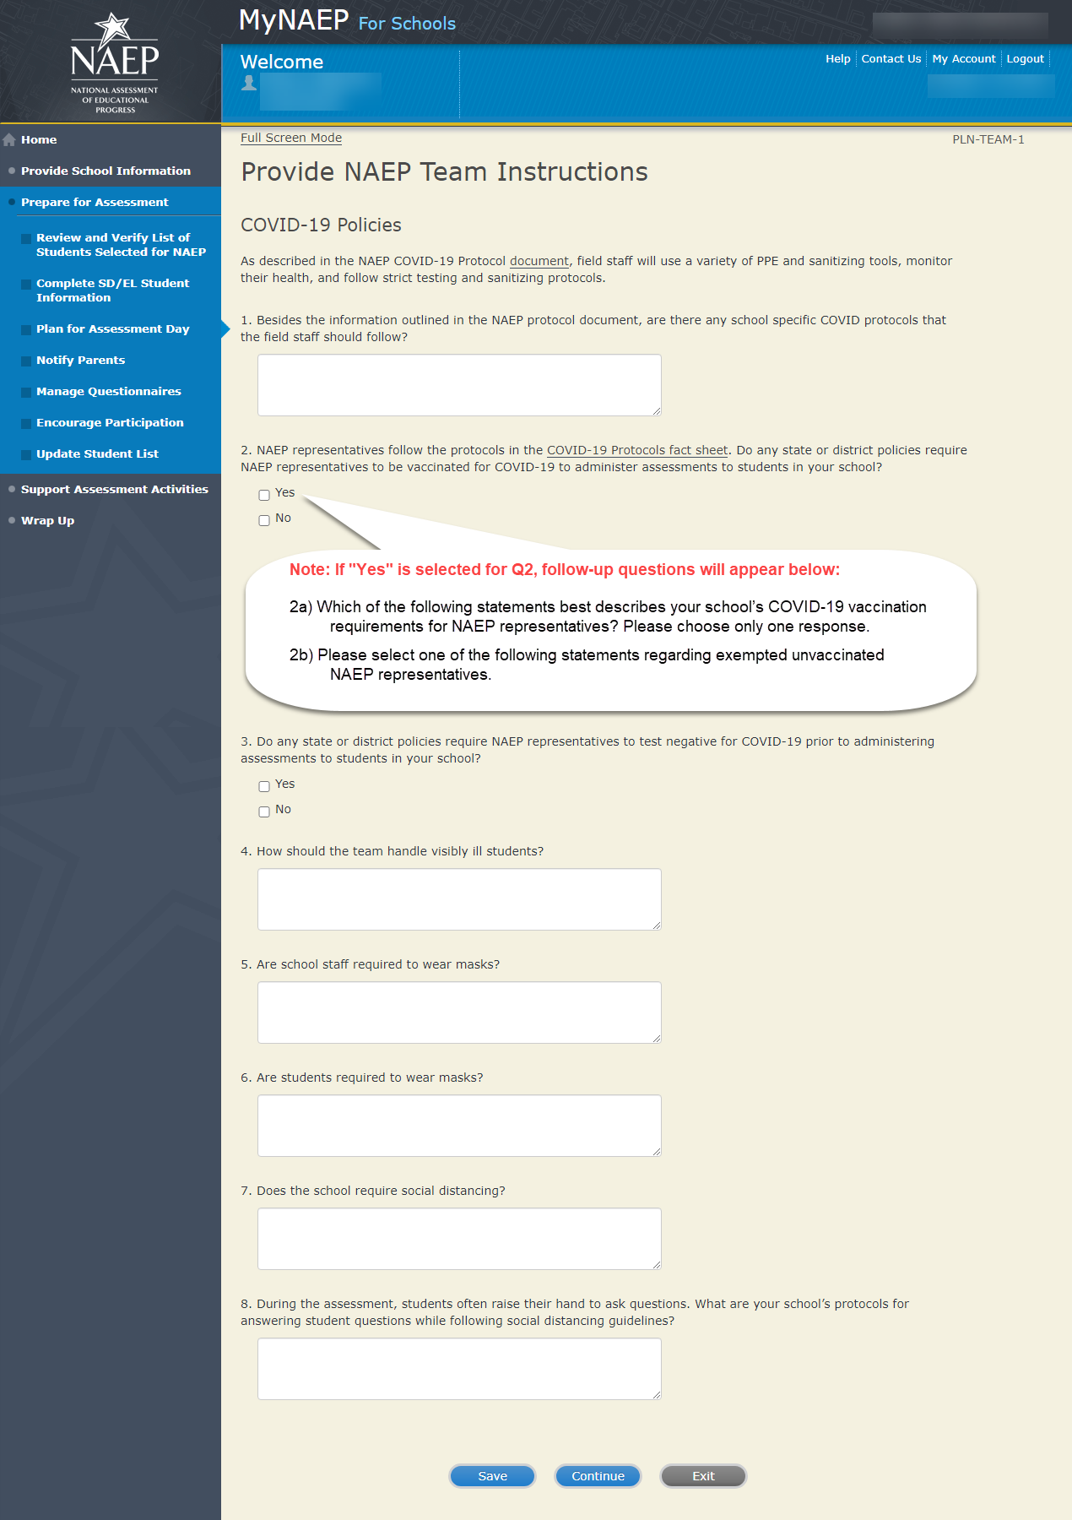

Before the Assessment-PLN-TEAM-2
1. Where should the team park?
2. The team will bring their NAEP ID badges and check in at the front office. Do they need to follow any other school protocols?
3. The team will be bringing in several cases of tablets or laptops for testing the sampled students. Does your school have a suitable testing location on the first floor? If not, is there an available elevator that we can use when we arrive 60-90 minutes before testing is scheduled to begin (usually early morning)?
4. Where is the best place for the team to unload the equipment for testing that is closest to the testing location?
5. Before the assessment, your NAEP representative will need to briefly meet with you. Where will you be?
6. How and by what time does your school announce closings or delays?
7. The NAEP team wants to be sensitive to any special needs your students may have. Is there anything specific we need to know?
8. Students respond more positively when they know that the school administration supports NAEP. Can the principal or other school staff member take a moment during the daily announcements or before the assessment to introduce NAEP, reinforce its importance, and ask students to do their best?
Yes
No

9. NAEP provides appointment cards (available in the Support Assessment Activities section) to remind students of the assessment. Will you be printing and providing the students appointment cards?
I will be printing and distributing appointment cards to students
I will not be printing and distributing appointment cards to students

Summary of Changes from 2021 to 2022:
- Updated question to remove references to traumatic events due to COVID-19.
- Updated the student appointment cards printing to be electronically and printed by the school.

Screenshot
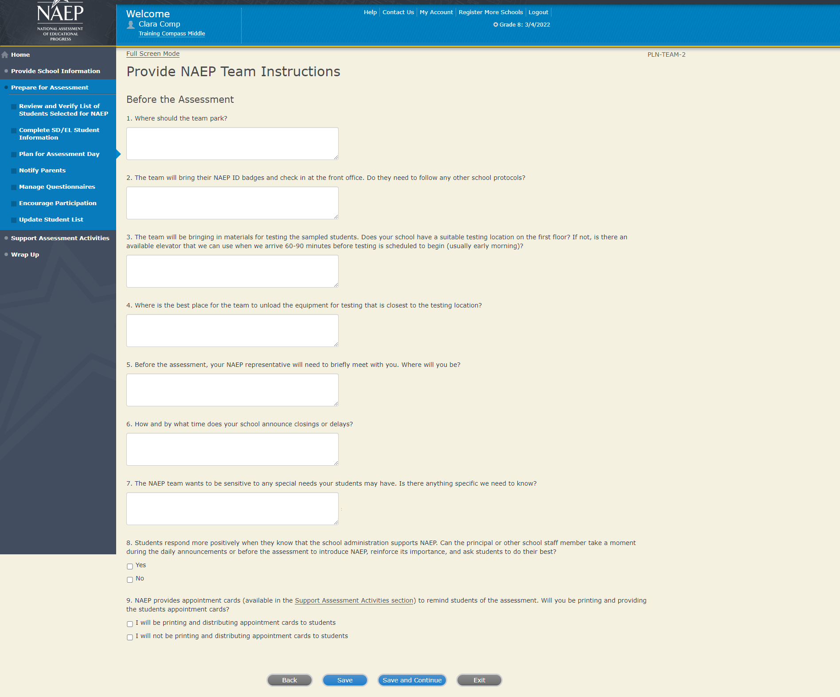

Provide NAEP Team Instructions
During the Assessment-PLN-TEAM-3

1. The law prohibits students from photographing or sharing NAEP questions. Please assist us with one of these security measures:

Notify students that cell phones are banned from the testing location
Notify students cell phones must be turned off and placed with their belongings
No assistance can be provided

2. In case of an emergency, who should the NAEP team contact for assistance?

3. Is there anything scheduled, such as a fire drill or assembly, that might interrupt the assessment?

4. Are there any procedures or protocols that the NAEP team should follow in the event of an emergency situation such as a lock-down or an extreme weather event?

5. How should the NAEP team handle restroom breaks? Do students need hall passes?

6. Is it possible for a school staff member to remain in the room(s) during the assessment? NAEP field staff will administer the entirety of the assessment, however schools have reported that it is beneficial to have a school staff member in the room. The staff member serves a familiar person for the students, helps with disruptive behavior, and knows school procedures should for any situations that could arise.
Yes
No

Summary of Changes from 2021 to 2022:
- Provided context for why it is beneficial to have school staff present in the testing locations.

Screenshot
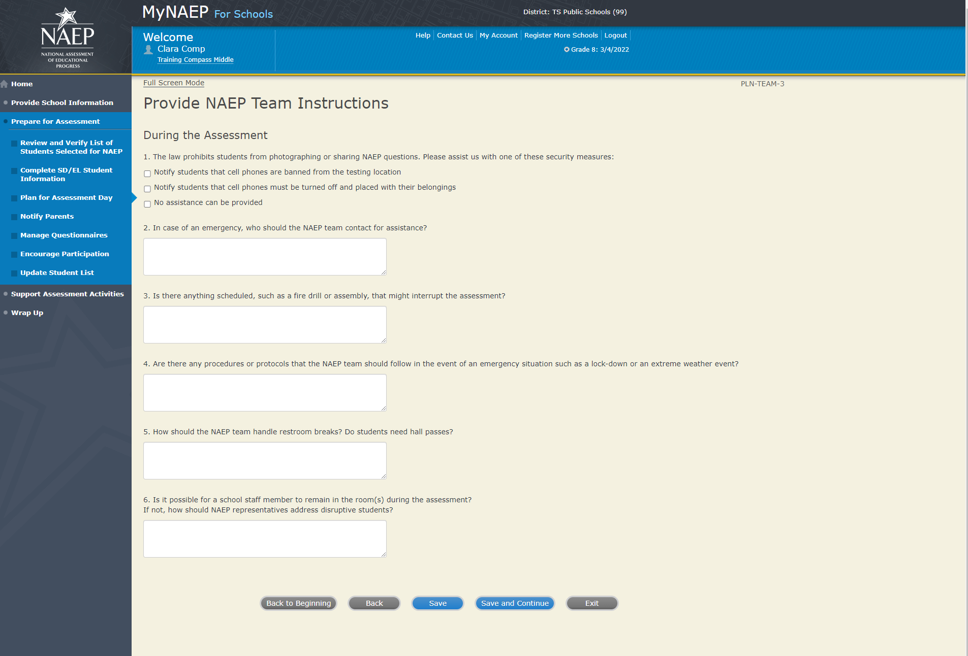

Provide NAEP Team Instructions

After the Assessment-PLN-TEAM-4

1. NAEP grants 90 minutes of community service to students who take the assessment. Would you like to distribute to students the certificates of community service?

Yes, we will be distributing the certificates of community service
No, we will not be offering the certificates of community service
We will not be offering certificates of community service to students

2. Students in the tablet sessions may be dismissed

- as a group once the last student is finished (students with extended time or later arrivals will be dismissed later, if needed), or
- individually as they finish after 70 minutes of testing

For all options, students may bring a book to read or complete schoolwork after they finish

Option 1: Dismiss as a group once the last student is finished
Option 2: Dismiss students individually as they finish but no earlier than 70 minutes after students begin the assessment

Additional Notes:

3. How should the NAEP team dismiss students who receive extended time, which may take up to three times as long?

4. Where should the NAEP team send students after the assessment?

5. After the assessment, your NAEP representative will need to briefly meet with you. Where will you be?

Summary of Changes from 2021 to 2022:
- Certificates of community service will be brought by field staff and distributed on assessment day.
- Removed the third dismissal policy and to only allow two options.
- Removed references to the red NAEP storage envelope

Screenshot
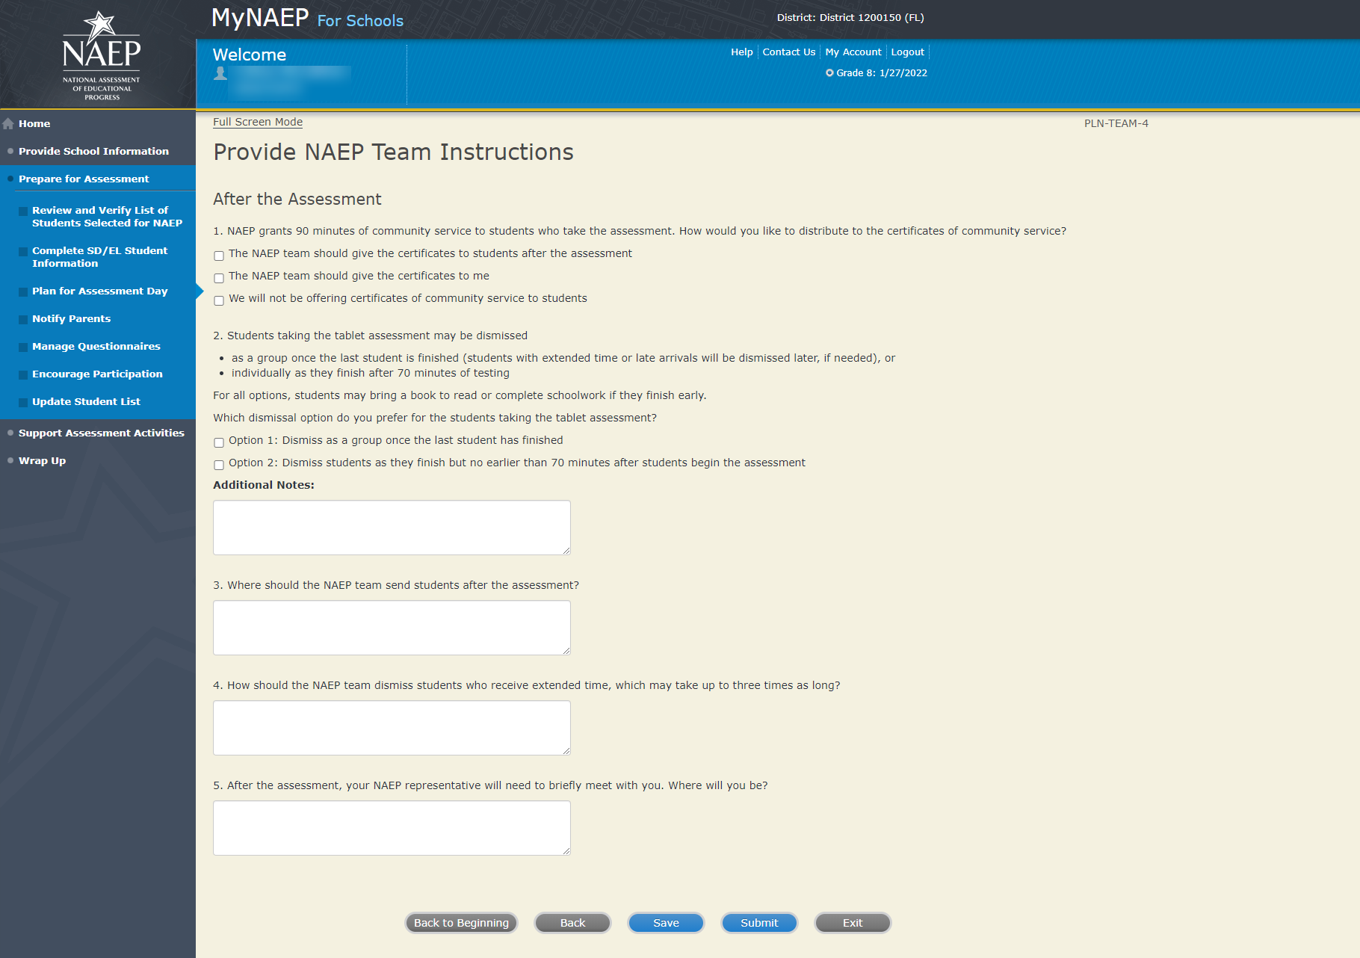

Sample of information contained in summary report:
Record Assessment Details page 1
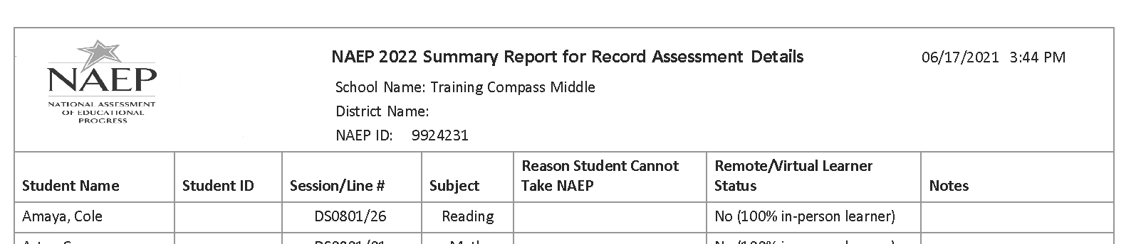

Notify Parents – Approved v.23

Note: In this section the school coordinator will download and customize the parent notification letter (see Appendix D2-11[public schools] and D2-12 [private schools] for the template of the letter), upload the customized letter to the system, and certify the date parents were notified. This is to ensure that parents/legal guardians are notified of their student’s selection to participate in NAEP, which is a requirement of the Reauthorized Elementary and Secondary Education Act (ESEA).
Prepare for Assessment
Notify Parents
All parents and guardians of selected students must be notified in writing before NAEP can conduct the assessment.
Complete the following:
- Watch Notify Parents Tutorial (3:29) (https://bcove.video/2xyrOUA)
- Download Parent/Guardian Notification Template
- Upload Letter
- Verify Parent/Guardian Notification
Additional Resources
- Parent's page on Nation’s Report Card website
- What Every Parent Should Know About NAEP: PDF version
- What Every Parent Should Know About NAEP: Video version
- Sample Questions Booklets

Summary of Changes from 2021 to 2022:
- No changes.

Screenshot
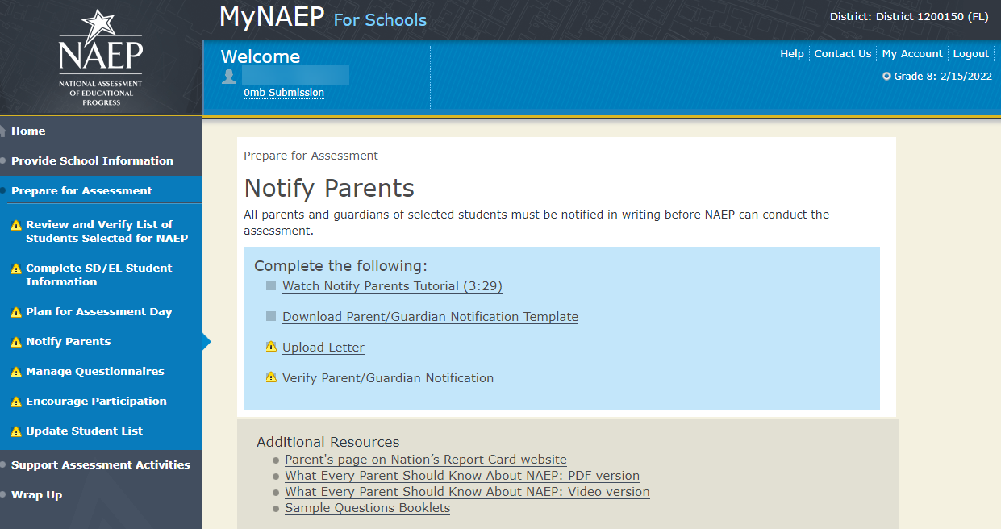

Download Parent/Guardian Notification Template

Download Parent/Guardian Notification Template-PAR-TMP-1
You can download, customize, and distribute the parent notification letter(s) below.
Parent/Guardian Notification Letter (mathematics and reading) (See Appendices D2-11 and D2-12)
Here are some suggestions for notifying parents about NAEP:
- Mail/email the letter to parents
- Send the letter home with students
- Include the letter on the school website or in a newsletter
Unable to download the template? Try disabling pop-up blockers or adding mynaep.com as a trusted site to your browser. Still having trouble? Contact the NAEP help desk at 1-800-283-6237.

Summary of Changes from 2021 to 2022:
- No changes.

Screenshot
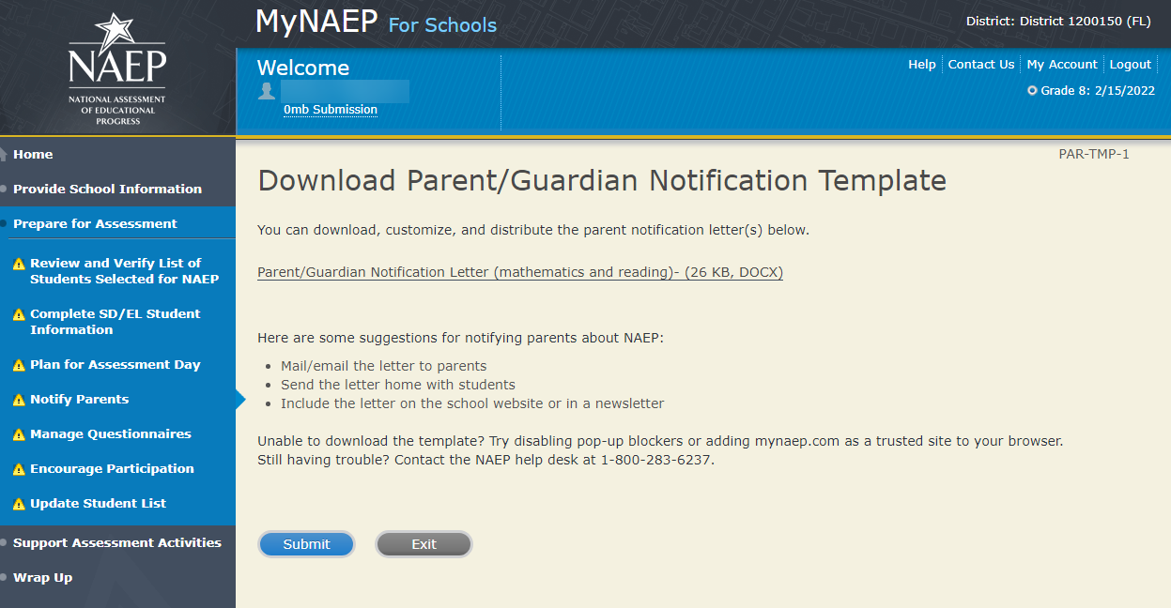

Upload Letter

Upload Letter-PAR-UPLD-1
1. When do you plan on distributing the letter?
2. Please upload the letter that you distributed to parents and guardians. If you distributed the letter in more than one language, just upload the English version.
Select Choose File or Browse... to locate and upload your file.
Summary of Changes from 2021 to 2022:
- No changes.

Screenshot

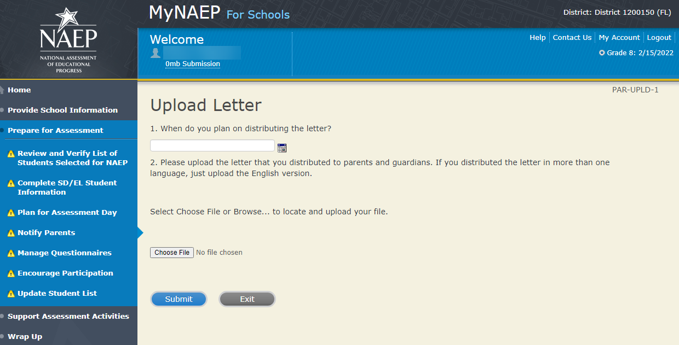

Verify Parent/Guardian Notification

Verify Parent/Guardian Notification-PAR-VER-1
Please tell us a few details about how you notified parents of the assessment.
1. When did you notify parents?
2. How did you notify them?
Mailed/emailed letter to parents
Sent letter home with students
Posted notice in newsletter
Other
*If you answered Other to the above question, please explain.
3. Other than updating the placeholder text, did you make any changes to the letter?
Yes No
4. Who received a notification?
Parents/guardians of sampled students only
Parents/guardians of all grade X students

5. Please certify that you notified parents and guardians of the assessment by typing your name in the box.
Summary of Changes from 2021 to 2022:
- No changes.

Screenshot
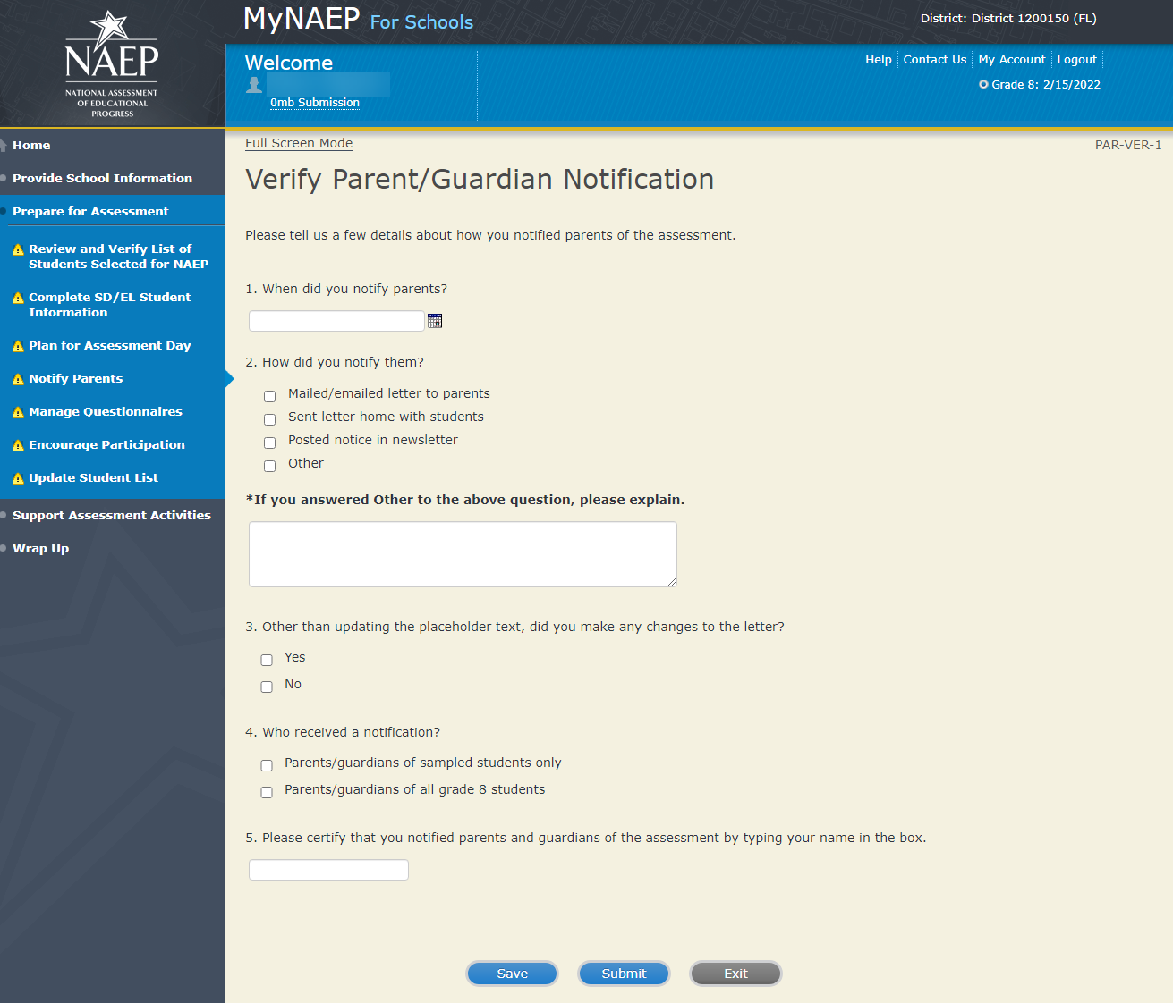

Manage Questionnaires - NEW

Note: In this section the school coordinator identifies respondents for school and teacher questionnaires, sends respondents links to online questionnaires, and monitors completion of questionnaires. Additionally, the school coordinator distributes information about NAEP to teachers (see Appendix D1-4). The results of the questionnaire are used to provide contextual data from schools and teachers in The Nation’s Report Card.
Prepare for Assessment
Manage Questionnaires
NAEP collects information using questionnaires to provide a context for reporting student performance.
- School Questionnaires gather information on school policies and characteristics.
- Teacher Questionnaires gather information on teacher training and instructional practices.
This section also allows you to monitor the completion of the questionnaires and to send reminders. Please note that each one of your questionnaire recipients will receive automatic reminder emails to complete the questionnaire weekly, so you will likely not need to send any reminders yourself.
Complete the following:
- Watch Manage Questionnaires Tutorial (4:03) (https://bcove.video/2xiQOiX)
- Identify Questionnaire Respondents
- Send Welcome Emails and Questionnaires
- Monitor Questionnaire Completion and Send Reminder Emails
Additional Resources
- Facts for Teachers (see Appendix D1-4)
- NAEP Survey Questionnaires for Teachers and Schools
Summary of Changes from 2021 to 2022:
- Removed the Print Reports link because field staff are being instructed to review questionnaire completion statuses directly from MyNAEP in the Monitor Questionnaire Completion and Send Reminder Emails link.
- Removed text discussing automatic reminders for recipients to complete questionnaires.
- Added a link to the NAEP Survey Questionnaires for Teachers and Schools in the Additional Resources section.

Screenshot
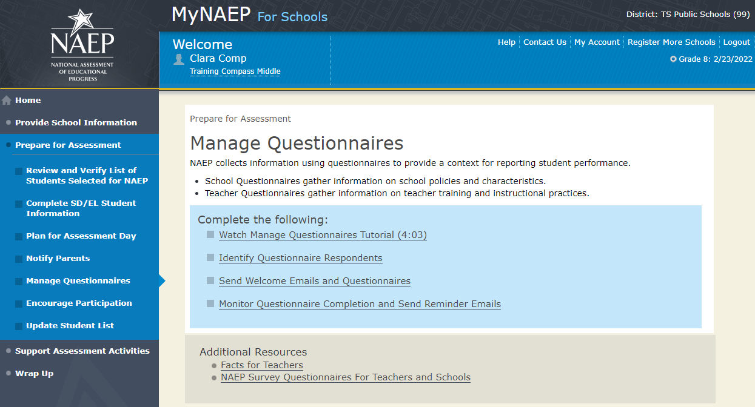

Identify Questionnaire Respondents

Identify Questionnaire Respondents-QX-RES-1
Check this box if all your teachers use the same email domain.
- For example, @myschool.edu
- What email domain do they use? @
- Select Save to save the domain for all teachers.
Select the Add Teacher button to enter contact information for all teachers who teach mathematics or reading to grade X students. (Note: teacher’s first name, last name, and email address are entered by the school coordinator as shown in the screenshot below)
- Please include special education, ESL, and resource teachers who teach <subjects> to grade X students.
- Make sure each name and email address is correct.
  - Select the pencil to make corrections.
  - Select the red x to delete a teacher.
- When finished entering all teachers, select Save and Continue.
Summary of Changes from 2021 to 2022:
- No Changes.
Screenshot
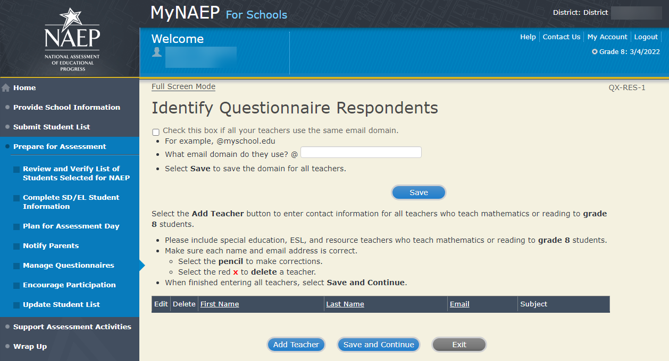

Send Welcome Emails and Questionnaires

Send Welcome Emails-QX-WEL-1
(see the Additional Resources section of this document for the text of the Welcome Email)
Now it's time to make sure that NAEP has the correct email addresses of your recipients. Select the Send buttons in the table below to send each person a welcome email.
Not sure if everyone received the welcome email?
- Check to ensure each recipient received the email.
- Double-check the email address. If the address is correct and the recipient still did not receive the email, the recipient should check his or her junk email folder.
- To add, edit, or delete recipients, return to the Identify Respondents page.
Summary of Changes from 2021 to 2022:
- Removed a bullet related to printing Hard Copy Reminders to place in recipients’ mailboxes.
Screenshot
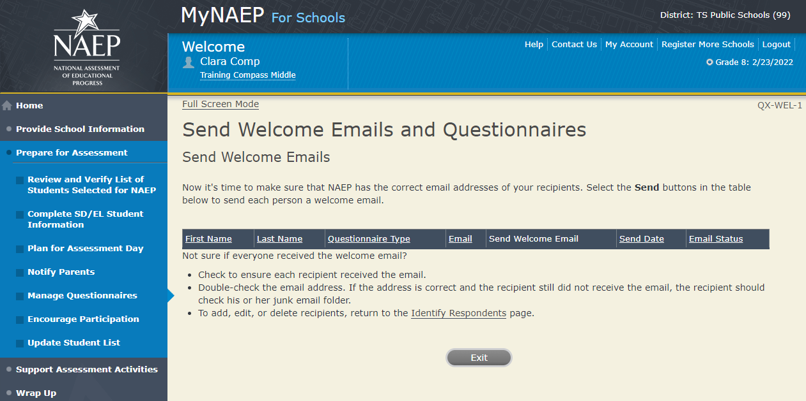

Monitor Questionnaire Completion and Send Reminder Emails

QX-MON-1
(see the Additional Resources section of this document for the text of the Reminder Email)

- Please confirm that these are the correct teachers and the list is complete, showing all teachers who teach <subjects> to grade X students.
- Monitor questionnaire completion using the Status column. Please ensure that all questionnaires have a status of "Completed" before your assessment day.
- Select Send to send teachers and administrators email reminders.
- If you need to add a teacher, select the Add Teacher button.
Summary of Changes from 2021 to 2022:
- Added social studies to the list of subjects for which teachers must be listed.
- Removed text referring the Print Hard Copy Reminder button as hard copy reminders are not being utilized for NAEP 2022.
- Removed text refencing displaying a green check mark, as that functionality has changed in MyNAEP for 2022.
Screenshot
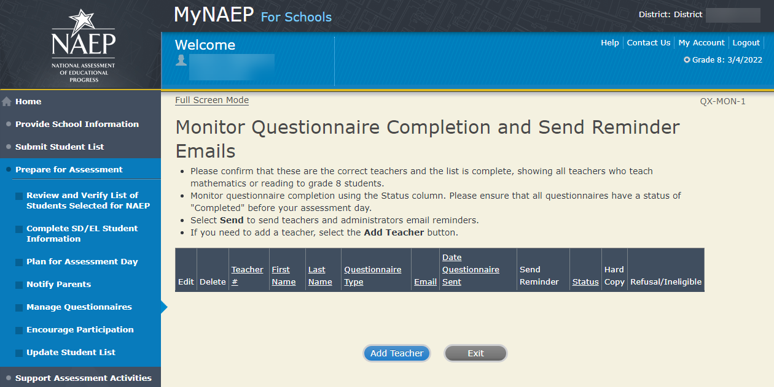

Encourage Participation – Approved v.23

Note: In this section the school coordinator can access resources to encourage participation among students to ensure that the administration is successful.

Prepare for Assessment

Encourage Participation

NAEP is successful because of your support, and we want NAEP to be a positive experience for everyone involved at your school. The more that teachers, parents, and students know about NAEP, the more smoothly assessment day will go.

If less than 90% of the selected students attend the assessment, the NAEP team may need to return to your school for a makeup assessment at a later date. Use the resources in this section to encourage students to attend and to do their best on NAEP.
Complete the following:
- Watch Encourage Participation Tutorial (2:06) (https://bcove.video/2xyGZwU)
- Review Resources
- Select Strategies to Encourage Participation

Summary of Changes from 2021 to 2022:
- Removed the Additional Resources links, since Measure Up has not been updated, and the digitally-based assessments link does not apply to long-term trend schools. The digitally-based assessments link will appear in the Introduce Online Resources page for schools participating in digitally-based assessments.
  - Measure Up News for the School Community
  - Digitally-based Assessments (https://nces.ed.gov/nationsreportcard/dba/)

Screenshot
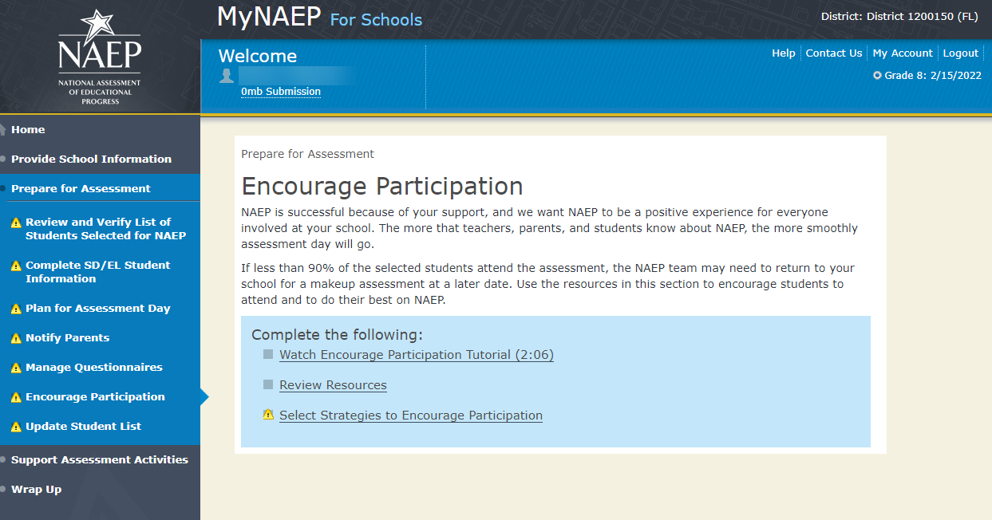

Review Resources

Review Resources-ENC-RES-1
Explore the resources below to promote NAEP in your school. Schools that implement these strategies have higher student participation.

- Notify Students
- Show NAEP Videos
- Introduce Online Resources
- Thank Students for their Participation

When you are finished, select the Submit button.

Summary of Changes from 2021 to 2022:
- No changes.

Screenshot
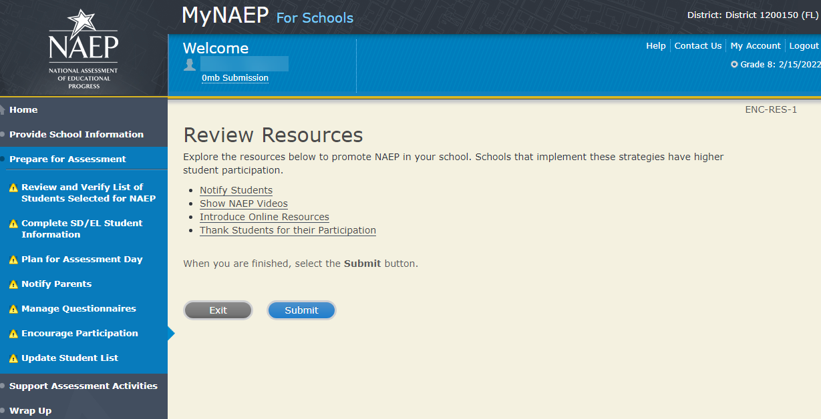

Notify Students about NAEP
ENC-STDT-1
It’s important for students to know the importance of NAEP and that they have been selected to represent their peers across the country. Use the templates below to share information about NAEP, its importance, and details about the upcoming assessment.
- Sample Morning Announcements - Grade 8
- Sample Student Notification Letter - Grade 8
- Social Media Posts - Grade 8

Summary of Changes from 2021 to 2022:
- No changes.

Screenshot
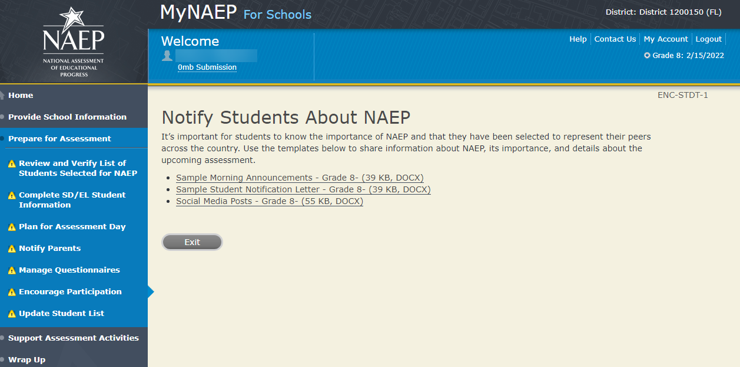

Videos
Videos-ENC-VID-1
See what real students and teachers have to say about NAEP. These videos share information about how NAEP results are used, and how students and teachers can make a difference through their participation.
- Introducing NAEP to Teachers (4:27) (https://youtu.be/zR1_pUdSlFg)
- Introducing NAEP to Students (4:36) (https://youtu.be/8drjkhe0iQU)
- What Every Parent Should Know About NAEP (4:51) (https://youtu.be/RurH739zdN0)
- Going Digital: NAEP Assessments for the Future (1:51) (https://youtu.be/-RJ4k0I6h2c)

Summary of Changes from 2021 to 2022:
- No changes.

Screenshot

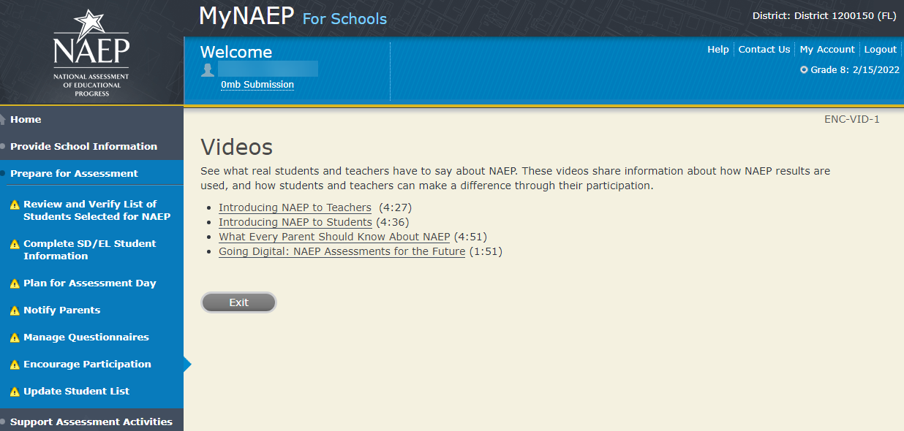

NAEP Online
NAEP Online-ENC-INOR-1
The Nation's Report Card website has resources for all audiences. (https://nces.ed.gov/nationsreportcard/)
Nation’s Report Card: Digitally Based Assessments (https://nces.ed.gov/nationsreportcard/dba/)
Learn how NAEP is using new technologies to assess students in a digital environment. Introduce this brief interactive tutorial https://enaep-public.naepims.org/2018/Tutorial_Intro_Webpage/index.html (https://nces.ed.gov/nationsreportcard/experience/) to students selected for the tablet assessments, so that they can become familiar with how to use the on-screen interactive tools.
Nation’s Report Card: Student’s page (https://nces.ed.gov/nationsreportcard/students/)
Students selected for NAEP can test themselves and answer real assessment questions (https://nces.ed.gov/nationsreportcard/nqt/) for different subject areas.
Nation’s Report Card: Educator's page (https://nces.ed.gov/nationsreportcard/educators/)
Teachers can create their own tests (https://nces.ed.gov/nationsreportcard/nqt/) using NAEP assessment items, and can also explore NAEP results.
Nation’s Report Card: Parent’s page (https://nces.ed.gov/nationsreportcard/parents/)
Parents can review what participation in NAEP means for their child (https://nces.ed.gov/nationsreportcard/parents/#sec2) and how results from assessments are used.

Summary of Changes from 2021 to 2022:
- No changes.

Screenshot
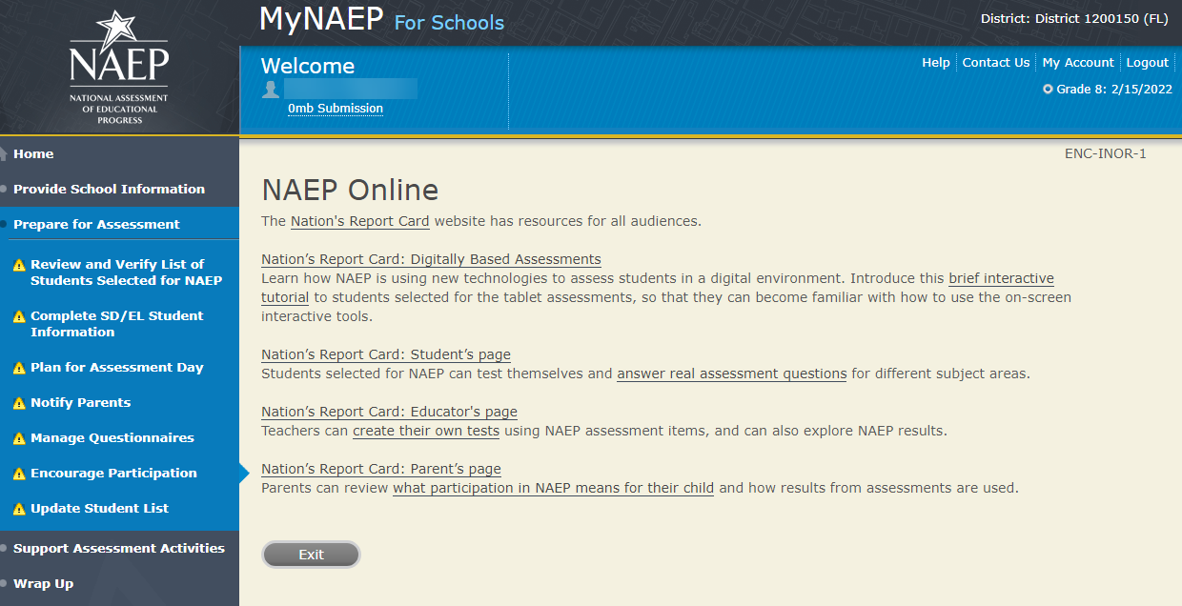

Thank Students for Their Participation
Thank Students for Their Participation ENC-THANK-1
Schools have been very creative in the variety of incentives used to encourage students to “show up” for the NAEP assessment. Many of their strategies did not cost the school anything. Examples of incentives that schools implemented include:
- extra credit;
- reduced-price or free school event tickets;
- raffle of gift certificates; and
- certificate for community service (provided by NAEP)
Work with your principal to consider ways to thank students for their participation.

Summary of Changes from 2021 to 2022:
- No changes.

Screenshot
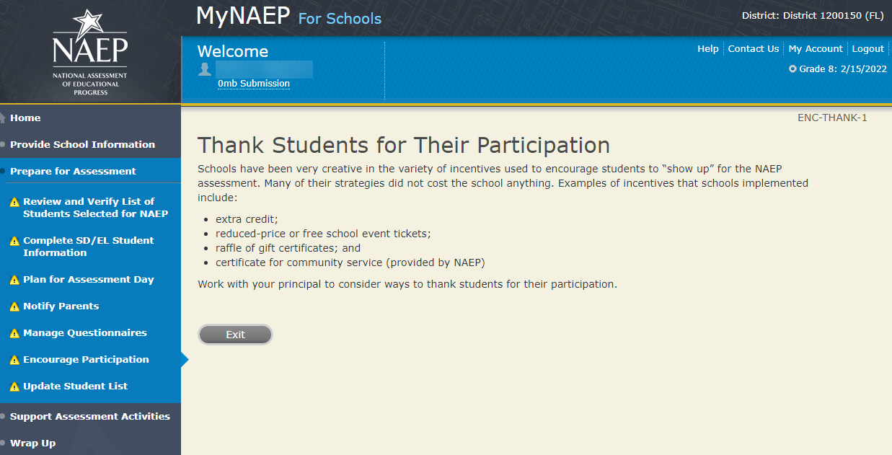

Encourage Participation

Select Strategies to Encourage Participation
ENC-STRAT-1
Which strategies below have you used or do you plan on using at your school? This information helps us develop more effective resources for you.
- Notify students
- Show NAEP videos
- Introduce NAEP online resources
- Thank students for their participation
- Other, specify
- None

Summary of Changes from 2021 to 2022:
- No changes.
Screenshot
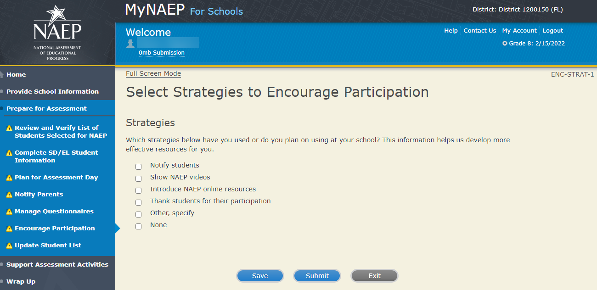

Update Student List - NEW
Note: In this section the school coordinator will identify any newly enrolled students since the original list of students was provided in the fall. The school coordinator will upload a current list of students via Excel or review original list and add newly enrolled students. This is meant to ensure all students have an opportunity to be sampled so NAEP can assess a representative sample of students.
Prepare for Assessment
Update Student List
A list of grade X students was submitted in the fall, and NAEP selected students from this list to participate. Any new students, or students who were mistakenly left off this list last fall, must have an opportunity to be selected.
In this section you will upload a list of all currently enrolled grade X students. The updated list should reflect January 2022 enrollment.
After you submit the current list, you will receive email notifications when you need to complete additional steps.
Complete the following:
- Watch Update Student List Tutorial (8:29) (https://bcove.video/2xj4v1r)
- Give Access for Student Data Specialist (optional)
- Submit Current List
Additional Resources
- Student List Requirements and Instructions
Summary of Changes from 2021 to 2022:
- No changes in this entire section, all screens are the same.

Screenshot
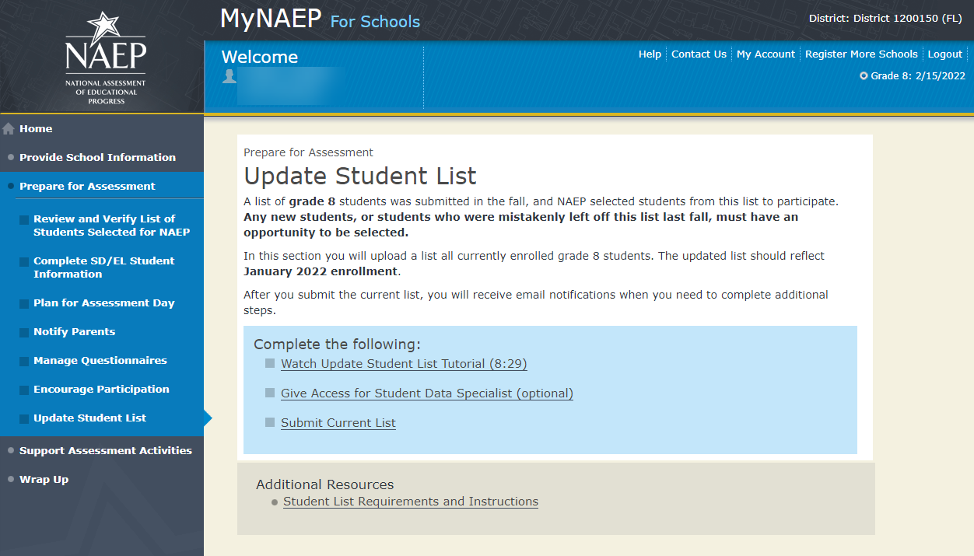
Update Student List

Give Access for Student Data Specialist
INES-SPE 1-1
The person at your school most familiar with creating a report of currently enrolled grade 8 students should submit the current roster in early January. The roster must be an Excel file, and it should include the following information for each student.
- Student ID (optional, no SSNs)
- First name
- Middle name/initial (optional)
- Last name
- Month of birth
- Year of birth
Use the table below if you would like to designate a student data specialist to complete this task.
- After entering the name and email information select Save
- Then select the Send Email button
- Select Submit

Screenshot
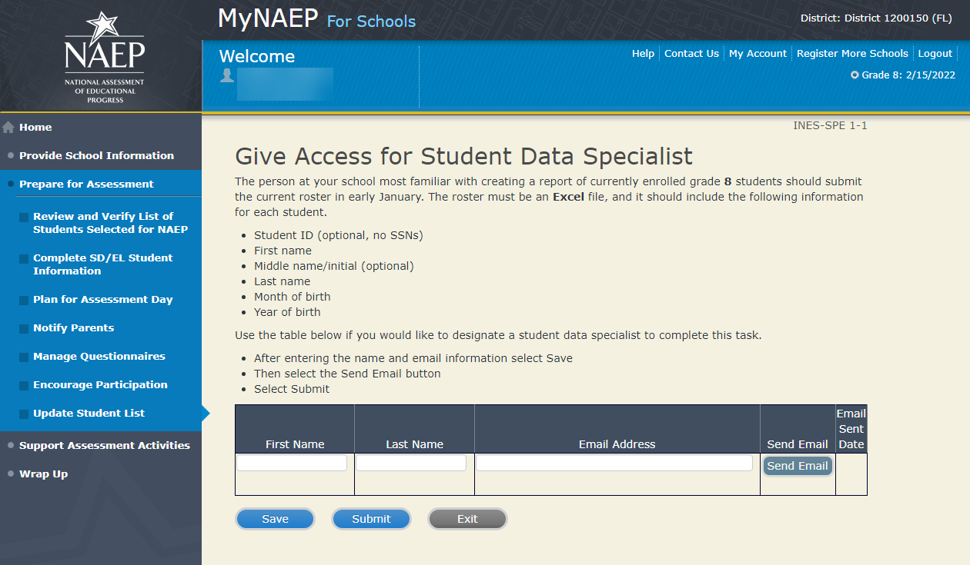

Submit Current List

Submit Current List
Prepare File-USL-SUB-1
NAEP needs a complete and current list of all students in grade X (not just new students). The list should reflect January 2021 enrollment and will help NAEP identify any students who have enrolled since the fall of 2020. Include all students, even students who are commonly excluded from other testing programs.
To prepare your list:
- Read the instructions.
- Download the Excel template.
- Read tips for formatting the Excel file.
- Select Continue when you are ready to upload your file.
Note: the details for the bullets above can be found in the Additional Resources section of this document under Student List Requirements and Instructions section of this document.

Screenshot
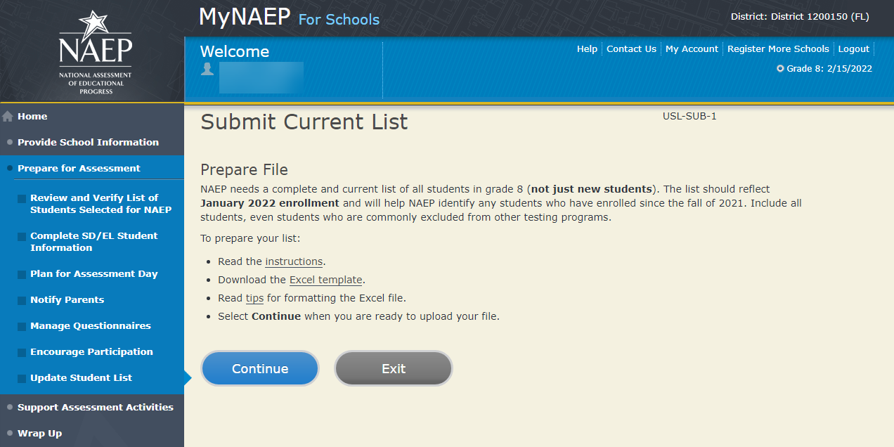

Submit Current List
Upload File-USL-SUB-2
- Does your student data file contain column headers?
- Date list is accurate as of:
Click to show calendar (mm/dd/yyyy)
- Click on the "Choose File" or "Browse..." button below. It will open a window in the browser on your computer that will allow you to navigate to where the student list file is located on your computer. This must be an Excel file containing all currently enrolled grade X students at your school.
- Double-click on the file (or select it and then click on the Open button). The name of the file (and the path) will appear in the File Name box below.
- Select the Upload button and proceed.
Screenshot
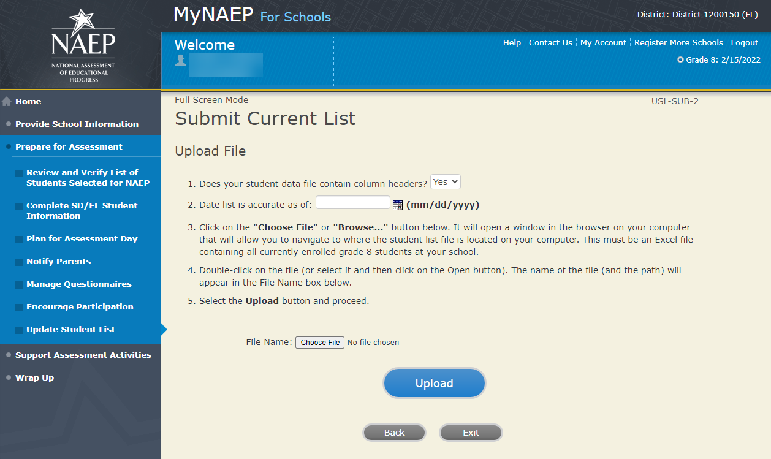
Submit Current List-USL-SUB-3
How is each student name formatted in your Excel file?
Split across multiple columns (regardless of order)
For example:
First Name Last Name
Rosa Parks
or
First Name Middle Name Last Name
Rosa Louise Parks

Contained within a single column (regardless of order)
For example:
Name
Rosa Parks
or
Name
Rosa Louise Parks

Screenshot

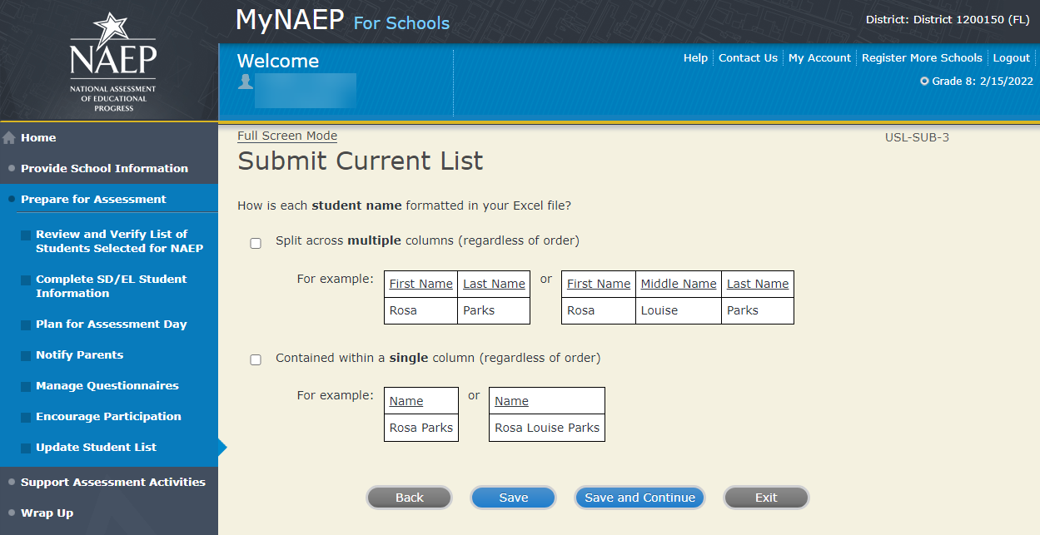

Submit Current List-SCR-SUB-4
How is date of birth formatted in your Excel file?
Split across multiple columns (regardless of order)
For example:
Month Year
1 2015
or
Month Day Year
1 20 2015

Contained within a single column (regardless of order)
For example:
Date of Birth
1/20/2015

Screenshot

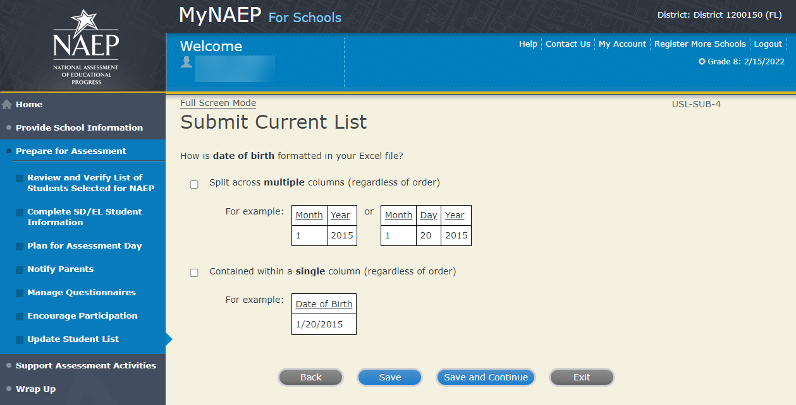
Submit Current List-SCR-SUB-8
How is month of birth formatted in your Excel file?
As a number (1 or 01)
As a word (January) or an abbreviation (Jan.)

Screenshot
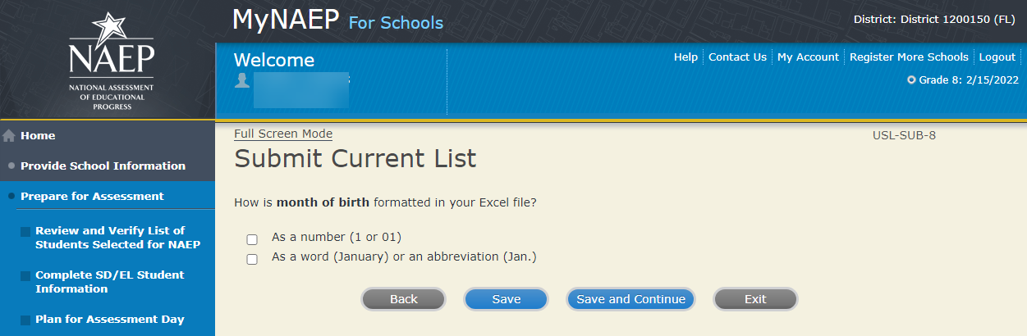

Submit Current List-USL-SUB-9
How is year of birth formatted in your Excel file?
As four digits (2016)
As two digits (16)

Screenshot
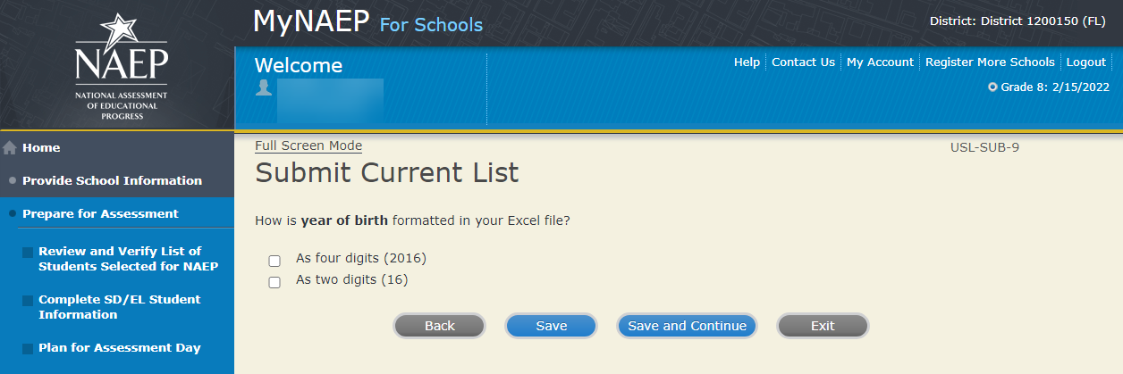
Submit Current List
Identify Your Columns-USL-SUB-5
NAEP needs to know what student data is in each column of your Excel file.
We have matched your column headings (on the left) with our required categories (on the right). For example, if your file has a column called "FName," the system already matched that to our "First Name" category.
- Review the matches in the table below, making any changes by selecting the drop-down menu.
- If your Excel file contains information that NAEP doesn't need (like homeroom), mark those columns as Not Applicable.
Tip: Do the column headings on the left display student data (e.g., Rosa) instead of column headings (e.g., Name)?
- Select the Back to Beginning button.
- On the Upload File screen, specify that your file does not contain column headers by selecting No for question number 1.

Screenshot
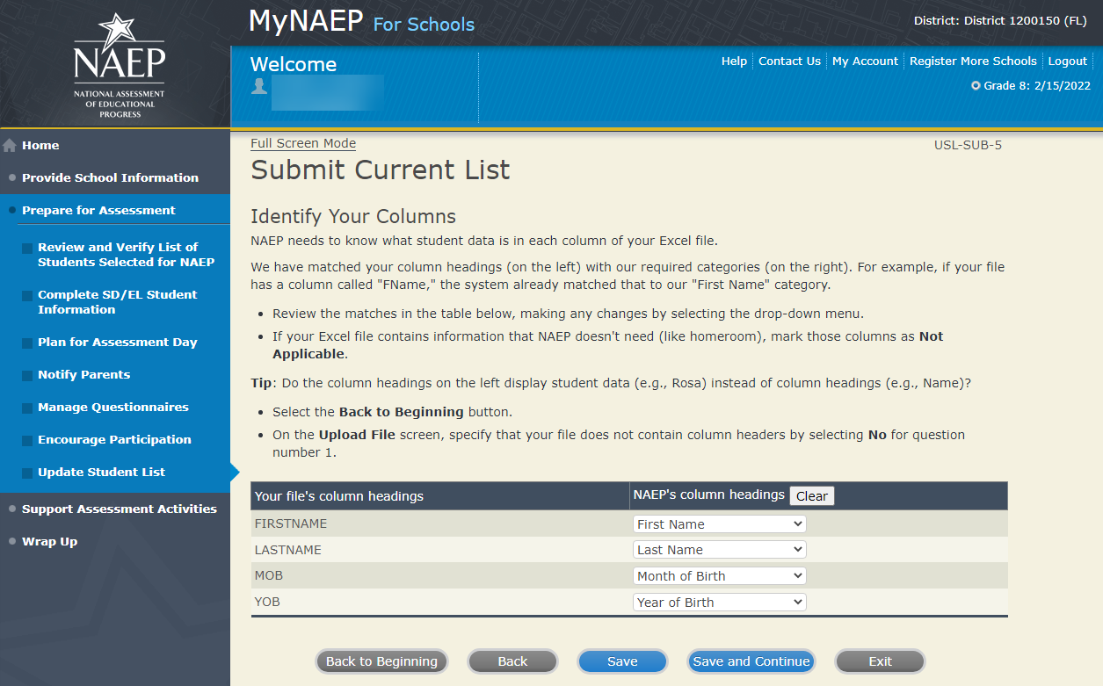
Submit Current List
Final Review-USL-SUB-13
You're almost done!
- Check to make sure that student names are in the appropriate columns and that months and years of birth appear correctly.
- Select the Edit pencil to make changes to individual students.
- If something looks wrong and you need to upload a new file, select Start Over.
- To complete this task, select Submit.
Screenshot
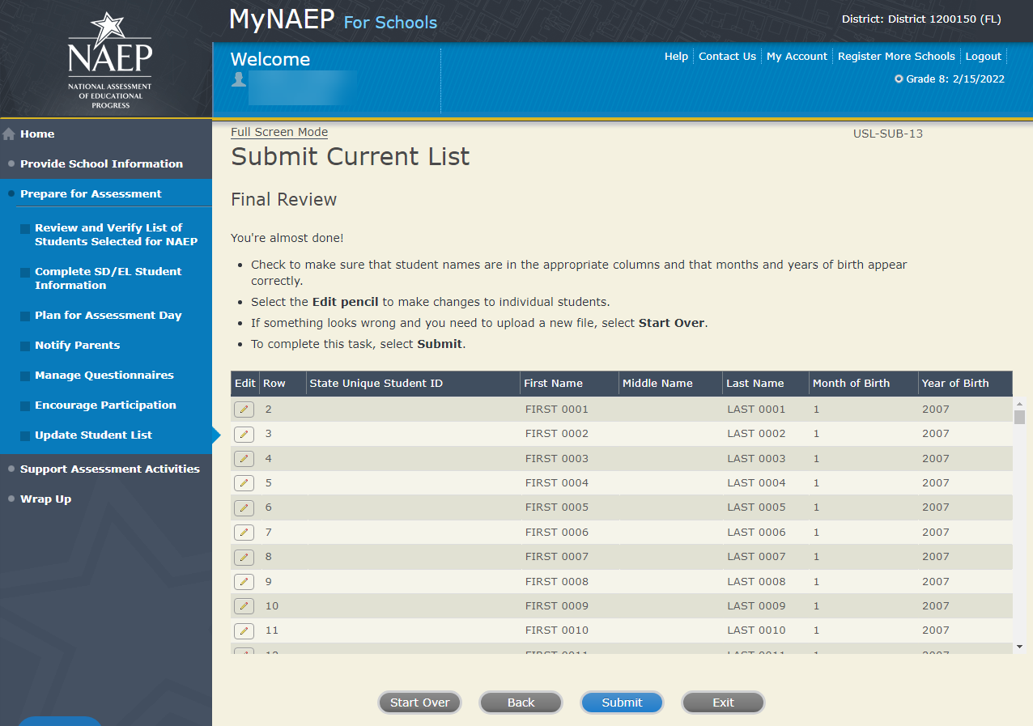
Submit Current List
Thank You – USL-SUB-14
Thank you for submitting your list. You will soon receive an email letting you know if any additional students are selected to participate in NAEP.
Screenshot
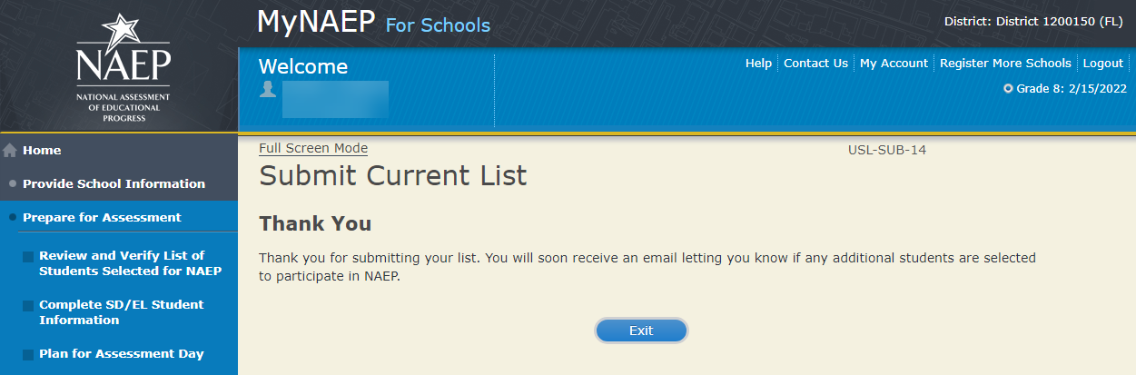

Support Assessment Activities - NEW

Support Assessment Activities
Help students remember the date, time, and location of the assessment. Use the link below to print Student Appointment Cards and distribute them to the students.
Circulate the Teacher Notification Letter and attach the Listing of Sampled Students so that teachers can direct students to the correct assessment location. This list is private and should be returned to you after the assessment.
Complete the following:
- Print Student Appointment Cards (see Additional Resources section of this document)
- Print Teacher Notification Letter for distribution to teachers (see Additional Resources section of this document)
- Print Listing of Sampled Students
Additional Resources
- Facts for Teachers (see Appendix D1-4)

Summary of Changes from 2021 to 2022:
- Removed reference to Measure Up since this publication has not been updated recently.

Screenshot
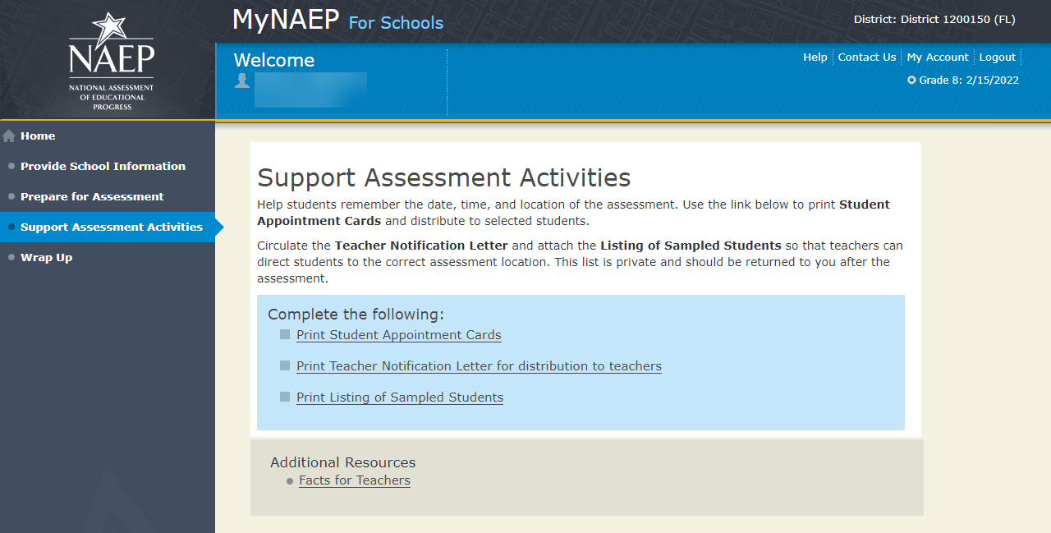

Wrap Up - NEW

Wrap Up
The final task remaining for you is to securely store and eventually dispose of all NAEP materials. Please safeguard all materials until the end of the school year. You will receive an email reminder at that time to destroy the materials in a secure manner.

Summary of Changes from 2019 to 2021:
- Replaced an instruction about storing the report in the NAEP storage envelope. Schools will not receive a storage envelope this year.

Screenshot
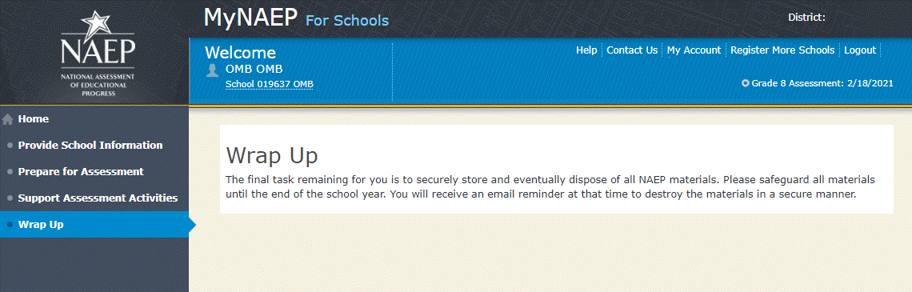

Note: The following content is the text that displays after clicking on the hyperlinks listed in the preceding pages of this document

Additional Resources

Prepare for Assessment

Instructions for the School Coordinator brochure

Instructions for the School Coordinator
Completing Preassessment Activities for NAEP 2022
Thank you for your support of the National Assessment of Educational Progress (NAEP) for 2022. We look forward to working with you to make NAEP a positive experience at your school. This begins with completing activities before the assessment.
For the upcoming assessments, the MyNAEP for Schools website will serve as your primary resource to prepare for the assessment. MyNAEP provides you with an electronic way to complete the preassessment tasks at your own pace. Visit the MyNAEP website at www.mynaep.com to get started. If you have not yet registered for MyNAEP, refer to the School Coordinator Responsibilities: A Guide to MyNAEP brochure you received earlier this fall for instructions, or your NAEP representative can assist you.
Your NAEP representative will follow up with you very soon to review the activities listed in this brochure and answer any questions you may have about completing these tasks. There are short video tutorials for each task, and we recommend reviewing them before completing the tasks.
If you need assistance before then, contact the NAEP help desk at
1-800-283-NAEP (6237) or by email at NAEPHelp@westat.com.
Thank you for your support of the National Assessment of Educational Progress!
December 6, 2021
On December 6, 2021, the sections of Prepare for Assessment on MyNAEP will be available to schools. At that time you can begin to complete the preassessment tasks listed below by selecting the Prepare for Assessment link.
Review and Verify List of Students Selected for NAEP
In this section, you will review the list of students selected for NAEP for accuracy and completeness. This section must be completed before completing the SD/EL student information.
- Update missing or incorrect student demographic data.
- Update missing or incorrect classifications for students with disabilities (SD), 504 plans, English learners (EL).
- Indicate if there are students attending your school who have been displaced from their regular school by an event such as a fire or hurricane.
- Identify how students are attending classes such as full time in-person, hybrid (part-time) or full-time virtual learner.
Complete SD/EL Student Information
In this section, you will review the list of students identified as SD and/or EL and provide information on what accommodations (if any) students require for NAEP.
- Review NAEP inclusion policy.
- Identify up to five specialists at your school to provide information for students with disabilities and English learners.
- Indicate how each student identified as SD and/or EL should be assessed on NAEP.
Plan for Assessment Day
In this section, you will provide information to help the NAEP team plan for assessments at your school.
- Review the student group assignments for testing and provide the start time(s) and testing location(s).
- Answer questions necessary to plan the assessment logistics.
- Answer questions about COVID policies to safely administer the assessment.

Notify Parents/Guardians
By law, the parents/guardians of the students selected for NAEP must be notified in writing before the assessments can take place. In this section, you are given instructions for notifying parents/guardians about the assessment and will confirm that parents/guardians of the students selected for NAEP have been notified.
- Notify parents/guardians as soon as possible using the Parent/Guardian Notification Letter (see Appendices D2-11 and D2-12) available to download in this section (available in both English and Spanish).
- Verify parent/guardian notification.
- Upload your Parent/Guardian Notification Letter and indicate when you plan to send the letter.
Manage Questionnaires
In this section, you will identify school staff members to complete online NAEP questionnaires and you will ensure that questionnaires are completed by the assessment date.
- Identify who will complete Teacher Questionnaires and record their email addresses and which subjects they teach.
- Confirm who will complete the School Questionnaire.
- Send welcome emails and questionnaire links to questionnaire recipients.
Encourage Participation
In this section, you will review strategies that can help motivate students to participate on NAEP. There are links to videos and other promotional materials.
- Record what strategies you plan to use in your school.
- Note that makeup sessions may be needed if the assessment is canceled due to weather or if attendance at the assessment is less than 90 percent.
January 3, 2022
On January 3, 2022, the remaining section of Prepare for Assessment on MyNAEP will be available to schools.
Update Student List
In this section, you will update the list of students currently enrolled in the selected grade. NAEP will use this list to identify students who were not included on the original list of students submitted to NAEP in the fall.
- You will be notified if any new students have been selected for NAEP as a result of updating the student list. For any newly sampled students, complete the “Provide Demographic Data for Newly Selected Students,” “Complete SD/EL Information for Newly Selected Students” (if necessary), and “Notify Parents of Newly Selected Students.”
1 week before assessment
Approximately 1 week before your assessment, visit the Support Assessment Activities section.
Support Assessment Activities
In this section, you have access to material for notifying students and faculty about the NAEP assessment.
- Print Student Appointment Cards to distribute to students to notify them of the date, time, and location of the assessment.
- Print the Teacher Notification Letter and distribute to all teachers. This letter provides the date, time, and location for each scheduled visit date..
- Print the List of Students Selected for NAEP and the Measure Up newsletter and distribute them, along with the Teacher Notification Letter, to all teachers for the sampled grade.
Thank you for helping us make NAEP in your school a success!
Remember to visit the MyNAEP for Schools website at www.mynaep.com to receive details about the assessment activities in your school.
What Is NAEP?
The National Assessment of Educational Progress (NAEP) is the largest continuing and nationally representative assessment of what our nation’s students know and can do in core subjects. NAEP is congressionally mandated, and was first administered in 1969 to measure student achievement nationally. Teachers, principals, parents, policymakers, and researchers all use NAEP results to assess progress and develop ways to improve education in the United States.
For more information, visit http://nces.ed.gov/nationsreportcard or contact the NAEP help desk at 1-800-283-NAEP (6237) or by email at NAEPHelp@westat.com.
Brochure layout
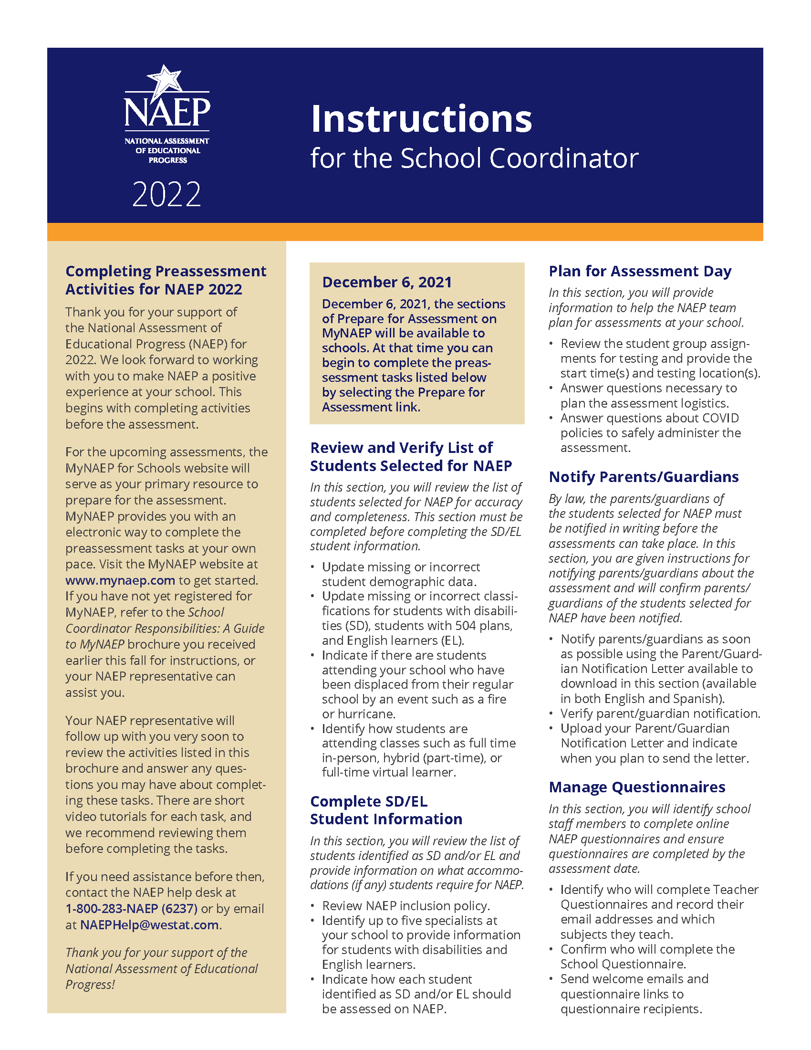

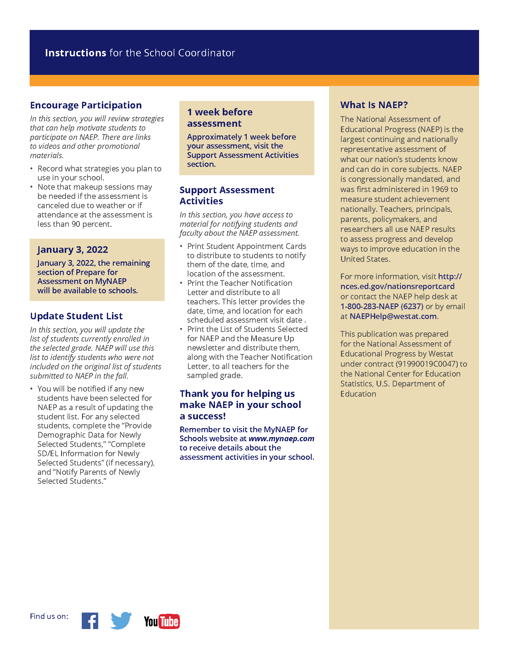

Digitally-based Assessments

This resource is a hyperlink to the Nation’s Report Card site: https://nces.ed.gov/nationsreportcard/dba/.
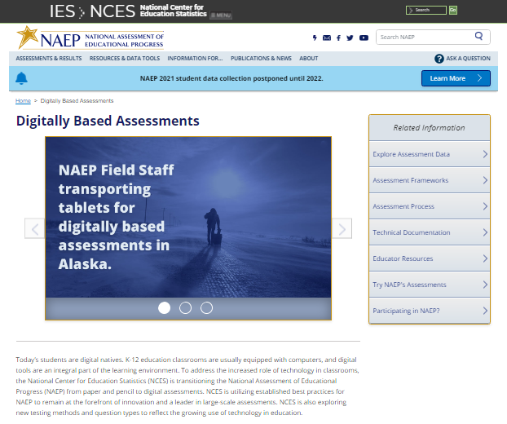

Review and Verify List of Students Selected for NAEP

Information Needed to Review and Verify List of Students Selected for NAEP

You will review and confirm the following information for each selected student.
- State Unique Student ID (optional, can be left blank)
- Month of Birth
- Year of Birth
- Gender
- Race/ethnicity
- National School Lunch Program eligibility status – only required if column appears (reduced price lunch, free lunch, student not eligible)
- Student with disability classification (IEP, 504 and requires accommodations)
- English Learner (Limited English Proficiency) status
- Reason student cannot take NAEP (are any students withdrawn from school or ineligible for NAEP)
- Remote/virtual learning program participation (part or full-time)

Determine if any selected students cannot take NAEP
Please use the reasons below to determine if any selected students cannot take NAEP.
- Withdrawn
- Graduated
- Expelled
- Attends all classes on a different campus
- Traditional homeschool learner - parent provides curriculum and may/may not act as instructor
- Student listed more than once
- Foreign exchange student
- Student deceased
- Long-term illness/homebound (will not be in school during NAEP testing)
- Parent notified about NAEP and refused NAEP testing
- Student notified about NAEP and refused NAEP testing
- Student meets (or met) participation criteria for the state alternate assessment (student is currently eligible or was eligible in the past to take the state alternate assessment)
- Student is classified as an English learner and has been enrolled in U.S. schools less than 1 full academic year before the NAEP assessment and cannot access NAEP
- Full-time virtual learner (does not attend school in-person)

Review and verify student demographic information
NAEP collects demographic information to report results for student groups. Please provide any missing information, and review for accuracy.

- Race/Ethnicity:
  - Hispanic, of any race: A person of Mexican, Puerto Rican, Cuban, Central or South American, or other Spanish (but not Portuguese) culture of origin, regardless of race.
  - White, not Hispanic: A person having origins in any of the original peoples of Europe (except Spain), North Africa, or the Middle East.
  - Black or African American, not Hispanic: A person having origins in any of the Black peoples of Africa.
  - Asian, not Hispanic: A person having origins in any of the original peoples of the Far East, Southeast Asia, the Indian Subcontinent, including, for example, Cambodia, China, Japan, India, Korea, Malaysia, Pakistan, the Philippine Islands, Thailand, and Vietnam.
  - American Indian or Alaska Native, not Hispanic: A person having origins in any of the original peoples of North and South America (including Central America), and who maintains tribal affiliation or community attachment.
  - Native Hawaiian or Pacific Islander, not Hispanic: A person having origins in any of the original people of Hawaii, Guam, Samoa, or other Pacific Islands.
  - Two or More Races (Non-Hispanic): A person who identifies with two or more of the non-Hispanic categories above.
- School Lunch Status – if column appears:
  - Student not eligible to participate: Student is not eligible for free or reduced-price lunch.
  - Free lunch: Student is eligible for free lunch. Schools participating in Provisions 2 or 3 of the National School Lunch Program (NSLP) should code all students as “free lunch.”
    - If it is not possible to distinguish between “free” and “reduced price” for some students, code these students as eligible for free lunch.
  - Reduced price lunch: Student is eligible for reduced-price lunch.
  - School not participating: School does not participate in the NSLP. When used, this code must apply to all students.

Review and verify classifications of Students with Disabilities (SD) and English Learners (EL)
Please indicate each student’s SD/EL classification with these codes.
- Students with disabilities (SD):
  - Yes, IEP: Student has a formal Individualized Education Plan (IEP) or the student’s IEP is in progress.
  - Yes, 504: Student has a 504 plan and needs accommodations to participate in NAEP. If the student does not need accommodations for NAEP, classify the student as No, not SD.
  - No, not SD: Student does not have an IEP.
- English learners (EL):
  - Yes, EL: A student who has not achieved full English proficiency, and is in the process of acquiring English language skills and knowledge. Some schools refer to these students as limited English proficient (LEP).
  - No, Formerly EL: A student who has achieved full English proficiency, is monitored, and is included in EL subgroup for accountability reporting for 2 years (or 4 years depending on state policy) after exiting.
  - No, not EL: Student is not an English learner.

Dept. of Agriculture Memo Authorizing Release of NSLP to NAEP

This memo replaces the United States Department of Agriculture (USDA) Letter
Date: School Year 2021-22
To: School Nutrition Program Personnel
From: National Assessment of Educational Progress (NAEP)
Subject: Policy on Limited Disclosure of Children's Eligibility Information to NAEP

As stated in the Eligibility Manual for School Meals (Section 5 - Confidentiality and Disclosure, Disclosure Requirements), school food authorities may disclose, without parent/guardian consent, children’s names and eligibility status (whether they are eligible for free meals or free milk or reduced price meals) to persons directly connected with the administration or enforcement of a Federal or State education program, such as NAEP, as permitted by section 9(b)(6)(A)(ii)(I) of the Richard B. Russell National School Lunch Act.
The relevant section from page 88 of the Eligibility Manual for School Meals is shown below:
Because NAEP is a Federal education program, LEAs may disclose, without parent or guardian consent, children’s names and eligibility status to persons directly connected to the administration or enforcement of NAEP. Additionally, LEAs may disclose children’s names and eligibility status to persons directly connected with the administration or enforcement of State educational assessment programs to the extent the State assessment is part of the NAEP. Other State education programs may access participants' names and eligibility status, without parent or guardian consent. However, in both situations, the program must be established at the State (not local) level.
The term “persons directly connected” for the purpose of disclosure to NAEP includes Federal, State, and local program operators responsible for NAEP administration or compliance, and their contractors. This does not imply that these persons have routine access to participants' eligibility status. There must be a "need to know" relating to the administration or enforcement of a Federal education program or for legitimate NAEP purposes.
The above information is available on the FNS website at https://fns-prod.azureedge.net/sites/default/files/cn/SP36_CACFP15_SFSP11-2017a1.pdf and then select, “Eligibility Manual.”

Complete SD/EL Student Information

Inclusion on NAEP Fact Sheet

Inclusion on NAEP
Students with Disabilities and English Learners
WHAT IS NAEP?
The National Assessment of Educational Progress (NAEP) is the largest continuing and nationally representative assessment of what our nation’s students know and can do in core subjects such as mathematics and reading.
NAEP is congressionally mandated, and was first administered in 1969 to measure student achievement nationally. Teachers, principals, parents, policymakers, and researchers all use NAEP results to assess progress and develop ways to improve education in the United States.
The Importance of Inclusion
The responses of students with disabilities and English learners on NAEP represent those of hundreds of other similar students. Without them, information about how to best meet the educational needs of these students would be lost. NAEP incorporates inclusive policies and practices into every aspect of the assessment, including selection of students, participation in the assessment administration, and valid and effective accommodations. Such best practices are essential to ensuring an inclusive assessment that yields meaningful NAEP results for all students with disabilities and English learners. By representing their peers across the nation on NAEP, students with disabilities and English learners help to ensure that NAEP results can be used to inform efforts to improve educational programs.
To ensure that the National Assessment of Educational Progress (NAEP) reflects the educational progress of all students, students with disabilities and English learners must be included to the fullest extent possible.
Selection
Students with disabilities and English learners are selected to participate in NAEP just like any other student. NAEP is administered to a sample of students who represent the student population of the nation as a whole and of individual states and districts participating in the Trial Urban District Assessment (TUDA). Within each selected school and grade to be assessed, students are chosen at random to participate in NAEP. Regardless of race/ethnicity, socioeconomic status, disability, status as an English learner, or any other factors, every student has the same chance of being chosen.
For more information about NAEP, visit http://nces.ed.gov/nationsreportcard
For More Information Contact your NAEP State Coordinator with specific questions about including students with disabilities and English learners. Details of the National Assessment Governing Board’s policy on testing and reporting results on students with disabilities and English learners on NAEP are available at https://www.nagb.gov/content/dam/nagb/en/documents/publications/inclusion-special-population-naep.pdf http://www.nagb.org/ publications/inclusion- special-population-naep.pdf. Current NAEP accommodations and inclusion policies are posted on the website at http://nces.ed.gov/nationsreportcard/about/inclusion.asp.

Participation
Many students with disabilities and English learners are able to participate in the assessment administration alongside their peers.
Participating in NAEP allows students with disabilities and English learners to experience a large-scale assessment administration without high-stakes consequences. Since NAEP does not produce scores for individual students or results for schools, participation in NAEP is not tied to grades or evaluations of students, teachers, or schools.
Accommodations
Students with disabilities and English learners are provided with testing accommodations so that they can demonstrate their content knowledge and skills on NAEP. NAEP offers a comprehensive set of accommodations to increase access to testing for students with disabilities and English learners. To ensure that appropriate accommodations are determined for individual students, NAEP relies on school staff to make inclusion and accommodations decisions for those students selected for the assessment.
The accommodations allowed on NAEP and those allowed in states are often similar, but there may be some differences. Sometimes these differences result from the way that the subject being measured is defined in the NAEP frameworks. For example, NAEP does not allow read-aloud of any part of the NAEP reading test except the instructions, because decoding words is part of what the NAEP framework is measuring.
Your NAEP State Coordinator has developed inclusion guidelines for including students with disabilities and English learners on NAEP and provided them to schools selected for the assessment. These instructions will highlight any differences between NAEP and your state’s policies and provide guidance on how to include and accommodate sampled students.

Brochure layout
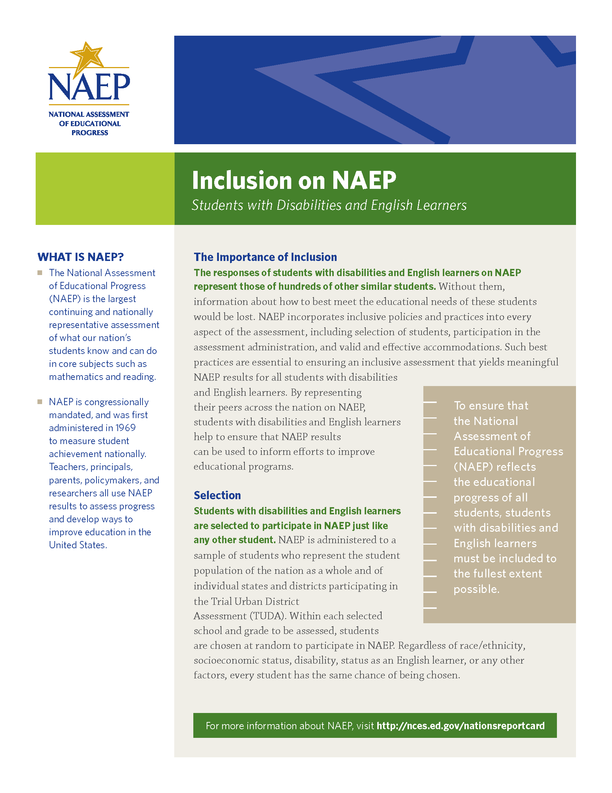

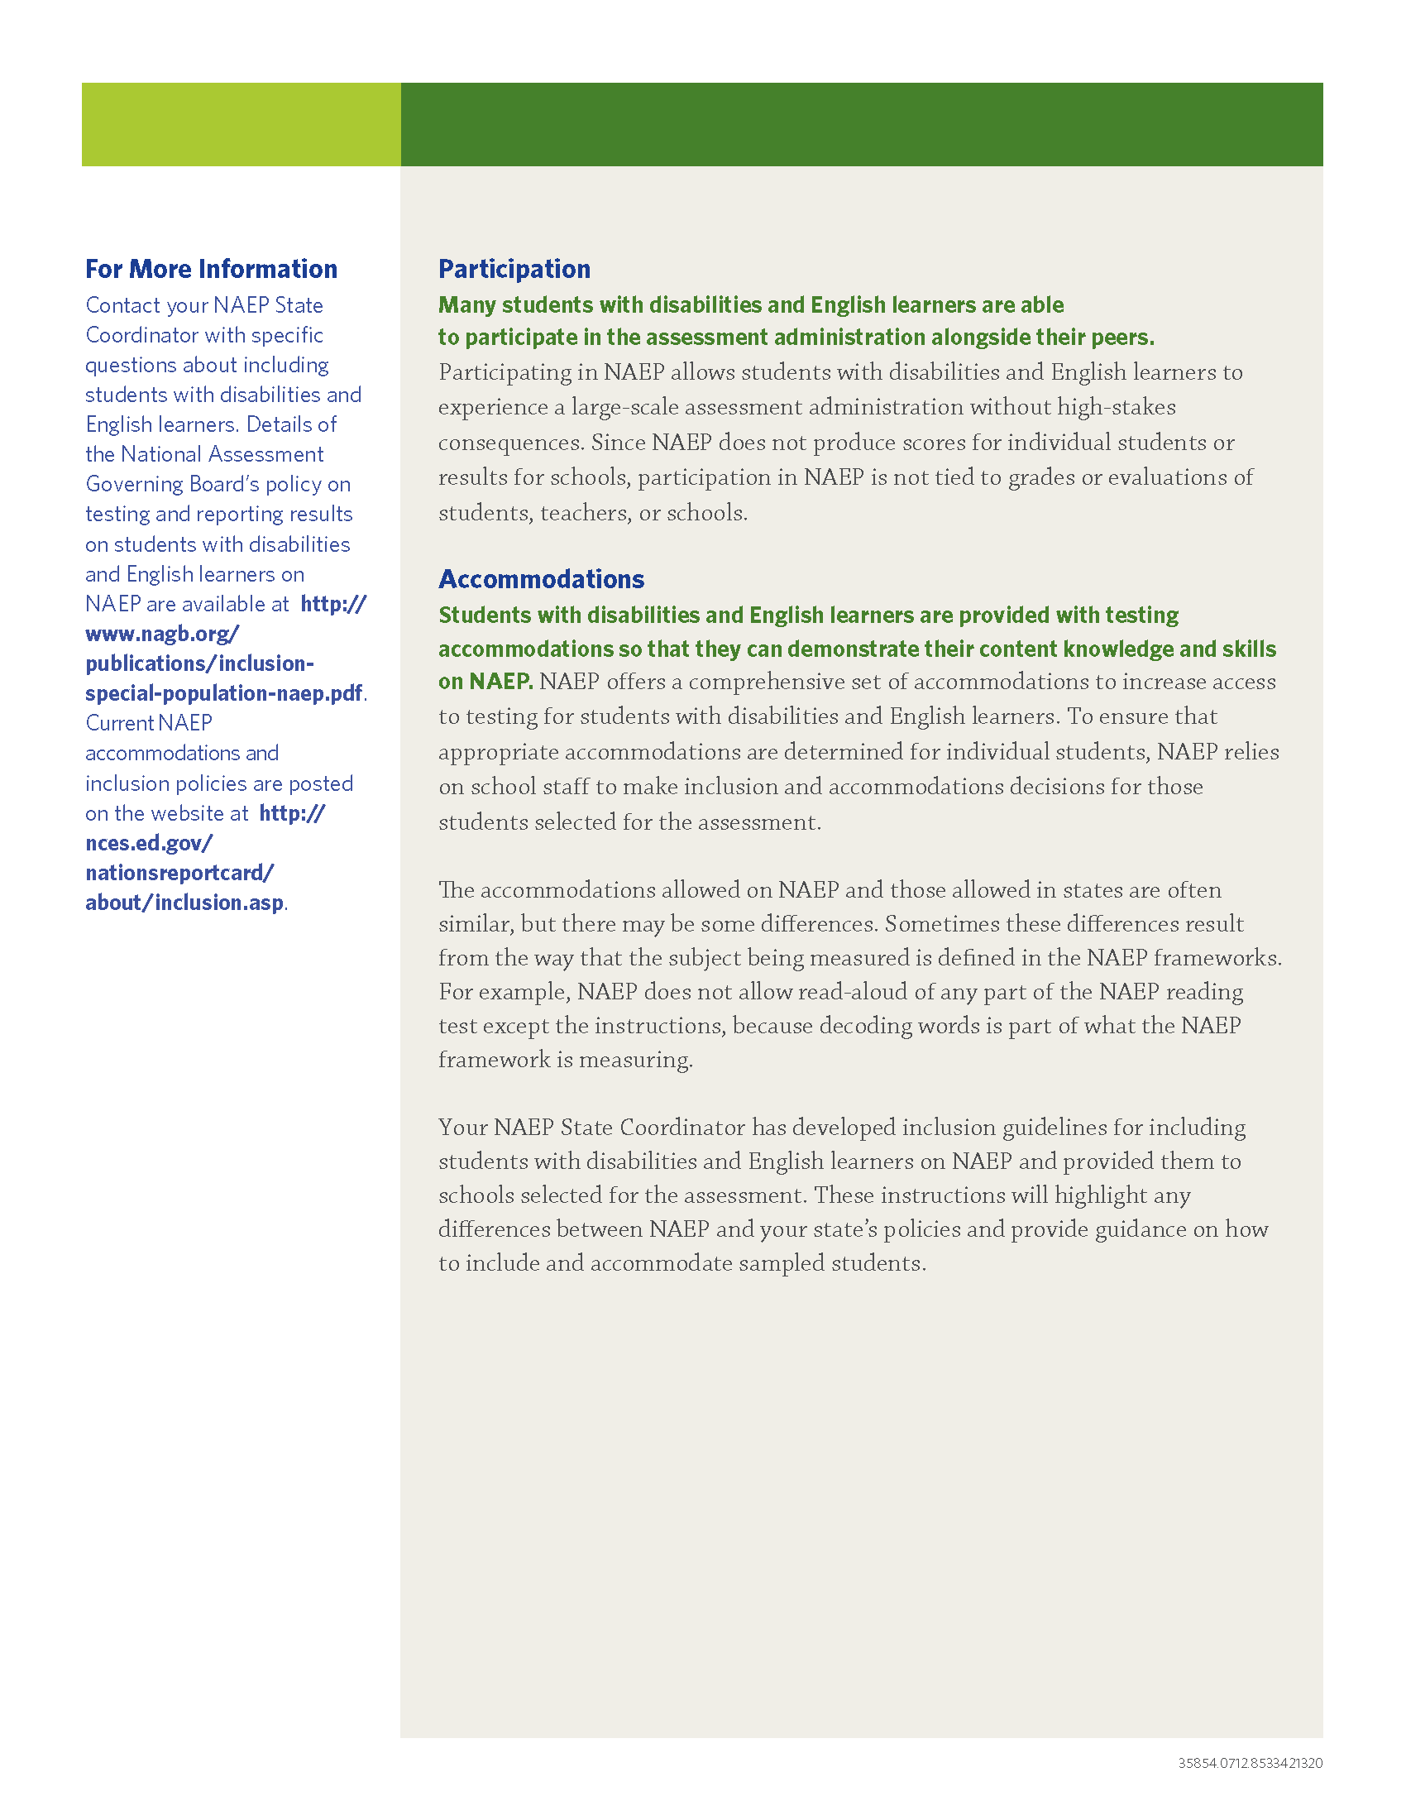

Letter from Department of Education Encouraging Inclusion
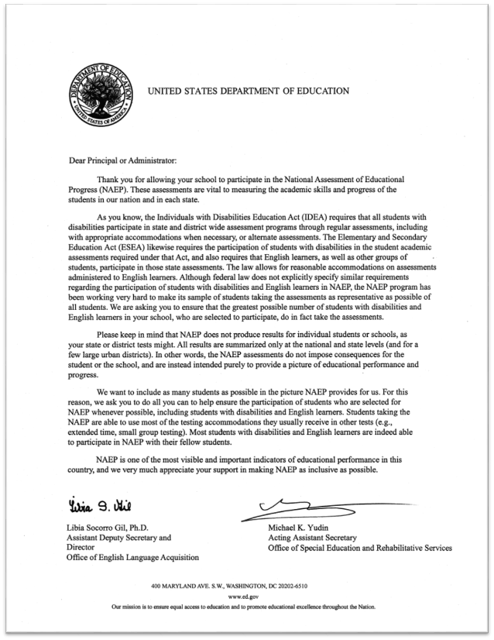

Information Needed to Include SD/EL Students

Information Needed to Include Students with Disabilities
You will enter the following information for each sampled student classified as a student with disability (SD).
- The IDEA category that best describes the student’s disability. The following categories are used by the Individual with Disabilities Education Act (IDEA).
  - Specific learning disability
  - Hearing impairment/deafness
  - Visual impairment/blindness
  - Speech or language impairment
  - Intellectual disability
  - Emotional disturbance
  - Orthopedic impairment
  - Traumatic brain injury
  - Autism
  - Development delay (age 9 or younger)
  - Other health impairment (specify)

- The degree of each student's disability.
  - Mild
  - Moderate
  - Profound/Severe

- Grade-level performance for the subject to be assessed.
  - At or above grade level
  - One year below grade level
  - Two or more years below grade level
  - Not receiving instruction in the designated subject (<subjects>)

- How is the student assessed on the state assessment? If your state does not offer a state assessment, use classroom assessments as a reference point.
  - With accommodations
  - Without accommodations
  - With an alternate assessment, etc.

- Testing accommodations that each student typically receives.

Information Needed to Include English Learners (EL)
You will enter the following information for each sampled student classified as an English Learner (Limited English Proficiency).

- Each student’s primary language.

- How long has each student received academic instruction in English?
  - Does not receive instruction primarily in English
  - Less than 1 year
  - 1 to 2 years
  - 2 to 3 years
  - 3 years or more

- Grade-level performance for the subject to be assessed.
  - At or above grade level
  - One year below grade level
  - Two or more years below grade level
  - Not receiving instruction in the designated subject (math or reading)

- Each student’s English proficiency for listening, reading, speaking and writing.
  - No proficiency
  - Beginning
  - Intermediate
  - Advanced

- How long has each student been enrolled in U.S. schools?
  - Less than 1 full academic year
  - 1 full academic year or more

- Testing accommodations that each student typically receives.

Notify Parents

Parent’s page on Nation’s Report Card website

This resource is a hyperlink to the NCES site: https://nces.ed.gov/nationsreportcard/parents/
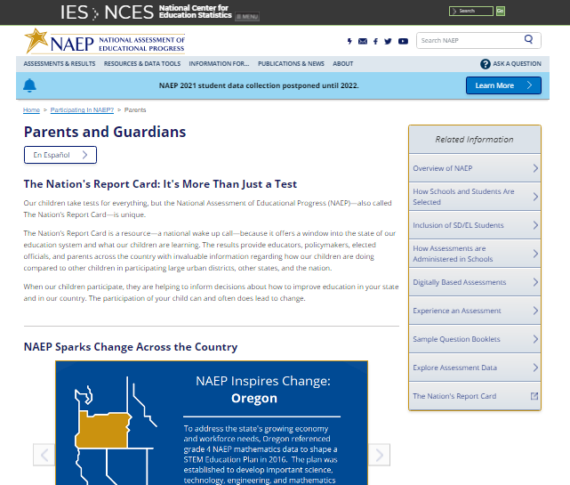

What Every Parent Should Know About NAEP: PDF version
This brochure is available here on the NCES website: http://nces.ed.gov/nationsreportcard/pdf/parents/2012469.pdf.

What Every Parent Should Know About NAEP: Video version
This video is available here on the NCES website: https://youtu.be/RurH739zdN0.

Sample Questions Booklets
This resource is a hyperlink to all the sample questions booklets posted on the NCES site: https://nces.ed.gov/nationsreportcard/about/booklets.aspx.

Manage Questionnaires

Manage Questionnaires Welcome Email
Dear [TQ Respondent Name],
The National Assessment of Educational Progress (NAEP) is the only ongoing assessment of what our nation’s students know and can do in a variety of subjects. [Grade] [4/8] students at [school name] will take [mathematics and reading/civics and U.S. history/civics, mathematics, reading, and U.S. history] assessments on [assessment date].
In addition to conducting assessments, NAEP uses a teacher questionnaire to gather information concerning years of teaching experience, frequency of assignments, use of teaching materials, and availability and use of computers. [School coordinator name] has identified you as a respondent. Your responses will provide important information for educators, policymakers, and researchers to better understand the context in which students learn. This enhanced understanding can help improve education in our nation's classrooms.
Please select the link below or copy/paste into your browser to receive your questionnaire link and password in two additional emails.
[VerifyURL]
Visit https://nces.ed.gov/nationsreportcard/experience/survey_questionnaires.aspx to explore how your responses contribute to NAEP’s ability to report on what our nation’s students know and can do.

Manage Questionnaires Reminder Email

Dear [TQ Respondent Name],

Thank you for supporting the National Assessment of Educational Progress (NAEP). Recently, you received an email asking you to complete the NAEP Teacher Questionnaire for [SCHOOL NAME]. Please disregard this email if you have already completed the questionnaire.

- Select the questionnaire link below or copy/paste into your browser.
- See separate email for password, the subject is NAEP Teacher Questionnaire – Password.
- Your school’s NAEP representative is monitoring questionnaire progress. The representative will prepare and assign a hardcopy if you cannot complete the online questionnaire by [assessment date].

[LINK]

For technical assistance, contact the NAEP help desk at 1-800-283-NAEP (6237) or naephelp@westat.com.

Visit https://nces.ed.gov/nationsreportcard/experience/survey_questionnaires.aspx to explore how your responses contribute to NAEP’s ability to report on what our nation’s students know and can do.

Encourage Participation

Digitally-based Assessments
This resource is a hyperlink to the Nation’s Report Card site: https://nces.ed.gov/nationsreportcard/dba/.

Update Student List

Student List Requirements and Instructions


Update Student List

NAEP 2022 Instructions
Part I: Requirements
NAEP needs a complete and current list of all students in the selected grade.
- The Excel list should reflect January 2022 enrollment. Include all students, even students who are commonly excluded from other testing programs.
- NAEP will compare this new list against the original list submitted in the fall of 2021. This comparison will produce “newly identified students” who have enrolled since the fall. NAEP may draw a random sample of newly identified students to take the assessment.
- The student list must be a Microsoft Excel file (version 95 or later). NAEP cannot convert PDF files or other formats to Excel. If your student information is available in a different format, copy and paste the student data into an empty Excel template.
- NAEP cannot provide the fall Excel student list. An empty template is available for downloading.
- Contact the NAEP Help Desk at naephelp@westat.com or 1-800-283-6237 for assistance.
Include the following information for each student in the selected grade.
- Student first name
- Student last name
- Month of birth
- Year of birth
If available, please include…
- Student middle name/initial
- State unique student ID (do not use Social Security numbers)
Part II: List Format
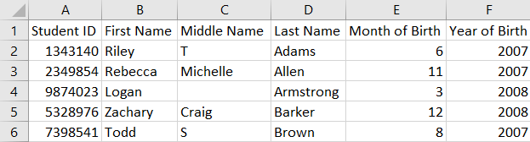
You will answer questions about your Excel file’s format during the upload process. Will your file have all student information in separate columns? Good! This is the preferred format.

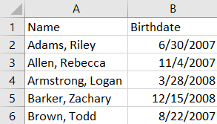
NAEP also accepts student names and birth dates formatted in single columns.
- During the upload, you will indicate whether the student name column includes middle names, specify the order of names, and select characters that separate names (spaces, commas, slashes or other). Middle names and initials are optional. The example to the right is last name, first name.
- The same idea applies to birth dates, too. The example to the right is mm/dd/yyyy.
Part III: Pre-upload Checklist
Formatting errors can cause the file upload to fail. Save time by using this pre-upload checklist. If you can check off everything on this list, then you’re ready.
- The file was prepared after January 1st and contains all currently enrolled students in the selected grade (not just new students who have enrolled since the fall).
- The filename ends with .xls or .xlsx.
- Blank rows do not start until after the last student record. There are no blank cells or rows within the required student information (blanks for middle names and student IDs are ok).
- The file has only one worksheet with data; any extra worksheets are blank.
- The file does not have any footers or images at the bottom.
- The header for my file is in a single row, and there are no images at the top.
- I understand how student names are formatted in my file.
- I understand how month and year of birth are formatted in my file.

Part IV: Special Situations & Tips
- The first row of data in your file will be read as the column headers. Each succeeding row will be considered a student record.
- Use the most current enrollment information available, so that all students have an equal opportunity to be selected for NAEP.
- Schools with more than one grade-level to be assessed should submit separate Excel files for each grade.
- Year-round schools with multiple tracks of students should not include any students who will be on break on the scheduled assessment date.
- If MyNAEP cannot process your file, try selecting the Back button and revising your answers about how the Excel file is formatted. In the example below, the user checked the wrong box for the number of digits in the birth year. The red text at the top of the screen will display the number of digits in the birth year (in this case, four).
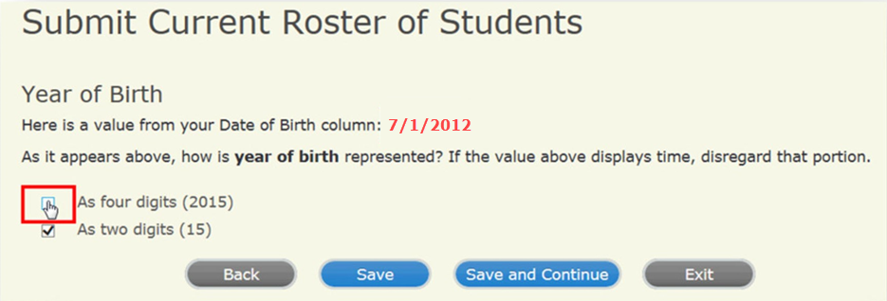

Support Assessment Activities

Teacher Notification Letter
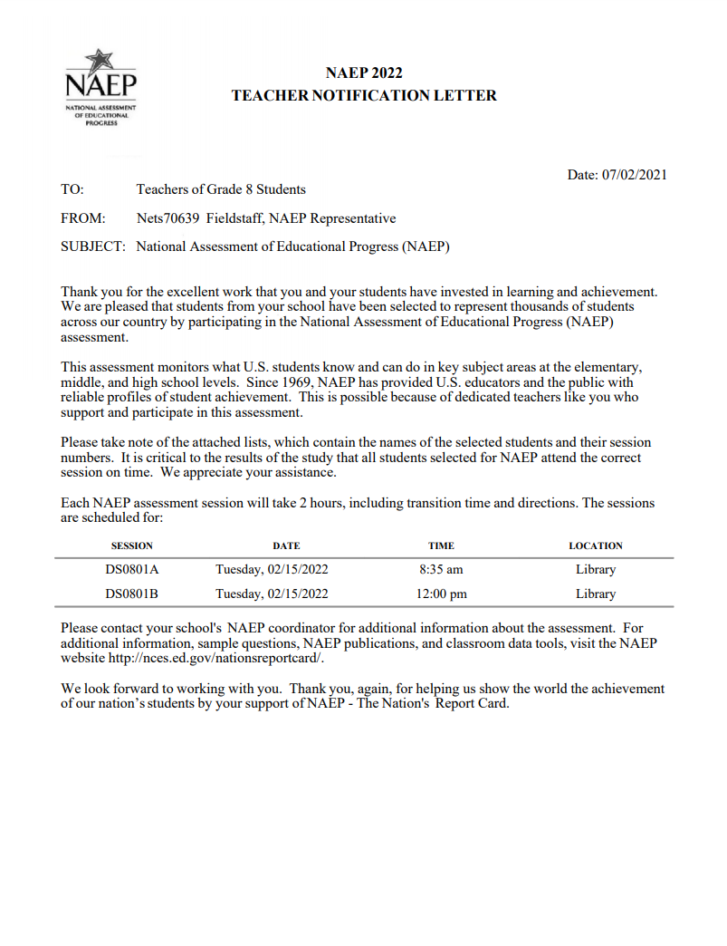

Appointment Cards
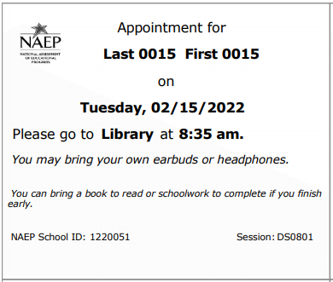

Please note that parents/legal guardians are required to receive notification of student participation but NAEP does not require explicit parental consent (by law, parents/guardians of students selected to participate in NAEP must be notified in writing of their child’s selection prior to the administration of the assessment).

