National Center for Education Statistics

Attachment 1: Recruitment, Consent Forms, and Receipt Acknowledgment Materials

2023-24 National Teacher and Principal Survey (NTPS)
Respondent Portal Usability Testing and Focus Groups

OMB# 1850-0803 v.319

June 2022

2023-24 NTPS Portal Pretesting
Attachment 1
Recruitment, Consent Forms, and Receipt Acknowledgment Materials

Table of Contents
Email text for personal and professional contacts for usability testing 2
Short recruitment advertisement text for Craigslist for usability testing 3
Census Bureau broadcast message: Participants Needed for a Study 3
Email text for personal and professional contacts for focus groups 4
Phone text for personal and professional contacts for focus groups after email 4
Privacy Protection Email 6
Consent Email (after scheduling interview by phone) 6
Reminder email (sent 1 business day before interview) 7
Teams Attachment 9
Consent online form for usability testing 13
Informed Consent for focus group 14
Incentive Receipt Acknowledgement Form for Focus Group 15

Email text for personal and professional contacts for usability testing

Dear [contact]:
The U.S. Census Bureau is assisting with a study conducted by the National Center for Education Statistics (NCES) of the U.S. Department of Education. In an effort to improve a web survey, we are specifically looking for school administrators or administrative support staff for elementary, middle, or high schools to participate in a one-time, voluntary web survey and provide feedback after completing it.
If you are eligible and participate in the study, you will receive $75 as a thank you for your participation.
What will I be doing in a usability study?
This study is virtual. You will be asked to complete a web survey and do several short tasks using the web while sharing your screen using Microsoft (MS) Teams. You will also be asked questions about your experience with and perceptions of the web surveys.
What types of information will I be asked to provide?
As part of this study, you will be asked to verify or provide school contact information and basic information for each teacher at your school, including teacher names, email addresses, and subject matter(s) taught. Please be assured that both the National Center for Education Statistics (NCES) of the U.S. Department of Education and the U.S. Census Bureau follow strict procedures to protect the confidentiality of study participants. All of the information you provide may be used only for statistical purposes and may not be disclosed, or used, in identifiable form for any other purpose except as required by law (20 U.S.C. §9573 and 6 U.S.C. §151).
How long is a session?
The session will last approximately 90 minutes.
When and where?
The study will be held [DAYS, DATES] virtually using MS Teams.
Interested in participating?
Please reply to this email with your contact information or call me at [ADD PHONE]. I’ll ask you some questions to help us determine if you are eligible for the study.
If someone you know is interested in participating, please contact [contact info].
Thank you for your time and help with this important study.
Sincerely,
[Recruitment Contact Info]

Short recruitment advertisement text for Craigslist for usability testing

K-12 School Staff Needed for Testing a National School Survey- Receive $75
The U.S. Census Bureau is looking for administrative staff in K-12 schools to participate in a virtual interview about their school. Specifically, we are seeking staff who can best provide information about the teachers at their school, including each teacher's name, email address, and subjects taught. Staff from public, charter, or private schools are welcome to participate. Administrative staff who participate in the virtual interview will complete a portion of the National Teacher and Principal Survey for the National Center for Education Statistics (NCES) using their work computer.
Interviews are around 90 minutes and will take place in May and June 2022 using Microsoft Teams. Participants will receive $75.
Please email your contact information to csm.participate@census.gov or call Kevin at (301) 763-4979 and mention TEACHER LISTING to learn more.

Census Bureau broadcast message: Participants Needed for a Study
From the Desk of Paul Beatty, Chief, Center for Behavioral Science Methods...
The U.S. Census Bureau is looking for administrative staff in K-12 schools to participate in a virtual interview about their school. Specifically, we are seeking staff who can best provide information about the teachers at their school, including each teacher's name, email address, and subjects taught. Staff from public, charter, or private schools are welcome to participate. Administrative staff who participate in the virtual interview will complete a portion of the National Teacher and Principal Survey for the National Center for Education Statistics (NCES) using their work computer.
Interviews are around 90 minutes and will take place in May and June 2022 using Microsoft Teams. Participants will receive $75.
If you know anyone who meets these criteria, please let them know about this research opportunity. Please have them email their contact information to csm.participate@census.gov or call Kevin at (301) 763-4979 and mention TEACHER LISTING to learn more.

Email text for personal and professional contacts for focus groups

Dear [contact]:
The U.S. Census Bureau is assisting with a study conducted by the National Center for Education Statistics (NCES) of the U.S. Department of Education. Our records indicate you were the named coordinator for your school for the 2020-21 National Teacher and Principal Survey. We are interested in getting feedback on the surveys and web interface design and whether the materials provided encouraged staff to participate in the surveys. We invite you to participate in a focus group on these topics. Focus groups will be virtual through Microsoft (MS) Teams and held on multiple dates and times in [month].
Would you like participate in this voluntary ninety-minute focus group?
You will receive $75 as a thank you for your participation and you do not need to be at the school to participate.
To sign up please click the below link to answer a few questions.
[QUALTRICS Link to screener questions]
What will I be doing in the focus group?
This study is virtual. You will be shown images of the National Teacher and Principal Portal and survey screens. You will first be asked to answer some survey questions one-on-one with a Census Bureau researcher. The rest of the time will be spent in a group discussion about other survey screens and contact materials. We will ask you your opinion on the screens and whether you used the information available in the survey to encourage participation from the staff in your school. Approximately three to five other schools will also be participating in the focus group portion.
How long is a session?
The session will last approximately 90 minutes.
When and where?
The study will be held [DAYS, DATES] virtually using MS Teams.
Interested in participating?
Please reply to this email with your contact information or call me at [ADD PHONE]. I’ll ask you some questions to make sure you are eligible for the study.
Thank you for your time and help with this important study.
Sincerely,
[Recruitment Contact Info]

Phone text for personal and professional contacts for focus groups after email

[Talking to live person]
Hi this is [Name] from the U.S. Census Bureau, is this [ person’s name]? Our records indicate that you were the survey coordinator for your school in the 2020-21 National Teacher and Principal Survey.
[If they volunteer that they don’t remember the survey:] It is ok if you don’t remember this survey.

We are calling you because we are interested in getting your feedback and thoughts on a website for the National Teacher and Principal Survey. We are going to hold a 90-minute focus group and would like you to participate in it. The focus group will be virtually over Microsoft Teams. You will receive $75 cash for participation.
Are you interested in participating?
[Yes] Great thank you, I just have a few questions to ask to confirm your eligibility. [Go to screener].

[If need to leave a message]
Hi this is [Name] from the U.S. Census Bureau, I am trying to reach [person’s name]. We are wondering if they might be interested in participating in a virtual focus group for $75 to give feedback on an education survey they completed last year. If interested please give me a call back at xxx-xxx-xxxx or email me at csm.recruiting@census.gov.
Thank you for your time!

Privacy Protection Email
(All participants who call in for recruiting will be sent this email.)
Dear [participant name]:
Thanks for taking some time to answer my questions today. If you qualify, someone will be back in touch with you soon to schedule an interview.
The U.S. Census Bureau is required by law to protect your information. We are conducting this voluntary survey​ on behalf of the National Center for Education Statistics under the Education Sciences Reform Act of 2002 (ESRA 2002, 20 U.S.C., § 9543). All of the information you provide may be used only for statistical purposes and may not be disclosed, or used, in identifiable form for any other purpose except as required by law (20 U.S.C. §9573 and 6 U.S.C. §151).
Your privacy is also protected by the Privacy Act, Title 5 U.S. Code. Routine uses of these data are limited to those identified in the Privacy Act System of Record Notice titled, “SORN COMMERCE/Census-7, Demographic Survey Collection (non-Census Bureau Sampling Frame).”
We estimated that completing the screening questions will take 10 minutes on average. This information collection has been approved by the Office of Management and Budget (OMB). You can validate that this survey is a legitimate federally-approved information collection using the Office of Management and Budget's approval number 1850-0803, which expires June 30, 2025. We are required to tell you this number to conduct this survey. Send comments regarding this estimate or any other aspect of this survey, including suggestions for reducing the time it takes to complete this survey to adrm.pra@census.gov.
Thank you for your time and your assistance,
[name]

Consent Email (after scheduling interview by phone)

Greetings [participant name],
We are looking forward to working with you on [Date, Time] for the upcoming education study. At the above time please log into the Teams calendar invite below from a desktop or laptop computer. If you have any issues please call me at [Interviewer phone number].
Below you will find a link to a webpage where you can give your signature to consent to participate in this research. We are also including instructions on how to access Microsoft Teams. Please sign the consent form before the time of your interview.
[Consent form link]
During the session, we are going to ask you to provide information about the teachers in your school, including their name, e-mail address, and subject matter taught. You will need access to this information during the session.

[Teams meeting link]
If you have any questions please contact me at [email] or [phone number].
Thank you,
[name]
[Teams attachment]

NCES is authorized to conduct NTPS by the Education Sciences Reform Act of 2002 (ESRA 2002, 20 U.S.C. §9543). All of the information you provide may be used only for statistical purposes and may not be disclosed, or used, in identifiable form for any other purpose except as required by law (20 U.S.C. §9573 and 6 U.S.C. §151).
According to the Paperwork Reduction Act of 1995, no persons are required to respond to a collection of information unless it displays a valid OMB control number. The valid OMB control number for this voluntary information collection is 1850-0803 and the approval expires 06/30/2025. The time required to complete this information collection is estimated to average 90 minutes per response, including the time to review instructions and complete and review the information collection. If you have any comments concerning the accuracy of the time estimate, suggestions for improving this collection, or comments or concerns about the contents or the status of your individual submission of this questionnaire, please e-mail: maura.spiegelman@ed.gov, or write directly to: Maura Spiegelman, National Center for Education Statistics, Potomac Center Plaza, 550 12th Street, SW, Room 4035, Washington, DC 20202.

Reminder email (sent 1 business day before interview)

Greetings [participant name],
We are looking forward to working with you on [Date, Time, Time Zone]. At the above time please log into the Teams calendar invite below from a desktop or laptop computer. If you have any issues please call me at [Interviewer phone number].
Below you will find a link to a webpage where you can give your signature to consent to participate in this research. We are also including instructions on how to access Microsoft Teams. If you have not already done so please sign the consent form before the time of your interview.
[Consent form link]
During the session, we are going to ask you to provide information about the teachers in your school, including their name, e-mail address, and subject matter taught. You will need access to this information during the session.

[Teams meeting link]
If you have any questions please contact me [Interviewer e-mail] or [Interviewer phone number].
Thank you,
[name]
[Teams attachment]
NCES is authorized to conduct NTPS by the Education Sciences Reform Act of 2002 (ESRA 2002, 20 U.S.C. §9543). All of the information you provide may be used only for statistical purposes and may not be disclosed, or used, in identifiable form for any other purpose except as required by law (20 U.S.C. §9573 and 6 U.S.C. §151).
According to the Paperwork Reduction Act of 1995, no persons are required to respond to a collection of information unless it displays a valid OMB control number. The valid OMB control number for this voluntary information collection is 1850-0803 and the approval expires 06/30/2025. The time required to complete this information collection is estimated to average 90 minutes per response, including the time to review instructions and complete and review the information collection. If you have any comments concerning the accuracy of the time estimate, suggestions for improving this collection, or comments or concerns about the contents or the status of your individual submission of this questionnaire, please e-mail: maura.spiegelman@ed.gov, or write directly to: Maura Spiegelman, National Center for Education Statistics, Potomac Center Plaza, 550 12th Street, SW, Room 4035, Washington, DC 20202..

Teams Attachment

- You will receive an invitation that looks like this. Click the link to join at the time of your meeting:
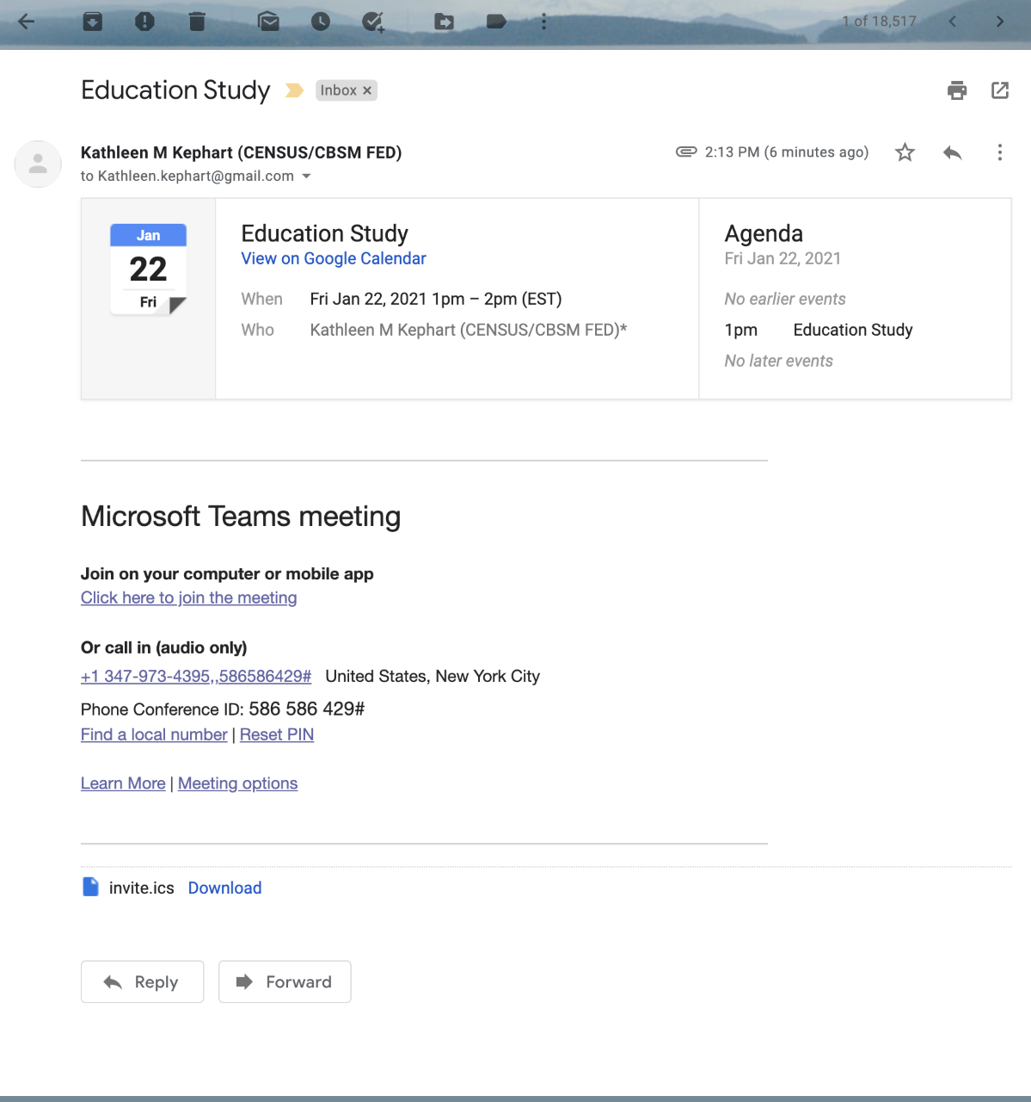

- If you already have Teams installed, feel free to use that. Otherwise select “continue on this browser.” Do NOT use Firefox:
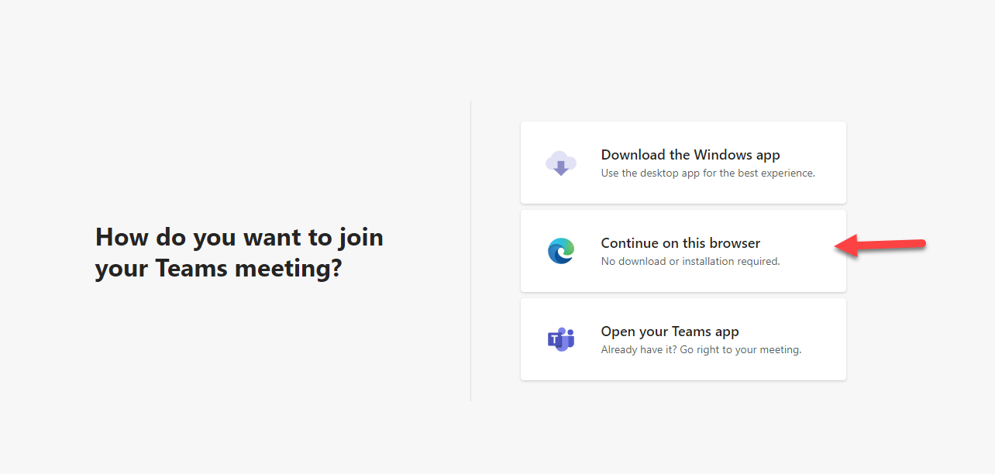

- Be sure to give permission to use your camera and microphone. Enter a name and click “join now”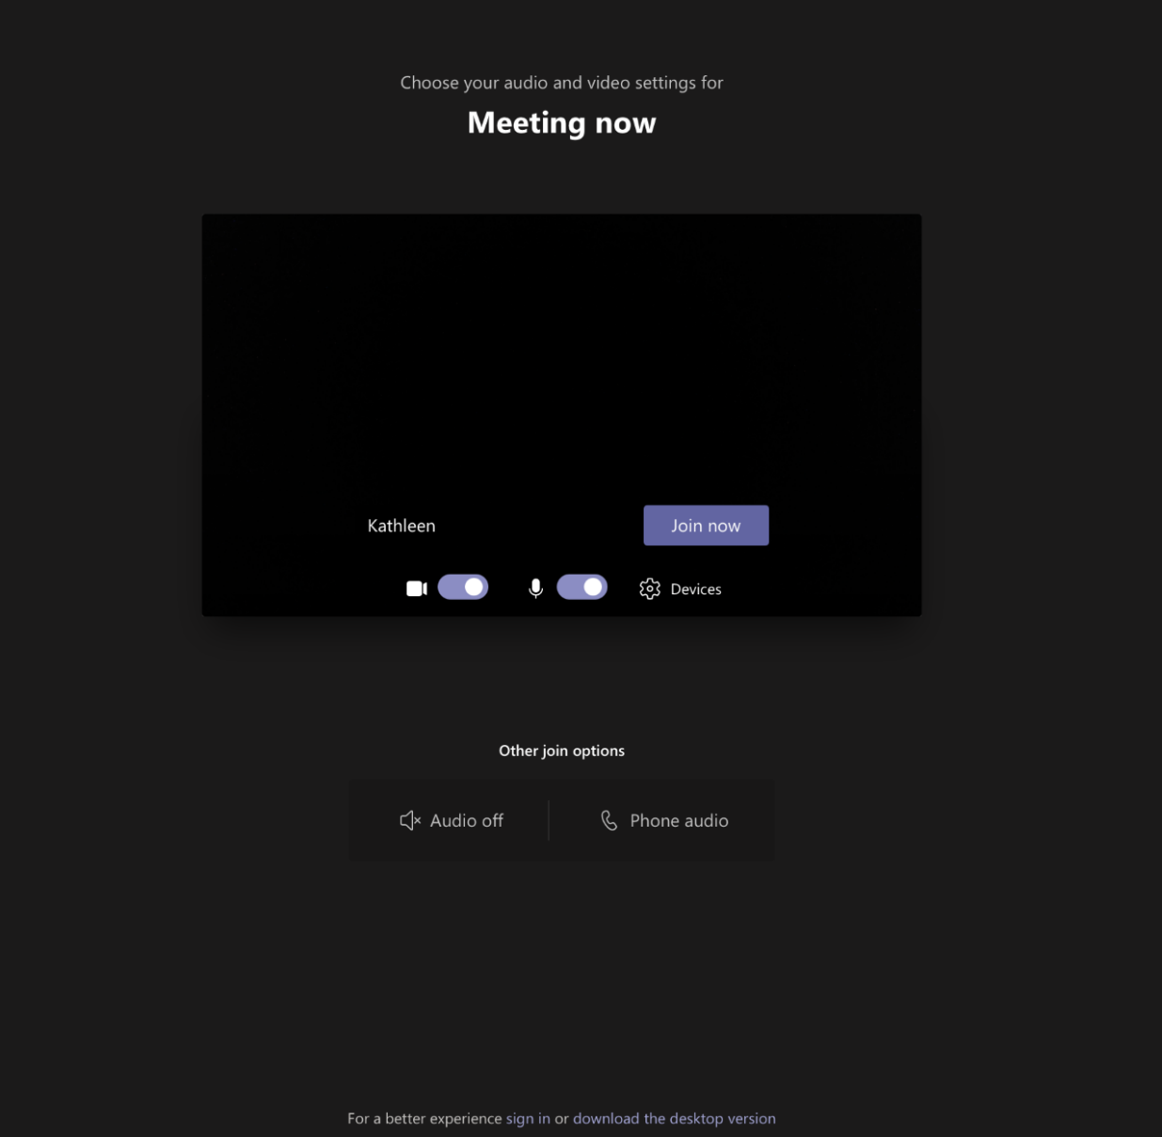

- This is how you share your screen
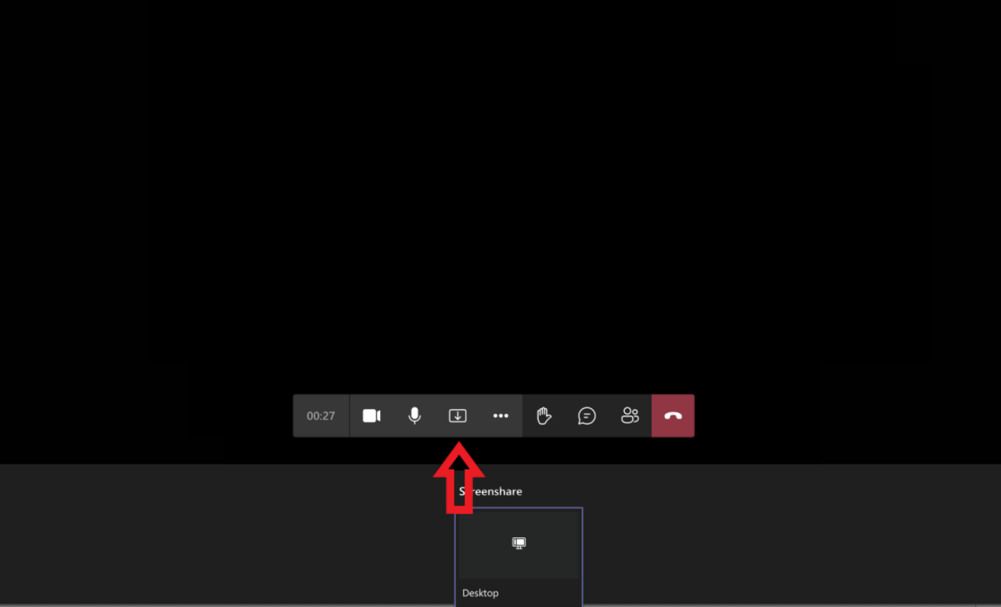

Consent online form for usability testing

National Teacher and Principal Survey Consent Form to Participate in Research

Purpose. The National Teacher and Principal Survey (NTPS) is conducted by the National Center for Education Statistics (NCES), part of the U.S. Department of Education. The U.S. Census Bureau is under contract with NCES to develop the questionnaire. The purpose of this study is to evaluate the web portal.
Procedures. If you agree to participate, the U.S. Census Bureau will ask you to complete select questionnaire items from the NTPS. The U.S. Census Bureau will also ask you a series of debriefing questions that will help us revise the questionnaire. The interview should take about 90 minutes.

Confidentiality. Your participation is voluntary and all of the information you provide may be used only for statistical purposes and may not be disclosed, or used, in identifiable form for any other purpose except as required by law (20 U.S.C. §9573 and 6 U.S.C. §151). Your name will not be attached to the answers you provide. Your interview may be observed by NCES-approved staff members and they are also bound to keep your name and information you provide confidential from your school or district.

Possible Risks and Discomforts. We do not anticipate any risks or discomforts for respondents. However, should you feel uncomfortable with any question asked you may skip the question or stop the interview at any time.

Voluntary Participation. Your participation is completely voluntary. Deciding to not participate will not be held against you. If you agree to participate, we will mail you $75 cash once the session is over.
With your permission, we would like to record this interview. The interview will be audio recorded and computer screen recorded for the survey portion to make sure we don’t miss anything that you say and to help us write a report summarizing the results of the interviews. Direct quotes may be used in reports or in research presentations, but your name will never be used in any reports or presentations. If you do not wish to be recorded you may still participate in the interview and will still receive $75 once the session is over.
I have read and understand the statements above. I consent to participate in this study.
Signature: _____________ Date:

The information that you provide in the spaces below will be used to release any incentive payments (cash) to you. Census Bureau personnel will mail your incentive via USPS Priority Mail no later than five business days after completion of your interview. You will receive your incentive in about two weeks after the completion of your interview, depending on the speed of mail service.

In the box below, please enter your name and the address where you want your incentive to be sent.

Finally please sign below and enter today's date.

Informed Consent for focus group

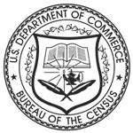
Privacy Notice
For Individual Participants
2020-2021 NTPS Coordinator Focus Groups

This study will focus on your experience as a coordinator for your school’s 2020-21 National Teacher and Principal (NTPS) Survey sponsored by the National Center for Education Statistics (NCES). The Census Bureau is administering this focus group on behalf of the NCES. NCES staff want to better understand the experience you had using the NTPS Portal and specifically whether you found the Resources tab in the NTPS Portal helpful. Results from this focus group will be used to improve future NTPS interfaces. This focus group is being conducted under the Education Sciences Reform Act of 2002 (ESRA 2002, 20 U.S.C. §9543).
A screen and audio recording of this virtual focus group will be captured for qualitative analysis and quality assurance. Participating in the focus group implies consent for the purposes stated. Only staff directly involved in the research project will have access to the recordings. Your participation is voluntary and all of the information you provide may be used only for statistical purposes and may not be disclosed, or used, in identifiable form for any other purpose except as required by law (20 U.S.C. §9573 and 6 U.S.C. §151). The OMB control number for this study is 1850-0803.

Incentive Receipt Acknowledgement Form for Focus Group

