**Application Portal**

**Screen shots**

1. **New Account/Registration**
2. Login page

1. Burden Disclosure Statement

1. Create User Account

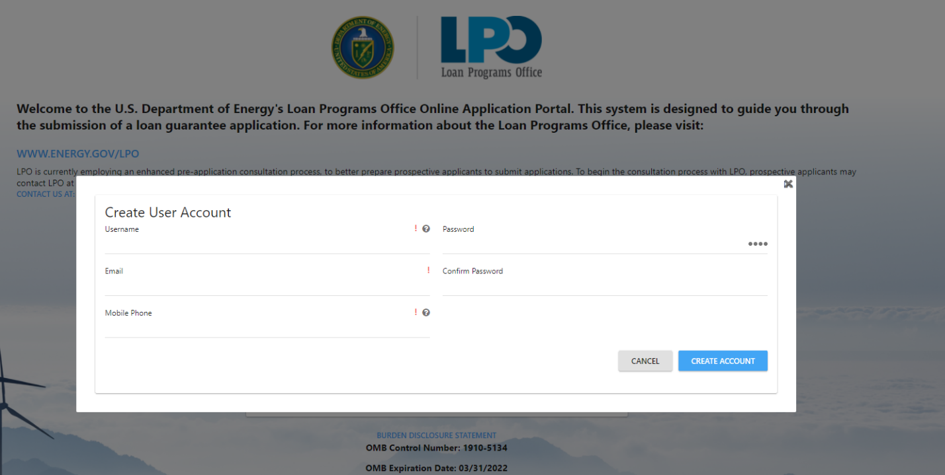

1. New Application Registration

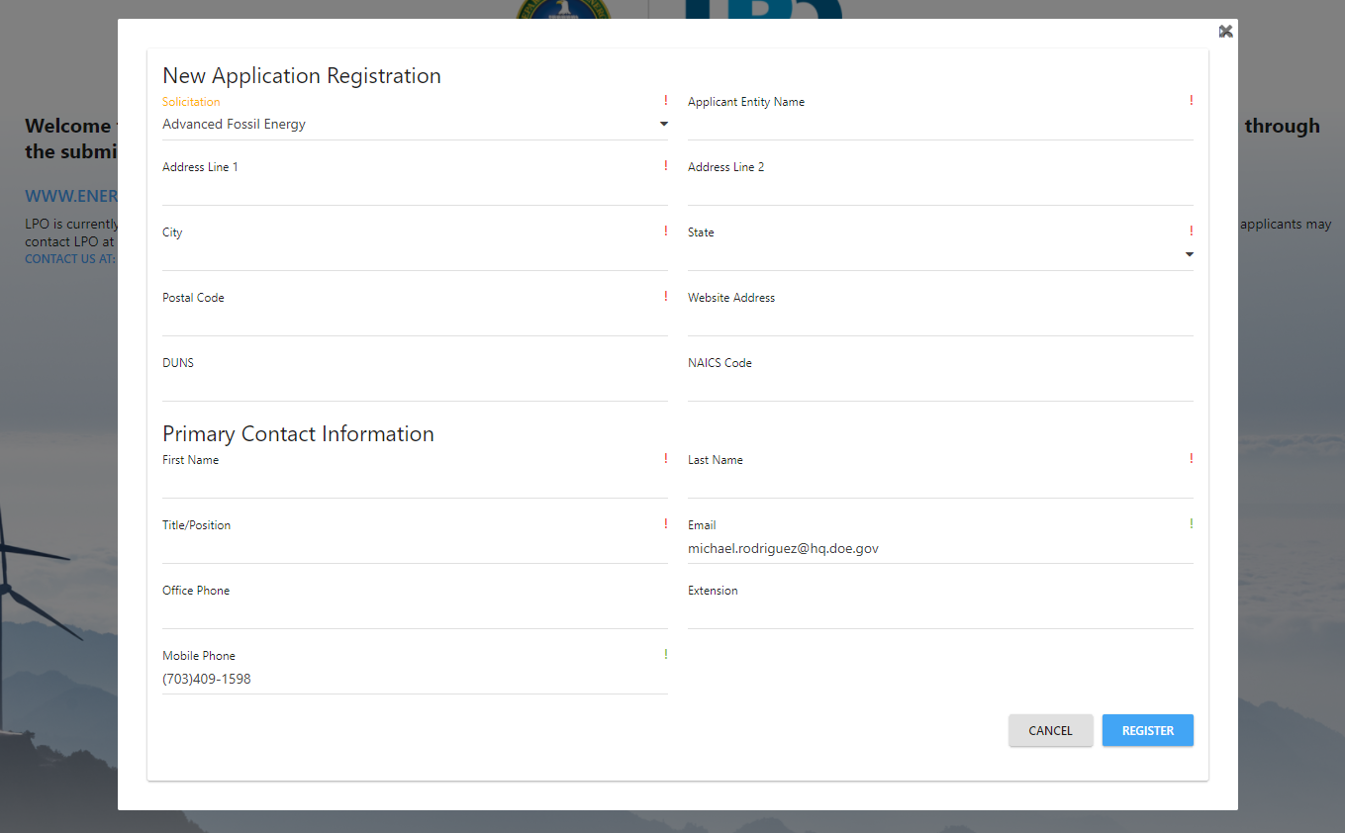

**Part I Application**

1. Part I – Project Information

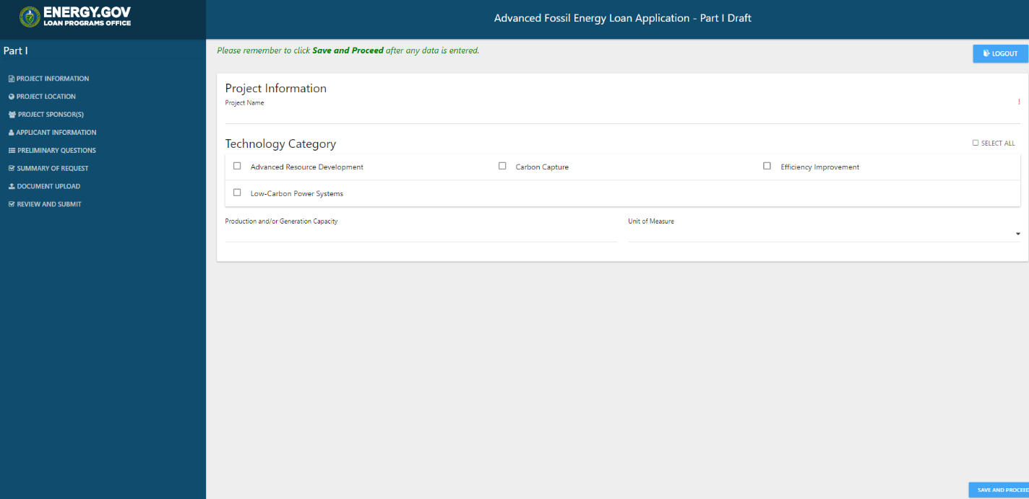

1. Part I – Project Location

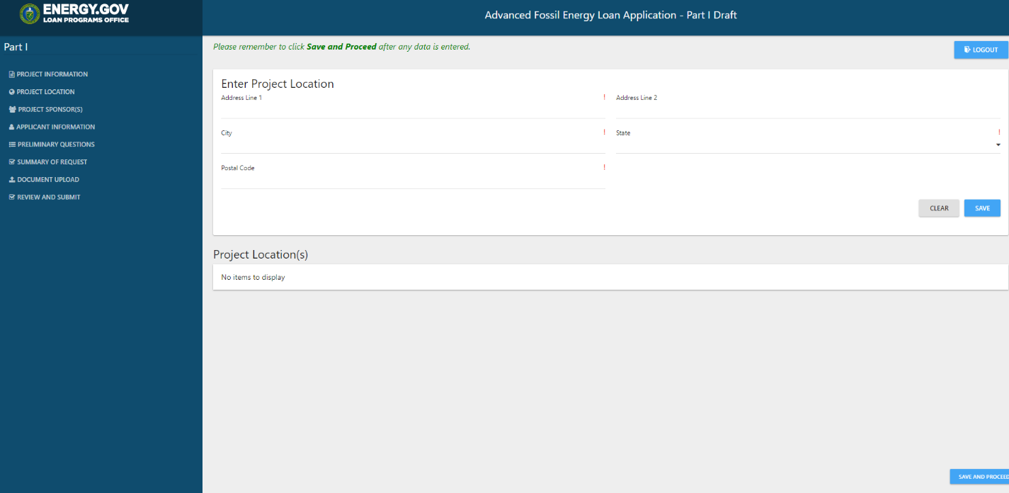

1. Part I – Project Sponsor

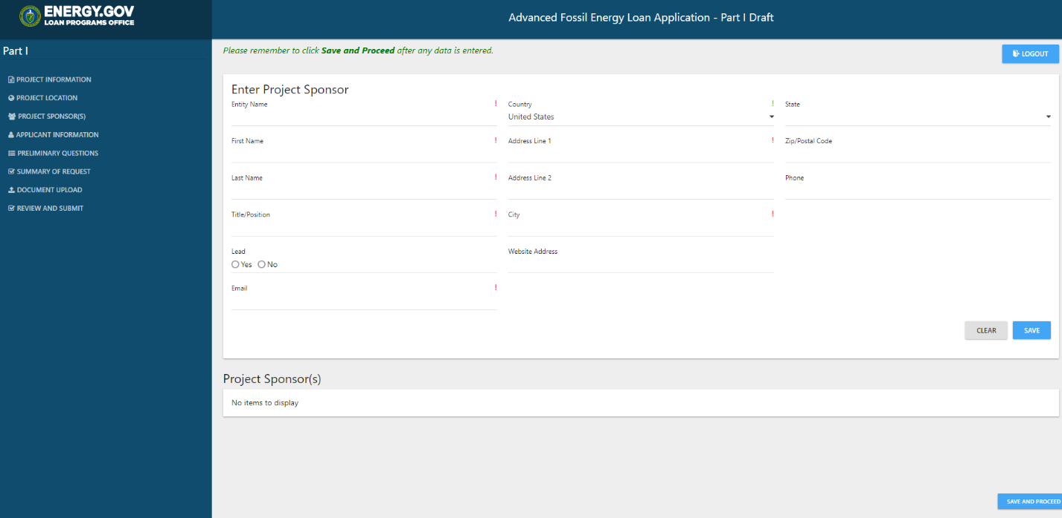

1. Part I – Applicant Information

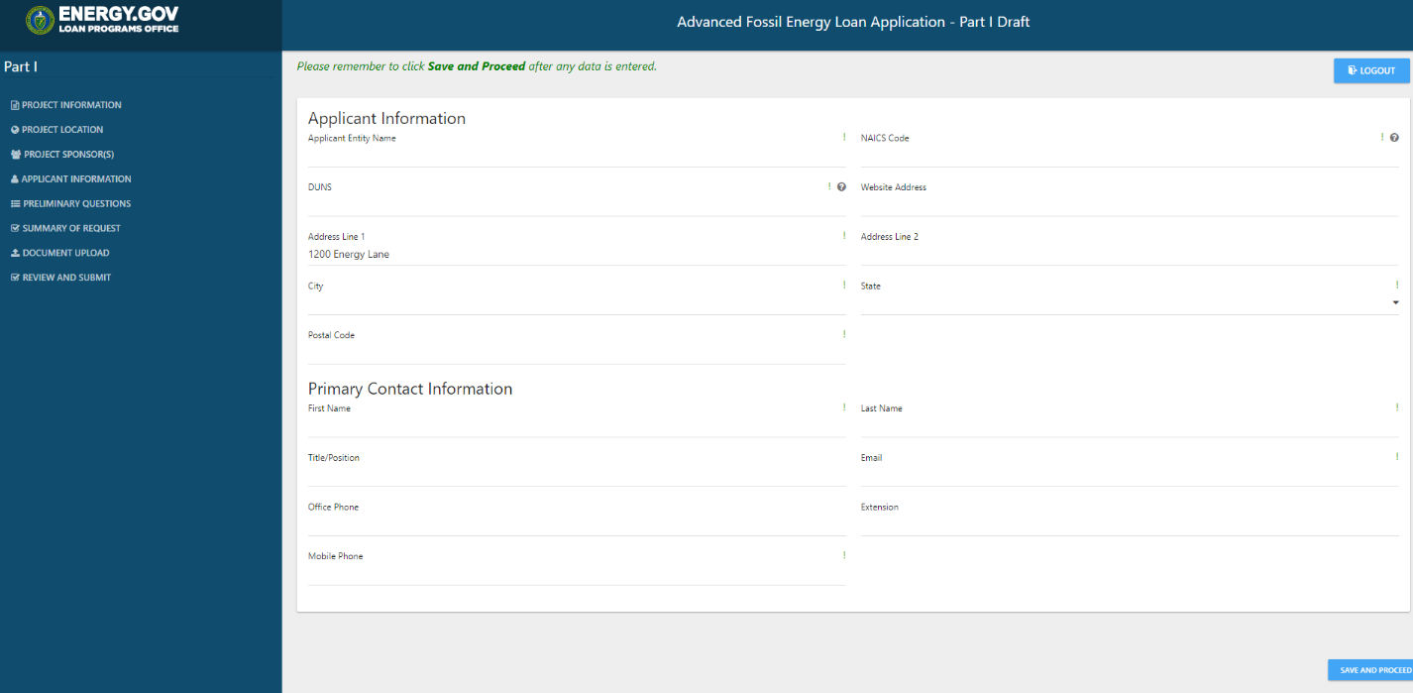

1. Part I – Preliminary Questions

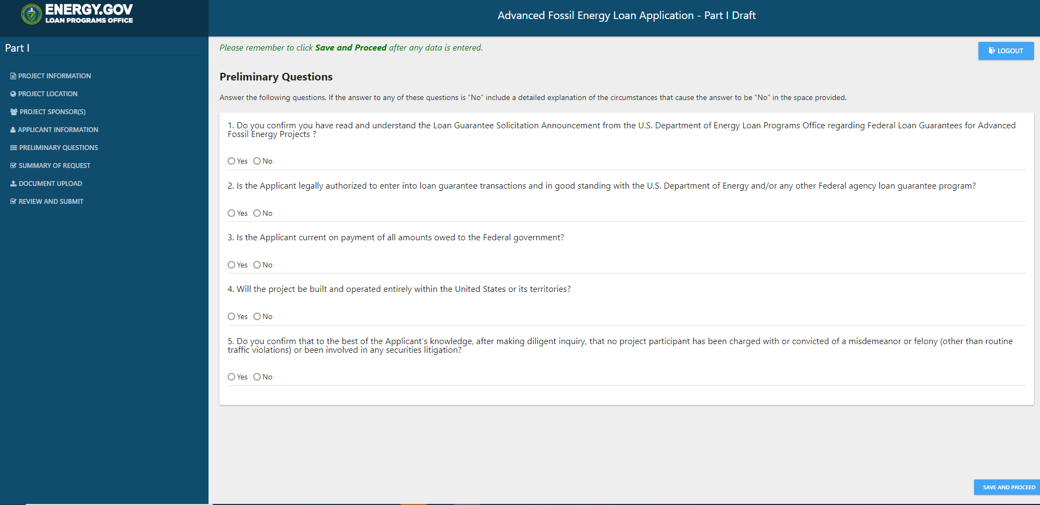

1. Part I – Summary of Request

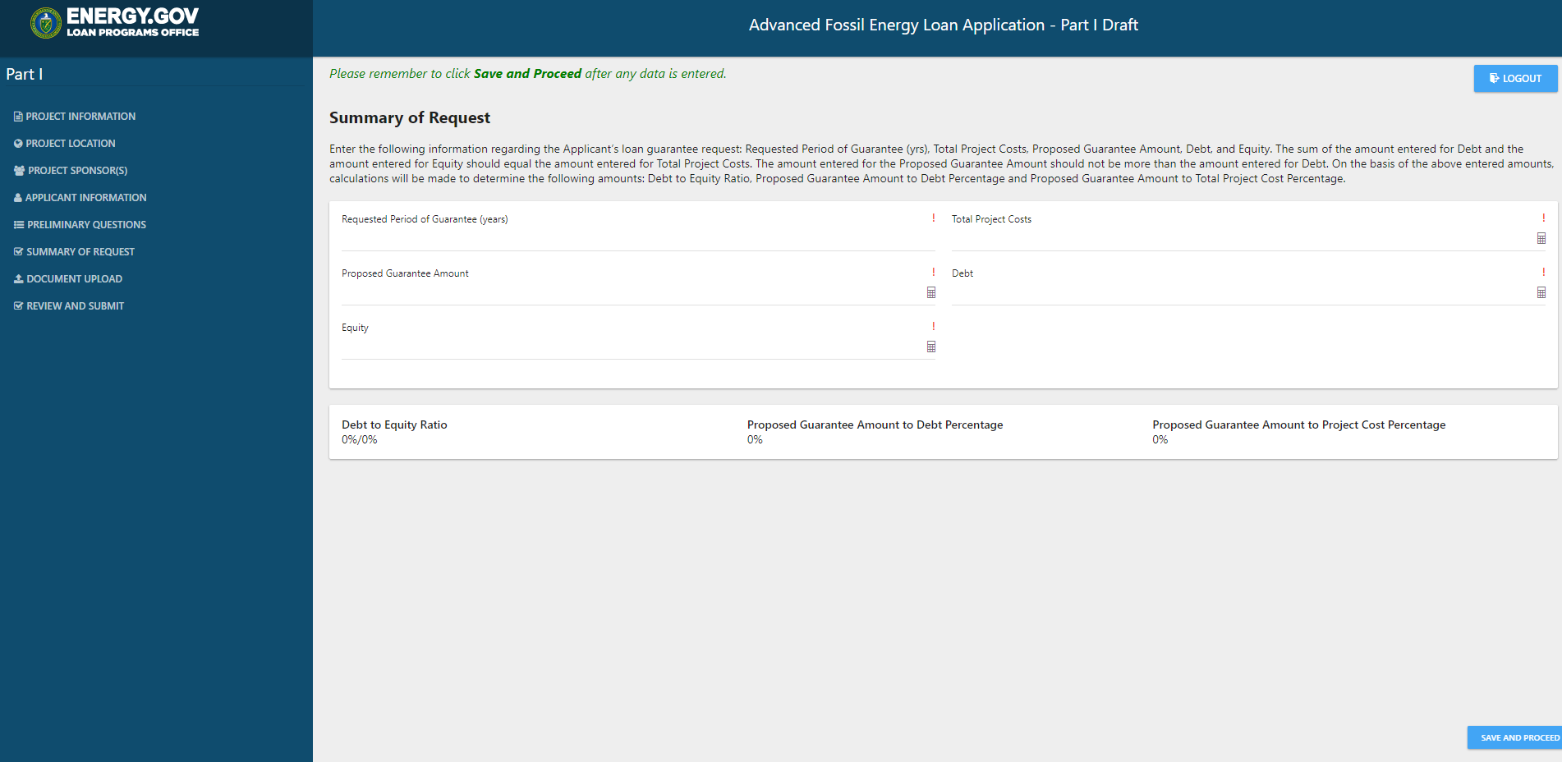

1. Part I – Document Upload

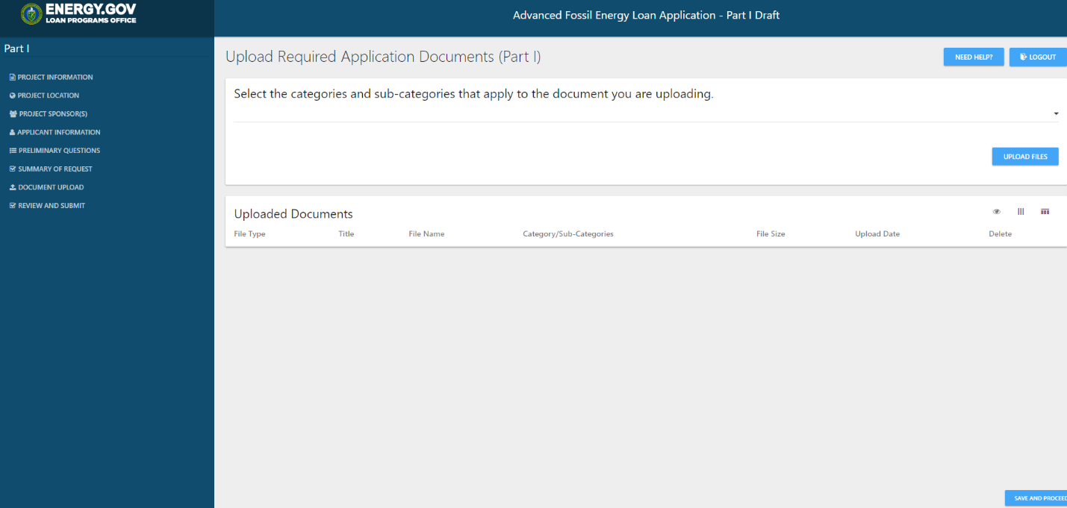

1. Review and Submit

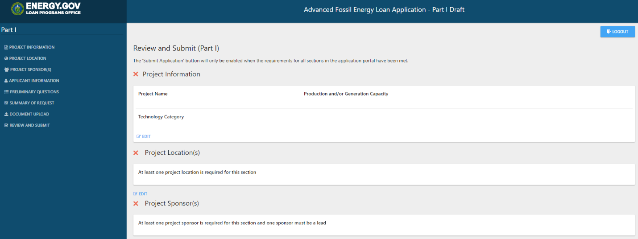

1. **Part II Application (applies to Title XVII/TELGP applications only)**
2. Part II – Document Upload 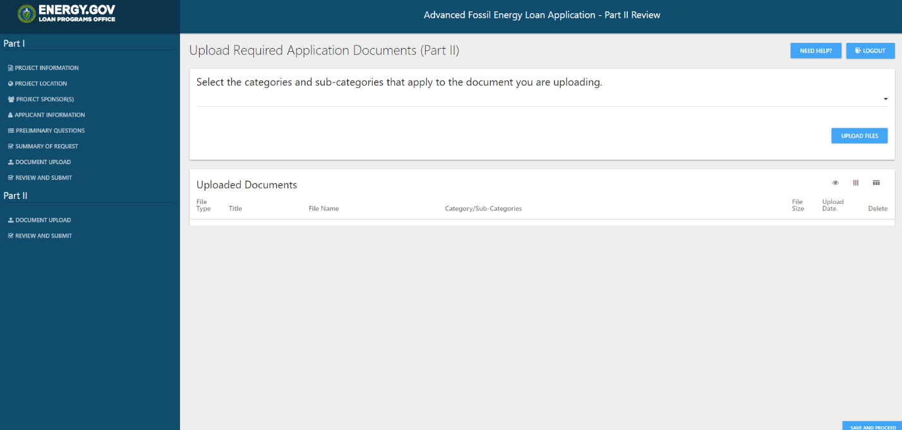
3. Part II – Review and Submit

