United States Environmental Protection Agency | Office of Pollution Prevention and Toxics  Washington, DC 20460 | EPA-740-B-22-003ss  February 2022

TOXICS RELEASE INVENTORY
Pollution Prevention Reporting Guide

Section 313 of the Emergency Planning and Community Right-to-Know Act of 1986 (EPCRA) requires certain facilities manufacturing, processing, or otherwise using listed toxic chemicals to report the annual quantity of such chemicals entering each environmental medium. Such facilities must also report pollution prevention data for such chemicals, pursuant to Section 6607 of the Pollution Prevention Act (PPA), 42 U.S.C. 13106. EPCRA section 313 established the Toxics Release Inventory (TRI).

Contents
Section 1.0 Introduction 1
Section 2.0 Source Reduction Activity Reporting 2
Section 2.1 Material Substitutions and Modifications 2
Section 2.2 Product Modifications 6
Section 2.3 Process and Equipment Modifications 8
Section 2.4 Inventory and Material Management 11
Section 2.5 Operating Practices and Training 13
Section 3.0 Pollution Prevention Optional Additional Information 15
Section 3.1 Topics to Consider Expanding Upon 15
Section 3.2 Example: Optional P2 Narratives 16
Appendix A. List of Source Reduction Codes A-1
Appendix B. Crosswalk of Source Reduction Codes, New to Original B-1
Appendix C. Green Engineering/Green Chemistry Codes C-1

LIST OF TABLES
Table ‎3-1: Tips and Questions to Consider 15
Table ‎C-1: Crosswalk to Prior Year Green Chemistry Codes 21

LIST OF FIGURES

Figure ‎2-1: Material Substitutions and Modifications Decision Tree 3
Figure ‎2-2: Product Modifications Decision Tree 7
Figure ‎2-3: Process and Equipment Modifications Decision Tree 10

LIST OF EXAMPLES
Example 1: How to Report Source Reduction Activities: Source Reduction Activity Scenarios 12
Example 2: Optional P2 Narratives 14

DISCLAIMER
This guide is intended to assist facilities with Pollution Prevention Act (PPA) section 6607 interpretation of source reduction activity reporting to EPA’s Toxics Release Inventory Program. These recommendations do not supersede any statutory or regulatory requirements, are subject to change, and are not independently binding on either EPA or covered facilities. Additionally, if a conflict exists between guidance on this site and the statutory or regulatory requirements, the conflict must be resolved in favor of the statute or regulation.
Although EPA encourages facilities to consider these recommendations, in reviewing this document, facilities should be aware that these recommendations were developed to address common circumstances at typical facilities. Facilities are encouraged to contact the Agency with any additional or clarifying questions about the recommendations in this document, or if the facility believes that EPA has incorrectly characterized a particular source reduction activity or recommendation.
Additional guidance documents, including industry specific and chemical specific guidance documents, are also available on TRI’s GuideME website: https://ofmpub.epa.gov/apex/guideme_ext/f?p=guideme:gd-list

Introduction
This document contains guidance information and recommendations specific to Toxics Release Inventory (TRI) reporting for facilities submitting a TRI Form R report. For each chemical, facilities are required to annually report their activities that prevent or reduce the generation of TRI chemical waste during manufacturing, processing, or otherwise use activities. Information is reported within Section 8.10, “Did your facility engage in any newly implemented source reduction activities for this chemical during the reporting year?”
Facilities report source reduction activities using any of the 24 source reduction codes organized across five categories: “Material Substitutions and Modifications”; “Product Modifications”; “Process and Equipment Modifications”; “Inventory and Material Management”; and “Operating Practices and Training”. Of these 24 codes, 10 are associated with green chemistry or green engineering activities and are marked with a symbol following the code descriptions.
In effect as of reporting year 2021, changes to the source reduction categories and codes have consolidated and refined existing codes as well as increased the tracking of green chemistry and engineering practices. ‎Appendix A lists all source reduction categories and codes in effect for reporting year 2021 and onward. ‎Appendix B provides a crosswalk between the new set of source reduction codes and those in place for reporting years 2020 and prior. ‎Appendix C focuses on the subset of codes specific to green chemistry and green engineering and includes a crosswalk to the prior green chemistry codes used between reporting years 2012 and 2020.
Below are definitions and examples for each of the source reduction codes to aid in understanding activities covered under the code and reporting of newly implemented activities. In general, codes are listed in each category from narrow applicability to broader, meaning that there may be some overlap in codes, or some codes may be “nested.” If a source reduction activity could be reported under more than one code, facilities should select the most detailed option. Understanding the function of the chemical will help with identifying the applicable category(ies) and code(s). TRI’s Reporting Forms and Instructions provide details on reporting requirements.
Upon selection of the code that best describes the source reduction activity implemented, facilities must specify the method used to identify the source reduction activity and are encouraged to provide the anticipated reduction (range estimate) in annual waste quantities managed as well as details about the implemented practices (e.g., chemical alternative names) as optional comments.

Source Reduction Activity Reporting
For TRI reporting purposes, facilities must report all source reduction activities started or fully implemented during the year for the chemical being reported. Codes available for reporting source reduction activities are described below. TRI groups these codes into categories to facilitate exploration and the tracking of progress to implement pollution prevention (P2) and reduce toxic chemical releases into the environment.

Material Substitutions and Modifications
Material Substitutions and Modifications refer to changing input purity or dimensions, or replacing a raw material, feedstock, reagent, or other substance with environmentally preferable alternatives.
S01 Substituted a fuel
S02 Substituted an organic solvent
S03 Substituted raw materials, feedstock, or reactant chemical
S04 Substituted manufacturing aid, processing aid, or other ancillary chemical
S05 Modified content, grade, or purity of a chemical input
S06 Other material modifications made
Substitutions of a TRI-listed chemical with another TRI chemical may qualify as source reduction, provided the substitution reduces the overall toxicity or quantity of the chemical managed as waste. Facilities are encouraged to report substitutions of toxic chemicals with less toxic alternatives (even substitutions within the same TRI chemical category; for example, changes from chromium (VI) compounds to chromium (III) compounds).
To obtain information on chemical toxicity to aid in determining whether substitutions are preferable alternatives, several resources are available including EPA’s Risk-Screening Environmental Indicators (RSEI) toxicity weights and EPA’s Safer Chemical Ingredients List (SCIL).
The decision tree for material substitutions and modifications (Figure ‎2-1) is structured from specific to broad chemical use functions. First, facilities should identify the primary function of the chemical in the context for which it is being substituted and then use the decision tree to select the first applicable code (as the codes are ordered from most to least specific). For example, if a TRI-listed organic chemical is used as a solvent within a facility and is substituted with another chemical or technique, the facility should report S02 (“Substituted an organic solvent”) even if the same chemical is used for a different purpose elsewhere in the facility.
Note: Where substitutions require concurrent implementation of new techniques or installation of new equipment, facilities should also report these changes using codes in the Process and Equipment Modifications category.
Figure ‎2-1: Decision Tree for Material Substitutions and Modifications
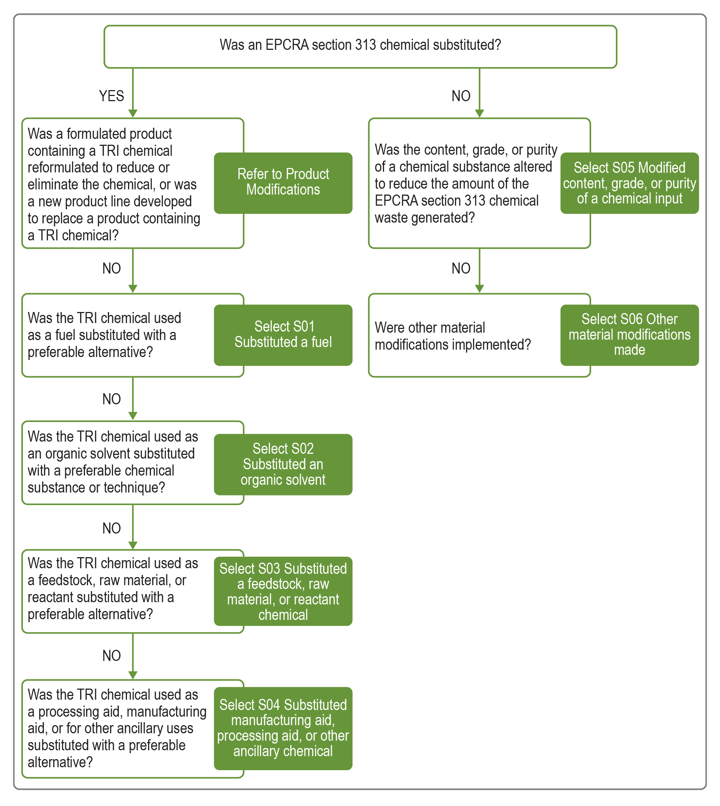
S01 Substituted a fuel covers activities such as changing grades of fuel or switching from one type of fuel to another. Fuel types include natural gas, oil, or coal that are used to produce energy or electricity necessary for a manufacturing process. [ Green Chemistry code]
Examples:
- Switching from coal to natural gas to eliminate releases of mercury compounds and lead compounds
- Switching from No. 6 fuel oil to No. 4 fuel oil to improve combustion efficiency, reducing the generation and release of polycyclic aromatic compounds
Raw Material is a crude, unprocessed, or partially processed material used as a basic input material in a process; examples include materials extracted or harvested, such as minerals, tars (e.g., coal tar), metals, grain, and forest resources.
Feedstock is a raw material or starting material (chemical) needed in an industrial process. The terms feedstock and raw materials are often used interchangeably, and what is considered a raw material or feedstock may vary significantly from industry to industry.
A reactant is a natural or synthetic chemical that undergoes a chemical transformation and is consumed during a reaction. A reagent is any chemical that participates in a chemical reaction but is not necessarily consumed. Reactant and reagent are often used interchangeably to mean a substance that undergoes a chemical reaction.
S02 Substituted an organic solvent refers to substituting an organic TRI chemical used as a solvent with another substance or implementing a technique that obviates the need for the TRI chemical. This code covers most uses of TRI organic solvent chemicals (e.g., cleaning, degreasing, process solvents, extraction solvents, carrier solvents), except for instances where a facility produces a formulated product that contains a solvent.
[Green Chemistry code]
Examples:
- Replacing methyl isobutyl ketone as a solvent for degreasing with a semi-aqueous cleaning solvent containing limonene, thereby eliminating fugitive emissions of methyl isobutyl ketone
- Changing the mold release agent used during the manufacture of molded high-temperature resins from methanol to isopropanol
- Switching from dichloromethane (methylene chloride) to supercritical carbon dioxide (scCO-₂) in solvent extraction of caffeine from coffee beans to produce decaffeinated coffee
S03 Substituted raw materials, feedstock, or reactant chemical refers to the substitution of starting materials, commonly referred to as raw materials, feedstocks, reagents, or reactants used in a process. This code also covers the substitution of intermediate materials (e.g., coatings, solder). These materials are consumed during chemical reactions and/or are typically incorporated into the final product. [Green Chemistry code]
Examples:
- Substituting solvent-based photochemical coatings (e.g., methylene chloride, 1,1,1-trichlorethane, or perchloroethylene) with aqueous base coating of 1% sodium carbonate
- Switching from chromium compounds to synthetic tannins or another mineral tannage for the leather tanning process
- Switching to lead-free solder for manufacturing of printed circuit boards to eliminate generation of lead waste at the facility
- Substituting soda-lime glass for leaded glass, eliminating the need for lead in the manufacturing process
S04 Substituted manufacturing aid, processing aid, or other ancillary chemical refers to the substitution of chemicals used to aid the manufacturing process but not incorporated or intended to become part of the product. [ Green Chemistry code]
Chemical processing aid is a chemical added to a reaction mixture to aid in the manufacture or synthesis of another chemical substance but is not intended to remain in or become part of the product or product mixture.
Manufacturing aid is a chemical that aids the manufacturing process but does not become part of the resulting product and, unlike a chemical processing aid, is not added to the reaction mixture during the manufacture or synthesis of another chemical substance.
Ancillary or other use is a chemical used for purposes other than aiding chemical processing or manufacturing.
Examples:
- Replacing TRI-listed perfluorinated surfactants used for chrome plating with non-perfluorinated alternatives
- Switching the emulsions solution in a rod drawing machine to a synthetic solution, which improves the quality of copper wire produced by the machine and reduces the amount of copper shavings generated and managed as waste
- Switching to a new homogeneous nickel catalyst for production of adiponitrile, increasing reaction efficiency and minimizing the amount of unreacted 1,3-butadiene managed as waste
S05 Modified content, grade, or purity of a chemical input refers to using a chemical input with a lower concentration of impurities or unwanted components. [Green Chemistry code]
Examples:
- Switching from zinc that has 1% lead content to a higher-grade zinc with 0.003% lead content, to reduce the amount of lead waste generated
- Using enzymes at double concentration to decrease the amount of acetaldehyde needed in ethyl alcohol production
- Changing the concentration of 1,2,4-trimethylbenzene from 3% to 1% in the mineral spirits used for wet milling aluminum powder to make aluminum pigments
S06 Other material modifications made refers to modifications not covered by other codes in the category. Activities may relate to physical material changes such as changing dimension of sheet blanks introduced in machining to reduce scrap metal

Product Modifications
Product Modifications refer to changing the end product through design, composition, formulation, or packaging changes, as well as full final product replacements that reduce the generation of waste.
The decision tree for product modifications (Figure ‎2-2) is structured to help select the appropriate code:
S11 Reformulated or developed new product line
S12 Altered dimensions, components, or final design of product
S13 Modified product packaging
S14 Other product modifications made
S11 Reformulated or developed new product line refers to changes to the ingredients or their proportions in a formulated product or development of a completely new product line marketed as such to customers. [Green chemistry code]
A formulated product is a mixture of different chemicals combined in specific ratios to give the mixture desirable properties. Examples include paints, detergents, personal care products, adhesives, and insecticides.
Reformulation refers to changes in the ingredients or their proportions in a formulated product.
Product line refers to a product or group of products with distinct branding.
Examples:
- Reviewing a formula to minimize the amount of a chemical used before product quality suffers (e.g., reduced amount of zinc added to compound master) by studying when the product quality changed
- Reformulating a paint product to develop a paint product free of volatile organic compounds
- Reformulating a paint product to include the minimum amount of mixed isomers of xylene, sunsetting product lines that contain mixed isomers of xylene, and developing new product lines to replace the original paint products
S12 Altered dimensions, components, or final design of product refers to changes to manufactured end products; examples include textiles, food, automobiles, or metal parts. Changes may involve altering dimensions, components used in the product, or design specifications. This code is intended to capture activities other than those focused on chemicals or allied product manufacture.
Examples:
- Altering product components to design a new product line, such as formaldehyde-free particleboard
- Redesigning décor flooring products to use less resin during production, which reduces formaldehyde releases
- Changing dimensions of a machined part to minimize scrap generation
S13 Modified product packaging refers to changes in packaging integral to the final product. Examples include the container used to hold the product, product labels, caps, foils, and wrapping. Note that this code is only intended to capture changes to packaging that affect waste management quantities of the chemical reported to TRI.
Note: A common reporting error is selecting S13 to describe strategies to reduce packaging that do not impact quantities of TRI chemicals. Facility initiatives to reduce packaging that do not impact quantities of TRI chemicals should not be reported as source reduction.
Examples:
- Switching the ethylene-vinyl acetate adhesive used to seal food packaging to an adhesive formulation containing less vinyl acetate
- Switching to glycol ether-free ink for printing product labels to reduce fugitive releases of glycol ethers
- Switching from polyurethane foam to an alternative packaging material, eliminating the management of diisocyanates (a component of polyurethane foams)
Figure ‎2-2: Decision Tree for Product Modifications
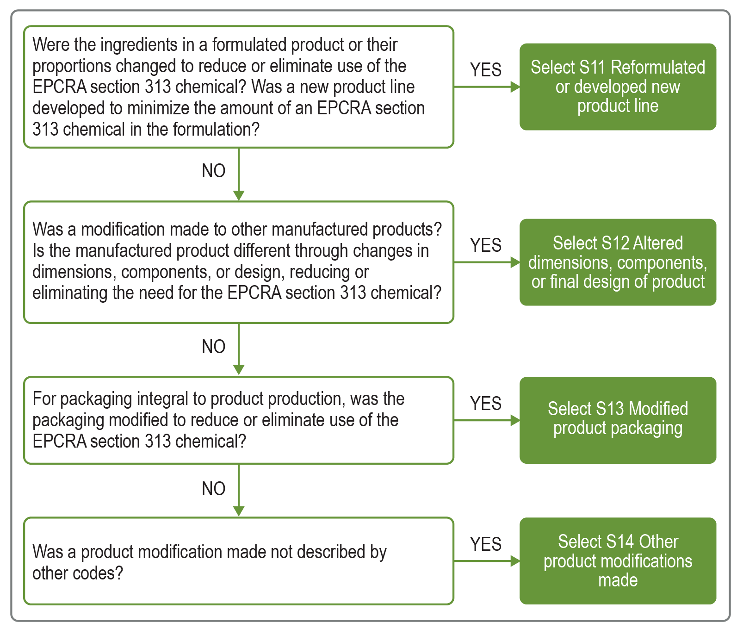

Process and Equipment Modifications
Process and Equipment Modifications refer to improvements to industrial processes and/or associated equipment, including implementation of new processes that produce less waste; direct re-use of chemicals; or technological changes impacting synthesis, formulation, fabrication, assembly, and surface treatments such as cleaning, degreasing, surface preparation, and finishing.
The decision tree for process and equipment modifications (Figure ‎2-3) is structured to help select the appropriate code:
S21 Optimized process conditions to increase efficiency
S22 Instituted recirculation within a process
S23 Implemented new technology, technique, or process
S24 Modified or updated equipment or layout
S25 Other process modifications made
S21 Optimized process conditions to increase efficiency refers to adjustments to process conditions such as pressure, temperature, input ratios, and processing time to positively influence process efficiency (e.g., improved product yield while decreasing production related waste). [ Green chemistry code]
Examples:
- Increasing dyeing time, resulting in greater fixation of copper metallized dyes, and a decrease in the amount of copper compounds managed as waste
- Increasing bath temperature and decreasing withdrawal rate of parts from plating bath to reduce the amount of chromium compounds remaining in exhausted plating baths that must be managed as waste
- Collecting data on variations in batch process times, temperatures, and yields to determine optimal reaction conditions, which ensure formic acid reacts fully during the manufacture of basic organic chemicals and is not managed as waste
S22 Instituted recirculation within a process refers to the introduction of a direct recirculation system in the process that extends the utility of chemicals used during manufacturing or ensures that starting materials are reacted completely. Chemicals or materials containing EPCRA section 313 chemicals used within the process are returned for direct reuse while maintaining form and ability to function. [ Green chemistry code]
Recirculation refers to the direct return of a chemical (product or component part) within a process or between processes, while maintaining its form and ability to function for reuse.
Recirculation is distinct from recycling, in that the latter involves a reclamation step.
Note: To qualify as source reduction, recirculation should be integral to the process and would not involve mechanical, chemical, or other reclamation steps to allow for reuse. For additional guidance on distinctions between recirculation and recycling, see the Interpretations of Waste Management Activities.
Examples:
- Installing a distillation column to condense unreacted methanol and return it directly to the reaction vessel for the production of biodiesel from used cooking oil
- Installing a closed loop recirculation system on a vapor degreaser to directly reuse 1-bromopropane until solvent is completely spent, minimizing the amount of 1-bromopropane used and managed as waste
S23 Implemented new technology, technique, or process refers to the use of new technology, techniques, or processes within the manufacturing process that reduce use of TRI chemicals or production of wastes that contain TRI chemicals. Examples include use of biotechnology that utilizes biological systems, living organisms, or processes to develop or create different products, nanotechnology, new coating application techniques, or the use of a new catalyst. [ Green chemistry code]
Note: the use of biotechnology for waste treatment should not be reported as a source reduction activity.
Examples:
- Implementing a thermal stripping technique to replace solvent stripping when removing hydrocarbons from engines, eliminating the use of 1,1,1-trichloroethane for engine cleaning
- Switching from spray painting metal parts to electrostatic powder coating to eliminate air emissions of toluene from the original coating material
- Implementing permanent mold casting as an alternative to sand casting methods to eliminate management of waste foundry sand containing lead
- Transitioning from machining brass parts to extruding them, reducing scrap generation and the amount of copper and zinc managed as waste
S24 Modified or updated equipment or layout refers to equipment or layout improvements that optimize the efficiency of processing steps and reduce waste generation.
Examples:
- Changing computer numerical control (CNC) machinery, resulting in more accurate tooling and reducing scrap generated
- Relocating cold solvent cleaning tanks to a location where air turbulence and temperature do not promote vapor loss of cleaning solvent
- Reconstructing a chiller in a poultry processing facility by replacing certain parts such as temperature sensors, which reduces losses of the chlorodifluoromethane (HCFC-22) refrigerant to the environment
Figure ‎2-3: Decision Tree for Process and Equipment Modifications
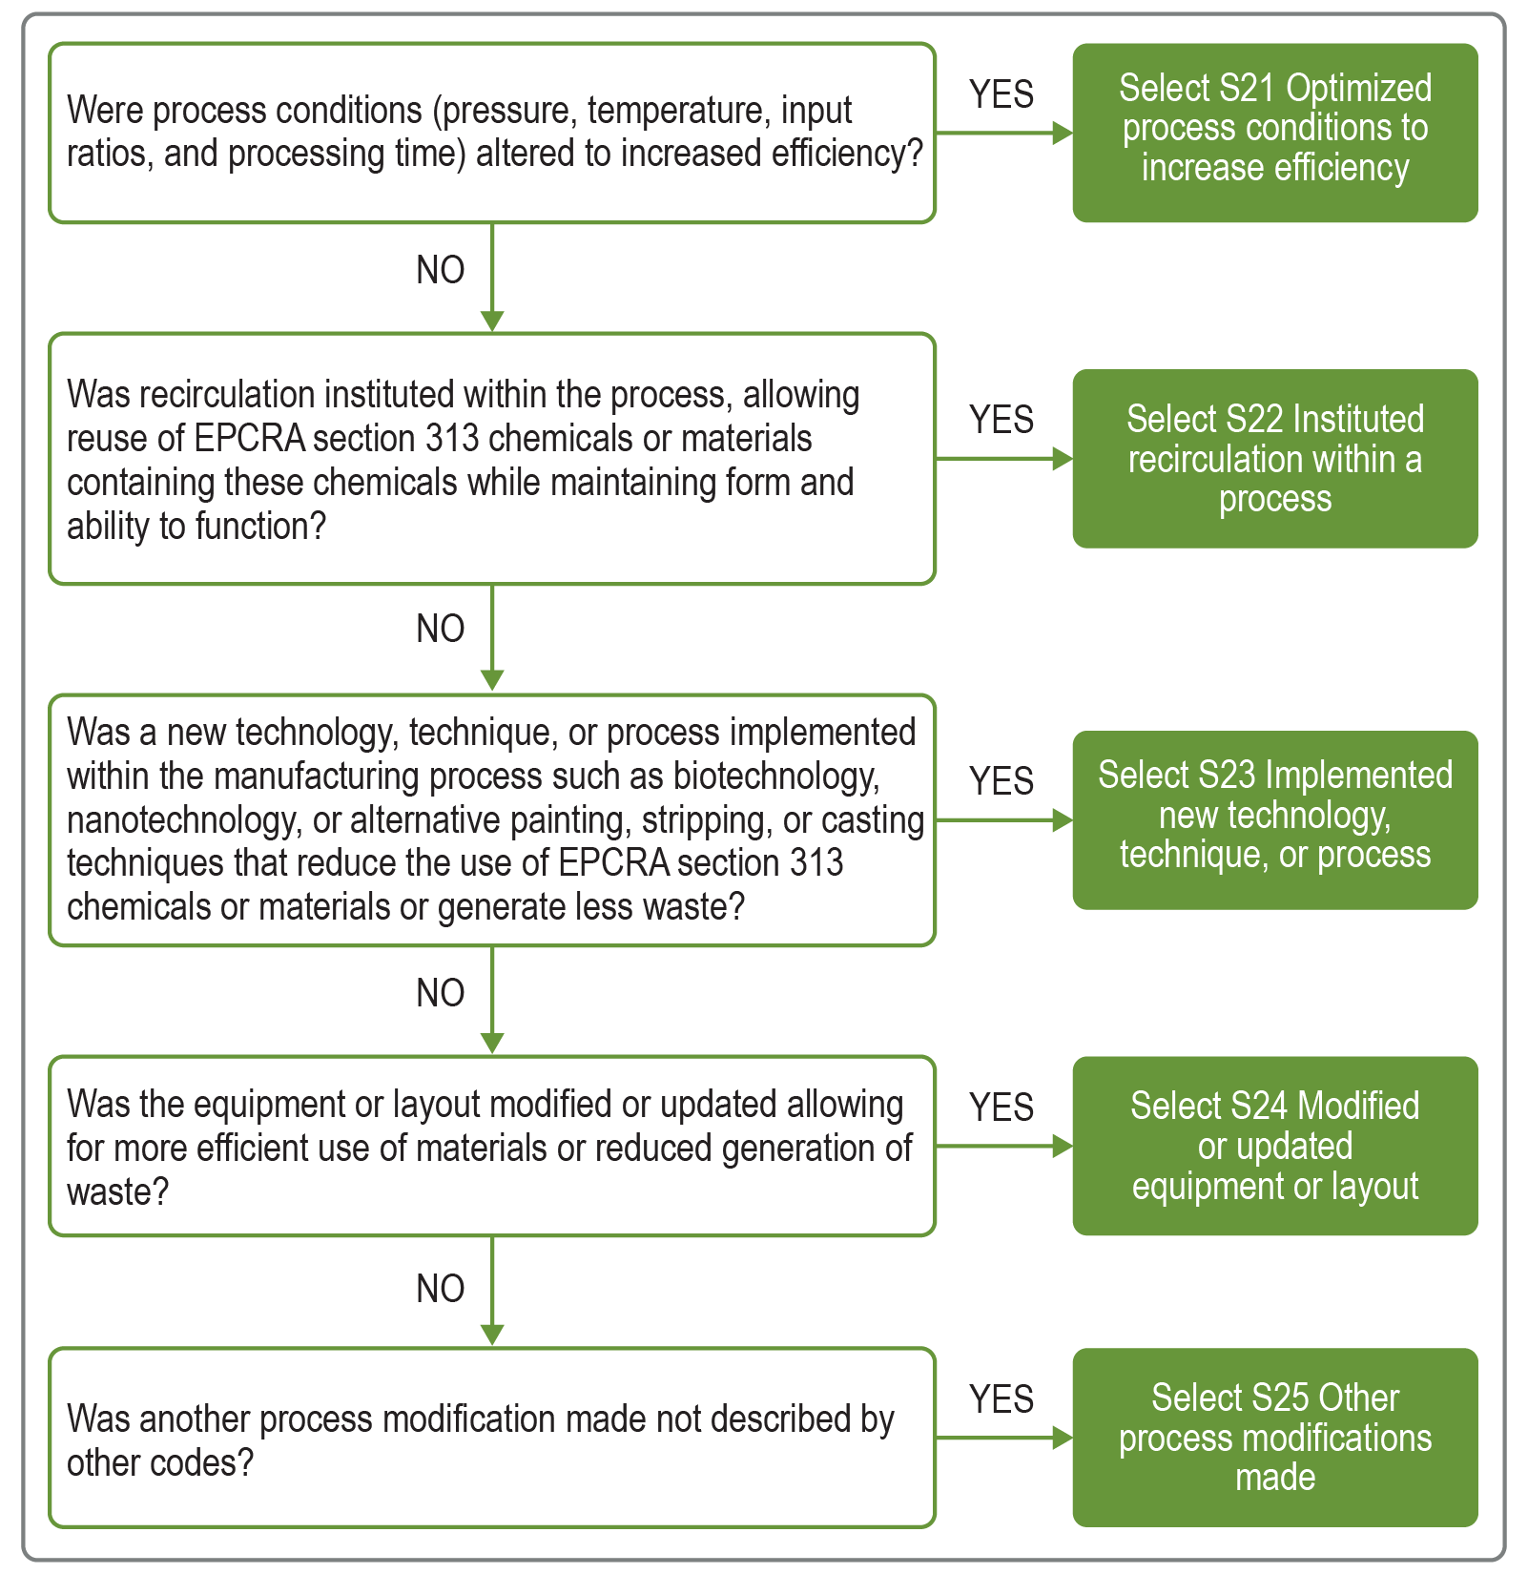

Inventory and Material Management
Inventory and Material Management refers to improvements in procurement, inventory tracking, preventative monitoring, and storage and handling of chemicals and materials while on-site at a facility to optimize their use and prevent spills and leaks during operation.
S31 Instituted better labeling, testing, or other inventory management practices
S32 Changed size or type of containers procured
S33 Improved containment or material handling operations
S34 Improved monitoring system of potential spill or leak sources
S35 Other improvements to inventory and material management
S31 Instituted better labeling, testing, or other inventory management practices refers to more efficient management of chemicals and materials through labeling, material testing, material exchange programs, or other inventory management practices.
Examples:
- Implementing a system to track quantities of custom-mixed resin formulations in inventory to avoid expiration on shelves and minimize generation of formaldehyde-containing waste when expired resin is discarded
- Testing diethanolamine in inventory past its shelf life to determine if it is still suitable for use in production of detergents
S32 Changed size or type of containers procured refers to changes to the size, volume, or dimension of containers procured, or ordering materials in a different kind of container
Examples:
- Ordering smaller volumes of resins containing diisocyanates to keep material from expiring while in inventory and subsequently being managed as waste
- Switching from ordering 55-gallon drums to 350-gallon reusable totes of nitric acid, which can be returned to the supplier and refilled to minimize generation of empty containers for disposal
S33 Improved containment or material handling operations includes changes to handling techniques or equipment, as well as changes to containment of chemicals while in inventory, in process equipment, or during movement throughout the facility
Examples:
- Installing lids (e.g., roll-type covers) on all cold cleaning tanks and dip tanks to reduce fugitive releases of methanol during cleaning of metal parts
- Using a specialized drum-lifting attachment on a forklift to minimize spills while lifting barrels of acetophenone into and out of hot water baths during the manufacturing of specialty chemicals
S34 Updated monitoring practices of potential spill or leak sources refers to changing procedures or equipment used to examine or monitor potential spill or leak sources, as well as methods for detecting spill and leaks anywhere they might occur
Examples:
- Installing additional high-level storage tank alarms on storage tanks of cresol used for the manufacture of pesticide intermediates
- Installing a leak detection system to automatically stop ozone generation if a leak to atmosphere is detected while ozone clean-in-place procedures are used to clean equipment used for flavor compound synthesis

Operating Practices and Training
Operating Practices and Training refer to improvements in maintenance, production scheduling, process monitoring, and other practices that enhance operator expertise and housekeeping measures that eliminate or minimize waste.
S41 Improved scheduling, record keeping, or procedures for operations, cleaning, and maintenance
S42 Changed production schedule to minimize equipment and material changeovers
S43 Introduced in-line product quality monitoring or other process analysis system
S44 Other changes made in operating practices or operator training
S41 Improved scheduling, record keeping, or procedures for operations, cleaning, and maintenance refers to improvements related to maintenance, typically reflected in new or revised written standard operating procedures.
Examples:
- Initiating a preventative maintenance program, including scheduled sump and machine cleaning, and periodic inspections of wipers and oil seals to postpone contamination of waste fluids and reduce waste generation
- Scheduling regular preventative maintenance of batch reactors to minimize fugitive emissions of dichloromethane during synthesis
S42 Changed production schedule to minimize equipment and material changeovers refers to planning and sequencing production so that only necessary operations are performed, and that no operation is needlessly undone by a following operation.
Examples:
- Switching changeout of aluminum etch baths from time-based to throughput-based, ensuring better bath exhaustion and reducing the amount of nitric acid managed as waste
- Scheduling paint batch mixing from lighter shades to darker and allowing some residue from the previous batch to remain in the mixing equipment for the next batch, minimizing the amount of n-butyl alcohol use for cleaning between batches
S43 Introduced in-line product quality monitoring or other process analysis system refers to the use of manual or automated process analysis or quality analysis [ Green Chemistry code]
Examples:
- Monitoring cyanide baths used in copper plating to ensure that the minimum amount of cyanide compounds are added, resulting in smaller amounts of cyanide and copper compounds managed as waste
- Adding screening points to quality control protocols to spot product defects and reduce the number of machined aluminum parts that do not meet specifications, reducing the amount of aluminum dust managed as waste.
Example 1: How to Report Source Reduction Activities: Source Reduction Activity Scenarios
Scenario 1. Changing solvent-borne coating to powder coating on cabinets
A facility uses a spray system to apply paint to metal parts, which are then assembled into cabinets. The paint formulation contains toluene, an organic solvent chemical on the TRI chemical list. In order to reduce toluene emissions, the facility switches from spray coating the metal parts to applying a powder coating that cures in an oven, eliminating the use of toluene or any other TRI solvent chemical. The switch to the powder coating necessitates a new system for coating application and curing, in addition to the new powder coating material.
How should the facility report this source reduction activity?
- Since the facility must make significant changes to its equipment, the facility should select code S23 (Implemented new technology, technique, or process) under Process and Equipment Modifications to report implementing a new technique—powder coating—at the facility.
- Since the facility substituted the solvent-borne coating material for powder coating, the facility should select S03 (Substituted raw materials, feedstock, or reagent chemical) under Material Substitutions and Modifications. While the coating substitution resulted in the elimination of an organic solvent, the facility should report S03 because this was achieved through the substitution of the entire coating material, not just the individual organic solvent.
Scenario 2. Using a mechanical process to replace solvent-based paint stripping
A facility that reconstructs aircraft uses a paint-stripping solution to remove paint from aircraft parts during the repair process. The stripping solution contains dichloromethane (methylene chloride) and formic acid, both of which are TRI-listed chemicals. To reduce quantities of these chemicals that will inevitably need to be managed as waste, the facility installs and uses sand-blasting equipment for most paint stripping, which dramatically reduces the need for and use of the dichloromethane-formic acid solution.
How should the facility report this source reduction activity?
- Since the facility must make significant changes to its equipment, the facility should select code S23 (Implemented new technology, technique, or process) under Process and Equipment Modifications to report implementing the sand-blasting technique for paint stripping. This source reduction activity should be reported on the Form Rs for formic acid and dichloromethane.
- The facility substituted use of a chemical with a mechanical technique.
- On the Form R for dichloromethane, the facility should select S02 (Substituted an organic solvent) because the facility substituted the use of a solution containing an organic solvent with a new technique.
- On the Form R for formic acid, the facility should select S04 (Substituted manufacturing aid, processing aid, or other ancillary chemical) because it replaced the solution containing formic acid (a chemical “otherwise used” for an “ancillary or other use”) with a new technique.
Facilities are encouraged to provide additional details about the source reduction activities implemented including estimated return on investment, anticipated reductions, benefits of change, extent of implementation (pilot, single manufacturing line, or plant-wide).

Optional Additional Information on Pollution Prevention

Topics to Consider Expanding Upon
For any of the reported source reduction activities, tell us your story. We encourage you to provide as much detail as possible, because we want you to get the credit that you deserve, and because we may showcase your achievements to the public. TRI is not just about releases! It is so much more. Detailed descriptions help communities better understand your P2 activities.
Consider the tips and questions listed below when reporting source reduction activities, waste management activities, and any other P2 practices implemented at your facility. The tips are organized by topic to help you provide specific and meaningful additional information. Section 8.11 shows all optional P2 reported text submitted with your TRI report.
Table ‎3-1: Tips and Questions to Consider
Topic | Tips and Questions
General | - Which releases (to air, water, land) or waste management quantities changed?  - Were there other benefits (e.g., costs, product quality?)  - Provide links to information sources
Source Reduction Categories
Material substitutions and modifications | - Identify original chemical and the chemical(s) or material(s) used as a substitute  - How effective is the substitution? Are there deficiencies or advantages to using the alternative chemical or material?  - Describe the chemical’s use(s) in the facility; was the substitution implemented for all uses of the chemical in the facility?  - Discuss any concurrent equipment modifications required to implement this substitution
Product modifications | - How has demand from customers influenced this source reduction activity?  - Have customers requested changes to the product?  - Are customers resistant to using the modified product? Why?  - How is the facility marketing the modified products?  - Was product distribution affected by the modifications?
Process and equipment modifications | - Which processes were affected? How was the process improved?  - Which technologies were used, installed, or replaced?  - Did implementation of new techniques or modifications require changes to other processes within the facility?  - Did process modifications require changes to input materials and chemicals?  - Provide links to equipment manufacturers
Inventory and material management | - How have changes to inventory management resulted in P2?  - Have changes to procurement and material management resulted in changes to other facility operations?
Operating practices and training | - What procedures or processes are affected by changes to operating practices or training?  - How often are training programs administered?
Other Topics
Incentives and methods to identify source reduction or pollution prevention activities | - Why did you implement this activity?  - Who provided the idea or assisted with implementation?

Example: Optional P2 Narratives
Example 2: Optional P2 Narratives
EPA promotes P2 efforts by sharing your stories on our website (https://www.epa.gov/tri) and featuring examples in other publications, including EPA’s annual TRI National Analysis. Share your success and demonstrate your environmental stewardship. Below is an example of the usefulness of detailed information.
Chemical: Styrene
Source Reduction Activity: S44 – Other changes made in operating practices or operator training
Usefulness | Source Reduction Optional Text (Reported in Section 8.11)
Most Useful | Operator knowledge of equipment and material increased, providing better and more efficient startups and product changeovers. Increased capacity in the reactors made it possible to extend the residence time of the chemicals, which produces a purer grade of product and reduces waste generation.
Moderately Useful | Process parameters and employee retention and training programs dramatically reduced scrap rates and improved yields.
Least Useful | All operators participated in a new training program.

List of Source Reduction Codes
2021 Category | 2021 Code | Green Chemistry code
Material Substitutions and Modifications | S01 Substituted a fuel
 | S02 Substituted an organic solvent
 | S03 Substituted raw materials, feedstock, or reactant chemical
 | S04 Substituted manufacturing aid, processing aid, or other ancillary chemical
 | S05 Modified content, grade, or purity of a chemical input
 | S06 Other material modifications made
Product Modifications | S11 Reformulated or developed new product line
 | S12 Altered dimensions, components, or final design of product
 | S13 Modified product packaging
 | S14 Other product modifications made
Process and Equipment Modifications | S21 Optimized process conditions to increase efficiency
 | S22 Instituted recirculation within a process
 | S23 Implemented new technology, technique, or process
 | S24 Modified or updated equipment or layout
 | S25 Other process modifications made
Inventory and Material Management | S31 Instituted better labeling, testing, or other inventory management practices
 | S32 Changed size or type of containers procured
 | S33 Improved containment and material handling operations
 | S34 Updated monitoring practices of potential spill or leak sources
 | S35 Other improvements to inventory and material management
Operating Practices and Training | S41 Improved scheduling, record keeping, or procedures for operations, cleaning, and maintenance
 | S42 Changed production schedule to minimize equipment and material changeovers
 | S43 Introduced in-line product quality monitoring or other process analysis system
 | S44 Other improvements to operating practices or operator training

Crosswalk of Source Reduction Codes, New to Original
All source reduction codes labeled as “original” were in effect since reporting year 1991 until 2020 except for the codes specific to green chemistry activities, which were added to the TRI reporting form in 2012. See Appendix C for green chemistry code details. The crosswalk tracks the new consolidated set of 24 codes to the previous set of 49 source reduction codes.

2021 Category | 2021 Code | Original Code | Original Category
Material Substitutions and Modifications | S01 Substituted a fuel | N/A | Raw Material Modifications
 | S02 Substituted an organic solvent | W56 Reduced or eliminated an organic solvent | Process modifications
 | S03 Substituted raw materials, feedstock, or reactant chemical | W42 Substituted raw materials | Raw Material Modifications
 |  | W43 Substituted a feedstock or reagent chemical with a different chemical
 |  | W73 Substituted coating materials used | Surface Preparation and Finishing
 | S04 Substituted manufacturing aid, processing aid, or other ancillary chemical | N/A | Raw Material Modifications
 |  | W53 Used a different process catalyst | Process Modifications
 |  | W61 Changed to aqueous cleaners | Cleaning and Degreasing
 | S05 Modified content, grade, or purity of a chemical input | W41 Increased purity of raw material | Raw Material Modifications
 | S06 Other material modifications made | W49 Other raw material modifications made
Product Modifications | S11 Reformulated or developed new product line | W84 Developed a new chemical product to replace a previous chemical product | Product Modifications
 | S12 Altered dimensions, components, or final design of product | W82 Modified design or composition of product
 | S13 Modified product packaging | W83 Modified packaging
 | S14 Other product modifications made | W89 Other product modifications made
Process and Equipment Modifications | S21 Optimized process conditions to increase efficiency | W50 Optimized reaction conditions or otherwise increased efficiency of synthesis | Process Modifications
 | S22 Instituted recirculation within a process | W51 Instituted recirculation within a process
 | S23 Implemented new technology, technique, or process | W57 Used biotechnology in manufacturing process
 |  | W60 Changed to mechanical stripping/cleaning devices (from solvents or other materials) | Cleaning and Degreasing
 |  | W74 Improved application technique | Surface Preparation and Finishing
 |  | W75 Changed from spray to other system
 | S24 Modified or updated equipment or layout | W52 Modified equipment, layout, or piping | Process Modifications
 |  | W59 Modified stripping/cleaning equipment | Cleaning and Degreasing
 |  | W65 Redesigned parts racks to reduce drag out
 |  | W66 Modified or installed rinse systems
 |  | W67 Improved rinse equipment design
 |  | W72 Modified spray systems or equipment | Surface Preparation and Finishing
 | S25 Other process modifications made | W58 Other process modifications made | Process Modifications
 |  | W71 Other cleaning and degreasing modifications made | Cleaning and Degreasing
 |  | W78 Other surface preparation and finishing modifications made | Surface Preparation and Finishing
Inventory and Material Management | S31 Instituted better labeling, testing, or other inventory management practices | W36 Implemented inspection or monitoring program of potential spill or leak sources | Inventory Control
 |  | W22 Began to test outdated material - continue to use if still effective
 |  | W23 Eliminated shelf-life requirements for stable materials
 |  | W24 Instituted better labeling procedures
 |  | W25 Instituted clearinghouse to exchange materials that would otherwise be discarded
 | S32 Changed size or type of containers procured | W55 Changed from small volume containers to bulk containers to minimize discarding of empty containers | Process Modifications
 | S33 Improved containment or material handling operations | W31 Improved storage or stacking procedures | Spill and Leak Prevention
 |  | W32 Improved procedures for loading, unloading, and transfer operations
 |  | W35 Installed vapor recovery systems
 |  | W54 Instituted better controls on operating bulk containers to minimize discarding of empty containers | Process Modifications
 |  | W63 Modified containment procedures for cleaning units | Cleaning and Degreasing
 | S34 Improved monitoring practices of potential spill or leak sources | W33 Installed overflow alarms or automatic shut-off valves | Spill and Leak Prevention
 | S35 Other improvements to inventory and material management | W29 Other changes made in inventory control | Inventory Control
 |  | W39 Other changes made in spill and leak prevention | Spill and Leak Prevention
Operating Practices and Training | S41 Improved scheduling, record keeping, or procedures for operations, cleaning, and maintenance | W13 Improved maintenance, scheduling, record keeping, or procedures | Good Operating Practices
 |  | W64 Improved draining procedures | Cleaning and Degreasing
 |  | W68 Improved rinse equipment operation
 | S42 Changed production schedule to minimize equipment and material changeovers | W14 Changed production schedule to minimize equipment and feedstock changeovers | Good Operating Practices
 | S43 Introduced in-line product quality monitoring or other process analysis system | W15 Introduced in-line product quality monitoring or process analysis system
 | S44 Other improvements to operating practices and training | W19 Other changes made in operating practices

Green Engineering/Green Chemistry Codes
The TRI program strives to track the implementation of new concepts in pollution prevention as strategies evolve over time. With the increasing prominence of green engineering and chemistry, TRI added six codes specific to green chemistry in reporting year 2012 and expanded the set in 2021 to track the adoption of these practices in industry. This new set of green engineering and chemistry codes better captures the array of techniques and principles central to these concepts. In turn, the TRI program can now track implementation of a wider variety of green engineering and chemistry practices. Table ‎C-1 shows a crosswalk of the current green engineering/green chemistry source reduction codes to prior green chemistry codes used between reporting years 2012 and 2020.
Table ‎C-1: Crosswalk to Prior Year Green Chemistry Codes
2021 Category | Green Engineering / Green Chemistry Codes  (2021 Code) | Green Chemistry Codes  (Original Code)
Material Substitutions and Modifications | S01 Substituted a fuel | N/A
 | S02 Substituted an organic solvent | W56 Reduced or eliminated use of an organic solvent*
 | S03 Substituted raw materials, feedstock, or reactant chemical | W43 Substituted a feedstock or reagent chemical with a different chemical
 | S04 Substituted manufacturing aid, processing aid, or other ancillary chemical | N/A
 | S05 Modified content, grade, or purity of a chemical input | N/A
Product Modifications | S11 Reformulated or developed new product line | W84 Developed a new chemical product to replace a previous chemical product
Process and Equipment Modifications | S21 Optimized process conditions to increase efficiency | W50 Optimized reaction conditions or otherwise increased efficiency of synthesis
 | S22 Instituted recirculation within a process | N/A
 | S23 Implemented new technology, technique, or process | W57 Used biotechnology in manufacturing process
Operating Practices and Training | S43 Introduced in-line product quality monitoring or other process analysis system | W15 Introduced in-line product quality monitoring or other process analysis system

In this document Toxics Release Inventory reporting refers to the information required to be disclosed under Section 313 of the Emergency Planning and Community Right-to Know Act (EPCRA) and Section 6607 of the Pollution Prevention Act (PPA).

