- From the HUD Contact Us page on the agency website the public will click on a link to submit an inquiry to the HUD Secretary and will be taken to the page below to review the disclaimer and enter a captcha image before being directed to the inquiry submission from.
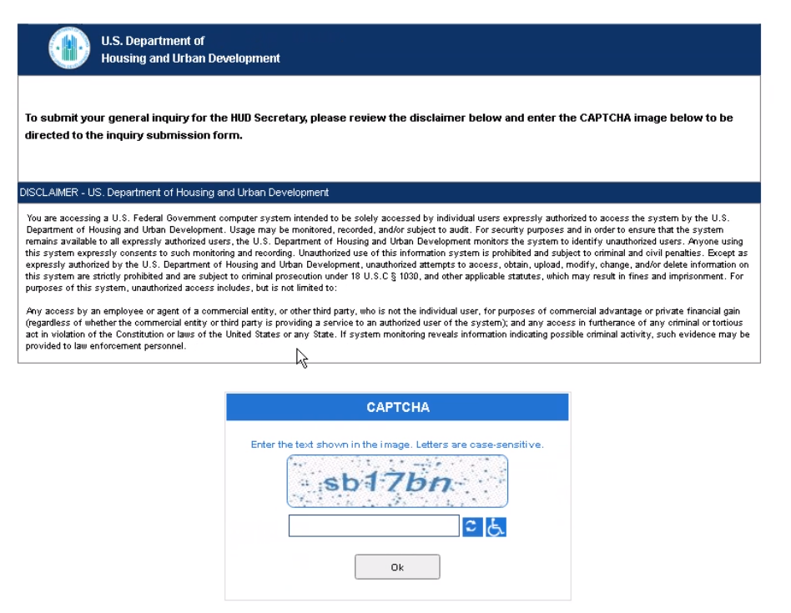

- Submission Form – On this form the user will have the ability to upload any supporting documentation and enter information about what they are seeking and contact details. Upon submission the user will be presented with a confirmation message.

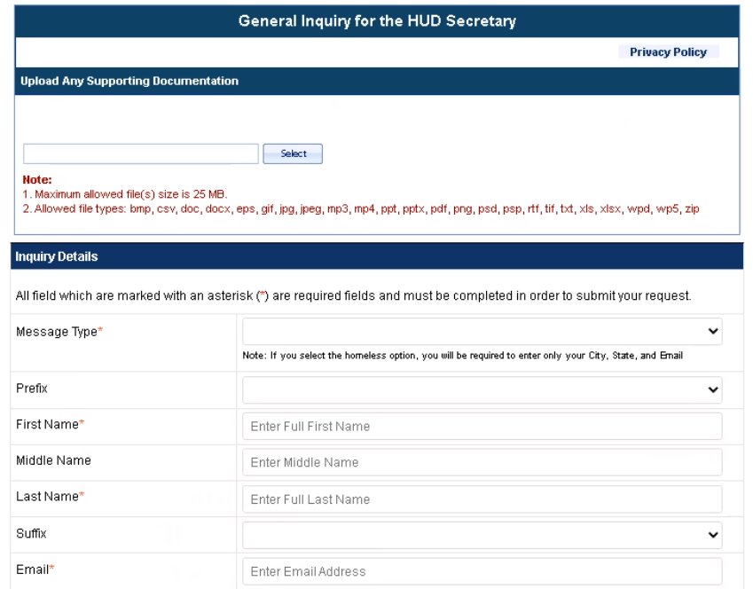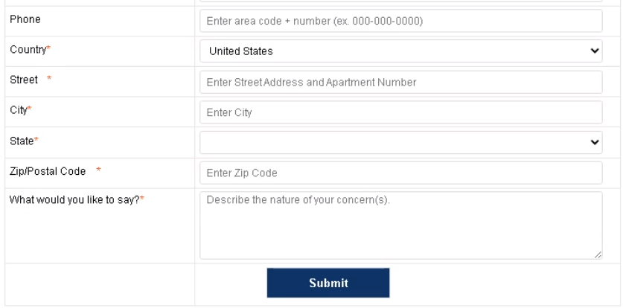

- The confirmation message will advise that the form can’t be modified after submission.

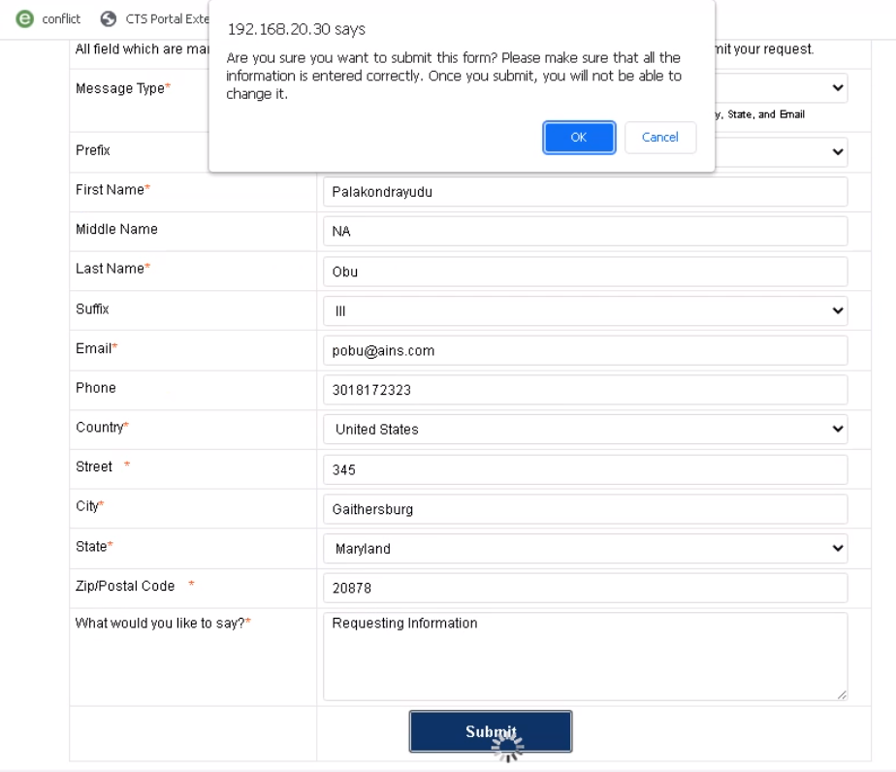
- Upon successful submission a confirmation prompt will be displayed. Clicking OK will return the user to the Contact Us page of the HUD website.



