NASS is requesting non-substantive changes to the Field Crops docket.
In February 2020 OMB approved a substantive change to the Field Crops docket to address changes to the sugarcane and sugarbeets questionnaires. This submission is another change to the March and June sugarcane questionnaires based on discussions with industry. The prices paid to growers questions for the most recent crop will now be asked in June instead of March to better capture end of season sales.
The questions being moved from March to June are:
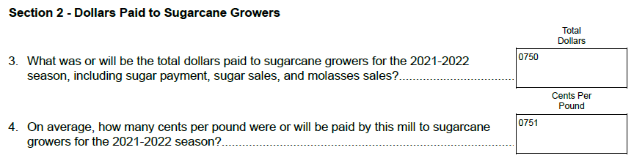
The revised questionnaires are loaded into the ROCIS submission system.
No changes are being made to the methodology or sampling for the surveys and there will be no net change in respondent burden.

