Appendix E.2 – Pre-ordering App Examples - Electronic
This attachment provides possible examples of the mobile, pre-ordering apps.
Exhibit 1: These are screen shots from two, existing electronic pre-ordering apps that are available to students on their mobile devices.

Exhibit 1

Pre-ordering Apps:

Below are screen shots of two pre-ordering apps that are currently commercially available and in use in schools. This does not represent all possible apps (in some cases, images are behind password protected screens that FNS does not have access to). The numbers and locations of schools using these apps are not publicly available, nor are any additional images of these apps.

Similar to the paper apps above, possible interventions may include modifying an existing pre-ordering app to provide a smaller number of choices, up to and including the possibility of an app allowing the selection of only reimbursable meals.

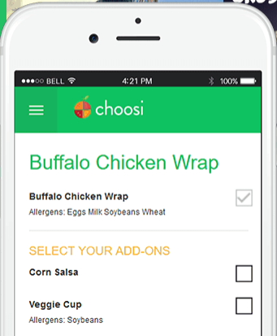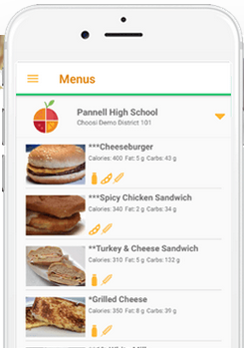

Depending on the experimental condition, students who chose to use a modified, pre-ordering app will give up some level of choice in terms of food selection in favor of the convenience of pre-ordering and having an expedited line to obtain the meal.

