Attachment G.1 Recruitment Flyer/Handout for Focus Group
OMB Control No.: 0584-0524
Expiration Date: 12/31/2022
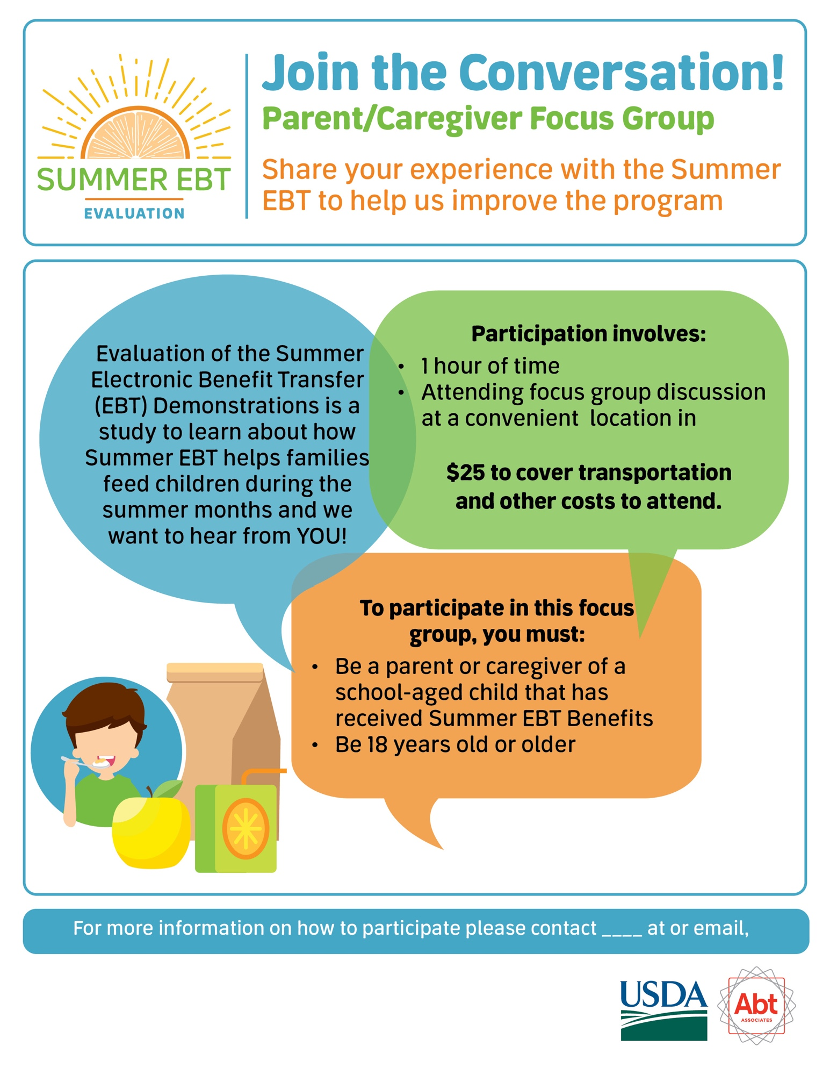

REVERSE SIDE OF FLYER

The Food and Nutrition Service (FNS) is conducting this study to obtain information about the experiences of the Summer Electronic Benefit Transfer (EBT) Project by grantees, retailers, school districts and participants. Participation in this study is voluntary and the information collected will be used to understand how Summer EBT projects are implemented in varying settings. This study does not collect personally identifiable information. Information collected in this study will be kept private to the full extent permitted by law. According to the Paperwork Reduction Act of 1995, an agency may not conduct or sponsor, and a person is not required to respond to, a collection of information unless it displays a valid OMB control number. The valid OMB control number for this information collection is 0584-0524. The time required to provide this information collection is estimated to average 1 minute per response, including the time to review instructions, search existing data resources, gather and maintain the data needed, and complete and review the collection of information. Send comments regarding this burden estimate or any other aspect of this collection of information, including suggestions for reducing this burden, to: USDA/Food and Nutrition Service, Office of Policy Support, 1320 Braddock Place, 5th Floor, Alexandria, VA 22314 ATTN: PRA (0584-0524).

