Attachment A-1

FNS-843- Report of Disqualification from Participation: Institution and Responsible Principals/Individuals

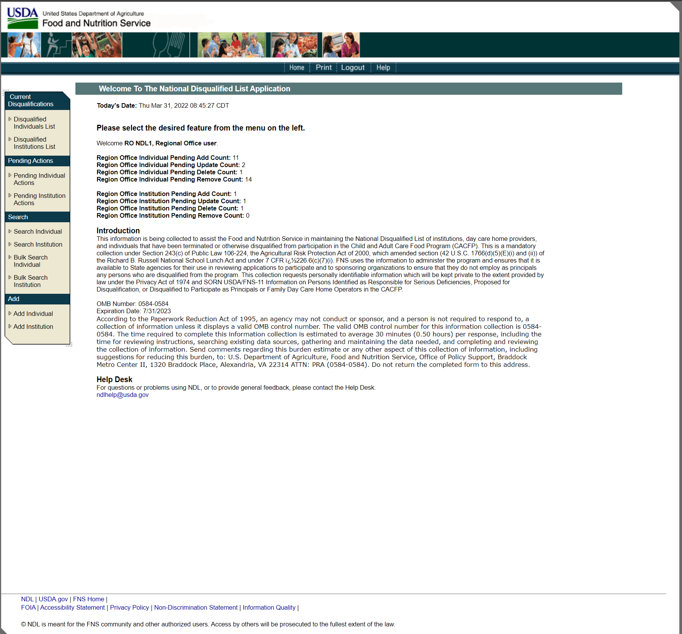

Attachment A-1

FNS-843- Report of Disqualification from Participation: Institution and Responsible Principals/Individuals

