This document contains screen shots of the process a user would follow to obtain access to the FMMI financial system that USDA uses.

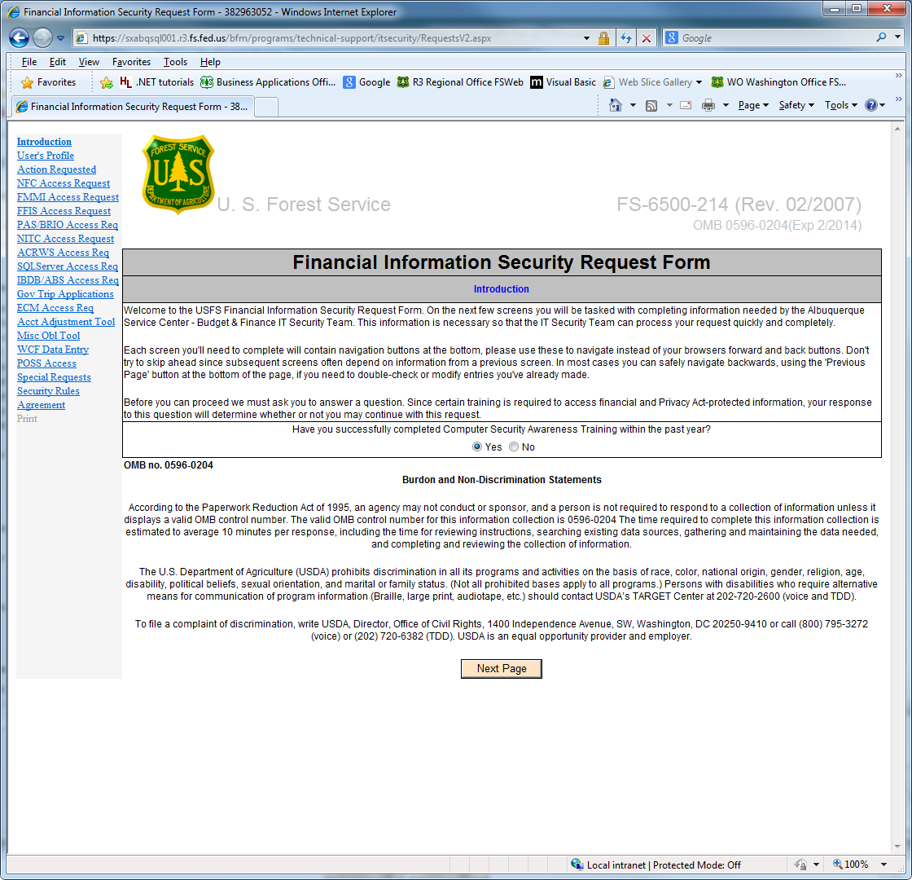

User verifies taking mandatory computer security awareness training within the last year and can read the Burdon and Non-Discrimination Statements prior to clicking on Next Page.

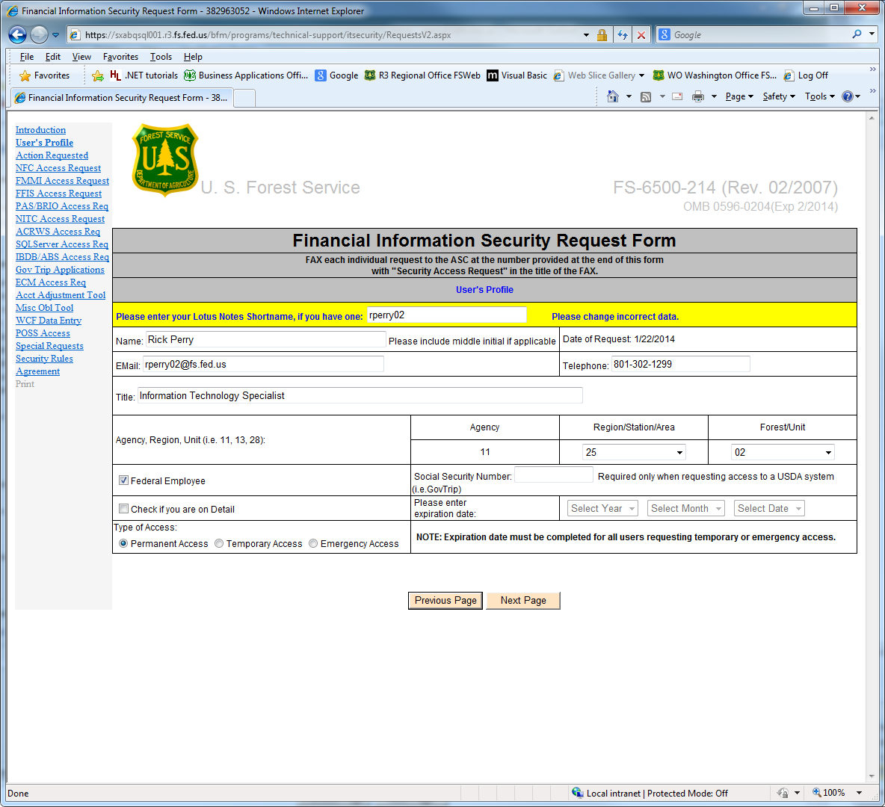

User puts in their “Lotus Shortname”, which is their active directory log on ID, and the form is auto populated with information from the Lotus Domino employee directory database. User verifies information and adds any data that is not included and click Next Page. If they do not have a Lotus Shortname, they can manually fill out the form, and click Next Page.

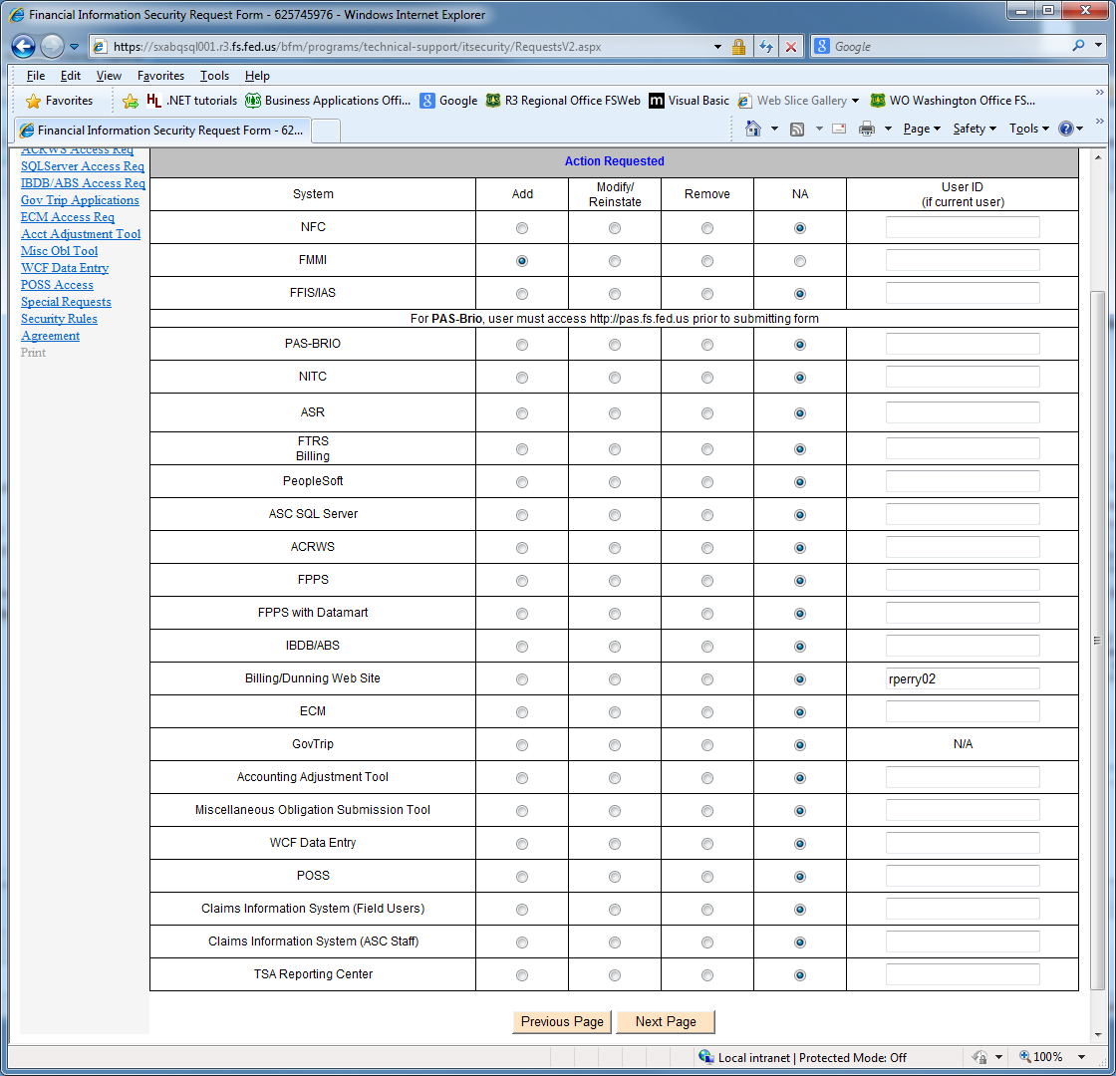

The user selects which system that they need to be added to, need to modify their current access in or need to be deleted from. They include their user ID if they know it, and then select Next Page.

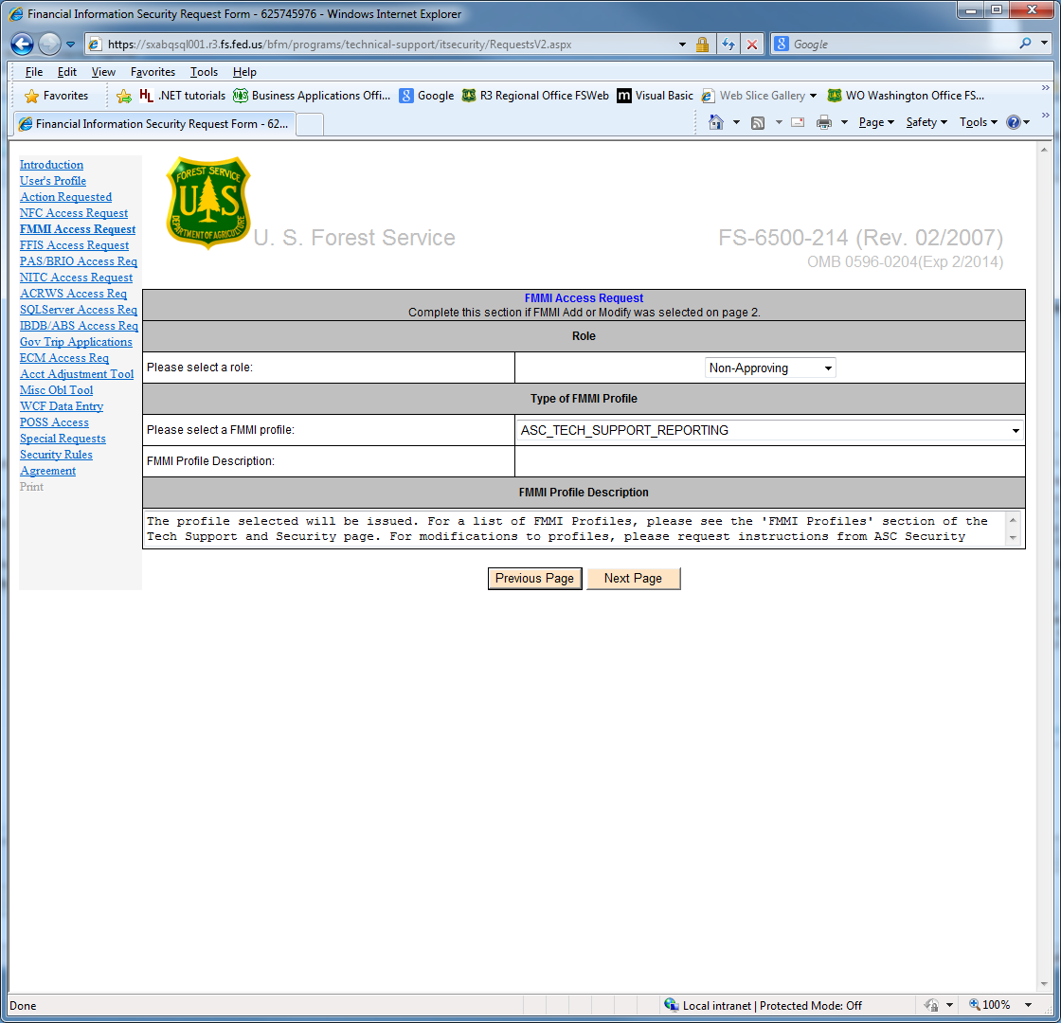

The user, in the case of FMMI, selects the type of role they need, approving, or non-approving, and then selects the profile they need. Information on the various systems access types is available on the Forest Service’s Albuquerque Service Center, Budget and Finance, System Security page. After they select the needed role and profile, they click on Next Page.

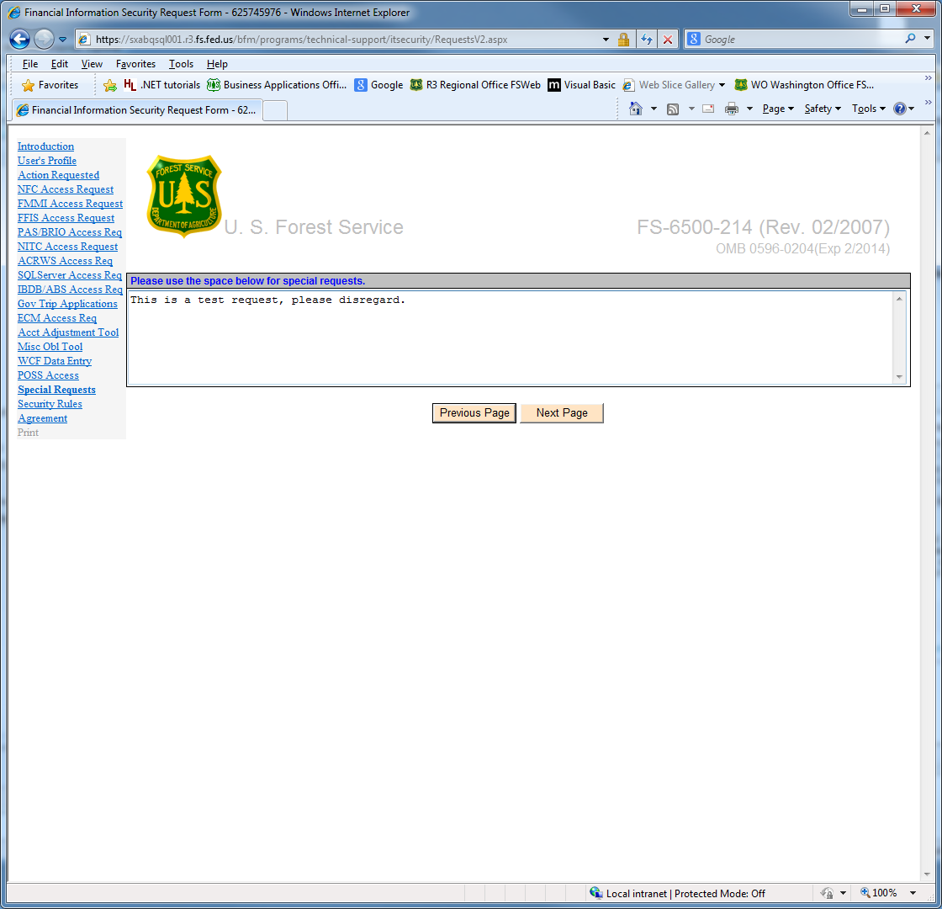

The user has the opportunity to make any special requests they may have, and then click on Next Page.

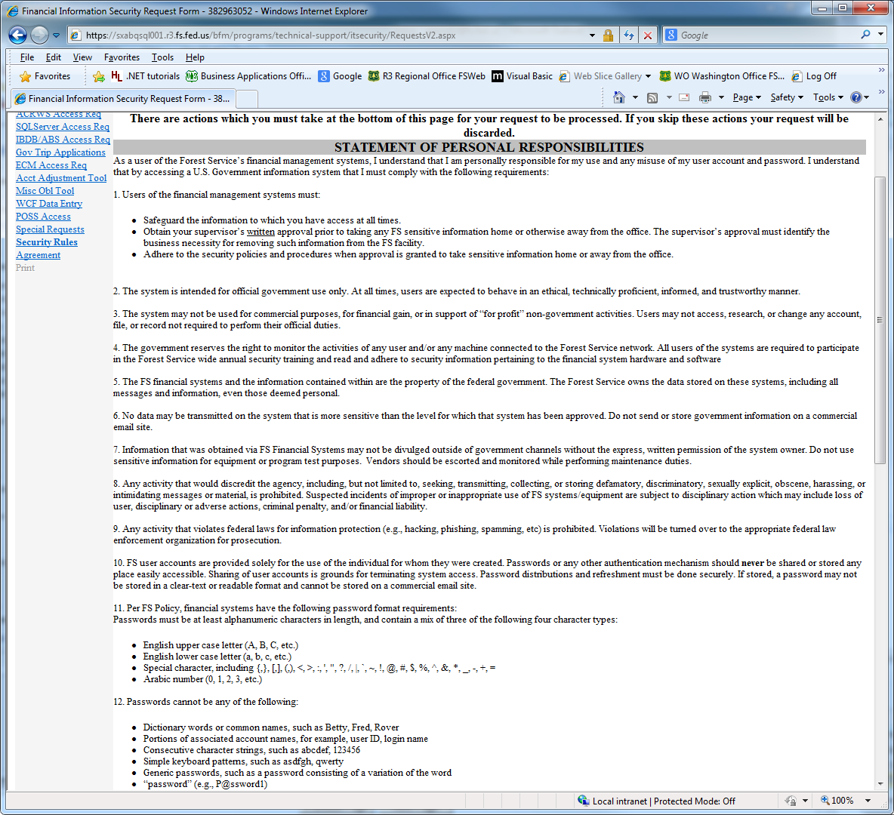

The user reads the Statement of Personal Responsibilities.

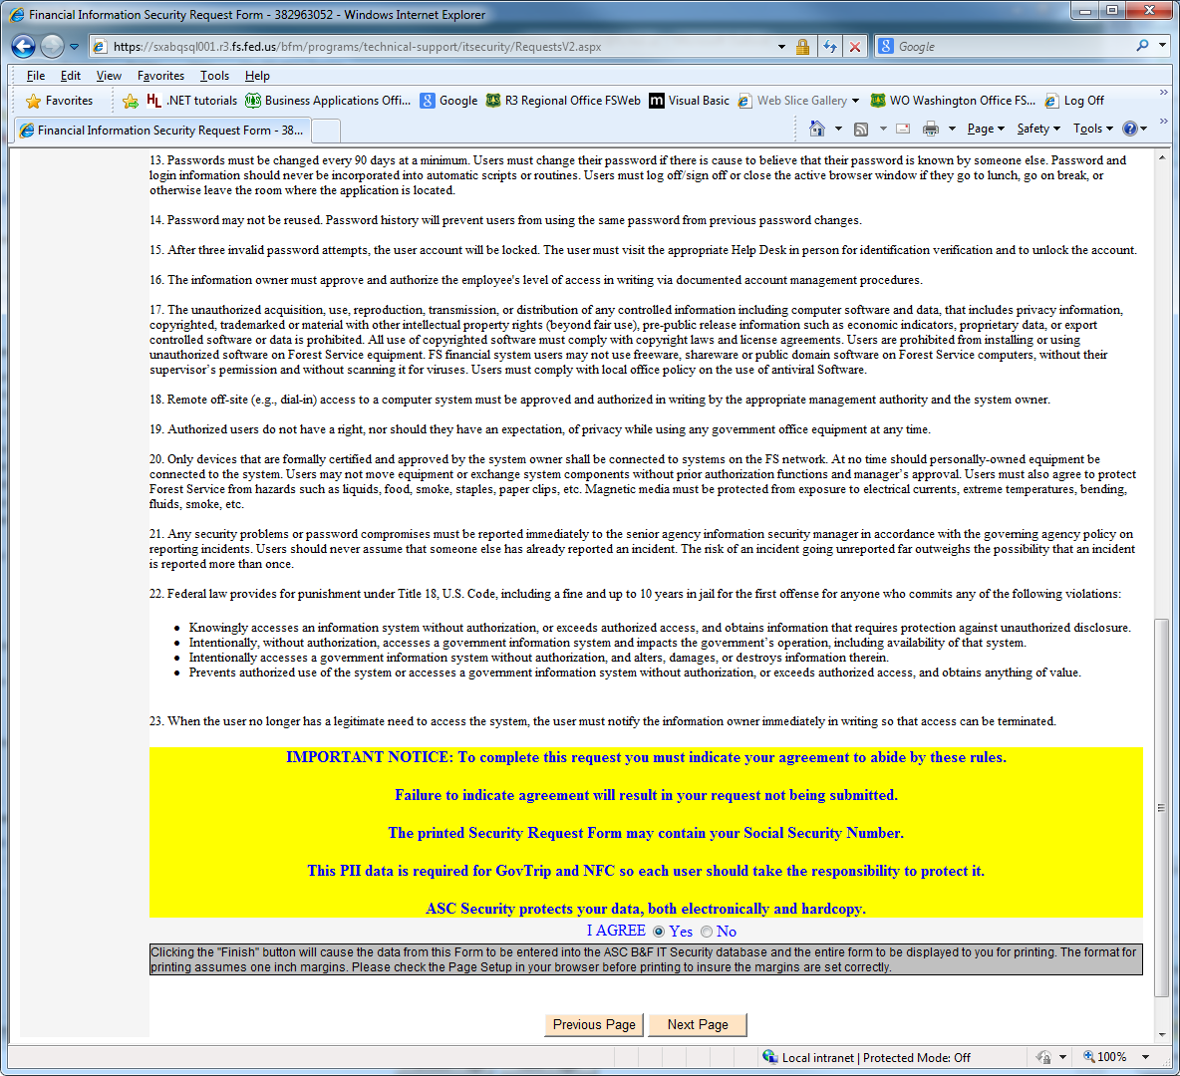

The user continues to read the Statement of Personal Responsibilities and Agrees or does not Agree, and clicks Next Screen. If they do not agree, their request is discarded.

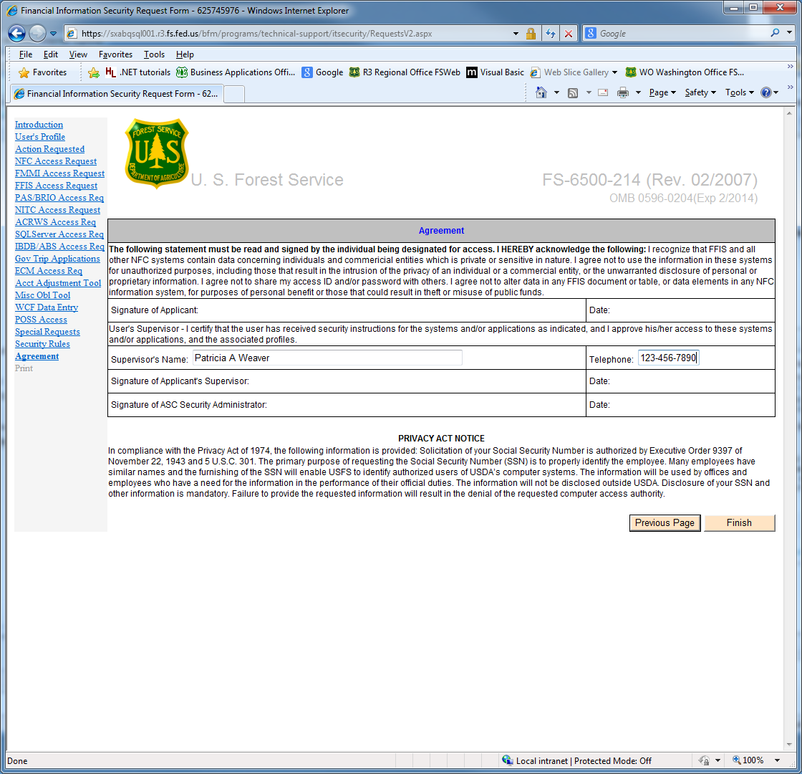

The user verifies their supervisor’s name, and adds their telephone number, and clicks Finish.

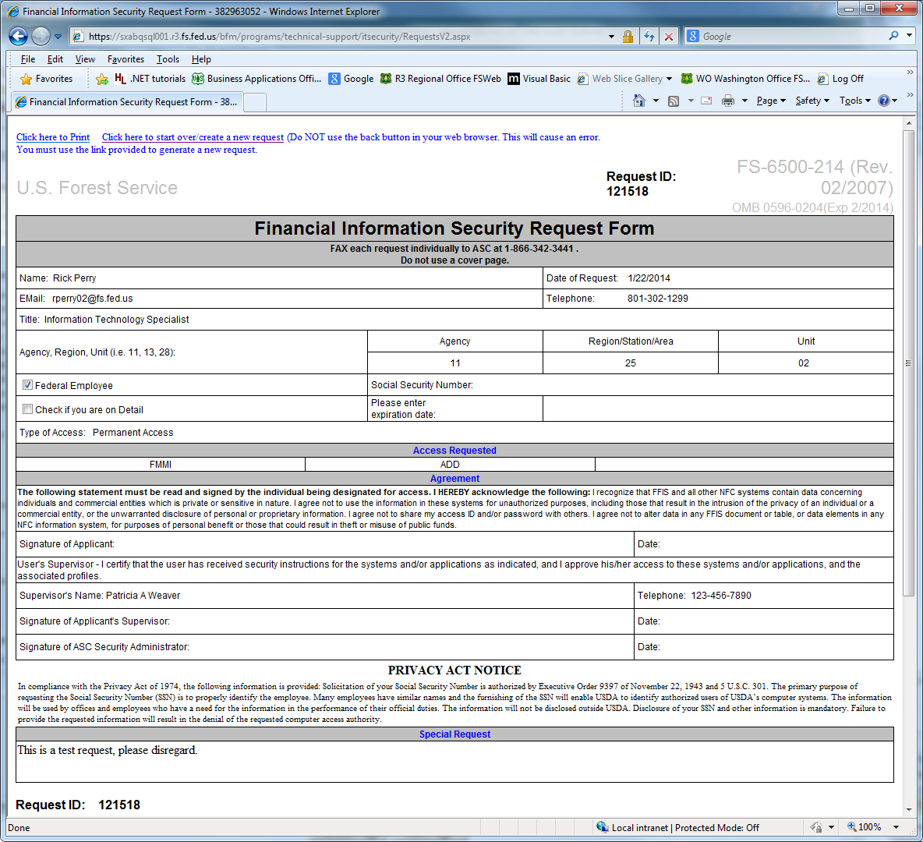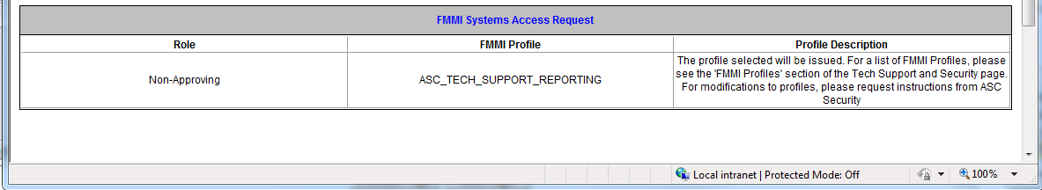

The finished form is displayed, with the Request ID included. The user clicks on the “Click here to Print” link in the top left corner, to print a hard copy of the form for them to sign and have their supervisor sign. The hard copy form (displayed on the following 2 pages) is then faxed to the Forest Service’s Albuquerque Service Center Budget and Finance’s Security group, who will log the fax as being received and who will do the requested action as long as signatures are present. These forms are then maintained electronically for audit purposes.

Form as printed by user. 