Survey Name: Annual Wholesale Trade Survey (AWTS)
OMB Approval Number: 0607-0195
OMB Expiration Date: 12/31/2023
Type of Request: Non-substantive change

This non-substantive change request pertains to the 2022 Annual Wholesale Trade Survey (AWTS), which is tentatively slated to be sent to respondents in January 2023. SA-42A (merchant wholesalers, excluding manufacturers’ sales branches and offices), SA-42A-MSBO (manufacturers’ sales branches and offices), and SA-42A-AGBR (agents, brokers, and electronic markets) are the three electronic form types associated with the AWTS. In the original clearance package approved by OMB for this survey (with an expiration date of 12/31/2023), the United States Census Bureau noted, “in response to a request from the Bureau of Economic Analysis (BEA), the AWTS will also collect annual detailed operating expenses and annual sales tax information during survey year 2022. Respondents are only asked to provide data for these two items in years ending in ‘2’ and ‘7’, which coincide with the Economic Census collection. Merchant wholesalers, excluding manufacturers’ sales branches and offices, will receive the detailed operating expenses and sales tax questions. Conversely, manufacturers’ sales branches and offices will only see the sales tax question. Companies that fall under the agents, brokers, and electronic markets category will not be asked to provide detailed operating expenses or sales tax information.” As previously mentioned, survey year 2022’s data will be collected from respondents during calendar year 2023. Consequently, the United States Census Bureau is officially seeking OMB’s permission to add the detailed operating expenses and annual sales tax questions to SA-42A and to add the sales tax question to SA-42A-MSBO for survey year 2022. No changes will be made to SA-42A-AGBR.
The detailed operating expenses and sales tax questions used for survey year 2022 will be the same as the ones used for survey year 2017 (i.e., the last time the AWTS respondents were asked these questions) with one exception. For survey year 2017, the set of detailed operating expenses questions included a question about interest expense. The interest expense question will not be included for survey year 2022. The overall burden estimates will not be affected by the inclusion of these questions, as our current estimates take into account the periodic collection of detailed operating expenses and sales tax information.
The drafts of the two impacted form types, SA-42A and SA-42A-MSBO, have been provided in their entirety. Nevertheless, the following screenshots show how the detailed operating expenses and sales tax questions will be presented to respondents during survey year 2022:

Detailed Operating Expenses
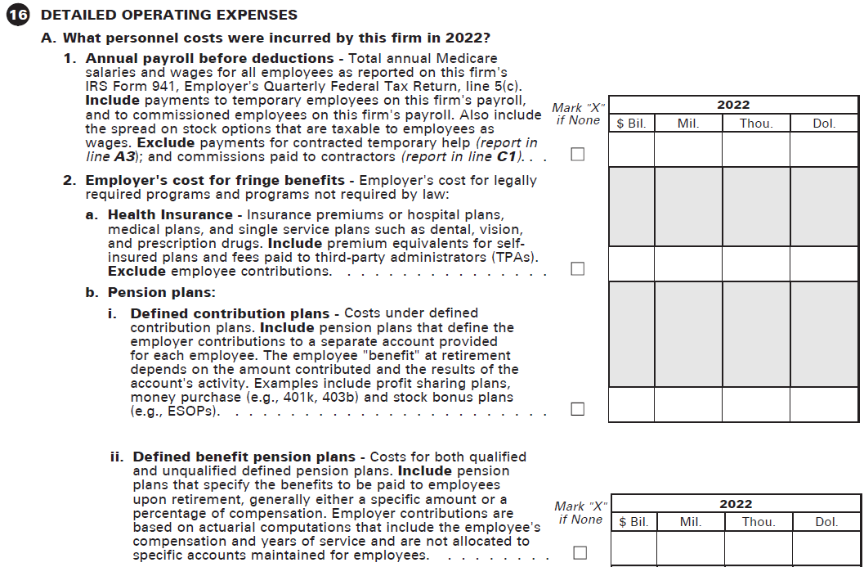
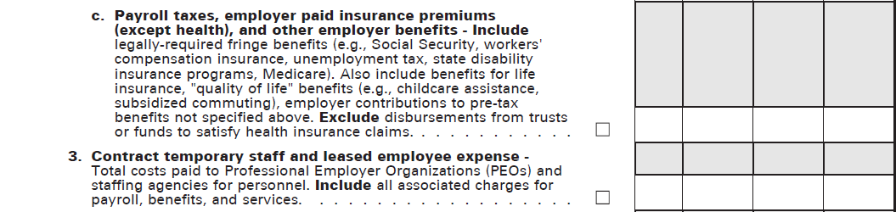
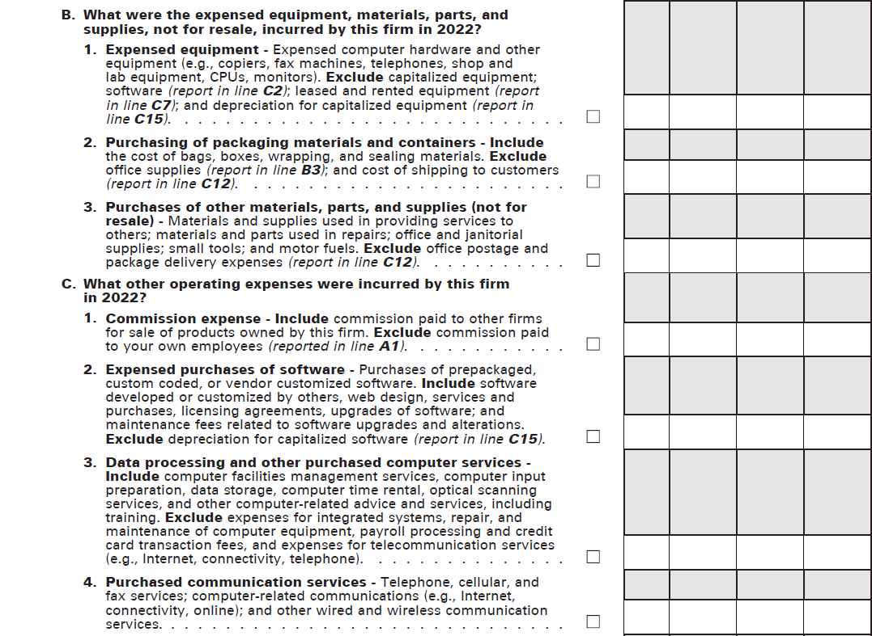
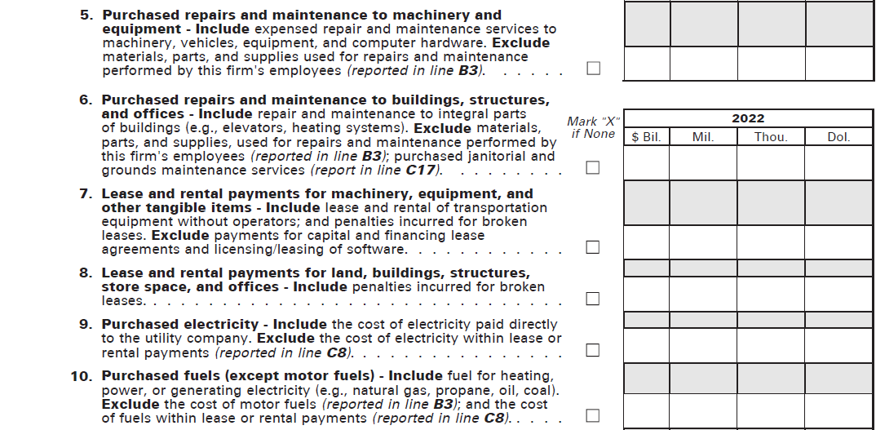

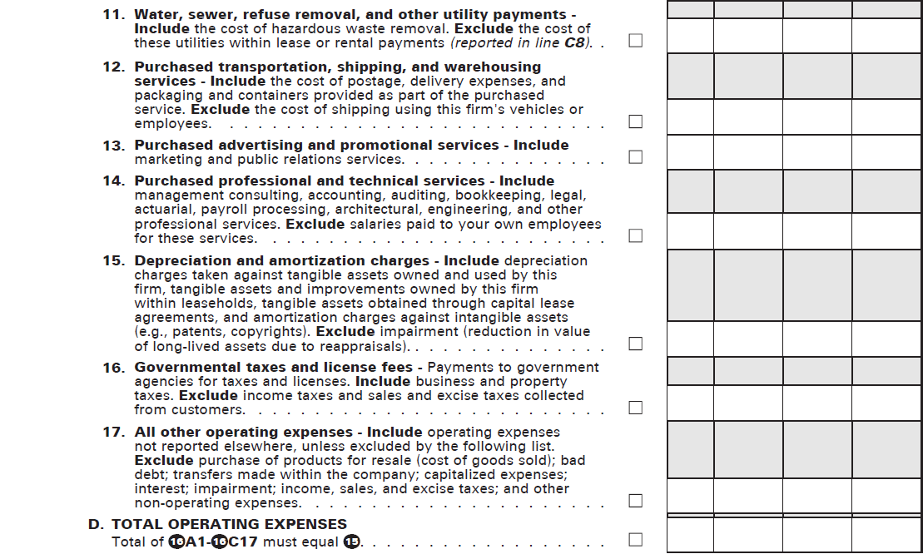
Sales Tax
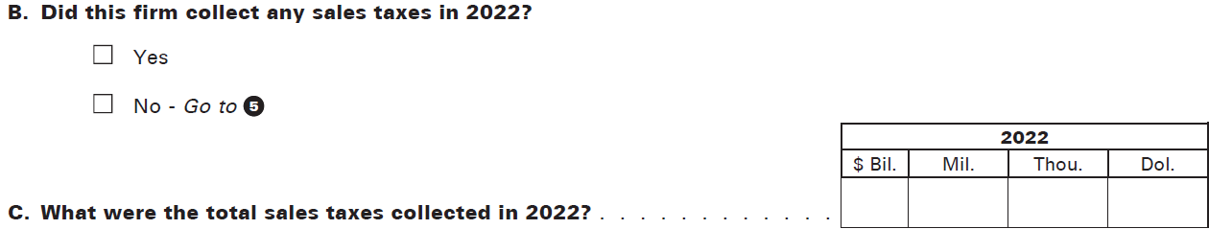

Any questions related to this request can be directed to John Dougherty (john.dougherty@census.gov).

