Attachment K.
Centurion Instrument Screens
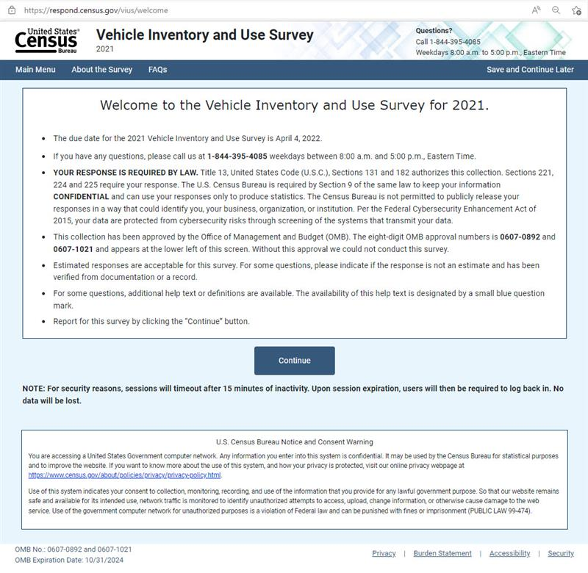

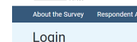

The Centurion instrument links to the About the Survey and Information for Respondents page.
Information about OMB approval is shown on the Information for Respondents page linked from the Centurion instrument.
Information for Respondents (census.gov)

Legal Authority and Confidentiality
YOUR RESPONSE IS REQUIRED BY LAW. Title 13 United States Code (U.S.C.), Sections 131 and 182 authorize this collection. Sections 221, 224, and 225 require your response. The U.S. Census Bureau is required by Section 9 of the same law to keep your information CONFIDENTIAL and can use your responses only to produce statistics.
This collection has been approved by the Office of Management and Budget (OMB). The eight-digit OMB approval number is 0607-0892 and appears on the electronic instrument and the paper questionnaire used for this survey. Without this approval we could not conduct this survey.
The Census Bureau is not permitted to publicly release your responses in a way that could identify you, your business, organization or institution. Per the Federal Cybersecurity Enhancement Act of 2015, your data are protected from cybersecurity risks through screening of the systems that transmit your data.

