The screen capture images that follow show ALL of the questions included in the survey. Questions numbered with decimals (e.g., 17.1, 17.3, 17.3.1, 17.4, 19.1, 19.1.2, 19.1.4, 19.1.5, 19.1.6) are only displayed when a preceding response option is selected, triggering branching display logic for the sub-question. For example, selecting the response option “Other, please specify.” triggers display of a follow-up question and open-ended response text box.
The actual survey appears as one web page; this enables the respondent to view the entire set of questions except the questions that appear only when a specific option is selected. The pagination of this document accommodates the screen capture images.

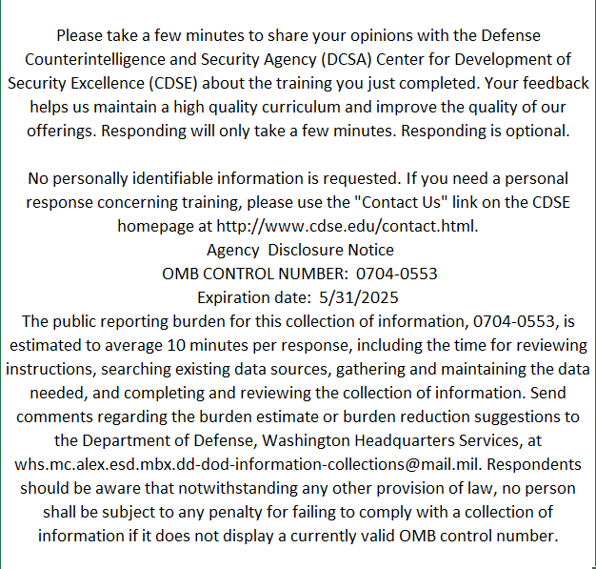
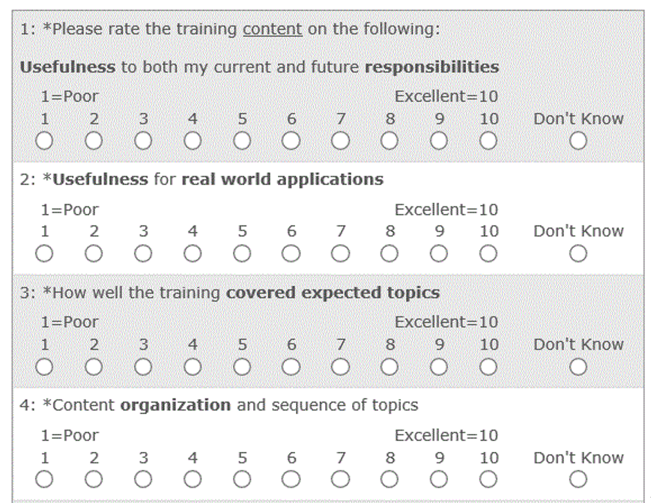
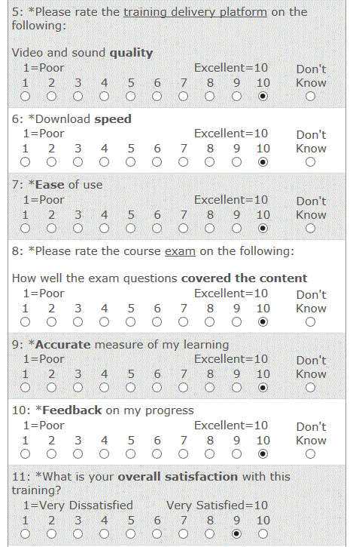

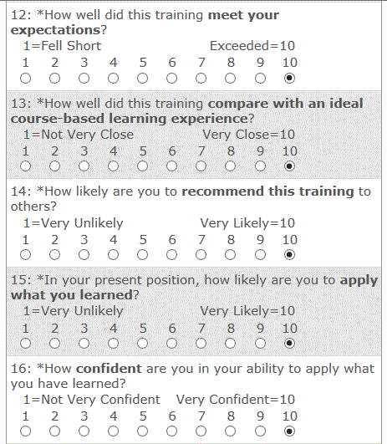

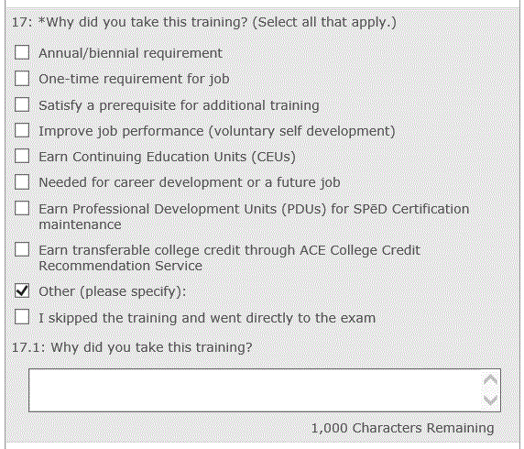

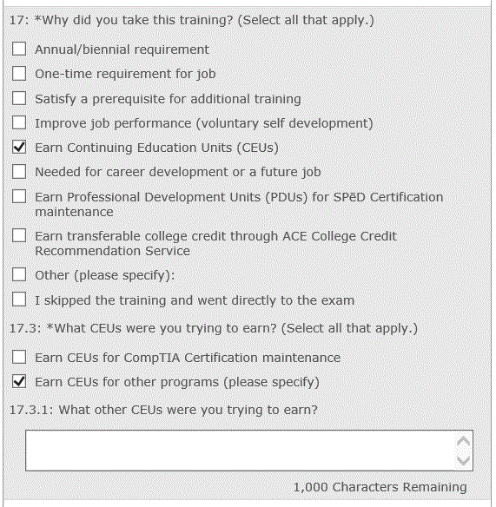

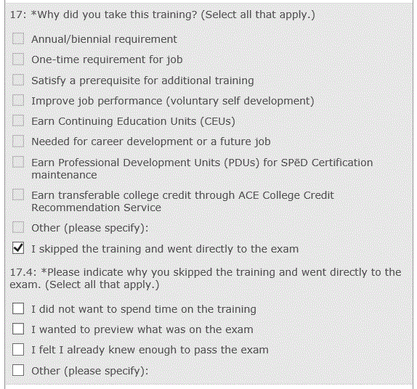
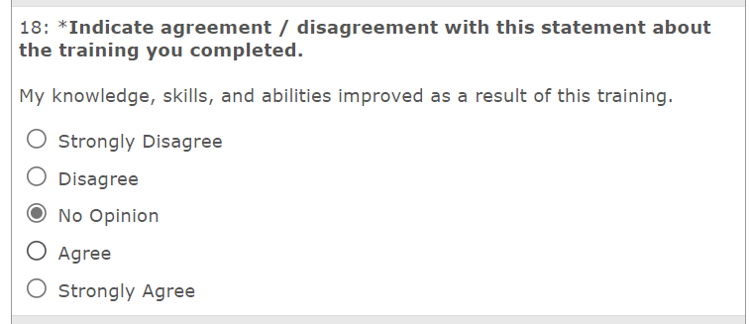
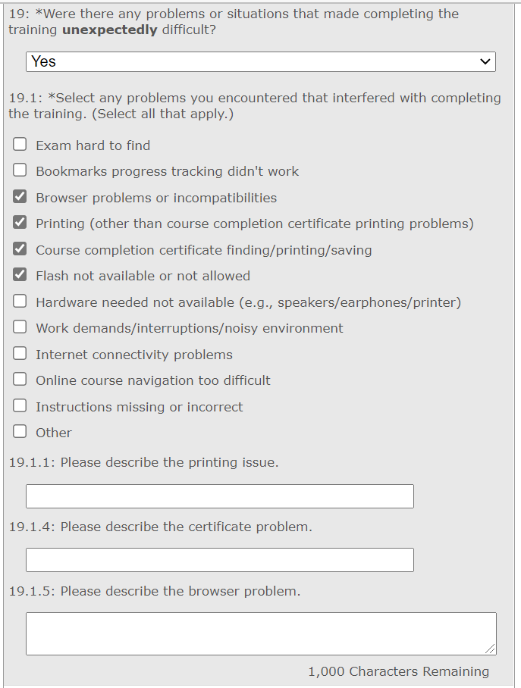
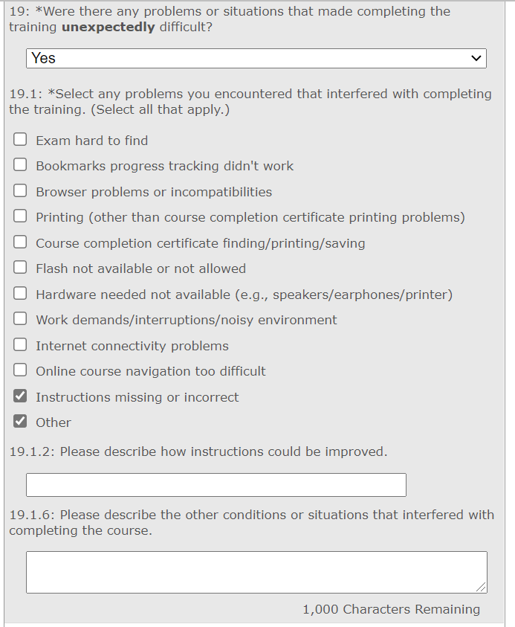
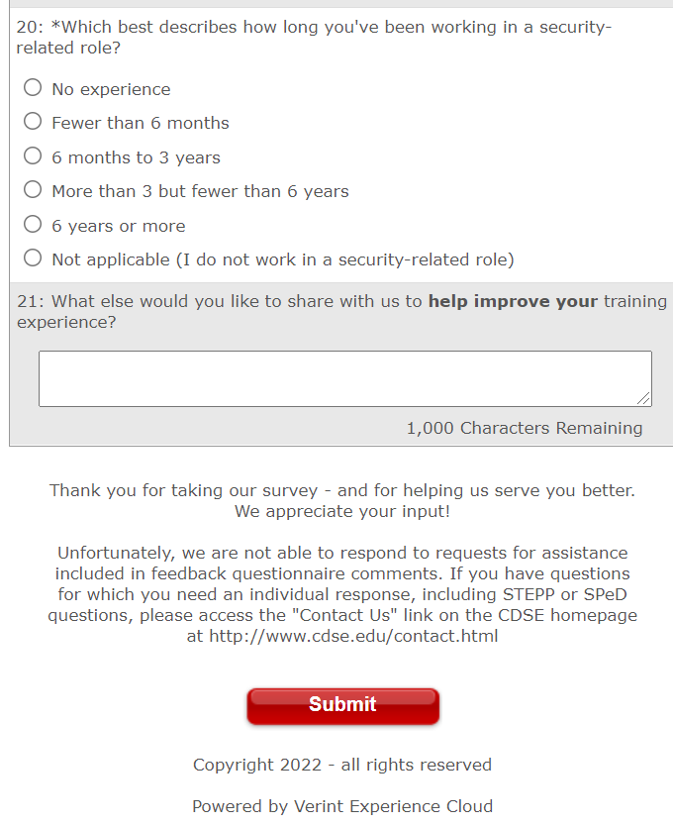

Submission Confirmation Message
