National Center for Health Statistics  
3311 Toledo Road  
Hyattsville, Maryland 20782

**U.S. DEPARTMENT OF HEALTH & HUMAN SERVICES**

Centers for Disease Control and Prevention

Dear [CITY] Resident,

It’s not too late to participate in the National Survey of Family Growth (NSFG)! The information is used to help understand health and health behaviors in the United States. If you have already completed your brief screening survey online, thank you! If you have not, please have an adult in your household complete the 3-minute screening survey online. It can also be completed using the enclosed paper form and returned in the postage-paid envelope.

Based on the answers to the screening questions, you or someone else in your household may be asked to complete the main NSFG survey. **The selected person will receive $40 as a token of appreciation**.

**Go online:**

|  |
| --- |
| * https://nsfg.rti.org * Log in using your password: **<<passcode>>** |

**OR**

**Mail:**

|  |
| --- |
| * **Fill out the short paper form** included with this letter and return it in the enclosed postage-paid envelope |

The NSFG has been conducted by the National Center for Health Statistics (NCHS) since 1973. This study provides key information on health and health care, plans and experiences related to having children, and other general health behaviors. NCHS has asked RTI International (RTI), a nonprofit research organization, to carry out the survey.

If you have questions, you may call RTI toll-free at 800–262–4494. This number is answered Monday – Friday, 9am - 5pm (ET).

For more information about the study and for examples of how NSFG data are used, please look at the enclosed Family Facts sheet or visit the NSFG website at www.cdc.gov/nchs/nsfg/participant.htm.

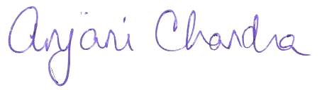Thank you for your consideration.

Anjani Chandra, Ph.D. Andy Peytchev, Ph.D.

Principal Investigator Principal Investigator

National Center for Health Statistics RTI International