Submitted to:
CDC OSH

Submitted by:
ICF
ICF proprietary and confidential. Do not copy, distribute, or disclose.
February 23, 2022
Attachment R8. NYTS Cognitive Testing Guides
Qualitative Inquiry to Support Tobacco-Related Surveillance and Applied Research
Table of Contents
NYTS Interviewer Guide – Item Set 1 (Demographics, E-Cigarettes and Other Heated Tobacco Products, Messaging, Social Media, and Advertisements) 1
1.1 Demographics 1
1.2 E-cigarette use 3
1.3 Vaping 17
1.4 Heated Tobacco 18
1.5 Antitobacco Messaging 21
1.6 E-cigarette Advertisements 22
1.7 E-cigarettes and Social Media 24
1.8 Tobacco Advertisements 27
NYTS Interviewer Guide – Item Set 2 (Cigarettes, E-Cigarette Ads, Social Media, and Discrimination) 30
2.1 Cigarettes 31
2.2 Cigars 37
2.6 Marijuana Cigars 45
2.7 Hookah 46
2.8 Roll-your-own Cigarettes 51
2.9 Pipe Tobacco 54
2.10 Bidis 57
2.11 Opinions on Tobacco (A) 60
2.12 Adolescent Discrimination Distress Index 63
2.13 Tobacco Exposure 65
NYTS Interviewer Guide – Item Set 3 (Demographics, Antitobacco Messaging, Exposure, and Environment) 69
3.1 Chewing Tobacco, Snuff, or Dip 70
3.2 Snus 75
3.3 Nicotine Pouches 78
3.4 Oral Nicotine Products 83
3.5 All Tobacco Products 87
3.6 Healthcare 89
3.7 Opinions on Tobacco (B) 91
3.8 Neighborhood Environment Scale 94
3.9 Home and School 94

NYTS Interviewer Guide – Item Set 1 (Demographics, E-Cigarettes and Other Heated Tobacco Products, Messaging, Social Media, and Advertisements)
Instructions:
- Introduce yourself and ensure that tech is working; respondent should be able to access the web survey and share their screen.
- Briefly discuss the goal of the larger survey and the goal of this interview (i.e., to understand how easy or hard these questions are to answer)
- This is YOUR interview. YOUR chance to give important feedback so kids like you can have a better survey experience.
- Remind the student of consent highlights:
- If possible, take the survey in a private location, away from other family members or your parents.
- Information will not be shared and is only used internally without your name and personal information
- You can skip any question. But, if you feel the question is so uncomfortable that you want to skip it, I’ll ask you why you feel that way.
- The interview will be recorded, and we will take notes.
- Explain process.
- Read each question to yourself and answer it through the web survey.
- Pause when you see a stop sign in the survey and I’ll ask you some questions about how you answered.
- There are no wrong answers to any of the questions you will see. In fact, we aren’t going to use the answers you provide in any way. We are more interested in what you think of the questions and response choices you will see. We want your honest feedback about what you think about these questions and response choices. We didn’t write any of these questions so nothing you say about them will bother us.
- Jump in with comments as you’re trying to answer.
- Start with a practice question to make sure they understand how probes work.
- Avoid use or reference to the National Youth Tobacco Survey or NYTS to minimize the introduction of bias.
- After you explain the instructions ask if the respondent has any questions.

Generic probes (use these when the respondent hesitates or appears confused about an item):
- In your own words, what is this question asking?
- Are there any unfamiliar or confusing words in this question?
- How sure are you about your answer? Why?
- How do you think we could make this question less confusing or easier to understand?
- Was anything about this question uncertain or uncomfortable?
  - If so, what is it?
  - If so, do you think others would not want to respond honestly to this question?

Question/Screen (verbatim from NYTS interview) |  |  | Question-specific Probes (if required) |  | Notes (for interviewer use)
  - Demographics
The first eight questions ask some background information about you.
How old are you?
- 9 years old
- 10 years old
- 11 years old
- 12 years old
- 13 years old
- 14 years old
- 15 years old
- 16 years old
- 17 years old
- 18 years old
- 19 years old or older
What is your sex?
- Male
- Female
What grade are you in?
- 6th
- 7th
- 8th
- 9th
- 10th
- 11th
- 12th
- Ungraded or other grade
Are you Hispanic, Latino, Latina, or of Spanish origin? (Select one or more)  - No, not of Hispanic, Latino, Latina, or Spanish origin à [EXCLUSIVE]  - Yes, Mexican, Mexican American, Chicano, or Chicana  - Yes, Puerto Rican  - Yes, Cuban  - Yes, Another Hispanic, Latino, Latina, or Spanish origin |  |  | [IF HISPANIC]:  - Are the categories clear?  - Are there any other categories that you think we should include (i.e. LatinX)?
What race or races do you consider yourself to be? (Select one or more)
- American Indian or Alaska Native
- Asian
- Black or African American
- Native Hawaiian or Other Pacific Islander
- White
Which of the following best describes you?  - Heterosexual (straight)  - Gay or lesbian  - Bisexual  - I describe my sexual orientation some other way  - I am not sure about my sexual orientation (questioning)  - I do not know what this question is asking |  |  | - How did you come up with your answer?  - Were there any categories you hadn’t heard before?  - Were there other answer categories you wish were there?
What sex were you assigned at birth, on your original birth certificate?  - Male  - Female  - Refused  - I don’t know |  |  | - In your own words, what is this question asking?  - How clear or confusing was the question? How easy or hard to answer?
Do you currently describe yourself as male, female, or transgender?  - Male  - Female  - Transgender  - None of these |  |  | - In your own words, what is this question asking?  - How clear or confusing was the question? How easy or hard to answer?  - Were there any categories you hadn’t heard before?  - Were there other answer categories you wish were there?
Question Group Probes:
- Were these questions what you expected to see when you saw the introduction (“The first eight questions ask some background information about you”)?
- How clear or confusing were these questions?
- Did the answer options for race match what you expected to see? Did they include the race you would usually consider yourself to be?
- Did you feel comfortable answering these questions? Did you feel comfortable answering these questions so early in the survey?

1.2 E-cigarette use
The next several sections of questions ask about your use of particular kinds of tobacco products, such as e-cigarettes, cigarettes, cigars, smokeless tobacco, hookahs, roll-your own-cigarettes, pipes, snus, dissolvable tobacco, bidis, heated tobacco products, and nicotine pouches.

At the beginning of each section, you will see a brief description and an image showing examples of each kind of tobacco product.

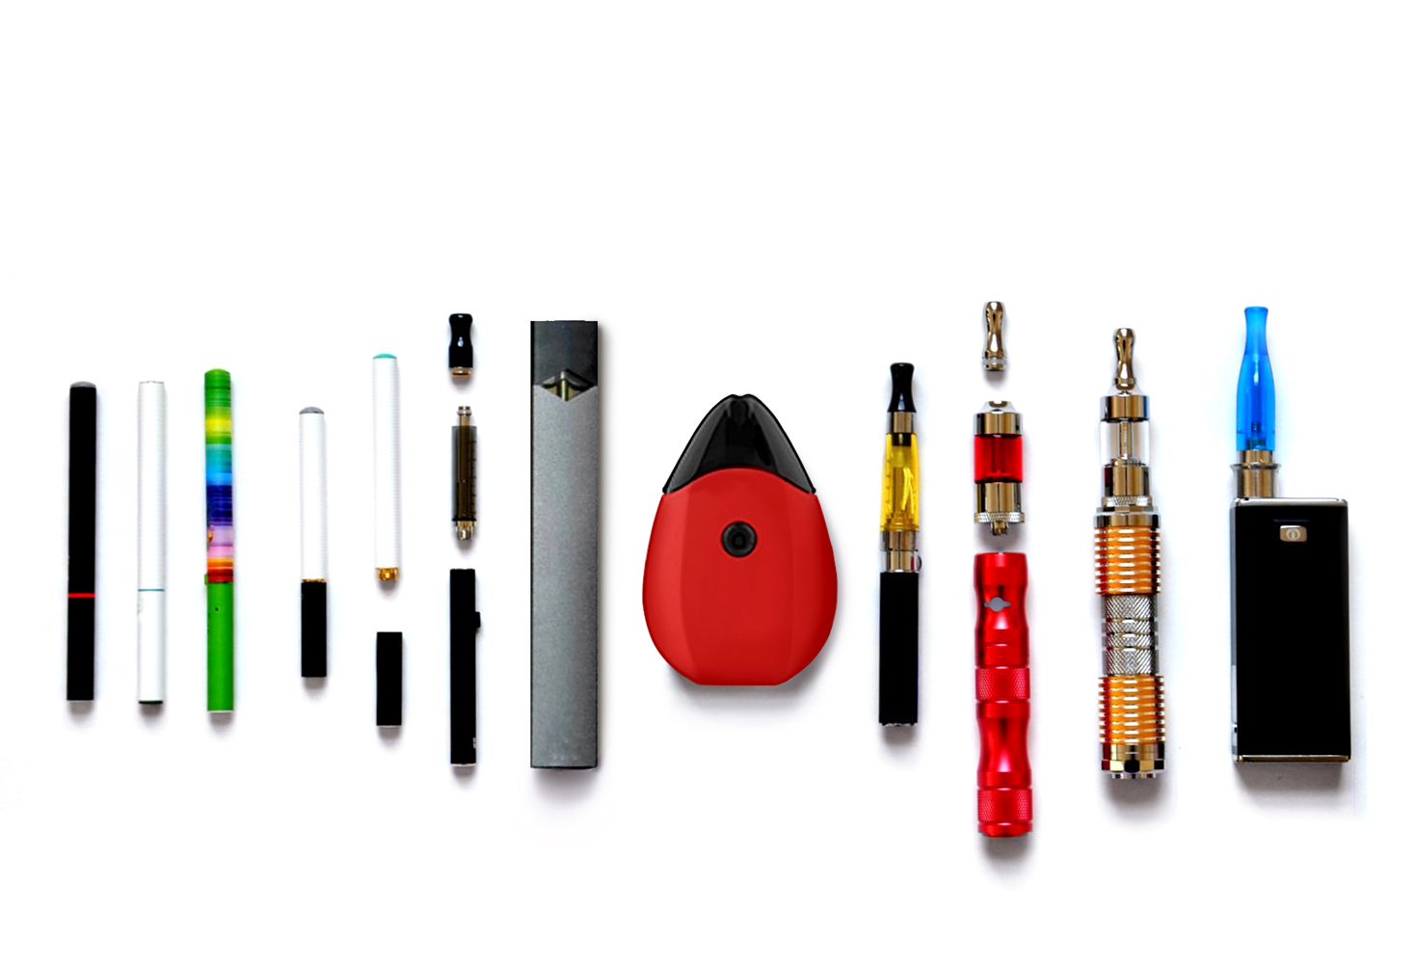

The next several questions are about electronic cigarettes or e-cigarettes, such as JUUL, Vuse, NJOY, Puff Bar, blu, or Bidi Stick. You also may know them as vapes, mods, e-cigs, e-hookahs, or vape-pens.  E-cigarettes are battery powered devices that usually contain a nicotine-based liquid that is vaporized and inhaled.  For the rest of this survey, these products and devices will be called e-cigarettes. |  |  |  | - How clear or confusing was the description of e-cigarettes? Were there any unfamiliar words in the description?  - How well did the description fit the images shown? To what extent did you use the images versus the description in order to understand what types of products it was asking about?  - Is ‘e-cigarette’ a term that you or other people your age use? Are there are other terms that should be used?  - What tobacco products do you think of as e-cigarettes? Do vapes fit into that category? How do e-cigarettes differ from regular cigarettes?
Have you ever used an e-cigarette, even once or twice?
- Yes
- No
[INTERVIEWER: CONTINUE BELOW FOR EVER E-CIGARETTE USERS. NEVER E-CIGARETTE USERS WILL SKIP TO PAGE X.]
Question Universe: ever e-cigarette users [known]
How old were you when you first used an e-cigarette, even once or twice?
- 8 years old or younger
- 9 years old
- 10 years old
- 11 years old
- 12 years old
- 13 years old
- 14 years old
- 15 years old
- 16 years old
- 17 years old
- 18 years old
- 19 years old or older
Question Universe: ever e-cigarette users [known]  In total, on how many days have you used e-cigarettes in your entire life?  - 1 day  - 2 to 10 days  - 11 to 20 days  - 21 to 50 days  - 51 to 100 days  - Over 100 days |  |  |  | [IF MORE THAN ONE DAY:]  - Walk me through how you figured out your answer to this question.  - How sure are you about your answer?
Question Universe: ever e-cigarette users [or unknown]  During the past 30 days, on how many days did you use e-cigarettes?  Specify: |__|__| (Range 0 – 30) |  |  |  | - How easy or hard was it to answer with a specific number of days?  - How would you respond to this item if you did not use e-cigarettes during the past 30 days?
Question Universe: ever/current e-cigarette users [known]
When was the last time you used an e-cigarette, even one or two times? (Please choose the first answer that fits)
- Earlier today
- cNot today, but sometime during the past 7 days
- Not during the past 7 days, but sometime during the past 30 days
- Not during the past 30 days, but sometime during the past 6 months
- Not during the past 6 months, but sometime during the past year
- 1 to 4 years ago
- 5 or more years ago
Question Universe: ever/current e-cigarette users [known]  Why did you first use an e-cigarette? (Select one or more)  - A friend used them  - A family member used them  - To try to quit using other tobacco products, such as cigarettes  - They cost less than other tobacco products, such as cigarettes  - They were easier to get than other tobacco products, such as cigarettes  - I’ve seen people on TV, online, or in movies use them  - They are less harmful than other forms of tobacco, such as cigarettes  - They were available in flavors, such as menthol, mint, candy, fruit, or chocolate  - I could use them unnoticed at home or at school  - I could use them to do tricks  - I was curious about them  - I was feeling anxious, stressed, or depressed  - To get a high or buzz from nicotine  - I used them for some other reason (specify:) |  |  |  | - How easy or hard was it to remember why you first used an e-cigarette?  - How confident are you in your response? Were there any responses that applied to you that you didn’t select? If so, why?  - Any responses missing that should be added?  - Any responses that we can delete?
Question Universe: current e-cigarette users [known]  INTERVIEWER: ASK IF CURRENT E-CIGARETTE USER. OTHERWISE, SKIP TO NEXT QUESTION.  Why do you currently use e-cigarettes? (Select one or more)  - A friend uses them  - A family member uses them  - To try to quit using other tobacco products, such as cigarettes  - They cost less than other tobacco products, such as cigarettes  - They are easier to get than other tobacco products, such as cigarettes  - I’ve seen people on TV, online, or in movies use them  - They are less harmful than other forms of tobacco, such as cigarettes  - They are available in flavors, such as menthol, mint, candy, fruit, or chocolate  - I can use them unnoticed at home or at school  - I can use them to do tricks  - I am curious about them  - Because I feel anxious, stressed, or depressed  - To get a high or buzz from nicotine  - I use them for some other reason (specify:) |  |  |  | - Do you consider yourself a current e-cigarette user?  - What does “current use” mean to you?
Question Universe: ever e-cigarette user [known]
Have you ever purchased an e-cigarette device (including disposable devices), pod, cartridge, single hit, or e-liquid refill while at school or on school property?
- Yes
- No
Question Group Probes:
- How easy or hard was it for you to answer these questions? Why? Which were hardest?
- How clear or confusing were the different answer options for these questions?
- What does “Select one or more” mean to you?
- [INTERVIEWER: SKIP IF PAST 30-DAY E-CIGARETTE USER] When you were answering these questions about e-cigarettes, were you thinking about tobacco and nicotine, or were you thinking about other substances like marijuana?
[INTERVIEWER: CONTINUE BELOW FOR PAST 30-DAY E-CIGARETTE USERS. OTHERWISE, SKIP TO PAGE X.]
Question Universe: past 30-day e-cigarette user [known]  Which of the following best describes the type of e-cigarette you have used in the past 30 days?  If you have used more than one type, please think about the one you use most often.  - A disposable e-cigarette (for example, Puff Bar or Bidi Stick)  - An e-cigarette that uses pre-filled or refillable pods or cartridges (for example, JUUL, Vuse, or Suorin)  - An e-cigarette with a tank that you refill with liquids (including mod systems that can be customized by the user)  - I don’t know the type |  |  |  | - How did you figure out which type of e-cigarette you used?  - If needed, did the brand examples help you decide?  - Which of the response options were confusing?
Question Universe: past 30-day e-cigarette user [known]  During the past 30 days, what e-cigarette brands did you use? (Select one or more)  - Bidi Stick  - blu  - JAK  - JUUL  - Hyde  - Leap  - Logic  - Mojo  - NJOY  - Posh (including Posh Plus)  - Puff Bar  - SMOK (including NOVO)  - STIG  - Suorin  - Vuse  - Some other brand(s) not listed here (specify): ________________________  - Not sure / I don’t know the brand |  |  |  | - If some other brand: Is that a common brand where you live? Do you know other people your age who use that brand? Have you heard of any of the brands listed here or do any of them sound familiar?  - If not sure/don’t know: Is there a reason you don’t remember the brand, like that someone else bought it for you or you buy lots of different brands? Have you heard of any of the brands listed here or do any of them sound familiar?
Question Universe: past 30-day e-cigarette user reporting >1 brand [known]
During the past 30 days, what brand of e-cigarettes did you usually use? (Choose only one answer)
- I did not use a usual brand
- Bidi Stick
- blu
- JAK
- JUUL
- Hyde
- Leap
- Logic
- Mojo
- NJOY
- Posh (including Posh Plus)
- Puff Bar
- SMOK (including NOVO)
- STIG
- Suorin
- Vuse
- Some other brand not listed here (specify): __________________________
- Not sure / I don’t know the brand
Question Universe: past 30-day e-cigarette users [known]  Did any of the e-cigarettes that you used in the past 30 days contain nicotine?  A. Yes  B. No  C. Don’t know |  |  |  | - In your own words, can you describe what nicotine is?  - How do you know if your e-cigarette contained nicotine?
Question Universe: past 30-day e-cigarette users [known]  Nicotine salts, or “nic salts”, is a type of nicotine that is found in some e-liquids, pods, and cartridges. Did any of the e-cigarettes that you used in the past 30 days contain nicotine salts?  - Yes  - No  - Don’t know |  |  |  | - For those reporting Don’t Know: did you not know what nicotine salts were?  - Or did you not know if your product contained them?
Question Universe: past 30-day e-cigarette user [known]  Were any of the e-cigarettes that you used in the past 30 days flavored to taste like menthol, mint, clove or spice, alcoholic drinks, candy, fruit, chocolate, or any other non-tobacco flavor?  Do not think about tobacco flavor when answering this question.  - Yes  - No  - Don’t Know |  |  |  | - What does “non-tobacco flavor” mean to you in this question? What does “tobacco flavor” mean?  - Would you have answered differently if it didn’t say “Do not think about tobacco flavor when answering this question?
Question Universe: past 30-day e-cigarette user [known]  Were any of the e-cigarettes that you used in the past 30 days flavored to taste like tobacco?  - Yes  - No  - Don’t Know |  |  |  | What does “flavored to taste like tobacco” mean to you?  Did you think about added artificial flavorings, naturally occurring tobacco flavor, or both?
Question Universe: past 30-day users of flavored e-cigarettes  What flavors were the e-cigarettes that you have used in the past 30 days? (Select one or more)  - Tobacco-flavor  - Menthol  - Mint  - Spice (such as cinnamon, vanilla, or clove)  - Fruit  - Chocolate  - Alcoholic drinks (such as wine, margarita, or other cocktails)  - Non-alcoholic drinks (such as coffee, soda, lemonade, or other beverage)  - Candy, desserts, or other sweets  - Some other flavor not listed here (Specify): __________________________ |  |  |  | What do you think of the answer choices?  What’s the difference between menthol and mint?
Question Universe: past 30-day user of flavored e-cigarettes  Did any of the flavors that you used in the past 30 days have names or descriptions that included the word “ice” or “iced” (for example, blueberry ice or strawberry ice)?  - Yes  - No  - Don’t know |  |  |  | - Have you ever heard of “iced” flavors?  - Was anything about this question confusing?
Question Universe: past 30-day user of flavored e-cigarettes  Did any of the flavors that you used in the past 30 days have a name that did not describe a specific flavor, such as “solar,” “purple,” “jazz,” “island bash,” “fusion” or some other word or phrase?  - Yes (specify): ___________________  - No  - Don’t know |  |  |  | - Was anything about this question confusing?  - Would you describe these flavors any differently?  - Are any example words (e.g., jazz) missing?
Question Universe: past 30-day e-cigarette user [known]  During the past 30 days, how did you get your e-cigarette devices, pods, cartridges, or e-liquid refills? (Select one or more)  - I bought them myself  - I had someone else buy them for me  - I asked someone to give me some  - Someone offered them to me  - I got them from a friend  - I got them from a family member  - I took them from a store or another person  - I got them in some other way (specify): _____________________________ |  |  |  | - Were any response options confusing?
Question Universe: past 30-day e-cigarette user [known]  During the past 30 days, where did you buy your e-cigarette devices, pods, cartridges, or e-liquid refills? (Select one or more)  - I did not buy e-cigarettes during the past 30 days à [EXCLUSIVE RESPONSE]  - I bought them from another person (a friend, family member, or someone else)  - A gas station or convenience store  - A grocery store  - A drugstore  - A mall or shopping center kiosk/stand  - A vending machine  - On the Internet (such as a product website, online vape or tobacco store or other online marketplace)  - Through the mail  - Through a delivery service (such as DoorDash or Postmates)  - A vape shop or tobacco shop  - Some other place not listed here (specify): __________________________ |  |  |  | - If did not buy last 30 days: Where did you get your e-cigarette products? Did you pay any money for them? [INTERVIEWER: NOTE RESPONSE FROM PRIOR QUESTION]
Question Universe: past 30-day e-cigarette user (who got a product from someone else)
Earlier you answered that you got or bought your e-cigarette devices, pods, cartridges, or e-liquid refills from another person, such as a friend or family member during the past 30 days. How old was this person?
- Younger than 18 years old
- 18 years old
- 19 years old
- 20 years old
- 21 years old or older
- I don’t know
Question Universe: past 30-day e-cigarette user (who got a product from someone else)  During the past 30 days, which of the following e-cigarette product(s) did you get or buy from another person? (Select one or more)  - A new e-cigarette device (including disposable devices)  - A pod, cartridge, or e-liquid refill  - A hit or a drag from another person’s e-cigarette device  - Something else (specify:) _______________________________________ |  |  |  | - Were any of the response options confusing?
Question Universe: past 30-day e-cigarette user [known]
During the past 30 days, how often did you use someone else’s e-cigarette device?
- Never
- Rarely
- Sometimes
- Most of the Time
- Always
Question Universe: past 30-day users of e-cigarettes [known]  Are you seriously thinking about quitting e-cigarettes? (Please choose the first answer that fits)  - Yes, during the next 30 days  - Yes, during the next 6 months  - Yes, during the next 12 months  - Yes, but not during the next 12 months  - No, I am not thinking about quitting e-cigarettes |  |  |  | If “no”, why not? Are they truly not interested in quitting, or do they not consider that they would even need to quit (e.g., they do not consider themselves to be e-cigarette users)
Question Universe: past 30-day users of e-cigarettes [known]
During the past 12 months, how many times have you stopped using e-cigarettes for one day or longer because you were trying to quit using e-cigarettes for good?
- I did not try to quit during the past 12 months
- 1 time
- 2 times
- 3 to 5 times
- 6 to 9 times
- 10 or more times
Question Universe: e-cigarette users who reported ≥1 quit attempt in past 12 months [known]  When you tried to quit using e-cigarettes, did you use any of the following? (Select one or more)  - I did not use any resources à [EXCLUSIVE]  - Help or advice from a parent or caregiver  - Help or advice from a friend or peer  - Help or advice from a teacher or coach  - Help, advice, or counseling from a doctor or health care provider  - Treatment from a hospital, medical center, or some other facility  - Help or advice you found on the Internet  - A mobile app or texting program  - A telephone helpline or Quitline  - Something else (specify): ________________________________ |  |  |  | - Which of the response options were confusing?  - Any options missing?  - Any options that can be deleted?
Question Group Probes:
- Were words in this new to you? Which ones? What did they mean in your own words?
- Which of the response options seemed confusing?
- How easy or hard was it to remember the brands you used?
- Was there anything confusing about these questions? What was it?
- How easy or hard was it to answer for the past 30 days?
- [IF NOT ALREADY PROBED]: How easy or hard was it to remember your specific experiences, like flavors and where you got your products from?
- When you were answering these questions about e-cigarettes, were you thinking about tobacco and nicotine, or were you thinking about other substances like marijuana?
[INTERVIEWER: CONTINUE BELOW FOR NEVER E-CIGARETTE USERS. CURRENT E-CIGARETTE USERS WILL SKIP TO PAGE X.]
Question Universe: never e-cigarette users [known]

Have you ever been curious about using an e-cigarette?
- Definitely yes
- Probably yes
- Probably not
- Definitely not
Question Universe: never e-cigarette users [known]
Do you think that you will try an e-cigarette soon?
- Definitely yes
- Probably yes
- Probably not
- Definitely not
Question Universe: never e-cigarette users [known]
Do you think you will use an e-cigarette in the next year?
- Definitely yes
- Probably yes
- Probably not
- Definitely not
Question Universe: never e-cigarette users [known]
If one of your best friends were to offer you an e-cigarette, would you use it?
- Definitely yes
- Probably yes
- Probably not
- Definitely not
Question Group Probes:
- In your own words, what is the difference between “definitely yes/no” and “probably yes/no”?
- How easy or hard was it to imagine what you would do? What experiences did you think about?
- When you were answering these questions about e-cigarettes, were you thinking about tobacco and nicotine, or were you thinking about other substances like marijuana?

Vaping
Question/Screen (verbatim from NYTS interview) |  |  |  | Question-specific Probes (if required) |  |  | Notes (for interviewer use)
The next questions ask about other substances that could be vaped.
Have you ever vaped any of the following substances (even once)?
Response options: Yes, No, Don’t Know
- Marijuana (also called pot, weed, or cannabis), including THC, THC concentrates, hash oil, or waxes
- CBD or CBD oils
- Synthetic marijuana or cannabinoids, such as K2 or Spice
- Another substance Specify): ___________________
Have you vaped any of the following substances during the past 30 days?
Response options: Yes, No, Don’t Know
- Marijuana (also called pot, weed, or cannabis), including THC, THC concentrates, hash oil, or waxes
- CBD or CBD oils
- Synthetic marijuana or cannabinoids, such as K2 or Spice
- Another substance Specify): ___________________
Question Group Probes:
- How easy or hard was it to differentiate between the different things you could vape?
- How are marijuana and CBD the same or different?
- How sure were you about your answers?
- How comfortable were you responding to questions about marijuana?
- How comfortable were you responding to questions about CBD?
- How comfortable were you responding to questions about synthetic marijuana?
- How honestly do you think people will respond to questions about use of these substances?
  - Heated Tobacco
The next section is about heated tobacco products such as iQOS or Eclipse. You may know them as heated cigarettes or “heat-not-burn” tobacco products. Heated tobacco products heat processed tobacco leaf in the form of sticks (“heatsticks”), plugs, or capsules to produce a vapor that the user inhales. They are different from e-cigarettes, which heat a liquid to produce a vapor.  Do not think about e-cigarettes when answering these questions.  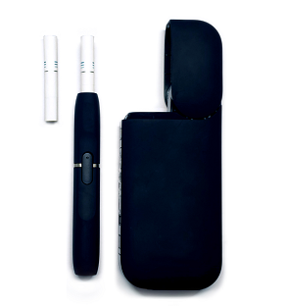 |  | - In your own words, what is a heated tobacco product?  - How is a heated tobacco product different from an e-cigarette or vape in your mind?  - Have you heard of any of the examples of heated tobacco products given (iQOS, glo, Eclipse)?  - How well did the description fit the images shown? To what extent did you use the images versus the description in order to understand what types of products it was asking about?
Before today, have you heard of heated tobacco products?
- Yes
- No
- Don’t know/Not Sure
Have you ever used a heated tobacco product, even just one time?  - Yes  - No  - Don’t Know/Not Sure |  | [IF DON’T KNOW]:  - What makes you unsure about having used heated tobacco products?
[INTERVIEWER: CONTINUE BELOW FOR EVER (OR DK) HEATED TOBACCO USERS. NEVER USERS SKIP TO PAGE X.]
Question Universe: ever heated tobacco product user [or unknown/don’t know]  During the past 30 days, on how many days did you use a heated tobacco product?  Specify: |__|__| (Range 0 – 30) |  | [IF NOT ALREADY PROBED]:  - How easy or hard was it to answer with a specific number of days?
[INTERVIEWER: CONTINUE BELOW FOR PAST 30 DAY HEATED TOBACCO USERS. EVER USERS SKIP TO PAGE X.]
Question Universe: past 30-day heated tobacco product user [known]
Were any of the heated tobacco products that you used in the past 30 days flavored to taste like menthol, mint, clove or spice, alcoholic drinks, candy, fruit, chocolate, or any other non-tobacco flavor?
Do not think about tobacco flavor when answering this question.
- Yes
- No
- Don’t Know
Question Universe: past 30-day heated tobacco product user [known]
Were any of the heated tobacco products that you used in the past 30 days flavored to taste like tobacco?
- Yes
- No
- Don’t Know

Question Universe: past 30-day users of flavored heated tobacco products
What flavors were the heated tobacco products that you have used in the past 30 days? (Select one or more)
- Tobacco-flavor
- Menthol
- Mint
- Spice (such as cinnamon, vanilla, or clove)
- Fruit
- Chocolate
- Alcoholic drinks (such as wine, margarita, or other cocktails)
- Non-alcoholic drinks (such as coffee, soda, lemonade, or other beverage)
- Candy, desserts, or other sweets
- Some other flavor not listed here (Specify): ________________________
Question Universe: past 30-day heated tobacco product user [known]
During the past 30 days, how did you get your heated tobacco products? (Select one or more)
- I bought them myself
- I had someone else buy them for me
- I asked someone to give me some
- Someone offered them to me
- I got them from a friend
- I got them from a family member
- I took them from a store or another person
- I got them in some other way (Specify): ____________________________
Question Universe: past 30-day heated tobacco product user [known]
During the past 30 days, where did you buy your heated tobacco products? (Select one or more)
- I did not buy heated tobacco products during the past 30 days à [EXCLUSIVE RESPONSE]
- I bought them from another person (a friend, family member, or someone else)
- A gas station or convenience store
- A grocery store
- A drugstore
- A mall or shopping center kiosk/stand
- A vending machine
- On the Internet (such as a product or store website, eBay, or Facebook Marketplace)
- Through the mail
- Through a delivery service (such as DoorDash or Postmates)
- A vape shop or tobacco shop
- Some other place not listed here (Specify): __________________________
Question Group Probes:
- Can you describe the heated tobacco products you’ve used? What else would you call it?
- [IF NOT ALREADY PROBED]: How easy or hard was it to remember your specific experiences, like flavors and where you got your products from during the past 30 days? Did you also think about specific experiences outside of this 30-day window?

Antitobacco Messaging
The next seven questions are about different topics related to antitobacco messaging.
A warning label tells you if a product is harmful to you and can be either a picture or words.  During the past 30 days, how often did you see a warning label on…  Response options: Never, Rarely, Sometimes, Most of the time, Always, I didn’t see this tobacco product packaging in the past 30 days  - An e-cigarette package?  - A cigarette package?  - A cigar, cigarillo, or little cigar package?  - A package of chewing tobacco, snuff, or dip?  - A package of hookah tobacco? |  | [IF NEVER USER AND RESPONDS]:  - Where did you see this packaging in the past 30 days?  - Did you see warning labels on any other tobacco products that we did not ask about?
In the past 12 months, have you seen or heard The Real Cost, on television, the internet, social media, or radio as part of ads about tobacco?  - Yes  - No  - Not sure |  | - How clear was “television, the internet, social media, or the radio”? Are there any other places you may have seen these ads?  - How sure were you that the ads you saw were from The Real Cost (vs. some other anti-tobacco message)?
  - E-cigarette Advertisements
The next five questions ask about e-cigarette advertisements.
Do not think about cigarettes or other tobacco products when answering these questions.
When you are using the Internet, how often do you see ads or promotions for e-cigarettes?  - I do not use the Internet  - Never  - Rarely  - Sometimes  - Most of the time  - Always | - What does “using the internet” mean to you?  - What kinds of ads where you thinking of?
When you read newspapers or magazines, how often do you see ads or promotions for e-cigarettes?  - I do not read newspapers or magazines  - Never  - Rarely  - Sometimes  - Most of the time  - Always | - Did you include online or electronic newspapers or e-cigarettes?
When you go to a convenience store, supermarket, gas station, kiosk/storefront, or shopping center, how often do you see ads or promotions for e-cigarettes?  - I never go to a convenience store, supermarket, gas station, kiosk/storefront, or shopping center  - Never  - Rarely  - Sometimes  - Most of the time  - Always | - What types of stores were you thinking about?  - Where there any types of stores you weren’t sure whether to include?  - Where there any response options that didn’t make sense?
When you watch TV or streaming services (such as Netflix, Hulu, or Amazon Prime), or go to the movies, how often do you see ads or promotions for e-cigarettes?  - I do not watch TV or streaming services, or go to the movies  - Never  - Rarely  - Sometimes  - Most of the time  - Always | - In your own words, what is this question asking that’s different from the earlier question asking about “using the internet”  - Would you change your answer after thinking about it?
When you watch TV or streaming services (such as Netflix, Hulu, or Amazon Prime), or go to the movies, how often do you see people or characters using e-cigarettes?  - I do not watch TV or streaming services, or go to the movies  - Never  - Rarely  - Sometimes  - Most of the time  - Always | - What do you think this question is asking that’s different from the last question?  - Is it ever hard to tell the difference between an ad and a character? What about in YouTube videos or similar?
Question Group Probes:
- At the beginning of this section, it said, “Do not think of cigarettes or other tobacco products when answering these questions.” How easy or hard was it to separate e-cigarettes from cigarettes or other tobacco products for these questions?
- How well did the response options (Never, Rarely, etc.) fit the questions?
  - E-cigarettes and Social Media
The next several questions ask about e-cigarettes and social media (such as YouTube, Instagram, Snapchat, Twitter, Facebook, Reddit, TikTok, or Twitch).
Do not think about cigarettes or other tobacco products when answering these questions.
How often do you use social media?  - Never / I don’t use social media à [skip to next section]  - Less than one time per week  - About one time per week  - A few times per week  - Less than 1 hour, daily  - About 1-2 hours, daily  - About 3-4 hours, daily  - 4 hours or more, daily | - Did any response options seem unclear or not useful?  - What timeframe were you thinking of when answering this question?
Question Universe: students who report using social media  When you use social media, how often do you see posts or content (pictures, videos, or text) related to e-cigarettes?  - Never à [SKIP TO Q135]  - Less than monthly  - Monthly  - Weekly  - Daily | - How easy or hard was it to answer this question? How clear or unclear were the question and response options?  - If they see posts: Do these posts promote (i.e., say positive things) e-cigarettes or do these posts discuss the negative effects of e-cigarettes? Who made these posts?
Question Universe: students who report seeing e-cigarette posts  On which social media sites have you seen posts or content related to e-cigarettes? (Select one or more)  - Facebook  - Instagram  - Snapchat  - TikTok  - Twitch  - Twitter  - Reddit  - YouTube  - Some other site (specify: _______________________) | - In your own word, what is a “social media site”? Did you include apps when answering? Would it change your answer?
Question Universe: students who report using social media  When you use social media, how often do you post pictures or videos of yourself or someone else using e-cigarettes?  - Never  - Less than monthly  - Monthly  - Weekly  - Daily | - Can you re-phrase the question in your own words?  - Were you thinking of all the pictures you posted or just of those featuring someone using e-cigarettes?  - Would you answer differently after thinking about this?
Question Universe: students who report using social media  When you use social media, how often have you liked, commented, or shared posts or content (pictures, videos, or text) related to e-cigarettes?  - Never  - Less than monthly  - Monthly  - Weekly  - Daily | - In your own words, what is this question asking? What kind of posts or content were you thinking of?  - Is there any other methods of interaction with social media content that you think are missing?
Question Universe: students who report using social media  Who usually posted the content related to e-cigarettes on your social media? (Select one or more)  - People I know in real life  - Online friends I have not met in real life  - Celebrities or social media influencers  - E-cigarette brands or sellers  - Online news articles  - Public health campaigns (e.g., Truth Initiative, Real Cost)  - Other (Specify): _______________________________________ | - How well did the response options match the question for you?
  - Tobacco Advertisements
The next five questions ask about advertisements for cigarettes and other tobacco products (cigarettes, cigars, smokeless tobacco, hookahs, roll-your-own cigarettes, pipes, snus, dissolvable tobacco, bidis, heated tobacco products, and nicotine pouches).
Do not think of e-cigarettes when answering these questions.
When you are using the Internet, how often do you see ads or promotions for cigarettes or other tobacco products?  - I do not use the Internet  - Never  - Rarely  - Sometimes  - Most of the time  - Always |  | - What does “using the internet” mean to you?  - What kinds of ads where you thinking of?
When you read newspapers or magazines, how often do you see ads or promotions for cigarettes or other tobacco products?  - I do not read newspapers or magazines  - Never  - Rarely  - Sometimes  - Most of the time  - Always |  | - Did you include online or electronic newspapers or e-cigarettes?
When you go to a convenience store, supermarket, gas station, kiosk/storefront, or shopping center, how often do you see ads or promotions for cigarettes or other tobacco products?  - I never go to a convenience store, supermarket, gas station, kiosk/storefront, or shopping center  - Never  - Rarely  - Sometimes  - Most of the time  - Always |  | - What types of stores were you thinking about?  - Where there any types of stores you weren’t sure whether to include?  - Where there any response options that didn’t make sense?
When you watch TV or streaming services (such as Netflix, Hulu, or Amazon Prime), or go to the movies, how often do you see ads or promotions for cigarettes or other tobacco products?  - I do not watch TV or streaming services, or go to the movies  - Never  - Rarely  - Sometimes  - Most of the time  - Always |  | - In your own words, what is question asking that’s different from the earlier question asking about “using the internet”  - Would you change your answer after thinking about it?
When you watch TV or streaming services (such as Netflix, Hulu, or Amazon Prime), or go to the movies, how often do you see people or characters using cigarettes or other tobacco products?  - I do not watch TV or streaming services, or go to the movies  - Never  - Rarely  - Sometimes  - Most of the time  - Always |  | - What do you think this question is asking that’s different from the last question?  - Is it ever hard to tell the difference between an ad and a character? What about in YouTube videos or similar?
Question Group Probes:
- At the beginning of this section, it said, “Do not think of e-cigarettes when answering these questions.” How easy or hard was it to separate cigarettes from e-cigarettes for these questions? What did you think about when the question asked about “cigarettes or other tobacco products?”
- How well did the response options (Never, Rarely, etc.) fit the questions?

NYTS Interviewer Guide – Item Set 2 (Cigarettes, E-Cigarette Ads, Social Media, and Discrimination)
Instructions:
- Introduce yourself and ensure that tech is working; respondent should be able to access the web survey and share their screen.
- Briefly discuss the goal of the larger survey and the goal of this interview (i.e., to understand how easy or hard these questions are to answer)
- This is YOUR interview. YOUR chance to give important feedback so kids like you can have a better survey experience.
- Remind the student of consent highlights:
- If possible, take the survey in a private location, away from other family members or your parents.
- Information will not be shared and is only used internally without your name and personal information
- You can skip any question. But, if you feel the question is so uncomfortable that you want to skip it, I’ll ask you why you feel that way.
- The interview will be recorded, and we will take notes.
- Explain process.
- Read each question to yourself and answer it through the web survey.
- Pause when you see a stop sign in the survey and I’ll ask you some questions about how you answered.
- There are no wrong answers to any of the questions you will see. In fact, we aren’t going to use the answers you provide in any way. We are more interested in what you think of the questions and response choices you will see. We want your honest feedback about what you think about these questions and response choices. We didn’t write any of these questions so nothing you say about them will bother us.
- Jump in with comments as you’re trying to answer.
- Start with a practice question to make sure they understand how probes work.
- Avoid use or reference to the National Youth Tobacco Survey or NYTS to minimize the introduction of bias.

Generic probes (use these when the respondent hesitates or appears confused about an item):
- In your own words, what is this question asking?
- Are there any unfamiliar or confusing words in this question?
- How sure are you about your answer? Why?
- How do you think we could make this question less confusing or easier to understand?
- Did anything about this question uncertain or uncomfortable?
  - If so, what is it?
  - If so, do you think others would not want to respond honestly to this question?
Question/Screen (verbatim from NYTS interview) | Question-specific Probes (if required) | Notes (for interviewer use)

Cigarettes
The next several sections of questions ask about your use of particular kinds of tobacco products, such as e-cigarettes, cigarettes, cigars, smokeless tobacco, hookahs, roll-your own-cigarettes, pipes, snus, dissolvable tobacco, bidis, heated tobacco products, and nicotine pouches.

At the beginning of each section, you will see a brief description and an image showing examples of each kind of tobacco product.

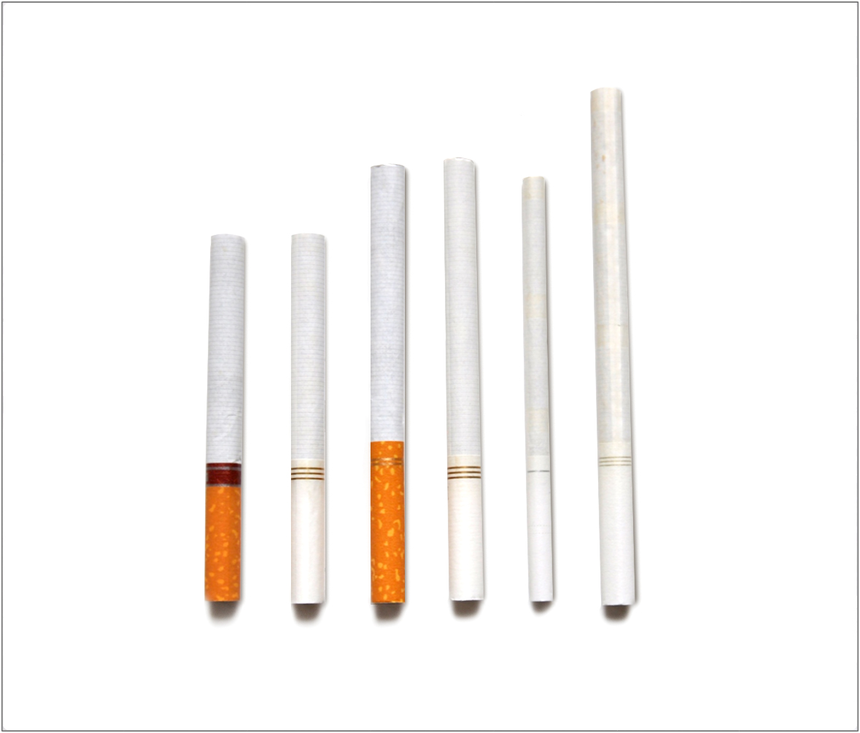
The next several questions are about smoking cigarettes (ones that have to be lit and burned). | - What is a “cigarette” in your own words?  - How is it different from other things a person could smoke?  - How did the definition in the questionnaire change how you think about what a cigarette is?  - How well did the description fit the images shown? To what extent did you use the images versus the description in order to understand what types of products it was asking about?
Have you ever smoked a cigarette, even one or two puffs?
- Yes
- No
[INTERVIEWER: CONTINUE BELOW FOR EVER CIGARETTE USERS. NEVER USERS SKIP TO PAGE X.]
Question Universe: ever cigarette smokers [known]
How old were you when you first smoked a cigarette, even one or two puffs?
- 8 years old or younger
- 9 years old
- 10 years old
- 11 years old
- 12 years old
- 13 years old
- 14 years old
- 15 years old
- 16 years old
- 17 years old
- 18 years old
- 19 years old or older
Question Universe: ever cigarette smokers [known]
About how many cigarettes have you smoked in your entire life?
- 1 or more puffs but never a whole cigarette
- 1 cigarette
- 2 to 5 cigarettes
- 6 to 15 cigarettes (about 1/2 a pack total)
- 16 to 25 cigarettes (about 1 pack total)
- 26 to 99 cigarettes (more than 1 pack, but less than 5 packs)
- 100 or more cigarettes (5 or more packs)
Question Universe: ever cigarette smokers [or unknown]  During the past 30 days, on how many days did you smoke cigarettes?  Specify: |__|__| (Range: 0 – 30) | - How easy or hard was it to answer with a specific number of days?
Question Universe: ever/current cigarette smokers [known]  When was the last time you smoked a cigarette, even one or two puffs? (Please choose the first answer that fits)  - Earlier today  - Not today but sometime during the past 7 days  - Not during the past 7 days but sometime during the past 30 days  - Not during the past 30 days but sometime during the past 6 months  - Not during the past 6 months but sometime during the past year  - 1 to 4 years ago  - 5 or more years ago | - How did you come up with your answer?
[INTERVIEWER: CONTINUE BELOW FOR PAST 30 DAY CIGARETTE USERS. EVER USERS SKIP TO PAGE X.]
Question Universe: past 30-day cigarette smokers [known]
During the past 30 days, on the days you smoked, about how many cigarettes did you smoke per day? A pack usually has 20 cigarettes in it.
- Less than 1 cigarette per day
- 1 cigarette per day
- 2 to 5 cigarettes per day
- 6 to 10 cigarettes per day
- 11 to 20 cigarettes per day
- More than 20 cigarettes per day
Question Universe: past 30-day cigarette smokers [known]
During the past 30 days, what brands of cigarettes did you smoke? (Select one or more)
- American Spirit
- Camel
- Eagle
- Kool
- Marlboro
- Maverick
- Newport
- L&M
- Pall Mall
- Winston
- Some other brand not listed here (Please specify: _____________________)
- Not sure / I don’t know the brand
Question Universe: past 30-day cigarette smokers reporting more than 1 brand [known]  During the past 30 days, what brand of cigarettes did you usually smoke? (Choose only one answer)  - I did not smoke a usual brand  - American Spirit  - Camel  - Eagle  - Kool  - Marlboro  - Maverick  - Newport  - L&M  - Pall Mall  - Winston  - Some other brand not listed here (Please specify): ________________________________________  - Not sure / I don’t know the brand | [IF R CHOOSES “NOT SURE” TO THIS QUESTION OR PREVIOUS]:  - Can you tell me more about why you weren’t sure about the brand?
Question Universe: past 30-day cigarette smokers [known]  Menthol cigarettes are cigarettes that taste like mint. During the past 30 days, were the cigarettes that you usually smoked menthol?  - Yes  - No  - Not sure | - Did you understand what we meant when we described menthol cigarettes as tasting like mint? Is there another way you would distinguish menthol from other cigarettes?  - In your own words, what does “usually smoked” mean here?
Question Universe: past 30-day cigarette smokers [known]
During the past 30 days, how did you get your cigarettes? (Select one or more)
- I bought them myself
- I had someone else buy them for me
- I asked someone to give me some
- Someone offered them to me
- I got them from a friend
- I got them from a family member
- I took them from a store or another person
- I got them in some other way (specify): _______________________________
Question Universe: past 30-day cigarette smokers [known]  During the past 30 days, where did you buy your cigarettes? (Select one or more)  - I did not buy cigarettes during the past 30 days à [EXCLUSIVE RESPONSE]  - I bought them from another person (a friend, family member, or someone else)  - A gas station or convenience store  - A grocery store  - A drugstore  - A mall or shopping center kiosk/stand  - A vending machine  - On the Internet (such as a product or store website, eBay or Facebook Marketplace)  - Through the mail  - Through a delivery service (such as DoorDash or Postmates)  - A vape shop or tobacco shop  - Some other place not listed here (specify): _________________________________ | - Were there any other places you’d want to buy them that weren’t listed?
Question Universe: past 30-day cigarette user (who got a product from someone else)
Earlier you mentioned that you got or bought your cigarettes from another person, such as a friend or family member during the past 30 days. How old was this person?
- Younger than 18 years old
- 18 years old
- 19 years old
- 20 years old
- 21 years old or older
- I don’t know
Question Universe: past 30-day users of cigarettes [known]  Are you seriously thinking about quitting cigarettes? (Please choose the first answer that fits)  - Yes, during the next 30 days  - Yes, during the next 6 months  - Yes, during the next 12 months  - Yes, but not during the next 12 months  - No, I am not thinking about quitting cigarettes | - How did you decide whether you’re “seriously thinking” about quitting?  - What does the phrase “seriously thinking” mean in your own words?
Question Universe: past 30-day users of cigarettes [known]  During the past 12 months, how many times have you stopped smoking cigarettes for one day or longer because you were trying to quit smoking cigarettes for good?  - I did not try to quit during the past 12 months  - 1 time  - 2 times  - 3 to 5 times  - 6 to 9 times  - 10 or more times | - How did you come up with your answer?  - What about the question was confusing?
[INTERVIEWER: CONTINUE BELOW FOR NEVER CIGARETTE SMOKERS. EVER SMOKERS SKIP TO PAGE X.]
Question Universe: never cigarette smokers [known]
Have you ever been curious about smoking a cigarette?
- Definitely yes
- Probably yes
- Probably not
- Definitely not
Question Universe: never cigarette smokers [known]
Do you think that you will try a cigarette soon?
- Definitely yes
- Probably yes
- Probably not
- Definitely not
Question Universe: never cigarette smokers [known]
Do you think you will smoke a cigarette in the next year?
- Definitely yes
- Probably yes
- Probably not
- Definitely not
Question Universe: never cigarette smokers [known]
If one of your best friends were to offer you a cigarette, would you smoke it?
- Definitely yes
- Probably yes
- Probably not
- Definitely not
Question Group Probes:
- In your own words, what’s the difference between “definitely yes/no” and “probably yes/no”?
- What else was confusing about the past few questions?
  - Cigars
The next several questions are about the use of cigars, cigarillos, or little cigars such as Swisher Sweets, Middleton’s (Black & Mild), Backwoods, Garcia y Vega, Cheyenne, White Owl, or Dutch Masters.  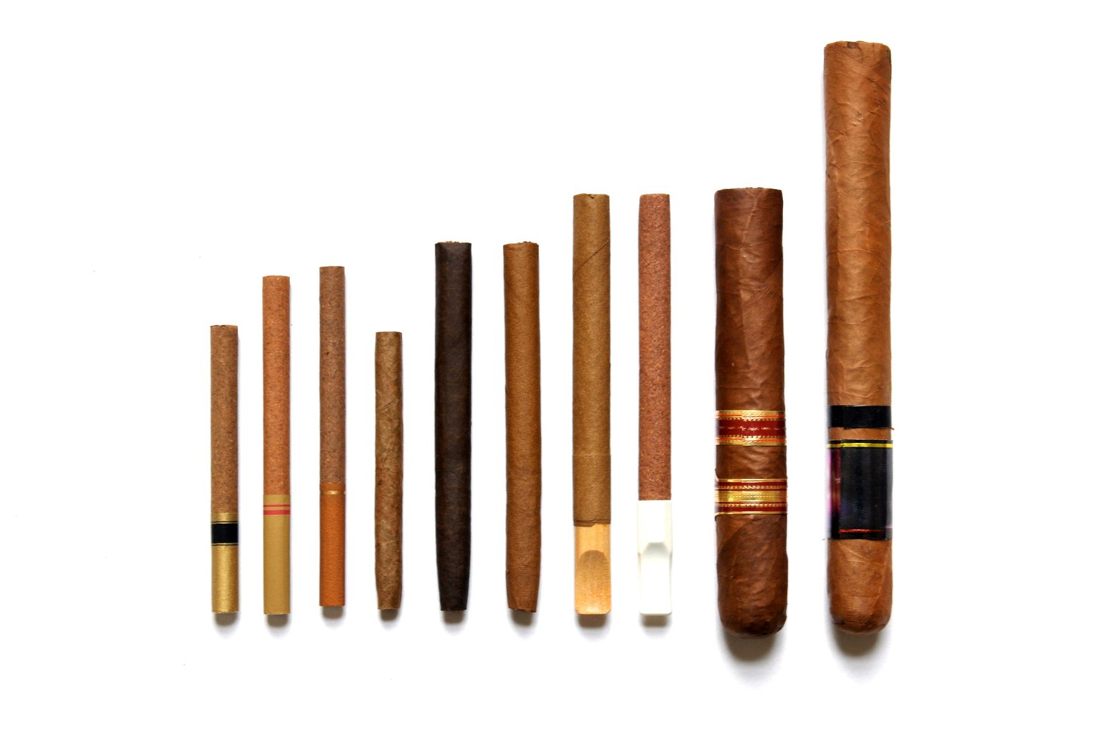 | - In your own words, how is a cigar different from a cigarette? How about a cigarillo or little cigar, how is that different from a cigarette? How is a cigar, cigarillos, or little cigar different from each other?  - How well did the description fit the images shown? To what extent did you use the images versus the description in order to understand what types of products it was asking about?
Have you ever smoked a cigar, cigarillo, or little cigar, even one or two puffs?
- Yes
- No
[INTERVIEWER: CONTINUE BELOW FOR EVER CIGAR SMOKERS. NEVER SMOKERS SKIP TO PAGE X.]
Question Universe: ever cigar smokers [known]
How old were you when you first smoked a cigar, cigarillo, or little cigar, even one or two puffs?
- 8 years old or younger
- 9 years old
- 10 years old
- 11 years old
- 12 years old
- 13 years old
- 14 years old
- 15 years old
- 16 years old
- 17 years old
- 18 years old
- 19 years old or older
Question Universe: ever cigar smokers [or unknown]  During the past 30 days, on how many days did you smoke cigars, cigarillos, or little cigars?  Specify: |__|__| (Range 0 – 30) | [IF NOT ALREADY PROBED]:  - How easy or hard was it to answer with a specific number of days?
[INTERVIEWER: CONTINUE BELOW FOR PAST 30 DAY CIGAR SMOKERS. EVER SMOKERS SKIP TO PAGE X.]
Question Universe: past 30-day cigar smokers [known]
During the past 30 days, on the days that you smoked, about how many cigars, cigarillos, or little cigars did you smoke per day?
- Less than 1 cigar, cigarillo, or little cigar per day
- 1 per day
- 2 to 5 per day
- 6 to 10 per day
- 11 to 20 per day
- More than 20 per day
Question Universe: past 30-day cigar smokers [known]  During the past 30 days, which of the following types of cigars have you smoked? (Select one or more)  - Regular cigars  - Cigarillos  - Little Cigars  - Don’t Know à [EXCLUSIVE] | How did you know the differences between these types of cigars?  [if select DK] – did you select this response because you didn’t know how these products were different? Or because you didn’t know what you smoked?
Question Universe: past 30-day cigar smokers [known]
During the past 30 days, what brands of cigars, cigarillos, or little cigars did you smoke? (Select one or more)
- Backwoods
- Cheyenne
- Dutch Masters
- Garcia Y Vega
- Middleton’s (including Black & Mild)
- Optimo
- Phillies
- Swisher Sweets
- White Owl
- Some other brand not listed here (specify): ____________________
- Not Sure / I don’t know the brand
Question Universe: past 30-day cigar user reporting >1 brand [known]
During the past 30 days, what brand of cigars, cigarillos, or little cigars did you usually use? (Choose only one answer)
- I did not use a usual brand
- Backwoods
- Cheyenne
- Dutch Masters
- Garcia Y Vega
- Middleton’s (including Black & Mild)
- Optimo
- Phillies
- Swisher Sweets
- White Owl
- Some other brand not listed here (specify): ____________________
- Not Sure / I don’t know the brand
Question Universe: past 30-day cigar user [known]  Were any of the cigars, cigarillos, or little cigars that you used in the past 30 days flavored to taste like menthol, mint, clove or spice, alcoholic drinks, candy, fruit, chocolate, or any other non-tobacco flavor?  Do not think about tobacco flavor when answering this question.  - Yes  - No  - Don’t Know | What does “non-tobacco flavor” mean to you in this question? What does “tobacco flavor” mean?  Would you have answered differently if it didn’t say “Do not think about tobacco flavor when answering this question?
Question Universe: past 30-day e-cigarette user [known]  Were any of the cigars, cigarillos, or little cigars that you used in the past 30 days flavored to taste like tobacco?  - Yes  - No  - Don’t Know | What does “flavored to taste like tobacco” mean to you?  Did you think about added artificial flavorings, naturally occurring tobacco flavor, or both?
Question Universe: past 30-day users of flavored cigars  What flavors were the cigars, cigarillos, or little cigars that you have used in the past 30 days? (Select one or more)  - Tobacco-flavor  - Menthol  - Mint  - Spice (such as cinnamon, vanilla, or clove)  - Fruit  - Chocolate  - Alcoholic drinks (such as wine, margarita, or other cocktails)  - Non-alcoholic drinks (such as coffee, soda, lemonade, or other beverage)  - Candy, desserts, or other sweets  - Some other flavor not listed here (Specify: _____________________________) | What do you think of the answer choices?  What’s the difference between menthol and mint?
Question Universe: past 30-day user of flavored cigars  Did any of the flavors that you used in the past 30 days have names or descriptions that included the word “ice” or “iced” (for example, blueberry ice or strawberry ice)?  - Yes  - No  - Don’t know | Have you ever heard of “iced” flavors?  Was anything about this question confusing?
Question Universe: past 30-day user of flavored cigars  Did any of the flavors that you used in the past 30 days have a name that did not describe a specific flavor, such as “solar,” “purple,” “jazz,” “island bash,” “fusion” or some other word or phrase?  - Yes (specify): ___________________  - No  - Don’t know | - Was anything about this question confusing?  - Would you describe these flavors any differently?  - Are any example words (e.g., jazz) missing?
Question Universe: past 30-day cigar smokers [known]
During the past 30 days, how did you get your cigars, cigarillos, or little cigars? (Select one or more)
- I bought them myself
- I had someone else buy them for me
- I asked someone to give me some
- Someone offered them to me
- I got them from a friend
- I got them from a family member
- I took them from a store or another person
- I got them in some other way (specify: ___________________________________)
Question Universe: past 30-day cigar smokers [known]
During the past 30 days, where did you buy your cigars, cigarillos, or little cigars? (Select one or more)
- I did not buy cigars, cigarillos, or little cigars during the past 30 days à [EXCLUSIVE RESPONSE]
- I bought them from another person (a friend, family member, or someone else)
- A gas station or convenience store
- A grocery store
- A drugstore
- A mall or shopping center kiosk/stand
- A vending machine
- On the Internet (such as a product or store website, eBay, or Facebook Marketplace)
- Through the mail
- Through a delivery service (such as DoorDash or Postmates)
- A vape shop or tobacco shop
- Some other place not listed here (specify): ________________________________
Question Universe: past 30-day cigar user (who got a product from someone else)
Earlier you mentioned that you got or bought your cigars, cigarillos, or little cigars from another person, such as a friend or family member during the past 30 days. How old was this person?
- Younger than 18 years old
- 18 years old
- 19 years old
- 20 years old
- 21 years old or older
- I don’t know
Question Group Probes:
- Can you describe the type or brand of cigar or thing you were smoking? What else would you call it?
- [IF NOT ALREADY PROBED]: How easy or hard was it to remember your specific experiences, like flavors and where you got your products from?
[INTERVIEWER: CONTINUE BELOW FOR NEVER CIGAR SMOKERS. EVER SMOKERS SKIP TO PAGE X.]
Question Universe: never cigar smokers [known]
Have you ever been curious about smoking a cigar, cigarillo, or little cigar?
- Definitely yes
- Probably yes
- Probably not
- Definitely not
Question Universe: never cigar smokers [known]
Do you think you will try a cigar, cigarillo, or little cigar soon?
- Definitely yes
- Probably yes
- Probably not
- Definitely not
Question Universe: never cigar smokers [known]
Do you think you will smoke a cigar, cigarillo, or little cigar in the next year?
- Definitely yes
- Probably yes
- Probably not
- Definitely not
Question Universe: never cigar smokers [known]
If one of your best friends were to offer you a cigar, cigarillo, or little cigar, would you smoke it?
- Definitely yes
- Probably yes
- Probably not
- Definitely not
Question Group Probes:
- IF NOT PROBED ALREADY: In your own words, what is the difference between “definitely yes/no” and “probably yes/no”?

Marijuana Cigars
The next question asks about marijuana use in cigars, cigarillos, or little cigars. Sometimes people take the tobacco out of a cigar, cigarillo, or little cigar and replace it with marijuana (also called pot, weed, or cannabis). This is sometimes called a blunt.
Have you ever smoked part or all a cigar, cigarillo, or little cigar with marijuana in it?  - Yes  - No | - If yes: Did you include those when answering the questions about cigars in the last section? Do you also use tobacco/nicotine-only cigars? Which do you use more often?
Question Group Probes:
- Before today had you heard about marijuana being used or smoked in cigars, cigarillos, or little cigars?
- Have you ever heard the term, “blunt”?
- How would you describe this kind of cigar in your own words?
- To what extent are you comfortable responding to questions about marijuana use?
- To what extent do you think people will respond honestly to questions about marijuana use?

Hookah
The next several questions are about smoking tobacco in a hookah, which is a type of waterpipe. Shisha (or hookah tobacco) is smoked in a hookah.  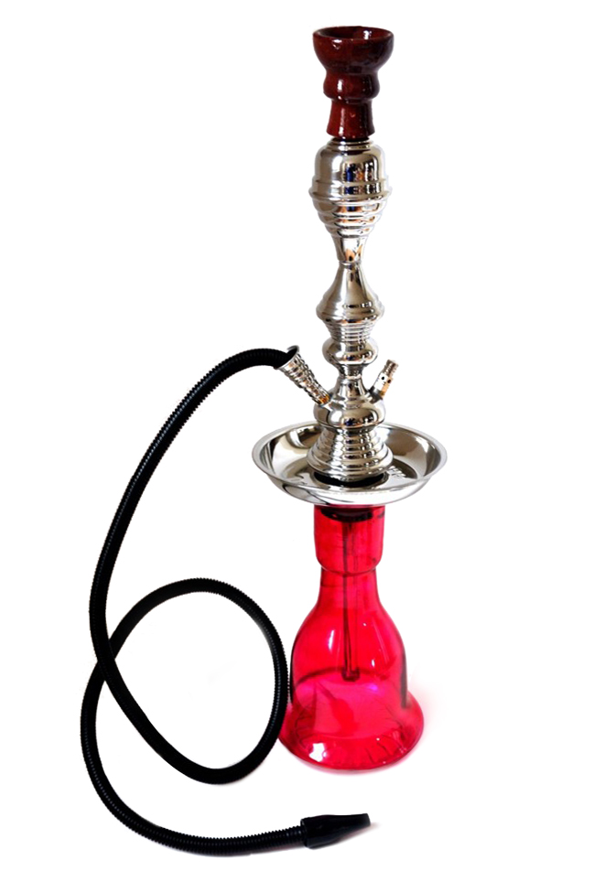 | GOAL: Ensure they know what hookah is.  - Before today had you heard of the term hookah?  - How would you describe a water pipe?  - How well did the description fit the images shown? To what extent did you use the images versus the description in order to understand what types of products it was asking about?
Have you ever smoked tobacco in a hookah or waterpipe, even one or two puffs?
- Yes
- No
[INTERVIEWER: CONTINUE BELOW FOR EVER HOOKAH USERS. NEVER USERS SKIP TO PAGE X.]
Question Universe: ever hookah users [known]
How old were you when you first smoked tobacco in a hookah or waterpipe, even one or two puffs?
- 8 years old or younger
- 9 years old
- 10 years old
- 11 years old
- 12 years old
- 13 years old
- 14 years old
- 15 years old
- 16 years old
- 17 years old
- 18 years old
- 19 years old or older
Question Universe: ever hookah users [or unknown]  During the past 30 days, on how many days did you smoke tobacco in a hookah or waterpipe?  Specify: |__|__| (Range 0 – 30) | [IF NOT ALREADY PROBED]:  - How easy or hard was it to answer with a specific number of days?
[INTERVIEWER: CONTINUE BELOW FOR PAST 30 DAY HOOKAH USERS. EVER USERS SKIP TO PAGE X.]
Question Universe: past 30-day hookah users [known]
During the past 30 days, where did you smoke tobacco in a hookah or waterpipe? (Select one or more)
- At my house
- At a friend’s house
- At a family member’s house, other than my house
- At a hookah bar
- At a café or restaurant
- Some other place not listed here
Question Universe: past 30-day hookah user [known]
Was any of the tobacco in a hookah or waterpipe that you used in the past 30 days flavored to taste like menthol, mint, clove or spice, alcoholic drinks, candy, fruit, chocolate, or any other non-tobacco flavor?
Do not think about tobacco flavor when answering this question.
- Yes
- No
- Don’t Know
Question Universe: past 30-day hookah user [known]
Was any of the tobacco in a hookah or waterpipe that you used in the past 30 days flavored to taste like tobacco?
- Yes
- No
- Don’t Know
Question Universe: past 30-day users of flavored hookah tobacco
What flavors was the tobacco in a hookah or waterpipe that you have used in the past 30 days? (Select one or more)
- Tobacco-flavor
- Menthol
- Mint
- Spice (such as cinnamon, vanilla, or clove)
- Fruit
- Chocolate
- Alcoholic drinks (such as wine, margarita, or other cocktails)
- Non-alcoholic drinks (such as coffee, soda, lemonade, or other beverage)

- Candy, desserts, or other sweets
- Some other flavor not listed here (Specify: _____________________________)
Question Universe: past 30-day hookah user [known]
During the past 30 days, how did you get your hookah tobacco? (Select one or more)
- I bought it myself
- I had someone else buy it for me
- I asked someone to give me some
- Someone offered it to me
- I got it from a friend
- I got it from a family member
- I took it from a store or another person
- I got it in some other way (Specify): _________________________________
Question Universe: past 30-day hookah user [known]
During the past 30 days, where did you buy your hookah tobacco? (Select one or more)
- I did not buy hookah tobacco during the past 30 days à [EXCLUSIVE RESPONSE]
- I bought it from another person (a friend, family member, or someone else)
- A gas station or convenience store
- A grocery store
- A drugstore
- A mall or shopping center kiosk/stand
- A vending machine
- On the Internet (such as a product or store website, eBay, or Facebook Marketplace)
- Through the mail
- Through a delivery service (such as DoorDash or Postmates)
- A vape shop or tobacco shop
- Some other place not listed here (Specify): ________________________________
Question Universe: past 30-day hookah user (who got a product from someone else)
Earlier you mentioned that you got or bought your hookah tobacco from another person, such as a friend or family member. How old was this person?
- Younger than 18 years old
- 18 years old
- 19 years old
- 20 years old
- 21 years old or older
- I don’t know
Question Group Probes:
- [IF NOT ALREADY PROBED]: How easy or hard was it to remember your specific experiences, like flavors and where you got your products from?
INTERVIEWER: CONTINUE BELOW FOR NEVER HOOKAH USERS. CURRENT USERS SKIP TO PAGE X.
Question Universe: never hookah users [known]
Have you ever been curious about smoking tobacco in a hookah or waterpipe?
- Definitely yes
- Probably yes
- Probably not
- Definitely not
Question Group Probes:
- IF NOT PROBED ALREADY: In your own words, what is the difference between “definitely yes/no” and “probably yes/no”?
  - Roll-your-own Cigarettes
The next few questions are about roll-your-own cigarettes.  Do not think about manufactured cigarettes when answering these questions. | - In your own words, what is this definition saying? What kinds of cigarettes should you include or exclude?  - How well did the description fit the images shown? To what extent did you use the images versus the description in order to understand what types of products it was asking about?
Have you ever smoked roll-your-own cigarettes, even just one time?
- Yes
- No
[INTERVIEWER: CONTINUE BELOW FOR EVER ROLL-YOUR-OWN USERS. NEVER USERS SKIP TO PAGE X.]
Question Universe: ever users of roll-your-own tobacco products [or unknown]  During the past 30 days, on how many days did you smoke roll-your-own cigarettes?  Specify: |__|__| (Range 0 – 30) | [IF NOT PROBED ALREADY]:  - How easy or hard was it to answer with a specific number of days?
[INTERVIEWER: CONTINUE BELOW FOR PAST 30 DAY ROLL-YOUR-OWN USERS. EVER USERS SKIP TO PAGE X.]
Question Universe: past 30-day roll-your-own user [known]
Were any of the roll-your-own cigarettes that you used in the past 30 days flavored to taste like menthol, mint, clove or spice, alcoholic drinks, candy, fruit, chocolate, or any other non-tobacco flavor?
Do not think about tobacco flavor when answering this question.
- Yes
- No
- Don’t Know
Question Universe: past 30-day roll-your-own user [known]
Were any of the roll-your-own cigarettes that you used in the past 30 days flavored to taste like tobacco?
- Yes
- No
- Don’t Know

Question Universe: past 30-day users of flavored roll-your-own cigarettes
What flavors were the roll-your-own cigarettes that you have used in the past 30 days? (Select one or more)
- Tobacco-flavor
- Menthol
- Mint
- Spice (such as cinnamon, vanilla, or clove)
- Fruit
- Chocolate
- Alcoholic drinks (such as wine, margarita, or other cocktails)
- Non-alcoholic drinks (such as coffee, soda, lemonade, or other beverage)
- Candy, desserts, or other sweets
- Some other flavor not listed here (Specify: _____________________________)
Question Universe: past 30-day roll-your-own user [known]
During the past 30 days, how did you get your roll-your-own cigarettes? (Select one or more)
- I bought them myself
- I had someone else buy them for me
- I asked someone to give me some
- Someone offered them to me
- I got them from a friend
- I got them from a family member
- I took them from a store or another person
- I got them in some other way (specify: _______________________________)
Question Universe: past 30-day roll-your-own user [known]  During the past 30 days, where did you buy your roll-your-own cigarettes? (Select one or more)  - I did not buy roll-your-own cigarettes during the past 30 days à [EXCLUSIVE RESPONSE]  - I bought them from another person (a friend, family member, or someone else)  - A gas station or convenience store  - A grocery store  - A drugstore  - A mall or shopping center kiosk/stand  - A vending machine  - On the Internet (such as a product or store website, eBay, or Facebook Marketplace)  - Through the mail  - Through a delivery service (such as DoorDash or Postmates)  - A vape shop or tobacco shop  - Some other place not listed here (specify): ________________________________ | - In your own words, what does it mean to “buy your roll-your-own cigarettes”?
Question Group Probes:
- Can you describe the roll-your-own cigarettes you’ve used? What else would you call it?
- How easy or hard was it to remember your specific experiences, like flavors and where you got your products from?
  - Pipe Tobacco
The next few questions are about smoking tobacco in a pipe.  Do not think about smoking tobacco in a hookah (waterpipe) when answering these questions.  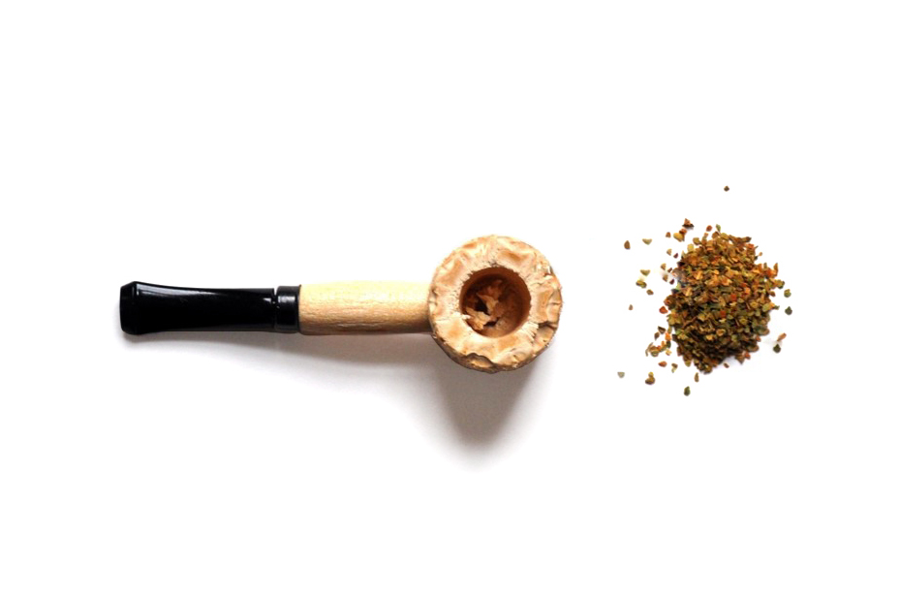 | - In your own words, what is this definition asking you to include or exclude?  - Have you had any pipe smoking experiences you weren’t sure whether should be included or excluded?  - How well did the description fit the images shown? To what extent did you use the images versus the description in order to understand what types of products it was asking about?
Have you ever smoked pipes filled with tobacco (not hookah or waterpipe), even just one time?  - Yes  - No | - In your own words, what does “filled with tobacco mean? All tobacco? Some tobacco? Did you include any pipes you smoked that were filled with tobacco and something else?
[INTERVIEWER: CONTINUE BELOW FOR EVER PIPE USERS. NEVER USERS SKIP TO PAGE X.]
Question Universe: ever users of pipes [or unknown]  During the past 30 days, on how many days did you smoke pipes filled with tobacco?  Specify: |__|__| (Range 0 – 30) | [IF NOT PROBED ALREADY]:  - How easy or hard was it to answer with a specific number of days?
[INTERVIEWER: CONTINUE BELOW FOR PAST 30 DAY PIPE USERS. EVER USERS SKIP TO PAGE X.]
Question Universe: past 30-day pipe tobacco user [known]
Were any of the pipes filled with tobacco that you used in the past 30 days flavored to taste like menthol, mint, clove or spice, alcoholic drinks, candy, fruit, chocolate, or any other non-tobacco flavor?
Do not think about tobacco flavor when answer this question.
- Yes
- No
- Don’t Know
Question Universe: past 30-day pipe tobacco user [known]
Were any of the pipes filled with tobacco that you used in the past 30 days flavored to taste like tobacco?
- Yes
- No
- Don’t Know

Question Universe: past 30-day users of flavored pipe tobacco
What flavors were the pipes filled with tobacco that you have used in the past 30 days? (Select one or more)
- Tobacco-flavor
- Menthol
- Mint
- Spice (such as cinnamon, vanilla, or clove)
- Fruit
- Chocolate
- Alcoholic drinks (such as wine, margarita, or other cocktails)
- Non-alcoholic drinks (such as coffee, soda, lemonade, or other beverage)
- Candy, desserts, or other sweets
- Some other flavor not listed here (Specify: _____________________________)
Question Universe: past 30-day pipe tobacco user [known]
During the past 30 days, how did you get your pipe tobacco? (Select one or more)
- I bought it myself
- I had someone else buy it for me
- I asked someone to give me some
- Someone offered it to me
- I got it from a friend
- I got it from a family member
- I took it from a store or another person
- I got it in some other way (specify: ___________________________________)
Question Universe: past 30-day pipe tobacco user [known]
During the past 30 days, where did you buy your pipe tobacco? (Select one or more)
- I did not buy pipe tobacco during the past 30 days à [EXCLUSIVE RESPONSE]
- I bought it from another person (a friend, family member, or someone else)
- A gas station or convenience store
- A grocery store
- A drugstore
- A mall or shopping center kiosk/stand
- A vending machine
- On the Internet (such as a product or store website, eBay, or Facebook Marketplace)
- Through the mail
- Through a delivery service (such as DoorDash or Postmates)
- A vape shop or tobacco shop
- Some other place not listed here (specify): _________________________________
Question Group Probes:
- Can you describe the pipes you’ve used? What else would you call it?
- [IF NOT ALREADY PROBED]: How easy or hard was it to remember your specific experiences, like flavors and where you got your products from?
  - Bidis
The next several sections of questions ask about your use of particular kinds of tobacco products, such as e-cigarettes, cigarettes, cigars, smokeless tobacco, hookahs, roll-your own-cigarettes, pipes, snus, dissolvable tobacco, bidis, heated tobacco products, and nicotine pouches.

At the beginning of each section, you will see a brief description and an image showing examples of each kind of tobacco product.

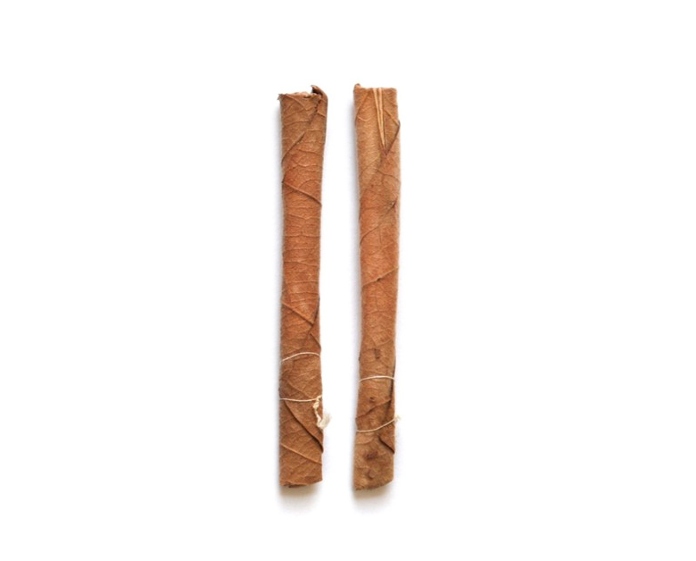
The next few questions are about bidis. Bidis are small brown cigarettes wrapped in a leaf that are typically tied on one or both ends with a string. | - In your own words, what is a bidi?  - How is a bidi different from a cigarette in your mind?  - How well did the description fit the images shown? To what extent did you use the images versus the description in order to understand what types of products it was asking about?
Have you ever smoked bidis, even just one time?
- Yes
- No
[INTERVIEWER: EVER BIDI SMOKERS CONTINUE BELOW. NEVER SMOKERS SKIP TO PAGE X.]
Question Universe: ever users of bidis [or unknown]  During the past 30 days, on how many days did you smoke bidis?  Specify: |__|__| (Range 0 – 30) | - How easy or hard was it to count the number of days?
[INTERVIEWER: PAST 30 DAY BIDI SMOKERS CONTINUE BELOW. EVER SMOKERS SKIP TO PAGE X.]
Question Universe: past 30-day bidis user [known]
Were any of the bidis that you used in the past 30 days flavored to taste like menthol, mint, clove or spice, alcoholic drinks, candy, fruit, chocolate or any other non-tobacco flavor?
- Yes
- No
- Don’t Know
Question Universe: past 30-day bidis user [known]
Were any of the bidis that you used in the past 30 days flavored to taste like tobacco?
- Yes
- No
- Don’t Know

Question Universe: past 30-day users of flavored bidis
What flavors were the bidis that you have used in the past 30 days? (Select one or more)
- Tobacco-flavor
- Menthol
- Mint
- Spice (such as cinnamon, vanilla, or clove)
- Fruit
- Chocolate
- Alcoholic drinks (such as wine, margarita, or other cocktails)
- Non-alcoholic drinks (such as coffee, soda, lemonade, or other beverages)
- Candy, desserts, or other sweets
- Some other flavor not listed here (Specify): _________________________
Question Universe: past 30-day bidis user [known]
During the past 30 days, how did you get your bidis? (Select one or more)
- I bought them myself
- I had someone else buy them for me
- I asked someone to give me some
- Someone offered them to me
- I got them from a friend
- I got them from a family member
- I took them from a store or another person
- I got them in some other way (Specify): ____________________________
Question Universe: past 30-day bidis user [known]
During the past 30 days, where did you buy your bidis? (Select one or more)
- I did not buy bidis during the past 30 days à [EXCLUSIVE RESPONSE]
- I bought them from another person (a friend, family member, or someone else)
- A gas station or convenience store
- A grocery store
- A drugstore
- A mall or shopping center kiosk/stand
- A vending machine
- On the Internet (such as a product or store website, eBay, or Facebook Marketplace)
- Through the mail
- Through a delivery service (such as DoorDash or Postmates)
- A vape shop or tobacco shop
- Some other place not listed here (Specify): ___________________________
Question Group Probes:
- Can you describe the bidis you’ve used? What else would you call it?
- [IF NOT ALREADY PROBED]: How easy or hard was it to remember your specific experiences, like flavors and where you got your products from?
  - Opinions on Tobacco (A)
The next 9 questions ask about your thoughts on tobacco products.
How much do you think people harm themselves when they smoke cigarettes some days but not every day?
- No harm
- Little harm
- Some harm
- A lot of harm
How much do you think people harm themselves when they smoke cigars, cigarillos, or little cigars, some days but not every day?
- No harm
- Little harm
- Some harm
- A lot of harm
Do you believe that cigars, cigarillos, or little cigars are less addictive, equally addictive, or more addictive than cigarettes?
- Less addictive
- Equally addictive
- More addictive
- I have never heard of cigars, cigarillos, or little cigars
- I don’t know enough about these products
How much do you think people harm themselves when they use chewing tobacco, snuff, dip or snus, some days but not every day?  - No harm  - Little harm  - Some harm  - A lot of harm | For this question, did you think about each of these products, individually, or collectively? Would your answer have changed if we asked about each product separately?
Do you believe that chewing tobacco, snuff, dip or snus are (LESS ADDICTIVE, EQUALLY ADDICTIVE, or MORE ADDICTIVE) than cigarettes?  - Less addictive  - Equally addictive  - More addictive  - I have never heard of chewing tobacco, snuff, dip or snus  - I don’t know enough about these products | For this question, did you think about each of these products, individually, or collectively?  Would your answer have changed if we asked about each product separately?
Question Universe: all students  How much do you think people harm themselves when they use nicotine pouches or other oral nicotine products some days but not every day?  - No harm  - Little harm  - Some harm  - A lot of harm | For this question, did you think about each of these products, individually, or collectively? Would your answer have changed if we asked about each product separately?
Question Universe: all students  Do you believe that nicotine pouches or other oral nicotine products are (LESS ADDICTIVE, EQUALLY ADDICTIVE, or MORE ADDICTIVE) than cigarettes?  - Less addictive  - Equally addictive  - More addictive  - I have never heard of nicotine pouches or other oral nicotine products  - I don’t know enough about these products | For this question, did you think about each of these products, individually, or collectively? Would your answer have changed if we asked about each product separately?
How much do you think people harm themselves when they use e-cigarettes some days but not every day?

- No harm
- Little harm
- Some harm
- A lot of harm
Do you believe that e-cigarettes are (LESS ADDICTIVE, EQUALLY ADDICTIVE, or MORE ADDICTIVE) than cigarettes?

- Less addictive
- Equally addictive
- More addictive
- I have never heard of e-cigarettes
- I don’t know enough about these products
How much do you think people harm themselves when they smoke tobacco in a hookah or waterpipe some days but not every day?

- No harm
- Little harm
- Some harm
- A lot of harm
Do you believe that smoking tobacco in a hookah or waterpipe is (LESS ADDICTIVE, EQUALLY ADDICTIVE, or MORE ADDICTIVE) than cigarettes?

- Less addictive
- Equally addictive
- More addictive
- I have never heard of smoking tobacco in a hookah or waterpipe
- I don’t know enough about these products
Question Group Probes:
- What did “some days but not every day” mean in your own words?
- What kind of harm were you thinking about?
- IF R CHOSES “I DON’T KNOW ENOUGH”: What did you think this question was asking?
- Did you notice that some questions ask about “believe” instead of “think”? In your own words what’s the difference? Would it change your answer?

Adolescent Discrimination Distress Index
After each statement, tell us whether you have experienced each of the following types of discrimination because of your race or ethnicity. Remember we are only interested in occasions when racial-ethnic discrimination was at least partly responsible for your experience.  Response options: Yes, No  - You were discouraged from joining an advanced level class.  - You were wrongly disciplined or given after-school detention.  - You were given a lower grade than you deserved.  - You were discouraged from joining a club.  - Others your age did not include you in their activities.  - People expected more of you than they expected of others your age.  - People expected less of you than they expected of others your age.  - People assumed your English was poor.  - You were hassled by police.  - You were hassled by a store clerk or store guard.  - You were called racially insulting names.  - You received poor service at a restaurant or store.  - People acted as if they thought you were not smart.  - People acted as if they were afraid of you.  - You were threatened. | - Did you understand what racial-ethnic discrimination is?  - How comfortable were you answering these questions?  - Did the instructions, questions, and response options match in your mind? Anything confusing about the instructions? Do you think they are needed or could be changed in any way? Longer? Shorter?  - Which of the specific questions are worded in a confusing way or were hard to answer?
If you had this experience, did it upset you?  Response options: Not at all, Slightly, Moderately, Considerably, Extremely  - You were discouraged from joining an advanced level class.  - You were wrongly disciplined or given after-school detention.  - You were given a lower grade than you deserved.  - You were discouraged from joining a club.  - Others your age did not include you in their activities.  - People expected more of you than they expected of others your age.  - People expected less of you than they expected of others your age.  - People assumed your English was poor.  - You were hassled by police.  - You were hassled by a store clerk or store guard.  - You were called racially insulting names.  - You received poor service at a restaurant or store.  - People acted as if they thought you were not smart.  - People acted as if they were afraid of you.  - You were threatened. | - What did “being upset” mean to you?  - IF R CHOSE “MODERATELY”, “CONSIDERABLY,” OR “EXTREMELY”: How did you choose between your answer and one of the other options next to it?
  - Tobacco Exposure
The next four questions ask about you being around other people’s tobacco smoke.
Do not include exposure to vapor from e-cigarettes.
During the past 7 days, on how many days did someone smoke tobacco products in your home while you were there?  - 0 days  - 1 day  - 2 days  - 3 days  - 4 days  - 5 days  - 6 days  - 7 days | [IF MORE THAN 0]:  - How easy or hard was it to remember the number of days?  - How confident do you feel about your answer?  - Were you thinking only about people who live in your home, or visitors as well?
During the past 7 days, on how many days did you ride in a vehicle when someone was smoking a tobacco product?  - 0 days  - 1 day  - 2 days  - 3 days  - 4 days  - 5 days  - 6 days  - 7 days | [IF MORE THAN 0 AND NOT PROBED ABOVE]:  - How easy or hard was it to remember the number of days?  [IF NOT PROBED ABOVE]:  - How confident do you feel about your answer?
During the past 30 days, on how many days were you exposed to the smoke from someone who was smoking tobacco products in an indoor public place? Examples of indoor public places are school buildings, stores, restaurants, and sports arenas. Do not think about homes when answering this question.  - 0 days  - 1 or 2 days  - 3 to 5 days  - 6 to 9 days  - 10 to 19 days  - 20 to 29 days  - All 30 days | - What kinds of places did you think about when answering this question?  - Did you know what we meant when we asked about being “exposed” to smoke? How did you determine if you were “exposed” to smoke? What did this mean to you?
During the past 30 days, on how many days were you exposed to the smoke from someone who was smoking tobacco products in an outdoor public place? Examples of outdoor public places are school grounds, sidewalks, parking lots, stadiums, and parks.  - 0 days  - 1 or 2 days  - 3 to 5 days  - 6 to 9 days  - 10 to 19 days  - 20 to 29 days  - All 30 days | - In your own words, how is this question different from the last one?  - What kinds of places did you think about when answering this question?
Question Group Probes:
- At the beginning of this section, it said, “Do not include exposure to vapor from e-cigarettes.” How easy or hard was it to separate tobacco smoke from e-cigarette vapor for these questions? Are you usually aware of the difference?
- Would you change your answers now that you’ve had a chance to think about it?
The next five questions ask about being around other people’s e-cigarette vapor.
Do not include exposure to smoke from cigarettes or other tobacco products.
During the past 7 days, on how many days did someone use e-cigarettes in your home while you were there?
- 0 days
- 1 day
- 2 days
- 3 days
- 4 days
- 5 days
- 6 days
- 7 days

During the past 7 days, on how many days did you ride in a vehicle when someone was using an e-cigarette?

- 0 days
- 1 day
- 2 days
- 3 days
- 4 days
- 5 days
- 6 days
- 7 days
During the past 30 days, on how many days were you exposed to the vapor from someone who was using an e-cigarette in an indoor public place? Examples of indoor public places are school buildings, stores, restaurants, and sports arenas. Do not think about homes when answering this question.  - 0 days  - 1 or 2 days  - 3 to 5 days  - 6 to 9 days  - 10 to 19 days  - 20 to 29 days  - All 30 days | How did you determine if you were “exposed” to vapor from someone’s e-cigarette? What did this mean to you?
During the past 30 days, on how many days were you exposed to the vapor from someone who was using an e-cigarette in an outdoor public place? Examples of outdoor public places are school grounds, sidewalks, parking lots, stadiums, and parks.
- 0 days
- 1 or 2 days
- 3 to 5 days
- 6 to 9 days
- 10 to 19 days
- 20 to 29 days
- All 30 days
While at school or on school property, have you ever seen anyone using an e-cigarette, such as JUUL, Vuse, NJOY, Puff Bar, blu, or Bidi Stick in any of the following locations? (Select one or more)  - Yes, inside a school bathroom or locker room  - Yes, inside a classroom  - Yes, inside some other area of the school (hallway, cafeteria)  - Yes, outside of the school, such as in the parking lot, sidewalk, sports field, or other school grounds  - Yes, somewhere else not listed here [Specify): _______________________  - No à [EXCLUSIVE] | [IF YES]:  - How easy or hard was it to remember where you saw someone using an e-cigarette?  - For those answering “somewhere else” – what types of locations were you thinking about?  - Was it clear that we wanted to know experiences on school property, only?
Question Group Probes:
- [IF NOT PROBED ABOVE]: At the beginning of this section, it said “Do not include exposure to smoke from cigarettes or other tobacco products.” How easy or hard was it to separate tobacco smoke from e-cigarette vapor for these questions? Are you usually aware of the difference?

NYTS Interviewer Guide – Item Set 3 (Demographics, Antitobacco Messaging, Exposure, and Environment)
Instructions:
- Introduce yourself and ensure that tech is working; respondent should be able to access the web survey and share their screen.
- Briefly discuss the goal of the larger survey and the goal of this interview (i.e., to understand how easy or hard these questions are to answer)
- This is YOUR interview. YOUR chance to give important feedback so kids like you can have a better survey experience.
- Remind the student of consent highlights:
- If possible, take the survey in a private location, away from other family members or your parents.
- Information will not be shared and is only used internally without your name and personal information
- You can skip any question. But, if you feel the question is so uncomfortable that you want to skip it, I’ll ask you why you feel that way.
- The interview will be recorded, and we will take notes.
- Explain process.
- Read each question to yourself and answer it through the web survey.
- Pause when you see a stop sign in the survey and I’ll ask you some questions about how you answered.
- There are no wrong answers to any of the questions you will see. In fact, we aren’t going to use the answers you provide in any way. We are more interested in what you think of the questions and response choices you will see. We want your honest feedback about what you think about these questions and response choices. We didn’t write any of these questions so nothing you say about them will bother us.
- Jump in with comments as you’re trying to answer.
- Start with a practice question to make sure they understand how probes work.
- Avoid use or reference to the National Youth Tobacco Survey or NYTS to minimize the introduction of bias.

Generic probes (use these when the respondent hesitates or appears confused about an item):
- In your own words, what is this question asking?
- Are there any unfamiliar or confusing words in this question?
- How sure are you about your answer? Why?
- How do you think we could make this question less confusing or easier to understand?
- Did anything about this question uncertain or uncomfortable?
  - If so, what is it?
  - If so, do you think others would not want to respond honestly to this question?

Question/Screen (verbatim from NYTS interview) | Question-specific Probes (if required) |  | Notes (for interviewer use)
  - Chewing Tobacco, Snuff, or Dip
The next several sections of questions ask about your use of particular kinds of tobacco products, such as e-cigarettes, cigarettes, cigars, smokeless tobacco, hookahs, roll-your own-cigarettes, pipes, snus, dissolvable tobacco, bidis, heated tobacco products, and nicotine pouches.

At the beginning of each section, you will see a brief description and an image showing examples of each kind of tobacco product.
The next several questions are about the use of chewing tobacco, snuff, or dip, such as Copenhagen, Grizzly, Skoal, or Red Seal.  Do not think about snus or dissolvable tobacco products when you answer these questions.  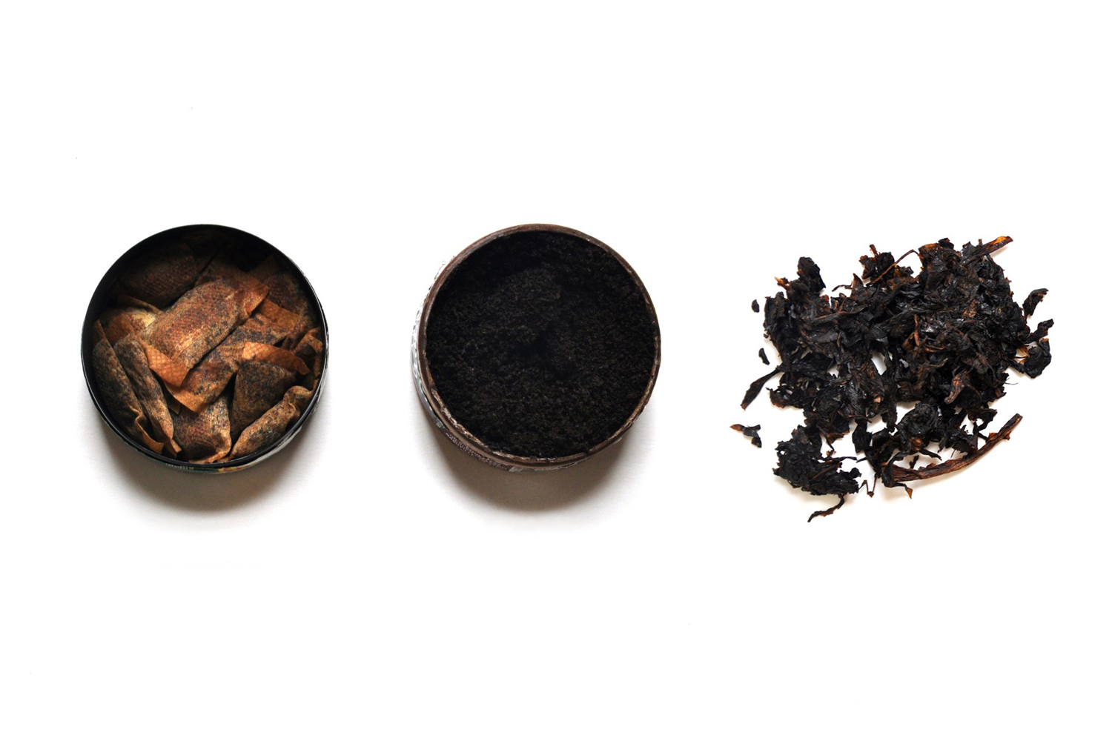 | - In your own words, what is chewing tobacco? What is snuff? What is dip?  - Have you heard of any of the brands mentioned in the description? Which one(s)?  - How well did the description fit the images shown? To what extent did you use the images versus the description in order to understand what types of products it was asking about?
Have you ever used chewing tobacco, snuff, or dip, even just a small amount?
- Yes
- No
[INTERVIEWER: CONTINUE BELOW FOR EVER CHEWING TOBACCO USERS. NEVER USERS SKIP TO PAGE X.]
Question Universe: ever smokeless tobacco users [known]
How old were you when you first used chewing tobacco, snuff, or dip, even just a small amount?
- 8 years old or younger
- 9 years old
- 10 years old
- 11 years old
- 12 years old
- 13 years old
- 14 years old
- 15 years old
- 16 years old
- 17 years old
- 18 years old
- 19 years old or older
Question Universe: ever smokeless tobacco users [or unknown]  During the past 30 days, on how many days did you use chewing tobacco, snuff, or dip?  Specify: |__|__| (Range 0 – 30) | [IF NOT ALREADY PROBED]:  - How easy or hard was it to answer with a specific number of days?
[INTERVIEWER: CONTINUE BELOW FOR PAST 30 DAY CHEWING TOBACCO USERS. EVER USERS SKIP TO PAGE X.]
Question Universe: ever smokeless tobacco users [known]
During the past 30 days, what brands of chewing tobacco, snuff, or dip did you use? (Select one or more)
- Copenhagen
- Grizzly
- Kodiak
- Longhorn
- Red Man
- Red Seal
- Skoal
- Timber Wolf
- Some other brand(s) not listed here (specify): ______________
- Not sure / I don’t know the brand
Question Universe: past 30-day chewing tobacco, snuff, or dip user reporting >1 brand [known]
During the past 30 days, what brand of chewing tobacco, snuff, or dip did you usually use? (Choose only one answer)
- I did not use a usual brand
- Copenhagen
- Grizzly
- Kodiak
- Longhorn
- Red Man
- Red Seal
- Skoal
- Timber Wolf
- Some other brand not listed here (specify): __________________
- Not sure / I don’t know the brand
Question Universe: past 30-day smokeless tobacco user [known]  Was any of the chewing tobacco, snuff, or dip that you used in the past 30 days flavored to taste like menthol, mint, clove or spice, alcoholic drinks, candy, fruit, chocolate, or any other non-tobacco flavor?  Do not think about tobacco flavor when answering this question.  - Yes  - No  - Don’t Know | What does “non-tobacco flavor” mean to you in this question? What does “tobacco flavor” mean?  Would you have answered differently if it didn’t say “Do not think about tobacco flavor when answering this question?
Question Universe: past 30-day smokeless tobacco user [known]  Was any of the chewing tobacco, snuff, or dip that you used in the past 30 days flavored to taste like tobacco?  - Yes  - No  - Don’t Know | What does “flavored to taste like tobacco” mean to you?  Did you think about added artificial flavorings, naturally occurring tobacco flavor, or both?
Question Universe: past 30-day users of flavored smokeless tobacco  What flavors was the chewing tobacco, snuff, or dip that you have used in the past 30 days? (Select one or more)  - Tobacco-flavor  - Menthol  - Mint  - Spice (such as cinnamon, vanilla, or clove)  - Fruit  - Chocolate  - Alcoholic drinks (such as wine, margarita, or other cocktails)  - Non-alcoholic drinks (such as coffee, soda, lemonade, or other beverage)  - Candy, desserts, or other sweets  - Some other flavor not listed here (Specify): __________________________ | What do you think of the answer choices?  What’s the difference between menthol and mint?
Question Universe: past 30-day smokeless tobacco user [known]
During the past 30 days, how did you get your chewing tobacco, snuff, or dip? (Select one or more)
- I bought it myself
- I had someone else buy it for me
- I asked someone to give me some
- Someone offered it to me
- I got it from a friend
- I got it from a family member
- I took it from a store or another person
- I got it in some other way (Specify): ________________________________
Question Universe: past 30-day smokeless tobacco user [known]
During the past 30 days, where did you buy your chewing tobacco, snuff, or dip? (Select one or more)
- I did not buy chewing tobacco, snuff, or dip during the past 30 days à [EXCLUSIVE RESPONSE]
- I bought it from another person (a friend, family member, or someone else)
- A gas station or convenience store
- A grocery store
- A drugstore
- A mall or shopping center kiosk/stand
- A vending machine
- On the Internet (such as a product or store website, eBay or Facebook Marketplace)
- Through the mail
- Through a delivery service (such as DoorDash or Postmates)
- A vape shop or tobacco shop
- Some other place not listed here (Specify): ___________________________
Question Universe: past 30-day smokeless tobacco user (who got a product from someone else)
Earlier you mentioned that you got or bought your chewing tobacco, snuff, or dip from another person, such as a friend or family member. How old was this person?
- Younger than 18 years old
- 18 years old
- 19 years old
- 20 years old
- 21 years old or older
- I don’t know
Question Group Probes:
- Can you describe the chewing tobacco product(s) you’ve used? What else would you call it?
- [IF NOT ALREADY PROBED]: How easy or hard was it to remember your specific experiences, like flavors and where you got your products from?
[INTERVIEWER: CONTINUE BELOW FOR NEVER CHEWING TOBACCO USERS. CURRENT USERS SKIP TO PAGE X.]
Question Universe: never smokeless tobacco product users [known]
Have you ever been curious about using chewing tobacco, snuff, or dip?
- Definitely yes
- Probably yes
- Probably not
- Definitely not
Question Group Probes:
- IF NOT PROBED ALREADY: In your own words, what is the difference between “definitely yes/no” and “probably yes/no”?
  - Snus
The next few questions are about snus, such as Camel Snus, Marlboro Snus, or General Snus. Snus is a type of smokeless tobacco that comes in a small pouch that you put under your lip. Snus is different from some other smokeless tobacco products such as nicotine pouches, because it does contain tobacco leaf.  Do not think about chewing tobacco, snuff, dip, nicotine pouches, or other oral nicotine products when answering these questions.  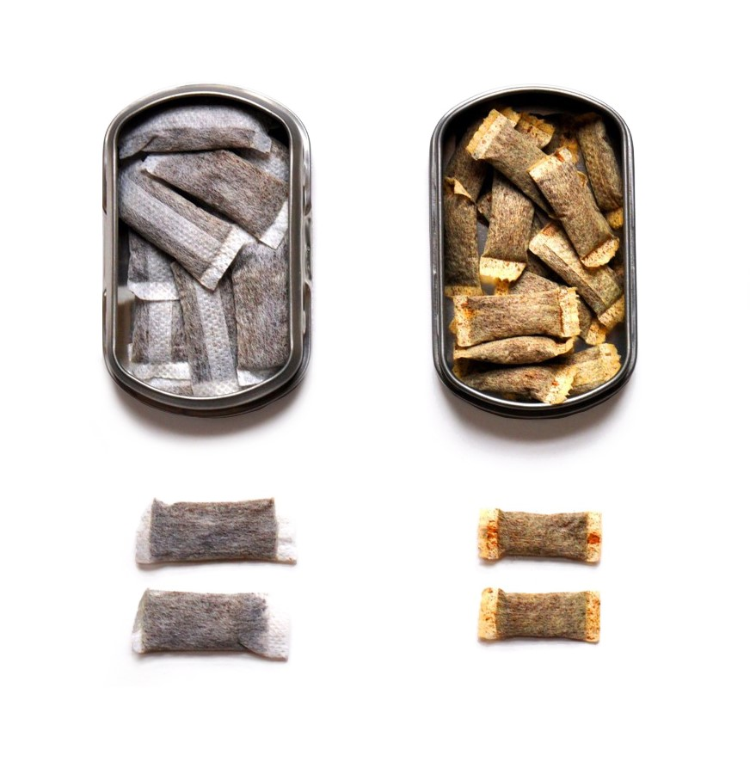 | - Had you ever heard of snus before today?  - What is snus, in your own words? How is it different from chewing tobacco or other types of smokeless tobacco? What types of products would you include or exclude?  - How well did the description fit the images shown? To what extent did you use the images versus the description in order to understand what types of products it was asking about?
Have you ever used snus, even just one time?
- Yes
- No
[INTERVIEWER: CONTINUE BELOW FOR EVER SNUS USERS. NEVER USERS SKIP TO PAGE X.]
Question Universe: ever users of snus [or unknown]  During the past 30 days, on how many days did you use snus?  Specify: |__|__| (Range 0 – 30) | [IF NOT PROBED ALREADY]:  - How easy or hard was it to answer with a specific number of days?
[INTERVIEWER: CONTINUE BELOW FOR PAST 30 DAY SNUS USERS. EVER USERS SKIP TO PAGE X.]
Question Universe: past 30-day snus user [known]
Was any of the snus that you used in the past 30 days flavored to taste like menthol, mint, clove or spice, alcoholic drinks, candy, fruit, chocolate, or any other non-tobacco flavor?
Do not think about tobacco flavor when answering this question.
- Yes
- No
- Don’t Know
Question Universe: past 30-day snus user [known]
Was any of the snus that you used in the past 30 days flavored to taste like tobacco?
- Yes
- No
- Don’t Know

Question Universe: past 30-day users of flavored snus
What flavors was the snus that you have used in the past 30 days? (Select one or more)
- Tobacco-flavor
- Menthol
- Mint
- Spice (such as cinnamon, vanilla, or clove)
- Fruit
- Chocolate
- Alcoholic drinks (such as wine, margarita, or other cocktails)
- Non-alcoholic drinks (such as coffee, soda, lemonade, or other beverage)
- Candy, desserts, or other sweets
- Some other flavor not listed here (Specify): _____________________________
Question Universe: past 30-day snus user [known]
During the past 30 days, how did you get your snus? (Select one or more)
- I bought it myself
- I had someone else buy it for me
- I asked someone to give me some
- Someone offered it to me
- I got it from a friend
- I got it from a family member
- I took it from a store or another person
- I got it in some other way (specify): __________________________________
Question Universe: past 30-day snus user [known]
During the past 30 days, where did you buy your snus? (Select one or more)
- I did not buy snus during the past 30 days à [EXCLUSIVE RESPONSE]
- I bought it from another person (a friend, family member, or someone else)
- A gas station or convenience store
- A grocery store
- A drugstore
- A mall or shopping center kiosk/stand
- A vending machine
- On the Internet (such as a product or store website, eBay, or Facebook Marketplace)
- Through the mail
- Through a delivery service (such as DoorDash or Postmates)
- A vape shop or tobacco shop
- Some other place not listed here (specify): ______________________________
Question Group Probes:
- Can you describe the snus product(s) you’ve used? What else would you call it?
- [IF NOT ALREADY PROBED]: How easy or hard was it to remember your specific experiences, like flavors and where you got your products from?
  - Nicotine Pouches
The next section is about nicotine pouches such as Zyn, on!, Velo, or Rogue. These small, flavored pouches are filled with a nicotine-containing powder. Users place nicotine pouches in their mouth and do not need to spit. Nicotine pouches are different from some other smokeless tobacco products such as snus, dip, or chewing tobacco, because they do not contain any tobacco leaf.  Do not think about chewing tobacco, snuff, dip, snus, or other oral nicotine products when answering these questions.  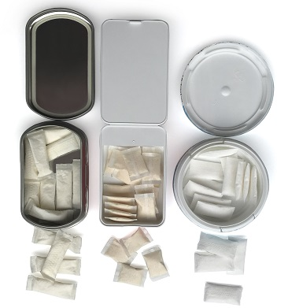 | - In your own words, what is a nicotine pouch?  - How is a nicotine pouch different from chewing tobacco? How is nicotine pouch different from snus? From other oral nicotine products?  - Have you heard of any of the examples of nicotine pouches?  - How well did the description fit the images shown? To what extent did you use the images versus the description in order to understand what types of products it was asking about?
Before today, have you heard of nicotine pouches?
- Yes
- No
- Don’t know/Not Sure
Have you ever used a nicotine pouch, even just one time?  - Yes  - No  - Don’t Know/Not Sure | [IF DON’T KNOW]:  - What makes you unsure about having used nicotine pouches?
[INTERVIEWER: CONTINUE BELOW FOR EVER (OR DK) NICOTINE POUCH USERS. NEVER USERS SKIP TO PAGE X.
Question Universe: ever nicotine pouch user [or unknown/don’t know]  During the past 30 days, on how many days did you use a nicotine pouch?  Specify: |__|__| (Range 0 – 30) | [IF NOT ALREADY PROBED]:  - How easy or hard was it to answer with a specific number of days?
[INTERVIEWER: CONTINUE BELOW FOR PAST 30 DAY NICOTINE POUCH USERS. EVER USERS SKIP TO PAGE X.
Question Universe: past 30-day nicotine pouch user [known]
During the past 30 days, what nicotine pouch brands did you use? (Select one or more)
- on!
- Rogue
- Velo
- Zyn
- Some other brand(s) not listed here (specify): ________________
- Not sure / I don’t know the brand
Question Universe: past 30-day nicotine pouch user reporting >1 brand [known]
During the past 30 days, what brand of nicotine pouches did you usually use? (Choose only one answer)
- I did not use a usual brand
- on!
- Rogue
- Velo
- Zyn
- Some other brand(s) not listed here (specify): _________________
- Not sure / I don’t know the brand

Question Universe: past 30-day nicotine pouch user [known]  Were any of the nicotine pouches that you used in the past 30 days flavored to taste like menthol, mint, clove or spice, alcoholic drinks, candy, fruit, chocolate, or any other non-tobacco flavor?  Do not think about tobacco flavor when answering this question.  - Yes  - No  - Don’t Know | [if not already prompted]  What does “non-tobacco flavor” mean to you in this question? What does “tobacco flavor” mean?  Would you have answered differently if it didn’t say “Do not think about tobacco flavor when answering this question?
Question Universe: past 30-day user of nicotine pouches [known]  Were any of the nicotine pouches that you used in the past 30 days flavored to taste like tobacco?  - Yes  - No  - Don’t Know | [if not already prompted]  What does “flavored to taste like tobacco” mean to you?  Did you think about added artificial flavorings, naturally occurring tobacco flavor, or both?
Question Universe: past 30-day users of flavored nicotine pouches  What flavors were the nicotine pouches that you have used in the past 30 days? (Select one or more)  - Tobacco-flavor  - Menthol  - Mint  - Spice (such as cinnamon, vanilla, or clove)  - Fruit  - Chocolate  - Alcoholic drinks (such as wine, margarita, or other cocktails)  - Non-alcoholic drinks (such as coffee, soda, lemonade, or other beverage)  - Candy, desserts, or other sweets  - Some other flavor not listed here (Specify): _________________________ | What do you think of the answer choices?  What’s the difference between menthol and mint?
Question Universe: past 30-day user of flavored nicotine pouches  Did any of the flavors that you used in the past 30 days have names or descriptions that included the word “ice” or “iced” (for example, blueberry ice or strawberry ice)?  - Yes  - No  - Don’t know | - Have you ever heard of “iced” flavors?  - Was anything about this question confusing?
Question Universe: past 30-day user of flavored nicotine pouches  Did any of the flavors that you used in the past 30 days have a name that did not describe a specific flavor, such as “solar,” “purple,” “jazz,” “island bash,” “fusion” or some other word or phrase?  - Yes (specify): ___________________  - No  - Don’t know | - Was anything about this question confusing?  - Would you describe these flavors any differently?  Are any example words (e.g., jazz) missing?
Question Universe: past 30-day nicotine pouch user [known]
During the past 30 days, how did you get your nicotine pouches? (Select one or more)
- I bought them myself
- I had someone else buy them for me
- I asked someone to give me some
- Someone offered them to me
- I got them from a friend
- I got them from a family member
- I took them from a store or another person
- I got them in some other way (Specify): ____________________________

Question Universe: past 30-day nicotine pouch user [known]
During the past 30 days, where did you buy your nicotine pouches? (Select one or more)
- I did not buy nicotine pouches during the past 30 days à [EXCLUSIVE RESPONSE]
- I bought them from another person (a friend, family member, or someone else)
- A gas station or convenience store
- A grocery store
- A drugstore
- A mall or shopping center kiosk/stand
- A vending machine
- On the Internet (such as a product or store website, eBay, or Facebook Marketplace)
- Through the mail
- Through a delivery service (such as DoorDash or Postmates)
- A vape shop or tobacco shop
- Some other place not listed here (Specify): __________________________

Question Group Probes:
- Can you describe the nicotine pouches you’ve used? What else would you call it?
- [IF NOT ALREADY PROBED]: How easy or hard was it to remember your specific experiences, like flavors and where you got your products from?
  - Oral Nicotine Products
The next few questions are about other oral nicotine products. Oral nicotine products come in a variety of shapes and types, such as lozenges, discs, tablets, gums, dissolvable tobacco products, and other products. Examples of these products include Velo Nicotine Lozenges, Rogue Lozenges, Rogue Tablets, Verve discs, or Stonewall. Most oral nicotine products dissolve in your mouth and do not require spitting.  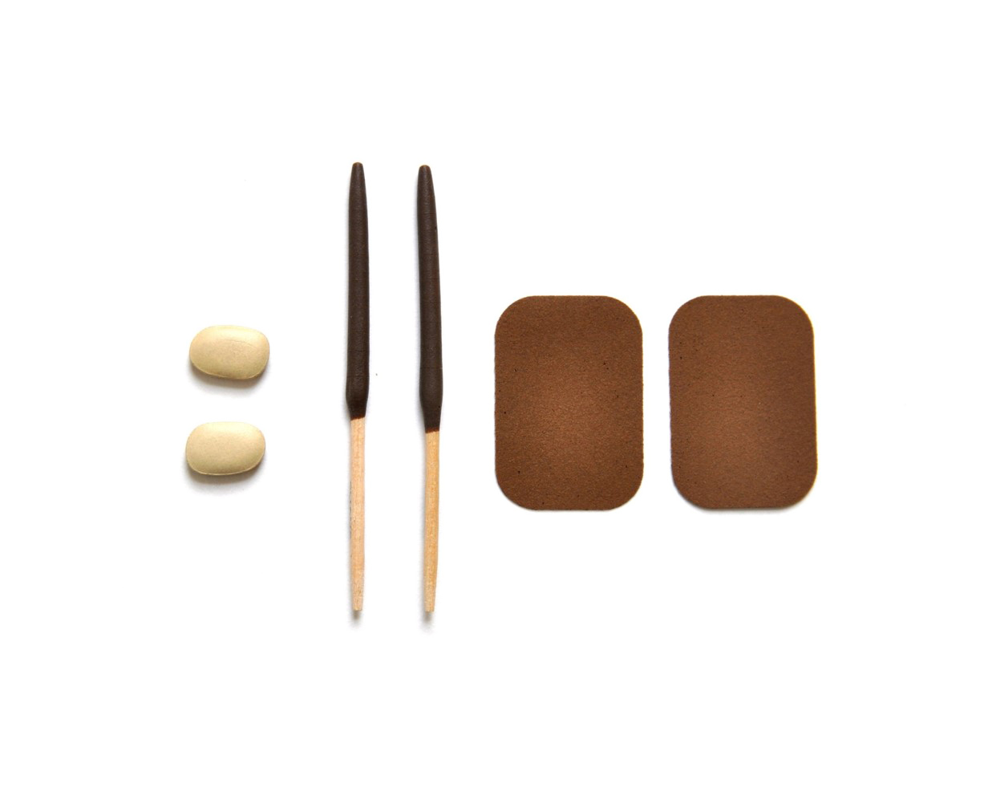  Do not think about chewing tobacco, snuff, dip, snus or nicotine pouches when answering these questions. | - In your own words, what are oral nicotine products? How are these products different from other smokeless tobacco products?  - Have you heard of any of the brands mentioned in the description? Which one(s)?  - Were any of the shapes and types (lozenges, discs, tablets, etc.) hard to understand?  - How well did the description fit the images shown? To what extent did you use the images versus the description in order to understand what types of products it was asking about?
Have you ever used oral nicotine products, even just one time?
- Yes
- No
[INTERVIEWER: CONTINUE BELOW FOR EVER DISSOLVABLE TOBACCO USERS. NEVER USERS SKIP TO PAGE X.
Question Universe: ever users of oral nicotine products [or unknown]  During the past 30 days, on how many days did you use oral nicotine products?  Specify: |__|__| (Range 0 – 30) | [IF NOT PROBED ALREADY]:  - How easy or hard was it to answer with a specific number of days?
[INTERVIEWER: CONTINUE BELOW FOR PAST 30 DAY DISSOLVABLE TOBACCO USERS. EVER USERS SKIP TO PAGE X.]
Question Universe: past 30-day oral nicotine user [known]
Were any of the oral nicotine products that you used in the past 30 days flavored to taste like menthol, mint, clove or spice, alcoholic drinks, candy, fruit, chocolate, or any other non-tobacco flavor?
Do not think about tobacco flavor when answering this question.
- Yes
- No
- Don’t Know
Question Universe: past 30-day oral nicotine product user [known]
Were any of the oral nicotine products that you used in the past 30 days flavored to taste like tobacco?
- Yes
- No
- Don’t Know

Question Universe: past 30-day users of flavored oral nicotine products
What flavors were the oral nicotine products that you have used in the past 30 days? (Select one or more)
- Tobacco-flavor
- Menthol
- Mint
- Spice (such as cinnamon, vanilla, or clove)
- Fruit
- Chocolate
- Alcoholic drinks (such as wine, margarita, or other cocktails)
- Non-alcoholic drinks (such as coffee, soda, lemonade, or other beverage)
- Candy, desserts, or other sweets
- Some other flavor not listed here (Specify): ___________________________
Question Universe: past 30-day oral nicotine user [known]
During the past 30 days, how did you get your oral nicotine products? (Select one or more)
- I bought them myself
- I had someone else buy them for me
- I asked someone to give me some
- Someone offered them to me
- I got them from a friend
- I got them from a family member
- I took them from a store or another person
- I got them in some other way (specify): _______________________________
Question Universe: past 30-day oral nicotine user [known]
During the past 30 days, where did you buy your oral nicotine products? (Select one or more)
- I did not buy oral nicotine products during the past 30 days à [EXCLUSIVE RESPONSE]
- I bought them from another person (a friend, family member, or someone else)
- A gas station or convenience store
- A grocery store
- A drugstore
- A mall or shopping center kiosk/stand
- A vending machine
- On the Internet (such as a website or a secondary source, like eBay or Facebook marketplace)
- Through the mail
- Through a delivery service (such as DoorDash or Postmates)
- A vape shop or tobacco shop
- Some other place not listed here (specify): _____________________________
Question Group Probes:
- Can you describe the oral nicotine product(s) you’ve used? What else would you call it?
- [IF NOT ALREADY PROBED]: How easy or hard was it to remember your specific experiences, like flavors and where you got your products from?
  - All Tobacco Products
[INTERVIEWER: CONTINUE BELOW FOR PAST 30-DAY USERS OF ANY TOBACCO PRODUCT (SEE SCREENER RESPONSES). FOR NEVER OR FORMER USERS, SKIP TO PAGE X.
Instruction Universe: current (past 30-day) tobacco product user (any product) [known]

In answering the next 5 questions, please think about all of the tobacco products that you have used in the past 30 days, including e-cigarettes, cigarettes, cigars, smokeless tobacco, snus, nicotine pouches, other oral nicotine products, hookahs, heated tobacco products, pipe tobacco, bidis, and roll-your own-cigarettes.

Question Universe: current (past 30-day) tobacco product user (any product) [known]  During the past 30 days, on how many days did you use any tobacco product(s)?  Specify: |__|__| (Range 1 – 30) | Walk me through how you answered this question (particularly if respondent uses more than 1 tobacco product).
Question Universe: past 30-day users of any tobacco product [known]  During the past 30 days, have you had a strong craving or felt like you really needed to use a tobacco product of any kind?  - Yes  - No | - In your own words, what is this question asking?
Question Universe: past 30-day users of any tobacco product [known]  How soon after you wake up do you want to use a tobacco product of any kind?  - I do not want to use tobacco products  - Within 5 minutes  - From 6 to 30 minutes  - From more than 30 minutes to 1 hour  - After more than 1 hour but less than 24 hours  - I rarely want to use tobacco products | - How well did the response options fit your answer to this question?
Question Universe: past 30-day tobacco product users (any product) [known]  Are you seriously thinking about quitting the use of all tobacco products? (Please choose the first answer that fits)  - Yes, during the next 30 days  - Yes, during the next 6 months  - Yes, during the next 12 months  - Yes, but not during the next 12 months  - No, I am not thinking about quitting the use of all tobacco products | - What does “seriously thinking about quitting” mean to you here? How did you decide on your answer?  - For those answering [E], are you not interested in quitting, or do you not consider yourself to be a tobacco product user?
Question Universe: past 30-day tobacco product users (any product) [known]
During the past 12 months, how many times have you stopped using all tobacco products for one day or longer because you were trying to quit all tobacco products for good?
- I did not try to quit all tobacco products during the past 12 months
- 1 time
- 2 times
- 3 to 5 times
- 6 to 9 times
- 10 or more times

Instruction Universe: past 30-day tobacco product users (any product) [known]
The next few questions are about getting tobacco products.
Question Universe: past 30-day tobacco product users (any product) [known]
During the past 30 days, did anyone refuse to sell you any tobacco products because of your age?
- I did not try to buy any tobacco products during the past 30 days
- Yes
- No

INTERVIEWER: CONTINUE HERE FOR ALL RESPONDENTS.
Instruction Universe: never, former users of any tobacco product [known/unknown]
The next two questions ask your thoughts about getting tobacco products.
How easy do you think it is for people your age to buy tobacco products in a store?  - Easy  - Somewhat easy  - Not easy at all | - What kinds of stores were you thinking of?
How easy do you think it is for people your age to buy tobacco products online?
- Easy
- Somewhat easy
- Not easy at all

  - Healthcare
The next several questions are about visits to a doctor, dentist, nurse, or other health professional during the past 12 months.
Have you visited a doctor, dentist, or nurse in the past 12 months?  - Yes  - No | - Did you notice that the question asked about the past 12 months?
Please think about cigarettes, only, when answering the next two questions.
During any of these visits to a doctor, dentist, nurse, or other health professional, were you asked if you used cigarettes?
- Yes
- No
During any of these visits, were you advised to not use cigarettes?
- Yes
- No
Please think about e-cigarettes, only, when answering the next two questions.
During any of these visits to a doctor, dentist, nurse, or other health professional, were you asked if you used e-cigarettes?
- Yes
- No
During any of these visits, were you advised to not use e-cigarettes?
- Yes
- No
Please think about all other tobacco products when answering the next two questions.
This includes: cigars, chewing tobacco, snuff, or dip, smokeless tobacco products, snus, nicotine pouches, other oral nicotine products, hookah, heated tobacco products, pipe tobacco, bidis, or roll-your-own cigarettes.
Do not think of e-cigarettes or manufactured cigarettes when answering these questions.
During any of these visits to a doctor, dentist, nurse, or other health professional, were you asked if you used any of these other tobacco products?
- Yes
- No
During any of these visits, were you advised to not use any of these other tobacco products?
- Yes
- No
Question Group Probes:
- For the last couple questions, what products were you thinking about?
- What is a “manufactured cigarette” in your own words?
  - Opinions on Tobacco (B)
The next 8 questions ask about your thoughts on tobacco products.
Compared to a typical cigarette, would you think that a cigarette advertised as low nicotine would be…
- Much less harmful
- Slightly less harmful
- Equally harmful
- Slightly more harmful
- Much more harmful
Do you think that e-cigarettes…
- Never contain nicotine
- Rarely contain nicotine
- Sometimes contain nicotine
- Usually contain nicotine
- Always contain nicotine
How strongly do you agree with the statement ‘All tobacco products are dangerous’?  - Strongly agree  - Agree  - Disagree  - Strongly disagree | What products did you consider?
Do you think that breathing the vapor from other people’s e-cigarettes causes…  - No harm  - Little harm  - Some harm  - A lot of harm | Can you describe what this question is asking in your own words (specifically what “breathing the vapor from other people’s e-cigarettes” means)?
Not including the vapor from e-cigarettes, do you think that breathing smoke from other people’s cigarettes or other tobacco products causes…  - No harm  - Little harm  - Some harm  - A lot of harm | Can you describe what this question is asking in your own words?
Out of every 10 students in your grade at school, how many do you think smoke cigarettes?  - 0  - 1  - 2  - 3  - 4  - 5  - 6  - 7  - 8  - 9  - 10 | - How did you come up with your answer to this question?
Out of every 10 students in your grade at school, how many do you think use e-cigarettes?  - 0  - 1  - 2  - 3  - 4  - 5  - 6  - 7  - 8  - 9  - 10 | - What is the difference between this question and the last one?  - Now that you’ve had a chance to think about it, would you change your answer?
Please complete the following sentence. My friends think that e-cigarette use is…

- Completely acceptable
- Mostly acceptable
- Mostly not acceptable
- Not acceptable
Question Group Probes:
- What kind of harm were you thinking about?
- Some of these questions ask about cigarettes and others ask about e-cigarettes. How clear or confusing was it to understand which questions asked about which type of products?
  - Neighborhood Environment Scale
How true are each of the following statements about your neighborhood?  Response options: Not at all true, A little true, Sort of true, Very true  - There are plenty of safe places to walk or spend time outdoors in my neighborhood  - Every few weeks, some kid in my neighborhood gets beat-up or mugged.  - Every few weeks, some adult gets beat-up or mugged in my neighborhood.  - I have seen people using or selling drugs in my neighborhood.  - In the morning or later in the day, I often see drunk people on the street in my neighborhood.  - Most adults in my neighborhood respect the law.  - I feel safe when I walk around my neighborhood by myself during the day.  - People who live in my neighborhood often damage or steal each other’s property.  - I feel safe when I walk around my neighborhood by myself at night.  - In my neighborhood, the people with the most money are the drug dealers. | - Did the response options make sense for all the questions?  - How did you choose between the response options? What is the difference between “A little true” and “Sort of true”?  - Which of the specific questions are worded in a confusing way or were hard to answer?  - What were you thinking about when you saw the word ‘neighborhood (i.e., how did you define ‘neighborhood’)?

Home and School
The last fourteen questions ask about your experiences at home and at school.
Does anyone who lives with you now…? (Select one or more)  - Use e-cigarettes  - Smoke cigarettes  - Smoke cigars, cigarillos, or little cigars  - Use chewing tobacco, snuff, or dip  - Use snus  - Use nicotine pouches  - Use other oral nicotine products  - Smoke tobacco in a hookah or waterpipe  - Use heated tobacco products  - Smoke pipes filled with tobacco (not hookah or waterpipe)  - Smoke bidis  - Smoke roll-your-own cigarettes  - No one who lives with me now uses any form of tobacco à [EXCLUSIVE] | - How did you decide “who lives with you”?
Do you speak a language other than English at home?
- Yes
- No
Sexual orientation is a person’s emotional, romantic, and/or sexual attraction to another person. There are many ways a person can describe their sexual orientation and many labels a person can use. Which of these options best describes your sexual orientation?  - Heterosexual (straight)  - Gay or Lesbian  - Bisexual, Pansexual, or Queer  - Asexual  - Not Sure  - I do not know what this question is asking | - How did you come up with your answer?  - Were there any categories you hadn’t heard before?  - Were there other answer categories you wish were there?  - If you could write-in your own response, would that have changed your answer?
Some people describe themselves as transgender and/or nonbinary when the way they think or feel about their gender is different from their sex assigned at birth. Do you identify as transgender and/or nonbinary?  - No, I am not transgender and/or nonbinary  - Yes, I am transgender and/or nonbinary  - I am not sure if I am transgender and/or nonbinary  - I am not sure yet or questioning if I am transgender and/or nonbinary  - I do not know what this question is asking | - In your own words, what is this question asking?  - How clear or confusing was the question? How easy or hard to answer?
During the past two weeks, how often have you been bothered by any of the following problems?  Response options: Not at all, Several Days, More than half of the days, Nearly every day  - Little interest or pleasure in doing things  - Feeling down, depressed, or hopeless  - Feeling nervous, anxious, or on edge  - Not being able to stop or control worrying | - This question asks about experiences during the past two weeks. Do you think this is typical of your normal experiences?  - How clear are these response options?
Does your family own a vehicle (such as a car, van, or truck)?
- No
- Yes, one
- Yes, two or more
Do you have your own bedroom?
- No
- Yes
How many computers (including laptops and tablets, not including game consoles and smartphones) does your family own?
- None
- One
- Two
- More than two
During the past 12 months, how many times did you travel on vacation with your family?
- Not at all
- Once
- Twice
- More than twice
During the past 12 months, how would you describe your grades in school?
- Mostly A’s
- Mostly B’s
- Mostly C’s
- Mostly D’s
- Mostly F's
- None of these grades
- Not sure
Because of a physical, mental, or emotional condition, do you have serious difficulty concentrating, remembering, or making decisions?
- Yes
- No
Question Group Probes:
- How did it feel or sound for the intro to this section to talk about “the last fourteen questions”? Did you notice that?
- Were these questions what you expected when the intro said, “your experiences at home and at school”? How else would you describe these questions?
- How clear or confusing were these questions? Was there anything that was hard to answer?
- How comfortable did you feel answering these questions? Did you feel like you could answer honestly?
- How did the COVID-19 pandemic change any of your responses to the questions? For example, did you travel on vacation less during the past 12 months than you normally would have in any other year? Did you have more experiences with anxiety or stress, or get better or worse grades, than you normally would have?

